Standard deviation
Students learn to calculate and interpret standard deviation to understand how spread and variability affect datasets. They apply this to real-world examples, comparing fatigued and non-fatigued driver data to see how standard deviation informs reliability and consistency.
Students will need at least one digital device per pair to interact with the NSW Government ‘Test your tired self’ webpage and GeoGebra during this lesson.

Learning intentions
- To understand standard deviation as a measure of data spread.
- To be able to use standard deviation to compare and interpret datasets.

Success criteria
- I can calculate the standard deviation of a dataset using a scientific calculator or digital tools.
- I can explain what standard deviation reveals about data consistency and variability.
- I can compare datasets using standard deviation alongside other measures of centre and spread.
- I can justify which measures of centre and spread are most appropriate for a given dataset.

Outcomes
A student:
- develops understanding and fluency in mathematics through exploring and connecting mathematical concepts, choosing and applying mathematical techniques to solve problems, and communicating their thinking and reasoning coherently and clearly MAO-WM-01
- displays and analyses datasets using summary statistics and graphical representations
MST-11-08
Mathematics Standard 11–12 Syllabus © NSW Education Standards Authority (NESA) for and on behalf of the Crown in right of the State of New South Wales, 2024.

Associated numeracy outcomes
A student:
- recognises and applies functional numeracy concepts in practical situations, including personal and community, workplace and employment, and education and training contexts N6-1.1
- applies numerical reasoning and mathematical thinking to clarify, efficiently solve and communicate solutions to problems N6-1.2
- chooses and applies efficient strategies to analyse and solve everyday problems involving data, graphs, tables, statistics and probability N6-2.3
Numeracy Stage 6 (CEC) Syllabus © NSW Education Standards Authority (NESA) for and on behalf of the Crown in right of the State of New South Wales, 2021.

Content

Measures of centre and spread
- Describe the mean, median and mode as measures of centre and calculate their values for a dataset in graphical form and tabular form, using a scientific calculator and other digital tools
- Identify the range and standard deviation as measures of spread to describe variation in a dataset
- Calculate the range and population standard deviation $σ$ of a dataset using a scientific calculator or other digital tools
- Compare datasets using measures of centre and measures of spread
- Examine the merits of each measure of centre and justify where each measure is most appropriately used
- Identify and describe real-world examples illustrating appropriate and inappropriate uses of measures of centre and measures of spread
Mathematics Standard 11–12 Syllabus © NSW Education Standards Authority (NESA) for and on behalf of the Crown in right of the State of New South Wales, 2024.

Table 1: lesson summary
Section | Summary of activity | Teaching strategies | Teaching points
Activating prior knowledge | Students view a Transport for NSW fatigue video (bit.ly/fatiguecrashes) and complete the NSW Government ‘Test your tired self’ activity (bit.ly/TestYourTiredSelf). They note information on fatigue-related facts, then discuss how fatigue affects driving performance and reaction time. | Class discussion | Fatigue significantly increases crash risk and impairs reaction time. Real-world contexts provide meaningful data for statistical investigation. This activity builds curiosity and relevance for analysing driver data.
Connecting learning | Using Appendix A, students analyse fatigued and non-fatigued driver datasets, for steering and speed variation. Answers can be displayed using slides 4 and 5 of the PowerPoint Standard deviation. Slides 6 and 7 introduce the formal definition of standard deviation and include an example to demonstrate why an additional measure of spread is needed by comparing 2 datasets. Using GeoGebra (bit.ly/standarddeviationvisual), students visualise how changes in data affect the mean and standard deviation, then calculate standard deviation using calculators and interpret variability between datasets. | Think-Pair-Share  Pose-Pause-Pounce-Bounce | The aim of this activity is to develop students’ understanding that standard deviation measures variability around the mean and to establish a need for an additional measure of spread. Outliers can increase the standard deviation and reduce how representative the mean is of the dataset. Standard deviation therefore provides deeper insight into data consistency than the range alone.
Releasing responsibility | Students analyse 3 sleep datasets using Appendix B or by displaying slide 9. They calculate the mean and standard deviation and justify which class gets the most sleep, using data to explore how variation affects interpretation. | Pose-Pause-Pounce-Bounce  Notes to future forgetful selves  Think-Pair-Share | The intention of this activity is to support students in recognising that standard deviation helps judge the consistency and reliability of datasets. Uniform changes to all data values affects the mean but not the standard deviation. Comparing standard deviations therefore supports informed interpretation of real-world data.
Independent practice | Students respond to targeted questioning about interpreting standard deviation and demonstrate their understanding using Appendix C. | Less, Same, More | Students deepen their conceptual understanding of how changes to a dataset affect the mean and standard deviation, building the foundation needed to interpret and apply the normal distribution in Year 12 Standard 2 Mathematics.

Activity structure
This resource contains references to car accidents and road safety. Teachers should be mindful that some students may have prior experiences or sensitivities connected to this topic.
Please use the associated PowerPoint Standard deviation to display images in this lesson.

Activating prior knowledge
- Show students the Transport for NSW video ‘Most fatigue crashes happen close to home’ (0:30) (bit.ly/fatiguecrashes).
- Distribute the link ‘Test your tired self’ (bit.ly/TestYourTiredSelf) to students and ask them to complete the test. Ask them to pay close attention to the facts that appear throughout the test.
Students must indicate they are at least 17 years old to complete the test. Questions such as ‘How many hours until your next drive?’ and ‘Will your drive be longer than 1 hour?’ cannot be answered truthfully if they don’t have a licence. Students can base their answers on how long it will take them to get home from school, regardless of the mode of travel. They may also repeat the test with different responses to explore how results change.
Within this test, a blood alcohol content (BAC) of 0.05 is mentioned. BAC may need to be defined to some students as blood alcohol content and that an individual’s BAC must be under 0.05 to legally drive, as it effects a person’s ability to react to changes on the road. Students will learn more about BAC in Lesson 9 – blood alcohol content and Lesson 10 – applications of the BAC formula in this unit.
- Initiate a class discussion to unpack student results from the test as well as what they discovered from the facts presented. Some related facts, from the ‘Towards zero – Fatigue’ webpage (bit.ly/TowardsZeroFatigue) could also be discussed. These include:
- Fatigue-related crashes are almost 3 times as likely to be fatal than crashes not involving fatigue.
- Being awake for 17 hours has a similar effect on driving performance as a blood alcohol content (BAC) of 0.05.
The purpose of this activity is to highlight the dangers of driving when fatigued as well as spark curiosity on the various causes of accidents on our roads.

Connecting learning
- Explain to students that driver fatigue is one of the 3 main causes of accidents on NSW roads. In a Think-Pair-Share (bit.ly/thinkpairsharestrategy) ask students to consider how Transport NSW might be able to monitor or measure fatigue.
Students may note that fatigue is much harder to track or prove than speeding or drink driving. Some examples of how driver fatigue can be detected or predicted are outlined on the ‘Road Safety Technology’ (bit.ly/roadsafetytechnology) webpage. These include cameras that monitor a driver’s eyelids and head position, as well as in-vehicle sensors that detect steering-wheel movements and lane position.
- Distribute Appendix A ‘Datasets’ to all students. Advise students that it includes 2 datasets: Dataset A – fatigued drivers and Dataset B – non-fatigued drivers. The data includes 2 fatigue indicators:
- the steering variation, measured in degrees, which shows how much the driver’s steering wheel is moving around
- the speed variation, measured in km/h, which tells us how much the driver’s speed is changing from the speed limit.
- Give each pair of students one fatigue indicator to focus on, ensuring that both fatigue indicators are covered across the class.
- Students are to compare and contrast the 2 datasets with the assigned fatigue indicator. Students can use the 2 frequency tables that have been provided in Appendix A to support their analysis.
Students should be encouraged to calculate the mean, median and mode as measures of centre, as well as the range as a measure of spread, using tabular form.
- Bring the class together to discuss the analysis, selecting pairs so that both indicators are addressed. During the discussion, display the measures of centre and spread for each dataset and indicator using slides 4 and 5.
- Ask students in a Think-Pair-Share to discuss the merits of each measure of centre and range for all the datasets and indicators discussed and justify which measure is most appropriate for each.
Students may share that for Dataset A – steering variation, the mean and median didn’t best reflect the data due to 2 extreme values. Students may consider whether these values are outliers.
Students first learned about outliers and the associated formula in Lesson 8 of Unit 1 – getting healthy.
- Explain to students that there is another way that data can be analysed, in terms of the measure of spread, called the standard deviation.
- Use slide 6 to display the NESA Glossary definition for standard deviation, explaining that the symbol for standard deviation of a population is $σ$.
Standard deviation: a measure of the variability or spread of a dataset. It gives an indication of the degree to which the individual data values are spread around their mean.
- Display slide 7 to explain standard deviation by comparing 2 datasets that have the same mean, median, mode and range. Use the self-explanation prompt to guide a discussion on what is the same and what is different about the 2 datasets.
- Animate the slide to show a parallel boxplot that represents the dataset. Prompt students to consider how this visual representation supports their previous thinking about what was the same and what was different.
- Animate the slide to reveal each dataset’s standard deviation, reinforcing its definition and visually showing that a larger standard deviation means the data is more spread out around the mean.
- Explain to students that they will now be returning to Appendix A ‘Datasets’ for further analysis using the standard deviation.
- Distribute the GeoGebra link ‘The mean and standard deviation of a set of data’ (bit.ly/standarddeviationvisual) which contains an interactive dot plot, originally created by Maths Learning Centre University of Adelaide (geogebra.org/u/mathslearninguofa).
Students may need to be told that ‘sd’ refers to standard deviation.
- Before modelling the given datasets, allow students time to freely manipulate the points to explore how the mean and standard deviation change. Prompt discussion with guiding questions such as:
- What needs to happen for the standard deviation to be 0?
- Can you make the mean equal to 3 and the standard deviation equal to 1?
- What does this distribution look like?
This exploratory phase is intended to support visualisation of centre and spread at different means.
- Instruct students to drag the points in GeoGebra, such that their dot plot represents:
- Dataset A – steering variation, recording the mean and standard deviation
- then Dataset B – steering variation, recording the mean and standard deviation.
Explain that the displayed values for the mean and standard deviation are approximations, as it may be difficult to place points at exact values. Emphasise that the purpose of the GeoGebra interactive is to deepen conceptual understanding of centre and spread rather than to obtain precise calculations. Students should be prompted to observe how changes in the distribution affect both the mean and the standard deviation.
- Use the Pose-Pause-Pounce-Bounce questioning strategy (PDF 557 KB) (bit.ly/posepausepouncebounce) to initiate a class discussion for students to share what they discovered. Suggested prompts could include:
- What patterns do you notice in how the data behaves when you adjust the points?
- What features help explain why one standard deviation is larger or smaller than another?
- How do outliers or extreme values affect the standard deviation, and what does this tell you about the dataset?
- Explain to students that the standard deviation can be calculated accurately using their calculators.
See Approved calculators for the full list of the approved calculators and the approval process for calculator suppliers.
- Demonstrate for students how to use their calculator to calculate the standard deviation for a single dataset as well as datasets in tabular form.
Most calculators allow users to calculate both population and sample standard deviation. Explicitly clarify to students that they should use the population standard deviation, as the syllabus does not reference sample standard deviation. The symbol for population standard deviation is $σ$.
- Instruct students in their pairs to use their calculator to accurately calculate the standard deviation for their given indicator from the datasets in Appendix A, for both the fatigued and non-fatigued drivers, confirming their results from the GeoGebra activity.
Students may have already found the mean and standard deviation using the GeoGebra activity. Using their calculator will accurately calculate these statistics.
- In a Think-Pair-Share, ask students to now consider the merits of each measure of centre and spread, that is, the mean, median, mode, range and standard deviation, and discuss where each measure is most appropriately used.
Students may note that when the standard deviation is large, the mean and median become less representative of the dataset, particularly if outliers are present. They might also recognise that the mode is only useful when values repeat, and that the range does not show how data is distributed.
- Encourage students to justify which measures or combination of measures best represent each dataset using evidence from their calculations and discuss what these differences suggest about the behaviour of fatigued drivers compared to non-fatigued drivers.

Releasing responsibility
- Distribute the 3 datasets from Appendix B ‘Comparing using the standard deviation,’ to the class.
This can also be displayed using slide 9.
- Using a Think-Pair-Share, have students discuss which class they think is getting the most sleep, without performing any calculations.
Students may share that it’s difficult to tell which class gets the most sleep just by looking at the numbers, since all 3 datasets have very similar values.
Some students might notice that Class 3 has a few higher scores, so they may believe that this class gets the most sleep.
- Have students use their calculator to determine the mean and standard deviation for each dataset, then justify which class they believe gets the most sleep and which has the most consistent sleep.
Class 1: mean $= 7.1\dot{3}$ and standard deviation $≈ 0.3859$. Class 2: mean $=7.0\dot{6}$ and standard deviation $≈ 0.16997$. Class 3: mean $= 7.6\dot{3}$ and standard deviation $≈ 0.6182$.
Class 3 has the highest mean, indicating the greatest average sleep. Class 2 has the smallest standard deviation, indicating the most consistent sleep. Students should justify which measure they prioritise depending on whether the focus is on maximising average sleep or consistency.
- It may be helpful to use the GeoGebra link ‘The mean and standard deviation of a set of data’ (bit.ly/standarddeviationvisual), to help students visualise how the data is spread for each of the 3 classes. This allows them to see that a larger standard deviation indicates the scores are more spread out from the mean and therefore less consistent, while a smaller standard deviation indicates the data is more tightly clustered around the mean and therefore more consistent.
- Use the Pose-Pause-Pounce-Bounce questioning strategy to prompt students to think critically about what standard deviation tells us about the dataset and how it affects interpretation of the mean. Some suggested prompts include:
- What does the standard deviation reveal about data spread and consistency?
- What might a large standard deviation suggest about the usefulness of the mean?
- How does comparing the standard deviations of 2 datasets help us judge which one is more reliable or consistent?
- Why might standard deviation be a more useful measure of spread than the range in some real-world contexts?
- Students are to create notes to their future forgetful selves (bit.ly/notestofutureself) explaining how to calculate standard deviation using their calculator and writing a definition of standard deviation in their own words.

Independent practice
- Distribute Appendix C ‘Less, Same, More’ for students to complete in their pairs.
- On completion of the ‘Less, Same, More’ table, students will apply their knowledge to a past HSC question.
Students could use a whiteboard marker and plastic sleeve for the ‘Less, Same, More’ activity, making it easy to manipulate the datasets.
It’s important that students develop a solid understanding of the relationship between the mean and the standard deviation for their future learning of The normal distribution in Year 12, if they choose to complete the Year 12 Standard 2 Mathematics course.

Assessment and differentiation

Suggested opportunities for differentiation
Activating prior knowledge
- Provide a short summary sheet of key fatigue facts for students who find the online test text heavy.
Connecting learning
- Provide partially completed tables for measures of centre and spread for students requiring additional structure.
- Extend students by asking them to evaluate how well the standard deviation and range describe the spread of each dataset and explain which measure they believe gives a clearer picture of variability.
Releasing responsibility
- Offer calculator step guides or screenshots for students needing support when calculating standard deviation.
Independent practice
- Challenge confident students to create an alternative ‘Less, Same, More’ dataset and explain its effect on both mean and standard deviation.

Suggested opportunities for assessment
Activating prior knowledge
- Use questioning to gauge students’ ability to link fatigue to reaction time and driving consistency.
Connecting learning
- Review students’ calculations of measures of centre and spread to assess accuracy and method.
- Observe student reasoning during GeoGebra exploration to assess conceptual understanding of variability and standard deviation.
Releasing responsibility
- Check students’ notes to their future forgetful selves for correct calculation steps and accurate interpretation of standard deviation.
Independent practice
- Analyse responses in the ‘Less, Same, More’ task to assess understanding of how data transformations affect mean and standard deviation.

Appendix A

Datasets
Below are 2 datasets: Dataset A – fatigued drivers and Dataset B – non-fatigued drivers. The data includes 2 fatigue indicators:
- The steering variation, measured in degrees, which shows how much the driver’s steering wheel is moving around.
- The speed variation, measured in km/h, which tells us how much the driver’s speed is differing from the speed limit.

Dataset A – fatigued drivers
ID | Steering variation | Speed variation
1 | 2.5 | 4
2 | 2.8 | 5
3 | 2.6 | 4
4 | 2.9 | 3
5 | 2.7 | 10
6 | 2.8 | 5
7 | 4.3 | 8
8 | 3.0 | 6
9 | 2.7 | 8
10 | 2.6 | 4
11 | 2.8 | 3
12 | 2.7 | 6
13 | 6.8 | 5
14 | 2.8 | 6
15 | 2.7 | 7

Dataset B – non-fatigued drivers
ID | Steering variation | Speed variation
1 | 1.2 | 2
2 | 1.5 | 3
3 | 1.3 | 1
4 | 1.1 | 4
5 | 1.4 | 3
6 | 1.6 | 2
7 | 1.3 | 3
8 | 1.2 | 2
9 | 1.6 | 4
10 | 1.5 | 1
11 | 1.2 | 3
12 | 1.3 | 3
13 | 1.7 | 3
14 | 1.5 | 2
15 | 1.4 | 1

Score | Frequency | $$fx$$

Dataset A – steering variation

Dataset A – speed variation
Score | Frequency | $$fx$$
Dataset B – steering variation
Score | Frequency | $$fx$$

Dataset B – speed variation
Score | Frequency | $$fx$$

Appendix B

Comparing using the standard deviation
Below are datasets that show how many hours of sleep students in 3 different classes got last night.
Calculate the mean and standard deviation for each class and justify which class got the most sleep.
Class 1
6.5, 6.5, 7, 7, 7, 7, 7, 7, 7, 7, 7.5, 7.5, 7.5, 7.5, 8
Class 2
7, 7, 7, 7, 7, 7, 7, 7, 7, 7, 7, 7, 7, 7.5, 7.5
Class 3
6.5, 7, 7, 7, 7.5, 7.5, 7.5, 7.5, 7.5, 8, 8, 8, 8, 8.5, 9

Appendix C

Less, Same, More
- Find the mean and standard deviation for the dataset in the middle cell.
- Complete all the other cells by finding different datasets that meet the mean and standard deviation conditions. For example, the cell above the middle cell needs data that has the same standard deviation as the original dataset but a larger mean.
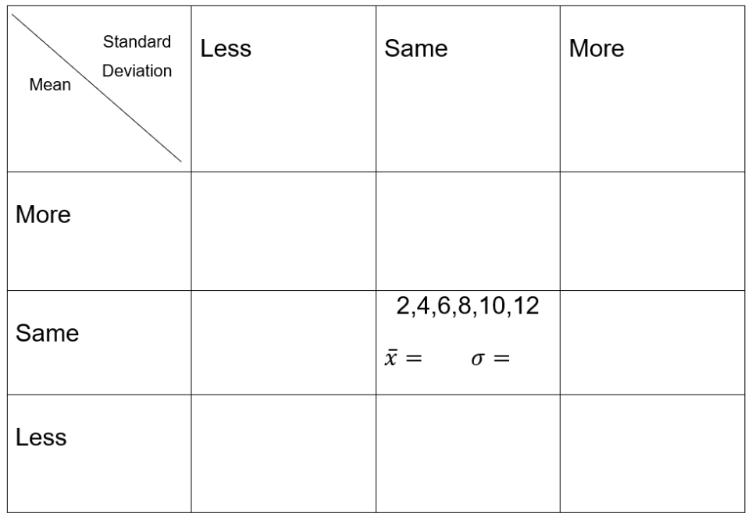

2015 Mathematics General 2 Q27 (d) ii. (NESA, 2015)
In a small business, the 7 employees earn the following wages per week:
$$\$300, \$490, \$520, \$590, \$660, \$680, \$970$$
Each employee receives a $20 pay increase.
What effect will this have on the standard deviation?

Sample solutions

Appendix A – datasets

Dataset A – steering variation
Score | Frequency | $$fx$$
2.5 | 1 | 2.5
2.6 | 2 | 5.2
2.7 | 4 | 10.8
2.8 | 4 | 11.2
2.9 | 1 | 2.9
3.0 | 1 | 3.0
4.3 | 1 | 4.3
6.8 | 1 | 6.8
Total | 15 | 46.7
Dataset B – steering variation
Score | Frequency | $$fx$$
1.1 | 1 | 1.1
1.2 | 3 | 3.6
1.3 | 3 | 3.9
1.4 | 2 | 2.8
1.5 | 3 | 4.5
1.6 | 2 | 3.2
1.7 | 1 | 1.7
Total | 15 | 20.8

Dataset A – speed variation
Score | Frequency | $$fx$$
3 | 2 | 6
4 | 3 | 12
5 | 3 | 15
6 | 3 | 18
7 | 1 | 7
8 | 2 | 16
9 | 0 | 0
10 | 1 | 10
Total | 15 | 84
Dataset B – speed variation
Score | Frequency | $$fx$$
1 | 3 | 3
2 | 4 | 8
3 | 6 | 18
4 | 2 | 8
Total | 15 | 37

Appendix C – Less, Same, More
These are some suggested solutions, however more solutions exist.
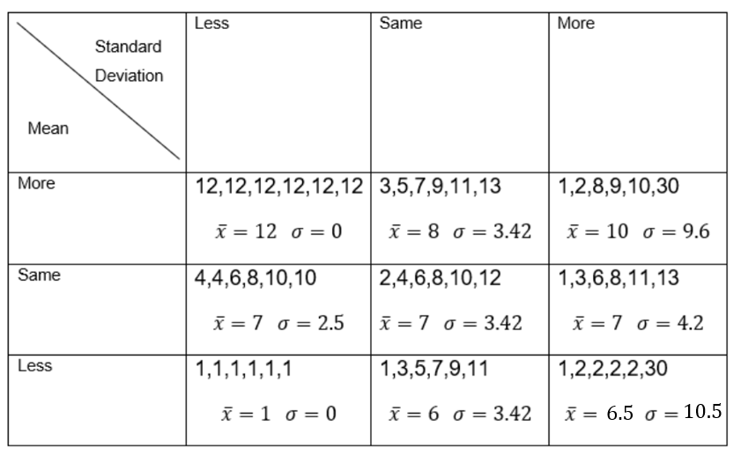
2015 Mathematics General 2 Q27 (d) ii.
If all the wages increase by $20 this will have no effect on the standard deviation as the spread of the scores will remain the same.

References
This resource contains NSW Curriculum and syllabus content. The NSW Curriculum is developed by the NSW Education Standards Authority (NESA). This content is prepared by NESA for and on behalf of the Crown in right of the State of New South Wales. The material is protected by Crown copyright.
Please refer to the NESA Copyright Disclaimer for more information https://www.nsw.gov.au/education-and-training/nesa/copyright.
NESA holds the only official and up-to-date versions of the NSW Curriculum and syllabus documents. Please visit NESA https://www.nsw.gov.au/education-and-training/nesa and NSW Curriculum https://curriculum.nsw.edu.au.
Mathematics Standard Stage 11–12 Syllabus © NSW Education Standards Authority (NESA) for and on behalf of the Crown in right of the State of New South Wales, 2024.

© State of New South Wales (Department of Education), 2026
The copyright material published in this resource is subject to the Copyright Act 1968 (Cth) and is owned by the NSW Department of Education or, where indicated, by a party other than the NSW Department of Education (third-party material).
Copyright material available in this resource and owned by the NSW Department of Education is licensed under a Creative Commons Attribution 4.0 International (CC BY 4.0) license.

This license allows you to share and adapt the material for any purpose, even commercially.
Attribution should be given to © State of New South Wales (Department of Education), 2026.
Material in this resource not available under a Creative Commons license:
- the NSW Department of Education logo, other logos and trademark-protected material
- material owned by a third party that has been reproduced with permission. You will need to obtain permission from the third party to reuse its material.
Links to third-party material and websites
Please note that the provided (reading/viewing material/list/links/texts) are a suggestion only and implies no endorsement, by the New South Wales Department of Education, of any author, publisher, or book title. School principals and teachers are best placed to assess the suitability of resources that would complement the curriculum and reflect the needs and interests of their students.
If you use the links provided in this document to access a third-party's website, you acknowledge that the terms of use, including licence terms set out on the third-party's website apply to the use which may be made of the materials on that third-party website or where permitted by the Copyright Act 1968 (Cth). The department accepts no responsibility for content on third-party websites.

