Shape of a distribution
Students learn how to interpret back-to-back stem-and-leaf plots and describe data as symmetrical, positively skewed or negatively skewed. They use measures of centre and shape to compare datasets in real-world contexts, linking this to why insurance companies charge drivers differently.
Students will need at least one digital device per pair to interact with an online comprehensive car insurance quote during this lesson.

Learning intentions
- To know how to interpret a variety of graphical displays in context.
- To understand how the shape of a distribution can be used to describe datasets.

Success criteria
- I can describe the shape of a dataset as symmetrical, positively skewed or negatively skewed.
- I can interpret back-to-back stem-and-leaf plots to compare 2 datasets.
- I can use measures of centre and spread to support comparisons between groups.
- I can justify my conclusions in context using mathematical reasoning.

Outcomes
A student:
- develops understanding and fluency in mathematics through exploring and connecting mathematical concepts, choosing and applying mathematical techniques to solve problems, and communicating their thinking and reasoning coherently and clearly MAO-WM-01
- displays and analyses datasets using summary statistics and graphical representations
MST-11-08
Mathematics Standard 11–12 Syllabus © NSW Education Standards Authority (NESA) for and on behalf of the Crown in right of the State of New South Wales, 2024.

Associated numeracy outcomes
A student:
- applies numerical reasoning and mathematical thinking to clarify, efficiently solve and communicate solutions to problems N6-1.2
- chooses and applies efficient strategies to analyse and solve everyday problems involving data, graphs, tables, statistics and probability N6-2.3
Numeracy Stage 6 (CEC) Syllabus © NSW Education Standards Authority (NESA) for and on behalf of the Crown in right of the State of New South Wales, 2021.

Content

Display and interpret grouped and ungrouped data
- Represent a numerical dataset as either a frequency distribution table or a cumulative frequency distribution table and graph the associated histogram with polygon, both with and without using digital tools
- Identify and describe the shape of the distribution of a dataset as either symmetric, positively skewed or negatively skewed
- Interpret and analyse dot plots, line graphs, sector graphs, stem-and-leaf plots, back-to-back stem-and-leaf plots and divided bar charts related to real-world applications

Measures of centre and spread
- Identify and describe datasets as uniform, unimodal, bimodal or multimodal

Five-number summary and box plots
- Compare and contrast the measures of centre, spread and shape using parallel box plots
Mathematics Standard 11–12 Syllabus © NSW Education Standards Authority (NESA) for and on behalf of the Crown in right of the State of New South Wales, 2024.

Table 1: lesson summary
Section | Summary of activity | Teaching strategies | Teaching points
Activating prior knowledge | Students revise the differences between all types of car insurance and predict how age and gender might influence quotes. Using an NRMA website (nrma.com.au/car-insurance) and information from Appendix A, students obtain quotes for drivers of different ages and genders, displayed on slide 4 of the PowerPoint Shape of a distribution. | Think-Pair-Share  Pose-Pause-Pounce-Bounce | Link students’ prior knowledge to real-world data and use a relevant driving question to encourage curiosity and active engagement.
Connecting learning | Students investigate why insurance prices differ by looking at a range of data using slides 6–7 and Appendix B. They then define the shape of a distribution using slide 8, before progressing to back-to-back stem-and-leaf plots on slides 9–10. | Think-Pair-Share  Notice and wonder | Apply data analysis skills to real-world contexts, using evidence to support conclusions. Explore how different types of skewness convey meaning across various graphical representations.
Releasing responsibility | Students revisit the driving question: Why do insurance companies charge different amounts for different drivers? And make notes on skewness in different types of graphical representations. | Notes to future forgetful selves | Highlight how combining visual (shape) and numerical (centre and spread) information strengthens data analysis and interpretation.
Independent practice | Students apply their understanding to past HSC questions using slides 12–15, comparing datasets using back-to-back stem-and-leaf plots and parallel box plots. | Peer feedback | Strengthen students’ responses by developing their reasoning and written communication skills.

Activity structure
Please use the associated PowerPoint Shape of a distribution to display images in this lesson.

Activating prior knowledge
In Lesson 3 – ongoing costs, students examined the definitions for different types of insurance and obtained quotes depending on whether the car was used or new.
- Initiate a class discussion to revise students’ understanding of the differences between compulsory and non-compulsory third-party insurance, as well as comprehensive insurance.
Compulsory third-party insurance, also known as a green slip, is mandatory for all registered vehicles and covers injuries or death to other people if you cause an accident. Non-compulsory third-party insurance (property damage) is optional insurance that covers damage to other people’s property or vehicle if you’re at fault. Comprehensive insurance is optional but provides the highest level of cover including damage to your own car and damage to other people’s cars or property.
- Explain to students that each pair in the class will obtain an insurance quote for the same car, but with a driver of a different age and gender. Display slide 4 to show the details.
Depending on class sizes, there may be multiple pairs using the same date of birth and gender. Divide the class up into pairs, so that each category of age and gender is accounted for.
- In a Think-Pair-Share (bit.ly/thinkpairsharestrategy) ask students to predict how or if the quotes may differ for car insurance.
- Allocate each pair a different category from slide 4 and distribute Appendix A ‘Comprehensive insurance information’ which contains the required information to obtain a quote using ‘NRMA Car insurance quotes’ (nrma.com.au/car-insurance).
NRMA has been selected as the insurer to provide students with clear instructions on how to obtain insurance quotes. The department has no affiliation with NRMA and teachers may wish to use an alternate insurer or a range of insurers.
The information provided in Appendix A was accurate at the time of publication, although it is encouraged to check this prior to completing the activity with your class.
When this resource was created, the dates of birth were chosen to represent a comparison between a 17–18-year-old driver and a 35–36-year-old driver. These may need to be updated to preserve the intended age range.
- Once all pairs have obtained their quote, use the Pose-Pause-Pounce-Bounce questioning strategy (PDF 557 KB) (bit.ly/posepausepouncebounce) to discuss pair’s findings with the class, comparing each of the quotes to see if their initial predictions were correct. A suggested prompt:
- Which factors seem to affect the cost the most?
Students should identify that prices for individuals born in 2008 are significantly higher than for those born in 1989. Among the 2008 cohort, young males are charged more than young females, while for the 1989 cohort, prices also differ by gender but to a lesser extent.
Sample solutions of quotes have been provided.

Connecting learning
- Explain to students that during this lesson they will be answering the driving question:
Why do insurance companies charge different amounts for different drivers?
- Display slide 6 of the PowerPoint, which shows the data for transport accidents by age. In a Think-Pair-Share, ask students to consider what they notice and wonder (bit.ly/noticewonderstrategy) about the graph.
Students may notice that the orange line is higher than the others, which represents the age group of 15–24. They may wonder why there were more transport accidents in 2020–2021. They may wonder whether these individuals were the drivers or passengers.
Students may wonder about the vertical dotted line. This marks a change in NSW hospital admission policies in 2017–2018, which affected how cases were recorded, making data from that year onward not directly comparable with earlier years. For the purposes of this lesson this line should be ignored, although it is a good discussion point to have with the class.
- Repeat step 2 using slide 7, which shows the data for transport accidents by gender.
Students should be told that the ‘Persons’ totals include presentations for which the sex was not reported. Students may notice that the line for ‘Males’ is far higher than the line for ‘Females’ and ‘Persons’. They may wonder why there were more transport accidents in 2020-2021.
- Initiate a class discussion that connects the accident data back to the driving question, encouraging students to consider how the evidence might explain differences in insurance pricing.
- Explain to the class that they will now be analysing data on speeding fine offenders to see if this can contribute to answering the driving question, specifically looking at the age of the ‘Data on the speeding fines by the offender’s postcode’ (bit.ly/finesbypostcode).
- Distribute Appendix B ‘Analysing speeding fines’ to each student and have them work in pairs to complete the analysis.
The appendix lists 12 ages in the dataset for 2014. A brief discussion could explore why there are 12 ages provided for the ‘Top 10 highest speeds recorded’. This is because 2 speeds in the top 10 were recorded by 2 different drivers each, resulting in 2 pairs of duplicate speeds.
Students have previously learned about frequency tables, calculating measures of centre and spread and stem-and-leaf plot in Unit 1 – getting healthy.
To extend students, they could test to see if ‘50’ in the 2015 data is an outlier using the formula from their Mathematics Standard 1 and 2 – HSC reference sheet. Students have previously learned this concept in Unit 1 – getting healthy.
- Once pairs have completed their analysis, initiate a class discussion to share their answers, encouraging students to consider how the evidence might explain differences in insurance pricing.
- Explain to students that another way to analyse data when presented in various ways is by looking at the shape of the distribution.
Students have previously learned how to identify and describe the shape and distribution of a dataset using the terms symmetrical, negatively skewed and positively skewed in the Stage 4 Data analysis outcome MA4-DAT-C-02.
- Use slide 8 to review this terminology which has the NESA glossary definitions.
Teachers may wish to discuss strategies to help students remember the difference between positively and negatively skewed. For example, remind them that the ‘tail’ of the distribution points in the direction of the skew and the ‘tail’ pulls the mean in that direction.
- Draw students’ attention to the word ‘unimodal’ and ask students what its definition might be. Continue the discussion so students can describe the definition of uniform, unimodal, bimodal and multimodal.
Students have previously learned how to identify and describe datasets as having no modes (uniform), one mode (unimodal), 2 modes (bimodal) or multiple modes (multimodal) in the Stage 4 Data analysis outcome MA4-DAT-C-02.
- Have students return to Appendix B and describe the shape of each dataset using the terms symmetrical, negatively skewed or positively skewed, as well as uniform, unimodal, bimodal or multimodal.
Students should identify that the 2014 dataset appears almost symmetrical, but not as a bell shape/normal distribution as they saw on slide 8, whereas 2015 was positively skewed and uniform.
- In a Think-Pair-Share, have students compare the mean and median of each dataset. Ask them to discuss whether the numbers are similar or different and what that tells them about the shape of the data.
Students may notice that for the 2014 dataset, which was almost symmetrical, the mean and median are close in value. For the 2015 dataset which was positively skewed, the mean was greater than the median.
- In a Think-Pair-Share, ask the class to consider how the mean and median would compare if one of the datasets were negatively skewed.
Students should share that the median would be the same, but the mean would be less than the median.
- Clarify with the class, returning to slide 8 for the graphical displays if needed, that:
- Symmetrical datasets have the mean and median very close in value.
- Negatively skewed datasets have the mean less than the median.
- Positively skewed datasets have the mean larger than the median.
- Explain to the class that the previous speeding fines data could have been displayed as a back-to-back stem-and-leaf plot which may have made it easier to compare.
- Display slide 9, which shows the syllabus glossary definition for back-to-back stem-and-leaf plots. Use the self-explanation prompts on the slide to discuss with the class the key features of a back-to-back stem-and-leaf plot.
- Animate slide 9 to reveal the back-to-back stem-and-leaf plot and discuss with the class why this display makes it easier to compare 2014 and 2015, including how the shapes of the distributions can be quickly assessed.
- Explain to the class that they will now look at one more dataset to collect evidence towards their driving question, which is data related to compulsory third-party insurance claims (CTP green slip) by age and gender.
- Display slide 10, which presents a back-to-back stem-and-leaf plot comparing the ages of females and males who have made compulsory third-party (CTP) insurance claims.
This dataset has been created to align with the New South Wales Government Motor Accidents Authority Annual Report 2012–2013, with statements published by greenslips.com.au ‘Take a look at NSW claims statistics’ (bit.ly/greenslipsnswclaims).
- In a Think-Pair-Share, have students compare the skewness of each dataset using the back-to-back stem-and-leaf plot and what this might suggest about each dataset in terms of the context. In their discussions, encourage students to consider how this set of data might explain differences in insurance pricing.
Students should note that the distribution for males was positively skewed, while the distribution for females was roughly symmetrical. In context, this indicates that younger males are making more compulsory third-party insurance claims than older males. For females, most claims appear to come from those in their 30s.
- Animate slide 10, revealing the parallel box plot for the same dataset. Guide students to compare it with the back-to-back stem-and-leaf plot, discussing which features of the data are easier to see in each representation. The discussion should include features such as measures of centre, spread and shape.
Students previously learned about box plots and parallel box plots in Unit 1 – getting healthy.

Releasing responsibility
- Initiate a class discussion in relation to the driving question, asking students to respond to it with reference to the 3 different datasets that they have analysed.
Why do insurance companies charge different amounts for different drivers?
- Explain to students that when describing and analysing datasets both the shape and measures of centre and spread are useful to use.

When describing datasets, the shape provides a quick visual sense of the data, including symmetry, skewness and outliers. Measures of centre and spread, such as the mean, median, mode and range, offer numerical summaries. It is important to connect these observations to the context to explain what the data reveals about the population.
- Use the Pose-Pause-Pounce-Bounce questioning strategy to guide students in explaining how the shape of a distribution relates to measures of centre and spread. Draw out that for a negatively skewed distribution the mean is less than the median, while for a positively skewed distribution the mean is greater than the median.
- Have students make notes to their future forgetful selves (bit.ly/notestofutureself) on identifying and describing the shape of the distribution of a dataset as either symmetric, positively skewed or negatively skewed.
Student notes should include examples of different graphs, such as histograms, stem-and-leaf plots and box plots, as well as a strategy to remember the difference between positively and negatively skewed.
- Students may benefit from completing practice questions on identifying and describing skewness of datasets as well as further practice analysing datasets in terms of measures of centre and spread.

Independent practice
- Use slide 12 to display a past HSC question, specifically 2016 Mathematics General 2 HSC examination, Question 29c.
- In a Think-Pair-Share, ask students to discuss their answer as to whether Pat is correct with justifications.
When students share their justifications, see how close they are to the NESA marking criteria sample answer:
Pat is correct since the women’s median age (55) is higher than the men’s median age (45) and there are more women in the older age group (negatively skewed).
- Animate slide 12 to reveal the sample answer for students to compare with their own justifications and answers.
- Use slide 13 to display another HSC question for students to attempt in their pairs. This question is also comparing 2 datasets, but instead of a back-to-back stem-and-leaf plot, it is comparing 2 boxplots.
Students have previously learned to compare parallel boxplots in Unit 1 – getting healthy. In this unit they also learned how to calculate five number summaries.
- Have students exchange their responses with another pair, adding annotations that suggest improvements and highlighting parts of the work they thought were clear or well done.
- Use slide 14 to show the NESA HSC marker’s feedback for that question. Ask pairs to evaluate their own responses and make any improvements.
- Finally, progress to slide 15 which shows the NESA sample answer as well as the marking criteria. Students should compare their answer to the sample and analyse the marking criteria in relation to their response.
- Initiate a class discussion for students to share the feedback they received from their peers, how their responses compared with the sample answer, and what the marking criteria suggests about how they could strengthen future answers.

Assessment and differentiation

Suggested opportunities for differentiation
Activating prior knowledge
- To extend students, they could alter their responses to either: ‘How many incidents or claims have you had in the past 5 years that involved a motor vehicle where an excess was paid?’ or ‘How many times has your licence been disqualified, cancelled or suspended due to driving offences in the past 3 years?’ and discuss how and why this may change the cost of the insurance.
- A detailed scaffold of instructions that includes screenshots of the website may be required for students needing additional support.
Connecting learning
- To extend students, encourage them to test for outliers using the formula on their HSC reference sheet.
- A class discussion could occur to look at the variety of the different age groupings on slides 6 and 7 and how this may affect the results. For example, comparing the 0–4 age group to the 5–14 age group, where one has 5 options of ages and the other has 10.
- To support students, further examples and representations of skewed and symmetrical datasets may need to be provided.
Releasing responsibility
- A scaffold for notes may need to be provided, suggesting what could be included, sub-heading prompts and sentence starters.
Independent practice
- To extend students, ask them to design an additional question comparing 2 new datasets.
- This activity could be completed as a class.

Suggested opportunities for assessment
Activating prior knowledge
- Observe students’ reasoning in the Think-Pair-Share predictions activity and use these to refer to throughout the lesson.
- Use the class discussion responses to assess students’ understanding of how driver characteristics influence cost.
Connecting learning
- Use questioning during the Think-Pair-Share activity to assess students’ understanding of positive and negatively skewed datasets.
- Appendix B can be collected as evidence of accurate data analysis.
Releasing responsibility
- Students’ notes to their future forgetful selves can be collected to check their understanding of the shape of a distribution.
- Use discussion responses to check if students can justify links between data shape and real-world implications.
Independent practice
- Evaluate written responses against marking criteria for summative assessment.
- Use peer-assessment annotations as evidence of students’ ability to identify strengths and areas for improvement.

Appendix A

Comprehensive insurance information
Using the information provided, find a quote for comprehensive car insurance using ‘NRMA Car insurance quotes’ (nrma.com.au/car-insurance).
Question | Response
Select Get a quote and select your policy type | Comprehensive
What’s your car’s registration number? | Select Make and model in the statement below the registration number.
What’s your car’s make and model? | 2025 Toyota Corolla 5D Hatchback, Continuous variable, Ascent Sport Hybrid
When should we start this policy | Use the current date
What address is your car parked at most of the time? | Use the school’s address
Where is the car parked? | Driveway of off-street parking
How many kilometres is this car driven each year? | 10 001–15 000
Do you use your car for anything other than private use? | No
Is there any finance on this car? | No
Is the primary policyholder a person or business? | Person
Do you drive this car? | Yes
What’s your date of birth? | [Enter your group’s allocated date of birth]
Which gender do you best identify with? | [Select your allocated gender]
Are you an existing NRMA Insurance customer or NRMA member | No
How old were you when you got your provisional or full licence? | 17
How many incidents or claims have you had in the past 5 years that involved a motor vehicle where an excess was paid? | 0
How many times has your licence been disqualified, cancelled, or suspended due to driving offences in the past 3 years? | 0
We’d like to follow up with you | Do NOT enter email, select next.

Appendix B

Analysing speeding fines
2014 data
Below are the ages of drivers listed as the Top 10 highest speeds recorded by speed cameras in NSW 2014, as recorded by Data.NSW – Department of Customer Service (bit.ly/finesbypostcode). All drivers were male.
22, 22, 22, 34, 26, 34, 25, 29, 23, 33, 31, 28
- Complete the frequency distribution table for this dataset and then graph an associated histogram with polygon.
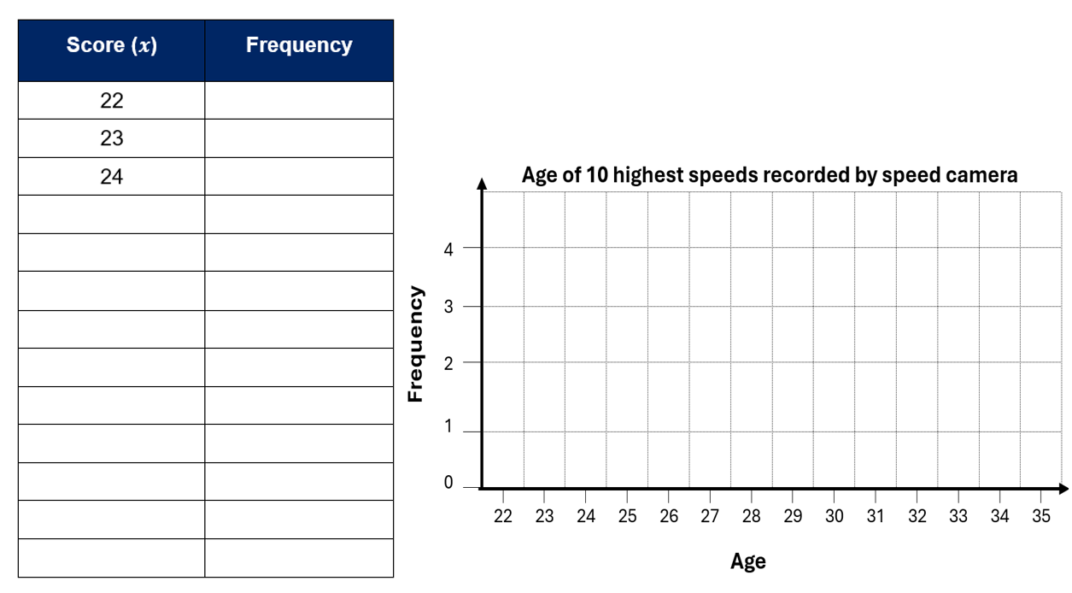
- Find the mean, mode, range and median for the dataset.
- What do the measures of centre and spread suggest in relation to the driving question: Why do insurance companies charge different amounts for different drivers?
2015 data
Below are the ages of the drivers listed as the Top 10 highest speeds recorded by speed cameras in NSW 2015. All drivers were male.
29, 22, 19, 23, 26, 30, 32, 50, 25, 20
- Complete a stem-and-leaf plot to represent the data.
2015 age of highest speeds recorded
1 | 9
2 | 0 2 3 5 6 9
3 | 0 2
4
5 | 0
- Find the mean, mode, range and median for the dataset.
- What do the measures of centre and spread suggestion in relation to the driving question Why do insurance companies charge different amounts for different drivers?
- Compare these measures of centre and spread to those from 2014.

Sample solutions

Appendix A – comprehensive insurance information
These sample solutions were prepared in October 2025. The quoted figures are provided as examples only and will likely differ when students complete the task.
- Group 1 – male and date of birth:1 March 2008
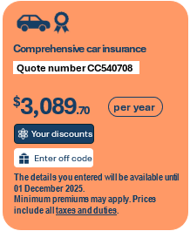
- Group 2 – female and date of birth: 1 March 2008


- Group 3 – male and date of birth: 1 March 1989
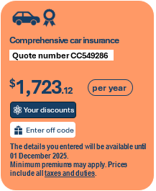
- Group 4 – female and date of birth: 1 March 1989


Appendix B – analysing speeding fines
2014 data
22, 22, 22, 34, 26, 34, 25, 29, 23, 33, 31, 28

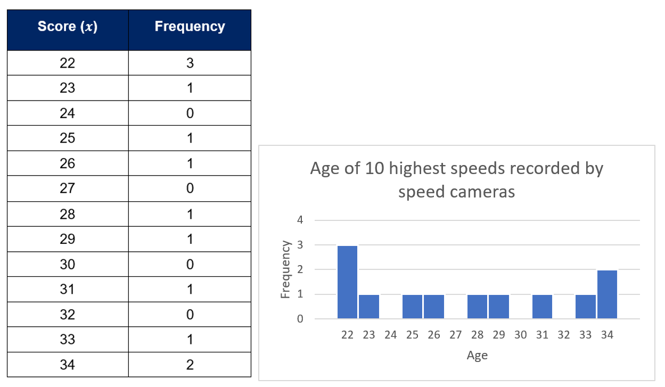
- Mean = 27.42, mode = 22, range = 12, median = 27.
- This dataset shows that the average age of the top 10 highest speeds recorded by NSW speed cameras in 2014 was 27, supporting why insurers charge young drivers, especially males, more. Interestingly, quotes revealed that comprehensive insurance for a 35-year-old male costs almost half that of an 18-year-old male, suggesting that not only young males but males in general may warrant higher premiums than females.
Connecting learning: the dataset is almost symmetrical and is unimodal.
2015 data
29, 22, 19, 23, 26, 30, 32, 50, 25, 20

2015 age of highest speeds recorded
1 | 9
2 | 0 2 3 5 6 9
3 | 0 2
4
5 | 0
- Mean = 27.6, mode = no mode, median = 25.5 and range = 31.
- This dataset has a mean age of 27.6 and a median of 25.5, showing most drivers are relatively young, supporting why insurers charge higher premiums for younger drivers, in particular males. The high maximum age of 50 and range of 31 though highlights that risk isn’t limited to the youngest drivers.
- Compared to 2014, the 2015 dataset has a similar average age but a lower median and a much larger range, showing more variation in driver ages.
Connecting learning: the dataset is positively skewed.

References
This resource contains NSW Curriculum and syllabus content. The NSW Curriculum is developed by the NSW Education Standards Authority (NESA). This content is prepared by NESA for and on behalf of the Crown in right of the State of New South Wales. The material is protected by Crown copyright.
Please refer to the NESA Copyright Disclaimer for more information https://www.nsw.gov.au/education-and-training/nesa/copyright.
NESA holds the only official and up-to-date versions of the NSW Curriculum and syllabus documents. Please visit NESA https://www.nsw.gov.au/education-and-training/nesa and NSW Curriculum https://curriculum.nsw.edu.au.
Mathematics Standard 11–12 Syllabus © NSW Education Standards Authority (NESA) for and on behalf of the Crown in right of the State of New South Wales, 2024.
Numeracy Stage 6 (CEC) Syllabus © NSW Education Standards Authority (NESA) for and on behalf of the Crown in right of the State of New South Wales, 2021.

© State of New South Wales (Department of Education), 2026
The copyright material published in this resource is subject to the Copyright Act 1968 (Cth) and is owned by the NSW Department of Education or, where indicated, by a party other than the NSW Department of Education (third-party material).
Copyright material available in this resource and owned by the NSW Department of Education is licensed under a Creative Commons Attribution 4.0 International (CC BY 4.0) license.

This license allows you to share and adapt the material for any purpose, even commercially.
Attribution should be given to © State of New South Wales (Department of Education), 2026.
Material in this resource not available under a Creative Commons license:
- the NSW Department of Education logo, other logos and trademark-protected material
- material owned by a third party that has been reproduced with permission. You will need to obtain permission from the third party to reuse its material.
Links to third-party material and websites
Please note that the provided (reading/viewing material/list/links/texts) are a suggestion only and implies no endorsement, by the New South Wales Department of Education, of any author, publisher, or book title. School principals and teachers are best placed to assess the suitability of resources that would complement the curriculum and reflect the needs and interests of their students.
If you use the links provided in this document to access a third-party's website, you acknowledge that the terms of use, including licence terms set out on the third-party's website apply to the use which may be made of the materials on that third-party website or where permitted by the Copyright Act 1968 (Cth). The department accepts no responsibility for content on third-party websites.

