New car categorical data
Students analyse new car sales data to explore categorical data and compare how different graphs represent information. They use a spreadsheet to interpret trends and make data-informed conclusions.
Students will need at least one digital device per pair to interact with a spreadsheet during this lesson. This spreadsheet is protected with the password: Mathematics.

Learning intentions
- To understand how to choose appropriate graphs to represent categorical data.
- To be able to interpret and communicate information from categorical data using graphical displays.

Success criteria
- I can identify suitable graph types for categorical data.
- I can interpret information shown in categorical graphs.
- I can construct accurate graphs from a categorical dataset.
- I can describe how graph choice influences the conclusions drawn from the data.

Outcomes
A student:
- develops understanding and fluency in mathematics through exploring and connecting mathematical concepts, choosing and applying mathematical techniques to solve problems, and communicating their thinking and reasoning coherently and clearly MAO-WM-01
- displays and analyses datasets using summary statistics and graphical representations
MST-11-08
Mathematics Standard 11–12 Syllabus © NSW Education Standards Authority (NESA) for and on behalf of the Crown in right of the State of New South Wales, 2024.

Associated numeracy outcomes
A student:
- recognises and applies functional numeracy concepts in practical situations, including personal and community, workplace and employment, and education and training contexts N6-1.1
- applies numerical reasoning and mathematical thinking to clarify, efficiently solve and communicate solutions to problems N6-1.2
- determines whether an estimate or an answer is reasonable in the context of a problem, evaluates results and communicates conclusions N6-1.3
- chooses and applies appropriate operations with whole numbers, familiar fractions and decimals, percentages, rates and ratios to analyse and solve everyday problems N6-2.1
- chooses and applies efficient strategies to analyse and solve everyday problems involving data, graphs, tables, statistics and probability N6-2.3
- chooses and applies appropriate numeracy operations and techniques to analyse and resolve everyday situations N6-2.6
Numeracy Stage 6 (CEC) Syllabus © NSW Education Standards Authority (NESA) for and on behalf of the Crown in right of the State of New South Wales, 2021.

Content

Display and interpret grouped and ungrouped data
- Use a spreadsheet to organise and represent data using appropriate graphs
- Represent categorical datasets in tables and column graphs as appropriate, with and without using digital tools
- Select the type of graph best suited to represent various single datasets and justify the choice of graph
- Interpret and analyse dot plots, line graphs, sector graphs, stem-and-leaf plots, back-to-back stem-and-leaf plots and divided bar charts related to real-world applications
- Analyse a statistical infographic and justify the choice of graphical representations used for the relevant dataset
Mathematics Standard 11–12 Syllabus © NSW Education Standards Authority (NESA) for and on behalf of the Crown in right of the State of New South Wales, 2024.

Table 1: lesson summary
Section | Summary of activity | Teaching strategies | Teaching points
Activating prior knowledge | Students engage in a discussion about different car brands and reflect on their popularity. Using slide 4 of New car categorical data, they interpret sales data for various car brands presented in a sector graph and consider its advantages and limitations. On slide 5 (also in Appendix A), students analyse an infographic to determine the key message it is intended to convey. | Think-Pair-Share  Notice and wonder  Pose-Pause-Pounce-Bounce | This activity aims to familiarise students with different car brands while giving them an opportunity to analyse a sector graph and consider its purpose. It also includes an infographic to help students interpret and make sense of the information presented.
Connecting learning | Using the spreadsheet, students calculate the difference in sales volume between 2 years. Using this data, they make judgements regarding the appropriateness of different graphs to display relevant information. Slide 7 requires students to make further analysis of a sector graph in relation to fuel types and this is consolidated in ‘Analysing a sector graph’ tab in the spreadsheet. | Think-Pair-Share  Notice and wonder  Mini whiteboards | This activity aims to further develop students’ capacity to interpret, analyse and evaluate categorical data displays in contexts, and while using a spreadsheet.
Releasing responsibility | Students discuss which graphs suit categorical data, identify when each is appropriate, and conclude that only the mode is a meaningful measure of central tendency. | Think-Pair-Share | This activity aims to develop students’ understanding of how to represent and interpret categorical data. They learn to choose suitable graphs and recognise that the mode is the only meaningful measure of central tendency for this type of data.
Independent practice | Students examine slide 9 to compare a sector graph and a divided bar chart, noting similarities and differences. They then create an alternative graph on slide 10 and share their work with peers. The activity concludes with a class discussion on which graphs are easiest to interpret and suitable for categorical data. | Notice and wonder  Visibly random groups of 3  Vertical non-permanent surfaces  Gallery walk  Two stars and a wish | This activity helps students understand how different graphs represent the same categorical data. They learn to compare graph types and recognise which graphs such as column, dot or picture graphs are most effective for interpreting proportions.

Activity structure
Please use the associated PowerPoint New car categorical data to display images in this lesson.

Activating prior knowledge
- Lead a class discussion to have students list any car brands, makes or models that they know.
- Display slide 4 of the PowerPoint and ask students what they notice and wonder (bit.ly/noticewonderstrategy) about it.
Students may notice that Toyota had the largest share of car sales in 2024 compared to other brands. They may also notice that several brands have similar sized sections, showing that their sales are quite close. Students may wonder what the percentage of the total market each brand represents and wonder why Toyota’s share is quite larger compared to other brands (could theorise that they have more models available, better prices).
- In a Think-Pair-Share (bit.ly/thinkpairsharestrategy), ask students to consider what the positives and negatives of using the sector graph are.
Students should note the advantage that the most popular category is clear and the limitation that the ranking of the other categories and their quantities is much harder to interpret.
- In a Think-Pair-Share, have students consider what other types of graphs would be more suitable if we wanted to display the top 10 brands of cars for 2024.
- Display the infographic on slide 5.
A student copy of the infographic can be found in Appendix A ‘Infographic’.
- Using the Pose-Pause-Pounce-Bounce (bit.ly/posepausepouncebounce) questioning strategy, collate the following information about the infographic.
- Which graphs or charts can you see?
- Is there a story that the infographic is trying to tell? If so, what is it?
- What makes this infographic effective or ineffective?
- Why have the designers selected these types of graphs?
- Click to animate slide 5 to pose a Think-Pair-Share question.

Connecting learning
- With a device between pairs of students, ask them to open the spreadsheet New car categorical data.
Appendix B ‘Save a local copy of a file’ can be used to provide information about one way of sharing a spreadsheet with students.
if you wish to make changes to the spreadsheet, the password is ‘Mathematics’.
- In a Think-Pair-Share, ask students to provide a brief description of the information that is currently provided on the ‘Car sales data’ tab.
- Direct students’ attention to the calculations in cells E4 and F4 and lead a class discussion on what the purpose of the calculations is, then instruct students to drag down the formulas to fill the remaining cells.
- Ask students if there is anything they notice and wonder about the results of the calculations.
Students may notice that the Toyota Prado has a substantial percentage difference and may wonder why this is the case. They may notice that some models have decreased in sales. They may also notice that there is no order to how the models are listed. Students may wonder what factors may explain why some vehicles rose in sales while others dropped.

Organising data
- Use a Think-Pair-Share to ask students to explain why this data is either categorical or numerical.
Highlight the common misconception that students may classify the data as numerical simply because it contains numbers. Prompt them to consider the underlying question being asked and the type of answers it produces.
Categorical and numerical data has been covered in Lesson 1 – designing questions and data classifications of Unit 1 – getting healthy.
- If not discussed, highlight to students that the data is not organised in any meaningful order. Using this observation, explain that before we can choose appropriate graphs, the dataset needs to be organised in ways that make patterns easier to see.
- In a Think-Pair-Share, ask students, ‘How could we organise this dataset to make it easier to analyse?’
- After the discussion, guide students through the following steps to consider the most appropriate organisation of the data.
- Highlight cells B4:D13
- Click Sort from the Data ribbon
- Sort the data by brand (A to Z), by sales volume (largest to smallest and smallest to largest).
Note: no year has been referenced to sort to allow students to further reason and justify what they believe is an appropriate sorting method.
- Discuss with students how each sorting method highlights different patterns in the data and why different orders may be useful depending on the question being asked.
- Lead a class discussion as to why it may be important to know about the popularity of a car with regards to its total sales.
Main reasons include the effect that this type of popularity can have on resale value, availability and dealer discounts. The teacher can also extend this discussion to include the difference between popularity and best. For example, ‘Car X might be the best car, but if you aren’t able to get affordable parts for it in Y years, how good is it?’

Representing data
- Explain that now the dataset has been organised, students will represent it using appropriate graphs.
- Instruct students to navigate to the ‘Evaluating displayed data’ tab.
- In the spaces provided, students are to represent the May-25 data in the indicated graphs.
To achieve this, in the ‘Car sales data sheet’, select cells B4:C13. Go to the Insert tab → choose Clustered Column (as an example). With the chart selected, go to Chart Design → Move Chart, choose Object in: and select Evaluating displayed data, then select OK.
- Students complete the 4 questions on evaluating displayed data.
- Lead a class discussion on the students’ responses to the reflection questions.
Ensure the discussion includes why a line graph is not appropriate for categorical data. Emphasise that the focus should be on choosing a graph type that suits the nature of the data, not simply which graph is easier to read.
- Have students consider the following information:
Knowing which fuel types are the most popular helps you make a smarter choice when buying a car because it affects fuel availability, running costs, servicing options and how future proof your car will be.
- Ask students to list as many fuel types as possible and to rank what they believe to be the 3 most popular in terms of car sales.
- Display slide 7 for students to compare their estimations with the sector graph.
- Using mini whiteboards (bit.ly/miniwhiteboards), pose the following questions for students to interpret and analyse the sector graph
- Which fuel type has the highest percentage of sales?
- What percentage of sales are for diesel vehicles?
- By how many percentage points do petrol sales exceed diesel sales?
- Instruct student pairs to progress to the ‘Analysing a sector graph’ tab on their spreadsheet to complete the questions.

Releasing responsibility
- Explain to students that different graph types can change what we notice in categorical data, and that choosing the right graph is essential for accurate interpretation.
- In a Think-Pair-Share, have students reflect on the different types of graphs used throughout the lesson and decide which are most appropriate for representing categorical data, giving reasons for their choices.
- Extend the discussion by identifying all the graph types that could be produced from categorical data (column graphs, sector graphs, divided bar charts). As a class, clarify when each graph is the most suitable and why. Students compare their earlier Think-Pair-Share responses, with the teacher, highlighting key insights and addressing misconceptions.
- In a Think-Pair-Share, have students consider whether the mean, median, mode or range can be applied to categorical data.
Guide them to the conclusion that for nominal categorical data only the mode is meaningful. Discuss that for ordinal categorical data, measures like the median can be used, although numerical measures such as the mean cannot as values represent categories, not quantities.

Independent practice
- Display slide 9 of the PowerPoint and ask students what they notice and wonder about the sector graph and the divided bar chart.
Students may notice that both graphs are displaying the same countries and their share of sales. They may also notice that the percentages are the same in both graphs but are displayed differently. They may wonder why we need 2 different graphs to show the same information. They may also wonder which graph makes it easier to compare the sizes of each country’s sales.
- Assign students to visibly random groups of 3 (bit.ly/visiblegroups) at vertical non-permanent surfaces (bit.ly/VNPSstrategy), and have them list the similarities and differences between a sector graph and a divided bar chart.
Similarities: both show parts of a whole, use proportions or percentages, and help visualise how a total is divided.
Differences: a sector graph uses slices of a circle, while a divided bar chart uses segments of a rectangle. Divided bar charts typically allow for more accurate comparisons between categories as lengths are easier to judge than angles.
- Still working in their groups of 3, display slide 10. Students are to create another type of graph that represents the same information and is not a sector graph.
- Student groups are to then conduct a gallery walk (bit.ly/DLSgallerywalk) and give peer feedback in the form of 2 stars and a wish (bit.ly/DLSpeerfeedback).
- As a class, discuss what students noticed during the gallery walk. Specifically, which types of graphs were easiest to read and interpret and why those graphs were more effective than others.
The teacher should direct the discussion to identify that with categorical data, only a column, dot or picture graph is also appropriate in addition to what has been identified in the lesson.

Assessment and differentiation

Suggested opportunities for differentiation
Activating prior knowledge
- Provide word banks to support recall for students needing scaffolding.
- Offer challenge prompts (for example, ‘Which type of data, categorical or numerical, best suits each dataset?’) for extension.
- Allow visual learners to sketch graphs instead of describing them verbally during ‘notice and wonder.’
Connecting learning
- Provide step-by-step spreadsheet instructions with screenshots for students less confident with Excel.
- Allow advanced students to explore additional tabs or create custom graphs from raw data.
- When listing popular fuel types, provide brief explanations of common fuel types (petrol, diesel, hybrid, plug-in hybrid, electric) for students who may not be familiar with the differences.
Releasing responsibility
- Provide guiding questions such as, ‘Which graph best represents categorical data and why? for scaffolding.
- Challenge students to consider data misrepresentation or limitations of certain graph types.
Independent practice
- Provide structured comparison tables (for example, similarities/differences between graphs) for support.
- Offer optional digital tools (Excel, Canva, Desmos) for students comfortable creating graphs independently.

Suggested opportunities for assessment
Activating prior knowledge
- Observe contributions during Think–Pair–Share for understanding of categorical data.
- Use questioning such as, ‘Why is a sector graph effective here?’ to gauge prior conceptual knowledge.
Connecting learning
- Monitor spreadsheet progress to confirm correct use of formulas and data interpretation.
- Review written responses in the ‘Evaluating displayed data’ tab to check reasoning and accuracy.
Releasing responsibility
- Use whole-class discussion to evaluate students’ ability to justify their graph selection.
Independent practice
- Observe group discussions and the gallery walk for understanding of graph types and justifications. Use peer feedback (‘Two stars and a wish’) to assess communication and reasoning skills.
- Collect final created graphs for evaluation against success criteria (accuracy, appropriateness and justification).

Appendix A

Infographic
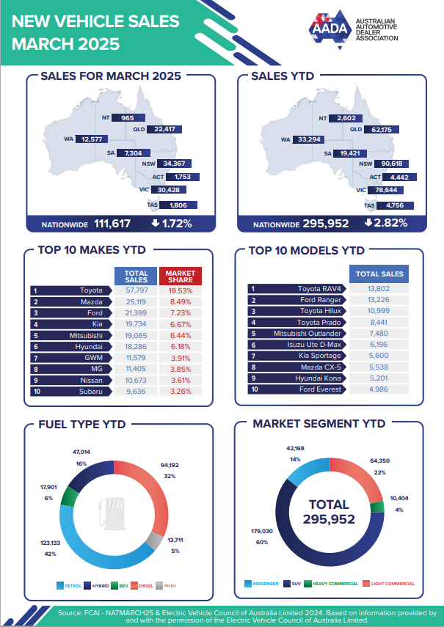
‘New Vehicle Sales March 2025’ from the Australian Automotive Dealer Association (AADA). Image sourced from the AADA 2025.04.03 – New Vehicle Sales Report – March Data (PDF 518 KB).

Appendix B

Save a local copy of a file
How to save a local copy of an Excel spreadsheet.

File sharing and saving
- Save the Excel file Salaries in a place where students can easily access the file. This could be done through Google Classroom, by sharing a OneNote link, or by emailing students a copy of the document.
- Have students open the document on their own device.
- Instruct students to select the File tab and then Save a Copy.
Figure 1: Save a Copy screenshot
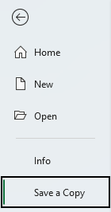
- Students can save the document in their individual OneDrive by selecting this option.
Figure 2: Save to OneDrive screenshot
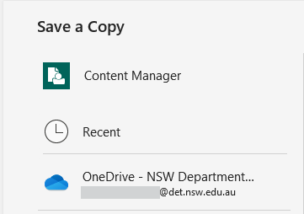
- Best practice would be to keep the file name the same. Students can then select save and a copy will be stored on their OneDrive.
Figure 3: Save with the same file name screenshot
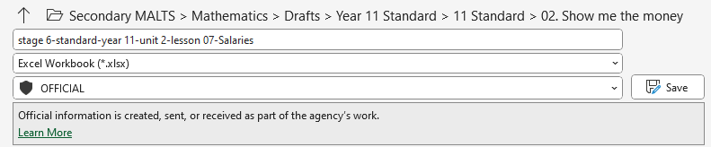

References
This resource contains NSW Curriculum and syllabus content. The NSW Curriculum is developed by the NSW Education Standards Authority (NESA). This content is prepared by NESA for and on behalf of the Crown in right of the State of New South Wales. The material is protected by Crown copyright.
Please refer to the NESA Copyright Disclaimer for more information https://www.nsw.gov.au/education-and-training/nesa/copyright.
NESA holds the only official and up-to-date versions of the NSW Curriculum and syllabus documents. Please visit NESA https://www.nsw.gov.au/education-and-training/nesa and NSW Curriculum https://curriculum.nsw.edu.au.
Mathematics Standard 11–12 Syllabus © NSW Education Standards Authority (NESA) for and on behalf of the Crown in right of the State of New South Wales, 2024.
Numeracy Stage 6 (CEC) Syllabus © NSW Education Standards Authority (NESA) for and on behalf of the Crown in right of the State of New South Wales, 2021.

© State of New South Wales (Department of Education), 2026
The copyright material published in this resource is subject to the Copyright Act 1968 (Cth) and is owned by the NSW Department of Education or, where indicated, by a party other than the NSW Department of Education (third-party material).
Copyright material available in this resource and owned by the NSW Department of Education is licensed under a Creative Commons Attribution 4.0 International (CC BY 4.0) license.

This license allows you to share and adapt the material for any purpose, even commercially.
Attribution should be given to © State of New South Wales (Department of Education), 2026.
Material in this resource not available under a Creative Commons license:
- the NSW Department of Education logo, other logos and trademark-protected material
- material owned by a third party that has been reproduced with permission. You will need to obtain permission from the third party to reuse its material.
Links to third-party material and websites
Please note that the provided (reading/viewing material/list/links/texts) are a suggestion only and implies no endorsement, by the New South Wales Department of Education, of any author, publisher, or book title. School principals and teachers are best placed to assess the suitability of resources that would complement the curriculum and reflect the needs and interests of their students.
If you use the links provided in this document to access a third-party's website, you acknowledge that the terms of use, including licence terms set out on the third-party's website apply to the use which may be made of the materials on that third-party website or where permitted by the Copyright Act 1968 (Cth). The department accepts no responsibility for content on third-party websites.

