Formulas with spreadsheets
Students see the benefits of using a spreadsheet to manage and make decisions about their business. They will utilise measurement formulas, calculate GST for invoices and analyse profit and loss.
Students will need at least one digital device per pair to interact with a spreadsheet during this lesson. If you need to adjust the data in the spreadsheet, the password to unlock the worksheets is ‘mathematics’.

Learning intentions
- To be able to utilise formulas and complete calculations in a spreadsheet.
- To be able to utilise a spreadsheet to make informed decisions.

Success criteria
- I can correctly enter formulas in a spreadsheet.
- I can use a spreadsheet to calculate goods and service tax (GST), value-added tax (VAT), profit and loss.
- I can correctly write formulas used to calculate measurements in a spreadsheet.
- I can use a spreadsheet to investigate the impact of changes.
- I can justify decisions using the information and calculations from a spreadsheet.

Outcomes
A student:
- develops understanding and fluency in mathematics through exploring and connecting mathematical concepts, choosing and applying mathematical techniques to solve problems, and communicating their thinking and reasoning coherently and clearly MAO-WM-01
- selects and applies algebraic techniques to solve problems involving equations and formulas MST-11-01
- solves financial problems involving budgeting and purchasing MST-11-04
- solves problems involving measurement in practical contexts MST-11-05

Associated numeracy outcomes
A student:
- recognises and applies functional numeracy concepts in practical situations, including personal and community, workplace and employment, and education and training contexts N6-1.1
- applies numerical reasoning and mathematical thinking to clarify, efficiently solve and communicate solutions to problems N6-1.2
- chooses and applies appropriate operations with whole numbers, familiar fractions and decimals, percentages, rates and ratios to analyse and solve everyday problems N6-2.1
- chooses and applies efficient strategies to analyse and solve everyday problems involving metric relationships, distance and length, area, volume, time, mass, capacity and temperature N6-2.2
- chooses and applies efficient strategies to analyse and solve everyday problems involving money and finance N6-2.4
Numeracy Stage 6 (CEC) Syllabus © NSW Education Standards Authority (NESA) for and on behalf of the Crown in right of the State of New South Wales, 2021.

Content

Formulas and equations
- Use a spreadsheet to perform calculations involving formulas

Managing money

Purchasing goods
- Apply percentage increase and decrease to determine the cost of goods, and profit and loss
- Calculate the goods and service tax (GST) or value-added tax (VAT) when purchasing goods and services in Australia and internationally
- Solve problems involving GST or VAT

Applications of measurement

Perimeter, area and volume
- Solve practical problems involving the surface area of prisms, cylinders, spheres and composite solids in a variety of contexts
- Solve practical problems involving volume and capacity of prisms, cylinders, spheres, cones, pyramids and composite solids in a variety of contexts
Mathematics Standard 11–12 Syllabus © NSW Education Standards Authority (NESA) for and on behalf of the Crown in right of the State of New South Wales, 2024.

Table 1: lesson summary
Section | Summary of activity | Teaching strategies | Teaching points
Retrieval practice | Students are provided with a spreadsheet and given the context of a landscaping business to revisit cell references in a spreadsheet, how to add formulas and calculations to a spreadsheet and GST and VAT calculations. Appendix A provides instructions on saving local copies of the spreadsheet. | Notice and wonder  Think-Pair-Share | Identify effective strategies for using spreadsheets to complete calculations.
Activating prior knowledge | Students use the ‘Inventory list’ tab in the spreadsheet to calculate profit and loss and to apply a percentage change to cost prices. They are given scenarios that require them to calculate a percentage and a sale price. | Pose-Pause-Pounce-Bounce | Identify effective strategies for calculating profit, loss and percentage increases.
Connecting learning | Students continue in the spreadsheet, using the information in Appendix B to create a quote and then adjust it for a client. Appendix C is available for students who need more information about some features. Students then complete a quote for a new client using Appendix D, the ‘Quote 2’ tab and the ‘Quote calculations’ tab, using formulas. Students need to change data, consider the impact on the business and make a recommendation as a result. | Assessing and advancing questions  Think-Pair-Share | Consider how to use a spreadsheet to enter data and make changes easily using formulas.
Releasing responsibility | Discuss the benefits of using spreadsheets to make decisions when running a business. Then, consider how different calculations for profit can communicate different information. | Think-Pair-Share  Pose-Pause-Pounce-Bounce  Would you rather | Recognise the benefits of using spreadsheets to record data, perform calculations and make changes, and the importance of understanding how calculations are made.
Independent practice | Students complete Appendix E, then discuss their answers as a class. |  | Apply knowledge of how to use spreadsheets to answer HSC style questions.

Activity structure

Retrieval practice
- With a device between pairs, students are to navigate to the spreadsheet Formulas with spreadsheets, which introduces students to using a spreadsheet for running a business. The spreadsheet includes invoices, inventory lists, quotes and calculations.
Appendix A ‘Save a local copy of a file’ has been provided with suggestions on how to share the file with students.
The spreadsheet Formulas with spreadsheets solutions has also been provided to support teachers with this learning episode. References to this spreadsheet have been included throughout the teaching advice.
- Instruct pairs of students to navigate to the ‘Invoice' tab of the spreadsheet.
- Read the following scenario:
Lucy runs a landscaping business. She recently completed a job for a client, installing a vertical garden wall and some pot plants for their apartment balcony. Lucy has generated a list of the items with their pricing for the invoice.
- Explain to students that an invoice is a business document given to a customer that lists the goods or services provided and the amount the customer is required to pay.
- Ask students what they Notice and wonder (bit.ly/noticewonderstrategy) about the information included in the invoice in the spreadsheet.
Students should notice that the invoice contains the following details: contact information for both the business and the client, an invoice number, a date, a description of the invoice, a list of items and their corresponding pricing. They will notice that the total amounts, GST and the GST rate are missing. They may wonder what an ABN number is, an Australian Business Number, which is a unique 11-digit identifier that shows the business is registered and helps with taxation.
- Use a class discussion to check that students remember that the GST rate in Australia is $10\%$.
Students solved financial problems in the Stage 4 Fractions, decimals and percentages outcome MA4-FRC-C-01 involving percentages, specifically considering GST, profit and loss.
- In a Think-Pair-Share (bit.ly/thinkpairsharestrategy), ask students to complete the light blue sections of the spreadsheet, cells E28 to E31, by entering formulas into relevant cells. This includes calculations for the subtotal, GST amount, total amount payable, as well as typing in the current GST rate.
Teachers may need to demonstrate the solution: use of the sum formula for the subtotal in cell E28, =sum(E14:E27); in cell E29, the GST rate should be 10%; in cell E30, we enter the calculation =E28*E29; and in cell E31, we enter the calculation =E28+E30.
- Pose the following scenario to the class:
Lucy’s friend runs a landscaping business in the Cook Islands and has asked if she can use Lucy’s spreadsheet for her business. The Cook Islands has a VAT rate of 15%.
- Explain to students that VAT is equivalent to GST in Australia.
- Ask pairs to change the tax rate in cell E29 of the spreadsheet to 15% and ask the students what changes they notice as a result.
NESA’s teaching advice states that, ‘Goods and services tax (GST) calculations should include finding the GST amount, the final cost, and finding the original cost of goods before GST was added’ (NESA 2024). These skills were introduced in the Stage 4 Fractions, decimals and percentages outcome MA4-FRC-C-01. Some students may benefit from additional practice to consolidate these concepts.

Activating prior knowledge
- Continuing in their pairs, instruct students to navigate to the ‘Inventory list’ tab in the spreadsheet.
- Conduct a class discussion to clarify students’ understanding of the terms ‘profit’ and ‘loss’.
Students may also need to review the terms ‘cost’ and ‘sale price’.
The NESA syllabus glossary defines:
- profit as ‘the excess of total revenue above the total cost of selling goods or services’
- loss as ‘the difference between the total cost and the total revenue of producing and selling goods or services where the cost is greater than the revenue.’ (NESA 2024)
- Initiate a class discussion on how to use a calculator to find profit and loss, and how this process can be represented as a formula using cell referencing.
- Ask students to enter formulas into the light blue cells D3 and E3 to calculate the amount of profit or loss and the percentage profit or loss for the inventory list.
The formula in cell D3 should be $=\text{C3}-\text{B3}$, answer $-1.00$. The formula in cell E3 could be =(D3/B3)*100 or =(D3/B3) with the use of percentage formatting, answer $-4.35$.
Students may need assistance to understand that a loss is represented as a negative value and a profit is a positive value. Check that students have the correct formulas and answers before moving on to the next instruction.
- Use the Pose-Pause-Pounce-Bounce questioning strategy (PDF 557 KB) (bit.ly/posepausepouncebounce) to examine why the first inventory item is running at a loss and explore possible reasons this can occur in a business.
- Instruct student pairs to fill down their formulas for columns D and E to row 33 to calculate the profit or loss amounts and percentages for all inventory items.
- Use a Think-Pair-Share for students to consider whether Lucy should compare the profit of different items as a percentage or in dollar amounts when determining if an item is generating enough profit. For example, is the vertical garden herb planter with a cost price of $10 and a sale price of $12 generating the same profit as the round plant pot with a cost price of $68 and a sale price of $70?
Students should recognise that both items generate a profit of $2. However, the item that costs $10 and is then sold for $12 generates a profit of 20%, while the item that costs $68 and sells for $70 only generates a profit of 2.9%.
- Ask student pairs to calculate what Lucy’s overall profit or loss amount was for the items in her invoice from ‘Retrieval practice’.
Students may need to be reminded that labour rates are not included in the profit and loss calculations.
A sample spreadsheet solution has been provided in the spreadsheet Formulas with spreadsheets solutions. Lucy made an overall profit of $39.
- Undertake a class discussion with student pairs sharing their strategies on how they calculated the overall profit for the invoice items.

Connecting learning
- Continue with students in their pairs, working with the spreadsheet.
- Explain the following to students:
Rohan Brown from Clunes has approached Lucy’s Landscaping for a quote to provide 3 separate raised rectangular vegetable gardens framed by wooden sleepers.
He would also like Lucy to supply the soil, mulch and a variety of vegetables and herbs to plant in the gardens.
- Distribute Appendix B ‘Quote 1’ to each student pair.
- Display the ‘Quote calculations’ tab of the spreadsheet and explain to students that they are providing a quote to a client for the construction of 3 raised rectangular vegetable gardens. They are to use the information provided in Appendix B to help them complete their formulas and calculations in the light blue cells of the ‘Quote calculations’ tab of the spreadsheet.
Students will not need to use perimeter and garden edging calculations with this quote as the garden beds are 3-dimensional.
- Demonstrate to students how to use the drop-down item description menu in the costings part of the spreadsheet and show students where to transfer their subtotal price amount into the ‘Quote 1’ tab.
Students may have an issue copying their subtotal price from I23 on the ‘Quote calculations’ tab and pasting it to C14 on the ‘Quote 1’ tab due to the formula in the subtotal cell. If they see the error #REF!, students will need to right-click in the cell and choose the second option, paste values, or they can type the number in manually.
You may need to discuss the rounding of quantities for the volume of soil, mulch and number of plants. See Appendix C ‘Spreadsheet features’ on how students can do this without affecting formulas.
- Ask students assessing and advancing questions (bit.ly/supportingstrategies) to make students’ thinking visible and to support students in connecting prior learning to the calculations and measurement formulas as they complete the quote. Some suggestions are provided in the following table:
Table 2: assessing and advancing questions
Assessing questions | Advancing questions
How do you enter a formula into the spreadsheet? | Can you use cell referencing to make your formulas reusable or more efficient?
Which cells should contain input values and which should contain formulas? | How could you structure the spreadsheet so changes automatically update all calculations?
Is that a reasonable calculation? Can you explain your thinking? | How could you verify or crosscheck this result using a different method or estimate?
Before moving on, students can either take a screenshot of their quote calculations to keep a record or copy the ‘Quote calculations’ tab, renaming it before making changes. Instructions for copying a sheet in Excel can be found in Appendix C.
- Explain that Rohan Brown would now like to change his order and read the following to students:
Lucy’s client Rohan has considered the provided quote and would like to proceed but has decided to remove garden bed 3. Can you provide Rohan with an adjusted quote?
- In a Think-Pair-Share, have student pairs make changes to their spreadsheet calculations and quote sheet. Discuss with students what the minimum changes they needed to make were.
If students used the base area calculation as a reference for volume and number of plants, removing this one cell will remove the others. Students would also need to remove amounts from the number of sleepers and adjust their hourly rate.
In the spreadsheet Formula with spreadsheets solutions, the ‘quote calculations – Quote 1a’ tab reflects the changes made by the client.
- Explain to the class that a new client has approached Lucy’s Landscaping:
Iris Smith from Lismore has approached Lucy’s Landscaping for a quote to provide 2 individual rectangular garden beds with plastic garden edging at the front of her house.
She would also like Lucy to supply the soil, mulch and a variety of shrubs, large flowering plants and colourful annuals.
- Distribute Appendix D ‘Quote 2’ to each pair of students and instruct them to complete the quote using the ‘Quote calculations’ tab and ‘Quote 2’ tab for the final quote to the client.
Students will need to use perimeter and garden edging calculations with this quote.
- Have student pairs write their final quote prices on the board.
- Undertake a class discussion asking students to explain why there are a variety of different prices for the same quote, for both Quote 1 and Quote 2.
During this discussion, highlight the decisions made by the groups with the highest and lowest quote prices. Students may have different views on how long it takes to complete the job, depending on their knowledge of tools, and they may have chosen different combinations of plants. This is also an opportunity to discuss the reasonableness of answers and for student pairs to check their calculations.
In the Formulas with spreadsheets solutions file, the assumption has been made that Lucy will use a rotary hoe to save time digging out the garden beds and include more of the cheaper plants to make her quote more competitive.
- Explain to students that:
Iris has chosen to go ahead with the quote. However, between the quote and the actual job completion date, there was a price change to the mulch. Mulch now costs you $100 per cubic metre.
- In a Think-Pair-Share, ask students to use the spreadsheet to provide Lucy with advice on how this price change impacts her business and to make a recommendation for Lucy to either pass this cost onto the client or not.
Use the following question prompts to guide student thinking:
- What impact does changing the cost price of the mulch have on the quote?
- What impact does changing the cost price have on Lucy’s profit?
- What change could Lucy make to maintain her profit? How does this change the quote?
In the spreadsheet Formulas with spreadsheets solutions, an inventory item has been added ‘Mulch price increase (per cubic metre)’ and the impact of this change is shown in the tab ‘Quote calculations – Quote 2a’ tab.
This question has no right or wrong answer and is posed for students to justify their reasoning. Students may choose to absorb the price increase and honour the price quoted and then increase their sale price for new quotes or they may choose to pass on the cost to the client to maintain their profit.

Releasing responsibility
- Use the Pose-Pause-Pounce-Bounce questioning strategy to elicit students’ understanding on how using the spreadsheet helps with decision making. Useful question prompts may include:
- How might the formulas and cell referencing in the spreadsheet help a business owner make decisions?
- How can a spreadsheet be useful for calculating GST?
- Why might using a spreadsheet be an advantage for tracking profit and loss in a business?
- Read the following ‘Would you rather’ scenario to students and use a Think-Pair-Share to discuss:
Would you rather calculate profit in a spreadsheet as a dollar amount or as a percentage?
Students should recognise that when comparing profit in dollars on items sold, the original price is relevant, whereas when comparing profit as a percentage on items sold, the original price is irrelevant as the percentage can be more easily compared. Students should also note that percentages can be deceiving. For example, if an item cost 50 cents and is then sold for $1.00, it generates a profit of 100%, but the profit is only 50 cents. In contrast, if an item cost $500, it would need to sell for $1000 to generate the same percentage profit.
- Use the Pose-Pause-Pounce-Bounce questioning strategy to ask students how the calculations in a spreadsheet would be different if calculating profit as a percentage or as a dollar value. Useful question prompts may include:
- How would the formulas be the same?
- How would the formulas be different?

Independent practice
- Distribute Appendix E ‘HSC style spreadsheet questions’ for each student to complete individually.
Students will answer these questions without the use of a spreadsheet. The questions from Appendix E, with completed formulas, have been included in the Formulas with spreadsheets solutions file to support the sample solutions provided in the appendix.
- Pair students to discuss their answers and make any changes before discussing as a whole class.

Assessment and differentiation

Suggested opportunities for differentiation
Retrieval practice
- Students can be provided with a glossary of the business terms used before the start of the lesson, such as invoice, inventory, quotation, GST, VAT, subtotals, cost price, sales price, profit and loss.
- Pair students with more spreadsheet experience with less confident students for guided practice and mentor support.
- Display the spreadsheet on the screen to be able to demonstrate how to navigate and use different features of the spreadsheet.
Activating prior knowledge
- Students can use other methods and calculators to confirm that the spreadsheet formulas and calculations are correct.
- Students can be extended into more complex spreadsheet functions, such as VLOOKUP.
- Discussion can be extended to what Lucy could do to lessen the impact on her profit after the cost price increase.
Connecting learning
- Scenarios and the sections of the spreadsheet that students need to complete can be adjusted to suit the capability levels of students.
- Students can use their notes and their NESA Mathematics Standard 1 and 2 – HSC reference sheet to look up the measurement formulas they have used throughout Unit 3 – making things.
- Students can write or type up notes of the steps they took to complete Quote 1 in the spreadsheet so they can reference this to complete Quote 2 in the next part of the lesson.

Releasing responsibility
- Prompts can be adapted to meet students’ needs. Support learners by focusing on using spreadsheets to calculate profit, and extend learners by exploring multi-step reasoning.
Independent practice
- Students could complete the first question, then discuss with a peer before attempting question 2.
- The formula parts of each question could be changed to a multiple-choice response to provide students with the opportunity to recognise the correct formula.

Suggested opportunities for assessment
Retrieval practice
- Demonstrate to students how to use the ‘Show Formulas’ button in the ‘Formulas’ tab of the spreadsheet to allow easy observation of students' formulas to quickly check for correct formula syntax. This can be used throughout the learning episode.
- Students can rename the spreadsheet to include their names and save this as evidence of their understanding throughout the learning episode or save regular screenshots of their work.
Activating prior knowledge
- During class discussions, observe students’ reasoning for why a business would sell an item at a loss.
Connecting learning
- Monitor student responses for the assessing and advancing questions.
- Observe students’ reasoning around adjustments made to their spreadsheets.
Releasing responsibility
- Have students use peer assessment by explaining their formulas to a partner and verifying accuracy.
Independent practice
- Appendix E can be collected as evidence of students’ understanding.
- Students could be extended to write a spreadsheet HSC style question with solutions and swap with their peers.

Appendix A

Save a local copy of a file

File sharing and saving
- Save the Excel file Formulas with spreadsheets in a place where students can easily access the file.
This could be done through Google Classroom, by sharing a OneNote link or by emailing students a copy of the document.
- Have students open the document on their own device.
- Instruct students to select the File tab and then Save a Copy.
Figure 1: save a copy screenshot

- Students can save the document on their individual OneDrive by selecting this option.
Figure 2: save to OneDrive screenshot
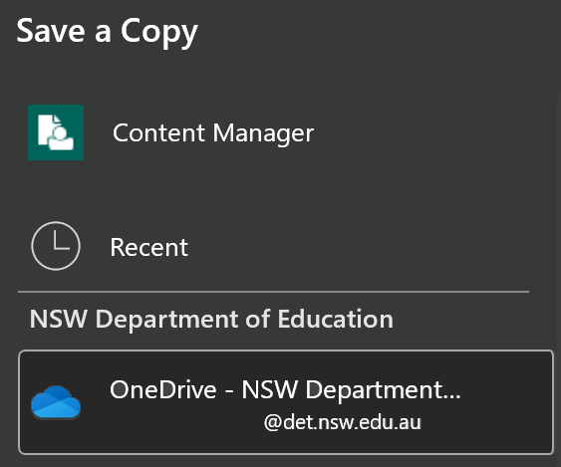
Best practice would be to keep the file name the same. Students can then select Save and a copy will be stored on their OneDrive.
Figure 3: save with the same file name screenshot
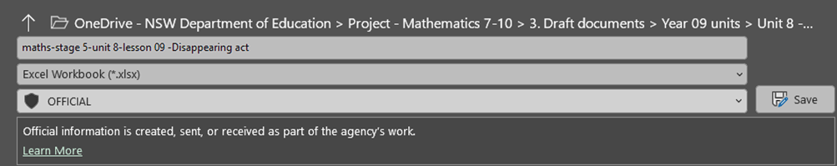

Appendix B

Quote 1
Lucy has designed each garden bed with treated pine sleepers, used to frame the garden beds, to be held in place with black garden posts, as per the following diagram.
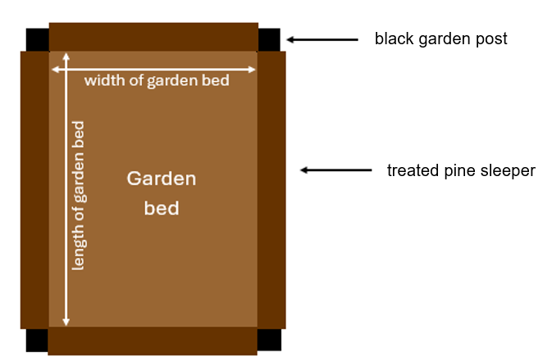
Lucy has recorded the following measurements for each of the garden beds:
Measurements | Garden bed 1 | Garden bed 2 | Garden bed 3
Width (m) | 1.2 | 0.9 | 0.6
Height (m) | 0.6 | 0.6 | 0.6
Length (m) | 1.8 | 1.2 | 0.9
Treated pine sleepers come in the following measurements:
- 1.8 m length (200 mm x 75 mm)
- 1.2 m length (200 mm x 75 mm).
Lucy will make each garden bed 3 sleepers high, totalling a height of 600 mm.
Lucy will include a black garden post in each corner of the garden beds to secure the sleepers. This will provide stability and ensure the garden beds are at right angles.
- Use the ‘Quote calculations’ tab of the spreadsheet to enter the dimensions of the garden beds, then calculate the following for each garden bed:
- the base area
- the volume of Vegi mix soil and mulch needed
- the number of treated pine sleepers
- the number of plants (6 per ${\text{m}}^{\text{2}}$).
Note: as the garden beds are raised, the perimeter and the plastic garden edging are not required for this quote and can be left blank.
- Use the costings section of the spreadsheet on the ‘Quote calculations’ tab to choose your item descriptions from the drop-down arrow, then complete the quantity cells in light blue to generate your total prices and subtotal price.
- Add ‘standard landscaping hourly rate’ to the costings description and estimate the hours required, recording this in the quantity column.
- Transfer your subtotal price to the light blue cell in the ‘Quote 1’ tab.

Appendix C

Spreadsheet features

Using the increasing and decreasing decimal buttons in the spreadsheet
Students can use the increase and decrease decimal number option in the ribbon to maintain their formulas when they adjust the calculations.
Figure 1: screenshot of decimal buttons
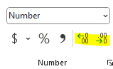

Instructions to copy a sheet in the spreadsheet
- Right-click on the sheet tab and select Move or Copy. An option box will appear.
Figure 2: screenshot of sheet tab options
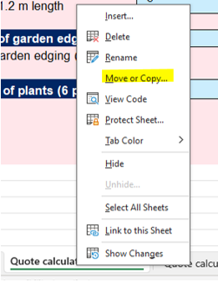
- In the option box, check the box next to Create a copy and choose which sheet you would like it to be placed before, then select OK.
Figure 3: screenshot of the ‘Move or Copy’ option box
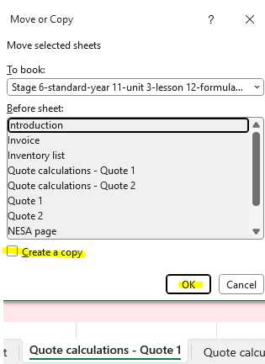
- Students can use their mouse to drag the new tab if it is not exactly where they like it.
- Students can then right-click and select Rename to change the tab name to ‘Quote 1a’.

Appendix D

Quote 2
Lucy has determined the following measurements for each of the garden beds:
Measurements | Garden bed 1 | Garden bed 2
Width (m) | 1.5 | 1.5
Height (m) | 0.3 | 0.3
Length (m) | 2 | 3
Lucy will remove the existing lawn and dig the rectangular garden beds to allow a depth of 0.3 m for the compost soil.
The plastic garden edging is flexible and comes in 10 m lengths. This edging will be secured by partially digging it into the ground. This will ensure that grass doesn’t grow into the garden bed, allowing the soil and mulch to stay in the garden and making it easier for lawn maintenance.
- Use the ‘Quote calculations’ tab of the spreadsheet to enter the dimensions of the garden beds, then calculate the following for each garden bed:
- the perimeter
- the base area
- the volume of compost soil and mulch needed
- the length of plastic garden edging needed
- the number of plants (5 per ${\text{m}}^{\text{2}}$).
- Use the costings section of the spreadsheet to choose your item descriptions from the drop-down arrow and then complete the quantity cells in light blue to generate your total prices and subtotal price.
- Choose the standard landscaping hourly rate and estimate the number of hours you think it would take for you to complete this job.
- Transfer your subtotal price to the light blue cell in the ‘Quote 2’ tab.

Appendix E

HSC style spreadsheet questions
Question 1
Below is a screenshot of part of an invoice.
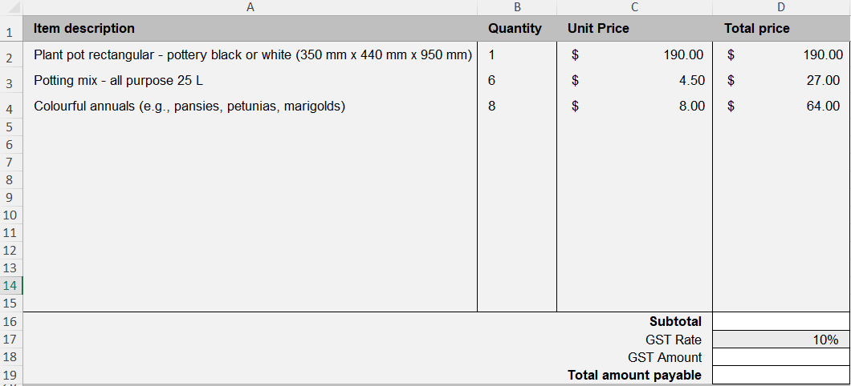
- Calculate the value for ‘Subtotal’ in cell D16.
- Write down a formula that could be used to find the value for ‘GST Amount’ in cell D18. Include appropriate cell references in your formula.
- Calculate the value for ‘Total amount payable’ in cell D19.

Question 2
Jake is building a blanket box out of wood for the end of his bed. The lid of the box will be upholstered, and the rest of the box will be stained and varnished.
Jake has placed the following information into the spreadsheet below to calculate how much stain and varnish he will need.
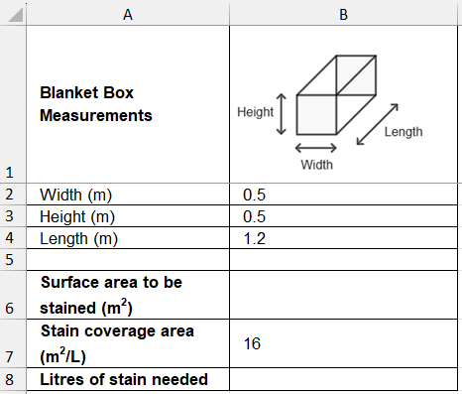
- Calculate the value for ‘Surface area to be stained’ in cell B6.
- Write down a formula that could be used in cell B8 for ‘Litres of stain needed’. Include appropriate cells in your formula.
- Jake finds a different stain and varnish product with a coverage area of 10${\text{m}}^{\text{2}}\text{/L}$. In which cell of the spreadsheet will he make this change and what impact will this have on ‘Litres of stain needed’?

Sample solutions
Solutions for the activities relating to the Formulas with spreadsheets Excel file have been provided in the Formulas with spreadsheets solutions Excel file and in teacher notes within the lesson.

Appendix E – HSC style spreadsheet questions
Question 1
- $\$190+\$27+\$64=\$281$.
- Formula is: =D16*D17
GST amount is: $\$281×10\%=\$28.10$.
- Total amount payable in cell D19 is: $\$281+\$28.10=309.10$.
Question 2
- Surface area to be stained in cell B6 is: $\left(2×0.5×0.5\right)+\left(2×1.2×0.5\right)+\left(0.5×1.2\right)=2.3m^{2}$.
- Formula is: =B6/B7.
- The change will be made in cell B7. Changing the value from 16 to 10 will increase the number of litres of stain and varnish that will need to be used.

References
This resource contains NSW and syllabus content. The NSW Curriculum is developed by the NSW Education Standards Authority (NESA). This content is prepared by NESA for and on behalf of the Crown in right of the State of New South Wales. The material is protected by Crown copyright.
Please refer to the NESA Copyright Disclaimer for more information https://www.nsw.gov.au/education-and-training/nesa/copyright.
NESA holds the only official and up-to-date versions of the NSW Curriculum and syllabus documents. Please visit NESA https://www.nsw.gov.au/education-and-training/nesa and NSW Curriculum https://curriculum.nsw.edu.au.
Mathematics Standard 11–12 Syllabus © NSW Education Standards Authority (NESA) for and on behalf of the Crown in right of the State of New South Wales, 2024.
Numeracy Stage 6 (CEC) Syllabus © NSW Education Standards Authority (NESA) for and on behalf of the Crown in right of the State of New South Wales, 2021.
NSW Education Standards Authority (NESA) (2024) ‘Glossary’, Mathematics Advanced 11–12 (2024), NESA website, accessed 22 July 2025.

© State of New South Wales (Department of Education), 2026
The copyright material published in this resource is subject to the Copyright Act 1968 (Cth) and is owned by the NSW Department of Education or, where indicated, by a party other than the NSW Department of Education (third-party material).
Copyright material available in this resource and owned by the NSW Department of Education is licensed under a Creative Commons Attribution 4.0 International (CC BY 4.0) license.

This license allows you to share and adapt the material for any purpose, even commercially.
Attribution should be given to © State of New South Wales (Department of Education), 2026.
Material in this resource not available under a Creative Commons license:
- the NSW Department of Education logo, other logos and trademark-protected material
- material owned by a third party that has been reproduced with permission. You will need to obtain permission from the third party to reuse its material.
Links to third-party material and websites
Please note that the provided (reading/viewing material/list/links/texts) are a suggestion only and implies no endorsement, by the New South Wales Department of Education, of any author, publisher, or book title. School principals and teachers are best placed to assess the suitability of resources that would complement the curriculum and reflect the needs and interests of their students.
If you use the links provided in this document to access a third-party's website, you acknowledge that the terms of use, including licence terms set out on the third-party's website apply to the use which may be made of the materials on that third-party website or where permitted by the Copyright Act 1968 (Cth). The department accepts no responsibility for content on third-party websites.

