Volume of pyramids and cones
Students learn about the volume of pyramids and cones in the real-life context of farming.

Learning intention
- To be able to solve problems involving the volume of pyramids and cones.

Success criteria
- I can apply appropriate strategies to calculate the volume of a pyramid or cone.
- I can use Pythagoras’ theorem to calculate the perpendicular height of a pyramid or cone.
- I can describe the relationship between the volume of a prism or cylinder and the volume of a pyramid or cone with the same base area and perpendicular height.

Outcomes
A student:
- develops understanding and fluency in mathematics through exploring and connecting mathematical concepts, choosing and applying mathematical techniques to solve problems, and communicating their thinking and reasoning coherently and clearly MAO-WM-01
- selects and applies algebraic techniques to solve problems involving equations and formulas MST-11-01
- solves problems involving measurement in practical contexts MST-11-05
Mathematics Standard 11–12 Syllabus © NSW Education Standards Authority (NESA) for and on behalf of the Crown in right of the State of New South Wales, 2024.

Associated numeracy outcomes
A student:
- recognises and applies functional numeracy concepts in practical situations, including personal and community, workplace and employment, and education and training contexts N6-1.1
- applies numerical reasoning and mathematical thinking to clarify, efficiently solve and communicate solutions to problems N6-1.2
- determines whether an estimate or an answer is reasonable in the context of a problem, evaluates results and communicates conclusions N6-1.3
- chooses and applies appropriate operations with whole numbers, familiar fractions and decimals, percentages, rates and ratios to analyse and solve everyday problems N6-2.1
- chooses and applies efficient strategies to analyse and solve everyday problems involving metric relationships, distance and length, area, volume, time, mass, capacity and temperature N6-2.2
- chooses and applies efficient strategies to analyse and solve everyday problems involving location, space and design N6-2.5
- chooses and applies appropriate numeracy operations and techniques to analyse and resolve everyday situations N6-2.6
Numeracy Stage 6 (CEC) Syllabus © NSW Education Standards Authority (NESA) for and on behalf of the Crown in right of the State of New South Wales, 2021.

Content

Formulas and equations
- Substitute numbers into linear and non-linear algebraic expressions, equations and formulas
- Evaluate the subject of a formula, given the value of other pronumerals in the formula
- Apply given formulas to solve problems in a variety of contexts

Applications of measurement

Perimeter, area and volume
- Apply Pythagoras’ theorem to solve problems involving right-angled triangles
- Solve practical problems involving volume and capacity of prisms, cylinders, spheres, cones, pyramids and composite solids in a variety of contexts
Mathematics Standard 11–12 Syllabus © NSW Education Standards Authority (NESA) for and on behalf of the Crown in right of the State of New South Wales, 2024.

Table 1: lesson summary
Section | Summary of activity | Teaching strategies | Teaching points
Activating prior knowledge | Students identify 3-dimensional solids displayed on slide 4 of PowerPoint Volume of pyramids and cones and are asked to consider the features of each solid by identifying their similarities and differences. | Think-Pair-Share | Identify the features of prisms, cylinders, prism and cones.
Connecting learning | Students are shown 2 videos of water being poured into a prism from a pyramid (bit.ly/pyramidvolume) and from a cone into a cylinder (bit.ly/cone3into1cylinder), and use slide 6 to develop the volume formulas. Students are then given Appendix A to complete. Students are shown farming equipment on slide 7 and are then given a scenario on slide 8 to calculate and compare volumes. Slide 9 shows 2 pyramids with different slant heights shown for students to calculate the perpendicular height of each and explain why the different slant heights produce the same perpendicular height. | Notice and wonder  Pose-Pause-Pounce-Bounce  Think-Pair-Share | Understand the relationship between the formulas for prisms, pyramids, cylinders and cones, recognising that to find that the volume of a pyramid or cone is one-third of the volume of a prism or cylinder.
Releasing responsibility | Students practise finding the volume of pyramids and cones, using worked examples on slides 11–14. Students then use the instructions in Appendix B to make notes. | Worked examples (Your turn) | Formalise the use of the formulas to calculate the volume of a pyramid and a cone.
Independent practice | Students revisit the Approaching questions scaffold on slide 16 before completing Appendix C. They use a class discussion to compare strategies and solutions to the problems. |  | Apply volume formulas for pyramids and cones in complex, non-routine problems.

Activity structure
Please use the associated PowerPoint Volume of pyramids and cones to display images in this lesson.

Activating prior knowledge
- Display slide 4 from the PowerPoint and ask students to identify the solids by name.
- Animate the slide to show an example of something that is similar between 2 of the solids.
- In a Think-Pair-Share (bit.ly/thinkpairsharestrategy), ask students to identify similarities and differences between the solids.
The solids are a square-based pyramid, a cylinder, a cone and a cube. Students should be encouraged to use mathematical language of vertices/vertex, edges, faces, height and cross-section.

Connecting learning
- Show students the video ‘Prisms and Pyramids [ACT 3]: How Many Rectangular Pyramids Does It Take To Fill a Rectangular Prism’ (0:40) (bit.ly/pyramidvolume), asking them to consider, while watching the video, what the connection is between the volume of a pyramid and the volume of a prism.
- Use the Pose-Pause-Pounce-Bounce questioning strategy (PDF 557 KB) (bit.ly/posepausepouncebounce) to draw attention to the relationship between the volume of a pyramid and a prism. Useful question prompts may include:
- What do you notice about the height of the pyramid and prism?
- How many times was the pyramid emptied into the prism and what does that mean about their volume?
- Show students the video ‘Prisms and Pyramids [ACT 3]: How Many Cones Does It Take To Fill a Cylinder?‘ (0:35) (bit.ly/cone3into1cylinder).
- Use the Pose-Pause-Pounce-Bounce questioning strategy to draw further attention to the relationship between the volume of a pyramid, prism, cylinder and cone and their formulas. Useful question prompts may include:
- Why is it important for the base and height of the solids to be the same?
- How could these demonstrations be used to develop the formula for the volume of a pyramid and cone?
- Display slide 6 from the PowerPoint, which shows a prism and a pyramid, and animate the slide to reveal information indicating that the pyramid and prism have the same size base and the same perpendicular height.
- Ask students how they think the demonstration in the video helps us to understand how the formula for the volume of a pyramid is created, before animating the slide to reveal the relationship between the 2 solids and the formula for the volume of each shape.
- Animate the slide again to reveal a cylinder and a cone, with the same information regarding the size of the base and the perpendicular height of the solids.
- Ask students to predict how the cylinder’s volume formula changes to create the formula for a cone, then animate the slide to reveal the relationship and the formulas.
- Use the Pose-Pause-Pounce-Bounce questioning strategy to draw attention to how the formulas for volume of a pyramid and cone are used. Useful question prompts may include:
- How would the calculation be affected if the base of the pyramid were not a square?
- How is the perpendicular height different to the slant height of a cone?
- How could we calculate the volume of a cone if we were given the slant height instead of the perpendicular height?
Students should recall that the formula for all prisms is $V=Ah$, so should recognise that the formula $V=\frac{1}{3}Ah$ will apply for all pyramids.
Students should recognise that the slant height is longer than the perpendicular height of a cone and that the perpendicular height can be found using Pythagoras’ theorem.
- Ask students to review their copy of the NESA Mathematics Standard 1 and 2 – HSC reference sheet and have them locate and annotate where the formula for volume of a pyramid is on the sheet.
- Distribute Appendix A ‘Pyramids and cones’ and ask students to work in pairs to complete the activities.
- Use a class discussion to review student answers to the questions in Appendix A.
The aim of the questions is to draw out understanding of the relationship between the volumes of 3D solids that share the same base area and height.
Some pacing adjustment may be needed to familiarise students with substituting into the formula.
- Display slide 7, which shows some feed spreaders used in farming. Ask students what they Notice and wonder (bit.ly/noticewonderstrategy).
Students may wonder what the images represent. Students should notice that the fertiliser spreaders are either cone shaped or pyramid shaped.
You might explain that the tools are designed so that gravity makes the material flow to the bottom, so it doesn’t need to be scooped out and works best with dry material or liquids that flow. They are less effective with sludge material, such as cement or cake icing, as additional assistance is needed for these materials to go through the funnel.
- Read the following scenario and display slide 8, which shows diagrams of 2 smaller spreaders:
A company, Farmwell, is manufacturing a new spreader for a hobby farmer and wants to advertise its spreader as bigger than its competitor’s Spreadwell, which will save farmers time. However, the dimensions look the same. Is the company’s claim true?
- In a Think-Pair-Share (bit.ly/thinkpairsharestrategy), ask students to predict which spreader is larger before calculating the volume of both spreaders and deciding if the company’s claim is true.
The volume of the cone-shaped spreader is $13 688 {\text{cm}}^{\text{3}}$ and the volume of the pyramid-shaped spreader is $18 000 {\text{cm}}^{\text{3}}$.
Students needed to calculate the perpendicular height of the cone before calculating the volume.
- Display slide 9, which contains images of 2 pyramids that have the same base, but different representations of slant height.
- Animate the slide and use the self-explanation prompts to discuss the different approaches needed to calculate the volume of the pyramids.
Students should recognise that the length of the slant heights is different because the length of the base of the right-angled triangles is different.
- Ask students to work in pairs to find the perpendicular height of Pyramid A or Pyramid B and then share their work with another pair to compare their solutions.
Students should achieve answers that round to a value of 3 cm.
- Use the Pose-Pause-Pounce-Bounce questioning strategy to facilitate a discussion about the pyramids and the slant heights. Useful question prompts may include:
- Why do the different slant heights produce the same perpendicular height?
- How do we know that the pyramids are congruent?
Students may need to be reminded of the meaning of the term ‘congruent’.

Releasing responsibility
- Use slides 11–14 from the PowerPoint to model worked examples of volume of a cone or pyramid using the Worked examples (Your turn) method (bit.ly/supportingstrategies).
- Animate each worked example to utilise the self-explanation prompts to guide students in articulating their understanding of calculating the volume of a cone or pyramid using Pythagoras’ theorem and using the formula to find the perpendicular height of the cone or pyramid when given the volume.
Students may benefit from revisiting the measurement formulas on the NESA Mathematics Standard 1 and 2 – HSC reference sheet as they complete the Appendix B .
- Distribute a copy of Appendix B ‘Instructions for foldable notes’ to pairs of students and ask them to follow the instructions to create a foldable to summarise information for their future forgetful selves on calculating the volume of a cone and pyramid.
The video of how to make the foldable (bit.ly/foldableexample) can be shown if students require extra support.
- Some students may benefit from completing practice questions from an existing resource on finding the volume of pyramids and cones before moving on to the next activity.

Independent practice
- Use slide 16 from the PowerPoint to activate prior knowledge of the Approaching questions scaffold for students.
- Distribute Appendix C ‘HSC style questions’ to students and ask them to work in pairs to solve the problems.
- Students compare their work with another pair of students to check for strategies used and reasonableness of answers.
- In a class discussion, students share strategies on how they solved the problems and the strengths and weaknesses that they found when comparing their strategy to another pair.

Assessment and differentiation

Suggested opportunities for differentiation
Activating prior knowledge
- Students may benefit from being provided with concrete models of pyramids, cones, cylinders and cubes.
- Use sentence starters or graphic organisers for students to document similarities and differences between solids.
Connecting learning
- Support students with pacing adjustment while completing Appendix A when they are unfamiliar with the use of this formula.
- Provide the net of a pyramid and a ruler for students to measure the base lengths of the right-angled triangles in Pyramid A and Pyramid B on slide 9.
Releasing responsibility
- Allow more autonomous learners to create their own volume problems for peers to solve, encouraging deeper engagement and extension.
Independent practice
- Provide a scaffold for students needing help with structuring their problem-solving approach.

Suggested opportunities for assessment
Activating prior knowledge
- Monitor student contributions on slide 4 as assessment of conceptual understanding of the similarities and differences between prisms, pyramids, cylinders and cones.
Connecting learning
- Collect completed Appendix A activities problem solutions for formal assessment of applied skills.
- Collect responses from the Think-Pair-Share activity on calculating volume and application of Pythagoras’ theorem to calculate perpendicular heights.
Releasing responsibility
- Review students’ foldable notes for completeness and accuracy as evidence of understanding.
Independent practice
- Collect completed Appendix C problem solutions to check for understanding of calculating the volume of pyramids and cones.

Appendix A

Pyramids and cones
Calculate the volume of the solids and answer the questions below each table.
Solid | Diagram | Volume calculation
Cube | 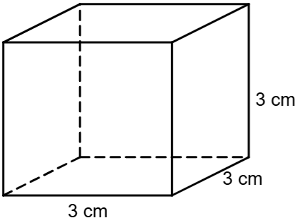 | $$V=Ah$$
Square-based pyramid | 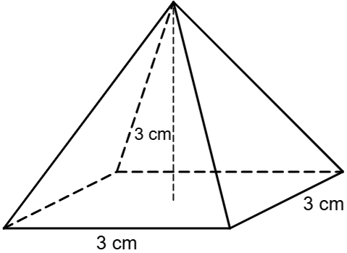 | $$V=\frac{1}{3}Ah$$
How is the relationship between a prism and its associated pyramid affected by the shape of its base?

Solid | Diagram | Volume calculation
Cylinder | 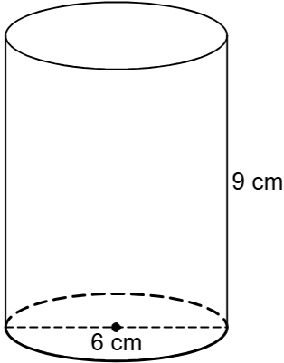
Cone | 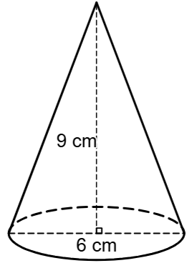
If you know the volume of a cylinder, how can you use that to predict the volume of a cone with the same dimensions?

Solid | Diagram | Volume calculation
Rectangular prism | 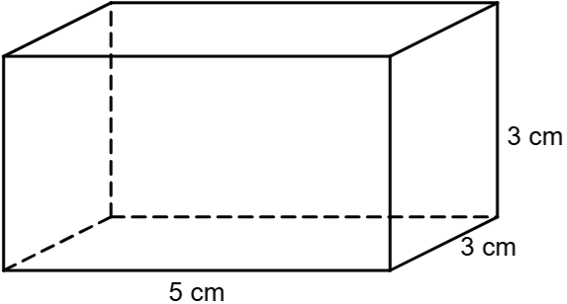
Rectangle-based pyramid | 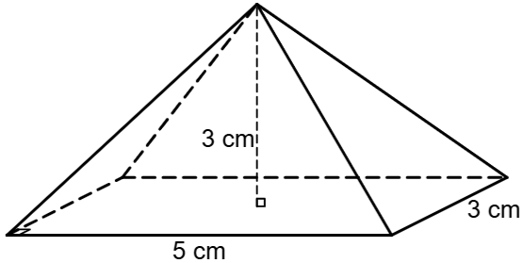
If you filled the pyramid with water, how many times would you have to pour it into the prism to fill it completely?
Solid | Diagram | Volume calculation
Octagonal prism | 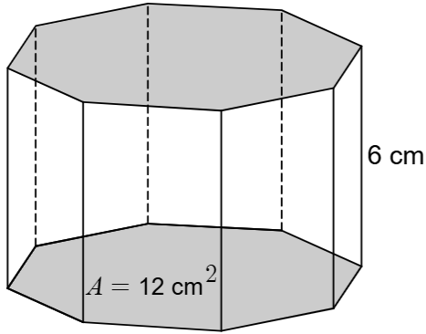
Octagonal pyramid | 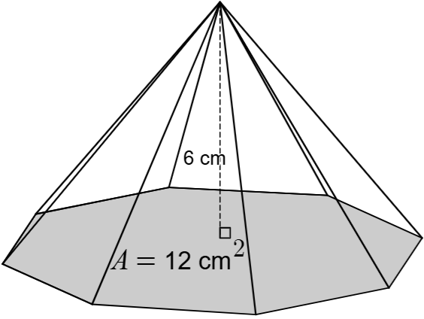
How would you explain how to calculate the volume of a pyramid or cone?

Appendix B

Instructions for foldable notes
Step 1: hold an A4 piece of paper in portrait. Fold the page in thirds lengthways. The folds will be approximately 7 cm from each side.
Step 2: fold the page in half horizontally to create 6 sections on the paper. Cut along the horizontal line to the midway point to make 2 doors on each side.
Step 3: fold the upper left door over, write the title ‘Cone’ on the outside of the door, draw a picture of a cone, marking the radius and perpendicular height of the cone, and write the formula for volume (see Figure 1).
Figure 1 – demonstration of Step 3
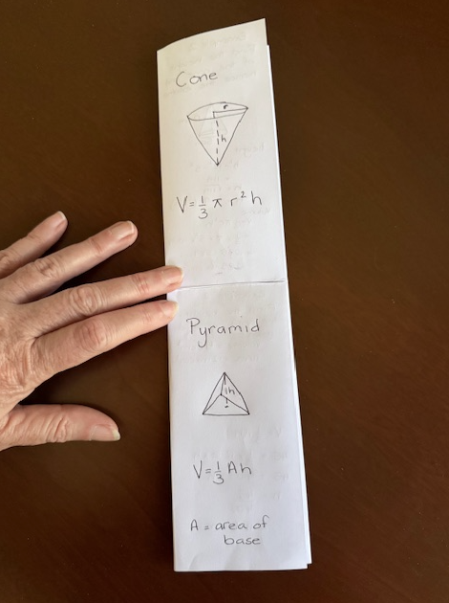
Step 4: fold the upper right door over, copy and complete ‘Cone example 1’ below in the space on the door (see Figure 2).
Figure 2 – demonstration of Step 4
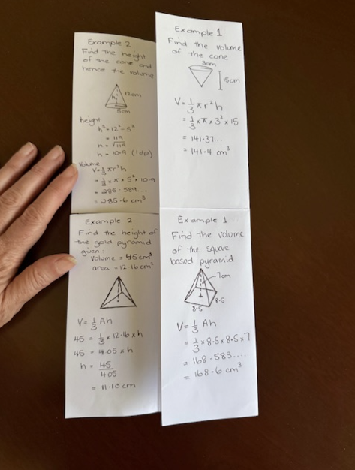
Cone example 1
Find the volume of the ice-cream cone to 1 decimal place.
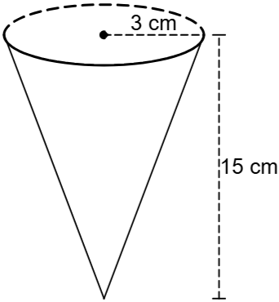
$$V=\frac{1}{3}Ah \\ =\frac{1}{3}×π×3^{2}×□ \\ =□$$
Step 5: open both doors. On the inside upper left door write ‘Cone example 2’, copy the question below and complete the solution (see Figure 3).
Figure 3 – demonstration of Step 5
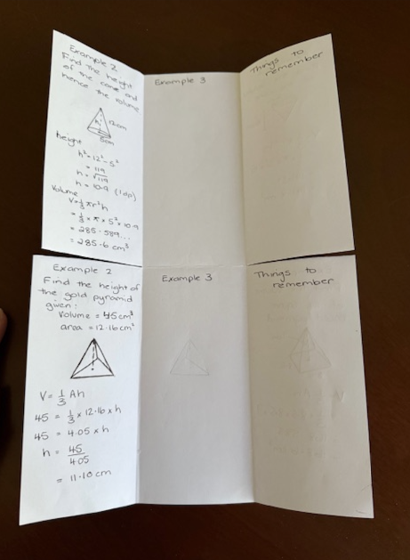
Cone example 2
Find the height of the cone and hence the volume (both to 1 decimal place).
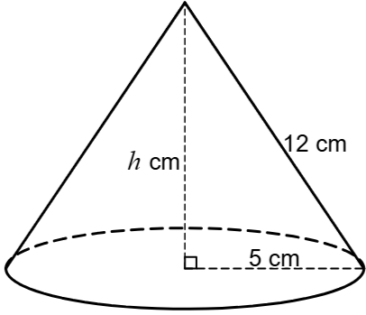
Step 6: on the inside upper centre section of the foldable, write your own example for calculating the volume of a cone.
Step 7: on the inside upper right door write things you need to remember when calculating the volume of a cone.
Steps 8–12: on the bottom half of the page, complete steps 3–7, focusing on calculating the volume of a pyramid.
Pyramid example 1
Find the volume of the square-based pyramid, correct to 2 decimal places.
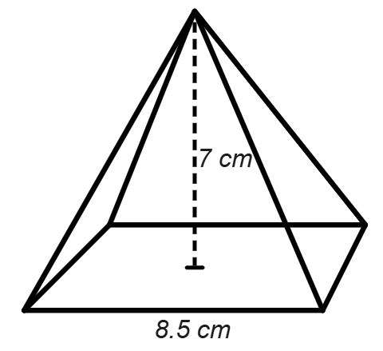
$$V=\frac{1}{3}Ah \\ =\frac{1}{3}×8.5×□×7 \\ =□$$
Pyramid example 2
Find the height of the gold pyramid ornament given its volume is $45 cm^{3}$ and the area of one face is $12.16 cm^{2} to 2 decimal places.$
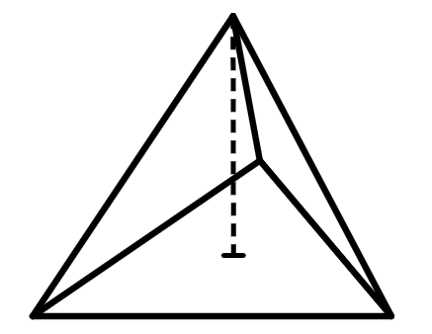
Step 13: finally, glue the top middle blank section in your book, fold all the doors in and fold up the lower section.

Appendix C

HSC style questions
Question 1 – adapted from 2018 HSC Mathematics General HSC exam paper, Question 13 (NESA 2018)
A rectangular pyramid has base side lengths of $3x$ and$4x$. The perpendicular height of the pyramid is $2x$. All measurements are in metres.
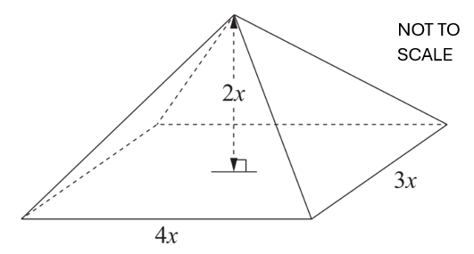
Write an expression for the volume of the pyramid in cubic metres.
Question 2 – adapted from 2017 HSC Mathematics General HSC exam paper Question 30(e) (NESA 2017)
A solid is made up of a sphere sitting inside a cone.
The sphere, centre $O$, has a radius of 4$cm$ and sits 2$cm$ inside the cone. The solid has a total height of 15 $cm.$ The solid and its cross section is shown.
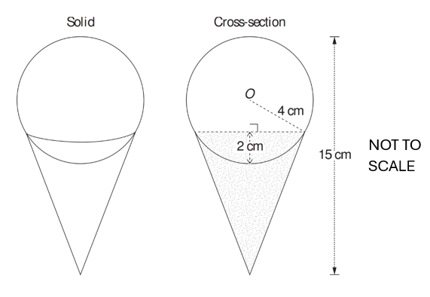
Using the formula $V=\frac{1}{3}πr^{2}h,$ where $r$ is the radius of the cone’s circular base and $h$ is the perpendicular height of the cone, find the volume of the cone, correct to the nearest $\text{c}{\text{m}}^{\text{3}}.$

Sample solutions

Appendix A – pyramids and cones
Solid | Diagram | Volume calculation
Cube |  | $$V=3×3×3 \\ =27 {\text{cm}}^{3}$$  Volume is $27 {\text{cm}}^{3}$.
Square-based pyramid |  | $$V=\frac{1}{3}×3×3×3 \\ =9 {\text{cm}}^{3}$$  Volume is 9${\text{cm}}^{3}$.
How is the relationship between a prism and its associated pyramid affected by the shape of its base?
It’s not affected. If the base is the same and the perpendicular height is the same, the volume of the pyramid is always one-third of the prism.
Solid | Diagram | Volume calculation
Cylinder |  | $$V=π×3^{2}×9 \\ =254.469…{\text{cm}}^{3}$$  Volume is 254.5${\text{cm}}^{3}$.
Cone |  | $$V=\frac{1}{3}×π×3^{2}×9 \\ = 84.823…{\text{cm}}^{3}$$  Volume is $84.8 {\text{cm}}^{3}$.
If you know the volume of a cylinder, how can you use that to predict the volume of a cone with the same dimensions?
You can just multiply the volume by one-third.
Solid | Diagram | Volume calculation
Rectangular prism |  | $$V=5×3×3 \\ =45 {\text{cm}}^{3}$$  Volume is 45${\text{cm}}^{\text{3}}$.
Rectangle-based pyramid |  | $$V=\frac{1}{3}×5×3×3 \\ =15 {\text{cm}}^{\text{3}}$$  Volume is 15${\text{cm}}^{\text{3}}$.
If you filled the pyramid with water, how many times would you have to pour it into the prism to fill it completely?
You would need to pour the water in 3 times.
Solid | Diagram | Volume calculation
Octagonal prism | 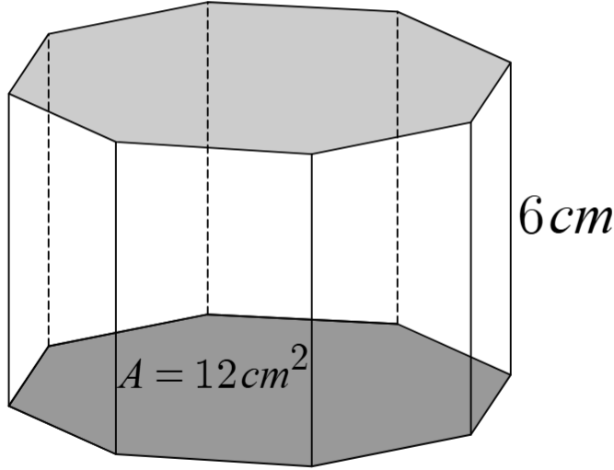 | $$V=12×6 \\ =72 {\text{cm}}^{\text{3}}$$  Volume is 72${\text{cm}}^{\text{3}}$.
Octagonal pyramid | 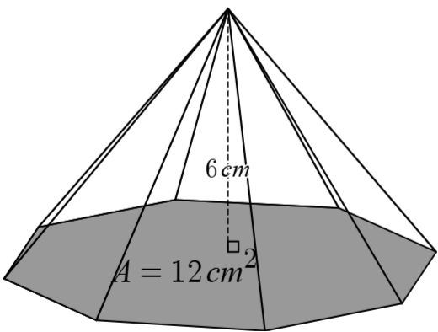 | $$V=\frac{1}{3}×12×6 \\ =24 {\text{cm}}^{\text{3}}$$  Volume is$24 {\text{cm}}^{\text{3}}$.
How would you explain how to calculate the volume of a pyramid or cone?
To calculate the volume of a prism or cone you need to find the area of the base, multiply it by the perpendicular height and multiply by one-third.

Appendix C – HSC style questions
Question 1 | $$V=\frac{1}{3}Ah \\ =\frac{1}{3}×3x×4x×2x \\ =8x^{3} {\text{m}}^{\text{3}}$$
Question 2 | Radius of cone  $$r=\sqrt{4^{2}-2^{2}} \\ =\sqrt{12} \text{cm}$$  Height of cone  $$h=15-\left(4+2\right) \\ =9 \text{cm}$$  Volume of cone  $$V=\frac{1}{3}πr^{2}h \\ =\frac{1}{3}×π×{\left(\sqrt{12}\right)}^{2}×9 \\ =113.097… \\ =113 {\text{cm}}^{3} (nearest {\text{cm}}^{3})$$

References
This resource contains NSW and syllabus content. The NSW Curriculum is developed by the NSW Education Standards Authority (NESA). This content is prepared by NESA for and on behalf of the Crown in right of the State of New South Wales. The material is protected by Crown copyright.
Please refer to the NESA Copyright Disclaimer for more information https://www.nsw.gov.au/education-and-training/nesa/copyright.
NESA holds the only official and up-to-date versions of the NSW Curriculum and syllabus documents. Please visit NESA https://www.nsw.gov.au/education-and-training/nesa and NSW Curriculum https://curriculum.nsw.edu.au.
Mathematics Standard 11–12 Syllabus © NSW Education Standards Authority (NESA) for and on behalf of the Crown in right of the State of New South Wales, 2024.
Numeracy Stage 6 (CEC) Syllabus © NSW Education Standards Authority (NESA) for and on behalf of the Crown in right of the State of New South Wales, 2021.

© State of New South Wales (Department of Education), 2026
The copyright material published in this resource is subject to the Copyright Act 1968 (Cth) and is owned by the NSW Department of Education or, where indicated, by a party other than the NSW Department of Education (third-party material).
Copyright material available in this resource and owned by the NSW Department of Education is licensed under a Creative Commons Attribution 4.0 International (CC BY 4.0) license.

This license allows you to share and adapt the material for any purpose, even commercially.
Attribution should be given to © State of New South Wales (Department of Education), 2026.
Material in this resource not available under a Creative Commons license:
- the NSW Department of Education logo, other logos and trademark-protected material
- material owned by a third party that has been reproduced with permission. You will need to obtain permission from the third party to reuse its material.
Links to third-party material and websites
Please note that the provided (reading/viewing material/list/links/texts) are a suggestion only and implies no endorsement, by the New South Wales Department of Education, of any author, publisher, or book title. School principals and teachers are best placed to assess the suitability of resources that would complement the curriculum and reflect the needs and interests of their students.
If you use the links provided in this document to access a third-party's website, you acknowledge that the terms of use, including licence terms set out on the third-party's website apply to the use which may be made of the materials on that third-party website or where permitted by the Copyright Act 1968 (Cth). The department accepts no responsibility for content on third-party websites.

