Volume and capacity with the Trapezoidal rule
Students build on their understanding of the Trapezoidal rule to estimate volumes and capacities of irregular shapes. They apply these skills to real-world contexts.

Learning intention
- To be able to use the Trapezoidal rule to find volume and capacity.

Success criteria
- I can identify the cross-section and height of a prism.
- I can calculate the area of the cross-section of a prism using the Trapezoidal rule.
- I can apply the formula $V=Ah$ to calculate the volume.
- I can convert measures between volume and capacity.
- I can correctly apply the Trapezoidal rule to solve problems.

Outcomes
A student:
- develops understanding and fluency in mathematics through exploring and connecting mathematical concepts, choosing and applying mathematical techniques to solve problems, and communicating their thinking and reasoning coherently and clearly MAO-WM-01
- selects and applies algebraic techniques to solve problems involving equations and formulas MST-11-01
- solves problems involving measurement in practical contexts MST-11-05

Associated numeracy outcomes
A student:
- applies numerical reasoning and mathematical thinking to clarify, efficiently solve and communicate solutions to problems N6-1.2
- determines whether an estimate or an answer is reasonable in the context of a problem, evaluates results and communicates conclusions N6-1.3
- chooses and applies efficient strategies to analyse and solve everyday problems involving metric relationships, distance and length, area, volume, time, mass, capacity and temperature N6-2.2
Numeracy Stage 6 (CEC) Syllabus © NSW Education Standards Authority (NESA) for and on behalf of the Crown in right of the State of New South Wales, 2021.

Content

Formulas and equations
- Substitute numbers into linear and non-linear algebraic expressions, equations and formulas
- Evaluate the subject of a formula, given the value of other pronumerals in the formula
- Apply given formulas to solve problems in a variety of contexts

Applications of measurement

Practicalities of measurement
- Identify and convert between the metric units of capacity: millilitres (mL), litres (L), kilolitres (kL) and megalitres (ML)
- Identify and convert between units of volume and capacity, using $1 cm^{3}=1 mL$, $1{ m}^{3}=1000 L=1 kL$ and $1000 kL=1 ML$

Perimeter, area and volume
- Apply the Trapezoidal rule $A≈\frac{h}{2}\left(d_{f}+d_{l}\right)$, where $A$ is the area, $d_{f}$ and $d_{l}$ are the lengths of the parallel sides of the trapezium, $d_{f}$ is the first length and $d_{l}$ is the last length, and $h$ is the perpendicular distance between them, to solve a variety of practical problems involving area, volume and capacity for up to four applications
Mathematics Standard 11–12 Syllabus © NSW Education Standards Authority (NESA) for and on behalf of the Crown in right of the State of New South Wales, 2024.

Table 1: lesson summary
Section | Summary of activity | Teaching strategies | Teaching points
Retrieval practice | Using slide 4 of the PowerPoint Volume and capacity with the Trapezoidal rule, students calculate the capacity of water held in a stormwater drain. Teachers may show a visual aid on unit conversions on slide 5, if needed. | Assessing and advancing questions | Gauge students’ understanding of volume formulas, unit conversions, and the relationship between volume and capacity. Develop fluency in converting between units such as cubic metres, kilolitres and megalitres.
Activating prior knowledge | Students apply the Trapezoidal rule twice to estimate the area of an irregular block of land, displayed on slide 7. They use their notes and reference sheets to support their calculations and collaborate to identify errors. |  | Reinforce the Trapezoidal rule as a method for approximating area in irregular shapes.
Connecting learning | Students apply the Trapezoidal rule to measure the area of a garden shown on slide 9 and compare the estimates obtained with different applications of the rule on slide 10. On slide 11, they use the measurements of 4 applications of the Trapezoidal rule to find the approximate volume of the garden. Students estimate the volume of rainwater falling on a man-made reservoir using 2 applications of the Trapezoidal rule on slide 12. | Pose-Pause-Pounce-Bounce  Notice and wonder | Develop understanding of how multiple applications of the Trapezoidal rule increase accuracy.  Connect area calculations to volume via the formula $V=Ah$.
Releasing responsibility | Students summarise their learning using the scaffold in Appendix A. They are shown a picture of a resin coffee table on slide 14 and use slide 15 to consider how to find the amount of resin used to make the table. | Four quadrant notes  Think-Pair-Share | Apply the Trapezoidal rule to a new real-world context involving volume estimation.
Independent practice | Students are shown a photo of a dam with a traverse line and offsets and asked how they would apply the Trapezoidal rule to find the volume of the dam before being shown 2 methods on slide 17. Students calculate the volume of the dam, given the average depth is $2.2 \text{m}$ and slide 18 shows a possible solution. Slide 19 reminds students of scaffolding questions to support problem-solving for Appendix B. Students attempt the problem independently, then collaborate to discuss and check solutions. | Pose-Pause-Pounce-Bounce | Consolidate understanding of the Trapezoidal rule and its application to volume problems.  Promote confidence in using problem-solving scaffolds.

Activity structure
Please use the associated PowerPoint Volume and capacity with the Trapezoidal rule to display images in this lesson.

Retrieval practice
- Display slide 4 from the PowerPoint, which shows the image of the stormwater drain below, and ask students to calculate the number of megalitres of water the drain will hold when full.
Figure 1: screenshot of the drain
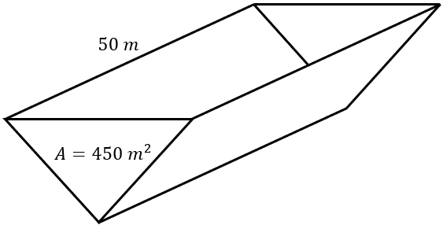
Students should be encouraged to use their NESA Mathematics Standard 1 and 2 – HSC reference sheet for the conversions $1 \text{c}{\text{m}}^{\text{3}}=1 \text{mL}$ and $1 {\text{m}}^{\text{3}}=1000 \text{L}$.
Students were introduced to calculating the volume and capacity in Lesson 7 – volume in this unit. If required by students, teachers can display slide 5, which shows a visual representation of the conversions between volume and capacity.
- Ask students assessing and advancing questions (bit.ly/supportingstrategies) to gather information on students’ current level of understanding of volume and capacity. Some suggestions are provided in the following table:

Table 2: assessing and advancing questions
Assessing questions | Advancing questions
What is the formula for finding the volume of a prism? | If $1 m^{3}=1000 \text{L}=1 \text{kL}$, can you now find the capacity of the drain?
What units of measurement can be used to represent the volume of a prism? | If $1000 \text{kL}=1 \text{ML}$, can you now find the capacity of the drain in megalitres?
What is the relationship between measurements of volume and capacity? | How does calculating the volume help you determine the capacity?
What units of measurement are used for capacity? | Why might the values for the volume of water in a drain and the capacity of the drain be quite different?
- Animate slide 4 to reveal the solution.

Activating prior knowledge
- Display slide 7, which shows a parcel of land and a question asking students to use the Trapezoidal rule to calculate the area of land, and ask students to work in pairs to calculate the area.
Advise students they may find it useful to use their copy of the NESA Mathematics Standard 1 and 2 – HSC reference sheet for the Trapezoidal rule and their Four quadrant notes from Lesson 5 – irregularly shaped blocks of land and Trapezoidal rule in this unit.
- Ask students to compare their solutions with another pair, to check the solution and to identify and discuss possible differences in working.
The area of the block of land is $33 300 {\text{m}}^{2}$. Solutions can be found in the ‘Sample solutions’ section.

Connecting learning
- Display slide 9 from the PowerPoint and ask students to read the information on the slide. Animate the slide to reveal further information.
- Use the Pose-Pause-Pounce-Bounce questioning strategy (PDF 557 KB) (bit.ly/posepausepouncebounce) to discuss the measurements they think Oscar should make to find a better estimate for the area of the garden. Useful question prompts may include:
- How might Oscar calculate an estimate for the area of the garden?
- How might Oscar improve the accuracy of his estimate?
- Why would more applications of the Trapezoidal rule provide more accuracy than one application?
Students should realise that they can use more than one application of the Trapezoidal rule to improve the accuracy of the estimate, if they had more measurements. Students used the Trapezoidal rule with 4 applications in Lesson 5 – irregularly shaped blocks of land and Trapezoidal rule in this unit.
- Display slide 10 and ask students what they Notice and wonder (bit.ly/noticewonderstrategy).
They may notice the pattern in the calculations, that the first and last values in the brackets are the same and the other values are repeated. They may notice that the numerator in the fraction, which is the height of the trapezium, becomes smaller with more applications of the Trapezoidal rule.
Students may wonder how much more accurate the calculation will be if more trapeziums were used or if there is a more efficient way of entering the calculation into their calculator.
- Display slide 11 and use the Pose-Pause-Pounce-Bounce questioning strategy to check for understanding of how to calculate the volume of a 3-dimensional solid. Useful question prompts may include:
- What does the 0.4 represent in the calculation?
- Is the shape of the garden a prism?
- Why was Oscar able to calculate the volume of soil by multiplying the area of the garden by $0.4$?
- Display slide 12, which contains a question about a reservoir and an outline of it, and ask students to complete it in pairs.
- Have neighbouring pairs compare their solutions and explain differences in the method they chose.
Solutions for the reservoir question can be found in the ‘Sample solutions’ section.

Releasing responsibility
- Ask groups to complete Four quadrant notes to their future forgetful selves (bit.ly/supportingstrategies) from Appendix A ‘Four quadrant notes’ at their vertical non-permanent surfaces (bit.ly/VNPSstrategy).
- Display slide 14 from the PowerPoint to show a coffee table filled with resin and ask them what they Notice and wonder.
Students may notice that the table is called a river resin table and may associate the table with the diagram of the reservoir seen earlier in the lesson. They may wonder how the table is made.
Explain to students that the table is made using 2 slabs of timber. Each piece has a straight edge and a rough, unfinished edge. The slabs are placed in a tray with a small gap between the slabs. Resin is mixed and poured into the gap to solidify and hold the pieces in place.
- Display slide 15 and use a Think-Pair-Share (bit.ly/thinkpairsharestrategy) for students to discuss how they could use the Trapezoidal rule to estimate the volume of resin used to make the table.
Students should recognise that the offsets have been measured from each of the long edges of the table to the resin. They will need to use the offsets with 2 applications of the Trapezoidal rule to find an estimate for the area of the wood.
Students will then need to subtract the area of wood from the area of the table, to provide an estimate of the amount of resin. They then need to multiply the estimated area by the height of the table to find the volume of the resin.
- Ask students in pairs to calculate an estimate for the volume of resin required to create the table.
- Have neighbouring pairs of groups compare their solutions.
Solutions for this question can be found in the ‘Sample solutions’ section.

Independent practice
- Display slide 17 from the PowerPoint and use a Pose-Pause-Pounce-Bounce to check student understanding of how they could use the Trapezoidal rule to calculate the volume of the dam. Useful question prompts may include:
- How would you describe what you see in the photo?
- What do you think ‘traverse length’ means?
- Why is the length of the traverse line useful?
- Why might people disagree about the number of trapeziums formed by the measurements?
- How would you use the Trapezoidal rule to calculate an estimate for the volume of the dam?
Students may identify 4 or 8 trapeziums in the picture. There are 8 smaller trapeziums, 4 on each side of the traverse line. Adding the measurements on each side of the traverse line gives the length of the top and bottom edges of 4 larger trapeziums, which are spanning the traverse line.
Students should recognise that they need to use the Trapezoidal rule to obtain an estimate for the area of the dam, then multiply the area by the depth to determine the volume of the dam.
- In their pairs, have students calculate the volume of the dam in kilolitres, using an average depth of $2.2 \text{m}$ for the depth of the dam.
- Display slide 18 and ask students to consider the solutions displayed.
- Use a Pose-Pause-Pounce-Bounce to discuss the methods used and the solution. Useful question prompts may include:
- How would you explain the advantages of each method?
- Why is the calculation of the volume only given as an approximate answer?
- Distribute Appendix B ‘Creek wall’ to each student.
- Display slide 19 from the PowerPoint to activate prior knowledge of the Approaching questions scaffold for students.
- Encourage students first to attempt the question independently and then pair up to support each other through the check process, verbalising the reasoning behind their solution steps.
Teachers may choose to display the sample solutions during a whole class share.

Assessment and differentiation

Suggested opportunities for differentiation
Retrieval practice
- Support students needing revision with visual aids and simplified conversion charts.
- Extend high-achieving students by posing multi-step problems involving percentage fills or evaporation losses.
Activating prior knowledge
- Support students by providing partially completed examples or step-by-step guides.
- Challenge advanced students to apply the Trapezoidal rule to more complex shapes or more applications.
Connecting learning
- Provide students with printed copies of the 3 versions of the garden drawing and encourage them to annotate the drawings to improve their understanding of the Trapezoidal rule.
- Provide guiding questions or sentence starters for students needing support in interpreting the problem.
- Encourage higher-achieving students to explore variations such as partial rainfall capture or evaporation for the reservoir question.
Releasing responsibility
- Challenge students to consider if they could add the offsets to then apply only 2 applications of the Trapezoidal rule.
Independent practice
- Extend learning by asking high achievers to consider variability in dam depth and its effect on volume estimates.
- Challenge advanced students by asking them to create and solve their own similar volume problems.

Suggested opportunities for assessment
Retrieval practice
- Use questioning to check understanding of volume formulas and unit conversions.
Activating prior knowledge
- Monitor discussions and check for the correct application of the Trapezoidal rule.
- Use peer feedback quality as an informal assessment of understanding.
Connecting learning
- Use peer feedback discussions to assess understanding of measurement layout and area estimation.
- Observe how students apply the Trapezoidal rule and relate area to volume.
- Check students’ calculations and reasoning during feedback swaps.
- Use class discussion responses to assess conceptual grasp of rainfall volume.
Releasing responsibility
- Review Four quadrant notes for depth of understanding and clarity.
Independent practice
- Collect and review individual solutions for accuracy and method.
- Use whole-class solution sharing to clarify common errors and extend understanding.

Appendix A

Four quadrant notes
Example 1  The diagram shows the overhead outline of a garden. Use 2 applications of the Trapezoidal rule to estimate the volume of topsoil needed for the garden if the depth of the topsoil is 150 mm.  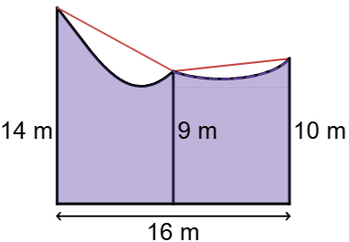  $$A≈\frac{h}{2}\left(d_{f}+d_{l}\right) \\ =\frac{8}{2}×\left(+9\right)+\frac{8}{2}×\left(9+\right) \\ ={\text{ m}}^{2}$$Convert 150 mm to m, $150÷=$  $$V={\text{ m}}^{2}× \\ V= {\text{m}}^{3}$$ | Example 2  The diagram shows an overhead view of a drinking trough that is $50 \text{cm}$ deep and is built on the side of a brick wall. Use 3 applications of the Trapezoidal rule to calculate the maximum capacity of the trough.  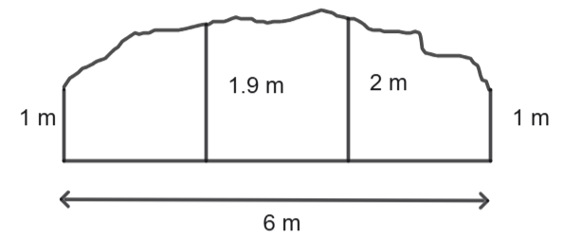
Things to remember | Example 3

Appendix B

Creek wall
The diagram shows the cross-section of a wall across a creek.
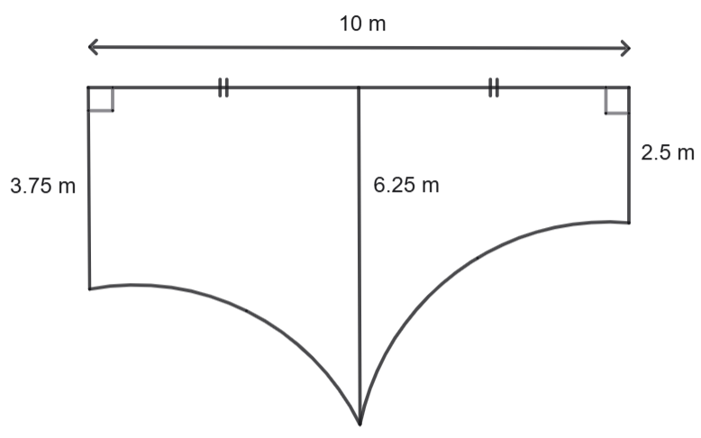
- Use 2 applications of the Trapezoidal rule to estimate the area of the cross-section of the wall.
- The wall has a uniform thickness of 750 mm. The weight of $1 {\text{m}}^{3}$ of concrete is 2.4 tonnes. How many tonnes of concrete are in the wall? Give the answer to 3 significant figures.
- When the builders ordered the concrete, they used the Trapezoidal rule to estimate the volume of concrete needed to build the wall. Explain why there would be leftover concrete after the wall was built.

Sample solutions

Activating prior knowledge – Trapezoidal rule
$$A≈\frac{90}{2}×\left(187+185\right)+\frac{90}{2}×\left(185+183\right) \\ =33 300 {\text{m}}^{2}$$

Reservoir
$$A≈\frac{400}{2}×\left(100+300\right)+\frac{400}{2}×\left(300+400\right) \\ =160 000 {\text{m}}^{2}$$
Convert 20 mm into metres, $20÷1000=0.02 \text{m}$
$$V=Ah \\ V=160 000×0.02 \\ V=3200 {\text{m}}^{3}$$
Therefore, the estimated amount of water in the reservoir is $3200 {\text{m}}^{\text{3}}$

Resin table
Front edge:
$$A≈\frac{40}{2}×\left(15+27\right)+\frac{40}{2}×\left(27+33\right) \\ =2040 {cm}^{2}$$
Back edge:
$$A≈\frac{40}{2}×\left(28+14\right)+\frac{40}{2}×\left(14+12\right)$$$=1360$ ${cm}^{2}$
Area of table:
$$A=80×50 \\ =4000 \text{c}{\text{m}}^{\text{2}}$$
Subtracting the area of wood from the area of the table:
$$\text{Area of resin}=\text{area of table - }\left(\text{front area + back area}\right) \\ =4000-\left(2040+1360\right) \\ =600 \text{c}{\text{m}}^{\text{2}}$$
$$V=600×4 \\ =2400 \text{c}{\text{m}}^{\text{3}}$$
The volume of resin is $2400 {\text{cm}}^{\text{3}}$.

Appendix A – Four quadrant notes
Example 1  The diagram shows the overhead outline of a garden. Use 2 applications of the Trapezoidal rule to estimate the volume of topsoil needed for the garden if the depth of the topsoil is 150 mm.  $$A≈\frac{h}{2}\left(d_{f}+d_{l}\right) \\ A=\frac{8}{2}×\left(14+9\right)+\frac{8}{2}×\left(9+10\right) \\ =168 {\text{m}}^{\text{2}}$$  Convert 150 mm to m, $150÷1000=0.15$  $$V=168 {\text{m}}^{2}×0.15 \\ V=25.2 {\text{m}}^{3}$$ | Example 2  The diagram shows an overhead view of a drinking trough that is $50 \text{cm}$ deep and is built on the side of a brick wall. Use 3 applications of the Trapezoidal rule to calculate the maximum capacity of the trough.  $$A≈\frac{h}{2}\left(d_{f}+d_{l}\right) \\ A=\frac{2}{2}×\left(1+1.9\right)+\frac{2}{2}×\left(1.9+2\right)+\frac{2}{2}×\left(2+1\right) \\ =9.8 {\text{m}}^{2} \\ V=9.8 {\text{m}}^{2}×0.5 \\ V=4.9 {\text{m}}^{3}$$Capacity is $4.9 \text{kL}$

Appendix B – creek wall
- $A≈\frac{5}{2}×\left(3.75+6.25\right)+\frac{5}{2}×\left(6.25+2.5\right)$
$$=46.875 {\text{m}}^{2}$$
- Convert 750 mm into metres, 750$÷1000=0.75 \text{m}$
$$V=\text{Ah} \\ V=46.875×0.75 \\ V=35.15625 {\text{m}}^{3}$$
The weight of the concrete is $35.15625×2.4=84.375 \text{tonnes}$
Therefore, the amount of concrete in the creek wall is $84.4 \text{tonnes}$ (correct to 3 significant figures).
- There would be leftover concrete because the Trapezoidal rule overestimates the area of the creek wall. When this overestimated area was used to calculate the volume, it resulted in more concrete being ordered than was needed, as shown in the diagram below.
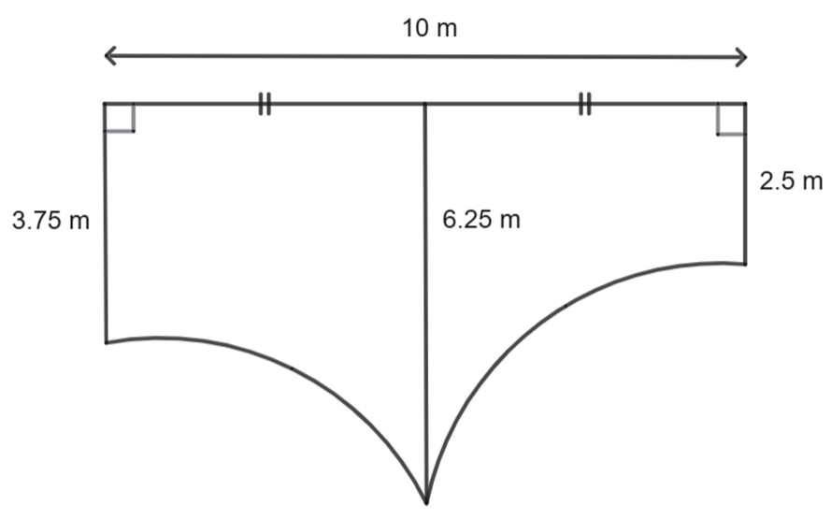
Excess area included
Excess area included

References
This resource contains NSW and syllabus content. The NSW Curriculum is developed by the NSW Education Standards Authority (NESA). This content is prepared by NESA for and on behalf of the Crown in right of the State of New South Wales. The material is protected by Crown copyright.
Please refer to the NESA Copyright Disclaimer for more information https://www.nsw.gov.au/education-and-training/nesa/copyright.
NESA holds the only official and up-to-date versions of the NSW Curriculum and syllabus documents. Please visit NESA https://www.nsw.gov.au/education-and-training/nesa and NSW Curriculum https://curriculum.nsw.edu.au.
Mathematics Standard 11–12 Syllabus © NSW Education Standards Authority (NESA) for and on behalf of the Crown in right of the State of New South Wales, 2024.
Numeracy Stage 6 (CEC) Syllabus © NSW Education Standards Authority (NESA) for and on behalf of the Crown in right of the State of New South Wales, 2021.

© State of New South Wales (Department of Education), 2026
The copyright material published in this resource is subject to the Copyright Act 1968 (Cth) and is owned by the NSW Department of Education or, where indicated, by a party other than the NSW Department of Education (third-party material).
Copyright material available in this resource and owned by the NSW Department of Education is licensed under a Creative Commons Attribution 4.0 International (CC BY 4.0) license.

This license allows you to share and adapt the material for any purpose, even commercially.
Attribution should be given to © State of New South Wales (Department of Education), 2026.
Material in this resource not available under a Creative Commons license:
- the NSW Department of Education logo, other logos and trademark-protected material
- material owned by a third party that has been reproduced with permission. You will need to obtain permission from the third party to reuse its material.
Links to third-party material and websites
Please note that the provided (reading/viewing material/list/links/texts) are a suggestion only and implies no endorsement, by the New South Wales Department of Education, of any author, publisher, or book title. School principals and teachers are best placed to assess the suitability of resources that would complement the curriculum and reflect the needs and interests of their students.
If you use the links provided in this document to access a third-party's website, you acknowledge that the terms of use, including licence terms set out on the third-party's website apply to the use which may be made of the materials on that third-party website or where permitted by the Copyright Act 1968 (Cth). The department accepts no responsibility for content on third-party websites.

