Surface area
Students calculate the surface area of prisms, cylinders and composite solids in the context of building and painting wooden items.

Learning intention
- To be able to solve problems involving calculating the surface area of prisms, cylinders and composite solids.

Success criteria
- I can calculate the surface area of prisms.
- I can calculate the surface area of cylinders.
- I can calculate the surface area of composite solids composed of prisms and cylinders.
- I can apply Pythagoras’ theorem to calculate an unknown length in a solid.

Outcomes
A student:
- develops understanding and fluency in mathematics through exploring and connecting mathematical concepts, choosing and applying mathematical techniques to solve problems, and communicating their thinking and reasoning coherently and clearly MAO-WM-01
- solves problems involving measurement in practical contexts MST-11-05

Associated numeracy outcomes
A student:
- recognises and applies functional numeracy concepts in practical situations, including personal and community, workplace and employment, and education and training contexts N6-1.1
- applies numerical reasoning and mathematical thinking to clarify, efficiently solve and communicate solutions to problems N6-1.2
- determines whether an estimate or an answer is reasonable in the context of a problem, evaluates results and communicates conclusions N6-1.3
- chooses and applies efficient strategies to analyse and solve everyday problems involving metric relationships, distance and length, area, volume, time, mass, capacity and temperature N6-2.2
Numeracy Stage 6 (CEC) Syllabus © NSW Education Standards Authority (NESA) for and on behalf of the Crown in right of the State of New South Wales, 2021.

Content

Applications of measurement

Perimeter, area and volume
- Solve practical problems involving the surface area of prisms, cylinders, spheres and composite solids in a variety of contexts
Mathematics Standard 11–12 Syllabus © NSW Education Standards Authority (NESA) for and on behalf of the Crown in right of the State of New South Wales, 2024.

Table 1: lesson summary
Section | Summary of activity | Teaching strategies | Teaching points
Activating prior knowledge | Students are shown a rectangular prism and 3 nets on slide 4 and asked to decide which is the net of the prism. They calculate the surface area of the prism and answer questions about their strategy. | Pose-Pause-Pounce-Bounce | Activate prior knowledge of calculating the surface area of a rectangular prism.
Connecting learning | A scenario is given for students to consider how to calculate surface area. Students complete Appendix A which includes questions involving different types of prisms. Students reflect on different strategies which could be used to calculate surface area. They complete Appendix B. | Pose-Pause-Pounce-Bounce  Assessing and advancing questions | Use real-world contexts to highlight that surface area depends on correctly identifying all exposed faces and dimensions. Emphasise delaying rounding until the final answer, as early rounding can accumulate errors.
Releasing responsibility | Students are asked to complete Appendix C and identify and discuss possible errors and misconceptions when calculating surface area. They are then given a problem on slide 6 which requires them to calculate the surface area and volume of a solid before and after the dimensions are doubled. | Visibly random groups of 3  Non-permanent vertical surfaces  Four quadrant notes  Same Surface, Different Deep  Pose-Pause-Pounce-Bounce | Identify possible errors that may be made when calculating surface area. Identify similarities and differences when calculating surface area and volume. Recognise that doubling dimensions does not result in doubling surface area and volume.
Independent practice | Students are reminded of the Approaching questions scaffold on slide 8 and are then asked to complete Appendix D. | Visibly random groups of 3  Vertical non-permanent surfaces | Consolidate understanding of calculations involving surface area by completing HSC style questions.

Activity structure
Please use the associated PowerPoint Surface area and volume to display images in this lesson.

Activating prior knowledge
- Display slide 4 and ask students to indicate, by holding up the relevant number of fingers in front of their chest, which of the nets would form the rectangular prism shown.
Explain to students that net 3 is the only one that forms the provided rectangular prism.
- Ask students to calculate the area of the net of the rectangular prism.
- Facilitate a class discussion of ideas and reasoning using the Pose-Pause-Pounce-Bounce questioning strategy (PDF 557 KB) (bit.ly/posepausepouncebounce). Useful question prompts may include:
- How did you know which net matched the prism?
- How did you decide which nets did not match the prism?
- How would you calculate the surface area of the prism?
- How is calculating the area of the net the same as calculating the surface area of the prism?

Connecting learning
- Read the following scenario to students:
Jess owns a small business building and decorating custom wood furniture. A customer has ordered a set of planter boxes, which are in the shape of open prisms with a $45 \text{cm}$ square base and height of $30 \text{cm}$, to be painted in a vibrant blue. Jess will need to paint the entire exterior surface. What area will need to be painted?
- Use the Pose-Pause-Pounce-Bounce questioning strategy to discuss how the surface area of the box would be calculated. Useful question prompts may include:
- How is the net of this shape different to the net of the previous rectangular prism on slide 4?
- Why would the shape of the planter box be called an open prism?
- How would you explain a strategy you could use to correctly calculate the surface area of the box?
- How might drawing the net of the box be useful?
- Tell students that Jess has received a few orders for planter boxes in different shapes and they are going to calculate the surface area of them. Distribute Appendix A ‘Planter boxes’ to pairs of students and ask them to complete it.
Explain to students that when considering paint for the planter boxes they are to assume that the base is also to be planted.
Students have previously solved problems involving the surface area of right prisms and cylinders in the Stage 5 Area and surface area A Core outcome MA5-ARE-C-01.
- Ask students assessing and advancing questions (bit.ly/supportingstrategies) to establish understanding and connect to new situations. Some suggestions are provided in the following table.
Table 2: assessing and advancing questions
Assessing questions | Advancing questions
Have you counted the number of sides in the shape? | How does counting the sides help with the calculations?
What strategy have you already tried? | Could you use your strategy for any shaped prism?
Can you see a pattern? | How would you describe the net of the prism?
What have you noticed about the shapes of the faces of the prism? | Does your answer seem reasonable?
How might making a list be useful? | Can you think of a different strategy that would also work?
- Use the Pose-Pause-Pounce-Bounce questioning strategy to facilitate discussion that identifies common errors, compares strategies, and deepens accuracy and reasoning in surface area calculations. Useful question prompts may include:
- What might be a common mistake made when calculating surface area?
- What is a useful strategy to support achieving a correct answer?
- Do you prefer using addition or subtraction methods for composite areas and why?
- What change would you make to your calculations if the prisms were closed?
- Why can rounding too early cause calculation errors, particularly when using $π$?
- Distribute a copy of Appendix B ‘Spot the mistake’ and ask students to work in pairs to answer the questions.
- Use the Pose-Pause-Pounce-Bounce questioning strategy to discuss the errors made and how they might be avoided. Useful question prompts may include:
- How can we ensure we use the correct values when answering a question?
- How can we ensure we include all surfaces of the shape when finding surface area?
- How can we set out our work to help us know what we have done in the solution?

Releasing responsibility
- Assign students to visibly random groups of 3 (bit.ly/visiblegroups) at vertical non-permanent surfaces (bit.ly/VNPSstrategy) and ask them to complete Four quadrant notes to their future forgetful selves (bit.ly/supportingstrategies) from Appendix C ‘Four quadrant notes’.
- Use the Pose-Pause-Pounce-Bounce questioning strategy to check for understanding of the methods used to calculate surface area of prisms and composite solids. A useful question prompt may include:
- What errors might someone make when calculating the surface area of prisms and composite solids?
Students may suggest that they don’t find the area of all the faces, particularly when the composite solid has many faces, or that rounding off intermediate calculations too early can lead to a final answer that is inaccurate.
- Display slide 6 from the PowerPoint, which has a Same Surface, Different Deep problem (bit.ly/S_S_D_D), and ask students to continue to work in their groups of 3 on their vertical non-permanent surfaces to answer the questions.
Figure 1: Same Surface, Different Deep problem
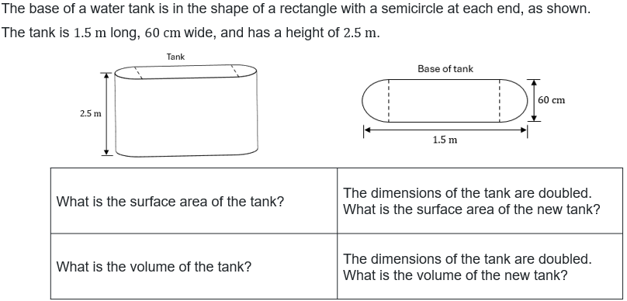
- Use the Pose-Pause-Pounce-Bounce questioning strategy to discuss the strategies used and how the doubling of dimensions impacted the surface area and volume. Useful question prompts may include:
- What was a useful strategy used to calculate the surface area and volume of the solid?
- Why might converting the dimensions to metres be useful for the calculations?
- What impact did doubling the dimensions have on the surface area and volume calculations?
Students might suggest that converting to metres makes the answers smaller and easier to understand. Student should recognise that doubling the dimensions did not result in doubling the original surface area and volume.

Independent practice
- Display slide 8 from the PowerPoint, reminding students of the Approaching questions scaffold.
- Continuing in their groups of 3 on vertical non-permanent surfaces, have students attempt the problems in Appendix D ‘HSC style questions’, before comparing solutions with a neighbouring group.

Assessment and differentiation

Suggested opportunities for differentiation
Activating prior knowledge
- Provide models of the nets for students who may struggle with visualising the solids formed by the nets.
Connecting learning
- Support student understanding by using colours in the solutions to represent the base and other sections of the solid.
- Encourage students to use different problem-solving strategies, for example, calculating individual face areas or combining faces to allow for varied approaches.
Releasing responsibility
- Students may benefit from drawing the net of the water tank to ensure the area of all faces has been calculated.
- Students could be extended to consider what might happen to the surface area and volume if the dimensions were halved, rather than doubled.
Independent practice
- Provide problems of varying difficulty, including HSC style questions that range from straightforward surface area calculations to problems involving composite solids.
- Suggest that students draw nets and break down complex solids into simpler shapes, tailored to their level of confidence.

Suggested opportunities for assessment
Activating prior knowledge
- Assess students’ ability to identify the correct net for a rectangular prism and their reasoning for calculating the area of the net.
- Collect or observe calculations to check fluency with area computation and spatial reasoning.
Connecting learning
- While students calculate the surface area of planter boxes, observe their reasoning, communication and use of geometric concepts.
- Use responses during the Pose-Pause-Pounce-Bounce questioning strategy to assess depth of understanding on concepts such as open prisms, nets, applying Pythagoras for hypotenuse, or composite shapes.
- Monitor students’ verbal explanations to determine conceptual clarity, especially on the differences between solutions, for example, Jess compared to Lachlan’s strategies.
Releasing responsibility
- Monitor the Four quadrant notes to assess students’ reflective understanding, ability to summarise key concepts and ability to identify common errors for future reference.
Independent practice
- Use students’ responses to the problems to formally assess procedural fluency and problem-solving applied to surface areas of prisms and composite solids.
- Observe or collect evidence of how students apply scaffolding strategies to approach complex problems.

Appendix A

Planter boxes
- A customer has ordered a set of planter boxes, which are in the shape of open rectangular prisms with a $45 \text{cm}$ square base and height of $30 \text{cm}$, to be painted in a vibrant blue. Jess will need to paint the entire exterior surface.
What area will need to be painted?
- Jess has received an order for a planter box for placement in a corner in the shape of an open right-angled triangular prism.
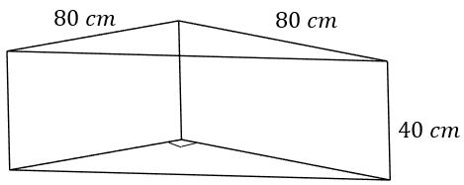
Calculate the surface area of the planter box.

- A planter box in an L-shape was ordered.
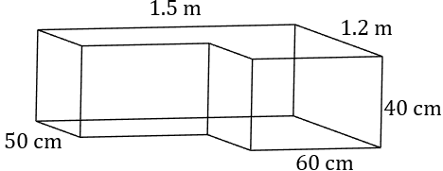
Jess asked an employee, Lachlan, to calculate the surface area. When Lachlan showed his calculations to Jess, she found he had used a different strategy to the one she would have used.
Lachlan’s strategy:
$$A=\text{area} \text{of} \text{base} \text{+} \text{area} \text{of} \text{vertical} \text{faces} \\ =(150×120-70×90)+\left(2×120+2×150\right)×40 \\ =33 300 {\text{cm}}^{2}$$
Jess’s strategy:
$$A=\text{area} \text{of} \text{base} \text{+} \text{area} \text{of} \text{vertical} \text{faces} \\ =(150×50+70×60)+(150×40+120×40+60×40+70×40+90×40+50×40) \\ =33 300 {\text{cm}}^{\text{2}}$$
- Explain why Lachlan used subtraction and Jess has used addition to calculate the area of the base.
- Describe the strategy Lachlan has used to calculate the area of the vertical faces.
- Outline the advantages of each solution.

- A customer has ordered a wooden storage chest with a lid.
Jess needs to calculate the surface area of the chest.
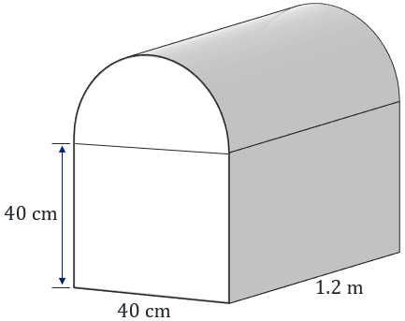
- How would you describe the shape of the box and lid?
- How can Jess calculate the area of the curved surface?
- Calculate the surface area of the wooden chest.

Appendix B

Spot the mistake
Identify the mistakes in the solutions, explaining what the mistake is and showing the correct working.
Solid | Calculation | Explain the error | Correct working
Calculate the surface area of the water trough.  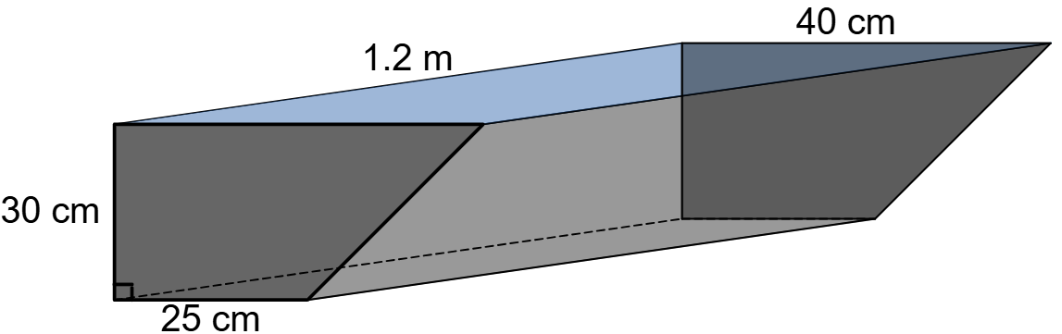  Image created using Desmos and is licensed under the Desmos Terms of Service. | Length of sloped edge:  $$d^{2}={15}^{2}+{30}^{2} \\ =1125$$  $$d=\sqrt{1125} \\ =33.541$$  Area of ends:  $$A=2×\frac{30}{2}\left(25+40\right) \\ =1950 {\text{cm}}^{2}$$  Area of rectangles:  $$A=1.2×25+1.2×30+1.2×33.541 \\ =106.2492 {\text{cm}}^{2}$$  Total surface area:  $$A=1950+106.2492 \\ =2056.2492 {\text{cm}}^{2}$$  Surface area is $2056.2 {\text{cm}}^{\text{2}}$.
Calculate the surface area of the wood used for a rolling pin, which has plastic handles.  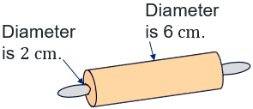 | Area of ends:  $$A=2\left(π×6^{2}-π×2^{2}\right) \\ =201.0619… {\text{cm}}^{2}$$  Area of curved surface:  $$A=2×π×6×30 \\ =1130.9733…{c\text{m}}^{2}$$  Total surface area:  $$A=201.0619…+1130.9733… \\ =1332.0352…{\text{cm}}^{2}$$  Surface area is $1332 {\text{cm}}^{\text{2}}$.
Calculate the exterior surface area of a toy chest with a half cylinder lid.  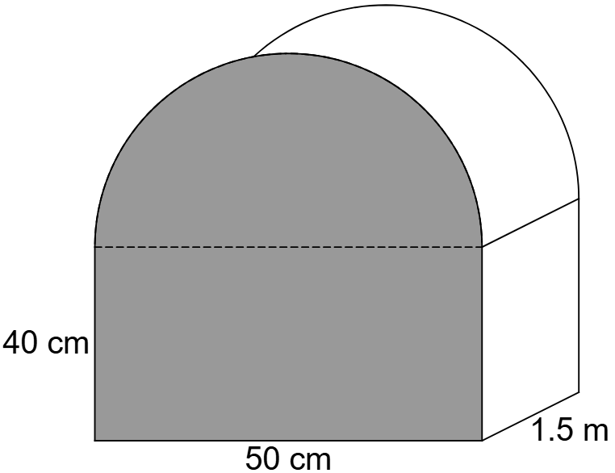 | Area of cross-section:  $$A=40×50+\frac{1}{2}×π×{25}^{2} \\ =2981.7477… {\text{cm}}^{\text{2}}$$  Surface area:  $$A=2981.7×150 \\ =447262.155… {\text{cm}}^{2}$$  Surface area is $447 262 {\text{cm}}^{2}$.

Appendix C

Four quadrant notes
Example 1  Calculate the surface area of the solid.  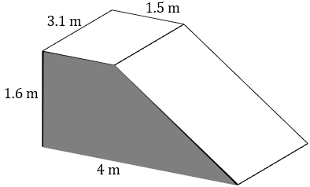  Length of slope:  $$d^{2}={\boxed{}}^{2}+{\boxed{}}^{2} \\ =8.81$$  $$d=\sqrt{8.81} \\ =2.968…$$  Area of trapeziums:  $$A=2×\frac{\boxed{}}{2}×\left(\boxed{}+\boxed{}\right) \\ =\boxed{}{\text{m}}^{2}$$  Area of rectangles:  $$A=3.1×\boxed{}+3.1×\boxed{}+3.1×\boxed{}+3.1×\boxed{} \\ =\boxed{}{\text{cm}}^{2}$$  Total surface area:  $$A=\boxed{}+\boxed{} \\ =\boxed{} {\text{m}}^{2}$$  The surface area is $\boxed{}{\text{ m}}^{2}$. | Example 2  Calculate the surface area of the solid.  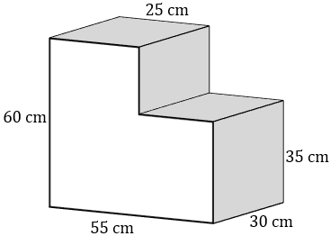
Things to remember | Example 3

Appendix D

HSC style questions
- A composite solid is shown. The top section is a cylinder with a height of $9 \text{cm}$ and a diameter of $10 \text{cm}$. The bottom section is a rectangular prism with a height of $8 \text{cm}$, a length of $15 \text{cm}$ and a breadth of $12\text{ cm}$.
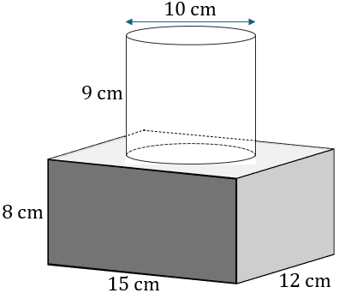
Find the total surface area of the composite solid in ${\text{cm}}^{\text{2}}$, correct to 1 decimal place.
- A composite solid consists of a triangular prism which fits exactly on top of a cube, as shown.
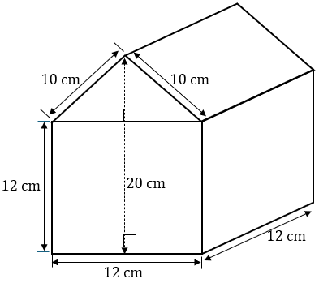
Find the surface area of the composite solid.
- A right-angled triangular prism has a surface area of $600 {\text{cm}}^{\text{2}}$. The triangular cross-section has a base length of $12\text{ cm}$ and a height of $5 \text{cm}$, as shown.
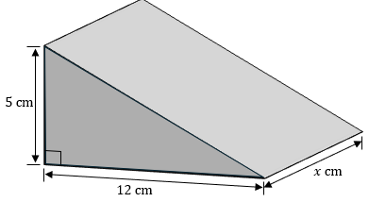
What is the length, $x$, between the 2 triangular ends of the prism?

Sample solutions

Appendix A – planter boxes

$$A=\text{area of base} + \text{area of 4 vertical sides} \\ =\left(45×45\right)+\left(4×45×30\right) \\ =7425 {cm}^{2}$$

Calculate the length of the long side:
$$l^{2}={80}^{2}+{80}^{2} \\ =12 800 \\ \text{l}=\sqrt{12 800} \\ =113.137... cm$$
$$A=\text{area of triangle base}+\text{area of 3 vertical sides} \\ =\left(\frac{1}{2}×80×80\right)+\left(2×80×40+113.137…×40\right) \\ =14 125.4834 {cm}^{2}$$
The surface area of the box is $14 125.5 {cm}^{2}$.

- Explain why Lachlan has used subtraction and Jess has used addition to calculate the area of the base.
Lachlan has used the dimensions of the longer sides to find the area of the large rectangle and has then subtracted the missing section.
Jess has divided the shape into 2 rectangles and has added the area of each rectangle to find the total area.
- Describe the strategy Lachlan has used to calculate the area of the vertical faces.
Lachlan has recognised that all the vertical faces have a length of $40$cm. He has added the different lengths of all the rectangles together and multiplied by $40$cm to find the total area of the vertical sides.
- Outline the advantages of each solution.
Lachlan’s strategy is very concise, but it could be confusing.
Jess’s strategy has more writing, but it is systematic and can be checked very easily.

- The box is a rectangular prism. The lid is half of a cylinder.
- Jess can picture the curved surface as a rectangle. The length of the rectangle is $1.2 \text{m}$ and the breadth of the rectangle is half the circumference of the cylinder.
- $A=2×area of cross section+area of rectangle sides and base+area of curved surface$ $=(2×40×40+2×\frac{1}{2}×π×{20}^{2})+(3×120×40)+(\frac{1}{2}×2×π×20×120)$ $=26 396.45943... {\text{cm}}^{2}$
The surface area of the chest is $26 396.5 {\text{cm}}^{\text{2}}$.

Appendix B – spot the mistake
Solid | Calculation | Explain the error | Correct working
Calculate the surface area of the water trough. | Length of sloped edge:  $$d^{2}={15}^{2}+{30}^{2} \\ =1125$$  $$d=\sqrt{1125} \\ =33.541$$  Area of ends:  $$A=2×\frac{30}{2}\left(25+40\right) \\ =1950 {\text{cm}}^{\text{2}}$$  Area of rectangles:  $$A=1.2×25+1.2×30+1.2×33.541 \\ =106.2492 {\text{cm}}^{\text{2}}$$  Total surface area:  $$A=1950+106.2492 \\ =2056.2492 {\text{cm}}^{\text{2}}$$  Surface area is $2056.2 {\text{cm}}^{\text{2}}$. | Used the incorrect value of $1.2$, forgetting to convert $1.2$ metres to $120$ centimetres. | Length of sloped edge:  $$d^{2}={15}^{2}+{30}^{2} \\ =1125$$  $$d=\sqrt{1125} \\ =33.541$$  Area of ends:  $$A=2×\frac{30}{2}\left(25+40\right) \\ =1950 {\text{cm}}^{\text{2}}$$  Area of rectangles:  $$A=120\left(30+25+33.541\right) \\ =10 624.92 {\text{cm}}^{\text{2}}$$  Total surface area:  $$A=1950+10 624.92 \\ =12 574.92 {\text{cm}}^{\text{2}}$$  Surface area is $12574.9 {\text{cm}}^{\text{2}}$.
Calculate the surface area of the wood used for a rolling pin, which has plastic handles. | Area of ends:  $$A=2\left(π×6^{2}-π×2^{2}\right) \\ =201.0619… {\text{cm}}^{\text{2}}$$  Area of curved surface:  $$A=2×π×6×30 \\ =1130.9733…{\text{cm}}^{\text{2}}$$  Total surface area:  $$A=201.0619…+1130.9733… \\ =1332.0352…{\text{cm}}^{\text{2}}$$  Surface area is $1332 {\text{cm}}^{\text{2}}$. | Incorrectly used the diameters for the end circles. Should have used the radii instead in all calculations. | Area of ends:  $$A=2\left(π×3^{2}-π×1^{2}\right) \\ =50.26548… {\text{cm}}^{\text{2}}$$  Area of curved surface:  $$A=2×π×3×30 \\ =565.4866776…{\text{cm}}^{\text{2}}$$  Total surface area:  $$A=50.26548…+565.4866776… \\ =615.75…{\text{cm}}^{\text{2}}$$  Surface area is $615.8 {\text{cm}}^{\text{2}}$.
Calculate the exterior surface area of a toy chest with a half cylinder lid. | Area of cross-section:  $$A=40×50+\frac{1}{2}×π×{25}^{2} \\ =2981.7477… {\text{cm}}^{\text{2}}$$  Surface area:  $$A=2981.7×150 \\ =447 262.1556… {\text{cm}}^{\text{2}}$$  Surface area is $447 262 {\text{cm}}^{\text{2}}$. | Incorrectly found the volume instead of the surface area. | Area of ends:  $$A=2\left(40×50+\frac{1}{2}×π×{25}^{2}\right) \\ =5963.495…{\text{cm}}^{\text{2}}$$  Area of remaining rectangles:  $$A=150×50+2×150×40 \\ =19 500 {\text{cm}}^{\text{2}}$$  Area of curved surface:  $$A=\frac{1}{2}×2×π×25×150 \\ =11 780.972…{\text{cm}}^{\text{2}}$$  Total area:  $$A=5963.495+19500+11780.972 \\ =37 244.467…{\text{cm}}^{\text{2}}$$  Surface area is $37 244.5 {\text{cm}}^{\text{2}}$.

Appendix C – Four quadrant notes
Example 1  Calculate the surface area of the solid.  Length of slope:  $$d^{2}={\boxed{2.5}}^{2}+{\boxed{1.6}}^{2} \\ =8.81$$  $$d=\sqrt{8.81} \\ =2.968…$$  Area of trapeziums:  $$A=2×\frac{\boxed{1.6}}{2}×\left(\boxed{1.5}+\boxed{4}\right) \\ =\boxed{8.8} {\text{m}}^{2}$$  Area of rectangles:  $$A=3.1×\boxed{1.5}+3.1×\boxed{1.6}+3.1×\boxed{4}+3.1×\boxed{2.968} \\ =\boxed{31.2108…}{\text{m}}^{2}$$  Total surface area:  $$A=\boxed{8.8}+\boxed{31.2108…} \\ =\boxed{40.0108…} {\text{m}}^{2}$$  The surface area is $\boxed{40}{ \text{m}}^{2}$. | Example 2  Calculate the surface area of the solid.  Front and back:  $$A=2\left(60×55-25×30\right) \\ =5100 {\text{cm}}^{2}$$  Top and bottom:  $$A=2\left(55×30\right) \\ =3300 {\text{cm}}^{2}$$  Left and right:  $$A=2\left(30×60\right) \\ =3600 {\text{cm}}^{\text{2}}$$  Total surface area:  $$A=5100+3300+3600 \\ =12 000 {\text{cm}}^{\text{2}}$$  The surface area is $12 000 {\text{cm}}^{2}$.

Releasing responsibility – Same Surface, Different Deep
Surface area | Area of top and bottom: circle and rectangle  $$A=2×(π×{0.3}^{2}+0.6×0.9) \\ =1.645… {\text{m}}^{2}$$  Area of vertical surface: cylinder and 2 rectangles  $$A=(2×π×0.3×2.5)+2×\left(0.9×2.5\right) \\ =9.212… {\text{m}}^{2}$$  Total surface area:  $$A=1.645+9.212 \\ =10.8578…{\text{m}}^{2}$$  The surface area is $10.9 {\text{m}}^{\text{2}}$.
Surface area, doubled dimensions | Area of top and bottom: circle and rectangle  $$A=2×(π×{0.6}^{2}+1.2×1.8) \\ =6.581… {\text{m}}^{\text{2}}$$  Area of vertical surface: cylinder and 2 rectangles  $$A=(2×π×0.6×5)+2×\left(1.8×5\right) \\ =36.849…{\text{m}}^{\text{2}}$$  Total surface area:  $$A=6.581+36.849 \\ =43.43 {\text{m}}^{\text{2}}$$  The surface area when dimensions are doubled is $43.4 {\text{m}}^{\text{2}}$.
Volume | Volume of cylinder:  $$V=π×{0.3}^{2}×2.5 \\ =0.706… {\text{m}}^{\text{3}}$$  Volume of middle: rectangular prism  $$V=0.9×0.6×2.5 \\ =1.35{\text{ m}}^{\text{3}}$$  Total volume:  $$V=0.706+1.35 \\ =2.056{ \text{m}}^{3}$$  The volume is $2.1 {\text{m}}^{3}$.
Volume, doubled dimensions | Volume of cylinder:  $$V=π×{0.6}^{2}×5 \\ =5.654… {\text{m}}^{\text{3}}$$  Volume of middle: rectangular prism  $$V=1.8×1.2×5 \\ =10.8{ \text{m}}^{3}$$  Total volume:  $$V=5.654+10.8 \\ =16.454{… \text{m}}^{3}$$  The volume when dimensions are doubled is $16.45 {\text{m}}^{\text{3}}$.

Appendix D – HSC style questions
- Surface area base and sides of rectangular prism:
$$A=2×8×15+2×8×12+12×15 \\ =612 {\text{cm}}^{\text{2}}$$
Area of the top of the prism:
$$A=15×12-π×5^{2} \\ =101.46…\text{c}{\text{m}}^{\text{2}}$$
Area of curved surface and top circle:
$$A=2×π×5×9+π×5^{2} \\ =361.283…{\text{cm}}^{\text{2}}$$
Total surface area:
$$A=612+101.46…+361.283… \\ =1074.743…{\text{cm}}^{\text{2}}$$
The total surface area is $1074.7 {\text{cm}}^{\text{2}}$.
Alternatively:
Surface area of rectangular prism (including the circle that has ‘popped up’):
$$A=2×8×15+2×8×12+2×12×15 \\ =792 {\text{cm}}^{\text{2}}$$
Area of curved surface of ‘pop up’ cylinder:
$$A=2×π×5×9 \\ =282.74333…{\text{cm}}^{\text{2}}$$
Total surface area:
$$A=792+282.743… \\ =1074.743…{\text{cm}}^{\text{2}}$$
The total surface area is $1074.7{\text{ cm}}^{\text{2}}$.
- Height of triangle:
$$h^{2}={10}^{2}-6^{2} \\ =64 \\ h=\sqrt{64} \\ =8 \text{cm}$$
Area of front and back:
$$A=2\left(12×12+\frac{1}{2}×12×8\right) \\ =384 {\text{cm}}^{\text{2}}$$
Area of rectangular faces:
$$A=3×12×12+2×12×10 \\ =672 {\text{cm}}^{\text{2}}$$
Total surface area:
$$A=384+672 \\ =1056{ \text{cm}}^{2}$$
The surface area is $1056{cm}^{2}$.
- Length of hypotenuse:
$$d^{2}=5^{2}+{12}^{2} \\ =169 \\ d=\sqrt{169} \\ =13$$

Area of front and back triangles:
$$A=2\left(\frac{1}{2}×12×5\right) \\ =60 {\text{cm}}^{2}$$
Area of rectangles:
$$A=13×x+12×x+5×x \\ =30x {\text{cm}}^{\text{2}}$$
Total surface area:
$$A=30x+60$$
Substitute $A=600$:
$$600=30x+60 \\ 30x=540 \\ x=\frac{540}{30} \\ =18 \text{cm}$$
The length between the triangles is $18 \text{cm}$.

References
This resource contains NSW and syllabus content. The NSW Curriculum is developed by the NSW Education Standards Authority (NESA). This content is prepared by NESA for and on behalf of the Crown in right of the State of New South Wales. The material is protected by Crown copyright.
Please refer to the NESA Copyright Disclaimer for more information https://www.nsw.gov.au/education-and-training/nesa/copyright.
NESA holds the only official and up-to-date versions of the NSW Curriculum and syllabus documents. Please visit NESA https://www.nsw.gov.au/education-and-training/nesa and NSW Curriculum https://curriculum.nsw.edu.au.
Mathematics Standard 11–12 Syllabus © NSW Education Standards Authority (NESA) for and on behalf of the Crown in right of the State of New South Wales, 2024.
Numeracy Stage 6 (CEC) Syllabus © NSW Education Standards Authority (NESA) for and on behalf of the Crown in right of the State of New South Wales, 2021.

© State of New South Wales (Department of Education), 2026
The copyright material published in this resource is subject to the Copyright Act 1968 (Cath) and is owned by the NSW Department of Education or, where indicated, by a party other than the NSW Department of Education (third-party material).
Copyright material available in this resource and owned by the NSW Department of Education is licensed under a Creative Commons Attribution 4.0 International (CC BY 4.0) license.

This license allows you to share and adapt the material for any purpose, even commercially.
Attribution should be given to © State of New South Wales (Department of Education), 2026.
Material in this resource not available under a Creative Commons license:
- the NSW Department of Education logo, other logos and trademark-protected material
- material owned by a third party that has been reproduced with permission. You will need to obtain permission from the third party to reuse its material.
Links to third-party material and websites
Please note that the provided (reading/viewing material/list/links/texts) are a suggestion only and implies no endorsement, by the New South Wales Department of Education, of any author, publisher, or book title. School principals and teachers are best placed to assess the suitability of resources that would complement the curriculum and reflect the needs and interests of their students.
If you use the links provided in this document to access a third-party's website, you acknowledge that the terms of use, including licence terms set out on the third-party's website apply to the use which may be made of the materials on that third-party website or where permitted by the Copyright Act 1968 (Cth). The department accepts no responsibility for content on third-party websites.

