Volume
Students deepen their understanding of volume and capacity by examining how each is calculated. Students investigate pools, calculating their volume and capacity.
Students will need at least one digital device per pair to interact with websites during this lesson.

Learning intentions
- To be able to calculate the volume and capacity of prisms, cylinders and composite solids.

Success criteria
- I can calculate the volume and capacity of prisms and cylinders.
- I can convert between units of volume and capacity.
- I can calculate the volume and capacity of composite solids composed of prisms and cylinders.

Outcomes
A student:
- develops understanding and fluency in mathematics through exploring and connecting mathematical concepts, choosing and applying mathematical techniques to solve problems, and communicating their thinking and reasoning coherently and clearly MAO-WM-01
- selects and applies algebraic techniques to solve problems involving equations and formulas MST-11-01
- solves problems involving measurement in practical contexts MST-11-05

Associated numeracy outcomes
A student:
- recognises and applies functional numeracy concepts in practical situations, including personal and community, workplace and employment, and education and training contexts N6-1.1
- applies numerical reasoning and mathematical thinking to clarify, efficiently solve and communicate solutions to problems N6-1.2
- determines whether an estimate or an answer is reasonable in the context of a problem, evaluates results and communicates conclusions N6-1.3
- chooses and applies efficient strategies to analyse and solve everyday problems involving metric relationships, distance and length, area, volume, time, mass, capacity and temperature N6-2.2
- chooses and applies appropriate numeracy operations and techniques to analyse and resolve everyday situations N6-2.6
Numeracy Stage 6 (CEC) Syllabus © NSW Education Standards Authority (NESA) for and on behalf of the Crown in right of the State of New South Wales, 2021.

Content

Formulas and equations
- Substitute numbers into linear and non-linear algebraic expressions, equations and formulas
- Evaluate the subject of a formula, given the value of other pronumerals in the formula
- Apply given formulas to solve problems in a variety of contexts

Applications of measurement

Practicalities of measurement
- Identify and convert between the metric units of length: millimetres (mm), centimetres (cm), metres (m) and kilometres (km)
- Identify and convert between units of volume and capacity, using $1 cm^{3}=1 mL$, $1{ m}^{3}=1000 L=1 kL$ and $1000 kL=1 ML$

Perimeter, area and volume
- Solve practical problems involving volume and capacity of prisms, cylinders, spheres, cones, pyramids and composite solids in a variety of contexts
Mathematics Standard 11–12 Syllabus © NSW Education Standards Authority (NESA) for and on behalf of the Crown in right of the State of New South Wales, 2024.

Table 1: lesson summary
Section | Summary of activity | Teaching strategies | Teaching points
Activating prior knowledge | Students complete the activity in Appendix A to recall properties of prisms and pyramids. They then summarise the key ideas and address misconceptions in a class discussion. | Visibly random groups of 3  Vertical non-permanent surfaces  Gallery walk  Pose-Pause-Pounce-Bounce | Students revise volume using justifying and reasoning statements.
Connecting learning | Students consider the shapes of pools and how their volume might be calculated, using a website (bit.ly/poolvolume). Slide 4 of the PowerPoint Volume prompts students to consider the name of a prism by considering pool designs. Students refer to the NESA Mathematics Standard 1 and 2 – HSC reference sheet to locate conversions for capacity. Slide 5 is used to remind students of the conversion from $\text{c}{\text{m}}^{\text{3}}$ to $\text{mL}$. Students are asked how the volume of a prism is calculated before completing Appendix B and comparing solutions. Slides 6–7 provide a scenario to support understanding of the difference between volume and capacity. | Pose-Pause-Pounce-Bounce  Think-Pair-Share | Students use real-world applications to deepen understanding of volume and capacity calculations of prisms, clarifying the distinction between volume and capacity.
Releasing responsibility | Students complete Appendix C. Slide 9 prompts students to consider errors that may be made when calculating the volume of a triangular prism. Students then make notes on volume and capacity. | Notes to their future forgetful selves  Pose-Pause-Pounce-Bounce | Students develop a deeper understanding of volume and capacity by analysing common mistakes, recognising misconceptions and practising correct solutions.
Independent practice | Students use slide 11 to review the ‘Approaching questions scaffold’, before completing Appendix D. |  | Students consolidate understanding of volume and capacity calculations by applying the skills to complex, real-world problems and HSC style questions.

Activity structure
Please use the associated PowerPoint Volume to display images in this lesson.

Activating prior knowledge
- Assign students to visibly random groups of 3 (bit.ly/visiblegroups) to work at vertical non-permanent surfaces (VNPS) (bit.ly/VNPSstrategy).
- Distribute a set of cards to each group from Appendix A ‘Always, sometimes, never’ and adhesive putty. Ask groups to decide whether each statement is always true, sometimes true or never true. Students are to write the headings ‘always true’, ‘sometimes true’ and ‘never true’ on the VNPS and use the adhesive putty to arrange the cards under the heading that reflects their decision.
You may wish to cut up the set of cards before the lesson.
- As students post each card, they should explain and justify their decision to their group members.
- Students complete a gallery walk (bit.ly/DLSgallerywalk) of other groups’ boards, noting similarities and differences. Ask students to return to their own board and consider whether to change any of their classifications.
- Facilitate a class discussion of ideas and reasoning using the Pose-Pause-Pounce-Bounce questioning strategy (PDF 557KB) (bit.ly/posepausepouncebounce). After posing each question, allow a wait time for deeper thinking. Useful question prompts may include:
- Why doesn’t $V=lbh$ always work?
- Is a pyramid ever a prism?
- Why can a height sometimes be horizontal?
These questions are a guide only. It is recommended that teachers select questions based on the needs of the students in their class.

Connecting learning
- In pairs, ask students to discuss different pool shapes they have seen.
- Distribute a device to each pair and ask students to navigate to the website ‘Swimming Pool Volume Calculator’ (bit.ly/poolvolume).
- Students should consider the size of pools with different dimensions and discuss how they might calculate the volume of different pool shapes by adjusting the ‘Pool shape’ in the drop-down menu.
- Encourage students to enter a variety of dimensions in the boxes for each of the pool shapes to notice how the volume of a pool changes depending on the values used for length, width and depth.
- Instruct students to scroll down the page to the heading How to Calculate Swimming Pool Volume?
- Ask students to read the explanation of the calculations for each pool shape and discuss with their partner whether the calculation methods are effective.
Highlight that:
- halving the length and width of the circular/oval pools finds the radius, which corresponds to the cylinder formula
- the kidney-shaped pool uses addition, which resembles the Trapezoidal rule.
Students were introduced to the Trapezoidal rule in Lesson 5 – irregularly shaped blocks of land and Trapezoidal rule in this unit.
- Use a class discussion to consider if the method used to calculate the volume of the kidney-shaped pool would result in an underestimation or an overestimation.
Students should be encouraged to explain their reasoning of why they believe there would be an underestimation or overestimation.
Students may suggest that there will be an overestimation because the kidney shape dips in between the lengths B and C. Alternatively, they may suggest that there will be an underestimation because the formula uses a value of 0.45 instead of 0.5 and because the pool has rounded edges, unlike a trapezium.
- Use the Pose-Pause-Pounce-Bounce questioning strategy to compare the website’s methods with the formula $V=Ah$. Useful question prompts may include:
- How would you describe the strategies used on the website?
- Why is using the formula $V=Ah$ an effective way to calculate the volume of a prism?
Students should recognise that the website suggests finding the area of the top of the pool and then, using the average depth to make the pool resemble a prism, multiplying the area by the depth.
The formula suggests that volume represents layers of the same area to make a three-dimensional shape. To calculate the volume of a prism, the area of the cross-section is found and then it is multiplied by the height of the prism, which is the depth of the pool in this scenario.
The strategy used by the website is the same as using the formula.
- Display slide 4 from the PowerPoint, which contains 3 images of different pool shapes.
- Read the following scenario aloud to students.
Dan plans to sell and install fibreglass pools. He has 3 designs for customers to choose from. He has decided to name the pools by their shape but isn’t sure what to call one of the pools.
What name should he use for the third pool?
- Use the Pose-Pause-Pounce-Bounce questioning strategy to identify suitable names for the third pool, based on the view. Useful question prompts may include:
- What type of prism is the pool?
- Once the pool is in the ground, what shape can be seen?
While the upward-facing side of the pool is a rectangle, the shape of the pool is a trapezoidal prism.
- Read the following scenario aloud to students.
Dan decides to call the third pool a rectangular pool, because that is the shape the customers can see when the pool is in the ground.
When advertising the pools, Dan needs to inform potential customers of the capacity of the pools.
- Ask students to review their copy of the NESA Mathematics Standard 1 and 2 – HSC reference sheet. Have them locate the conversions for capacity on the sheet.
- Display slide 5 and use the Pose-Pause-Pounce-Bounce questioning strategy to ensure students understand how this information can be used to convert between volume and capacity. Useful question prompts may include:
- How would we convert cubic centimetres into millilitres?
- How would we convert litres to cubic metres?
- What do you think $\text{kL}$ and $\text{ML}$ stand for?
- What do you think a gigalitre is?
- How do the images support our understanding of the conversions?
Students can convert cubic centimetres into millilitres by changing the unit.
There are multiple ways to convert litres to cubic metres; one way is to divide the number of litres by 1000.
The $\text{kL}$ stands for ‘kilolitre’ and $\text{ML}$ stands for ‘megalitre’. For reference, swimming pools can be measured in kilolitres while dams are often measured in megalitres. Warragamba Dam holds just over $2 000 000 \text{ML}$.
A gigalitre ($\text{GL}$) is $1000 \text{ML}$. Keepit Dam (a major concrete dam on the Namoi River in NSW) holds approximately $419 \text{GL}$.
- Animate the slide to reveal 2 conversion problems and use a Think-Pair-Share (bit.ly/thinkpairsharestrategy) for students to answer them.
- Animate the slide again to reveal the solutions.
- Explain to students that they will now be calculating both the volume and the capacity of given pools. Distribute Appendix B ‘Pool measurements’ to each pair and ask students to work together to complete the questions.
At this stage, students assume the volume and capacity of the pool are equal. This assumption is later refined by recognising that wall and floor thickness means the volume of the excavation exceeds the pool’s capacity.
Volume is the amount of space occupied by an object (NESA 2024). Capacity often refers to the amount a container can hold. It is often used in relation to the volume of fluids (NESA 2024). Volume is the amount of space the pool takes up in the ground, while capacity is the amount of water that will fill it.
Students previously studied capacity in the Volume A Core outcome MA5-VOL-C-01. Revision of these skills can be found in Lesson 9 – deep dive of Stage 5 Unit 3 – prisms and cylinders.
- Once completed, students compare their solutions with a neighbouring pair. Solutions have been provided.
- Initiate a class discussion encouraging students to reflect on whether the pool’s volume and capacity would really be equal in a real-world context.
- Display slide 6, which contains a diagram of a hole dug for a pool and the following scenario.
Angus was excited when the excavator dug the hole for his new concrete pool.
He measured the hole and determined how much dirt had been excavated.
- Ask students to calculate the volume of dirt removed, then animate the slide to reveal the solution.
- Display slide 7 to reveal the next part of the scenario:
Angus used the measurements he’d taken, $V=89.5 {\text{m}}^{\text{3}},$ to place an order for a water tanker to fill the pool.
But as the tanker finished filling the pool, Angus discovered he’d ordered too much water.
How much water (in litres) did Angus order and why does this exceed the pool’s true capacity?
- Use a Think-Pair-Share to discuss the question.
Students should calculate that Angus ordered $89 500 \text{kL}$. They may recognise that Angus had forgotten to consider the thickness of the concrete walls.
- Animate the slide to reveal a new diagram, showing the pool and the concrete walls. In a Think-Pair-Share, have students calculate the internal dimensions of the pool, given the pool’s concrete thickness is $0.1 \text{m}$.
- Animate the slide to show the internal dimensions of the pool and the second question for students to answer in their pairs.
- Animate the slide to reveal the solution and use the Pose-Pause-Pounce-Bounce questioning strategy to check for understanding of the difference between volume and capacity. Useful question prompts may include:
- How would you explain what we are measuring when we are measuring volume?
- How would you explain what we are measuring when we are measuring capacity?
- How would you explain the difference between the volume of water in a pool and the capacity of a pool?
Students may discuss that the diagram shows that water does not fill right up to the top of the pool’s surface and that Angus had ordered an extra $9500 \text{L}$.

Releasing responsibility
- Distribute Appendix C ‘Spot the mistakes’ activity. In pairs, students identify and correct the errors in the sample volume and capacity calculations.
Students correct the errors arising from common misconceptions, such as confusing volume and capacity and using the additive principle instead of multiplicative principle.
- Have pairs compare their corrected solutions with a neighbouring group. After discussion, they may refine their answers.
- Display slide 9 which shows a triangular prism. Use the Pose-Pause-Pounce-Bounce questioning strategy to assess students’ understanding of how to calculate the volume of a triangular prism. A useful question prompt may include:
- What errors might someone make when calculating the volume of a triangular prism?
Students may suggest that someone may use incorrect dimensions. For example, they may confuse the height of the triangle with the slant height or the height of the prism.
- Students are to create notes to their future forgetful selves (bit.ly/notestofutureself) on how to calculate the volume of a prism and cylinder and how to convert units of measurement to capacity.
Students may find it useful to also annotate their HSC reference sheet to further support their understanding of the formulas and conversions included.

Independent practice
- Use slide 11 to activate prior knowledge of the ‘Approaching questions’ scaffold for students.
- Distribute Appendix D ‘HSC style questions’ for students to work on individually.
- Students compare their answers with a neighbour and give feedback on calculations.
- Students refine their ideas based on the feedback.

Assessment and differentiation

Suggested opportunities for differentiation
Activating prior knowledge
- Teachers circulate to clarify vocabulary or concepts if needed while working on Appendix A task.
- Teachers could suggest sentence starters like ‘I think this statement is always true because …’
- Teacher could supply visual aids or concrete models of solids to support students.
Connecting learning
- If students are unfamiliar with different pools, for example, they may have only seen the local council pool, you may wish to provide support by showing pictures of different-shaped pools from a website.
- Challenge students by discussing why the website included 0.45 in their formula.
- Challenge students to investigate how the volume of the circular pool would change if the dimensions were doubled.
Releasing responsibility
- Students may benefit from discussing each of the misconceptions in Appendix C.
Independent practice
- Support students with worked examples or a printed visual aid if they are struggling to calculate volume.

Suggested opportunities for assessment
Activating prior knowledge
- Take note of any misconceptions that arise from the Pose-Pause-Pounce-Bounce questioning.
Connecting learning
- Collect Appendix B as evidence of learning.
Releasing responsibility
- Collect responses to Appendix C as evidence of learning.
- Monitor student notes and annotated reference sheets to assess understanding.
- Monitor student responses when identifying potential errors to check for understanding of how to calculate the volume of prisms.
Independent practice
- Collect responses to Appendix D as evidence of learning.

Appendix A

Always, sometimes, never
The front and back faces of a prism are joined by squares.
The cross-section of a triangular prism is an equilateral triangle.
A pyramid is a type of prism.
The sides joining the front and back faces of a prism are perpendicular to the faces.
The volume of a prism is the same numerical value as its capacity.
The sides joining the front and back faces of a triangular prism are triangles.
The volume of a prism is $V=lbh$.
A prism can have curved edges.
The cross-section of a prism is the same shape but can be different sizes.
The volume of a prism is $A=2(lb+lh+bh)$.
The volume of a composite prism is the same as adding the separate volumes.
The volume increases when the height of a prism is increased.
The volume of a cylinder is $V=πr^{2}h$.

Appendix B

Pool measurements
Dan constructs fibreglass pools and has completed the designs below, which display the measurements of the pools for customers. Calculate the volume of water in each pool and the capacity of each pool.
Pool shape | Circular pool | Rectangular pool | Octagon pool
Pool design | 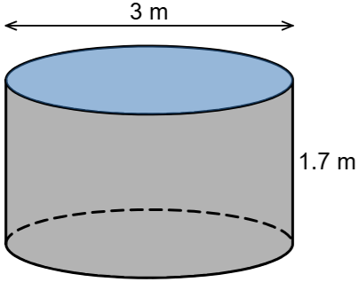  Image created using Desmos and is licensed under the Desmos Terms of Service. | 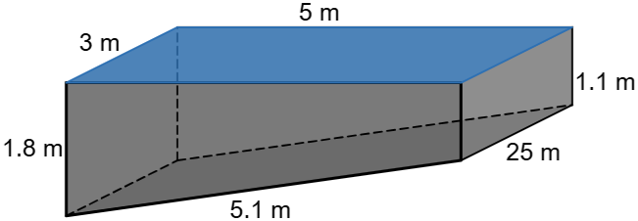  Image created using Desmos and is licensed under the Desmos Terms of Service. | 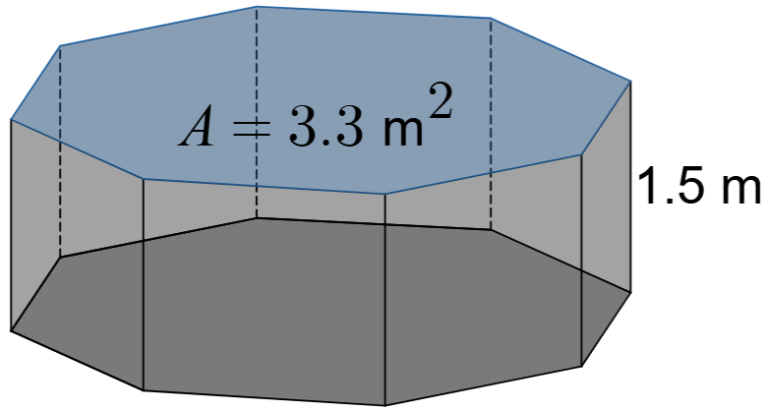  Image created using Desmos and is licensed under the Desmos Terms of Service.
Volume of water
Capacity of pool

Appendix C

Spot the mistakes
Identify the mistakes in each question below, explaining what the error is and showing the correct working.
Solid | Calculation | Explain the error | Correct working
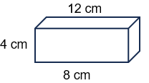  A tackle box | $$V=12+8+4 \\ =24 \text{c}{\text{m}}^{\text{3}}$$  The volume is $24 \text{c}{\text{m}}^{\text{3}}$.
A sewing box  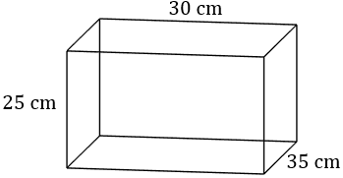 | $$V=2×(25×30+30×35+35×25) \\ =5350 \text{c}{\text{m}}^{\text{2}}$$  The volume is $5 350 \text{c}{\text{m}}^{\text{2}}$.
A water trough  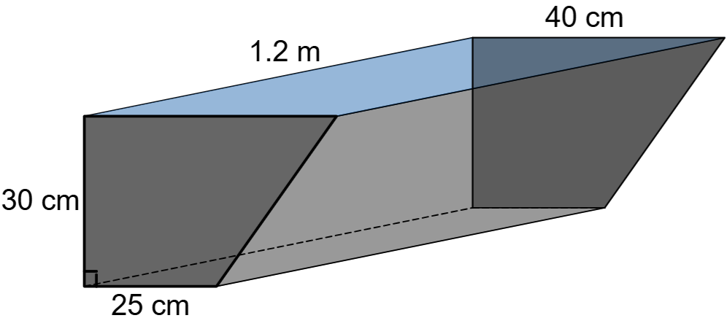  Image created using Desmos and is licensed under the Desmos Terms of Service. | Area of cross-section  $$A=\frac{30}{2}\left(25+40\right) \\ =975 {\text{cm}}^{\text{2}}$$  Volume of trough  $$V=975×120 \\ =117 000 {\text{cm}}^{\text{3}}$$  Capacity  $$117 00 {cm}^{3}=117 000÷100 \\ =1170\text{ L}$$  Capacity of trough is $1170 \text{L}$.
A lean-to shelter  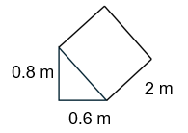 | $$V=2×0.8×0.6 \\ =0.96 {\text{m}}^{\text{3}}$$  The volume is $0.96 {\text{m}}^{\text{3}}$.
Chocolate bar, an equilateral triangular prism with sides of $5 \text{cm}$  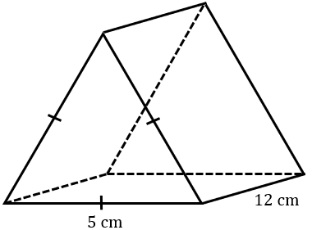 | $$V=\frac{1}{2}×5×5×12 \\ =150$$Volume is $150 \text{c}{\text{m}}^{\text{3}}$.
A toy chest with a half cylinder lid  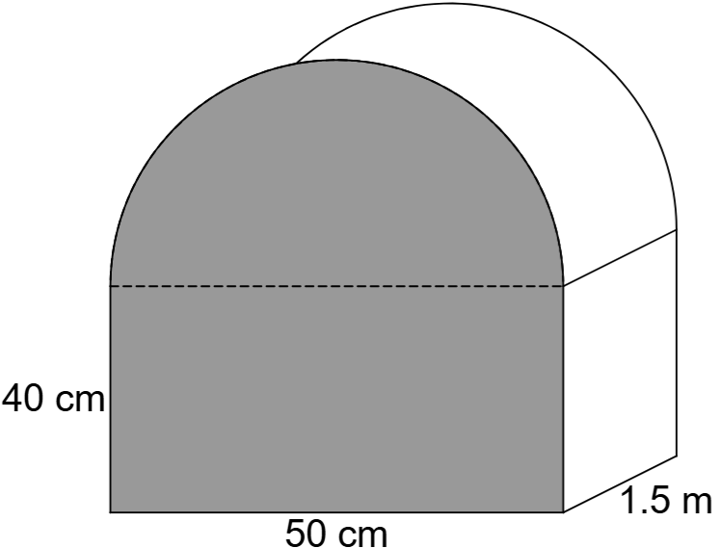 | Area of cross-section  $$A=40×50+\frac{1}{2}×π×{25}^{2} \\ =2981.7477… {\text{cm}}^{\text{2}}$$  Volume  $$V=2981.7477×1.5 \\ =4472.62155… {\text{cm}}^{\text{3}}$$  Volume is $4472.6 cm^{3}$.
Concrete bollard  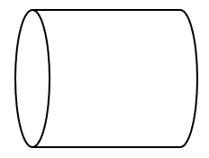  d =$15 \text{cm}$, length = $1 \text{m}$ | $$V=π×{15}^{2}×100 \\ =70 685.83… \text{c}{\text{m}}^{\text{3}}$$  Volume is $70 686 \text{c}{\text{m}}^{\text{3}}$.
Cement pipe  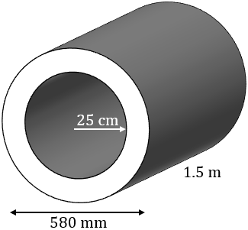 | Area of end  $$A=π×{29}^{2}-π×{25}^{2} \\ =678.58401…{\text{cm}}^{2}$$  Capacity  $$V=678.58401…×1.5 \\ =1017.87602… {\text{cm}}^{3} \\ =1017.876÷1000 \text{L} \\ =1.017876 \text{L}$$  Capacity is $1 \text{L}$.

Appendix D

HSC style questions
- A shaker toy for a toddler in the shape of a right triangular prism is filled with spheres.
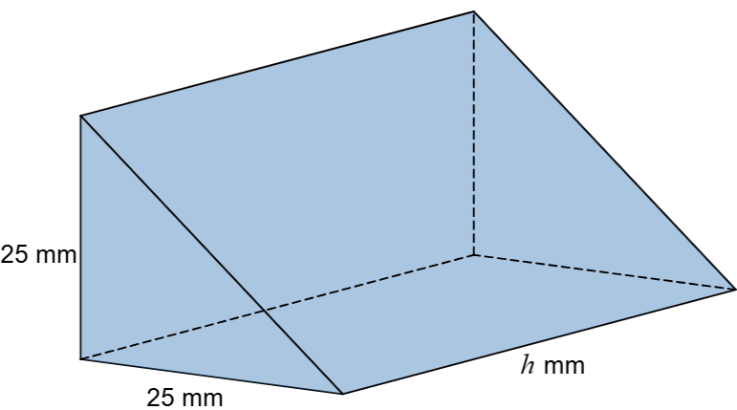
Image created using Desmos and is licensed under the Desmos Terms of Service
The base and perpendicular height of the triangular base of the prism are both $25 \text{mm}$. The height of the prism is $h \text{mm}$.
The shaker contains 40 spheres each with a volume of $55 \text{m}{\text{m}}^{\text{3}}$. The amount of empty space in the shaker is $1237.5 \text{m}{\text{m}}^{\text{3}}$.
What is the height of the triangular prism? Give your answer to the nearest $\text{mm}$.
- A pool slide with a step, as shown below, is manufactured using foam.
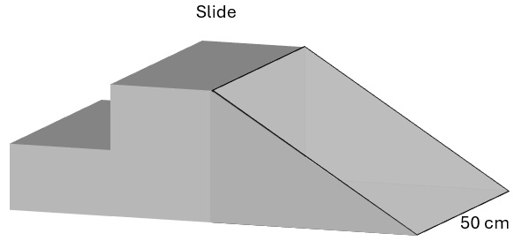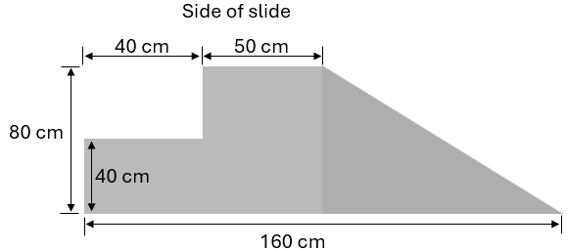
Calculate the volume of foam needed to make the slide.

Sample solutions

Appendix A – always, sometimes, never
S | The front and back faces of a prism are joined by squares.
S | The cross-section of a triangular prism is an equilateral triangle.
N | A pyramid is a type of prism.
S | The sides joining the front and back faces of a prism are perpendicular to the faces.
A | The volume of a prism is the same numerical value as its capacity.
N | The sides joining the front and back faces of a triangular prism are triangles.
S | The volume of a prism is $V=lbh$.
N | A prism can have curved edges.
N | The cross-section of a prism is the same shape but can be different sizes.
N | The volume of a prism is $V=2(lb+lh+bh)$.
A | The volume of a composite prism is the same as adding the separate volumes.
S | The volume increases when the height of a prism is increased.
A | The volume of a cylinder is $V=πr^{2}h$.

Appendix B – pool measurements
Pool design
Volume of water and capacity of pool | $$V=π×{1.5}^{2}×1.7 \\ =12.016… {\text{m}}^{\text{3}} \\ C=12.01659…×1000 \\ =12 017 \text{L (nearest litre)}$$ | $$V=\frac{5}{2}×\left(1.8+1.1\right)×3 \\ =21.75 {\text{m}}^{\text{3}} \\ C=21.75×1000 \\ =21 750 \text{L}$$ | $$V=3.3×1.5 \\ =4.95 {\text{m}}^{\text{3}} \\ C=4.95×1000 \\ =4950 \text{L}$$

Appendix C – spot the mistakes
Solid | Calculation | Explain the error | Correct working
A tackle box | $$V=12+8+4 \\ =24 \text{c}{\text{m}}^{\text{3}}$$  The volume is $24 \text{c}{\text{m}}^{\text{3}}$. | To find the volume the measurements should have been multiplied, not added. | $$V=12×8×4 \\ =384 \text{c}{\text{m}}^{\text{3}}$$  The volume is $384 \text{c}{\text{m}}^{\text{3}}$.
A sewing box | $$V=2×(25×30+30×35+35×25) \\ =5350 \text{c}{\text{m}}^{\text{2}}$$  The volume is $5350 \text{c}{\text{m}}^{\text{2}}$. | They have calculated the surface area, not the volume. | $$V=25×30×35 \\ =26 250 \text{c}{\text{m}}^{\text{3}}$$  The volume is $26 250 \text{c}{\text{m}}^{\text{3}}$.
A water trough | Area of cross-section  $$A=\frac{30}{2}\left(25+40\right) \\ =975 {\text{cm}}^{\text{2}}$$  Volume of trough  $$V=975×120 \\ =117 000 {\text{cm}}^{\text{3}}$$  Capacity  $$117 000 {\text{cm}}^{3}=117 000÷100 \\ =1170 \text{L}$$  Capacity of trough is $1170 \text{L}$. | The conversion from volume to capacity is incorrect.  $1 {cm}^{3}=1 \text{mL}$  and $1 \text{L}=1000 \text{mL}$. | Area of cross-section  $$A=\frac{30}{2}\left(25+40\right) \\ =975 {\text{cm}}^{\text{2}}$$  Volume of trough  $$V=975×120 \\ =117 000 {\text{cm}}^{\text{3}}$$  Capacity  $$117 000 {cm}^{3}=117 000 \text{mL} \\ =117 000÷1000 \\ =117 \text{litres}$$
A lean-to shelter | $$V=2×0.8×0.6 \\ =0.96 {\text{m}}^{\text{3}}$$  The volume is $0.96 {\text{m}}^{\text{3}}$. | The cross-section is a triangle. The working shows an incorrect formula. The correct formula for the area of a triangle is $A=\frac{1}{2}bh$. | $$V=\frac{1}{2}×0.8×0.6×2 \\ =0.48 {\text{m}}^{\text{3}}$$  The volume is $0.48 {\text{m}}^{\text{3}}$.
Chocolate bar, an equilateral triangular prism with sides of $5 \text{cm}$ | $$V=\frac{1}{2}×5×5×12 \\ =150$$Volume is $150 \text{c}{\text{m}}^{\text{3}}$. | This calculation needs the height of the triangle to use the formula $A=\frac{1}{2}bh$as the area of the base. | Height of the triangle  $$h=\sqrt{5^{2}-2.5^{2}} \\ =4.33…$$  $$V=\frac{1}{2}×5×4.33…×12 \\ =129.90.....$$Volume is $130 \text{c}{\text{m}}^{\text{3}}$.
A toy chest with a half cylinder lid | Area of cross-section  $$A=40×50+\frac{1}{2}×π×{25}^{2} \\ =2981.7477… {\text{cm}}^{\text{2}}$$  Volume  $$V=2981.7477×1.5 \\ =4472.62155…$$Volume is $4472.6 cm^{3}$. | The depth of the toy chest is $1.5 \text{m}$ and needs to be in $\text{cm}$. | Area of cross-section  $$A=40×50+\frac{1}{2}×π×{25}^{2} \\ =2981.7477… {\text{cm}}^{\text{2}}$$  Volume  $$V=2981.7477×150 \\ =447 262.155…$$  Volume is $447 262.2 {cm}^{3}$.
Concrete bollard  d=15 cm, length = 1 m | $$V=π×{15}^{2}×100 \\ =70 685.83… \text{c}{\text{m}}^{\text{3}}$$  Volume is $70 686 \text{c}{\text{m}}^{\text{3}}$. | Should have used the length of the radius, not the diameter. | $$V=π×{7.5}^{2}×100 \\ =17 671.459… \text{c}{\text{m}}^{\text{3}}$$  Volume is $17 671.5 \text{c}{\text{m}}^{\text{3}}$.
Cement pipe | Area of end  $$A=π×{29}^{2}-π×{25}^{2} \\ =678.58401…{\text{cm}}^{2}$$  Capacity  $$V=678.58401…×1.5 \\ =1017.87602… {\text{cm}}^{3} \\ =1017.876÷1000 \text{L} \\ =1.017876\text{ L}$$  Capacity is $1 \text{L}$. | The volume is correctly calculated, but it is then converted to capacity. However, the thickness of the pipe is not an internal measurement, so it is not the capacity of the pipe. | Area of end  $$A=π×{29}^{2}-π×{25}^{2} \\ =678.58401…{\text{cm}}^{2}$$  Volume  $$V=678.58401…×1.5 \\ =1017.87602… {\text{cm}}^{3}$$  Capacity is $1 \text{L}$.

Appendix D – HSC style questions
- Volume of the triangular prism
$$V=\frac{1}{2}×25×25×h \\ =312.5h \text{m}{\text{m}}^{\text{3}}$$Volume of the 40 spheres
$$V=40×55 \\ =2200 \text{m}{\text{m}}^{\text{3}}$$
Volume of empty space
$$V=1237.5 \text{m}{\text{m}}^{\text{3}}$$
Total volume of prism
$$V=2200+1237.5 \\ =3437.5 \text{m}{\text{m}}^{\text{3}}$$
Height of prism
$$3437.5=312.5h \\ h=11$$$∴$ Height of prism is $11 \text{mm}$.
- Volume of foam:
$$V=\left(40×40+80×50+\frac{1}{2}×70×80\right)×50 \\ =420 000 {\text{cm}}^{\text{3}}$$

References
This resource contains NSW Curriculum and syllabus content. The NSW Curriculum is developed by the NSW Education Standards Authority (NESA). This content is prepared by NESA for and on behalf of the Crown in right of the State of New South Wales. The material is protected by Crown copyright.
Please refer to the NESA Copyright Disclaimer for more information https://www.nsw.gov.au/education-and-training/nesa/copyright.
NESA holds the only official and up-to-date versions of the NSW Curriculum and syllabus documents. Please visit NESA https://www.nsw.gov.au/education-and-training/nesa and NSW Curriculum https://curriculum.nsw.edu.au.
Mathematics Standard 11–12 Syllabus © NSW Education Standards Authority (NESA) for and on behalf of the Crown in right of the State of New South Wales, 2024.
Numeracy Stage 6 (CEC) Syllabus © NSW Education Standards Authority (NESA) for and on behalf of the Crown in right of the State of New South Wales, 2021.
© State of New South Wales (Department of Education), 2026
The copyright material published in this resource is subject to the Copyright Act 1968 (Cath) and is owned by the NSW Department of Education or, where indicated, by a party other than the NSW Department of Education (third-party material).
Copyright material available in this resource and owned by the NSW Department of Education is licensed under a Creative Commons Attribution 4.0 International (CC BY 4.0) license.

This license allows you to share and adapt the material for any purpose, even commercially.
Attribution should be given to © State of New South Wales (Department of Education), 2026.
Material in this resource not available under a Creative Commons license:
- the NSW Department of Education logo, other logos and trademark-protected material
- material owned by a third party that has been reproduced with permission. You will need to obtain permission from the third party to reuse its material.
Links to third-party material and websites
Please note that the provided (reading/viewing material/list/links/texts) are a suggestion only and implies no endorsement, by the New South Wales Department of Education, of any author, publisher, or book title. School principals and teachers are best placed to assess the suitability of resources that would complement the curriculum and reflect the needs and interests of their students.
If you use the links provided in this document to access a third-party's website, you acknowledge that the terms of use, including licence terms set out on the third-party's website apply to the use which may be made of the materials on that third-party website or where permitted by the Copyright Act 1968 (Cth). The department accepts no responsibility for content on third-party websites.

