Composite area
Students apply their knowledge of area to solve real-world problems involving the area of composite shapes.

Learning intention
- To be able to calculate the area of composite shapes.

Success criteria
- I can identify the plane shapes that make up a composite shape.
- I can explain when to add or subtract the areas of plane shapes to calculate the area of a composite shape.

Outcomes
A student:
- develops understanding and fluency in mathematics through exploring and connecting mathematical concepts, choosing and applying mathematical techniques to solve problems, and communicating their thinking and reasoning coherently and clearly MAO-WM-01
- selects and applies algebraic techniques to solve problems involving equations and formulas MST-11-01
- solves problems involving measurement in practical contexts MST-11-05

Associated numeracy outcomes
A student:
- recognises and applies functional numeracy concepts in practical situations, including personal and community, workplace and employment, and education and training contexts N6-1.1
- applies numerical reasoning and mathematical thinking to clarify, efficiently solve and communicate solutions to problems N6-1.2
- chooses and applies appropriate operations with whole numbers, familiar fractions and decimals, percentages, rates and ratios to analyse and solve everyday problems N6-2.1
- chooses and applies efficient strategies to analyse and solve everyday problems involving metric relationships, distance and length, area, volume, time, mass, capacity and temperature N6-2.2
- chooses and applies efficient strategies to analyse and solve everyday problems involving money and finance N6-2.4
- chooses and applies efficient strategies to analyse and solve everyday problems involving location, space and design N6-2.5
- chooses and applies appropriate numeracy operations and techniques to analyse and resolve everyday situations N6-2.6
Numeracy Stage 6 (CEC) Syllabus © NSW Education Standards Authority (NESA) for and on behalf of the Crown in right of the State of New South Wales, 2021.

Content

Formulas and equations
- Substitute numbers into linear and non-linear algebraic expressions, equations and formulas
- Evaluate the subject of a formula, given the value of other pronumerals in the formula
- Apply given formulas to solve problems in a variety of contexts

Applications of measurement

Perimeter, area and volume
- Solve practical problems requiring the calculation of perimeters and areas of triangles, rectangles, parallelograms, trapeziums, circles, sectors of circles and composite shapes in a variety of contexts
- Apply Pythagoras’ theorem to solve problems involving right-angled triangles
Mathematics Standard 11–12 Syllabus © NSW Education Standards Authority (NESA) for and on behalf of the Crown in right of the State of New South Wales, 2024.

Table 1: lesson summary
Section | Summary of activity | Teaching strategies | Teaching points
Retrieval practice | Display slide 4 of the PowerPoint Composite area for students to find the area of circles and sectors. Students to use NESA’s Mathematics Standard 1 and 2 – HSC reference sheet. | Mini whiteboards | Students revise the area of circles and sectors given different measurements and discuss more efficient strategies when multiple ways are possible.
Activating prior knowledge | Display slide 6 of the PowerPoint to choose an appropriate measuring device for making clothes and its level of accuracy. Distribute Appendix A for students to dissect a T-shirt into composite shapes to find the area and the amount and cost of material to make it. | Think-Pair-Share | Students identify plane shapes that make up a composite shape. Students can dissect into smaller shapes to get a more accurate area measurement.
Connecting learning | Students sketch a skirt pattern and find the amount of material to make it, using composite shapes. Students discuss different strategies to find the area of composite shapes. Display slide 8 for students to calculate the area and material needed for a quarter circle skirt design. Display slide 9 to explain to students what a seam is. | Visibly random groups of 3  Vertical non-permanent surfaces  Gallery walk  Oops I forgot | Students choose plane shapes to make a composite shape and find its area. Students discuss strategies for either adding or subtracting the area of shapes to find the area of the composite shape. Students find the area of composite shapes involving circles and sectors.
Releasing responsibility | Distribute Appendix B so that each of the 6 questions is at a separate station around the room for groups to rotate through to find the areas of different composite shapes. Provide each group with 6 blank sheets of paper. | Notes to their future forgetful selves | Students solve a variety of composite shape area questions using more than one strategy. Students write notes on when it’s best to add or subtract the areas of composite shapes.
Independent practice | Students work independently to complete the NRICH activity ‘Quadrature of the lunes’ (bit.ly/Quadrature_Lunes). | Mini whiteboards | Students apply knowledge of Pythagoras’ theorem and the area of circles and sectors.

Activity structure
Please use the associated PowerPoint Composite area to display images in this lesson.

Retrieval practice
- Distribute mini whiteboards (bit.ly/miniwhiteboards) to each student.
- Students are to review their copy of the NESA Mathematics Standard 1 and 2 – HSC reference sheet to locate any relevant formulas that would help them to find the area of circles and sectors.
Students should be able to locate the formula for the area of a sector, which they can reference throughout the lesson.
- Display slide 4 of the PowerPoint. This slide contains a total of 5 images for students to calculate the area, allowing them to check their understanding of finding the area of circles and sectors.
- Click to animate each new image. Provide students with time to answer each question, asking them to explain how they found the area of each shape to a shoulder partner and then show their answers on their mini whiteboards.
Students should be familiar with calculating the area of circles and sectors from the Stage 4 Area outcome MA4-ARE-C-01. If students require further revision, teachers can refer to Lesson 6 – area of a circle and Lesson 7 – area of a sector of Stage 4 Unit 15 – exploring circles.
Solutions to slide 4 in animation order are: 2827.43 ${mm}^{2}$, 78.54 ${cm}^{2}$, 24.89 $m^{2}$, 211.18 ${mm}^{2}$ and 50.27 ${cm}^{2}$ (radius is 4 cm).
- Click to show a further animation on slide 4 which asks students to show another way of finding the area of the sector.
Some possible alternatives could include students finding the area of a quarter of a circle first and then multiplying their answer by 3 or students choosing to show the fraction of the circle as $\frac{270}{360}$ instead of $\frac{3}{4}$ in their area calculation.
- Conduct a class discussion by asking students which method was easier: finding the area of the sector of three-quarters of the circle or first finding the area of a circle and then subtracting the area of a quadrant.
Students should realise that in this case, finding the area of the three-quarter sector is more efficient and there is less chance of making calculation errors.

Activating prior knowledge
- Display slide 6 of the PowerPoint. In a Think-Pair-Share (bit.ly/thinkpairsharestrategy), ask students:
- Which measuring device would you use for making clothes. Explain your choice.
- What is the level of accuracy of the measuring devices?
- Would you use centimetres or millimetres when making clothing?
Students should select option B – sewing tape or measuring tape and explain that the tape needs to be flexible to measure around parts of the body. The measuring tape has metric and imperial measurements on either side.
Explain to students that the measuring tape on the metric side can be measured accurately to the nearest millimetre and the imperial side to an eighth of an inch (the inch is the smallest unit and smaller than this is represented as fractions of it).
Students should be able to draw on their experiences, even from online shopping, that most measurements for clothing are given in centimetres and that millimetres may be used when a greater degree of accuracy is required. Examples may include precise sleeve lengths and better fits around curves such as shoulders (darting or pleating).
- Explain to students that even though body measurements are taken in centimetres, buying fabric uses a combination of centimetres and metres. The width of the roll of fabric is often given in centimetres or metres and the length of fabric you need to buy is advertised in cost per metre.
Teachers may choose to show examples of buying fabric from relevant websites.
- Distribute Appendix A ‘Area of a T-shirt’ to pairs of students.
- Using the measurements provided on the front and back views of the T-shirt, ask students to estimate the amount of fabric needed to make the shirt.
Encourage students to dissect the shirt into a variety of shapes. While students are undertaking the activity, take note of different strategies you would like to highlight in the upcoming class discussion.
Students could use the trapezoidal rule or a semicircle to calculate the area of the sleeves more accurately.
- Advise students that it costs $12 per metre for plain 148 cm wide jersey fabric. Ask pairs to calculate how much it will cost to make the shirt.
As the fabric is 148 cm wide, this will fit both the front and back of the shirt side by side (sleeves cannot fit across, as this means the sleeve would have 2 seams). The length of the shirt is 75 cm, plus you will need an extra 20 cm for the sleeves, which can also fit side by side on the fabric. Round the total length of fabric to 1 m to allow for cutting between pieces and seams. Total cost is $12 for 1 metre. The sample solution in Appendix A shows a layout of the pieces on the fabric.
- Conduct a class discussion to check for understanding, to see if students arrived at similar costings and to share the strategy they used to find the area of the shirt.

Connecting learning
- By working in visibly random groups of 3 (bit.ly/visiblegroups) at vertical non-permanent surfaces (bit.ly/VNPSstrategy), challenge students to create a sketch of a skirt pattern for one person in their group to wear. Students will have to approximate the amount of material they need. Justifying it using calculations.
The reference to a skirt pattern is to encourage students to incorporate multiple shapes.
If students choose a sarong or a kilt, encourage them to complete a second design that incorporates different shapes or to enhance the sarong by adding features such as a curved edge.
Alternatively, teachers could provide students with measuring tapes, butchers paper and sticky tape for students to make the physical pattern. Teachers can show this infographic (bit.ly/Skirt_types) on different skirt types to provide students with ideas.
- Students are to do a gallery walk (bit.ly/DLSgallerywalk) of each other’s skirt patterns, noting the common shapes used and how the amount of material was calculated.
While students are undertaking the gallery walk, teachers are to take notes of groups’ strategies for the following class discussion, such as adding areas of shapes or subtracting areas of shapes, depending on the skirt design. This is also an opportunity to check students’ understanding of area formulas.
- Conduct a class discussion to allow different groups to explain their reasoning for why they decided to use their chosen strategy to find the area of the shapes used to make their skirt patterns.
- Display slide 8 of the PowerPoint showing a quarter circle skirt pattern traced onto a rectangular piece of fabric, along with images showing the fraction of the circle and what the skirt would look like when finished. Explain that the dotted lines are where the fabric will be cut. Ask groups to calculate the area of fabric for the skirt.
Area is $\left(\frac{1}{4}×π×{110}^{2}\right)-\left(\frac{1}{4}×π×{55}^{2}\right)=7127.49 {cm}^{2}.$
- Announce to students, ‘Oops I forgot, we also need to cut some material for a waistband’ (bit.ly/OIFstrategy). Ask groups to calculate the area of fabric for a rectangular waistband that measures 87 cm long and 8 cm wide.
Area is $87×8=696 {cm}^{2}.$
- Now that they have all the skirt pattern measurements, ask groups to calculate the unknown length of fabric that they would need to buy, which minimises the number of seams.
- Display slide 9 to help explain to students that a seam is the space between the sewing line and the cutting line of the fabric. The width of a seam can vary and usually ranges from 1 cm to 1.5 cm.
Students should consider values around 120 cm (1.2 m) to allow space for cutting between the skirt hem and the waistband (110 cm + 8 cm) and to reduce cost, not paying for more material than is needed.

Releasing responsibility
- Print and distribute Appendix B ‘Area of composite shapes station questions’ so that one question is at each of the 6 stations around the room.
- Assign students to 6 equal random groups. Place each group at a starting station.
- Provide each group with 6 blank sheets of paper, one for each station question. Students will write down their solutions and place them on the teacher’s desk.
Make sure students write the question number at the top of each page. Students will need to complete a minimum of 3 station questions to provide enough opportunity to compare and look at alternative strategies.
- Once groups have completed the station questions, the teacher will place the completed solutions at the relevant station question.
- Groups are to rotate back through at least 3 of the station questions they have completed to see if they can find an alternative method for solving each question. If they cannot, they should explain and justify why.
- Students are to create notes to their future forgetful selves (bit.ly/notestofutureself) on when it is best to add or subtract the areas of composite shapes by using 2 of the station questions as examples.

Independent practice
- Display the NRICH activity ‘Quadrature of the lunes’ (bit.ly/Quadrature_Lunes).
- Students are to work independently, either in their workbooks or using mini whiteboards, to respond to the question.
Teachers can choose if they would like students to attempt to construct the quadrature.
Sample student solutions can be found on the Student Solutions tab of the NRICH activity; however, the second question uses content students have not covered in Stage 5 Core outcomes. Students can use right-angled trigonometry to find the angle at C and then use the base angles of an isosceles triangle and the angle sum of a triangle to find other relevant angles.

Assessment and differentiation

Suggested opportunities for differentiation
Retrieval practice
- Teachers can provide further practice on finding the area of a circle if students require support.
- Teachers can use this as an opportunity to provide interleaving practice by including finding the circumference of some of the circles.
- Students could be extended to thinking about when units of measurement are not whole numbers, when it is best to convert diameter to radius or leaving calculations as divided by 2 in the formula.
Activating prior knowledge
- Students may require more background information to engage with the context of sewing clothes.
- Teachers can bring in the physical measuring devices for students to get a better sense of how they work.
- The activity can be extended by providing other clothing patterns that can be dissected into more complex shapes.
- Students might be asked to add a pocket to the front of the T-shirt.
Connecting learning
- The skirt design can be an opportunity to include a local context, such as students from different cultural backgrounds sharing their designs.
- Students can be supported by providing a more hands-on experience using butchers paper and measuring tapes.
- Students can be challenged to create a skirt design that incorporates 3 or more different shapes.
- In calculating the amount of fabric for the quarter circle skirt pattern, students could consider ways to adjust the pattern to reduce the amount of fabric needed. Such as splitting the quarter up into more sections, requiring more sewing due to more seams.
- Students could further investigate the percentage wastage of material.
- Students could be extended with the quarter circle skirt pattern by providing a what-if question, ‘What if the waistband was elasticised and could stretch out by another 10 cm? What would the new measurements be?’
Releasing responsibility
- The number and types of questions provided at the stations can be adjusted according to class size, ability level and available class time.
- Students can be supported by leaving each group’s completed solution at the station.
- Further discussions can be had about appropriate rounding, such as with the solar pool cover for the swimming pool.
Independent practice
- Teachers can provide assessing and advancing questions (bit.ly/supportingstrategies) to further support students in attempting the questions.
- Teachers may want to provide retrieval practice on finding a missing angle using trigonometry before students attempt the questions.

Suggested opportunities for assessment
Retrieval practice
- Students displaying their answers on mini whiteboards allows the teacher to check for understanding.
Activating prior knowledge
- Appendix A can be collected as evidence of student learning on finding the area of composite shapes.
- During the class discussions, observe students’ reasoning and justification in response to the provided prompts.
Connecting learning
- Students will demonstrate their Working mathematically skills in discussions and justifications.
- Monitor group work and responses in class discussions to check for student understanding of correctly identifying shapes and using the correct formulas to find their area.
- When placed in groups of 3, students provide and receive peer feedback on their understanding.
Releasing responsibility
- Teachers can assess students Working mathematically through their explanations and justifications of alternative methods.
- Station question group solutions can be collected at the end of the activity as evidence of students’ understanding of finding the area of composite shapes.
Independent practice
- Teachers could ask students to explain their thinking or justify the strategy to assess Working mathematically in solving the questions.
- Students could be encouraged and extended into using other methods to find missing information. For example, students who have covered Stage 5 Path content with trigonometry could use the sine rule to find missing angles.

Appendix A

Area of a T-shirt
Dissect the front and back of the T-shirt into familiar shapes and use the measurements provided to estimate the amount of fabric needed to make the shirt.
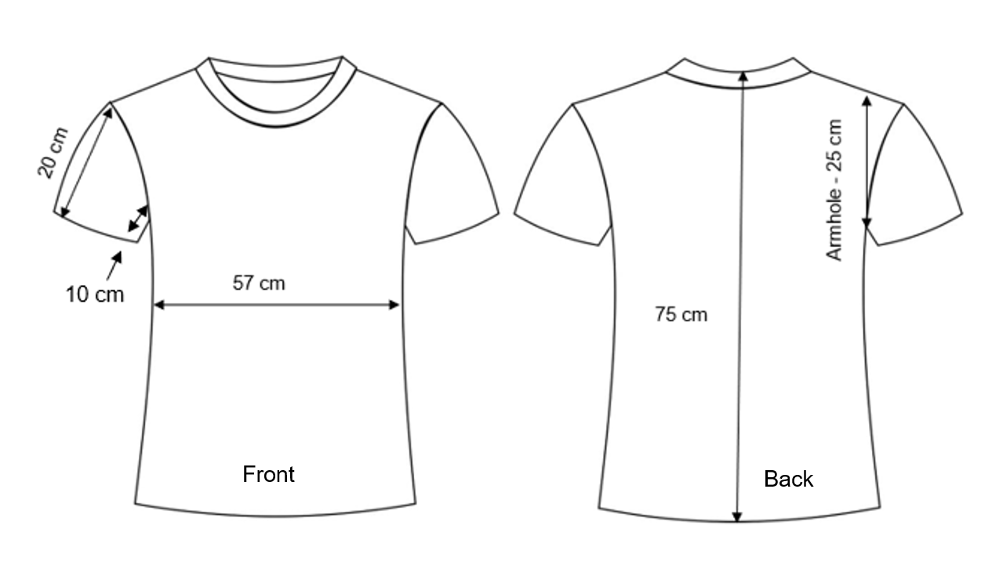Image licensed under Pixabay Content License.

Appendix B

Area of composite shapes station questions
Question 1
Zoltan is building a path around a rectangular raised garden bed with the following dimensions: 1600 mm by 800 mm. The path needs to be 830 mm wide to accommodate wheelchair access. Find the area of the path in square metres.
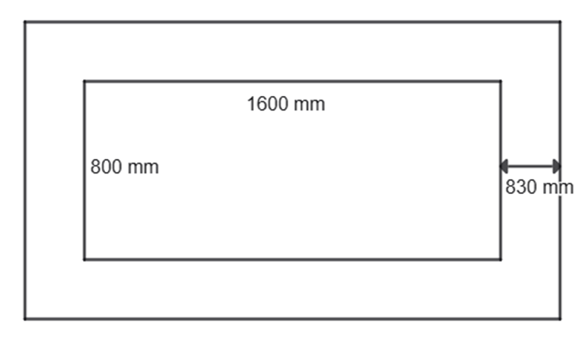

Question 2
The athletics club needs to re-turf the grassed section of the shot-put field below. Find the area of the shaded section, rounded to one decimal point.
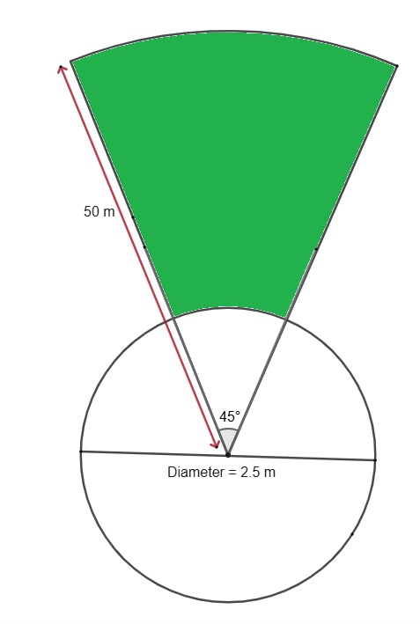

Question 3
Here is a diagram of a playground area. It consists of part of a circle, with centre O, where the radius OB measures 40 m and the angle AOB is a right angle. It also consists of a rectangle with a width of 20 m.
What is the area of the whole playground, correct to the nearest square metre?
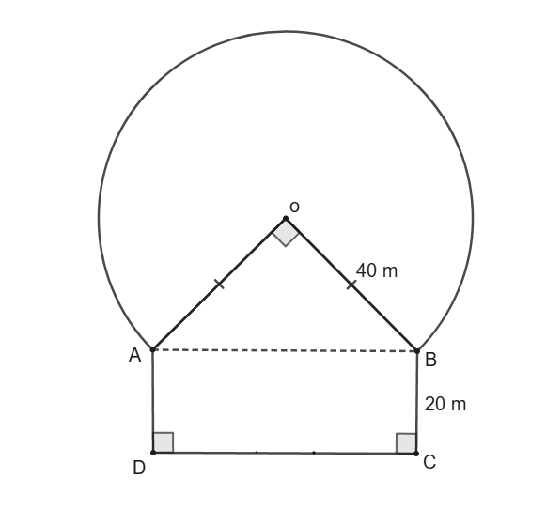
Question 4
Jay is creating this design to put on the front of his visual diary. He wants to cover the shaded section in blue felt. What is the area of felt needed?
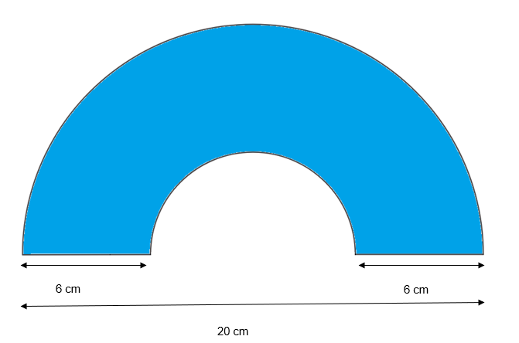
Question 5
A family is placing the following pool design in their backyard. They want to put a solar pool cover over the top of the pool to keep the water warm during the cooler weather. The cost of the pool cover is $23.05/$m^{2}.$ Calculate the cost of the pool cover.
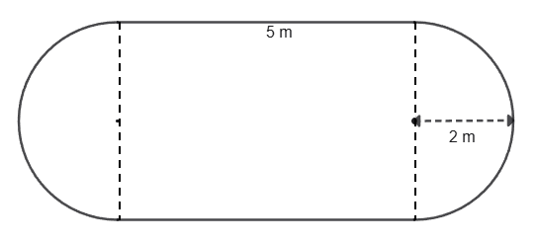
Question 6
Carmel has a small unit with a concrete patio in the shape below. She needs to reseal the concrete and the product she wants to use comes in 2 sizes:
- 1 L costs $30.72 and covers an area of 3 square metres
- 15 L costs $262.04 and covers an area of 50 square metres.
Advise Carmel on the most cost-effective method for resealing the area.
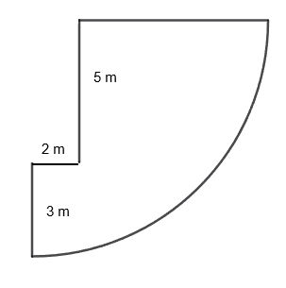

Sample solutions

Appendix A – area of a T-shirt
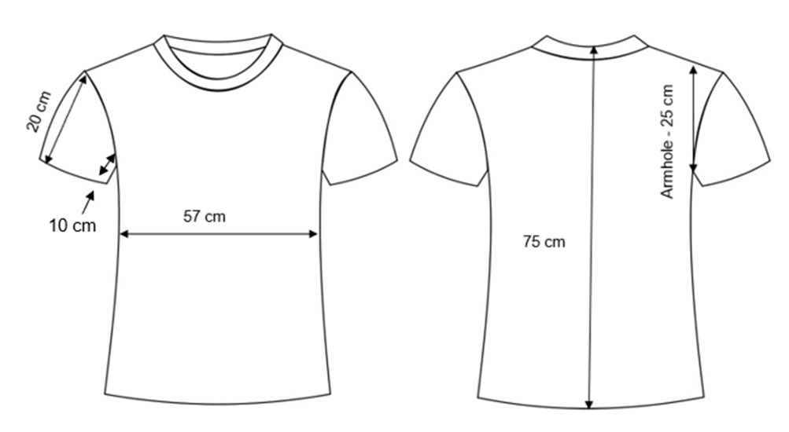
The main body of the shirt
Rectangle front and back: $57×75×2=8550 {cm}^{2}$.
Sleeves
Trapeziums – use Pythagoras’ theorem to find perpendicular height ${25}^{2}-{10}^{2}=22.9 cm$
Trapezium area (front and back x 2): $\left(\frac{1}{2}×22.9×\left(20+10\right)\right)×4=1374 {cm}^{2}$.
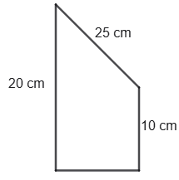
Total estimated area of T-shirt: $8550+1374=9924 {cm}^{2}$.
Example of T-shirt pieces laid out onto the fabric.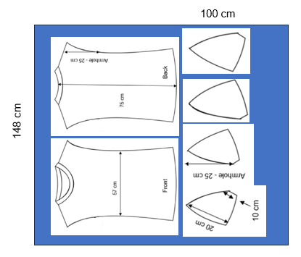

Appendix B – area of composite shapes station questions
Question 1
Outer rectangle dimensions:
Length is $1.6+0.83+0.83=3.26 m$, width is $0.8+0.83+0.83=2.46 m$.
Area of the outer rectangle is $3.26×2.46=8. 0196 m^{2}$.
Area of the garden is 0.$8×1.6=1.28 m^{2}$.
Area of the path is the area of the outer rectangle – area of the garden, $8.0196-1.28=6.7396 m^{2}$.
An alternative strategy is to split the path section into multiple rectangles and add their areas.
Question 2
Area of shaded section is large sector – small sector.
Area is ($\frac{45}{360}×π×{50}^{2})-\left(\frac{45}{360}×π×{1.25}^{2}\right)=981.1 m^{2}$.
An alternative strategy is to find the area of the large circle and subtract the area of the smaller circle and then multiply the area by $\frac{45}{360}$.
Question 3
Area of the playground is the area of the sector + area of the triangle + area of the rectangle.
Need to use Pythagoras’ theorem to find the length of the rectangle
$${40}^{2}+{40}^{2}={AB}^{2} \\ \sqrt{3200}=AB \\ AB=56.56854249 m$$
Area of the sector is $\frac{3}{4}×π×{40}^{2}=3769.911184 m^{2}$.
Area of the triangle is $\frac{1}{2}×40×40=800 m^{2}$.
Area of the rectangle is $20×\sqrt{3200}=1131.37085m^{2}$.
Total area is $3769.911184+800+1131.37085=5701.282034 m^{2}$
Total area is $5701 m^{2}$ to the nearest square metre.
An alternative strategy is to find the area of the circle and subtract the area of the quarter sector and then add on the area of the triangle and rectangle.
Question 4
The shaded area of the design is the large semicircle – the small semicircle.
Need to find the radius of the small semicircle: $\left(20-6-6\right)÷2=4 cm$.
The shaded area is $\left(\frac{1}{2}×π×{10}^{2}\right)-\left(\frac{1}{2}×π×4^{2}\right)=131.9468915 {cm}^{2}$. This would be rounded to $132 {cm}^{2}$.
An alternative strategy is to find the area of the large circle and subtract the area of the smaller circle and then multiply the area by half.
Question 5
The area of the pool is the area of a circle + the area of the rectangle.
Area of the circle is $π×2^{2}=12.56637061 m^{2}$
Area of the rectangle is $5×4=20 m^{2}$.
Total area of the pool is $12.56637061+20=32.56637061 m^{2}$
This would round to $33 m^{2}$
The cost of the pool cover is $33×23.05=\$760.65$.
An alternative strategy is to find the area of the semicircles and add to the area of the rectangle.
Question 6
Area of the patio is area of the sector – area of the rectangle.
Area of the sector is $\frac{1}{4}×π×8^{2}=50.26548246 m^{2}$.
Area of the rectangle is $5×2=10 m^{2}$.
Total patio area is $50.26548246-10=40.26548246 m^{2}$.
This would be rounded to $41 m^{2}$.
The 1 L tin at $30.72 covers 3$m^{2}.$ Carmel would need $41÷3=13.66666667$ tins. This would round up to 14 tins. This would cost her $14×30.72=\$430.08$.
Therefore, it’s more cost-effective for Carmel to buy the 15 L at $262.04.

References
This resource contains NSW Curriculum and syllabus content. The NSW Curriculum is developed by the NSW Education Standards Authority. This content is prepared by NESA for and on behalf of the Crown in right of the State of New South Wales. The material is protected by Crown copyright.
Please refer to the NESA Copyright Disclaimer for more information https://educationstandards.nsw.edu.au/wps/portal/nesa/mini-footer/copyright.
NESA holds the only official and up-to-date versions of the NSW Curriculum and syllabus documents. Please visit the NSW Education Standards Authority (NESA) website https://educationstandards.nsw.edu.au/ and the NSW Curriculum website https://curriculum.nsw.edu.au/.
Mathematics Standard 11–12 Syllabus © NSW Education Standards Authority (NESA) for and on behalf of the Crown in right of the State of New South Wales, 2024.
Numeracy Stage 6 (CEC) Syllabus © NSW Education Standards Authority (NESA) for and on behalf of the Crown in right of the State of New South Wales, 2021.

© State of New South Wales (Department of Education), 2025
The copyright material published in this resource is subject to the Copyright Act 1968 (Cth) and is owned by the NSW Department of Education or, where indicated, by a party other than the NSW Department of Education (third-party material).
Copyright material available in this resource and owned by the NSW Department of Education is licensed under a Creative Commons Attribution 4.0 International (CC BY 4.0) license.

This license allows you to share and adapt the material for any purpose, even commercially.
Attribution should be given to © State of New South Wales (Department of Education), 2025.
Material in this resource not available under a Creative Commons license:
- the NSW Department of Education logo, other logos and trademark-protected material
- material owned by a third party that has been reproduced with permission. You will need to obtain permission from the third party to reuse its material.
Links to third-party material and websites
Please note that the provided (reading/viewing material/list/links/texts) are a suggestion only and implies no endorsement, by the New South Wales Department of Education, of any author, publisher, or book title. School principals and teachers are best placed to assess the suitability of resources that would complement the curriculum and reflect the needs and interests of their students.
If you use the links provided in this document to access a third-party's website, you acknowledge that the terms of use, including licence terms set out on the third-party's website apply to the use which may be made of the materials on that third-party website or where permitted by the Copyright Act 1968 (Cth). The department accepts no responsibility for content on third-party websites.

