Irregularly shaped blocks of land and Trapezoidal rule
Students consider an irregularly shaped block of land and find the perimeter and area in the context of fencing and farming goats. Students examine the accuracy of multiple applications of the Trapezoidal rule.

Learning intentions
- To understand how to calculate the perimeter and area of composite shapes.
- To understand how to calculate the approximate area of an irregular shape using the Trapezoidal rule.

Success criteria
- I can calculate the perimeter of an irregular shape.
- I can calculate the area of an irregular shape.
- I can use the Trapezoidal rule to find the area of a piece of land.
- I can explain how increasing the number of trapeziums improves the accuracy of an area.

Outcomes
A student:
- develops understanding and fluency in mathematics through exploring and connecting mathematical concepts, choosing and applying mathematical techniques to solve problems, and communicating their thinking and reasoning coherently and clearly MAO-WM-01
- selects and applies algebraic techniques to solve problems involving equations and formulas MST-11-01
- solves problems involving measurement in practical contexts MST-11-05

Associated numeracy outcomes
A student:
- recognises and applies functional numeracy concepts in practical situations, including personal and community, workplace and employment, and education and training contexts N6-1.1
- applies numerical reasoning and mathematical thinking to clarify, efficiently solve and communicate solutions to problems N6-1.2
- determines whether an estimate or an answer is reasonable in the context of a problem, evaluates results and communicates conclusions N6-1.3
- chooses and applies appropriate operations with whole numbers, familiar fractions and decimals, percentages, rates and ratios to analyse and solve everyday problems N6-2.1
- chooses and applies efficient strategies to analyse and solve everyday problems involving metric relationships, distance and length, area, volume, time, mass, capacity and temperature N6-2.2
- chooses and applies efficient strategies to analyse and solve everyday problems involving money and finance N6-2.4
- chooses and applies appropriate numeracy operations and techniques to analyse and resolve everyday situations N6-2.6
Numeracy Stage 6 (CEC) Syllabus © NSW Education Standards Authority (NESA) for and on behalf of the Crown in right of the State of New South Wales, 2021.

Content

Formulas and equations
- Substitute numbers into linear and non-linear algebraic expressions, equations and formulas
- Evaluate the subject of a formula, given the value of other pronumerals in the formula
- Apply given formulas to solve problems in a variety of contexts

Applications of measurement

Practicalities of measurement
- Identify and convert between metric units of area, using ${1 cm}^{2}=100 {mm}^{2}$, $1 m^{2}=10 000 {cm}^{2}$, $1 ha=10 000 m^{2}$ and $1 {km}^{2}=1 000 000{ m}^{2}$

Perimeter, area and volume
- Solve practical problems requiring the calculation of perimeters and areas of triangles, rectangles, parallelograms, trapeziums, circles, sectors of circles and composite shapes in a variety of contexts
- Apply Pythagoras’ theorem to solve problems involving right-angled triangles
- Calculate perimeters and areas of irregularly shaped blocks of land by dissection into triangles, rectangles and trapeziums
- Apply the Trapezoidal rule $A≈\frac{h}{2}\left(d_{f}+d_{l}\right)$, where $A$ is the area, $d_{f}$ and $d_{l}$ are the lengths of the parallel sides of the trapezium, $d_{f}$ is the first length and $d_{l}$ is the last length, and $h$ is the perpendicular distance between them, to solve a variety of practical problems involving area, volume and capacity for up to four applications
Mathematics Standard 11–12 Syllabus © NSW Education Standards Authority (NESA) for and on behalf of the Crown in right of the State of New South Wales, 2022.

Table 1: lesson summary
Section | Summary of activity | Teaching strategies | Teaching points
Retrieval practice | Students are introduced to a scenario on slide 4 of the PowerPoint Irregularly shaped blocks of land and Trapezoidal rule where Walter wants to sell a block (slide 5) and part of a rural property (slide 6). Students calculate the area and selling price for both properties. Slide 7 could be shown as a reminder of how to convert square metres to hectares. Students then compare 3 ways to write the solution to the area of the rural property on slide 8 and discuss which is easiest to communicate. | Mini whiteboards  Pose-Pause-Pounce-Bounce | Students have multiple ways to find the area of the block and the methods are compared to deepen their understanding. The rural property revises converting units.
Activating prior knowledge | Students are given a scenario of a new property for Walter on slide 10 and use Appendix A to examine how Walter’s parcel of land can be dissected into various familiar plane shapes. Slide 11 provides a picture of the same image. | Visibly random groups of 3  Vertical non-permanent surfaces  Gallery walk  Pose-Pause-Pounce-Bounce | Students collaborate and use mathematical reasoning of the properties of plane shapes to dissect the piece of land.
Connecting learning | Slide 13 shows an explanation of a traverse offset survey from the teaching advice in the syllabus. Students use Appendix B to determine the perimeter and cost of fencing. Slide 14 provides a picture of the same image and slide 15 supports students by stating the cost of fencing. Students then find the area of the property to determine how many goats it can support. The area of the trapezium is used to calculate land divided into a number of strips in Appendix C. | Visibly random groups of 3  Vertical non-permanent surfaces  Check reasonableness  Notice and wonder | These activities apply the knowledge of perimeter and area of composite shapes to a real-world block of land. They also build familiarity with the area of a trapezium.
Releasing responsibility | Display slide 17 for students to compare formulas for the area of a trapezium with the Trapezoidal rule. Students locate and annotate the Trapezoidal rule on the NESA Mathematics Standard 1 and 2 – HSC reference sheet. Students learn to apply the Trapezoidal rule through modelled worked examples on slides 18–21. Then use it to complete the last question from Appendix C. Display slide 22 to compare 2 different solution methods. Students reflect on their learning by completing four quadrant notes on Appendix D. | Notice and wonder  Worked examples (Your turn)  Visibly random groups of 3  Vertical non-permanent surfaces  Pose-Pause-Pounce-Bounce  Four quadrant notes | Students develop proficiency in using the Trapezoidal rule and reinforce mathematical communication to encourage a deeper understanding of how increasing the number of applications improves accuracy.
Independent practice | Students practise applying the Trapezoidal rule to an HSC style question on Appendix E. An extension question in Appendix F connects algebra with the Trapezoidal rule for further challenge. | Visibly random groups of 3  Vertical non-permanent surfaces | This activity allows students to practise at a skill level comparable to an HSC question.

Activity structure
Please use the associated PowerPoint Irregularly shaped blocks of land and Trapezoidal rule to display images in this lesson.

Retrieval practice
- Display slide 4 of the PowerPoint and read the following scenario to students.
Walter is looking to sell some of his property before moving to Tasmania. He wants to sell a block and part of a rural farm. He estimates that he could sell them at $375 per $m^{2}$ for the block and $8000 per $ha$ for the rural property.
- Display slide 5, which shows a diagram of the block in more detail. In pairs, students are to use mini whiteboards (bit.ly/miniwhiteboards) to find the area of the land in $m^{2}$, and the price he should list it for sale.
Solutions can be found in the sample solutions for ‘Retrieval practice’.
- Initiate a class discussion on the methods students used to find the area.
Students should be familiar with calculating the area of composite shapes from the Stage 4 Area outcome MA4-ARE-C-01.
- Display slide 6, which shows a diagram of part of a rural farm with measurements shown in km. In pairs, students calculate the area of the farm in $km^{2}$, $m^{2}$ and $ha$, as well as the price he should list it for sale.

Students should be familiar with area conversions from the Stage 4 Area outcome
MA4-ARE-C-01.
Teachers may wish to revise area conversions using activities from Lesson 8 – which quadrat of Stage 4 Unit 7 – length and area.
Alternatively, you could display slide 7 to remind students of the conversion of square metres to hectares.
- Display slide 8, which contains the answer for the area of the rural property from slide 6 in the different units of measurement.
The worked solutions for the calculations can be found in the sample solutions for ‘Retrieval practice’.
- Use the Pose-Pause-Pounce-Bounce questioning strategy (PDF 557 KB) (bit.ly/posepausepouncebounce) to discuss which of the answers is easiest to communicate and which of the answers is easiest for calculating the price of the block of land.
Students were introduced to different prefixes for units of measurement in Lesson 1 – prefixes for units of measurement.
The measurements were in $km$ and this unit provides the smallest number so it is easiest to communicate the solution in $km^{2}.$ Having the area in $m^{2}$ is easiest to calculate the price as it is also given in $m^{2}$.

Activating prior knowledge
- Display slide 10 of the PowerPoint and read the following scenario to students.
Walter has found on the internet a property in Tasmania, where he could keep goats. Each goat requires at least 0.1 hectares of natural bushland. Since Walter can’t physically inspect the property in person, he needs to calculate how many goats the land can support and how much fencing wire to order, as the current fencing is inadequate.
- Assign students to visibly random groups of 3 (bit.ly/visiblegroups) at vertical non-permanent surfaces (bit.ly/VNPSstrategy). Distribute an A3 copy of Appendix A ‘The block’ in a plastic pocket with adhesive putty.
A larger image of the block can be found on slide 11.
- Ask groups to brainstorm and draw on the plastic pocket how to dissect the land into known shapes so they can find the perimeter and area.
- Students are to conduct a gallery walk (bit.ly/DLSgallerywalk) of each other’s solutions, noting any groups’ answers that are different or interesting.
- Use the Pose-Pause-Pounce-Bounce questioning strategy to discuss the shapes that students used. Some suggested prompts include:
- Why did you choose those shapes?
- What are the properties of these shapes that will help you to find the perimeter or area of the block of land?
- How do you know that the sides of your shapes are parallel?
- Is there a way to dissect this shape to ensure you have right angles and parallel lines?
This lesson could be contextualised by using a local parcel of land. Measurements can be found using the NSW Government’s spatial tool ‘Explorer’ (https://portal.spatial.nsw.gov.au/explorer/index.html).
We want students to see the need for right angles and parallel lines for the accuracy of measurements. Having lines at right angles to the traverse allow us to create right-angled triangles that are the easiest to calculate. Parallel lines allow us to create rectangles and trapeziums as they are properties of both shapes which allows us to dissect the block with the minimum number of shapes.
The smallest number of shapes are created by using a traverse offset survey. A traverse offset survey involves running a main traverse line and measuring offsets from it to determine the area or perimeter of parcels of land.

Connecting learning
- Display slide 13 of the PowerPoint to show an explanation of why this is an accurate way to survey a piece of land.
The traverse survey is used to demonstrate multiple shapes in one composite figure. This image has come from the teaching advice section of the syllabus.
The language of ‘traverse survey’ is not part of the syllabus, however, it is an example of the content point: ‘Calculate perimeters and areas of irregularly shaped blocks of land by dissection into triangles, rectangles and trapeziums’.
- Distribute an A3 copy of Appendix B ‘Traverse survey’ to each group for them to continue to work on their vertical non-permanent surfaces. It shows the same block of land cut up using a traverse offset survey.
An image of the block from Appendix B is on slide 14.
- Students calculate the perimeter and then the cost of fencing the property.
- Display costings using slide 15 for students to refer to while calculating the cost of fencing.
Chain link fencing is sold in 100 metre lengths for $455.
Calculating the length of the sides will require the use of Pythagoras’ theorem, which was reviewed in Lesson 3 – Pythagoras’ theorem.
- Have students check with a neighbouring group for the reasonableness of their answer (bit.ly/checkreasonableness).
The solution can be shared with students from the sample solutions for Appendix B.
- Students continue to use their vertical non-permanent surfaces to calculate the area of the property.
Students were introduced to the area of a variety of plane shapes in Lesson 4 – area of plane shapes.
- Students are to calculate the number of goats that could be kept on this piece of land. Animate slide 15 to show the number of $ha$ per goat.
- Have students check with a neighbouring group for the reasonableness of their answer.
- Students return to their desks, staying in their groups of 3. Distribute Appendix C ‘Area of a trapezium’, which shows the boundary of a section (HKFE) of the parcel of land.
- Have groups consider and discuss what they notice and wonder (bit.ly/noticewonderstrategy) about the 4 images before conducting a class discussion using the question prompts below.
- Why have we chosen to use trapeziums and not rectangles to calculate the area?
- Will the calculation of the area of the land be less or more than the actual area of the land?
- Why is it the approximate area of the land?
Students should notice that this is a section of Walter’s block of land. Each picture shows the section divided up into strips, each increasing by one strip. They may wonder how this might help estimate the size of the land.
Using trapeziums instead of rectangles reduces the gap between the shape and the boundary, providing a more accurate approximation.
In this case, as the trapeziums are below the boundary of the land, the approximate area calculated is less than the amount of land.
- Groups return to their vertical non-permanent surfaces to calculate the size of the land using the areas of trapeziums for the first 3 diagrams from Appendix C.
- In a class discussion, ask students how the calculation for the area of the block of land changes with the inclusion of more trapeziums.
Students should suggest that the more trapeziums taken, the larger the area and the more accurate the solution, as it is closer to the curve of the boundary and includes more of the block of land.

Releasing responsibility
- Students are back at their desks for the start of this section.
- Display slide 17 of the PowerPoint showing the area of a trapezium and the Trapezoidal rule.
- Ask students to consider what they notice and wonder, comparing the area of a trapezium formula and the Trapezoidal rule.
Students should notice the similarities such as the number of terms and the $\frac{h}{2}$. Students may wonder how $d_{f}$ and $d_{l}$ compare to $a$ and $b$.
- Explain the meaning and placement of the variables in the Trapezoidal rule.
$h-$this is the perpendicular height
$d_{f}-$the distance of the first line
$d_{l}-$the distance of the last line
Students may become confused between the use of the words trapezium, trapezia and trapezoid, and need reassurance that the terms mean the same shape.
- Students should review their copy of the NESA Mathematics Standard 1 and 2 – HSC reference sheet and locate and annotate where the Trapezoidal rule is on the sheet. Students will need to reference this for the rest of the lesson.
Support students when locating the Trapezoidal rule on the Mathematics Standard 1 and 2 – HSC reference sheet. The Trapezoidal rule is below the formula for the area of a trapezium.
- Display slides 18 to 21 to model examples of the Trapezoidal rule using the Worked examples (Your turn) method (bit.ly/supportingstrategies).
Animate slides 18 and 20 to show the self-explanation prompts. Animate slides 19 and 21 to show the solutions.
- Groups return to their vertical non-permanent surfaces to calculate the approximate area of the fourth diagram from Appendix C using the Trapezoidal rule.
- Display slide 22 with comparative solutions and have students discuss in their groups what is the same and what is different.
- Animate the self-explanation prompts to undertake a class discussion on which solution is the more efficient strategy.
The second solution uses common factors to simplify the addition where the numbers are the same.
Students may have different opinions about which method is more efficient. The first method could be considered more efficient as it directly applies the rule, while the second may be preferred because it involves fewer calculations, reducing the chance of error when entering values into the calculator.
- Use the Pose-Pause-Pounce-Bounce questioning strategy to discuss the impact of using more applications of the Trapezoidal rule.
- In their groups of 3, ask students to complete four quadrant notes to their future forgetful selves (bit.ly/supportingstrategies) from Appendix D ‘Four quadrant notes’.
In example 3, students could use 1, 2, 3 or 4 applications of the Trapezoidal rule. Additionally, they could be encouraged to include an area conversion.

Independent practice
- Reassign students to new visibly random groups of 3 at vertical non-permanent surfaces.
- Distribute Appendix E ‘HSC style question’ to each group. This appendix contains a modified HSC style question for students to attempt. When finished, groups can check the reasonableness of their solution with a neighbouring group.
Appendix F ‘Extension’ is available for broadening student understanding. It involves algebra and the Trapezoidal rule.

Assessment and differentiation

Suggested opportunities for differentiation
Retrieval practice
- The scenario and diagrams associated with slide 4 must be read and described to students with vision impairment.
- Support students by revising area conversions and connecting them to the length conversions.
Activating prior knowledge
- The scenario on slide 10 must be read to students with vision impairment.
- Teachers may wish to adjust the scenario on slide 10 of the PowerPoint to remove the initial reference to goats per hectare, if they would like to include a discussion about what further information is needed.
- Contextualise the lesson by using a local piece of land.
- Challenge students by asking them to find the least number of shapes the land would require.
- Support students with a list of properties of plane shapes.
Connecting learning
- Teachers may wish to revise parts of Lesson 1 – traverse survey of Stage 5 Unit 9 – surveying to provide students with a simpler shape to complete an initial traverse survey with.
- Students may be extended by asking them to examine the minimum number of shapes when calculating area in Appendix B, as some students may not recognise ABC as one triangle.
- Support students by conducting a class discussion on how they might find the length of a side or how to calculate the area of separate shapes.
Releasing responsibility
- Support students by using various forms of the word trapezium to familiarise them.
- Extend students by showing them how to take out the common factor, as on slide 17 of the PowerPoint and discussing the most efficient method.
Independent practice
- Support students by using assessing and advancing questions to assist with HSC style questions.
- Challenge students by having them complete Appendix E independently.
- Challenge students by having them complete Appendix F. This question includes algebra within the context of a Trapezoidal rule question.

Suggested opportunities for assessment
Retrieval practice
- Formatively assess student reasoning skills when answering the property question using mini whiteboards.
- Formatively assess student ability to convert between units of area in activities in this section.
Activating prior knowledge
- Observe students’ mathematical communication when dissecting the block of land.
- Listen for students’ justification of choices and understanding of geometric properties during the discussions in this section.
Connecting learning
- Observe students’ ability to apply Pythagoras’ theorem and correct use of proportional reasoning when calculating the cost of fencing per 100 $m$.
- When calculating the area, students should be observed for efficiency of methods used and their ability to convert units of area.
Releasing responsibility
- Review Appendix D for evidence of learning the Trapezoidal rule.
Independent practice
- Collect Appendix E and/or F as evidence of students learning the Trapezoidal rule.

Appendix A

The block
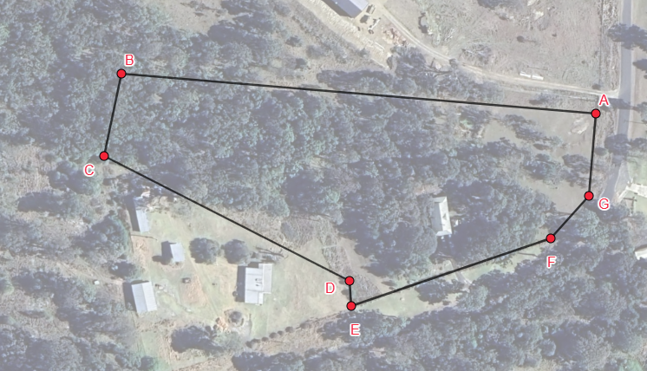

Appendix B

Traverse survey
The diagonal AC has measurements of$10 m, 24 m, 118 m, 103 m$ and $14 m.$ The traverse lengths are $43 m$, $69 m$, $83 m$ and $53 m$ as moving from A to C. Round all answers to the nearest metre or nearest square metre.
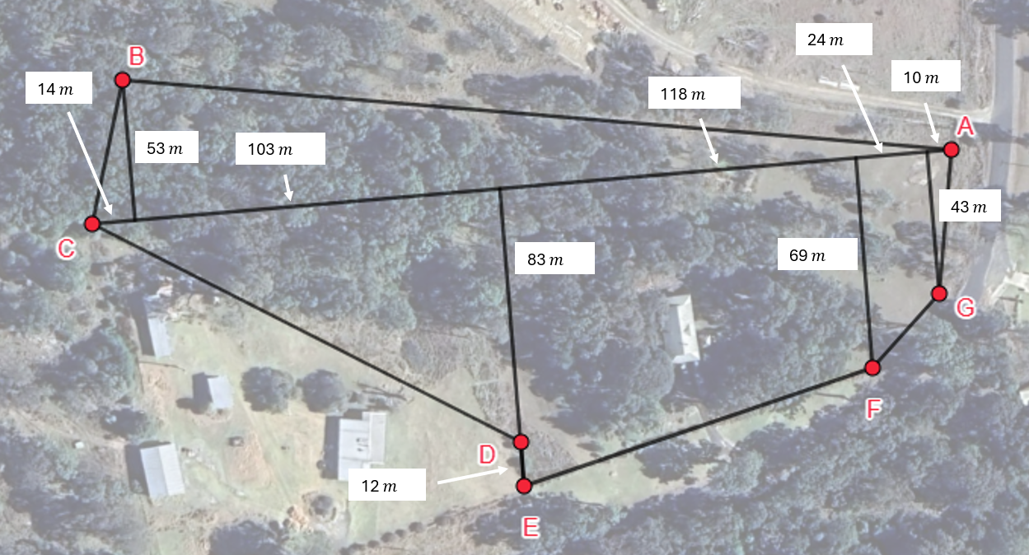

Appendix C

Area of a trapezium
Compare the approximate areas of these sections of land (HKFE).
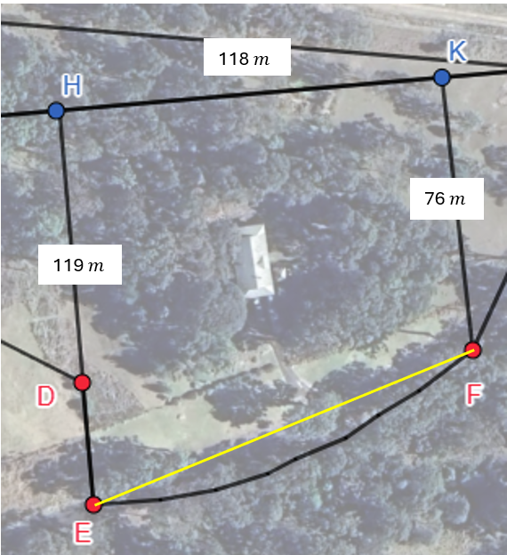 | 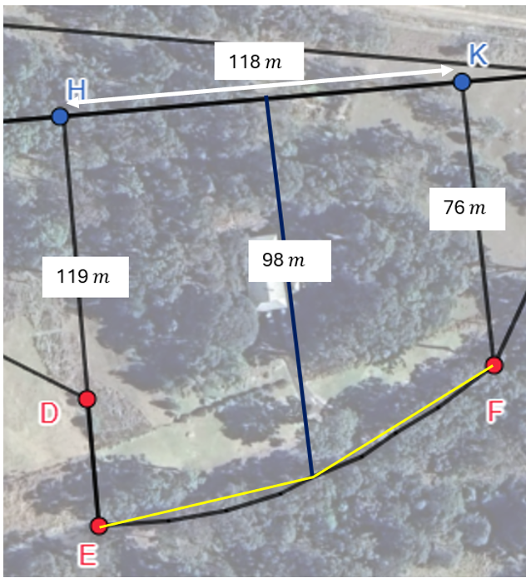
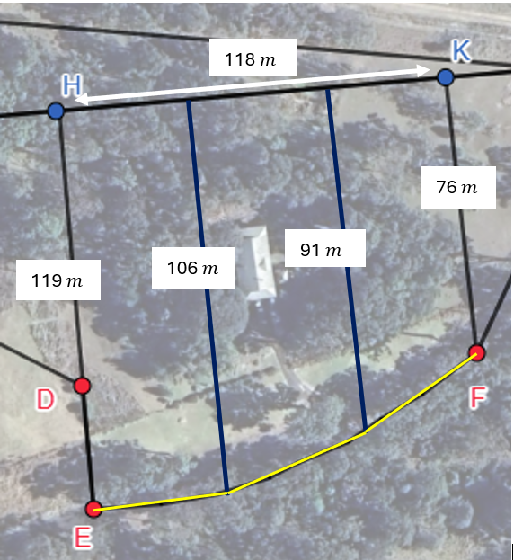 | 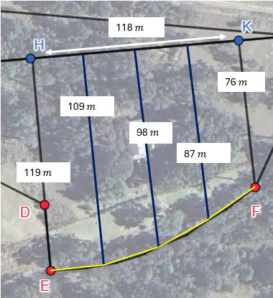

Appendix D

Four quadrant notes
Example 1  Use 2 applications of the Trapezoidal rule to calculate the approximate area of the garden. Is this approximate area over or under the actual area?  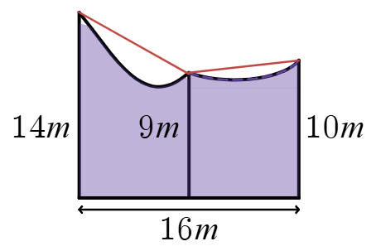  $$A≈\frac{h}{2}\left(d_{f}+d_{l}\right) \\ =\frac{8}{2}×\left(□+9\right)+\frac{8}{2}×\left(9+□\right) \\ =□ m^{2}$$  The approx. area is more than the actual area. | Example 2  Calculate the approximate area of the block of land, using 3 applications of the Trapezoidal rule. Is this approximate area over or under the actual area?  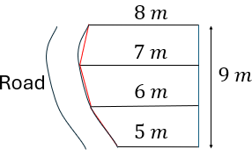
Things to remember | Example 3

Appendix E

HSC style question
The diagram shows a garden consisting of a rectangle and a semicircle. The semicircle has a radius of 50 m. The dimensions of the rectangle are 100 m and 150 m. A lake occupies a section of the garden as shown. The rest of the garden is a grassed section. Some measurements from the end of the grassed section to the edge of the lake are also shown.
- Using 2 applications of the Trapezoidal rule, calculate the approximate area of the grassed section, in hectares.
- Hence, calculate the approximate area of the lake, to the nearest square metre.
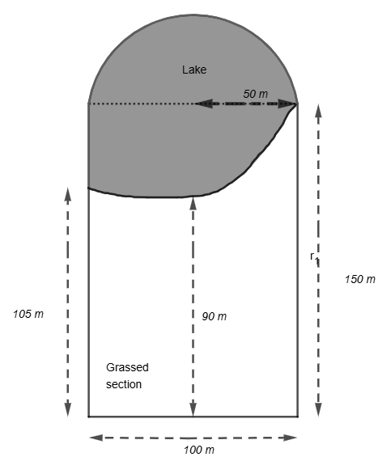

Appendix F

Extension
A tunnel is excavated with a cross-section as shown.
- Find an expression for the area of the cross-section using the Trapezoidal rule.
- The area of the cross-section must be 900 $m^{2}.$The tunnel is 60 $m$ wide. If the value of $a$ increases by 2 metres by how much will $b$ change?
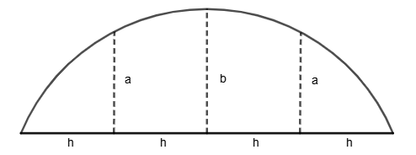

Sample solutions

Retrieval practice
Block of land  $$A=47×26+62×24 \\ =2710 m^{2}$$  Selling for $1 016 250 | Rural farm  $$A=1.8×1.4+0.6×1.3 \\ =3.3 km^{2}$$  Selling for $2 640 000

Appendix B – traverse survey

Perimeter
$$AB=\sqrt{{53}^{2}+{256}^{2}} \\ =261.4287… \\ =261 m$$ | $$EF=\sqrt{{118}^{2}+{26}^{2}} \\ =120.8304… \\ =121 m$$
$$BC=\sqrt{{53}^{2}+{14}^{2}} \\ =54.8178… \\ =55 m$$ | $$FG=\sqrt{{26}^{2}+{24}^{2}} \\ =35.3836… \\ =35 m$$
$$CD=\sqrt{{117}^{2}+{83}^{2}} \\ =143.4503… \\ =143 m$$ | $$GA=\sqrt{{43}^{2}+{10}^{2}} \\ =44.1474… \\ =44 m$$
$$DE= 12 m$$ | $$P=261+55+143+12+121+35+44 \\ =671 m$$
Cost of fencing
$$671÷100=6.71 \\ ≈7 \\ Cost=7×455 \\ =\$3185$$

Area
Working anticlockwise
$$∆ABC=\frac{1}{2}×269×53 \\ =7128.5 m^{2} \\ =7129 m^{2}$$ | $$FGJI=\frac{24}{2}×(69+43) \\ =1344 m^{2}$$
$$∆CDH=\frac{1}{2}×117×83 \\ =4855.5 m^{2} \\ =4856 m^{2}$$ | $$∆GAJ=\frac{1}{2}×10×43 \\ =215 m^{2}$$
$$EFIH=\frac{118}{2}×\left(83+69\right) \\ =8968 m^{2}$$ | $$Total=7129+4856+8968+1344+215 \\ =22,512 m^{2} \\ =2.2512 ha$$
Number of goats:$2.3÷0.1=23$

Appendix C – area of a trapezium
One application
$$EFIH=\frac{118}{2}×(119+76) \\ =11 505 m^{2}$$
Two applications
$$EFIH=\frac{59}{2}×\left(119+98\right)+\frac{59}{2}×\left(98+76\right) \\ =11 535 m^{2}$$
Three applications
$$EFIH=\frac{39.3}{2}×\left(119+106\right)+\frac{39.3}{2}×\left(106+91\right)+\frac{39.3}{2}×\left(91+76\right) \\ =11 574 m^{2}$$

Appendix D – Four quadrant notes
Example 1  Use 2 applications of the Trapezoidal rule to calculate the approximate area of the garden.  $$A≈\frac{h}{2}\left(d_{f}+d_{l}\right) \\ =\frac{8}{2}×\left(14+9\right)+\frac{8}{2}×\left(9+10\right) \\ =168 m^{2}$$ | Example 2  Calculate the approximate area of the block of land, using 3 applications of the Trapezoidal rule.  $$A≈\frac{h}{2}\left(d_{f}+d_{l}\right) \\ =\frac{3}{2}×\left(8+7\right)+\frac{3}{2}×\left(7+6\right)+\frac{3}{2}×\left(6+5\right) \\ =58.5 m^{2}$$

Appendix E – HSC style questions
- Grassed section
$$A≈\frac{50}{2}×\left(105+90\right)+\frac{50}{2}×\left(90+150\right) \\ =10 875 m^{2}$$
- Area of lake
$$A≈\left( \frac{1}{2}×π{×50}^{2}+150×100\right)-10 875 \\ =8052 m^{2}$$

Appendix F – extension
- $A≈\frac{h}{2}×\left(0+a\right)+\frac{h}{2}×\left(a+b\right)+\frac{h}{2}×\left(b+a\right)+\frac{h}{2}×\left(a+0\right)$$$=\frac{h}{2}×\left(4a+2b\right) \\ =h(2a+b)$$
- $900=15×\left(2a+b\right)$
$$60=2a+b \\ 900=15×\left(2a+4+b\right) \\ 60=a+b+4 \\ b must be 4 metres shorter.$$

References
This resource contains NSW Curriculum and syllabus content. The NSW Curriculum is developed by the NSW Education Standards Authority. This content is prepared by NESA for and on behalf of the Crown in right of the State of New South Wales. The material is protected by Crown copyright.
Please refer to the NESA Copyright Disclaimer for more information https://educationstandards.nsw.edu.au/wps/portal/nesa/mini-footer/copyright.
NESA holds the only official and up-to-date versions of the NSW Curriculum and syllabus documents. Please visit the NSW Education Standards Authority (NESA) website https://educationstandards.nsw.edu.au/ and the NSW Curriculum website https://curriculum.nsw.edu.au/.
Mathematics Standard 11–12 Syllabus © NSW Education Standards Authority (NESA) for and on behalf of the Crown in right of the State of New South Wales, 2024.
Numeracy Stage 6 (CEC) Syllabus © NSW Education Standards Authority (NESA) for and on behalf of the Crown in right of the State of New South Wales, 2021.

© State of New South Wales (Department of Education), 2025
The copyright material published in this resource is subject to the Copyright Act 1968 (Cth) and is owned by the NSW Department of Education or, where indicated, by a party other than the NSW Department of Education (third-party material).
Copyright material available in this resource and owned by the NSW Department of Education is licensed under a Creative Commons Attribution 4.0 International (CC BY 4.0) license.

This license allows you to share and adapt the material for any purpose, even commercially.
Attribution should be given to © State of New South Wales (Department of Education), 2025.
Material in this resource not available under a Creative Commons license:
- the NSW Department of Education logo, other logos and trademark-protected material
- material owned by a third party that has been reproduced with permission. You will need to obtain permission from the third party to reuse its material.
Links to third-party material and websites
Please note that the provided (reading/viewing material/list/links/texts) are a suggestion only and implies no endorsement, by the New South Wales Department of Education, of any author, publisher, or book title. School principals and teachers are best placed to assess the suitability of resources that would complement the curriculum and reflect the needs and interests of their students.
If you use the links provided in this document to access a third-party's website, you acknowledge that the terms of use, including licence terms set out on the third-party's website apply to the use which may be made of the materials on that third-party website or where permitted by the Copyright Act 1968 (Cth). The department accepts no responsibility for content on third-party websites.

