Area of plane shapes
Students identify what measurements they need to calculate the area of rectangles, triangles, parallelograms and trapeziums. They then calculate the length of missing sides to solve problems involving areas.

Learning intention
- To know how to apply the area of a rectangle, triangle, parallelogram and trapezium to solve problems.

Success criteria
- I can identify the perpendicular height of various shapes.
- I can use Pythagoras’ theorem to calculate unknown lengths.
- I can explain how to calculate the area of various shapes.
- I can solve problems involving a variety of shapes.

Outcomes
A student:
- develops understanding and fluency in mathematics through exploring and connecting mathematical concepts, choosing and applying mathematical techniques to solve problems, and communicating their thinking and reasoning coherently and clearly MAO-WM-01
- selects and applies algebraic techniques to solve problems involving equations and formulas MST-11-01
- solves problems involving measurement in practical contexts MST-11-05

Associated numeracy outcomes
A student:
- recognises and applies functional numeracy concepts in practical situations, including personal and community, workplace and employment, and education and training contexts N6-1.1
- applies numerical reasoning and mathematical thinking to clarify, efficiently solve and communicate solutions to problems N6-1.2
- determines whether an estimate or an answer is reasonable in the context of a problem, evaluates results and communicates conclusions N6-1.3
- chooses and applies appropriate operations with whole numbers, familiar fractions and decimals, percentages, rates and ratios to analyse and solve everyday problems N6-2.1
- chooses and applies efficient strategies to analyse and solve everyday problems involving metric relationships, distance and length, area, volume, time, mass, capacity and temperature N6-2.2
Numeracy Stage 6 (CEC) Syllabus © NSW Education Standards Authority (NESA) for and on behalf of the Crown in right of the State of New South Wales, 2021.

Content

Formulas and equations
- Substitute numbers into linear and non-linear algebraic expressions, equations and formulas
- Evaluate the subject of a formula, given the value of other pronumerals in the formula
- Apply given formulas to solve problems in a variety of contexts

Applications of measurement

Perimeter, area and volume
- Solve practical problems requiring the calculation of perimeters and areas of triangles, rectangles, parallelograms, trapeziums, circles, sectors of circles and composite shapes in a variety of contexts
- Apply Pythagoras’ theorem to solve problems involving right-angled triangles
Mathematics Standard 11–12 Syllabus © NSW Education Standards Authority (NESA) for and on behalf of the Crown in right of the State of New South Wales, 2024.

Table 1: lesson summary
Section | Summary of activity | Teaching strategies | Teaching points
Retrieval practice | Use slide 4 of the PowerPoint Area of plane shapes for students to discuss which triangle has the largest area. | Think-Pair-Share | Students review that the perpendicular height is used to calculate the area of a triangle.
Activating prior knowledge | Use slide 6 to show a sailboat and discuss the shapes the sails make to approximate the area. | Pose-Pause-Pounce-Bounce | Students recall plane shapes, their properties and how to calculate their areas.
Connecting learning | In groups, have students complete Don Steward’s activity ‘fraction of rectangles’ (bit.ly/fractions-of-rectangles). Then use slide 8 to discuss the measurements required to cut a sail out of a rectangle with a certain area. Students then complete Appendix A and calculate the shapes’ areas that they can. | Visibly random groups  Vertical non-permanent surfaces  Assessing and advancing questions | Students calculate areas of parallelograms, trapeziums and triangles using the perpendicular height. They are required to find the missing measurements they need using Pythagoras’ theorem. Students then look at shapes to determine when they can find the area with the measurements required or with Pythagoras’ theorem.
Releasing responsibility | Students write notes and include shapes from Appendix A as examples. | Notes to future forgetful selves  TAG feedback | Students summarise their learning for future use.
Independent practice | Students complete Appendix B in groups. | Visibly random groups  Vertical non-permanent surfaces | Students attempt non-routine problems involving areas of plane shapes.

Activity structure
Please use the associated PowerPoint Area of plane shapes to display images in this lesson.

Retrieval practice
This activity has been modified from Lesson 12 – too clever by half of Stage 4 Unit 7 – length and area.
- Display Figure 1, which can be found on slide 4 of the PowerPoint.
- In a Think-Pair-Share (bit.ly/thinkpairsharestrategy) ask students to identify which triangle they believe has the biggest area and why.
Figure 1: Which triangle has the bigger area?
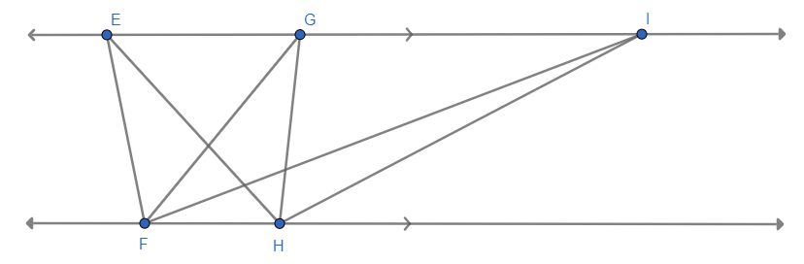
All triangles have the same area, as the length of the base and the perpendicular height are the same for all triangles. This activity is provided to remind students of this and check their prior knowledge of how to calculate the area of a triangle.

Activating prior knowledge
- Display slide 6 of the PowerPoint, which shows a sailboat.
- Use the Pose-Pause-Pounce-Bounce questioning strategy (PDF 557 KB) (bit.ly/posepausepouncebounce) to discuss how you could estimate the size of the sails. Some suggested prompts include:
- What shapes do the sails roughly represent?
- How do we calculate the area of those shapes?
- What measurements would we need from the sails?
Students should recognise that the shapes of the sails reflect triangles, parallelograms and trapeziums. Students should recall the formulas to calculate the area of these shapes. Students should be familiar with this knowledge and these skills from the Stage 4 Area outcome
MA4-ARE-C-01.
If students need more time reviewing how to calculate the areas of these shapes, it is advised that they complete activities from the lessons in Stage 4 Unit 7 – length and area.
Students would benefit from reviewing their copy of the NESA Mathematics Standard 1 and 2 – HSC reference sheet to reference the formula for the area of a trapezium. Students should note that the formulas for the area of the other shapes are not on the reference sheet and students are expected to memorise these.
- State to students that the size of a sail can determine its performance. For example, larger sails can catch more wind and increase speed, but in strong winds they can overpower the boat, making it uncontrollable.

Connecting learning
- Assign students to visibly random groups of 3 (bit.ly/visiblegroups) at vertical non-permanent surfaces (bit.ly/VNPSstrategy).
- Have students complete Don Steward’s activity ‘fraction of rectangles’ (bit.ly/fractions-of-rectangles), where students are to break up shapes into the specified fraction of the rectangle provided.
It is suggested that the teacher prints the grids on A3 paper and places them in a plastic pocket to complete the activity. There are 60 grids in this activity. It is advised that the teacher does not use all the grids, but a variety that represent triangles, parallelograms and trapeziums. The area of rectangles will be used to justify that they have created shapes that have a certain fraction of the area.
- Ask students assessing and advancing questions (bit.ly/supportingstrategies) to check for understanding and deepen student thinking. Some suggestions are provided in the following table.
Table 2: assessing and advancing questions
Assessing questions | Advancing questions
What is the area of the whole space provided? How can you use that to find the area of the shape you need to draw? | What are the properties of a parallelogram/trapezium? Does that limit where you can draw lines?
How do you calculate the area of a triangle/parallelogram/trapezium? | How can you justify that you are correct?
What are the measurements used to calculate the area of a triangle/parallelogram/trapezium? How does that help us solve the problem? | Could you find the length of the slant height and calculate the perimeter? How does that compare to the perimeter of the rectangle?
- Display slide 8 of the PowerPoint, which shows a rectangular piece of cloth, with a triangle to be cut out of it to create a sail for a model sailing boat.
- Use the Pose-Pause-Pounce-Bounce questioning strategy to ask students what measurements were required to calculate the area of the sail.
This questioning aims to determine if students recognise they need the perpendicular height to calculate the area of these shapes. If they do not, the teacher should remind students.
- Ask students to return to their groups on vertical non-permanent surfaces and ask them to determine the dimensions of cloth required to make a sail.
- Ask students assessing and advancing questions to check for understanding and deepen student thinking. Some suggestions are provided in the following table.
Table 3 – assessing and advancing questions
Assessing questions | Advancing questions
What do you need to calculate the area of a triangle? | What have we used previously to find missing sides in right-angled triangles?
Can you identify where there are right-angled triangles on the sail? | Should we leave our answer in decimal form or as the square root of a number? Which would give a more accurate answer?
Why can’t we use the slant height to calculate the area? | What would happen to the area if the slant height increased but the cut length (2 m) remained the same?
- Ask non-volunteer students what they needed to do to find the lengths of the sides they needed to find the area.
Students should state that they used Pythagoras’ theorem to find the perpendicular height of $\sqrt{12}$, and then used that to find the length of the base to end up with the dimensions of approximately 3.5 m by 9.1 m.
- Distribute Appendix A ‘Shapes’ to each group of students and ask them to group the shapes into the following categories:
- There is enough information to calculate the area.
- Pythagoras’ theorem is needed to find a measurement before calculating the area.
- There is not enough information to calculate the area.
- Use the Pose-Pause-Pounce-Bounce questioning strategy to initiate a sharing of responses and reasoning.
- Ask students to calculate the area of the shapes they can.

Releasing responsibility
- Have students write notes to their future forgetful selves (bit.ly/notestofutureself) on how to calculate the area of triangles, parallelograms and trapeziums. Some suggested prompts to help students with their notes include:
- What information is needed to calculate the area and how do you check for that?
- When do you need to use Pythagoras’ theorem to find lengths?
- Is there any other information or tips they find valuable?
- Have students include shapes from Appendix A to add an example or examples to their notes.
- Have students provide peer feedback on each other’s notes in their groups of 3 using the TAG feedback strategy (bit.ly/DLSpeerfeedback).
- Provide students with time to enact the feedback.
The area of these shapes can be calculated in a variety of ways, so there is no one correct way for students to write their notes, but it provides the opportunity for their notes to be specific to their preferred method.

Independent practice
- Continuing in their random groups of 3, have students attempt the non-routine problems from Appendix B ‘Non-routine problems’.
- If group answers differ, pair them and state ‘At least one of you is incorrect’ for them to discuss their reasoning and adjust accordingly.

Assessment and differentiation

Suggested opportunities for differentiation
Retrieval practice
- Students may benefit from the base measurement FH to be displayed on the diagram.
- Displaying the triangles in distinct colours may support student understanding of the diagram.
Activating prior knowledge
- Students with backgrounds in sailing can be asked to provide more information about how the area of the sails affects the speed of a boat.
- Students may benefit from lines drawn onto the sailboat image to visualise shapes that we could use to approximate the area.
Connecting learning
- Students may benefit from the teacher providing an example or cutting one rectangle together as a class from the ‘fraction of rectangles’ task before students attempt other shapes.
- The ‘fraction of rectangles’ task can be chosen to suit different ability levels. Starting with fractions of $\frac{1}{2}$ and $\frac{1}{4}$ before moving on to $\frac{1}{3}$ and $\frac{2}{3}$. The last grid is for further challenge.
- Advancing questions are provided to move students along and provide scaffolding in the ‘fractions of rectangles’ activity and when finding the values for the sail.
Releasing responsibility
- Students can be provided a list of terminology they should include when writing their notes to their future forgetful selves to develop their written mathematical communication skills.

Independent practice
- Students can be provided with an example of each non-routine task from Appendix B before attempting the task in their groups.
- Challenge students to divide the triangles into 4 smaller triangles of equal area or explore whether it’s possible to split any triangle into 3 equal-area triangles.
- Challenge students to create their own parallelogram problem.
- Ask students to reason about what changes they made to try and make the values for area and perimeter closer.

Suggested opportunities for assessment
Retrieval practice
- Students’ prior knowledge of the area of the triangle and using the slant height or perpendicular height will come out in discussions in this activity. Students may need to review areas of plane shapes if they think they need to use the slant height to calculate the area.
Activating prior knowledge
- Students’ prior knowledge of how to identify and calculate the area of triangles, parallelograms and trapeziums should come out in responses to prompts in this section. Students may need to review these before attempting this lesson.
Connecting learning
- Students provide peer feedback when working in groups of 3.
- Working on vertical non-permanent surfaces provides the teacher with the opportunity to view student work as they work on tasks, so they can intervene if any misconceptions or misunderstandings arise.
- Assessing questions have been provided for students to show their understanding of calculating area and finding the perpendicular height.
- Review students’ answers to Appendix A as evidence of students’ ability to identify when they can calculate the area of a shape and their accuracy in calculating the area.
Releasing responsibility
- Students’ ability to communicate mathematically will be seen in the modified notes they create, including the understanding between slant height and perpendicular height.
- Students provide peer feedback on each other’s notes to refine their mathematical communication skills.
Independent practice
- Review student responses to Appendix B for their approaches to problem solving, their mathematical reasoning and ability to apply concepts of area to a non-routine problem.

Appendix A

Shapes
A  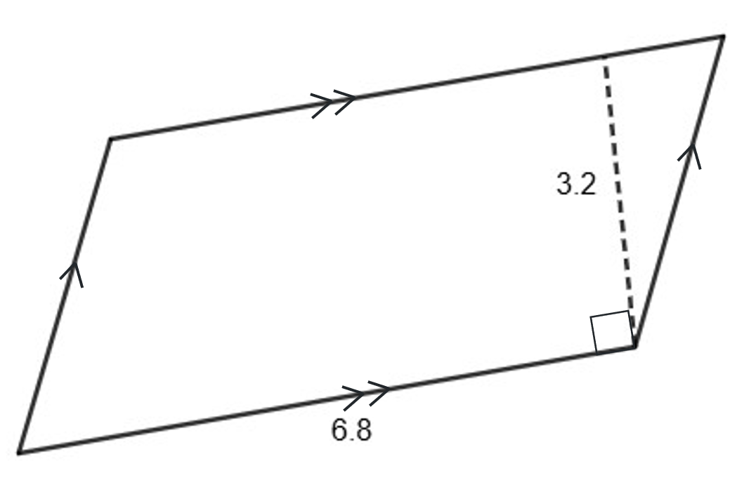 | B  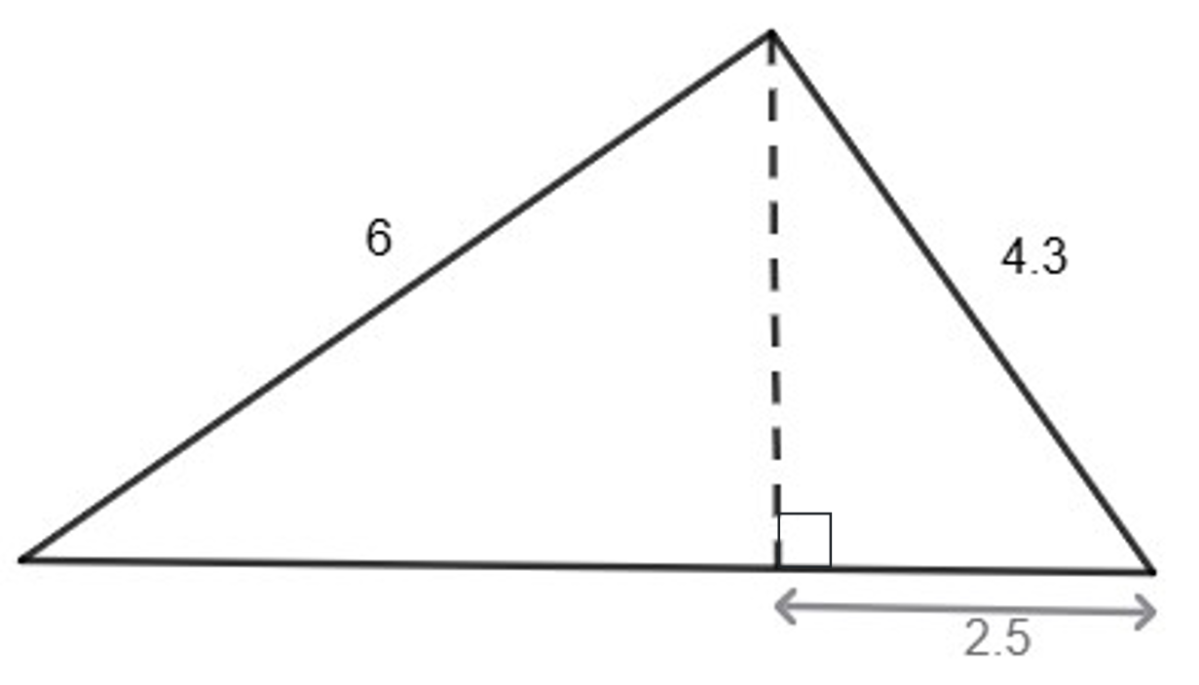
C  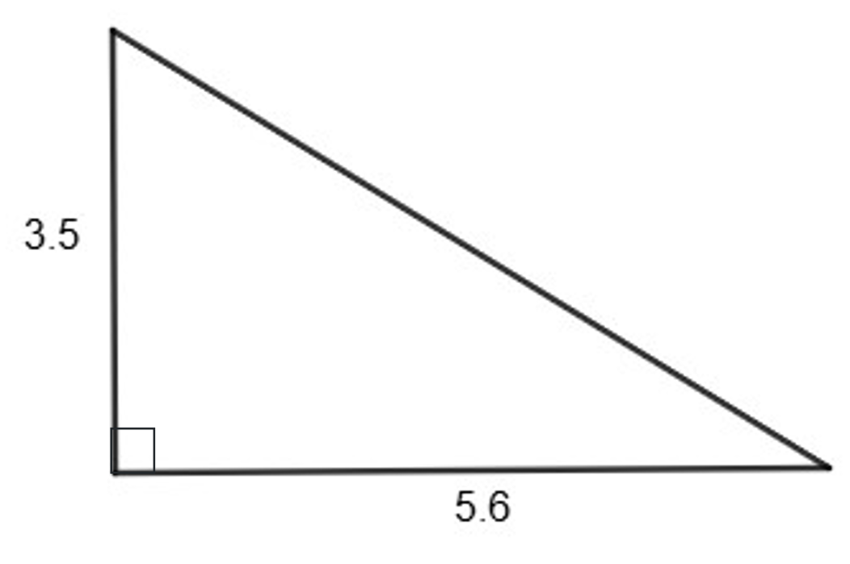 | D  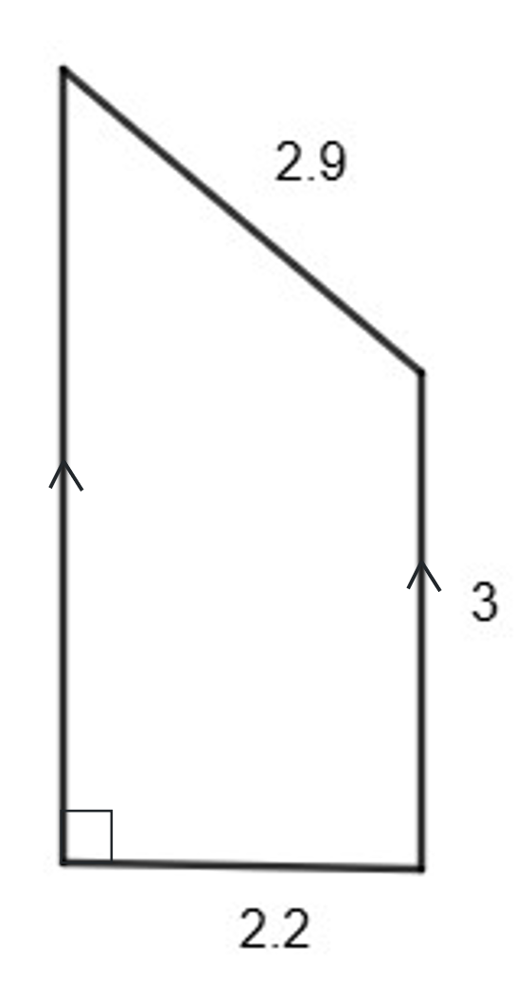
E  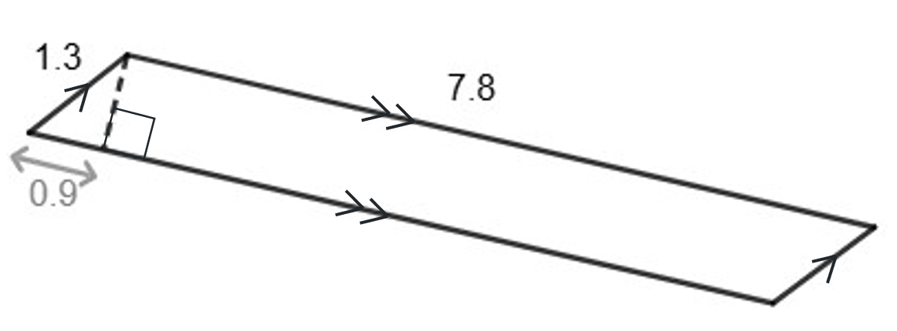 | F  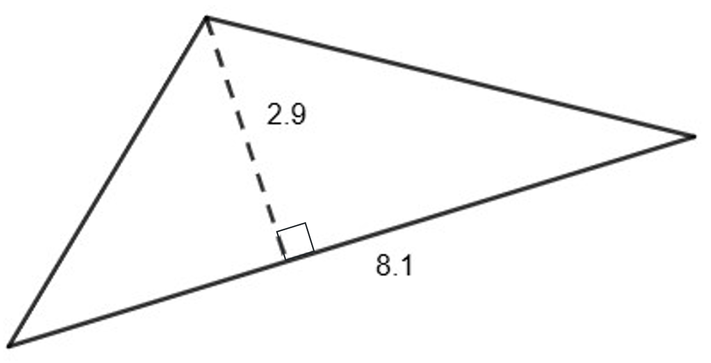
G  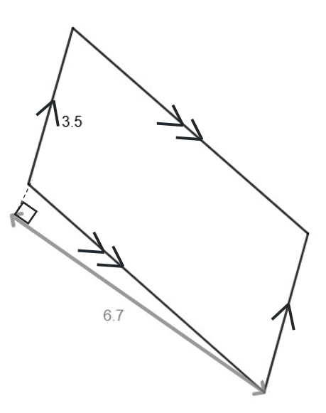 | H  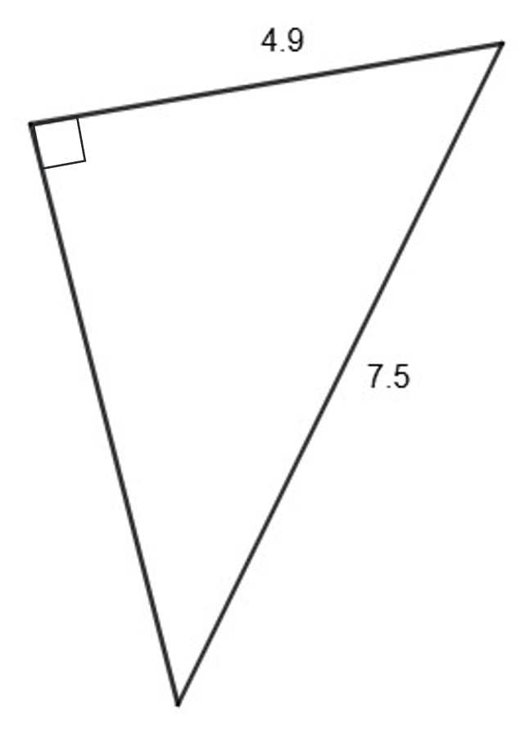

I  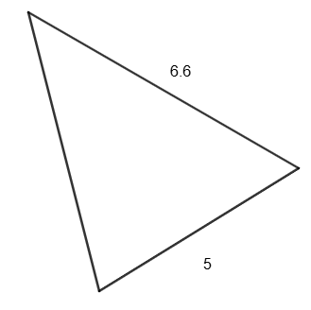 | J  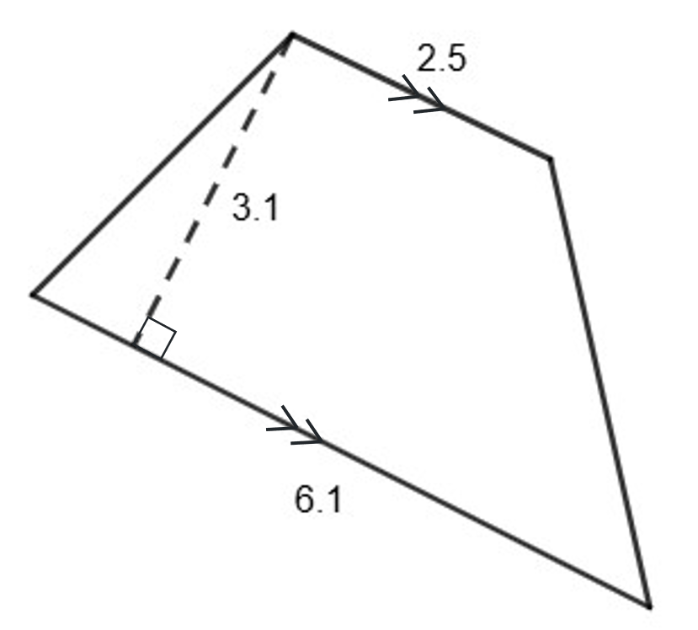
K  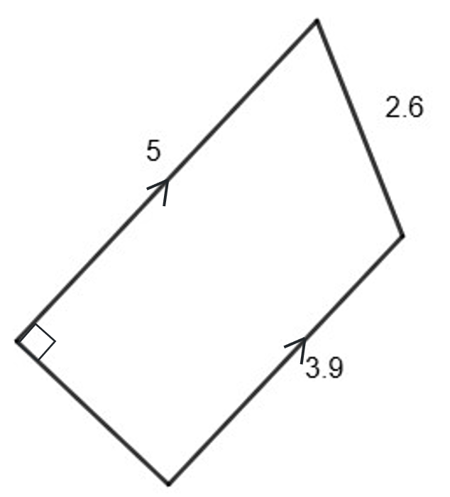 | L  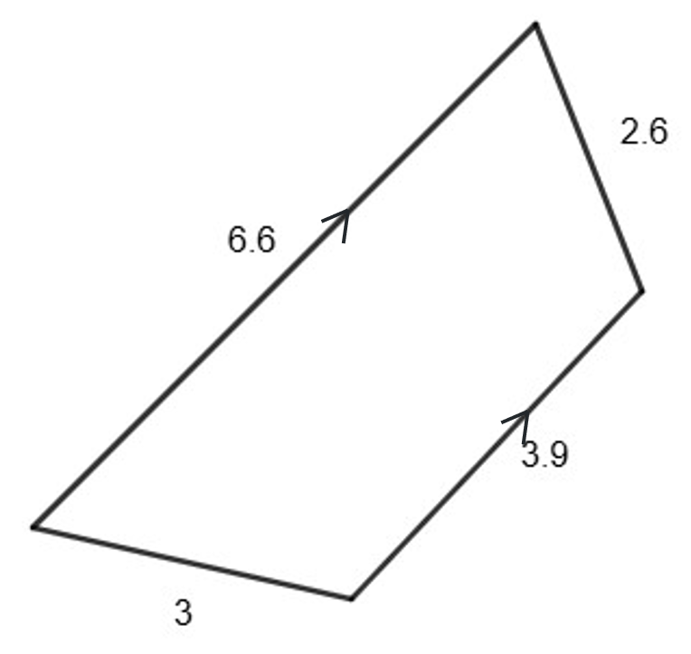
M
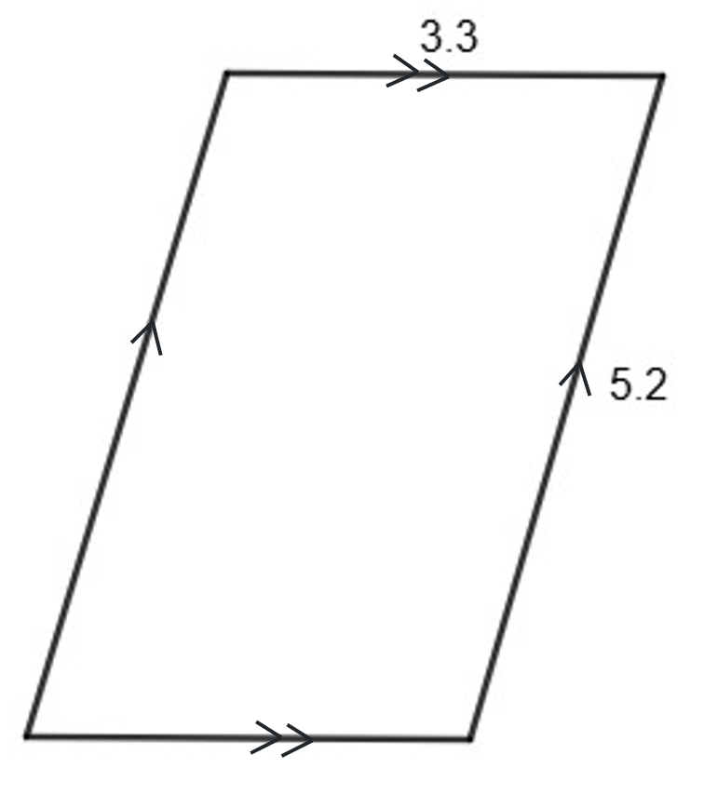

Appendix B

Non-routine problems

Triangles
This activity has been adapted from Don Steward’s blog median activity ‘triangles cut into triangles’ (bit.ly/triangles-into-triangles).
- Cut the triangle into 3 smaller triangles, so they have the same area.
- Justify how they have been cut, using appropriate calculations.
- Compare the perimeter of each triangle. Are they also the same? Why or why not?
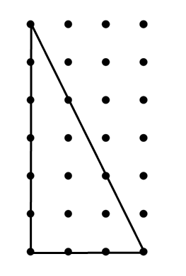

Parallelograms
This activity has been adapted from Don Steward’s blog median activity ‘equable parallelograms’ (bit.ly/equable-parallelograms).
For each of the following parallelograms, the value of their area (A) = the value of their perimeter (P).
Find the value of the missing measurements.
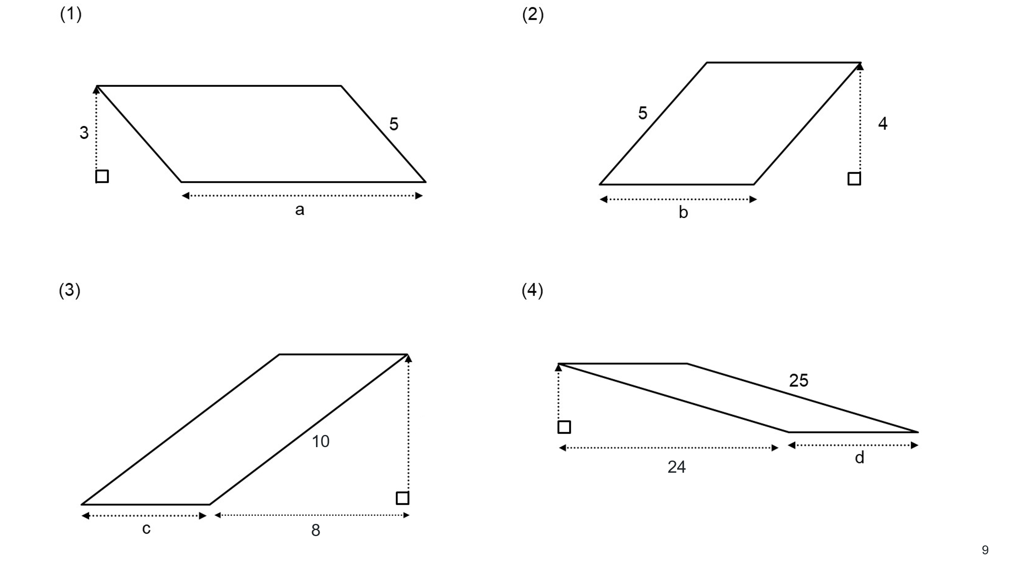

Trapeziums
Construct an isosceles trapezium in which the perimeter and area have values as close as possible. An example of an isosceles trapezium has been given below.
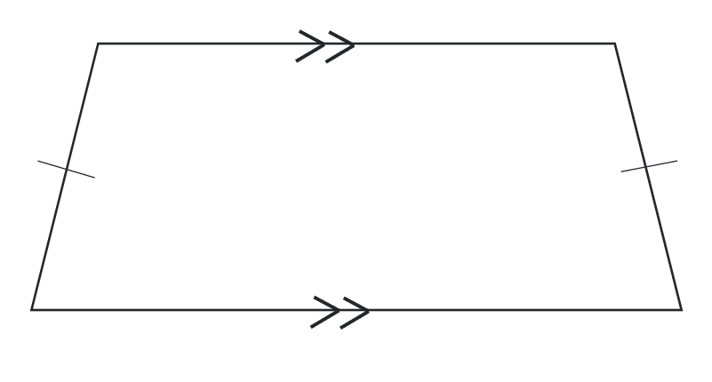

Sample solutions

Appendix A – shapes
Area can be found | Requires Pythagoras’ theorem to calculate the area | Area cannot be found
A, C, F, G, J | B, D, E, H, K | I, L, M
- $6.8×3.2=21.76$ square units
- $c^{2}=a^{2}+b^{2}$$${4.3}^{2}=a^{2}+{2.5}^{2}$$
$${4.3}^{2}-{2.5}^{2}=a^{2} \\ 12.24=a^{2}$$
$$a=\sqrt{12.24} \\ =3.5 units$$
$$c^{2}=a^{2}+b^{2}$$
$$6^{2}=12.24+b^{2} \\ 6^{2}-12.24=b^{2} \\ 23.76=b^{2}$$
$$b=\sqrt{23.76} \\ =4.9 units$$
$\frac{1}{2}×3.5×\left(2.5+4.9\right)=12.95$ square units
- $\frac{1}{2}×3.5×5.6=9.8$ square units
- $c^{2}=a^{2}+b^{2}$$${2.9}^{2}={2.2}^{2}+b^{2} \\ {2.9}^{2}-{2.2}^{2}=b^{2}$$
$$3.57=b^{2} \\ b=\sqrt{3.57} \\ ≈1.89 units$$
$$A=\frac{1}{2}×2.2×\left(3+\left(1.89+3\right)\right)$$$A=20.83$ square units
- $c^{2}=a^{2}+b^{2}$
$${1.3}^{2}={0.9}^{2}+b^{2} \\ {1.3}^{2}-{0.9}^{2}=b^{2}$$
$$0.88=b^{2}$$
$$b=\sqrt{0.88} \\ ≈0.9 units$$
$7.8×0.9=7.02$ square units
- $\frac{1}{2}×2.9×8.1=11.745$ square units
- $3.5×6.7=23.45$ square units
$$c^{2}=a^{2}+b^{2} \\ {7.5}^{2}={4.9}^{2}+b^{2} \\ {7.5}^{2}-{4.9}^{2}=b^{2} \\ 32.24=b^{2} \\ b=\sqrt{32.24} \\ ≈5.7 units$$
$\frac{1}{2}×5.7×4.9=13.965$ square units
- $\frac{1}{2}\left(2.5+6.1\right)×3.1=13.33$ square units

- $5-3.9=1.1$
$$c^{2}=a^{2}+b^{2}$$
$${2.6}^{2}={1.1}^{2}+b^{2} \\ {{2.6}^{2}-1.1}^{2}=b^{2}$$
$$5.55=b^{2}$$
$$b=\sqrt{5.55} \\ ≈2.4 units$$
$\frac{1}{2}\left(3.9+5\right)×2.4=10.68$ square units

Appendix B – non-routine problems

Triangles
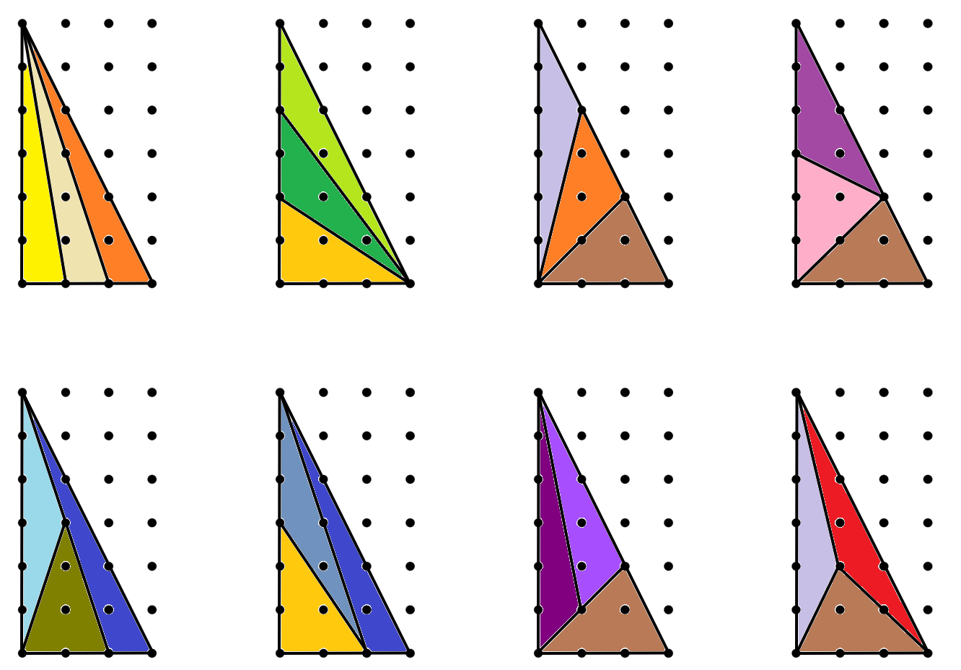

Parallelograms
- $P=2\left(a+5\right), A=5×3=15$
$$15=2\left(a+5\right) \\ 7.5=a+5 \\ 2.5=a$$
- $P=2b+10, A=4b$
$$2b+10=4b \\ 10=2b \\ 5=b$$
- Calculate the perpendicular height:
$$c^{2}=a^{2}+b^{2} \\ {10}^{2}=8^{2}+h^{2}$$
$${10}^{2}-8^{2}=h^{2} \\ 36=h^{2} \\ 6=h$$
$$P=2\left(c+10\right) \\ A=6c$$
$$6c=2\left(c+10\right) \\ 3c=c+10 \\ 2c=10 \\ c=5$$
- Calculate the perpendicular height:
$$c^{2}=a^{2}+b^{2} \\ {25}^{2}={24}^{2}+h^{2}$$
$${25}^{2}-{24}^{2}=h^{2} \\ 49=h^{2} \\ 7=h$$
$$P=2\left(d+25\right) \\ A=7d$$
$$7b=2\left(d+25\right) \\ 7b=2d+50 \\ 5b=50 \\ b=10$$

Trapeziums
Some suggested solutions are below.
Trapezium dimensions
- Top parallel line: 6 units
- Bottom parallel line: 10 units
- Slant height: 5 units
Perpendicular height: 4.6 units
$$c^{2}=a^{2}+b^{2}$$
$$5^{2}=2^{2}+b^{2}$$
$$5^{2}-2^{2}=b^{2}$$
$$21=b^{2} \\ b=\sqrt{21} \\ =4.6$$
Perimeter calculation: $P=6+10+2×5=26$units
Area calculation:
$$Area=\frac{1}{2}×\left(6+10\right)×4.6 \\ =36.8 square units$$
That’s close, but we can do even better.
Let’s adjust slightly to bring the area closer to the perimeter.
Improved trapezium dimensions
- Top parallel line: 6 units
- Bottom parallel line: 9 units
- Slant height: 5 units
Perpendicular height:
$$c^{2}=a^{2}+b^{2}$$
$$5^{2}={1.5}^{2}+b^{2} \\ 5^{2}-{1.5}^{2}=b^{2}$$
$$22.75=b^{2}$$
$$b=\sqrt{22.75} \\ =4.77$$
Perimeter: $P=9+6+5+5=25$
Area: $A=\frac{1}{2}\left(6+9\right)×4.77=35.78$
Second improved trapezium dimensions
- Top parallel line: 6 units
- Bottom parallel line: 9 units
- Slant height: 4 units
Perpendicular height:
$$c^{2}=a^{2}+b^{2}$$
$$4^{2}={1.5}^{2}+b^{2}$$
$$4^{2}-{1.5}^{2}=b^{2}$$
$$13.75=b^{2}$$
$$b=\sqrt{13.75} \\ =3.71$$
Perimeter: $P=9+6+4+4=23$
Area: $A=\frac{1}{2}\left(6+9\right)×3.71=27.83$

References
This resource contains NSW Curriculum and syllabus content. The NSW Curriculum is developed by the NSW Education Standards Authority. This content is prepared by NESA for and on behalf of the Crown in right of the State of New South Wales. The material is protected by Crown copyright.
Please refer to the NESA Copyright Disclaimer for more information https://educationstandards.nsw.edu.au/wps/portal/nesa/mini-footer/copyright.
NESA holds the only official and up-to-date versions of the NSW Curriculum and syllabus documents. Please visit the NSW Education Standards Authority (NESA) website https://educationstandards.nsw.edu.au/ and the NSW Curriculum website https://curriculum.nsw.edu.au/.
Mathematics Standard 11–12 Syllabus © NSW Education Standards Authority (NESA) for and on behalf of the Crown in right of the State of New South Wales, 2024.
Numeracy Stage 6 (CEC) Syllabus © NSW Education Standards Authority (NESA) for and on behalf of the Crown in right of the State of New South Wales, 2021.
Steward D (20 October 2016) ‘triangles cut into triangles’, Don Steward Blogspot, accessed 17 November 2025.
Steward D (27 November 2017) ‘equable parallelograms’, Don Steward Blogspot, accessed 17 November 2025.

© State of New South Wales (Department of Education), 2025
The copyright material published in this resource is subject to the Copyright Act 1968 (Cth) and is owned by the NSW Department of Education or, where indicated, by a party other than the NSW Department of Education (third-party material).
Copyright material available in this resource and owned by the NSW Department of Education is licensed under a Creative Commons Attribution 4.0 International (CC BY 4.0) license.

This license allows you to share and adapt the material for any purpose, even commercially.
Attribution should be given to © State of New South Wales (Department of Education), 2025.
Material in this resource not available under a Creative Commons license:
- the NSW Department of Education logo, other logos and trademark-protected material
- material owned by a third party that has been reproduced with permission. You will need to obtain permission from the third party to reuse its material.
Links to third-party material and websites
Please note that the provided (reading/viewing material/list/links/texts) are a suggestion only and implies no endorsement, by the New South Wales Department of Education, of any author, publisher, or book title. School principals and teachers are best placed to assess the suitability of resources that would complement the curriculum and reflect the needs and interests of their students.
If you use the links provided in this document to access a third-party's website, you acknowledge that the terms of use, including licence terms set out on the third-party's website apply to the use which may be made of the materials on that third-party website or where permitted by the Copyright Act 1968 (Cth). The department accepts no responsibility for content on third-party websites.

