Buy now, pay later
Students examine different buy now, pay later services to justify which one they would use, considering the additional costs or conditions.
Students will need at least one digital device per pair to interact with websites during this lesson.

Learning intention
- To understand the costs associated with buy now, pay later services.

Success criteria
- I can identify and explain potential costs for buy now, pay later services.
- I can calculate the total cost for a buy now, pay later service.
- I can compare buy now, pay later services to justify which is the best suited to a given context.

Outcomes
A student:
- develops understanding and fluency in mathematics through exploring and connecting mathematical concepts, choosing and applying mathematical techniques to solve problems, and communicating their thinking and reasoning coherently and clearly MAO-WM-01
- solves financial problems involving budgeting and purchasing MST-11-04

Associated numeracy outcomes
A student:
- recognises and applies functional numeracy concepts in practical situations, including personal and community, workplace and employment, and education and training contexts N6-1.1
- applies numerical reasoning and mathematical thinking to clarify, efficiently solve and communicate solutions to problems N6-1.2
- determines whether an estimate or an answer is reasonable in the context of a problem, evaluates results and communicates conclusions N6-1.3
- chooses and applies appropriate operations with whole numbers, familiar fractions and decimals, percentages, rates and ratios to analyse and solve everyday problems N6-2.1
- chooses and applies efficient strategies to analyse and solve everyday problems involving money and finance N6-2.4
- chooses and applies appropriate numeracy operations and techniques to analyse and resolve everyday situations N6-2.6
- chooses and uses appropriate technology to analyse and solve problems, represent information and communicate solutions in a range of practical contexts N6-3.2

Content

Managing money
Purchasing goods
- Examine payment options involving buy now, pay later and analyse the costs associated with these services for purchasing goods
- Compare the total cost of using different methods of purchasing goods and justify which method of purchasing is best suited to a given context
Mathematics Standard 11–12 Syllabus © NSW Education Standards Authority (NESA) for and on behalf of the Crown in right of the State of New South Wales, 2024.
Table 1: lesson summary
Section | Summary of activity | Teaching strategies | Teaching points
Activating prior knowledge | Use slide 4 of the PowerPoint Buy now, pay later to complete a ‘Would you rather’ activity. | Pose-Pause-Pounce-Bounce  Think-Pair-Share | Students review their knowledge of buy now, pay later services.
Connecting learning | Students use the Moneysmart website ‘Buy now, pay later service’ (bit.ly/moneysmart-BNPL) to complete a PMI table in Appendix A before researching different services to see how one of the people in the scenarios in Appendix A would be charged. Students then share the fees and costs they came across and compare with another group to decide the best deal. All buy now, pay later services are then collated for students to rank in order of most to least desirable. | Pose-Pause-Pounce-Bounce  Turn and talk | Students research all the fees and costs to compare services.
Releasing responsibility | Students complete a PMI analysis for buy now, pay later services in Appendix C | PMI analysis | Students evaluate the benefits and disadvantages of buy now, pay later services.
Independent practice | Students create their own buy now, pay later service using Appendix D, justifying their choices before applying it to a situation on slide 6 and comparing it to a buying on terms deal. Have students complete the exit ticket in Appendix E. | Gallery walk  Two stars and a wish  Pose-Pause-Pounce-Bounce  Exit ticket | Students apply their knowledge of buy now, pay later services to create their own.

Activity structure
Please use the associated PowerPoint Buy now, pay later to display images in this lesson.

Activating prior knowledge
- Display slide 4 of the PowerPoint, which shows 2 buy now, pay later services.
- Use the Pose-Pause-Pounce-Bounce questioning strategy (PDF 557 KB) (bit.ly/posepausepouncebounce) to gather information on students’ understanding of each of the dot points for each service.
The services on slide 4 involve the following:
- Quick setup: easy for you to join up to the buy now, pay later service.
- Free when you pay on time: no extra costs if you do not miss the payment date.
- Smart limits: set a maximum limit on your account that you can spend.
- Cap late fees: there is a maximum amount you can be charged for paying late.
- Repayment flexibility: you can choose between paying weekly, fortnightly or monthly, also you can pay more than the minimum amount with no extra fees.
- Pay later, interest free: no interest charged and no initial cost.
- Approval in minutes: approval of certain dollar amounts quickly so you can start spending.
- Earn instant cashback: earn cashback when buying with their service and reward partners to use at a later date.
- In a Think-Pair-Share (bit.ly/thinkpairsharestrategy), deepen student thinking by asking them to discuss which service they would rather use as a customer (wouldyourathermath.com/users-guide/) and what other information they would need to make a decision.
The information provided is similar to what is shown on websites for buy now, pay later services. Students should note that there are many other hidden fees and costs associated with these deals as a consumer and as a business.
Students learned about buy now, pay later services in the Stage 5 Financial mathematics A Core outcome MA5-FIN-C-01.

Connecting learning
- Show students the video ‘What to know about BNPL: Buy Now, Pay Later’ (2:08) (https://www.britannica.com/video/buy-now-pay-later-explained/-309641).
- In a Think-Pair-Share, ask students to discuss something surprising or new they learned from watching the video.
Students may state that buy now, pay later services are essentially a short-term loan, often interest-free, but with hidden risks and that using them does not help to build a credit rating and may lead to unseen debt.
- Assign pairs of students a scenario from Appendix A ‘Scenarios’ which contains scenarios of people using buy now, pay later services and incurring a late payment.
There are only 5 scenarios in Appendix A as students with the same scenario will later compare the services they researched.
- In their pairs, ask students to navigate to the Moneysmart webpage ‘Buy now, pay later service’ (bit.ly/moneysmart-BNPL). They are to visit the websites of up to 3 companies from the list under the heading How buy now pay later works to find information about fees, costs and features related to their scenario. Students then calculate the total amount due for the person in their scenario for each of the different companies. These can include but are not limited to:
- account keeping fees
- establishment fees
- late fees
- interest free periods
- caps of late fees
- implications to future loans
- payment fees
- bounced back payment
- payment processing fees.
Students with the same scenario should be encouraged to research different buy now, pay later services from different companies.
Students may need prompts to navigate to different parts of the website to find this information. Students who have researched the same company can compare information and explain how they found it.
A variety of companies should be researched across the class. Assigning students a company will ensure you have a variety of services to compare later in the lesson.
Alternatively, Appendix B ‘Terms and conditions’ can be used for LaterPay and FuturePay, which were used in the ‘Activating prior knowledge’ section of this lesson.
- Use the Pose-Pause-Pounce-Bounce questioning strategy to ask students what fees and costs they found, where they found them and why they think some companies made them harder to find.
Students may note that all hidden fees and potential costs should be stated in the terms and conditions. Some websites might include summarised tables of these on their information pages.
- Ask students to turn and talk (bit.ly/classroomtalkmoves) to share the results of their service research with another pair that was assigned the same scenario. Students should compare the buy now, pay later services they researched and decide which would be the best for a general customer.
Students may need to return to the websites to find any other fees and costs.

Releasing responsibility
- Continuing in their pairs, have students complete a PMI (bit.ly/PMI_plusminusinteresting) about using a buy now, pay later service using Appendix C ‘PMI table’.
- Use the Pose-Pause-Pounce-Bounce questioning strategy to complete a class PMI table.

Independent practice
- Ask students to create their own buy now, pay later service by completing the parameters and justification in Appendix D ‘Buy now, pay later service’. These include the associated fees and costs. Students must justify their choices.
- Students are to give peer feedback on 2 students’ buy now, pay later services using Two stars and a wish (bit.ly/DLSpeerfeedback), focusing on their justification and reasoning for their choices.
- Instruct students to return to their seats and adjust their service from the feedback provided.
- Display slide 6 of the PowerPoint, which shows Wylie’s financial situation. Ask students to find the total amount Wylie pays for his purchase using the buy now, pay later service the students created.
- Have students display their buy now, pay later services around the classroom using adhesive putty.
- Instruct students to calculate the total amount Wylie would pay for his purchase for 3 other buy now, pay later services from the class.
- Animate slide 6 to reveal Wylie’s other option, which was buying on terms. Ask students to calculate the ‘buying on terms option’ for buying the speaker, and then compare the results of the buy now, pay later service with the buying on terms promotional deal.
The deal costs Wylie 100 × 10% = $10 deposit and instalments of 8 × 13 = $104. Total amount charged would be 10 + 104 = $114.
- Use the Pose-Pause-Pounce-Bounce questioning strategy to start a class discussion to compare if it is better to buy on terms or use a buy now, pay later service. Some suggested prompts include:
- What are the benefits of each of these options?
- When would you consider buying on terms over a buy now, pay later service?
- Ask students to complete the exit ticket (bit.ly/exitticketstrategy) in Appendix E ‘HSC-style question’.
This appendix is a modified buy now, pay later services example from Question 20 of NESA’s HSC Mathematics Standard 2 – annotated sample examination materials (bit.ly/standard2-sample-exam).

Assessment and differentiation

Suggested opportunities for differentiation
Activating prior knowledge
- LaterPay and FuturePay options can be modified, added to or restricted to enable students or extend them.
- You could change LaterPay and FuturePay to real buy now, pay later services for students to complete the ‘Would you rather’ activity.
- Provide students with prompts to help them engage with the Think-Pair-Share, such as, ‘What do we think is similar in each of the options?’
Engaging in content
- Appendix A could be adjusted for students with low literacy by simplifying the language, writing in shorter sentences or in dot point form.
- Enable students by having them use highlighters to find important information in the scenarios in Appendix A.
- Students could be supplied with the charges for LaterPay and FuturePay from Appendix B rather than finding their own companies and information on their websites.
- Specific buy now, pay later services could be selected for students to explore if there are specific fees you want students to focus on.
- Students could research the cost to the company when partnering with a buy now, pay later service.
Releasing responsibility
- For less confident students, provide them with prompts to complete the PMI table such as, ‘Would the late fee cap be seen as a strength or a weakness of the buy now, pay later service?’

Independent practice
- Rather than creating their own, students could be given a variety of buy now, pay later services to find Wylie’s total amount paid.
- Students could be provided with a payment schedule showing the breakdown of Wylie’s payments, like seen in the sample question of NESA’s HSC Mathematics Standard 2 – annotated sample examination materials (bit.ly/standard2-sample-exam).
- Students can be challenged to create a deal either buying on terms or as a buy now, pay later service that may mislead customers. This could be seen in their justification.

Suggested opportunities for assessment
Activating prior knowledge
- Students are formatively assessed on their knowledge of buy now, pay later services and the costs associated through discussions and the ‘Would you rather’ activity. The pace and content of the lesson can be adjusted accordingly from the information gained in this activity.
Engaging in content
- Students’ understanding of different fees and costs can be observed when collating the costs found on the websites, particularly when named differently across services.
- Students’ digital literacy is assessed when navigating websites. Students who struggle to use search engines or navigate websites may need to be explicitly taught what to search for and where it may be on a webpage.
- Students ranked lists and justifications can be used as evidence of learning how to compare different methods of purchasing goods.
Releasing responsibility
- Collect Appendix C to see students’ understanding of the positives and negatives of using a buy now, pay later service.
Independent practice
- Collect students’ responses to Appendix D to assess their understanding of the costs associated with buy now, pay later services and comparing them with other services.
- Student’s responses to prompts in this section could gather student understanding of comparing different methods of purchasing goods, given different contexts.

Appendix A

Scenarios
- Sarah recently bought a new laptop costing $1000 using a buy now, pay later service, splitting the cost into several easy payments. Unfortunately, due to a sudden job loss, Sarah's financial situation became tight, and she missed a payment. She didn't have enough funds to cover her instalment on the due date and wasn’t able to get the funds for a month afterwards.
- Alex used a buy now, pay later service to purchase concert tickets costing $150 for an event he was excited about. However, life got busy, and he completely forgot to check the due date for the payment. As a result, his payment was late, causing him to potentially incur a penalty. He paid the account in full the following day.
- Maria planned to buy a pair of shoes for $120 for an upcoming vacation using a buy now, pay later service. When her payment was due, she didn’t realise that she had an automatic subscription charge that drained her account, leaving her with insufficient funds for her instalment. This triggered a missed payment, and her account was flagged as overdue. Maria noticed this the following day and paid the missed instalment.
- James tried to make his buy now, pay later payment through the mobile app for his car insurance of $1300, but his credit card expired, preventing him from completing the transaction. He didn’t receive any notification that the payment had failed and didn't realise until the next week that the payment had not gone through, resulting in a missed payment and extra charges. He did update his card details the following week when the next instalment was drawn from his account.
- Emily bought home essentials using a buy now, pay later service equating to $350, but shortly after she had to undergo an unexpected medical procedure. The costs of her treatment drained her budget, and she didn’t have the extra funds to pay her buy now, pay later instalment on time. As a result, she may face late fees and the possibility of her account being frozen. Emily wasn’t able to pay her account until she was able to work again a few months later.

Appendix B

Terms and conditions

LaterPay terms and conditions
Welcome to LaterPay! These Terms and Conditions govern your use of LaterPay's services. By using LaterPay, you agree to these Terms. Please read them carefully.
Overview | LaterPay offers small loan services that allow users to make purchases and pay later in instalments. Your use of LaterPay constitutes an agreement to these Terms.
Eligibility | To use LaterPay, you must:  - be at least 18 years old  - reside in a supported country  - have a valid payment method  - pass our credit assessment.
Loan Terms | Loan amounts are subject to approval based on credit worthiness to a maximum of $2000.  Payments are divided into 4 equal instalments of 25% of the cost price.  Late payments may incur fees as described in Fees and Charges.
Payment and Repayment | Payments are automatically deducted from your linked payment method.  Early repayments are allowed with no penalties.  Failure to make payments may impact your credit score and result in account restrictions.
Fees and Charges | - Monthly fee: $0  - Purchase interest rate: 0%  - Late payment fee: $10  If you miss a payment, a $10 late fee may apply, and you won’t be able to spend with LaterPay until you have paid the overdue instalments. If late fees are applied, they are capped at:  - 1 late fee per instalment (there are 4 instalments per purchase)  - 2 late fees per purchase  - 1 late fee per day  - 12 late fees per year.
Account Suspension and Termination | LaterPay reserves the right to suspend or terminate your account if:  - fraudulent activity is detected  - payments are repeatedly missed  - terms are violated.
Privacy Policy | We collect and use personal information in accordance with our Privacy Policy.  Your data will not be shared with third parties without consent, except as required by law.
Amendments | LaterPay may modify these Terms at any time. Changes will be effective upon posting on our website.
Contact Us | For questions or support, contact us at:  email: info@laterpay.com  By using LaterPay, you acknowledge and agree to these Terms.

FuturePay terms and conditions
FuturePay allows you to pay for your purchase over 5 instalments, due on the dates outlined in the Payment Schedule for your purchase. In some cases, FuturePay may require you to make a payment at the time of purchase.
- To be eligible to apply to use our Products you must:
- be an individual who is at least 18 years old
- be capable of entering into a legally binding contract
- have a valid and verifiable email address and Australian mobile telephone number
- provide a valid delivery address in Australia
- be the holder of a Card to use as a Payment Method.
- All Orders are subject to FuturePay’s approval – for example, if you have any overdue payments, FuturePay will not be available to you.
- The delivery/quality of goods and services and all refunds are the responsibility of the retailer where you make the purchase or the third-party supplier who supplies the third-party goods available through our platforms.
- You may make early payments, otherwise FuturePay will automatically process payments in accordance with the due date stated on your Payment Plan. If a payment is not processed on or before the due date, late fees will apply.
- No interest charges are payable by you for the use of our products.
- The FuturePay subscription fee is $9.99/month.
- If you fail to pay according to the Payment Plan, late fees will apply on each payment that is due but not received. Late Fees will not be applied until the day immediately following the day that the payment is due.
We may delay the application of, or waive wholly or partly, any late fee at our discretion. If late fees are incurred as a result of FuturePay’s error, please let us know, and we will waive or refund such fees.
We apply maximum Late Fee caps according to the following table:
Original order value | Applicable late fee:
$40 or below | One late fee of 25% of the original order value when you first fail to make a payment in accordance with your payment plan.
Above $40 | For each order, the sum of late fees will be capped at the lower of 25% of the original order value or $58.  Up to this maximum cap, for each late payment we will charge:  - an initial $10 late fee if you fail to make a payment in accordance with your Payment plan, plus  - a further $6 late fee if the late payment remains unpaid 7 days after your payment was due.
Please read these Terms carefully as they impose rules, obligations and other responsibilities on you in respect of your use of, and access to, our products. You should print a copy of these Terms for your records.

Appendix C

PMI table
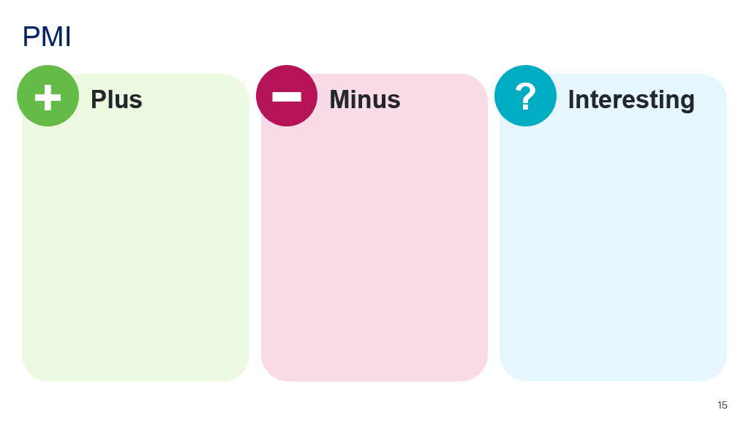

Appendix D

Buy now, pay later service
Features | Details
Service name
Establishment fee
Account keeping fee
Late fees
Late fee cap
Other fees or costs
Justification:

Appendix E

HSC-style question
Kimberley uses a buy now, pay later payment option to make a purchase of $100. Her repayments are split across 4 equal payments over 6 weeks. No interest is charged.
Kimberley misses her final payment and is charged a late fee of $17. Kimberley’s payment schedule is shown, with her balance totalling $42. 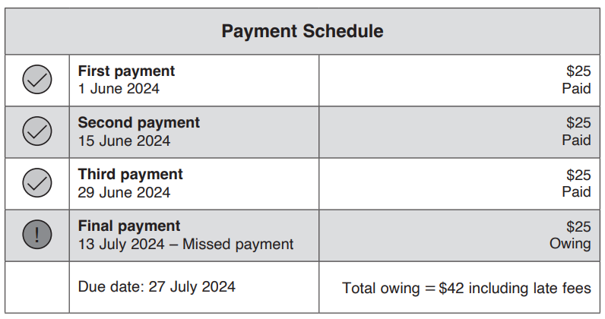
      - Find the total amount Kimberley pays for her purchase if repaying in full on 27 July 2024.
      - Kimberley’s retailer offered buying on terms where she could have paid a 5% deposit and $13 per week for 8 weeks for the same item. Would it be better to ask if this would have been a better option for Kimberley? Justify your response.

Sample solutions

Appendix A and C
Name | LaterPay | FuturePay
Sarah | Instalment amount: $1000 ÷ 4 = $250 each.  Missed one instalment payment, missed for a month (assume only one missed instalment charged late fee of $10 for one missed instalment).  One missed instalment + late fee: $250 + $10 = $260 owed immediately.  Remaining 3 instalments: $250 × 3 = $750.  Total due: $260 + $750 = $1010. | 5 instalments: $1000 ÷ 5 = $200 each.  Missed one instalment payment for a month.  Late fees for each missed instalment: $10 immediately + $6 after 7 days = $16 total per missed instalment.  Maximum late fees capped at 25% of order value or $58, so maximum late fees = $58.  Total owed = $1000 + $58 late fees + subscription fees (assuming one month = $9.99) = $1067.99.
Alex | Instalment amount: $150 ÷ 4 = $37.50 each.  Payment late by one day but paid full balance next day.  Late fee applies if payment missed the due date, so one late fee: $10.  Total due = $150 + $10 late fee = $160. | 5 instalments = $150 ÷ 5 = $30 each.  Missed payment by one day, paid next day (so late fee applies).  Late fee: $10 (no 7-day additional fee since paid next day).  Max late fees cap = 25% of $150 = $37.50 (not reached here).  Total owed = $150 + $10 late fee + subscription fee (one month) = $169.99.
Maria | Instalment amount: $120 ÷ 4 = $30 each.  Missed payment for one instalment, paid the next day.  Late fee applies: $10 for missed instalment.  Total due = $120 + $10 late fee = $130. | 5 instalments = $120 ÷ 5 = $24 each.  Missed one instalment, paid next day.  Late fee: $10 only.  Late fees cap = 25% × $120 = $30 (not reached here).  Total owed = $120 + $10 late fee + subscription fee = $139.99.
James | Instalment amount: $1300 ÷ 4 = $325 each.  Missed payment, didn't realise until next week (late by approximately 7 days).  One late fee: $10  Total due = $1300 + $10 late fee = $1310. | 5 instalments = $1300 ÷ 5 = $260 each  Missed one instalment payment for ~7 days.  Late fees: $10 immediate + $6 after 7 days = $16.  Late fees cap = 25% × $1300 = $325 (capped at $58 per terms, since max $58 or 25%, whichever is lower) → Maximum late fee = $58.  Total owed = $1300 + $16 late fees (only one instalment missed, so $16 < cap) + subscription fee = $1315.99.
Emily | Instalment amount: $350 ÷ 4 = $87.50 each.  Missed payment(s) for several months (assume 3 instalments missed).  Late fees capped at 2 per purchase, so maximum late fees = $20.  Total due = $350 + $20 late fees = $370. | 5 instalments = $350 ÷ 5 = $70 each.  Missed 3 instalments over a few months.  Late fees for each instalment: $10 + $6 = $16.  Total late fees if all 3 missed = $16 × 3 = $48.  Late fees cap = 25% × $350 = $87.50 (or $58 whichever is lower, so maximum late fees = $58).  Late fees capped at $58.  Total owed = $350 + $58 late fees + subscription fees for the months missed (assume 3 months): $9.99 × 3 = $29.97.  Total: $350 + $58 + $29.97 = $437.97.

Appendix C – PMI table
Plus: no interest, budget friendly as payments are week to week or an agreed time frame.
Minus: easy to overspend, fees can add up, having multiple services at one time can make it confusing and might affect loan applications and credit reports.
Interesting: there are many services, there are different fees for different services, you can set limits.

Appendix E – HSC-style question
            - 25 + 25 + 25 + 42 = $117.
            - 100 × 0.05 = 5
13 × 8 = 104
104 + 5 = $109
Kimberly would have saved $8 if buying on terms instead of using the buy now, pay later option.

References
This resource contains NSW Curriculum and syllabus content. The NSW Curriculum is developed by the NSW Education Standards Authority. This content is prepared by NESA for and on behalf of the Crown in right of the State of New South Wales. The material is protected by Crown copyright.
Please refer to the NESA Copyright Disclaimer for more information https://educationstandards.nsw.edu.au/wps/portal/nesa/mini-footer/copyright.
NESA holds the only official and up-to-date versions of the NSW Curriculum and syllabus documents. Please visit the NSW Education Standards Authority (NESA) website https://educationstandards.nsw.edu.au and the NSW Curriculum website https://curriculum.nsw.edu.au.
Mathematics Standard 11–12 Syllabus © NSW Education Standards Authority (NESA) for and on behalf of the Crown in right of the State of New South Wales, 2024.

© State of New South Wales (Department of Education), 2025
The copyright material published in this resource is subject to the Copyright Act 1968 (Cth) and is owned by the NSW Department of Education or, where indicated, by a party other than the NSW Department of Education (third-party material).
Copyright material available in this resource and owned by the NSW Department of Education is licensed under a Creative Commons Attribution 4.0 International (CC BY 4.0) license.

This license allows you to share and adapt the material for any purpose, even commercially.
Attribution should be given to © State of New South Wales (Department of Education), 2025.
Material in this resource not available under a Creative Commons license:
- the NSW Department of Education logo, other logos and trademark-protected material
- material owned by a third party that has been reproduced with permission. You will need to obtain permission from the third party to reuse its material.
Links to third-party material and websites
Please note that the provided (reading/viewing material/list/links/texts) are a suggestion only and implies no endorsement, by the New South Wales Department of Education, of any author, publisher, or book title. School principals and teachers are best placed to assess the suitability of resources that would complement the curriculum and reflect the needs and interests of their students.
If you use the links provided in this document to access a third-party's website, you acknowledge that the terms of use, including licence terms set out on the third-party's website apply to the use which may be made of the materials on that third-party website or where permitted by the Copyright Act 1968 (Cth). The department accepts no responsibility for content on third-party websites.

