Budgeting
Students will prepare a personal budget using a spreadsheet and use their budget to make informed financial decisions.
Students will need at least one digital device per pair to interact with websites and a spreadsheet during this lesson.
Learning intentions and success criteria should be shared with students later in the lesson.

Learning intention
- To know how to prepare a personal budget.

Success criteria
- I can define ‘fixed’ and ‘discretionary’ spending.
- I can use a spreadsheet to create a budget.
- I can explain the need for an emergency fund and how to establish one.
- I can use my budget to make decisions about spending.

Outcomes
A student:
- develops understanding and fluency in mathematics through exploring and connecting mathematical concepts, choosing and applying mathematical techniques to solve problems, and communicating their thinking and reasoning coherently and clearly MAO-WM-01
- solves financial problems involving budgeting and purchasing MST-11-04

Associated numeracy outcomes
A student:
- recognises and applies functional numeracy concepts in practical situations, including personal and community, workplace and employment, and education and training contexts N6-1.1
- applies numerical reasoning and mathematical thinking to clarify, efficiently solve and communicate solutions to problems N6-1.2
- chooses and applies efficient strategies to analyse and solve everyday problems involving money and finance N6-2.4
- chooses and applies appropriate numeracy operations and techniques to analyse and resolve everyday situations N6-2.6
- chooses and uses appropriate technology to analyse and solve problems, represent information and communicate solutions in a range of practical contexts N6-3.2

Content

Managing money
Budgeting
- Prepare a personal budget for a given income, considering fixed and discretionary spending
- Use a spreadsheet to model personal and household budgets
- Examine budgeting, saving, establishing an emergency fund with 3 to 6 months of living expenses, and monitoring spending as strategies designed to minimise financial problems
Mathematics Standard 11–12 Syllabus © NSW Education Standards Authority (NESA) for and on behalf of the Crown in right of the State of New South Wales, 2024.
Table 1: lesson summary
Section | Summary of activity | Teaching strategies | Teaching points
Activating prior knowledge | Students use Appendix A to categorise costs into income and expenses before estimating their costs. Pose questions to guide students to think about how spending compares to income and how this information can support financial decision-making. Reveal the learning intentions and success criteria on slide 3 of the PowerPoint Budgeting. | Think-Pair-Share  Pose-Pause-Pounce-Bounce | Students demonstrate their understanding of a variety of living costs and incomes.
Connecting learning | Show students the YouTube video ‘What is a Budget’ (2:22) (bit.ly/what-is-a-budget) up to 1:13. Use slide 5 to define types of expenses before having students further categorise their card list.  Students download (bit.ly/BudgetPlannerSpreadsheet) and fill it in for the average household using NSW EduChat (chat.education.nsw.gov.au) to help with estimates. Students discuss features of the budget planner and its graph before modifying for what-if scenarios in Appendix C. | Pose-Pause-Pounce-Bounce  Think-Pair-Share | Students develop an understanding of fixed and discretionary expenses. Students complete a budget spreadsheet and use it to make financial decisions.
Releasing responsibility | Introduce an emergency fund as savings that cover 3–6 months of living expenses. Students discuss and calculate their personal emergency fund amount using their budget spreadsheets.  Students discuss who would have larger emergency funds and why, before calculating how long it would take to establish one.  Students then use slide 7 as a guide to write notes. | Think-Pair-Share  Pose-Pause-Pounce-Bounce  Notes to future forgetful selves | Students learn how to calculate the amount needed for an emergency fund using a budget and how long it would take for them to establish one.
Independent practice | Students receive a financial case study describing Lisa’s financial situation (Appendix D) to create a budget, including how long it would take them to save an emergency fund and providing advice on how Lisa can save more. | Pose-Pause-Pounce-Bounce | Students apply their knowledge to show their learning in the lesson and provide financial advice.

Activity structure
Please use the associated PowerPoint Budgeting to display images in this lesson.

Activating prior knowledge
- Distribute Appendix A ‘Income and expenses’ to pairs of students.
- In a Think-Pair-Share (bit.ly/thinkpairsharestrategy), ask students to categorise the cards into income or expenses.
- Ask pairs to estimate the amount an individual would receive or pay for each of the scenarios given on the cards in Appendix A. Students should also determine how often it would be received or paid and write both sets of information on their cards.
For example, on the electricity bill card, students may write down $300 per quarter.
- Use the Pose-Pause-Pounce-Bounce questioning strategy (PDF 557 KB) (bit.ly/posepausepouncebounce) to initiate a class discussion and pose the following questions:
- How can we use the information on the cards to find out how much we are spending?
- How can we use the information on the cards to help us make financial decisions?
Students should suggest creating a budget.
- Reveal the learning intentions and success criteria on slide 3 of the PowerPoint.

Connecting learning
- Show students the YouTube video ‘What is a Budget’ (2:22) (bit.ly/what-is-a-budget) up to 1:13.
- Conduct a class discussion asking students what they think are the key pieces of information from the video.
- Display slide 5 of the PowerPoint to show the definitions of fixed and discretionary spending.
- Ask student pairs to return to their cards and further categorise their expenses into fixed and discretionary spending.
- Undertake a class discussion, randomly asking a few pairs to explain and justify their choices.
- With a device between pairs of students, ask students to download the budget planner spreadsheet from the ‘Moneysmart’ website ‘Budget planner’ (bit.ly/BudgetPlannerSpreadsheet).
Teachers will also need to display the budget planner on their screens to be able to demonstrate and support students.
Appendix B ‘Budget spreadsheet download and share instructions’ has been provided to show how to download and share files from this lesson.
- Instruct students to fill in the income and expenses on the budget spreadsheet for the average family household or their own personal household. Students can estimate values based on their prior knowledge and experiences.
Students could use the averages they calculated in Lesson 16 – living costs to populate some of the household bills in this section.
- Demonstrate to students how they can change the time frequency of the budget in cell G9 to monthly, weekly and so on.
- In a Think-Pair-Share, ask students how they think the spreadsheet changes the dollar amounts when they select the different time periods.

Depending on the students’ knowledge of spreadsheets, they may suggest that an IF statement or VLOOKUP table would be used, depending on what is selected in the Frequency column (E) and View cell (G9). If students are ready and want to advance their spreadsheeting skills, this could be introduced in this section; otherwise, simple calculations would be acceptable as an answer.
- Instruct students to compare the graphs generated on their budget spreadsheets with another pair. Ask students to consider the following questions:
- How does the graph help us to understand our financial situation?
- Are the budgets in surplus? What does this mean?
- Which categories have the largest number of expenses? How can this information help us?
- Are there any savings listed? What is the benefit of placing savings in the budget?
Student discussions should reflect that the graph helps us to interpret the information from the budget spreadsheet and provides a discussion starting point about their financial situation.
- Distribute Appendix C ‘What if scenarios’, for students to investigate and discuss in pairs.
Students should be encouraged to modify their spreadsheets to explore available options. The purpose of these questions is for students to establish that discretionary spending is the first thing to remove to avoid financial problems, then potentially find cheaper options for fixed spending, such as cheaper groceries.
The last question highlights the importance of creating an emergency fund, as having no income results in a negative budget, making it impossible to cover expenses without savings.
- Use the Pose-Pause-Pounce-Bounce questioning strategy for students to share ideas and reasoning for some of the scenarios they explore in Appendix C.
Teachers should choose scenarios that have generated a variety of different approaches to reflect different priorities.

Releasing responsibility
- State to students that financial advisors recommend that people save 3–6 months of living expenses as an emergency fund.
- In a Think-Pair-Share, ask students:
- What emergencies could happen that would warrant having an emergency fund?
- Why do you think they suggest 3–6 months of living expenses for an emergency fund?
- How do you think you would calculate the amount needed for your emergency fund?
Students may state that losing your job or having a leave of absence from work, including a medical emergency, may be considered. They may also state that appliances or items needed to live, such as a fridge or washing machine, may break and need to be replaced straight away.
The time of 3–6 months usually covers the cost of most scenarios. Teachers may need to explain that money in a normal savings account doesn’t earn any or very little interest, so further funds should be invested elsewhere to generate more income.
Students may state that to calculate the amount in an emergency fund, we need to add all our living expenses and multiply them by the number of months required, 3 months for the minimum and 6 months for the maximum.
- Ask students to calculate the amount needed for their emergency fund from their spreadsheet.
- Ask students to use their budgets to determine how long it would take to save the minimum emergency fund amount.
- Conduct a class discussion, randomly asking pairs of students to share their strategy for saving an emergency fund.
Students may suggest finding the surplus annual income from their budget or their allocated savings and dividing that amount by the amount needed for the emergency fund to find the time it will take to save for it.
- Display slide 7 of the PowerPoint and ask students to use the prompting questions to write notes to their future forgetful selves.

Independent practice
- Provide pairs of students with Appendix D ‘Case study’, which outlines Lisa’s financial profile.
- Ask students to:
- create a budget for Lisa using the budget planner or by creating their own spreadsheet
- calculate the amount Lisa needs to save to establish an emergency fund and how long it will take
- provide Lisa with advice on where she could save money in her spending and expenses from her budget.
- Use the Pose-Pause-Pounce-Bounce questioning strategy for students to share the advice they provided to Lisa to help her save money.

Assessment and differentiation

Suggested opportunities for differentiation
Activating prior knowledge
- Students from non-English speaking backgrounds may benefit from using pictures or icons to represent common expenses.
- Encourage students to add to the cards and think beyond typical expenses, including irregular or unexpected costs, for example, car registration, which is only paid yearly, or emergency medical bills.
- Provide a range of typical costs for each category to help guide estimates.
- Use a collaborative digital tool such as Microsoft Office apps or Padlet (padlet.com) to record expenses in real time, enabling participation without the pressure of speaking aloud.
Connecting learning
- Encourage debate on ambiguous expenses, such as car expenses, to develop critical thinking.
- Provide sentence starters to help students explain their reasoning (for example, ‘I think this is discretionary because ...’).
- Students can be encouraged to create their own budget spreadsheet rather than using the one provided.
- Students may benefit from further question prompts to help interpret graphs.
- Students can be challenged to create their own ‘what if’ scenario.

Releasing responsibility
- Provide real-life scenarios/examples to explain emergencies (for example, losing a job, car breakdown).
- Provide guided examples or a step-by-step checklist on how to calculate the amount needed for an emergency fund.
- Offer practice problems with sample numbers before applying to their own budgets.
- Challenge them to explore strategies to increase savings rate or reduce time needed, for example, budgeting adjustments, income sources.
Independent practice
- For students creating their own spreadsheets, direct them to help pages on formulas they may use, such as IF statements and drop-down lists.
- Encourage students to use correct terminology from the lesson when explaining where Lisa can save more money.

Suggested opportunities for assessment
Activating prior knowledge
- Monitor student engagement and the relevance/accuracy of listed expenses.
- Prompts in this section will show students' prior knowledge of budgeting.
Connecting learning
- During categorisation and discussion of fixed versus discretionary spending, note students’ ability to justify their choices.
- Students provide oral responses to what-if scenarios and justify their budget adjustments and choices demonstrating their reasoning skills and their ability to make financial decisions using a budget.
Releasing responsibility
- Review students’ emergency fund calculations for accuracy.
- Collect and review notes to their future forgetful selves for comprehension of budgeting, spending categories and emergency fund concepts.
Independent practice
- Review budgets for accuracy, completeness and appropriate categorisation.
- Students’ responses to how Lisa can save money will show their understanding of fixed and discretionary expenses and which can be reduced to save more money.
- Review students’ calculations for an emergency fund as evidence of learning how to establish one.

Appendix A

Income and expenses
Groceries | Mortgage/rent | Car insurance
Bonuses | Furniture/appliances | Car loan repayments
Internet | Electricity bill | Charity donations
Interest from savings/investments | Centrelink payments | Take-home pay
Water bill | Overtime | Clothing
Eating at restaurants | Mobile phone plan | Sports
Car registration | Childcare | Excursions

Appendix B

Budget spreadsheet download and share instructions

Download instructions
In preparation, teachers need to download the budget planner spreadsheet from the Moneysmart website ‘Budget planner’ (bit.ly/BudgetPlannerSpreadsheet) to share with their students. Alternatively, if you use Microsoft 365 or Microsoft Teams, you can provide these instructions directly to students to save to their OneDrive.
- Select the Excel spreadsheet link on the Budget planner webpage. This will download the spreadsheet to your device.
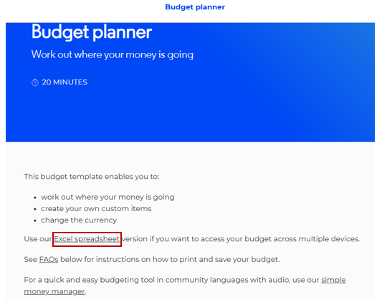

File sharing and saving
- Save the Excel file budget-planner_moneysmart in a place where students can easily access the file.
This could be done through Google Classroom, by sharing a OneNote link, or by emailing students a copy of the document.
- Have students open the document on their own device.
- Instruct students to select the File tab and then Save a Copy.
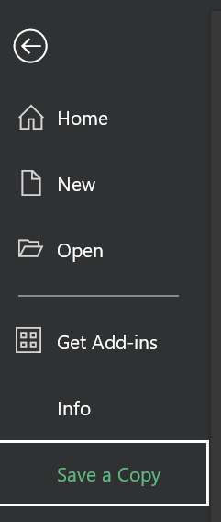
- Students can save the document in their individual OneDrive by selecting this option.
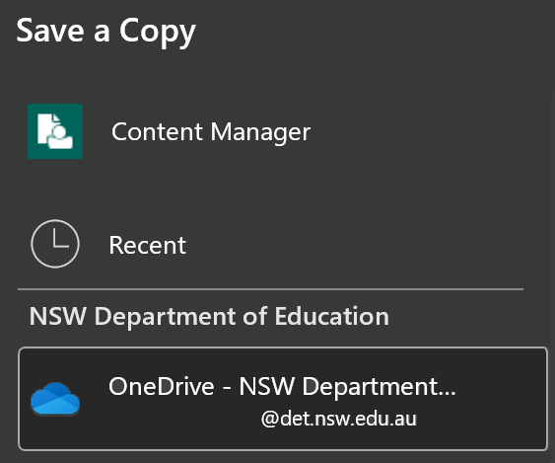
- Best practice would be to keep the file name the same. Students can then select Save and a copy will be stored on their OneDrive.
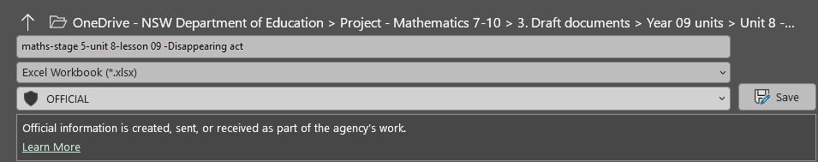

Appendix C

‘What if’ scenarios
- What if you had an unexpected expense this month, how would you adjust your budget?
- What if your income suddenly decreased by 20%, what expenses could you reduce or eliminate?
- What if you planned to save for a big purchase, how would you change your spending habits?
- What if you received a bonus or extra income, how would you allocate it between spending, saving and debt?
- What if your rent or housing costs increased, what would you prioritise cutting back on?
- What if you tracked all your expenses for a month, what surprises might you find and how would that change your budget?
- What if you lost your job, how would that affect your budget and how long could you survive without income?

Appendix D

Case study
Create a budget for Lisa using the budget planner or by creating your own spreadsheet.
Use the budget or spreadsheet to provide advice on:
- the amount of money Lisa needs to save to establish an emergency fund and how long it will take
- where she could save money on her spending and expenses from her budget.

Profile
Lisa is a 28-year-old marketing coordinator living in a mid-sized city. She rents an apartment and enjoys a balanced lifestyle with some entertainment and savings goals.
Lisa earns a monthly salary (after tax) of $5584. She has investments that also give her around $33 per month. She has expenses which include:
- Rent: $600 per week
- Utilities (electricity, water): $750 per quarter (every 3 months)
- Internet and phone: $100 per month
- Groceries: $100 per week
- Transportation: $40 per week
- Health insurance: $200 per month
- Entertainment: $150 per week
- Gym membership: $240 per month
- Miscellaneous (clothes, personal care, subscriptions): $250 per month
- Savings goal: $80 per week (for a holiday)
- HECS debt: voluntary payment of $220 per month.

Sample solutions

Appendix A – income and expenses
Note: some students may argue that bills such as water, electricity and groceries are discretionary as you choose how much you use, but it is still something that is essential or mandatory and have some costs associated even though that cost varies.
Income | Fixed spending | Discretionary spending
Take-home pay  Bonuses  Overtime  Interest from savings/investments  Centrelink payments | Mortgage/rent  Water bill  Electricity bill  Internet  Mobile phone plan  Car insurance  Car loan repayments  Car registration  Childcare  Groceries | Eating at restaurants  Furniture/appliances  Charity donations  Clothing  Sports  Excursions

Appendix D – case study – Lisa’s budget
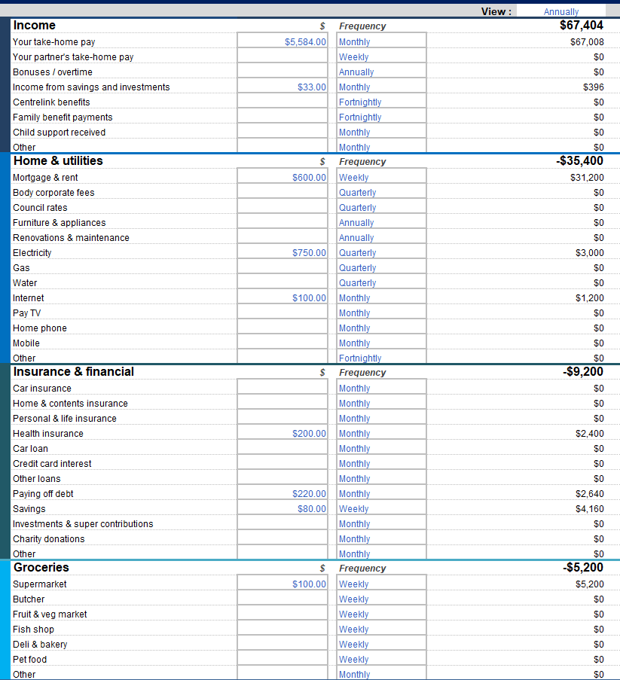
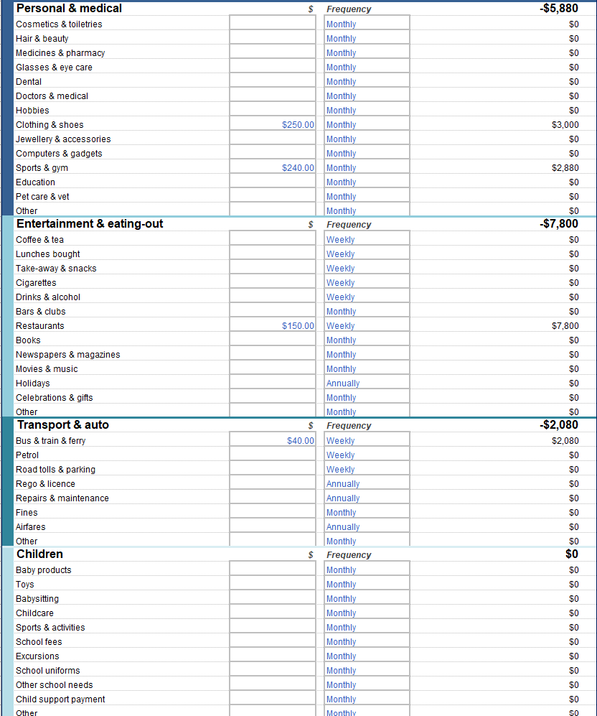
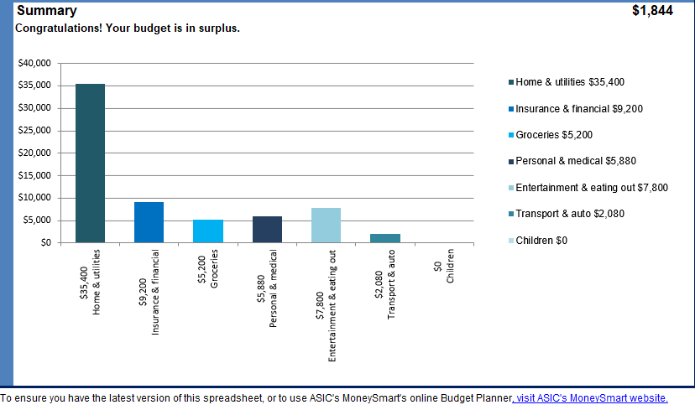
Annually, Lisa can save $1844 if she sticks to her current budget. Her annual expenses amount to $65 560 (this includes $4160 in savings for a holiday). She will need at least $\$65560÷4=\$16390$ for an emergency fund.
Considering she has a surplus of $1844 per year, $\frac{\$16390}{\$1844}≈8 years and 10 months$ she would need to be saving for nearly 9 years to save up the minimum amount for an emergency fund.
If we just include expenses and leave out savings and paying off HECS debt, her annual expenses are $58 760. She will need at least $\$58760÷4=\$14690$ for an emergency fund.
Considering she has a surplus of $1844 per year, $\frac{\$14690}{\$1844}≈8 years$. She would need to be saving for 8 years to save up the minimum amount for an emergency fund.
Lisa can save in many places in her budget. Some suggestions are:
- search around if a cheaper provider exists for her utilities, phone, internet and health insurance
- avoid making voluntary payments for her HECS debt
- put less savings towards a holiday
- spend less on things like clothing and shoes and put $50 a month towards savings instead
- get rid of her gym membership and run outside and use household items to exercise
- spend less on entertainment or budget the same amount for a fortnight rather than a week.

References
This resource contains NSW Curriculum and syllabus content. The NSW Curriculum is developed by the NSW Education Standards Authority. This content is prepared by NESA for and on behalf of the Crown in right of the State of New South Wales. The material is protected by Crown copyright.
Please refer to the NESA Copyright Disclaimer for more information https://educationstandards.nsw.edu.au/wps/portal/nesa/mini-footer/copyright.
NESA holds the only official and up-to-date versions of the NSW Curriculum and syllabus documents. Please visit the NSW Education Standards Authority (NESA) website https://educationstandards.nsw.edu.au and the NSW Curriculum website https://curriculum.nsw.edu.au.
Mathematics Standard 11–12 Syllabus © NSW Education Standards Authority (NESA) for and on behalf of the Crown in right of the State of New South Wales, 2024.

© State of New South Wales (Department of Education), 2025
The copyright material published in this resource is subject to the Copyright Act 1968 (Cth) and is owned by the NSW Department of Education or, where indicated, by a party other than the NSW Department of Education (third-party material).
Copyright material available in this resource and owned by the NSW Department of Education is licensed under a Creative Commons Attribution 4.0 International (CC BY 4.0) license.

This license allows you to share and adapt the material for any purpose, even commercially.
Attribution should be given to © State of New South Wales (Department of Education), 2025.
Material in this resource not available under a Creative Commons license:
- the NSW Department of Education logo, other logos and trademark-protected material
- material owned by a third party that has been reproduced with permission. You will need to obtain permission from the third party to reuse its material.
Links to third-party material and websites
Please note that the provided (reading/viewing material/list/links/texts) are a suggestion only and implies no endorsement, by the New South Wales Department of Education, of any author, publisher, or book title. School principals and teachers are best placed to assess the suitability of resources that would complement the curriculum and reflect the needs and interests of their students.
If you use the links provided in this document to access a third-party's website, you acknowledge that the terms of use, including licence terms set out on the third-party's website apply to the use which may be made of the materials on that third-party website or where permitted by the Copyright Act 1968 (Cth). The department accepts no responsibility for content on third-party websites.

