Living costs
Students interpret and calculate household living costs through real utility bills and cost-saving scenarios. Students engage in financial decision-making tasks that require them to apply mathematical reasoning and justify their conclusions.

Learning intentions
- To be able to read household bills.
- To understand how household costs are calculated.

Success criteria
- I can interpret information from water, gas and electricity bills.
- I can calculate the amount owed on a household bill.
- I can explain how to calculate annual household costs.
- I can compare the costs of an electricity, water or gas alternative.

Outcomes
A student:
- develops understanding and fluency in mathematics through exploring and connecting mathematical concepts, choosing and applying mathematical techniques to solve problems, and communicating their thinking and reasoning coherently and clearly MAO-WM-01
- solves financial problems involving budgeting and purchasing MST-11-04

Associated numeracy outcomes
A student:
- recognises and applies functional numeracy concepts in practical situations, including personal and community, workplace and employment, and education and training contexts N6-1.1
- determines whether an estimate or an answer is reasonable in the context of a problem, evaluates results and communicates conclusions N6-1.3
- chooses and applies appropriate operations with whole numbers, familiar fractions and decimals, percentages, rates and ratios to analyse and solve everyday problems N6-2.1
- chooses and applies efficient strategies to analyse and solve everyday problems involving money and finance N6-2.4
- chooses and applies appropriate numeracy operations and techniques to analyse and resolve everyday situations N6-2.6

Content

Managing money
Budgeting
- Calculate household costs including electricity, water and gas usage from household bills
Mathematics Standard 11–12 Syllabus © NSW Education Standards Authority (NESA) for and on behalf of the Crown in right of the State of New South Wales, 2024.
Table 1: lesson summary
Section | Summary of activity | Teaching strategies | Teaching points
Activating prior knowledge | Students brainstorm types of common household bills and classify them as a fixed or variable cost. Using slides 4 and 5 of the PowerPoint Living costs, students interpret information from electricity and gas usage graphs to identify trends. | Think-Pair-Share  Data talk | Check for student understanding of what household bills are and if they vary depending on usage.
Connecting learning | Using Appendix A, in expert groups, students analyse an electricity, gas or water bill. They then regroup to share findings and identify common features across bills. Use slide 7 to explain the features of fixed costs and usage charges in a bill. Use slides 8–9 to explain a tariff. | Visibly random groups of 3  Jigsaw groups  Pose-Pause-Pounce-Bounce  Vertical non-permanent surfaces | Identify common features of household bills.  Highlight fixed and usage charges, as well as time of use or seasonal tariffs.
Releasing responsibility | Use slides 11–12 for students to complete a worked example. Distribute Appendix B for students to practise calculating the cost of electricity using tariff pricing before having a class discussion around why different geographical regions have different pricing structures. Using Appendix C, students calculate household costs based on a variety of household bills. Students then predict the effect of increasing the number of people in a household before looking at how the increase affects household bills. | Worked example (Your turn)  Visibly random groups of 3  Vertical non-permanent surfaces  Pose-Pause-Pounce-Bounce | Students can communicate their reasoning as to why electricity prices vary based on geographical regions. Students identify that as the household size increases, some parts of household bills will increase while others will remain constant.
Independent practice | Using Appendix D, groups select a real-world scenario and then calculate and justify the better financial decision. | Visibly random groups of 3  Vertical non-permanent surfaces | Compare options and justify choices using both calculations and reasoning.

Activity structure
Please use the associated PowerPoint Living costs to display images in this lesson.

Activating prior knowledge
- Facilitate a class discussion to brainstorm types of household bills students are familiar with. Record their contributions on the board to create a shared list.
Students may be aware of bills such as electricity, water and gas, as well as other household costs such as internet, council rates or rent. If students have not already mentioned these items, prompt them to consider other common household expenses such as internet, council rates or rent.
- In a Think-Pair-Share (bit.ly/thinkpairsharestrategy), ask students to classify each bill as either fixed or variable and justify their response.
Students should identify that bills such as electricity, water and gas are variable, as they depend on usage, while bills such as internet, council rates and rent are fixed.
- Use slide 4 of the PowerPoint to display the graph of electricity usage from a household bill. Explain to students that electricity usage is measured in kilowatt-hours which is shown on the $y$-axis. Kilowatt-hours is the number of kilowatts of electricity used per hour. Lead a data talk (bit.ly/supportingstrategies) by prompting students to:
- describe what the graph shows
- discuss any patterns or trends they observe
- suggest possible reasons for these patterns.

Students may suggest that usage varies each month with the highest usage between November and January and the lowest usage in June and July. Students may assume this is because people are using air conditioning over the hotter months. They may also consider why usage in August is higher than July or September.
Students are familiar with interpreting graphs from the Stage 4 Data classification and visualisation outcome MA4-DAT-C-01.
- Explain to students that the next slide will display a graph of gas usage for the same household. Explain to students that gas usage is measured in megajoules which is shown on the $y$-axis. Ask students in a Think-Pair-Share to predict if gas usage will be the same as electricity. Why or why not?
- Display the graph on slide 5 that shows gas usage from the same household as the electricity graph and ask students to notice and wonder (bit.ly/noticewonderstrategy) the difference between electricity usage and gas usage.
Students may notice that when electricity usage was low in June and July, gas usage was high and wonder why this is the case. Students may suggest that higher gas usage in winter is due to increased use of gas heaters and gas hot water systems.

Connecting learning
- Assign students to visibly random group of 3 (bit.ly/visiblegroups) and distribute each group one bill from Appendix A ‘Utility bills’. Explain to the class that for their bill, they will be analysing its key features, including due dates, amount due, usage and fixed charges.
Each student in the group will need a copy of the bill they are analysing.
Students should identify features such as due dates and amount due, usage and fixed charges, as well the infographics on bills. Teachers may wish to ask prompting questions such as:
- How do you know how much to pay and when?
- How do you know how much you have used this billing cycle?
- What information do the graphs provide?
- Find another group with the same bill and share their interpretation of the features. Provide time to refine the answers.
- Regroup students so that each new group includes one person who looked at the electricity bill, one who looked at the gas bill and one who looked at the water bill. Have them discuss the features of their bills to identify common features.
This activity is a jigsaw task (bit.ly/jigsawgroupstrategy) where each member of the group learns something from a different utility bill and brings it back to their group.
- Return students to their original group to share what they have learned about the features of each bill using the following prompts:
- Were there any key terms that are common in each bill?
- How is usage measured for each bill?
- What information does the graph provide for each bill? How does that inform usage?
- In a Pose-Pause-Pounce-Bounce (PDF 557 KB) (bit.ly/posepausepouncebounce), lead a discussion to check for understanding of features on a bill.
- Click to animate slide 7 of the PowerPoint to show students that in electricity, gas and water bills, there are fixed charges and usage charges. Lead a class discussion to check for understanding around why there are fixed and usage charges. Some prompts could include:
- Where are the fixed and usage charges displayed on bills?
- Why do you think there are fixed and usage charges in bills?
- How are the fixed charges calculated?
- How are usage charges calculated?
There are 2 animations on slide 7, one to highlight fixed charges and one to highlight usage charges.
- Using slides 8–9, explain to students that a tariff is the pricing structure that determines how much you pay for the electricity and gas you use. Lead a class discussion to check for understanding around tariff structures. Some prompts could include:
- How are peak, shoulder and off-peak times determined?
- Why do you think electricity is charged at different prices at different times?
- Why are there different charges for gas usage over summer and winter?
- Why are there different steps for gas usage? How are the charges different?

Releasing responsibility

Calculating electricity costs
‘Usage’ in the following questions is assumed to be average monthly usage. In the ‘Activating prior knowledge’ section of the lesson, students were made aware of fluctuations in monthly usage; however, to estimate annual costs, averages will be used.
- Use slides 11–12 of the PowerPoint to demonstrate how to calculate the cost of electricity using the Worked example (Your turn) method (bit.ly/supportingstrategies).
Animate slides 11–12 to display the self-explanation prompts and ‘Your turn’ solution.
- Distribute Appendix B ‘Electricity costs’ to each group at vertical non-permanent surfaces (bit.ly/VNPSstrategy). Explain to students that they will need to calculate the cost of electricity for a single person household in different regions of NSW for a month to estimate the cost of electricity for the year.
For this activity, electricity usage on each card is the same. The tariff and supply charges for electricity vary depending on the region. If teachers would prefer to use current tariff rates, they can update the cards using appropriate electricity company websites.
- Once groups have finished calculating the cost of electricity for their region, use the Pose-Pause-Pounce-Bounce questioning strategy to discuss why students think the cost of electricity in the different regions of NSW is different. Some possible prompts include:
- Which region has the most expensive electricity? Why might this be?
- Should the cost of electricity be the same for all regions? Why or why not?

Calculating household bills
- Distribute a household card from Appendix C ‘Household bills’ to each group of students at vertical non-permanent surfaces. Explain to students that each card will have the bills of a household with a different number of people and they need to calculate the yearly household bill.
- Once students have finished calculating the yearly cost of household bills, ask students to discuss the following question in their groups:
‘Would the electricity usage of a 4-person household be double that of a 2-person household? Why or why not?’
- Using the Pose-Pause-Pounce-Bounce questioning strategy, lead a class discussion around what happens to household costs as the number of people in the household increases. Some possible prompts are:
- Which household costs do you think increase when more people live together? Why?
- Are there any costs that stay the same no matter how many people live in the house?
- Do all costs increase at the same rate as the number of people in the house? Why or why not?
Students may notice that the fixed charges for electricity, water and gas do not change but the usage charges will. Internet and rent or mortgage costs do not change with more people. Not all bills will increase by the same rate as the number of people in the house, as people’s use of utilities will vary. Types of usage habits, such as the number of lights on in the house, may not change with an increased number of people and therefore not increase the usage.

Independent practice
In their groups, on vertical non-permanent surfaces, students are randomly allocated a scenario from Appendix D ‘Scenarios’ to complete. They need to use calculations and reasoning to determine which option is financially better.
Teachers may wish to allow groups to choose which scenario they are going to complete or allocate the class the same scenario or provide each group with a random scenario.

Assessment and differentiation

Suggested opportunities for differentiation
Activating prior knowledge
- Support students by placing them in pairs to brainstorm.
- Support students by providing a list of common bills and asking them to classify the bills.
- Extend students by asking them what factors could cause variation in the usage of electricity and gas in each month.
- Extend students by having them suggest usage behaviours that may increase or decrease electricity or gas usage.
Connecting learning
- Encourage students to highlight the key aspects of the bill to support them with interpreting the bill.
- Support students by brainstorming what they may expect to see on a bill based on prior knowledge.
- Extend students by asking them to explain why pricing structures exist and how it may change consumption usage.
Releasing responsibility
- Support students by changing Appendix B into faded example problems.
- Appendix B keeps the same electricity usage for each region but varies the rates. Support students’ number sense by asking them to predict whether the total cost will increase or decrease before calculating.
- Support students by having multiple groups working on the same scenario so students can gain and receive peer feedback while working at vertical non-permanent surfaces.
- Appendix C keeps the rates and supply charges for electricity, gas and water usage the same but varies the usage. Support students’ number sense by asking them to identify which parts of the bill will remain constant and which ones change.
- Extend students by asking them to justify if the cost of household bills decreases per person as the number of people in the household increases.
Independent practice
- Support students by having multiple groups complete the same scenario so students can gain and receive peer feedback while working at vertical non-permanent surfaces.
- Extend students by providing them with a choice of which scenario they wish to complete.
- Extend students by asking them to consider not just the financial implications, but other reasons why one option may be better than the other.

Suggested opportunities for assessment
Activating prior knowledge
- Monitor student responses during class discussions to check for understanding of what household bills are.
- Monitor student responses during the data talk to check for understanding of how to interpret and compare graphs.
Connecting learning
- Students working in visibly random groups of 3 can provide and receive feedback on the key elements of a bill and their meaning.
- The Pose-Pause-Pounce-Bounce questioning strategy allows teachers to check for student understanding of how to read a utility bill.
Releasing responsibility
- Student responses to the self-explanation prompts during worked examples provide an opportunity to assess student reasoning.
- Monitor student progress in the ‘Your turn’ section to check for understanding of how to calculate electricity costs.
- Students working at vertical non-permanent surfaces means the teacher can assess student progress on calculating household bills and provide support where appropriate.
- Students demonstrate their Working mathematically skills when discussing and justifying why different regions in NSW are charged different amounts for electricity.
- Students working in visibly random groups of 3 can provide and receive feedback on how to calculate household costs from bills.
- Students working at vertical non-permanent surfaces means the teacher an assess student progress and provide support on calculating household costs from household bills and provide support where appropriate.
- Students demonstrate their Working mathematically skills in discussions and justifications of how an increase in the number of people in a household affects household costs.
Independent practice
- Students demonstrate their Working mathematically skills in calculations and justifications of which option they would recommend.

Appendix A

Utility bills
Distribute one household bill to each group.

Water bill
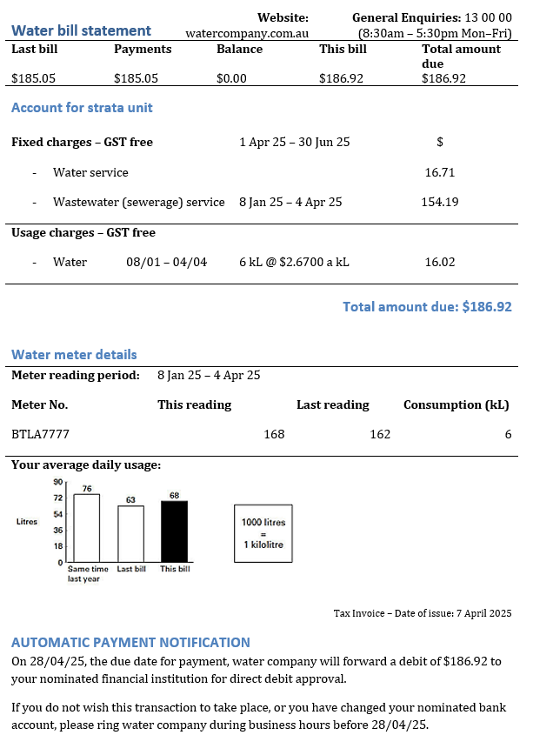

Electricity bill
Electricity company  John Doe  12 Fake Lane  Mateland NSW 2259 | Account details  Acc no.: 100715  Tax invoice number: 202525/103813  Issue date: 01 May 2025  Address: 12 Fake Lane, Mateland NSW
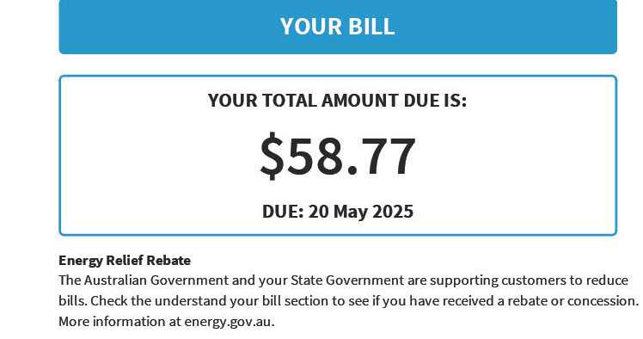
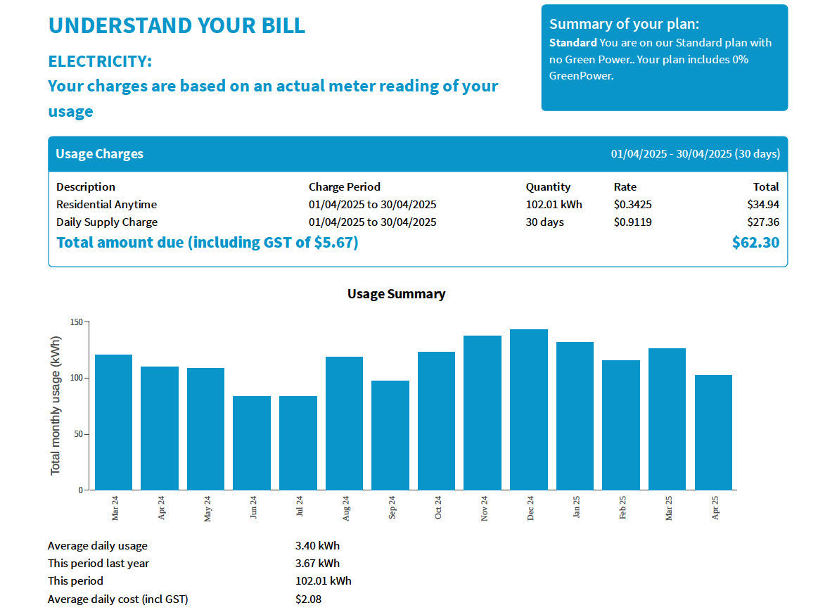
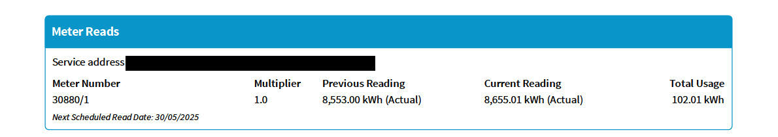
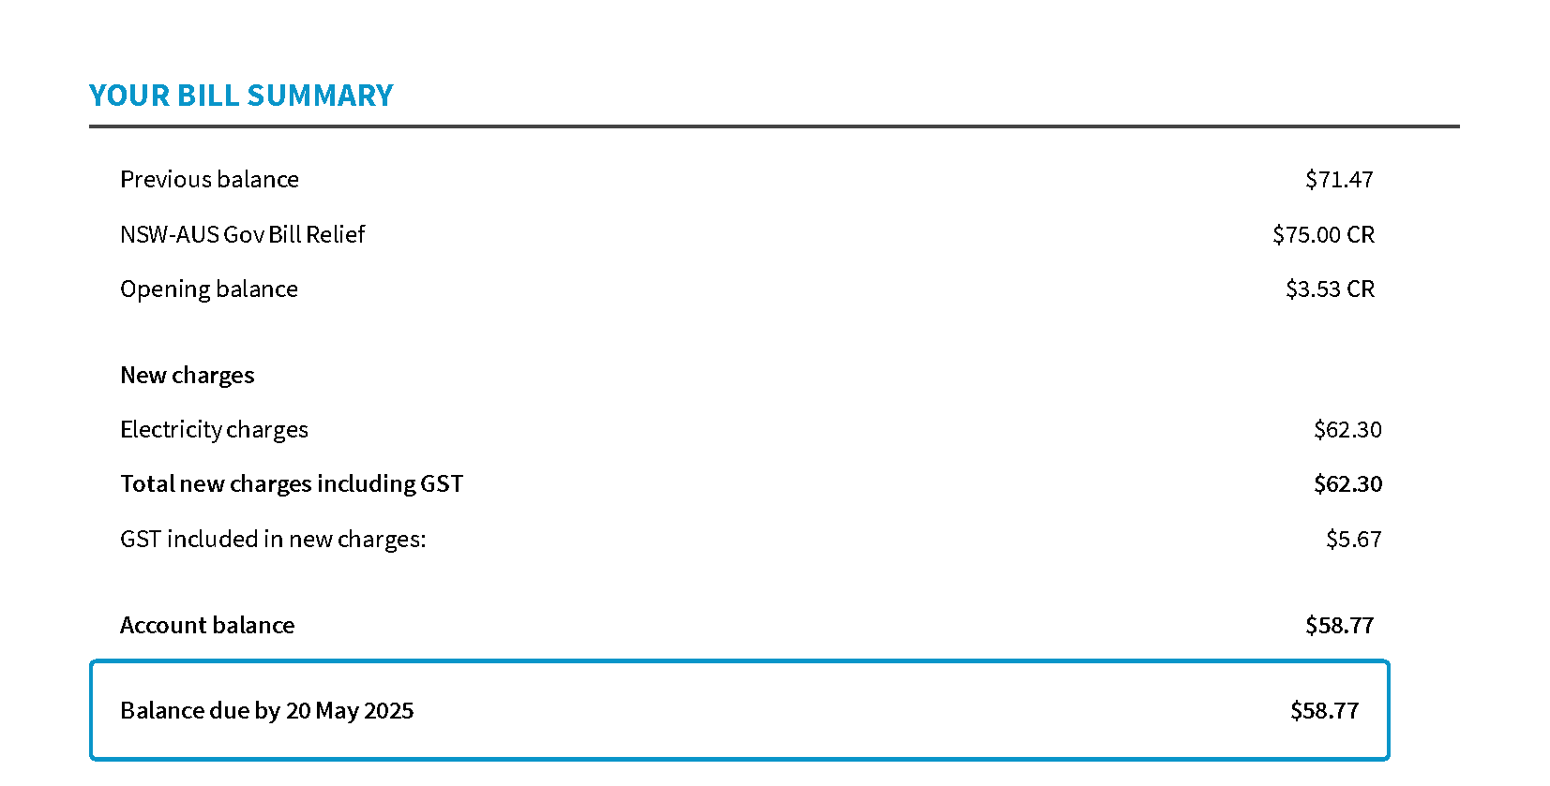

Gas bill
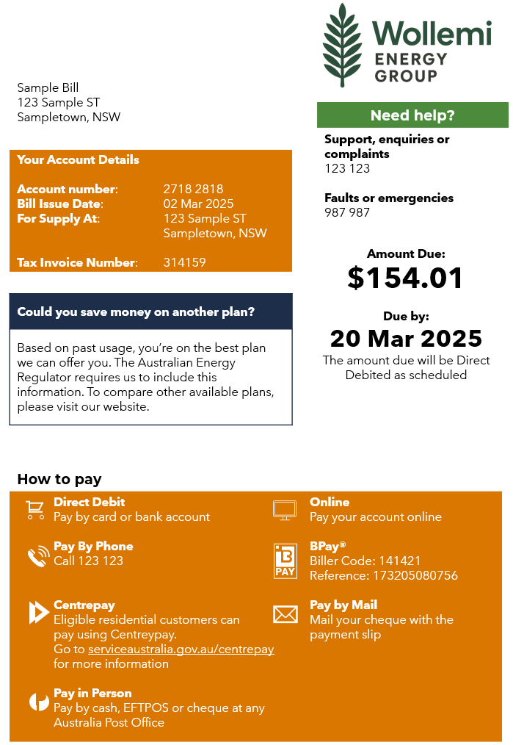
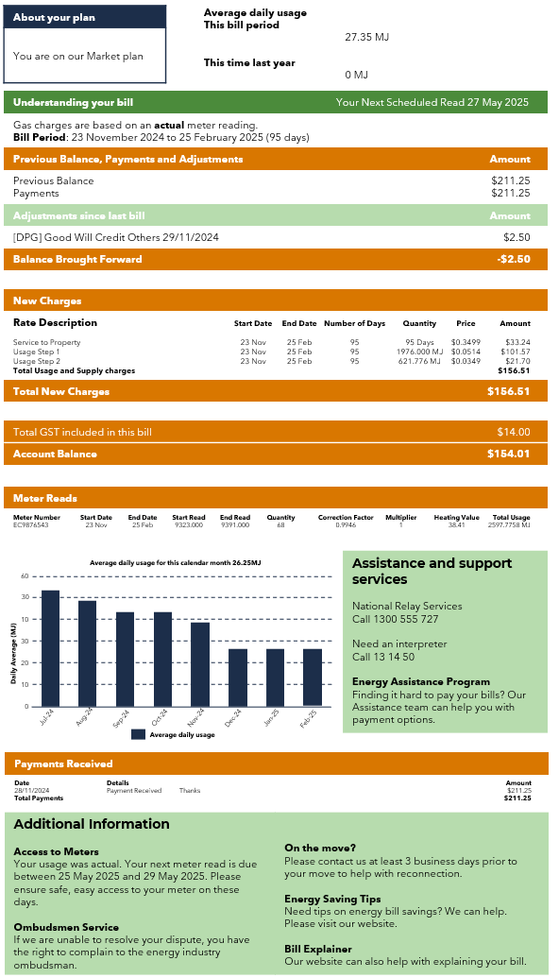

Appendix B

Electricity costs
Task 1: a single person living by themselves in the Central Coast area has the following electricity usage for a month. Estimate how much they will spend on electricity in a year.
Tariff description | Usage (kWh) | Rate | Cost
Peak time | 143.427 | $0.5060/kWh
Shoulder time | 51.930 | $0.2618/kWh
Off-peak time | 54.102 | $0.1815
Supply charge | 30 days | $0.9790/day
Total
Yearly spend:
Task 2: a single person living by themselves in the North-West Slopes area has the following electricity usage for a month. Estimate how much they will spend on electricity in a year.
Tariff description | Usage (kWh) | Rate | Cost
Peak time | 143.427 | $0.3995/kWh
Shoulder time | 51.930 | $0.3774/kWh
Off-peak time | 54.102 | $0.2510/kWh
Supply charge | 30 days | $1.4028/day
Total
Yearly spend:

Task 3: a single person living by themselves in the Orana area has the following electricity usage for a month. Estimate how much they will spend on electricity in a year.
Tariff description | Usage (kWh) | Rate | Cost
Peak time | 143.427 | $0.4687/kWh
Shoulder time | 51.930 | $0.4049/kWh
Off-peak time | 54.102 | $0.2600/kWh
Supply charge | 30 days | $1.6386/day
Total
Yearly spend:

Appendix C

Household bills
Calculate an estimate for the annual cost of household bills based off the information provided.
Household 1: in a household of one person, the household has the following bills:
Bill type | Usage | Rate
Electricity usage | 284.82 kWh | $0.3676/kWh
Electricity supply | 30 days | $1.4028/day
Gas usage | 436.33 MJ | $0.041/MJ
Gas supply | 30 days | $0.65/day
Water usage | 44.25 kL | $2.35/kL
Water supply | Per quarter | $196.19/quarter
- internet: an NBN 25 plan, which costs $50.00 per month
- rent: $2500 per month.
Find the total amount the household spends on bills in a year.

Household 2: in a household of 2 people, the household has the following bills:
Bill type | Usage | Rate
Electricity usage | 586.41 kWh | $0.3676/kWh
Electricity supply | 30 days | $1.4028/day
Gas usage | 648.37 MJ | $0.041/MJ
Gas supply | 30 days | $0.65/day
Water usage | 63.96 kL | $2.35/kL
Water supply | Per quarter | $196.19/quarter
- internet: an NBN 50 plan, which costs $65.00 per month
- rent: $2500 per month.
Find the total amount the household spends on bills in a year.

Household 3: in a household of 3 people, the household has the following bills:
Bill type | Usage | Rate
Electricity usage | 824.31 kWh | $0.3676/kWh
Electricity supply | 30 days | $1.4028/day
Gas usage | 990.08 MJ | $0.041/MJ
Gas supply | 30 days | $0.65/day
Water usage | 98.67 kL | $2.35/kL
Water supply | Per quarter | $196.19/quarter
- internet: an NBN 100 plan, which costs $80.00 per month
- rent: $2500 per month.
Find the total amount the household spends on bills in a year.

Household 4: in a household of 4 people, the household has the following bills:
Bill type | Usage | Rate
Electricity usage | 1228.54 kWh | $0.3676/kWh
Electricity supply | 30 days | $1.4028/day
Gas usage | 1754.57 MJ | $0.041/MJ
Gas supply | 30 days | $0.65/day
Water usage | 165.36 kL | $2.35/kL
Water supply | Per quarter | $196.19/quarter
- internet: an NBN 100 plan, which costs $80.00 per month
- council rates: $500 per quarter
- mortgage repayments: $2400 per month.
Find the total amount the household spends on bills in a year.

Household 5: in a household of 5 people, the household has the following bills:
Bill type | Usage | Rate
Electricity usage | 1286.57 kWh | $0.3676/kWh
Electricity supply | 30 days | $1.4028/day
Gas usage | 2020.16 MJ | $0.041/MJ
Gas supply | 30 days | $0.65/day
Water usage | 213.72 kL | $2.35/kL
Water supply | Per quarter | $196.19/quarter
- internet: an NBN 250 plan, which costs $95.00 per month
- council rates: $500 per quarter
- mortgage repayments: $2400 per month.
Find the total amount the household spends on bills in a year.

Household 6: in a household of 6 people, the household has the following bills:
Bill type | Usage | Rate
Electricity usage | 1766.64 kWh | $0.3676/kWh
Electricity supply | 30 days | $1.4028/day
Gas usage | 2038.0 MJ | $0.041/MJ
Gas supply | 30 days | $0.65/day
Water usage | 245.46 kL | $2.35/kL
Water supply | Per quarter | $196.19/quarter
- internet: an NBN 250 plan, which costs $95.00 per month
- council rates: $500 per quarter
- mortgage repayments: $2600 per month.
Find the total amount the household spends on bills in a year.

Appendix D

Scenarios
Scenario 1
Jasmine has just moved into a small house on the South Coast of NSW. She uses gas for hot water and cooking. She is trying to decide whether to keep her mains gas connection supplied by the gas network or move to gas from delivered bottles. To estimate her usage, Jasmine averaged her last 3 years’ gas usage which showed her that she uses 2847 MJ in summer and 5286 MJ in winter. She has collected the following information to help her make her decision:
Mains gas usage charges:
- daily supply charge of $0.75/day
- tariff breakdown.
Season | Tariff
Summer | Step 1 (first one 250 MJ): $0.048/MJ  Step 2 (next 2000 MJ): $0.044/MJ  Step 3 (remaining): $0.042/MJ
Winter | Step 1 (first one 250 MJ): $0.052/MJ  Step 2 (next 2000 MJ): $0.048/MJ  Step 3 (remaining): $0.046/MJ
Bottled gas:
- Each 45 kg bottle provides approximately 2200 MJ of energy.
- Each bottle costs $135, including delivery.
Justify why Jasmine should or should not keep her mains gas connection.

Scenario 2
Carlos is planning to install a solar panel system with a battery (hybrid system) to reduce his reliance on electricity from the grid. To help inform his decision, he has gathered information about the cost of the hybrid system and details from a recent electricity bill.
Quarterly electricity bill breakdown:
Tariff description | Usage (kWh) | Rate | Cost
Peak time | 448.269 | $0.5060/kWh
Shoulder time | 162.306 | $0.2618/kWh
Off-peak time | 162.306 | $0.1815/kWh
Supply charge | 90 days | $0.9790/day
Total
A solar provider has given Carlos the following 10-year cost estimate for a hybrid system. Even with a battery, Carlos may still need a small amount of electricity from the grid at times – this is called grid backup usage.
Component | Cost
5 kW solar system (after rebates) | $6000
13.5 kWh battery | $10 500
Installation | $2000
Maintenance | $150/year
Estimated grid backup usage | 300 kWh/year
Grid energy cost | $0.35/kWh
Reduced supply charge (grid backup only) | $0.50/day
Justify why Carlos should or should not install the hybrid system.

Scenario 3
Ava has become concerned about her expensive water bills. She currently uses a typical amount of water for a 2-person household. To help her reduce her bills, she is considering installing several water-saving devices. She has determined the following information.
Current water charges:
- fixed service charge: $75 per quarter
- usage charge: $2.45/kL
- annual usage: 180 kL.
Water saving devices Ava is considering:
Device | Upfront cost | Expected annual saving
Dual-flush toilet | $350 | 10 kL
Water-efficient showerhead | $90 | 15 kL
Rainwater tank (2000 L, plumbed) | $2400 | 25 kL
When will the water-saving devices become financially beneficial?

Sample solutions

Appendix B – electricity costs
Task 1: a single person living by themselves in the Central Coast area has the following electricity usage for a month. Estimate how much they will spend on electricity in a year.
Tariff description | Usage (kWh) | Rate | Cost
Peak time | 143.427 | $0.5060/kWh | $72.57
Shoulder time | 51.930 | $0.2618/kWh | $13.60
Off-peak time | 54.102 | $0.1815/kWh | $9.82
Supply charge | 30 days | $0.9790/day | $29.37
Total |  |  | $125.36
Yearly spend: $125.36 × 12 = $1504.32
Task 2: a single person living by themselves in the North-West Slopes area has the following electricity usage for a month. Estimate how much they will spend on electricity in a year.
Tariff description | Usage (kWh) | Rate | Cost
Peak time | 143.427 | $0.3995/kWh | $57.30
Shoulder time | 51.930 | $0.3774/kWh | $19.60
Off-peak time | 54.102 | $0.2510/kWh | $13.58
Supply charge | 30 days | $1.4028/day | $42.08
Total |  |  | $132.56
Yearly spend: $132.56 × 12 = $1590.72

Task 3: a single person living by themselves in the Orana area has the following electricity usage for a month. Estimate how much they will spend on electricity in a year.
Tariff description | Usage (kWh) | Rate | Cost
Peak time | 143.427 | $0.4687/kWh | $67.22
Shoulder time | 51.930 | $0.4049/kWh | $21.03
Off-peak time | 54.102 | $0.2600/kWh | $14.07
Supply charge | 30 days | $1.6386/day | $49.16
Total |  |  | $151.48
Yearly spend: $151.48 × 12 = $1817.76

Appendix C – household bills
Household 1
Electricity: $146.78/month
Gas: $37.39/month
Water: $300.18/quarter
Total: (146.78 + 37.39 + 50 + 2500) × 12 + 300.18 × 4 = $34 010.76
Household 2
Electricity: $257.65/month
Gas: $46.08/month
Water: $346.50/quarter
Total: (257.65 + 46.08 + 65 + 2500) × 12 + 346.50 × 4 = $35 810.76
Household 3
Electricity: $345.10/month
Gas: $60.09/month
Water: $428.06/quarter
Total: (345.10 + 60.09 + 8 0 + 2500) × 12 + 428.06 × 4 = $37 532.52
Household 4
Electricity: $493.70/month
Gas: $91.44/month
Water: $584.79/quarter
Total: (493.70 + 91.44 + 80 + 2400) × 12 + (584.79 + 500) × 4 = $41 120.84
Household 5
Electricity: $515.03/month
Gas: $102.33/month
Water: $698.43/quarter
Total: (515.03 + 102.33 + 95 + 2400) × 12 + (698.43 + 500) × 4 = $42 142.04
Household 6
Electricity: $691.50/month
Gas: $103.06/month
Water: $773.02/quarter
Total: (691.50 + 103.06 + 95 + 2600) × 12 + (773.02 + 500) × 4 = $46 966.80

Appendix D – scenarios
Scenario 1
Mains gas cost:
- summer: 2847 MJ
- winter: 5286 MJ.
Season | Usage (kWh) | Cost
Summer | Step 1: 1250 MJ  Step 2: 2874 − 1250 = 1597 MJ | Step 1: 1250 × 0.048 = $60  Step 2: 1597 × 0.044 = $70.27
Winter | Step 1: 1250 MJ  Step 2: 2000 MJ  Step 3: 5286 − 3250 = 2036 MJ | Step 1: 1250 × 0.052 = $65  Step 2: 2000 × 0.048 = $96  Step 3: 2036 × 0.046 = $93.66
Supply | $0.75/day | 0.75 × 36 5= $273.75
Total |  | $658.68
Bottled gas:
Total usage: 2847 + 5286 = 8133 MJ
Number of bottles required: $\frac{8133}{2200}=3.7 (4 \text{bottles})$
Total cost: 4 × 135 = $540
It is cheaper for Jasmine to disconnect her mains gas and move to bottled gas.

Scenario 2
Electricity bill:
Tariff description | Usage | Rate | Cost
Peak time | 448.269 | $0.5060/kWh | $$448.269×0.5060=\$226.82$$
Shoulder time | 162.306 | $0.2618/kWh | $$162.306×0.2618=\$42.49$$
Off-peak time | 162.306 | $0.1815/kWh | $$162.306×0.1815=\$29.46$$
Supply charge | 90 days | $0.9790/day | $$90×0.9790=\$88.11$$
Total |  |  | $$\$386.88$$
Yearly cost: $386.88×4=\$1547.52$
10-year cost: $1547.52×10=\$15,475.20$
Hybrid system:
Component | Cost | 10-year cost
5 kW solar system (after rebates) | $6000 | $$\$6000$$
13.5 kWh battery | $10 500 | $$\$10 500$$
Installation | $2000 | $$\$2000$$
Maintenance | $150/year | $$150×10=\$1500$$
Estimated grid backup usage | 300 kWh/year | $$300×10=3000 \text{kWh}$$
Grid energy cost | $0.35/kWh | $$3000×0.35=\$1050$$
Reduced supply charge (grid backup only) | $0.50/day | $$0.50×365×10=\$1825$$
Total 10-year cost: $\$22 875$
It is financially better for Carlos not to install a hybrid system.
Students may suggest non-financial reasons as to why Carlos should install a hybrid system such as environmental factors.
Scenario 3
Current water charges: $75×4+2.45×180=\$741/\text{year}$
Total water savings: $10+15+25=50 \text{kL}/\text{year}$
Water charges after savings: $75×4+2.45×130=\$618.50/\text{year}$
Savings per year: $741-618.50=\$122.50$
Cost to install water saving devices: $350+90+2400=\$2840$
Years before savings becoming financially beneficial: $\frac{2840}{122.5}=23.1 (24 \text{years})$

References
This resource contains NSW Curriculum and syllabus content. The NSW Curriculum is developed by the NSW Education Standards Authority. This content is prepared by NESA for and on behalf of the Crown in right of the State of New South Wales. The material is protected by Crown copyright.
Please refer to the NESA Copyright Disclaimer for more information https://educationstandards.nsw.edu.au/wps/portal/nesa/mini-footer/copyright.
NESA holds the only official and up-to-date versions of the NSW Curriculum and syllabus documents. Please visit the NSW Education Standards Authority (NESA) website https://educationstandards.nsw.edu.au and the NSW Curriculum website https://curriculum.nsw.edu.au.
Mathematics Standard 11–12 Syllabus © NSW Education Standards Authority (NESA) for and on behalf of the Crown in right of the State of New South Wales, 2024.

© State of New South Wales (Department of Education), 2025
The copyright material published in this resource is subject to the Copyright Act 1968 (Cth) and is owned by the NSW Department of Education or, where indicated, by a party other than the NSW Department of Education (third-party material).
Copyright material available in this resource and owned by the NSW Department of Education is licensed under a Creative Commons Attribution 4.0 International (CC BY 4.0) license.

This license allows you to share and adapt the material for any purpose, even commercially.
Attribution should be given to © State of New South Wales (Department of Education), 2025.
Material in this resource not available under a Creative Commons license:
- the NSW Department of Education logo, other logos and trademark-protected material
- material owned by a third party that has been reproduced with permission. You will need to obtain permission from the third party to reuse its material.
Links to third-party material and websites
Please note that the provided (reading/viewing material/list/links/texts) are a suggestion only and implies no endorsement, by the New South Wales Department of Education, of any author, publisher, or book title. School principals and teachers are best placed to assess the suitability of resources that would complement the curriculum and reflect the needs and interests of their students.
If you use the links provided in this document to access a third-party's website, you acknowledge that the terms of use, including licence terms set out on the third-party's website apply to the use which may be made of the materials on that third-party website or where permitted by the Copyright Act 1968 (Cth). The department accepts no responsibility for content on third-party websites.

