Government payments
Students learn about the availability of different types of government payments and how to calculate income from these payments.
Students will need at least one digital device per pair to access the given websites during this lesson.

Learning intentions
- To know about the different types of government payments.
- To be able to calculate income from government payments.

Success criteria
- I can find information on different government payments.
- I can identify the criteria to be eligible for a government payment.
- I can justify the total income a person may receive from the government in different scenarios.

Outcomes
A student:
- develops understanding and fluency in mathematics through exploring and connecting mathematical concepts, choosing and applying mathematical techniques to solve problems, and communicating their thinking and reasoning coherently and clearly MAO-WM-01
- solves financial problems involving earning money and taxation MST-11-03

Associated numeracy outcomes
A student:
- recognises and applies functional numeracy concepts in practical situations, including personal and community, workplace and employment, and education and training contexts N6-1.1
- applies numerical reasoning and mathematical thinking to clarify, efficiently solve and communicate solutions to problems N6-1.2
- chooses and applies efficient strategies to analyse and solve everyday problems involving money and finance N6-2.4
- chooses and applies appropriate numeracy operations and techniques to analyse and resolve everyday situations N6-2.6
- chooses and uses appropriate technology to access, organise and interpret information in a range of practical personal and community, workplace and employment, and education and training contexts N6-3.1

Content

Earning money
Ways of earning
- Calculate an individual’s earnings from commission, sliding scale commission, piecework, royalties, government payments and as a sole trader
Mathematics Standard 11–12 Syllabus © NSW Education Standards Authority (NESA) for and on behalf of the Crown in right of the State of New South Wales, 2024.
Table 1: lesson summary
Section | Summary of activity | Teaching strategies | Teaching points
Activating prior knowledge | Students brainstorm what they know about government payments and listen to a podcast introducing them (bit.ly/SBSGovPayments). Students interpret an area graph on income support payments from Appendix A. | Think-Pair-Share  Notice and wonder  Pose-Pause-Pounce-Bounce | Students gain an understanding of Australia’s social security system and the types of government payments available.
Connecting learning | Students apply their knowledge to a scenario from slide 4 of the PowerPoint Government payments. Students use ‘Centrelink Payment and Service Finder’ (bit.ly/Payment_Finder) to find payments for the scenario. Students access ‘A guide to Australian Government payments’ (bit.ly/AusGovPayments) to confirm eligibility and payment rates for the scenario. | Turn and talk  Class discussion | Students can use available tools and resources to support them in finding information on government payment eligibility and payment rates.
Releasing responsibility | Display slides 6–9 of the PowerPoint to model worked examples of finding the payment rate from a table. Students work in groups to apply their knowledge to another person’s situation. | Worked examples (Your turn)  Mini whiteboards  Pose-Pause-Pounce-Bounce | Students can interpret payment rate tables and calculate income from government payments.
Independent practice | Students apply their knowledge to a variety of different scenarios by completing Appendix B. | Visibly random groups of 3  Scavenger hunt | Students can find the payment rate for a variety of scenarios using different payment rate tables.

Activity structure
Please use the associated PowerPoint Government payments to display images in this lesson.

Activating prior knowledge
- In a Think-Pair-Share (bit.ly/thinkpairsharestrategy), ask students to brainstorm everything they know about government payments.
Students may need support in understanding that government payments are also known by other names, such as Centrelink or Services Australia.
They may share their knowledge of various payment types, including but not limited to the disability support pension, age pension, youth allowance, rent assistance, and so on.
Types of payments students share should be written on the board for them to refer to later.
- Play the SBS Podcast ‘How can government payments support you? | Australia Explained’ (10:23) (bit.ly/SBSGovPayments) from 2:05–4:16.
A focus on payments that mainly affect students and young people is featured in the time section indicated. You may choose to play the podcast further to include other payments such as family tax benefit, age pension, disability support pension, and so on.
- Ask students to reflect on their brainstorm and ask if any other payments need to be added to the list.
- Distribute Appendix A ‘Income support payment trends’ to each pair of students.
Alternatively, if you can’t print in colour, display the graph on the board.
- Instruct pairs to discuss what they notice and wonder (bit.ly/noticewonderstrategy) about the graph.
Students may notice the timeline is for a short period; the vertical axis is in millions and that there is a jump/spike in 2021 for unemployment benefits. Students may wonder how to accurately read the information from the graph and why some coloured areas are bigger than others. Students may require additional support to interpret the area graph.
- Use the Pose-Pause-Pounce-Bounce questioning strategy (PDF 557 KB) (bit.ly/posepausepouncebounce) to pose the following questions:
- Which income support payment is received by the most people? Why?
- What trend do you notice about age pension payments? Do you think this trend will continue?
- What do you think is the reason for the large increase in the number of people receiving unemployment payments between 2020 and 2021?
- Australia’s population in 2021 was 25.7 million (25 700 000). Do you think a lot of Australians receive income support payments? Explain why or why not.
Responses to the question prompts:
- Most people receive the age pension due to the wide range of ages who can claim this payment, including anyone who is 67 years of age or older.
- Age pension payments are increasing and will continue to increase while the largest demographic of baby boomers is retiring.
- COVID-19 caused many businesses to close or reduce the number of staff, resulting in high rates of unemployment.
- In 2021, there was close to 6 000 000 people receiving income support payments, which represented about 23% of the population. Less than 25% of the population received income support payments. The population continues to increase, but the number of people receiving income payments dropped back down to about 5 000 000 in 2022.

Connecting learning
- Display slide 4 of the PowerPoint and pose the following scenario to students:
Jake is 16 years old and is enrolled in Year 11 at his local high school. He lives with and cares for his mum, who has a disability and receives a disability support pension. They are currently renting an apartment.
- Continuing in their pairs, ask students to write down what types of government payments they think Jake might be able to access.
Students should refer to the list on the board developed during the ‘Activating prior knowledge’ section. Students are to keep their lists to reflect on later in the lesson.
- Conduct a class discussion on why students think it’s important for Jake to receive these benefits.
- Continue to display slide 4 and distribute a device to each pair.
- Instruct students to go to the website ‘Centrelink Payment and Service Finder’ (bit.ly/Payment_Finder).
Figure 1: screenshot of Centrelink Payment and Service Finder webpage
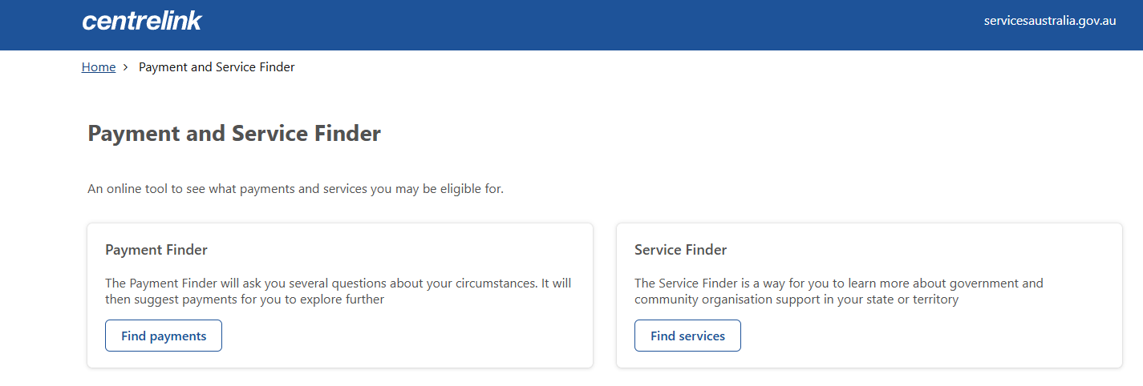
- Direct students to select the Find payments option and use the information from Jake’s scenario to help them answer the questions. Have students select the Show results button to view a list of payments Jake may be able to receive.
Figure 2: screenshot of the Show results button
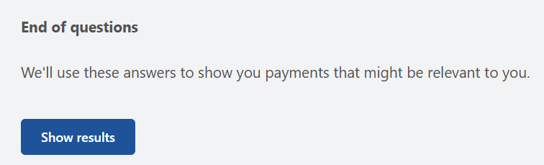
Students can provide different information to the Payment finder questions. They can also select Show more underneath some of the payment options to see additional eligibility information.
Advise students not to select the Estimate rate now button as the questions require detailed personal information. At this point you may need to address language that students are unfamiliar with from the Show more information, for example, dependent, guardian, tertiary, and so on.
- Instruct pairs to turn and talk (bit.ly/classroomtalkmoves) with another pair to discuss any differences they had when entering in responses to the questions and if they think Jake would be eligible for the suggested payments.
- Conduct a class discussion on the types of government payments Jake may be eligible to receive and why. Compare this with their initial list on the board.
At this point, students will only be able to determine the following:
- he is not eligible to receive a youth allowance or the tertiary access payment as he lives at home.
- further information is needed to determine his eligibility for carer payments and understand the definition of constant care. This will also affect his eligibility for the pension education supplement.
- Jake will be eligible for the carer allowance as he provides care for his mum, who has a disability.
- further information on income test requirements is needed to determine eligibility for the low-income health care card.
- further information is needed about Jake’s health to determine eligibility for the Medicare safety net.
- Continuing in their pairs, instruct students to go to the website ‘A guide to Australian Government payments’ (bit.ly/AusGovPayments) and select the link A guide to Australian Government payments under the section Download and read at the top of the page.
Figure 3: screenshot of A guide to Australian Government payments website
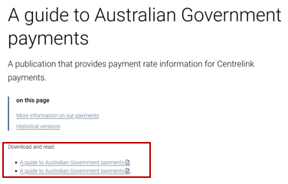
The first link under the heading Download and read is a PDF, and the second link is a Microsoft Word document. Advise students to choose which version suits their situation.
- Allocate each pair a different government payment from the list of possible options to research for Jake.
- Animate slide 4 to provide further information about Jake. Instruct students to use this information to determine Jake’s eligibility and work out the payment rate from the tables given.
Students who are allocated the carer payment and the pension education supplement should work together to determine eligibility for both, as one relies on the other.
The definition of constant care is full-time which means the carer can’t work or study full-time. This means Jake won’t be eligible for both carer payment and the pension education supplement.
- Conduct a class discussion asking pairs to present their findings and conclude which government payments Jake is eligible to receive and how much money he will receive each fortnight.
Responses here will vary depending on the information decided on for Jake’s situation. Basic eligibility will be that he receives the carer allowance of $159.30 per fortnight and the carer supplement of $600 per year. As Jake’s mum has a disability, she is already receiving the disability support pension and Jake will be covered for other government benefits under this.

Releasing responsibility
- Use slides 6–9 from the PowerPoint to model finding the payment rate from a table using the Worked examples (Your turn) method (bit.ly/supportingstrategies).
There are animations on slide 7. Animate to show the key information needed from the question to determine the section needed in the table, then animate to show where the solution came from in the table.
Advise students that other criteria for eligibility, such as income and asset tests, have not been included in the worked examples or further questions due to the complex nature of individual circumstances. Students should assume that these eligibility requirements have been met.
- Place students into pairs and instruct students to continue using ‘A guide to Australian Government payments’ (bit.ly/AusGovPayments) on their devices, this time to find out how much Jake’s mum receives on her disability support pension, what other government payments Jake’s mum is eligible for and the payment amounts.
- Instruct students to calculate the total amount of income Jake and his mum receive from government payments, both fortnightly and yearly.
- Use the Pose-Pause-Pounce-Bounce questioning strategy to initiate a class discussion for students to explain and provide reasoning for the following question: ‘Are the government payments Jake and his mum receive enough to live on?’
Students are to provide reasoning using local pricing contexts such as rental costs, supermarket costs, access to public transport, community transport or taxis, medical costs, education costs, and so on. Students will learn about budgeting in more detail in Lesson 17 – budgeting.

Independent practice
- Assign students to visibly random groups of 3 (bit.ly/visiblegroups) to complete the scavenger hunt task from Appendix B ‘Scavenger hunt’.
- Print one set of question cards, separate each card, and place the cards around the room. A vertical non-permanent surface could be useful at each card to assist the groups with their calculations.
- Each group should start at one of the cards. The students work in their groups of 3 to solve the problem.
- Once a group has solved the problem, they need to move around the room to find the solution on another card. Once they have found their solution, they should solve the question attached to the solution and repeat the process.
- The activity is finished once the group returns to their original card.
Cards are printed in order, so the solution on the top of each card is the answer to the previous card.

Assessment and differentiation

Suggested opportunities for differentiation
Activating prior knowledge
- Teachers will need to adjust the pace of the initial brainstorming and discussions depending on students’ current prior knowledge and the connections they have around Australia’s social security system and the types of government payments available.
- The Pose-Pause-Pounce-Bounce questions could be modified to target deeper reasoning using the ‘Wiederhold question matrix’ (bit.ly/wiederhold-matrix) or asking questions that require increased critical thinking or prediction.
Connecting learning
- Students may require additional support to find information in the Centrelink Payment and Service Finder tool. Teachers may choose to demonstrate to the whole class before pairs apply this to the scenario.
- Students may require additional literacy support to understand the terminology used in the ‘A guide to Australian Government payments’ document.
- Teachers may choose to print only the relevant pages from the ‘A guide to Australian Government payments’ document to reduce the cognitive load in navigating the document.
- When discussing with students, teachers can encourage students to justify their decisions.
Releasing responsibility
- Further worked examples could be provided if students require more explicit teaching of reading and interpreting payment tables.
- Providing students with a printout of the disability support pension information can reduce the cognitive load of navigating the ‘A guide to Australian Government payments’ document.
- Students can be provided with a list of living expense amounts to support them to answer the question ‘Are the government payments Jake and his mum receive enough to live on?’

Independent practice
- Teachers may wish to adjust the ‘Scavenger hunt’ by including letters at the top of some or all pages for students to find a code word.
- Students can complete the ‘Scavenger hunt’ individually to make it more challenging.
- Students could be challenged to create their own question that would fit into the ‘Scavenger hunt’.

Suggested opportunities for assessment
Activating prior knowledge
- Brainstorming allows the teacher to check for understanding of the level of depth of the student’s prior knowledge.
- A Think-Pair-Share provides students with the opportunity to reflect on the podcast.
- Monitor responses to the Pose-Pause-Pounce-Bounce question prompts to check for student understanding of interpreting trends and information from the area graph.
Connecting learning
- Monitor the student pair discussions and their decision-making while working through the ‘Centrelink payment and services finder tool’.
- Teachers could collect student responses to Jake’s scenario, providing evidence of decision-making on eligibility and payment rates.
Releasing responsibility
- Monitor student responses to the ‘Your turn’ slide to check for understanding.
- Monitor student calculations on mini whiteboards to assess students’ understanding and interpretation of payment tables.
Independent practice
- When placed in groups of 3, students provide and receive peer feedback on their understanding.
- As students complete the ‘Scavenger hunt’, teachers could ask students to explain and justify their thinking.

Appendix A

Income support payment trends

Trends in people receiving income support payments, by payment type, June 2001–June 2022
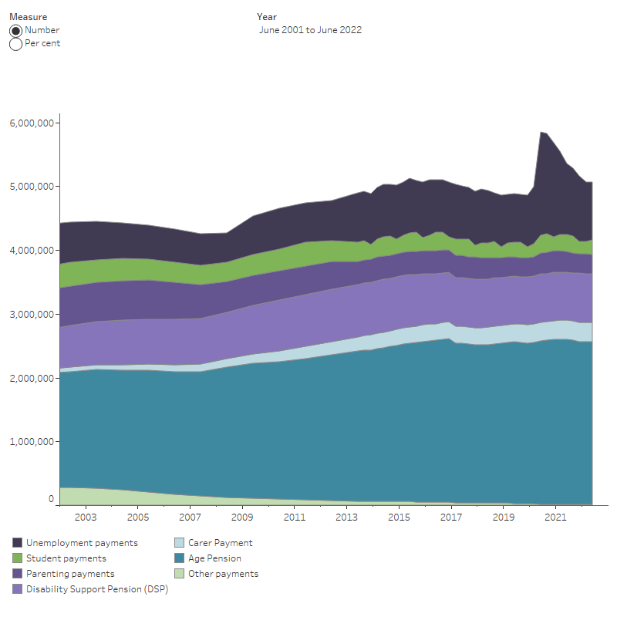
‘Trends in people receiving income support payments, by payment type, June 2001 to June 2022’ by Australian Institute of Health and Welfare is licensed under CC-BY-4.0.

Appendix B

Scavenger hunt
$670.30
A 23-year-old single parent who is studying full-time applies for ABSTUDY.
What is their typical total fortnightly payment?
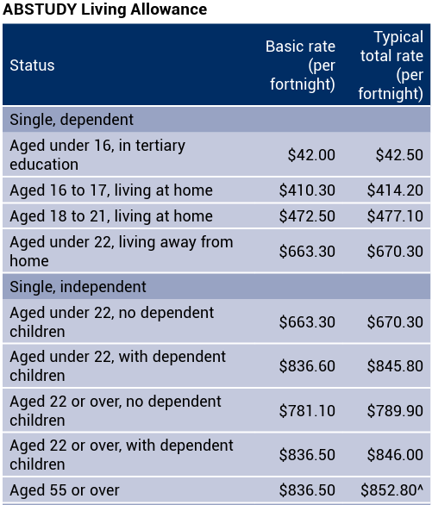

$846  What is the basic fortnightly payment for a 19-year-old single student living away from home under Youth Allowance?  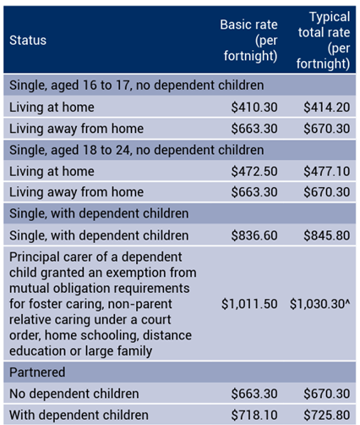 |  | $663.30  Jane is 30, married with 2 children and currently studying and working part-time earning $550 per week. If she goes to full-time study, what is the fortnightly difference between her income and the typical total rate for Austudy payments?  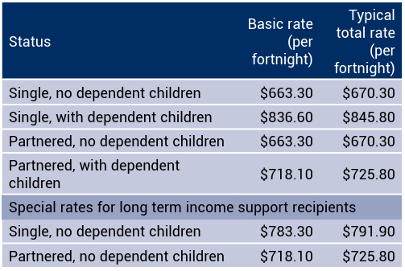

$374.20  Jo is doing her budget for attending university full-time. She’s single, aged 18 and living at home. Advise Jo on the typical total rate of Youth Allowance for the year.  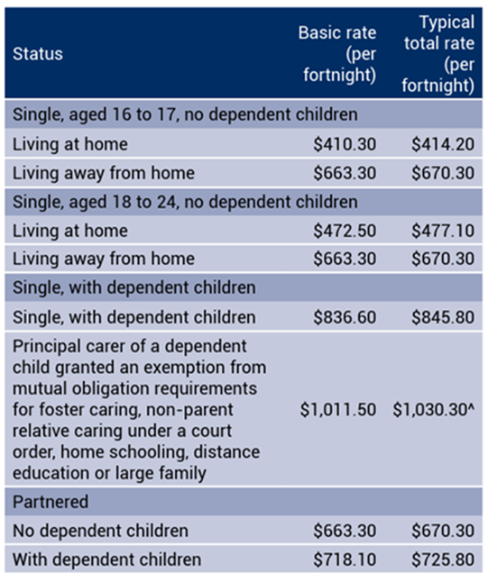 |  | $12 404.60  Jim has become eligible for the Disability Support Pension and has calculated his typical total rate as $29 874/year. Jim is over 21 years of age and married. This is the incorrect amount, what should the yearly rate actually be?  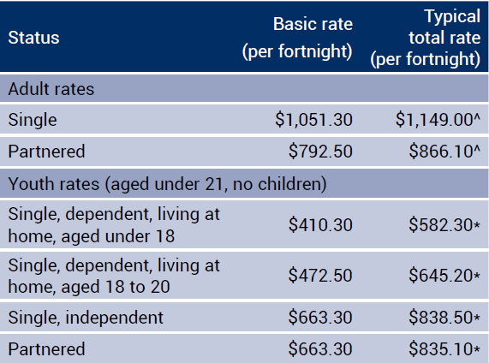

$22 518.60  Sophie is 22 and claiming a basic rate Youth Allowance. She recently moved back home after living with her partner and didn’t inform Centrelink for 6 months. How much money does Sophie need to pay back to Centrelink?  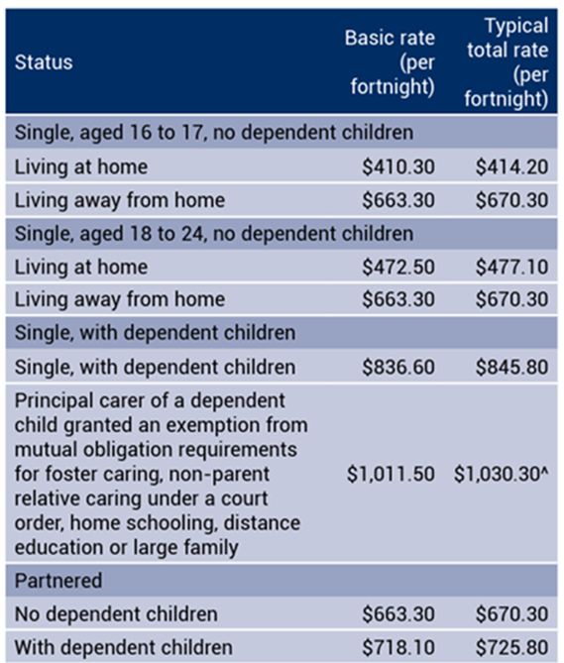 |  | $2480.40  Lionel is married and on an Age Pension. His wife recently also qualified for the Age Pension. What amount did their typical total rate fortnightly pension payment increase by?  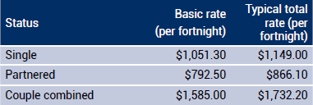

$866.10  Drew is a single parent who recently qualified for the Carer Payment as his son was diagnosed with a severe disability. What is the typical total rate for the year Drew can receive?  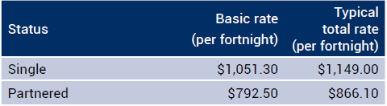 |  | $29 874  Drew recently found out that he could also qualify for a Carer Allowance. How much extra per year does this give Drew?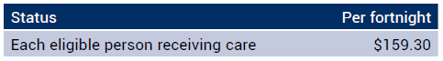

$4141.80  Ashley is 17, living at home and currently receives the typical total rate per fortnight from the ABSTUDY Living Allowance. How much does his fortnightly payment increase by when he turns 18?  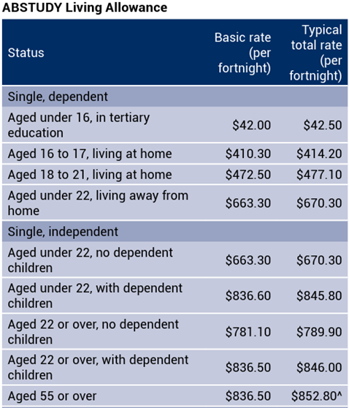 |  | $62.90  Rob is 33 and recently had an accident at work. He has used up his leave entitlements. Rob is applying for the JobSeeker Payment for 3 months while he recovers. He has a partner. What is the typical total rate Rob can receive for the 3 months?  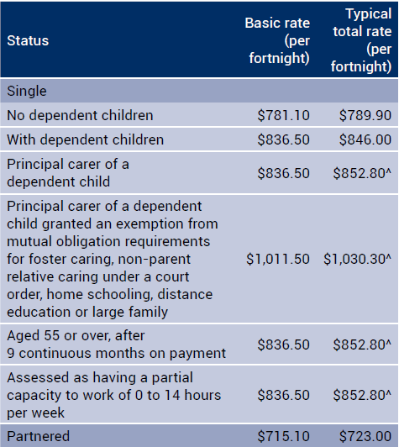

$4699.50  Daisy is the principal carer for a foster child and has recently lost her job and needs to apply for the JobSeeker Payment. Advise Daisy on how much her typical total fortnightly payment rate will be.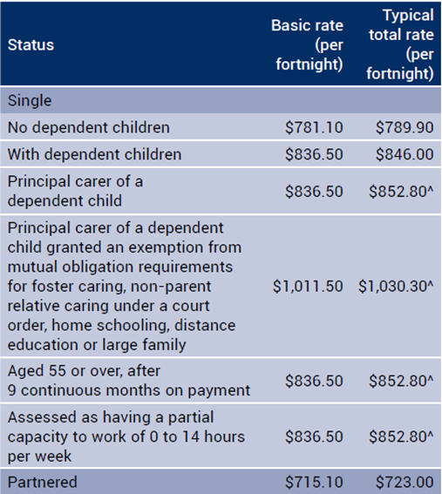 |  | $1030.30  A family place their 2-year-old child into childcare while they both attend work. The childcare centre charges a fee of $13 per hour. The family receives a Child Care Subsidy rebate of 90% of the hourly rate. What is the total cost they need to pay for an 8-hour day of care?

$10.40  Geoff is 35, single, with no children and lives and works on his farm and receives the Farm Household Allowance. He’s hoping he will only need to claim this for the next 6 months. Advise Geoff on the typical total rate he can receive over 6 months.  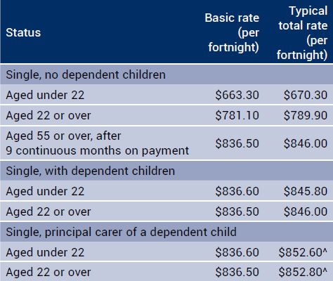 |  | $10 268.70  Casey has a full-time apprenticeship and wants to know how much Youth Allowance he can claim. Casey is 19, single and living in a shared house with friends. Advise Casey on what his typical total payment rate per fortnight.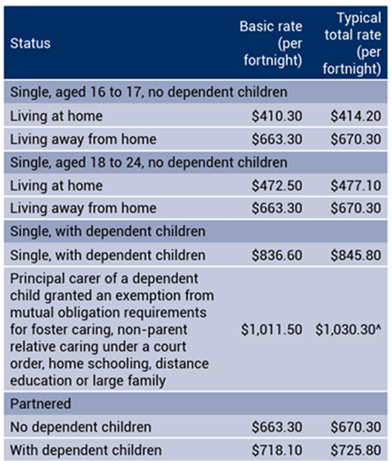

References
This resource contains NSW Curriculum and syllabus content. The NSW Curriculum is developed by the NSW Education Standards Authority. This content is prepared by NESA for and on behalf of the Crown in right of the State of New South Wales. The material is protected by Crown copyright.
Please refer to the NESA Copyright Disclaimer for more information https://educationstandards.nsw.edu.au/wps/portal/nesa/mini-footer/copyright.
NESA holds the only official and up-to-date versions of the NSW Curriculum and syllabus documents. Please visit the NSW Education Standards Authority (NESA) website https://educationstandards.nsw.edu.au and the NSW Curriculum website https://curriculum.nsw.edu.au.
Mathematics Standard 11–12 Syllabus © NSW Education Standards Authority (NESA) for and on behalf of the Crown in right of the State of New South Wales, 2024.

© State of New South Wales (Department of Education), 2025
The copyright material published in this resource is subject to the Copyright Act 1968 (Cth) and is owned by the NSW Department of Education or, where indicated, by a party other than the NSW Department of Education (third-party material).
Copyright material available in this resource and owned by the NSW Department of Education is licensed under a Creative Commons Attribution 4.0 International (CC BY 4.0) license.

This license allows you to share and adapt the material for any purpose, even commercially.
Attribution should be given to © State of New South Wales (Department of Education), 2025.
Material in this resource not available under a Creative Commons license:
- the NSW Department of Education logo, other logos and trademark-protected material
- material owned by a third party that has been reproduced with permission. You will need to obtain permission from the third party to reuse its material.
Links to third-party material and websites
Please note that the provided (reading/viewing material/list/links/texts) are a suggestion only and implies no endorsement, by the New South Wales Department of Education, of any author, publisher, or book title. School principals and teachers are best placed to assess the suitability of resources that would complement the curriculum and reflect the needs and interests of their students.
If you use the links provided in this document to access a third-party's website, you acknowledge that the terms of use, including licence terms set out on the third-party's website apply to the use which may be made of the materials on that third-party website or where permitted by the Copyright Act 1968 (Cth). The department accepts no responsibility for content on third-party websites.

