Commission
Students revise how money can be earned through commission and learn about sliding scale commission structures by using spreadsheets to model and calculate total earnings.
Students will need at least one digital device per pair to interact with the Commission spreadsheet during this lesson.

Learning intentions
- To know how people earn money from commission, including sliding scale commission.
- To understand how to use a spreadsheet to model commission.

Success criteria
- I can calculate the percentage of a quantity.
- I can define commission, including sliding scale commission.
- I can use a spreadsheet to calculate commission, including sliding scale commission.
- I can solve problems involving sliding scale commission.

Outcomes
A student:
- develops understanding and fluency in mathematics through exploring and connecting mathematical concepts, choosing and applying mathematical techniques to solve problems, and communicating their thinking and reasoning coherently and clearly MAO-WM-01
- solves financial problems involving earning money and taxation MST-11-03

Associated numeracy outcomes
A student:
- recognises and applies functional numeracy concepts in practical situations, including personal and community, workplace and employment, and education and training contexts N6-1.1
- applies numerical reasoning and mathematical thinking to clarify, efficiently solve and communicate solutions to problems N6-1.2
- chooses and applies appropriate operations with whole numbers, familiar fractions and decimals, percentages, rates and ratios to analyse and solve everyday problems N6-2.1
- chooses and applies efficient strategies to analyse and solve everyday problems involving money and finance N6-2.4
- chooses and uses appropriate technology to access, organise and interpret information in a range of practical personal and community, workplace and employment, and education and training contexts N6-3.1

Content

Earning money
Ways of earning
- Calculate an individual’s earnings from commission, sliding scale commission, piecework, royalties, government payments and as a sole trader
- Use a spreadsheet to model an employee’s income including overtime, salary, bonuses, commission, piecework and royalties
Mathematics Standard 11–12 Syllabus © NSW Education Standards Authority (NESA) for and on behalf of the Crown in right of the State of New South Wales, 2024.
Table 1: lesson summary
Section | Summary of activity | Teaching strategies | Teaching points
Retrieval practice | Use Appendix A for students to complete a percentage-based treasure hunt. | Visibly random groups of 3 | This activity checks students’ understanding of prior learning of calculating the percentage of a quantity.
Activating prior knowledge | Use slide 4 of the PowerPoint Commission to present a commission scenario where students must recommend to a customer which TV to purchase. Define ‘commission’ and use slide 5 to ask a hinge point question before using Appendix B to calculate commission problems. | Think-Pair-Share  Hinge point question | Students show their prior learning of commission from Stage 5 to calculate earnings and justify their decisions.
Connecting learning | Use the ‘Flat rate commission’ worksheet tab from the spreadsheet Commission to calculate commission and total earnings and check answers from Appendix B. Use slide 7 to introduce a sliding scale commission problem before defining ‘sliding scale commission’ using slide 8. | Think-Pair-Share | Students use the spreadsheet to calculate commission. Students show their conceptual understanding of percentages by creating an ordered list. Sliding scale commission is introduced to discuss why there would be different types of commission.
Releasing responsibility | Use slides 10–11 to complete a worked example on how to manually calculate commission using a sliding scale before completing Appendix D and discussing when students would pick a flat rate over a sliding scale. Using the ‘Sliding scale commission’ worksheet tab, have students enter the appropriate numbers and formulas to determine total earnings for employees of a real estate company. Students then write notes (Appendix E) on sliding scale commissions. | Worked examples (Your turn)  Pose-Pause-Pounce-Bounce  Think-Pair-Share  Visibly random groups of 3  Vertical non-permanent surfaces  Four quadrant notes | Model to students how to solve sliding scale commissions manually and using a spreadsheet to develop spreadsheet skills.
Independent practice | Use slides 14–17 for students to unpack and attempt HSC-style questions in pairs before assigning marks to their worked solution. | Approaching questions scaffold  Pose-Pause-Pounce-Bounce | Reflect and reason with students where marks should be allocated in an HSC-style question.

Activity structure
Please use the associated PowerPoint Commission to display images in this lesson.

Retrieval practice
- Print one set of question cards from Appendix A ‘Treasure hunt’, separate each card and place the cards around the room with adhesive putty. This should be done prior to the lesson commencing.
- Assign students to visibly random groups of 3 (bit.ly/visiblegroups) to complete the treasure hunt task.
- Each group should start at a different card and work together to answer the question. Once a group has answered the question, they need to move around the room to find their solution on another card. Groups then solve that problem and repeat the process. The activity is finished once the group returns to their original card.
Cards are printed in order so the solution to one question is the answer on the next card. Appendix A could be printed per group of 3 and shuffled for students to complete connecting questions with correct answers to form a circle.
Students are familiar with percentages from the Stage 4 Fractions, decimals and percentages outcome MA4-FRC-C-01.

Activating prior knowledge
- Pose the following scenario for students:
You are an employee at an electrical retail store and are paid a base wage and a 3% commission on sales. A customer comes in looking to buy a smart TV. They have a budget of $900 and are deciding between 2 options. They ask for your recommendation.
- Display slide 4 of the PowerPoint to show the 2 options and their features.
- In a Think-Pair-Share (bit.ly/thinkpairsharestrategy), ask students which TV they would recommend the customer buy.
Students are familiar with the concept of commission as it was covered in the Stage 5 Financial Mathematics A outcome MA5-FIN-C-01.
Students might suggest EconoView as it has nearly the same features but is cheaper for the customer or they may suggest the VistaEdge as it would pay them a higher commission.
- Define commission as ‘the sum or percentage paid for services, for example, to an agent or salesperson’.
This definition of ‘commission’ is from the glossary of the Mathematics Standard 11–12 Syllabus.
- In a Think-Pair-Share, ask students to consider some of the implications of earning money by commission.
Students may suggest some of the following:
- can earn more than being paid per hour if they make lots of sales
- more incentive to work harder
- income would change from pay to pay depending on their sales
- if they are new or still learning, they initially won’t be able to earn a lot.
- Use slide 5 to display the following hinge point question (bit.ly/hingepointquestions).
Given you usually earn $100 as a base wage per day and 3% commission on sales, if you sold the VistaEdge TV for $849, what would be the total amount you earned that day?
It is suggested that if students cannot answer this question that they complete activities from Lesson 6 – percentage of my earnings of Stage 5 – Unit 5 – financial mathematics before completing Appendix B.
- Distribute Appendix B ‘Commission problems’ to each pair of students. Ask students to place the questions in order from least earned to the most earned without using a calculator.
- Invite a few randomly selected pairs to explain their reasoning of how they ordered the earnings. Encourage them to justify their choices.
Students should show their understanding of percentages of a quantity in this activity. This improves students’ ability to check for reasonableness of answers.

Connecting learning
- With a device between each pair of students, provide them with a digital copy of the Commission spreadsheet.
There are instructions on how to distribute a spreadsheet in Appendix C ‘Save a local copy of a file’. Displaying the Commission spreadsheet for students to view and follow along is highly recommended.
- Have students open the ‘Flat commission’ worksheet tab and enter the appropriate values or formulas into each cell in to complete the table using Appendix B.
Students should enter the base wage, sales and commission rate values into the appropriate cells for each question and formulas in the ‘Commission earned’ and ‘Total earnings’ cells.
The teacher may need to model how to write a formula for students. For Question 1, the formula to enter into cell F4 is =D4*E4 and the formula for cell G4 is C4+F4.
Figure 1: screenshot of the ‘Flat commission’ sheet
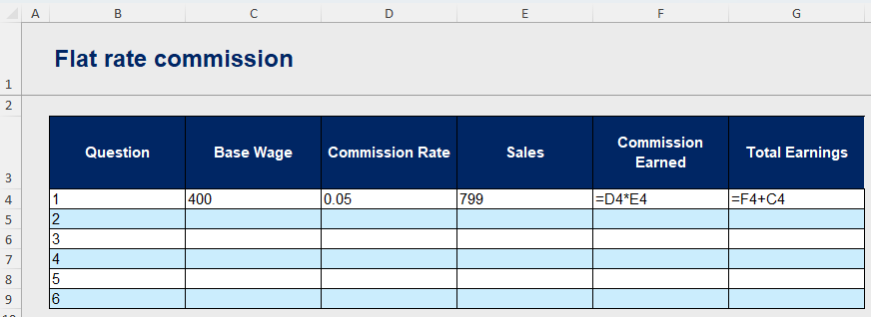
- Once students have completed the table on the ‘Flat commission’ worksheet tab, students can use the results to check their answers to Appendix B.
- Display slide 7 of the PowerPoint to pose the following question to students and provide time for them to attempt it.
A real estate agent earns a base wage of $750. They also receive 2% commission on the first $800 000 of a property’s sale price and 2.5% on any amount over $800 000. Last week, they sold a house for $1 500 000. Calculate their total earnings for the week.
- Animate the solution. Using a Think-Pair-Share, ask students how this question is different from the questions in Appendix B.
- Display slide 8 to define sliding scale commission as ‘a payment structure where the commission rate changes based on the total sales value or the level of performance achieved’.
- In a Think-Pair-Share, ask students to consider why a company may use a decreasing or increasing sliding scale commission pay structure.

Students may suggest the following for decreasing sliding scale commission:
- it still rewards effort but helps the company control commission costs on large sales
- it may encourage selling multiple smaller items instead of relying on large one-off sales.
Students may suggest the following for increasing sliding scale commission:
- it motivates employees to sell more, as they are paid a higher percentage the more they sell
- it encourages employees to increase the selling price or upsell to reach higher commission brackets.

Releasing responsibility
- Use slides 10–11 of the PowerPoint to model how to calculate earnings using sliding commission using the Worked examples (Your turn) method (bit.ly/supportingstrategies). Animate to reveal self-explanation prompts and solutions.
- Distribute Appendix D ‘Flat rate versus sliding scale’ to pairs of students to complete.
- Use the Pose-Pause-Pounce-Bounce questioning strategy (PDF 557 KB) (bit.ly/posepausepouncebounce) to start a class discussion on whether students would rather earn a flat rate of commission or sliding scale. Some suggested prompts include:
- In which scenarios did the sliding scale commission lead to a higher income? Why?
- When might a flat rate commission be better for a salesperson?
- If you were a salesperson who mostly sells lower-priced items, which commission method would you prefer? Why?
- How could a sliding scale commission motivate a salesperson differently than a flat rate?
Students may note that when selling lower-priced items, a flat rate may be more beneficial as many sliding scale commissions increase in percentage as you go up the scale.
- Direct students to the ‘Sliding scale commission’ worksheet tab and pose the following problem to students:
You are the payroll manager at Summit Property Group. Your task is to calculate the total weekly earnings for each employee for the month of May. This includes their base wage and commission, which is based on a sliding scale of 2% on the first $700 000 in sales and 1.25% on any amount above that. Use the provided spreadsheet to determine each employee’s commission and total pay based on their sales figures.
- In a Think-Pair-Share, discuss the following prompts to consider the information presented in the spreadsheet.
- Where did the values in the sales column come from? What about their associated commission rates?
- Which cells could be filled in directly from the information in the scenario? Which cells require a formula to be entered?
- What would the formula in the ‘Commission’ column look like?
- Provide time for students to write formulas and values in the ‘Sliding scale commission’ worksheet tab.
The spreadsheet is self-checking. As students calculate and enter a value into the ‘Total pay’ column, a tick (✓) or a cross (✗) will appear.
Students can write out the values in columns D and E or use the IF function to populate the cells in those columns. The IF function uses the format =IF(logical test, value if true, value if false). For example, in D10 you may use the formula =IF(C10>700000, 700000, C10) and in E10 you may use the formula =IF(C10>700000, C10-700000, 0).
Cell F10 should have the formula =D10*$C$5+E10*$C$6.
Column H should have =F10+G10 or something similar in each of the cells to complete the table.
Figure 2: screenshot of ‘Sliding scale commission’ spreadsheet showing self-checking feature
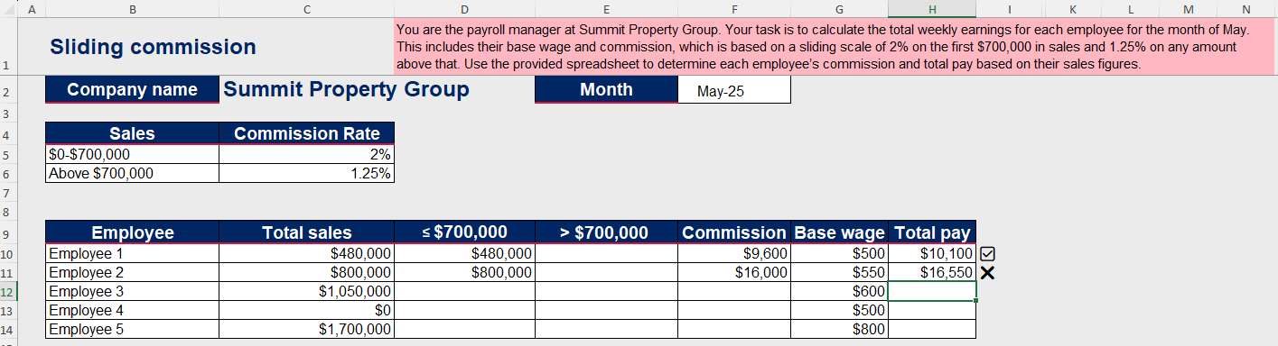
- Have students return to their visibly random groups of 3 at vertical non-permanent surfaces (bit.ly/VNPSstrategy) and distribute Appendix E ‘Four quadrant notes’ (bit.ly/supportingstrategies) for students to complete.

Independent practice
- Use slide 13 of the PowerPoint to unpack the ‘Approaching questions scaffold’ for students.
The ‘Approaching questions scaffold’ offers students a 4-step framework to work through questions. Each step is accompanied by an icon which corresponds to different aspects of the solution process.
- Display the HSC-style question from slide 14 of the PowerPoint. Animate the slide to highlight key information to help students unpack the question.
- Use the Pose-Pause-Pounce-Bounce questioning strategy to discuss with students the key information and plan their steps.
- Have students return to their visibly random groups of 3 at their vertical non-permanent surface to complete the question.
- Display slide 15 showing the solution.
- Using slide 16, display the HSC-style question and ask students to answer. Animate slide 16 to highlight key terms.
- Display slide 17 to show the solution.
- In groups, students are to create a marking criteria in their notebook for both questions and allocate marks to their solutions.
This is so each group can have their own marking criteria without any influence from other groups.
- Each group is to find another group and discuss their marking criteria to come to a consensus on how to allocate marks.
- Use the Pose-Pause-Pounce-Bounce questioning strategy to lead a class discussion around how many marks the question should be assigned and allocation of marks for the question.
Students may benefit from additional practice with an existing resource.

Assessment and differentiation

Suggested opportunities for differentiation
Activating prior knowledge
- Support students by discussing some of the key terms from the scenario such as ‘base wage’ and ‘commission’ to help them recall their prior knowledge.
- Pose the following adjustment to the scenario ‘What if the manufacturing company is offering a $10 bonus for every EconoView 55 4K Smart TV sold?’ and ask students to justify with calculations which option they would recommend.
Connecting learning
- Support students with their spreadsheet skills by giving them a version of the ‘Flat rate commission’ worksheet tab with the formulas embedded in the first row for reference.
- Extend students by having them predict and verify what happens when they manipulated the commission rate.
Releasing responsibility
- Support students by providing additional scaffolds such as breaking down the sliding commission into smaller parts.
- Extend students by reversing the problem. Provide students with the total earnings and they must calculate the sales. Ask students to identify at which point the sliding scale applies and justify their reasoning.
Independent practice
- Support students by modifying the HSC-style question on slide 16 to remove the sliding scale. Instead, the question could be:
At Pinnacle Properties, real estate agents are paid a base wage and commission on their monthly property sales. The commission is 1.8% of their sales. Jackson’s total earnings for the month was $19 500 which includes a base wage of $500 and the commission he earned from his monthly sales. Calculate the value of Jackson’s monthly sales.
- Extend students by creating their own sliding commission problem and providing it to a peer to solve.

Suggested opportunities for assessment
Activating prior knowledge
- Monitor conversations occurring in the Think-Pair-Share activity to check students’ understanding of earning a commission.
- Monitor student responses in class discussions to check for understanding of commission and its implications.
- Collect Appendix B from students to check for understanding of earning a commission.
Connecting learning
- Collect the Commission spreadsheet to check for student understanding of how to use a spreadsheet to calculate commission.
- Monitor student responses in class discussions to check for student understanding of sliding scale commission.
Releasing responsibility
- Monitor student responses in the ‘Your turn’ section to check for understanding of how to solve sliding scale commission problems.
- Feedback on correct numbers or formulas is embedded in the spreadsheet.
- Collect Appendix D or E as evidence of learning how to calculate sliding scale commission.
- Review students’ notes to their future forgetful selves for understanding of sliding commission.
Independent practice
- Monitor student responses during the Pose-Pause-Pounce-Bounce then check for understanding on how to solve sliding scale commission problems using the ‘Approaching questions scaffold’.
- Monitor responses in the Pose-Pause-Pounce-Bounce to check for student reasoning of where marks should be allocated to the problem.

Appendix A

Treasure hunt
$84
What is 6% of $900?
$54
A worker earns $1250 per week and pays 18% of it as rent. How much does the worker’s rent cost?
$225
A product costing $1200 is discounted by 25%.
What is the new price?
$900
Calculate 15% of $640.
$96
You earn 5% commission from a $900 sale. How much commission did you earn?
$45
An author earns a 5% royalty on book sales. If the total sales amount to $6000 in one year, how much does the author earn?
$300
An item worth $500 decreases by 20% in the first year. What is its value after the first year?
$400
A salesperson earns 12% commission. If they made $1500 in commission, what was the total sale amount?
$12 500
10% is added to the price of an item.
Find the amount to be added if the price of an item is $200.
$20
A person saves $80 a week. If this increases by 5%, how much do they now save per week?

Appendix B

Commission problems
Order the following problems from who earns the most to the least, before calculating the actual earnings in each scenario.
- A travel agent earns a weekly base wage of $400 plus 5% commission on all bookings made. Last week she made $799 in sales. Calculate her total earnings for the week.
- An influencer earns a base wage of $400 per week from a part-time retail job and receives 5% commission on sales made through affiliate links. Last week, $3250 worth of products were purchased through their links. Calculate the total earnings for the week.
- A sales representative earns a base wage of $400 plus a 7.5% commission on sales made. She made $3250 in sales last week. Calculate her earnings for last week.
- A furniture salesperson earns a base wage of $700 per week and a 7.5% commission on all sales. Last week, they made $3250 in sales. Calculate their total earnings for the week.
- A gym equipment seller is paid only commission at 10% of sales, with no base wage. Last week, they sold $3250 worth of equipment. Calculate their total earnings for the week.
- A real estate agent earns a base wage of $500 per week and a 2.2% commission on property sales. Last week, she sold $1 350 000 in property. Calculate her total earnings.

Appendix C

Save a local copy of a file
How to save a local copy of an Excel spreadsheet.

File sharing and saving
- Save the Excel file Commission in a place where students can easily access the file.
This could be done through Google Classroom, by sharing a OneNote link, or by emailing students a copy of the document.
- Have students open the document on their own device.
- Instruct students to select the File tab and then Save a Copy.
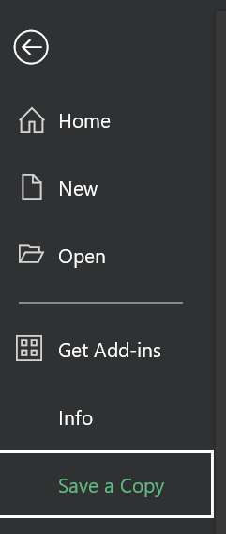
- Students can save the document in their individual OneDrive by selecting this option.
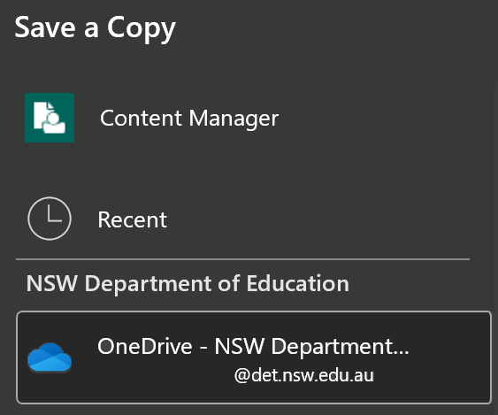
- Best practice would be to keep the file name the same. Students can then select Save and a copy will be stored on their OneDrive.
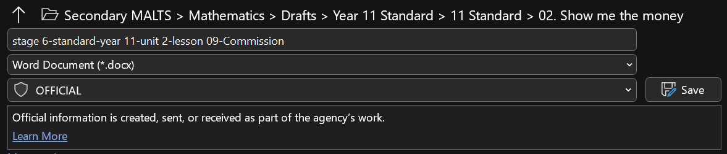

Appendix D

Flat rate versus sliding scale
For each of the following scenarios, calculate who earns more commission and justify why.
- Car sale of $30 000:
- Alex sells cars and earns a flat 5% commission on every sale
- Jamie sells cars and earns a sliding scale commission
- 3% on the first $20 000 of the car’s price
- 6% on any amount above $20 000.
- House sale for $950 000:
- Taylor earns a flat 2% commission on all houses sold
- Morgan earns a sliding scale commission
- 1.5% on the first $500 000
- 3% on any amount above $500 000.
- Art sales of $800 and $1500 (2 separate sales):
- Sam earns a flat 8% commission on every artwork sold
- Jordan earns a sliding scale commission
- 5% on artwork priced up to $1000
- 20% on artwork priced over $1000.

Appendix E

Four quadrant notes
Example 1  A wholesale electronics distributor pays their sales representatives a base wage of $600 per week. They also receive a commission of 4% on the first $10 000 of weekly sales and 2% on any amount above $10 000. Last week, Sam sold $16 000 worth of electronics.  Calculate the Sam’s total earnings for the week.  Above $\$10 000: \$16 000-____= ____$  Commission: $____×4\%+____×2\%=____$  Total earnings: $____+____=____$ | Example 2  A car salesperson earns a commission of 3% on the first $30 000 of vehicle sales for the week and then 4% on any amount above $30 000. Last week, they sold cars worth $48 000.  Calculate the total earnings for the week.
Things to remember | Example 3

Sample solutions

Appendix B – commission problems
- Commission: $\$799×0.05=\$39.95$
Total earnings: $\$400+\$39.95=\$439.95$
- Commission: $\$3250×0.05=\$162.50$
Total earnings: $\$400+\$162.50=\$562.50$
- Commission: $\$3250×0.075=\$243.75$
Total earnings: $\$400+\$243.75=\$643.75$
- Commission: $\$3250×0.075=\$234.75$
Total earnings: $\$700+\$234.75=\$934.75$
- Commission: $\$3250×0.1=\$325$
Total earnings: $\$325$
- Commission: $\$1 350 000×0.022=\$29 700$
Total earnings: $\$500+\$29 700=\$30 200$

Appendix D – flat rate versus sliding scale
Scenario | Flat rate earnings | Sliding scale earnings | Who earns more? | Justification
Car sale ($30 000) | $1500 | $1200 | Alex | Most of the sale is in the lower percentage of earning on a sliding scale, which means the majority of the commission is charged at the lower rate.
Real estate ($950 000) | $19 000 | $21 000 | Morgan | Nearly half of the sale is charged at 3%. The rest is at 1.5%. This is more than 2% flat, meaning that Morgan benefits from the higher house price in his earning in commission.
Art sale ($800) | $64 | $40 | Sam | Since it is less than $1000, you earn commission at a rate lower.
Art sale ($800 and $1500) | $184 | $340 | Jordan  Combined: Jordan | Since it is more than $1000, you are charged at a higher rate of interest.

Appendix E – four quadrant notes
Example 1  A wholesale electronics distributor pays their sales representatives a base wage of $600 per week. They also receive a commission of 4% on the first $10 000 of weekly sales and 2% on any amount above $10 000. Last week, they sold $16 000 worth of electronics.  Calculate the sales representative’s total earnings for the week.  Above $\$10 000: \$16 000-\$10 000=\$6000$  Commission: $$\$10 000×0.04+\$6000×0.02=\$520$$  Total earnings: $\$600+\$520=\$1120$ | Example 2  A car salesperson earns a commission of 3% on the first $30 000 of vehicle sales for the week and then 4% on any amount above $30 000. Last week, they sold cars worth $48 000.  Calculate the total earnings for the week.  Above $\$30 000:\$48 000-\$30 000=\$18 000$  Commission: $$\$30 000×0.03+\$18 000×0.04=\$1620$$  Total earnings: $\$1620$

References
This resource contains NSW Curriculum and syllabus content. The NSW Curriculum is developed by the NSW Education Standards Authority. This content is prepared by NESA for and on behalf of the Crown in right of the State of New South Wales. The material is protected by Crown copyright.
Please refer to the NESA Copyright Disclaimer for more information https://educationstandards.nsw.edu.au/wps/portal/nesa/mini-footer/copyright.
NESA holds the only official and up-to-date versions of the NSW Curriculum and syllabus documents. Please visit the NSW Education Standards Authority (NESA) website https://educationstandards.nsw.edu.au/ and the NSW Curriculum website https://curriculum.nsw.edu.au/.
Mathematics Standard 11–12 Syllabus © NSW Education Standards Authority (NESA) for and on behalf of the Crown in right of the State of New South Wales, 2024.
NESA (NSW Education Standards Authority) (2024) ‘Glossary’, Resources, NSW Curriculum website, accessed 14 August 2025.

© State of New South Wales (Department of Education), 2025
The copyright material published in this resource is subject to the Copyright Act 1968 (Cth) and is owned by the NSW Department of Education or, where indicated, by a party other than the NSW Department of Education (third-party material).
Copyright material available in this resource and owned by the NSW Department of Education is licensed under a Creative Commons Attribution 4.0 International (CC BY 4.0) license.

This license allows you to share and adapt the material for any purpose, even commercially.
Attribution should be given to © State of New South Wales (Department of Education), 2025.
Material in this resource not available under a Creative Commons license:
- the NSW Department of Education logo, other logos and trademark-protected material
- material owned by a third party that has been reproduced with permission. You will need to obtain permission from the third party to reuse its material.
Links to third-party material and websites
Please note that the provided (reading/viewing material/list/links/texts) are a suggestion only and implies no endorsement, by the New South Wales Department of Education, of any author, publisher, or book title. School principals and teachers are best placed to assess the suitability of resources that would complement the curriculum and reflect the needs and interests of their students.
If you use the links provided in this document to access a third-party's website, you acknowledge that the terms of use, including licence terms set out on the third-party's website apply to the use which may be made of the materials on that third-party website or where permitted by the Copyright Act 1968 (Cth). The department accepts no responsibility for content on third-party websites.

