Salaries
Students will use a spreadsheet to analyse a company’s salary payroll and revenue and make informed decisions. They will then engage with HSC-style questions related to salaries.
Students will need at least one digital device per pair to interact with the Salaries spreadsheet during this lesson.

Learning intentions
- To understand the components and structure of a salary.
- To understand how to calculate income based on different pay frequencies.

Success criteria
- I can define a salary.
- I can explain the positives and negatives of earning a salary.
- I can convert between weekly, fortnightly, monthly and yearly salaries.
- I can justify choices for types of employment with calculations and reasoning.

Outcomes
A student:
- develops understanding and fluency in mathematics through exploring and connecting mathematical concepts, choosing and applying mathematical techniques to solve problems, and communicating their thinking and reasoning coherently and clearly MAO-WM-01
- solves financial problems involving earning money and taxation MST-11-03

Associated numeracy outcomes
A student:
- recognises and applies functional numeracy concepts in practical situations, including personal and community, workplace and employment, and education and training contexts N6-1.1
- determines whether an estimate or an answer is reasonable in the context of a problem, evaluates results and communicates conclusions N6-1.3
- chooses and applies appropriate operations with whole numbers, familiar fractions and decimals, percentages, rates and ratios to analyse and solve everyday problems N6-2.1
- chooses and applies efficient strategies to analyse and solve everyday problems involving money and finance N6-2.4
- chooses and applies efficient strategies to analyse and solve everyday problems involving location, space and design N6-2.5
- chooses and applies appropriate numeracy operations and techniques to analyse and resolve everyday situations N6-2.6
- chooses and uses appropriate technology to access, organise and interpret information in a range of practical personal and community, workplace and employment, and education and training contexts N6-3.1

Content

Earning money

Ways of earning
- Solve problems involving salaries
- Calculate weekly, fortnightly, monthly and yearly earnings assuming 1 year = 52 weeks
- Use a spreadsheet to model an employee’s income including overtime, salary, bonuses, commission, piecework and royalties
Mathematics Standard 11–12 Syllabus © NSW Education Standards Authority (NESA) for and on behalf of the Crown in right of the State of New South Wales, 2024.

Table 1: lesson summary
Section | Summary of activity | Teaching strategies | Teaching points
Retrieval practice | Students engage in a true-or-false activity involving statements about time period conversions. Distribute Appendix A which asks students to complete a conversion flowchart on converting time units. |  | This activity aims to reinforce students’ understanding of time conversions between weeks, fortnights, months and years.
Activating prior knowledge | Students participate in a guided discussion to compare different types of employment conditions using slide 4 of the PowerPoint Salaries. The term ‘salary’ is defined and students consider the benefits of earning a salary in comparison to a wage. | Pose-Pause-Pounce-Bounce  Think-Pair-Share  Plus, Minus, Interesting | This activity aims to reinforce key vocabulary and supports comprehension of salary-related concepts through structured written practice.
Connecting learning | Students use Appendix B and the Salaries spreadsheet to write formulas for conversions and answer questions to deepen understanding. | Think-Pair-Share  Pose-Pause-Pounce-Bounce | Students build their understanding of converting between different time periods and apply this knowledge to analyse real-world pay structures. Students develop skills in writing formulas in Excel, including the SUM function. They use the calculations to justify choices and decisions.
Releasing responsibility | Students work in groups to brainstorm the types of salary-related questions they may encounter. They list possible question types, supported by teacher prompts if needed. They then participate in a gallery walk and create a collated list. | Visibly random groups of 3  Vertical non-permanent surfaces  Gallery walk  Pose-Pause-Pounce-Bounce | This activity encourages students to use the syllabus document to understand the expectations of the course. The class discussion ensures clear understanding of HSC expectations and connects prior learning to assessment requirements.
Independent practice | Students use Appendix D to solve HSC-style questions before completing an exit ticket on slide 6. | Exit ticket | Consolidate students’ understanding of salary concepts by applying them to HSC-style questions.

Activity structure
Please use the associated PowerPoint Salaries to display images in this lesson.

Retrieval practice
- Inform students that this lesson will require them to convert between weeks, fortnights, months and years and to begin they will play a true or false game. Tell students that if the statement is true, students are to place their hands on their heads, and if the statement is false, they should place their hands on their hips. Use the following statements to run the true and false game.
Table 2: true and false statements
True statements | False statements
There are exactly 26 fortnights in a year. | 3 months is the same as 13 weeks.
We calculate one year to be 52 weeks. | A fortnight is the same as 10 days.
There are 12 months in a year. | There are 4 weeks in a month.
One fortnight is exactly 2 weeks. | 6 months has 26 weeks.
For the false statements, randomly select a student to explain why it is false and to provide the converse true statement.
Students should be familiar with converting between time periods from the Stage 5 Financial mathematics A outcome MA5-FIN-C-01.
- Group students into pairs and ask them to complete Appendix A ‘Converting time units’. Students are required to provide the general calculations for converting a yearly salary into weeks, fortnights and months.
- In a Think-Pair-Share ask students to consider where else they could draw arrows to show possible conversions between time units and where arrows cannot be drawn. Have students justify their decisions.
Students should recognise that you can convert between weeks and fortnights, but not between weeks and months, or fortnights and months, as these vary. When calculating a monthly salary we are calculating the average month to account for these variations.

Activating prior knowledge
- Pose the following statement to students, also found on slide 4 of the PowerPoint:
Some employees are paid the same amount every pay cycle, even if they work extra hours. Others are paid based on the exact number of hours they work.
- Using the Pose-Pause-Pounce-Bounce questioning strategy (PDF 557 KB) (bit.ly/posepausepouncebounce) ask students which type of employment they would prefer and why.
Students should justify their responses based on the number of hours they would need to work. Some suggested prompts include:
- What are the positives and negatives of being paid a set amount rather than being paid by the hour?
- Do you agree or disagree with another student’s statement? Why?
Note, there is no correct answer.
- Click to animate the slide to display the following statement. Ask students to decide which method of pay they would prefer.
Some employees receive paid sick leave and annual leave as part of their employment conditions. Others (usually casual employees) do not but receive a higher hourly rate instead.
- Using the Pose-Pause-Pounce-Bounce questioning strategy, ask students why they stayed with their initial choice or modified it when provided with the extra information.
Students may discuss benefits to being paid if sick, other students may still see a benefit in forgoing the sick leave to be paid per hour of work.
- Click to animate the slide again and repeat the previous 2 steps with the following statement.
Some employees have a predictable income and entitlements like personal leave and holiday pay. Others trade these benefits for flexibility and a higher hourly pay.
- Inform students that the first option in each statement has been describing some of the features of a salary while the second sentence is referencing the conditions of casual employees earning a wage.
- Provide students with the definition of ‘salary’ from the NESA glossary.
The glossary defines a salary as ‘A fixed regular payment made by an employer to an employee for their work or services. The amount of salary paid is usually expressed as an annual sum, which is then divided into equal payments over the course of the year such as weekly, fortnightly or monthly.’
- In a Think-Pair-Share (bit.ly/thinkpairsharestrategy), ask students to complete a Plus, Minus, Interesting (PMI) table (bit.ly/PMI_plusminusintersting) for earning a salary.

Connecting learning
- Pose the following scenario to students.
You have been hired to audit an advertising company that has incomplete records of employee salaries. Some employees only have their annual salary recorded, while others are listed as being paid weekly, fortnightly or monthly. Your job is to use the data provided in the Excel file to organise this information, so the company’s accounts are accurate and the board of directors can easily compare employee salaries across the different pay periods.
- With at least one device between pairs of students distribute Appendix B ‘Auditing a company’s financial information’ and a digital copy of the Salaries spreadsheet.
Appendix B can be completed as a teacher-led activity if students require additional modelling of spreadsheet skills. It is recommended to display the spreadsheet for students to view and follow along with.
Appendix C ‘Save a local copy of a file’ contains instructions on providing students with access to the spreadsheet file.
- As students work through Appendix B, use the following prompts to monitor their understanding and encourage deeper thinking.
Table 3: suggested prompts
Check for understanding | Deepen student thinking
How did you decide which formula to use to calculate the monthly/weekly/fortnightly salary? | Is there a more efficient way to calculate some of the sections of salaries using a single formula and copying it down? Why or why not?
Can you explain what the number 52 (or 26 or 12) represents in your formula? | If an employee were moved from weekly pay to monthly pay, would their total earnings change? Why or why not?
Which cell(s) did you use in your calculation, and why? | Imagine the company wants to cut $200 000 off total salary expenses. What are some strategies they could try, and how would you model those in the spreadsheet?
What does it mean if the profit/loss cell shows a negative number?
- Facilitate a class discussion using the Pose-Pause-Pounce-Bounce questioning strategy, encouraging students to share their ideas and reasoning to questions in Appendix B.

Releasing responsibility
- Place students into visibly random groups of 3 (bit.ly/visiblegroups). Using vertical non-permanent surfaces (bit.ly/VNPSstrategy), have students list what pieces of information may be included in a typical salary question.
Students may need some guidance to get started on this task. Students can refer to the syllabus to understand what they are expected to know and be able to do by the end of the course. The Stage 6 Earning money outcome MST-11-03 could be displayed for students while completing this activity.
The teacher may also suggest some common requirements of questions including converting a yearly salary to a salary per week, or a requirement to compare 2 salaries.
- Provide students with an opportunity to conduct a gallery walk (bit.ly/DLSgallerywalk) of the vertical non-permanent surfaces to make suggestions they hadn’t thought of in their own groups.
- Collate a list on the board with volunteer students sharing potential questions they hadn’t considered before asking randomly selected students to share common expected questions.
Some suggestions include:
- Convert between salaries that are paid yearly, monthly, fortnightly and weekly.
- Compare 2 or more salaries that are paid in different frequencies.
- Calculate what an increase to a yearly salary would have on a weekly, fortnightly or monthly salary.
- Interpret a salary that is embedded in a table.
- Calculate a salary that has extra (bonus) payments included.
Note the last suggestion states calculating a bonus using a spreadsheet.

Independent practice
- Distribute Appendix D ‘HSC-style questions’ to each student and have them complete the question.
- Have students compare their solutions with a partner. If the students’ work differs for a particular question, they are to work together to come to the right solution.
- Provide the following exit ticket (bit.ly/exitticketstrategy) on slide 6 of the PowerPoint for students to complete individually.
Chris is currently paid a salary of $96 000 per year. He receives an annual pay rise of 3.5% in line with inflation. How much will Chris earn per month after his pay rise?

Assessment and differentiation

Suggested opportunities for differentiation
Activating prior knowledge
- The teacher can provide a verbal scaffold for responses, for example, ‘I prefer [type of employment] because …’ or model examples of responses for students to create their own.
- The activity can be completed as a class, discussing pros and cons on the graphic organiser on the board so students can visualise ideas before making a decision.
- Extend students by asking the question ‘How might salary affect motivation or job satisfaction?’
Connecting learning
- The teacher can provide students with a sheet of formulas or screenshots to support students’ navigation and use of spreadsheets.
- The teacher can model writing some formulas in Excel before students try independently.
- Appendix B can be chunked into steps, preferably each worksheet tab, with the class progressing as a group.
- Students who have developed skills in spreadsheets can perform further analysis using functions in spreadsheets for scenarios such as looking up a certain job’s salary using the VLOOKUP function.
Releasing responsibility
- Students can be supported by offering them past HSC papers, previous school trial exams, or past assessment tasks for guidance.
- To extend students, the teacher can encourage students to consider how marks might be allocated across different types of questions.
Independent practice
- The teacher can provide scaffolds to students to model their questions.
- Allow students to use the flowchart they made in Appendix A to help solve problems.
- Extend question 4 in Appendix D by asking students what percentage increase on both their wages would they need to earn the same amount.

Suggested opportunities for assessment
Retrieval practice
- Observe students ease of responses to gauge their understanding of time conversions.
Activating prior knowledge
- Students have opportunities to contribute to and hear from their partner and class discussions, these act as opportunities for self and peer reflection.
- Monitor responses in class discussions to check for student understanding of the benefits of earning a salary.
Connecting learning
- Monitor student responses and calculations in the spreadsheet to check for understanding of converting pay frequencies and writing formulas on spreadsheets.
- Students will show their Working mathematically skills in their reasoning and justifications in discussions for this section.
Releasing responsibility
- Use this as a diagnostic tool to identify gaps in student understanding about the exam expectations.
Independent practice
- Collect and review completed Appendix D questions to assess students’ ability to independently solve typical HSC-style salary questions.
- Use partner discussions to encourage peer assessment and error correction.
- The exit ticket serves as a summative assessment to check the overall understanding of solving problems involving salaries.

Appendix A

Converting time units
Complete the following conversion diagram by adding numbers inside the arrows.
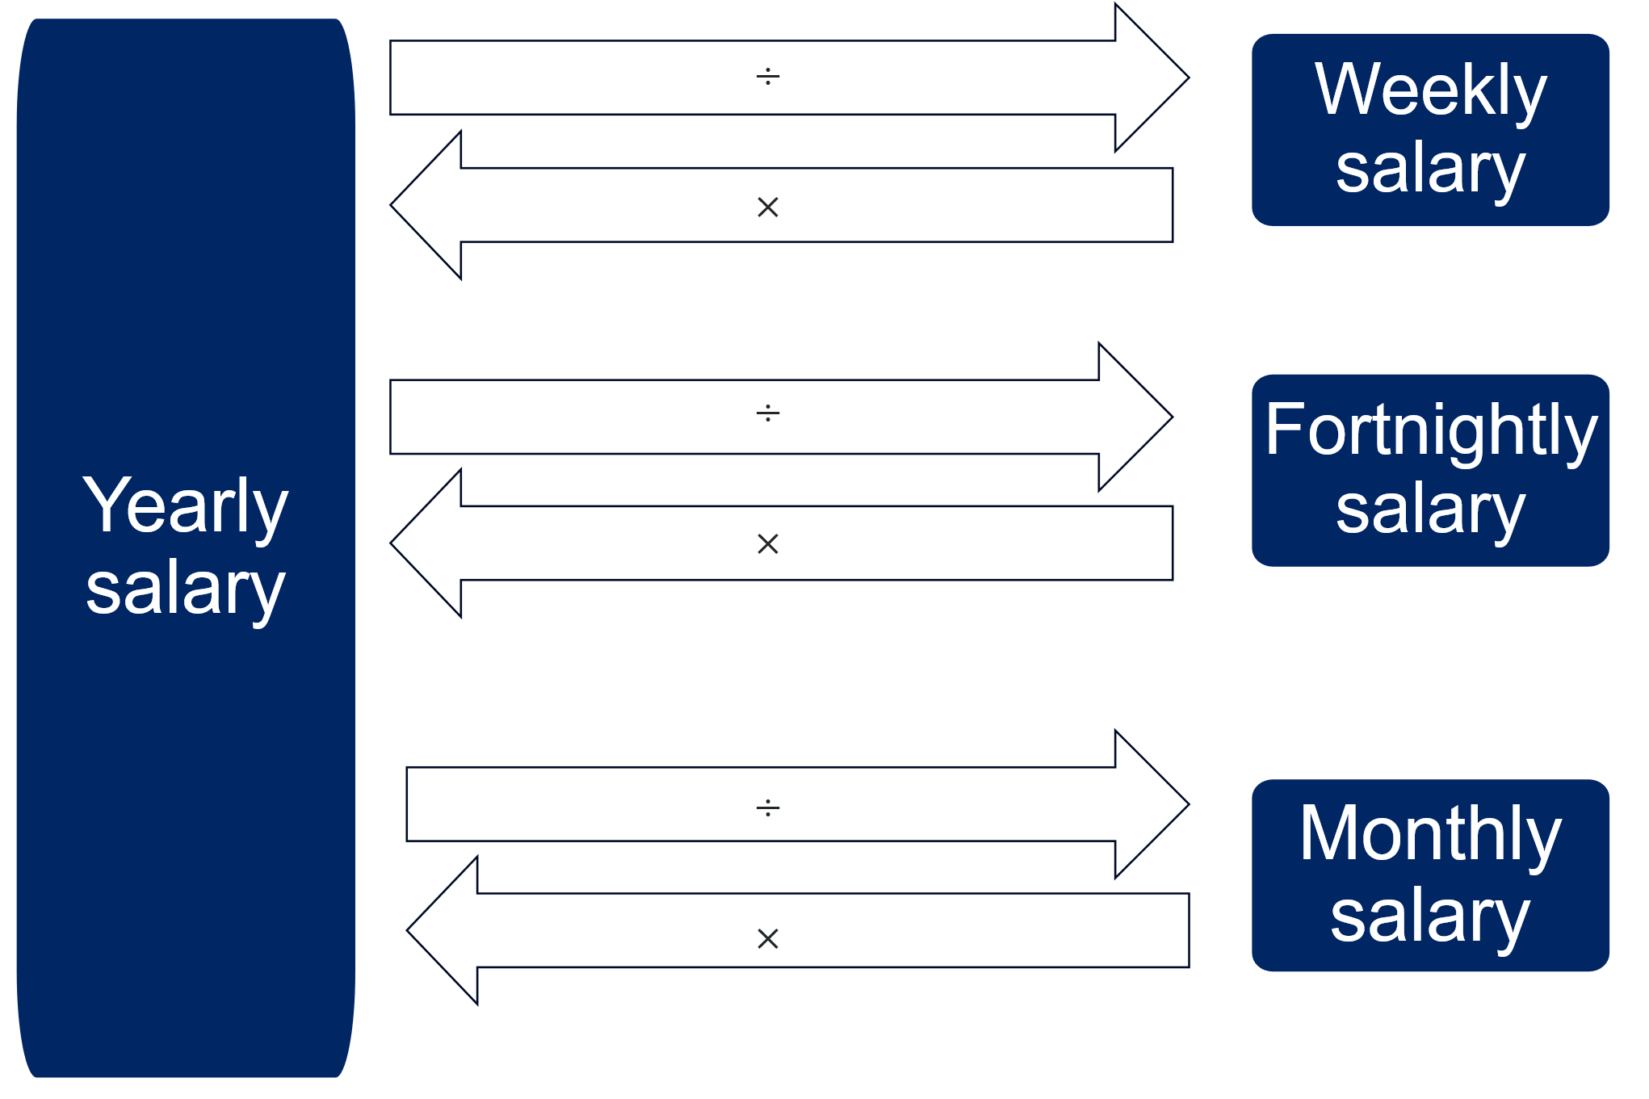

Appendix B

Auditing a company's financial information
You have been hired to audit an advertising company that has incomplete records of employee salaries. Some employees only have their annual salary recorded, while others are listed as being paid weekly, fortnightly or monthly. Your job is to use the data provided in the Excel file to organise this information, so the company’s accounts are accurate and the board of directors can easily compare employee salaries across the different pay periods.
Step 1: go to the ‘Company structure and salary’ worksheet tab.
This sheet shows the salary breakdown for each employee. However, some records are incomplete.
Step 2: use spreadsheet formulas to calculate all the missing values in the table. Remember, the = sign at the start of your formula, * is multiplication and / is division.
Question set 1:
- Which role earns the most and least per month? Why do you think this is the case?
Step 3: calculate monthly staff costs
Now that you know how much each position is paid, you need to calculate the total salary cost for all employees.
- Go to the ‘Company monthly salary costs’ worksheet tab.
This sheet will help you determine how much the company spends each month on salaries.

Question set 2:
- Where have these values populated from? Select a cell to show the formula to confirm your thinking.
- What if the company wanted to look at yearly expenditure? How would you modify the formula, so that these cells populated the yearly salaries?
Step 4: calculate the monthly expenditure
- Use formulas to calculate the total monthly salary for each job type in the column G ‘Total monthly salary’, considering the number of employees in each role.
- Use the SUM function, by typing =SUM and selecting the cells you’d like to add together in cell B6 to calculate the total expenditure of the company per month.
Question set 3:
- What are the benefits of using a formula over a manual calculation in a spreadsheet?
- How much revenue do you believe the company should be making to guarantee they can pay their employees each month? Justify your answer.
Step 5: analyse profit or loss
Now it’s time to determine whether the company is operating at a profit or a loss.
- Navigate to the ‘Company Profit Loss’ worksheet tab.
- Use the revenue and total monthly salary figures to calculate the profit or loss for each month in column G ‘Monthly profit/loss’.
- Use the SUM function in cell B6 to calculate the yearly profit/loss.
Question set 4:
- In which month did the company make the biggest loss, and how much was it?
- What could the company do to reduce salary expenditure? Justify your answer using data from your spreadsheet.

Appendix C

Save a local copy of a file
How to save a local copy of an Excel spreadsheet.

File sharing and saving
- Save the Excel file Salaries in a place where students can easily access the file.
This could be done through Google Classroom, by sharing a OneNote link, or by emailing students a copy of the document.
- Have students open the document on their own device.
- Instruct students to select the File tab and then Save a Copy.

- Students can save the document in their individual OneDrive by selecting this option.
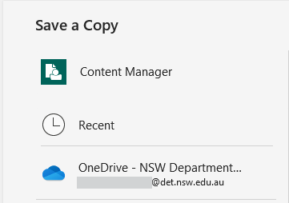
- Best practice would be to keep the file name the same. Students can then select Save and a copy will be stored on their OneDrive.
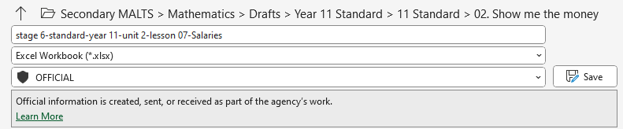

Appendix D

HSC-style questions
- Amy earns $78 000 per year. What would her fortnightly pay be?
- Bronwyn currently earns $1350 per week at Company A. She has been offered another job, at Company B, that will pay $72 500. Which job pays the most and by how much?
- The table below shows the salary details for 2 employees at a logistics company.
Employee | Salary type | Amount | Bonus (annual)
Tania | Fortnightly | $2200 | $1000
James | Annual | $58 000 | $0
- Who earns more, Tania or James? Justify your answer with appropriate mathematical calculations.
- James and Tania each receive a 3% salary increase. Assuming Tania’s bonus remains unchanged, determine who will now have the higher total earnings. Justify your answer with appropriate mathematical calculations.
- A company has the following salary pay structure:
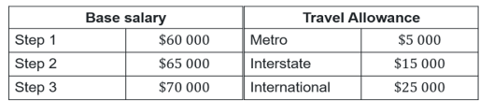
Dylan is currently on Step 2 of the base salary and travels interstate. He has been offered a position that is on Step 3 of the base salary and requires metro travel. If Dylan wanted the job that paid the most, should he accept this offer? Justify your decision with relevant mathematical calculations.
- Taylor earns a salary of $78 000 per year, paid weekly. Jordan earns $40 per hour and works 42 hours per week but does not get paid during leave. They both decide to use 4 weeks leave. Who has earned more at the end of the year and by how much?

Sample solutions

Appendix A – converting time units
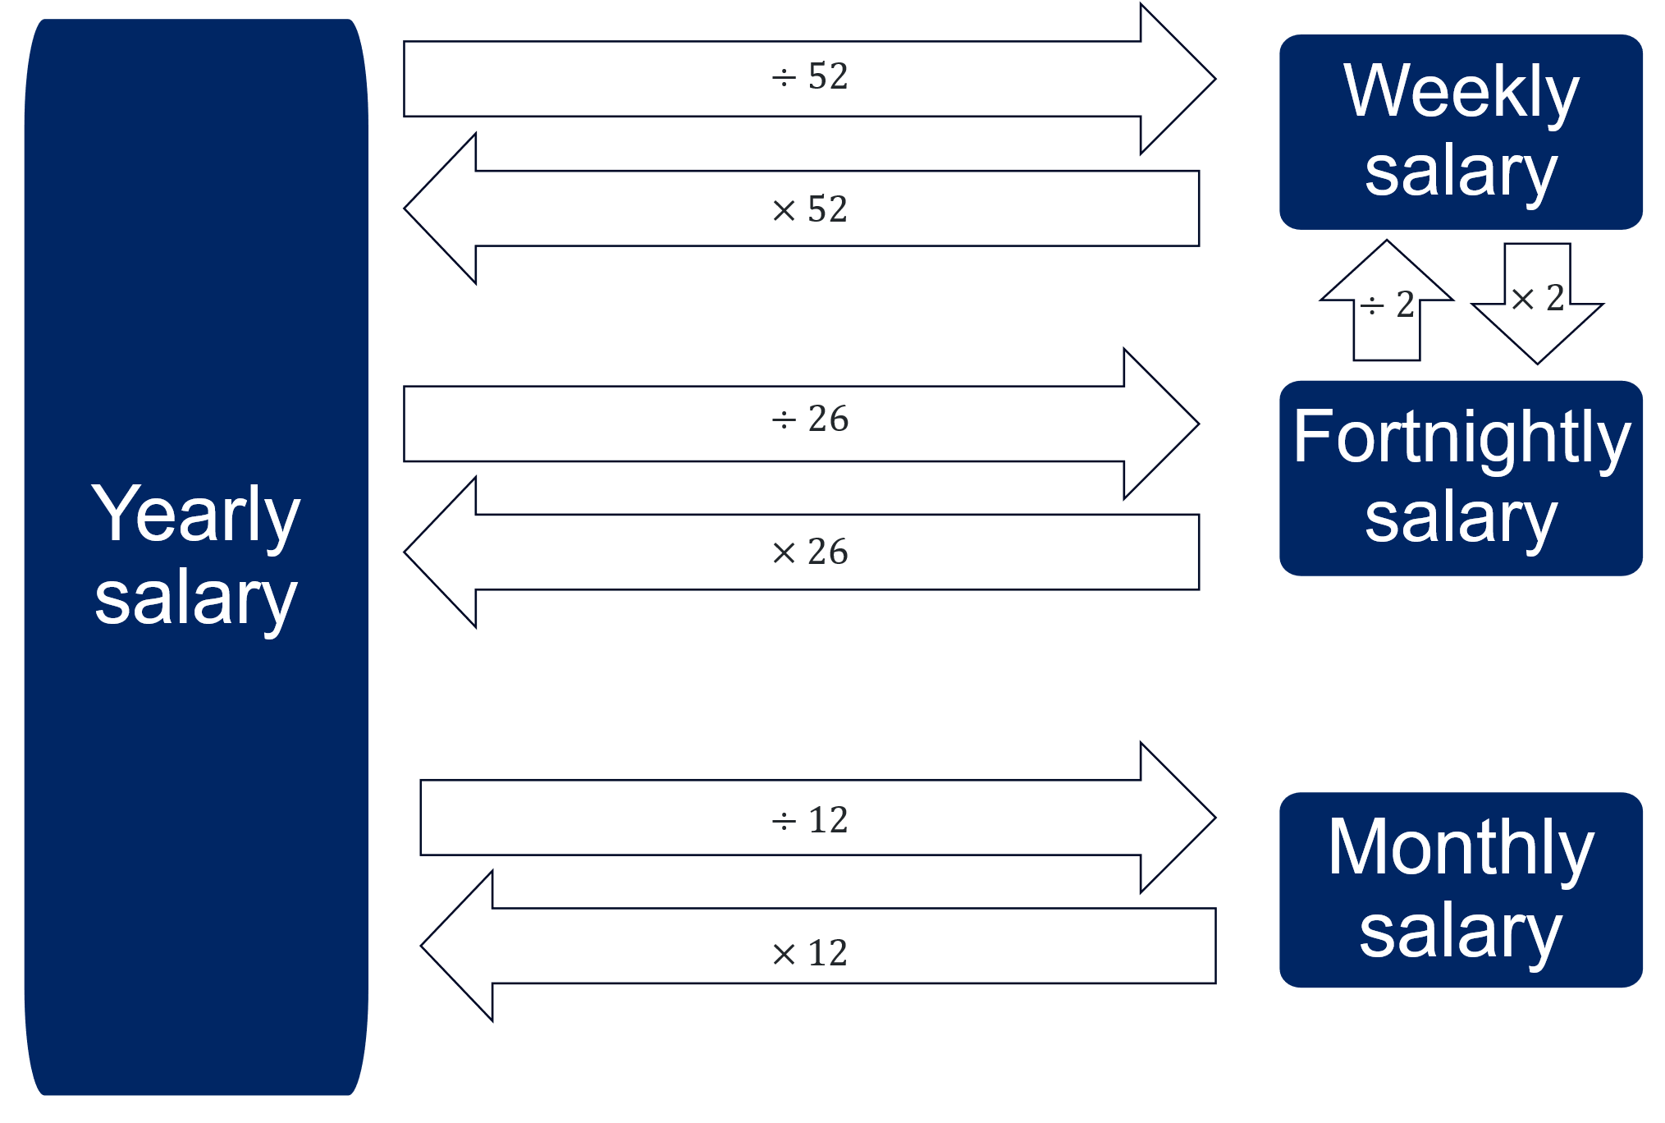

Appendix B – auditing a company's financial information
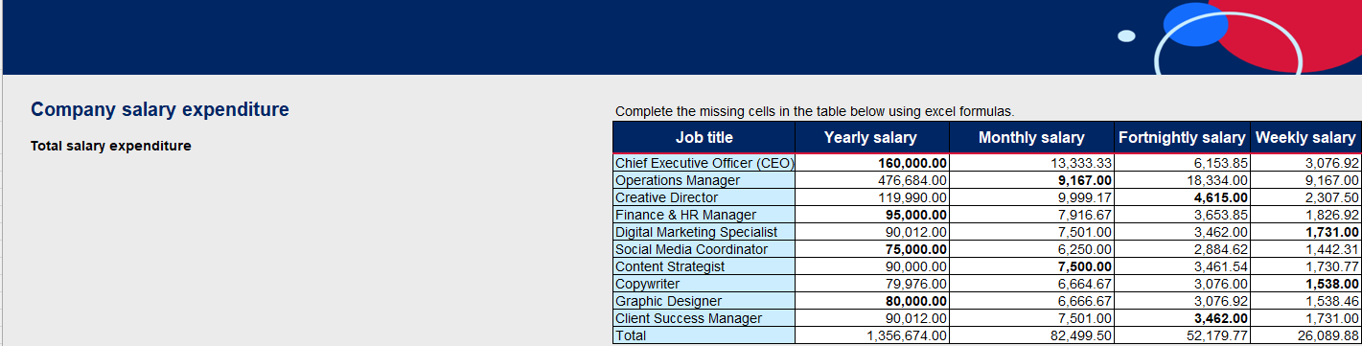
Question set 1:
- The Chief Executive Officer earns the most and the Social Media Coordinator earns the least. I believe this is because of the level of the job. The CEO gets paid the most because they’re in charge of the whole company and make the big decisions. The Social Media Coordinator earns less because their job is more focused and doesn’t carry as much responsibility. Pay usually depends on how important and complex the job is.
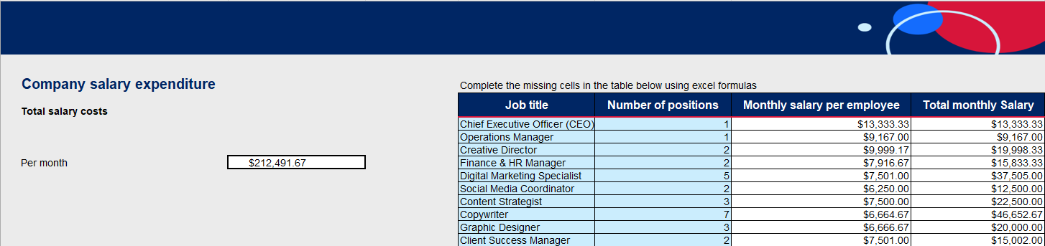
Question set 2:
- These values have populated from referencing the cell across worksheet tabs. It is referencing the monthly salaries from the ‘Company structure and salary’ worksheet tab.
- If we wanted to change to the yearly salaries we should just be able to change the current cell reference, so it is referencing column B instead of C. We should also change the heading of that column to ‘Yearly salary’.
Question set 3:
- $212 491.67.
- The benefit of using a formula means that if any of these salaries change then the formulas will update themselves to align to the new values.
- The company should make around $300 000 per month as they want to make sure they are covered if something goes wrong in a month’s time so they can still pay their employees. We also don’t know if they have manufacturing costs or other costs for their company so these should be considered too.
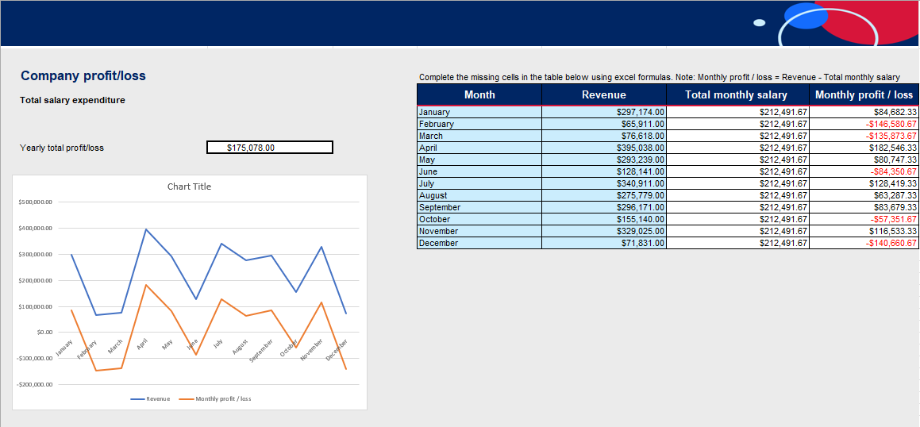
Question set 4:
- February had the biggest loss, and it was $146 580.67.
- The company could reduce salary expenses without cutting staff by freezing pay rises or bonuses. They could also introduce a shorter workweek, such as a 4-day week, with adjusted salaries. Another option is offering voluntary unpaid leave or career breaks to reduce overall payroll costs. The could also consider how many people are required to perform a job and see where they can streamline processes.

Appendix D – HSC-style questions
- 78 000 ÷ 26 = $3000.
- 1350 × 52=$70 200
72 500 − 70 200 = 2300
Company B pays more by $2300.
- Logistics company:
- Tania earns = $2200 × 26 + 1000 = $58 200
- $58 200 − $58 000 = $200
Tania earns $200 more.
- James’ salary: $58 000 × 1.03 = $59 740
Tania’s salary: $2200 × 26 × 1.03 + 1000 = $59 916
Tania now earns $176 more.
- Dylan currently earns: $65 000 + $15 000 = $80 000
The Step 3 position earns: $70 000 + $5000 = $75 000
Dylan should not accept this offer as he would lose $5000 annually.
- Taylor earns $78 000/year
Jordan earns $40 × 42 × 48 weeks = $80 640.
Jordan earns more: $80 640 – 78 000 = $2640.

Exit ticket
96 000 × 1.035 = $99 360
99 360 ÷ 12 = $8280
Chris will earn $99 360 yearly and $8 280 monthly.

References
This resource contains NSW Curriculum and syllabus content. The NSW Curriculum is developed by the NSW Education Standards Authority. This content is prepared by NESA for and on behalf of the Crown in right of the State of New South Wales. The material is protected by Crown copyright.
Please refer to the NESA Copyright Disclaimer for more information https://educationstandards.nsw.edu.au/wps/portal/nesa/mini-footer/copyright.
NESA holds the only official and up-to-date versions of the NSW Curriculum and syllabus documents. Please visit the NSW Education Standards Authority (NESA) website https://educationstandards.nsw.edu.au and the NSW Curriculum website https://curriculum.nsw.edu.au.
Mathematics Standard 11–12 Syllabus © NSW Education Standards Authority (NESA) for and on behalf of the Crown in right of the State of New South Wales, 2024.

© State of New South Wales (Department of Education), 2025
The copyright material published in this resource is subject to the Copyright Act 1968 (Cth) and is owned by the NSW Department of Education or, where indicated, by a party other than the NSW Department of Education (third-party material).
Copyright material available in this resource and owned by the NSW Department of Education is licensed under a Creative Commons Attribution 4.0 International (CC BY 4.0) license.

This license allows you to share and adapt the material for any purpose, even commercially.
Attribution should be given to © State of New South Wales (Department of Education), 2025.
Material in this resource not available under a Creative Commons license:
- the NSW Department of Education logo, other logos and trademark-protected material
- material owned by a third party that has been reproduced with permission. You will need to obtain permission from the third party to reuse its material.
Links to third-party material and websites
Please note that the provided (reading/viewing material/list/links/texts) are a suggestion only and implies no endorsement, by the New South Wales Department of Education, of any author, publisher, or book title. School principals and teachers are best placed to assess the suitability of resources that would complement the curriculum and reflect the needs and interests of their students.
If you use the links provided in this document to access a third-party's website, you acknowledge that the terms of use, including licence terms set out on the third-party's website apply to the use which may be made of the materials on that third-party website or where permitted by the Copyright Act 1968 (Cth). The department accepts no responsibility for content on third-party websites.

