Piecework
Students learn about piecework through the context of a content creator, making connections to direct variation by solving problems using equations and graphs.

Learning intentions
- To know that piecework is a way of earning money.
- To understand the connection between piecework and direct variation.

Success criteria
- I can explain how to earn money through piecework.
- I can use an equation to calculate the total amount earned by piecework.
- I can use a direct variation graph to find the amount I would earn using piecework.
- I can compare earning money through piecework to a wage.

Outcomes
A student:
- develops understanding and fluency in mathematics through exploring and connecting mathematical concepts, choosing and applying mathematical techniques to solve problems, and communicating their thinking and reasoning coherently and clearly MAO-WM-01
- models and interprets linear relationships to solve problems and make predictions in practical contexts MST-11-02
- solves financial problems involving earning money and taxation MST-11-03

Associated numeracy outcomes
A student:
- recognises and applies functional numeracy concepts in practical situations, including personal and community, workplace and employment, and education and training contexts N6-1.1
- determines whether an estimate or an answer is reasonable in the context of a problem, evaluates results and communicates conclusions N6-1.3
- chooses and applies appropriate operations with whole numbers, familiar fractions and decimals, percentages, rates and ratios to analyse and solve everyday problems N6-2.1
- chooses and applies efficient strategies to analyse and solve everyday problems involving money and finance N6-2.4
- chooses and uses appropriate technology to access, organise and interpret information in a range of practical personal and community, workplace and employment, and education and training contexts N6-3.1

Content

Linear relationships
Direct variation
- Identify and represent direct variation of the form $y=kx$ from descriptions of situations in which one quantity varies directly with another quantity
- Graph and analyse equations of the form $y=kx$ to solve problems in a variety of contexts

Earning money
Ways of earning
- Calculate an individual’s earnings from commission, sliding scale commission, piecework, royalties, government payments and as a sole trader
Mathematics Standard 11–12 Syllabus © NSW Education Standards Authority (NESA) for and on behalf of the Crown in right of the State of New South Wales, 2024.

Table 1: lesson summary
Section | Summary of activity | Teaching strategies | Teaching points
Activating prior knowledge | Students discuss the ‘Would you rather’ scenario on slide 4 of the PowerPoint Piecework. | ‘Would you rather’  Think-Pair-Share | Gather information about what students know about salaries, royalties and piecework.
Connecting learning | Define piecework to students and ask them to provide an example.  Revisit the terminology and features of direct variation by asking students to connect to the scenario. Slide 6 has the solution and how this same question could be worded using the language of earning money and direct variation. Students then complete Appendix A.  Return to slide 4 and ask students to find the number of posts or videos a content creator would need to match the $4000 monthly salary. Ask students if their opinion has changed for the ‘Would you rather’ activity and why. | Think-Pair-Share  Visibly random groups of 3  Vertical non-permanent surfaces  Assessing and advancing questions  Pose-Pause-Pounce-Bounce  Notice and wonder | Students connect how to use direct variation equations and graphs to solve problems involving piecework.
Releasing responsibility | Students write notes using Appendix B.  Use slide 8 to show direct variation graphs and ask students to complete problems from Appendix C. | Notes to forgetful future selves | Students summarise their learning and solve problems.
Independent practice | Students complete Appendix D. |  | Students apply their knowledge to an HSC-style question.

Activity structure
Please use the associated PowerPoint Piecework to display images in this lesson.

Activating prior knowledge
- Display slide 4 of the PowerPoint, which shows the following ‘Would you rather’ scenario
(wouldyourathermath.com/users-guide/):
‘Would you rather’:
- Receive a fixed monthly salary of $4000 for creating content (videos and social media posts) for a company, no matter how many posts or videos you create.
- Earn $0.15 per view of videos you’ve created, $1 per comment on videos or social media posts you’ve created and $2 per share of the content.
- Earn $500 per video created and $100 per social media post created, with no minimum number of posts or videos.
- Use a Think-Pair-Share (bit.ly/thinkpairsharestrategy), for students to discuss what type of earnings each scenario represents and which they would choose and why.
There is no correct answer for this activity as each has its advantages and disadvantages.
Choosing a fixed wage provides financial security and a predictable income. This option also reduces the pressure to constantly produce new content, making it easier to plan and manage your time.
Earning through royalties means you continue to earn money over time from content you've already created. For example, a video made years ago could still be generating income. This structure supports long-term earning potential.
Getting paid per video or post means your income depends on your productivity. This method offers flexibility and the potential to earn more if you work efficiently. It rewards extra effort and high output.
The third option is piecework, as students earn through the amount they produce, which students will learn about in this lesson. Students may already be familiar with the concept of piecework as it was previously covered in the Stage 5 Financial mathematics A outcome MA5-FIN-C-01.

Connecting learning
- Define piecework to students as: ‘Employment where a worker is paid a fixed rate for each item produced or action performed regardless of the time taken.’ Ask students to share any examples they may know.
This definition was sourced from the syllabus glossary. Some examples include picking fruit on a farm where you earn money for the amount or weight of fruit that you pick, or a photographer who earns money for the number of quality photos they take for media companies.
- In a Think-Pair-Share, ask students what type of relationship they think this represents and explain why.
Students should, based on previous lessons in this unit, connect piecework to direct variation. Piecework is an example of direct variation as it starts at zero and increases at a constant rate.
- Refer students to the third option of the ‘Would you rather’ scenario on slide 4 of the PowerPoint. State to students that earning money by creating videos or posts are each an example of direct variation relationships.
- In a Think-Pair-Share, ask students what the independent variable, dependent variable and constant of variation are and to write a direct variation equation for earning money by creating videos.
The independent variable, dependent variable and constant of variation are defined in Lesson 2 – direct variation. The independent variable is the number of videos, the dependent variable is the amount earned and the constant of variation is the rate per video.
- Display slide 6 which shows the independent and dependent variables, the constant of variation and the equation, as well as the ways it can be written, using the language of earning money and the language of direct variation.
- In a Think-Pair-Share, ask students to identify the key words that indicate direct variation.
Students should recognise that key phrases such as ‘varies directly’ and ‘per’ indicate that it is a direct variation relationship.
- Distribute Appendix A ‘Piecework scenarios’ to each student to check their understanding of piecework and direct variation relationships. The appendix asks students to identify the independent and dependent variables and constant of variation before solving the problems.
- Have students swap work with a partner to compare answers and provide peer feedback.
- Assign students to visibly random groups of 3 (bit.ly/visiblegroups) at vertical non-permanent surfaces (bit.ly/VNPSstrategy).
- Return to slide 4 and in their groups of 3, ask students to find the number of posts and/or videos they would need to make each month under options 2 and 3, to match the salary of $4000 in the first option.
- Ask students assessing and advancing questions (bit.ly/supportingstrategies) to check for understanding and deepen student thinking. Some suggestions are provided in the following table:
Table 1: assessing and advancing questions
Assessing questions | Advancing questions
If you only created videos, how many would you need to create? | How many different solutions can you find?
How could you verify your answer once you've calculated the number of posts and videos? | Which solution would allow you to earn $4000 as quickly as possible?
How does the amount per post or video affect the number of posts or videos you need to create?
- Use the Pose-Pause-Pounce-Bounce questioning strategy (PDF 557 KB) (bit.ly/posepausepouncebounce) to check for understanding by asking students if their position for the ‘Would you rather’ scenario has changed and why.

Releasing responsibility
      - Have students create notes to their future forgetful selves (bit.ly/notestofutureself) using Appendix B ‘Notes to future forgetful selves’.
      - Display slide 8 of the PowerPoint which shows a direct variation graph for the amount the influencer earns for creating a social media post and a graph which shows the number of hours required to create a social media post.
      - Gather information by asking students what they notice and wonder (bit.ly/noticewonderstrategy).
Students may notice that the dependent variable for the first graph is the independent variable for second graph. They may also notice that it takes 0.75 hours or 45 minutes to create a post and the influencer earns $100 per post.
They may wonder how we could use the graphs to compare to the salary or change into a singular graph to compare the time taken to earn the same amount.
      - Distribute Appendix C ‘Direct variation graphs’ to pairs of students to complete. Ask students to use the 2 graphs to answer the questions.
      - Use the Pose-Pause-Pounce-Bounce questioning strategy to ask students:
- how they found the amount of time taken to earn certain amounts
- how they calculated how much money they could earn given the amount of time they could work.

Independent practice
Distribute Appendix D ‘HSC-style questions’ to each pair of students. Encourage students to use calculations and/or graphs to support their reasoning and justifications.

Assessment and differentiation

Suggested opportunities for differentiation
Activating prior knowledge
- The job in the ‘Would you rather’ scenario can be changed to appeal to students’ interests.
- The ‘Would you rather’ activity has no correct answers and is subject to opinion, all students should be able to contribute.
- Students may benefit from revisiting their notes on royalties when comparing them to piecework.
- Challenge students to explain the advantages and disadvantages of earning through royalties and piecework to justify their choices.
Connecting learning
- Students could be given a list of jobs to suggest if they could be paid through piecework rather than brainstorming their own examples.
- Students can complete Appendix A in pairs.
- Students can be challenged to create a linear model of the number of posts and videos needed to earn $4000.
Releasing responsibility
- Students can be challenged to provide a variety of questions involving direct variation graphs and equations.
- Students may benefit from reviewing how to read a solution from a graph prior to completing Appendix B.
- Students can be extended by calculating the gradient of the graph and defining it as the constant of variation to find an equation.

Independent practice
- Students can be provided with scaffolding prompts to help solve the problems.
- If students are still developing their skills in solving problems involving rates, Question 2 can be omitted from Appendix D.
- Challenge students to decide how to modify the rates such that they are equal regardless of the job they choose.

Suggested opportunities for assessment
Activating prior knowledge
- Monitor student responses in the ‘Would you rather’ activity to check for understanding of piecework and how to calculate earnings.
Connecting learning
- Student’s examples for jobs where you could earn money through piecework show their understanding of what piecework is.
- Collect Appendix A as evidence of learning solving problems involving direct variation or piecework.
- Students show their ability to calculate earnings through piecework by finding how many posts or videos are needed to earn $4000. This can be collected as evidence of learning.
Releasing responsibility
- Review students’ notes to their future forgetful selves to check for understanding of what piecework is, how you calculate it and how it relates to direct variation.
- Collect Appendix C as evidence of student understanding of solving direct variation problems graphically.
Independent practice
- Appendix D could be collected as an exit ticket (bit.ly/exitticketstrategy) as evidence of learning piecework.

Appendix A

Piecework scenarios
For each of the following questions:
- State the independent variable, dependent variable and constant of variation.
- Write the direct variation equation to represent the scenario.
- Solve the problem.
- The number of photo shoots completed is directly proportional to the amount earned. The rate is $80 per photo shoot. If 8 photo shoots are completed in one month, how much money will be earned?
- Mark works at a factory where he earns $2 per box he packs. If he packs 150 boxes in one day, how much money does he earn?
- Mia is a tutor who charges $25 per student for her services. If she earned $150 for her session, how many people did she tutor?
- Lucas earns $15 per pet sitting session. If he looks after 4 pets each day for a week (7 days), how much will he earn in total?
- The amount of money earned is directly proportional to the number of minutes of audio transcribed. If the rate is $0.70 per minute, how much will be earned for transcribing 3 audio files, each 10 minutes long?
- The number of oranges picked is directly proportional to the amount earned. The rate for each orange is $0.12. If $60 was earned at a market, how many oranges were picked?
- Liam is a car detailer who earns $60 per car for a full detail. If he details 10 cars in a week, how much money will he earn?

Appendix B

Notes to future forgetful selves
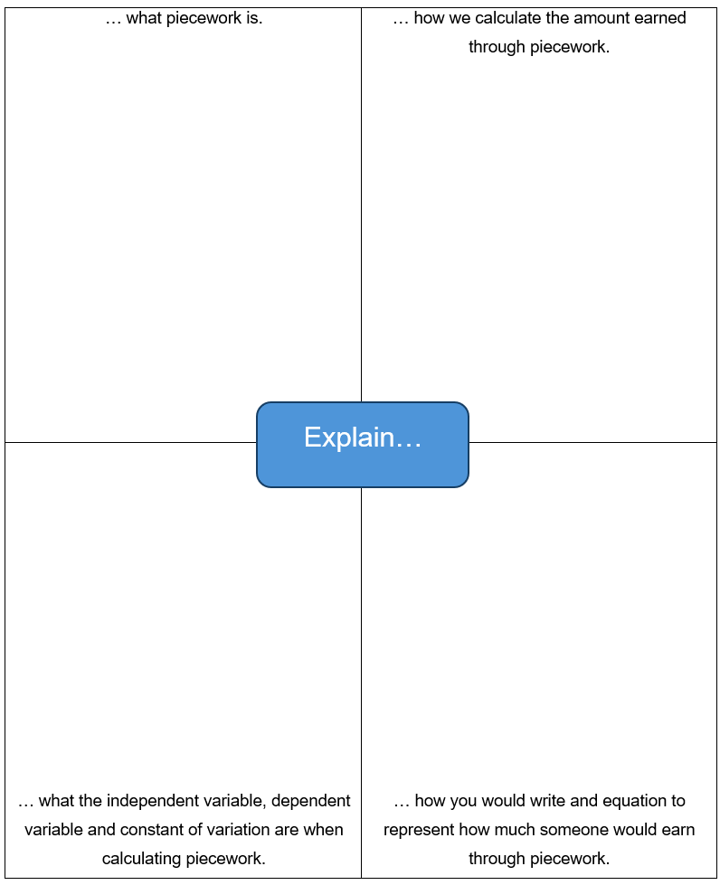

Appendix C

Direct variation graphs
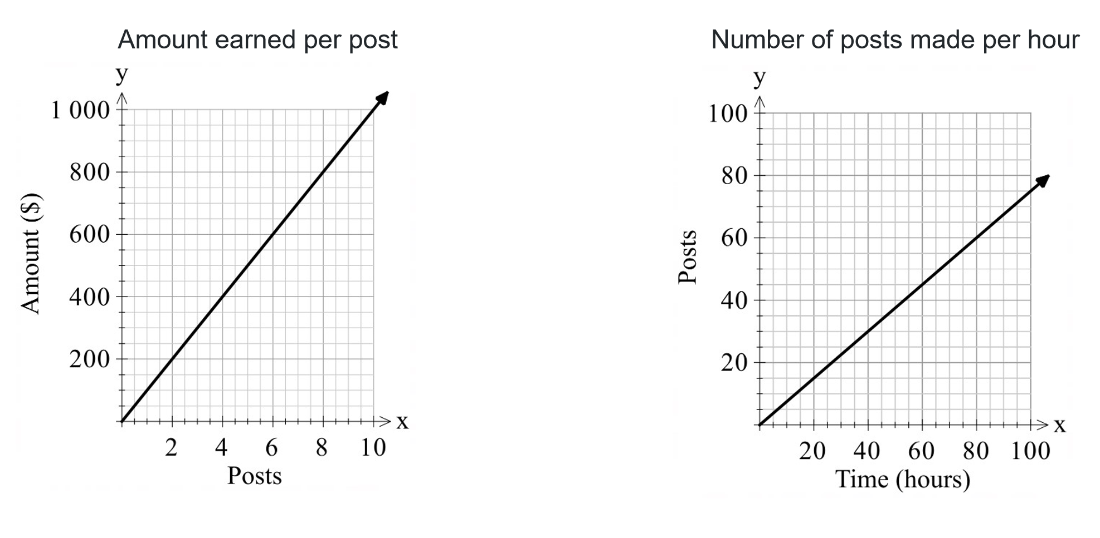

Questions
- A content creator has been contracted by a company to make 5 posts for their social media channel.
- Find how long it will take them to create these posts.
- Find the amount they would earn from these posts.
- A content creator assigns 35 hours a week to create posts.
- Find the maximum number of posts that could be created.
- Find the amount earned for that many posts.
- A content creator is looking to make at least $4000 in a month.
- Find the number of posts they would need to create.
- Find the amount of time needed to create this number of posts.

Challenge
- Calculate:
- how many posts the content creator can make per hour.
- how much the content creator earns per post.
- how much the content creator earns per hour.

Appendix D

HSC-style questions

Question 1
Gianni is comparing 2 different ways she can earn money through piecework working as a photographer. She has 2 options for earning money based on the number of photos she takes:
- Freelance photography (event photography):
- She earns $100 per event she photographs.
- She earns $5 per photo she takes at the event.
- She works up to 2 events per week and takes around 120 photos.
- Photography for a stock photo service:
- She uploads photos to a stock photo website where she earns $3 per photo.
- She uploads up to 450 photos per week.
Which option would earn Gianni more money over the course of one week? Support your answer with calculations.

Question 2
Xuso is comparing 2 different ways of earning money through piecework. He has 2 options for earning money by either delivering parcels on his motorcycle or by working for a delivery service that pays per trip, which he would do on public transport.
- Motorcycle deliveries:
- Xuso uses his motorcycle to deliver parcels and he earns $15 per delivery. His motorcycle uses one litre of fuel for every 17 km travelled. The cost of fuel is $1.67 per litre and the distance for each delivery is on average a 34 km round trip.
- Xuso makes 5 deliveries per day and works 5 days a week.
- Bus deliveries:
- Xuso also has the option to work for a delivery service that pays him $16 per delivery and he uses the bus for transportation. The bus fare costs $23.40 for 10 single trips and he needs to make 5 deliveries per day, 5 days a week.
Which option would earn Xuso more money after covering his transportation costs for one week? Support your answer with calculations.

Sample solutions

Appendix A – piecework scenarios
Q | Independent variable | Dependent variable | Constant of variation | Equation | Solution
1 | Number of photos | Amount earned | 80 | $$y=80x$$ | $$80×8=\$640$$
2 | Number of boxes packed | Amount earned | 2 | $$y=2x$$ | $$2×150=\$300$$
3 | Number of students | Amount earned | 25 | $$y=25x$$ | $\frac{150}{25}=6$ students
4 | Number of pets | Amount earned | 15 | $$y=15x$$ | $$15×4×7=\$420$$
5 | Number of minutes transcribed | Amount earned | 0.7 | $$y=0.7x$$ | $$0.7×10×3=\$21$$
6 | Number of oranges | Amount earned | 0.12 | $$y=0.12x$$ | $\frac{60}{0.12}=500$ oranges
7 | Number of cars detailed | Amount earned | 60 | $$y=60x$$ | $$60×10=\$600$$

Appendix C – direct variation graphs
- If a content creator received work from a company which asked them to create 5 posts it would:
- take them 6 hours and 40 minutes to create
- earn them $500.
- If the content creator could work 35 hours a week:
- They could create
$$y=0.75×35 \\ =26.25$$
26 posts.
- which would earn them:
$$y=100×26 \\ =2600$$
$2600 per week.
- To earn $4000 per month the content creator would have to:
- make 40 posts
- which would take 53 hours and 20 mins (That is around 12 hours per week).
- Rates
- 45 minutes or 0.75 hours per post
- $100 per post
- To convert to a wage, we can multiply the constants of variation ($0.75×100$) so they would earn the equivalent of $75 per hour they work or use the equation $y=75x$ to calculate the amount they can earn with the amount of time they have available.

Appendix D – HSC-style questions

Question 1
Type of earning | Freelance | Stock photos
Earnings | $$100+5×120=\$700$$  $$700×2 events=\$1400$$ | $$3×450=\$1350$$
$$1400-1350=\$50$$
So, Gianni would earn $50 more per week from freelance photography (event photography) compared to the stock photo service.

Question 2
Mode of transport | Motorcycle | Bus
Earnings | $$15×5=75$$  Deliveries per week  $$75×5=375$$  dollars per week | $5×5×16=400$  dollars per week
Cost of transport | $34÷17=2$L per delivery  The cost of fuel for each delivery is: $2×1.67=\$3.34$  Total fuel costs for 125 deliveries per week:  $$25×3.34=\$83.50$$ | $$\$23.40×5=\$117$$
Profit | $$375-83.50=\$291.50$$ | $$400-117=\$283$$
Difference in earnings:
$$291.50-283=\$8.50$$
Xuso would earn $8.50 more per week from using his motorcycle.

References
This resource contains NSW Curriculum and syllabus content. The NSW Curriculum is developed by the NSW Education Standards Authority. This content is prepared by NESA for and on behalf of the Crown in right of the State of New South Wales. The material is protected by Crown copyright.
Please refer to the NESA Copyright Disclaimer for more information https://educationstandards.nsw.edu.au/wps/portal/nesa/mini-footer/copyright.
NESA holds the only official and up-to-date versions of the NSW Curriculum and syllabus documents. Please visit the NSW Education Standards Authority (NESA) website https://educationstandards.nsw.edu.au and the NSW Curriculum website https://curriculum.nsw.edu.au.
Mathematics Standard 11–12 Syllabus © NSW Education Standards Authority (NESA) for and on behalf of the Crown in right of the State of New South Wales, 2024.

© State of New South Wales (Department of Education), 2025
The copyright material published in this resource is subject to the Copyright Act 1968 (Cth) and is owned by the NSW Department of Education or, where indicated, by a party other than the NSW Department of Education (third-party material).
Copyright material available in this resource and owned by the NSW Department of Education is licensed under a Creative Commons Attribution 4.0 International (CC BY 4.0) license.

This license allows you to share and adapt the material for any purpose, even commercially.
Attribution should be given to © State of New South Wales (Department of Education), 2025.
Material in this resource not available under a Creative Commons license:
- the NSW Department of Education logo, other logos and trademark-protected material
- material owned by a third party that has been reproduced with permission. You will need to obtain permission from the third party to reuse its material.
Links to third-party material and websites
Please note that the provided (reading/viewing material/list/links/texts) are a suggestion only and implies no endorsement, by the New South Wales Department of Education, of any author, publisher, or book title. School principals and teachers are best placed to assess the suitability of resources that would complement the curriculum and reflect the needs and interests of their students.
If you use the links provided in this document to access a third-party's website, you acknowledge that the terms of use, including licence terms set out on the third-party's website apply to the use which may be made of the materials on that third-party website or where permitted by the Copyright Act 1968 (Cth). The department accepts no responsibility for content on third-party websites.

