Royalties
Students are introduced to the concept of royalties by exploring earnings from music streams, before modelling these earnings using a spreadsheet.
Students will need at least one digital device per pair to interact with the Royalties spreadsheet during this lesson.

Learning intentions
- To understand how royalties are earned.
- To understand the connection between royalties and direct variation.

Success criteria
- I can explain how to earn money through royalties.
- I can identify the independent variable, dependent variable and constant of variation.
- I can model a direct variation relationship on a spreadsheet.
- I can calculate the total amount earned through royalties.

Outcomes
A student:
- develops understanding and fluency in mathematics through exploring and connecting mathematical concepts, choosing and applying mathematical techniques to solve problems, and communicating their thinking and reasoning coherently and clearly MAO-WM-01
- models and interprets linear relationships to solve problems and make predictions in practical contexts MST-11-02
- solves financial problems involving earning money and taxation MST-11-03

Associated numeracy outcomes
A student:
- recognises and applies functional numeracy concepts in practical situations, including personal and community, workplace and employment, and education and training contexts N6-1.1
- determines whether an estimate or an answer is reasonable in the context of a problem, evaluates results and communicates conclusions N6-1.3
- chooses and applies appropriate operations with whole numbers, familiar fractions and decimals, percentages, rates and ratios to analyse and solve everyday problems N6-2.1
- chooses and applies efficient strategies to analyse and solve everyday problems involving money and finance N6-2.4
- chooses and applies efficient strategies to analyse and solve everyday problems involving location, space and design N6-2.5
- chooses and applies appropriate numeracy operations and techniques to analyse and resolve everyday situations N6-2.6
- chooses and uses appropriate technology to access, organise and interpret information in a range of practical personal and community, workplace and employment, and education and training contexts N6-3.1

Content

Linear relationships
Linear modelling
- Use a spreadsheet to model a linear relationship in a variety of contexts

Direct variation
- Identify and represent direct variation of the form $y=kx$ from descriptions of situations in which one quantity varies directly with another quantity
- Graph and analyse equations of the form $y=kx$ to solve problems in a variety of contexts

Earning money

Ways of earning
- Calculate an individual’s earnings from commission, sliding scale commission, piecework, royalties, government payments and as a sole trader
- Use a spreadsheet to model an employee’s income including overtime, salary, bonuses, commission, piecework and royalties
Mathematics Standard 11–12 Syllabus © NSW Education Standards Authority (NESA) for and on behalf of the Crown in right of the State of New South Wales, 2024.
.
Table 1: lesson summary
Section | Summary of activity | Teaching strategies | Teaching points
Retrieval practice | Students discuss which is larger, 12.5% of 72 or 72% of 12.5. | Think-Pair-Share | Students recall how to find a percentage of an amount.
Activating prior knowledge | Students listen to a portion of ‘Somebody That I Used To Know’ (4:03) by Gotye featuring Kimbra (bit.ly/gotye-somebody-that-i-used-to-know) to discuss how much money Gotye would make from views on YouTube. State this is an example of a royalty, before brainstorming other jobs that may earn money through royalties. | Think-Pair-Share  Pose-Pause-Pounce-Bounce | This would be a real-life example of royalties except that Gotye never monetised his YouTube channel.
Connecting learning | Ask students how they would calculate Gotye’s earnings if he earned $0.003 per view and then generalise to any amount. Connect this to direct variation and compare how the variables change compared to when it was a wage. Use the spreadsheet Royalties to model this relationship with an equation, table of values and graph.  Modify the scenario to account for Kimbra receiving 5% of Gotye’s royalties. Then have students investigate changing the constant of variation on both Gotye and Kimbra’s earnings. | Pose-Pause-Pounce-Bounce  Think-Pair-Share | Students connect calculating royalties to direct variation including the constant of variation, independent and dependent variables in context and model it on a spreadsheet for both amount per stream and percentage of earnings.
Releasing responsibility | Students complete notes using an existing source and write notes using Appendix B. | Frayer diagram  Pose-Pause-Pounce-Bounce | Students summarise their learning and apply it to a variety of jobs, developing their estimating skills.
Independent practice | Use Appendix C and the ‘Approaching questions scaffold’ to answer HSC-style questions. | Approaching questions scaffold  Pose-Pause-Pounce-Bounce | Students apply their knowledge to decipher HSC-style questions focusing on understanding the question and planning to answer.

Activity structure

Retrieval practice
- In a Think-Pair-Share (bit.ly/thinkpairsharestrategy), ask students which is larger, 12.5% of 72 or 72% of 12.5.
This activity is designed to assess students’ understanding of how to calculate a percentage of a value. Both expressions result in an answer of 9. Students with a deeper grasp of percentages will recognise, without performing any calculations, that the answers are the same. Using the commutative law, the order of multiplication doesn’t affect the result, so the 2 expressions created to calculate the result are equivalent for this specific question.
Students should be familiar with calculating a percentage of a quantity from the Stage 4 Fractions, decimals and percentages outcome MA4-FRC-C-01.

Activating prior knowledge
- Play an extract of the YouTube video ‘Gotye - Somebody That I Used To Know (feat. Kimbra) [Official Music Video]’(4:03) (bit.ly/goyte-somebody-that-i-used-to-know).
- Let students know that this song has over 2.4 billion views on YouTube. Using a Think-Pair-Share strategy, ask students to estimate how much they think Gotye has earned from those views and to explain the reasoning behind their estimates.
Students should come up with a variety of amounts, but the way they created their estimate would be to multiply the number of views by a certain amount or take a fraction or percentage of the views. This is an example of a direct variation relationship.
- Reveal to students that Gotye does not make any money from YouTube because he did not monetise his YouTube channel.
- Tell students that if he had monetised his YouTube channel this would be an example of a royalty. Use the Pose-Pause-Pounce-Bounce questioning strategy (PDF 557 KB) (bit.ly/posepausepouncebounce) to ask students what a royalty is.
Students should be familiar from royalties from the Stage 5 Financial mathematics A outcome MA5-FIN-C-01.
A royalty is defined as a payment made to the owner or creator of a product or intellectual property such as a patent, novel, song or artwork. Typically calculated as a percentage of the total sales.
Given the rise of streaming services, royalties are also paid on a per stream basis.
- Check for understanding by asking students to brainstorm different jobs where royalties would be earned.
Some examples could include percentage of profits for an author for a novel they wrote, earnings from the number of times someone watched a show a screenwriter wrote for a streaming service, or a percentage of profits made from an app given the number of times it was downloaded onto a device.

Connecting learning
- State to students that the amount earned by royalties can be calculated in multiple ways, these include a percentage of sales (or profit) or a specified amount for the number of views (or downloads).
- Ask students to calculate how much Gotye could have earned if he received 0.003 cents for each stream of ‘Somebody that I used to know’ for 2.4 billion views. Students may benefit from using mini whiteboards (bit.ly/miniwhiteboards).
- If all students successfully answered this question, select a random student to share their method of calculating the answer. Otherwise, use the Pose-Pause-Pounce-Bounce questioning strategy to unpack any misconceptions students may have.
The value Gotye would have earned is $7 200 000.
Misconceptions may include how to write 2.4 billion or converting the value to dollars by either multiplying by $0.003 or dividing the total amount by 100 to convert to dollars.
- In a Think-Pair-Share, ask students to write an equation linking the royalty payments (R) to the number of downloads (n). Have students share their solutions on a mini whiteboard.
- State to students that this is an example of direct variation and use the Pose-Pause-Pounce-Bounce strategy to justify why in a class discussion. Some suggested prompts include:
- What does the equation and graph of a direct variation relationship look like?
- What are the independent and dependent variables and what is the constant of variation in this context?
- How does the constant of variation relate to the independent and dependent variables?
Students could justify that this is a direct variation relationship by stating features of the equation or graph they created to generalise finding the amount Gotye could earn given any number of views.
Students should recognise that the number of views is the independent variable, the amount earned would be the dependent variable and the constant of variation would be the amount earned per view.
Students should recognise that the constant of variation is a rate, the ratio of the dependent variable to the independent variable, such as the amount paid per item. In this scenario it is the amount per stream.
The constant of variation also represents the gradient of the linear graph, describing the change in the dependent variable each time the independent variable increases by 1.
- Tell students that they will be modelling this relationship in a spreadsheet. With a device between pairs of students, ask them to open the spreadsheet Royalties and fill in the constant of variation.
Appendix A ‘Save a local copy of a file’ has been provided to show how to share a spreadsheet with students.
- Decide as a class the scale for the independent variable. Have students change the title of the column to reflect the context and fill in the agreed numbers.
Students should recognise that they should include zero, as you can have zero views, and go to a value beyond 2.4 billion, as that is the number of views currently, if you wanted to use the graph for projected earnings. Students could pick any number in between or systematically select numbers to break it evenly in the table on the spreadsheet.
- Ask students to complete the table of values using formulas.
- Instruct students to create a scatter graph using the table of values.
A tutorial can be found by watching the YouTube video ‘Plotting an x-y Scatter Chart in Excel’ (0:53) (bit.ly/plotting-xychart-excel).
- Have students modify the labels on the axes and the title by selecting the graph.
A tutorial can be found by watching the YouTube video ‘How to Add X and Y Axis Labels in an Excel Graph’ (1:42) (bit.ly/adding-labels-excel-chart).
- Use the graph created to calculate how much Gotye would have earned when he reached 500 million views. Ask random students to share their answer and method.
Students should be able to read the values from the graph by going along the $x$-axis to 500 million and then up to the position on the graph and then read off the $y$-axis to estimate the amount earned, depending on the accuracy of the scale of the graph. Alternatively, students could read the value from the table or use the equation.
The amount earned should be around $5 million dollars.
- State to students that Kimbra also featured on the song and is entitled to royalties of 5%.
- Using mini whiteboards, ask students to calculate how much Kimbra would have earned if the amount earned from streaming was $100 000, $500 000 or $750 000.
- In a Think-Pair-Share, deepen student thinking by asking students how they could modify their spreadsheet to calculate the amount Kimbra would have earned from streams on YouTube.
Students should suggest that they could create a new column that represents Kimbra’s earnings and multiply the amount Gotye earns by the percentage earned in royalties which can be represented by 5%, $\frac{1}{20}$ or 0.05. A sample solution has been provided in the spreadsheet for students who are developing their modelling and spreadsheeting skills.
- Ask students to create a new column in their spreadsheet to represent Kimbra’s earnings and add the graph of Kimbra’s earnings on the same axes as Gotye’s.
Students can add a graph to the same axes by selecting the graph, then Chart design in the ribbon, then Select data.
Figure 1: Excel ribbon to select data to add to a graph
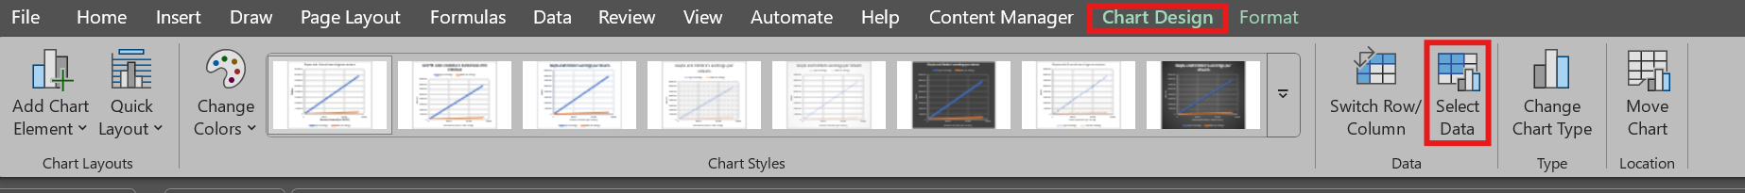
A ‘Select Data Source’ pop up box will appear. Students are to select Add under ‘Legend Entries (Series)’ then select cell F2 for the ‘Series name’ and cells F3 to F28 for the
‘Series Y values’.
- Use the graph created to calculate how much Gotye would have earned when he reached 2 billion views. Ask random students to share how they found it.
Students may try to use their graph to estimate or solve using an equation.
Students could also be shown how to use a spreadsheet using the Goal Seek function using the YouTube video ‘How to Use Goal Seek in Excel – Tutorial’ (2:52) (bit.ly/goal-seek-excel).
- Have students approximate what would happen to Gotye and Kimbra’s earning for each of the following scenarios and verify their thinking using their spreadsheet:
- The amount per view changed from $0.01 to $0.02
- The amount per view changed from $0.01 to $0.005
- The amount per view changed from $0.01 to $0.015.
- Use the Pose-Pause-Pounce-Bounce questioning strategy to gather information about student thinking. Some suggested prompts include:
- What were your approximations and why did you estimate it to be that amount?
- What changed in your estimations as you went along?
- Why do you think that when it doubled, the amount earned also doubled?
Students should gather that if you multiply the rate or constant of variation by an amount then the whole value is multiplied by that amount as they are proportional.

Releasing responsibility
- Students are to practise questions from an existing resource.
- Use the Pose-Pause-Pounce-Bounce strategy to ask students if there were any that differed to their estimated list and why they thought it would have been higher.
- Distribute Appendix B ‘Frayer diagram’ (bit.ly/frayerdiagram) for students to complete notes.

Independent practice
- Between pairs of students, distribute Appendix C ‘Actual earnings’ for students to complete using the following ‘Approaching questions scaffold’. This appendix contains scenarios of pay earned through royalties.
Figure 2: approaching questions scaffold
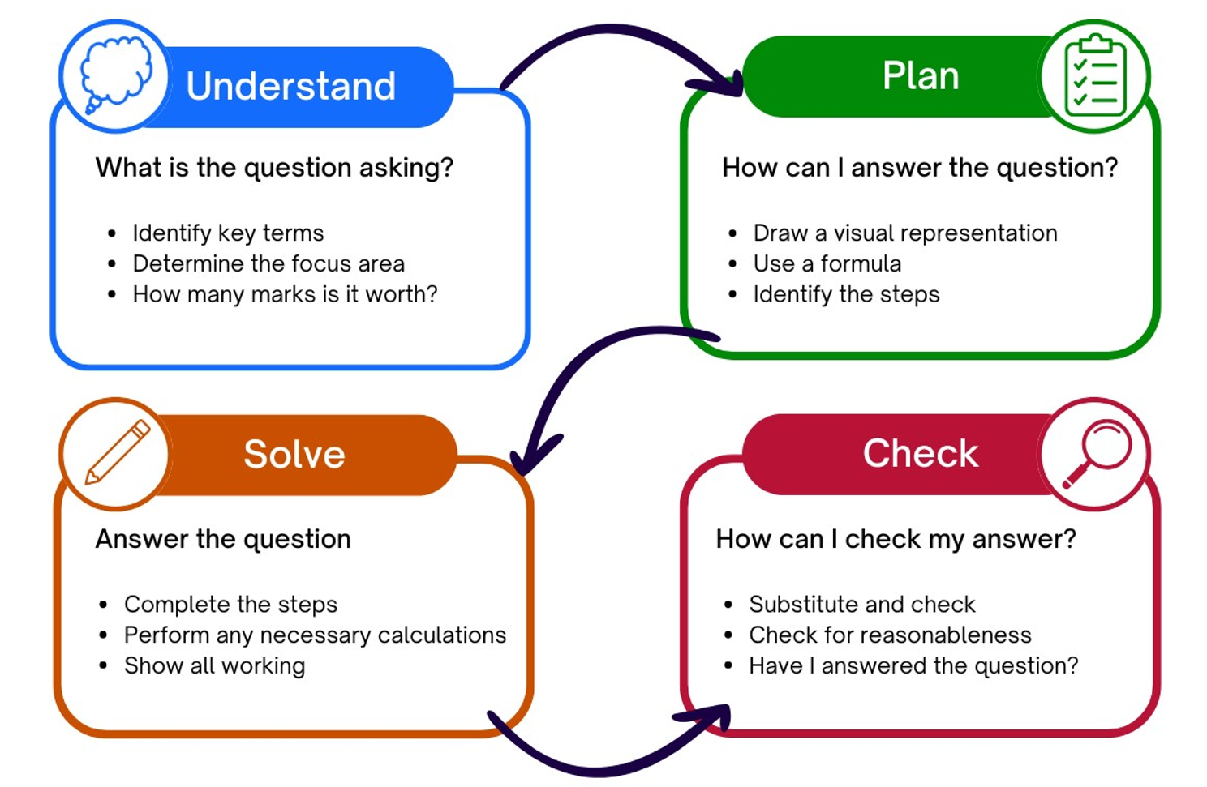
Students can be encouraged to use their spreadsheet to perform calculations or verify their calculations.
- Have students compare their answers with another pair.
- Use the Pose-Pause-Pounce-Bounce strategy to ask students about the equation they used to represent earnings, including the copyright fees and if it is still a direct variation relationship.
Students should understand that when copyright fees are included, the relationship is no longer a direct variation; subtracting a constant fee changes it into a linear relationship instead.

Assessment and differentiation

Suggested opportunities for differentiation
Retrieval practice
- To enable students, change the numbers to whole numbers or multiples for 5.
- Students may benefit from converting between fractions, decimals and percentages.
- Students may benefit from using visual representations to estimate the value of the percentages.
- Challenge students to create a percentage problem that creates the same solution.
Activating prior knowledge
- Select a song that is relevant to your students’ interests.
- Enable students by displaying a variety of jobs on the board and have students identify and justify which could earn money through royalties.
Connecting learning
- Students may benefit from seeing 2.4 billion in numbers to recognise its magnitude.
- If students answer incorrectly, it is advised that teachers complete activities from Lesson 5 – I need more money of Stage 5 Unit 5 – financial mathematics to deepen their understanding of calculating royalties.
- Students may benefit from reviewing their notes on direct variation to help answer prompts in this section.
- Challenge students to justify why this is a direct variation relationship, using the definition.
- Students who are familiar or more confident using a spreadsheet could create this relationship from scratch, rather than using the template and the pace of the lesson could be adjusted.
- Challenge students to explain the similarities and differences between earning per stream and earning a percentage of profits to deepen their understanding of royalties.
- Students may benefit from modelling the amount Kimbra earns against the amount Gotye earns, where the amount Gotye earns would be the independent variable and the amount Kimbra earns would be the dependent variable, modifying the percentage she would earn as a royalty to help generalise the equation.
Releasing responsibility
- Students can be provided prompts for their notes depending on their need.
- Some students may benefit from writing notes on how to perform actions in a spreadsheet.
- Students can be prompted to use visual representations, such as a bar model, to help estimate the expected amount for questions from existing sources.
Independent practice
- Teachers can model and students can apply the ‘Approaching questions scaffold’ to answer questions in Appendix C.
- Questions in Appendix C can be modified to include less words, or bold important information for students to help them identify the key information in the question.

Suggested opportunities for assessment
Retrieval practice
- Students’ responses to the activity will check their understanding of calculating a percentage of a value.
Activating prior knowledge
- Students’ responses to prompts will check their understanding of royalties.
- Students identifying what other jobs could earn money through royalties is evidence of understanding what a royalty is.
Connecting learning
- Mini whiteboards and hinge questions have been used to assess students’ understanding of calculating the amount earned through royalties.
- Evidence of students’ understanding of the constant of variation, independent and dependent variables can be determined when applying these terms to the context of royalties.
- Students’ ability to model using a spreadsheet can be seen through their responses to prompts in this lesson. The spreadsheet could also be collected as evidence of learning how to model a linear relationship using a spreadsheet.
Releasing responsibility
- Review Appendix B for student understanding of what royalties are.
Independent practice
- Review student responses to Appendix C to show their understanding of calculating royalties.

Appendix A

Save a local copy of a file
How to save a local copy of an Excel spreadsheet needs to be updated for each lesson.

File sharing and saving
- Save the Excel spreadsheet Royalties in a place where students can easily access the file.
This could be done through Google Classroom, by sharing a OneNote link, or by emailing students a copy of the document.
- Have students open the document on their own device.
- Instruct students to select the File tab and then Save a Copy.

- Students can save the document in their individual OneDrive by selecting this option.
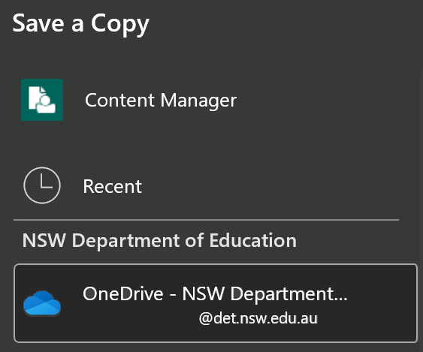
- Best practice would be to keep the file name the same. Students can then select Save and a copy will be stored on their OneDrive.
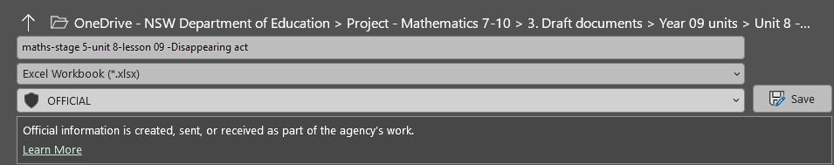

Appendix B

Frayer diagram
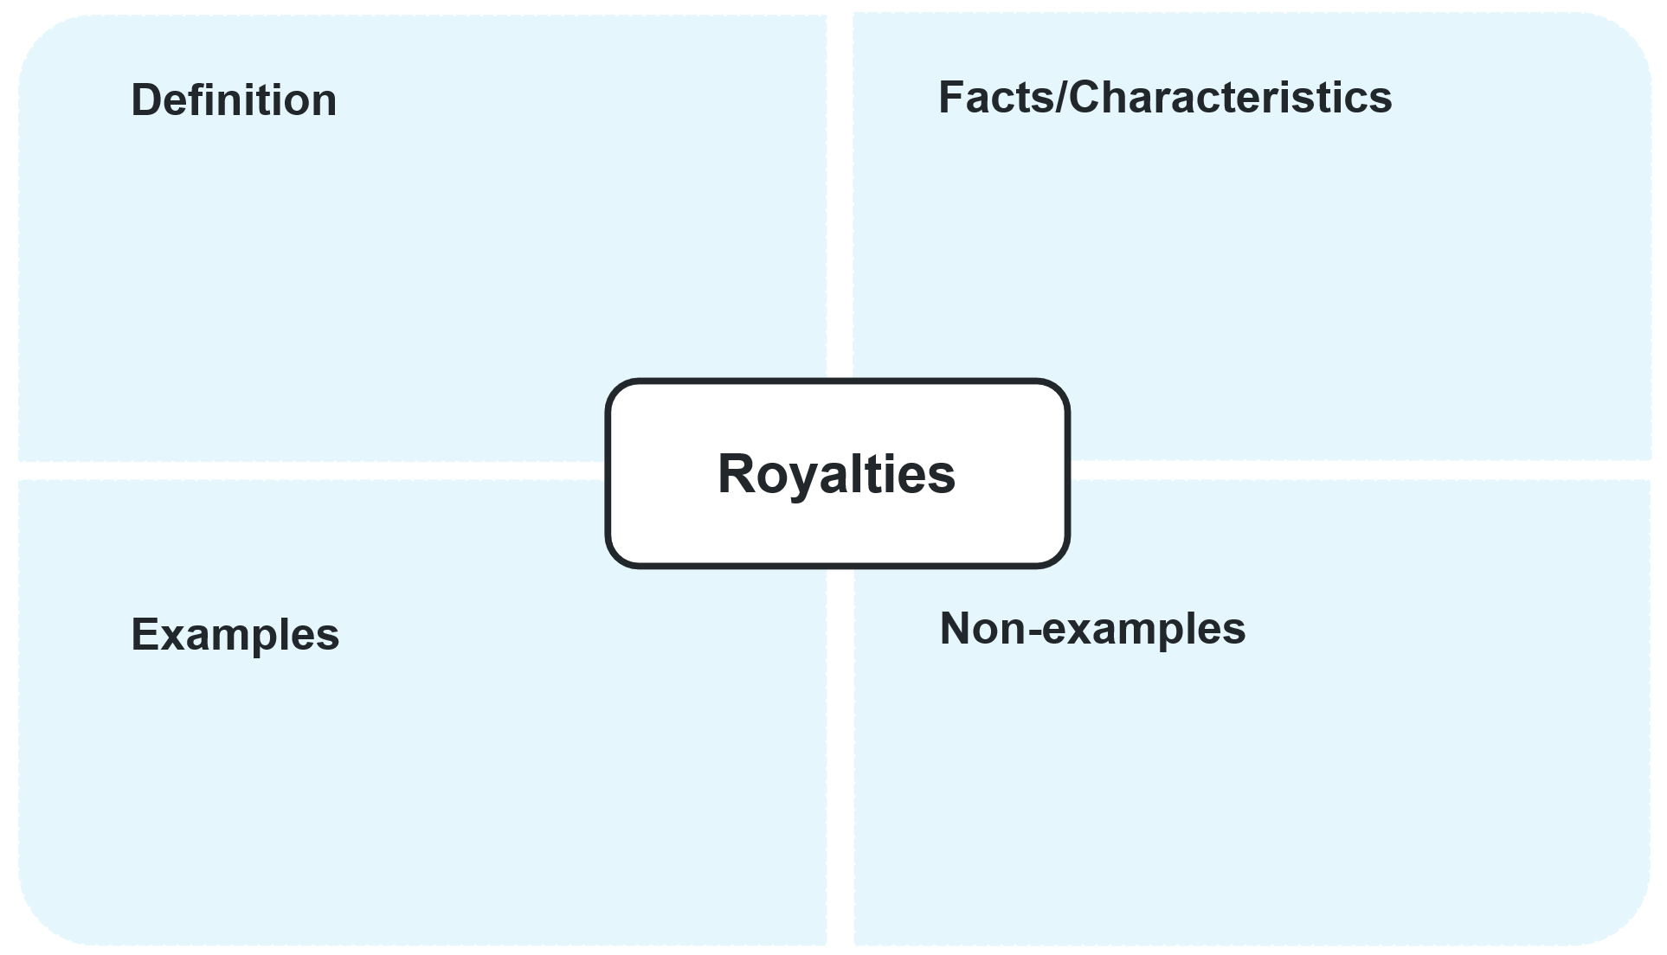

Appendix C

Actual earnings
- A music producer writes a song and collaborates with a famous singer. The song generates royalties through streaming services and album sales. The producer earns royalties from the streams of the song at $4 per 1000 streams. The song in its first week has 29 046 806 streams. The singer gets paid 5% of the producer’s royalties and the producer must pay a copyright registration fee of $100 to protect the song. Calculate the amount earned from streams for the producer and the singer.
- An author writes a children's book and works with an illustrator to create the visuals. The book is sold in bookstores and online platforms, generating royalties. The author earns 15% royalties from the book's sales, while the illustrator receives 5%. Together, the author and illustrator, pay a copyright fee to protect the intellectual property, which costs $200. Given they made 6500 sales in its first year and the book cost $10, calculate the amount earned by the author and illustrator.
- A fashion designer collaborates with a clothing manufacturer to produce a line of clothing. The clothing line earns royalties based on sales in stores. The manufacturer receives 50% of the profits from sales revenue. The designer earns royalties of 10% of the manufacturer’s profits. Considering the line earns $5 million dollars in profits, calculate the amount earned by the fashion designer.
- A video game developer creates a game and hires a freelance artist to create character designs. The game generates royalties from sales and in-game purchases. The developer receives 25% of the game’s sales as royalties. The developer pays the artist 5% of the royalties for their designs and covers a copyright fee of $300 to protect the game's intellectual property. Calculate the amount earned by the developer and the artist if the game sold $500 000 in the first year.

Sample solutions

Appendix B – Frayer diagram
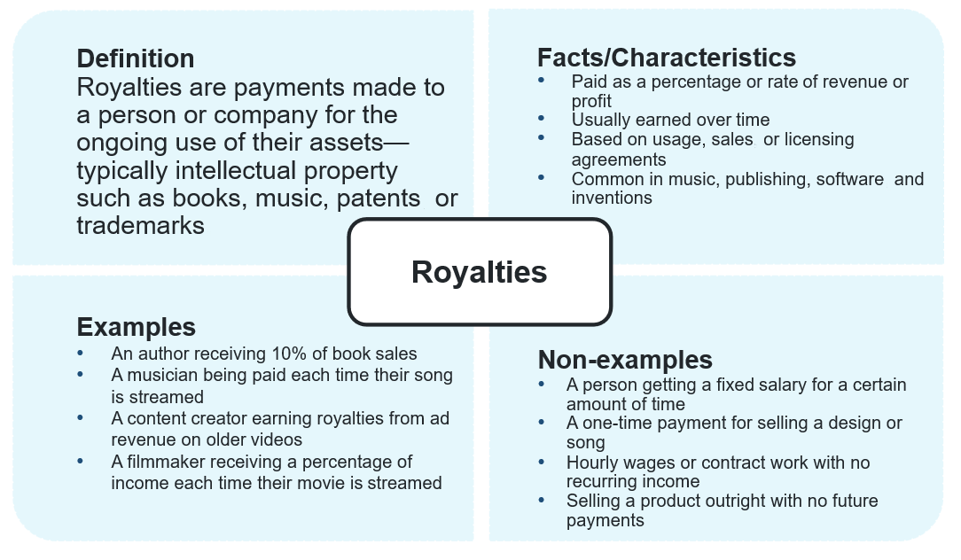

Appendix C – actual earnings
- Music producer and singer's earnings from streams
- Royalties per 1000 streams: $4
- Total streams in the first week: 29 046 806
- Singer’s share of royalties: 5%
- Copyright registration fee: $100.
Total royalties earned from streams:
To find the total earnings from the streams, we divide the total number of streams by 1000 and multiply by the royalty rate per 1000 streams.
Total earnings $=\frac{29 046 806}{1000}×4=\$29 046.81$
Singer’s earnings $=29 046.81×5\%=\$1452.34$Producer’s earnings $=29 046.81×95\%=\$27 594.47$Subtract the copyright fee: $\$27 594.47-\$100=\$27 494.47$.
- Author and illustrator's earnings from book sales
- Royalties for the author: 15%
- Royalties for the illustrator: 5%
- Sales in the first year: 6500 books
- Price per book: $10
- Copyright registration fee: $200.
Total earnings $=6500×\$10=\$65 000$
Take away copyright fee: $\$65 000-\$200=\$64 800$
Author’s earnings $=\$64 800×15\%=\$9750$
Illustrator’s earnings $=\$64 800×5\%=\$3240$.

- Fashion designer's earnings from clothing line sales
- Royalties for the designer: 10% of profits
- Manufacturer’s profit: 50%
- Sales of clothing line: $5 000 000
Manufacturer's profit $=\$5 000 000×50\%=\$2 500 000$
Designer’s earnings $=\$2 500 000×10\%=\$250 000$.
- Video game developer and artist's earnings from game sales
- Royalties for the developer: 25%
- Royalties for the artist: 5% of the developer’s royalties
- Copyright fee of $300
- Earned $500 000
Developer’s earnings $=\$500 000×25\%-\$300=\$124 700$
Artist’s earnings $=\$125 000×5\%=\$6250$.

References
This resource contains NSW Curriculum and syllabus content. The NSW Curriculum is developed by the NSW Education Standards Authority. This content is prepared by NESA for and on behalf of the Crown in right of the State of New South Wales. The material is protected by Crown copyright.
Please refer to the NESA Copyright Disclaimer for more information https://educationstandards.nsw.edu.au/wps/portal/nesa/mini-footer/copyright.
NESA holds the only official and up-to-date versions of the NSW Curriculum and syllabus documents. Please visit the NSW Education Standards Authority (NESA) website https://educationstandards.nsw.edu.au and the NSW Curriculum website https://curriculum.nsw.edu.au.
Mathematics Standard 11–12 Syllabus © NSW Education Standards Authority (NESA) for and on behalf of the Crown in right of the State of New South Wales, 2024.

© State of New South Wales (Department of Education), 2025
The copyright material published in this resource is subject to the Copyright Act 1968 (Cth) and is owned by the NSW Department of Education or, where indicated, by a party other than the NSW Department of Education (third-party material).
Copyright material available in this resource and owned by the NSW Department of Education is licensed under a Creative Commons Attribution 4.0 International (CC BY 4.0) license.

This license allows you to share and adapt the material for any purpose, even commercially.
Attribution should be given to © State of New South Wales (Department of Education), 2025.
Material in this resource not available under a Creative Commons license:
- the NSW Department of Education logo, other logos and trademark-protected material
- material owned by a third party that has been reproduced with permission. You will need to obtain permission from the third party to reuse its material.
Links to third-party material and websites
Please note that the provided (reading/viewing material/list/links/texts) are a suggestion only and implies no endorsement, by the New South Wales Department of Education, of any author, publisher, or book title. School principals and teachers are best placed to assess the suitability of resources that would complement the curriculum and reflect the needs and interests of their students.
If you use the links provided in this document to access a third-party's website, you acknowledge that the terms of use, including licence terms set out on the third-party's website apply to the use which may be made of the materials on that third-party website or where permitted by the Copyright Act 1968 (Cth). The department accepts no responsibility for content on third-party websites.

