Direct variation
Students use the context of wages to develop the concept of direct variation. They learn about the features of a direct variation relationship, the language used and its representations.

Learning intentions
- To know what direct variation is.
- To be able to represent direct variation in a variety of ways.

Success criteria
- I can explain what direct variation is.
- I can give an example of direct variation.
- I can represent direct variation as an equation and a graph.
- I can write an equation from a worded problem and solve it.

Outcomes
A student:
- develops understanding and fluency in mathematics through exploring and connecting mathematical concepts, choosing and applying mathematical techniques to solve problems, and communicating their thinking and reasoning coherently and clearly MAO-WM-01
- selects and applies algebraic techniques to solve problems involving equations and formulas MST-11-01
- models and interprets linear relationships to solve problems and make predictions in practical contexts MST-11-02
- solves financial problems involving earning money and taxation MST-11-03

Associated numeracy outcomes
A student:
- recognises and applies functional numeracy concepts in practical situations, including personal and community, workplace and employment, and education and training contexts N6-1.1
- determines whether an estimate or an answer is reasonable in the context of a problem, evaluates results and communicates conclusions N6-1.3
- chooses and applies appropriate operations with whole numbers, familiar fractions and decimals, percentages, rates and ratios to analyse and solve everyday problems N6-2.1
- chooses and applies efficient strategies to analyse and solve everyday problems involving money and finance N6-2.4
- chooses and applies appropriate numeracy operations and techniques to analyse and resolve everyday situations N6-2.6
- chooses and uses appropriate technology to access, organise and interpret information in a range of practical personal and community, workplace and employment, and education and training contexts N6-3.1

Content

Formulas and equations
- Represent a word problem as a linear equation, solve the equation and interpret the solution in the context of the problem

Linear relationships
Direct variation
- Recognise that a direct variation relationship of the form $y=kx$ produces a straight-line graph
- Explain that a direct variation relationship of the form $y=kx$ is a graph that passes through the origin with gradient being the constant of variation
- Identify and represent direct variation of the form $y=kx$ from descriptions of situations in which one quantity varies directly with another quantity
- Graph and analyse equations of the form $y=kx$ to solve problems in a variety of contexts

Earning money
Ways of earning
- Solve problems involving wages, penalty rates for overtime, weekends and public holidays, given an hourly rate of pay
Mathematics Standard 11–12 Syllabus © NSW Education Standards Authority (NESA) for and on behalf of the Crown in right of the State of New South Wales, 2024.
Table 1: lesson summary
Section | Summary of activity | Teaching strategies | Teaching points
Retrieval practice | Revise converting between tables of values, graphing on a Cartesian plane and equations using Appendix A. |  | Review students’ understanding and fluency of graphing linear relationships.
Activating prior knowledge | Use slide 4 of the PowerPoint Direct variation for students to compare spreadsheet wage questions with tables of values and their graphs, seen in the previous lesson. | Think-Pair-Share  Mini whiteboards  Pose-Pause-Pounce-Bounce | Students identify and compare similarities and differences between wage linear relationships and show their understanding of multiple representations.
Connecting learning | Students compare linear relationships using Appendix B. State that direct variation graphs go through (0,0) and are in the form of $y=kx$ and ask students to identify which graph represents that.  Use slide 6 to show the equation of direct variation and ask students what each part represents before identifying for Josie’s context.  Have students identify more characteristics of direct variation relationships using Appendix C before using slide 7 to formally define direct variation.  Use Appendix D to run an ‘always, sometimes, never’ activity. | Pose-Pause-Pounce-Bounce  Hinge point question  Non-examples  Think-Pair-Share  Always, sometimes, never | Students identify the characteristics and definition of a direct variation relationship in a variety of representations, including terminology used and connecting it to their prior knowledge.
Releasing responsibility | Students complete the Frayer diagram in Appendix E.  Use slide 9 to show the phrases used with direct variation before completing Appendix F. | Frayer diagram  Think-Pair-Share | Students summarise learning and apply the language of direct variation to a variety of contexts.
Independent practice | Use slide 11 to show an HSC-style question for students to complete as a class before completing Appendix G in groups. | Visibly random groups  Vertical non-permanent surfaces  Pose-Pause-Pounce-Bounce | Students apply their knowledge to HSC-style questions.

Activity structure
Please use the associated PowerPoint Direct variation to display images in this lesson.

Retrieval practice
- Distribute Appendix A ‘Representations of linear relationships’ to each student.
- Ask students to complete each activity, checking their progress as they go.
Students who are still developing confidence in graphing linear relationships from tables, as outlined in the Stage 5 Linear relationships A Core outcome MA5-LIN-C-01, are encouraged to complete additional activities from Lesson 2 – money matters of Stage 5 – Unit 6 – constant rates of change.

Activating prior knowledge
- Display slide 4 of the PowerPoint, which shows the screenshot below from Lesson 1 – spreadsheets through wages.
Figure 1: screenshot of spreadsheet
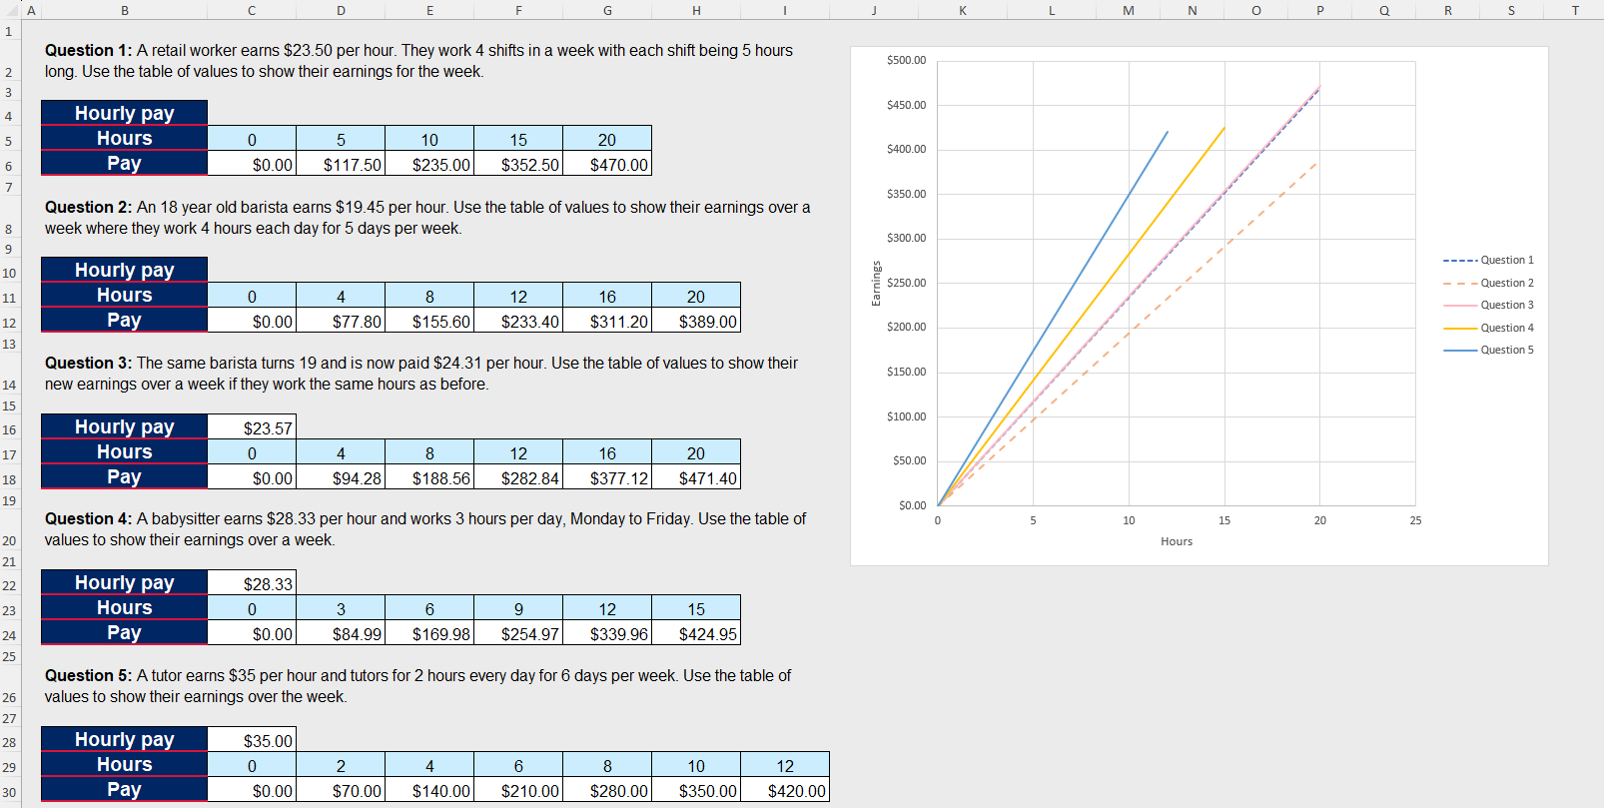
- In a Think-Pair-Share (bit.ly/thinkpairsharestrategy), ask students to compare the similarities and differences between the wage questions presented in the spreadsheet. Students will record these on their mini whiteboards (bit.ly/miniwhiteboards).
Students should identify the following similarities:
- Each question's table of values increases by a constant amount.
- All questions resulted in an increasing linear graph.
- If no hours are worked, then no pay is earned, resulting in all graphs going through the point (0,0).
- All questions could be graphed on the same set of axes, showing the relationship between hours worked and money earned.
Students should identify the following differences:
- The number of hours worked across each day of the week is different for each situation.
- The rates of pay give different constant increasing amounts.
- The steepness of the slope of each linear graph is different.
- Use the Pose-Pause-Pounce-Bounce questioning strategy (PDF 557 KB) (bit.ly/posepausepouncebounce) to prompt students to consider what information is given in each of the wage questions that tells them about the gradient (steepness) of the resulting linear graph.
Students should recognise that the hourly rate of pay is the gradient of the linear graph. Students should notice that the highest hourly rate of pay gave the steepest linear graph.

Connecting learning
- Distribute Appendix B ‘Examples of linear relationships’ to pairs of students and ask students to compare the 2 linear relationships.
Students should observe that both graphs are straight lines with the same gradient. They should also notice that one equation does not include a constant term, resulting in a $y$-intercept of 0, while the other graph includes a non-zero $y$-intercept.
- Tell students that direct variation graphs go through (0,0) and are in the form of $y=kx.$ In a Think-Pair-Share, ask students which graph represents direct variation and why.
- Display slide 6 of the PowerPoint which shows the equation for a direct variation relationship. This shows the independent and dependent variables and the constant of variation ($k$).
- Use the Pose-Pause-Pounce-Bounce questioning strategy to check for understanding of the terms using the following prompts:
- What do the terms ‘independent variable’ and ‘dependent variable’ mean? Where have you heard these terms before?
- Why do you think $k$ is known as the constant of variation? What else might it be called?
Students should connect independent and dependent variables from Stage 4 and 5 Science, as well as Unit 1 – getting healthy. These are defined as:
- independent variable: a variable used to represent values in the input values of a function. Generally represented on the horizontal axis of a graph.
- dependent variable: the variable used to represent the output values of a function. A dependent variable is generally represented on the vertical axis of a graph.
The constant of variation is also known as the constant of proportionality, for direct variation, and is also the gradient.
- In a Think-Pair-Share, check for understanding by asking the hinge point question (bit.ly/hingepointquestions) ‘Identify what the constant of variation and the independent and dependent variables are in Josie’s scenario’ using mini whiteboards.
Students should be able to identify the independent variable to be the hours, the dependent variable to be the amount of pay and the constant of variation to be the rate of pay per hour. If not, revise the terminology and provide students with another example.
- Distribute Appendix C ‘Examples and non-examples’ to pairs of students. The appendix provides students with examples and non-examples (bit.ly/nonexamplesstrategy) (PDF 68.8 KB) of graphs that represent direct variation.
- In a Think-Pair-Share, ask students the characteristics of a direct variation relationship by comparing the examples and non-examples from Appendix C.
Students should conclude that direct variation relationships go through (0,0) and are in the form of $y=kx$, which is a linear graph. Students should also realise that $k$ can be both positive and negative.
Students should recognise that $y=kx$ is in the same format as $y=mx+c$, but without the $c$ term, thus the reason why direct variation graphs go through the origin.
- Display slide 7 which has the following definition:
Direct variation is a proportional relationship where one quantity directly varies with respect to a change in another quantity. This implies that if there is an increase (or decrease) in one quantity then the other quantity will experience a proportionate increase (or decrease).
- In a Think-Pair-Share, ask students to explain what a direct variation relationship is in their own words. Encourage students to ask questions about any part of the definition they don’t understand.
- Designate a position in the room for ‘always’, ‘sometimes’ and ‘never’. For example, the far left could be ‘always’, the far right could be ‘never’ and the middle could be ‘sometimes’.
- Check for understanding by asking students if the following statements in Appendix D ‘Statements’ are true always, sometimes or never for direct variation relationships.

The statements in Appendix D are organised into ‘always’, ‘sometimes’ and ‘never’ and will need to be shuffled as you run the activity.
Alternatively, you could have students put their hands on parts of their body such as head is ‘always’, belly is ‘sometimes’ and bottom is ‘never’.
- Read the statements in any order to students and have them move to the location in the room designated with ‘always’, ‘sometimes’ or ‘never’.

Releasing responsibility
- Distribute Appendix E ‘Frayer diagram’ (bit.ly/frayerdiagram) to each student. Have students write their own definition of direct variation on their Frayer diagram and complete the other sections.
- Display slide 9 of the PowerPoint to show the example of Josie’s amount of pay using the terminology ‘directly varies with’ when stating that a relationship is represented by direct variation.
- In a Think-Pair-Share, ask students to write another relationship they believe has a direct variation relationship using the phrase ‘directly varies with’.
Some suggestions include:
- the cost of fruit directly varies with its weight
- the distance travelled at a specific speed varies directly with the time spent driving
- the perimeter of a square directly varies with the length of one side.
- Distribute Appendix F ‘Direct variation representations’ to each pair and ask students to complete the table showing the representations that can be used for direct variation relationships and identifying the independent variable, dependent variable and constant of variation.

Students who are still developing their flexibility moving between the graph and its equation can be shown explicitly how to do so using Lessons 6 to 7 of Stage 5 – Unit 6 – constant rates of change.
Students should be encouraged to use the knowledge from this lesson of the constant of variation to be able to find the gradient to create the equation for each direct variation relationship.

Independent practice
- Show slide 11 of the PowerPoint, which shows an example of an HSC-style question using direct variation language. On mini whiteboards, ask students to write the equation and identify what the independent and dependent variables are.
The answers on students’ mini whiteboards will show whether students should be shown how to identify the constant of variation as key information. This can be done using the ‘Approaching questions’ scaffold as a prompt to discuss how we identify where this information is found on slide 12.
Click to animate the slide for a solution.
- Click to show the second part of the question and ask students to answer on their mini whiteboards to check for understanding of correctly substituting into the equation and solving.
Click to animate the slide for the solution.
- Assign students to visibly random groups of 3 (bit.ly/visiblegroups) at vertical non-permanent surfaces (bit.ly/VNPSstrategy) and distribute Appendix G ‘HSC-style questions’ for students to attempt.
- Pair groups together that have different answers and state, ‘At least one of the groups is incorrect.’ Have them discuss their working together to come to a correct solution.
- Use the Pose-Pause-Pounce-Bounce questioning strategy for students to share their thoughts and reasoning, particularly focusing on how the question was worded, which could cause confusion.
Students may note that:
- Figaro must travel to and from work, which could be missed when creating an equation
- the fitness centre contains extra information that is not important to answer the question
- the rate isn’t displayed as a unit rate, so the constant of variation is either $\frac{1.5}{100}$ or 0.015.

Assessment and differentiation

Suggested opportunities for differentiation
Retrieval practice
- To support students further with graphing linear relationships, consider using scaffolding activities from Stage 5 – Unit 6 – constant rates of change.
Activating prior knowledge
- The table of values can be adjusted to go in ascending order and varying values to highlight the connection between the hours worked, the amount earned and the rate of pay.
- Challenge students to represent the amount Josie could earn in a variety of ways.
- Students may benefit from revising how to construct linear graphs. To provide additional practice, ask students to construct a straight-line graph based on either a table of values or an equation. This task can include making decisions such as choosing the scale.
- Extend students by having them classify a set of non-examples as either a linear or a non-linear relationship and justify their reasoning for each classification.
Connecting learning
- Students can be provided prompts with Appendix C to determine the characteristics of a direct variation relationship, such as ‘What is the $y$-intercept?’
- Students can be extended by asking them what would happen to the graph if Josie’s rate of pay increased or decreased to generalise what would happen if the constant of variation were to increase or decrease. How would that change the graph or expected output?
- Students can be challenged to make their own statement to contribute to the ‘always, sometimes or never’ activity.

Releasing responsibility
- The Frayer diagram can be created as a class.
- Appendix F can be modified to be a matching activity where students match the representations.
- Students can be provided with a Cartesian plane with an appropriate scale to focus on graphing direct variation relationships in Appendix F.
- Appendix F can be modified by only supplying one representation rather than 2.
- Students can be extended in Appendix F if tables of values without an equation are included, as they would have to use the independent and dependent variables to calculate the value of the constant of variation.
Independent practice
- Students can be provided scaffolding prompts to help solve the problems, such as identifying the independent and dependent variables, as well as the constant of variation.

Suggested opportunities for assessment
Retrieval practice
- Students’ responses will demonstrate their ability to interpret and connect the different representations of a linear relationship. If the class demonstrates limited recall of graphing linear relationships, the teacher should incorporate additional teaching and learning activities to build students’ fluency and understanding before continuing with the lesson.
Activating prior knowledge
- Students’ flexibility with representations and communicating mathematically can be seen in responses to activities in this section.
Connecting learning
- Students’ knowledge of linear equations, in particular $y$-intercepts and gradients, can be seen in the comparison activity before defining a direct variation relationship. Students are encouraged to use the correct terminology.
- The hinge point question is used to check student understanding of independent variables, dependent variables and the constant of variation.
- Student responses to the characteristics of a direct variation relationship is evidence of learning about direct variation relationships.
- The ‘always, sometimes or never’ activity provides insight into the majority of the class’s understanding of the characteristics of a direct variation relationship. If the majority of the class gets a question wrong, it provides the opportunity to deal with the misconception before using the concept in harder contexts.
Releasing responsibility
- Review Appendix E as evidence of learning about direct variation relationships.
- Collect Appendix F as evidence of students’ learning about representing direct variation relationships in a variety of forms.
- Student responses to relationships that can be represented by direct variation show their understanding when applying it to a different context.
Independent practice
- Review student responses to Appendix G to show their understanding of writing equations from worded problems.

Appendix A

Representations of linear relationships

Activity 1
Complete the table of values using the equation provided.
$$y=3x-4$$
$$x$$ | $$0$$ | $$2$$ | $$4$$ | $$7$$ | $$9$$ | $$10$$
$$y$$

Activity 2
Sketch the graph using the table of values provided.
$$x$$ | $$-2$$ | $$-1$$ | $$0$$ | $$1$$ | $$2$$ | $$3$$
$$y$$ | $$8$$ | $$5$$ | $$2$$ | $$-1$$ | $$-4$$ | $$-7$$
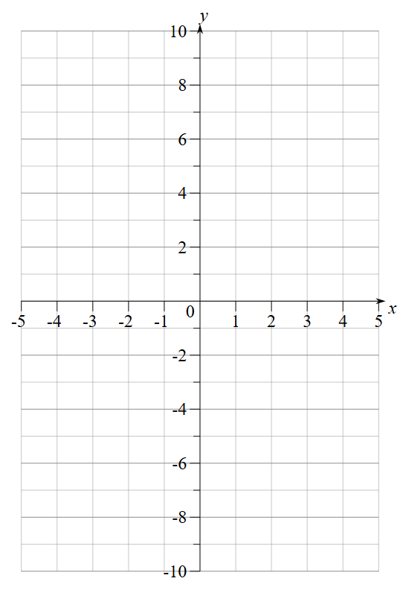

Activity 3
Complete the table of values using the graph provided.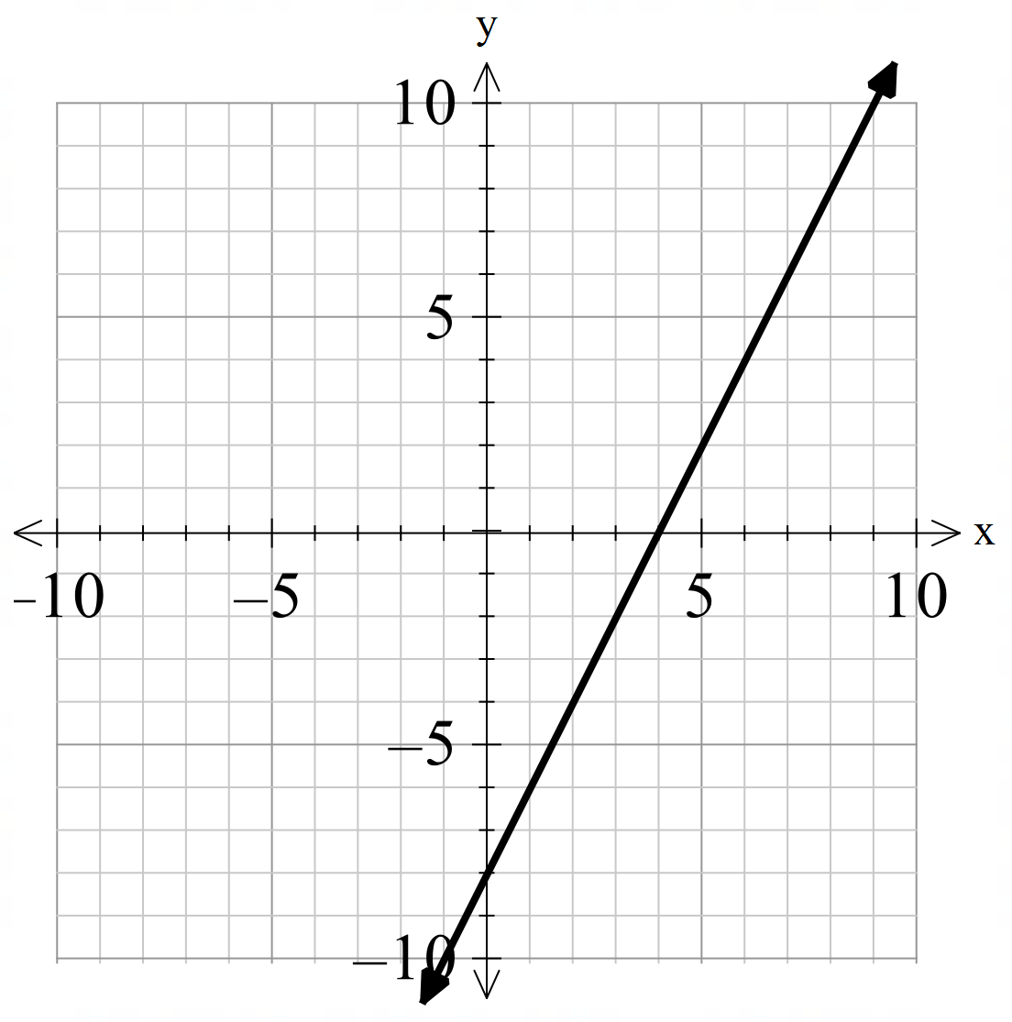
$$x$$
$$y$$

Activity 4
Complete the table of values and sketch the graph using the equation provided.
$$y=-4x+1$$
$$x$$ | $$-2$$ | $$-1$$ | $$0$$ | $$1$$ | $$2$$ | $$3$$
$$y$$

Appendix B

Examples of linear relationships
Linear relationship 1 | Linear relationship 2
Josie works for $x$ hours and earns $14.38 per hour. Represent the amount she earns ($y$) for the number of hours she works. | Josie works for $x$ hours and earns $14.38 per hour and received a one-off bonus payment of $50. Represent the amount she earns ($y$) for the number of hours she works.
$$y=14.38x$$ | $$y=14.38x+50$$
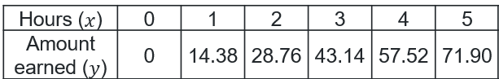 | 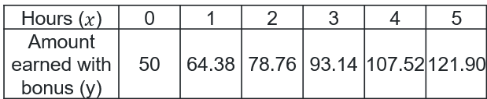
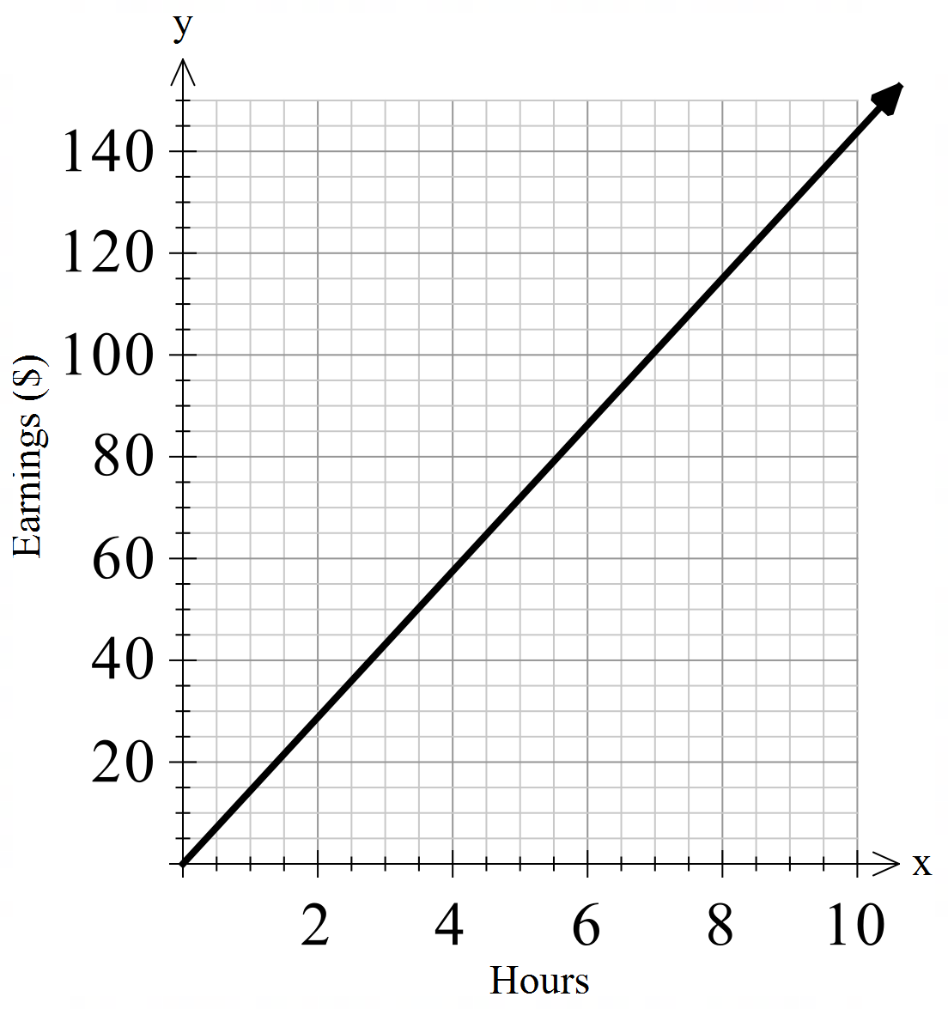 | 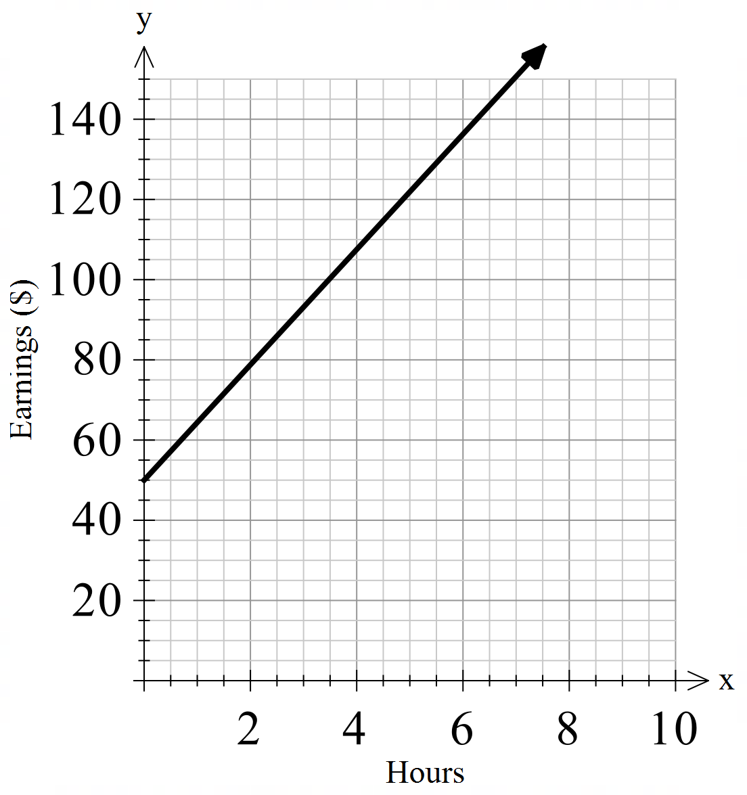

Appendix C

Examples and non-examples
Examples | Non-examples
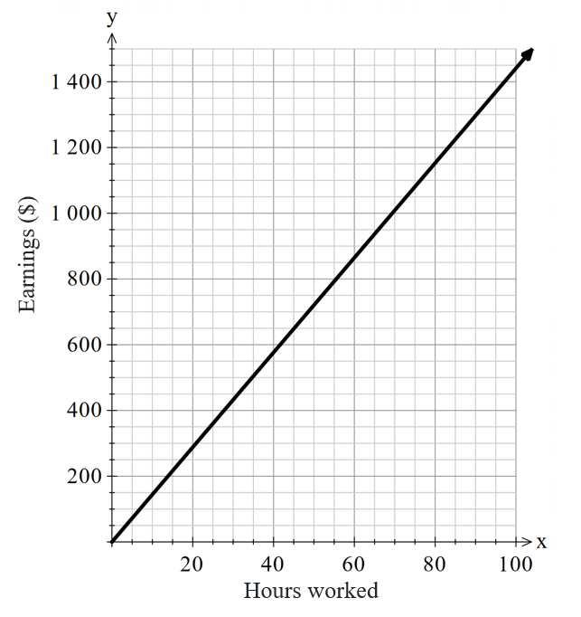 | 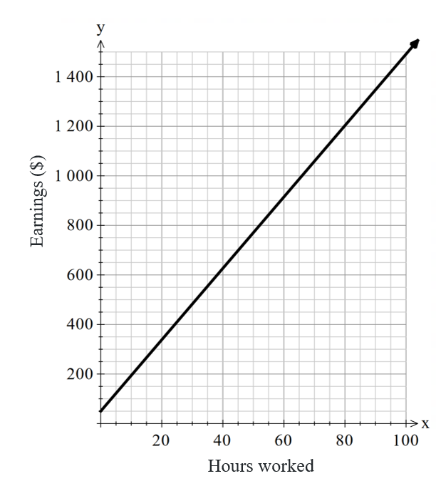
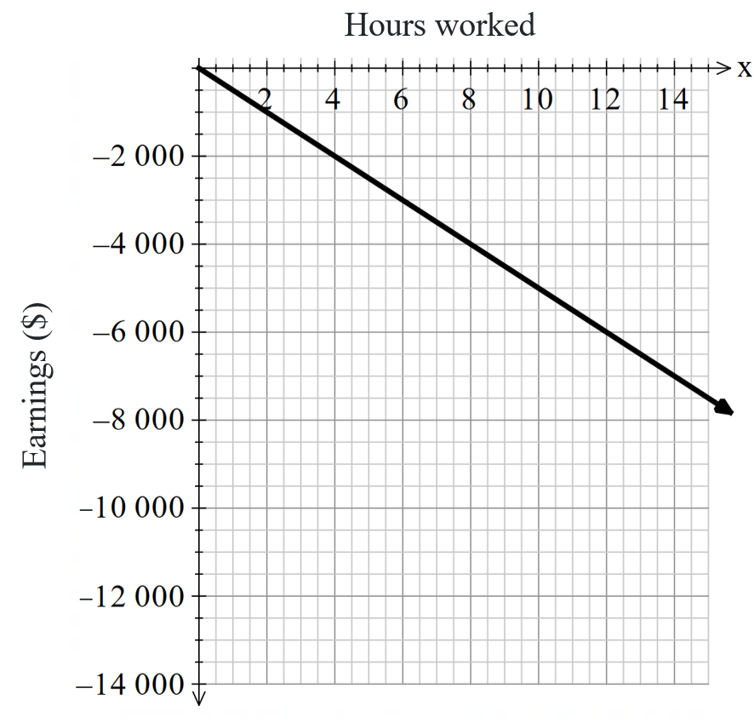 | 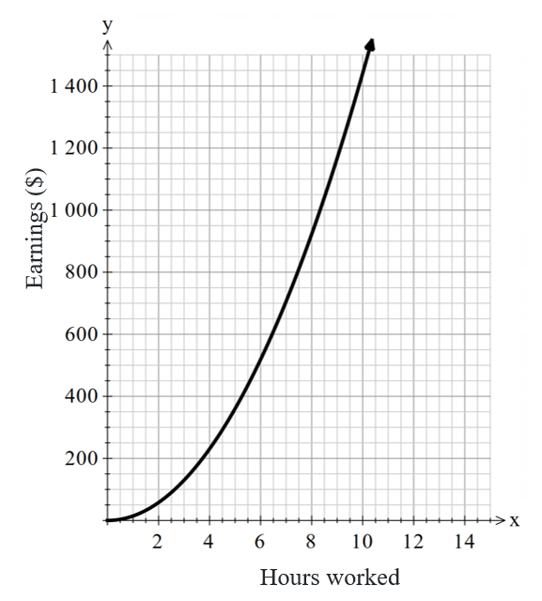
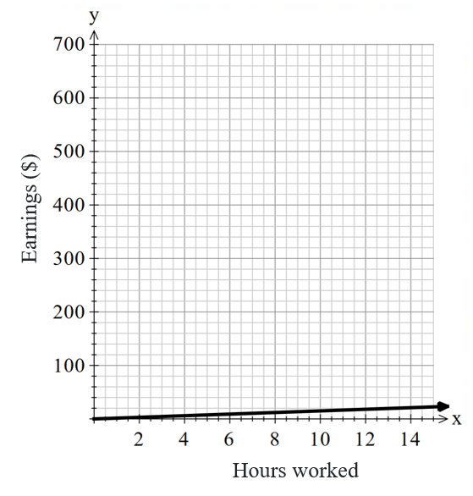 | 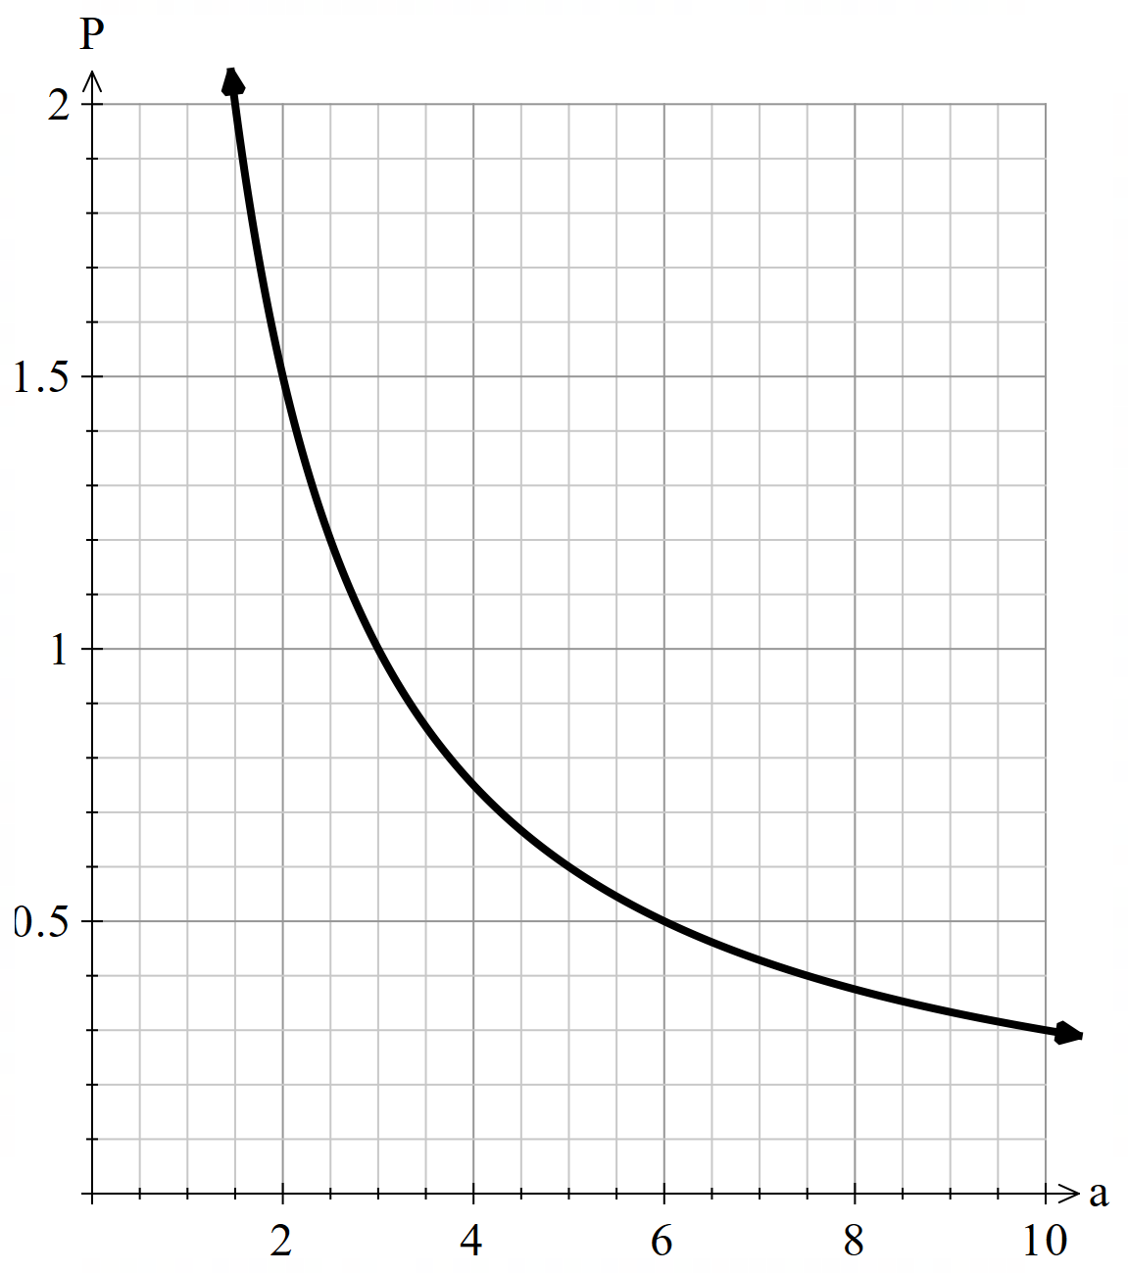
$$y=15x$$ | $$y=15x^{2}$$
$y=\frac{x}{3}$ or $y=\frac{1}{3}x$ | $$y=\frac{3}{x}$$
$$C=-3d$$ | $$R=1000t+2$$

Appendix D

Statements
Read these statements in any order to students and have them move to the location in the room designated with ‘always’, ‘sometimes’ or ‘never’ for direct variation relationships.
Always:
- The graph goes through the origin (0,0).
- Direct variation relationships can be represented in the form $y=kx$.
- A direct variation relationship is a type of linear relationship.
- A direct variation relationship creates a linear graph.
Sometimes:
- If one variable increases, the other variable also increases.
- Direct variation relationships can be used to represent a relationship between 2 variables.
- Independent variables and dependent variables are represented by$x$and $y.$
- A direct variation relationship has a negative gradient.
Never:
- A direct variation relationship creates a non-linear graph.

Appendix E

Frayer diagram
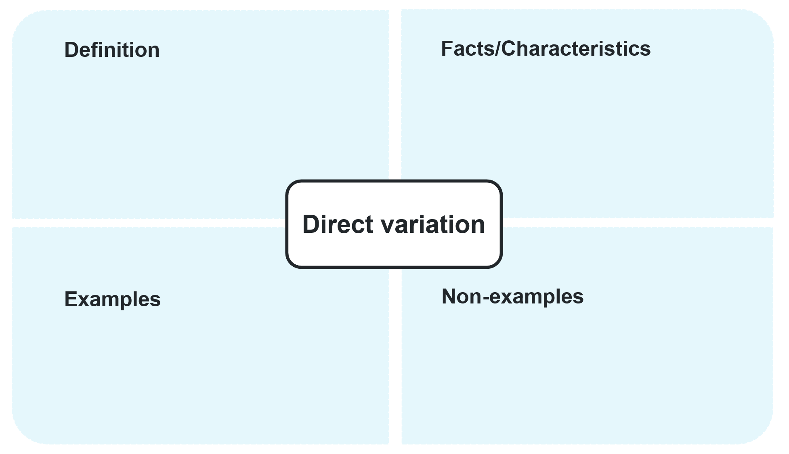

Appendix F

Direct variation representations
Worded problem | Equation | Graph
The cooking time directly varies with the quantity of food being prepared, assuming the cooking method and heat level remain constant. Each serving takes 20 minutes to cook. | $$T=20q$$
 | $$C=40d$$ | 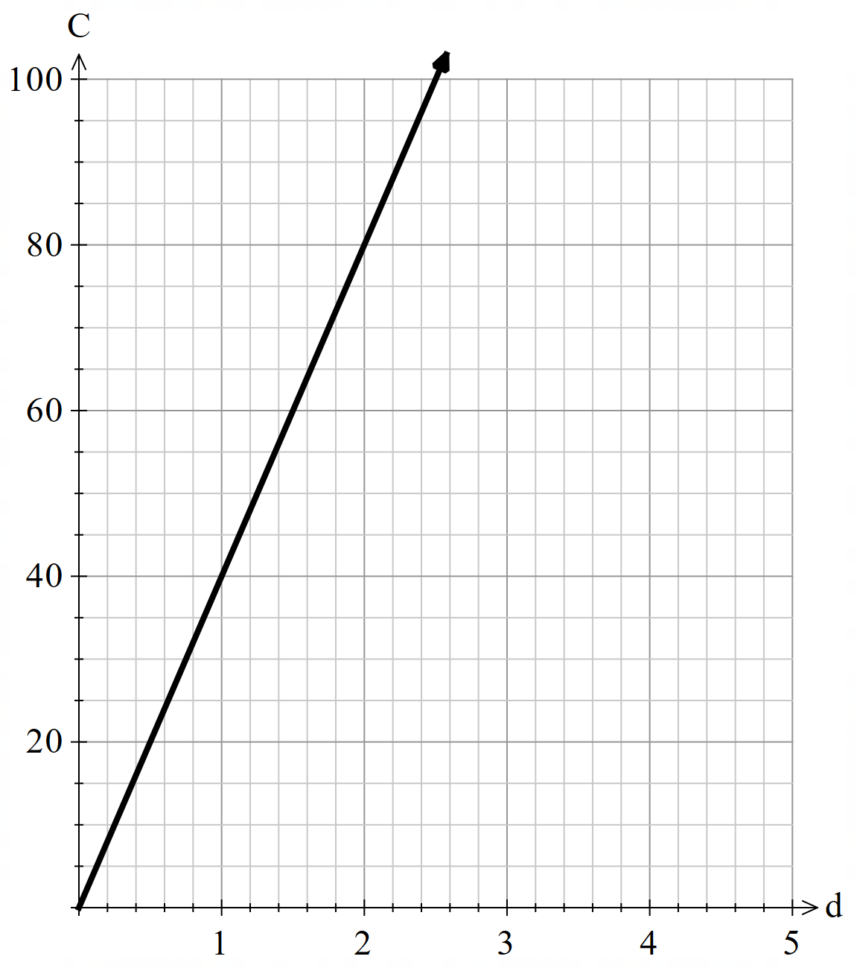
The height of a building directly varies with the number of floors when each floor has the same height. Each floor is 3 metres high. |  | 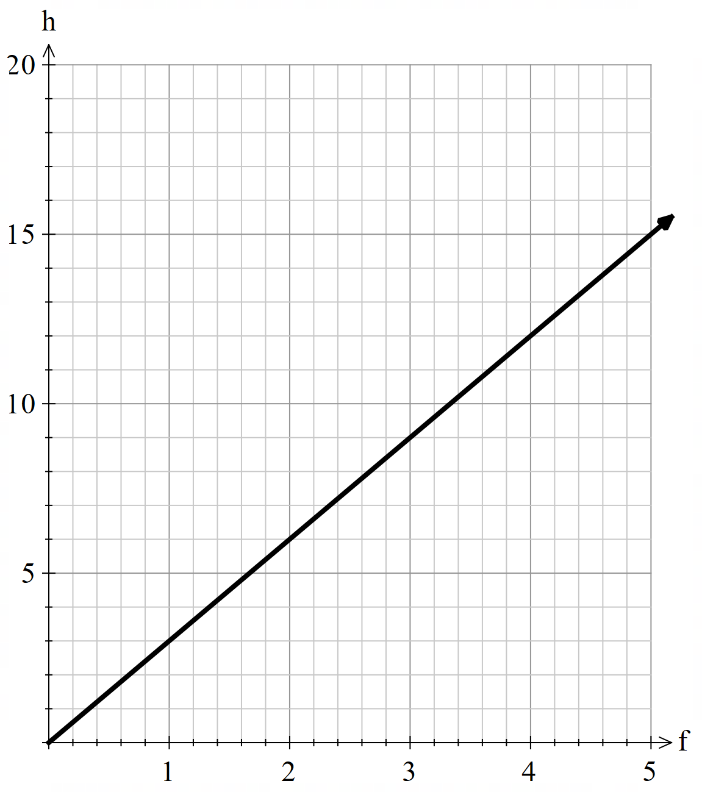
The time required to print a document directly varies with the number of pages being printed, assuming the printer speed is constant. The printer takes 0.2 minutes to print a page. | $$T=0.2p$$
The amount of sugar required for a recipe directly varies with the number of servings. Each serving requires a quarter of a cup of sugar. | $$S=\frac{n}{4}$$
The shipping cost of a package directly varies with its weight. It costs $2 per kilogram. |  | 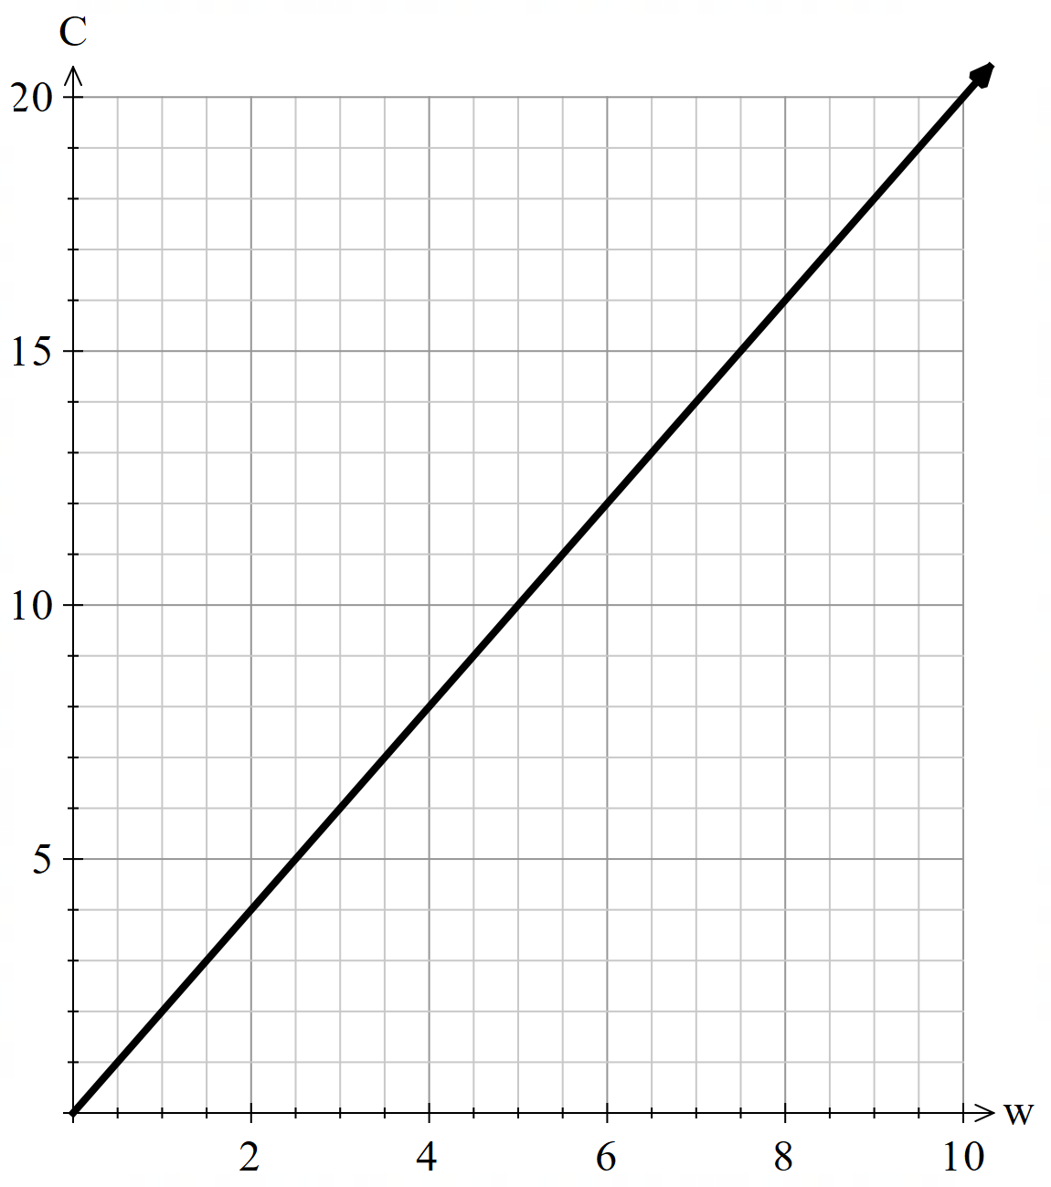
The amount of paint needed to cover a surface directly varies with the area to be painted. One square metre uses $\frac{1}{10}$ of a litre. |  | 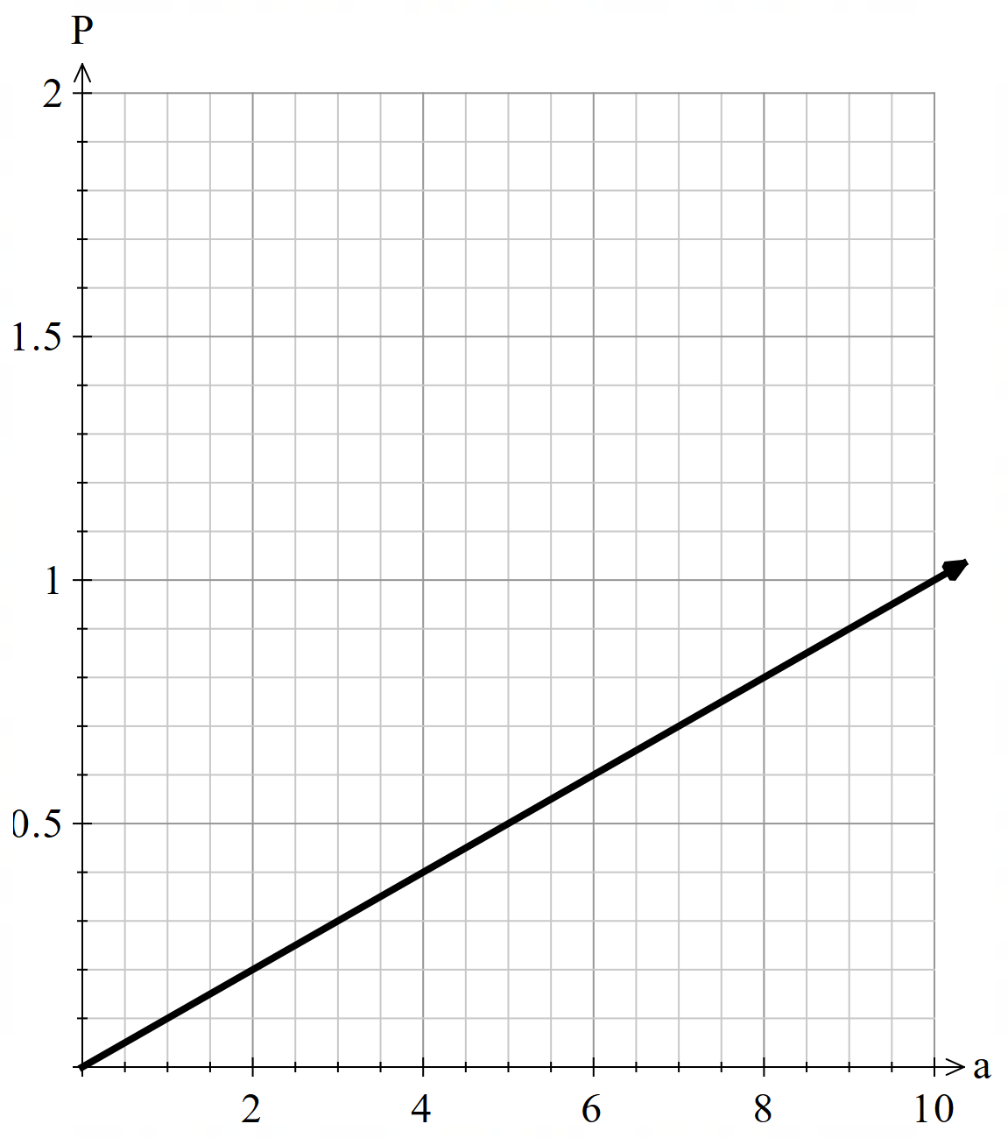

Appendix G

HSC-style questions
- The driving distance from Figaro’s home to his work is $d$ km. He drives to and from work 5 times each week.
- Write an equation to represent the total distance travelled.
- Given Figaro lives 32 km from his place of work, calculate the distance he travels in a week.
- A fitness centre uses 4 exercise bikes for $h$ hours every day of the year. The purchase price of each bike is $600 and the operating cost for each bike is 1.2 cents per hour.
- Write an equation for the total cost, C in dollars, of operating these 4 exercise bikes for one year in terms of hours (h).
- Find the value of h (correct to 3 decimal places) if the total cost of operating these 4 exercise bikes for one year is $250.
- If the usage of the exercise bikes halves per day, does the total operating cost halve as well? Justify your answer with appropriate calculations and reasoning.
- Paris is researching a motorbike. The motorbike uses fuel at the rate of 1.5 L/100 km.
- Write an equation showing how the litres used directly varies with the distance travelled.
- Calculate the amount of fuel used if Paris travels 10 000 km in a year.

Sample solutions

Appendix A – representations of linear relationships
Activity 1  $$y=3x-4$$  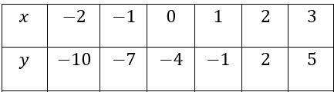 | Activity 3  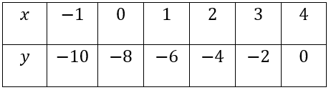
Activity 2  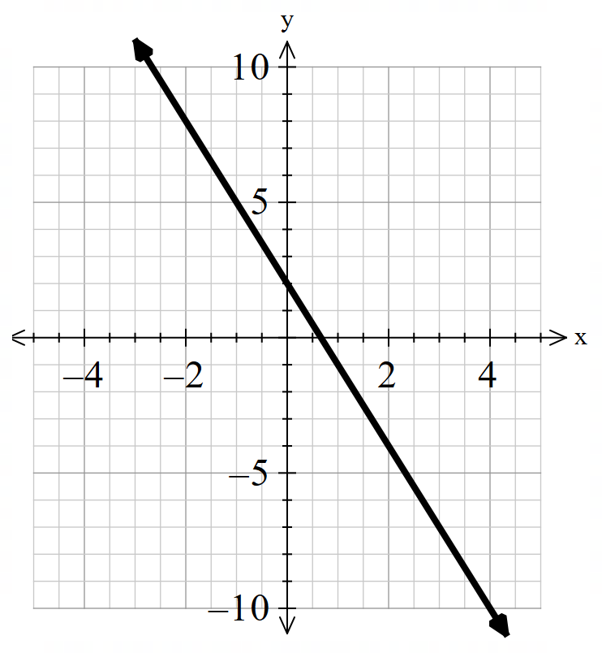 | Activity 4  $$y=-4x+1$$  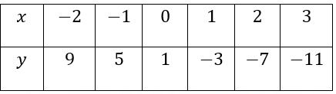  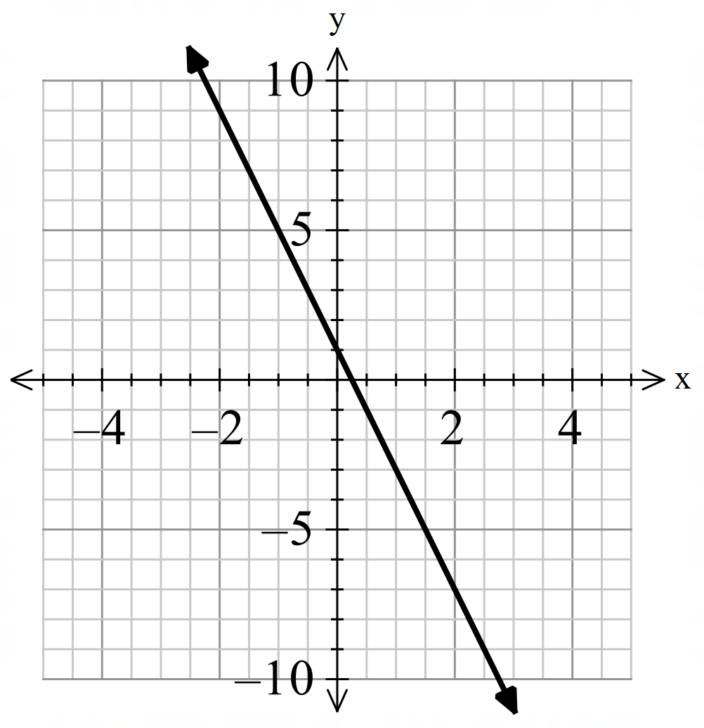

Appendix E – Frayer diagram
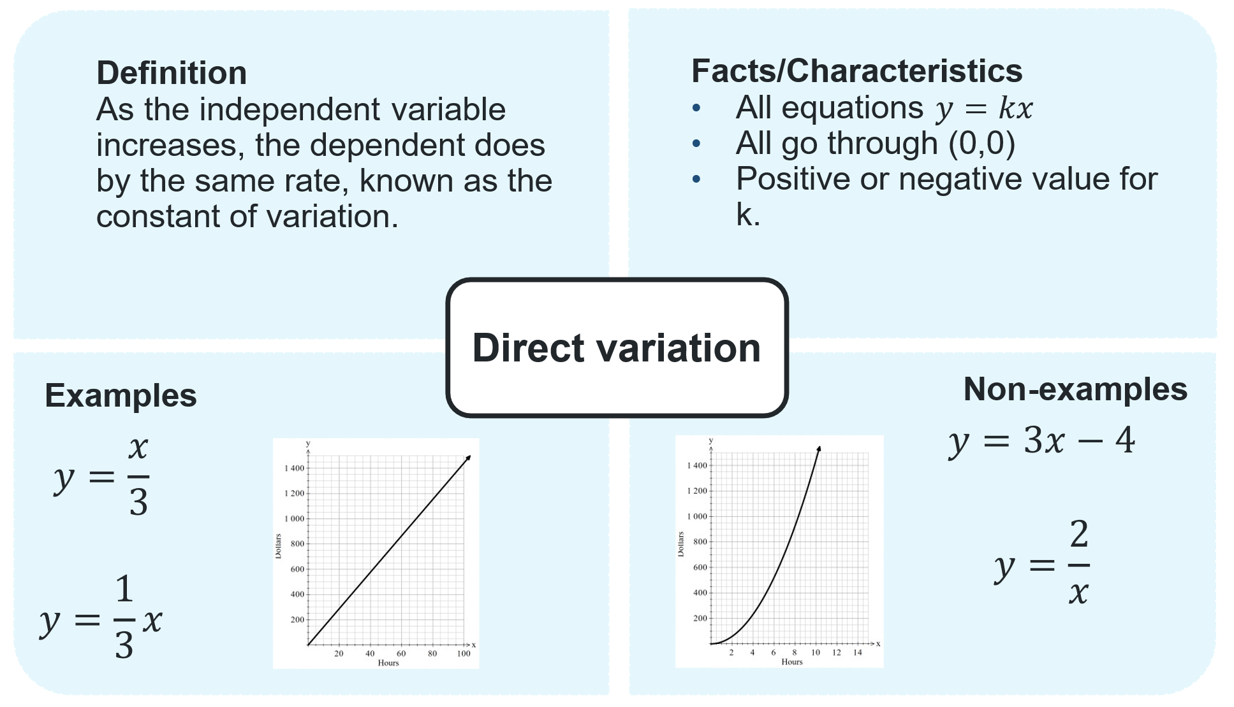

Appendix F – direct variation representations
Worded problem | Equation | Graph
The cooking time directly varies with the quantity of food being prepared, assuming the cooking method and heat level remain constant. Each serving takes 20 minutes to cook. | $$T=20q$$ | 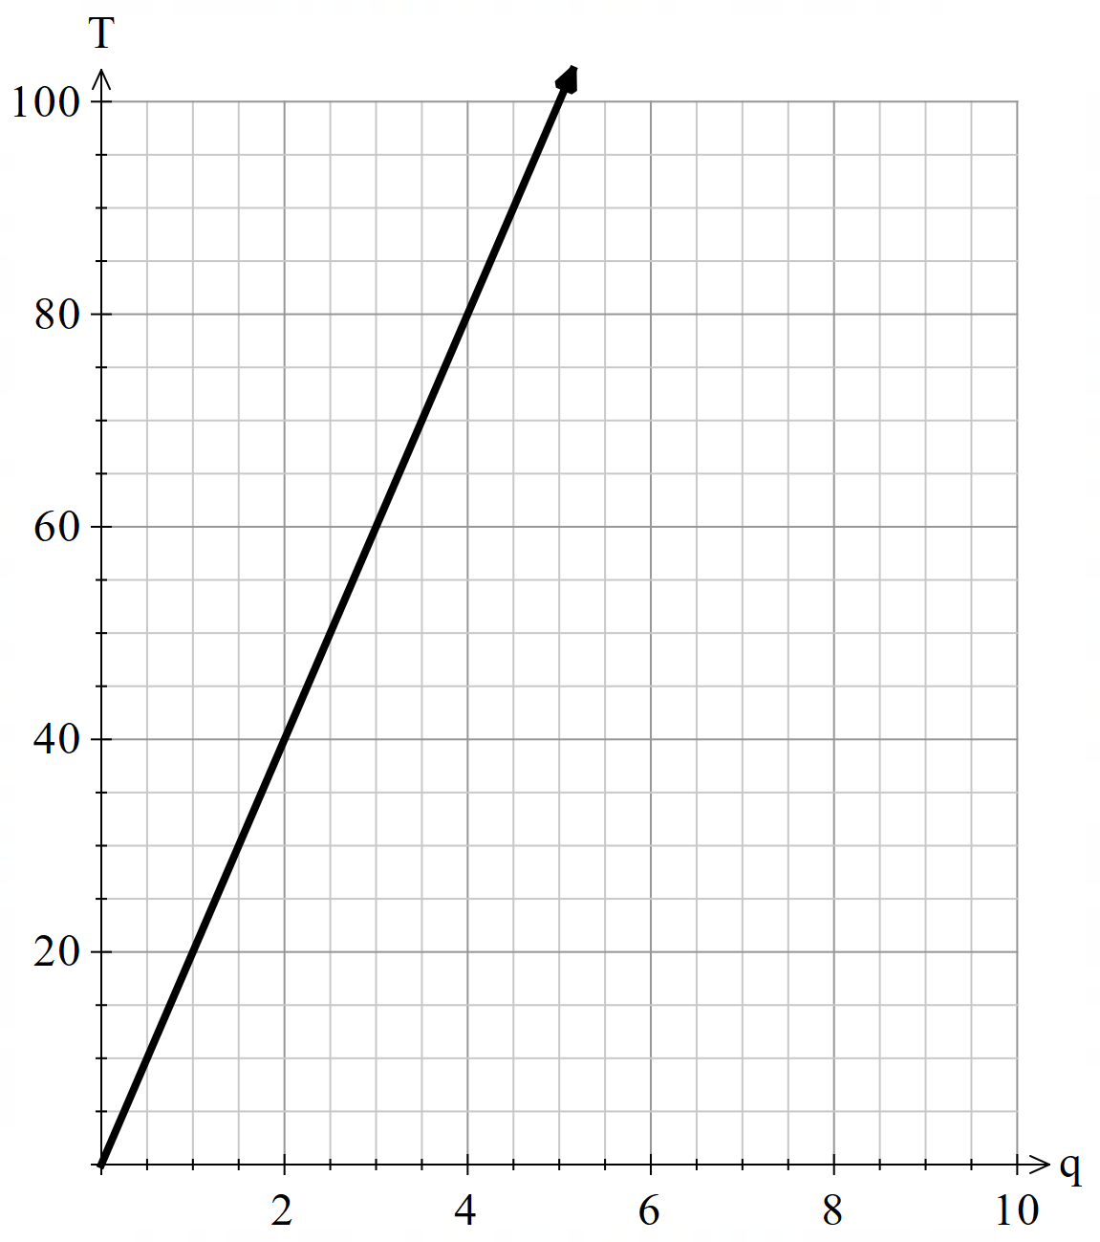
The total cost of renting a car directly varies with the number of days the car is rented. The car cost $40 a day. | $$C=40d$$
The height of a building directly varies with the number of floors when each floor has the same height. Each floor is 3 metres high. | $$h=3f$$
The time required to print a document directly varies with the number of pages being printed, assuming the printer speed is constant. The printer takes 0.2 minutes to print a page. | $$T=0.2p$$ | 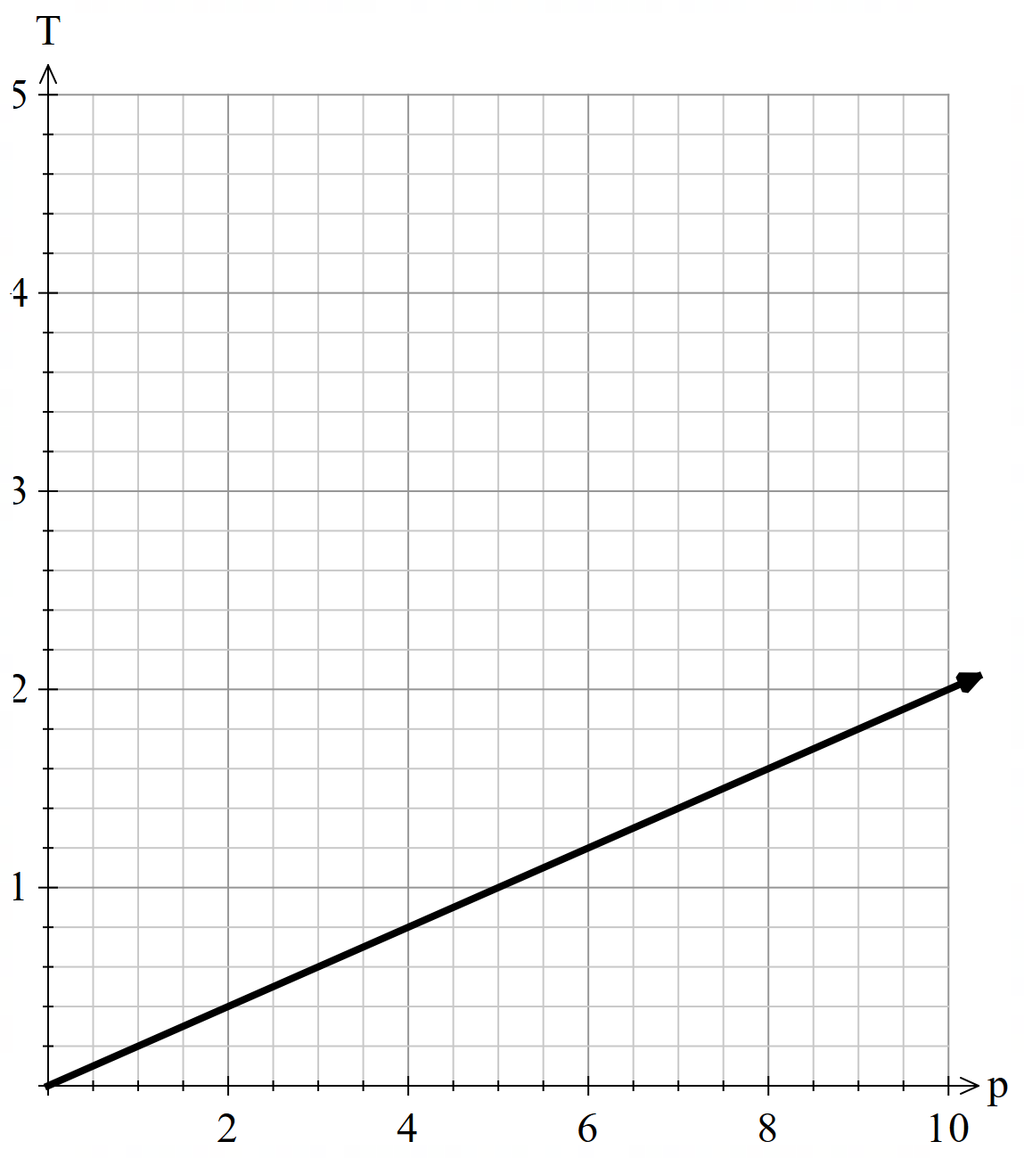
The amount of sugar required for a recipe directly varies with the number of servings. Each serving requires a quarter of a cup of sugar. | $$S=\frac{n}{4}$$ | 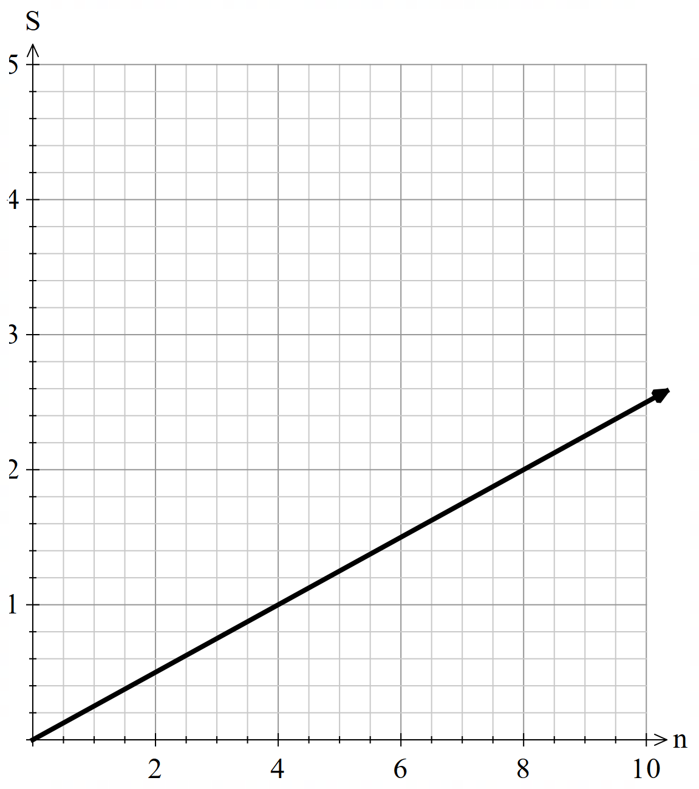
The shipping cost of a package directly varies with its weight. It costs $2 per kilogram. | $$C=2w$$
The amount of paint needed to cover a surface directly varies with the area to be painted. One square metre uses $\frac{1}{10}$ of a litre. | $$P=\frac{1}{10}a$$

Appendix G – HSC-style questions
- The driving distance from Figaro’s home to his work is $d$ km. He drives to and from work 5 times each week.
- $y=5×2d$(as he drives there and back)$y=10d$
- $y=10×32$
$y=320$ km
- A fitness centre uses 4 exercise bikes for $h$ hours every day of the year. The purchase price of each bike is $600 and the operating cost for each bike is 1.2 cents per hour.
- $c=1.2×4×h$$$c=4.8h$$$c=0.048h$ (in terms of dollars)
- $250=0.048×h$
$$\frac{250}{0.048}=h \\ h≈5208.333$$Approximately 5208 hours a year.
- Yes, it halves. As one increases or decreases, so does the other, and it is by the same rate because they are proportional.
For example, if we halve the hours of the previous answer to 2604, then the cost is $0.048×2604≈\$124.99$ which is around half of the amount.
- Paris is researching a motorbike. The motorbike uses fuel at the rate of 1.5 L/100 km.
- $y=\frac{1.5}{100}x$
- $y=\frac{1.5}{100}×10000=150$litres

References
This resource contains NSW Curriculum and syllabus content. The NSW Curriculum is developed by the NSW Education Standards Authority. This content is prepared by NESA for and on behalf of the Crown in right of the State of New South Wales. The material is protected by Crown copyright.
Please refer to the NESA Copyright Disclaimer for more information https://educationstandards.nsw.edu.au/wps/portal/nesa/mini-footer/copyright.
NESA holds the only official and up-to-date versions of the NSW Curriculum and syllabus documents. Please visit the NSW Education Standards Authority (NESA) website https://educationstandards.nsw.edu.au/ and the NSW Curriculum website https://curriculum.nsw.edu.au/.
Mathematics Standard 11–12 Syllabus © NSW Education Standards Authority (NESA) for and on behalf of the Crown in right of the State of New South Wales, 2024.

© State of New South Wales (Department of Education), 2025
The copyright material published in this resource is subject to the Copyright Act 1968 (Cth) and is owned by the NSW Department of Education or, where indicated, by a party other than the NSW Department of Education (third-party material).
Copyright material available in this resource and owned by the NSW Department of Education is licensed under a Creative Commons Attribution 4.0 International (CC BY 4.0) license.

This license allows you to share and adapt the material for any purpose, even commercially.
Attribution should be given to © State of New South Wales (Department of Education), 2025.
Material in this resource not available under a Creative Commons license:
- the NSW Department of Education logo, other logos and trademark-protected material
- material owned by a third party that has been reproduced with permission. You will need to obtain permission from the third party to reuse its material.
Links to third-party material and websites
Please note that the provided (reading/viewing material/list/links/texts) are a suggestion only and implies no endorsement, by the New South Wales Department of Education, of any author, publisher, or book title. School principals and teachers are best placed to assess the suitability of resources that would complement the curriculum and reflect the needs and interests of their students.
If you use the links provided in this document to access a third-party's website, you acknowledge that the terms of use, including licence terms set out on the third-party's website apply to the use which may be made of the materials on that third-party website or where permitted by the Copyright Act 1968 (Cth). The department accepts no responsibility for content on third-party websites.

