Spreadsheets through wages
Students will use a spreadsheet to calculate earnings from a payslip. They will apply spreadsheet skills like cell referencing and graphing to compare projected versus actual earnings through data analysis and discussion.
Students will need at least one digital device per pair to interact with the Wages spreadsheet during this lesson.

Learning intentions
- To understand how to calculate the amount earned through wages.
- To be able to use a spreadsheet to model a relationship.

Success criteria
- I can calculate the amount earned for a specific time period.
- I can input data into a spreadsheet.
- I can explain how to populate a table of values using cell references.
- I can interpret a graph that represents earnings over time.

Outcomes
A student:
- develops understanding and fluency in mathematics through exploring and connecting mathematical concepts, choosing and applying mathematical techniques to solve problems, and communicating their thinking and reasoning coherently and clearly MAO-WM-01
- models and interprets linear relationships to solve problems and make predictions in practical contexts MST-11-02
- solves financial problems involving earning money and taxation MST-11-03

Associated numeracy outcomes
A student:
- recognises and applies functional numeracy concepts in practical situations, including personal and community, workplace and employment, and education and training contexts N6-1.1
- determines whether an estimate or an answer is reasonable in the context of a problem, evaluates results and communicates conclusions N6-1.3
- chooses and applies appropriate operations with whole numbers, familiar fractions and decimals, percentages, rates and ratios to analyse and solve everyday problems N6-2.1
- chooses and applies efficient strategies to analyse and solve everyday problems involving money and finance N6-2.4
- chooses and applies appropriate numeracy operations and techniques to analyse and resolve everyday situations N6-2.6
- chooses and uses appropriate technology to access, organise and interpret information in a range of practical personal and community, workplace and employment, and education and training contexts N6-3.1

Content

Linear relationships
Linear modelling
- Use a spreadsheet to model a linear relationship in a variety of contexts

Earning money
Ways of earning
- Solve problems involving wages, penalty rates for overtime, weekends and public holidays, given an hourly rate of pay
- Use a spreadsheet to model an employee’s income including overtime, salary, bonuses, commission, piecework and royalties
Mathematics Standard 11–12 Syllabus © NSW Education Standards Authority (NESA) for and on behalf of the Crown in right of the State of New South Wales, 2024.

Table 1: lesson summary
Section | Summary of activity | Teaching strategies | Teaching points
Activating prior knowledge | Students use the ‘Payslip’ worksheet tab from the Wages spreadsheet to calculate earnings for a specific pay period and identify information from a payslip. Students then discuss how young workers receive an hourly wage increase on their birthday. | Pose-Pause-Pounce-Bounce  Think-Pair-Share | Connect students’ existing experiences with work and age-based wage changes.
Connecting learning | Define wages and connect it to students’ own experiences.  Students use the ‘Calculate earnings’ worksheet tab from the spreadsheet to develop the use of cell referencing and absolute cell referencing when calculating wages. Students then develop a graphical understanding of wage calculations. Instructions for sharing the spreadsheet are found in Appendix A. | Think-Pair-Share  Notice and wonder | Emphasise the connection between the graphical representation and the algebraic formula and develop students’ understanding of how to write a formula to calculate wage earnings.
Releasing responsibility | Use slides 4–9 of the PowerPoint Spreadsheets through wages to check for student understanding of wages and spreadsheet formulas.  Students then write notes about wage calculations and spreadsheet formulas. | Mini whiteboards  Notes to future forgetful selves | Check for understanding of how to write and use formulas and cell referencing, as well as identifying the independent variables before students write their own notes.
Independent practice | Students use the ‘Projected pay’ worksheet tab from the Wages spreadsheet for students to apply their understanding of wage calculations by comparing projected earnings to actual earnings over a set time period. They will analyse the data provided and then share their findings with reasoning. | Mini whiteboards  Pose-Pause-Pounce-Bounce | Students develop the ability to critically reflect on predicted pay and actual pay, providing reasons why these may differ.

Activity structure
Please use the associated PowerPoint Spreadsheets through wages to display images in this lesson.

Activating prior knowledge
- With a digital device between each pair, provide students with the Wages spreadsheet file.
There are instructions on how to distribute a spreadsheet in Appendix A ‘Save a local copy of a file’. If students are building their spreadsheeting skills, it is advised that the teacher models how to write formulas for students to follow along.
- Direct students to the ‘Payslip’ worksheet tab and explain to students that Jo Worker’s payslip is missing her pay for the hours worked. Have students use the spreadsheet to calculate how much Jo earned for this week and enter it into the pink cell.
Students familiar with spreadsheets may use cell referencing to enter a formula to calculate this while other students may use a calculator. Once this value has been entered, the spreadsheet will update to display Jo’s net pay.
Students are familiar with wages from the Stage 5 Financial mathematics A outcome
MA5-FIN-C-01.
- Using the Pose-Pause-Pounce-Bounce questioning strategy (PDF 557 KB) (bit.ly/posepausepouncebounce), lead a class discussion to identify information that can be gathered from the payslip. Some questions include:
- How old is Jo?
- What is Jo’s hourly rate? Do you think it is a reasonable hourly rate?
- What does 22.74 represent? Why is this not whole hours?
- In a Think-Pair-Share (bit.ly/thinkpairsharestrategy), ask students what will happen to Jo’s hourly rate when she turns 16.
Students with part time jobs may be aware that when they turn 16, their hourly rate increases.

Connecting learning
- Define a wage as ‘a regular payment earned by employees, typically paid on a weekly or fortnightly basis, usually calculated on an hourly rate’.
- Conduct a class discussion about students’ jobs, their rates of pay and how much they typically earn per week. If students are not yet working, ask them to Think-Pair-Share different types of work where you earn a wage.
Examples may include working in a supermarket, as a barista, waiter, an apprentice or tradesperson.
Students may discuss that their weekly earnings change depending on the days that they work due to penalty rates. Penalty rates will be studied in Lesson 3 of this unit.
- Direct students to the ‘Calculating earnings’ worksheet tab and explain that they will be filling out the table of values.
Students are familiar with completing tables of values from the Stage 4 Linear relationships outcome MA4-LIN-C-01.
Steps 4–14 develop students’ spreadsheet skills. Students may already be proficient with cell referencing. If this is the case, the teacher may decide to skip some or all of these steps.
- In a Think-Pair-Share, ask students how they might complete the table of values for Question 1.
Students may suggest typing calculations directly into each cell (for example, =23.5*0), use cell referencing (for example, =23.5*C5) or entering values manually from a calculator.
- Provide time for students to complete the first table of values using a method of their choice.
- Explain to students that if they use cell referencing to enter the formula =23.5*C5 into C6, then they can drag across to fill in the other cells in the table.
- Provide time for students to update their table of values to use cell references and dragging across. Have them use the same method to complete the table of values in Question 2.
- Explain to students that the rate of pay for Question 2 has now increased due to the barista turning 19. In a Think-Pair-Share, ask students how they may update the spreadsheet to reflect this.
Students may suggest that they need to update every cell in the table or simply update cell C12 and drag across.
- Explain to students that a more efficient way would be to have a separate cell with the rate of pay that can be referred to and updated when changes occur. Using Question 3, model to students that the rate of pay will be entered into cell C16 and the formula in cell C18 would be =C16*C17.
- Provide time for students to do this and drag across to complete the table of values.
Students should notice that when they drag the cell across, the values all return to $0.00 and realise that it is incorrect.
- Model to students how to see a formula in a cell by selecting the Formulas ribbon and then Show formulas.
- In a Think-Pair-Share, ask students why the formulas for Question 3 are incorrect.
Students should notice that the formulas in cells D18 to I18 do not refer to the rate of pay that was entered into cell C16.
- Explain to students that in a spreadsheet, if you want a formula to always refer to a specific cell when you drag it across to other cells, then you need to use absolute cell referencing. Model to students how to do this in cell C18 by entering the formula =$C$16*C17 and then dragging across.
- Provide time for students to update their table of values for Question 3.
- Explain to students that the hourly rate for a 19-year-old was incorrectly determined from the award rate. The correct rate is $23.57. Have students update the hourly rate on the spreadsheet and observe the subsequent changes.
- Provide time for students to complete the table of values for Questions 4 and 5.
- The graph will automatically generate as students enter data into the table of values.
Figure 1: screenshot of completed table of values
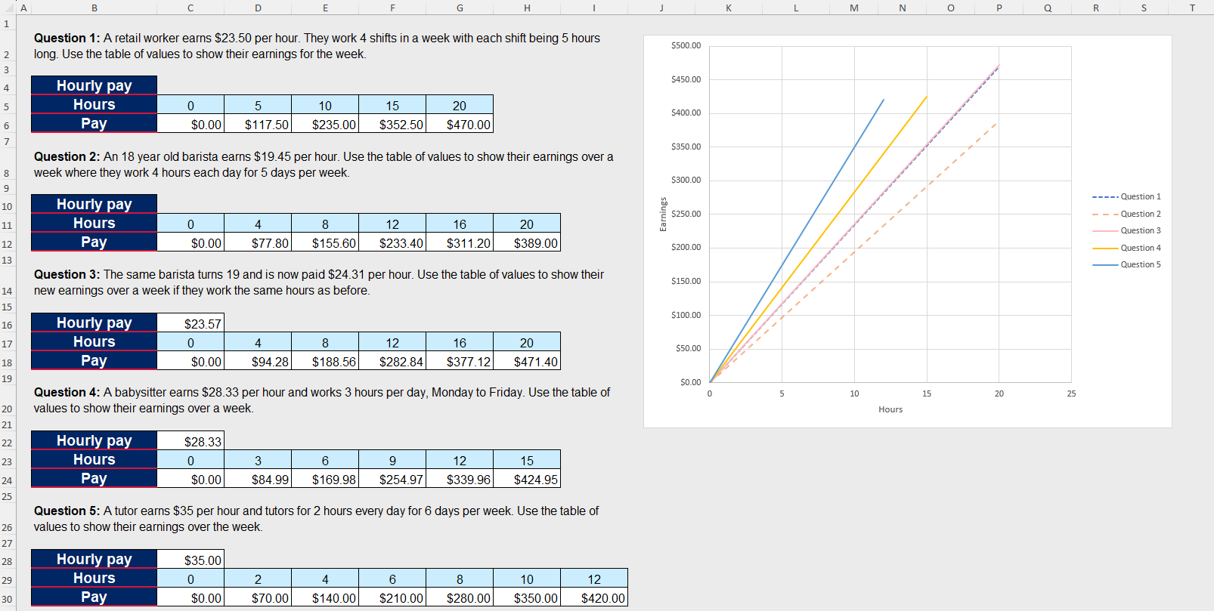
- Ask students what they notice and wonder (bit.ly/noticewonderstrategy) about the graphs that were produced.
Students may notice that:
- all the graphs start at (0,0)
- they are all straight lines.
Students may wonder:
- What part of the question causes the gradients to change?
- Do all wage calculations produce a straight line?
- Explain to students that wage calculations form a straight line because they represent direct variation – as the ‘hours worked’ increases, the ‘amount earned’ increases at a constant rate.
Direct variation is studied in depth in Lesson 2 – direct variation of Unit 2 – show me the money.

Releasing responsibility
- Check students’ understanding of wages and spreadsheet formulas by using mini whiteboards (bit.ly/miniwhiteboards) and slides 4–9 of the PowerPoint. Students should record their answer to each question on their mini whiteboards. Click to animate answers.
- Ask students to create notes to their future forgetful selves (bit.ly/notestofutureself) on wage calculations and spreadsheet formulas.

Independent practice
- Direct students to the ‘Projected pay’ worksheet tab and present the following scenario which is also outlined in the worksheet tab.
Alex is looking for a job so that he can earn $1500 to purchase an e-bike by the end of January. He has found and applied for the following job advertisement:
CASUAL JOB OPPORTUNITY: Retail Assistant Wanted!
Position: Casual retail assistant
Location: Another Pretend Business
Rate of pay: $17.20 per hour (junior rate, plus super)
Hours: 4–8 hours per week (after school and Saturdays)
- Using mini whiteboards, ask students to determine the number of hours Alex would have to work to earn enough money to reach his goal.
Students can use the spreadsheet to perform the calculation. They should obtain a decimal answer of 87.2093.
- Discuss with students why it is necessary to round up to determine the number of hours Alex must work.
Students might consider from their own jobs that some shifts include portions of an hour, which could come up in this discussion.
- State to students that there are 12 weeks between when Alex starts work to the end of January and have them determine the average number of hours Alex must work each week to reach his goal. Students are to use their mini whiteboards to show their thinking.
- Have students enter the information from the scenario and their working out into the ‘Rate of pay’ and ‘Hours per week’ cells.
- Have students calculate the anticipated weekly wage and complete the table of values to verify that Alex will reach his target earnings by the end of January.
- As students complete the table of values, the graph will automatically generate.
Figure 2: screenshot of graph when rate of pay and hours are entered
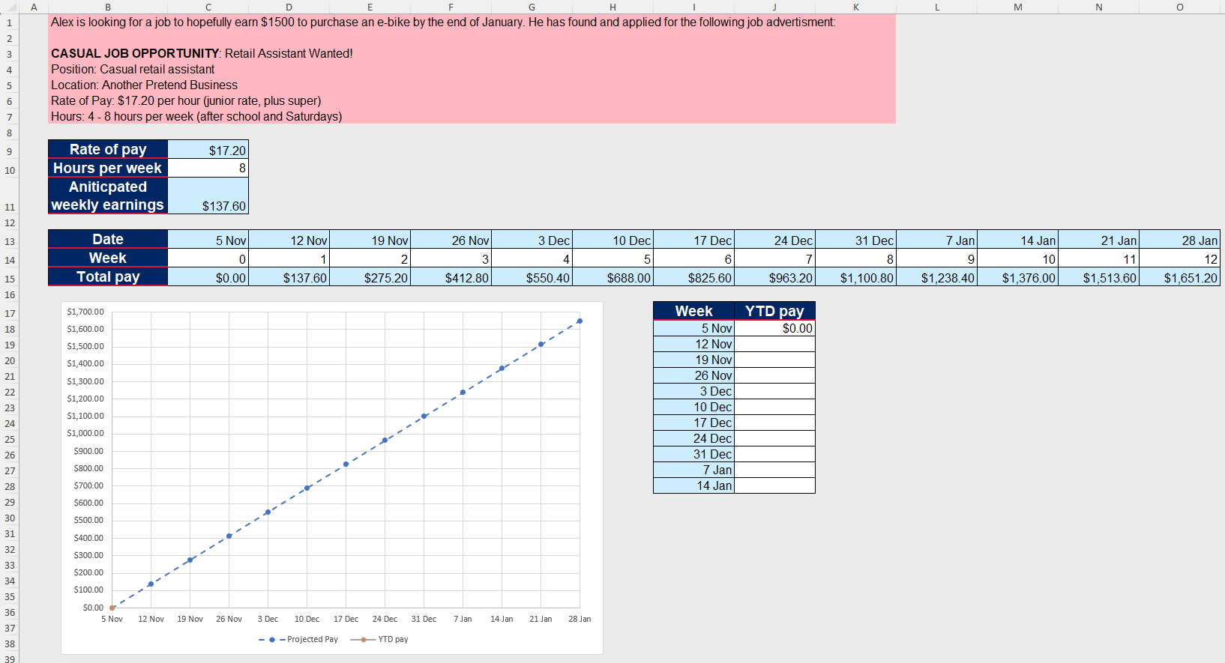
- Ask students if they know what YTD or ‘year-to-date’ means. If they are unfamiliar with the term, explain that it is the period from the beginning of the year until the current date and it is used to show the cumulative amount someone has earned or spent so far this year.
- In a Think-Pair-Share, ask students why cumulative earnings would be useful for this scenario.
Cumulative values represent the running total of data across an ordered dataset. They are often displayed using graphs.
Students should be familiar with cumulative frequency from Unit 1 – getting healthy.
- Direct students to the ‘YTD’ worksheet tab which shows weekly pay slips for the time period that Alex has worked. Have students transfer the YTD gross earnings into the table in the ‘Projected pay’ worksheet tab.
Teachers may wish to print the ‘YTD’ worksheet tab for students or demonstrate how to use cell referencing across worksheet tables (for example, in cell J19 of the ‘Projected pay’ worksheet tab, enter =YTD!C8).
- In pairs, have students solve the following problem:
From 14 January onwards, how many more hours would Alex need to work to reach his target of $1500?
Figure 3: screenshot of completed ‘Projected pay’ worksheet
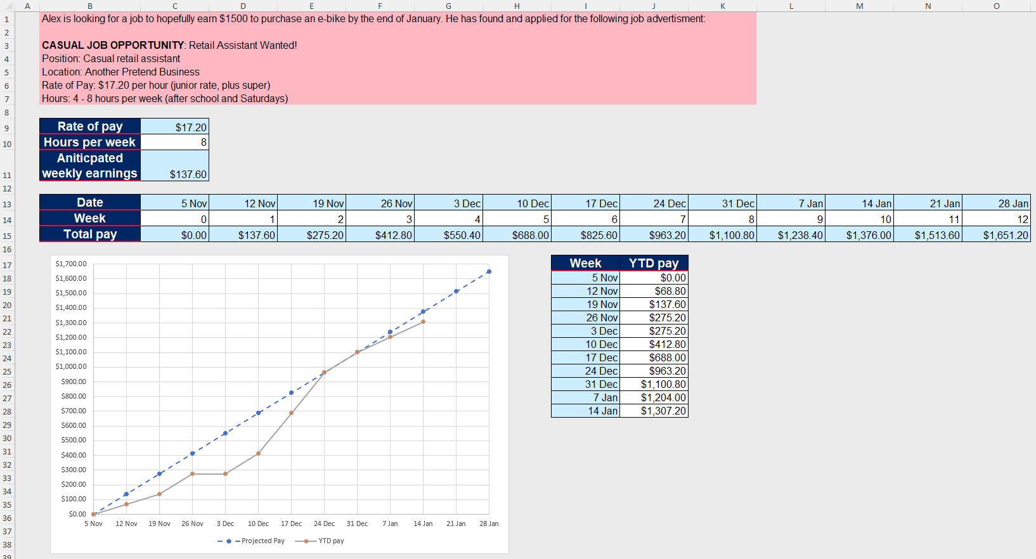
- Use the Pose-Pause-Pounce-Bounce questioning strategy to discuss how students determined their answer. The following are prompts that could be used in the discussion:
- What do you think happened between 26 November and 3 December?
- Between the 10 December and 24 December, the YTD graph increases faster than the Predicted pay graph. Provide a reason why this may have occurred.
- When does Alex work his expected 8 hours? How do you know?
- If the YTD line is below the Projected pay line, does that mean that Alex did not work as many hours as he anticipated?

Encourage students to think about why the YTD graph does not meet the expectations of the job advertisement. Some possible explanations for each section are:
- Between 5 November to 19 November Alex was new, so he was rostered on for less hours.
- Alex’s pay between 19 November and 26 November is parallel to the projected pay, indicating that he was working his expected hours.
- From 26 November to 3 December, the graph is flat, indicating that Alex did not work that week.
- From 3 December to 10 December, Alex’s YTD pay is parallel to the predicted pay.
- From 10 December to 24 December, the YTD is steeper than the predicted pay, indicating that Alex is working more hours. This may be due to a need for more staff in the lead up to Christmas.
- Between 24 December and 31 December, his YTD pay is the same as the predicted pay, meaning that Alex has earned as much as he was predicted to earn up until 31 December.
- From 31 December onwards, Alex is working consistent hours per week as indicated by the steady increase in the YTD graph; however it is not as many hours as he anticipated.

Assessment and differentiation

Suggested opportunities for differentiation
Activating prior knowledge
- Provide support to students who require help understanding a payslip.
Connecting learning
- In the notice and wonder, extend students by posing ‘What if?’ questions such as ‘What would happen to the graph if someone earned $50 per hour?’
- Support students by providing scaffolded prompts such as ‘What do you notice about the lines on the graph?’ to direct their thinking to specific features.
- Adjust the pace of the lesson by providing small video tutorials for students who are confident using spreadsheets.
- The spreadsheet activities can be completed as a class for students to follow along.
Releasing responsibility
- Support student understanding of the questions by showing a spreadsheet as they answer the questions on their mini whiteboards.
- Extend students by asking more questions around direct variation, such as ‘Which variable is the dependent variable?’ or questions where students must identify if the situation is direct variation or a linear equation.
Independent practice
- Support students by focusing on one section of the graph and explain why the rate of change is either more or less than predicted.
- Extend students by asking them to use the graph to extrapolate if Alex would reach his earning target.
- Extend students by asking them to determine how many hours Alex worked in each pay period based on his payslips.

Suggested opportunities for assessment
Activating prior knowledge
- Students’ knowledge of calculating a wage given the number of hours worked can be seen when students calculate the amount Jo Worker has earned. If students are not confident with this, it is advised to complete activities from Lesson 2 – What should I do when I am older? of Stage 5 – Unit 5 – financial mathematics.
Connecting learning
- Think-Pair-Shares provide students with the opportunity to reflect on their understanding of wages and how to enter it into a spreadsheet for efficient use.
- Review students’ spreadsheets to assess students’ ability to model a linear relationship.
Releasing responsibility
- Collect students’ notes to their future forgetful selves to check for understanding on wage calculations and spreadsheet formulas.
Independent practice
- Students will show their understanding of cumulative frequency when discussing YTD graphs.
- Students’ understanding of how the amount earned through wages varies over time can be seen in responses to prompts in this section.

Appendix A

Save a local copy of a file
How to save a local copy of an Excel spreadsheet.

File sharing and saving
- Save the Excel file Wages in a place where students can easily access the file.
This could be done through Google Classroom, by sharing a OneNote link or by emailing students a copy of the document.
- Have students open the document on their own digital device.
- Instruct students to select the File tab and then Save a Copy.
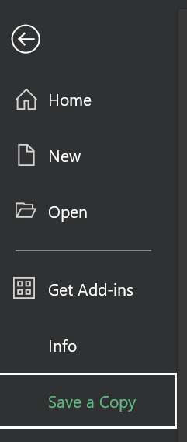
- Students can save the document in their individual OneDrive by selecting this option.
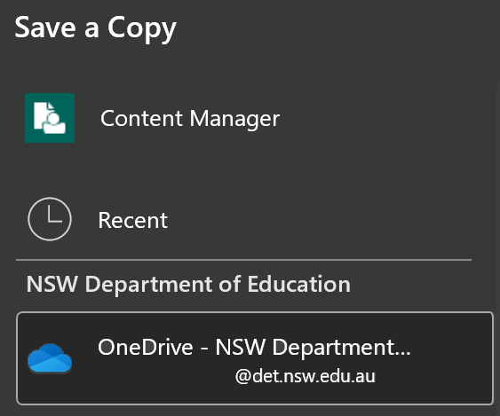
- Best practice would be to keep the file name the same. Students can then select Save and a copy will be stored on their OneDrive.
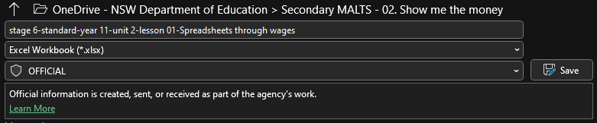

References
This resource contains NSW Curriculum and syllabus content. The NSW Curriculum is developed by the NSW Education Standards Authority. This content is prepared by NESA for and on behalf of the Crown in right of the State of New South Wales. The material is protected by Crown copyright.
Please refer to the NESA Copyright Disclaimer for more information https://educationstandards.nsw.edu.au/wps/portal/nesa/mini-footer/copyright.
NESA holds the only official and up-to-date versions of the NSW Curriculum and syllabus documents. Please visit the NSW Education Standards Authority (NESA) website https://educationstandards.nsw.edu.au and the NSW Curriculum website https://curriculum.nsw.edu.au.
Mathematics Standard 11–12 Syllabus © NSW Education Standards Authority (NESA) for and on behalf of the Crown in right of the State of New South Wales, 2024.

© State of New South Wales (Department of Education), 2025
The copyright material published in this resource is subject to the Copyright Act 1968 (Cth) and is owned by the NSW Department of Education or, where indicated, by a party other than the NSW Department of Education (third-party material).
Copyright material available in this resource and owned by the NSW Department of Education is licensed under a Creative Commons Attribution 4.0 International (CC BY 4.0) license.

This license allows you to share and adapt the material for any purpose, even commercially.
Attribution should be given to © State of New South Wales (Department of Education), 2025.
Material in this resource not available under a Creative Commons license:
- the NSW Department of Education logo, other logos and trademark-protected material
- material owned by a third party that has been reproduced with permission. You will need to obtain permission from the third party to reuse its material.
Links to third-party material and websites
Please note that the provided (reading/viewing material/list/links/texts) are a suggestion only and implies no endorsement, by the New South Wales Department of Education, of any author, publisher, or book title. School principals and teachers are best placed to assess the suitability of resources that would complement the curriculum and reflect the needs and interests of their students.
If you use the links provided in this document to access a third-party's website, you acknowledge that the terms of use, including licence terms set out on the third-party's website apply to the use which may be made of the materials on that third-party website or where permitted by the Copyright Act 1968 (Cth). The department accepts no responsibility for content on third-party websites.

