Formulas and medication dosages
Students will substitute into, rearrange and evaluate formulas to calculate safe medication dosages for children and adults using Fried’s, Young’s and Clark’s formulas.

Learning intention
- To be able to substitute into, rearrange and evaluate formulas.

Success criteria
- I can substitute values into formulas to evaluate the subject of a formula.
- I can select and use an appropriate dosage formula (Fried’s, Young’s or Clark’s) based on the information provided.
- I can apply formulas to solve problems in medical contexts.
- I can explain why accuracy is important when calculating medication dosages.

Outcomes
A student:
- develops understanding and fluency in mathematics through exploring and connecting mathematical concepts, choosing and applying mathematical techniques to solve problems, and communicating their thinking and reasoning coherently and clearly MAO-WM-01
- selects and applies algebraic techniques to solve problems involving equations and formulas MST-11-01

Content

Formulas and equations
- Substitute numbers into linear and non-linear algebraic expressions, equations and formulas
- Evaluate the subject of a formula, given the value of other pronumerals in the formula
- Calculate the required medication dosages for children and adults given age or weight, using Fried’s, Young’s and Clark’s formula as appropriate
- Apply given formulas to solve problems in a variety of contexts
Mathematics Standard 11–12 Syllabus © NSW Education Standards Authority (NESA) for and on behalf of the Crown in right of the State of New South Wales, 2024.

Table 1: lesson summary
Section | Summary of activity | Teaching strategies | Teaching points
Retrieval practice | Students use mini whiteboards to answer 8 unit conversion questions on slide 4 of the PowerPoint Formulas and medication dosages and 3 hinge point questions on slide 5. | Mini whiteboards | Reinforce essential unit conversion skills needed for calculations relevant to the lesson and formatively assess substitution into formulas.
Activating prior knowledge | Use slide 7 to discuss a medicine dosage table. Students discuss the importance of calculating the dosage correctly. | Pose-Pause-Pounce-Bounce | Develop understanding of the critical need for accuracy in medication dosing, especially for children.
Connecting learning | Use slide 9 to discuss the 3 dosage formulas with the option of using slides 10–11 to model a worked example before students complete Appendix A to compare the 3 formulas and determine which formula is best to use under different circumstances. | Turn and talk  Worked examples (Your turn)  Pose-Pause-Pounce-Bounce | Looks at the importance of selecting the correct formula based on available data. Weight-based dosing (Clark’s formula) is often most accurate.
Releasing responsibility | Model examples of rearranging the formulas using slides 13–14. Use slide 15 to demonstrate a calculation error before students create and swap worked examples containing errors to identify and discuss mistakes. Students work through 4 dosage scenarios on slides 16–17, deciding on an appropriate formula and calculating doses, before a class discussion on formula selection, substitution errors, units and solution verification. | Worked examples (Your turn)  Think-Pair-Share | Developing habits of verifying answers for safety and accuracy.
Independent practice | Distribute Appendix B for groups to adjust dosages before a class discussion on preventing errors, informed by current research. | Visibly random groups of 3  Vertical non-permanent surfaces | Understand the importance of preventing errors with an emphasis on patient safety and the role of accurate medication administration.

Activity structure
Please use the associated PowerPoint Formulas and medication dosages to display images in this lesson.

Retrieval practice
- Using mini whiteboards (bit.ly/miniwhiteboards), have students answer the 8 questions on slide 4 of the PowerPoint to practise unit conversions that will be required in this lesson.
Clicking to animate the slides 4 and 5 will reveal the answer to question 1, then question 2, the answer to question 2 and so on.
- Have students answer the 3 questions on slide 5, writing their answers on mini whiteboards to check for prior knowledge.
Encourage students to show working and use inverse operations logically. Ensure students know how to enter the calculations into their calculator correctly, particularly for formulas involving fractions.

Activating prior knowledge
- Use slide 7 of the PowerPoint to display a medicine dosage table for ages 3 months to 12 years and an oral syringe. Use the Pose-Pause-Pounce-Bounce questioning strategy (PDF 557 KB) (bit.ly/posepausepouncebounce) to discuss the importance of calculating the dosage correctly. Some suggested prompts include:
- How easy is it to calculate these dosages? What would the dose be for a 6-year-old? What would the dose be for a child weighing 19 kg?
- Why does the dosage chart say to choose the dose for the child’s weight, if known, rather than the dose for the child’s age?
- Why are accurate dosages important, especially when working with babies and young children?
Dosing by weight versus age will be explored and discussed later in the lesson.
Accuracy is important because errors can have serious consequences, for example, the wrong medication dose can harm a patient.
- Explain to students that healthcare workers use formulas to determine more accurate medication dosages, especially for children and infants, where accuracy is critical. In this lesson students will compare 3 different dosage formulas for children.

Connecting learning
- Display slide 9 of the PowerPoint, which shows 3 different dosage formulas for children.
- Prompt students to turn and talk (bit.ly/classroomtalkmoves) to the person next to them to discuss:
- What are the similarities and differences in the 3 formulas?
- Why do you think there are 3 different formulas?
- If caring for a 15-month-old child, which formula would you use and why?
Possible student responses:
- All formulas use the adult dose as a starting point to calculate the child’s dose. The formulas themselves don’t specify units for the doses, which means the method works as long as both doses use the same units.
- Each formula uses different information about the child: Fried’s uses age in months, Young’s uses age in years and Clark’s uses weight. Some formulas are only suitable for certain age groups; for example, Fried’s formula is specifically for children aged 1–2 years.

- Having different formulas allows for flexibility and accuracy, depending on what information (age, weight) is available for each child. This ensures the most precise dosage calculation for each individual child, helping to keep them safe and effectively treated.
- For a 15-month-old child, Fried’s formula would be most appropriate because it is designed for children aged 1–2 years and uses age in months, which matches the information available for a 15-month-old.
- Use slides 10–11 to model applying the dosage formulas using the Worked examples (Your turn) method (bit.ly/supportingstrategies).
If students demonstrated understanding of substituting into formulas in ‘Retrieval practice’, this worked example could be skipped.
- Distribute Appendix A ‘Comparing formulas’ for students to complete in pairs.
- When complete, ask pairs to discuss their final answer on Appendix A ‘Comparing formulas’ with a neighbouring pair or share back to the class.
Students should share that when weight is known, Clark’s formula is the preferred method as it directly accounts for the child’s mass. The age-based formulas (Fried’s and Young’s) assume that the child’s height and weight are in the normal range for their age, which isn’t always the case.
- Use the Pose-Pause-Pounce-Bounce questioning strategy to deepen students’ thinking by posing the questions:
- Which formula should be used for a child around 2 years of age?
- At what age does Young’s formula become more appropriate to use than Fried’s formula?

Clark’s formula, using the actual weight of the child, is more accurate as the age-based formulas assume that the child’s height and weight are in the normal range for their age.
Students should notice that the dosage amounts using Fried’s formula become larger than Young’s formula as the child’s age increases. Students may consider the recommendation to use Young’s formula before the age of 2 as it provides a lower dose and would be safer to avoid overdosing.

Releasing responsibility
- Use slides 13–14 of the PowerPoint to model rearranging the dosage formulas to calculate the adult dose using the Worked examples (Your turn) method.
Click to animate the ‘Worked example’ slides for self-explanation prompts to appear. Click to animate the ‘Your turn’ slides for solutions to appear.
- Students may benefit from completing additional practice questions to consolidate their understanding of rearranging formulas to solve for the unknown variable.
- Use slide 15 to demonstrate an example of a calculation error. In the example, the error is not converting months to years when using Young’s formula.
- In pairs, ask students to create their own worked example that has an error and then swap with another pair to identify and explain the error made.
- Display slide 16. Ask students to read Scenario 1, then in a Think-Pair-Share, students should decide which formula is needed before completing the calculation. Encourage students to consider how reasonable their solution is (bit.ly/checkreasonableness).
- Click to animate the slide for the solution to Scenario 1.
- Click to animate the slide again for Scenario 2 to appear and repeat the Think-Pair-Share. Click again to animate the slide for the solution to Scenario 2.
- Display slide 17 and repeat the process of facilitating a Think-Pair-Share, then reveal the solution for Scenario 3 before repeating for Scenario 4.
- Facilitate a class discussion using the following prompts:
- How do you determine when to use Fried’s, Young’s or Clark’s formula?
- How can incorrect substitution affect a person’s health?
- What units do you need to watch out for?
- What should you check before and after solving any dosage problem?

Independent practice
- Assign students to visibly random groups of 3 (bit.ly/visiblegroups) at vertical non-permanent surfaces (bit.ly/VNPSstrategy).
- Explain to students that pharmacists and nurses often need to adjust the number of tablets patients are required to take based on the dosage prescribed by the doctor and the dosage in the tablets they have in stock.
- Distribute Appendix B ‘Dosage conversions’ for students to complete.
- Ask students to suggest a formula that could be used to work out the number of tablets/vials to give a patient, using information about the prescribed dose and the dosage of available stock.
Students should suggest the formula: $\text{Number of tablets or vials=}\frac{\text{Ordered dose to be given}}{\text{Dosage of available stock}}$
- Research by Lim et al. (2022) on hospital admissions in Australia reported that ‘two-thirds of medication-related hospital admissions are potentially preventable’. Conduct a class discussion on what can be done to prevent errors in giving or taking medication. Encourage students to elaborate on their responses and consider alternate viewpoints.

Prevention measures could include:
- taking the time to read the warnings and directions for use on medication packages
- reading the consumer medicine information leaflet that comes with prescription medicines and provides information on side effects, interactions with other medications or food and what to do in the case of an overdose
- not taking more than the required dose specified in 24 hours
- clearly understanding the prescription provided by the doctor and confirming these details are the same when filled by the pharmacist
- measuring liquid medication accurately.

Assessment and differentiation

Suggested opportunities for differentiation
Retrieval practice
- Model step-by-step rearranging for question 2 on slide 5 of the PowerPoint ($T=2a+5→a=\frac{T-5}{2}$).
- Ask confident students to explain their reasoning aloud for each question on slide 5 and predict common mistakes.
Activating prior knowledge
- Students could use physical measuring devices to attempt to measure given dosages to determine difficulties in measuring accurately.
Connecting learning
- Students could be challenged to compare percentage differences between Fried’s dose and Young’s dose in Appendix A.
Releasing responsibility
- Rather than having students determine which formula to use, they can be told the appropriate formula for each question and reason why that formula is to be used.
- To support students, scaffold a process to follow, for example, choose formula, write formula, substitute, calculate, check units.
- Challenge students to solve each scenario using 2 different formulas and compare results.
Independent practice
- The formulas or a partially completed worked example can be provided to support students to complete Appendix B.
- Students can be provided with other dosage conversion formulas for further practice. Some formulas can be found on the Ausmed website (bit.ly/AusmedFormulas).

Suggested opportunities for assessment
Retrieval practice
- Check mini whiteboard responses for accuracy.
- Observe if students write down working out and use inverse operations correctly.
Connecting learning
- Use the turn and talk discussion to listen for accurate identification of similarities and differences between formulas.
- Evaluate peer discussions when identifying errors for the correct identification of both the error and the reason it matters. Check if students recommend appropriate corrections.
Releasing responsibility
- Look for evidence of reasonableness checks in their working.
- Use contributions to Think-Pair-Share and class discussion to observe correct formula choice and justification.
Independent practice
- Engage in group discussions and use assessing and advancing questions (bit.ly/supportingstrategies) to check for understanding.
Table 1: assessing and advancing questions
Assessing questions | Advancing questions
Does the question require you to convert units? | Have you answered the question?
What information do you need from the question? | Is your answer reasonable? How could you check your answer?
- Check group work on vertical non-permanent surfaces for correct calculations and reasoning.

Appendix A

Comparing formulas
Fried’s formula: children 1–2 years ${Child}^{'}s dose=\frac{age of child \left(in months\right) × adult dose}{150}$
Young’s formula: children 1–12 years ${Child}^{'}s dose=\frac{age of child \left(in years\right) × adult dose}{age of child \left(in years\right) + 12}$
Clark’s formula: ${Child}^{'}s dose=\frac{weight of child \left(in kg\right) × adult dose}{70}$
- For each age listed, calculate the child’s dose using both Fried’s and Young’s formulas. Use an adult dose of 25 mL.
Age (months) | Age (years) | Child’s dosage – Fried’s formula (mL) | Child’s dosage – Young’s formula (mL) | Difference (mL)
21 | $$\frac{21}{12}=1.75$$
22 | $$\frac{22}{12}=$$
23
24
25
26
27

- Plot the dosages using one colour for Fried’s formula and a different colour for Young’s formula:
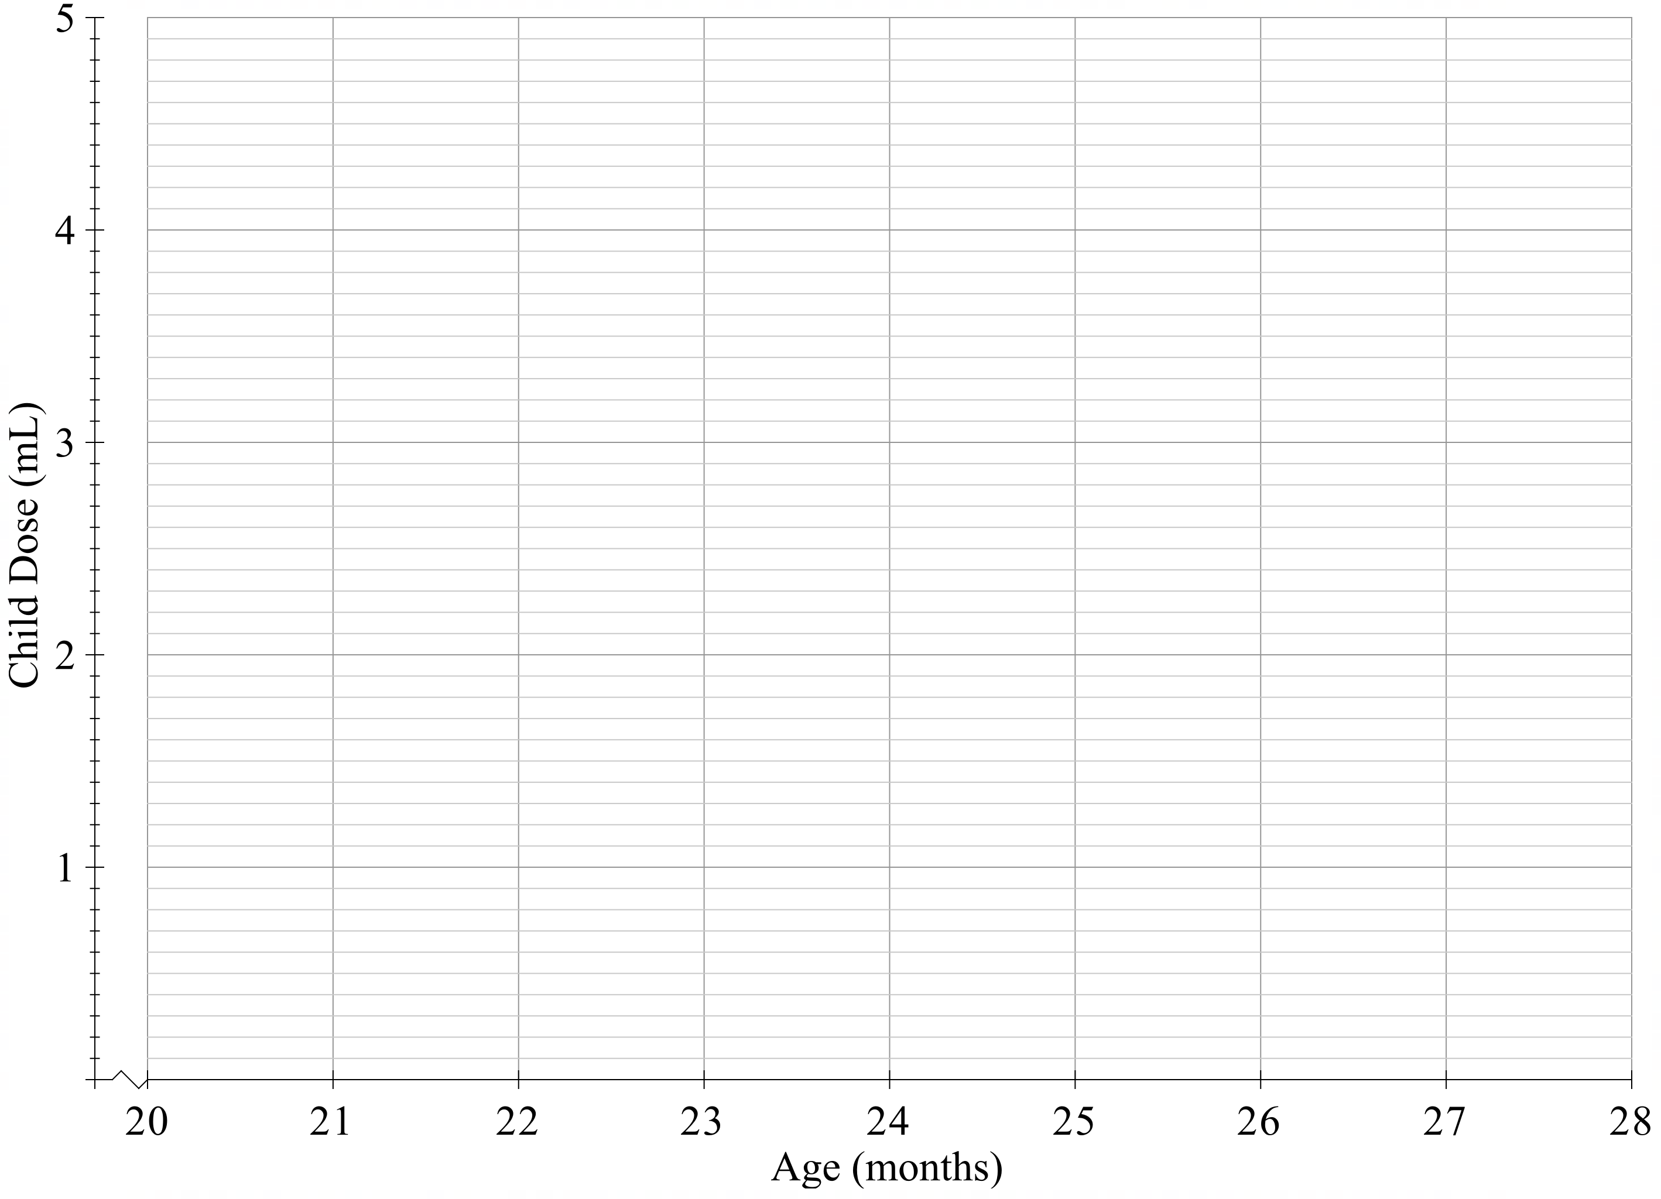
- Identify which formula’s graph is linear and explain how you can tell from the graph.

Emily is a healthcare worker. She has to administer medication to a 15-month-old child. She knows that the adult dose is 25 mL. Emily checks the child’s weight and finds that the child is 10 kg.
- Use all 3 dosage formulas to calculate the dose for this child.
Dosage using Fried’s formula
Dosage using Young’s formula
Dosage using Clark’s formula
- Which formula(s) would you choose in this situation? Justify your decision, considering the available information, consistency between formulas and the importance of accuracy in dosages.

Appendix B

Dosage conversions

Question 1
Louise’s doctor has prescribed 1 gram of a medication twice a day. Her nursing home has the medication in stock, but their tablets have a dosage amount of 250 milligrams. How many of these tablets will Louise need to take?

Question 2
Joe has a prescription from his doctor to take 200 milligrams of a medication 3 times per day. The pharmacist checks their stock, and they only have this medication in a 400-milligram dosage. How many tablets will the pharmacist advise Joe to take each time?

Question 3
Tom is a nurse who has just started his shift at the hospital. They’ve recently had a change in medication stock, and he needs to recheck the number of tablets required for each patient. Jim currently takes 3 tablets of 250 milligrams each. The new tablets come in 1.5-gram dosages. How many tablets does Jim need to take now?
Question 4
Penny is to be given 2.4 grams of a certain medication. Upon checking stock, her nurse finds that the medication is only available in 10 millilitre vials that each contain 600 milligrams. How many vials should the nurse give Penny? How many millilitres is this?

Sample solutions

Appendix A – comparing formulas

Age (months) | Age (years) | Child’s dosage – Fried’s formula (mL) | Child’s dosage – Young’s formula (mL) | Difference (mL)
21 | 1.75 | 3.50 | 3.18 | 0.32
22 | 1.83 | 3.67 | 3.31 | 0.36
23 | 1.92 | 3.83 | 3.45 | 0.38
24 | 2.00 | 4.00 | 3.57 | 0.43
25 | 2.08 | 4.17 | 3.69 | 0.48
26 | 2.17 | 4.33 | 3.83 | 0.50
27 | 2.25 | 4.50 | 3.95 | 0.55

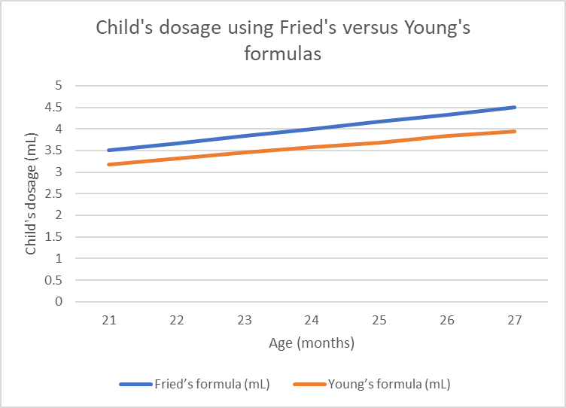
- Fried’s formula produces a linear graph (blue). You can tell because as age in months increases, the Fried’s dose increases by a constant amount each month (due to rounding, the increase is almost constant). This creates a straight line when graphed, showing a constant rate of change. In contrast, Young’s formula increases with age, but not at a constant rate, so its graph is not exactly linear (orange).

Dosage using Fried’s formula | $${Child}^{'}s dose=\frac{age of child \left(in months\right)×adult dose}{150} \\ =\frac{15×25}{150} \\ =\frac{375}{150} \\ =2.5 mL$$
Dosage using Young’s formula | $${Child}^{'}s dose=\frac{age of child \left(in years\right)×adult dose}{age of child \left(in years\right)+12} \\ =\frac{1.25×25}{1.25+12} \\ =\frac{31.25}{13.25} \\ ≈2.36 mL (2 decimal places)$$
Dosage using Clark’s formula | $${Child}^{'}s dose=\frac{weight of child \left(in kg\right)×adult dose}{70} \\ =\frac{10×25}{70} \\ =\frac{250}{70} \\ ≈3.57 mL (2 decimal places)$$
- In this situation, the calculated doses from all 3 formulas are similar (between 2.36 mL and 3.57 mL), showing some consistency, but accuracy is crucial in healthcare. Since weight is a direct measure and is available, Clark’s formula provides the most reliable dose for this child. When weight is known, Clark’s formula is the preferred method as it directly accounts for the child’s mass. The age-based formulas (Fried’s and Young’s) assume that the child’s height and weight are in the normal range for their age, which isn’t always the case. If weight is not known or available, Fried’s formula is more straightforward when given the age in months. If using Young’s formula, the age needs to be converted to years correctly. When comparing Fried’s and Young’s formulas (age-based) to Clark’s formula (weight-based), the dosage calculated using Fried’s formula is closer in value to the dosage using Clark’s formula.

Appendix B – dosage conversions
Question 1
1 gram is 1000 milligrams
$$Number of tablets=\frac{Ordered dose to be given}{Dosage of available stock} \\ Number of tablets= \frac{1000}{250} \\ Number of tablets=4$$
Louise needs to take 4 tablets twice a day.
Question 2
$$Number of tablets=\frac{Ordered dose to be given}{Dosage of available stock} \\ Number of tablets= \frac{200}{400} \\ Number of tablets=0.5$$
Joe needs to take half a tablet 3 times per day.
Question 3
Jim’s original dosage is $3×250=750$milligrams.
$$Number of tablets=\frac{Ordered dose to be given}{Dosage of available stock} \\ Number of tablets=\frac{750}{1500} \\ Number of tablets=0.5$$
Jim now only needs to take half a tablet.
Question 4
2.4 grams is 2400 mg
$$Number of vials=\frac{Ordered dose to be given}{Dosage of available stock} \\ Number of vials=\frac{2400}{600} \\ Number of vials=4$$
Penny needs to be given 4 vials, which is 40 mL since each vial contains 10 mL.

References
This resource contains NSW Curriculum and syllabus content. The NSW Curriculum is developed by the NSW Education Standards Authority. This content is prepared by NESA for and on behalf of the Crown in right of the State of New South Wales. The material is protected by Crown copyright.
Please refer to the NESA Copyright Disclaimer for more information https://educationstandards.nsw.edu.au/wps/portal/nesa/mini-footer/copyright.
NESA holds the only official and up-to-date versions of the NSW Curriculum and syllabus documents. Please visit the NSW Education Standards Authority (NESA) website https://educationstandards.nsw.edu.au/ and the NSW Curriculum website https://curriculum.nsw.edu.au/.
Mathematics Standard 11–12 Syllabus © NSW Education Standards Authority (NESA) for and on behalf of the Crown in right of the State of New South Wales, 2024.
Lim R, Ellett LMK, Semple S (2022) ‘The Extent of Medication-Related Hospital Admissions in Australia: A Review from 1988 to 2021’, Drug Saf, 45(3):249–257, doi: 10.1007/s40264-021-01144-1. (bit.ly/MedicationHospitalisation)

© State of New South Wales (Department of Education), 2025
The copyright material published in this resource is subject to the Copyright Act 1968 (Cth) and is owned by the NSW Department of Education or, where indicated, by a party other than the NSW Department of Education (third-party material).
Copyright material available in this resource and owned by the NSW Department of Education is licensed under a Creative Commons Attribution 4.0 International (CC BY 4.0) license.

This license allows you to share and adapt the material for any purpose, even commercially.
Attribution should be given to © State of New South Wales (Department of Education), 2025.
Material in this resource not available under a Creative Commons license:
- the NSW Department of Education logo, other logos and trademark-protected material
- material owned by a third party that has been reproduced with permission. You will need to obtain permission from the third party to reuse its material.
Links to third-party material and websites
Please note that the provided (reading/viewing material/list/links/texts) are a suggestion only and implies no endorsement, by the New South Wales Department of Education, of any author, publisher, or book title. School principals and teachers are best placed to assess the suitability of resources that would complement the curriculum and reflect the needs and interests of their students.
If you use the links provided in this document to access a third-party's website, you acknowledge that the terms of use, including licence terms set out on the third-party's website apply to the use which may be made of the materials on that third-party website or where permitted by the Copyright Act 1968 (Cth). The department accepts no responsibility for content on third-party websites.

