Outliers
Students explore a dataset from a real-life scenario and construct box plots to identify how extreme values affect statistical measures. They then develop an understanding of outliers and how to determine their impact on data analysis.
Students will need at least one digital device per pair to interact with Amplify (Desmos) during this lesson.

Learning intentions
To be able to apply formal methods to identify outliers.
To understand how outliers affect statistical analysis.

Success criteria
- I can explain the meaning of an outlier.
- I can identify an outlier using both visual and formal methods (formula).
- I can explain how an outlier affects measures like the mean, median and range.
- I can decide when it is appropriate to include or exclude an outlier and justify my reasoning.

Outcomes
A student:
- develops understanding and fluency in mathematics through exploring and connecting mathematical concepts, choosing and applying mathematical techniques to solve problems, and communicating their thinking and reasoning coherently and clearly MAO-WM-01
- selects and applies algebraic techniques to solve problems involving equations and formulas MST-11-01
- displays and analyses datasets using summary statistics and graphical representations
MST-11-08

Content

Formulas and equations
- Substitute numbers into linear and non-linear algebraic expressions, equations and formulas
- Evaluate the subject of a formula, given the value of other pronumerals in the formula

Five-number summary and box plots
- Determine quartiles from datasets displayed in histograms and dot plots, and represent these datasets as a box plot
- Interpret box plots to draw conclusions and make inferences about a dataset

Clusters and outliers
- Identify clusters, gaps and outliers and explain their occurrence in the context of the data
- Apply $Q1 - 1.5 × IQR$ and $Q3 + 1.5 × IQR$ to formally identify outliers
- Explain the impact of outliers on the measures of centre and spread
Mathematics Standard 11–12 Syllabus © NSW Education Standards Authority (NESA) for and on behalf of the Crown in right of the State of New South Wales, 2024.

Table 1: lesson summary
Section | Summary of activity | Teaching strategies | Teaching points
Activating prior knowledge | Students explore weight-loss data from a 12-week fitness program on slide 4 of the PowerPoint Outliers. They discuss patterns, unusual results, and possible explanations. They calculate the five-number summary and construct a box plot and compare their box plots with peers and refine them through feedback. Students reflect on whether the −12 kg result should be included or excluded, considering its effect on measures of centre and spread. | Think-Pair-Share  Notice and Wonder  Mini whiteboards | This section builds curiosity and engagement with real-world data, activates prior understanding of summary statistics and develops collaboration through comparison and peer feedback. Students are encouraged to think critically about data reliability and understand the concept of outliers.
Connecting learning | Students recall the definition of an outlier (slide 6) and propose informal boundaries for outliers. They complete the Amplify (Desmos) activity ‘When does it become an outlier?’ (bit.ly/DesmosOutliers) (screens 2–5) to test their reasoning. | Turn and talk  Think-Pair-Share | This section connects informal reasoning with formal definitions, strengthens conceptual understanding of outliers and introduces the use of IQR-based formulas.
Releasing responsibility | Class discussion links student ideas to the formal formula for determining outlier boundaries (slides 9–10). Students discuss why it is important to identify outliers and when to keep or remove them in data analysis.  Students complete the Amplify (Desmos) task before looking at worked examples of calculating outlier boundaries (slides 11–18) then complete a Frayer diagram using Appendix A. They revisit the dataset, recalculate the five-number summary excluding the outlier and redraw the box plots to represent the datasets. | Pose-Pause-Pounce-Bounce  Worked examples (Your turn) | This section provides scaffolded practice with formulas, reinforces accurate use of mathematical definitions, and highlights the effect of removing an outlier on the five-number summary and box plots.
Independent practice | Students work in groups to complete a task from Appendix B. They make their way through 4 task components and record their thinking each time. Students discuss the previous task in a class discussion before writing a summary of their conclusions. Students complete an individual exit ticket (slide 20). | Visibly random groups of 3  Vertical non-permanent surfaces  Pose-Pause-Pounce-Bounce  Exit ticket | This section promotes collaboration, reasoning, and flexibility in problem-solving. Students consolidate their learning through group discussion and checks individual understanding with the exit ticket.

Activity structure
Please use the associated PowerPoint Outliers to display images in this lesson.

Activating prior knowledge
- Display slide 4 from the PowerPoint which shows the statistical investigation process. Explain that this lesson will focus on stage 4, analysing data.
- Show students slide 5 which shows the dataset and read students the following scenario.
A fitness centre has developed a radical new fitness and diet program. It decides to conduct a study to show how effective the program is. The program tracks the weight loss of each participant in kilograms throughout the study.
After 12 weeks, the change for the 10 participants is recorded as follows:
Participant 1: −1.5 kg, Participant 2: −2.2 kg, Participant 3: −2.8 kg, Participant 4: −1.2 kg, Participant 5: −3.0 kg, Participant 6: −2.5 kg, Participant 7: −2.0 kg, Participant 8: −2.3 kg, Participant 9: −12.0 kg, Participant 10: −2.1 kg.
- In a Think-Pair-Share (bit.ly/thinkpairsharestrategy), ask students what they notice and wonder (bit.ly/noticewonderstrategy) about these results.
Students may notice that the losses seem to be between 1–3 kgs, except one loss that is significantly larger.
Students may wonder why there is one result that is significantly different and whether the participant did something different during the program. They may also wonder about the original weight of the people involved and whether they had much weight to lose.
- In pairs, using a mini whiteboard (bit.ly/miniwhiteboards), have students calculate the five-number summary for the data before drawing a box plot.
If students require further assistance with calculating the five-number summary, it is advised students review Lesson 6 – five-number summary.
A grid structure on the mini whiteboards would assist students in constructing their box plots. A sheet of grid paper inside a plastic sleeve would also work. A3 size would be ideal, but A4 would be sufficient.
- Have students compare their box plot with a neighbouring pair and discuss any differences. Students should then use the peer feedback received to review their plot and modify it if necessary.
Students will return to this box plot for a later activity. Please ask them not to erase the box plot.
- Using a Think-Pair-Share, guide students to reflect critically on these questions:
- What might the −12 kg value tell us about this dataset?
- What would the range of the data be?
- How should we decide whether to include or exclude this value in our analysis?
Student responses could suggest that the 12 kg loss is relevant as it is someone’s result, however, others could point out that it is significantly different and may suggest the measurement is incorrect.
Students may also notice that the −12 kg significantly affects the range of the dataset and therefore should not be included to better reflect the weight loss of most of the participants.

Connecting learning
- Explain to students that data that appears to stand out from the other members of the dataset by being unusually high or low, is called an outlier.
The NESA syllabus glossary defines an outlier as ‘A data value that appears to stand out from the other members of the dataset by being unusually high or low’. (NESA 2024)
This is displayed on slide 6 for students to read and/or write down.
- Return to the data on slide 5 of the PowerPoint and ask students to write the values down in their workbooks.
- Ask students to turn and talk (bit.ly/classroomtalkmoves) with a partner about where they would place boundaries in the data to identify outliers. They should discuss what values might be considered outliers at both the lower and upper ends of the dataset.
- Display slide 8 showing a new dataset displayed as a dot plot with a visibly extreme value.
- Ask students to think independently about the following prompt: How far away does a data value need to be before it is considered to be an outlier? before discussing with a partner. Suggested prompt questions include:
- Do you agree with your partner’s suggestions?
- What do you think is a fair way to decide if a value should be considered an outlier?
- Should the rules/boundaries for an outlier be the same for all datasets?
- Instruct students to record, in their workbooks, different ideas about how far away a value needs to be to be considered an outlier.
- Distribute one digital device to each pair and assign the Amplify (Desmos) activity ‘When does it become an outlier?’ (bit.ly/DesmosOutliers) for students to complete screens 2–3.
Before using this activity, you will need to set up an Amplify (Desmos) classroom (bit.ly/createdesmosclassroom) and use the pacing feature to restrict the students to screens 2–3.
Amplify provides the opportunity for immediate feedback as well as tailored feedback from the teacher as students progress.
Inform students that Desmos has represented an outlier with a single dot on the outskirts of the box plot.
- Use the shared class responses on screen 3 to initiate a class discussion about why Researcher #2 has chosen to exclude 30 and which of the answers gives a more appropriate median for the data.
- Extend the pacing to include up to screen 5 for students to complete.

Releasing responsibility
- Display slide 10 of the PowerPoint to introduce students to the formulas used to define the boundaries for an outlier.
- Refer students to screen 5 of the Desmos (Amplify) activity to unpack the visual in relation to these formulas in more detail with the class.
- Use slide 11 to demonstrate how the outlier boundary formulas are applied to formally identify outliers using an example dataset.
It is important for students to test the upper or lower boundary for outliers, even when one end of the data clearly has no outliers.
- Use the Pose-Pause-Pounce-Bounce questioning strategy (PDF 557 KB) (bit.ly/posepausepouncebounce) to discuss:
- Did your earlier ideas about outliers match the formal method?
- How do you know which formula is the right one to use?
The teacher should explain that these formulas will be used to accurately determine whether a value is an outlier, rather than relying on their own judgement.
It should be emphasised to students that these formulas appear on the HSC reference sheet and students are not required to memorise them. Teachers should explicitly direct students to where the formula appears on the reference sheet.
The teacher should now resume the pacing feature to allow students access to the rest of the Amplify (Desmos) activity.
- Ask students to complete the remaining screens of the Amplify (Desmos) task.
- Use the Pose-Pause-Pounce-Bounce questioning strategy to discuss:
- Why is it important to identify an outlier?
- When might you choose to keep or remove an outlier in data analysis?
- Use slides 12–19 of the PowerPoint to model worked examples of outlier boundary calculations using the Worked examples (Your turn) method (bit.ly/supportingstrategies).
- Ask students to complete Appendix A ‘Frayer diagram’ in pairs (bit.ly/frayerdiagram).
The teacher could check for understanding by asking random students to share their definitions of an outlier with the class.
- Ask students to swap their ‘Frayer diagram’ with another pair and discuss: Do we agree with each other’s examples and definitions?
- Ask students to return the Frayer diagrams to their original owners. Instruct each student to review their own diagram and make any necessary adjustments or additions based on the feedback or ideas they received from the other pair.
- Direct students to revisit the dataset from the activating prior knowledge activity and ask them to recalculate the five-number summary excluding the outlier and redraw the box plot underneath their existing box plot on their mini whiteboards.
The teacher may need to remind students that the outlier can be represented by a single dot or an asterisk on the box plot.
- Check for understanding by asking students to hold up their mini whiteboards showing their box plots without the outlier.
- Discuss with students, that once a researcher has identified which values in a dataset are outliers, they will decide on a case-by-case basis to determine whether to include or exclude outliers from their analysis.

Independent practice
- Assign students to visibly random groups of 3 (bit.ly/visiblegroups) at vertical non-permanent surfaces (bit.ly/VNPSstrategy).
- Randomly distribute one of the tasks from Appendix B ‘Workstation tasks’ to each group.
- Circulate the room and observe each groups’ solutions. Upon completion of one task, distribute another task to the group until all 4 tasks are completed.
The tasks can be completed in any order. As groups finish, ask them to begin considering any similarities or differences between the tasks.
- When all groups have completed all tasks, use the Pose-Pause-Pounce-Bounce questioning strategy to facilitate a class discussion about the tasks. Have students record a summary in their workbook in their own words.
- Consolidate learning using slide 21 for students to complete an exit ticket (bit.ly/exitticketstrategy) individually.

Assessment and differentiation

Suggested opportunities for differentiation
Activating prior knowledge
- Support students’ recall by supplying a faded example of the five-number summary to help them activate prior knowledge.
Connecting learning
- Support students by providing sentence starters such as: A data value if an outlier if it is …
- Support students by breaking down the question: How far away does the point need to be? Is it farther than the IQR?
- Extend students by getting them to construct their own dataset with an intentional outlier.
- Challenge students to explain how outliers distort the mean compared to the median.
Releasing responsibility
- Support students by providing templates with prompts: Find the $Q_{1}$… Now find $Q_{3}$… Then calculate the IQR …
- Challenge students to test the outlier formulas on skewed datasets and explain whether the boundaries still seem reasonable.
- Challenge students by asking them: What happens to the outlier boundaries if the dataset is doubled in size with the same spread?
Independent practice
- Support students by encouraging them to highlight quartiles and boundaries directly on their whiteboard.
- Challenge students to explore 2 outliers in the same dataset and analyse whether both should be treated equally.

Suggested opportunities for assessment
Activating prior knowledge
- Circulate as pairs determine the five-number summary to check for accuracy and strategy of calculating upper and lower quartiles.
- Questioning check: Who thinks –12 should be included in the analysis? Thumbs up/sideways/down. Note justifications.
Connecting learning
- Monitor the Amplify (Desmos) task in real time. Look at how students adjust boundaries and what they exclude/include. Select one correct and one misconception to project for class discussion.
Releasing responsibility
- Review student responses on screen 8 of the Desmos activity to gauge understanding of the impact of outliers on centre and spread of data.
- Collect students’ Frayer diagrams for misconceptions in definitions or examples. Use one strong and one weak example for whole-class feedback.
- Walk around and listen for how pairs negotiate agreement on definitions/examples.
Independent practice
- At their stations, ask students to hold up their redrawn plots (with and without outliers) on mini whiteboards. Scan quickly to see who correctly identifies and removes the outlier.
- Collect students’ exit ticket responses to assess understanding of determining outliers.

Appendix A

Frayer diagram
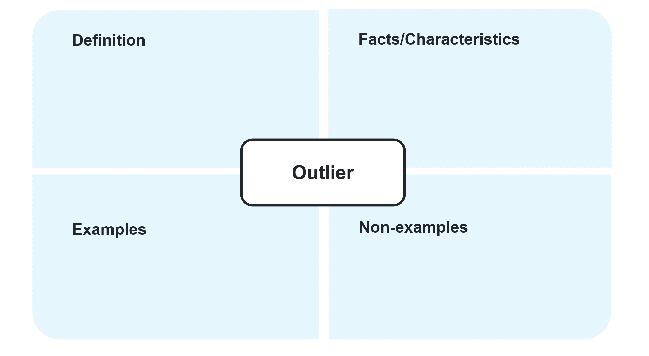

Appendix B

Workstation tasks

Task 1
A fitness coach tracked how many minutes 14 clients spent doing cardio exercises each day over a week as part of a new health program. The data shows the number of minutes each client exercised on a selected day.
23, 25, 22, 24, 21, 22, 22, 25, 19, 25, 22, 23, 21, 23
- Construct the five-number summary (minimum, $Q_{1}$, median, $Q_{3}$, maximum).
- Draw a box plot on the board.
- Calculate the outlier boundaries
- Identify any outliers.
- If there are any outliers, redraw the box plot without outliers underneath the original.
- Describe the data in context.

Task 2
As part of a ‘Healthy Habits’ program in regional NSW, 15 participants tracked how many cups of water they drank in one day. The data was displayed in a stem-and-leaf plot.
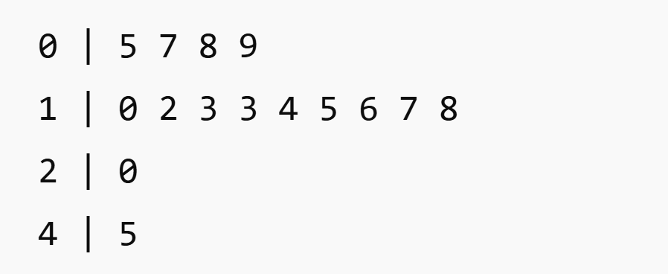
- Construct the five-number summary (minimum, $Q_{1}$, median, $Q_{3}$, maximum).
- Draw a box plot on the board.
- Calculate the outlier boundaries.
- Identify any outliers.
- If there are any outliers, redraw the box plot without outliers underneath the original.
- Compare the box plots in context.

Task 3
As part of a health awareness campaign at a high school in NSW, Year 10 students were anonymously surveyed about how many times they had vaped in the past week. Their responses are shown in the dot plot.
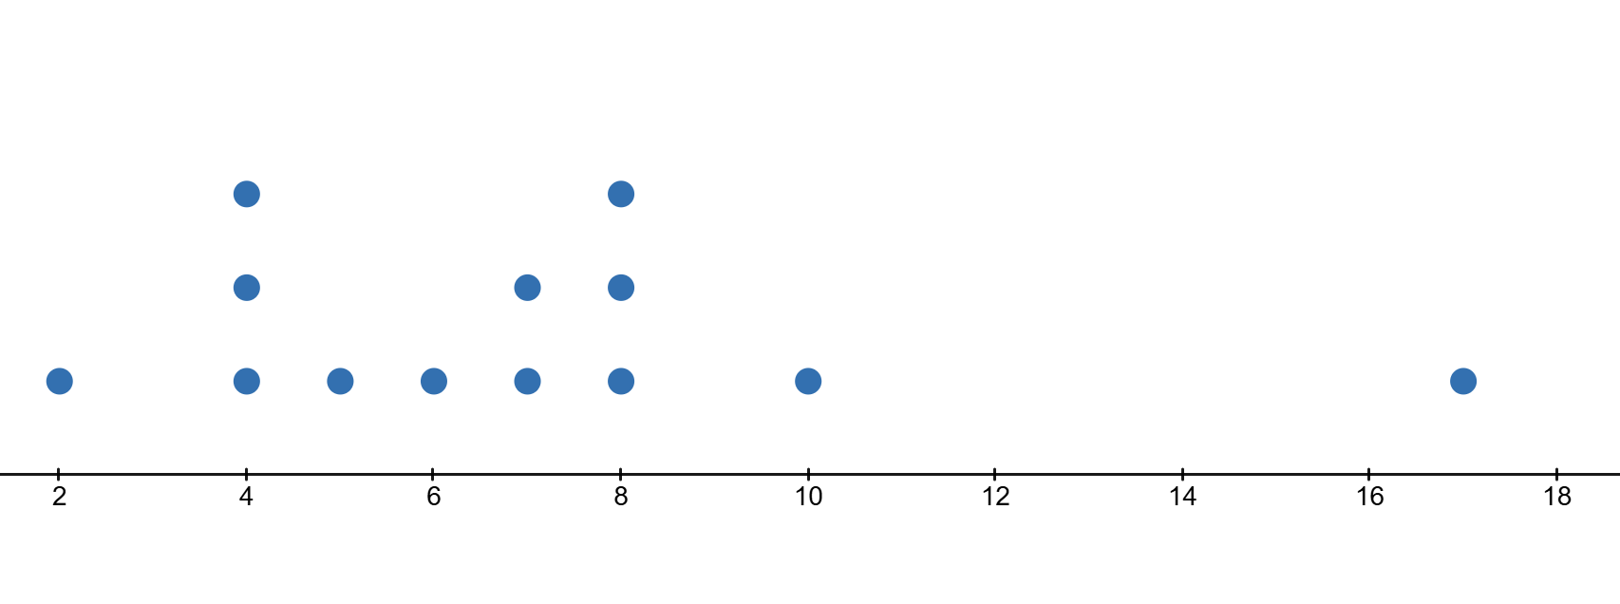
- Construct the five-number summary (minimum, $Q_{1}$, median, $Q_{3}$, maximum).
- Draw a box plot on the board.
- Calculate the outlier boundaries.
- Identify any outliers.
- If there are any outliers, redraw the box plot without outliers underneath the original.
- Compare the box plots in context.

Task 4
As part of a wellbeing survey in a regional NSW high school, Year 11 students were asked to rate, on a scale from 0–10, how confident they felt about managing stress. The scores represent students’ self-reported confidence level.
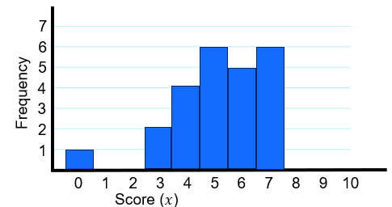
- Construct the five-number summary (minimum, $Q_{1}$, median, $Q_{3}$, maximum).
- Draw a box plot on the board.
- Calculate the outlier boundaries.
- Identify any outliers.
- If there are any outliers, redraw the box plot without outliers underneath the original.
- Compare the box plots in context.

Sample solutions

Appendix A – Frayer diagram
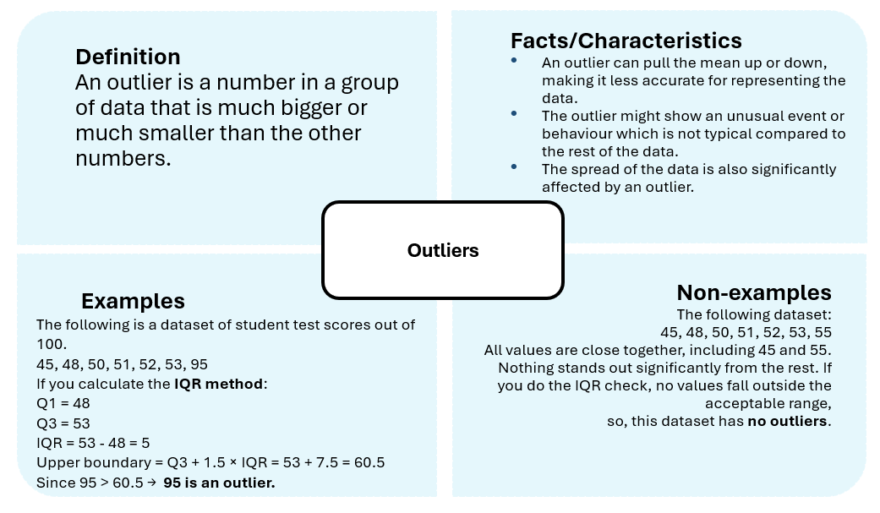

Appendix B – workstation tasks

Task 1
- Minimum = 19
$Q_{1}$= 22
Median = 22.5
$Q_{3}$ = 24
Maximum = 25
- 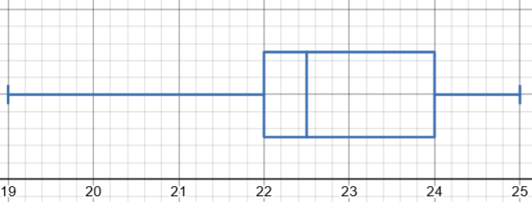
- Lower = $Q_{1} - 1.5×IQR = 22 - 3 = 19$
Upper = $Q_{3} + 1.5×IQR = 24 + 3 = 27$
- There are no outliers because no values are less than 19 or greater than 27.
- n/a.
- The clients exercised for between 19 and 25 minutes. 50% of the clients spent 22–24 minutes on cardio, showing that most clients exercised within a narrow range. No extreme outliers.

Task 2
- Minimum = 5
$Q_{1}$ = 9
Median = 13
$Q_{3}$ = 17
Maximum = 45
- 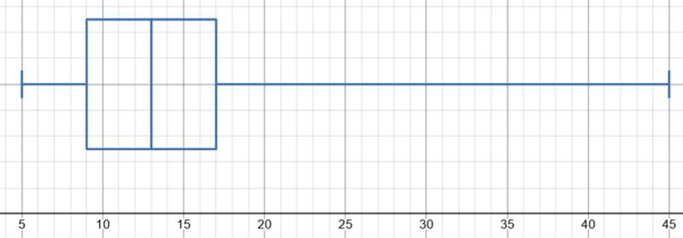
- Lower boundary = $Q_{1}-1.5×IQR=9-12=-3$
Upper boundary = $Q_{3}+1.5×IQR=17+12=29$
- 45 is an outlier because it is more than 29.
- 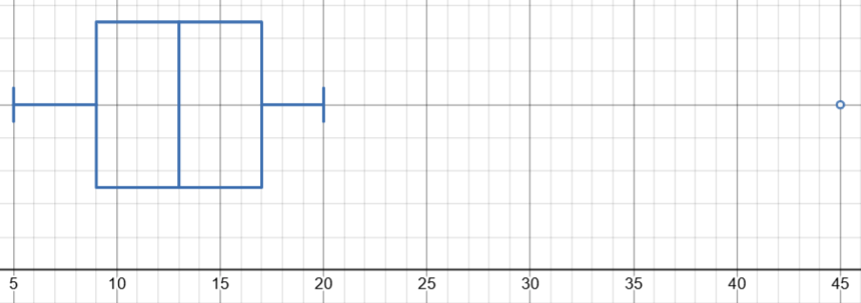
- The box plot with the outlier at 45 has a much longer right whisker and appears skewed, making the data seem more spread out. The outlier is shown as a separate dot. Without the outlier, the box plot looks more balanced and symmetric, better representing the main values between 5 and 20

Task 3
- Minimum = 2
$Q_{1}$ = 4
Median = 7
$Q_{3}$ = 8
Maximum = 17
- 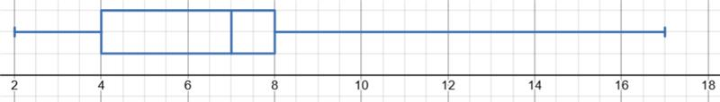
- Lower boundary =$Q_{1}-1.5×IQR=4-6=-2$Upper boundary = $Q_{3}+1.5×IQR=8+6=14$
- 17 is an outlier because it is more than 14.
- 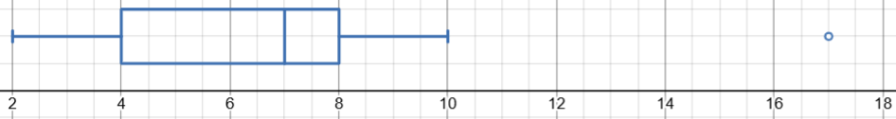
- The box plot including 17 has the same scale, however it exaggerates spread. The box plot marking 17 as an outlier, shows the bulk of data more clearly, with 17 flagged as unusual.

Task 4
- Minimum = 0
$Q_{1}$= 4
Median = 5
$Q_{3}$ = 6.5
Maximum = 7
- 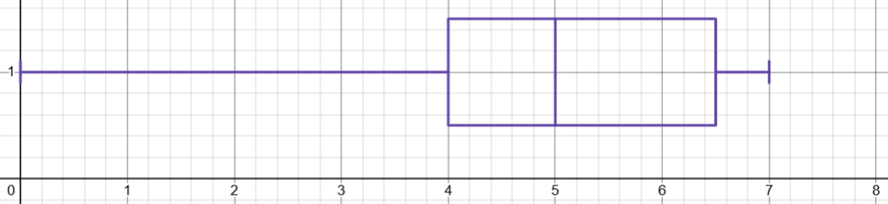
- Lower boundary =$Q_{1}-1.5×IQR=4-3.75=0.25$
Upper boundary = $Q_{3}+1.5×IQR=6.5+3.75=10.25$
- 0 is an outlier because it is less than 0.25.
- 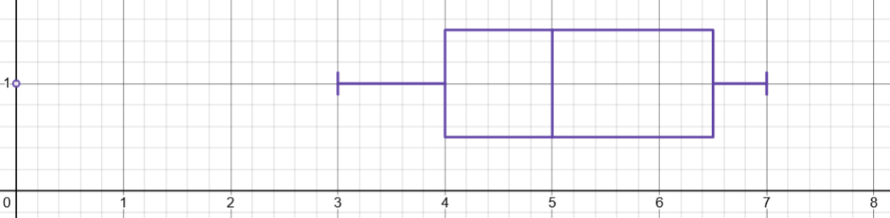
- Including the outlier (0) increases the overall range and highlights an extreme low score, but the main distribution of student confidence (3–7) is better represented when the outlier is shown separately. This shows that most students have moderate confidence, while a few may need extra support.

References
This resource contains NSW Curriculum and syllabus content. The NSW Curriculum is developed by the NSW Education Standards Authority. This content is prepared by NESA for and on behalf of the Crown in right of the State of New South Wales. The material is protected by Crown copyright.
Please refer to the NESA Copyright Disclaimer for more information https://educationstandards.nsw.edu.au/wps/portal/nesa/mini-footer/copyright.
NESA holds the only official and up-to-date versions of the NSW Curriculum and syllabus documents. Please visit the NSW Education Standards Authority (NESA) website https://educationstandards.nsw.edu.au/ and the NSW Curriculum website https://curriculum.nsw.edu.au/.
Mathematics Standard 11–12 Syllabus © NSW Education Standards Authority (NESA) for and on behalf of the Crown in right of the State of New South Wales, 2024.

© State of New South Wales (Department of Education), 2025
The copyright material published in this resource is subject to the Copyright Act 1968 (Cth) and is owned by the NSW Department of Education or, where indicated, by a party other than the NSW Department of Education (third-party material).
Copyright material available in this resource and owned by the NSW Department of Education is licensed under a Creative Commons Attribution 4.0 International (CC BY 4.0) license.

This license allows you to share and adapt the material for any purpose, even commercially.
Attribution should be given to © State of New South Wales (Department of Education), 2025.
Material in this resource not available under a Creative Commons license:
- the NSW Department of Education logo, other logos and trademark-protected material
- material owned by a third party that has been reproduced with permission. You will need to obtain permission from the third party to reuse its material.
Links to third-party material and websites
Please note that the provided (reading/viewing material/list/links/texts) are a suggestion only and implies no endorsement, by the New South Wales Department of Education, of any author, publisher, or book title. School principals and teachers are best placed to assess the suitability of resources that would complement the curriculum and reflect the needs and interests of their students.
If you use the links provided in this document to access a third-party's website, you acknowledge that the terms of use, including licence terms set out on the third-party's website apply to the use which may be made of the materials on that third-party website or where permitted by the Copyright Act 1968 (Cth). The department accepts no responsibility for content on third-party websites.

