Least-squares regression line
Students learn how to determine the equation of the least-squares regression line using a scientific calculator.
Students will need at least one digital device per pair to interact with a GeoGebra applet during this lesson.

Learning intention
- To be able to determine the equation of a least-squares regression line.

Success criteria
- I can explain how to find the least-squares regression line.
- I can input data into my scientific calculator.
- I can identify what $A$ and $B$ represent in the equation of the least-squares regression line.
- I can determine the equation of the least-squares regression line for a bivariate dataset using a calculator.

Outcomes

Mathematics Standard 2 outcomes
A student:
- develops understanding and fluency in mathematics through exploring and connecting mathematical concepts, choosing and applying mathematical techniques to solve problems, and communicating their thinking and reasoning coherently and clearly MAO-WM-01
- analyses bivariate datasets using statistical processes MST-12-S2-08

Associated Mathematics Standard 1 outcomes
A student:
- develops understanding and fluency in mathematics through exploring and connecting mathematical concepts, choosing and applying mathematical techniques to solve problems, and communicating their thinking and reasoning coherently and clearly MAO-WM-01
- displays and interprets bivariate datasets to solve problems and make predictions
MST-12-S1-06
Mathematics Standard 11–12 Syllabus © NSW Education Standards Authority (NESA) for and on behalf of the Crown in right of the State of New South Wales, 2024.

Associated Numeracy outcomes
A student:
- recognises and applies functional numeracy concepts in practical situations, including personal and community, workplace and employment, and education and training contexts
N6-1.1
- applies numerical reasoning and mathematical thinking to clarify, efficiently solve and communicate solutions to problems N6-1.2
- determines whether an estimate or an answer is reasonable in the context of a problem, evaluates results and communicates conclusions N6-1.3
- chooses and applies appropriate operations with whole numbers, familiar fractions and decimals, percentages, rates and ratios to analyse and solve everyday problems N6-2.1
- chooses and applies efficient strategies to analyse and solve everyday problems involving data, graphs, tables, statistics and probability N6-2.3
- chooses and uses appropriate technology to analyse and solve problems, represent information and communicate solutions in a range of practical contexts N6-3.2
Numeracy Stage 6 (CEC) Syllabus © NSW Education Standards Authority (NESA) for and on behalf of the Crown in right of the State of New South Wales, 2021.

Content

Mathematics Standard 2

Scatter plots and lines of best fit
- Determine the equation of the least-squares regression line for a bivariate dataset using a scientific calculator
Mathematics Standard 11–12 Syllabus © NSW Education Standards Authority (NESA) for and on behalf of the Crown in right of the State of New South Wales, 2024.

Table 1: lesson summary
Section | Summary of activity | Teaching strategies | Teaching points
Activating prior knowledge | Students analyse scatter plots in Appendix A and determine the equation of each of the 3 lines of best fit. They justify the suitability of each line of best fit and identify which one best represents the dataset, explaining why. | Pose-Pause-Pounce-Bounce  Think-Pair-Share | Emphasise informal reasoning about lines of best fit and the relationship between variables, recognising that initial judgements are based on visual interpretation rather than formal methods.
Connecting learning | Students use slides 4–5 and the GeoGebra applet (https://bit.ly/GeogebraLeast-squares) to explore minimising the sum of squares, then calculate the least-squares regression line using a scientific calculator and compare it with Appendix A. | Think-Pair-Share  Pose-Pause-Pounce-Bounce | The aim is to develop an understanding that the least-squares regression line minimises the sum of squared residuals and that technology can be used to determine its equation and interpret the gradient and intercept in context.
Releasing responsibility | Students use slide 7 of the PowerPoint Least-squares regression line to interpret calculator outputs, justify why the least-squares regression line is more accurate than visual estimation, and record notes on determining and interpreting the least-squares regression line. | Pose-Pause-Pounce-Bounce  Notes to future forgetful selves | Reinforce the objectivity and reliability of least-squares regression and the interpretation of parameters, supporting students to check reasonableness and connect algebraic results to graphical representations.
Independent practice | Students complete Appendix B using the Approaching questions scaffold, then compare and justify their solutions using key terminology. | Pose-Pause-Pounce-Bounce | The focus is on applying least-squares regression techniques and interpreting results in context, using appropriate statistical language to justify solutions.

Activity structure
Please use the associated PowerPoint Least-squares regression line to display images in this lesson.

Activating prior knowledge
- Pose the following scenario to students:
Influencers want to gain as many followers as possible to be able to receive work and endorsements. We want to see if influencers who follow more accounts gain more followers themselves.
- Distribute Appendix A ‘Lines of best fit for influencers’.
- In a Think-Pair-Share (bit.ly/thinkpairsharestrategy) ask students to interpret the 3 scatter plots and discuss:
- What happens as the number of accounts followed by an influencer increases?
- Is it what we would expect?
- In pairs, have students determine the equation for each line of best fit for the 3 scatter plots.
Students will refer to these equations later in the lesson.

Connecting learning
- Still referring to Appendix A, use the Pose-Pause-Pounce-Bounce questioning strategy (PDF 557KB) (bit.ly/posepausepouncebounce) to ask students to justify which line of best fit would make the best prediction using the data provided.
Students are not expected to know which line gives the best predictions at this point but may discuss the placement of the line of best fit. This discussion is for students to reflect on the best placement for the line of best fit.
- With at least one device between pairs of students, have students navigate to the GeoGebra applet ‘Least-squares regression line’ (https://bit.ly/GeogebraLeast-squares).
- Students follow the instructions on the applet to construct a line of best fit by selecting and dragging the Drag Me! points.
- Ask students to select Show squares and adjust the line of best fit, paying close attention to the blue squares, as well as the ‘Sum of Squares =’ in the top left-hand corner.
- Use the Pose-Pause-Pounce-Bounce questioning strategy to discuss the change in the line of best fit in relation to the squares displayed and the ‘Sum of Squares’. Some suggested prompts include:
- How do the squares change as the line of best fit is adjusted?
- What do you notice about the position of the vertices of each square?
- What happens to the ‘Sum of Squares’ as the squares become smaller?
- When looking at the ‘Sum of Squares’, what value do you think indicates a good line of best fit?
Students should recognise that each square represents the vertical distance between a data point and the line of best fit. As the line is adjusted closer to the data, the squares become smaller and the ‘Sum of Squares’ decreases. The smallest value for the sum of squares indicates the most accurate line of best fit.
- Ask students to select Show regression line to display the line of best fit that minimises the sum of the area of the squares, known as the ‘least-squares regression line’. Have them compare it to the line they created.
- Initiate a class discussion to again consider what the term ‘least-squares’ refers to.
Students should explain that it refers to the smallest total area of the squares formed by the vertical distances between the line and the data points on the scatter plot.
Students are not expected to know how the equation of the least-squares regression line is calculated mathematically but are required to know how to find it using a scientific calculator.

Releasing responsibility
- Explain to students that their calculator can find the equation of the least-squares regression line.
- Display slide 4 which shows the dataset used to create scatter plots in Appendix A.
- Ask students to enter the dataset into their calculators.
Students learnt how to enter datasets into their calculators in Lesson 4 – Pearson’s correlation coefficient.
- Display slide 5 which shows the equation of a line and the equation used for finding the least-squares regression line on a scientific calculator. Ask students to compare the 2, relating the variables $m, c, A$ and $B$.
Students should recognise that $B$ is the gradient as it is the coefficient of $x$and $A$ is the $y$-intercept as it is the constant. Some calculators use lowercase $a$ and $b$, so adjust the slide depending on the calculator model your students use.
- Explicitly show students how to find the values of $A$ and $B$ using their scientific calculators.
It is advised that teachers refer to the instruction manuals of the scientific calculators owned by students in their class.
- Once students have found the values of $A$ and $B$, have them find the equation of the least-squares regression line. This can be animated on slide 5.
- Have students return to Appendix A and compare the equation of the least-squares regression line with the equations of the lines of best fit they previously determined. Students should identify which equation most closely matches the least-squares regression line and justify their choice based on how well it represents the overall trend in the data.
- Use the Pose-Pause-Pounce-Bounce questioning strategy to discuss why the equation of the least-squares regression line is more accurate than fitting a line of best fit by eye.
A least-squares regression line is more accurate because it is calculated to minimise the total squared differences between the data points and the line, rather than relying on visual judgement. Unlike a line of best fit by eye, which relies on visual judgement and may differ from person to person, the least squares regression line is consistent and uses all data points to produce the most reliable model.
- Display slide 7 which shows a student who has found the values of $A$ and $B$ for a set of data.
- In a Think-Pair-Share ask students how they may know which value represents the gradient and which the $y$-intercept, given the data and values provided on the screen.
Students should do a check for reasonableness (bit.ly/checkreasonableness). The $y$-intercept should be a value that is reasonable in the context of the dependent variable and consistent with where the line crosses the $y$-axis on the graph. Students could create a sketch of the graph including the least-squares regression line to reflect on their values as well.
- Have students write notes to their future forgetful selves (bit.ly/notestofutureself). Some suggested prompts include:
- What is the least-squares regression line?
- How do you find the equation of the least-squares regression line using your calculator?
- What do the pronumerals $A$ and $B$ represent in the equation displayed on your calculator?
- Using an existing resource, have students practise finding the equation of the least-squares regression line using their scientific calculators.

Independent practice
- Distribute Appendix B ‘HSC-style questions’ to each student to complete.
- Have students compare their solutions with a partner, making corrections if needed after discussing.

Assessment and differentiation

Suggested opportunities for differentiation
Activating prior knowledge
- To support students, the first scatter plot can have the working shown to the find the equation of the line of best.
Connecting learning
- Students may benefit from a visual demonstration of the GeoGebra applet before completing the activity.
- Extend students by asking them to explain why minimising squared distances results in the best line of fit.
Releasing responsibility
- Provide a checklist or scaffold for using calculators to find $A$and $B$.
Independent practice
- Prompt students to identify key information before solving.
- Extend students by asking them to critique the reliability of predictions, including consideration of extrapolation.
- Students learning English as an additional language or dialect (EAL/D) may benefit from a keyword glossary when answering questions in Appendix B.

Standard 1 Mathematics adjustments and considerations
Mathematics Standard 1 students do not need to complete any work on the least-squares regression line. As this is the basis of this lesson, this lesson could be removed if you have a standalone Mathematics Standard 1 class.
Alternatively, if you have a combined Mathematics Standard 1 and 2 class, you could modify this lesson for Mathematics Standard 1 students to allow them to complete further work on creating a line of best fit by eye and with digital tools and examine lines of best fit to make predictions and recognise limitations of interpolation and extrapolation.

Suggested opportunities for assessment
Activating prior knowledge
- Observe student discussions to assess their ability to describe trends and variability in scatterplots.
- Ask students to justify their choice of “best” line to assess reasoning about fit.
- Monitor student responses to identify misconceptions about linear relationships.
Connecting learning
- Observe how students manipulate the GeoGebra applet to assess understanding of the sum of squares.
- Ask students to explain “least-squares” to assess conceptual understanding.
- Question why a smaller sum indicates a better fit to assess reasoning.
Releasing responsibility
- Observe students using calculators to assess accuracy in determining regression coefficients.
- Ask students to identify gradient and intercept to assess understanding of linear models.
- Review reasoning checks (for example, comparing the intercept to data) to assess interpretation.
Independent practice
- Review HSC-style responses to assess ability to calculate and apply regression lines.
- Assess use of appropriate mathematical language when interpreting equations.
- Evaluate predictions to assess understanding of validity and limitations.

Appendix A

Lines of best fit for influencers
Determine the equation of the line of best fit for each of the scatter plots.

Scatter plot 1
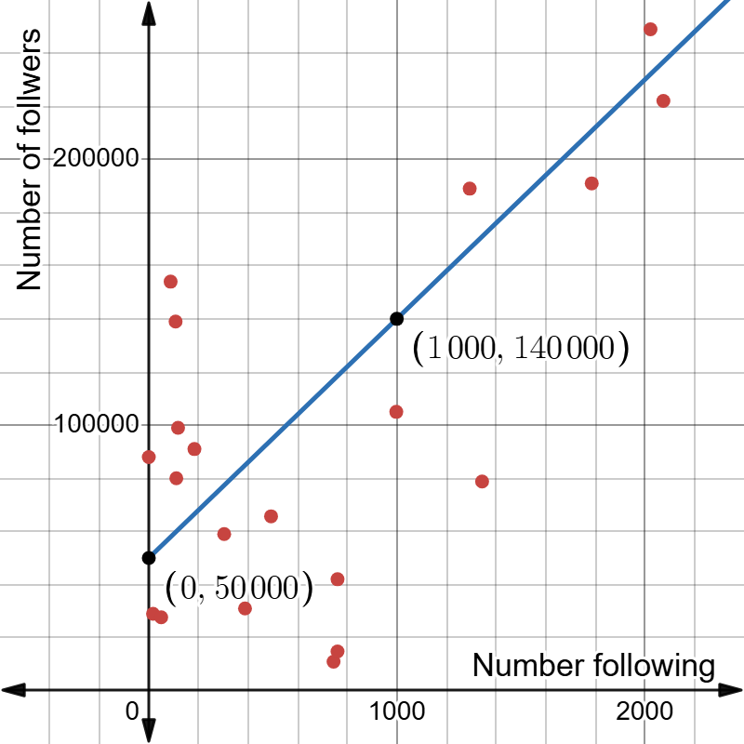

Scatter plot 2
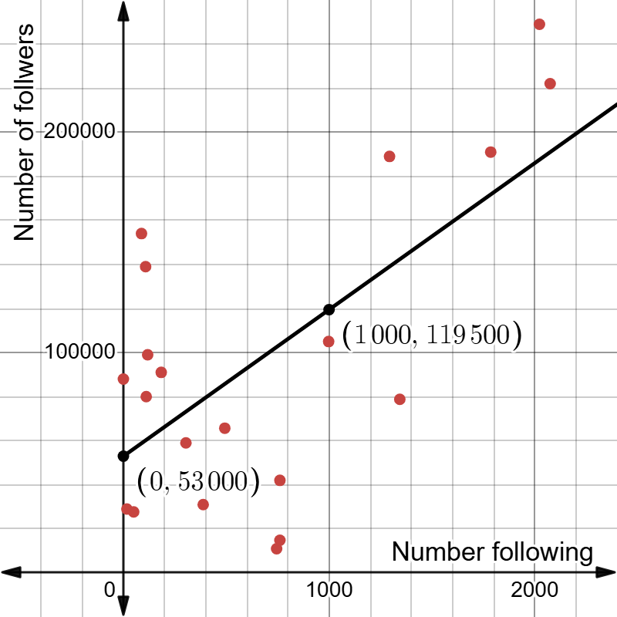

Scatter plot 3
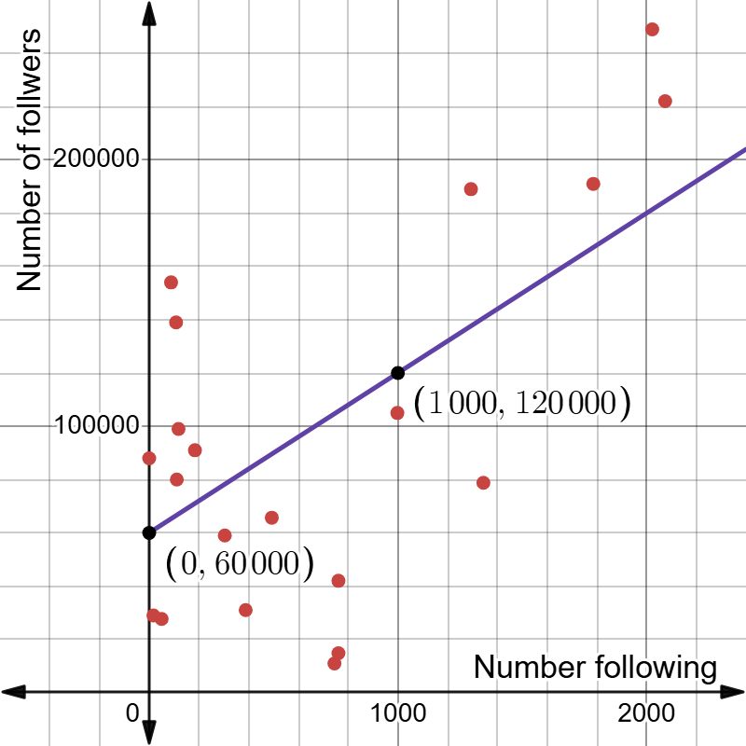

Appendix B

HSC-style questions
Question 1
A set of bivariate data is collected by measuring the dosage amount and time for recovery of 7 patients. The graph shows the scatter plot of these measurements.
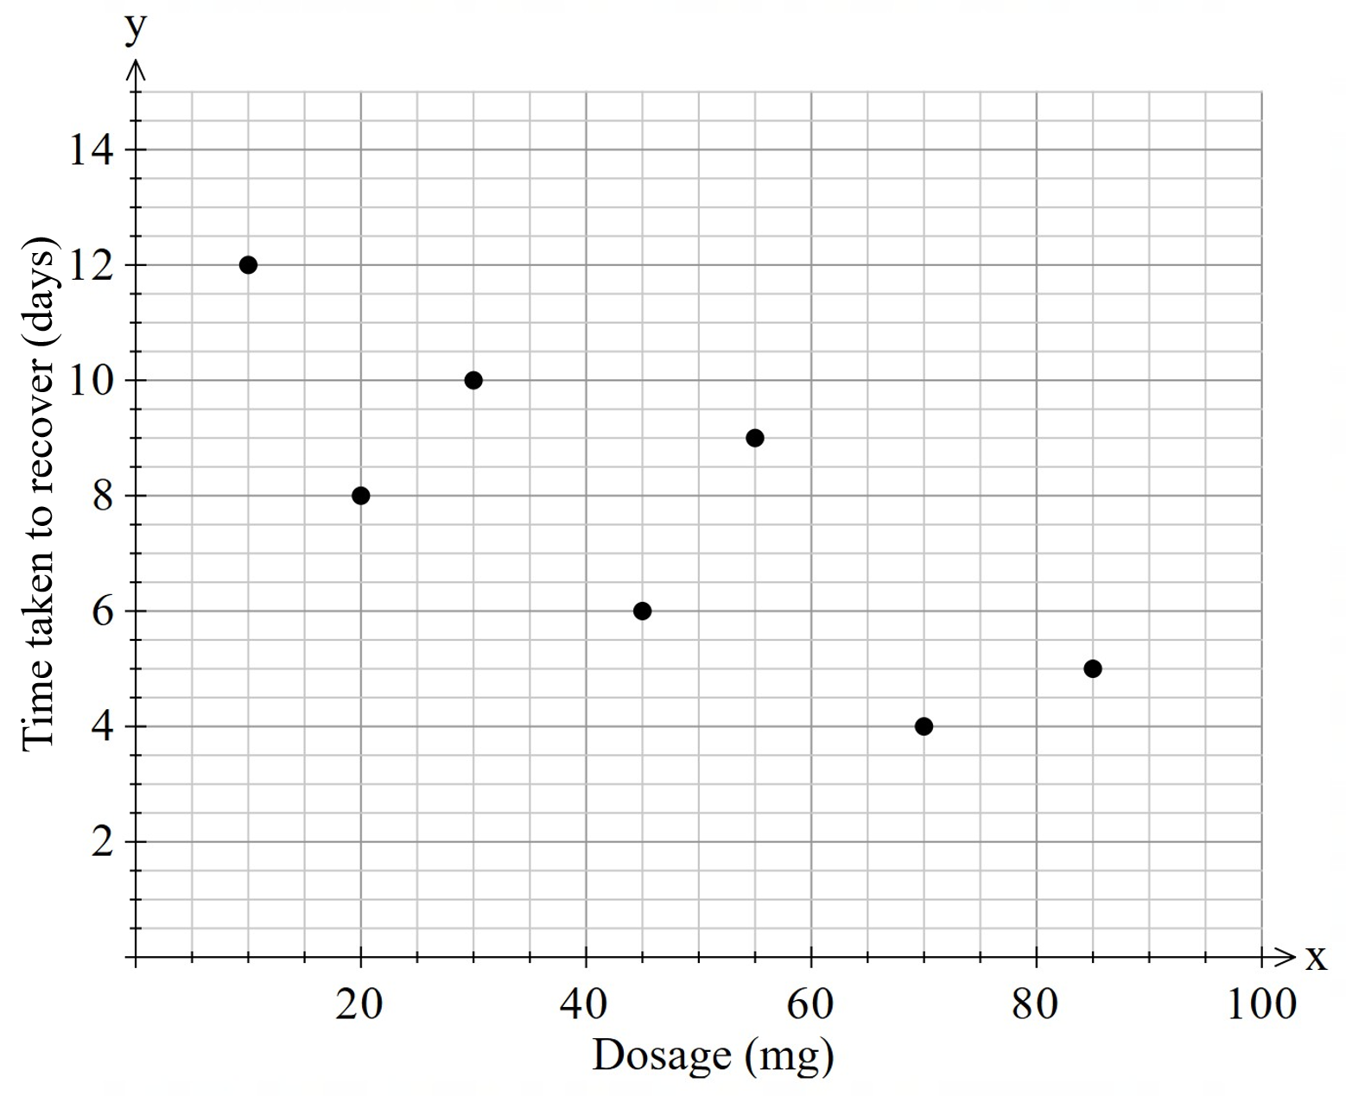
- Calculate the Pearson’s correlation coefficient for this data, correct to 2 decimal places.
- Identify the direction and strength of the linear association between dosage and recovery time.
- Find the equation of the least-squares regression line. The gradient and $y$-intercept should be correct to 2 decimal places.
- Using the equation of the least-squares regression line, calculate the predicted recovery time in days for a person whose dosage rate is 40 mg.

Question 2
A teacher surveyed the students in her Year 12 class to investigate the relationship between the distance travelled to school and the time taken to get to school.
The results for 5 students are shown on the scatter plot with the least-squares regression line.
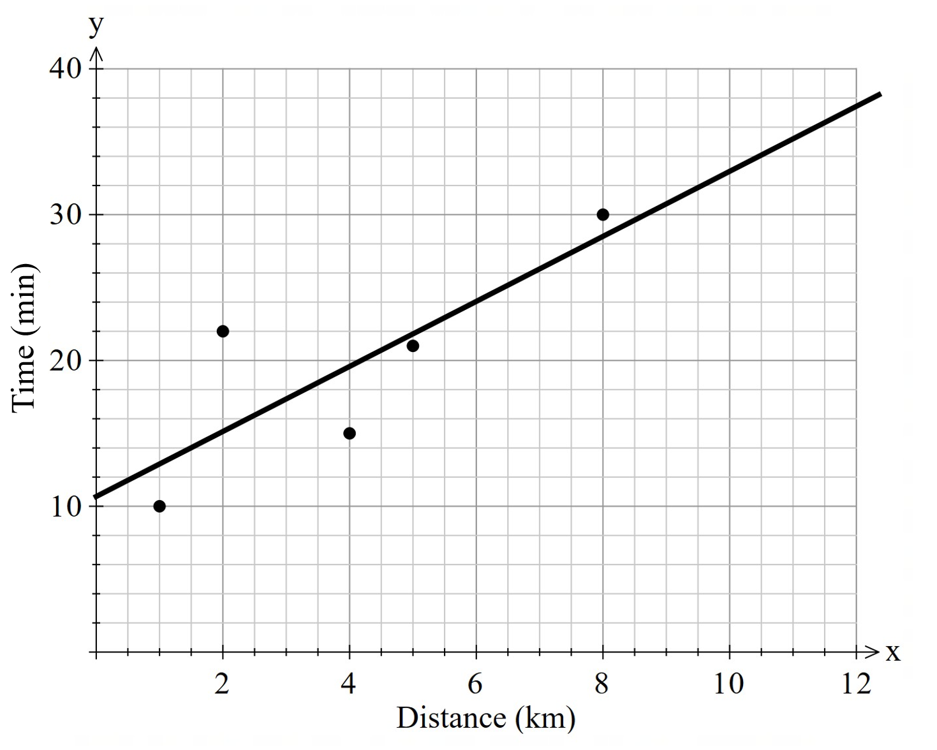
- Calculate Pearson’s correlation coefficient ($r$), correct to 4 decimal places. Use this to describe the relationship between the distance travelled to school and the time taken to get to school.
- Determine the equation of the least-squares regression line.
- From the data, the median distance to get to school, $a$, and the median time taken to get to school, $b$, are calculated.
By finding the coordinate ($a,b$), determine whether this point would lie on, below or above the least-squares regression line.

Sample solutions

Appendix A – lines of best fit for influencers
The following are sample solutions. Other equations of a line within a similar range could still be deemed correct, with a focus on students’ working out.
- Scatter plot 1: $y=90x+50 000$
- Scatter plot 2: $y=66.5x+53 000$
- Scatter plot 3: $y=60x+60 000$

Appendix B – HSC-style questions
Question 1
- $-0.81$
- Negative direction and a strong association.
- $y=11.60-0.09x$
- 8 days.
Question 2
- 0.81, which shows a strong, positive linear association.
- $y=2.23x+10.67$
- Median distance = 4 km
Median time = 22 mins
The point $(4, 22)$ would sit above the least-squares regression line.

References
This resource contains NSW Curriculum and syllabus content. The NSW Curriculum is developed by the NSW Education Standards Authority (NESA). This content is prepared by NESA for and on behalf of the Crown in right of the State of New South Wales. The material is protected by Crown copyright.
Please refer to the NESA Copyright Disclaimer for more information https://www.nsw.gov.au/education-and-training/nesa/copyright.
NESA holds the only official and up-to-date versions of the NSW Curriculum and syllabus documents. Please visit NESA https://www.nsw.gov.au/education-and-training/nesa/copyright and NSW Curriculum https://curriculum.nsw.edu.au.
Mathematics Standard 11–12 Syllabus © NSW Education Standards Authority (NESA) for and on behalf of the Crown in right of the State of New South Wales, 2024.
Numeracy Stage 6 (CEC) Syllabus © NSW Education Standards Authority (NESA) for and on behalf of the Crown in right of the State of New South Wales, 2021.

© State of New South Wales (Department of Education), 2026
The copyright material published in this resource is subject to the Copyright Act 1968 (Cth) and is owned by the NSW Department of Education or, where indicated, by a party other than the NSW Department of Education (third-party material).
Copyright material available in this resource and owned by the NSW Department of Education is licensed under a Creative Commons Attribution 4.0 International (CC BY 4.0) license.

This license allows you to share and adapt the material for any purpose, even commercially. Attribution should be given to © State of New South Wales (Department of Education), 2026.
Material in this resource not available under a Creative Commons license:
- the NSW Department of Education logo, other logos and trademark-protected material
- material owned by a third party that has been reproduced with permission. You will need to obtain permission from the third party to reuse its material.
Links to third-party material and websites
Please note that the provided (reading/viewing material/list/links/texts) are a suggestion only and implies no endorsement, by the New South Wales Department of Education, of any author, publisher, or book title. School principals and teachers are best placed to assess the suitability of resources that would complement the curriculum and reflect the needs and interests of their students.
If you use the links provided in this document to access a third-party's website, you acknowledge that the terms of use, including licence terms set out on the third-party's website apply to the use which may be made of the materials on that third-party website or where permitted by the Copyright Act 1968 (Cth). The department accepts no responsibility for content on third-party websites.

