Interpreting box plots
Students revisit how to display and interpret box plots, referring to the five-number summary and spread. Through discussion and comparison of parallel box plots, they consider what the graphs reveal about data distribution and make inferences about the data.

Learning intentions
- To understand how to compare the use of range and interquartile range (IQR) as measures of spread.
- To be able to interpret box plots to make conclusions and inferences about a dataset within a given context.

Success criteria
- I can find the IQR of a given dataset.
- I can explain when the range or the IQR is more appropriate to describe the spread of the data.
- I can make inferences about data from parallel box plots.
- I can compare 2 or more datasets using IQR, range, and box plots to justify conclusions about variability.

Outcomes
A student:
- develops understanding and fluency in mathematics through exploring and connecting mathematical concepts, choosing and applying mathematical techniques to solve problems, and communicating their thinking and reasoning coherently and clearly MAO-WM-01
- displays and analyses datasets using summary statistics and graphical representations
MST-11-08

Content

Quartiles and interquartile range
- Determine the interquartile range (IQR) of datasets
- Compare and contrast the use of range and IQR as measures of spread

Five-number summary and box plots
- Compare and contrast the measures of centre, spread and shape using parallel box plots
- Interpret box plots to draw conclusions and make inferences about a dataset
- Represent numerical datasets using a box plot to display a five-number summary, with and without using digital tools
Mathematics Standard 11–12 Syllabus © NSW Education Standards Authority (NESA) for and on behalf of the Crown in right of the State of New South Wales, 2024.

Table 1: lesson summary table
Section | Summary of activity | Teaching strategies | Teaching points
Activating prior knowledge | Display slide 5 of the PowerPoint Interpreting box plots and distribute Appendix A for students to complete. Students will compare and discuss their observations with peers. In groups, students generate possible datasets from the five-number summary and observe how different datasets can be represented using the same box plot. | Visibly random groups of 3  Vertical non-permanent surfaces  Pose-Pause-Pounce-Bounce | Students consolidate their understanding of box plot features, measures of centre and spread by creating and comparing datasets that satisfy the same five-number summary and visual representation.
Connecting learning | Distribute Appendix B, where students make inferences from parallel box plots in the context of sleep data. Students watch the video ‘Creating a Boxplot on Desmos ‘(1:54) (bit.ly/DesmosBoxPlots) before creating parallel box plots using the Desmos Graphing ‘Sleep data’ (bit.ly/SleepDesmos). Students then construct and compare box plots from datasets shown on slide 7. | Think-Pair-Share  Pose-Pause-Pounce-Bounce | Students strengthen their understanding of how box plots represent spread and distribution, recognise the limitations of range compared to IQR and median, and practise interpreting real-world data by making and justifying inferences.
Releasing responsibility | Use slide 9 for students to work in pairs to determine which of 3 statements is a lie. They will then create their own ‘Two truths and a lie’ about box plots to challenge their peers before they summarise their findings by writing notes to their future forgetful selves. | Two truths and a lie  Notes to future forgetful selves | Students developed a deeper understanding of how dataset changes affect medians and spreads, practised justifying and critiquing interpretations of box plots, and consolidated their knowledge by creating examples and making personal learning notes.
Independent practice | Use slide 11 to put students into the role of a personal trainer analysing Julie’s 5 km running data, noticing trends such as decreasing median times and increasing consistency. In new groups, they complete Appendix C by matching box plots to description cards and annotating their reasoning with evidence from the data. | Visibly random groups of 3  Gallery walk | Students developed skills in interpreting changes in box plots, considered limitations of data, and practised explaining and justifying their reasoning when comparing datasets.

Activity structure
Please use the associated PowerPoint Interpreting box plots to display images in this lesson.

Activating prior knowledge
- Display slide 4 of the PowerPoint which shows the statistical investigation process. Explain that in this lesson we will be focusing on stage 4 and 5 of the process.
- Assign students to visibly random groups of 3 (bit.ly/visiblegroups) at vertical non-permanent surfaces (bit.ly/VNPSstrategy).
- Distribute Appendix A ‘Creating datasets’. Explain to students that they will be comparing 3 different box plots representing sleep data for different groups of people. Explain that they are to write the five-number summary for each box plot and then answer the questions below each box plot.
Slide 5 includes a copy of dataset (1) that you can use to model the task for your class. These skills are revisited from Stage 5 Data analysis A outcome MA5-DAT-C-01.
- The final question in each of the 3 datasets has students create a dataset that fits the box plot and matches the five-number summary. As groups finish each task, have them compare their datasets with at least one other group.
Students should notice that different sets of data can satisfy the same five-number summary.
- Once the majority of groups have finished the 3 tasks, use the Pose-Pause-Pounce-Bounce questioning strategy (PDF 557 KB) (bit.ly/posepausepouncebounce) to facilitate a class discussion around how 2 different datasets can have the same five-number summary and therefore the same box plot. Suggested prompt questions include:
- Were all your datasets the same? Why or why not?
- How could 2 datasets look different in a dot plot or histogram even though their box plots are identical?
- What does this tell us about the strengths of box plots? What about their limitations?

Connecting learning
- Distribute Appendix B ‘Comparing datasets’ to pairs of students. Students will make inferences about the parallel box plots.
- Use a Pose-Pause-Pounce-Bounce questioning strategy to discuss student responses to the questions in Appendix B.
- Explain to students that they will now compare further groups and their sleep habits.
- Show students the video ‘Creating a Boxplot on Desmos’ (1:54) (bit.ly/DesmosBoxPlots) up to 1:27.
- Distribute one laptop per pair of students.
- Explain that students from Year 9 to Year 12 were asked how many hours they slept last night.
- Share the Desmos Graphing calculator activity ‘Sleep data’ (bit.ly/SleepDesmos) which records the data collected and instruct students to create parallel box plots using the skills demonstrated in the video. Dataset W represents Year 9, X represents Year 10, Y represents Year 11 and Z represents Year 12.
Students may need to be told to click the Zoom Fit button on the left of the screen to see their box plot. It has the appearance of a magnifying glass. Students will need to Offset boxplots so that they do not appear on top of each other. For example, an Offset of 3 will translate the boxplot 3 units above the $x$-axis.
Figure 1: Zoom Fit button and Offset on Desmos
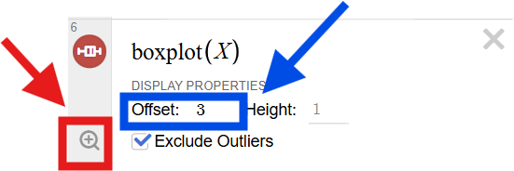
Image created using Desmos and is licensed under the Desmos Terms of Service.
Alternatively, students may use GeoGebra to create stacked boxplots using multiple variable analysis and following a similar process to that used to create histograms in Lesson 4 – cumulative frequency.
Figure 2: multiple boxplots drawn in Desmos using the Offset feature
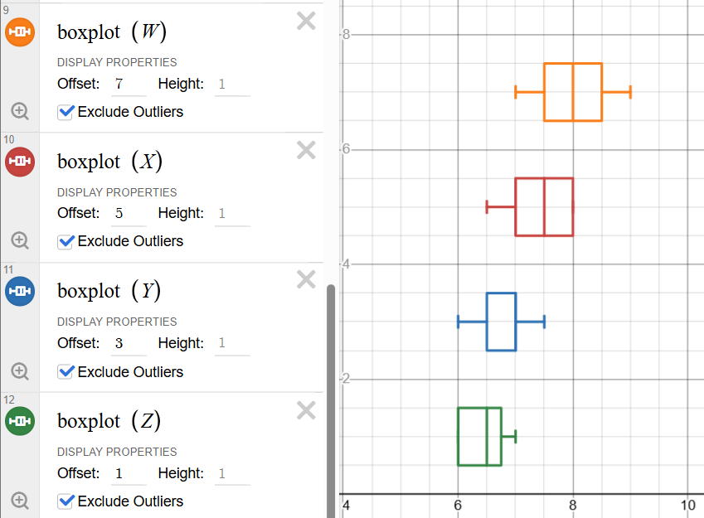
Image created using Desmos and is licensed under the Desmos Terms of Service.
- In a Think-Pair-Share (bit.ly/thinkpairsharestrategy), ask students to answer the following questions:
- How does sleep change across year levels?
- What do the median and spread tell us about each group?
- Display slide 7 of the PowerPoint and ask students to construct 3 box plots to represent the datasets given. The teacher should advise students to construct their 3 box plots on top of each other using the same scale so they can easily distinguish their similarities and differences.

Figure 3: boxplots of the data shown on slide 7
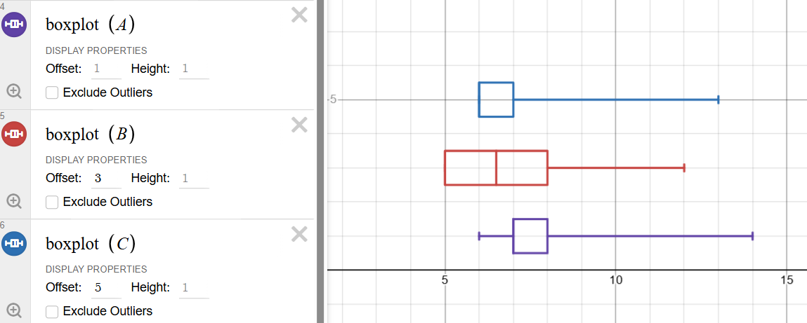
Image created using Desmos and is licensed under the Desmos Terms of Service.
- Use the Pose-Pause-Pounce-Bounce questioning strategy to initiate a class discussion. Ask the question: Looking at the 3 box plots, what can you tell me about how their spreads and medians compare, and how might these differences in distribution relate to sleep?
- Extend the class discussion by asking: If all the ranges were the same, why might comparing only the range be misleading?
The teacher should encourage students to conclude that range alone doesn’t show distribution, rather the IQR and median is needed for a better picture.

Releasing responsibility
- Display slide 9 of the PowerPoint, which shows a ‘Two truths and a lie’ (bit.ly/twotruthsoneliestrategy).
- Continuing to work in their pairs, ask students to discuss each case and decide which statement is a lie.
Students should establish that the lie is statement number 3.
- Ask pairs to create their own ‘Two truths and a lie’ on the topic of ‘Interpreting box plots’. Students should draw their own parallel box plots and then create their 3 statements.
Students may choose to use single box plots or parallel box plots.
- Students are to challenge a neighbouring pair to decide which one is their lie and why it is a lie. If this answer is different from the one intended by the writers, have each pair explain why they felt their statement was a lie.
Time permitting, pairs could continue to challenge other pairs and a competition could be held to determine which lie was the hardest to detect.
- Students are to create notes to their future forgetful selves (bit.ly/notestofutureself) on constructing and interpreting box plots. Students should also record things to consider when comparing data represented in box plots.

Independent practice
- Assign students to new visibly random groups of 3 at vertical non-permanent surfaces.
- Display slide 11 and read the following scenario to students.
Imagine you are a personal trainer, and a new client (Julie) has come to you with data of her 5 km runs. Analyse Julie’s data and provide insights and advice for her running progress.
- Ask students to specifically compare the median and spread, interpreting them in the context of the scenario. Students may need to be prompted to consider what may be missing from the data shown.
Students may notice that Julie’s median running time is decreasing and that she is becoming more consistent (the range and interquartile range have both shrunk since 2020). Students may also notice that the data does not include how often Julie runs or what her time data looks like in 2025.
- Distribute Appendix C ‘5 km running app matching activity’ to each group with adhesive putty. Ask the groups to match the sets of box plots representing 5 km running times over the years to the descriptions on the cards.
The teacher should cut out the matching activity before distributing it to students. The items are already arranged in their correct pairs.
- Instruct groups to annotate their matches with aspects of the data they used to help make their inferences.
- Students complete a gallery walk (bit.ly/DLSgallerywalk) and observe if there are any similarities or differences between the cards.
- Ask groups to discuss which cards were easier to match and which cards were harder to match and why.
The teacher should randomly select groups to share their insights with the class.

Assessment and differentiation

Suggested opportunities for differentiation
Activating prior knowledge
- Support students by providing a partially completed example of a box plot with annotated features.
- Challenge students by getting them to critique how well box plots communicate spread compared with histograms or dot plots.
- If students require more scaffolding, the teacher may ask them to begin by first writing down the following
- the minimum value
- the lower quartile ($Q_{1}$)
- the median
- the upper quartile ($Q_{3}$)
- the maximum value.
Connecting learning
- Support students to deepen their thinking in the Pose-Pause-Pounce-Bounce questioning by asking the following prompts
- Can you explain how the middle 50% of data compares across the box plots?
- What does the position of the median tell us about the data in each case?
- How might these differences affect the way we interpret sleep patterns in real life?
Releasing responsibility
- Support students with their notes to future forgetful selves by supplying them with headings such as definition, what it shows, how to find quartiles, range versus IQR, and so on.
- Challenge students with their notes to future forgetful selves by ensuring they write about how to compare different statistical values across parallel box plots.
Independent practice
- Support students by providing them with sentence starters to analyse the scenario.
- Challenge students by asking them to consider the missing information and critique the limitations of inferences.
- Challenge students with Appendix C by asking students ‘If you only had the median values, what important information would you miss?’

Suggested opportunities for assessment
Activating prior knowledge
- Circulate the room with a simple checklist and note if students can
- identify key features of a box plot
- use statistical vocabulary accurately.
- Observe which students were able to make the connection between data and the context.
Connecting learning
- Observe the box plots drawn for the activity on slide 6 to review students’ ability to correctly show medians and use an appropriate scale.
- During the ‘Comparing datasets’ activity, listen for whether peer critiques include mathematical reasoning.
Releasing responsibility
- Listen to student discussions for understanding and appropriate use of terminology as they determine which statement is a lie.
- Collect notes to future selves to assess clarity, completeness and use of vocabulary.
Independent practice
- Check group responses to the matching activity. For example, do they highlight specific features (median, IQR, range) or have they used vague statements, such as ‘looks better’?
- Include an exit ticket that checks understanding of the content points and student confidence of the concepts.

Appendix A

Creating datasets (1)
Step 1: on your vertical non-permanent surface, write the five-number summary for the following box plot:
Group 1 − Average sleep per day
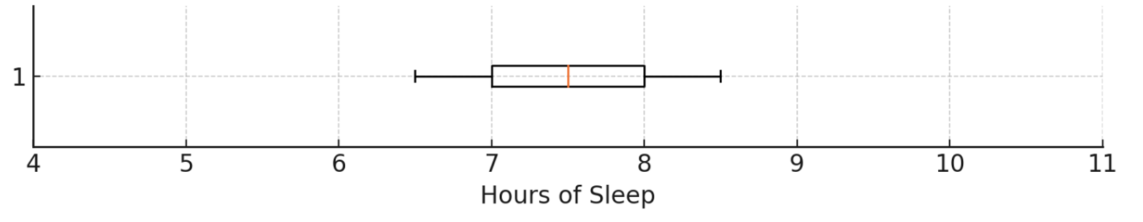
Step 2: answer these questions:
- What is the range of your dataset?
- What is the IQR of your dataset?
- Which measure (range or IQR) better describes the spread? Why?
- Write one ‘75% of people …’ and one ‘25% of people …’ statement from your data.
Step 3: create a set of 10–12 numbers that fits the box plot and matches your five-number summary.

Creating datasets (2)
Step 1: on your vertical non-permanent surface, write the five-number summary for the following box plot:
Group 2 – Average sleep per day
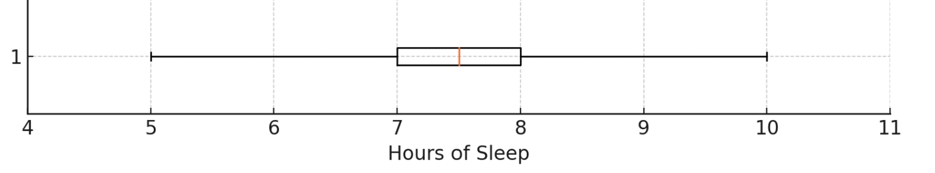
Step 2: answer these questions:
- What is the range of your dataset?
- What is the IQR of your dataset?
- Which measure (range or IQR) better describes the spread? Why?
- Write one ‘75% of people …’ and one ‘25% of people …’ statement from your data.
Step 3: create a set of 10–12 numbers that fits the box plot and matches your five-number summary.

Creating datasets (3)
Step 1: on your vertical non-permanent surface, write the five-number summary for the following box plot:
Group 3 – Average sleep per day
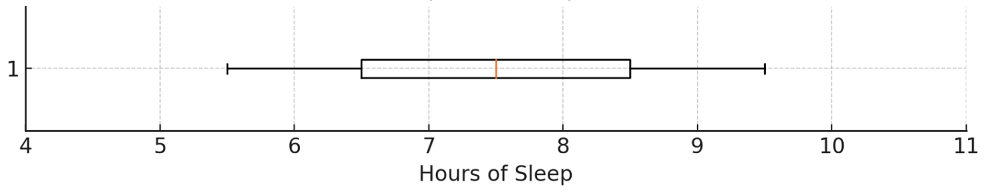
Step 2: answer these questions:
- What is the range of your dataset?
- What is the IQR of your dataset?
- Which measure (range or IQR) better describes the spread? Why?
- Write one ‘75% of people …’ and one ‘25% of people …’ statement from your data.
Step 3: create a set of 10–12 numbers that fits the box plot and matches your five-number summary.

Appendix B

Comparing datasets
A school surveyed students about the hours of sleep they get each night. Students also reported how often they use their phone within 30 minutes before sleep. Students were separated into 2 groups:
- Group 1 consisted of students who did not use their phone 30 minutes before bed
- Group 2 consisted of students who did use their phone 30 minutes before bed.
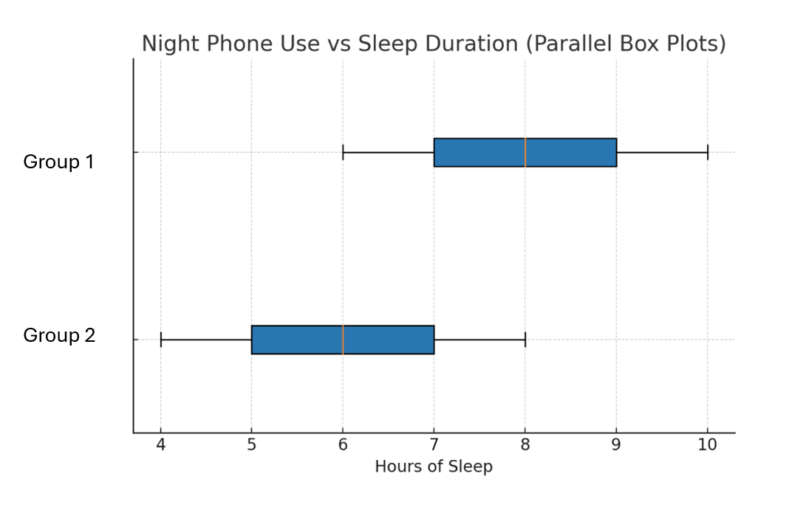
The results are displayed as parallel box plots.
Compare the box plots and consider the following questions:
- Consider the range and interquartile range to determine which group shows more consistent sleep hours?
- What might these box plots suggest about the relationship between phone use before bed and sleep duration?
- Could phone use be a cause of less sleep? Explain your answer.

Appendix C

5 km running app matching activity
Graph A  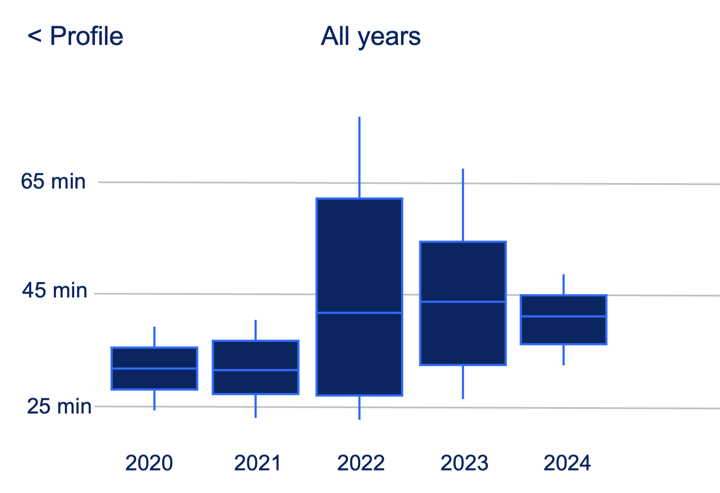 | Jo was a regular 5 km runner with strong times in 2020 and 2021. In 2022, they suffered a serious leg injury that kept them from running for months. Their times were much slower during recovery in 2023. By 2024, they are nearly back to their best and showing steady improvement.
Graph B  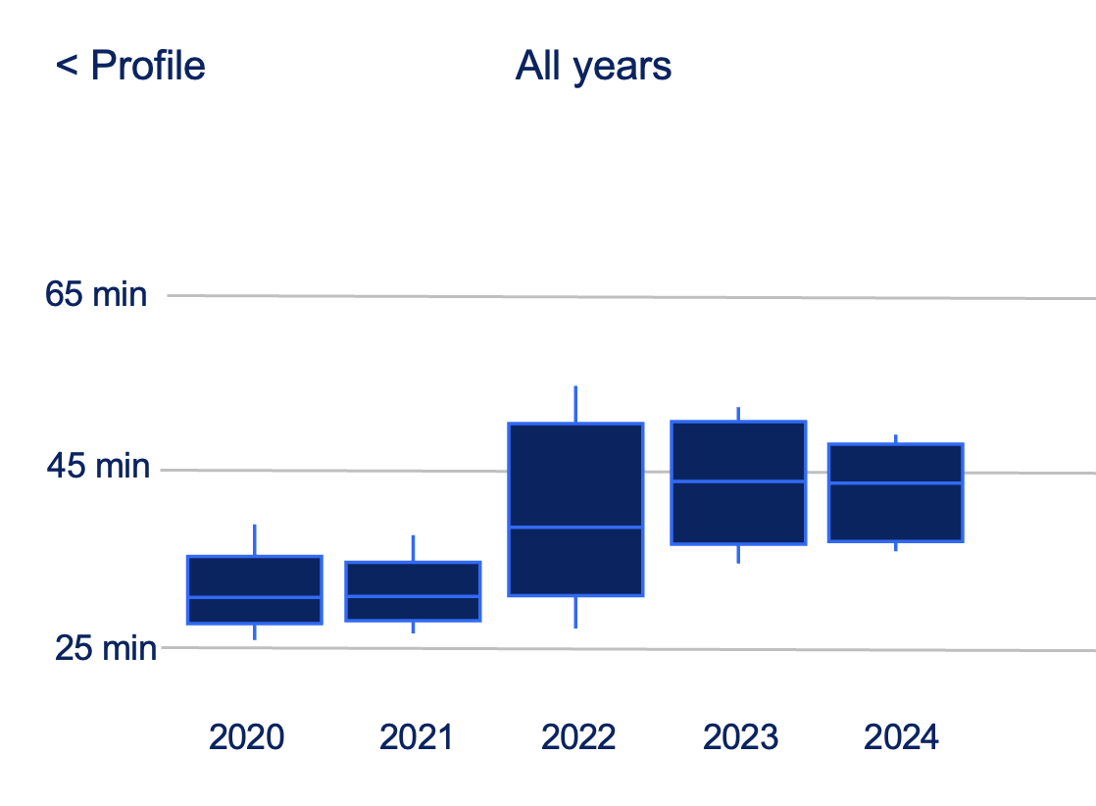 | Until 2022, Alex was focused on chasing personal bests – every run timed, every race a challenge. After starting a new job that year, his priorities shifted. Now, running is about staying healthy, clearing the mind, and enjoying the movement rather than beating the clock.
Graph C  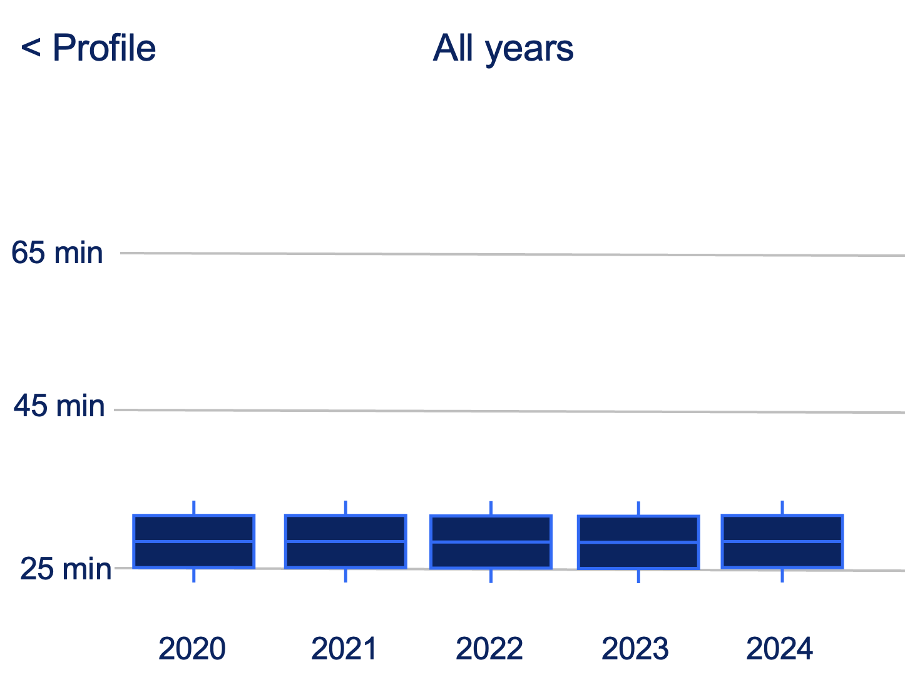 | For the past 5 years, Riley has hit the pavement with impressive precision – fast, focused, and remarkably consistent. Run after run, their pace barely wavers, a blend of speed and discipline that is as admirable as it is hard to match.
Graph D  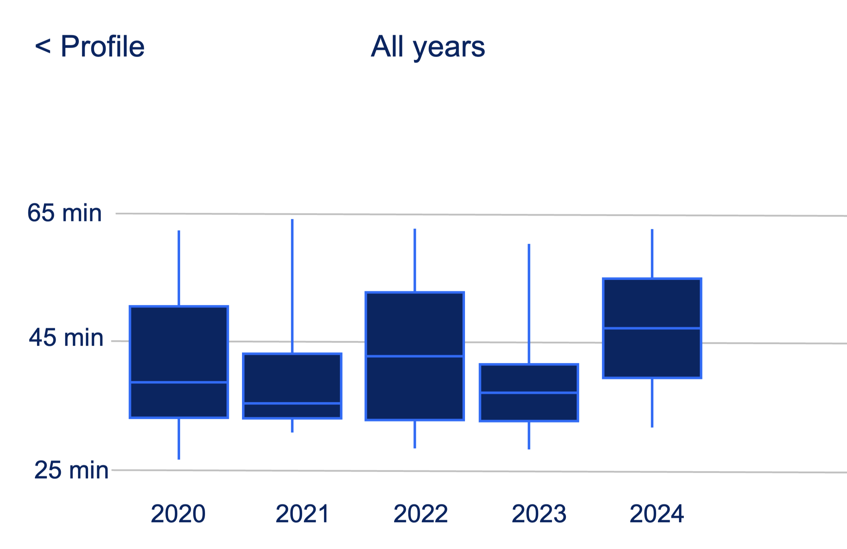 | Jordan uses the app on and off, sometimes tracking runs, sometimes forgetting altogether. His running routine is a bit inconsistent, and he has even forgotten to stop the app after finishing, leaving it recording while he walks around cooling down.
Graph E  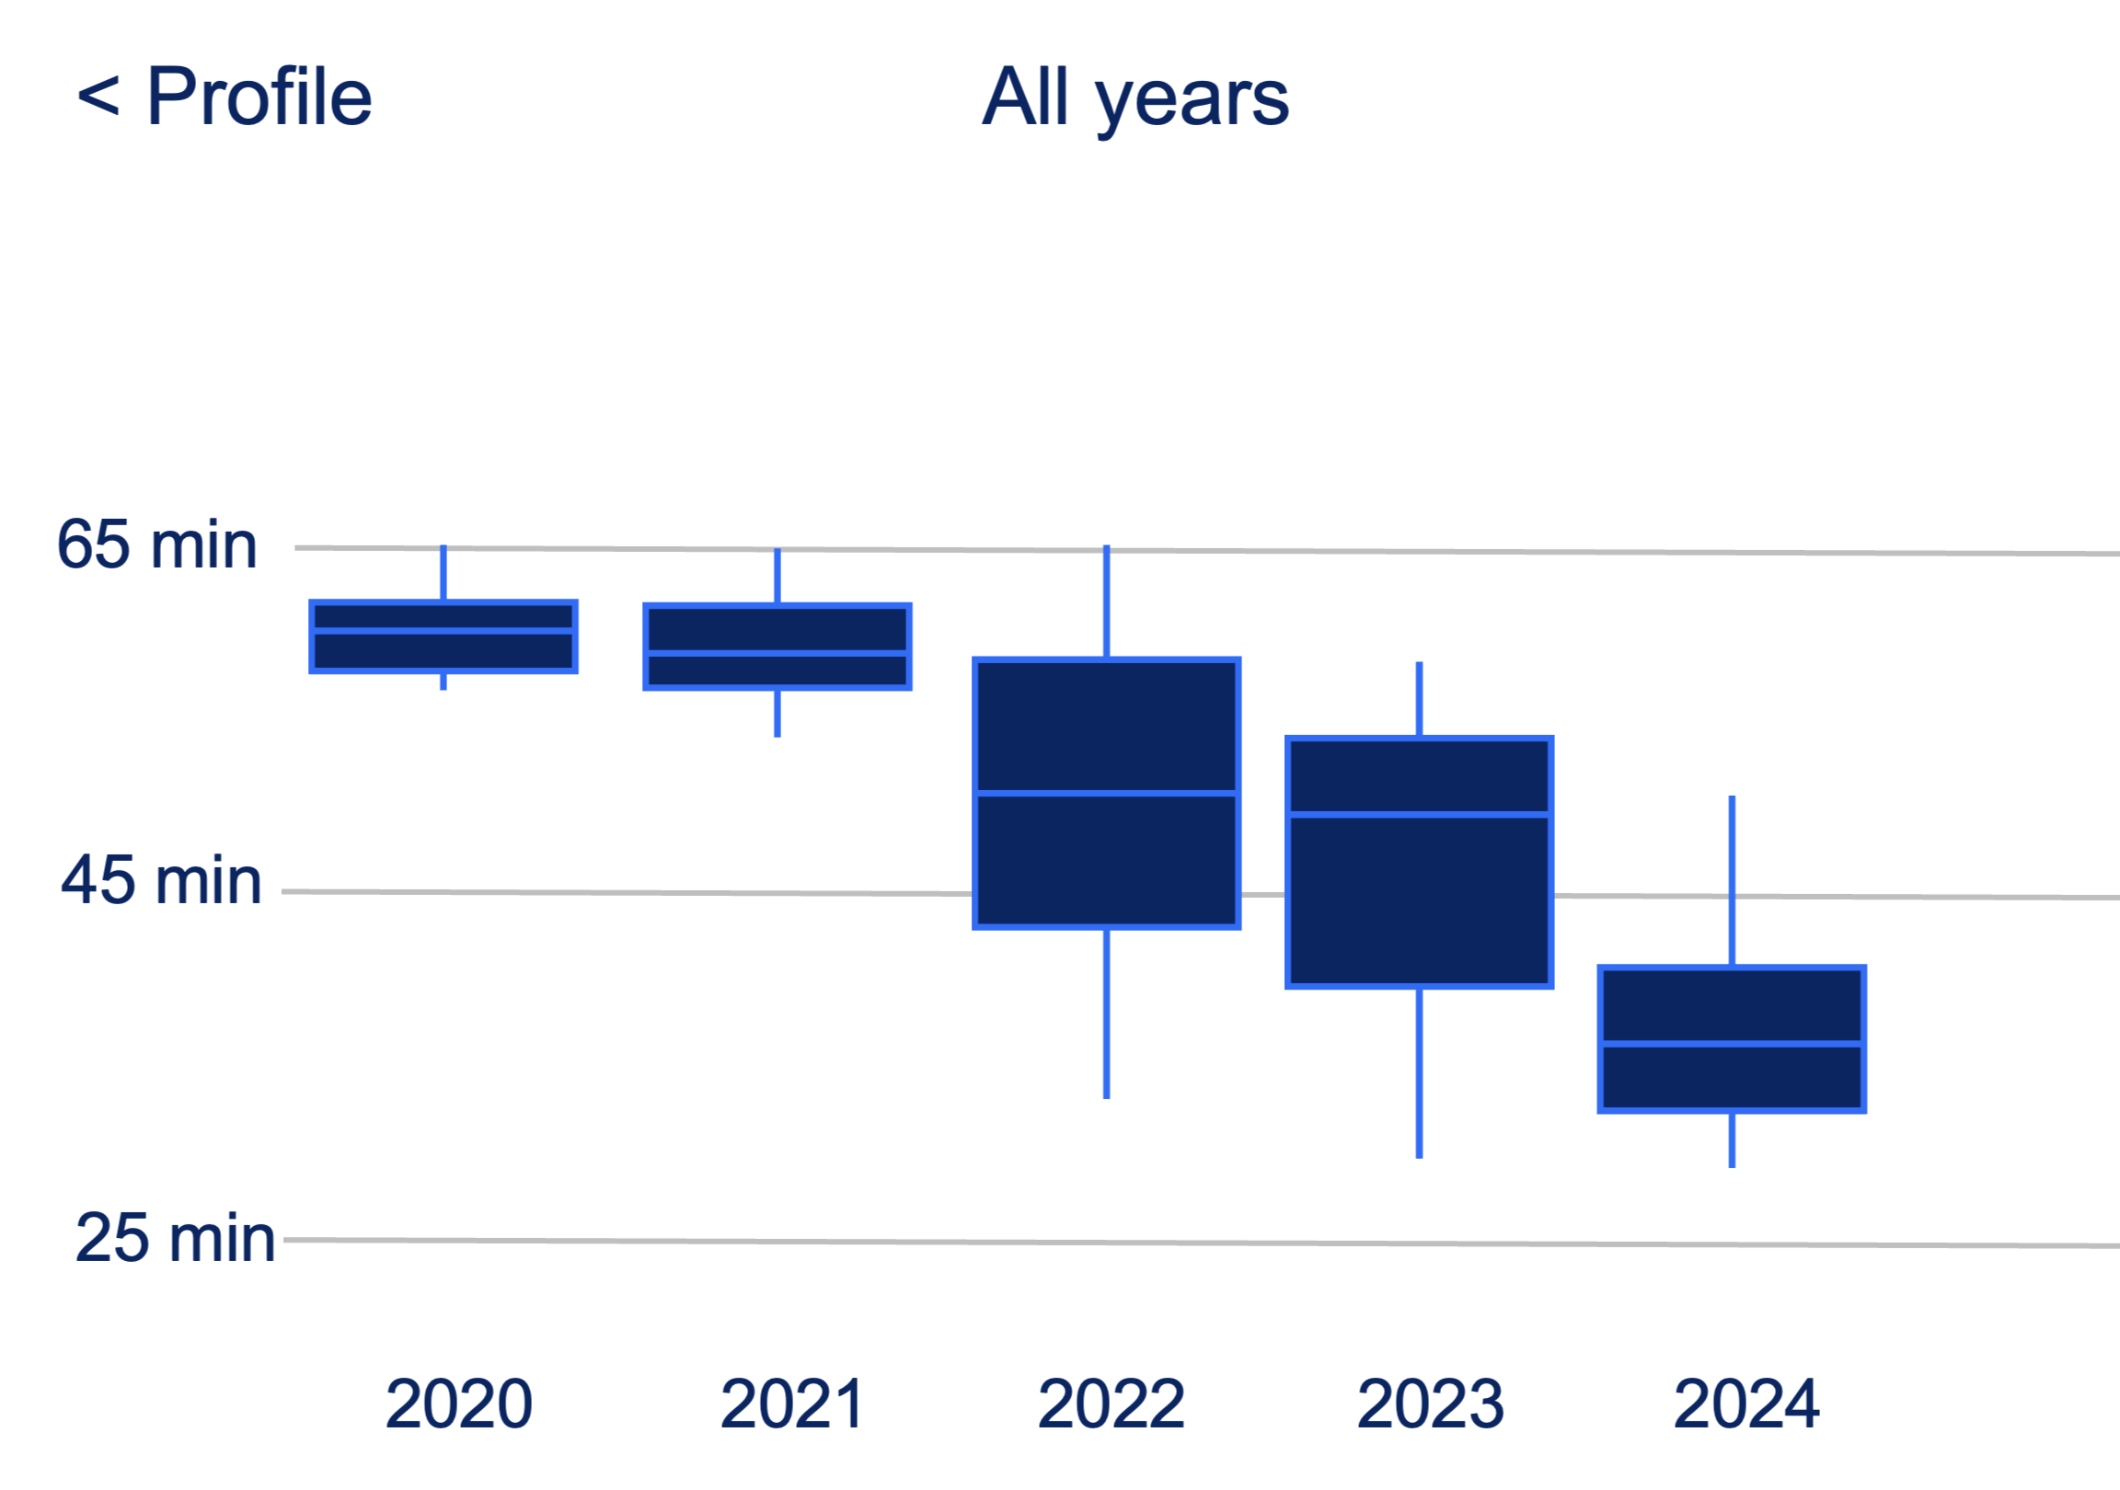 | In the beginning, Taylor found it hard to improve her pace but in 2022, something clicked. She settled into a routine, and since then, her times have steadily improved.
Graph F  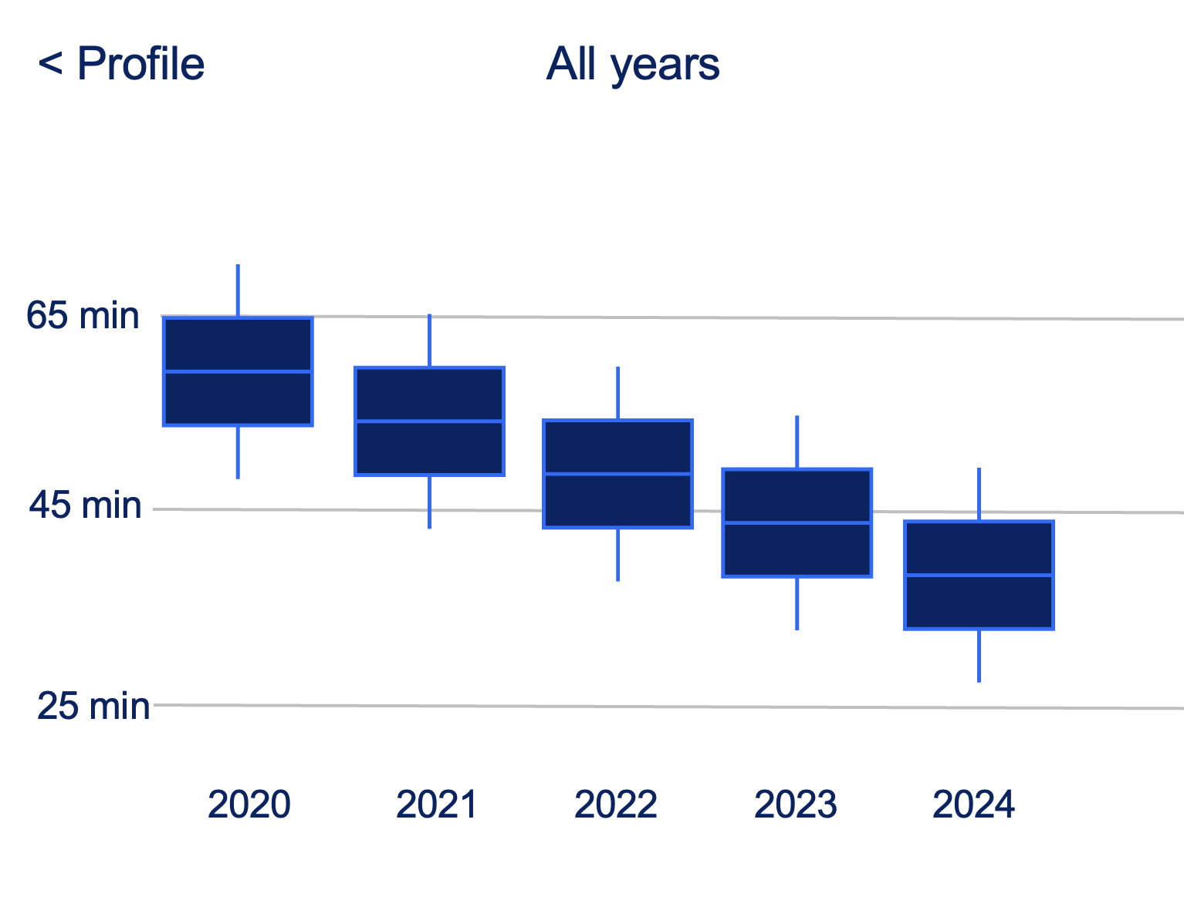 | Sam was only quite young when their dad first logged them into their 5 km running app and began tracking their runs. Since then, Sam has been gradually getting faster, building confidence and enjoying the steady progress.

Sample solutions

Appendix A – creating datasets (1)
Step 1: five-number summary: 6.5, 7, 7.5, 8 and 8.5.
Step 2:
- 2
- 1
- Both the range and interquartile range in this instance are reasonably reliable measures of spread as there doesn’t seem to be any significant outliers and the data is symmetrical.
- 75% of people consistently sleep for 7 hours or more. 25% of people consistently sleep for 7 hours or less.
Step 3: one possible answer could include: 6.5, 6.8, 7.2, 7.4, 7.6, 7.7, 8.3, 8.5.

Appendix A – creating datasets (2)
Step 1: five-number summary: 5, 7, 7.5, 8 and 10.
Step 2:
- 5
- 1
- The IQR because it is not affected by extreme values, whereas the range can be heavily influenced by just one very high or low data point. The IQR focuses on the middle 50% of the data, giving a more reliable indication of the typical spread.
- 75% of people are sleeping for 8 hours or less. 25% of people are only receiving 5–7 hours of sleep.
Step 3: one possible answer could include: 5, 5.5, 6.8, 7.2, 7.2, 7.4, 7.6, 7.7, 7.9, 8.1, 8.3, 10.

Appendix A – creating datasets (3)
Step 1: five-number summary: 5.5, 6.5, 7.5, 8.5 and 9.5.
Step 2:
- 4
- 2
- The IQR is generally better as it is not affected by extreme values, whereas the range can be heavily influenced by just one very high or low data point. This data is symmetrical so the range gives a quick sense of the full spread, while the IQR shows how spread out the middle 50% of the data is.
- 75% of people are receiving 6.5 hours or more of sleep on average. 25% of people are receiving 6.5 hours or less of sleep on average.
Step 3: one possible answer could include: 5.5, 6, 6.5, 7.2, 7.4, 7.6, 7.7, 8.5, 9, 9.5.

Appendix B – comparing datasets
- The groups are equally consistent in terms of spread as their range and IQR are equal, however group 1’s data is centred higher than group 2, indicating that group 1 is getting more hours of sleep each night.
- The median sleep hours for group 1 is higher than for group 2 suggesting that students who do not use phones before bed tend to have more hours of sleep, on average, than those who do use phones.
- We would need a proper experiment with a known sample size to establish whether phone use causes reduced sleep, however, the data shows an association between phone use and less sleep. Other factors could also affect sleep duration.

References
This resource contains NSW Curriculum and syllabus content. The NSW Curriculum is developed by the NSW Education Standards Authority. This content is prepared by NESA for and on behalf of the Crown in right of the State of New South Wales. The material is protected by Crown copyright.
Please refer to the NESA Copyright Disclaimer for more information https://educationstandards.nsw.edu.au/wps/portal/nesa/mini-footer/copyright.
NESA holds the only official and up-to-date versions of the NSW Curriculum and syllabus documents. Please visit the NSW Education Standards Authority (NESA) website https://educationstandards.nsw.edu.au/ and the NSW Curriculum website https://curriculum.nsw.edu.au/.
Mathematics Standard 11–12 Syllabus © NSW Education Standards Authority (NESA) for and on behalf of the Crown in right of the State of New South Wales, 2024.

© State of New South Wales (Department of Education), 2025
The copyright material published in this resource is subject to the Copyright Act 1968 (Cth) and is owned by the NSW Department of Education or, where indicated, by a party other than the NSW Department of Education (third-party material).
Copyright material available in this resource and owned by the NSW Department of Education is licensed under a Creative Commons Attribution 4.0 International (CC BY 4.0) license.

This license allows you to share and adapt the material for any purpose, even commercially.
Attribution should be given to © State of New South Wales (Department of Education), 2025.
Material in this resource not available under a Creative Commons license:
- the NSW Department of Education logo, other logos and trademark-protected material
- material owned by a third party that has been reproduced with permission. You will need to obtain permission from the third party to reuse its material.
Links to third-party material and websites
Please note that the provided (reading/viewing material/list/links/texts) are a suggestion only and implies no endorsement, by the New South Wales Department of Education, of any author, publisher, or book title. School principals and teachers are best placed to assess the suitability of resources that would complement the curriculum and reflect the needs and interests of their students.
If you use the links provided in this document to access a third-party's website, you acknowledge that the terms of use, including licence terms set out on the third-party's website apply to the use which may be made of the materials on that third-party website or where permitted by the Copyright Act 1968 (Cth). The department accepts no responsibility for content on third-party websites.

