Finding and using the equation of the line of best fit
Students determine the intercept and gradient of the line of best fit from a given graph to form an equation of the line. They then use the equation to interpret the relationship in context and make predictions.

Learning intentions
- To be able to determine the equation of a line of best fit.
- To be able to use the equation of the line of best fit to interpret relationships in context.

Success criteria
- I can identify the $y$-intercept from a graph.
- I can determine the equation of the line of best fit using the gradient and $y$-intercept.
- I can substitute values into the equation of a line of best fit to make predictions.

Outcomes

Mathematics Standard 2 outcomes
A student:
- develops understanding and fluency in mathematics through exploring and connecting mathematical concepts, choosing and applying mathematical techniques to solve problems, and communicating their thinking and reasoning coherently and clearly MAO-WM-01
- analyses bivariate datasets using statistical processes MST-12-S2-08

Associated Mathematics Standard 1 outcomes
A student:
- develops understanding and fluency in mathematics through exploring and connecting mathematical concepts, choosing and applying mathematical techniques to solve problems, and communicating their thinking and reasoning coherently and clearly MAO-WM-01
- displays and interprets bivariate datasets to solve problems and make predictions
MST-12-S1-06
Mathematics Standard 11–12 Syllabus © NSW Education Standards Authority (NESA) for and on behalf of the Crown in right of the State of New South Wales, 2024.

Associated Numeracy outcomes
A student:
- recognises and applies functional numeracy concepts in practical situations, including personal and community, workplace and employment, and education and training contexts
N6-1.1
- applies numerical reasoning and mathematical thinking to clarify, efficiently solve and communicate solutions to problems N6-1.2
- determines whether an estimate or an answer is reasonable in the context of a problem, evaluates results and communicates conclusions N6-1.3
- chooses and applies appropriate operations with whole numbers, familiar fractions and decimals, percentages, rates and ratios to analyse and solve everyday problems N6-2.1
- chooses and applies efficient strategies to analyse and solve everyday problems involving data, graphs, tables, statistics and probability N6-2.3
Numeracy Stage 6 (CEC) Syllabus © NSW Education Standards Authority (NESA) for and on behalf of the Crown in right of the State of New South Wales, 2021.

Content

Mathematics Standard 2

Scatter plots and lines of best fit
- Determine and interpret the intercept and gradient of the line of best fit from a given graph to form an equation of the line
- Examine lines of best fit to make predictions and recognise limitations of interpolation and extrapolation for bivariate datasets within a variety of contexts

Mathematics Standard 1

Scatter plots and lines of best fit
- Examine lines of best fit to make predictions and recognise limitations of interpolation and extrapolation for bivariate datasets within a variety of contexts
Mathematics Standard 11–12 Syllabus © NSW Education Standards Authority (NESA) for and on behalf of the Crown in right of the State of New South Wales, 2024.

Table 1: lesson summary
Section | Summary of activity | Teaching strategies | Teaching points
Activating prior knowledge | Students complete a ‘Convince me' activity using slides 4–7 of the PowerPoint Finding and using the equation of the line of best fit to justify correct statements about gradient and intercepts using mathematical reasoning. | Think-Pair-Share | Emphasise the correct interpretation of gradient and intercepts, including direction of gradient, rise over run, and identifying coefficients and constants in linear equations
Connecting learning | Students explore the relationship between song length and streams using Appendix A and slide 9. They then determine the equation of the line of best fit and use the equation to predict the number of streams for Taylor Swift’s 10-minute version of ‘All Too Well’. | Pose-Pause-Pounce-Bounce | The aim is to develop an understanding of modelling with lines of best fit, including selecting appropriate points, determining gradient and intercept, and interpreting variables in context.
Releasing responsibility | Students engage with worked examples (slides 11–14) to determine equations of lines of best fit and compare prediction methods. They then annotate Appendix A with notes to their future forgetful selves and complete Appendix B. | Worked examples (Your turn)  Pose-Pause-Pounce-Bounce  Notes to future forgetful selves | Reinforce accuracy and efficiency of using equations over graphs for prediction, and clarify processes for selecting points, forming equations and substituting values correctly.
Independent practice | Students complete the HSC-style questions in Appendix C in pairs using the ‘Approaching questions scaffold’ on slide 16. They then compare their solutions with a partner. |  | The focus is on applying modelling and interpretation of lines of best fit in HSC-style contexts.

Activity structure
Please use the associated PowerPoint Finding and using the equation of the line of best fit to display images in this lesson.

Activating prior knowledge
- Use slides 4–7 of the PowerPoint to complete a ‘Convince me’ activity. A ‘Convince me’ activity asks students to justify why one solution is correct over another.
- Display each slide and use a Think-Pair-Share (bit.ly/thinkpairsharestrategy) to ask students to justify their agreement with the given statement using appropriate mathematical reasoning.
Students should recognise that on:
- slide 4: the sign of the gradient follows the direction of the line
- slide 5: the $y$-intercept is in the equation of the line, not the $x$-intercept
- slide 6: to calculate the gradient, it is rise over run not run over rise
- slide 7: the gradient is the coefficient of $x$ and the $y$-intercept is the constant.

Connecting learning
- Initiate a class discussion by asking students to discuss the following statement:
The longer a song is, the less online streams it has.
The purpose of this conversation is for students to recognise that the number of streams for a song can vary with its length, but it is also influenced by factors such as genre, artist and other variables.
- Distribute Appendix A ‘Song length and number of streams’ to all students, which shows a scatter plot with a line of best fit representing the relationship between song length and number of streams. This scatter plot can also be shown using slide 9.
- Use the Pose-Pause-Pounce-Bounce questioning strategy (PDF 557 KB) (bit.ly/posepausepouncebounce) to discuss with students how they could predict the expected number of streams for Taylor Swift’s 10-minute version of the song ‘All Too Well’ using the scatter plot and line of best fit from Appendix A.
Students should identify that song length is the independent variable, and that 10 minutes has been converted to 600 seconds.
Students may suggest finding the predicted number of streams by increasing the scale for time length and extending the line to read the number of streams from the graph. Others may suggest finding the equation of the line of best fit, as it gives a more accurate prediction.
- Animate slide 9 to show the gradient-intercept form of a line, $y=mx+c$, and in a Think-Pair-Share ask students:
- What features do we need to find from the graph to determine the equation of a line?
- Which parts of the graph help us find them?
Students should explain that the gradient and $y$-intercept are needed to find the equation of the line.
Guide students to also recognise that the equation can be determined using 2 appropriate points from the line of best fit.
- In pairs, have students determine an equation for the line of best fit using the scatter plot in Appendix A. Students should then use their equation to predict the number of streams for Taylor Swift’s 10-minute version of ‘All Too Well’.
- Use the Pose-Pause-Pounce-Bounce questioning strategy to compare the equations and predictions students obtained. Some suggested prompts could include:
- Which points produced equations closest to the line of best fit?
- Why were some points more appropriate than others?
- How did the points selected affect the prediction?
- Could the equation still be determined without directly using the $y$-intercept? How?
HSC feedback has highlighted that one area students could improve in is selecting 2 appropriate points to find the equation of a line. As students share their chosen points, be sure to provide feedback on whether the points are appropriate, that is, they are integer values that the line passes through clearly.
There are a variety of points students could pick from the graph. Two points students could select include the $y$-intercept$(0, 2271)$ and $(150, 1800)$. Students may also select 2 other points from the line, rather than using the y-intercept, to calculate the gradient before determining the equation of the line.
Regardless of the 2 points students selected, they should obtain the equation of the line as
$y=-2.5x+2271$ or $y=-\frac{5}{2}x+2271$. Students may need to be reminded that this value is measured in millions. Taking that into consideration, the equation could also be $y=-2 500 000x+2271 000 000$.
Students should substitute $x = 600$ seconds into their equation to predict the number of streams. Students may obtain slightly different equations and predictions depending on the points selected from the line of best fit.

Releasing responsibility
- Use slides 11–14 to model worked examples of determining the equation of the line of best fit and using it to predict values using the Worked examples (Your turn) method (bit.ly/supportingstrategies).
- Use the Pose-Pause-Pounce-Bounce questioning strategy to discuss if it is better to predict values using the graph or the equation of the line of best fit.
Students may suggest that the equation is better for predictions because it gives a more precise value, especially for values not clearly shown on the graph. The graph is useful for a quick estimate or to check if their answer makes sense.
- Have students annotate Appendix A to complete notes to their future forgetful selves (bit.ly/supportingstrategies). Some suggested prompts include:
- What points should we select when finding the equation of a line of best fit?
- How do we find the equation of the line of best fit?
- How do we know where to substitute a known value into the equation of the line of best fit?
- Provide each student with a copy of Appendix B ‘Finding the equation of the line of best fit’ for them to complete.

Independent practice
- Distribute Appendix C ‘HSC-style questions’ to pairs of students for them to complete.
Students are encouraged to use the ‘Approaching questions scaffold’ on slide 16 to assist them when answering the HSC-style questions.
- Have students attempt the problems in Appendix C and compare their solutions with a partner.

Assessment and differentiation

Suggested opportunities for differentiation
Activating prior knowledge
- Enable students by providing sentence scaffolds for responses, such as:
- The $y$-intercept is … because …
- The gradient is positive because …
- From the graph we can see …
- Modify diagrams so students can see the $\frac{rise}{run}$ visually.
Connecting learning
- Support students by using guiding prompts. For example:
- Which variable is independent?
- What does this point represent?
- Extend students by asking them to evaluate the validity of extrapolation in the given context in Appendix A.
Releasing responsibility
- Support students by modifying Appendix B into faded examples (bit.ly/fadedexamplesstrategy).
- Extend students by asking them to derive equations from datasets with less obvious points to determine the line of best fit.
- Students may benefit from more practise of finding the equation of the line of best fit and using it.
Independent practice
- Allow students to compare solutions with a partner to discuss different methods, check calculations and justify interpretations of the line of best fit.
- Support students by encouraging them to use the ‘Approaching questions scaffold’ to break the question into smaller steps before solving.

Mathematics Standard 1 adjustments and considerations
Mathematics Standard 1 students do not need to complete any work on finding the equation of the line of best fit. As this is the basis of this lesson, this lesson could be removed if you have a standalone Mathematics Standard 1 class.
Alternatively, if you have a combined Mathematics Standard 1 and 2 class, you could modify this lesson for Mathematics Standard 1 students to allow them to complete further work on interpolating and extrapolating using a line of best fit by eye.

Suggested opportunities for assessment
Activating prior knowledge
- Observe Think-Pair-Share responses to assess identification of the gradient and $y$-intercept from graphs.
- Listen for accurate use of mathematical language, for example, ‘rise over run’ and ‘intercept’.
- Ask probing questions to assess reasoning, for example ‘How do you know the gradient is positive?’
Connecting learning
- Review student selection of points to assess whether they choose appropriate points on the line of best fit.
- Observe student explanations of independent variables, dependent variables and interpretation in context.
- Check accuracy of calculated gradients and interpretation of units (millions of streams).
Releasing responsibility
- Collect Appendix B as evidence of students’ fluency and understanding of how to determine the equation of the line of best fit when the $y$-intercept is shown on the graph.
- Review students’ notes to their future forgetful selves to gather any evidence of misconceptions that students may have.
Independent practice
- Ask students to justify their solution strategies to assess reasoning and communication.

Appendix A

Song length and number of streams
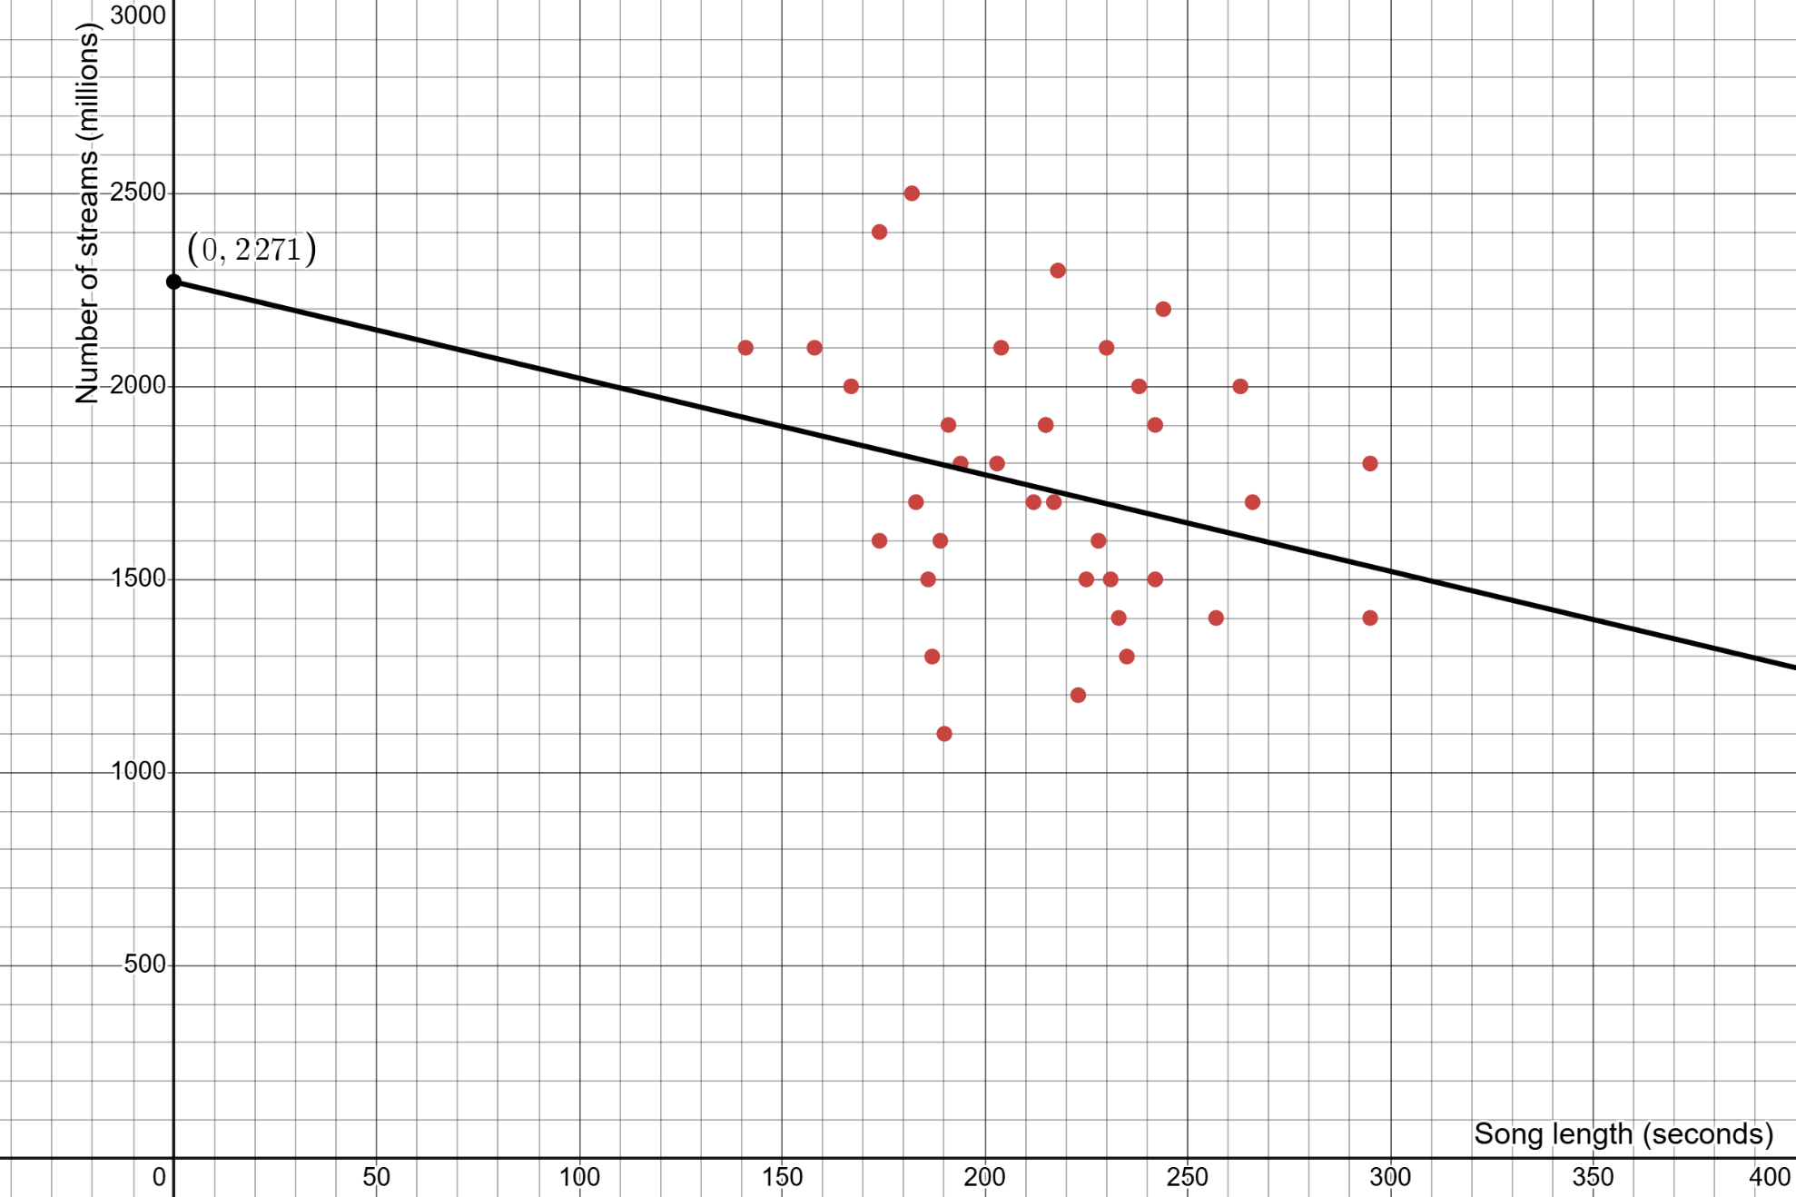

Appendix B

Finding the equation of the line of best fit
This appendix has questions that have been adapted from ‘Estimating lines of best fit to make predictions’ (bit.ly/khan-line-best-fit-predict) by Khan Academy.
- Jacob distributed a survey to his fellow students asking them how many hours they spent on the internet in the past day. He also asked them to rate their mood on a scale from 0 to 10, with 10 being the happiest. A line of best fit was fitted to the data to model the relationship.
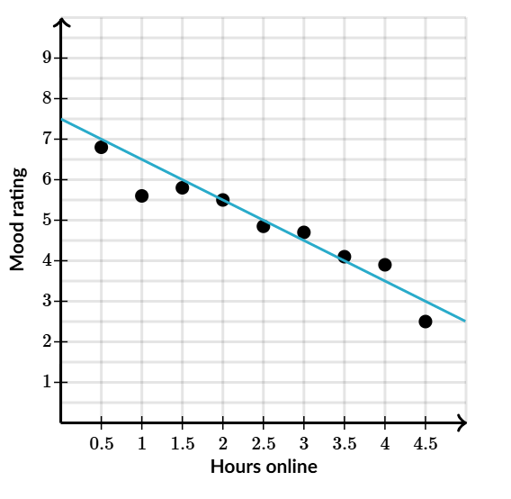
- Using the graph, estimate:
    - the mood rating for a student that spent 5 hours online
    - the hours someone spent online who had a mood rating of 5.
- Find the equation of the line of best fit.
- Based on the equation of the line of best fit, estimate:
    - the mood rating for a student that spent 5.5 hours online
    - the number of hours someone spent online who had a mood rating of 5.

- A bus company wanted to know if the number of complaints they received related to the number of buses it ran. The company carried out a study comparing the average number of buses per hour on different days and the number of complaints that were received on those days. A line was fit to the data to model the relationship.
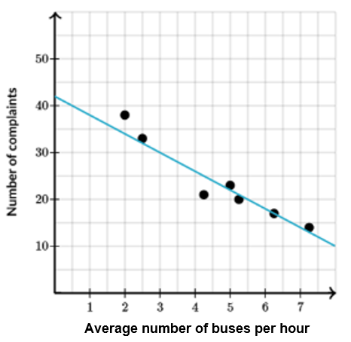
- Using the graph, estimate:
    - the number of complaints in a day where there was an average of 3.5 buses per hour
    - the number of buses running per hour if the company had 20 complaints.
- Find the equation of the line of best fit.
- Based on the equation of the line of best fit, estimate:
    - the number of complaints in a day where there was an average of 3.5 buses per hour
    - the number of buses running per hour if the company had 20 complaints.

- Cars lose value the further they are driven. A random sample of 11 cars for sale was taken. All 11 cars were the same make and model. A line of best fit was added to model the relationship between how far each car had been driven and its selling price.
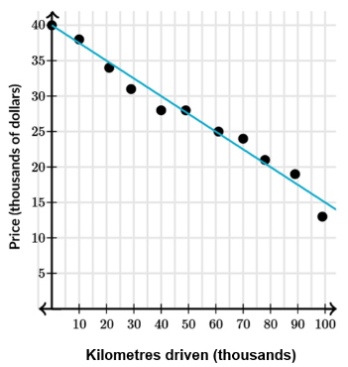
- Using the graph, estimate:
    - the price of a car that had been driven 55 000 kilometres
    - the expected number of kilometres driven for a car worth $25 000.
- Find the equation of the line of best fit.
- Based on the equation of the line of best fit, estimate:
    - the price of a car that had been driven 56 000 kilometres
    - the expected number of kilometres driven for a car worth $20 000.

Appendix C

HSC-style questions
Question 1
A bike rental company records how long customers use their bikes. Over a period of 10 days, the average distance ridden per customer was recorded in kilometres and the average rental time was recorded in minutes.
Using ($x$) as the average distance ridden and ($y$) as the average rental time, a line of best fit was calculated.
The equation of the line of best fit predicts that when the distance ridden is 0 km, the rental time is 20 minutes.
The 10 distances recorded were: 3, 4, 5, 6, 7, 8, 9, 10, 11, 12.
The total rental time for the 10 days was 500 minutes.
The line of best fit passes through the point $\left(x_{1}, y_{1}\right)$where $x_{1}$ is the mean of the average distances ridden and$y_{1}$ is the mean of the average rental times.
- Using the information provided, by first finding the values of the point $(x_{1}, y_{1})$, plot $\left(x_{1}, y_{1}\right)$and the $y$-intercept on the grid provided to form the line of best fit.
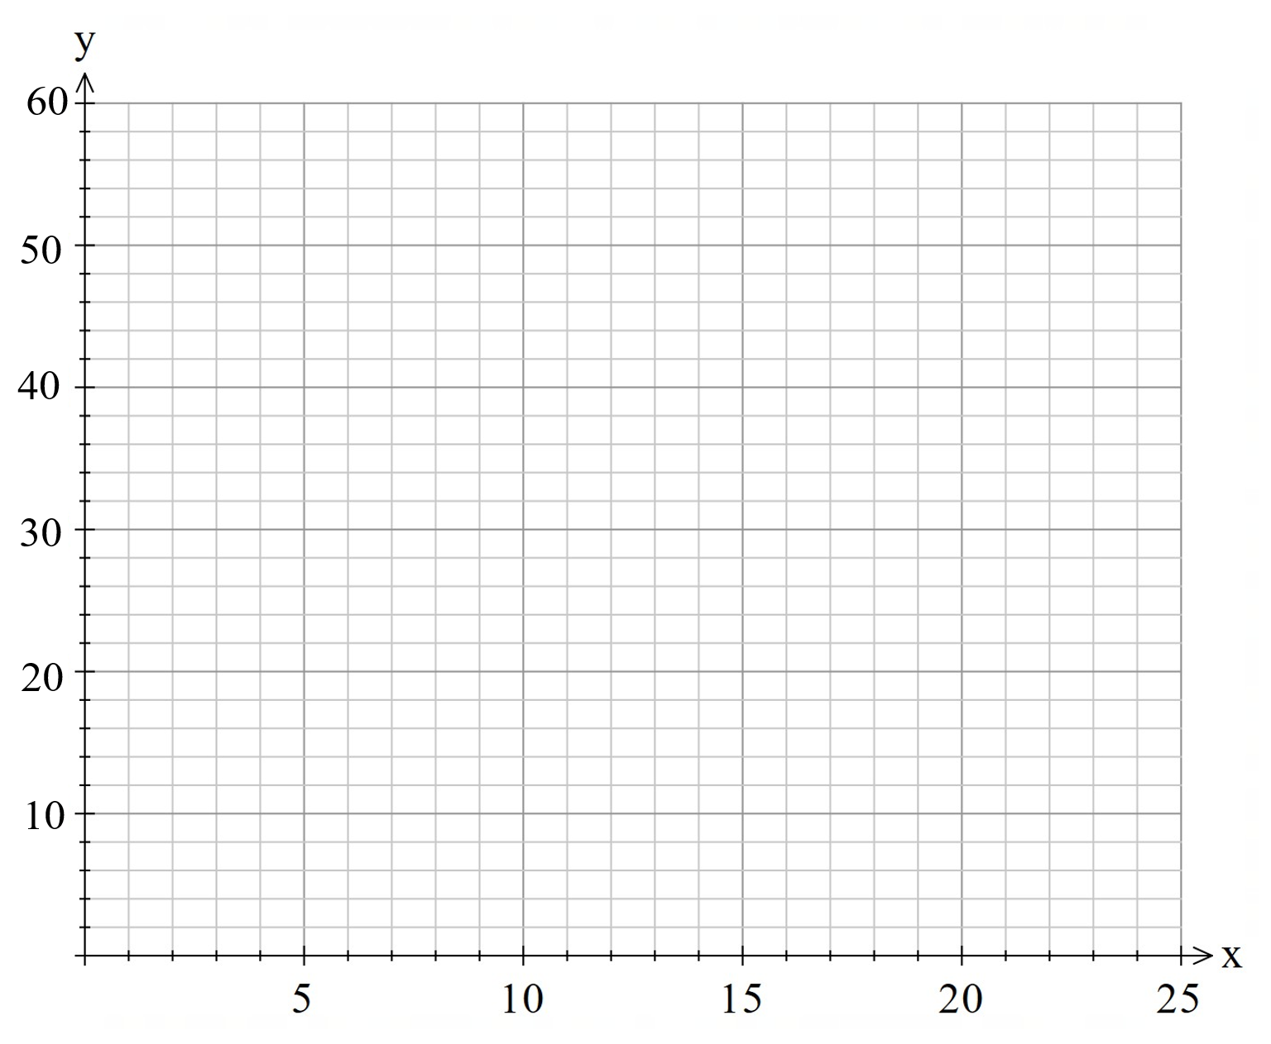
- What is the equation of the line of best fit?
- In the context of the data set, identify one problem with using the line of best fit to predict the rental time when the distance ridden is 25 km.
Question 2
A wildlife researcher is investigating the relationship between daily temperatures and the number of frogs heard croaking near a wetland.
For 20 days, at the same time each evening, the researcher records:
- the temperature (°C)
- the number of frog croaks in a 30-second interval.
The researcher represents the temperature data in the box plot shown below.
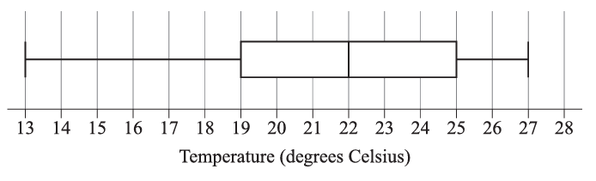
The mean temperature is 0.4°C below the median temperature.
A total of 760 frog croaks were counted across the 20 days.
The researcher fits a line of best fit to the data $(x,y),$ where:
- $x$ is the temperature (°C)
- $y$ is the number of croaks in a 30-second interval.
The equation of the line of best fit is $y = -12.8 + mx$where $m$ is the gradient. The line of best fit passes through the point $(a, b)$, where $a$ is the mean temperature and $b$ is the mean number of croaks.
Using the information provided, calculate the expected number of croaks in a 30-second interval when the temperature is 20°C. Give your answer to the nearest whole number.

Sample solutions

Appendix B – finding the equation of the line of best fit

- Using the graph:
    - 5 hours online leads to a mood rating of around 2.5 mood rating.
    - A mood rating of 5 could be from around spending 2.5 hours online.
- $c=7.5$
Find the gradient with the points $\left(0, 7.5\right)$ and $\left(5, 2.5\right)$
$$m=-\frac{5}{5}=-1 \\ y=-x+7.5$$
- Using the equation:
    - $y=-\left(5.5\right)+7.5=2$
    - $5=-x+7.5$$$-2.5=-x \\ x=2.5$$

- Using the graph:
    - There would be around 28 complaints in a day.
    - There are about 5.5 buses per hour, so assume 6 buses as you can’t have half a bus.
- Equation of the line of best fit:
$$c=42$$
Find the gradient with the points $\left(0,42\right)$ and $\left(5.5,20\right)$
$$m=-\frac{22}{5.5}=-4 \\ y=-4x+42$$
- Using the equation:
    - $y=-4\left(3.5\right)+42=28$ complaints in a day
    - $20=-4x+42$$$-22=-4x \\ x=5.5$$
So, assume 6 buses as you can’t have half a bus.

- Using the graph:
    - The price of a car is approximately $27 000.
    - A car is driven around 60 000 km.
- $c=40$
Find the gradient with the points $\left(0,40\right)$ and $\left(60,25\right)$:
$$m=-\frac{15}{60}=-\frac{1}{4} \\ y=-\frac{1}{4}x+40$$
- Using the equation:
    - $y=-\frac{1}{4}\left(56\right)+40=26$
The car would cost around $26 000.
    - $20=-\frac{1}{4}x+40$$$-20=-\frac{1}{4}x \\ x=80$$
The car would have travelled around 80 000 km.

Appendix C – HSC-style questions
Question 1
Bike customers
- Calculate the means:
$$x_{1}=\frac{3+4+5+6+7+8+9+10+11+12}{10}=7.5 \\ y_{1}=\frac{500}{10}=50$$
Point $\left(x_{1}, y_{1}\right)=(7.5, 50)$
The $y$-intercept is $(0, 20)$.
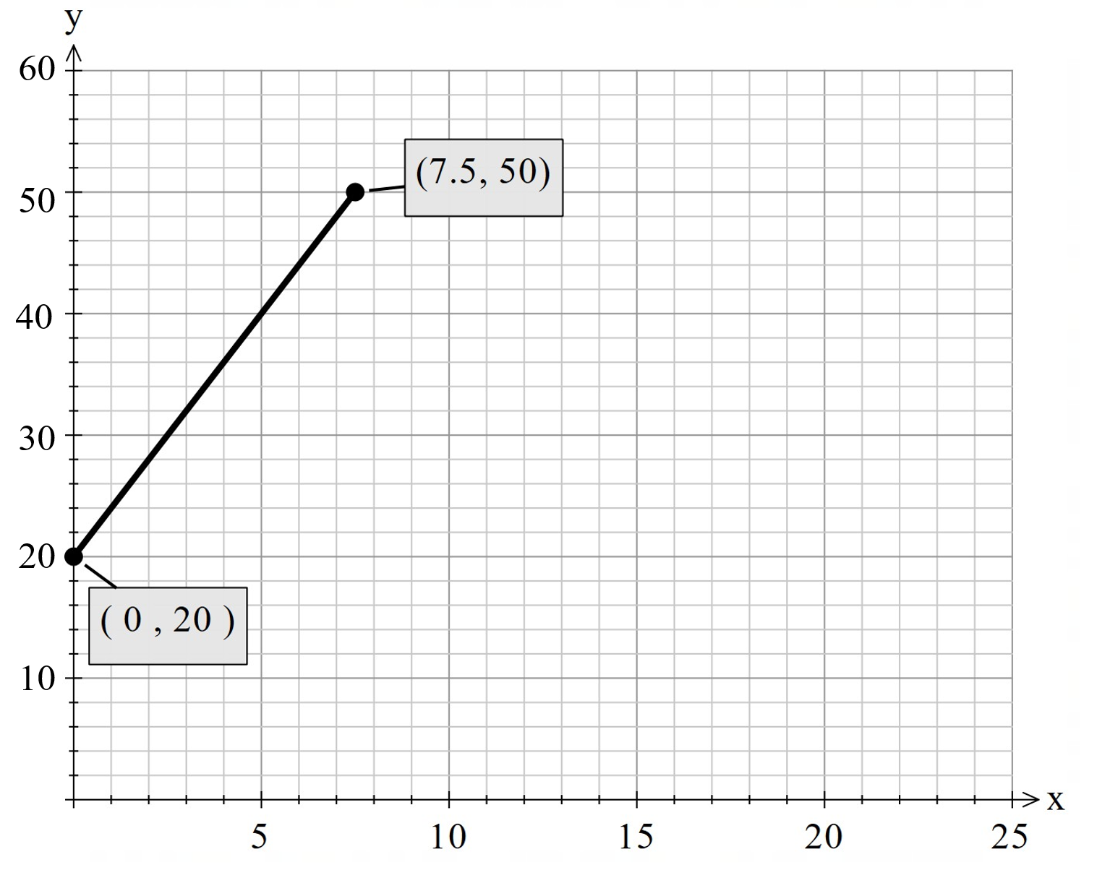
- Gradient = $\frac{30}{7.5}=4$
Equation of a line: $y=4x+20$
- The distances in the dataset were given from a range of 3 km to 12 km. Predicting a rental time for 25 km would involve extrapolation, which may not be reliable because the relationship between distance and rental time may not continue in the same way outside the data range.
Question 2
Find the mean temperature:
Mean = Median − 0.4
Median from the box plot is 22.
$$\text{mean temperature}=22-0.4=21.6°C$$
Find the mean number of croaks:
Total croaks is 760 across the 20 days.
$$\text{mean number of croaks}=\frac{760}{20}=38$$
Line of best fit passes through $(a, b)$, where $a$ is the mean temperature and $b$ is the mean number of croaks. $∴\left(a,b\right)=(21.6, 38)$.
Substitute into the equation of a line:
$$38=-12.8+m\left(21.6\right) \\ 50.8=21.6m \\ m=\frac{50.8}{21.6} \\ m≈2.35$$
Write the equation of the line of best fit:
$$y=-12.8+2.35x$$
Predict the number of croaks when $x=20$:
$$y=-12.8+2.35\left(20\right) \\ =34.2$$
The number of croaks in a 30-second interval when the temperature is $20°C$ is predicted to be 34.

References
This resource contains NSW Curriculum and syllabus content. The NSW Curriculum is developed by the NSW Education Standards Authority (NESA). This content is prepared by NESA for and on behalf of the Crown in right of the State of New South Wales. The material is protected by Crown copyright.
Please refer to the NESA Copyright Disclaimer for more information https://www.nsw.gov.au/education-and-training/nesa/copyright.
NESA holds the only official and up-to-date versions of the NSW Curriculum and syllabus documents. Please visit NESA https://www.nsw.gov.au/education-and-training/nesa and NSW Curriculum https://curriculum.nsw.edu.au.
Mathematics Standard 11–12 Syllabus © NSW Education Standards Authority (NESA) for and on behalf of the Crown in right of the State of New South Wales, 2024.
Numeracy Stage 6 (CEC) Syllabus © NSW Education Standards Authority (NESA) for and on behalf of the Crown in right of the State of New South Wales, 2021.
Khan Academy (n.d.) ‘Estimating equations of lines of best fit, and using them to make predictions’, Unit 7: Data and modelling, Khan Academy website, accessed 17 June 2026.

© State of New South Wales (Department of Education), 2026
The copyright material published in this resource is subject to the Copyright Act 1968 (Cth) and is owned by the NSW Department of Education or, where indicated, by a party other than the NSW Department of Education (third-party material).
Copyright material available in this resource and owned by the NSW Department of Education is licensed under a Creative Commons Attribution 4.0 International (CC BY 4.0) license.

This license allows you to share and adapt the material for any purpose, even commercially.
Attribution should be given to © State of New South Wales (Department of Education), 2026.
Material in this resource not available under a Creative Commons license:
- the NSW Department of Education logo, other logos and trademark-protected material
- material owned by a third party that has been reproduced with permission. You will need to obtain permission from the third party to reuse its material.
Links to third-party material and websites
Please note that the provided (reading/viewing material/list/links/texts) are a suggestion only and implies no endorsement, by the New South Wales Department of Education, of any author, publisher, or book title. School principals and teachers are best placed to assess the suitability of resources that would complement the curriculum and reflect the needs and interests of their students.
If you use the links provided in this document to access a third-party's website, you acknowledge that the terms of use, including licence terms set out on the third-party's website apply to the use which may be made of the materials on that third-party website or where permitted by the Copyright Act 1968 (Cth). The department accepts no responsibility for content on third-party websites.

