Creating and using the line of best fit by hand
Students learn how to effectively draw a line of best fit by eye, using their model to interpolate and extrapolate from the graph and understand its limitations given its context.
Students will need at least one digital device per pair to interact with a webpage during this lesson.

Learning intentions
- To be able to create a line of best fit to represent a relationship between 2 variables.
- To be able to use a line of best fit to make predictions.

Success criteria
- I can draw a line of best fit by eye through a scatter plot.
- I can explain the differences between interpolating and extrapolating.
- I can interpolate and extrapolate using a line of best fit.
- I can explain the limitations of a model given the context.

Outcomes

Mathematics Standard 2 outcomes
A student:
- develops understanding and fluency in mathematics through exploring and connecting mathematical concepts, choosing and applying mathematical techniques to solve problems, and communicating their thinking and reasoning coherently and clearly MAO-WM-01
- analyses bivariate datasets using statistical processes MST-12-S2-08

Associated Mathematics Standard 1 outcomes
- develops understanding and fluency in mathematics through exploring and connecting mathematical concepts, choosing and applying mathematical techniques to solve problems, and communicating their thinking and reasoning coherently and clearly MAO-WM-01
- displays and interprets bivariate datasets to solve problems and make predictions
MST-12-S1-06
Mathematics Standard 11–12 Syllabus © NSW Education Standards Authority (NESA) for and on behalf of the Crown in right of the State of New South Wales, 2024.

Associated Numeracy outcomes
A student:
- recognises and applies functional numeracy concepts in practical situations, including personal and community, workplace and employment, and education and training contexts
N6-1.1
- applies numerical reasoning and mathematical thinking to clarify, efficiently solve and communicate solutions to problems N6-1.2
- determines whether an estimate or an answer is reasonable in the context of a problem, evaluates results and communicates conclusions N6-1.3
- chooses and applies efficient strategies to analyse and solve everyday problems involving data, graphs, tables, statistics and probability N6-2.3
- chooses and applies appropriate numeracy operations and techniques to analyse and resolve everyday situations N6-2.6
Numeracy Stage 6 (CEC) Syllabus © NSW Education Standards Authority (NESA) for and on behalf of the Crown in right of the State of New South Wales, 2021.

Content

Mathematics Standard 2

Scatter plots and lines of best fit
- Create a line of best fit on a scatter plot for a bivariate dataset, by eye and with digital tools
- Examine lines of best fit to make predictions and recognise limitations of interpolation and extrapolation for bivariate datasets within a variety of contexts

Mathematics Standard 1

Scatter plots and lines of best fit
- Create a line of best fit on a scatter plot for a bivariate dataset, by eye and with digital tools
- Examine lines of best fit to make predictions and recognise limitations of interpolation and extrapolation for bivariate datasets within a variety of contexts
Mathematics Standard 11–12 Syllabus © NSW Education Standards Authority (NESA) for and on behalf of the Crown in right of the State of New South Wales, 2024.

Table 1: lesson summary
Section | Summary of activity | Teaching strategies | Teaching points
Activating prior knowledge | Students play a game using the JustPark’s website (justpark.com/creative/reaction-time-test/) and then select See how we worked out your age. They identify the independent and dependent variables, as well as use the graph to make predictions. | Think-Pair-Share  Pose-Pause-Pounce-Bounce | The purpose of this section is to connect prior understanding of associations to real-world contexts, reinforcing interpretation of relationships and the roles of independent and dependent variables when using linear models for predictions.
Connecting learning | Slide 4 of the PowerPoint Creating and using the line of best fit by hand and Appendix A are used to revisit scatter plot interpretation as students analyse reaction-time data, make observations and predict values both within and beyond the collected age range. Students justify their prediction strategies and recognise the need for a line that would make it easier to predict values when estimating values outside the data. Students then draw and compare their own lines using Appendix A, discussing strategies. | Think-Pair-Share  Pose-Pause-Pounce-Bounce | The aim is to develop students’ understanding of lines of best fit as a model for describing relationships and making predictions, including the distinction between interpolation and extrapolation and their relative reliability.
Releasing responsibility | Define a line of best fit, then use slide 6 to model interpolation and extrapolation before students consolidate their understanding using Appendix B. Students discuss the reliability of lines of best fit before completing Appendix C. | Pose-Pause-Pounce-Bounce  Frayer diagram | Emphasise the variability in constructing lines of best fit and support students to evaluate the reliability of predictions, particularly when comparing interpolation and extrapolation.
Independent practice | Use Appendix D, alongside slide 8, to identify key information in HSC-style questions. Discuss when and why a provided graph should be used and then attempt the problems. |  | The focus is on applying interpretation of lines of best fit in contexts, recognising acceptable ranges of answers and justifying reasoning despite variation in models.

Activity structure
Please use the associated PowerPoint Creating and using the line of best fit by hand to display images in this lesson.

Activating prior knowledge
- Initiate a class discussion with students about whether their age would affect their reaction time and if so, describe the association it might have.
Students can describe the association noting its form, strength and/or direction.
- Have students navigate to JustPark’s webpage ‘How old are your reactions?’ (justpark.com/creative/reaction-time-test/). Students are to select the arrow to play the game.
- Once students have been given their age from their reaction time, have them select the arrow at the bottom of the page under See how we worked out your age.
The webpage displays a graph illustrating the relationship between age and reaction time. It also shows each user’s reaction time, alongside the age they were assigned, highlighting how their predicted age was determined.
- Explain to students that JustPark created a linear model of the data they collected to make predictions for all ages and reaction times.
- In a Think-Pair-Share (bit.ly/thinkpairsharestrategy), ask students why the independent variable is age and the dependent variable is reaction time.
Students should share that as you get older, your reaction time increases, rather than your reaction time impacting your age, to justify why age would be the independent variable in this scenario.
- Ask students to use the graph to find the following values:
- the predicted reaction time if you were 18 or 50 years of age
- the predicted age if you have a reaction time of approximately 500 milliseconds.
Students can move their cursor along the graph to reveal different values.
Those who are 18 years of age have a predicted reaction time of 296 milliseconds and those who are 50 years of age have a predicted reaction time of 574. If you have a reaction time of approximately 500 milliseconds, you would be approximately 42 to 43 years old.
- Use the Pose-Pause-Pounce-Bounce questioning strategy (PDF 557 KB) (bit.ly/posepausepouncebounce) to discuss with students how they used the graph to find solutions for both an independent variable and a dependent variable.
Students should recognise that when given the independent variable, we find the value on the $x$-axis following along to the line and then to the corresponding $y$-value. When given the dependent variable, we find the value on the $y$-axis following along to the line and then to the corresponding $x$-value.

Connecting learning
- Distribute Appendix A ‘Reaction times by age scatter plot’ in a plastic sleeve to each student. Slide 4 of the PowerPoint can be used to display the same scatter plot.
The study from which this data is sourced can be found in the research article ‘Life-span changes in task switching’ by Melody Wiseheart (bit.ly/life-span-task-switching).
- In a Think-Pair-Share, ask students to:
- estimate the Pearson correlation coefficient and describe the strength and direction of the association
- provide at least 2 observations describing the relationship between age and reaction time in the scatter plot.
Students were introduced to Pearson’s correlation coefficient in Lesson 4 – Pearson’s correlation coefficient. Students should estimate the correlation coefficient to be between 0.8 and 0.9, representing a strong positive linear association.
Some observations include that reaction time increases with age, that it appears to increase rapidly after the age of 40, and that the maximum reaction time recorded belongs to the oldest participant.
- Animate slide 4 to prompt students to use the scatter plot in Appendix A to predict reaction times for a:
- 50 year old
- 70 year old
- 90 year old
- 10 year old.
- Initiate a class discussion for students to share their strategies and guide their thinking towards constructing a line to aid their predictions.
Ages 50 and 70 are within the collected data range, while ages 10 and 90 are outside the data range. Students may suggest they estimated reaction times for ages 50 and 70 by identifying values within the middle of the data. For ages 10 and 90, students may suggest they used the overall pattern of the points to make predictions.
Students may benefit from discussing the correlation coefficient as a reminder that predictions are more reliable when the correlation is stronger, as the data points lie closer to a linear pattern.
Students may suggest drawing a line over the data to show the predicted values for the data beyond the points provided.
- Using Appendix A in its plastic sleeve, have students draw a line with a ruler that represents the relationship between the 2 variables. Students then compare their lines with others in the class and discuss which best fits the data.
Students can remove Appendix A from their plastic sleeves and lay the plastic sleeves over each other’s work to compare their lines. Students should be encouraged to reference the points they predicted earlier to see if they align to the points on their lines.
- Use the Pose-Pause-Pounce-Bounce questioning strategy to discuss how students drew their lines and what the line represents. Some suggested prompts may include:
- Why is it not feasible for a line to pass through every point?
- How are the points distributed on either side of the line?
- What do we expect the gradient of the line to be for this data? What would it look like if the relationship was negative?
Students should share that they looked for the overall trend; in this scenario, the data shows a positive relationship. They should also note that they aimed to balance the line so that a similar number of points lie above and below it, while ignoring outliers where appropriate. The line should pass through the data, rather than simply connecting the first and last points. If these ideas are not raised, the teacher should explicitly highlight them.
Using a ruler is important when drawing the line. Teachers should emphasise that a clear ruler helps students accurately place the line while still viewing all data points.

Releasing responsibility
- Define a line of best fit to students using the following NESA glossary definition:
A line drawn through a scatter plot of data points that represents the nature of the relationship between 2 variables (NESA 2024).
- Display slide 6, which shows the scatter plot with a line of best fit added. It also includes references for how the reaction times for the ages 10, 50, 70 and 90 can be predicted from the line of best fit.
Students may also compare their own lines of best fit with the example solution shown on the slide.
- Remind students of the definitions for interpolating and extrapolating using the following NESA glossary definitions:
Interpolating: Making predictions between known data values (NESA 2024).
Extrapolating: Occurs when the fitted model, such as a line of best fit, is used to make predictions using values outside the range of the original data upon which the fitted model was based (NESA 2024).
Students were first introduced to the terms in the Year 11 Linear relationships outcome
MST-11-02.
- Ask students to identify, for each of the ages displayed, if the predictions were made by interpolating or extrapolating.
Students should recognise that the predicted values for 10 and 90 were found using extrapolation, whereas predictions for 50 and 70 were found using interpolation because they were within the range of the data which was around 20 to 80 years old.
- Use the Pose-Pause-Pounce-Bounce questioning strategy to discuss the reliability of predicted values when interpolating compared to extrapolating. Some suggested prompts include:
- Which set of reaction time predictions do you think is the most reliable?
- Would this model accurately predict the reaction time for a baby?
- Is there an age for this data when a prediction would not make sense? Justify your answer.
Students should recognise that interpolated values are generally considered reliable predictions because they fall within the range of the collected data and are supported by the pattern shown in the graph.
They should also recognise that, when making predictions through extrapolation, some of the predictions no longer make sense: a baby would not have a faster reaction time and there are no people alive beyond a certain age, so extrapolating for the age of 120 years old would not be appropriate.
- Distribute Appendix B ‘Scatter plots’ for students to draw a line of best fit by eye and use it to estimate unknown values.
- Distribute Appendix C ‘Frayer diagram and notes’ to students to complete structured notes, including a Frayer diagram (bit.ly/frayerdiagram).

Independent practice
- Distribute Appendix D ‘HSC-style questions’ and display slide 8 which shows the Approaching questions scaffold and remind them to highlight important information in each question.
- Have students attempt the problems in Appendix D and compare their solutions with a partner.
- Initiate a class discussion by pointing out that students obtained slightly different values because they drew slightly different lines of best fit. Ask students whether they believe these responses would still be awarded marks.
Highlight to students that, when drawing a line of best fit, there is a range of acceptable answers in which students receive marks, due to the variability of the model.

Assessment and differentiation

Suggested opportunities for differentiation
Activating prior knowledge
- Provide guiding questions or sentence starters, for example, ‘Age is the independent variable because …’ to support students in explaining their reasoning.
- Vision impaired students would benefit from a raised graph so they can feel where the points are on the scatter plot provided.
Connecting learning
- Provide a scaffold showing the steps for drawing a line for students needing additional support.
Releasing responsibility
- Provide the estimated point on the graph to support students to identify whether they are interpolating or extrapolating.
Independent practice
- Allow students to work with a partner to compare strategies and reasoning before finalising answers.
- Extend students by asking them to justify the reliability of their predictions and discuss limitations of the model.

Mathematics Standard 1 adjustments and considerations
The syllabus content in this lesson is the same for both Mathematics Standard 2 and Mathematics Standard 1. The lesson can be completed as is and adjustments made if necessary.

Suggested opportunities for assessment
Activating prior knowledge
- Ask students to justify why age is the independent variable and reaction time is the dependent variable to assess their understanding of variable relationships.
- Listen to responses during Think-Pair-Share discussions to gauge students’ prior knowledge of independent and dependent variables.
Connecting learning
- Observe students as they draw their lines to check if they represent the overall trend and balance points above and below the line.
Releasing responsibility
- Ask students to justify their predictions for reaction times at different ages to assess their understanding of using the line of best fit to make predictions.
- Review students’ responses on Appendix C to determine their ability to independently draw a line of best fit and make predictions.
Independent practice
- Use the HSC-style questions to assess students’ ability to interpret a line of best fit and make predictions from graphs.

Appendix A

Reaction times by age scatter plot
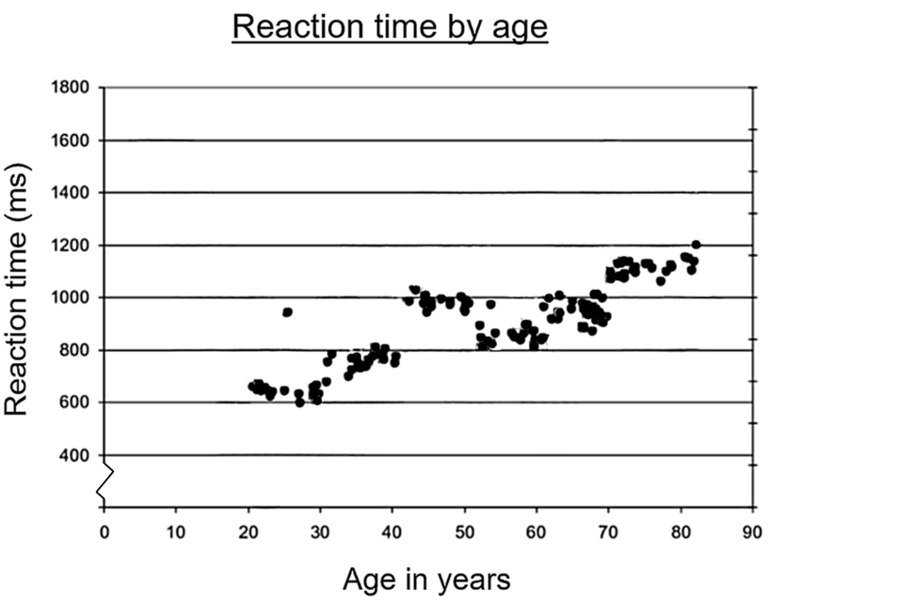

Appendix B

Scatter plots
This activity has been adapted from ‘Line of best fit’ (arc.educationapps.vic.gov.au/learning/sites/mathematics-lesson-plans/3882/Line-of-best-fit) from Arc by State of Victoria (Department of Education).
- For the following scatter plots, identify which is the most appropriate line of best fit for the data provided and justify why.
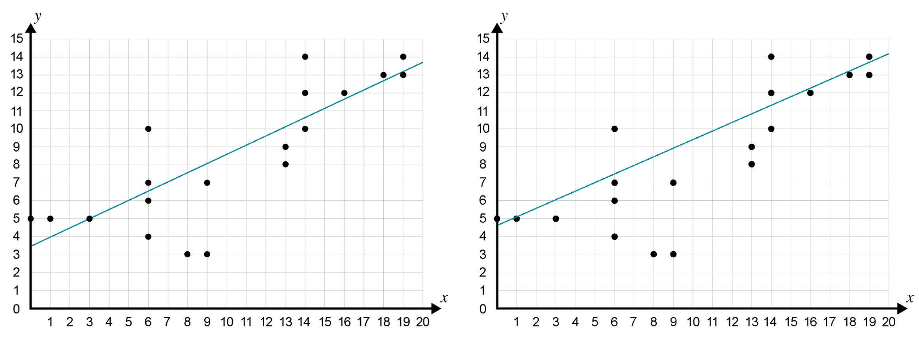
- Draw a line of best fit for the data provided in each of the following scatter plots and predict the value of the unknown variable using the line of best fit. State whether you are interpolating or extrapolating.
- Predict the value of $y$ when $x=20.5$.
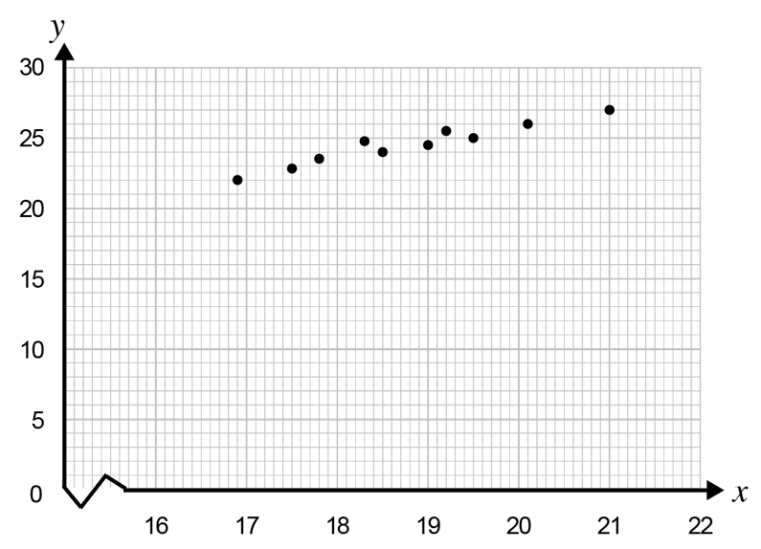
- Predict the value of $y$ when $x=8$.
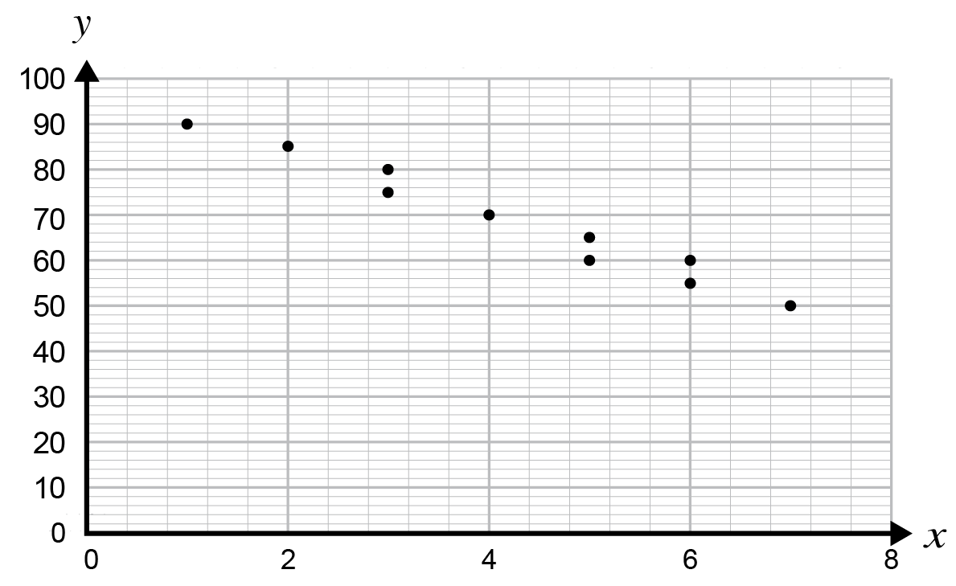
- Predict the value of $y$ when $x=10$.
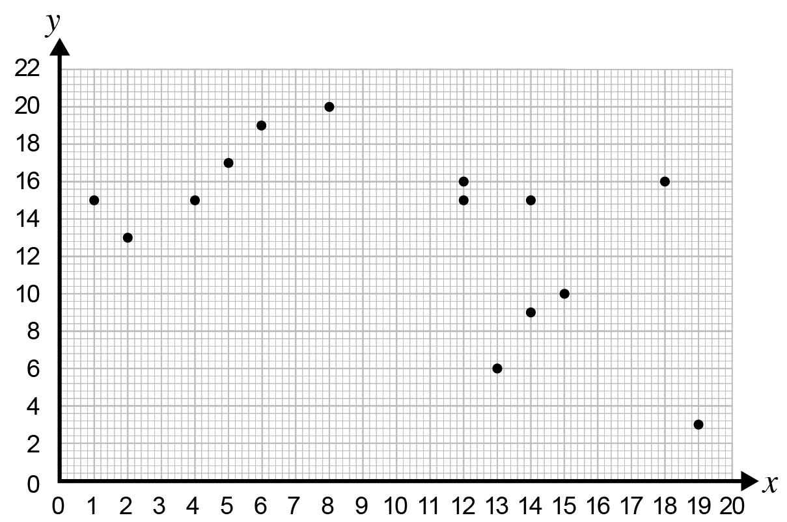
- Predict the value of $x$ when $y=8.5.$
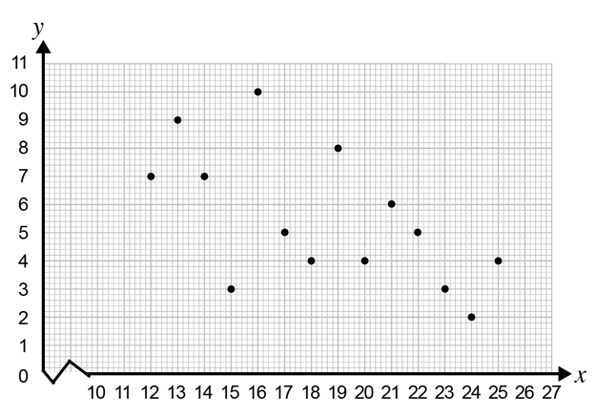

Appendix C

Frayer diagram and notes
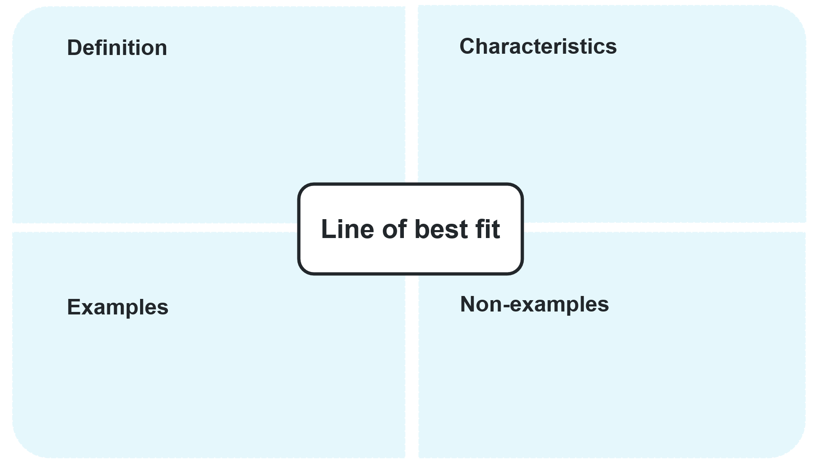

Guided notes
Answer the following questions in your own words.
- What does interpolation mean?
- What does extrapolation mean?
- Why is extrapolation usually riskier than interpolation?
- What should you reflect upon when using a line of best fit to make predictions? Discuss the limitations that may arise.

Appendix D

HSC-style questions
Question 1
A farmer fertilises the seeds in his wheat fields at varying concentrations. The data below gives the volume of wheat per hectare (yield) for various fertiliser concentrations:
Fertiliser concentration ($x$mL/L) | 1 | 2 | 4 | 7 | 8 | 10
Volume of wheat ($y$t) | 1.01 | 1.32 | 1.68 | 1.56 | 2.03 | 2.08
- Create a scatter plot and draw a line of best fit on the following Cartesian plane.
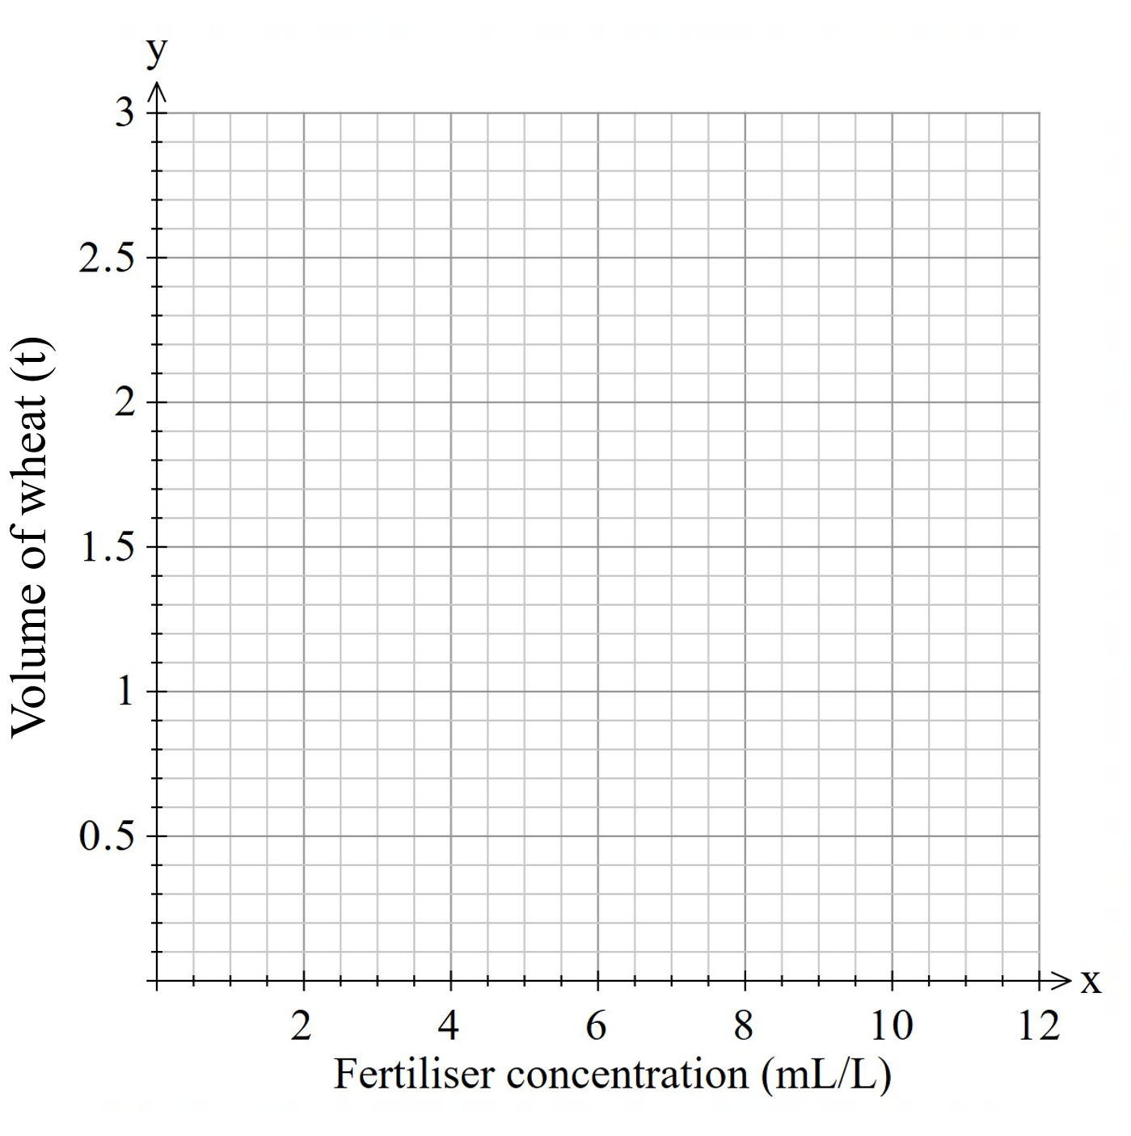
- Use the line of best fit to make predictions of the volume of wheat when using the following fertiliser concentrations: 5 mL/L, 10.8 mL/L and 3.5 mL/L.
- Use the line to make predictions of the fertiliser concentration given the following volumes of wheat: 1.7 t, 1.2 t and 2.4 t.
- Justify whether each of these predictions are an example of interpolating or extrapolating.
- Comment on the reliability of each prediction made in parts b and c.
Question 2
A weatherman is attempting to predict a city’s wind chill factor when compared to its temperature during winter. He collected the following data, displayed in the scatter plot below, from last winter.
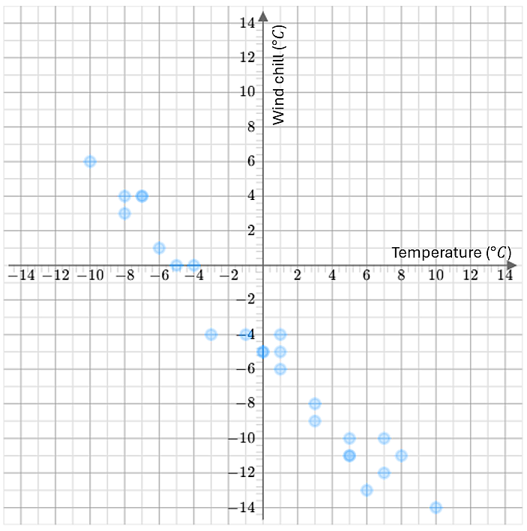
- Draw a line of best fit on the scatter plot.
- The wind chill was not recorded when the temperature was $-2°$. Explain why the line of best fit would provide a reasonable prediction for this point.
- Find the predicted wind chill when the temperature is $-2°$.

Question 3
Several cars took a brake test travelling at 80 km/h. The age of the car was measured against the stopping distance. The scatter plot shows the results.
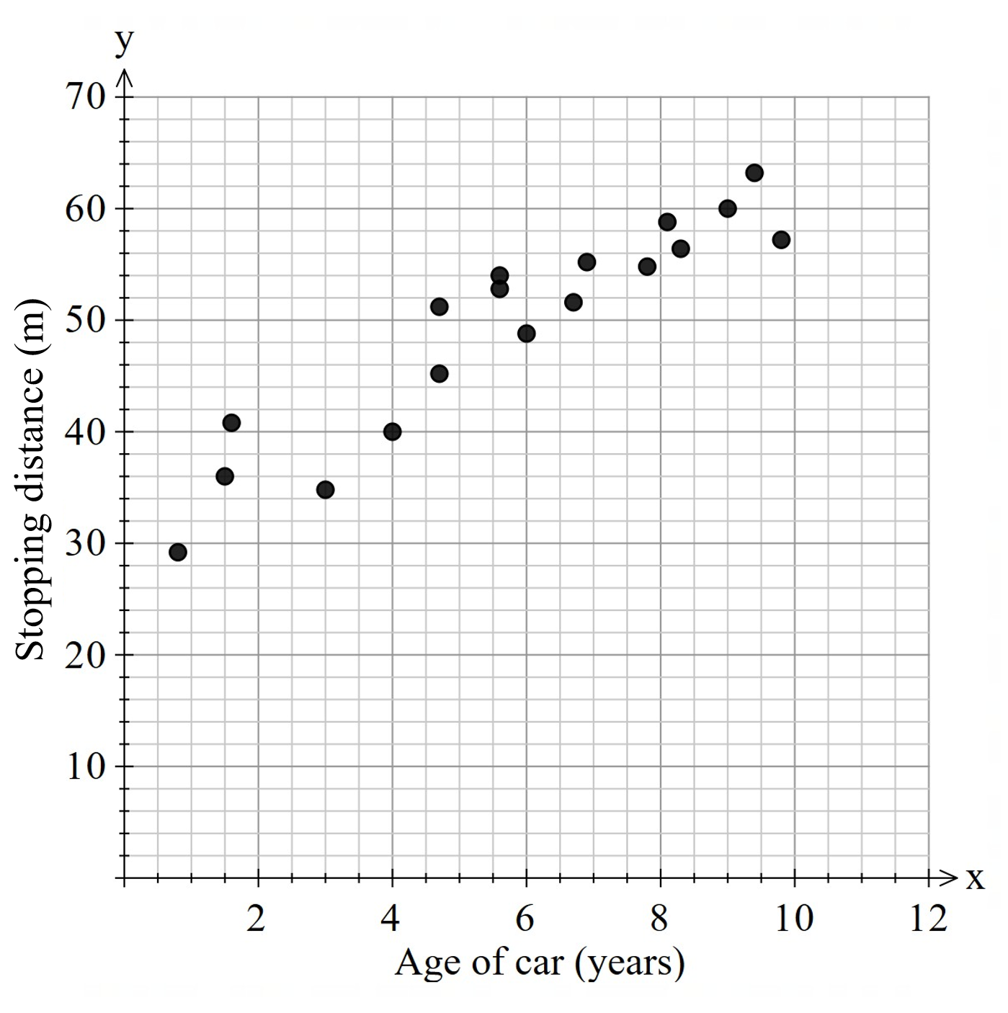
- Draw a line of best fit on the scatter plot.
- Using the line of best fit, predict what the stopping distance of a 6-year-old car could be.
- Why would it not be appropriate to estimate the age of a car that has a stopping distance of 10 m?
- Discuss whether this association may be causal. Justify your answer.

Question 4
In a research study, participants were asked about the number of hours they spend exercising per week and their resting heart rate. The results were recorded and graphed.
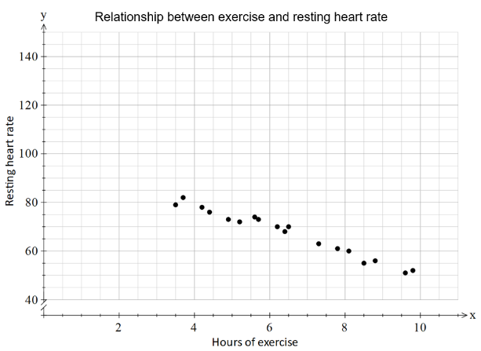
- Describe the bivariate dataset in terms of its form and direction.
- Explain why the number of hours of exercise is the independent variable.
- Draw a line of best fit through the scatter plot.
- Jeremy exercises 5 hours a week. Use the line of best fit to predict Jeremy’s resting heart rate.
- Explain why it is not appropriate to extrapolate the line of best fit to predict the resting heart rate of someone who exercises 14 hours a week.

Sample solutions

Appendix B – scatter plots
- The first line of best fit is the most accurate as the provided points are more evenly spread above and below the line.

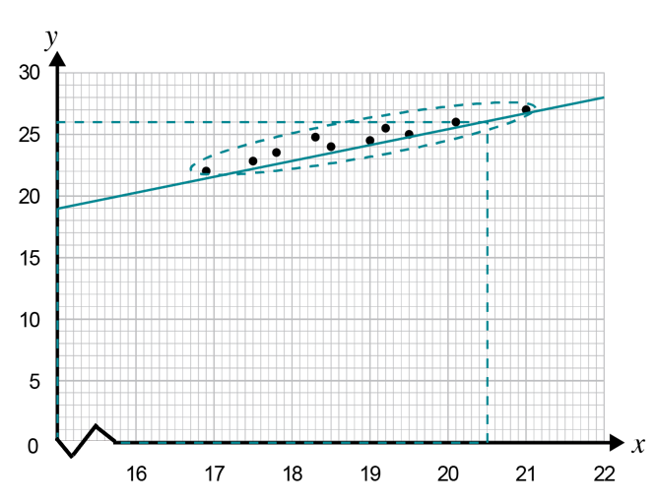
$x=20.5$, $y≈26$. Interpolation.

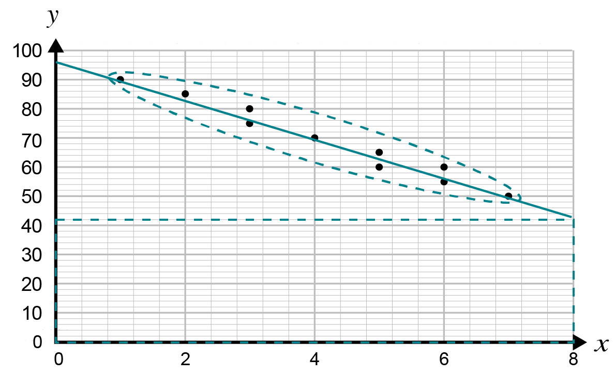
$x=8$, $y≈42$. Extrapolation.

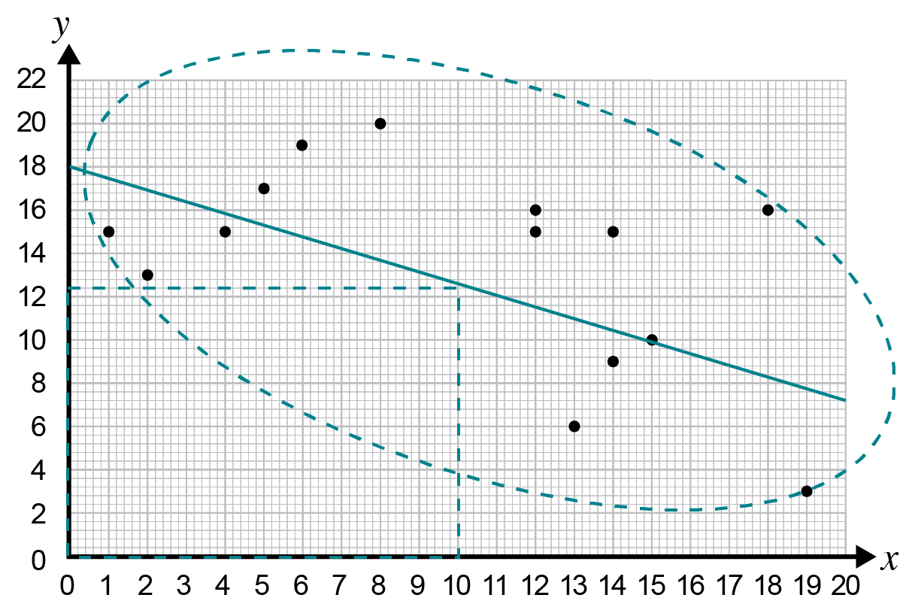
$x=10$ , $y≈12.5$. Interpolation.

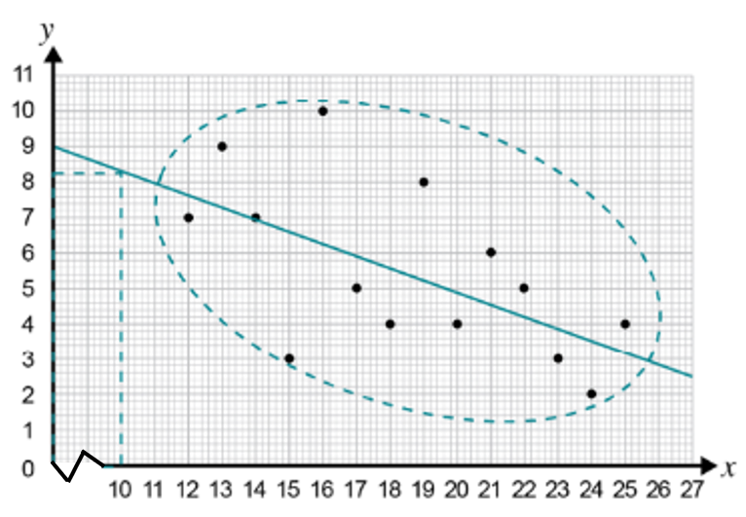
$y=8.5$, $x≈10$. Extrapolation.

Appendix C – Frayer diagram and notes
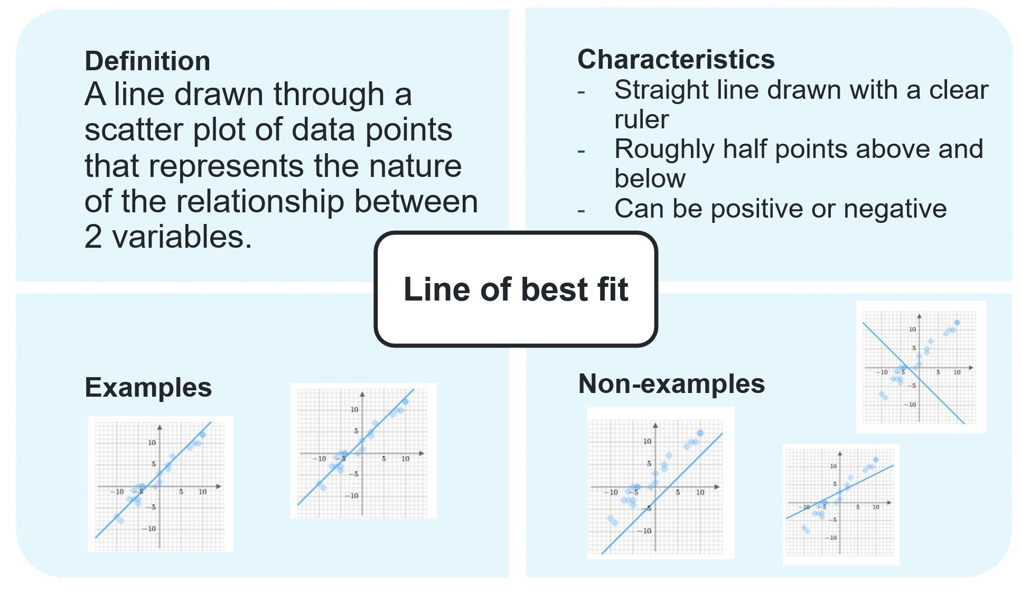

Appendix D – HSC-style questions
Question 1

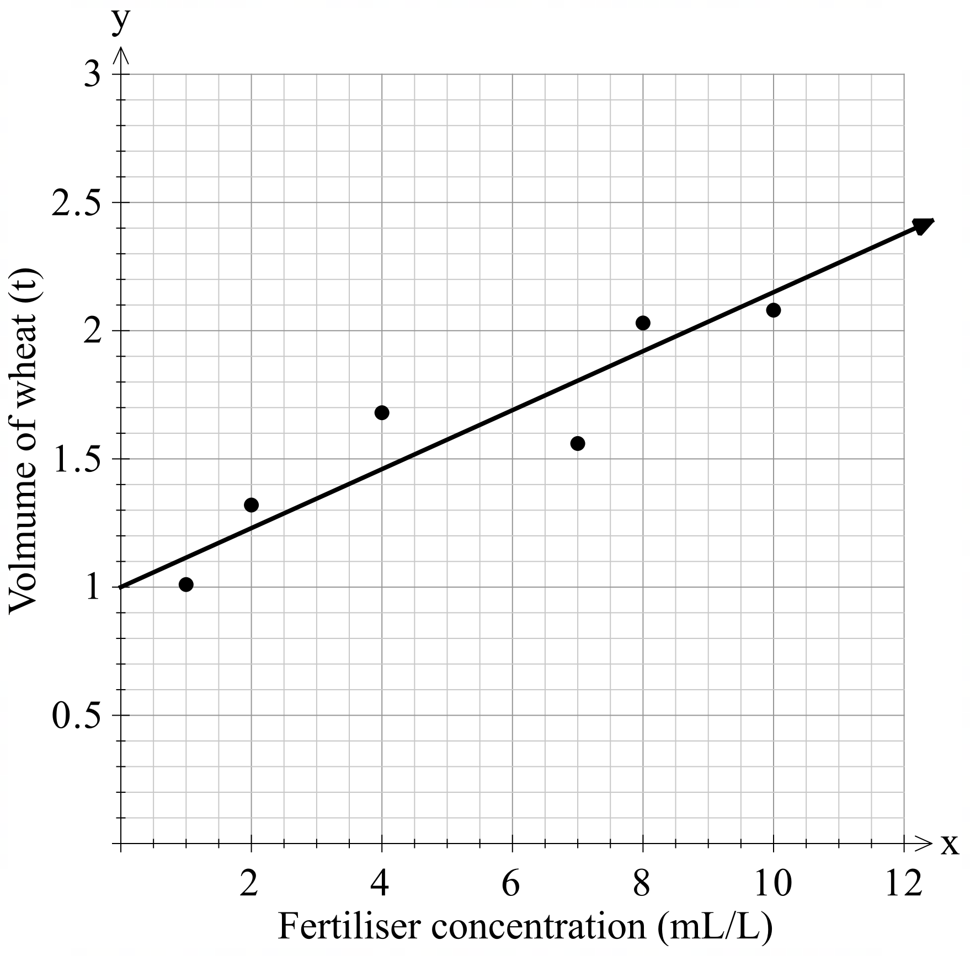
- 5 mL/L implies 1.6 t, 10.8 mL/L implies 2.25 t and 3.5 mL/L implies 1.6 t.
- 1.7 t implies 6 mL/L, 1.2 t implies 1.85 mL/L and 2.4 t implies 12 mL/L.
- All predictions involved interpolating, except 2.4 t implies 12 mL/L, as this was beyond the dataset provided.
- Interpolating is more reliable, as the data acts as evidence towards the prediction. Extrapolating is less reliable as there isn’t evidence and sometimes doesn’t make sense in the context, such as anything less than 1 t implies a negative concentration of fertiliser which isn’t possible.

Question 2

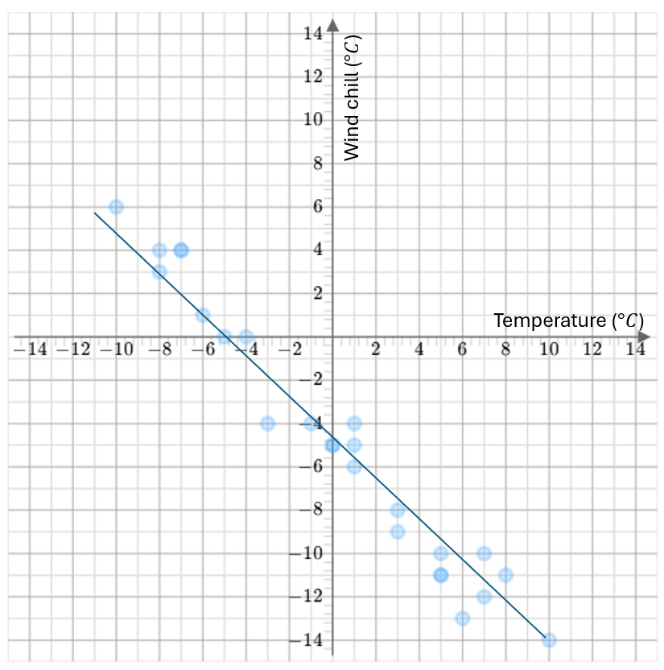
- This is interpolating, so the other data points around it provide evidence towards this being a reliable prediction.
- The wind chill is approximately $-2.9°$.

Question 3

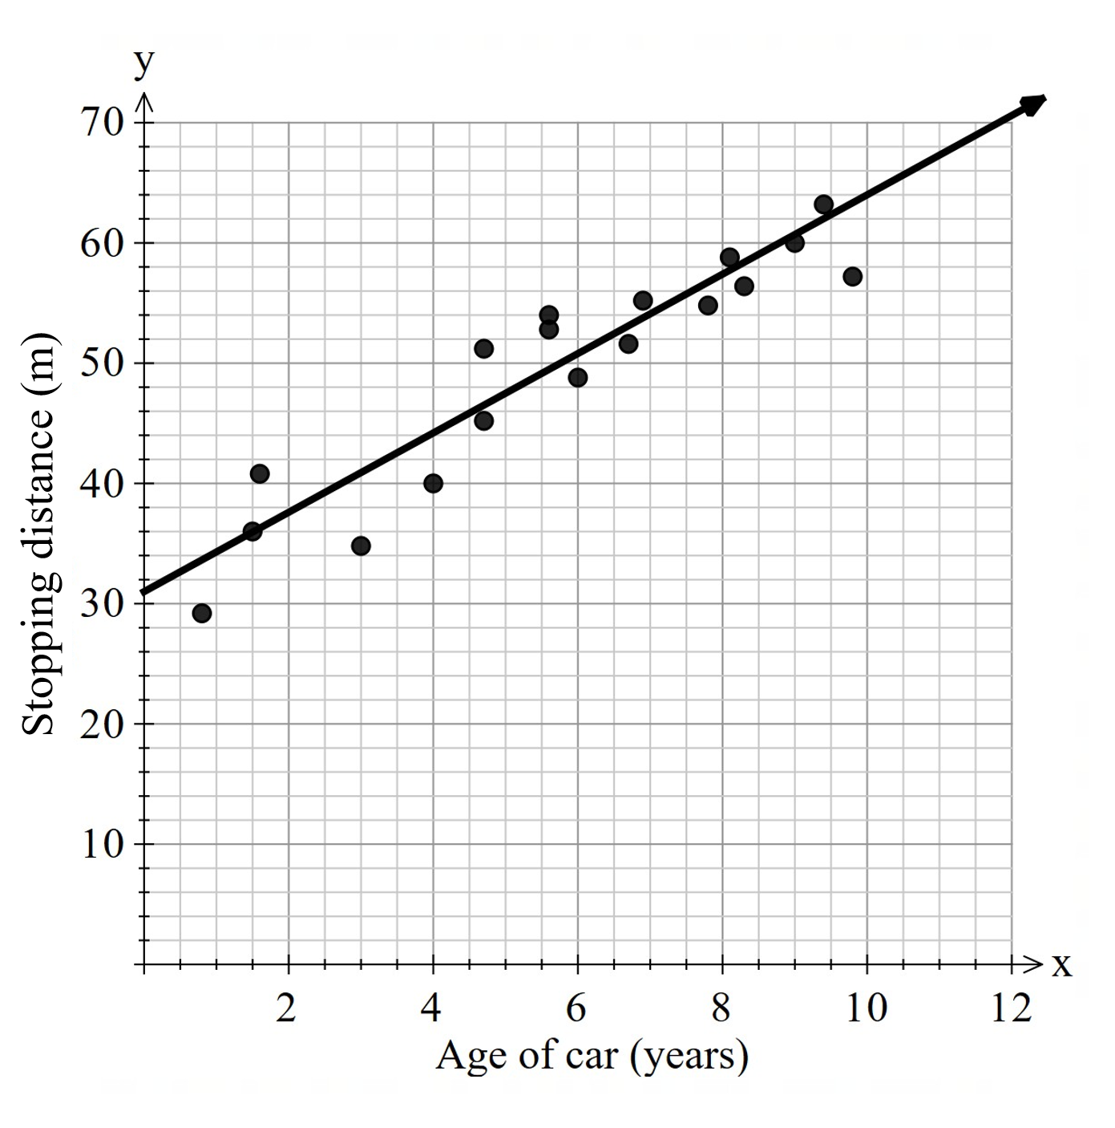
- A 6-year-old car would stop after approximately 50.5 m.
- A stopping distance of 10 m is not currently possible for cars travelling 80 km/h, as the model shows the age of a car as a negative number.
- Many things could change the stopping distance of a car. These cars may not have been fitted with new brakes and tires, so the parts of the car, rather than the vehicle itself, may be the cause.

Question 4
- The relationship between the variables is linear and negative.
- The number of hours of exercise and how active someone is may affect their heart rate, but someone’s resting heart rate does not impact how much they exercise.

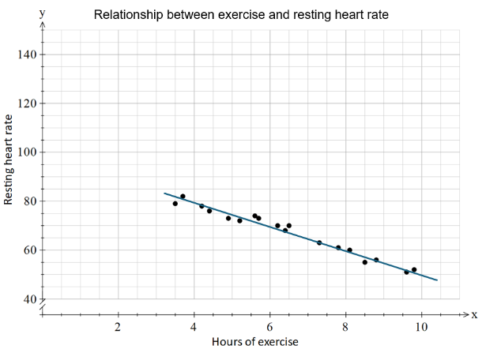
- Jeremy’s resting heart rate would be around 75 beats per minute.
- It is not appropriate, as you cannot have a resting heart rate that is negative.

References
This resource contains NSW Curriculum and syllabus content. The NSW Curriculum is developed by the NSW Education Standards Authority (NESA). This content is prepared by NESA for and on behalf of the Crown in right of the State of New South Wales. The material is protected by Crown copyright.
Please refer to the NESA Copyright Disclaimer for more information https://www.nsw.gov.au/education-and-training/nesa/copyright.
NESA holds the only official and up-to-date versions of the NSW Curriculum and syllabus documents. Please visit NESA https://www.nsw.gov.au/education-and-training/nesa and NSW Curriculum https://curriculum.nsw.edu.au.
Mathematics Standard 11–12 Syllabus © NSW Education Standards Authority (NESA) for and on behalf of the Crown in right of the State of New South Wales, 2024.
Numeracy Stage 6 (CEC) Syllabus © NSW Education Standards Authority (NESA) for and on behalf of the Crown in right of the State of New South Wales, 2021.
NESA (NSW Education Standards Authority) (2024) ‘Glossary’, Mathematics Standard 11–12 Syllabus, NSW Curriculum website, accessed 16 June 2026.
State of Victoria (Department of Education) (2025) ‘Line of best fit’, Sequence 9: Investigating statistics, Arc website, accessed 16 June 2026.

© State of New South Wales (Department of Education), 2026
The copyright material published in this resource is subject to the Copyright Act 1968 (Cth) and is owned by the NSW Department of Education or, where indicated, by a party other than the NSW Department of Education (third-party material).
Copyright material available in this resource and owned by the NSW Department of Education is licensed under a Creative Commons Attribution 4.0 International (CC BY 4.0) license.

This license allows you to share and adapt the material for any purpose, even commercially.
Attribution should be given to © State of New South Wales (Department of Education), 2026.
Material in this resource not available under a Creative Commons license:
- the NSW Department of Education logo, other logos and trademark-protected material
- material owned by a third party that has been reproduced with permission. You will need to obtain permission from the third party to reuse its material.
Links to third-party material and websites
Please note that the provided (reading/viewing material/list/links/texts) are a suggestion only and implies no endorsement, by the New South Wales Department of Education, of any author, publisher, or book title. School principals and teachers are best placed to assess the suitability of resources that would complement the curriculum and reflect the needs and interests of their students.
If you use the links provided in this document to access a third-party's website, you acknowledge that the terms of use, including licence terms set out on the third-party's website apply to the use which may be made of the materials on that third-party website or where permitted by the Copyright Act 1968 (Cth). The department accepts no responsibility for content on third-party websites.

