Pearson’s correlation coefficient
Students formalise the measure for correlation as Pearson’s correlation coefficient and use it to describe and compare the strength and direction of bivariate datasets.
Students will need at least one digital device per pair to interact with Amplify and GeoGebra during this lesson.

Learning intention
- To understand how to use a correlation coefficient to compare bivariate datasets.

Success criteria
- I can identify when I can use Pearson’s correlation coefficient ($r$).
- I can use Pearson’s correlation coefficient to describe the strength and direction of bivariate datasets.
- I can order the strength of relationships using Pearson’s correlation coefficient.
- I can calculate Pearson’s correlation coefficient using a scientific calculator.

Outcomes

Mathematics Standard 2 outcomes
A student:
- develops understanding and fluency in mathematics through exploring and connecting mathematical concepts, choosing and applying mathematical techniques to solve problems, and communicating their thinking and reasoning coherently and clearly MAO-WM-01
- analyses bivariate datasets using statistical processes MST-12-S2-08

Associated Mathematics Standard 1 outcomes
A student:
- develops understanding and fluency in mathematics through exploring and connecting mathematical concepts, choosing and applying mathematical techniques to solve problems, and communicating their thinking and reasoning coherently and clearly MAO-WM-01
- displays and interprets bivariate datasets to solve problems and make predictions
MST-12-S1-06

Associated Numeracy outcomes
A student:
- recognises and applies functional numeracy concepts in practical situations, including personal and community, workplace and employment, and education and training contexts
N6-1.1
- applies numerical reasoning and mathematical thinking to clarify, efficiently solve and communicate solutions to problems N6-1.2
- determines whether an estimate or an answer is reasonable in the context of a problem, evaluates results and communicates conclusions N6-1.3
- chooses and applies efficient strategies to analyse and solve everyday problems involving data, graphs, tables, statistics and probability N6-2.3
- chooses and applies appropriate numeracy operations and techniques to analyse and resolve everyday situations N6-2.6
Numeracy Stage 6 (CEC) Syllabus © NSW Education Standards Authority (NESA) for and on behalf of the Crown in right of the State of New South Wales, 2021.

Content

Mathematics Standard 2

Scatter plots and lines of best fit
- Calculate and interpret Pearson’s correlation coefficient for a bivariate dataset using a scientific calculator
- Describe the strength of a linear relationship between two variables as strong, moderate or weak, and its direction as positive or negative

Mathematics Standard 1

Scatter plots and lines of best fit
- Describe the strength of a linear relationship between two variables as strong, moderate or weak, and its direction as positive or negative
Mathematics Standard 11–12 Syllabus © NSW Education Standards Authority (NESA) for and on behalf of the Crown in right of the State of New South Wales, 2024.

Table 1: lesson summary
Section | Summary of activity | Teaching strategies | Teaching points
Activating prior knowledge | Students analyse 2 scatter plots on slide 4 of the PowerPoint Pearson’s correlation coefficient and describe the relationships using form, direction and strength, then compare the strength of the associations. | Think-Pair-Share  Pose-Pause-Pounce-Bounce | Emphasise the use of statistical language (form, direction and strength) to describe relationships and recognise that it can be difficult to determine strength from visual inspection alone when relationships appear similar.
Connecting learning | Students interpret Pearson’s correlation coefficient using slides 6–7 by linking values to scatter plots, comparing positive and negative relationships and exploring how magnitude relates to strength. Students use the Amplify activity ‘Correlation coefficient’ (hbit.ly/Correlationcoefficient) to develop and test their understanding. | Notice and wonder  Think-Pair-Share | The aim is to develop understanding of Pearson’s correlation coefficient as a numerical measure of the strength and direction of a linear relationship, linking visual patterns in scatter plots to formal values.
Releasing responsibility | Use slide 9 to define Pearson’s correlation coefficient and slide 10 to relate the definition to the number values for $r$. Students use the GeoGebra applet ‘Guess the correlation’ (bit.ly/Guessthecorrelation) to discuss and reason the estimates. Students calculate Pearson’s correlation coefficient with a scientific calculator using a dataset from slide 11. They then practise this skill using additional data. They consolidate understanding by completing Appendix A. | Pose-Pause-Pounce-Bounce  Frayer diagram | Reinforce the use of technology to calculate Pearson’s correlation coefficient and support interpretation in context, highlighting that strong correlation does not alone establish causation.
Independent practice | Students complete Appendix B using the ‘Approaching questions’ scaffold on slide 13, then compare and discuss their solutions. | Pose-Pause-Pounce-Bounce | The focus is on applying calculations and interpreting Pearson’s correlation coefficient in context, using key information to justify reasoning.

Activity structure
Please use the associated PowerPoint Pearson’s correlation coefficient to display images in this lesson.

Activating prior knowledge
- Display slide 4 of the PowerPoint showing the relationship between car weight (kg) and fuel consumption (L/100 km) and car weight (kg) and stopping distance (m).
- In a Think-Pair-Share (bit.ly/thinkpairsharestrategy), ask students to describe the correlation in each scatter plot using the language of form, direction and strength.
Students may observe that both relationships appear positive, linear and of moderate strength.
- Use the Pose-Pause-Pounce-Bounce questioning strategy (PDF 557KB) (bit.ly/posepausepouncebounce) to initiate a class discussion about which relationship appears stronger and how they can tell from the scatter plots.
Encourage students to justify their reasoning and respond to the ideas of others. Students may highlight that when relationships are similar it can be difficult to determine the strength from visual inspection alone.

Connecting learning
- Display slide 6 to reveal Pearson’s correlation coefficient for each of the previous scatter plots. Ask students to consider what they notice and wonder (bit.ly/noticewonderstrategy) about the numbers displayed with each scatter plot.
Students may notice:
- the numbers for both graphs are very similar and positive.
- the graph that looks slightly stronger has a slightly larger number.
Students may wonder:
- What do the numbers represent?
- What are the possible largest or smallest values?
- Does a larger number mean a stronger relationship?
- With at least one digital device per pair of students, assign the Amplify activity ‘Correlation coefficient (/bit.ly/Correlationcoefficient), using the pacing feature for students to complete screens 5–8.
Before completing this activity, you will need to set up an Amplify classroom (bit.ly/createamplifyclassroom) and use the pacing feature to restrict students to screens 5–8.
- Display slide 7 to reveal a third scatter plot showing car weight (kg) and fuel efficiency (km/L) and its Pearson’s correlation coefficient.
- In a Think-Pair-Share, ask students:
- How is the relationship in this scatter plot different from the previous 2?
- The value shown for this relationship is -0.94. What might the negative sign and the size of this number tell us about the relationship?
Guide students to notice that when the points trend upwards, the number shown is positive, and when the points trend downwards, the number shown is negative.
Encourage students to also consider the size of the number. Values closer to 1 or -1 have a stronger pattern with less spread, whereas values closer to 0 indicate a weaker relationship.

Releasing responsibility
- Use slide 9 to formally define Pearson’s correlation coefficient using the NESA Glossary.
- Display slide 10 which shows a number line labelled -1, 0, 1. Use the number line to explain that the value of $r$ describes both the direction and strength of a linear relationship between 2 variables.
Reinforce that a value of $r=0$ does not mean no relationship, but rather no linear relationship between the variables. Clarify that $r$ describes the strength and direction of a linear relationship between 2 variables. Highlight that $r$ measures association, not causation, and the strength of linear relationships only.
Explain that an $r$ value of 1 represents a perfectly positive linear relationship, where all points lie exactly on an increasing straight line, and an $r$ value of -1 represents a perfect negative linear relationship, where all points lie on a decreasing straight line.
While non-linear relationships can still show clear patterns, the value of $r$ will not accurately describe their strength.
- With at least one device per pair of students, have them navigate to the GeoGebra applet ‘Guess the correlation’ (bit.ly/Guessthecorrelation).
- Allow enough time for students to attempt a few different samples each, discussing their reasoning with their partner.
- Explain to students that our calculator can find Pearson’s correlation coefficient.
An optional extension is to briefly explain the idea behind Pearson’s correlation coefficient. Pearson’s correlation coefficient involves finding how much each coordinate pair deviates from the mean, multiplying those together and adding the results. This total sum is then divided by the number of coordinate pairs and their standard deviations to scale the result between $-1$ and $+1$.
- Display slide 11 which shows a dataset of car speed versus braking distance.
- Using the instruction manuals of the specific scientific calculators owned by students, demonstrate how to calculate Pearson’s correlation coefficient.
- Animate slide 11 and use the Pose-Pause-Pounce-Bounce questioning strategy to draw out students’ interpretation of the calculated correlation coefficient and their reasoning about causation using the questions on the slide.
The value of $r$ for the dataset of car speed versus braking distance is $0.991$ (correct to 3 decimal places). This indicates a very strong positive linear relationship between car speed and braking distance. In this context, it is reasonable to suggest a causal relationship, as increasing speed directly affects the distance required to stop. However, braking distance is also influenced by other factors such as road conditions and vehicle mass, so speed is not the only contributing factor. The value of $r$ alone does not establish causation and must be interpreted alongside the context.
- Using an existing resource, allow students to practise using their calculator to find Pearson’s correlation coefficient.
Ensure the existing resource requires students to calculate Pearson’s correlation coefficient from both a table of values and a scatter plot.
- To deepen understanding of Pearson’s correlation coefficient, have students complete Appendix A ‘Frayer diagram’ (bit.ly/frayerdiagram).

Independent practice
- Distribute Appendix B ‘HSC-style question’ to each student to complete.
Students are encouraged to use the ‘Approaching questions scaffold’ found on slide 13 of the PowerPoint.
- Have students compare their solutions with a partner.
- Use the Pose-Pause-Pounce-Bounce questioning strategy for students to share what key words in the question helped them answer each question.

Assessment and differentiation

Suggested opportunities for differentiation
Activating prior knowledge
- Provide sentence scaffolds (for example, ‘The association is ___, ___ and ___.’) to support students describing form, direction and strength.
- Extend students by asking them to justify which relationship is stronger and to explain the limitations of visual comparison.
Connecting learning
- Provide guiding prompts (for example, ‘Is the relationship increasing or decreasing?’ or ‘Are the points tightly clustered?’) to support students interpreting the value of $r$.
- Support students by focusing on interpreting the sign of $r$before considering its magnitude.
- Allow students to work in pairs to discuss and refine their interpretations during the Amplify activity.
- Extend students by asking them to explain why $r$ does not describe non-linear relationships effectively.
Releasing responsibility
- Support students by initially using smaller or simplified datasets before progressing to more complex examples.
- Allow students to work in pairs to discuss and refine their interpretations during the GeoGebra activity.
- Allow students to work with a partner to follow calculator steps and verify results.
- Extend students by asking them to interpret the meaning of the calculated $r$ value in context.
Independent practice
- Support students by prompting them to interpret the value of $r$ before answering extended questions.
- Allow students to work with a partner to discuss reasoning and compare solutions before finalising answers.
- Extend students by asking them to justify their interpretations of $r$ in context, including commenting on causation.

Standard 1 Mathematics adjustments and considerations
Mathematics Standard 1 students do not need to complete any work on Pearson’s correlation coefficient. As this is the basis of this lesson, this lesson could be removed if you have a standalone Mathematics Standard 1 class. Alternatively, if you have a combined Mathematics Standard 1 and 2 class, you could modify this lesson for Mathematics Standard 1 students to allow them to complete further work on describing the strength of a linear relationship between 2 variables as strong, moderate or weak, and its direction as positive or negative.

Suggested opportunities for assessment
Activating prior knowledge
- Observe student responses during the Think-Pair-Share to assess whether they can correctly describe form, direction and strength.
- Ask students to justify which relationship is stronger to assess their ability to interpret and compare scatter plots.
Connecting learning
- Observe student responses during discussion to assess whether they can interpret the sign and magnitude of the correlation coefficient.
- Ask students to explain what a given value of $r$ indicates about a relationship to assess their understanding of strength and direction.
Releasing responsibility
- Observe students as they calculate Pearson’s correlation coefficient to assess whether they can correctly use their calculator.
- Review students’ interpretations of $r$ to assess their understanding of the strength and direction of the relationship.
Independent practice
- Review student responses to assess their ability to calculate and interpret Pearson’s correlation coefficient.
- Ask students to identify key words in the question to assess their ability to interpret and respond to HSC-style questions.

Appendix A

Frayer diagram

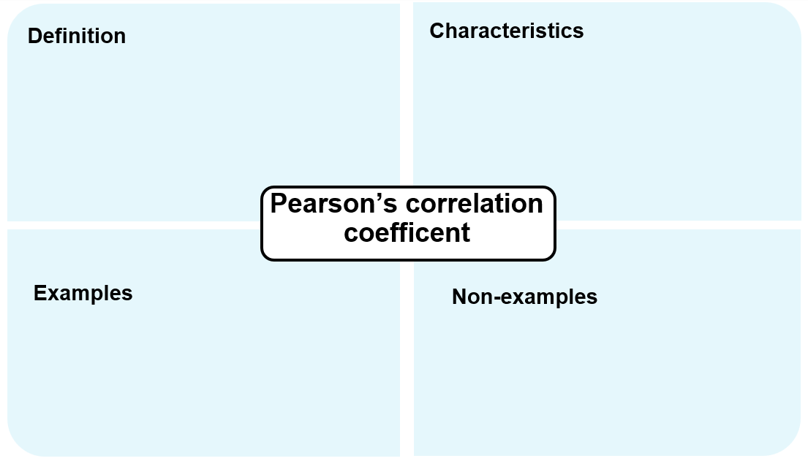
Appendix B

HSC-style question
A set of bivariate data is collected by recording the daily maximum temperature and the electricity used for air-conditioning in 7 households. The graph shows a scatter plot of those measurements.
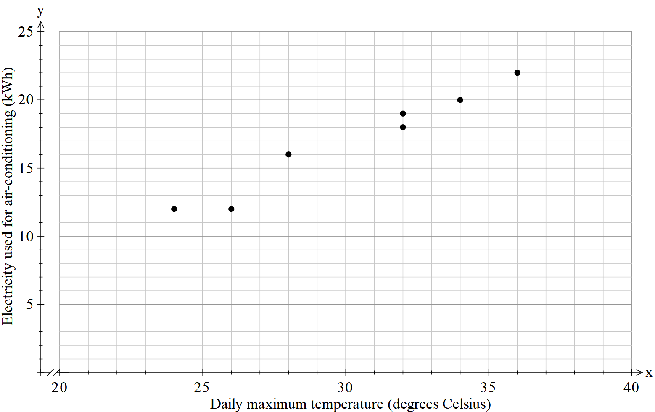
- Calculate Pearson’s correlation coefficient for the data, correct to 2 decimal places.
- Describe the direction and strength of the linear association between the daily maximum temperature and electricity used for air conditioning.
- What does the correlation coefficient reveal about the relationship between the daily maximum temperature and air-conditioning electricity usage, and what can you conclude about whether this relationship implies causation?

Sample solutions

Appendix A – Frayer diagram
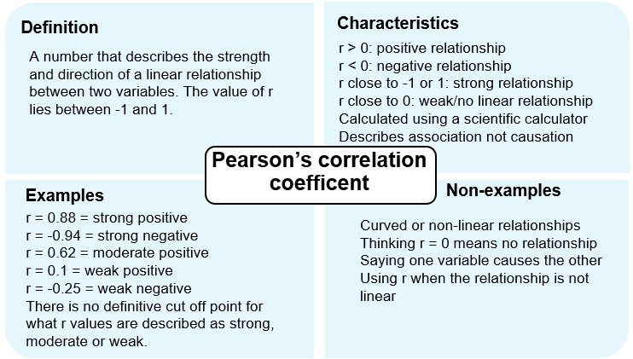

Appendix B – HSC-style question
- $r=0.98$ (correct to 2 decimal places)
- There is a strong positive linear association between the daily maximum temperature and electricity used for air-conditioning.
- This correlation coefficient indicates that as the daily maximum temperature increases, the electricity used for air conditioning tends to increase. This suggests that higher temperatures are associated with increased electricity usage for air conditioning. While this shows a strong association, it does not prove that temperature causes the increase in electricity usage as other factors may also influence this relationship.

References
This resource contains NSW Curriculum and syllabus content. The NSW Curriculum is developed by the NSW Education Standards Authority (NESA). This content is prepared by NESA for and on behalf of the Crown in right of the State of New South Wales. The material is protected by Crown copyright.
Please refer to the NESA Copyright Disclaimer for more information https://www.nsw.gov.au/education-and-training/nesa/copyright.
NESA holds the only official and up-to-date versions of the NSW Curriculum and syllabus documents. Please visit NESA https://www.nsw.gov.au/education-and-training/nesa/copyright and NSW Curriculum https://curriculum.nsw.edu.au.
Mathematics Standard 11–12 Syllabus © NSW Education Standards Authority (NESA) for and on behalf of the Crown in right of the State of New South Wales, 2024.
Numeracy Stage 6 (CEC) Syllabus © NSW Education Standards Authority (NESA) for and on behalf of the Crown in right of the State of New South Wales, 2021.
NESA (NSW Education Standards Authority) (2024) ‘Glossary’, Mathematics Standard 11–12 Syllabus, NSW Curriculum website, accessed 12 June 2026.

© State of New South Wales (Department of Education), 2026
The copyright material published in this resource is subject to the Copyright Act 1968 (Cth) and is owned by the NSW Department of Education or, where indicated, by a party other than the NSW Department of Education (third-party material).
Copyright material available in this resource and owned by the NSW Department of Education is licensed under a Creative Commons Attribution 4.0 International (CC BY 4.0) license.

This license allows you to share and adapt the material for any purpose, even commercially. Attribution should be given to © State of New South Wales (Department of Education), 2026.
Material in this resource not available under a Creative Commons license:
- the NSW Department of Education logo, other logos and trademark-protected material
- material owned by a third party that has been reproduced with permission. You will need to obtain permission from the third party to reuse its material.
Links to third-party material and websites
Please note that the provided (reading/viewing material/list/links/texts) are a suggestion only and implies no endorsement, by the New South Wales Department of Education, of any author, publisher, or book title. School principals and teachers are best placed to assess the suitability of resources that would complement the curriculum and reflect the needs and interests of their students.
If you use the links provided in this document to access a third-party's website, you acknowledge that the terms of use, including licence terms set out on the third-party's website apply to the use which may be made of the materials on that third-party website or where permitted by the Copyright Act 1968 (Cth). The department accepts no responsibility for content on third-party websites.

