Cumulative frequency
Students examine data on e-cigarette users displayed in frequency and cumulative frequency tables, as well as histograms and cumulative frequency histograms. They compare the usefulness of each for answering a variety of questions.
Students will need at least one digital device per pair to interact with the spreadsheet Smoking data during this lesson.

Learning intentions
- To be able to represent data in cumulative frequency tables.
- To be able to represent data in cumulative frequency histograms and polygons.

Success criteria
- I can represent numerical data in a frequency table.
- I can construct a cumulative frequency column in a frequency table.
- I can use the cumulative frequency column to identify missing values from the frequency column.
- I can make decisions based on data in a cumulative frequency table.

Outcomes
A student:
- develops understanding and fluency in mathematics through exploring and connecting mathematical concepts, choosing and applying mathematical techniques to solve problems, and communicating their thinking and reasoning coherently and clearly MAO-WM-01
- displays and analyses datasets using summary statistics and graphical representations
MST-11-08

Associated numeracy outcomes
- recognises and applies functional numeracy concepts in practical situations, including personal and community, workplace and employment, and education and training contexts N6-1.1
- applies numerical reasoning and mathematical thinking to clarify, efficiently solve and communicate solutions to problems N6-1.2
- chooses and applies efficient strategies to analyse and solve everyday problems involving data, graphs, tables, statistics and probability N6-2.3

Content

Display and interpret grouped and ungrouped data
- Represent a numerical dataset as either a frequency distribution table or a cumulative frequency distribution table and graph the associated histogram with polygon, both with and without using digital tools
- Interpret and consider limitations of graphical representations to make conclusions and predictions

Measures of centre and spread
- Describe the mean, median and mode as measures of centre and calculate their values for a dataset in graphical form and tabular form, using a scientific calculator and other digital tools
Mathematics Standard 11–12 Syllabus © NSW Education Standards Authority (NESA) for and on behalf of the Crown in right of the State of New South Wales, 2024.

Table 1: lesson summary table
Section | Summary of activity | Teaching strategies | Teaching points
Activating prior knowledge | Students discuss the infographic from Generation Vape (bit.ly/GenVapeW6Infographic). They are then to write a survey question for each of the statements in their assigned quadrant. | Think-Pair-Share  Notice and wonder | Students consider the types of questions that would need to be asked to collect different types of data.
Connecting learning | Use slide 5 of the PowerPoint Cumulative frequency for students to consider the benefit of displaying data in a frequency table. Display slide 6 and animate to reveal questions for students to answer using the data in the table. Use slide 7 to compare the same data displayed as a frequency histogram and compare answering the same questions using this display. Display slide 8 to reveal a cumulative frequency table and discuss the term ‘cumulative frequency’. Use slides 9 and 10 to answer the same questions using the cumulative frequency table and graph. | Think-Pair-Share  Mini whiteboards  Pose-Pause-Pounce-Bounce | Students compare and consider the benefits of frequency tables, histograms, cumulative frequency tables and cumulative frequency histograms.
Releasing responsibility | Use slides 12–19 to model how to calculate the median from a cumulative frequency table or graph. Use Appendix A to complete a Frayer diagram for cumulative frequency. Students complete Appendix B in groups. | Frayer diagram  Worked examples (Your turn)  Vertical non-permanent surfaces  Visibly random groups of 3 | Students may need to complete additional practise of calculating the median from an existing resource.
Independent practice | Provide students with a copy of the Smoking data spreadsheet. Show students the video ‘Histograms Using GeoGebra’ (https://bit.ly/HistogramGeoGebra). Students are to navigate to GeoGebra Classic website (https://www.geogebra.org/classic ). Students paste the data from the spreadsheet into GeoGebra to create histograms and frequency tables. Students should select the Cumulative option to produce cumulative graphs as well. Students are to calculate the median along with 3 other interesting calculations. |  | Students apply their skills to analyse smoking data.

Activity structure
Please use the associated PowerPoint Cumulative frequency to display images in this lesson.

Activating prior knowledge
- Distribute the infographic from Generation Vape (bit.ly/GenVapeW6Infographic) to each pair of students. Using a Think-Pair-Share (bit.ly/thinkpairsharestrategy), guide students to reflect critically on what they notice and wonder (bit.ly/noticewonderstrategy).
Students could be provided with a link to the infographic that they could access digitally to avoid printing.
Students may notice individual statistics from the infographic. Students may wonder how the data was collected or what is the size of the sample.
- Assign a quadrant from the infographic to each pair of students. Students are to write a survey question for each of the statements in their quadrant that could have been used to collect the data. Students should consider what type of data their survey question would collect.
- Students should combine with another pair working on the same quadrant to compare survey questions and provide peer feedback.

Connecting learning
- Display slide 4 which describes the statistical investigation process. Explain to students that once data has been collected, we need to decide how we will organise it so that it can be analysed to draw conclusions. This lesson will focus on stages 3 and 4 of the process.
- Display slide 5 from the PowerPoint and, using a Think-Pair-Share, guide students to reflect critically on the self-explanation prompts. Students could also compare this data with the data in the infographic they looked at in the ‘Activating prior knowledge’ section.
Students may respond that the benefit of displaying data in a frequency table is that it organises the data, making it easier to read. The decrease in the frequency of older age groups may be surprising, as they might expect it to increase. This decrease may be due to a smaller number of students in these age groups.
- Explain to students that the purpose of the data is to approximate the ages of e-cigarette users in a school to develop appropriate intervention programs.
- Display slide 6, and animate to reveal each of the questions below, one at a time. Ask students to use mini whiteboards (bit.ly/miniwhiteboards) to share their answers to each question.
- How many students in Year 7, aged 12–13, use e-cigarettes?
- How many students in Years 7–9, aged 12–15, use e-cigarettes?
- How many students from Years 7–11, aged 12–17 use e-cigarettes?
- What is the median age of e-cigarette users?
- What is the total number of e-cigarette users in this sample?
- Use the Pose-Pause-Pounce-Bounce questioning strategy (PDF 557 KB) (bit.ly/posepausepouncebounce) to check for understanding of how students found the answers to the questions.
Teachers may need to revise how to find the median from a frequency table. Students learned about this in Stage 4 Unit 9 – shape and skew, Lesson 4 – shooting hoops.
- Display slide 7 which shows the same information displayed as a frequency histogram. In a Think-Pair-Share, ask students to discuss how answering the same questions using the graph might differ to using the frequency table.

Students won’t identify too many differences. They may observe that the frequency histogram makes it easy to determine the mode of the data, but that it is harder to see the height of each column to determine totals.
Students learned about frequency histograms in Stage 4 Unit 2 – making decisions, Lesson 11 – going to the movies.
- Display slide 8 and ask students what they notice and wonder about the table.
Students may notice that the table shows the same data as the previous table and frequency histogram but it now has an additional column for cumulative frequency. Students may wonder what cumulative frequency means.
- In a Think-Pair-Share, ask students to discuss the word accumulation, and in what contexts they may have heard the word used. Teachers may need to provide a prompt such as ‘If someone has accumulated pairs of shoes, what do you think has happened?’
Students should recognise that the words accumulate and cumulative are similar. They may be aware that if a person accumulates pairs of shoes that it means they have increased the number of pairs they have. Students could be prompted to consider the gathering of dust being an accumulation of dust.
- Define the term ‘cumulative frequency’ and highlight to students how the values in the last column of the table on slide 8 accumulate.
The syllabus glossary defines cumulative frequency as ‘The accumulating total of frequencies within an ordered dataset.’ (NESA 2024)
- Display slide 9 and ask students to again answer the questions from step 3. Use a Think-Pair-Share to discuss the advantages and disadvantages of using the cumulative frequency data to assist with finding the solutions.
Advantages of cumulative frequency include quickly finding totals within ranges, efficiently calculating the median, and easily summing the total number of users.
- Display slide 10 and once again ask students to compare using the cumulative frequency histogram, the cumulative frequency table, the frequency histogram and frequency table to answer the questions. Ask them to identify which representation they would use to answer each question and to explain their reasoning.
- Using a Think-Pair-Share, ask students to discuss which representation they would use to answer each question.
Students should realise that tables show accurate numbers, where graphs need a small scale to be able to accurately read values.
Students should also realise that cumulative frequency tables and graphs allow them to easily identify the total number of people survey, or the number of people below a particular value.
Students should also identify that the median is easier to identify using cumulative data because you can easily see the total number of people and can identify where the median lies.

Releasing responsibility
- Use slides 12–19 to model for students how to find the median from a cumulative frequency table and graph using the Worked examples (Your turn) strategy (bit.ly/supportingstrategies).
- Distribute Appendix A ‘Frayer diagram’ (bit.ly/frayerdiagram) and ask students to complete it.
Slide 20 also displays the Frayer diagram if the teacher wishes to use this as a prompt.
- Assign students to visibly random groups of 3 (bit.ly/visiblegroups) at vertical non-permanent surfaces (bit.ly/VNPSstrategy).
- Distribute Appendix B ‘Open Middle’ to each group to complete on vertical non-permanent surfaces.
Before attempting the Open Middle problem, students may need practice adding a cumulative frequency column to a frequency table using an existing resource.
- Pair groups with another group to discuss the strategies they used to complete the problem. Encourage groups to determine if there is more than one solution.

Independent practice
- Provide students with a copy of the spreadsheet Smoking data.
- Show students the video ‘Histograms Using GeoGebra’ (5:48) (https://bit.ly/HistogramGeoGebra) up to 4:25.
- Students are to navigate to the GeoGebra Classic website (https://www.geogebra.org/classic)
- Instruct students to copy and paste the first column of data (2020) from the Smoking data spreadsheet into the first column of the spreadsheet in GeoGebra and then follow the instructions in the video to create a histogram and frequency table.
Students will notice that GeoGebra automatically groups the data, due to the range of the data. Teachers should highlight that it would not be practical to have one bar for each age.
Students should manually adjust the starting value and width of the bins to suit the data.
- Students are to use the Cumulative option to produce a cumulative frequency table and graph.
- Students should calculate the median for the data along with 3 other interesting calculations of their choice.
Students may choose to find how many people over 18 smoke, what is the most popular age to smoke, or how many people under 16 smoke, and so on.
- Students should then repeat this process to analyse the 2025 dataset from the Smoking data spreadsheet by drawing the histograms and frequency tables and performing calculations.

Assessment and differentiation

Suggested opportunities for differentiation
Activating prior knowledge
- There are no correct answers for the notice and wonder activity, so all students should be encouraged to participate and contribute to the discussion.
- Teachers could provide pairs with a variety of survey questions and ask pairs to match the question that was most likely used to collect the data in their quadrant of the infographic.
Connecting learning
- Teachers could add an additional column to the table with tally marks for students still working at this level.
- Teachers may choose to ask students to identify how many students in only one age group were e-cigarette users. For instance, how many students aged 12, use e-cigarettes?
- Students could also be asked to calculate other statistical measures such as the mode, mean and range of the data.
- Teachers may need to revise the features of a frequency histogram and how to draw them by hand. Students first encountered frequency histograms in Stage 4 Unit 2 – making decisions, Lesson 11 – going to the movies.
Releasing responsibility
- Teachers can allow repeated values initially for the Open Middle problem and then increase the challenge level by not allowing repeated values.
- Students could be asked to find the median for their solution to the Open Middle problem.
- Students may benefit from additional practice from an existing resource, on interpreting and drawing frequency and cumulative frequency tables and histograms.
Independent practice
- Students could also use the histogram command in Desmos to represent the smoking data.
- Students can also use the Frequency Polygon option to add this feature to their graph. Students will learn about frequency polygons and cumulative frequency polygons in Lesson 5 – frequency polygons.
- Challenge students to experiment with the start value and bin width to determine the effect on the frequency histogram.
- Teachers could choose to restrict the data range so that students do not need to use grouped data.
- Students can perform statistical calculations at their own level of readiness. Students with lower levels of readiness may focus on the mode and range, whilst students with higher levels of readiness can be challenged to calculate the mean, and even the standard deviation.

Suggested opportunities for assessment
Activating prior knowledge
- Student survey questions could be collected to provide evidence of their understanding of types of data and writing questions.
Connecting learning
- Teachers check students’ understanding of reading and interpreting frequency tables and histograms through the mini whiteboard activity.
Releasing responsibility
- Students’ Frayer diagrams can be collected to assess their understanding of cumulative frequency.
- Teachers should monitor student discussions when working on the Open Middle problem to assess their use of mathematical language and their understanding of cumulative frequency.
Independent practice
- Teachers could collect students’ calculations as evidence of their ability to analyse data.

Appendix A

Frayer diagram
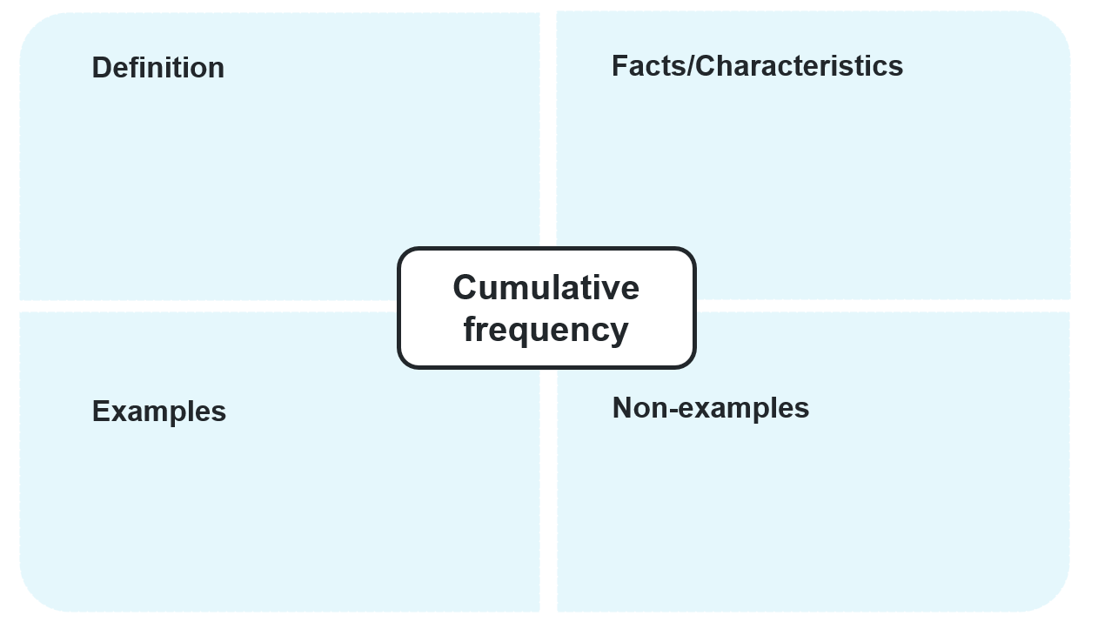

Appendix B

Open Middle
Directions: use the digits 0–9 at most twice each, to complete the frequency distribution table.
Score ($x$) | Frequency | Cumulative frequency
0 | 3 | 3
1
2
3
4
5 |  | 24
Challenge 1: Can you complete the activity without repeated values in the frequency column?
Challenge 2: What values are impossible to achieve in the cumulative frequency column for this problem?

Sample solutions

Appendix B – Open Middle
There are many possible answers. One example is:
Score ($x$) | Frequency | Cumulative frequency
0 | 3 | 3
1 | 6 | 9
2 | 5 | 14
3 | 3 | 17
4 | 3 | 20
5 | 4 | 24
Challenge 1: It is impossible to complete the frequency column without having some scores have the same frequency. The number 1 can’t be used in the frequency column because the 2 ones are required for the cumulative frequency column. The rest of the combinations can be eliminated by identifying the single-digit numbers that sum to 21 (the difference between 24 and 3).
Challenge 2: 4, 5, 11, 21, 22, 23 cannot appear in the cumulative frequency column due to overuse of 1 or 2. The numbers 6, 18 and 19 can only be achieved by misusing the 0 as the frequency for 5 or as the tens digit for the cumulative frequency at 2.

References
This resource contains NSW Curriculum and syllabus content. The NSW Curriculum is developed by the NSW Education Standards Authority. This content is prepared by NESA for and on behalf of the Crown in right of the State of New South Wales. The material is protected by Crown copyright.
Please refer to the NESA Copyright Disclaimer for more information https://educationstandards.nsw.edu.au/wps/portal/nesa/mini-footer/copyright.
NESA holds the only official and up-to-date versions of the NSW Curriculum and syllabus documents. Please visit the NSW Education Standards Authority (NESA) website https://educationstandards.nsw.edu.au/ and the NSW Curriculum website https://curriculum.nsw.edu.au/.
Mathematics Standard 11–12 Syllabus © NSW Education Standards Authority (NESA) for and on behalf of the Crown in right of the State of New South Wales, 2024.

© State of New South Wales (Department of Education), 2025
The copyright material published in this resource is subject to the Copyright Act 1968 (Cth) and is owned by the NSW Department of Education or, where indicated, by a party other than the NSW Department of Education (third-party material).
Copyright material available in this resource and owned by the NSW Department of Education is licensed under a Creative Commons Attribution 4.0 International (CC BY 4.0) license.

This license allows you to share and adapt the material for any purpose, even commercially.
Attribution should be given to © State of New South Wales (Department of Education), 2025.
Material in this resource not available under a Creative Commons license:
- the NSW Department of Education logo, other logos and trademark-protected material
- material owned by a third party that has been reproduced with permission. You will need to obtain permission from the third party to reuse its material.
Links to third-party material and websites
Please note that the provided (reading/viewing material/list/links/texts) are a suggestion only and implies no endorsement, by the New South Wales Department of Education, of any author, publisher, or book title. School principals and teachers are best placed to assess the suitability of resources that would complement the curriculum and reflect the needs and interests of their students.
If you use the links provided in this document to access a third-party's website, you acknowledge that the terms of use, including licence terms set out on the third-party's website apply to the use which may be made of the materials on that third-party website or where permitted by the Copyright Act 1968 (Cth). The department accepts no responsibility for content on third-party websites.

