Formalising correlation
Students formalise their understanding of correlation by describing the direction, strength and form of relationships shown in scatter plots. Students refine how strength is judged, distinguish correlation from causation and apply their understanding to determine the most suitable predictor in real-world contexts.

Learning intention
- To understand the concept of correlation.

Success criteria
- I can identify the association between 2 variables as linear or non-linear given a scatter plot.
- I can describe the strength of an association between 2 variables given a scatter plot.
- I can describe a linear association as either positive or negative given a scatter plot.
- I can explain the difference between correlation and causation.

Outcomes

Mathematics Standard 2 outcomes
A student:
- develops understanding and fluency in mathematics through exploring and connecting mathematical concepts, choosing and applying mathematical techniques to solve problems, and communicating their thinking and reasoning coherently and clearly MAO-WM-01
- analyses bivariate datasets using statistical processes MST-12-S2-08

Associated Mathematics Standard 1 outcomes
A student:
- develops understanding and fluency in mathematics through exploring and connecting mathematical concepts, choosing and applying mathematical techniques to solve problems, and communicating their thinking and reasoning coherently and clearly MAO-WM-01
- displays and interprets bivariate datasets to solve problems and make predictions
MST-12-S1-06
Mathematics Standard 11–12 Syllabus © NSW Education Standards Authority (NESA) for and on behalf of the Crown in right of the State of New South Wales, 2024.

Associated Numeracy outcomes
A student:
- recognises and applies functional numeracy concepts in practical situations, including personal and community, workplace and employment, and education and training contexts
N6-1.1
- applies numerical reasoning and mathematical thinking to clarify, efficiently solve and communicate solutions to problems N6-1.2
- determines whether an estimate or an answer is reasonable in the context of a problem, evaluates results and communicates conclusions N6-1.3
- chooses and applies efficient strategies to analyse and solve everyday problems involving data, graphs, tables, statistics and probability N6-2.3
- chooses and applies appropriate numeracy operations and techniques to analyse and resolve everyday situations N6-2.6
Numeracy Stage 6 (CEC) Syllabus © NSW Education Standards Authority (NESA) for and on behalf of the Crown in right of the State of New South Wales, 2021.

Content

Mathematics Standard 2

Bivariate datasets
- Explain the difference between variables that show correlation and those that have a causal relationship

Scatter plots and lines of best fit
- Describe the form of a dataset as a linear or non-linear based on the association between two variables
- Describe the strength of a linear relationship between two variables as strong, moderate or weak, and its direction as positive or negative

Mathematics Standard 1

Bivariate datasets
- Explain the difference between variables that show correlation and those that have a causal relationship

Scatter plots and lines of best fit
- Describe the form of a dataset as a linear or non-linear based on the association between two variables
- Describe the strength of a linear relationship between two variables as strong, moderate or weak, and its direction as positive or negative
Mathematics Standard 11–12 Syllabus © NSW Education Standards Authority (NESA) for and on behalf of the Crown in right of the State of New South Wales, 2024.

Table 1: lesson summary
Section | Summary of activity | Teaching strategies | Teaching points
Activating prior knowledge | Students analyse a scatter plot through a slow reveal using slides 4–7 from the PowerPoint Formalising correlation. They identify bivariate data, recognise independent and dependent variables and describe the relationship between variables. | Slow reveal graph  Pose-Pause-Pounce-Bounce | The purpose of this section is to activate prior knowledge of bivariate data and variable roles, and to surface misconceptions about association and causation before formal terminology is introduced.
Connecting learning | Students identify and describe features of scatter plots using Appendix A and Appendix B. Using slides 9–12, students classify and compare graphs to introduce the language of form, strength and direction. | Gallery walk  Pose-Pause-Pounce-Bounce  Think-Pair-Share | Emphasise students’ understanding of how to describe relationships in bivariate data by moving from informal observations to the formal language of form, strength and direction, while reinforcing that association does not imply causation.
Releasing responsibility | Students apply their knowledge to describe a scatter plot and define correlation. They then construct a flow chart to summarise how to describe associations in scatter plots using Appendix C. Students then complete Appendix D. | Pose-Pause-Pounce-Bounce | This section consolidates students’ understanding of how to describe associations by structuring their thinking into a clear process that can be applied across different scatter plots.
Independent practice | Students analyse scatter plots in Appendix E to determine which variable is the best predictor of house price, justifying their reasoning using form, strength and direction. |  | The aim is to provide opportunities for students to apply their understanding independently, using appropriate statistical language to interpret and compare relationships between variables in context.

Activity structure
Please use the associated PowerPoint Formalising correlation to display images in this lesson.

Activating prior knowledge
- Use slides 4–7 of the PowerPoint to complete the slow reveal graphs activity (slowrevealgraphs.com).
Students should notice the following for each slide:
- Slide 4: coordinates are revealed. Students should recognise that the graph shows 2 variables changing together, indicating bivariate data.
- Slide 5: the horizontal axis label is revealed. Students should recognise that this is the independent variable.
- Slide 6: the vertical axis label is revealed. Students should recognise that this is the dependent variable.
- Slide 7: the title is revealed.
- Use the Pose-Pause-Pounce-Bounce questioning strategy (PDF 557KB) (bit.ly/posepausepouncebounce) to initiate a class discussion. Possible questions include:
- What does this scatter plot suggest about the relationship between the 2 variables?
- How would you describe how the variables change together?
- Does this relationship suggest that one variable causes the other? Why or why not?
Students may recognise that as engine size increases, fuel consumption generally increases. They should identify that the dataset is bivariate data, with engine size as the independent variable and fuel consumption as the dependent variable, and recognise that the relationship shows association, not causation.

Connecting learning
- Provide each student with a copy of Appendix A ‘Guess my scatter plot’ in a plastic sleeve.
- Facilitate a class brainstorm of ‘yes or no’ questions that could be used to help identify each of the scatter plots.
- In pairs, students are to play the game, ‘Guess my scatter plot’:
- Students may need a divider between them so they cannot see each other’s graphs.
- Each student selects one scatter plot and marks it without showing their partner.
- Students take turns asking ‘yes or no’ questions about the features of the scatter plots to identify their partner’s graph.
- If a student receives a ‘yes’, they may ask another question. If they receive a ‘no’, their partner takes a turn.
- After each question, students should cross off graphs that don’t fit the answer to their question.
- On their turn, a student may guess the scatter plot at any time.
- The aim is to identify their partner’s scatter plot using as few questions as possible.
- After a few rounds of the game, discuss with the class which questions may have been more effective than others.
- Provide each pair of students with Appendix B ‘Scatter plot card sort’, with the scatter plots cut up as individual cards.
- Students are to sort the scatter plots into groups based on similarities they notice between the graphs. Students should be prepared to explain the reasoning behind their groupings.
- Have students complete a gallery walk (bit.ly/DLSgallerywalk) to observe how other pairs sorted the scatter plots.
- Use the Pose-Pause-Pounce-Bounce questioning strategy to discuss students’ observations and reasoning. Possible questions include:
- What similarities or patterns did you notice when grouping the scatter plots?
- What features of the scatter plots helped you decide which graphs belonged together?
- Did any pairs sort the graphs differently? What features led to those different groupings?
Students may group scatter plots based on whether the pattern appears straight or curved, whether the points trend upward or downward, and how closely the points cluster together.
Use the discussion to connect student observations to the formal terms of form as linear or non-linear, direction as positive or negative, and strength as strong, moderate or weak.
- Display slide 9 which shows 3 scatter plots side by side, each with a positive direction but with varying strengths.
- In a Think-Pair-Share (bit.ly/thinkpairsharestrategy), ask students:
- Which graph appears to show the strongest association?
- What features of the scatter plot helped you make that decision?
During the class sharing, guide students to notice features such as points lying close to an imaginary straight line, minimal spread around the pattern and a clear overall pattern formed by the points.
- Still displaying slide 9, conduct a class discussion by asking students when we would describe the association as strong, moderate or weak.
Guide students to notice that:
- Graph A: the points are tightly clustered and the overall pattern is very clear, therefore this would be described as having a strong association.
- Graph B: the upward pattern is still visible, however the points are more spread out, meaning this would be described as having a moderate association.
- Graph C: there is only a slight upward trend and the points are widely scattered, making the overall pattern harder to see.
Emphasise that strength describes how closely the points cluster around the overall pattern.
- Ask students to now return to Appendix A ‘Guess my scatter plot’ to play another round.
During this round, encourage students to refine their questions using statistical language. For example, instead of asking if the points ‘go up’, students could ask if the graph shows a positive association, whether the association appears strong or weak, or whether the pattern is linear or non-linear.

Releasing responsibility
- Display slides 11–13 to introduce the formal language for describing associations in scatter plots.
Students might identify that the form describes whether the pattern follows a straight line or a curve, strength describes how closely the points follow the pattern, and direction describes whether the points trend upward, downward or show no clear direction.
- Display slide 14 which shows the engine size versus fuel consumption scatter plot from earlier in the lesson. Initiate a class discussion and have students use the terminology they have learnt to formally describe the relationship shown in the scatter plot.
Students should describe the relationship as a strong, positive, linear association between engine size and fuel consumption.
- Use the Pose-Pause-Pounce-Bounce questioning strategy to initiate a class discussion. Possible questions include:
- Does this association imply that engine size causes fuel consumption?
- What is the difference between saying 2 variables are correlated and saying one variable causes the other?
Remind students that ‘causation’ means that changes in one variable directly produce changes in the other variable. Emphasise that a strong correlation does not necessarily mean there is a causal relationship.
- Animate slide 14 to formally define correlation using the NESA Glossary.
- Distribute Appendix C ‘Scatter plot flow chart’ for each student to complete.
- Explain to students that they are to fill in the blanks to summarise how to describe the association shown in a scatter plot.
The flow chart guides students through identifying the form, strength and direction of the association.
- Distribute Appendix D ‘Describing datasets’ for each student to complete. Ask students to use their flow chart to determine how to formally describe the association shown in the scatter plot.

Independent practice
- Distribute Appendix E ‘Independent practice activity’ which shows 3 scatter plots comparing house price with different independent variables.
- Students analyse the scatter plots and determine which independent variable would be the best predictor of house price, justifying their answer using the language of direction, strength and form.
- Have students compare their answers with a partner.

Assessment and differentiation

Suggested opportunities for differentiation
Activating prior knowledge
- Provide guiding prompts, for example, ‘What is changing?’ or ‘Which variable is on the horizontal axis?’ to support students to interpret each stage of the reveal.
- Extend students by asking them to justify the type of relationship and explain why it does not imply causation.
Connecting learning
- Provide question prompts or stems, for example, ‘Is the association positive or negative?’ and ‘Is the pattern linear?’ to support students asking effective ‘yes’ or ‘no’ questions.
- Support students by initially limiting the number of scatter plots in Appendix B or focusing on one feature before considering strength, direction and form.
- Allow students to work collaboratively with another group to discuss and refine their classifications and reasoning during the gallery walk.
- Extend students by asking them to justify their groupings using formal statistical language and compare alternative classifications.
Releasing responsibility
- The scaffold for the flow chart can be removed to extend students.
- Allow students to work with a partner to refine their flow chart and responses before finalising.
Independent practice
- Support students by focusing on describing direction, strength and form for one graph before comparing all 3.
- Allow students to work with a partner to discuss and justify which variable is the best predictor, before recording responses.

Mathematics Standard 1 adjustments and considerations
The syllabus content in this lesson is the same for both Mathematics Standard 2 and Mathematics Standard 1. The lesson can be completed as is with adjustments made where necessary.

Suggested opportunities for assessment
Activating prior knowledge
- Observe student responses during discussion to assess whether they can identify independent and dependent variables as they are revealed.
Connecting learning
- Observe student questions and responses during the guessing game to assess their understanding of the features of scatter plots.
- Ask students to justify their groupings during the card sort and gallery walk to assess their use of statistical language.
Releasing responsibility
- Review students’ flow charts to assess their understanding of how to describe form, strength and direction.
Independent practice
- Ask students to justify which variable is the best predictor of house price to assess their ability to apply their understanding of association in context.

Appendix A

Guess my scatter plot
- Mark a scatter plot in secret (use a divider if needed).
- Take turns asking ‘yes’ or ‘no’ questions to identify your partner’s scatter plot
- If the answer is ‘yes’, ask another question. If the answer is ‘no’, your turn ends.
- You may guess at any time. Aim to identify the graph in as few questions as possible.
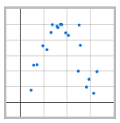 | 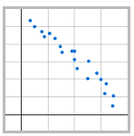 | 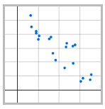 | 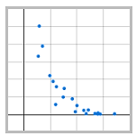
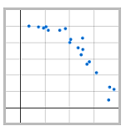 | 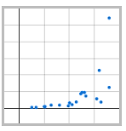 | 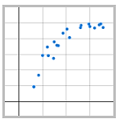 | 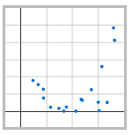
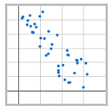 | 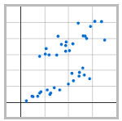 | 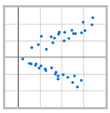 | 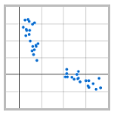
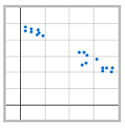 | 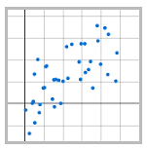 | 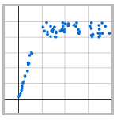 | 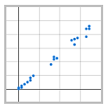

Appendix B

Scatter plot card sort

Appendix C

Scatter plot flow chart
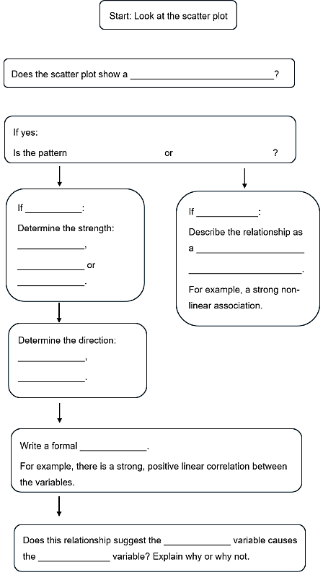

Appendix D

Describing datasets
A study investigated the relationship between the average number of minutes students spend on social media each day and the average number of minutes they spend studying each day. The averages for a group of students were recorded and displayed in the scatter plot.
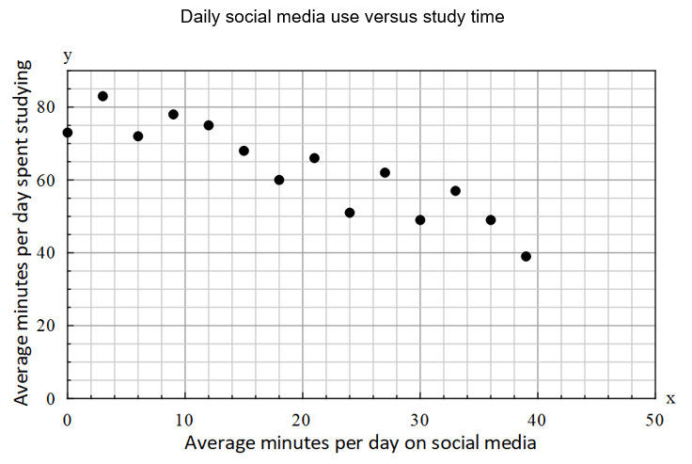
Use the flow chart you created to describe the association shown in the scatter plot.
In your response:
- identify the form, strength, and direction of the relationship
- write a full sentence describing the association between the variables
- state whether the relationship suggests causation and explain your reasoning.

Appendix E

Independent practice activity
Analyse the scatter plots and determine which independent variable would be the best predictor of house price, justifying your answer using the language of direction, strength and form.
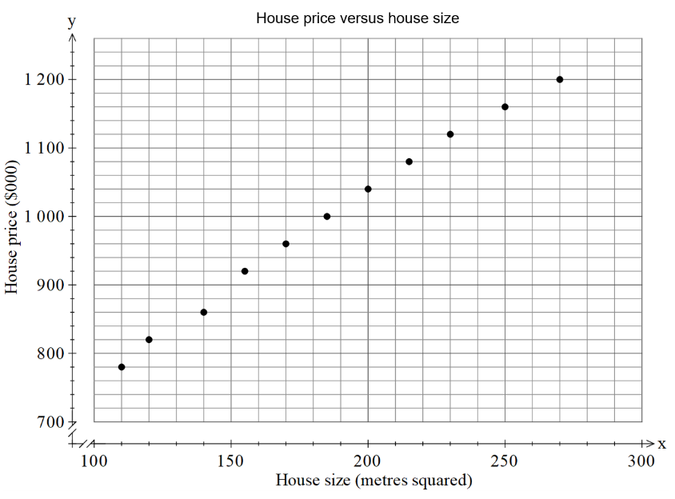 | 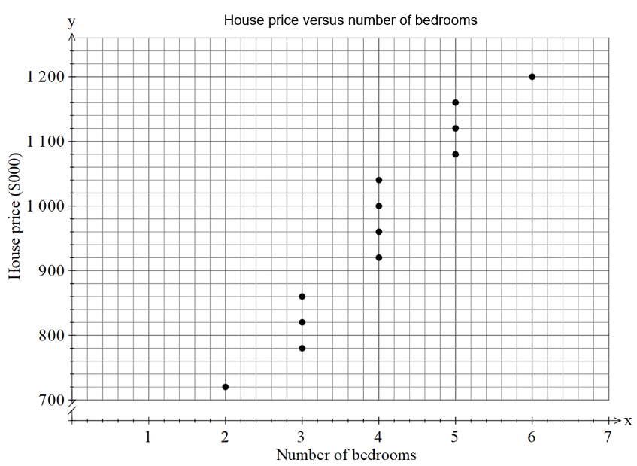 | 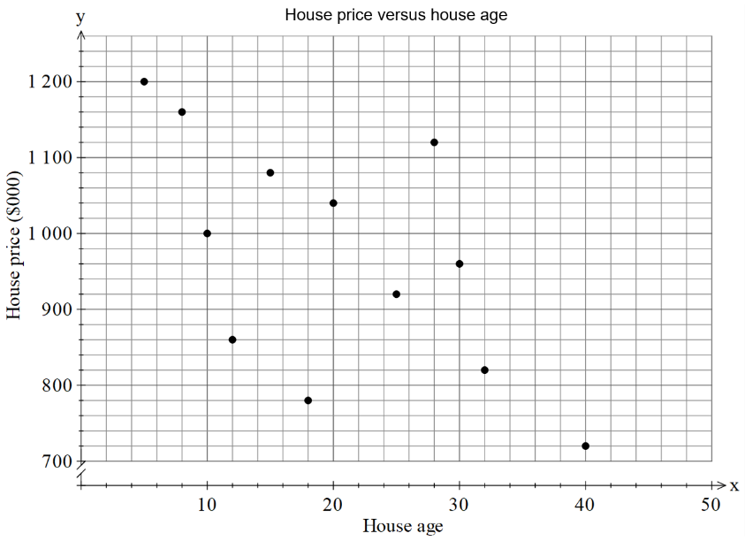

Sample solutions

Appendix C – scatter plot flow chart
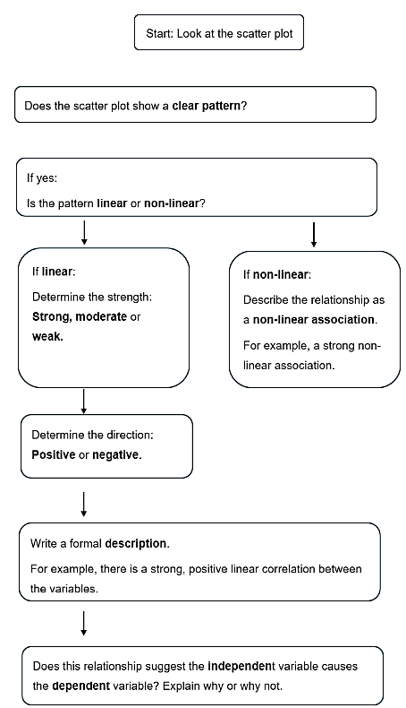

Appendix D – describing datasets
Form: linear
Strength: moderate
Direction: negative
There is a moderate, negative, linear correlation between the variables.
The relationship shows that the variables are related, but it does not prove that spending more time on social media directly causes students to study less.

Appendix E – Independent practice activity
House size would be the best predictor of house price.
The scatter plot of price versus size shows a strong, positive, linear association, as the points follow a clear upward pattern and lie close to a straight line.
The scatter plot of price versus number of bedrooms shows a moderate, positive, linear association, as the points generally increase but are more spread out.
The scatter plot of price versus age of the house shows a weak, negative, linear association, as the points are widely scattered with only a slight downward trend.
Therefore, house size is the most suitable predictor of house price because it shows the strongest linear association.

References
This resource contains NSW Curriculum and syllabus content. The NSW Curriculum is developed by the NSW Education Standards Authority (NESA). This content is prepared by NESA for and on behalf of the Crown in right of the State of New South Wales. The material is protected by Crown copyright.
Please refer to the NESA Copyright Disclaimer for more information https://www.nsw.gov.au/education-and-training/nesa/copyright.
NESA holds the only official and up-to-date versions of the NSW Curriculum and syllabus documents. Please visit NESA https://www.nsw.gov.au/education-and-training/nesa/copyright and NSW Curriculum https://curriculum.nsw.edu.au.
Mathematics Standard 11–12 Syllabus © NSW Education Standards Authority (NESA) for and on behalf of the Crown in right of the State of New South Wales, 2024.
Numeracy Stage 6 (CEC) Syllabus © NSW Education Standards Authority (NESA) for and on behalf of the Crown in right of the State of New South Wales, 2021.

© State of New South Wales (Department of Education), 2026
The copyright material published in this resource is subject to the Copyright Act 1968 (Cth) and is owned by the NSW Department of Education or, where indicated, by a party other than the NSW Department of Education (third-party material).
Copyright material available in this resource and owned by the NSW Department of Education is licensed under a Creative Commons Attribution 4.0 International (CC BY 4.0) license.

This license allows you to share and adapt the material for any purpose, even commercially. Attribution should be given to © State of New South Wales (Department of Education), 2026.
Material in this resource not available under a Creative Commons license:
- the NSW Department of Education logo, other logos and trademark-protected material
- material owned by a third party that has been reproduced with permission. You will need to obtain permission from the third party to reuse its material.
Links to third-party material and websites
Please note that the provided (reading/viewing material/list/links/texts) are a suggestion only and implies no endorsement, by the New South Wales Department of Education, of any author, publisher, or book title. School principals and teachers are best placed to assess the suitability of resources that would complement the curriculum and reflect the needs and interests of their students.
If you use the links provided in this document to access a third-party's website, you acknowledge that the terms of use, including licence terms set out on the third-party's website apply to the use which may be made of the materials on that third-party website or where permitted by the Copyright Act 1968 (Cth). The department accepts no responsibility for content on third-party websites.

