Flaws and fakes in data
Students revisit flaws in data collection before investigating how data can be manipulated through misleading graphs and statistics.

Learning intentions
- To recognise and explain how statistical calculations can be used to mislead an audience.
- To recognise and explain how graphs can be misleading, whether intentionally or unintentionally.

Success criteria
- I can explain why a data display might be misleading and suggest specific improvements.
- I can explain which measure of centre to use to support a persuasive argument.
- I can create a data display that supports a persuasive argument.

Outcomes
A student:
- develops understanding and fluency in mathematics through exploring and connecting mathematical concepts, choosing and applying mathematical techniques to solve problems, and communicating their thinking and reasoning coherently and clearly MAO-WM-01
- Displays and analyses datasets using summary statistics and graphical representations MST-11-08

Content
Population and sample
- Describe the potential faults in the design and practicalities of a data collection process by considering survey design, experiments and observational studies, and misunderstandings and misrepresentations
Mathematics Standard 11–12 Syllabus © NSW Education Standards Authority (NESA) for and on behalf of the Crown in right of the State of New South Wales, 2024.

Table 1: lesson summary table
Section | Summary of activity | Teaching strategies | Teaching points
Activating prior knowledge | Using Appendix A, students identify issues in data examples. Guide students through slides 4–6 of the Flaws and Fakes in Data PowerPoint to analyse and discuss the presented flaws. Use slide 7 to support students in summarising their observations using sentence starters. | Pose-Pause-Pounce-Bounce  Think-Pair-Share | Students will revise how faults in survey design and observational studies can lead to unreliable and biassed information.
Connecting learning | Using slide 9, show students news articles that appear untrustworthy and discuss features that affect credibility.  Using slide 10, analyse examples of data misrepresentation and discuss how survey limitations, misleading visuals and headline phrasing can distort public understanding.  Using slide 11, students evaluate different graph types to determine which would most effectively support specific claims about students’ sleep habits.  Use Appendix B for students to identifying misleading elements in graph design. | Pose-Pause-Pounce-Bounce  Think-Pair-Share | Students develop critical thinking skills by recognising how data can be misused or misrepresented in everyday media. By analysing real examples, students learn to question the reliability of data sources, understand the impact of statistical choices (like mean vs mode) and become more discerning consumers of information.
Releasing responsibility | Students discuss how graphs can be misleading then review slide 13, which outlines common techniques used to distort or misrepresent data visually.  Use slide 14 to explore how statistics can be misleading and support a discussion around the appropriate use of mean, median, and mode. Students create a personal summary and highlight key ways both statistics and graphs can be manipulated to mislead. | Pose-Pause-Pounce-Bounce  Notes to future forgetful selves | Students develop the ability to critically evaluate how data can be manipulated to create misleading impressions. By recognising these tactics, students become more informed interpreters of information, better prepared to question data in media, advertising and academic contexts.
Independent practice | Using slide 16, students consider a scenario and convince their principal to install lockers due to heavy backpacks causing back pain. Students discuss how they would construct a persuasive argument to present their case.  Using slide 17, students revise their initial persuasive pitch by incorporating techniques to make their argument more persuasive.  To further strengthen their case, students design an infographic or short report that includes at least one graph using fictional data to support their argument. | Visibly random groups of 3  Vertical non-permanent surfaces  Gallery walk | Students’ develop their ability to apply data literacy and persuasive communication in a real-world context. By creating their own graphs and evaluating those of others, students gain a deeper understanding of how visual and verbal elements can be used ethically or manipulatively, to influence an audience.

Activity structure
Please use the associated PowerPoint Flaws and fakes in data to display images in this lesson.

Activating prior knowledge
- Distribute Appendix A ‘Faults in survey questions and data collection’ to student pairs and ask them to identify any faults with the survey questions or data collection processes outlined in the examples.
- Use slides 4–6 of the PowerPoint and a Pose-Pause-Pouce-Bounce questioning strategy (PDF 557 KB) (bit.ly/posepausepouncebounce) to discuss each of the scenarios and their faults.
- Display the sentence starters on slide 7 for students to summarise their learning by discussing in a Think-Pair-Share (bit.ly/thinkpairsharestrategy).
Sampling techniques and survey question design featured in Lesson 1 – sampling techniques and Lesson 2 – designing questions and data classification.

Connecting learning
- Display slide 9 of the PowerPoint and ask students if the articles on the slide appear to be trustworthy. Give students time to observe the articles.
- Use the Pose-Pause-Pounce-Bounce questioning strategy to initiate a class discussion around the following question: When you read an article, what clues or features help you decide if the information is trustworthy or not? Suggested prompting questions include:
- What do you think about the sources of data mentioned in the article?
- How does the language used in the headline or text influence your trust?
- Why might a small sample size combined with a percentage be misleading?
The purpose of this activity is to prompt students to begin to think about credibility and misleading or biased information.
Students should recognise that the articles include unreliable sources and some of the headings use emotionally charged language with big claims. Students might notice that a percentage is used on a sample size of only 20 people which implies an exaggerated level of reliability.
- In a Think-Pair-Share, ask students to discuss the following: Can you recall a graph, advertisement or social media post you have seen that seemed untrustworthy? What made you think that?
- Display slide 10 showing examples of misrepresentations. In a Think-Pair-Share, ask students to discuss the prompts and suggest how the misrepresentations could be fixed.
The headline might lead the public to overestimate the overall fitness level of teens. The survey only measured the frequency of exercise, not the intensity or type of exercise, nor did it assess other indicators of physical fitness, such as strength, endurance or body composition. The sector chart misleads the viewer into thinking that all age groups attend the gym equally, when the proportions are significantly different.

Recognising misrepresentation in data
- Display slide 11 and ask students to discuss in pairs ‘If you wanted to say that Year 10 aren’t getting enough sleep, which graph would you choose and why?’ Other question prompts include:
- Which graph would you choose for the other year levels?
- Would you use the same graph for all year levels?
- Which graph do you think more accurately represents student sleep habits?
- Can using the mean instead of the mode (or vice versa) be considered misleading?

Some students reporting significantly higher sleep hours would result in the mode being lower than the mean.
The mean can provide a comprehensive picture by considering all data points, useful for understanding overall trends. However, the mode might be chosen to highlight the most common experience among students. The choice depends on the message the school wants to convey, whether to focus on the typical value or the average.
The mean can be affected by outliers, giving a skewed picture if there is a wide range of values. Conversely, the mode might not reflect the diversity of experiences if the data are widely spread or bimodal.
- Teachers should highlight that although the mean and mode have been calculated accurately, the fact that they differ means that they can be manipulated when reporting the results to support different messaging.

Recognising misrepresentations in graphs
- Explain to students that graphs can be misleading, often unintentionally, due to a variety of design choices that distort the data.
- Distribute Appendix B ‘What is wrong with the data display?’ for students to complete in their pairs.
- Have neighbouring pairs compare and discuss their responses with each other.

Releasing responsibility
- Use a Pose-Pause-Pounce-Bounce questioning strategy to have students share ways that graphs can be misleading.
- Use slide 13 to show a list of common ways a graph can be misleading and discuss any that students may not have already contributed.
- Use a Pose-Pause-Pounce-Bounce questioning strategy to have students share ways in which statistics can be misleading. Slide 14 can be used to discuss when mean, median and mode should be used.
Teachers could open this discussion to include other statistics such as minimum value, maximum value, range, interquartile range and standard deviation depending upon student prior knowledge.
- Have students create notes to their future forgetful selves (bit.ly/notestofutureself) to summarise the ways statistics and graphs can be used to mislead an audience.

Independent practice
- Display slide 16 of the PowerPoint and read the following scenario to students:
Students at your school are experiencing back pain from carrying heavy backpacks all day. A group of students approach the principal to request that lockers be installed. The principal, however, believes lockers are unnecessary.
- Assign students to visibly random groups of 3 (bit.ly/visiblegroups) and ask groups to consider the scenario and discuss how they would put forward an argument for lockers to their principal.
- Working at vertical non-permanent surfaces (bit.ly/VNPSstrategy), ask each group to write a short persuasive pitch (3–4 sentences) to present their case.
- Use slide 17 to support students with manipulating their argument to make it more persuasive. Ask students to adjust and rewrite their argument underneath their first one.
- Instruct students to use their persuasive pitch to create an infographic or report that contains at least one graph (using made up data) to support their argument for obtaining lockers.
The infographic or report could be created digitally or in student workbooks depending on the availability of technology.
- Students are to do a gallery walk (bit.ly/DLSgallerywalk) to observe the different approaches taken. During the gallery walk, ask groups to note down any misleading data, claims or graphs as well as the strategies used to present the information in an interesting or convincing way. Some questions to prompt student discussions could be:
- Would a different type of graph have more impact?
- Would a different type of graph be easier to interpret?
- How has language or font been used to make the argument more convincing?

Assessment and differentiation

Suggested opportunities for differentiation
Activating prior knowledge
- Encourage students to highlight or annotate directly on the example to reduce cognitive load.
- Challenge students to evaluate the implications of the faults in the scenarios (for example, ‘How could these errors affect decision-making?’).
Connecting learning
- Support students by highlighting key words or phrases in the articles for students to focus on.
- Challenge students to find their own article to evaluate credibility.
- Support students with Appendix B by pairing with a more confident peer.
- Challenge students to create their own misleading graph and then explain why it is deceptive.
Releasing responsibility
- For students who need support, provide a template or sentence starters for them to construct their notes to future forgetful selves.
- Challenge students to create a detailed infographic summarising key points including real-world examples.
Independent practice
- Allow some students to draft their infographic or report by using a scaffolded template with pre-set graph space and prompts for persuasive language.
- Challenge advanced students to include 2 graphs with the same data (one misleading, one fair) and explain the difference.

Suggested opportunities for assessment
Activating prior knowledge
- Listen to responses in the Think-Pair-Share, and check if students can compare their reflections and provide peer feedback.
- Collect student annotations or written responses from Appendix A for formal marking against criteria (for example, identifies bias, suggests improvements).
Connecting learning
- Observation during discussions (slides 9–11) helps assess students' ability to evaluate data credibility, recognise bias and use statistical terms correctly.
- After completing Appendix B, students can compare answers with another pair and reflect on any differences in interpretation.
Releasing responsibility
- Have students share their notes in small groups and provide feedback on clarity and completeness.
- Summatively assess students by asking them to create a mini-presentation explaining how statistics and graphs can be used to mislead.
Independent practice
- Collect 2–3 of the persuasive arguments at random to present to the class before the infographic stage, using these as a check on persuasive use of data and language.
- During the gallery walk, ask students to leave peer feedback notes identifying one strength and one potential misrepresentation (if any) in another group’s infographic or report.

Appendix A – faults in survey questions and data collection
Example | Question or process | Scenario | Faults
1 | Survey question | Don’t you agree that getting vaccinated is the safest and most responsible choice for protecting your community?
2 | Data collection | A health department uses hospital admission rates to assess the overall health of a community.
3 | Survey question | How often do you consume fast food regularly?
4 | Data collection | Question: What proportion of students use hand sanitiser when it is available at the entrance to the canteen?  Process  - Observe the canteen line from a distance during one or more lunch breaks.  - Record a tally for the number of:  - Students who use the sanitiser.  - Students who notice the sanitiser but don’t use it.  - Students who walk past without noticing.  - Calculate percentages and draw conclusions about the study.

Appendix B – What is wrong with the data display?
Fill in the table below to identify how information has been misrepresented.
Misleading graphs | Identify what is wrong with the data display | Explain how this issue might affect the interpretation of the data | Suggest how the data display could be improved
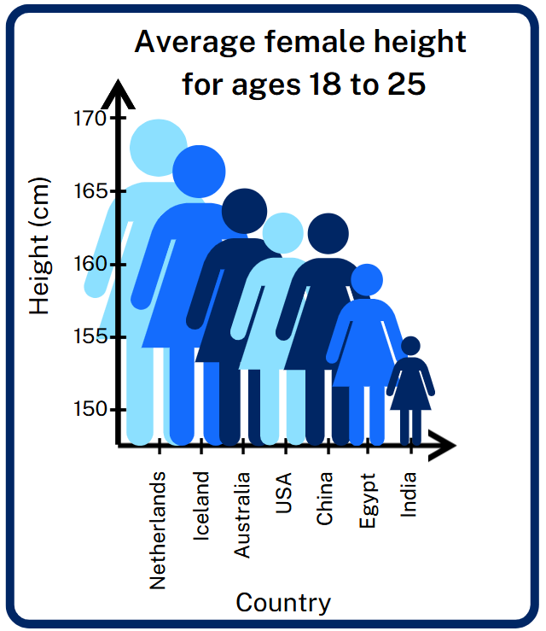
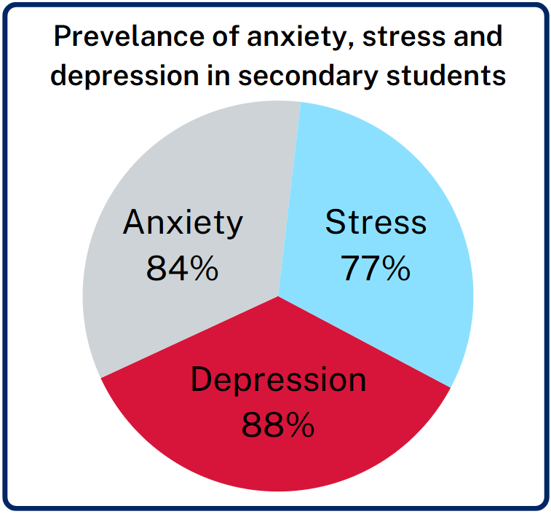
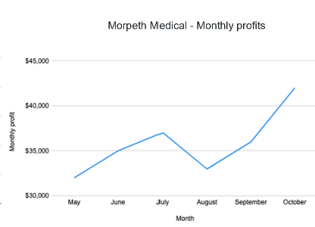
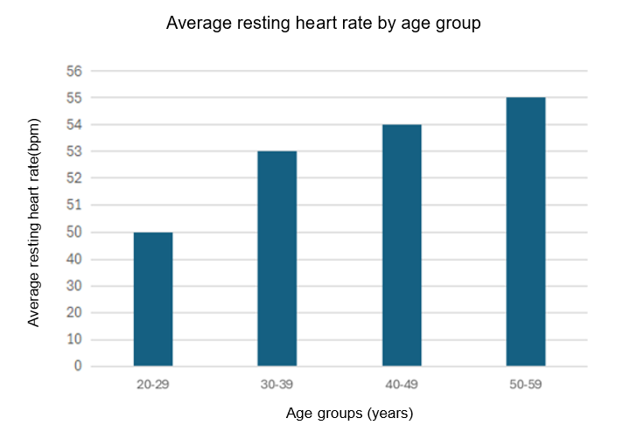
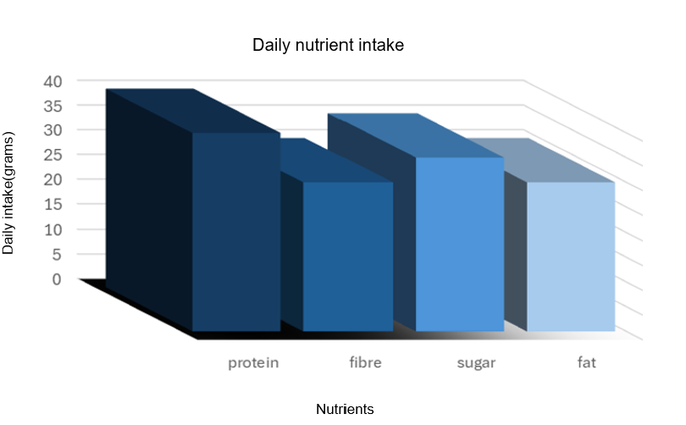
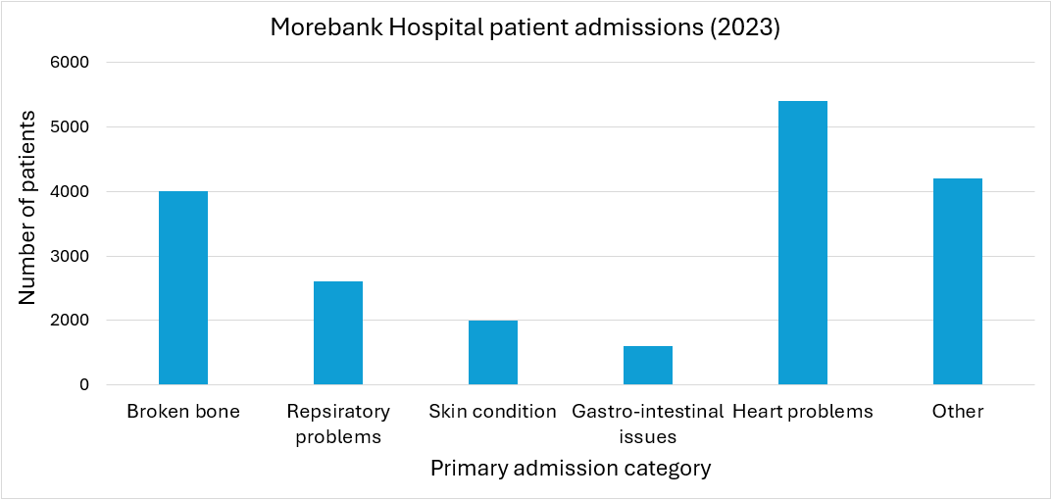
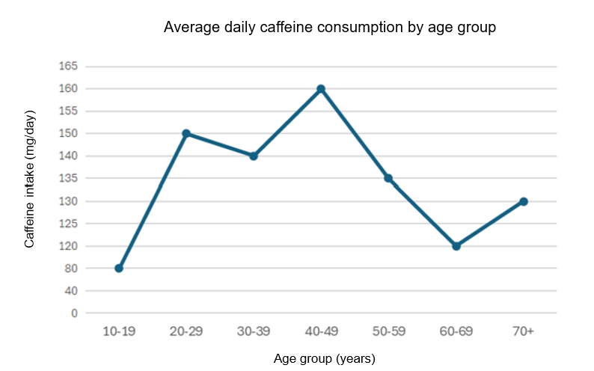

Sample solutions

Appendix A – faults in survey questions and data collection
Example | Question or process | Scenario | Faults
1 | Survey question | Don’t you agree that getting vaccinated is the safest and most responsible choice for protecting your community? | Question is leading and assumes agreement, which may pressure respondents to answer positively even if they have doubts.
2 | Data collection | A health department uses hospital admission rates to assess the overall health of a community. | Hospital admissions only capture severe cases and miss people who are healthy or managing conditions outside the hospital, so the data might not reflect the true health status of the entire community.
3 | Survey question | How often do you consume fast food regularly? | Students may have varying definitions of 'regularly,' with some thinking it means daily, while others might consider it weekly or monthly, leading to inconsistent data. If the response options are limited (for example, 'never,' 'sometimes,' 'always'), students who fall between these categories may feel compelled to choose an option that doesn’t accurately reflect their habits.
4 | Data collection | Question: What proportion of students use hand sanitiser when it is available at the entrance to the canteen?  Process  - Observe the canteen line from a distance during one or more lunch breaks.  - Record a tally for the number of:  - Students who use the sanitiser.  - Students who notice the sanitiser but don’t use it.  - Students who walk past without noticing.  - Calculate percentages and draw conclusions about the study. | The observer might unconsciously focus more on students who use the sanitiser, leading to an overestimation of its usage compared to those who do not. Observing during a particularly busy lunch period might skew results, as students may feel rushed and less likely to notice or use the sanitiser. External distractions, such as noise or social interactions, could prevent students from noticing the sanitiser, affecting the accuracy of the observations.

Appendix B – What is wrong with the data display?
Misleading graphs | Identify what is wrong with the data display | Explain how this issue might affect the interpretation of the data | Suggest how the data display could be improved
 | The images of people are scaled in both height and width, making the differences between countries appear much larger than they really are. | This exaggerates the differences in average height, leading viewers to believe there are bigger gaps than in reality. | Use a simple bar graph with equal bar widths and an appropriate scale starting at zero.
 | The sector graph adds up to more than 100%, which is misleading. Percentages overlap (for example, a student could have both anxiety and depression), but the chart suggests they are separate categories. | This misrepresents the data and could make people think the figures are incorrect or that most students experience all 3 issues at once. | Use a divided bar chart to show the percentage of students experiencing each condition, or a Venn diagram if overlaps are important.
 | The $y$-axis does not start at zero, making the profit changes look more dramatic than they actually are. | This exaggerates the variation in profits and may give the impression of extreme growth or loss when the changes are relatively small. | Start the $y$-axis at zero or clearly note the scale break so the data is not misleading.
 | Scale is not consistent. Starts off increasing by 10 and then continues increasing by 1. | Exaggerates the difference between the 3 higher age groups which only differ by 2 bpm. | Either continue the scale in increments of 10 or reduce the scale to increments of 5.
 | 3D effect distorts bar heights, making it hard to compare values accurately. | Could be used to make some nutrients appear lower/higher than they really are. | Use a 2D column graph.
 | Graph suggests comparisons, but categories are inconsistent (mix of specific conditions versus ‘Other’). | Could be used to downplay the importance of specific admission causes or shift focus away from detailed health issues by categorising many into ‘Other’. | Increase the number of categories to avoid including so many entries in ‘Other’.
 | A line graph is used for categorical age groups, which suggests continuous change between groups when they are separate categories. | Could be used to make it appear as though caffeine intake follows a smooth trend across ages, even though the data are group averages and not continuous. | Use a column graph to represent each category.

References
This resource contains NSW Curriculum and syllabus content. The NSW Curriculum is developed by the NSW Education Standards Authority. This content is prepared by NESA for and on behalf of the Crown in right of the State of New South Wales. The material is protected by Crown copyright.
Please refer to the NESA Copyright Disclaimer for more information https://educationstandards.nsw.edu.au/wps/portal/nesa/mini-footer/copyright.
NESA holds the only official and up-to-date versions of the NSW Curriculum and syllabus documents. Please visit the NSW Education Standards Authority (NESA) website https://educationstandards.nsw.edu.au/ and the NSW Curriculum website https://curriculum.nsw.edu.au/.
Mathematics Standard 11–12 Syllabus © NSW Education Standards Authority (NESA) for and on behalf of the Crown in right of the State of New South Wales, 2024.

© State of New South Wales (Department of Education), 2025
The copyright material published in this resource is subject to the Copyright Act 1968 (Cth) and is owned by the NSW Department of Education or, where indicated, by a party other than the NSW Department of Education (third-party material).
Copyright material available in this resource and owned by the NSW Department of Education is licensed under a Creative Commons Attribution 4.0 International (CC BY 4.0) license.

This license allows you to share and adapt the material for any purpose, even commercially.
Attribution should be given to © State of New South Wales (Department of Education), 2025.
Material in this resource not available under a Creative Commons license:
- the NSW Department of Education logo, other logos and trademark-protected material
- material owned by a third party that has been reproduced with permission. You will need to obtain permission from the third party to reuse its material.
Links to third-party material and websites
Please note that the provided (reading/viewing material/list/links/texts) are a suggestion only and implies no endorsement, by the New South Wales Department of Education, of any author, publisher, or book title. School principals and teachers are best placed to assess the suitability of resources that would complement the curriculum and reflect the needs and interests of their students.
If you use the links provided in this document to access a third-party's website, you acknowledge that the terms of use, including licence terms set out on the third-party's website apply to the use which may be made of the materials on that third-party website or where permitted by the Copyright Act 1968 (Cth). The department accepts no responsibility for content on third-party websites.

