Designing questions and data classification
Students examine issues with survey questions, classify data types, and apply principles of clarity, inclusivity and ethics to design effective surveys.
Students will need at least one digital device per pair to interact with Microsoft Forms or Google Forms during this lesson.

Learning intentions
- To understand how to apply questionnaire design principles to collect data.
- To be able to classify and describe data by its different types.

Success criteria
- I can write clear and unambiguous survey questions to collect data.
- I can explain how issues of privacy, bias, ethics and responsiveness to diverse groups and cultures relate to data collection.
- I can classify data using the terms categorical, numerical, nominal, ordinal, discrete and continuous.
- I can identify data that can be considered both numerical and categorical.

Outcomes
A student:
- develops understanding and fluency in mathematics through exploring and connecting mathematical concepts, choosing and applying mathematical techniques to solve problems, and communicating their thinking and reasoning coherently and clearly MAO-WM-01
- displays and analyses datasets using summary statistics and graphical representations
MST-11-08

Associated numeracy outcomes
- recognises and applies functional numeracy concepts in practical situations, including personal and community, workplace and employment, and education and training contexts N6-1.1
- applies numerical reasoning and mathematical thinking to clarify, efficiently solve and communicate solutions to problems N6-1.2
- chooses and applies efficient strategies to analyse and solve everyday problems involving data, graphs, tables, statistics and probability N6-2.3

Content

Statistical investigation process
- Identify an issue and pose a question to a targeted population to gather statistical information
- Develop a survey by applying questionnaire design principles of clear language, unambiguous questions and consideration of number of choices
- Examine issues of privacy, bias, ethics and responsiveness to diverse groups and cultures

Data classification
- Classify and describe variables as numerical or categorical
- Describe a numerical variable as discrete or continuous
- Describe a categorical variable as nominal or ordinal
- Identify collections of data that can be described as numerical or categorical depending on responses
Mathematics Standard 11–12 Syllabus © NSW Education Standards Authority (NESA) for and on behalf of the Crown in right of the State of New South Wales, 2024.

Table 1: lesson summary
Section | Summary of activity | Teaching strategies | Teaching points
Activating prior knowledge | Students explore whether dates are categorical or numerical data by recording their birthdate, comparing formats and discussing their reasoning. They use the flowchart from the PowerPoint Designing questions and data classification (slide 4) and glossary definitions (slides 5–6) to classify data types and justify their thinking. | Think-Pair-Share  Pose-Pause-Pounce-Bounce | Students revise the different types of data and identify examples where data could be classified as either categorical or numerical depending upon its purpose.
Connecting learning | Students analyse survey questions for clarity and effectiveness. They first examine inconsistently formatted birth dates (slide 9), discuss how formatting affects data analysis and suggest improvements. Then, using a flawed question about daily steps (slide 10), students identify ambiguity and consider better phrasing. Finally they complete Appendix A by identifying issues in survey questions, rewriting them, and classifying the type of data collected. Throughout this section students consider cultural differences, diversity, ethics, privacy and bias when evaluating and writing survey questions. | Think-Pair-Share  Pose-Pause-Pounce-Bounce | Students identify issues with poorly written survey questions and consider the implications this can have on survey results.
Releasing responsibility | Students consolidate their understanding of data types by creating a foldable (Appendix B) and generate 5 tips for writing effective survey questions. They then compare their tips to those on slide 12, write their own survey questions covering different data types, and use peer feedback to refine their questions. | Pose-Pause-Pounce-Bounce  TAG | This section places a further emphasis on responsible data collection practices.
Independent practice | Students use a digital tool such as Microsoft Forms to write survey questions and then complete the exit ticket from slide 14 to check their understanding of types of data. | Pose-Pause-Pounce-Bounce | Students consolidate their understanding of writing survey questions and use the technology to restrict answers to ensure data accuracy.

Activity structure
Please use the associated PowerPoint Designing questions and data classification to display images in this lesson.

Activating prior knowledge
- Explain to students that they are completing a survey and the survey question simply says ‘Date of birth’. Ask students to write down their response, either on mini whiteboards (bit.ly/miniwhiteboards) or in their books.
- Have them compare the format they used with the students around them. What was the most common format used by the class?
- Ask students to place their hands on their heads if they believe a date is categorical data, and on their hips if they believe it is numerical data.
- Use a Think-Pair-Share (bit.ly/thinkpairsharestrategy) for students to discuss whether dates are categorical or numerical data.
Students looked at different types of data in Lesson 4 – What does Google know about me? of Stage 4 unit 2 – making decisions.
Teachers could choose to pair up a student who believes dates are categorical data, with a student who believes they are numerical data.
- Use a Pose-Pause-Pounce-Bounce questioning strategy (PDF 557 KB) (bit.ly/posepausepouncebounce) for students to explain their reasoning.

If students have recorded their birth date as 25 July 2009 they may argue that a date is categorical. If they have recorded it as 25/07/09 they may argue it is numerical.
Dates can be considered either categorical or numerical data, depending on how they are used. While dates are represented by numbers, they also represent categories of time (days, months, years). If the focus is on specific points in time or categories of time (for instance, Mondays, January) they are being used as categorical data. If calculations involving time differences are meaningful (finding the duration between 2 dates), then they are being used as numerical data.
- Remind students that categorical data can be further divided into nominal and ordinal data, and that numerical data can be divided into discrete and continuous data. Teachers can use the flowchart on slide 4 of the PowerPoint to demonstrate this.
- Use slides 5 and 6 to remind students of the glossary definitions from the syllabus. Teachers will need to animate each slide to see the additional definitions.
The syllabus definitions are provided below for reference.
- Categorical: data associated with a categorical variable. Also known as qualitative data. A categorical variable describes a quality or characteristic of something. For example, your home state or blood type are categorical variables.
- Numerical: variables whose values are numbers, and for which arithmetic processes such as adding and subtracting, or calculating an average, make sense. For example, the number of children in a family or the number of days in a month.
- Nominal: a type of categorical variable whose values have no natural order in which they may be placed, for example, eye colour.
- Ordinal: a type of categorical variable whose responses have a natural order. For example, level of happiness: very unhappy, unhappy, neutral, happy, very happy.
- Discrete: individual and countable items that can be listed. For example, the number of children in a family.
- Continuous: a numerical variable that can take any value that lies within an interval. The values taken are subject to the accuracy of the measuring instrument used to obtain these values. For example, height, reaction time to a stimulus, and systolic blood pressure.
- Ask students to discuss in their pairs:
- If we are considering dates to be categorical data, would they be nominal or ordinal?
- If we are considering dates to be numerical data, would they be discrete or continuous?
- Use a Pose-Pause-Pounce-Bounce questioning strategy for students to share their ideas.
Students should suggest that if we are considering dates to be categorical data than they would be ordinal, as there is a definite order to the days in a month, the years or even the months themselves.
If we are considering dates to be numerical, then they would be discrete because they represent distinct points in time.
- Display slide 7 which shows the statistical investigation process and explain to students that this lesson will continue to focus on stage 2, where we will be studying the design of survey questions and considering the types of data they collect.

Connecting learning
- Display slide 9 of the PowerPoint and explain that it shows a list of responses to the birth date question they answered in the ‘Activating prior knowledge’ section.
- Ask students to identify which month has the most birthdays and provide time for them to work with the data.
Students should realise that this is difficult and time consuming because the dates are all in different formats.
- Use the website ‘Date format by Country 2025’ (https://worldpopulationreview.com/country-rankings/date-format-by-country) to display a map showing the popularity of different date formats around the world.
- Use a Think-Pair-Share for students to discuss the issues they encountered when trying to determine which month had the most birthdays, which date format was the easiest to work with, and how they could rewrite the question to make it easier for them to analyse the data.
Students should identify that providing a scaffold such as dd/mm/yyyy or an example format would assist in ensuring that all birthdays are entered using the same format.
Teachers could explain or demonstrate that in online forms, you can force participants to enter data in a particular format.
- Use a Think-Pair-Share for students to discuss what personal information we are collecting when we ask for birth dates.
When we ask for birth dates, we're collecting specific information that reveals a person's age, which can also indicate their generation and life experiences. Additionally, in some contexts, the birth date can be linked to other personal information, such as cultural or religious practices associated with certain ages.
- Use the website ‘Unusual birthday traditions around the world’ (https://obaninternational.com/blog/unusual-birthday-traditions-around-the-world/) to share some birthday traditions, especially those of Vietnam and China where your age at birth starts at 1, instead of 0.
- Use a Pose-Pause-Pounce-Bounce questioning strategy for students to discuss how cultural differences might affect the way people answer the question ‘What is your date of birth?’
- Display slide 10 which shows the survey question ‘How many steps do you walk in a day?’
- Use a Think-Pair-Share for students to discuss which answer they would choose and how cultural differences might affect the way people answer the question.
- Use the Pose-Pause-Pounce-Bounce questioning strategy for students to share their thoughts.

In some cultures, walking might not be a common mode of transportation due to urban design or lifestyle choices. Additionally, some individuals may have different definitions of what constitutes a 'step,' depending on their daily activities or mobility levels.
Students should realise that this is a poorly designed survey question as it is ambiguous. If students walk 5000 steps a day, there are two answers they could choose, and if they walk 12 000 steps a day, there is no suitable option.
- Working in pairs, students are to complete Appendix A ‘Survey questions’. They should identify any issues with the question that may lead to inaccurate results and rewrite the question to address the identified issue. For each revised question, students will also identify what type of data is being collected.
- Discuss with students why it is important to use language that is inclusive and respectful of diverse groups and how bias in question wording can lead to misrepresentation of data.
Using inclusive and respectful language is important because it helps to create an environment where everyone feels valued and understood. It ensures that our questions do not alienate or offend any group and that we accurately capture the experiences of all participants. This leads to more reliable and representative data.
Bias in question wording can lead individuals toward a particular answer, skewing the data. For example, if a question is phrased in a way that suggests a 'correct' answer or uses leading language, it might influence the responses. This can result in data that does not accurately reflect the true opinions or behaviours of the population being surveyed.

Releasing responsibility
- Distribute a copy of Appendix B ‘Foldable’ to each student. Have students make their own notes on the types of data and include their own examples.
- Students are to write 5 tips in their books, on what makes a good survey question.
- Display slide 12 and have students compare their tips to the ones suggested. Ask them to add anything they have missed to their own list.
- Students are to identify an area of interest and write 4 survey questions each designed to collect a different type of data: categorical nominal, categorical ordinal, numerical discrete, and numerical continuous.
- Students should swap their questions with 2 other students to receive feedback using the TAG strategy (bit.ly/DLSpeerfeedback).
- Use the Pose-Pause-Pounce-Bounce questioning strategy for students to share the considerations they made regarding privacy, bias, ethics and inclusivity.
- Explain to students that people working in health fields have access to very personal details about their patients. Conclude with a discussion on the ethical responsibilities of data collectors and how collected data can be stored securely to maintain privacy.

To maintain the privacy of collected data, several techniques can be used, including:
- Data anonymization: removing or masking personally identifiable information (PII) so individuals cannot be easily identified.
- Data encryption: encrypting data both in transit and at rest to protect it from unauthorised access.
- Access controls: restricting data access to authorised personnel only, using strong authentication methods like passwords, two-factor authentication or role-based access.
- Data minimisation: collecting only the data that is necessary for the purpose, reducing exposure of sensitive information.
- Secure storage: storing data in secure environments with appropriate physical and digital safeguards.
- Regular audits: conducting audits and monitoring access logs to detect and prevent unauthorised data access.
- Use of aggregated data: reporting data in aggregated or summarised form rather than individual-level data to protect privacy.
- Data retention policies: establishing policies to delete or archive data when no longer needed, minimising long-term risk.
- Consent and transparency: informing data subjects about how their data will be used and obtaining their consent.

Independent practice
- Students are to use a digital tool such as Google Forms or Microsoft Forms to create a digital version of the questions they created in the ‘Releasing responsibility’ section. Students should explore features such as requiring a question to be answered, answering in a particular format, and types of questions – multiple choice, short answer, ranking.
- Use a Pose-Pause-Pounce-Bounce questioning strategy for students to share how the features of digital tools can improve the accuracy of the data that is collected.
Digital tools provide data validation options such as ensuring people can only select one answer in a multiple-choice question, that numerical answers and dates occur within an acceptable range, requiring a question to be answered, restricting responses to a required format.
- Check for understanding of types of data by using the exit ticket on slide 14 to assess the student’s knowledge of variable types.

Assessment and differentiation

Suggested opportunities for differentiation
Activate prior knowledge
- Provide sentence stems or word banks (For example, ‘I think the date is __ data because __’) for students who need help expressing their reasoning.
- Ask more advanced students to write a short paragraph justifying whether dates are categorical or numerical using syllabus definitions.
- Ask students to come up with other real-world examples of data that could be argued to be either categorical or numerical depending on context (for example, times of day, temperature ranges).
Connecting learning
- Provide a partially completed frequency table or scaffold to help students count birth months more easily from the list on slide 8.
- Provide a printed copy of slide 8 and use colour coding or highlighters to group and identify months from the birth dates.
Releasing responsibility
- Provide a partially completed foldable for students who struggle with note-taking or organising information.
- Provide question stems or templates to help students craft clear and focused survey questions.
- For students needing more support, allow them to write questions targeting only one or two types of data instead of all.
- Encourage higher-achieving students to write more complex or multi-part questions that could capture different data types.

Independent practice
- Provide step-by-step guides or tutorials for students less familiar with Google Forms or Microsoft Forms.
- Pair students who are confident with technology skills with those needing support to foster peer learning.
- For students who need more guidance, pre-select certain features for them to explore (for example, making a question required or setting answer formats).
- Challenge advanced students to experiment with more complex features, such as conditional branching or data validation.

Suggested opportunities for assessment
Activate prior knowledge
- During class discussion, listen for misconceptions and use of precise mathematical language.
Connecting learning
- Collect student responses to Appendix A.
Releasing responsibility
- Collect or review foldables to check for correct understanding of data types and appropriate examples.
- Observe student interactions during TAG feedback to assess their ability to give and receive constructive critique.
- Evaluate students’ written questions for clarity, focus and correct classification of data types.
Independent practice
- Use the exit ticket to gauge individual understanding of variable types and data classification.
- Monitor students’ ability to apply correct question types aligned with the data they want to collect.

Appendix A

Survey questions
Question | Issue | Revised question | Type of data collected
How many steps do you walk every day?  - 1000  - 5000  - 10 000 | Not enough choices for answers. What do I select if I walk 2500 steps a day? | How many steps on average do you walk in a day?  - 0–2000  - 2001–5000  - 5001–8000  - more than 8000 | Categorical – ordinal
Do you walk enough steps each day?
How many steps do you walk on weekdays?
You walk at least 10 000 steps a day, right?
What’s your average step count per year?
How often do you exercise and how many steps do you walk?
Why do you fail to walk enough steps each day?
Do you use a pedometer or smart watch to track your impressive step count?
How many steps did you walk on 3 March?

Appendix B

Foldable
Paste this part into student's workbook | Paste this part into student’s workbook
Categorical data | Numerical data

Nominal | Ordinal | Discrete | Continuous
Example | Example | Example | Example

Foldable instructions
- Cut out both sheets around the outside rectangle. They should be the same size.
- Fold the first sheet in half along the long centre crease with the words on the outside.
- Fold the second sheet in half along the long centre crease, but with the headings on the inside of the fold.
- Slip the second sheet inside the first and glue, ensuring the columns with writing on them line up.
- Press shut along the fold line and cut the line between the categorical and numerical headings.
Figure 1: foldable example
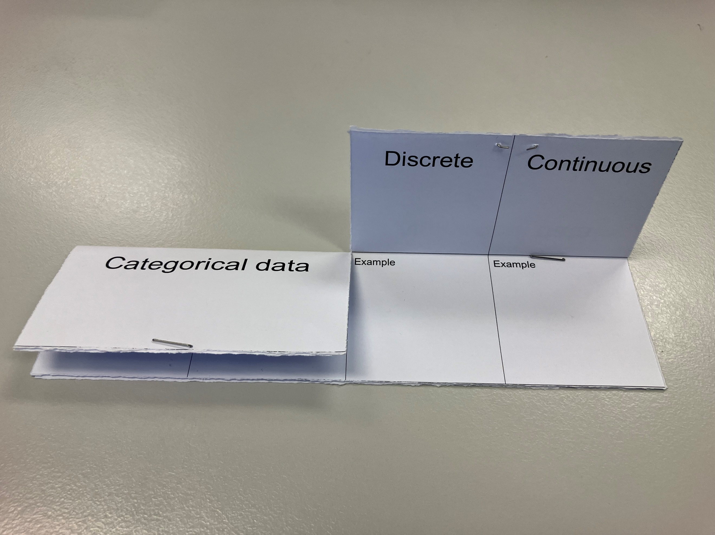

Sample solutions

Appendix A – survey questions
Question | Issue | Revised question | Type of data
Do you walk enough steps each day? | Leading question; assumes there's a correct or sufficient number of steps. | How often are you achieving your daily step count goal?  - Most of the time  - Some of the time  - Rarely | Categorical – ordinal
How many steps do you walk on weekdays? | Too vague; doesn’t define ‘weekdays’ or allow for variability between days. | How many steps do you typically walk on a weekday (Monday–Friday)? | Numerical – discrete
You walk at least  10 000 steps a day, right? | Biased and leading; pressures respondents to confirm a behaviour. | What is your usual daily step count? | Numerical – discrete
What’s your average step count per year? | Unreasonable unit of measurement; few people can accurately recall yearly averages. | Estimate how many steps you walk in a typical week. | Numerical – discrete
How often do you exercise and how many steps do you walk? | Double-barrelled; asks 2 unrelated things in one question. | - How many days a week do you usually walk for exercise? (For example, 0–7 days.)  - What is your average step count on those days? | Numerical – discrete
Why do you fail to walk enough steps each day? | Loaded and accusatory; assumes failure or lack of effort. | What factors influence how many steps you take each day?  For example, weather, time, motivation, health. | Categorical – nominal
Do you use a pedometer or smart watch to track your impressive step count? | Contains biased language (‘impressive’); may influence response. | Do you use any devices to track your steps?  Options: Yes – smart watch / Yes – phone app / No / Other. | Categorical – nominal
How many steps did you walk on 3 March? | Too specific and difficult to recall unless the respondent tracks daily steps precisely. | If you track your step count daily, what was your most recent daily step total? | Numerical – discrete

References
This resource contains NSW Curriculum and syllabus content. The NSW Curriculum is developed by the NSW Education Standards Authority. This content is prepared by NESA for and on behalf of the Crown in right of the State of New South Wales. The material is protected by Crown copyright.
Please refer to the NESA Copyright Disclaimer for more information https://educationstandards.nsw.edu.au/wps/portal/nesa/mini-footer/copyright.
NESA holds the only official and up-to-date versions of the NSW Curriculum and syllabus documents. Please visit the NSW Education Standards Authority (NESA) website https://educationstandards.nsw.edu.au/ and the NSW Curriculum website https://curriculum.nsw.edu.au/.
Mathematics Standard 11–12 Syllabus © NSW Education Standards Authority (NESA) for and on behalf of the Crown in right of the State of New South Wales, 2024.

© State of New South Wales (Department of Education), 2025
The copyright material published in this resource is subject to the Copyright Act 1968 (Cth) and is owned by the NSW Department of Education or, where indicated, by a party other than the NSW Department of Education (third-party material).
Copyright material available in this resource and owned by the NSW Department of Education is licensed under a Creative Commons Attribution 4.0 International (CC BY 4.0) license.

This license allows you to share and adapt the material for any purpose, even commercially.
Attribution should be given to © State of New South Wales (Department of Education), 2025.
Material in this resource not available under a Creative Commons license:
- the NSW Department of Education logo, other logos and trademark-protected material
- material owned by a third party that has been reproduced with permission. You will need to obtain permission from the third party to reuse its material.
Links to third-party material and websites
Please note that the provided (reading/viewing material/list/links/texts) are a suggestion only and implies no endorsement, by the New South Wales Department of Education, of any author, publisher, or book title. School principals and teachers are best placed to assess the suitability of resources that would complement the curriculum and reflect the needs and interests of their students.
If you use the links provided in this document to access a third-party's website, you acknowledge that the terms of use, including licence terms set out on the third-party's website apply to the use which may be made of the materials on that third-party website or where permitted by the Copyright Act 1968 (Cth). The department accepts no responsibility for content on third-party websites.

