Variables and scatter plots
Students are introduced to situations where 2 variables are measured together. They learn to distinguish between one-variable data and bivariate data, identify independent and dependent variables and represent paired numerical data using scatter plots.
Students will need at least one digital device per pair to interact with the GeoGebra applet during this lesson.

Learning intentions
- To understand that bivariate data describes relationships between 2 variables.
- To know how to represent the relationship between 2 variables graphically.

Success criteria
- I can identify situations where we use bivariate data over one-variable data.
- I can explain the difference between independent and dependent variables.
- I can represent bivariate data using a scatter plot.

Outcomes

Mathematics Standard 2 outcomes
A student:
- develops understanding and fluency in mathematics through exploring and connecting mathematical concepts, choosing and applying mathematical techniques to solve problems, and communicating their thinking and reasoning coherently and clearly MAO-WM-01
- analyses bivariate datasets using statistical processes MST-12-S2-08

Associated Mathematics Standard 1 outcomes
- develops understanding and fluency in mathematics through exploring and connecting mathematical concepts, choosing and applying mathematical techniques to solve problems, and communicating their thinking and reasoning coherently and clearly MAO-WM-01
- displays and interprets bivariate datasets to solve problems and make predictions
MST-12-S1-06
Mathematics Standard 11–12 Syllabus © NSW Education Standards Authority (NESA) for and on behalf of the Crown in right of the State of New South Wales, 2024.

Associated Numeracy outcomes
A student:
- recognises and applies functional numeracy concepts in practical situations, including personal and community, workplace and employment, and education and training contexts
N6-1.1
- applies numerical reasoning and mathematical thinking to clarify, efficiently solve and communicate solutions to problems N6-1.2
- determines whether an estimate or an answer is reasonable in the context of a problem, evaluates results and communicates conclusions N6-1.3
- chooses and applies efficient strategies to analyse and solve everyday problems involving data, graphs, tables, statistics and probability N6-2.3
- chooses and applies appropriate numeracy operations and techniques to analyse and resolve everyday situations N6-2.6
Numeracy Stage 6 (CEC) Syllabus © NSW Education Standards Authority (NESA) for and on behalf of the Crown in right of the State of New South Wales, 2021.

Content

Mathematics Standard 2

Bivariate datasets
- Distinguish between situations involving one-variable data and bivariate data and explain when each is needed
- Identify the independent and dependent variables within a bivariate dataset where appropriate

Scatter plots and lines of best fit
- Represent a bivariate dataset using a scatter plot

Associated Mathematics Standard 1

Bivariate datasets
- Distinguish between situations involving one-variable data and bivariate data and explain when each is needed
- Identify the independent and dependent variables within a bivariate dataset where appropriate

Scatter plots and lines of best fit
- Represent a bivariate dataset using a scatter plot
Mathematics Standard 11–12 Syllabus © NSW Education Standards Authority (NESA) for and on behalf of the Crown in right of the State of New South Wales, 2024.

Table 1: lesson summary
Section | Summary of activity | Teaching strategies | Teaching points
Activating prior knowledge | Students analyse incorrectly plotted points on a Cartesian plane using slide 4 of the PowerPoint Variables and scatter plots. Students identify errors, correct ordered pairs and explain the mistakes. | Think-Pair-Share | Reinforce correct plotting of coordinates, including order, sign and axis placement and address common plotting errors.
Connecting learning | Students classify scenarios on slide 6 as one-variable or bivariate data. Using slides 7–8, students analyse data in a table of values and compare graph types before introducing scatter plots. | Pose-Pause-Pounce-Bounce  Visibly random groups of 3  Vertical non-permanent surfaces  Gallery walk  Think-Pair-Share | The purpose of this section is for students to develop an understanding that one-variable data describes a single feature, while bivariate data explores relationships between 2 variables, typically represented using scatter plots.
Releasing responsibility | Students revise the definition of independent and dependent variables from slide 10. Students use the GeoGebra applet ‘Creating Scatter Plots’ (bit.ly/CreatingScatterPlots) to construct scatter plots digitally. Students evaluate scenarios using slides 12–15 to determine whether scenarios describe one-variable data or bivariate data and justify their reasoning. Students then complete Appendix A ‘Four quadrant notes’ to consolidate understanding. | Think-Pair-Share  Four quadrant notes | This section consolidates understanding of how to distinguish between one-variable and bivariate data and the implications this has for data representation.
Independent practice | Students complete Appendix B and discuss responses before comparing solutions with a partner. |  | Students consolidate their understanding of bivariate data and scatter plots by interpreting relationships between 2 variables in a new context.

Activity structure
Please use the associated PowerPoint Variables and scatter plots to display images in this lesson.

Activating prior knowledge
- Display slide 4 of the PowerPoint to present 8 points plotted on a Cartesian plane. Inform students that 4 of the points have been plotted incorrectly.
- In a Think-Pair-Share (bit.ly/thinkpairsharestrategy), have students:
- identify the incorrectly plotted points
- explain the errors that have been made and provide corrections.
The purpose of this section is to eliminate common errors when plotting points on a Cartesian plane, before constructing scatter plots.
The incorrect points are:
- $B$ plotted at $\left(7, 5\right).$ This is a sign error as the $x$-value should be $-7$
- $D$ plotted at$\left(-4, -6\right).$ The coordinates have been swapped here. It should be $(-6, -4)$
- $E$ plotted at $(7, 0)$. It has been plotted on the $x$-axis instead of the $y$-axis
- $G$ plotted at $(-2, -9)$ which is another sign error but in the $y$-value, placing the point in the incorrect quadrant.

Connecting learning
- Display slide 6 to pose the following 4 scenarios to students.
- What is the typical size of bushfires (measured in hectares)?
- Do bushfires that burn for longer require more water to extinguish?
- How long does it usually take firefighters to arrive at a bushfire?
- Do larger bushfires require more firefighters?
- Use the Pose-Pause-Pounce-Bounce questioning strategy (PDF 557 KB) (bit.ly/posepausepouncebounce) to determine whether the 4 scenarios involve one set of variables or 2 sets of variables. The following are some suggested prompts:
- Can you describe the datasets that might be collected?
- How many variables are being measured to answer these questions/prove these claims?
- How might you approach analysing this data?
Guide students to recognise the number of variables involved in each scenario.
- Scenario 1: one-variable (size of each bushfire). The data analysis would focus on describing the distribution or typical value of the data.
- Scenario 2: two variables (time that bushfires burn for and amount of water used). The data analysis would consider how one variable changes, compared with the other.
- Scenario 3: one-variable (time taken to arrive at each bushfire). The data analysis would focus on describing the spread and typical value of the data.
- Scenario 4: two variables (size of each bushfire and the number of firefighters). The data analysis would consider how the values of the 2 variables change together.
Avoid introducing formal language and representations at this stage. The emphasis is on recognising how many variables are involved and the type of question being investigated.
- Animate slide 6 to show students the definitions of ‘one-variable data’ and ‘bivariate data’ and have them identify which definition best matches each scenario.
One-variable data is a dataset that involves only one variable.
Bivariate data is data relating to the measurement of 2 variables.
- Display slide 7, which shows a table of values representing 2 variables collected across several bushfires. Use the self-explanation prompts on the slide to unpack and interpret the data presented in the table.
- By working in visibly random groups of 3 (bit.ly/visiblegroups) at vertical non-permanent surfaces (bit.ly/VNPSstrategy), ask students to decide how to represent the data graphically. Students should construct a graph they believe best represents the data and be prepared to justify their choices, including which variable was placed on each axis.
- Conduct a gallery walk (bit.ly/DLSgallerywalk), so students can examine the different representations created by the class and provide feedback on the strengths and limitations of each graph.
- Display slide 8 to show examples of possible graphical representations of the bushfire data.
- Use the Pose-Pause-Pounce-Bounce questioning strategy to facilitate a class discussion about the effectiveness of the different graph types. Possible prompts may include:
- What information is easy to see in these graphs?
- What information is difficult to see?
- Do these graphs clearly show the paired values for each bushfire? Why or why not?
Guide students to recognise:
- The data consists of paired values for each bushfire.
- Some graph types separate the variables instead of showing them as pairs.
- Column graphs compare values but do not clearly show which firefighter value matches each bushfire size.
- Line graphs can suggest a continuous change between bushfires, even though each bushfire is a separate event.
- Scatter plots are useful for displaying paired numerical data and showing how 2 variables change together.

Releasing responsibility
- Use slide 10 to revisit the definitions of ‘independent variable’ and ‘dependent variable’. Initiate a class discussion to determine which variable is independent and which is dependent in the given scenario, encouraging reasoning.
Students may be familiar with independent and dependent variables from the Stage 5 Data analysis B Core outcome MA5-DAT-C-02.
The size of the bushfire is the independent variable and the number of firefighters deployed is the dependent variable. The number of firefighters deployed changes in response to the size of the bushfire.
- Display slide 11 to show a scatter plot of the bushfire data. Use the suggested prompts to check students’ understanding of how the table of values is represented in the scatter plot and what the graph shows about the relationship between the 2 variables. Suggested prompts include:
- What do each of the points on the graph represent?
- Why do you think the independent variable is used as the scale on the $x$-axis?
- What does the overall pattern of the points suggest about the relationship between the 2 variables?
Each point represents a single bushfire, showing the paired values of the 2 variables. The independent variable is placed on the $x$-axis because it is used as the variable that we compare against to observe how changes in it are associated with changes in the other variable. The scatter plot shows that as the size of the bushfire increases, so does the number of firefighters deployed.
- With one digital device per pair of students, have students navigate to the GeoGebra applet ‘Creating Scatter Plots’ (bit.ly/CreatingScatterPlots).
- Display the applet to the class and demonstrate how to use it, explaining that for each scenario students are to:
- Identify which variable should be on the horizontal axis.
- Drag points to plot them on the scatter plot.
- Discuss within their pairs what the scatter plot represents in the context of the scenario.
- Select CHECK and refine if errors are detected, then select NEW PROBLEM.
The GeoGebra applet can show a variety of contexts to create scatter plots from.
The applet provides students with the opportunity to check their work, providing immediate feedback.
- Use slides 12–15 to display a scenario for students to discuss, in a Think-Pair-Share, who is correct and justify their reasoning.
After discussing with a partner, ask students to indicate their choice by holding up one finger for Sally and 2 fingers for Bob. Invite students to share their reasoning with the class.
Encourage students to refer to the number of variables being measured and determine whether the data is one-variable data or bivariate data. Where relevant, students should also identify the independent and dependent variables and justify which variable belongs on each axis.
- Remind students that bivariate numerical data can be displayed using a scatter plot. The NESA glossary definition can be used:
A visual representation of bivariate numerical data using the position of each dot on the horizontal and vertical axis to indicate the numerical values for an individual data point. Scatter plots are used to observe relationships between variables (NESA 2024).
- Explain to students that before constructing a scatter plot, it is important to determine whether the data is one-variable data or bivariate data and identify the independent and dependent variables.
- Distribute Appendix A ‘Four quadrant notes’ for students to complete (bit.ly/supportingstrategies). Students could complete the first 2 examples in pairs and then complete the rest independently.

Some prompts to assist students with completing the ‘Things to remember’ section are:
- What is the difference between a one-variable dataset and a bivariate dataset?
- What is the difference between the independent and dependent variables and which axis do they align to?
- In bivariate data, values are recorded as _____ of numbers.

Independent practice
- Distribute Appendix B ‘Scatter plot task’ and display slide 17 which shows the Approaching questions scaffold.
- Refer students to the ‘Understand’ section of the scaffold and ask students to highlight the key information in each question.
- Have students attempt the problems in Appendix B and compare solutions with a partner.

Assessment and differentiation

Suggested opportunities for differentiation
Activating prior knowledge
- Focus some students on identifying one incorrect point before extending to all 4.
- Reduce the number of points analysed for students who require additional support in identifying errors.
- Challenge students to create their own incorrectly plotted point and explain the mistake for a peer to identify.
Connecting learning
- Challenge students to rewrite a one-variable dataset scenario as a bivariate dataset scenario and vice versa.
- Support students by explicitly linking each row of the table to a single bushfire to reinforce the idea of paired data.
Releasing responsibility
- Provide guiding questions or sentence stems when analysing the data on slide 10 (for example ‘The independent variable is … because …’) to support students identifying and justifying variables.
- Provide a scaffold or checklist of steps for constructing a scatter plot to support students using the GeoGebra applet.
- Extend students by asking them to explain why the independent variable is placed on the $x$-axis and justifying their plotting decisions.
- Extend students by asking them to justify why one student is correct and why the other is incorrect using the context.
Independent practice
- Provide a partially completed scatter plot (for example, some points plotted) to assist in identifying the independent and dependent variables and correctly plotting the remaining points.
- Allow students to work with a partner to discuss axis selection, plotting accuracy and reasoning before recording responses.

Mathematics Standard 1 adjustments and considerations
The syllabus content in this lesson is the same for both Mathematics Standard 2 and Mathematics Standard 1. The lesson can be completed as is, with differentiation adjustments if necessary.

Suggested opportunities for assessment
Activating prior knowledge
- Observe student responses during the Think-Pair-Share to assess their ability to correctly interpret ordered pairs (horizontal then vertical movement from the origin).
Connecting learning
- Observe student responses during questioning to assess whether they can correctly identify the number of variables in each scenario.
- Monitor whether students can interpret what each pair or point represents in the context of a bushfire.
Releasing responsibility
- Observe student responses during questioning to assess whether they can correctly identify the independent and dependent variables.
- Student’s four quadrant notes can be collected to assess their understanding of one-variable data and bivariate data, independent and dependent variables and the steps to constructing a scatter plot.
Independent practice
- Observe students as they construct their scatter plot to assess whether they have plotted points accurately.
- Review student responses to assess their ability to interpret the scatter plot in the context of the question.

Appendix A

Four quadrant notes
Example 1 | Example 2
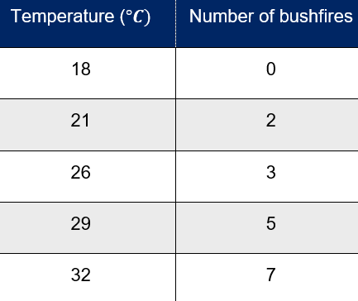 | 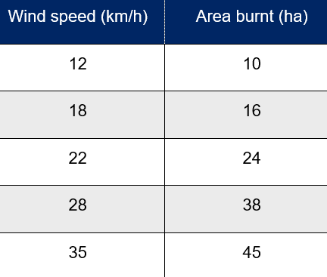
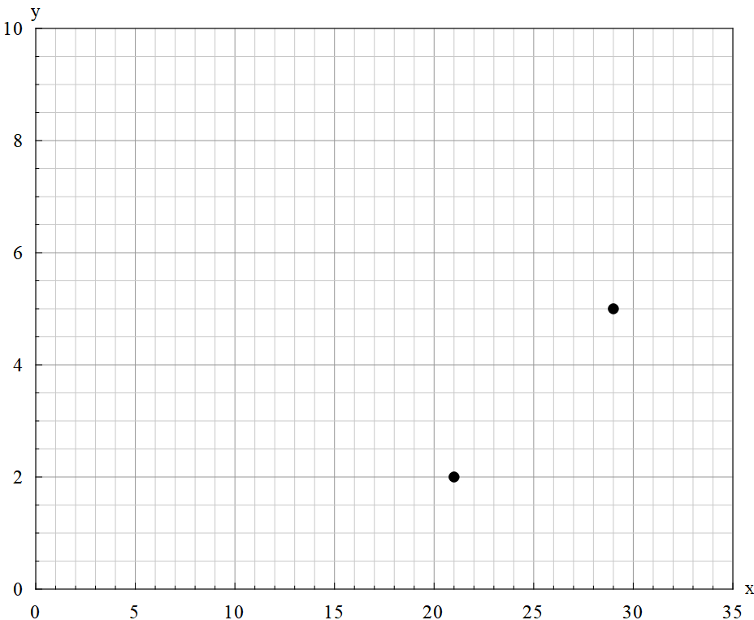 | 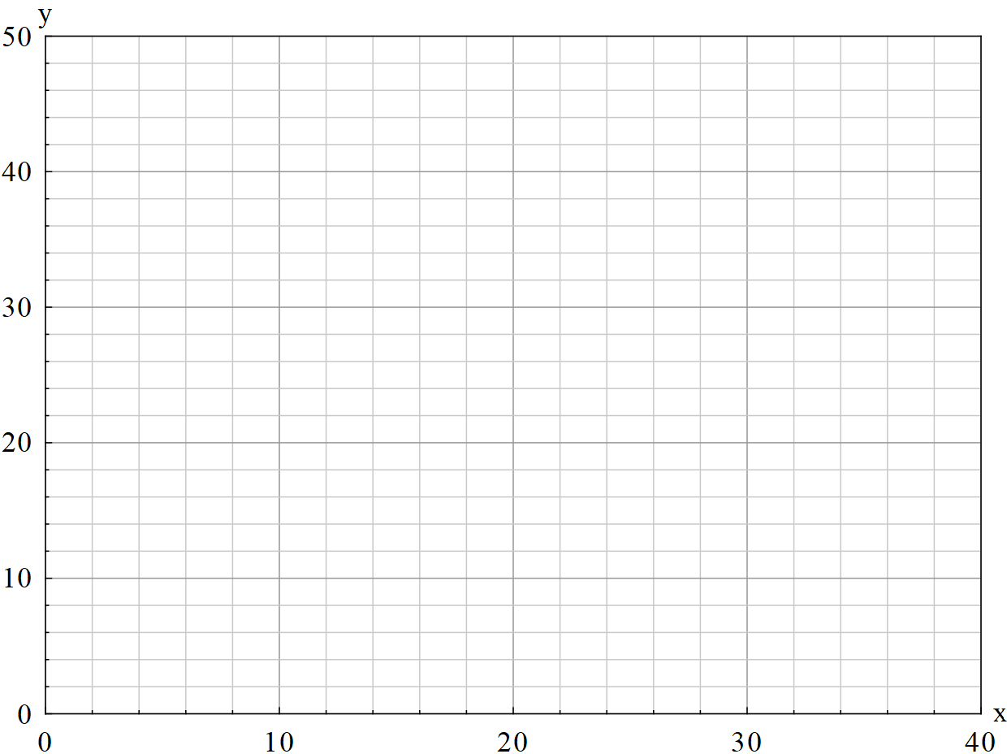
- Complete the scatter plot using the table of values.  - Which variable is independent and which is dependent? How do you know? | - Complete the scatter plot using the table of values.  - Which variable is independent and which is dependent? How do you know?
Things to remember | Example 3  Create your own example involving 2 variables.  For your example:  - state both variables  - identify the independent variable  - identify the dependent variable  - explain your reasoning  - draw a scatter plot by hand.

Appendix B

Scatter plot task
- Researchers recorded the age and height of several penguins in a colony.
Age (years) | 1 | 1 | 2 | 3 | 3 | 3 | 4 | 5 | 5 | 6 | 6 | 6 | 7 | 7 | 8 | 8
Height (cm) | 38 | 40 | 40 | 48 | 50 | 63 | 56 | 55 | 58 | 63 | 65 | 66 | 67 | 69 | 68 | 71
- Identify the independent and dependent variables. Explain your reasoning.
- Construct a scatter plot for the data. Ensure axes are clearly labelled, including units.
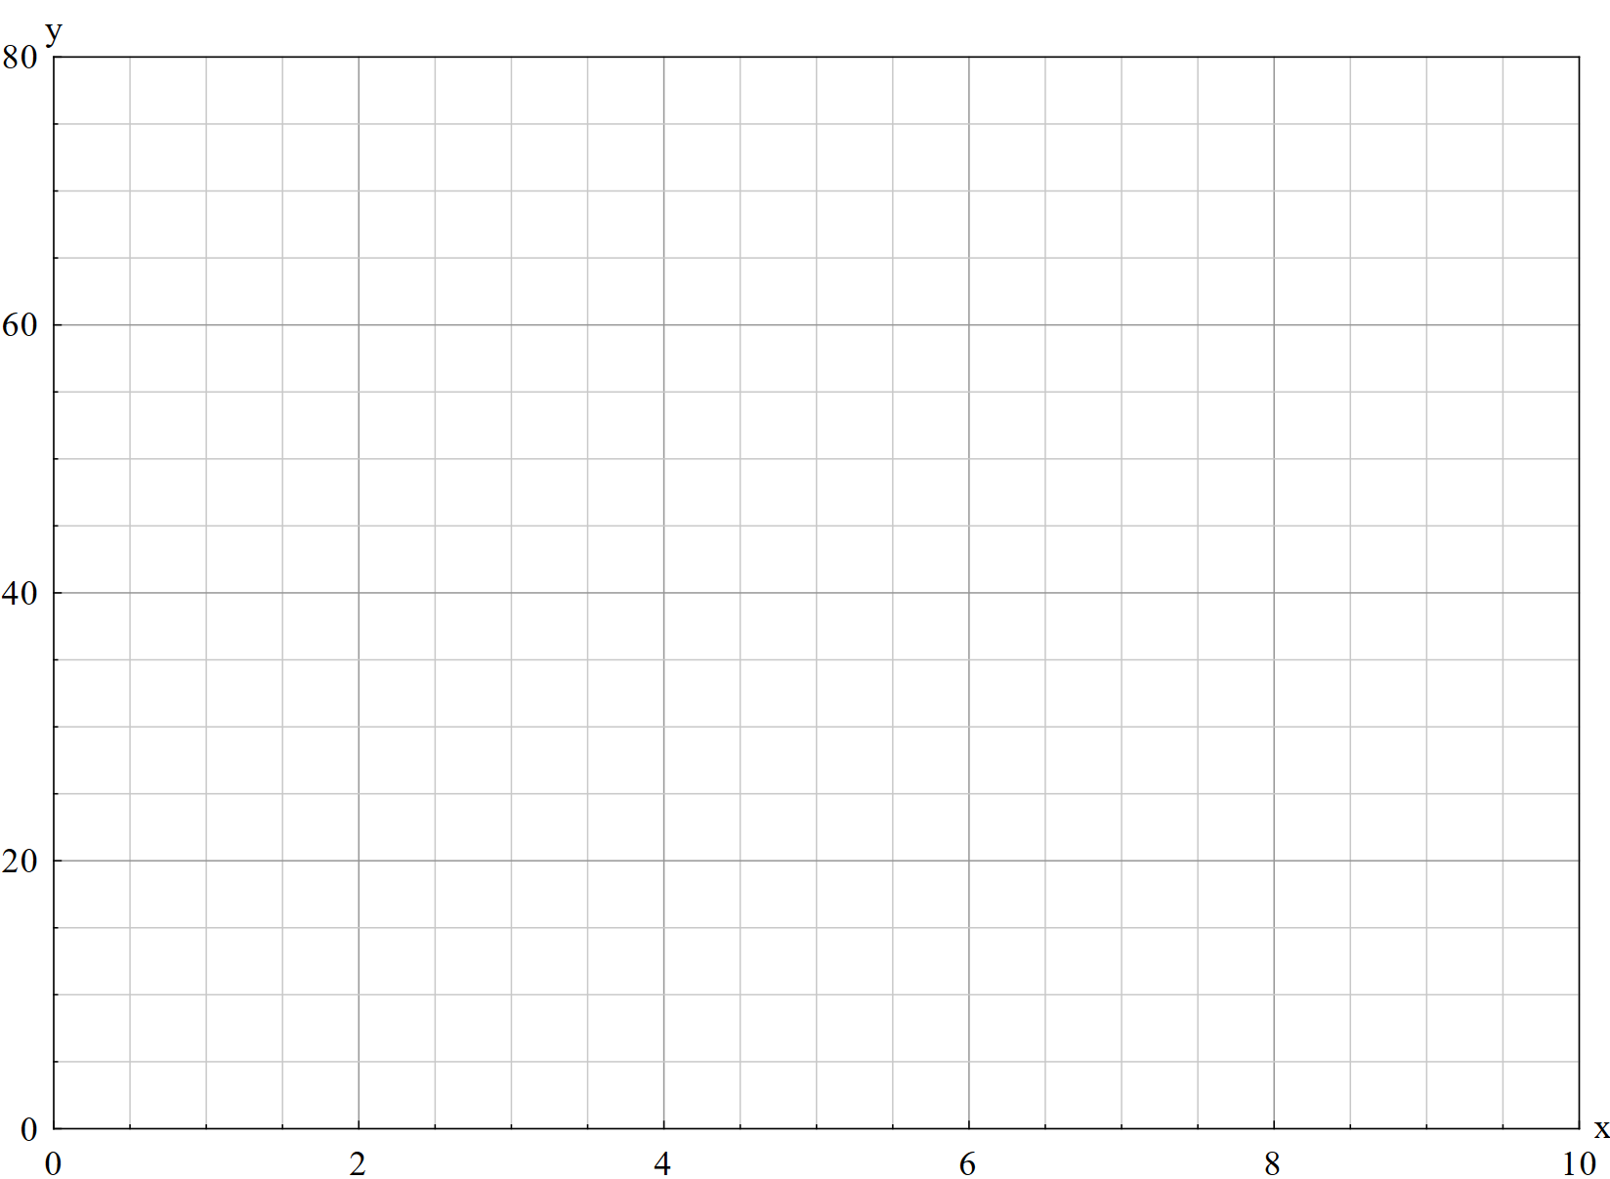
- Examine the scatter plot created. A student made the following observations about the data:
- the data shown is bivariate data, as 2 variables (age and height) are recorded for each penguin
- age is the dependent variable and height is the independent variable
- 3-year-old penguins are 50 cm tall.
- Identify the incorrect observation that the student has made and justify why.
- Rewrite the incorrect observation so that it accurately describes the dataset shown in the scatter plot.
- Using your scatter plot, describe how height changes as a penguin’s age changes. What evidence supports your answer?
- Estimate the height of a 9-year-old penguin using the scatter plot. Explain your reasoning.

Sample solutions

Appendix A – Four quadrant notes
Example 1 | Example 2
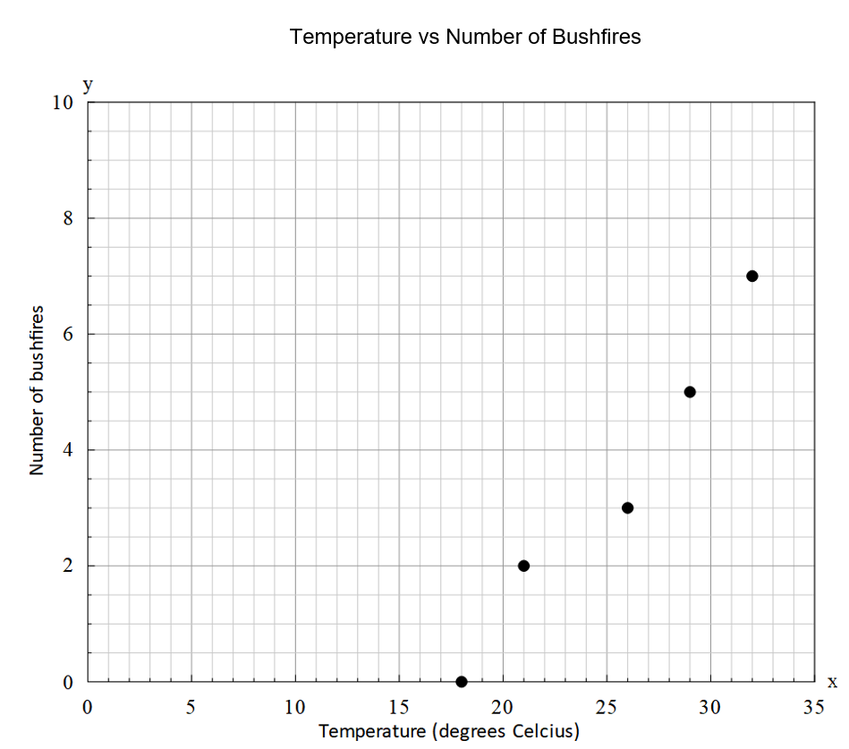 | 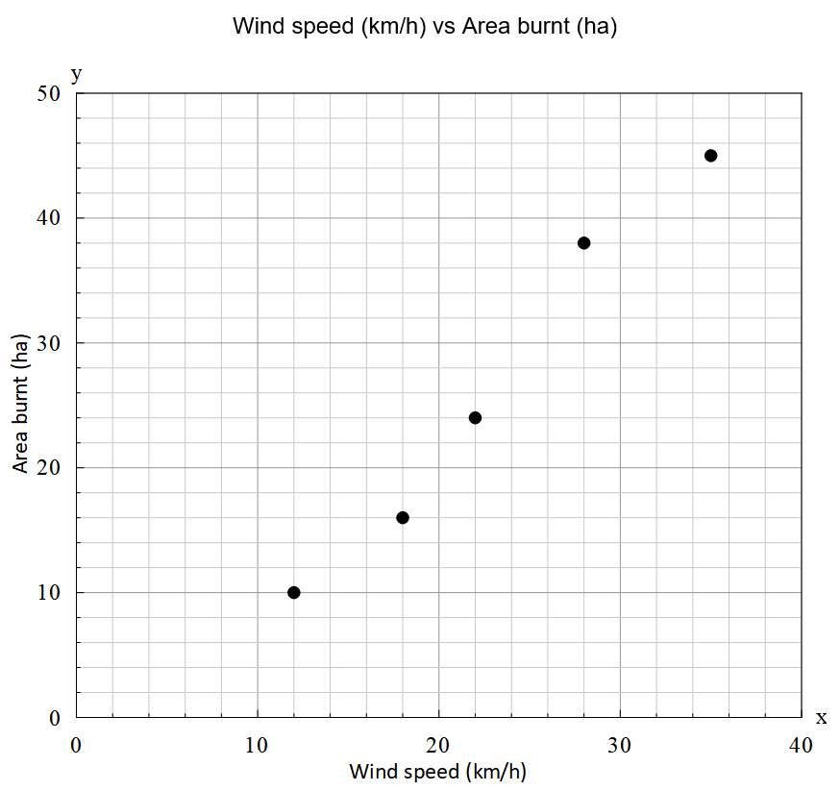
Independent variable: temperature (°C)  Dependent variable: number of bushfires  Temperature is the independent variable because it is a factor that may help explain changes in the number of bushfires. The number of bushfires is dependent because it may change in response to temperature. | Independent variable: wind speed (km/h)  Dependent variable: area burnt (ha)  Wind speed is the independent variable because it is a factor that may influence the area burnt by a bushfire. The area burnt is dependent because it may change in response to wind speed.
Things to remember  - A one-variable dataset involves one measurement.  - A bivariate dataset involves 2 measurements recorded together.  - The ‘independent variable’ is the variable that is used to explain or predict changes in another variable.  - The ‘dependent variable’ is the variable that changes in response to the independent variable.  - In bivariate data, values are recorded as pairs of numbers. | Example 3  - Students will supply their own example.

Appendix B – scatter plot task

- Independent variable – age (years)
Dependent variable – height (cm)
The height of a penguin changes as it gets older, so height depends on age.

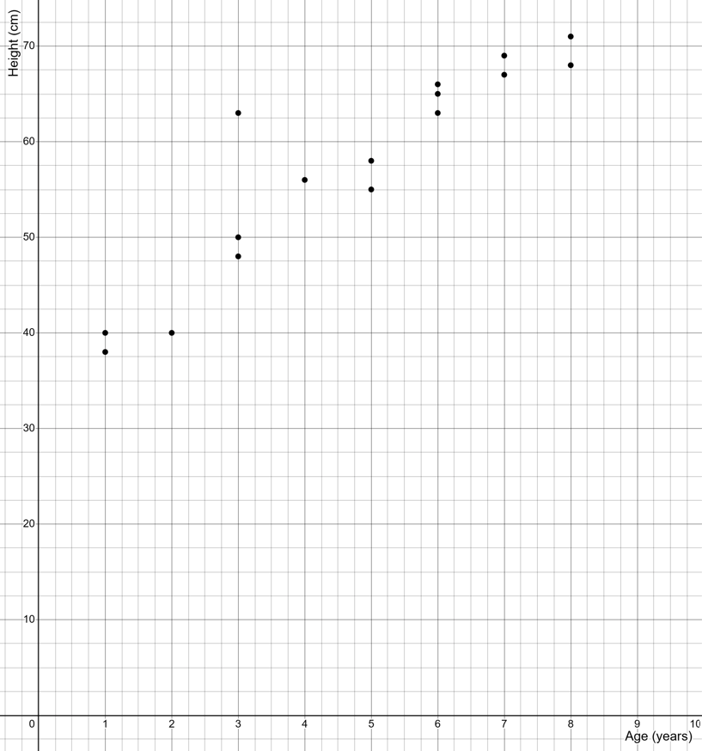

- 3-year-old penguins are 50 cm tall. This statement suggests that all 3-year-old penguins are 50 cm tall. However, the scatter plot shows that there are multiple heights for 3-year-old penguins.
- One 3-year-old penguin in the dataset has a height of 50 cm.
- Height generally increases as penguins age, as shown by the points moving upward from left to right on the scatter plot. Younger penguins, around 1–2 years, have heights of about 38–40 cm, while older penguins, around 7–8 years, have heights closer to 65–71 cm.
- The points show that height increases as age increases. At 7–8 years, penguins are around 67–71 cm tall, so continuing this pattern suggests that a 9-year-old penguin would be approximately 72–76 cm tall.

References
This resource contains NSW Curriculum and syllabus content. The NSW Curriculum is developed by the NSW Education Standards Authority (NESA). This content is prepared by NESA for and on behalf of the Crown in right of the State of New South Wales. The material is protected by Crown copyright.
Please refer to the NESA Copyright Disclaimer for more information https://www.nsw.gov.au/education-and-training/nesa/copyright.
NESA holds the only official and up-to-date versions of the NSW Curriculum and syllabus documents. Please visit NESA https://www.nsw.gov.au/education-and-training/nesa and NSW Curriculum https://curriculum.nsw.edu.au.
Mathematics Standard 11–12 Syllabus © NSW Education Standards Authority (NESA) for and on behalf of the Crown in right of the State of New South Wales, 2024.
Numeracy Stage 6 (CEC) Syllabus © NSW Education Standards Authority (NESA) for and on behalf of the Crown in right of the State of New South Wales, 2021.
NESA (NSW Education Standards Authority) (2024) ‘Glossary’, Mathematics Standard 11–12 Syllabus, NSW Curriculum website, accessed 12 June 2026.

© State of New South Wales (Department of Education), 2026
The copyright material published in this resource is subject to the Copyright Act 1968 (Cth) and is owned by the NSW Department of Education or, where indicated, by a party other than the NSW Department of Education (third-party material).
Copyright material available in this resource and owned by the NSW Department of Education is licensed under a Creative Commons Attribution 4.0 International (CC BY 4.0) license.

This license allows you to share and adapt the material for any purpose, even commercially.
Attribution should be given to © State of New South Wales (Department of Education), 2026.
Material in this resource not available under a Creative Commons license:
- the NSW Department of Education logo, other logos and trademark-protected material
- material owned by a third party that has been reproduced with permission. You will need to obtain permission from the third party to reuse its material.
Links to third-party material and websites
Please note that the provided (reading/viewing material/list/links/texts) are a suggestion only and implies no endorsement, by the New South Wales Department of Education, of any author, publisher, or book title. School principals and teachers are best placed to assess the suitability of resources that would complement the curriculum and reflect the needs and interests of their students.
If you use the links provided in this document to access a third-party's website, you acknowledge that the terms of use, including licence terms set out on the third-party's website apply to the use which may be made of the materials on that third-party website or where permitted by the Copyright Act 1968 (Cth). The department accepts no responsibility for content on third-party websites.

