Sampling techniques
Students use the context of ‘Is 10 000 steps enough?’ to learn about different sampling methods.
Students could be provided with one digital device per pair to interact with Polypad during this lesson instead of using physical playing cards.
Learning intentions and success criteria should be shared with students later in the learning episode.

Learning intention
- To understand the advantages and disadvantages of different sampling methods.

Success criteria
- I can explain the concept of a sample.
- I can describe different sampling methods.
- I can identify the benefits and limitations of using different sampling methods.
- I can justify why a sample is representative of a population.

Outcomes
A student:
- develops understanding and fluency in mathematics through exploring and connecting mathematical concepts, choosing and applying mathematical techniques to solve problems, and communicating their thinking and reasoning coherently and clearly MAO-WM-01
- displays and analyses datasets using summary statistics and graphical representations
MST-11-08

Associated numeracy outcomes
- recognises and applies functional numeracy concepts in practical situations, including personal and community, workplace and employment, and education and training contexts N6-1.1
- applies numerical reasoning and mathematical thinking to clarify, efficiently solve and communicate solutions to problems N6-1.2
- chooses and applies efficient strategies to analyse and solve everyday problems involving data, graphs, tables, statistics and probability N6-2.3

Content

Population and sample
- Compare and contrast systematic sampling, self-selected sampling, random sampling and stratified sampling
- Justify whether a sample obtained from a population is representative of the population by considering the sampling method
Mathematics Standard 11–12 Syllabus © NSW Education Standards Authority (NESA) for and on behalf of the Crown in right of the State of New South Wales, 2024.

Table 1: lesson summary
Section | Summary of activity | Teaching strategies | Teaching points
Activating prior knowledge | Students begin by responding with a thumbs up/down to whether they’ve heard the ‘10 000 steps a day’ health claim. They then learn about its origins as a marketing strategy before the 1964 Tokyo Olympics, with slide 3 of the PowerPoint Sampling techniques showing the Japanese symbol for 10 000. Students discuss average daily steps and variations across age and gender using slides 4 and 5. Slide 6 introduces the statistical investigation process. Students consider how data may have been collected and whether it represents a population or sample. | Think-Pair-Share  Pose-Pause-Pounce-Bounce  Notice and wonder | Students revise the definitions of population and sample and consider the purpose and steps of a statistical investigation.
Connecting learning | Teacher uses the sampling methods of self-selected, random, systematic and stratified sample to collect data on how many steps a day students walk. Students discuss the advantages and disadvantages of each method. Each of the sample datasets is compared, using statistical calculations, to the entire class which represents the population. | Think-Pair-Share  Pose-Pause-Pounce-Bounce | Students learn about the different methods of sampling and consider the advantages of each method and where bias could be introduced.
Releasing responsibility | Use slide 9 to outline descriptions of sampling techniques. Groups are given 3 scenario cards from Appendix A. They discuss which sampling method suits each scenario, justifying their reasoning. Each student completes a PMI table from Appendix B, adding sampling method descriptions from slide 9 to the top of each table and reflecting on the strengths, limitations and interesting aspects of each technique. | Visibly random groups of 3  Vertical non-permanent surfaces  Pose-Pause-Pounce-Bounce  Plus, minus, interesting | Students justify which sampling method is appropriate in different scenarios.
Independent practice | Students use a deck of playing cards to simulate sampling techniques. Students draw samples of 8 cards using ‘random’, ‘systematic’, and ‘stratified’ sampling, record results, and explain why self-selection isn’t used. They then use statistical calculations to discuss which method best reflects the population. The lesson concludes with slide 11 displaying a past HSC question as an exit ticket. | Pose-Pause-Pounce-Bounce  Exit ticket | Students apply their knowledge of sampling techniques and learn that samples taken using the same method, do not reflect the population in the same way.

Activity structure
Please use the associated PowerPoint Sampling techniques to display images in this lesson.

Activating prior knowledge
- Ask students to use a thumbs up or thumbs down to indicate if they have heard the adage that they need to walk 10 000 steps a day for their health.
- Ask volunteer students to suggest where the number 10 000 may have come from.
- Explain to students that the idea of walking 10 000 steps a day comes from a hugely successful marketing campaign ahead of the 1964 Olympics (Walking: Science confirms 10,000 steps a day). The number was chosen because the Japanese character for 10 000 resembles a person walking, and the idea caught on. Display slide 3 of the PowerPoint to show this symbol if students are interested.
- In a Think-Pair-Share (bit.ly/thinkpairsharestrategy), ask students to discuss:
- If 10 000 is an invented number of steps, what might be the average number of steps that a person takes in a day?
- What percentage of people do you think would walk 10 000 or more steps a day?
- How might this number change for different age groups?
- Do you think males or females would take more steps in a day?
- Use a Pose-Pause-Pounce-Bounce questioning strategy (PDF 557 KB) (bit.ly/posepausepouncebounce) for students to share their thoughts and ideas.
- Use slides 4 and 5 of the PowerPoint to display the proportion of people from different age groups that met or exceeded the 10 000 steps a day recommendation. (Note that the graph for children aged 5–17 years is for 12 000 steps a day.)
- Ask students to share what they notice and wonder (bit.ly/noticewonderstrategy) about the graphs. Encourage them to use mathematical language such as clusters, skewness, minimum, maximum, range and mode.
Teachers may choose to remind students of terminology they haven’t used to extend their vocabulary and to remind them of concepts they studied in Stage 4. Clusters and skewness will be more closely examined in Unit 4 – driving safely.
- Explain to students that the Australian Bureau of Statistics (ABS) planned a statistical investigation to determine physical activity levels in Australians. They wanted to find out how many steps a day people were taking.
- Display slide 6 to show a diagram of the statistical investigation process.
- Refer to stage 1 of the statistical investigation process. State to students that we understand what the ABS wanted to know and the question they used in their investigation. We also know that they considered people 5 years and older.
- Referring to stage 2, ask pairs to discuss how the data may have been collected.
- Use a Pose-Pause-Pounce-Bounce for pairs to share their ideas with the class. Discuss with students whether this data would represent a population or a sample.
Population and sample were previously explored in the Stage 4 Data analysis outcome
MA4-DAT-C-02.
The syllabus glossary defines a population as ‘The complete set of individuals, objects, places etc., that we want information about.’ (NESA 2024)
A sample is defined as ‘A subset of a population used to estimate characteristics of the population.’ (NESA 2024)
- Explain to students that, in most cases, collecting data from a population is impractical.
- Display the learning intentions and success criteria using slide 7 and explain to students that they will be learning about different methods to collect data samples.

Connecting learning
- Divide a whiteboard or similar display surface into 5 sections.
- Ask 8 students from your class to volunteer to tell you how many steps a day they take. Record these responses in the first section on the board, with the label self-selected.
- Explain to students that this is called a ‘self-selected’ sample. In a Think-Pair-Share, ask students to discuss the positive, negative and interesting aspects of self-selected sampling.
Students may identify that this technique is useful when a specific interest group is being studied for sensitive topics; and that participants would be motivated and engaged given they chose to participate. They may also identify that there is a high risk of bias, as only interested people will volunteer; it may lead to an over representation of people with strong opinions or vested interests.
- Use a random selection tool to select 8 students from your class to tell you how many steps a day they take. Record these on the board in the second section with the label ‘random sample’.
Students can be randomly selected by using craft sticks, names in a hat or digital technology, such as a random name selector (https://wheelofnames.com/). If students are unsure of how many steps they take a day, they could access their health data on their phone or pick a student they believe would have a comparable level of activity and use their step count.
- Explain to students that this is called a ‘random sample’. In a Think-Pair-Share, ask students to discuss the positive, negative and interesting aspects of random sampling.
Students may identify that everyone has an equal chance of being chosen but it doesn’t guarantee balanced subgroups, for example gender. They may also identify that it requires special tools to generate random selections.
- Randomly select a student and ask them to choose a number: 3, 4 or 5. Display a list of names of students in the class. Count through the roll, selecting every third, fourth or fifth name, depending on the number chosen. Ask the chosen students how many steps a day they take and record their answers in the third section of the board with the label ‘systematic sampling’.
- Explain to students that this is called a ‘systematic sample’. In a Think-Pair-Share, ask students to discuss the positive, negative and interesting aspects of systematic sampling.
Students may identify that this technique ensures a spread across the population but that they need a list of the population, and if the population was ordered in a particular way, it could introduce bias.
- Demonstrate a stratified sample with your class to develop a new sample and share the results on the board.
Classes could be stratified on gender or sporting house as a proportion of the class population. Teachers should expand the population to include the whole school and discuss alternative ways of stratifying including year levels, roll call groups, geographic areas and so on.
- Explain to students that this is called a ‘stratified sample’. In a Think-Pair-Share, ask students to discuss the positive, negative and interesting aspects of stratified sampling.
Students may identify that this technique ensures participation from all subgroups but is more complex to plan and organise.
- Use a Pose-Pause-Pounce-Bounce to ask students how well they think the different samples represent the whole class (population). They could consider if there was a particular sampling technique that they thought was more representative than the others.
- Collect data from the whole class (population) and record in the fifth section of the board.
- Ask students to perform statistical calculations on each of the 5 sets of data. Students could consider range, mean, median and mode.
- Use a Think-Pair-Share for students to discuss the results of the samples, compared to the whole class population. Which sampling technique most closely represented the class population?
- Use a Pose-Pause-Pounce-Bounce questioning technique for students to share their thoughts and justify their answer. Students should consider how the whole class population would compare to their whole year level, or with all students of their age in their town, and then across NSW or Australia.

Releasing responsibility
- Display slide 9 which shows descriptions of each sampling technique students were introduced to in the previous section of the lesson.
- Assign students to visibly random groups of 3 (bit.ly/visiblegroups).
- Randomly distribute to each group 3 cards from Appendix A ‘Scenario cards’.
- Prompt each group to discuss their scenario cards ensuring that they are explaining and justifying their reasoning.
- Groups should pair with another group to discuss their answers. If they disagree, they are to explain their reasoning to come to a consensus.
- Use the Pose-Pause-Pounce-Bounce questioning strategy to check for understanding of generalising the benefits of different sampling methods.
- How might you decide which sampling method is the better one to use?
- How does the choice of sampling method influence the way you would conduct a survey?
- How might your understanding of sampling methods influence your view of data that has been collected by a sample?
- Provide students with an individual copy of Appendix B ‘PMI tables’ (bit.ly/PMI_plusminusintersting) for them to complete using ideas from their discussion throughout the lesson. They should add the sampling techniques from slide 9 to the top of each table, next to the word ‘method’.

Independent practice
- Inform the class that they will work in pairs using playing cards to simulate the different sampling techniques. Distribute a pack of playing cards to each pair.
If playing cards are unavailable, this activity could be completed using ‘Two sets of playing cards – Polypad’ (bit.ly/PlayingCardsPolypad).
Students use the set called A full deck of cards. Instruct students to select Shuffle to shuffle the cards. They should then select Draw for a card to be turned and automatically moved to the side of the pack. They should then select Draw again. Students can move the drawn card from the pile of drawn cards, to enable them to see all drawn cards at once. Students will need to select Turn over to see the card drawn. They should repeat the process, according to the type of sampling they are replicating. When they begin a new activity, they will need to move all drawn cards back to the pack and select Shuffle to commence the next selection.
- Ask each pair to shuffle their deck of playing cards thoroughly. Explain to the class that when drawing the cards, each card represents a person in a survey about physical activity.
- Number cards represent the equivalent number of steps in thousands. For instance, a 2 in any suit would represent 2000 steps.
- Jack of any suit represents 15 000 steps.
- Queen of any suit represents 20 000 steps.
- King of any suit represents 30 000 steps.
- Before beginning the activity, use a Pose-Pause-Pounce-Bounce questioning strategy to discuss what outcome the students might expect from using a pack of cards in this way. Useful question prompts may include:
- What are the chances of selecting someone who walks 10 000 steps or more?
- What do we think the mode should be?
If students are not familiar with the contents of a pack of cards, teachers may wish to closely examine a pack of cards before beginning the activity.
- Students will select a sample of 8 cards using the random, systematic and stratified sampling techniques and record the results in their notebooks. Students should collect 3 samples using each of the sampling techniques, making a total of 9 samples, where each sample has 8 cards in it.
Cards can be stratified into red cards and black cards or by suits.
Students will need to split the cards into the desired groups and then remove a random number of cards from each group before selecting their sample of 8 cards. This will ensure that the groups are not the same, more closely resembling real life.
- Ask students why we are not considering self-selected sampling.
- Ask students to perform statistical calculations such as range, mean, median and mode on each of the 9 sets of data.
- Students need to compare the 3 samples for each technique and discuss how each of the samples were similar and different.
Students should realise that even if they use the same sampling technique, for instance random, each sample they obtain will be different and that some samples will more closely reflect the population than others.
- Ask students to discuss which sampling technique most closely represented the population (pack of cards).
Students need to consider the 3 datasets for each technique as a whole, and not just how a single dataset reflects the population.
- Use the Pose-Pause-Pounce-Bounce questioning strategy to reflect on the outcomes produced by the different sampling techniques. Some useful question prompts may include:
- Which sampling method produced results that most closely aligned with the original population (pack of cards)? Justify your answer.
- Could the cards have been stratified differently to get a more representative sample?
- Why do samples obtained using the same technique give different results?
- Should the cards be reassigned to the categories, so that each category has an equal chance of being selected?
- If we wanted to scale up this investigation to consider people in our town, the state, or all of Australia, what sampling method would we use? What would it look like?
- Display slide 11, which contains a past HSC question for students to answer as an exit ticket.

Assessment and differentiation

Suggested opportunities for differentiation
Activating prior knowledge
- A different topic could be chosen that more closely aligns with students’ interests.
- Students could focus on the results for only one age group.
Connecting learning
- Teachers may need to adjust the number of students in the samples according to the number of students in their class.
- Students could enter the data for each sample and population into a spreadsheet to perform statistical calculations and draw appropriate visual representations for analysis.
Releasing responsibility
- Students could complete the PMI tables from Appendix A in their groups of 3 before completing their own individual copies.
- Students could be provided with sentence starters to assist with their PMI tables.
Independent practice
- Students could be given a reduced population of cards from which to obtain their samples.
- Teachers could allow students to use spreadsheets to quickly perform statistical calculations to assist in analysing their data.

Suggested opportunities for assessment
- Listen for the use of statistical language during discussions.
Releasing responsibility
- Students’ PMI tables could be collected as evidence of their understanding of the different sampling techniques.
Independent practice
- Exit tickets can be collected as evidence of student understanding of the different sampling techniques.

Appendix A

Scenario cards
- A local gym wishes to understand the exercise habits of its members. Explain the benefits of using stratified sampling rather than random sampling. | - A school surveys students about their weekly physical activity. Explain the benefits of using systematic sampling rather than self-selected sampling.
- A hospital wishes to assess the effectiveness of a new weight loss program. Explain the benefits of using random sampling rather than self-selected sampling. | - A university conducts a study on students' dietary habits. Explain the benefits of using stratified sampling rather than systematic sampling.
- A government agency wants to evaluate public awareness of mental health services. Explain the benefits of using self-selected sampling rather than random sampling. | - A food company is checking the liquid level in their drink containers to ensure it is within approved limits. Explain the benefits of using systematic sampling rather than random sampling.
- A hospital studies dietary habits among patients with diabetes. Explain the benefits of using stratified sampling rather than random sampling. | - A supermarket asks customers to complete an online questionnaire about their grocery purchases. Explain the benefits of using self-selected sampling rather than systematic sampling.
- A health department wants to analyse sodium consumption across different age groups. Explain the benefits of using stratified sampling rather than random sampling. | - A nutritionist wants to choose clients from their database to assess their protein intake. Explain the benefits of using random sampling rather than self-selected sampling.

- A school counsellor surveys students about stress levels before exams. Explain why random sampling should be used instead of self-selected sampling. | - A workplace offers an anonymous mental health survey for employees. Explain why self-selected sampling should be used instead of systematic sampling.
- A mental health organisation studies the impact of therapy on different age groups. Explain why stratified sampling should be used instead of random sampling. | - A university researcher wants to collect responses on mindfulness habits from the enrolment list. Explain why systematic sampling should be used instead of random sampling.
- A psychologist wants to compare mental health outcomes between men and women. Explain why stratified sampling should be used instead of self-selected sampling. | - A hospital monitors recovery times for patients who had knee surgery. Explain why random sampling should be used instead of self-selected sampling.
- A government agency studies flu vaccination rates by selecting people from different states. Explain why stratified sampling should be used instead of random sampling. | - A pharmacy offers a voluntary questionnaire to customers about medication side effects. Explain why self-selected sampling should be used instead of systematic sampling.
- A research team wants to select patients who visit a clinic to participate in a blood pressure study. Explain why systematic sampling should be used instead of random sampling. | - A hospital wants to analyse wait times in different departments. Explain why stratified sampling should be used instead of self-selected sampling.
- A sports scientist surveys a mix of elite and amateur athletes about their training routines. Explain why stratified sampling should be used instead of random sampling. | - A fitness tracker company wants to collect data about daily step counts. Explain why self-selected sampling should be used instead of systematic sampling.

Appendix B

PMI tables
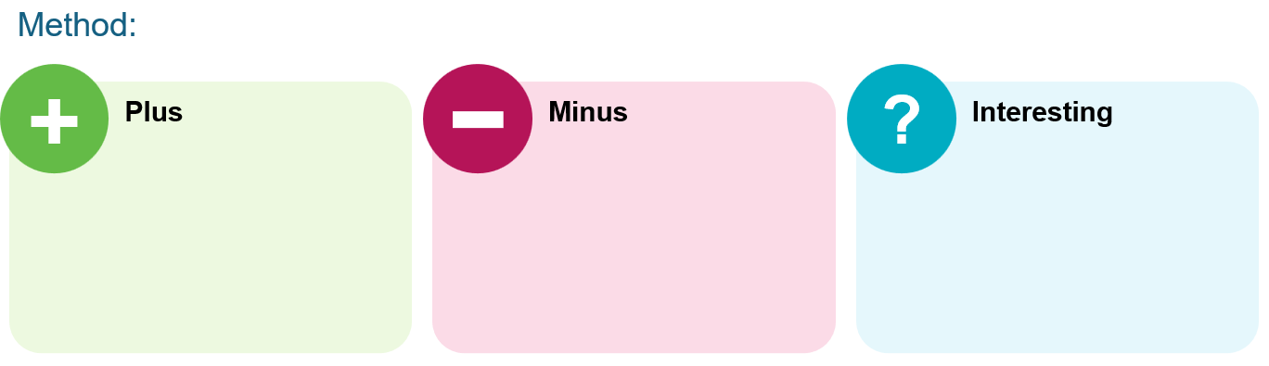

Sample solutions

Appendix A – scenario cards
- A stratified sample would be better than random sampling because it ensures gym members from different age groups or workout types are represented, whereas a random sample may result in an over-representation of one group.
- A systematic sample would be better than self-selected sampling because it ensures students are chosen at regular intervals, whereas a self-selected sample may over-represent students who are particularly active or inactive.
- A random sample would be better than self-selected sampling because it ensures all participants have an equal chance of selection, whereas a self-selected sample may over-represent those with extreme weight loss results.
- A stratified sample would be better than systematic sampling because it ensures students from different year levels or living arrangements are fairly represented, whereas a systematic sample may accidentally select students mostly from one category.
- A self-selected sample would be better than random sampling because it allows those with direct experience of mental health services to participate, whereas a random sample may include many people who have no opinion or experience.
- A systematic sample would be better than random sampling because it ensures an even distribution of drink containers across different production batches, whereas a random sample may cluster selections from the same batch.
- A stratified sample would be better than random sampling because it ensures diabetic patients from different age groups or severity levels are included, whereas a random sample may unintentionally select mostly one type of patient.
- A self-selected sample would be better than systematic sampling because it allows customers who are interested in providing feedback to participate, whereas a systematic sample may include shoppers who do not remember their purchases.
- A stratified sample would be better than random sampling because it ensures different age groups are represented in the study of sodium consumption, whereas a random sample may disproportionately select one age group.
- A random sample would be better than self-selected sampling because it ensures every client has an equal chance of being selected, whereas a self-selected sample may consist mostly of clients who are already health conscious.
- A random sample would be better than self-selected sampling because it ensures students of all stress levels are included, whereas a self-selected sample may over-represent students who are either extremely stressed or not stressed at all.
- A self-selected sample would be better than systematic sampling because it allows employees to voluntarily participate in a mental health survey, whereas a systematic sample may force unwilling participants to respond.
- A stratified sample would be better than random sampling because it ensures therapy outcomes are analysed within different age groups, whereas a random sample may over-represent one age group, leading to misleading conclusions.
- A systematic sample would be better than random sampling because it ensures an even distribution of students from the enrolment list, whereas a random sample may unintentionally select students from only one faculty or course.
- A stratified sample would be better than self-selected sampling because it ensures equal representation of men and women in a mental health study, whereas a self-selected sample may attract more responses from one gender.
- A random sample would be better than self-selected sampling because it ensures knee surgery patients with varying recovery times are included, whereas a self-selected sample may consist mostly of those with extreme recoveries.
- A stratified sample would be better than random sampling because it ensures equal representation from different states when studying flu vaccination rates, whereas a random sample may over-represent certain regions.
- A self-selected sample would be better than systematic sampling because it allows only customers who have experienced medication side effects to participate, whereas a systematic sample may include many customers who have had no side effects.
- A systematic sample would be better than random sampling because it ensures an even selection of patients throughout different times of day, whereas a random sample may unintentionally include only morning or evening visitors, which wouldn’t take into consideration that blood pressure may vary throughout the day.
- A stratified sample would be better than self-selected sampling because it ensures fair representation of patients from all hospital departments, whereas a self-selected sample may consist mostly of patients from departments with longer wait times.
- A stratified sample would be better than random sampling because it ensures that both elite and amateur athletes are included, whereas a random sample may over-represent one type of athlete.
- A self-selected sample would be better than systematic sampling because it allows only users who are willing to share their step counts to participate, whereas a systematic sample may include users who do not regularly track their steps.

Appendix B – PMI tables
Responses may vary from those listed below.
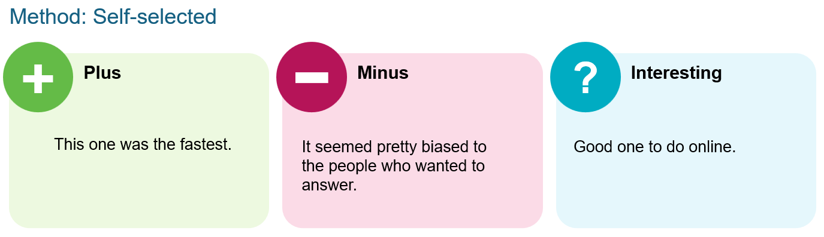
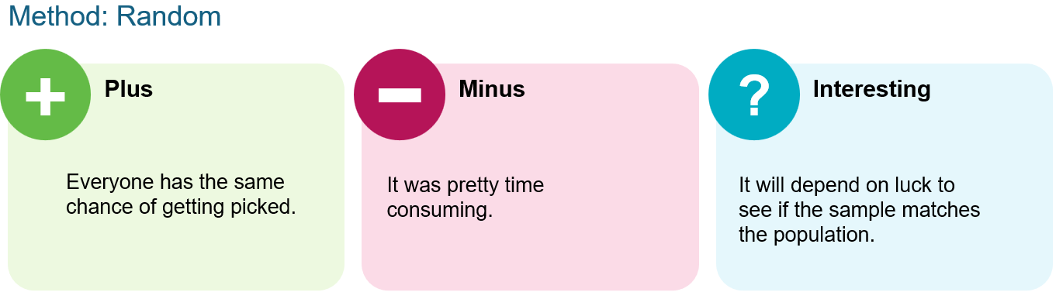
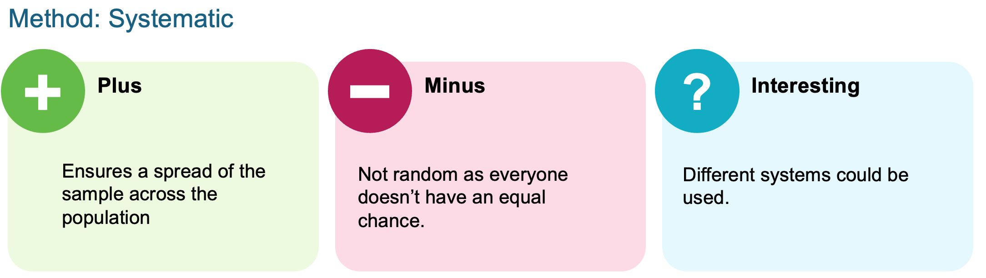
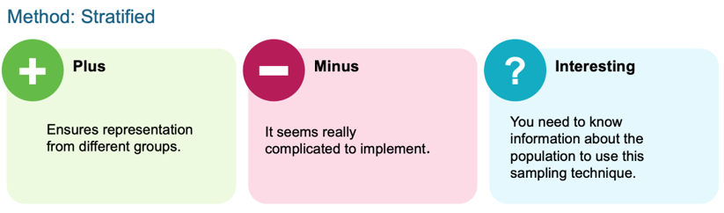

Exit ticket
A – Self-selected.
Individuals voluntarily chose to complete the questionnaire. There was no specific approach that required some kind of process or system being in place to select people and there isn’t an equal chance of being selected (random).

References
This resource contains NSW Curriculum and syllabus content. The NSW Curriculum is developed by the NSW Education Standards Authority. This content is prepared by NESA for and on behalf of the Crown in right of the State of New South Wales. The material is protected by Crown copyright.
Please refer to the NESA Copyright Disclaimer for more information https://educationstandards.nsw.edu.au/wps/portal/nesa/mini-footer/copyright.
NESA holds the only official and up-to-date versions of the NSW Curriculum and syllabus documents. Please visit the NSW Education Standards Authority (NESA) website https://educationstandards.nsw.edu.au/ and the NSW Curriculum website https://curriculum.nsw.edu.au/.
Mathematics Standard 11–12 Syllabus © NSW Education Standards Authority (NESA) for and on behalf of the Crown in right of the State of New South Wales, 2024.

© State of New South Wales (Department of Education), 2025
The copyright material published in this resource is subject to the Copyright Act 1968 (Cth) and is owned by the NSW Department of Education or, where indicated, by a party other than the NSW Department of Education (third-party material).
Copyright material available in this resource and owned by the NSW Department of Education is licensed under a Creative Commons Attribution 4.0 International (CC BY 4.0) license.

This license allows you to share and adapt the material for any purpose, even commercially.
Attribution should be given to © State of New South Wales (Department of Education), 2025.
Material in this resource not available under a Creative Commons license:
- the NSW Department of Education logo, other logos and trademark-protected material
- material owned by a third party that has been reproduced with permission. You will need to obtain permission from the third party to reuse its material.
Links to third-party material and websites
Please note that the provided (reading/viewing material/list/links/texts) are a suggestion only and implies no endorsement, by the New South Wales Department of Education, of any author, publisher, or book title. School principals and teachers are best placed to assess the suitability of resources that would complement the curriculum and reflect the needs and interests of their students.
If you use the links provided in this document to access a third-party's website, you acknowledge that the terms of use, including licence terms set out on the third-party's website apply to the use which may be made of the materials on that third-party website or where permitted by the Copyright Act 1968 (Cth). The department accepts no responsibility for content on third-party websites.

