Mathematics Standard Stage 6 (Year 11) – assessment task sample solutions
Getting healthy
Contents
About this resource 2
Sample response 3
Introduction 3
Method 3
Results 5
Conclusion 8
Reflection 9
Marking guidelines 10
References 15

About this resource
This document is Part 3 of an assessment package designed to assess the outcomes from Unit 1 – getting healthy of the Department of Education’s Stage 6 Year 11 sample scope and sequence.

Sample response

Introduction
The topic of interest that I decided to review is how much physical activity Stage 6 students do and whether this has changed since their junior school years. To investigate this, I have chosen the driving question: How many hours do students in senior years of schooling spend exercising, and has this changed?

Method
My target population is students in Years 11 and 12 at my school.
I asked about hours spent exercising in Stage 6 compared to Stage 5 (Year 10). To avoid bias, I was clear that this should include incidental and informal exercise as well as other forms of exercise, not just organised sport. I also asked students what they thought caused any changes and some general wellbeing questions.
Survey questions
- How many hours do you spend exercising in a typical school week? (Exercise could include many formal and informal activities. Examples include training for a sport, riding or walking to school, exercise as part of work duties, walking around the shops, playing with a family pet, and so on.)
Students select from a drop-down list of options:
- 0–0.5 hours
- 0.5–1 hour
- 1–1.5 hours
- 1.5–2 hours
- Etcetera
- Thinking back to Year 10, how many hours did you used to spend exercising in a typical school week?
Students select from a drop-down list of options:
- 0–0.5 hours
- 0.5–1 hour
- 1–1.5 hours
- 1.5–2 hours
- Etcetera
- If this has changed, why do you think it has changed?
Students select from a drop-down list of options:
- Hasn’t changed
- Changing demands from school
- Changing demands from home or work
- Personal choice
- Other or I would rather not say
- For each statement, students select ‘Strongly disagree’, ‘Disagree’, ‘Neutral’, ‘Agree’ or ‘Strongly agree’.
- I have enough time to spend on activities I enjoy.
- I have enough time to spend on activities that support my health and wellbeing.
- I have enough time to spend on study.
- Being in Stage 6 has made it harder to balance school and other activities.
- Overall, I feel my physical health is in a good place.
- Overall, I feel my mental health is in a good place.
For my sampling approach, I decided to use stratified sampling by randomly choosing students from each Stage 6 English class. This avoided bias as:
- English is compulsory, so all students will be represented
- classes are approximately equal in size (18–24 students), so representation will be fairly equal.
I will distribute my survey by randomly selecting students from each class and emailing them the survey during class time. This helps avoid bias because every student has an equal chance of being selected. The survey will be anonymous and optional, so students can answer honestly without pressure or fear of being identified. I will also ensure a similar number of students from each class are selected so the results are fairly representative.

Results
I used a spreadsheet to analyse my data based on the raw data that was collected by my online survey. I first ensured that I had an equal number of students from each English class to make sure the stratified sample was fair.
I also calculated the change in each activity for each student. The results can be seen below or in the tab ‘Final tables’ of the spreadsheet. I also calculated the mean for each by using the formula =AVERAGE(B83:B102) and changing the data range and I used conditional formatting to show increased (green), decreased (red) and unchanged (yellow) values.
 | Total exercise
 | Stage 6 | Year 10 | Change
 | 6 | 7 | -1
 | 7 | 9.5 | -2.5
 | 4 | 12 | -8
 | 4 | 4.5 | -0.5
 | 2 | 4 | -2
 | 2 | 0 | 2
 | 7 | 13 | -6
 | 0 | 1 | -1
 | 3 | 2.5 | 0.5
 | 8 | 4 | 4
 | 12.5 | 6.5 | 6
 | 5 | 10.5 | -5.5
 | 4 | 10 | -6
 | 4.5 | 2 | 2.5
 | 3.5 | 14 | -10.5
 | 8 | 15.5 | -7.5
 | 5.5 | 2.5 | 3
 | 2.5 | 7.5 | -5
 | 2 | 4.5 | -2.5
 | 2 | 4.5 | -2.5
Mean | 4.625 | 6.75 | -2.125
We can also see the changes in this column graph.
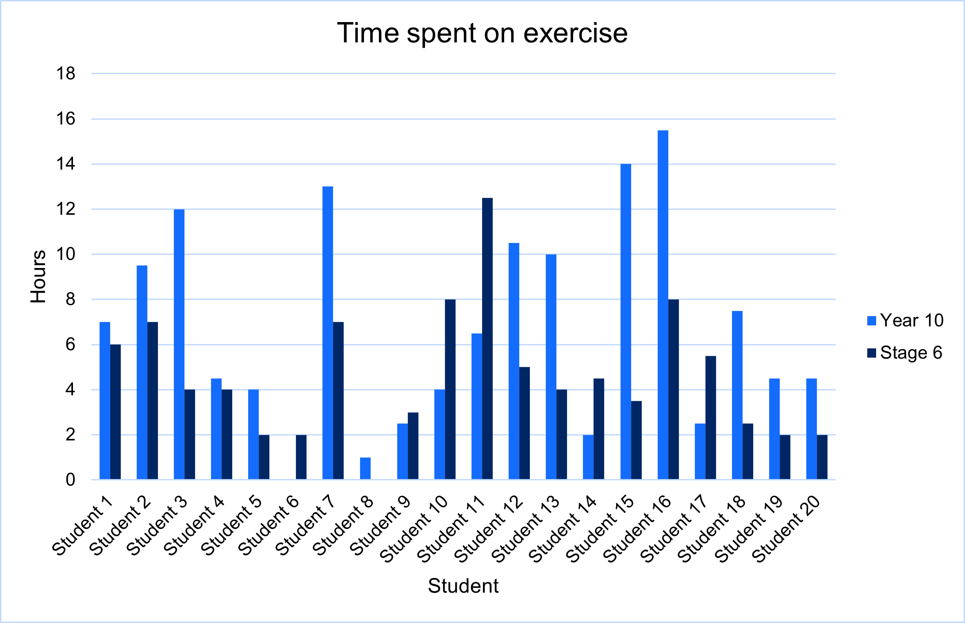
From this data, we can see that overall, as students move from Year 10 into Stage 6, they are spending less time on exercise, with an average of 4.625 hours per week in Stage 6 down from 6.75 in Year 10.
To find the 5-number summary of the data, I found the spreadsheet formulas to be inconsistent and not very useful. I instead created a new sheet (‘Calculating the mean and IQR’) and copied the data across. This allowed me to sort the data from lowest to highest using the ‘Sort’ and ‘Filter’ functions. I then shaded the rows that are relevant to each of the quartiles and used formulas like =(B17+B18)/2 to calculate the values. I used =B31-B29 to calculate the interquartile range, and “=B29-1.5*B33” and “=B31+1.5*B33” to find the limit of the outliers – changing cell values for each column. I then highlighted outliers in yellow.
 | Total exercise
 | Stage 6 | Year 10
1 | 0 | 0
2 | 2 | 1
3 | 2 | 2
4 | 2 | 2.5
5 | 2 | 2.5 | Q1
6 | 2.5 | 4 | Q1
7 | 3 | 4
8 | 3.5 | 4.5
9 | 4 | 4.5
10 | 4 | 4.5 | Med
11 | 4 | 6.5 | Med
12 | 4.5 | 7
13 | 5 | 7.5
14 | 5.5 | 9.5
15 | 6 | 10 | Q3
16 | 7 | 10.5 | Q3
17 | 7 | 12
18 | 8 | 13
19 | 8 | 14
20 | 12.5 | 15.5
Min | 0 | 0
Q1 | 2.25 | 3.25
Median | 4 | 5.5
Q3 | 6.5 | 10.25
Max | 12.5 | 15.5
IQR | 4.25 | 7
L outlier | -4.125 | -7.25
U outlier | 12.875 | 20.75
This can be seen in the box plots as well.
Exercise activities between Year 10 (blue) and Stage 6 (red)
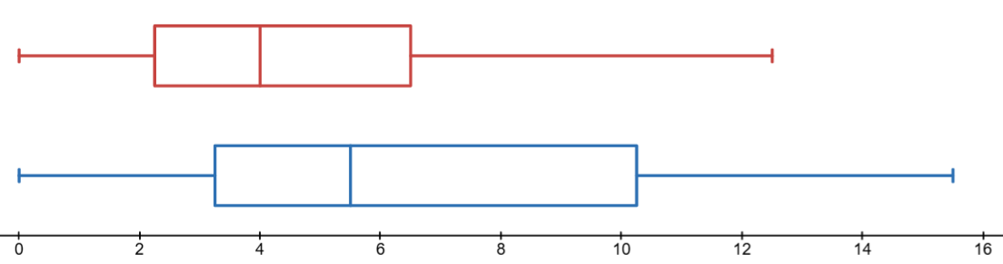
Both Year 10 and Stage 6 scores are positively skewed, and we can see a decrease overall as students move into the senior years. The median has decreased by 1.5 hours, while the third quartile has decreased by 3.75 hours, or over half an hour a day of exercise. Students who changed their level of exercise largely attributed it to personal choice (14), with only 8 students attributing changes to school demands.
The Wellbeing results were also tallied up, using the COUNTIF function, with results shown below.
 | Agree or Strongly Agree | Disagree or Strongly Disagree | Neutral
I have enough time to spend on activities I enjoy. | 8 | 12 | 0
I have enough time to spend on activities that support my health and wellbeing. | 12 | 5 | 3
I have enough time to spend on study. | 9 | 7 | 4
Being in Stage 6 has made it harder to balance school and other activities. | 11 | 3 | 6
Overall, I feel my physical health is in a good place. | 12 | 5 | 3
Overall, I feel my mental health is in a good place. | 8 | 9 | 3
These results show that while 60% of students agree or strongly agree that they have enough time to spend on activities that support their health and wellbeing, only 15% disagree that it has become harder to balance school and other activities. Only 60% and 40% agree that their physical and mental health respectively are in a good place, and only 40% agree that they have enough time to spend on activities they enjoy.

Conclusion
In answer to the driving question, ‘How many hours do students in senior years of schooling spend exercising and has this changed?’, the data shows that students spend a median of 4 and mean of 4.625 hours per week exercising in Stage 6, and there is a decrease in time spent exercising in the senior years, from 5.5 and 6.75 hours per week.
The causes of this change seem to be varied and complex. While 32.5% of students listed school demands as the reason for changes in their study habits, when it came to exercise and other activities it is no longer the most significant factor. Personal choice (23%) and demands of home or work (15%) are the main drivers of change in exercise levels. Similarly, home or work demands account for 33% of the changes in other activities, while personal choice is shown is at 27%.
Overall, the results show that Stage 6 students exercise for around 4 hours per week on average, and this has decreased compared to their junior years.

Reflection
Were the questions appropriate?
The questions were appropriate for the topic and answered the driving questions. For best results I think keeping an activity log over several weeks would give the clearest data, however that was not practical here.
Were you able to answer your driving question?
Yes, the data I gathered enabled me to answer my driving question and gave some insight into the causes of the problem.
Was 20 survey responses enough to draw a reasonable conclusion?
No. There are thousands of students in Stage 6 in NSW so 20 students from one school would not be enough to draw a reasonable conclusion. Even if we only consider our school, there are over 150 students in Stage 6 so 20 is still a small part of the population.
Would you change your method of data analysis and why?
I found the spreadsheet a good way to analyse the data. However, sometimes I had to be careful because small things would lead to data errors. To overcome this, I copied and pasted values only where possible. Also, the values had to be checked as when I used the Median function (for example) I got a different answer to the expected and COUNTIF counted ‘Disagree’ as well when asked to count ‘Agree’. However, being able to copy and paste or drag calculations saved a lot of time when looking at multiple datasets and graphs were very easy to create.
What advice would you give to someone conducting a similar investigation?
First, I would say to test your questions before you start. I had to change my survey after I realised the analysis would not give me the comparison I wanted. I would also suggest considering other categories of activity to consider where the decreased time spent exercising is being used, and if possible, using a diary or app to track activities. I would also suggest they ask as many people as they can for better conclusions.

Marking guidelines
Table 1 – student-facing rubric
Criteria | Working towards developing | Developing | Developed | Well-developed | Highly developed
Statistical investigation process  (MST-11-08,  MAO-WM-01) | Topic is unclear or lacks focus. Driving question is missing or irrelevant. Survey questions are vague, unclear or unrelated to the investigation. Sampling method is not identified or explained. | Topic and driving question are somewhat relevant to the investigation. Survey includes basic questions with some clarity. Sampling method is stated but justification is limited or unclear. | Clear and relevant topic with a well-posed driving question. Survey questions are mostly clear and purposeful. Sampling method is appropriate and justified. | Well-defined topic and clearly articulated driving question. Survey questions are clear, logical and mostly free of bias. Sampling approach and distribution method are well explained with consideration of fairness and bias. | Topic is insightful and strongly connected to the investigation. Driving question is precise and thought-provoking. Survey questions are unambiguous, logically sequenced and comprehensive. All methodological decisions are justified with strong awareness of bias, ethics and representativeness.
Teacher notes: uses an appropriate driving question and clearly defines the target population. Designs and distributes a survey using stratified random sampling across English classes. Demonstrates awareness of bias through anonymity, optional participation and random selection. Survey design is logical and mostly free from bias, with clear sequencing of questions.
Criteria | Working towards developing | Developing | Developed | Well-developed | Highly developed
Data displays (MST-11-08, MAO-WM-01) | Limited or incorrect graphs or tables. Displays may be incomplete or poorly labelled. Little or no evidence of digital tools being used. | Some graphs and tables are appropriate but formatting or labelling may be inconsistent. Basic use of digital tools is evident. | Graphs and tables are appropriate for the data type. Frequency or cumulative frequency tables are mostly accurate. Digital tools are used effectively and displays are clearly labelled. | Graphs and tables are well chosen and mostly accurate. Digital tools are used confidently to organise and present the data. Displays are clear, well formatted and support understanding of the results. | Graphs and tables are consistently well matched to the data and purpose of the investigation. Tables and graphical displays are accurate, well formatted and highly effective. Digital tools are used proficiently to produce polished displays that enhance interpretation.
Teacher notes: uses spreadsheets effectively to organise and present data. Constructs accurate tables of summary statistics, including mean, median, quartiles and IQR. Produces appropriate graphical representations (column graphs and box plots) that clearly support interpretation of trends and variation in the data. Minor inconsistencies in procedural explanation of spreadsheet functions are present but do not affect overall clarity.
Criteria | Working towards developing | Developing | Developed | Well-developed | Highly developed
Data analysis (MST-11-08, MAO-WM-01) | Minimal or incorrect calculations. Limited or no interpretation of the data. Analysis does not connect to the driving question. | Basic statistical calculations are attempted (for example, mean, median, range). Interpretation is limited with a basic attempt to connect results to the driving question. | Calculations include relevant measures, such as mean, median, range and possibly IQR or outliers. Analysis is mostly accurate and supports the conclusions drawn. | Accurate statistical calculations include several relevant measures. Analysis identifies trends, patterns or clusters in the data and links these trends to the driving question. | Comprehensive and accurate analysis using a variety of statistical measures and observations. Interpretation is insightful, clearly linked to the driving question, and acknowledges patterns, variability and possible limitations of the data.
Teacher notes: applies a range of statistical measures correctly to describe changes in physical activity between Year 10 and Stage 6. Identifies clear trends, including a decrease in exercise levels, supported by both numerical summaries and graphical representations. Integrates categorical survey data to explain contributing factors, such as personal choice and school demands. Demonstrates strong interpretation of variation and distribution, with meaningful connections drawn between datasets.
Criteria | Working towards developing | Developing | Developed | Well-developed | Highly developed
Conclusion and reflection (MST-11-08, MAO-WM-01) | No clear conclusion or one that does not address the driving question. Reflection is missing or extremely limited. | Conclusion attempts to address the driving question but is supported by limited evidence. Reflection briefly comments on aspects such as question quality or sampling. | Evidence-based conclusion that answers the driving question. Reflection discusses strengths and weaknesses of the data collection process and investigation design. | Clear and well-supported conclusion linked to the analysis. Reflection thoughtfully evaluates the investigation process, including sampling, question design and reliability of results. | Well-supported conclusion that synthesises research and data analysis. Reflection shows deep consideration of validity, bias, representativeness and limitations. Insightful and practical recommendations are provided for future investigations.
Teacher notes: provides a clear conclusion that directly addresses the driving question and is supported by statistical evidence. Accurately summarises key measures, including mean and median, to describe change over time. Reflection identifies limitations in sample size and sampling scope and suggests practical improvements to data collection. Demonstrates awareness of bias and reliability, though evaluation of methodological limitations remains largely descriptive.

References
This resource contains NSW Curriculum and syllabus content. The NSW Curriculum is developed by the NSW Education Standards Authority (NESA). This content is prepared by NESA for and on behalf of the Crown in right of the State of New South Wales. The material is protected by Crown copyright.
Please refer to the NESA Copyright Disclaimer for more information https://www.nsw.gov.au/education-and-training/nesa/copyright.
NESA holds the only official and up-to-date versions of the NSW Curriculum and syllabus documents. Please visit NESA https://www.nsw.gov.au/education-and-training/nesa and NSW Curriculum https://curriculum.nsw.edu.au/.
Mathematics Standard 11–12 Syllabus © NSW Education Standards Authority (NESA) for and on behalf of the Crown in right of the State of New South Wales, 2024.

© State of New South Wales (Department of Education), 2026
The copyright material published in this resource is subject to the Copyright Act 1968 (Cth) and is owned by the NSW Department of Education or, where indicated, by a party other than the NSW Department of Education (third-party material).
Copyright material available in this resource and owned by the NSW Department of Education is licensed under a Creative Commons Attribution 4.0 International (CC BY 4.0) license.

This license allows you to share and adapt the material for any purpose, even commercially. Attribution should be given to © State of New South Wales (Department of Education), 2026.
Material in this resource not available under a Creative Commons license:
- the NSW Department of Education logo, other logos and trademark-protected material
- material owned by a third party that has been reproduced with permission. You will need to obtain permission from the third party to reuse its material.
Links to third-party material and websites
Please note that the provided (reading/viewing material/list/links/texts) are a suggestion only and implies no endorsement, by the New South Wales Department of Education, of any author, publisher, or book title. School principals and teachers are best placed to assess the suitability of resources that would complement the curriculum and reflect the needs and interests of their students.
If you use the links provided in this document to access a third-party's website, you acknowledge that the terms of use, including licence terms set out on the third-party's website apply to the use which may be made of the materials on that third-party website or where permitted by the Copyright Act 1968 (Cth). The department accepts no responsibility for content on third-party websites.

