Trigonometry in three dimensions
Students explore 3-dimensional trigonometry problems by interpreting diagrams and identifying the relevant triangles for calculations. They develop strategies to extract 2-dimensional triangles from 3-dimensional diagrams and apply trigonometry to solve these problems.

Learning intentions
- To be able to interpret 3-dimensional contexts from diagrams.
- To be able to identify relevant triangles in 3-dimensional problems and apply trigonometry to solve them.

Success criteria
- I can extract 2-dimensional triangles from 3-dimensional diagrams.
- I can apply trigonometry to solve problems in three dimensions.
- I can justify my reasoning and explain the steps I take to solve a problem.

Outcomes
A student:
- develops understanding and fluency in mathematics through exploring and connecting mathematical concepts, choosing and applying mathematical techniques to solve problems, and communicating their thinking and reasoning coherently and clearly MAO-WM-01
- solves problems in three dimensions using trigonometry and simplifies expressions, proves results and solves problems involving compound angles using trigonometric identities
ME1-11-03

Content

Trigonometry in three dimensions
- Interpret information about a 3-dimensional context given in diagrammatical form
- Apply trigonometry to solve problems in three dimensions where a diagram is given
Mathematics Extension 1 11–12 Syllabus © NSW Education Standards Authority (NESA) for and on behalf of the Crown in right of the State of New South Wales, 2024.

Table 1: lesson summary
Section | Summary of activity | Teaching strategies | Teaching points
Activating prior knowledge | Students complete Appendix A, also shown on slide 4 of the PowerPoint Trigonometry in three dimensions. | Goal-free problem  Vertical non-permanent surfaces  Visibly random groups of 3  Gallery walk | The purpose of this section is for students to recall their Stage 5 and Year 11 Mathematics Advanced knowledge of finding unknown sides and angles in right-angled and non-right-angled triangles.
Connecting learning | Using the physical classroom, place a star image (Appendix C) or an image of your choice in the top corner. Have 2 students first stand in the corners of the room next to the star and then move to the middle of the room to form triangles, which are then used to calculate heights and distances. Students identify, describe, and sketch the triangles formed in the room and determine whether they are right-angled or non-right-angled. | Pose-Pause-Pounce-Bounce | The purpose of this section is to help students visualise 3-dimensional trigonometry by physically acting out and modelling the triangles in the classroom. By using the room, walls, floor and students as reference points, students can see that 3-dimensional problems are solved by identifying and drawing the appropriate 2-dimensional triangles within the space.
Releasing responsibility | Model worked examples using slides 6–7. Students then find the volume and surface area of the pyramids using slides 8–11. | Worked examples (Your turn)  Vertical non-permanent surfaces  Visibly random groups of 3  Gallery walk | Emphasise breaking 3-dimensional shapes into triangles, identifying what needs to be calculated first and selecting appropriate trigonometric methods.
Independent practice | Students are reminded of the ‘Approaching questions scaffold’ on slide 13 and complete Appendix B. | Approaching questions scaffold | The purpose of this section is for students to apply 3-dimensional trigonometry problem-solving skills to exam-style questions.

Activity structure
Please use the associated PowerPoint Trigonometry in three dimensions to display images in this lesson.

Activating prior knowledge
- Assign students to visibly random groups of 3 (bit.ly/visiblegroups) at vertical non-permanent surfaces (bit.ly/VNPSstrategy).
- Distribute Appendix A ‘Goal-free problem’ (bit.ly/goalfreeproblems) to groups and have them find as many missing sides and angles as possible. This appendix can also be displayed using slide 4.
This activity encourages students to recall their knowledge from Year 11 Mathematics Advanced to find missing angles and sides in both right-angled and non-right-angled triangles. Students learned the sine and cosine rule in the Year 11 Mathematics Advanced Trigonometry and measure of angles outcome MAV-11-04.
- Allow students to do a gallery walk (bit.ly/DLSgallerywalk) to compare their results and methods and to consider whether there were additional sides or angles they could have found.
Answers have been provided in the ‘Sample solutions’ section.

Connecting learning
- Place a star image or an image of your choosing in the top corner of the classroom. You may use Appendix C ‘Star image’ to set this up.
- Invite 2 students to stand in the corners of the room next to the star, as shown in Figure 1.
Figure 1: two students standing in the corners of the room next to the star
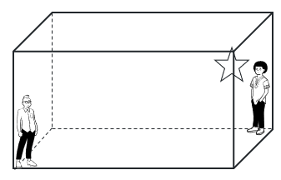
- Ask the class how many different triangles they can identify to calculate the height of the star. Encourage students to describe the triangle they are considering or to physically demonstrate it using the room as a reference.
The relevant triangles are illustrated in Figure 2.
Figure 2: relevant triangles of students standing in the classroom
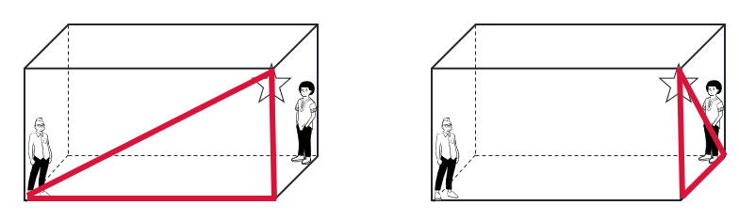
- Map out each of the triangles using the physical space of the classroom such as the floor, walls and corners to support students in developing their spatial awareness.
- Ask students to determine whether the triangles are right-angled or non-right-angled and justify their reasoning.
- Ask students to physically identify and sketch triangles that could be used to determine the distance between the 2 classmates, determining whether the triangles are right-angled or non-right-angled and explaining how each triangle supports the calculation.
The relevant triangles are illustrated in Figure 3.
Figure 4: relevant triangles of students standing in the classroom
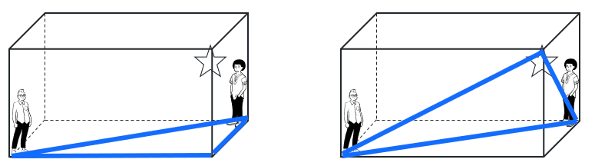
- Ask the 2 students to stand somewhere else in the room that is not in a corner.
- Ask students to physically identify and sketch triangles connecting the 2 students and the star. They should determine whether the triangles are right-angled or non-right-angled and explain how each triangle supports the calculation.
The relevant triangles are illustrated in Figure 4.
Figure 5: two students standing in the classroom away from the edge.
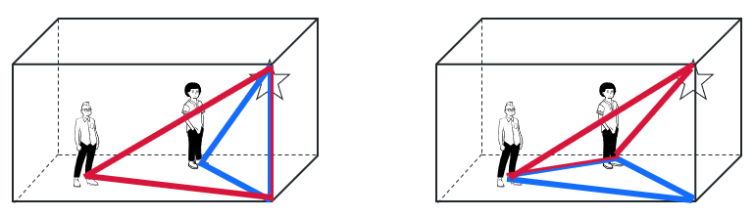
- Use the Pose-Pose-Pounce-Bounce questioning strategy (PDF 557 KB) (bit.ly/posepausepouncebounce) to check students’ understanding of how the students’ positions in the room affect the type and number of triangles connecting them to the star that can be formed. Some suggested prompts include:
- What differences do you notice between the triangles when the students were standing in the corners of the room compared with when they moved away from the corners?
- How does changing the students’ positions affect the types of triangles that can be formed in the room?
- What features of the classroom helped create right-angled triangles earlier and how has this changed now?
Students should recognise that fewer right-angled triangles can be formed when students are out of the corners, meaning the sine or cosine rule would need to be applied to find missing sides or angles.

Releasing responsibility
- Use slides 6–7 from the PowerPoint to model worked examples of finding diagonals of rectangular prisms using the Worked examples (Your turn) method (bit.ly/supportingstrategies).
Refer to and role-play the scenario of students standing in the classroom to support their spatial understanding of the 2 questions on slides 6 and 7, helping them visualise the measurements they are calculating.
- Return students to their previous visibly random groups of 3 at vertical non-permanent surfaces.
- Use slide 8 to display a pyramid and ask students to find the surface area and volume of the pyramid.
Students may need to be reminded of the formulas for the surface area and volume of a pyramid, which may have been taught in the Stage 5 Area and surface area B (Path) outcome MA5-ARE-P-01 and Volume B (Path) outcome MA5-VOL-P-01.
- Use slides 9 and 10 to reveal solutions.
- Use slide 11 to display a rectangular pyramid with similar measurements to the previous square pyramid. Explain to students that they will be finding the surface area and volume of this pyramid.
- In groups, have students discuss which calculations will change for a rectangular pyramid compared to a square pyramid. Then ask them to calculate both the surface area and volume for the rectangular pyramid.
- Encourage students to perform a gallery walk (bit.ly/DLSgallerywalk) observing other groups’ work before returning to their own group to refine their solutions.
- Identify a correct solution on one of the groups’ vertical non-permanent surfaces and gather the class to talk through the solution.
- Students may benefit from practising further questions from an existing resource focusing on 3-dimensional trigonometric problems that involve prisms or pyramids.

Independent practice
- Use slide 13 of the PowerPoint to remind students of the ‘Approaching questions scaffold’.
- Distribute Appendix B ‘HSC-style questions’ to all students.
- Have students complete the questions in pairs, encouraging students to discuss the methods they are using and to recreate the required 2-dimensional triangles in their workbooks alongside their calculations.
- Initiate a class discussion to explore the strategies students found most effective, encouraging them to explain their reasoning and justify their approach.

Assessment and differentiation

Suggested opportunities for differentiation
Activating prior knowledge
- Support students by suggesting specific angles and sides to find first.
- Challenge students to identify multiple strategies to find missing sides or angles.
Connecting learning
- To support students, provide 3-dimensional objects such as small boxes for students to manipulate as they complete questions.
- To support students, provide a diagram similar to Figure 1 and 2 to support their understanding of visualising the triangles.
Releasing responsibility
- To support students, provide them with the diagrams of the 2-dimensional triangles already extracted from the prism and pyramid.
Independent practice
- Provide scaffolding to support students by identifying the steps they should take to complete the questions.

Suggested opportunities for assessment
Activating prior knowledge
- Observe group interactions during the goal-free problem and gallery walk to identify misconceptions about right-angled and non-right angled triangles.
Connecting learning
- Monitor students as they model triangles in the classroom to identify potential gaps in spatial reasoning.
Releasing responsibility
- Students self-assess by reflecting on which sides and angles could not be found and why, discussing multiple methods where appropriate.
Independent practice
- Review students completed solutions to assess individual understanding and method selection.

Appendix A

Goal-free problem
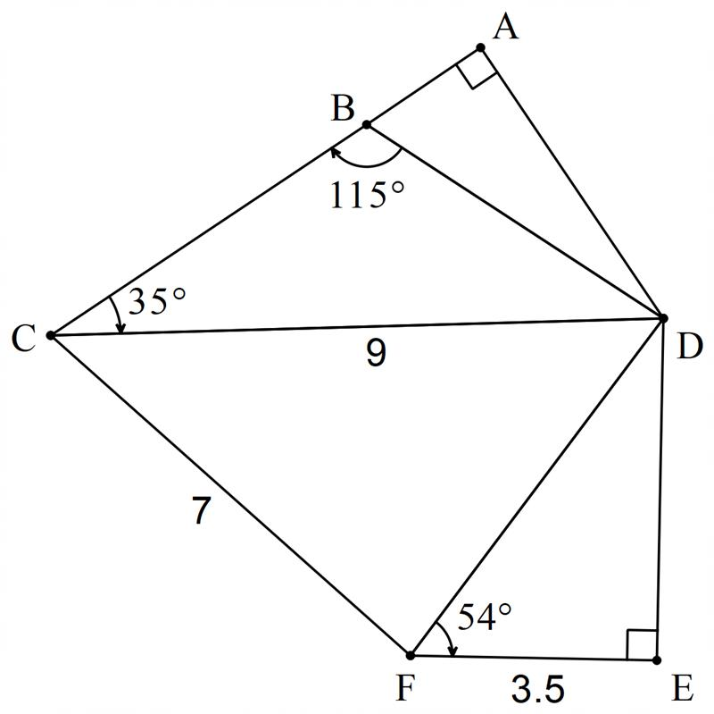

Appendix B

HSC-style questions
- In the rectangular prism shown, $AD=6\text{ cm}$, $AE=5\text{ cm}$, $EF=8\text{ cm}$. Point $M$ is the midpoint of $CD$.
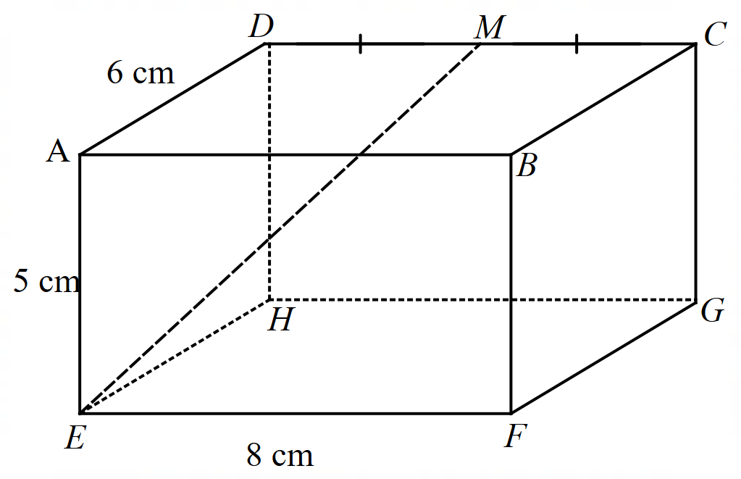
Find $∠AEM$, to the nearest degree.
- The base of a box is twice as wide as it is deep. If the diagonal $AG$ is 65 cm long and makes an angle of $40°$ with the base $ABCD$ find the dimensions of the box.
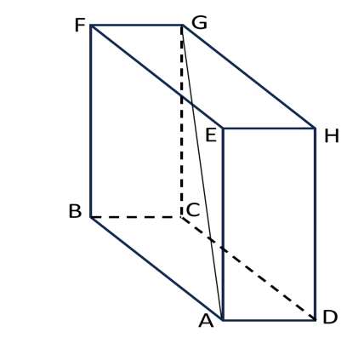

- In a square-based prism, the height is twice the length and breadth, as shown in the diagram below:
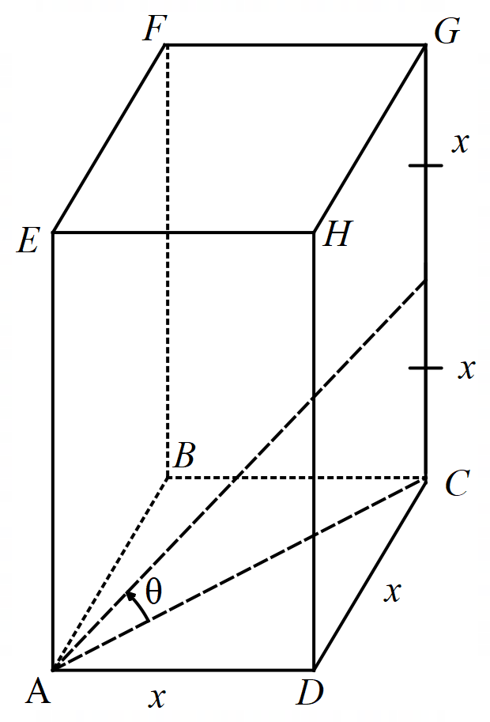
- Find the size of the angle marked to the nearest degree.
- Jane thinks the angle between the base ABCD and the longest diagonal AG will be double the angle found in part a. Is she correct?

Appendix C

Star image


Sample solutions

Appendix A – goal-free problem
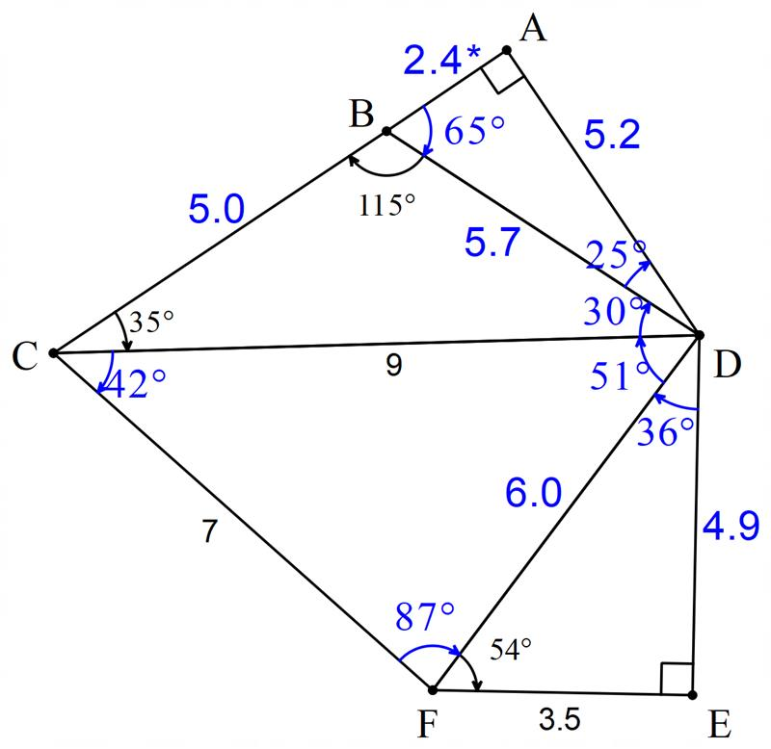
Note: the value 2.4 could be calculated as 2.3 if Pythagoras is used in calculations.
$$∠ABD=65° \\ ∠BDC=30°$$
$$\frac{BD}{\sin{35°}}=\frac{9}{\sin{115°}} \\ BD=\frac{9×\sin{35°}}{\sin{115°}} \\ BD=5.69… \\ ≈5.7$$
$$CB^{2}=9^{2}+{5.7}^{2}-2×5.7×9×cos30 \\ =24.6357… \\ CB=4.96… \\ ≈5.0$$
$$\sin{65°}=\frac{AD}{5.7} \\ AD=5.7×\sin{65°} \\ =5.156… \\ =5.2 \\ \cos{65°}=\frac{AB}{5.7} \\ AB=\cos{65°}×5.7 \\ =2.408… \\ ≈2.4$$
$$\cos{54°}=\frac{3.5}{FD} \\ FD=\frac{3.5}{\cos{54°}} \\ =5.954… \\ ≈6.0 \\ ∠FDE=36° \\ \tan{54°}=\frac{DE}{3.5} \\ DE=3.5×\tan{54°} \\ =4.817… \\ ≈4.8$$
$$\cos{∠FCD}=\frac{9^{2}+7^{2}-{6.0}^{2}}{2×9×7} \\ =\frac{47}{63} \\ ∠FCD=41.752… \\ ≈42°$$
$$\cos{∠FDC}=\frac{9^{2}+{6.0}^{2}-7^{2}}{2×9×6.0} \\ =\frac{17}{27} \\ ∠FDC=50.977… \\ ≈51° \\ ∠CFD=87°$$

Appendix B – HSC-style questions

$$AM^{2}=AD^{2}+DM^{2} \\ =6^{2}+4^{2} \\ AM=\sqrt{52} \\ =2\sqrt{13} \\ \tan{∠AEM}=\frac{2\sqrt{13}}{5} \\ ∠AEM=55°$$

$$∆ACG \\ \sin{40°=\frac{CG}{65}} \\ CG=65\sin{40°} \\ =41.7811… \\ ≈41.8 cm \\ \cos{40°=\frac{AC}{65}} \\ AC=65×\cos{40°} \\ =49.792889… \\ ≈49.8 cm$$Let $AB=2x$ and $AD=x$
$$AC^{2}=AD^{2}+AB^{2} \\ {49.8}^{2}=x^{2}+{\left(2x\right)}^{2} \\ {49.8}^{2}=5x^{2} \\ x^{2}=496.008… \\ x=22.27123… \\ ≈22.3 cm$$
Dimensions of the box are 22.3, 41.8 and 44.6 cm.

$$Base diagonal=\sqrt{\left(x^{2}+x^{2}\right)} \\ =\sqrt{2x^{2}} \\ =\sqrt{2}x$$
$$\tan{θ=\frac{x}{\sqrt{2}x}} \\ =\frac{1}{\sqrt{2}} \\ θ=\tan^{-1}{\frac{1}{\sqrt{2}}} \\ =35.26… \\ ≈35°$$

$$AC^{2}=x^{2}+x^{2} \\ =2x^{2} \\ AC=\sqrt{2}x$$
$$\tan{θ}=\frac{2x}{\sqrt{2}x} \\ =\frac{2}{\sqrt{2}} \\ θ= 64.735… \\ ≈65°$$$∴$ not double.

References
This resource contains NSW Curriculum and syllabus content. The NSW Curriculum is developed by the NSW Education Standards Authority (NESA). This content is prepared by NESA for and on behalf of the Crown in right of the State of New South Wales. The material is protected by Crown copyright.
Please refer to the NESA Copyright Disclaimer for more information https://www.nsw.gov.au/education-and-training/nesa/copyright.
NESA holds the only official and up-to-date versions of the NSW Curriculum and syllabus documents. Please visit NESA https://www.nsw.gov.au/education-and-training/nesa and NSW Curriculum https://curriculum.nsw.edu.au.
Mathematics Extension 1 11–12 Syllabus © NSW Education Standards Authority (NESA) for and on behalf of the Crown in right of the State of New South Wales, 2024

© State of New South Wales (Department of Education), 2026
The copyright material published in this resource is subject to the Copyright Act 1968 (Cth) and is owned by the NSW Department of Education or, where indicated, by a party other than the NSW Department of Education (third-party material).
Copyright material available in this resource and owned by the NSW Department of Education is licensed under a Creative Commons Attribution 4.0 International (CC BY 4.0) license.

This license allows you to share and adapt the material for any purpose, even commercially. Attribution should be given to © State of New South Wales (Department of Education), 2026.
Material in this resource not available under a Creative Commons license:
- the NSW Department of Education logo, other logos and trademark-protected material
- material owned by a third party that has been reproduced with permission. You will need to obtain permission from the third party to reuse its material.
Links to third-party material and websites
Please note that the provided (reading/viewing material/list/links/texts) are a suggestion only and implies no endorsement, by the New South Wales Department of Education, of any author, publisher, or book title. School principals and teachers are best placed to assess the suitability of resources that would complement the curriculum and reflect the needs and interests of their students.
If you use the links provided in this document to access a third-party's website, you acknowledge that the terms of use, including licence terms set out on the third-party's website apply to the use which may be made of the materials on that third-party website or where permitted by the Copyright Act 1968 (Cth). The department accepts no responsibility for content on third-party websites.

