Simplifying sums of sine and cosine functions
Students examine how a combination of sine and cosine functions can be rewritten as $R\cos{(x±α)}$ or $R\sin{(x±α)}$ and apply this form to graph functions accurately. They develop an understanding of how the transformed representation relates to the original combination, both algebraically and graphically.
Students may need at least one digital device per pair to interact with a graphing application during the ‘Independent practice’ section of this lesson.

Learning intentions
- To understand how $a\cos{x}+b\sin{x}$ can be expressed as a single sine or cosine function.
- To be able to compare the relationship between the algebraic and graphical forms of trigonometric functions.

Success criteria
- I can compare the graph of $a\cos{x}+b\sin{x}$ with the corresponding $R\cos{(x±α)}$ or $R\sin{(x±α)}$ function.
- I can convert $a\cos{x}+b\sin{x}$ into $R\cos{(x±α)}$ or $R\sin{(x±α)}$ algebraically.
- I can calculate $R$ and $α$ from given coefficients.
- I can use the $R\cos{(x±α)}$ or $R\sin{(x±α)}$ form to graph functions more accurately and efficiently.

Outcomes
A student:
- develops understanding and fluency in mathematics through exploring and connecting mathematical concepts, choosing and applying mathematical techniques to solve problems, and communicating their thinking and reasoning coherently and clearly MAO-WM-01
- solves problems in three dimensions using trigonometry and simplifies expressions, proves results and solves problems involving compound angles using trigonometric identities
ME1-11-03

Content

Further trigonometric equations
- Examine the representations of $a\cos{x}+b\sin{x}$ as $R\cos\left(x±α\right)$ or $R\sin\left(x±α\right)$ with and without graphing applications, where $a≠0 and b≠0$
- Apply the representations of $a\cos{x}+b\sin{x}$ as $R\cos{(x±α)}$ or $R\sin{(x±α)}$ to graph functions, solve equations of the form $a\cos{x}+b\sin{x}=c$ over restricted domains, and model and solve related problems
Mathematics Extension 1 11–12 Syllabus © NSW Education Standards Authority (NESA) for and on behalf of the Crown in right of the State of New South Wales, 2024.

Table 1: lesson summary
Section | Summary of activity | Teaching strategies | Teaching points
Activating prior knowledge | Students revisit adding functions graphically using Appendix A and identify key features such as amplitude and period from the graph. | Think-Pair-Share | The purpose of this activity is to reconnect students with combining functions and interpreting graphs, preparing them to link graphical features with algebraic forms.
Connecting learning | Using the Desmos graph ‘Simplifying sums of sine and cosine functions’, students explore $y=\sin{x}+\cos{x}$, confirming amplitude and period from key points. Students are guided through converting $y=\sin{x}+\cos{x}$ into the form $R\sin{(x+α)}$ using slide 4 of the PowerPoint, with animation and questioning to unpack the derivation of $R=\sqrt{2}$ and $α=\frac{π}{4}$. The Desmos graph is used to investigate cases such as  $y=\sin{2x}+\cos{2x}$ and $y=\sin{2x}+\cos{3x}.$  Alternative methods for finding $R$ and $α$ can then be discussed. Students then confirm equivalent forms of converting $\sin{x}+\cos{x}$ to $R\sin\left(x+α\right),R\cos{(x±α})$ through group work and a gallery walk, with solutions on slides 5–7. | Think-Pair-Share  Pose-Pause-Pounce-Bounce  Gallery walk | The goal is to connect graphical understanding with algebraic structure. Teachers should emphasise how $R$ represents amplitude and $α$ represents horizontal translation, that multiple equivalent forms produce the same graph and that the method applies only when trigonometric terms share the same angle (same multiple of $x$).
Releasing responsibility | Students complete worked examples using slides 9–10 and faded examples from Appendix B. Students create notes to their future selves. | Worked examples (Your turn)  Faded worked examples  Pose-Pause-Pounce-Bounce  Notes to future forgetful selves | Teachers should emphasise careful determination of $α$ (including quadrant considerations), the link between algebra and graph features.
Independent practice | Students compare methods for graphing trigonometric functions using Appendix C and apply both approaches to sketch graphs. A graphing application is used to check and refine solutions. | Think-Pair-Share  Worked example (comparison) | The goal is for students to evaluate and select efficient strategies. Teachers should emphasise that rewriting in the form $Rsin(x+α)$ or $Rcos(x+α)$ reveals key features (amplitude and translation), leading to more efficient and accurate graphing.

Activity structure
Please use the associated PowerPoint Simplifying sums of sine and cosine functions to display images in this lesson.

Activating prior knowledge
- Distribute Appendix A ‘Addition of trigonometric functions’, a plastic sleeve and whiteboard marker to all students. The appendix contains both $f(x)=\sin{x}$ and $g(x)=\cos{x}$ on the same set of axes.
- Initiate a class discussion to recall the amplitude and period of these trigonometric graphs.
Students learned how to describe amplitude and period in the Year 11 Mathematics Advanced Trigonometry and measure of angle outcome MAV-11-04.
- In pairs, allow time for students to discuss approaches and then graph $y=f\left(x\right)+g(x)$ on Appendix A.
Students learned how to graph $y=f\left(x\right)+g(x)$ in Unit 6 – further work with functions, Lesson 5 – addition and subtraction of functions. This unit covered the syllabus content from Further work with functions outcome ME1-11-01.
- In a Think-Pair-Share (bit.ly/thinkpairsharestrategy), ask students to discuss what they notice and wonder about the resulting graph of $y=f\left(x\right)+g(x)$. Guide students’ thinking when they share by using some suggested prompts to deepen their thinking:
- What do you notice about the shape of the graph of $y=\sin{x}+\cos{x}$? How does it compare to the graphs of $y=\sin{x}$ and $y=\cos{x}$?
- What do you notice about the amplitude of this graph compared with the amplitudes of $y=\sin{x}$ and $y=\cos{x}$?
- What can you say about how often this graph repeats? How does its period compare with the sine and cosine graphs?

Connecting learning
Students are yet to learn how to apply graph transformations to trigonometric functions. The content is covered in Year 12 Advanced Further graph transformations and modelling.
- Display the Desmos Graphing Calculator ‘Simplifying sums of sine and cosine functions’ (bit.ly/DesmosRandAlpha) for students, showing the graph of $y=\sin{x}+\cos{x}$ with 2 key points.
- Use this graph and the key points to identify the period $2π$ and the amplitude $\sqrt{2}≈1.414…$ of the graph $y=\sin{x}+\cos{x}$.
- Use the Pose-Pause-Pounce-Bounce questioning strategy (PDF 557KB) (bit.ly/posepausepouncebounce) to extend students’ thinking towards graph transformations. Some suggested prompts include:
- Which trigonometric graph does this most closely resemble: $y=\sin{x}$ or $y=\cos{x}$? Give reasons.
- How could this graph be obtained from $y=\sin{x}$ or $y=\cos{x}$ using graph transformations? Can you describe these transformations?
Students may observe that the graph $y=\sin{x}+\cos{x}$ resembles both $y=\cos{x}$ and $y=\sin{x}$ with a dilation of $\sqrt{2}$ and a horizontal translation of $\frac{π}{4}$ applied.
- Using the Desmos graph, open the folder titled ‘Investigating graph transformations’ by selecting the arrow. This will now display 4 equations and 2 sliders as shown in Figure 1.
Figure 1: Desmos Graphing Calculator 'Simplifying sums of sine and cosine functions'
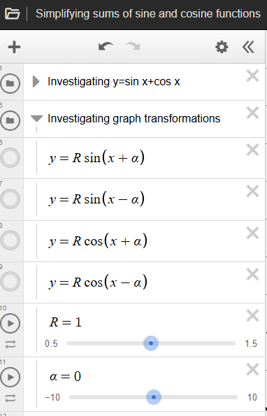
- Explain to the class that each of these equations represents a transformed sine or cosine function. Instead of using $\frac{y}{l}$ and $x-b$, we are using $R$ and $α$.
Students learned that replacing $y$ with $\frac{y}{l}$ corresponds to a vertical dilation by a factor of $l$ and replacing $x$ with $x-a$ corresponds to a horizontal translation of a graph by $a$ in the Year 11 Advanced Graph transformations outcome MAV-11-03.
- Select the first equation $y=R\sin{(x+α)}$ to display, toggling the circle next to it to display the graph.
- Use the provided Desmos sliders for both $R$ and $α$ to adjust the values until the graph of $y=R\sin{(x+α)}$ is the same as the graph of $y=\sin{x}+\cos{x}$. This will occur when $R=1.41…$ and $a=0.785…$
It will be helpful to have $\sqrt{2}=1.414…$ and $\frac{π}{4}=0.785…$ displayed for students.
- Repeat this process for the remaining 3 equations: $y=R\sin{(x-α)}, y=R\cos\left(x+α\right)$ and $y=R\cos{(x-α)}$ by toggling the circle next to each to show or hide the graph.
It will be helpful to have $\frac{7π}{4}=5.497…$ displayed for students.
- Initiate a class discussion to identify what students notice about the relationship between the $R$ and $α$ values that produce the same graph as $y=\sin{x}+\cos{x}$.
Students should share that each of the $R$ values is identical across the 4 equations. The $α$ values are either $\frac{π}{4}$ or $\frac{7π}{4}$.
- Using Desmos, toggle off the first 2 folders and select only ‘Investigating coefficients’ as shown in Figure 2.
Figure 2: Desmos Graphing Calculator 'Simplifying sums of sine and cosine functions'
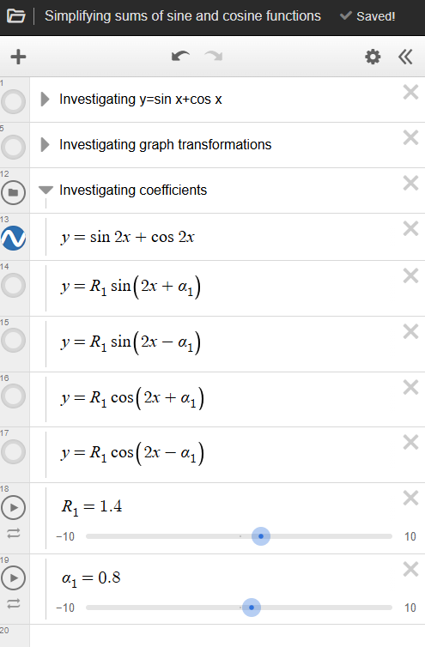
- Draw students’ attention to the $2x$ in the equation $y=\sin{2x}+\cos{2x}$ and ask the class whether they think the graph of $R\sin{(2x±α)}$ or $R\cos{(2x±α)}$ will produce the same shape and how the factor of 2 affects the graph.
- Use the graphing application to toggle on and off each of the 4 forms and use the sliders for $R$ and $α$ to show students that it works in the same way.
- Ask students to consider if this would work for the equation $y=\sin{2x}+\cos{3x}$ before adjusting the equation in Desmos to conclude that this method only works when both trigonometric terms have the same angle and involve the same multiple of $x$.
- Explain to the class that while the graphing application helped us see that
$y=sinx+cosx$, $y=\sqrt{2}\sin\left(x+\frac{π}{4}\right), y=\sqrt{2}\sin\left(x-\frac{7π}{4}\right), y=\sqrt{2}\cos\left(x+\frac{7π}{4}\right)$ and $y=\sqrt{2}\cos\left(x-\frac{π}{4}\right)$ produce the same graph, mathematicians often aim to show this algebraically without relying on technology. Writing a sum of trigonometric functions as a single function also makes important features of the graph, such as amplitude and translation, easier to identify. These are not immediately clear in forms like $a\cos{x}+b\sin{x}$.
- Display slide 4 of the PowerPoint and, in a Think-Pair-Share, ask students to recall the sum and difference expansion formulas and write the expansion for $\sin\left(x+α\right)$.
- Ask students to adjust their expansion to express $R\sin\left(x+α\right)$.
- Animate slide 4 to show that $R\sin{(x+α)}=R\sin{x}\cos{α}+R\sin{α}\cos{x}$.
- Remind students that we are wanting to convert $y=sin⁡x+cos⁡x$ to the form
$y=R\sin\left(x+α\right)$ since we know that it is equivalent to $y=\sqrt{2} sin\left(x + \frac{π}{4}\right)$.
- Slowly animate the slide to show how this is derived. Use the following prompts to deepen students’ understanding of the derivation:
- Why were the coefficients $+1$ added?
- How was the right-angled triangle used?
- How else could the value of $α$ have been found rather than using tangent?
- Why might using tangent be the most efficient method?
- Once we have written the function in the form $Rsin⁡(x+α)$, what information about the graph becomes immediately visible that was harder to see in $sin⁡x+cos⁡x$?
Students might suggest that using $\tan{α}$ allows the angle to be found without requiring the value of $R$. The form $R\sin{(x+α)}$ allows the amplitude, $R$ and the horizontal translation $α$ to be easily seen.
Students could also be exposed to other methods of finding $R$ and $α$, besides those shown on the slide. Rather than using the right-angled triangle, an alternative method could be:
$R\cos{α}=1$ and $R\sin{α}=1$
By squaring and adding these equations: $R^{2}\left(\cos^{2}{α}+\sin^{2}{α}\right)=1^{2}+1^{2}$
Using the Pythagorean triad: $R^{2}=1+1$
$$∴R=\sqrt{2}$$
By dividing the equations: $\frac{R\sin{α}}{R\cos{α}}=\frac{1}{1}$
$$\tan{α}=1 \\ α=\tan^{-1}{1}=\frac{π}{4}$$
- Explain to the class that they will now repeat this process to confirm their graphical understanding that $sinx+cosx=\sqrt{2}\sin\left(x-\frac{7π}{4}\right)=\sqrt{2}\cos\left(x+\frac{7π}{4}\right) =\sqrt{2}\cos\left(x-\frac{π}{4}\right)$. Divide the class into 3 groups, assigning each group one of these equations to work with.
- Once most groups have completed their equation students are to do a gallery walk (bit.ly/DLSgallerywalk) to view each of the forms.
- Use slides 5–7 to display the solutions for each of these.

Releasing responsibility
Students may generalise that $R=\sqrt{a^{2}+b^{2}}$ and $α=\tan^{-1}\left(\frac{b}{a}\right)$. Care must be taken when calculating $α$ by identifying the correct quadrant and correctly assigning $a$ and $b$.
It is also important to note that these generalisations are not provided as formulas on the Mathematics Extension 1 HSC Reference sheet and are not mentioned in the NESA syllabus content. As a result, within this unit both $R$ and $α$ are derived for each question.
- Use slides 9–10 to model worked examples of expressing $a\cos{x}+b\sin{x}$ in the form $R\cos{(x±α)}$ or $R\sin{(x±α)}$ using the Worked examples (Your turn) method (bit.ly/supportingstrategies).
- Display a graphing application to show students that the 2 expressions are equivalent by producing the same graph for the questions on slides 9 and 10. For slide 9, graph
$y=\sin{x}-2\cos{x}$ and $y=\sqrt{5}\text{sin}\left(x-63°26'\right)$.
- For each graph, prompt students to consider the amplitude and the translation that has occurred for the graph in the form $R\cos{(x±α)}$ or $R\sin{(x±α)}$.
For the graph of $y=2\text{cos}\left(x+\frac{π}{6}\right)$ from slide 10, students should identify that the amplitude is $2$ and that it is the cosine graph $y=\cos{x}$ translated horizontally $\frac{π}{6}$ units to the left.
Students should connect that $R$ will represent the amplitude when graphing $y=R\cos{(x±α)}$ or
$y=R\sin{(x±α)}$ and $α$ represents the horizontal translation.
- Use the Pose-Pause-Pounce-Bounce questioning strategy to prompt students to consider why we might want to rewrite an expression in this form. Suggested prompts include:
- Which form, $Rcos(x±α)$ or $Rsin(x±α)$ or $acosx+bsinx,$ is easier to use for sketching or solving equations?
- Distribute Appendix B ‘Faded worked examples’ (bit.ly/fadedexamplesstrategy) to each student to complete.
- Students are to create notes to their future forgetful selves (bit.ly/notestofutureself) by annotating Appendix B.
- Students may benefit from completing practice questions from an existing resource on expressing $a\cos{x}+b\sin{x}$ as $R\cos\left(x±α\right)$ or $R\sin\left(x±α\right)$.

Independent practice
- Distribute Appendix C ‘Comparing methods’, which shows a Worked example (comparison) (bit.ly/supportingstrategies) presenting 2 different methods for graphing the function $y=3\cos{x}-2\sin{x}$.
- In a Think-Pair-Share (bit.ly/thinkpairsharestrategy), have students read through the worked example and discuss the 2 different methods, comparing the approaches and considering the advantages of each.
Clarify for students that Method 1 involves subtracting the values of the already graphed functions $y=3\cos{x}$ and $y=2\sin{x}$ point by point, while Method 2 uses the simplified single-function form to graph more efficiently.
- In pairs, ask students to sketch the graph of $y=\cos{x}-\sin{x}$ using both methods shown in Appendix C.
- Once most pairs have attempted the sketch, use a graphing application to display the graph of $y=\cos{x}-\sin{x}$ for students to compare.
- Discuss the advantages and limitations of each method as a class.
Sketching the form $Rsin⁡(x+α)$ or $Rcos⁡(x+α)$ provides more key features of the graph from the function than sketching $y=f\left(x\right)+g(x)$.

Assessment and differentiation

Suggested opportunities for differentiation
Activating prior knowledge
- To support students, a table of values can be provided for each function.
- Challenge students to predict features of $y=f\left(x\right)+g(x)$ before sketching the graph.
Connecting learning
- Extend students by challenging them to consider what other value of alpha would work if
$α<0$ and explain why.
Releasing responsibility
- Use an additional Worked examples (Your turn) to gradually reduce support as students apply the method.
Independent practice
- Students could choose the method (algebraic conversion or graphing approach) that best supports their understanding rather than reproducing both methods.

Suggested opportunities for assessment
Activating prior knowledge
- Review student graphs of $y=f(x)+g(x)$ to check understanding of function addition.
Connecting learning
- Use Pose-Pause-Pounce-Bounce questioning to assess students’ understanding of translations, amplitude and period.
- Check students’ ability to explain how the right-angled triangle or algebraic derivation gives $R$ and $α$.
Releasing responsibility
- Review student work on Appendix B to determine whether they can independently apply the method.
- Use annotated ‘notes to their future forgetful selves’ to assess students’ conceptual understanding of the process.
Independent practice
- Assess students’ ability to explain advantages and limitations of each graphing method.

Appendix A

Addition of trigonometric functions
$f\left(x\right)=\sin{x}$ and $g\left(x\right)=\cos{x}$ are graphed below. Sketch the graph of $y=f\left(x\right)+g(x)$ on the same set of axes.
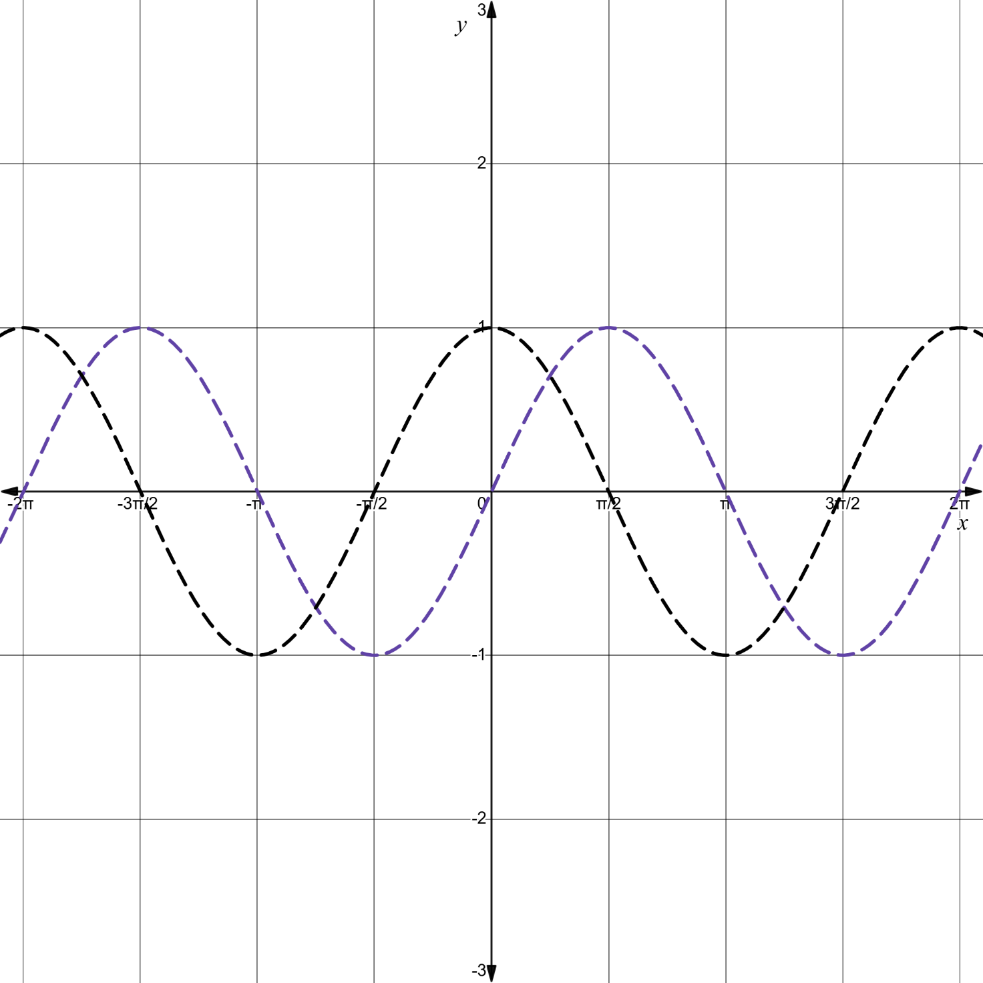

Appendix B

Faded worked examples
Question 1 | Question 2 | Question 3
Write $\sin{x}-\sqrt{3}\cos{x}$ in the form $R\sin{(x-α)}.$ | Write $5\sin{x}-2\cos{x}$ in the form $R\sin{(x-α)}.$ | Write $2\cos{x}+3\sin{x}$ in the form $R\cos{(x-α)}$.
$$\sin{x}-\sqrt{3}\cos{x}=R\sin\left(x-α\right)$$  $$\sin{x}-\sqrt{3}\cos{x}=R\text{sin}{x}\text{cos}{α}-R\text{cos}{x}\text{sin}{α}$$  $$1\sin{x}-\sqrt{3}\cos{x}=R\text{sin}{x}\text{cos}{α}-R\text{cos}{x}\text{sin}{α}$$ | $$5\sin{x}-2\cos{x}=R\sin\left(x-α\right)$$  $$5\sin{x}-2\cos{x}=R\text{sin}{x}\text{cos}{α}-R\text{cos}{x}\text{sin}{α}$$  $$5\sin{x}-2\cos{x}=R\text{sin}{x}\text{cos}{α}-R\text{cos}{x}\text{sin}{α}$$ | $$2\cos{x}+3\sin{x}=R\cos{(x-α)}$$
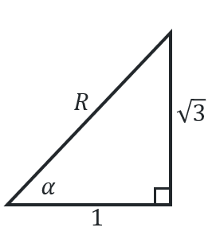  $$-R\sin{α}=-\sqrt{3}$$  $$\sin{α}=\frac{\sqrt{3}}{R}$$  $$R\cos{α}=1$$  $$\cos{α}=\frac{1}{R}$$ | 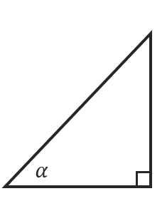  $$R\cos{α}=$$  $$-R\sin{α}=$$
$$R=\sqrt{1^{2}+{\left(\sqrt{3}\right)}^{2}}=2$$
$$\tan{α}=\sqrt{3}$$
$$α=\frac{π}{3}$$
$$∴\sin{x}-\sqrt{3}\cos{x}=2\sin\left(x+\frac{π}{3}\right)$$

Appendix C

Comparing methods
Sketch the graph $y=3\cos{x}-2\sin{x}$, for $0°≤x≤360°$.
Method 1 | Method 2
Sketch $f\left(x\right)=3\cos{x}$ and $g\left(x\right)=2\sin{x}.$  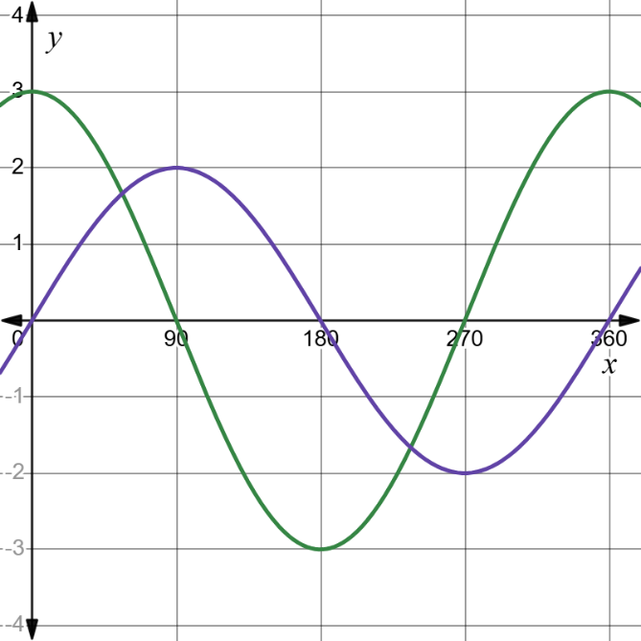  Sketch $y=f\left(x\right)-g(x)$  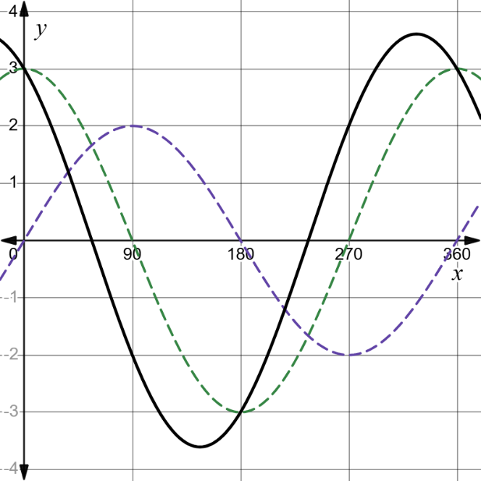 | $$3\cos{x}-2\sin{x}=R\cos\left(x+α\right)$$  $$3\cos{x}-2\sin{x}=R\cos{x}\cos{α}-R\sin{x}\sin{α}$$  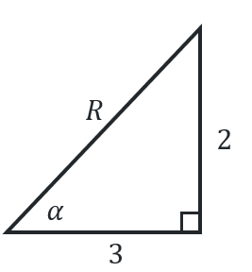  $R\cos{α}=3$  $$\cos{α}=\frac{3}{R}$$  $$-R\sin{α}=-2 \\ \sin{α}=\frac{2}{R}$$  $$R=\sqrt{3^{2}+2^{2}} \\ =\sqrt{13}$$  $$\tan{α}=\frac{2}{3} \\ α=\tan^{1}\left(\frac{2}{3}\right) \\ =33°41'$$  $$∴3\cos{x}-2\sin{x}=\sqrt{13}\cos{(x+33°{41}^{'})}$$  Amplitude $=\sqrt{13}$, translated $33°41'$ to the right of $y=\cos{x}$.  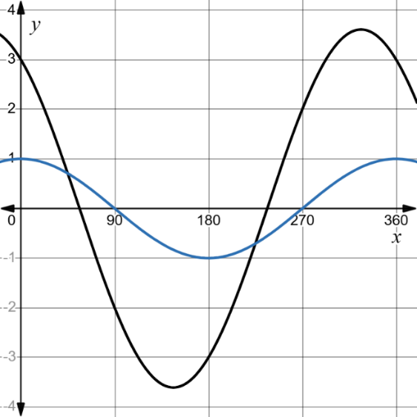

Sample solutions

Appendix B– faded worked examples
Question 1 | Question 2 | Question 3
Write $\sin{x}-\sqrt{3}\cos{x}$ in the form $R\sin{(x-α)}.$ | Write $5\sin{x}-2\cos{x}$ in the form $R\sin{(x-α)}.$ | Write $2\cos{x}+3\sin{x}$ in the form $R\cos{(x-α)}.$
$$\sin{x}-\sqrt{3}\cos{x}=R\sin\left(x-α\right)$$  $$\sin{x}-\sqrt{3}\cos{x}=R\text{sin}{x}\text{cos}{α}-R\text{cos}{x}\text{sin}{α}$$  $$1\sin{x}-\sqrt{3}\cos{x}=R\text{sin}{x}\text{cos}{α}-R\text{cos}{x}\text{sin}{α}$$ | $$5\sin{x}-2\cos{x}=R\sin\left(x-α\right)$$  $$5\sin{x}-2\cos{x}=R\text{sin}{x}\text{cos}{α}-R\text{cos}{x}\text{sin}{α}$$  $$5\sin{x}-2\cos{x}=R\text{sin}{x}\text{cos}{α}-R\text{cos}{x}\text{sin}{α}$$ | $$2\cos{x}+3\sin{x}=R\cos{(x-α)}$$  $$2\cos{x}+3\sin{x}=R\text{cos}{x}\text{cos}{α}+R\text{sin}{x}\text{sin}{α}$$  $$2\cos{x}+3\sin{x}=R\text{cos}{x}\text{cos}{α}+R\text{sin}{x}\text{sin}{α}$$
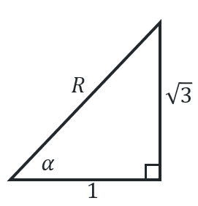  $-R\sin{α}=-\sqrt{3}$  $$\sin{α}=\frac{\sqrt{3}}{R}$$  $$R\cos{α}=1$$  $$\cos{α}=\frac{1}{R}$$ | 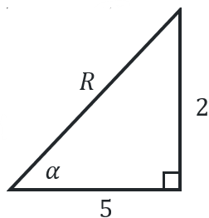  $R\cos{α}=5$  $$\cos{α}=\frac{5}{R}$$  $$-R\sin{α}=-2$$  $$\sin{α}=\frac{2}{R}$$ | 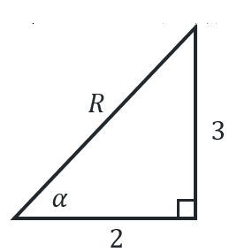  $R\cos{α}=2$  $$\cos{α}=\frac{2}{R}$$  $$R\sin{α}=3$$  $$\sin{α}=\frac{3}{R}$$
$$R=\sqrt{1^{2}+{\left(\sqrt{3}\right)}^{2}}=2$$  $$\tan{α}=\sqrt{3}$$  $$α=\frac{π}{3}$$ | $$R=\sqrt{5^{2}+2^{2}}=\sqrt{29}$$  $$\tan{α}=\frac{2}{5}$$  $α=\tan^{1}\left(\frac{2}{5}\right)=21°48'$ (nearest degree) | $$R=\sqrt{3^{2}+2^{2}}=\sqrt{13}$$  $$\tan{α}=\frac{3}{2}$$  $α=\tan^{1}\left(\frac{3}{2}\right)=56°19'$ (nearest degree)
$$∴\sin{x}-\sqrt{3}\cos{x}=2\sin\left(x+\frac{π}{3}\right)$$ | $$∴5\sin{x}-2\cos{x}=\sqrt{29}\sin\left(x-21°48'\right)$$ | $$∴2\cos{x}+3\sin{x}=\sqrt{13}\cos\left(x-56°19'\right)$$

References
This resource contains NSW Curriculum and syllabus content. The NSW Curriculum is developed by the NSW Education Standards Authority (NESA). This content is prepared by NESA for and on behalf of the Crown in right of the State of New South Wales. The material is protected by Crown copyright.
Please refer to the NESA Copyright Disclaimer for more information https://www.nsw.gov.au/education-and-training/nesa/copyright.
NESA holds the only official and up-to-date versions of the NSW Curriculum and syllabus documents. Please visit NESA https://www.nsw.gov.au/education-and-training/nesa and NSW Curriculum https://curriculum.nsw.edu.au.
Mathematics Extension 1 11–12 Syllabus © NSW Education Standards Authority (NESA) for and on behalf of the Crown in right of the State of New South Wales, 2024

© State of New South Wales (Department of Education), 2026
The copyright material published in this resource is subject to the Copyright Act 1968 (Cth) and is owned by the NSW Department of Education or, where indicated, by a party other than the NSW Department of Education (third-party material).
Copyright material available in this resource and owned by the NSW Department of Education is licensed under a Creative Commons Attribution 4.0 International (CC BY 4.0) license.

This license allows you to share and adapt the material for any purpose, even commercially. Attribution should be given to © State of New South Wales (Department of Education), 2026.
Material in this resource not available under a Creative Commons license:
- the NSW Department of Education logo, other logos and trademark-protected material
- material owned by a third party that has been reproduced with permission. You will need to obtain permission from the third party to reuse its material.
Links to third-party material and websites
Please note that the provided (reading/viewing material/list/links/texts) are a suggestion only and implies no endorsement, by the New South Wales Department of Education, of any author, publisher, or book title. School principals and teachers are best placed to assess the suitability of resources that would complement the curriculum and reflect the needs and interests of their students.
If you use the links provided in this document to access a third-party's website, you acknowledge that the terms of use, including licence terms set out on the third-party's website apply to the use which may be made of the materials on that third-party website or where permitted by the Copyright Act 1968 (Cth). The department accepts no responsibility for content on third-party websites.

