Sum and difference expansion formulas
In this lesson, students review exact trigonometric values and analyse the need for new rules to calculate non-standard angles. They will derive the sum and difference formulas and use these formulas to solve problems.

Learning intentions
- To be able to derive the sum and difference expansion formulas for sine, cosine and tangent.
- To understand how to use the sum and difference expansion formulas to solve problems.

Success criteria
- I can derive the sum and difference expansions formulas for cosine.
- I can use the sum and difference expansion formulas for cosine to derive the formulas for sine and tangent.
- I can use the sum and difference expansion formulas to solve problems.

Outcomes
A student:
- develops understanding and fluency in mathematics through exploring and connecting mathematical concepts, choosing and applying mathematical techniques to solve problems, and communicating their thinking and reasoning coherently and clearly MAO-WM-01
- solves problems in three dimensions using trigonometry and simplifies expressions, proves results and solves problems involving compound angles using trigonometric identities
ME1-11-03

Content

Further trigonometric identities
- Derive the sum and difference expansions for the trigonometric functions $\sin\left(A±B\right)=\sin{A}\cos{B}±\cos{A}\sin{B},\cos\left(A±B\right)=\cos{A}\cos{B}∓\sin{A}\sin{B}$ and $\tan\left(A±B\right)=\frac{\tan{A}±\tan{B}}{1∓\tan{A}\tan{B}}$
- Use sum and difference expansion formulas to solve problems and prove results
Mathematics Extension 1 11–12 Syllabus © NSW Education Standards Authority (NESA) for and on behalf of the Crown in right of the State of New South Wales, 2024.

Table 1: lesson summary
Section | Summary of activity | Teaching strategies | Teaching points
Activating prior knowledge | Students find the exact value of $\cos{75°}$ through a contextual problem on slides 4–5 of the PowerPoint Sum and difference expansion formulas, using the cosine rule. | Pose-Pause-Pounce-Bounce  Think-Pair-Share | The purpose of this activity is to highlight the limitation of relying on specific triangles to find exact values. Teachers should emphasise that while the cosine rule works here, it is not a scalable strategy for all angles.
Connecting learning | Students derive the cosine sum and difference formulas using Appendix A and slides 7–14, beginning with $cos⁡(A-B)$ and extending to $cos⁡(A+B)$. They apply these identities to re-evaluate $\cos{{75}^{∘}}$, confirming consistency with earlier results. Students then extend their understanding by deriving sine and tangent sum and difference formulas collaboratively. | Visibly random groups of 3  Vertical non-permanent surfaces | The focus is on building new mathematical knowledge from existing identities, reinforcing that mathematics is interconnected. Teachers should emphasise why identities work, not just the steps, particularly when transitioning from $cos⁡(A-B)$ to $cos⁡(A+B)$.
Releasing responsibility | Students consolidate their understanding by analysing all 6 sum and difference expansion formulas using slide 16. They complete Appendix B and Appendix C. | Faded worked examples | Careful attention should be given to algebraic accuracy, particularly with surds and substitution.
Independent practice | Students apply sum and difference formulas to increasingly complex problems using Appendix D and/or slides 18–22. | Approaching questions scaffold | Teachers should monitor students’ ability to choose appropriate formulas and execute substitutions accurately. Emphasise clear working, correct use of exact values and justification of steps.

Activity structure
Please use the associated PowerPoint Sum and difference expansion formulas to display images in this lesson.
Prior to commencing this lesson, ensure students demonstrate a strong understanding of the relevant Mathematics Stage 5 Linear relationships C (Path) outcome MA5-LIN-P-01, as they will need to use the distance formula to find the distance between 2 points located on the Cartesian plane.

Activating prior knowledge
- Display slide 4 of the PowerPoint, which presents the following scenario together with its diagram.
A marine construction crew is building a floating dock on a lake as shown in the diagram. The angle between 2 of the support beams is $75°$.
How might we find the exact value of $\cos{75°}$?
- Use the Pose-Pause-Pounce-Bounce questioning strategy (PDF 557KB) (bit.ly/posepausepouncebounce) to prompt students to reason through the scenario and justify their thinking. Suggested prompts include:
- Why might the construction crew want to use an exact value?
- If $75°=30°+45°,$ does that mean $\cos{75°}=\cos{30°}+\cos{45°}?$How could we show this?
Exact values help prevent rounding errors in subsequent calculations.
- Display slide 5, which shows a non-right-angled triangle with interior angles $45°,60° \text{and} 75°$.
- In pairs, have students use the cosine rule, to find the exact value of $\cos{75°}.$
- Animate slide 5 to reveal the solution, the exact value of $\cos{75°=\frac{\sqrt{6}-\sqrt{2}}{4}}$. Record this result for the class as it will be referenced later in the lesson.
- Initiate a class discussion to highlight that, although we used the cosine rule on a specific triangle to obtain $\cos{75°},$ we won’t usually be given a triangle that produces the exact angle we want. Mathematicians do not want to memorise more facts, instead they build new ones from old ones. Explain that this is the focus of today’s learning episode.

Connecting learning
- Explain to the class that there are formulas that allow us to calculate the exact value of expressions like $\cos{{75}^{∘}}$. Highlight that $75°$ can be written as the sum of $30°$ and $45°$. Ask students why $30°$ and $45°$ were selected, linking this to their understanding of exact value triangles.
- Distribute Appendix A ‘Deriving the sum and difference expansion formulas’ to each student. In their pairs, have students follow the scaffolded steps to derive the formula for $\cos{(A-B)}$.
Depending on the class, this can be teacher-led as a whole-class activity using slides 7–9.
- Use slides 7–9 to show the solutions to Appendix A, which outline the steps to derive $\cos{(A-B)}.$
The slides are animated, allowing each step to be explained in detail. Some suggested prompts that could be used on the slides to deepen students’ understanding include:
• Slide 7: Why are $\cos^{2}{A/B}$ and $\sin^{2}{A/B}$ underlined?
• Slide 9: How does using both methods help us understand where the formulas come from?
- Using the self-explanation prompt on slide 9, guide students to discover that they will need the formula for $\cos{(A+B)}$ rather than $\cos{(A-B)}$ to find the exact value of $\cos{75°}.$
Students may try to apply the identity $\cos{(A-B)}$ using $30°$ and $45°$ because it is the formula they have just derived. It is helpful to highlight that subtraction does not produce $75°$ ($30-45=-15$), so this identity is not the right tool. Use this moment to emphasise that some exact values require the sum formula instead, since $75=30+45$.
- Guide students to discover that replacing $B$ with $-B$ in the $\cos{(A-B)}$ formula will give the formula for $\cos{(A+B)}$. A suggested prompt may include:
- How could we adjust the $cos⁡(A-B)$ formula to get $cos⁡(A+B)$?
- In their pairs, have students replace $B$ with $-B$ in their $cos⁡(A-B)$ sum and differences expansion formula and explore how the expression simplifies.
- Slide 10 may need to be displayed, which demonstrates how $\cos\left(-B\right)=\cos{B}$ and $\sin\left(-B\right)=\sin{B}$.
This is prior knowledge from the Year 11 Mathematics Advanced Trigonometric and measure of angles outcome MAV-11-04.
- Allow students time to work in pairs to derive $cos⁡(A+B)$, then reveal the result by animating slide 10.
- Using the self-explanation prompt on slide 10, have students use this formula to find the exact value of $\cos{75°}$, comparing this answer to the one that was recorded in step 5 of the ‘Activating prior knowledge’ section.
Slide 11 can be used to display the solution. Students should discover that this gives the same result as their previous solution, $\cos{75°=\frac{\sqrt{6}-\sqrt{2}}{4}}.$ Slide 11 can be used to show the working for this solution.
- Initiate a class discussion, asking how we might find the exact value of $\sin{75°}$ or $\tan{75°}$ using the cosine sum and differences formulas. Some suggested prompts include:
- How are cosine and sine related?
- How are cosine, sine and tangent related?
Students should recall the complementary angle identities and the identity $\tan{θ}=\frac{\sin{θ}}{\cos{θ}}$.
- Assign students to visibly random groups of 3 (bit.ly/visiblegroups) at vertical non-permanent surfaces (bit.ly/VNPSstrategy).
Depending on class sizes, this can be done in pairs rather than groups of 3. Vertical non-permanent surfaces are used so students can compare working with others.
- Display slide 12 which consists of prompts to follow to derive the formulas for sine and tangent sum and differences expansion formulas. Leave this slide displayed as students work through deriving the sum and differences expansion formulas $\sin{(A+B)}$ and $\tan{(A+B)}$.
- Once students have started to finish deriving the formulas $\sin{(A+B)}$ and $\tan{(A+B)}$, ask them to now derive the formulas for $\sin{(A-B)}$ and $\tan{(A-B)}$.
- The derivation can be animated on slide 12 for $\sin{(A+B)}$ and on slide 13 for $\tan{(A+B)}.$ Slide 14 can be used to show the derivation of $\sin{(A-B)}$ and $\tan{(A-B)}$.

Releasing responsibility
- Display slide 16 which shows all 6 sum and difference expansions that students have just derived.
- Animate slide 16 to show a section of the Mathematics Extension 1 – HSC reference sheet (NESA 2024). Highlight that only 3 formulas are given and guide students to see how the other 3 can be deduced from them. Some suggested prompts may include:
- Why do you think only 3 formulas are given?
- How can you deduce the other 3 formulas from these?
- Discuss with students how these formulas, like previous formulas in Mathematics Advanced, also work in radians. Some suggested prompts to use may include:
- Why are radians preferred?
- How does using radians affect the formulas?
- Explain why radians make the identities exact and more consistent across Mathematics.
- Distribute Appendix B ‘Faded worked examples’ (bit.ly/fadedexamplesstrategy) for students to complete.
Please note that the third question in Appendix B requires significant surd manipulation, students may require guidance.
- Distribute Appendix C ‘Reference sheet notes’, which contains the relevant section from the HSC reference sheet, for students to annotate with notes to their future forgetful selves (bit.ly/notestofutureself). Students should be prompted to include notes that explain how each of the formulas are derived, as well as the additional formulas that are not included, that is, $\sin\left(A-B\right),\cos{(A-B)}$ and $\tan{(A-B)}$.
- Students may benefit from completing further practice questions from an existing resource on applying sum and difference expansion formulas.

Independent practice
- Use slide 18 to unpack the ‘Approaching questions scaffold’ for students.
- Distribute Appendix D ‘Further problems’ to each student which presents 2 problems involving the use of sum and difference expansion formulas.
Students can complete this activity individually, in pairs or in groups of 3 at vertical non-permanent surfaces. This decision will depend on how ready the class is to take on more challenging problems.
These questions have also been included on slides 19–20.
- Solutions have been provided on slides 21–22.

Assessment and differentiation

Suggested opportunities for differentiation
Activating prior knowledge
- To support students, provide a partially completed or scaffolded solution when students are finding the exact value of $\cos{75°}$ using the cosine rule.
- Challenge students to justify why alternative angles, such as $60°$ and $15°$, could or could not be used in the same context.
Connecting learning
- To support students, Appendix A can be completed as a whole-class activity with the teacher guiding students through the steps using the slides.
- Challenge students to make a list of all the possible angles they can now find the exact value of using the sum and difference expansion formulas derived, such as $75°$and $15°$.
Releasing responsibility
- Students could be extended to use the sum and difference expansion formulas to find the exact value of the reciprocal functions, $\operatorname{cosec}{x}$, $\sec{x}$ and $\cot{x}$.

Suggested opportunities for assessment
Activating prior knowledge
- Observe reasoning during the Pose-Pause-Pounce-Bounce discussion to assess students’ understanding of the purpose of exact values.
Connecting learning
- Monitor pair discussions for understanding of why 30° and 45° were chosen to check students’ understanding of exact values.
- Check students’ derivations of $\cos{(A-B)}$ by collecting Appendix A.
Releasing responsibility
- Observe completion of faded examples in Appendix B and note where students may require further prompting to complete the solutions correctly.
- Review notes and examples recorded by students in Appendix C for accuracy and completeness.
Independent practice
- Observe students’ solutions for accuracy in applying the sum and difference expansion formulas to further problems.

Appendix A

Deriving the sum and difference expansion formulas
A unit circle is shown below. Points $P$ and $Q$ have been placed on the unit circle, such that point $P$ makes the angle $A$ and point $Q$ makes the angle $B$ when measuring from the positive $x$-axis.
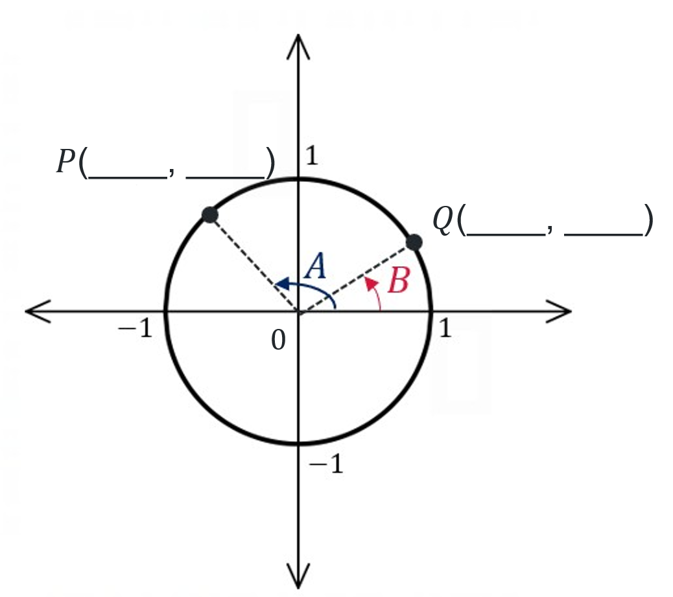
- Find the coordinates of $P$ and $Q$ in terms of $\sin{A},\cos{A},\sin{B}$ and $cos⁡B$.
$$P( ____ , ____ )$$
$$Q( ____ , ____ )$$
- Label the coordinates on the diagram above.
- Recall the distance formula, which finds the distance between 2 points.
$$d^{2}=(x_{2}-x_{1})^{2}+(y_{2}-y_{1})^{2}$$
Find an expression for $PQ^{2}$ using the distance formula between $P$ and $Q$. This expression should be in terms of $sin⁡A,cos⁡A,sin⁡B,cos⁡B$. Use identities to simplify the expression.
$PQ^{2}=$
- Form a triangle $OPQ$, where $O$ is the origin.
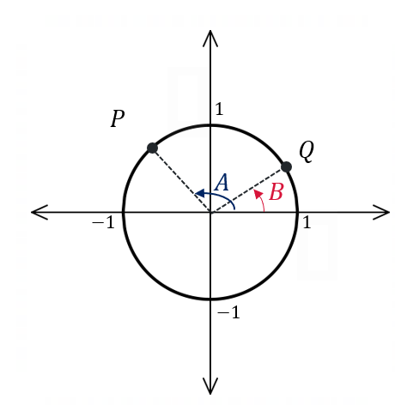
- Find an expression for $∠POQ$ in terms of $A$ and B.
- Use the cosine rule to find an expression for $PQ^{2}$. Remember that $P$ and $Q$ are points on the unit circle.
$$PQ^{2}=$$
- From step 3 and step 6, there are now 2 different expressions for $PQ^{2}$.
Set these 2 expressions to be equal and rearrange to make $cos⁡(A-B)$ the subject.

Appendix B

Faded worked examples
Question 1 | Question 2 | Question 3
Find the exact value of $\cos{15°}$. | Find the exact value of $\sin{\frac{7π}{12}}$. | Find the exact value of $\tan{\frac{5π}{12}}$.
Establish values for $A$ and $B$:  $$60°-45°=15°$$  $A=60°$ and $B=45°$ | Establish values for $A$ and $B$:  $$_____+_____=\frac{7π}{12}$$  $A=$____ and $B=$ ____ | Establish values for $A$ and $B$:  $$\frac{π}{3}+\frac{π}{4}=\frac{7π}{12}$$  $A=\frac{π}{3}$ and $B=\frac{π}{4}$
Use the sum and differences formula  $$\cos\left(A-B\right)=\cos{A}\cos{B}+\sin{A}\sin{B}$$  $$\cos{15°=\cos{(60°-45°)}}$$  $$=\cos{60°}\cos{45°}+\sin{60°}\sin{45°}$$  $$=\frac{1}{2}×\frac{1}{\sqrt{2}}+\frac{\sqrt{3}}{2}×\frac{1}{\sqrt{2}}$$  $$=\frac{1+\sqrt{3}}{2\sqrt{2}}×\frac{\sqrt{2}}{\sqrt{2}}$$  $$=\frac{\sqrt{2}+\sqrt{6}}{4}$$ | Use the sum and differences formula  $$\sin\left(A+B\right)=\sin{A}\cos{B}+\cos{A}\sin{B}$$  $$\sin{\frac{7π}{12}}=$$

Appendix C

Reference sheet notes
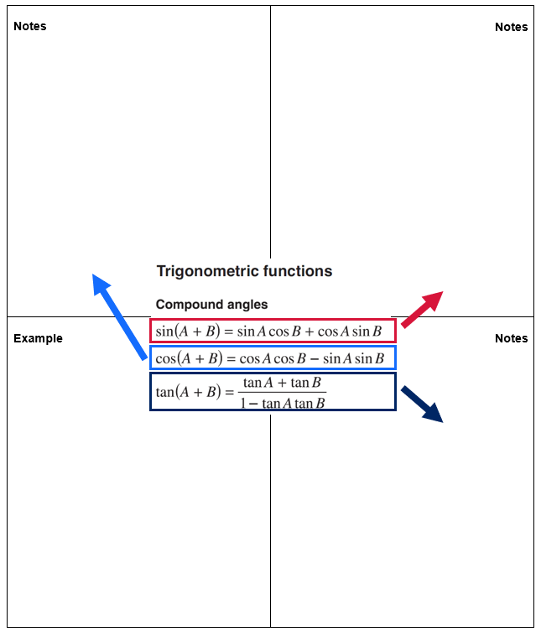

Appendix D

Further problems
- Lines $A$ and $B$ pass through the origin and make angles $α$ and $β$with the $x$-axis as shown. The gradients of the lines are 3 and 2 respectively.
Without finding $α$ or $β$, show that the angle between the lines satisfies: $\tan{(α-β)}=\frac{1}{7}$.
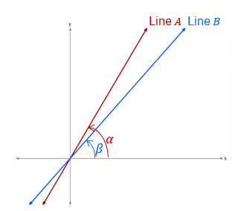
- Two vertical towers stand 26 metres apart on level ground. The Tower $A$ is 32 metres tall and Tower $C$ is 14 metres tall.
Point $P$ lies on the ground between the two towers, such that the angles of elevation from $P$ to the top of towers $A$ and $B$ are $α$ and $β$ respectively.
The diagram represents this information, labelling the top of tower $A$ as $B$ and the top of tower $B$ as $D$.
It is given that $∠BPD=45°$.
- Show that $β=135°-α$
- Hence, find distance $AP$.
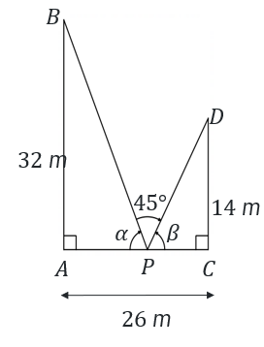

Sample solutions

Appendix B – faded worked examples
Question 1 | Question 2 | Question 3
Find the exact value of $\cos{15°}$. | Find the exact value of $\sin{\frac{7π}{12}}$. | Find the exact value of $\tan{\frac{5π}{12}}$
Establish values for $A$ and $B$:  $$60°-45°=15°$$  $A=60°$ and $B=45°$ | Establish values for $A$ and $B$:  $$\frac{π}{3}+\frac{π}{4}=\frac{7π}{12}$$  $A=\frac{π}{3}$ and $B=\frac{π}{4}$ | Establish values for $A$ and $B$:  $$\frac{π}{4}+\frac{π}{6}=\frac{5π}{12}$$  $A=\frac{π}{4}$ and $B=\frac{π}{6}$
Use the sum and differences formula:  $$\cos\left(A-B\right)=\cos{A}\cos{B}+\sin{A}\sin{B}$$  $$\cos{15°=\cos{(60°-45°)}}$$  $$=\cos{60°}\cos{45°}+\sin{60°}\sin{45°}$$  $$=\frac{1}{2}×\frac{1}{\sqrt{2}}+\frac{\sqrt{3}}{2}×\frac{1}{\sqrt{2}}$$  $$=\frac{1+\sqrt{3}}{2\sqrt{2}}×\frac{\sqrt{2}}{\sqrt{2}}$$  $$=\frac{\sqrt{2}+\sqrt{6}}{4}$$ | Use the sum and differences formula:  $$\sin\left(A+B\right)=\sin{A}\cos{B}+\cos{A}\sin{B} \\ \sin{\frac{7π}{12}}=\sin\left(\frac{π}{3}+\frac{π}{4}\right) \\ =\sin{\frac{π}{3}}\cos{\frac{π}{4}}+\cos{\frac{π}{3}}\sin{\frac{π}{4}} \\ =\frac{\sqrt{3}}{2}×\frac{1}{\sqrt{2}}+\frac{1}{2}×\frac{1}{\sqrt{2}} \\ =\frac{\sqrt{3}+1}{2\sqrt{2}}×\frac{\sqrt{2}}{\sqrt{2}} \\ =\frac{\sqrt{6}+\sqrt{2}}{4}$$ | Use the sum and differences formula:  $$\tan\left(A+B\right)=\frac{\tan{A}+\tan{B}}{1-\tan{A}\tan{B}}$$  $$\tan{\frac{5π}{12}}=\tan\left(\frac{π}{4}+\frac{π}{6}\right) \\ =\frac{\tan{\frac{π}{4}}+\tan{\frac{π}{6}}}{1-\tan{\frac{π}{4}}\tan{\frac{π}{6}}} \\ =\frac{1+\frac{1}{\sqrt{3}}}{1-\left(1×\frac{1}{\sqrt{3}}\right)}$$  $$=\left(1+\frac{1}{\sqrt{3}}\right)÷\left(1-\frac{1}{\sqrt{3}}\right) \\ =\frac{\sqrt{3}+1}{\sqrt{3}}÷\frac{\sqrt{3}-1}{\sqrt{3}} \\ =\frac{\sqrt{3}+1}{\sqrt{3}}×\frac{\sqrt{3}}{\sqrt{3}-1} \\ =\frac{\sqrt{3}+1}{\sqrt{3}-1} \\ =\frac{\sqrt{3}+1}{\sqrt{3}-1}×\frac{\sqrt{3}+1}{\sqrt{3}+1} \\ =\frac{3+2\sqrt{3}+1}{3-1} \\ =\frac{4+2\sqrt{3}}{2} \\ =2+\sqrt{3}$$

References
This resource contains NSW Curriculum and syllabus content. The NSW Curriculum is developed by the NSW Education Standards Authority (NESA). This content is prepared by NESA for and on behalf of the Crown in right of the State of New South Wales. The material is protected by Crown copyright.
Please refer to the NESA Copyright Disclaimer for more information https://www.nsw.gov.au/education-and-training/nesa/copyright.
NESA holds the only official and up-to-date versions of the NSW Curriculum and syllabus documents. Please visit NESA https://www.nsw.gov.au/education-and-training/nesa and NSW Curriculum https://curriculum.nsw.edu.au.
Mathematics Extension 1 11–12 Syllabus © NSW Education Standards Authority (NESA) for and on behalf of the Crown in right of the State of New South Wales, 2024

© State of New South Wales (Department of Education), 2026
The copyright material published in this resource is subject to the Copyright Act 1968 (Cth) and is owned by the NSW Department of Education or, where indicated, by a party other than the NSW Department of Education (third-party material).
Copyright material available in this resource and owned by the NSW Department of Education is licensed under a Creative Commons Attribution 4.0 International (CC BY 4.0) license.

This license allows you to share and adapt the material for any purpose, even commercially. Attribution should be given to © State of New South Wales (Department of Education), 2026.
Material in this resource not available under a Creative Commons license:
- the NSW Department of Education logo, other logos and trademark-protected material
- material owned by a third party that has been reproduced with permission. You will need to obtain permission from the third party to reuse its material.
Links to third-party material and websites
Please note that the provided (reading/viewing material/list/links/texts) are a suggestion only and implies no endorsement, by the New South Wales Department of Education, of any author, publisher, or book title. School principals and teachers are best placed to assess the suitability of resources that would complement the curriculum and reflect the needs and interests of their students.
If you use the links provided in this document to access a third-party's website, you acknowledge that the terms of use, including licence terms set out on the third-party's website apply to the use which may be made of the materials on that third-party website or where permitted by the Copyright Act 1968 (Cth). The department accepts no responsibility for content on third-party websites.

