Reciprocal trigonometric graphs
Students will graph $y=\sec{x}$, $y=\operatorname{cosec}{x}$ and $y=\cot{x}$, examine each graph’s properties and compare them to their reciprocals.
Students will need at least one digital device per pair to interact with Amplify Classroom during this lesson.
Learning intention and success criteria should be shared with students later in the learning episode.

Learning intention
- To be able to sketch and describe reciprocal trigonometric graphs.

Success criteria
- I can identify the key properties of each graph.
- I can compare the properties of each trigonometric graph with its reciprocal.
- I can sketch the reciprocal trigonometric functions in terms of degrees.
- I can sketch the reciprocal trigonometric functions in terms of radians.

Outcomes
A student:
- develops understanding and fluency in mathematics through exploring and connecting mathematical concepts, choosing and applying mathematical techniques to solve problems, and communicating their thinking and reasoning coherently and clearly MAO-WM-01
- solves problems involving inequalities, functions and their inverses, graphical relationships between functions, and parametric equations ME1-11-01

Content

Graphical relationships
- Graph $y=\sec{x}$, $y=\operatorname{cosec}{x}$ and $y=\cot{x}$ in both radians and degrees, identifying key properties including asymptotes, period, domain, range and symmetry, and compare each graph with the graph of its reciprocal
- Apply knowledge of graphical relationships to solve problems involving graphs of functions, justifying conclusions in the context of the problem where appropriate
Mathematics Extension 1 11–12 Syllabus © NSW Education Standards Authority (NESA) for and on behalf of the Crown in right of the State of New South Wales, 2024.

Table 1: lesson summary
Section | Summary of activity | Teaching strategies | Teaching points
Activating prior knowledge | Students’ complete screens 1–5 of the Amplify Classroom activity (bit.ly/ReciprocalTrigGraphs) and discuss responses. |  | Students activate prior knowledge of the behaviour of $y=\frac{1}{f\left(x\right)}$ as $f\left(x\right)→0.$
Connecting learning | Students continue with screens 6–7 of the Amplify Classroom activity, planning and sketching $y=\sec{x}$. Pacing is extended to screen 8 where they examine the properties of $y=\sec{x}$ before comparing the properties of $y=\cos{x}$ and $y=\sec{x}.$Students then use screens 11–16 to use the features of $y=\sin{x}$ and $y=\tan{x}$ to sketch  $y=\operatorname{cosec}{x}$ and $y=\cot{x}$. | Think-Pair-Share | Students sketch the reciprocal trigonometric functions, identifying key properties including asymptotes, period, domain, range and symmetry, and compare each graph with the graph of its reciprocal.
Releasing responsibility | Students graph the reciprocal functions by hand using Appendix A and compare solutions. | Turn and talk | Students sketch graphs in both degrees and radians.
Independent practice | Use The True Size (thetruesize.com) to compare the size of Greenland to Africa in the Mercator projection. Students use Appendix B to identify scalars that would be required to turn a circle into a rectangle, such as the Mercator projection and recognise these scalars match the function $f\left(x\right)=\sec{x}$. Students then make a short slideshow using the graph of $y=\sec{x}$ to explain why locations at different latitudes can be deceptive in size. |  | Students recognise a practical context where the features of the reciprocal graph, such as the range approaching infinity, can be used to solve problems.

Activity structure

Activating prior knowledge
- Assign the Amplify Classroom activity ‘Reciprocal trigonometric graphs’ (bit.ly/ReciprocalTrigGraphs) for students to complete screens 1–2.
Before using this activity, you will need to set up an Amplify Classroom (bit.ly/createamplifyclassroom) and use the pacing feature to restrict the students to screens 1–2, which concentrate on activating students’ prior knowledge of sketching reciprocal graphs.
Please note that Amplify Classroom and the Desmos graphics calculator use $\csc{x}$ rather than $\operatorname{cosec}{x}$, which has implications for the activities in this learning episode. It is recommended that this be explained to students.
- Using the teacher dashboard for screen 2, check students’ prior knowledge of the behaviour of $y=\frac{1}{f\left(x\right)}$ when $f\left(x\right)→0$.
- Extend the pacing to include screens 3–4. Use the teacher dashboard to check student sketches from screen 4 to check for understanding of how to sketch reciprocal functions.
Students were introduced to reciprocal functions in Lesson 6 – reciprocal functions.
- Extend the pacing to screen 5 to activate students’ prior knowledge of reciprocal trigonometric ratios.
Students were taught about reciprocal trigonometric ratios in Mathematics Advanced Unit 7 – Trigonometry.

Connecting learning

$$y=\sec{x}$$
- Extend pacing to include screens 6–7, where students will plan their sketch for $y=\sec{x}$.
- Extend pacing to screen 8 and allow time for students to sketch $y=\sec{x}$ using the information from screens 5–6.
- Display the students’ responses as an overlay on your teacher display through the teacher dashboard and discuss the similarities and differences between the predictions within the class.
Figure 1: displaying an overlay in Amplify Classroom
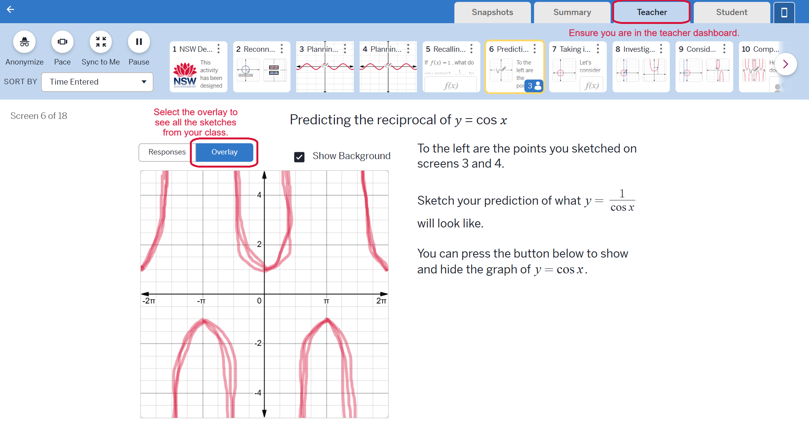
- Extend the pacing to include screens 9–10 to allow students time to compare their sketch with the graph of $y=\sec{x}$ and then examine the properties of $y=\sec{x}.$
- Using the teacher dashboard, check student responses from screen 10 and lead a class discussion to compare $y=\cos{x}$ and $y=\sec{x}$, describing which properties remain the same and which change.
Students can type ‘pi’ into the math input screens to get the value for $π.$
The period of both $y=\cos{x}$ and $y=\sec{x}$ is $2π$.
The domain of $y=\sec{x}$ excludes values where $\cos{x}=0$, resulting in vertical asymptotes at those points.
The range of $y=\cos{x}$ is $-1≤y≤1$ whereas the range of $y=\sec{x}$ is $y≥1$ or $y≤-1$.

$$y=\operatorname{cosec}{x}$$
- Restrict the activity to screens 11–13 using the pacing feature to allow students to consider the graph of $y=\text{cosec} x$.
Teachers may wish to use the teacher dashboard to display student sketches from screen 11 before allowing students to move onto screens 12–13.
- Lead a class discussion based on student responses from screen 13 to identify which properties of $y=\sin{x}$ and $y=\text{cosec} x$ remain the same and which properties change.
The period of both $y=\sin{x}$ and $y=\text{cosec} x$ is $2π$.
The domain of $y=\text{cosec} x$ excludes the values where $\sin{x=0}$, resulting in vertical asymptotes at those points.
The range of $y=\sin{x}$ is $-1≤y≤1$ whereas the range of $y=\text{cosec} x$ is $y≥1$ or $y≤1$.

$$y=\cot{x}$$
- Use the pacing feature to restrict the activity to screen 14 to allow students to consider sketch $y=\cot{x}$.
- In a Think-Pair-Share (bit.ly/thinkpairsharestrategy), ask students to consider what happens to $y=\cot{x}$ as $y=\tan{x}$ approaches and crosses a vertical asymptote.
Students may think that as $y=\tan{x}$ approaches and crosses a vertical asymptote that the point is not included in the graph of $y=\cot{x}$. Prompt students to consider this using the identity $\cot{θ}=\frac{\cos{θ}}{\sin{θ}}$ to consider if the point should be included in the graph of $y=\cot{x}$.
- Extend the pacing to include screens 15–16 for students to compare their sketch with the graph of $y=\cot{x}$ and then to consider properties of $y=\cot{x}$.
- Lead a discussion to compare the properties of $y=\tan{x}$ and $y=\cot{x}$.
Students should notice that the period of both $y=\tan{x}$ and $y=\cot{x}$ is $π$. The domain of $y=\cot{x}$ excludes values where $\tan{x}=0$, resulting in vertical asymptotes at those points. Both functions have a range of $(-∞,∞)$.

Releasing responsibility
- Distribute Appendix A ‘Graphing trigonometric reciprocals by hand’ to each student to complete.
Appendix A uses the notation $→0^{+}$ and $→0^{-}$. If students are not familiar with this notation, teachers can either adjust the appendix to say, ‘approaches zero from above/below’ and/or display screens 10, 13 or 16 to model the understanding of this notation to students using a graph.
- Have students compare their solutions through a turn and talk (bit.ly/classroomtalkmoves).

Independent practice
This section explores an application of $y=\sec{x}$.
This section can either be completed individually or in pairs.
- Ask students to open The True Size (thetruesize.com) website and delete the outlines of the USA, India and China.

To delete each of the outlines, students need to click on the outline and check the cross button in the dialog box on the left-hand side of the screen.
Figure 2: screenshot of website showing how to delete each outline.
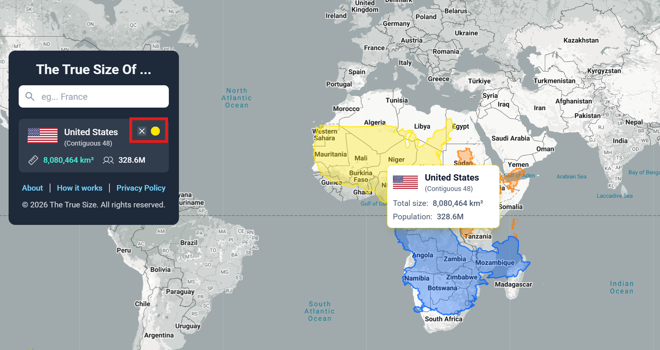
- Have students zoom out so that the entire world map is visible.
If students zoom out to the maximum, multiple copies of the map will appear adjacent to each other.
- Conduct a finger vote to determine which landmass students think is larger, Greenland or Africa. Cold-call non-volunteer students to estimate how many times larger their chosen landmass is compared to the other.
- Instruct students to enter Greenland into the dialogue box so that an outline appears around Greenland.
Figure 3: screenshot showing Greenland highlighted
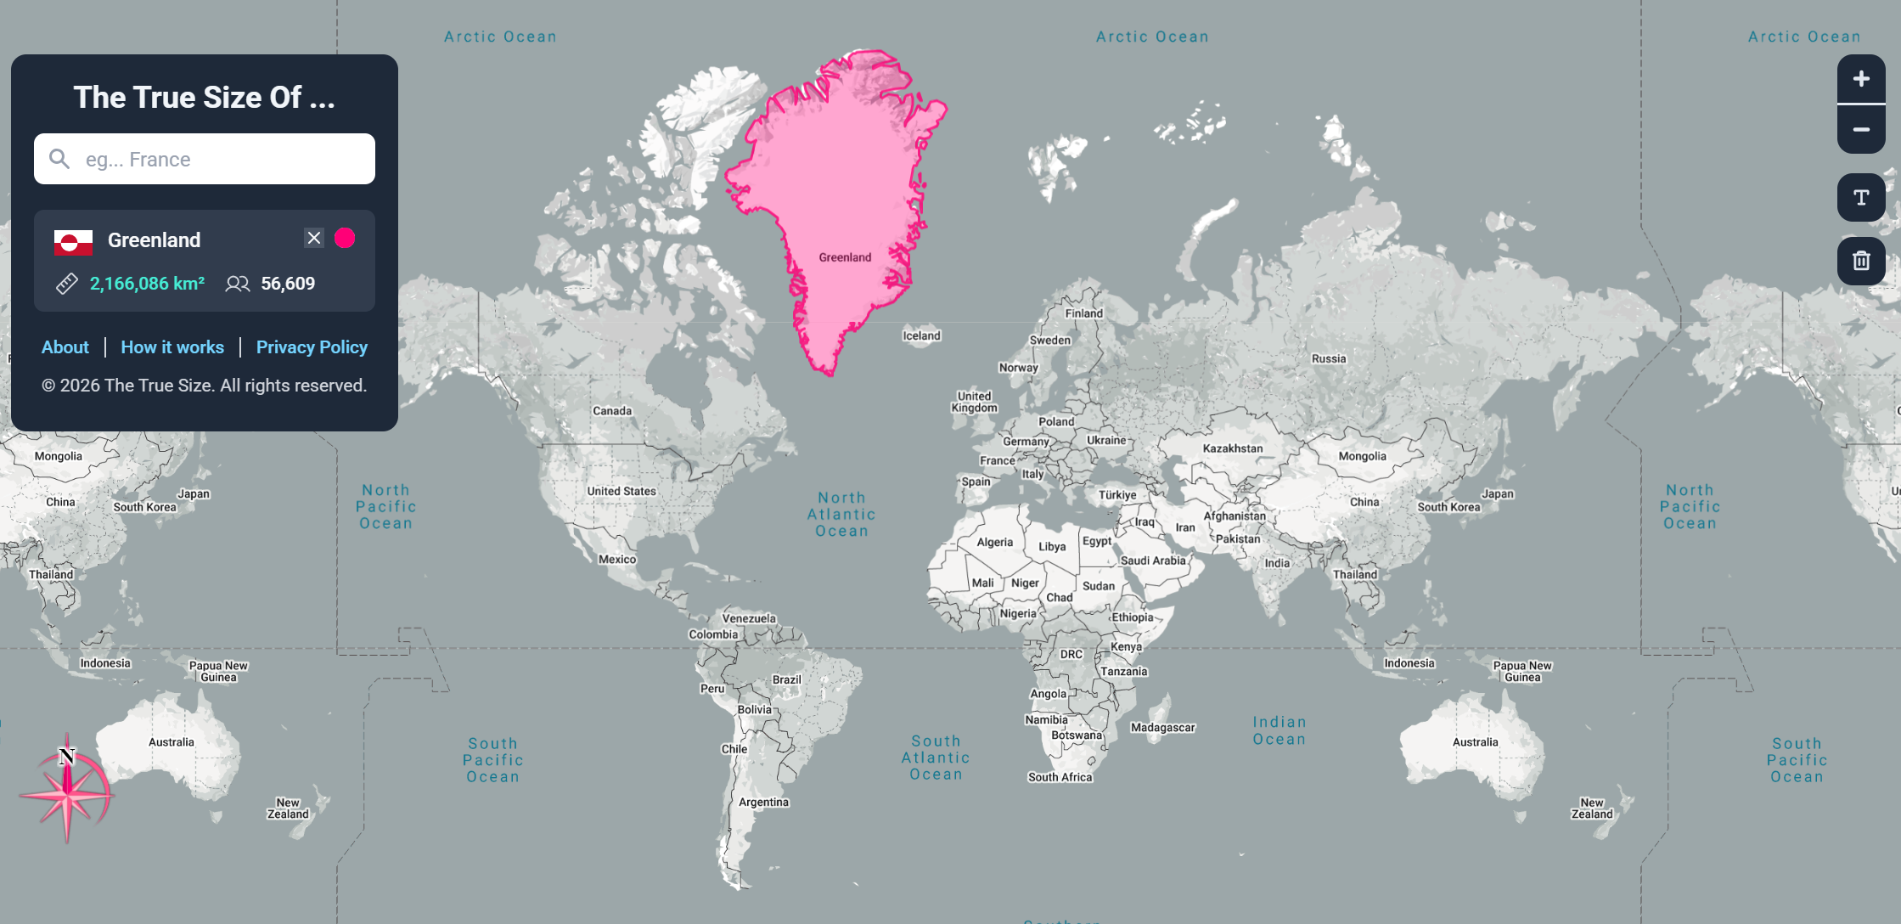
- Have students click and drag the outline of Greenland over Africa to compare relative sizes.
- Distribute a copy of the Mercator projection to each student and ask them to attempt to return the cylindrical map to the shape of a globe.
The Mercator projection world map can be printed from ‘Mercator projection of the world’ (bit.ly/MercatorProj)
- Facilitate a class discussion in which students share observations about the challenges of converting between a sphere and a cylinder, with particular attention to which lines of latitude are most affected.
- Distribute Appendix B ‘The unit circle with intervals’ and ask students to determine what factor each interval would need to be scaled by to dilate it to a length of 1, and how this could be represented mathematically.
If students do not identify the key property, reveal that the length of each interval is $\cos{x}$. To scale this length to 1, it must be multiplied by its reciprocal. Hence, in the Mercator projection, each line of latitude is scaled by $\sec{x}$.
- Ask students to develop a short slideshow that uses the graph of $y=sec⁡x$ to explain why visual comparisons between 2 locations on Earth (for example, Greenland and Africa) can be deceptive.

Assessment and differentiation

Suggested opportunities for differentiation
Activating prior knowledge
- The pacing of the screens can be further chunked to individual screens to support student understanding and recall.
Connecting learning
- Using the teacher dashboard, monitor students’ planning and predictions in their sketches, and use targeted questioning to ensure their reasoning is well considered.
Independent practice
- Students could be challenged to explain why parts of the North and South Poles are not visible on the Mercator projection map.

Suggested opportunities for assessment
Activating prior knowledge
- Monitor responses in class discussions to check for student understanding of the trigonometric graphs and why they have been asked to highlight the $x$-intercepts when
$y = ±1$.
Connecting learning
- Amplify Classroom saves responses, which can be reviewed later to assess student understanding of the key properties of each graph.
Releasing responsibility
- Appendix A could be collected to review student understanding of graphing reciprocal trigonometric functions by hand.
- As part of a turn and talk, students provide and receive peer feedback on their understanding.
Independent practice
- Observe students’ reasoning and justification in response to the activities involving the Mercator projection.
- The student-developed slideshow should be collected to review student reasoning.

Appendix A

Graphing trigonometric reciprocals by hand

$$y=\operatorname{cosec}{x}$$
As $\sin{x}→0^{-}$,  $$\operatorname{cosec}{x}→_____$$ | As $\sin{x}→0^{+}$,  $$\operatorname{cosec}{x}→______$$ | When $\sin{x}=1$,  $$\operatorname{cosec}{x}=______$$
Explain what is happening when $\sin{x}=0$ to the graph $y=\operatorname{cosec}{x}$.
______________________________________________________________________________
Sketch $y=cosec x$ by first sketching $y=\sin{x}$ over the domain $[-4π,4π]$. For each turning point and each vertical asymptote, write the equivalent angle in degrees next to the radian value on the $x$-axis.
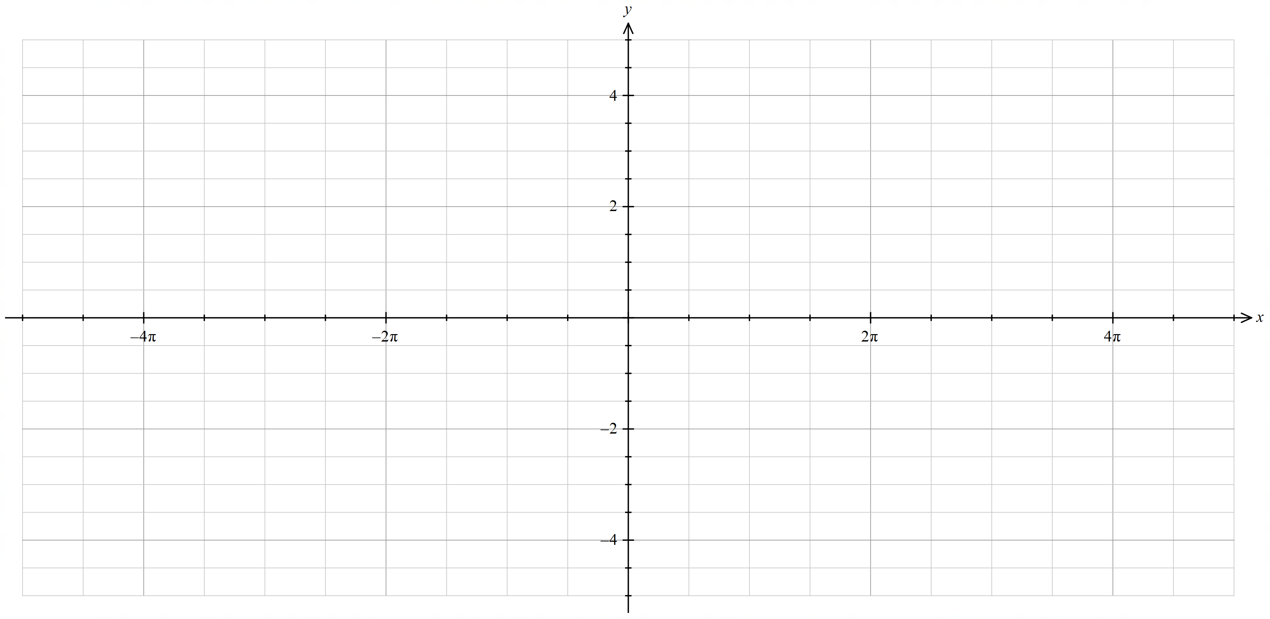
Domain of $y=\sin{x}$ : ________________ Range of $y=\sin{x}$ : ___________________
Domain of $y=\operatorname{cosec}{x}$ : ________________ Range of $y=\operatorname{cosec}{x}$ : ___________________

$$y=\sec{x}$$
As $\cos{x}→0^{-}$,  $$\sec{x}→_____$$ | As $\cos{x}→0^{+}$,  $$\sec{x}→______$$ | When $\cos{x}=1$,  $$\sec{x}=______$$
Explain what is happening when $\cos{x}=0$ to the graph $y=\sec{x}$.
______________________________________________________________________________
Sketch $y=secx$ by first sketching $y=\cos{x}$ over the domain $[-3π,3π]$. For each turning point and each vertical asymptote, write the equivalent angle in degrees next to the radian value on the
$x$-axis.
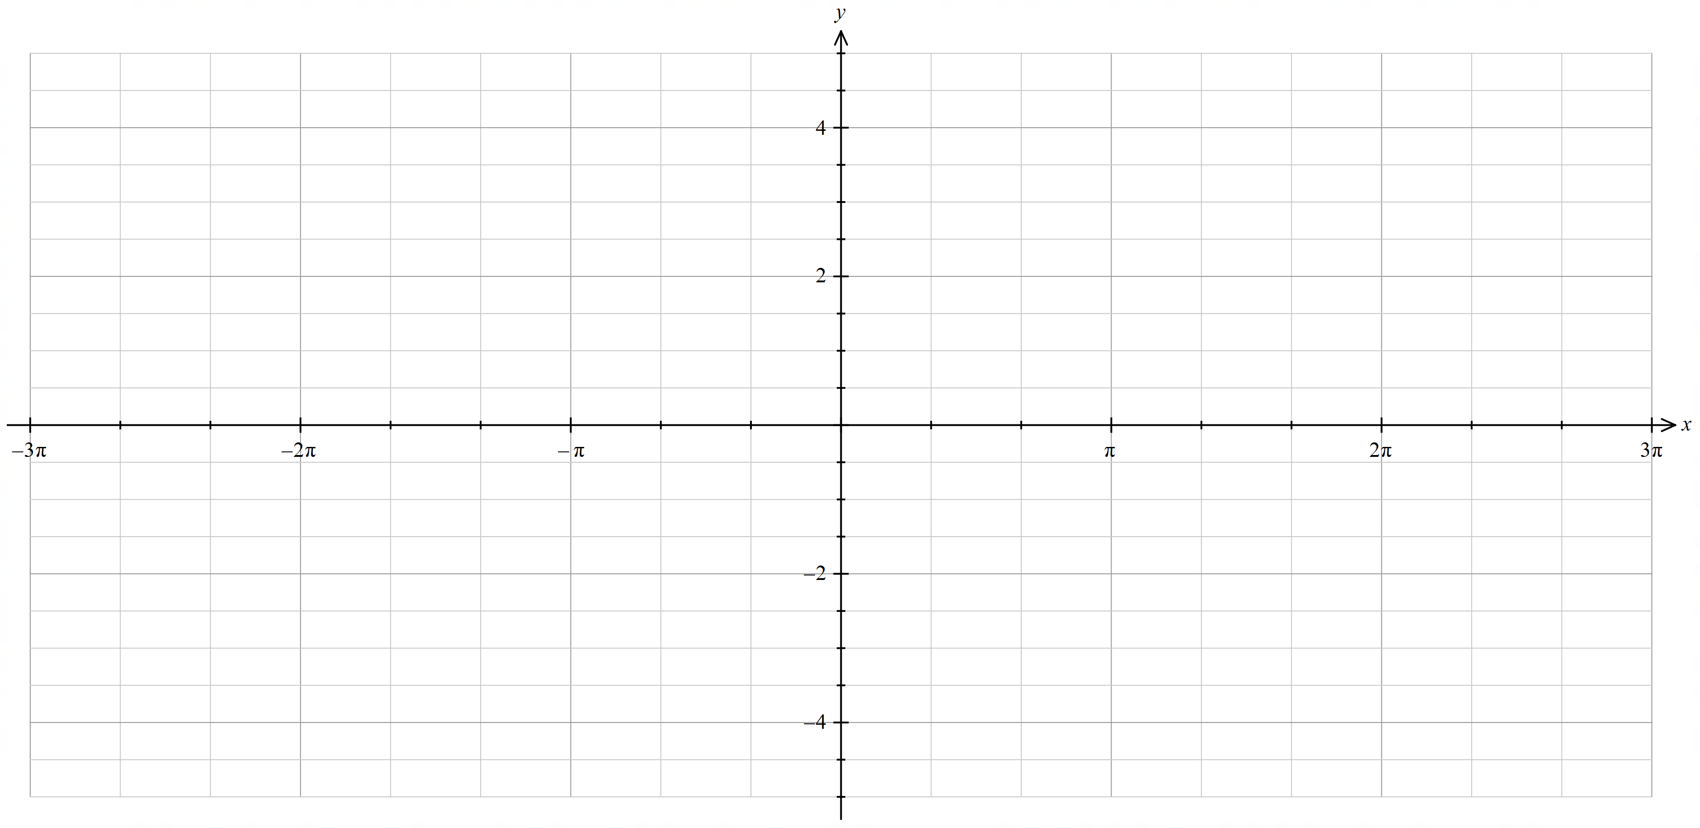
Domain of $y=\cos{x}$ : ________________ Range of $y=\cos{x}$ : ___________________
Domain of $y=\sec{x}$ : ________________ Range of $y=\sec{x}$ : ___________________

$$y=\cot{x}$$
When $\tan{x}=1$,  $$\cot{x}=______$$ | As $\tan{x}→0^{+}$,  $$\cot{x}→______$$ | As $\tan{x}→0^{-}$,  $$\cot{x}→______$$
$∴$ $\tan{x}=0$ corresponds to an ____________ on the graph of $y=\cot{x}$.
As $\tan{x}→∞$, $\cot{x}→______$ | As $\tan{x}→-∞$, $\cot{x}→______$
$∴$ an asymptote on the graph of $y=tan{x}$ corresponds to an ____________ on the graph of
$y=\cot{x}$.
Sketch $y=cotx$ by first sketching $y=\tan{x}$ over the domain $[-3π,3π]$. For each vertical asymptote and each $x$-intercept, write the equivalent angle in degrees next to the radian value on the $x$-axis.
Domain of $y=\tan{x}$ : ________________ Range of $y=\tan{x}$ : ___________________
Domain of $y=\cot{x}$ : ________________ Range of $y=\cot{x}$ : ___________________

Appendix B

The unit circle with intervals
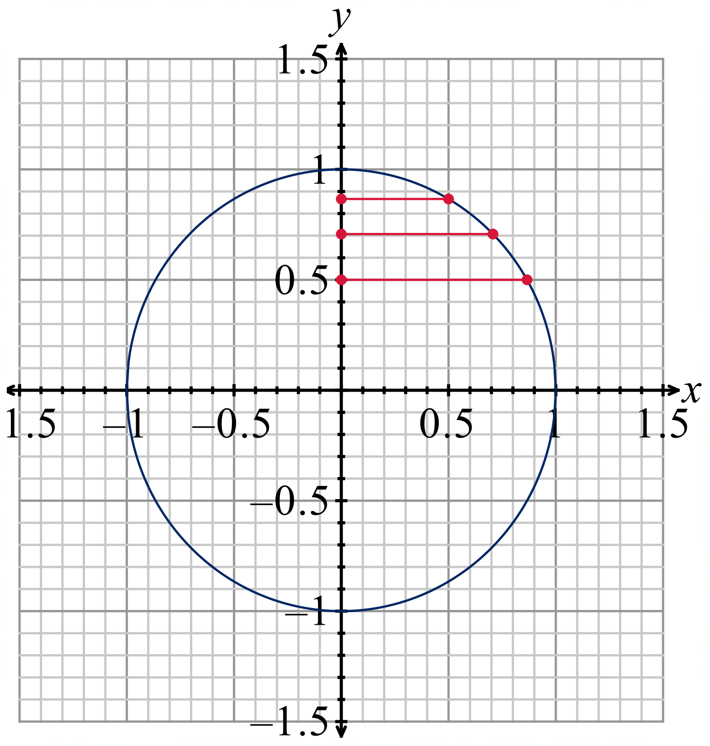

Sample solutions

Appendix A – graphing trigonometric reciprocals by hand

$$y=\operatorname{cosec}{x}$$
As $\sin{x}→0^{-}$,  $$\operatorname{cosec}{x}→-∞$$ | As $\sin{x}→0^{+}$,  $$\operatorname{cosec}{x}→∞$$ | When $\sin{x}=1$,  $$\operatorname{cosec}{x}=1$$
Explain what is happening when $\sin{x}=0$ to the graph $y=\operatorname{cosec}{x}$.
Vertical asymptote
Sketch $y=cosec x$ by first sketching $y=\sin{x}$ over the domain $[-4π,4π]$. For each turning point and each vertical asymptote, write the equivalent angle in degrees next to the radian value on the $x$-axis.
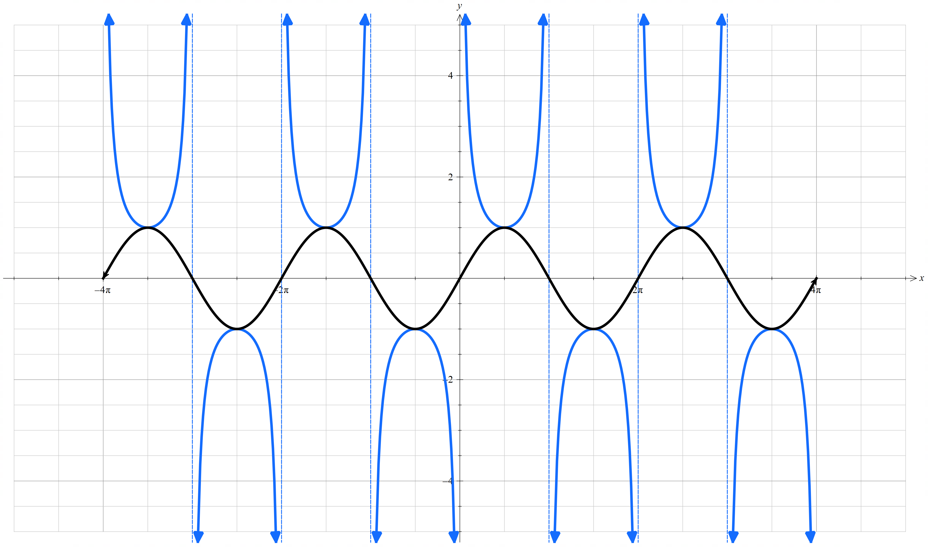
Domain of $y=\sin{x}$ : $[-4π,4π]$ Range of $y=\sin{x}$ : $[-1,1]$
Domain of $y=\operatorname{cosec}{x}$ : $x≠±kπ, k=0,1,2,3,4$ Range of $y=\operatorname{cosec}{x}$ : $\left(-∞,-1\right]∪[1,∞)$

$$y=\sec{x}$$
As $\cos{x}→0^{-}$,  $$\sec{x}→-∞$$ | As $\cos{x}→0^{+}$,  $$\sec{x}→∞$$ | When $\cos{x}=1$,  $$\sec{x}=1$$
Explain what is happening when $\cos{x}=0$ to the graph $y=\sec{x}$.
Vertical asymptote
Sketch $y=secx$ by first sketching $y=\cos{x}$ over the domain $[-3π,3π]$. For each turning point and each vertical asymptote, write the equivalent angle in degrees next to the radian value on the $x$-axis.
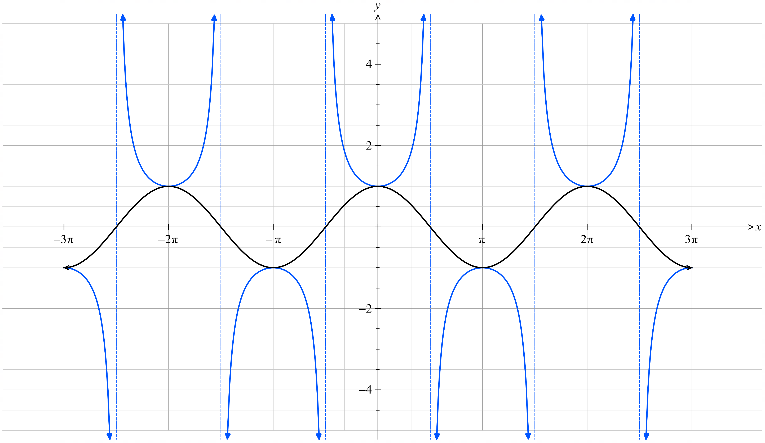
Domain of $y=\cos{x}$ : $[-3π,3π ]$ Range of $y=\cos{x}$ : $[-1,1]$
Domain of $y=\sec{x}$ : $x≠±\frac{π}{2}k, k=1, 3, 5$ Range of $y=\sec{x}$ : $\left(-∞,-1\right]∪[1,∞)$

$$y=\cot{x}$$
When $\tan{x}=1$,  $$\cot{x}=1$$ | As $\tan{x}→0^{+}$,  $$\cot{x}→∞$$ | As $\tan{x}→0^{-}$,  $$\cot{x}→-∞$$
$∴$ $\tan{x}=0$ corresponds to an asymptote on the graph of $y=\cot{x}$.
As $\tan{x}→∞$, $\cot{x}→0^{+}$ | As $\tan{x}→-∞$, $\cot{x}→0^{-}$
$∴$ an asymptote on the graph of $y=tan{x}$ corresponds to an intercept on the graph of $y=\cot{x}.$
Sketch $y=cotx$ by first sketching $y=\tan{x}$ over the domain $[-3π,3π]$. For each vertical asymptote and each $x$-intercept, write the equivalent angle in degrees next to the radian value on the $x$-axis.
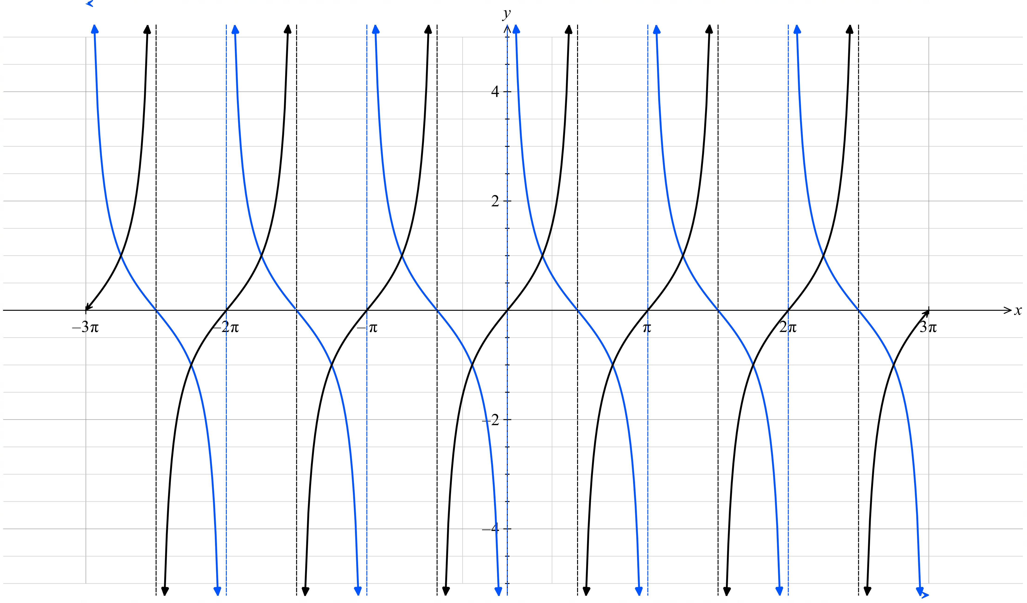
Domain of $y=\tan{x}$ : $x≠±\frac{π}{2}k, k=1, 3, 5$ Range of $y=\tan{x}$ : $(-∞,∞)$
Domain of $y=\cot{x}$ : $x≠±πk, k=0, 1, 2, 3$ Range of $y=\cot{x}$ : $(-∞,∞)$

References
This resource contains NSW Curriculum and syllabus content. The NSW Curriculum is developed by the NSW Education Standards Authority (NESA). This content is prepared by NESA for and on behalf of the Crown in right of the State of New South Wales. The material is protected by Crown copyright.
Please refer to the NESA Copyright Disclaimer for more information https://www.nsw.gov.au/education-and-training/nesa/copyright.
NESA holds the only official and up-to-date versions of the NSW Curriculum and syllabus documents. Please visit NESA https://www.nsw.gov.au/education-and-training/nesa and NSW Curriculum https://curriculum.nsw.edu.au.
Mathematics Extension 1 11–12 Syllabus © NSW Education Standards Authority (NESA) for and on behalf of the Crown in right of the State of New South Wales, 2024.

© State of New South Wales (Department of Education), 2026
The copyright material published in this resource is subject to the Copyright Act 1968 (Cth) and is owned by the NSW Department of Education or, where indicated, by a party other than the NSW Department of Education (third-party material).
Copyright material available in this resource and owned by the NSW Department of Education is licensed under a Creative Commons Attribution 4.0 International (CC BY 4.0) license.

This license allows you to share and adapt the material for any purpose, even commercially.
Attribution should be given to © State of New South Wales (Department of Education), 2026.
Material in this resource not available under a Creative Commons license:
- the NSW Department of Education logo, other logos and trademark-protected material
- material owned by a third party that has been reproduced with permission. You will need to obtain permission from the third party to reuse its material.
Links to third-party material and websites
Please note that the provided (reading/viewing material/list/links/texts) are a suggestion only and implies no endorsement, by the New South Wales Department of Education, of any author, publisher, or book title. School principals and teachers are best placed to assess the suitability of resources that would complement the curriculum and reflect the needs and interests of their students.
If you use the links provided in this document to access a third-party's website, you acknowledge that the terms of use, including licence terms set out on the third-party's website apply to the use which may be made of the materials on that third-party website or where permitted by the Copyright Act 1968 (Cth). The department accepts no responsibility for content on third-party websites.

