Reciprocal functions
Students will examine the relationship between the graph of $y=f(x)$ and the graph of $y=\frac{1}{f\left(x\right)}$ .
Students will need at least one digital device per pair to interact with Amplify Classroom and Desmos graphing calculator or GeoGebra during this lesson.

Learning intention
- To be able to graph $y=\frac{1}{f\left(x\right)}$ given $y=f(x)$.

Success criteria
- I can identify the reciprocal of $y=f(x)$.
- I can identify vertical asymptotes in $y=f(x)$ and $y=\frac{1}{f\left(x\right)}$.
- I can identify horizontal asymptotes in $y=f(x)$ and $y=\frac{1}{f\left(x\right)}$.
- I can describe the behaviour of $\frac{1}{f\left(x\right)}$ near the asymptotes.
- I can sketch $y=\frac{1}{f\left(x\right)}$.

Outcomes
A student:
- develops understanding and fluency in mathematics through exploring and connecting mathematical concepts, choosing and applying mathematical techniques to solve problems, and communicating their thinking and reasoning coherently and clearly MAO-WM-01
- solves problems involving inequalities, functions and their inverses, graphical relationships between functions, and parametric equations ME1-11-01

Content

Graphical relationships
- Examine the relationship between the graph of $y=f\left(x\right)$ and the graph of $y=\frac{1}{f(x)}$ using graphing applications, and graph $y=\frac{1}{f(x)}$ given $y=f\left(x\right)$ in algebraic or graphical form, identifying any vertical and horizontal asymptotes of $y=f\left(x\right)$ and $y=\frac{1}{f(x)}$
- Apply knowledge of graphical relationships to solve problems involving graphs of functions, justifying conclusions in the context of the problem where appropriate
Mathematics Extension 1 11–12 Syllabus © NSW Education Standards Authority (NESA) for and on behalf of the Crown in right of the State of New South Wales, 2024.

Table 1: lesson summary
Section | Summary of activity | Teaching strategies | Teaching points
Activating prior knowledge | Students engage with screens 1–11 of the Amplify Classroom activity ‘Reciprocal functions’ (bit.ly/ReciprocalFunctions) to examine a series of linear functions familiar from the Mathematics Advanced course and explore the behaviour of their reciprocals. | Notice and wonder  Pose-Pause-Pounce-Bounce | Students recall how to graph the reciprocal function examined in the Mathematics Advanced course, $y=\frac{1}{x}$ , and consider the impact of different graph transformations on the asymptotes.
Connecting learning | Students continue working through the remainder of the Amplify Classroom activity, investigating the reciprocals of a variety of different function types. At key points, students pause to discuss their observations and share how the features of $y=f\left(x\right)$ influence the structure and behaviour of $y=\frac{1}{f(x)}$. | Notice and wonder  Pose-Pause-Pounce-Bounce | Students observe that the reciprocal function has a vertical asymptote wherever the original function equals zero, and they explore how the sign of $f(x)$ influences whether the reciprocal tends towards $+∞$ or $-∞$.
Releasing responsibility | Students are supported with modelled examples using slides 4–5 of the PowerPoint and Appendix A, which provides a graph to write the solution to the ‘Your turn’ question. They then use an existing resource to build fluency before creating notes to their future forgetful selves. | Worked examples (Your turn)  Notes for future forgetful selves | Students develop fluency in sketching reciprocal functions by hand, including drawing asymptotes, identifying key values, and plotting behaviour around those asymptotes.
Independent practice | Students complete Appendix B and discuss their solutions with peers, comparing reasoning and identifying any impossible or ambiguous regions of the Venn diagram. | Think-Pair-Share | Students think flexibly about the properties of reciprocal functions, making connections across different function families and generalising the features of $y=\frac{1}{f\left(x\right)}$.

Activity structure
Please use the associated PowerPoint Reciprocal functions to display images in this lesson.

Activating prior knowledge
- Through a class discussion, check for understanding of the terms ‘reciprocal’ and ‘asymptote’ while introducing and clarifying the success criteria for the lesson.
- Assign the Amplify Classroom activity ‘Reciprocal functions’ (bit.ly/ReciprocalFunctions) for students to begin screens 1–11.
Before running this activity, you will need to set up an Amplify Classroom (bit.ly/createamplifyclassroom) and use the pacing feature to restrict students to screens 1–11.
Screens 1–11 focus on activating prior knowledge by examining linear functions and comparing their graphs to their reciprocals through a series of transformations.
- Highlight student responses to the questions on screens 8 and 11 of the Amplify Classroom activity. Use the Pose-Pause-Pounce-Bounce questioning strategy (PDF 557KB) (bit.ly/posepausepouncebounce) to prompt students to generalise emerging features of the reciprocal functions.
Students may observe that the vertical asymptote shifts with the transformation, that vertical asymptotes align with the $x$-intercepts of the original function and the horizontal asymptotes remain at $y=0$. Students may wonder how this applies to other functions.

Connecting learning
- Invite students to explore the reciprocals of additional functions by extending the pacing of the Amplify Classroom activity to include screens 12–21.
These screens investigate the relationship between the graph of $y=f(x)$ and $y=\frac{1}{f\left(x\right)}$ when $f(x)$ is a quadratic function with differing numbers of real solutions.
As students complete the screens, use the teacher dashboard to check student responses on screens 15, 17, 18 and 20. Pause the activity and discuss student responses to clarify misconceptions.
- Highlight student responses to the question on screen 21. Use the Pose-Pause-Pounce-Bounce questioning strategy to connect zeros of $y=f(x)$ with vertical asymptotes of $y=\frac{1}{f\left(x\right)}$ and to examine how the sign of $y=f(x)$ near a zero affects the behaviour of the reciprocal. Some possible prompts include:
- If a function has 3 zeros, how many vertical asymptotes will the reciprocal function have?
- What is one divided by a very large number?
- What is one divided by a fraction between zero and one?
- If the function is just above the $x$-axis near a zero, what happens to its reciprocal? What if it is just below the $x$-axis?
Students should recognise and be able to reason why the number of zeros in the original function corresponds to the number of vertical asymptotes in its reciprocal. They may also recognise that as $y=\frac{1}{f\left(x\right)}$ approaches each asymptote, its values increase or decrease without bound, depending on whether $y=f(x)$ was above or below the $x$-axis.
- Extend the pacing of the activity to include screens 22–25, which broadens the task to consider cubic functions and supports generalising those ideas to polynomial functions.
- Consolidate understanding by discussing how to sketch the reciprocal features when:
- $f(x)$ is above and below the $x$-axis
- $f\left(x\right)=1 \text{or}-1$
- $f(x)$ values are easily identifiable
- $|f\left(x\right)|<1$
- $\left|f\left(x\right)\right|>1$ .
- Extend the pacing to screens 26–27 to allow students to practise sketching.
- Conduct a class discussion comparing students’ sketches with the graphs of $y=\frac{1}{f\left(x\right)}$ they produced on screens 26–27.
- Remove pacing to have students complete the remaining screens, which explore reciprocal graphs of functions that are not polynomials.
- Engage the class in a discussion about what they notice for each function type.
Students may observe:
- Semi-circle function: the reciprocal has no horizontal asymptotes. Vertical asymptotes occur only where the semicircle intersects the $x$-axis.
- Exponential function: translating left or right does not change the horizontal asymptote. Translating up or down introduces a second horizontal asymptote, and a vertical asymptote will appear if the transformed function has an $x$-intercept.
- Reciprocal function: for $f\left(x\right)=\frac{1}{x-a}$, even though $\frac{1}{f\left(x\right)}=x-a$, the reciprocal retains a discontinuity at $x=a$. Translating the function horizontally will cause vertical asymptotes to appear accordingly.
- Constant function: when $f\left(x\right)=a$, there are no asymptotes provided $a≠0$.
- Zero function: when $f\left(x\right)=0$, $\frac{1}{f\left(x\right)}$ will be undefined for all $x$.

Releasing responsibility
- Use slides 4–6 of the PowerPoint to model worked examples of graphing a reciprocal function using the Worked examples (Your turn) method (bit.ly/supportingstrategies). Distribute Appendix A ‘Your turn (reciprocal functions)’ to support students as they attempt the ‘Your turn’ question.
- Display slide 4 again and lead a discussion around how looking at points around the vertical asymptote for $y=f(x)$ can help with the graph of $y=\frac{1}{f\left(x\right)}$.
Students should consider values of $x$ around $x=-4$, such as $x=-4.1$ and $x=-3.9$, to determine what $y=\frac{1}{f\left(x\right)}$ would look like.
- Use an existing resource to develop fluency in graphing reciprocal functions by hand.
- Using Appendix A as a guide, students should create notes to their future forgetful selves (bit.ly/notestofutureself) explaining how to sketch the graph of $y=\frac{1}{f\left(x\right)}$, including:
- how to identify vertical and horizontal asymptotes
- how to determine the behaviour of the reciprocal function around those asymptotes.

Independent practice
The following activity is based on ‘Rich Venn Diagram maths activities from Craig Barton’ (mathsvenns.com). If you are unfamiliar with this type of activity, take a moment to read the explanation on the webpage.
- Distribute Appendix B ‘Maths Venn – reciprocal functions’ in a plastic sleeve for students to complete.
Students should use a graphing application such as Desmos graphing calculator (www.desmos.com/calculator) or GeoGebra (www.geogebra.org/graphing?lang=en-AU) to verify solutions.
- Have students compare solutions with a peer and then, in a Think-Pair-Share (bit.ly/thinkpairsharestrategy), ask students to explain why they felt any section of the Venn diagram was impossible to complete, prompting deeper reasoning about reciprocal behaviour and asymptotes.

Assessment and differentiation

Suggested opportunities for differentiation
Activating prior knowledge
- A Notice and wonder strategy is used, allowing all students to participate without fear of incorrect answers.
- Sentence stems or visual prompts could be added to support students who benefit from additional scaffolding.
Connecting learning
- Adjust pacing in Amplify Classroom to tailor the gradual release of responsibility to students’ needs.
- Provide supplementary graphing practice after exploring each new function type in the activity. (For example, students could graph by hand after Screen 21).
- Encourage students to hypothesise about the behaviour of each reciprocal function before visualising it.
- Provide an extension by asking students to mathematically justify the asymptotes on screens 28–32.
Releasing responsibility
- Adapt the worked examples by modifying the function to meet students at their point of need.
- Modify self-explanation prompts to target specific aspects of understanding, such as asymptotes, sign behaviour or transformations.
- Select an existing resource that matches the level of support required by different learners.
- Provide sentence starters to support students using the Notes for future forgetful selves strategy.

Independent practice
- Allow students to collaborate in pairs or groups of 3 at non-permanent vertical surfaces for increased visibility and feedback.
- Challenge confident learners to explore other functions, such as those created by the sum and difference of functions and those not yet covered in the course and analyse the behaviour of their reciprocals.

Suggested opportunities for assessment
Activating prior knowledge
- Monitor student contributions during whole-class discussion to check understanding of asymptotes and the behaviour of $y=\frac{1}{f\left(x\right)}$ near asymptotes.
- Review saved student responses from Amplify Classroom to assess understanding of reciprocals of linear functions and the effects of transformations on asymptotes.
Connecting learning
- Facilitate discussions with students and observe their reasoning and justification in response to the prompts in the Amplify Classroom activity.
Releasing responsibility
- Collect and review Appendix A, the fluency-building resource, or students’ notes to their future forgetful selves as evidence of understanding of how to graph reciprocal functions.
Independent practice
- Students receive peer feedback through the Think-Pair-Share routine.
- Observe students’ reasoning and justification as they complete the Venn diagram task, noting misconceptions and strengths.

Appendix A

Your turn (reciprocal functions)
This diagram shows the graph of a function $f(x)$.
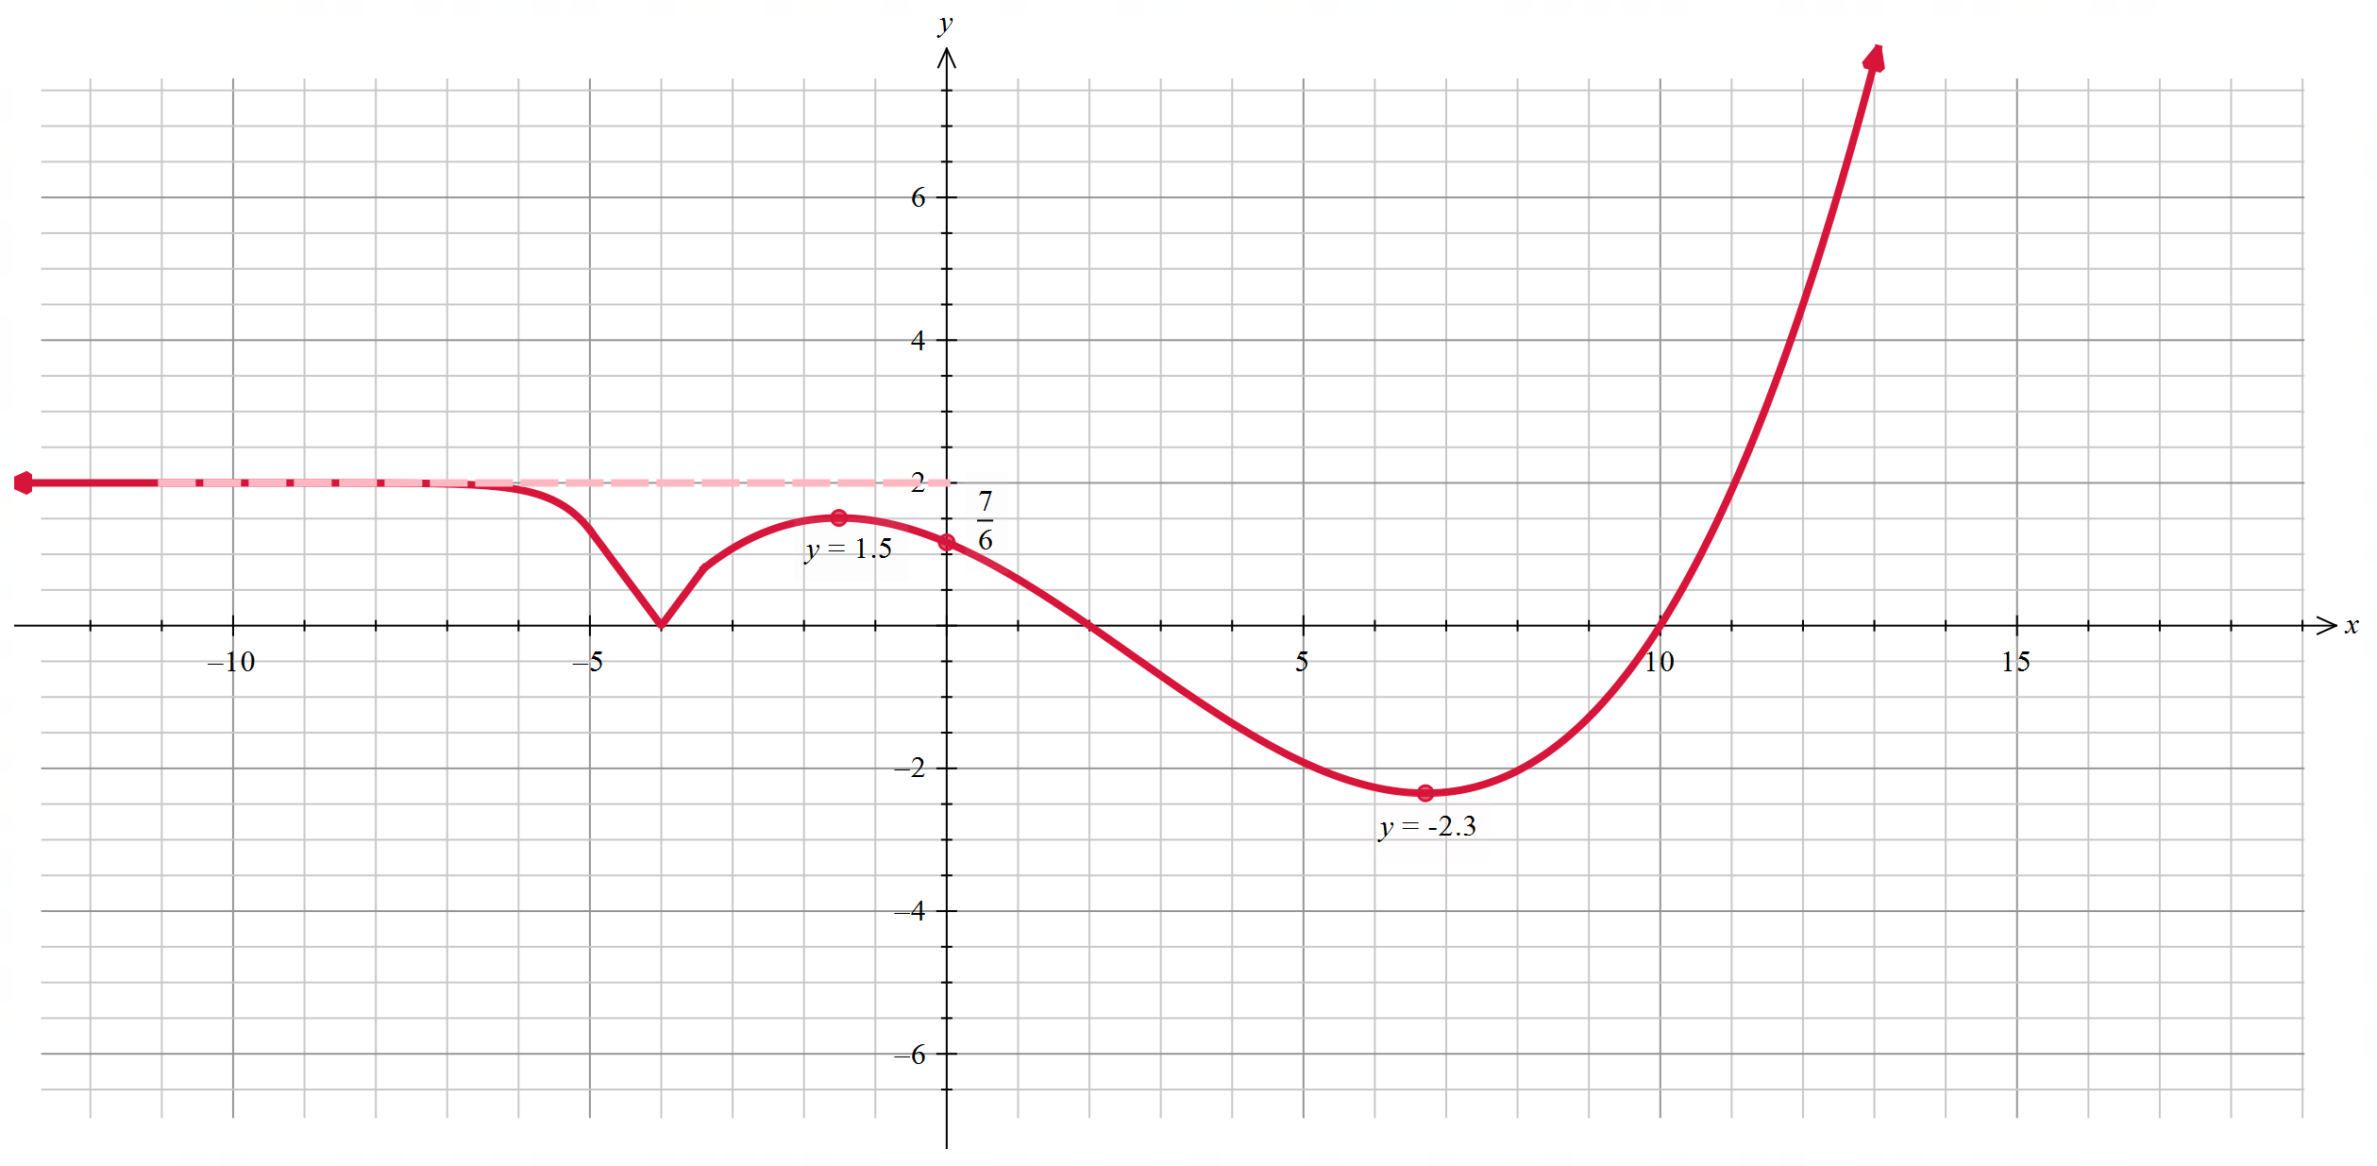
Draw a separate half-page graph of $y=\frac{1}{f\left(x\right)}$, showing all asymptotes and intercepts. 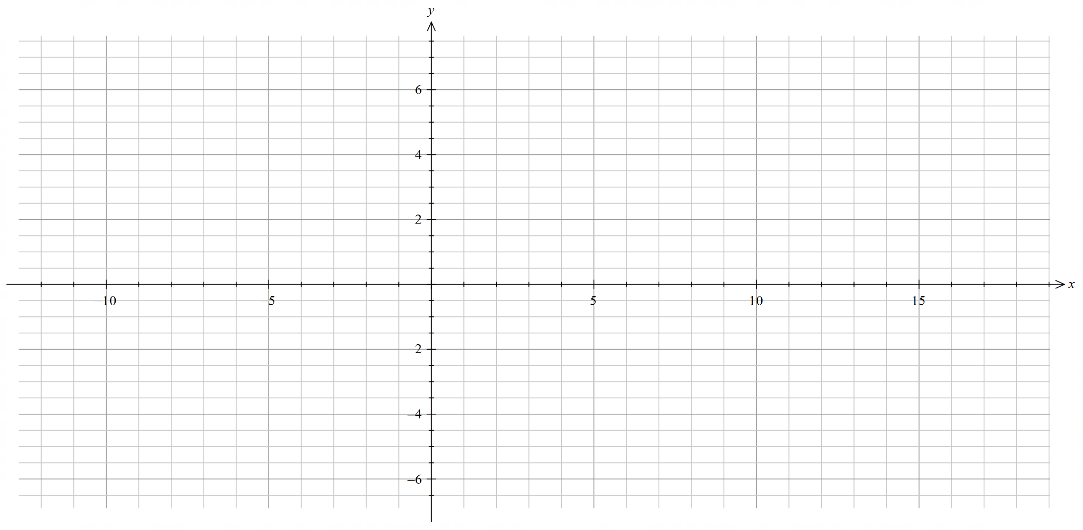

Appendix B – Maths Venn – reciprocal functions
Draw an appropriate graph that meets the conditions of each section of the Venn diagram.
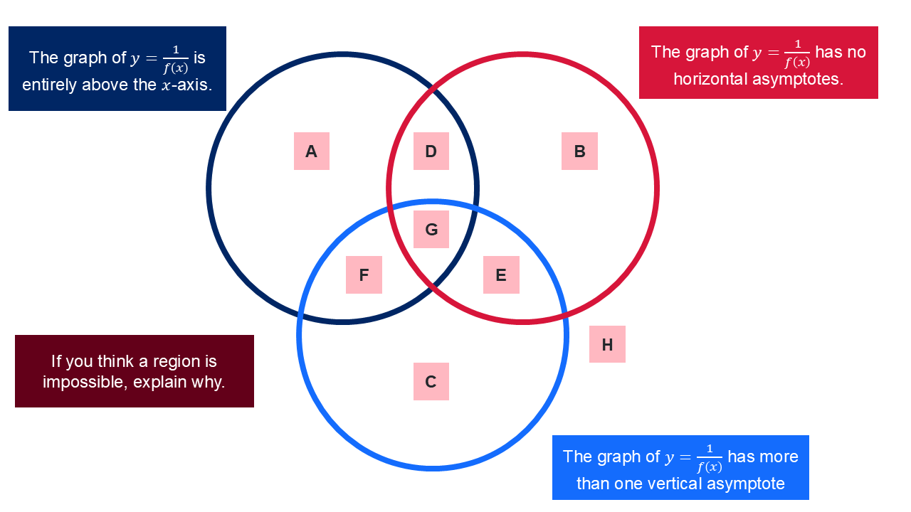

Sample solutions

Appendix A – Your turn (reciprocal functions)
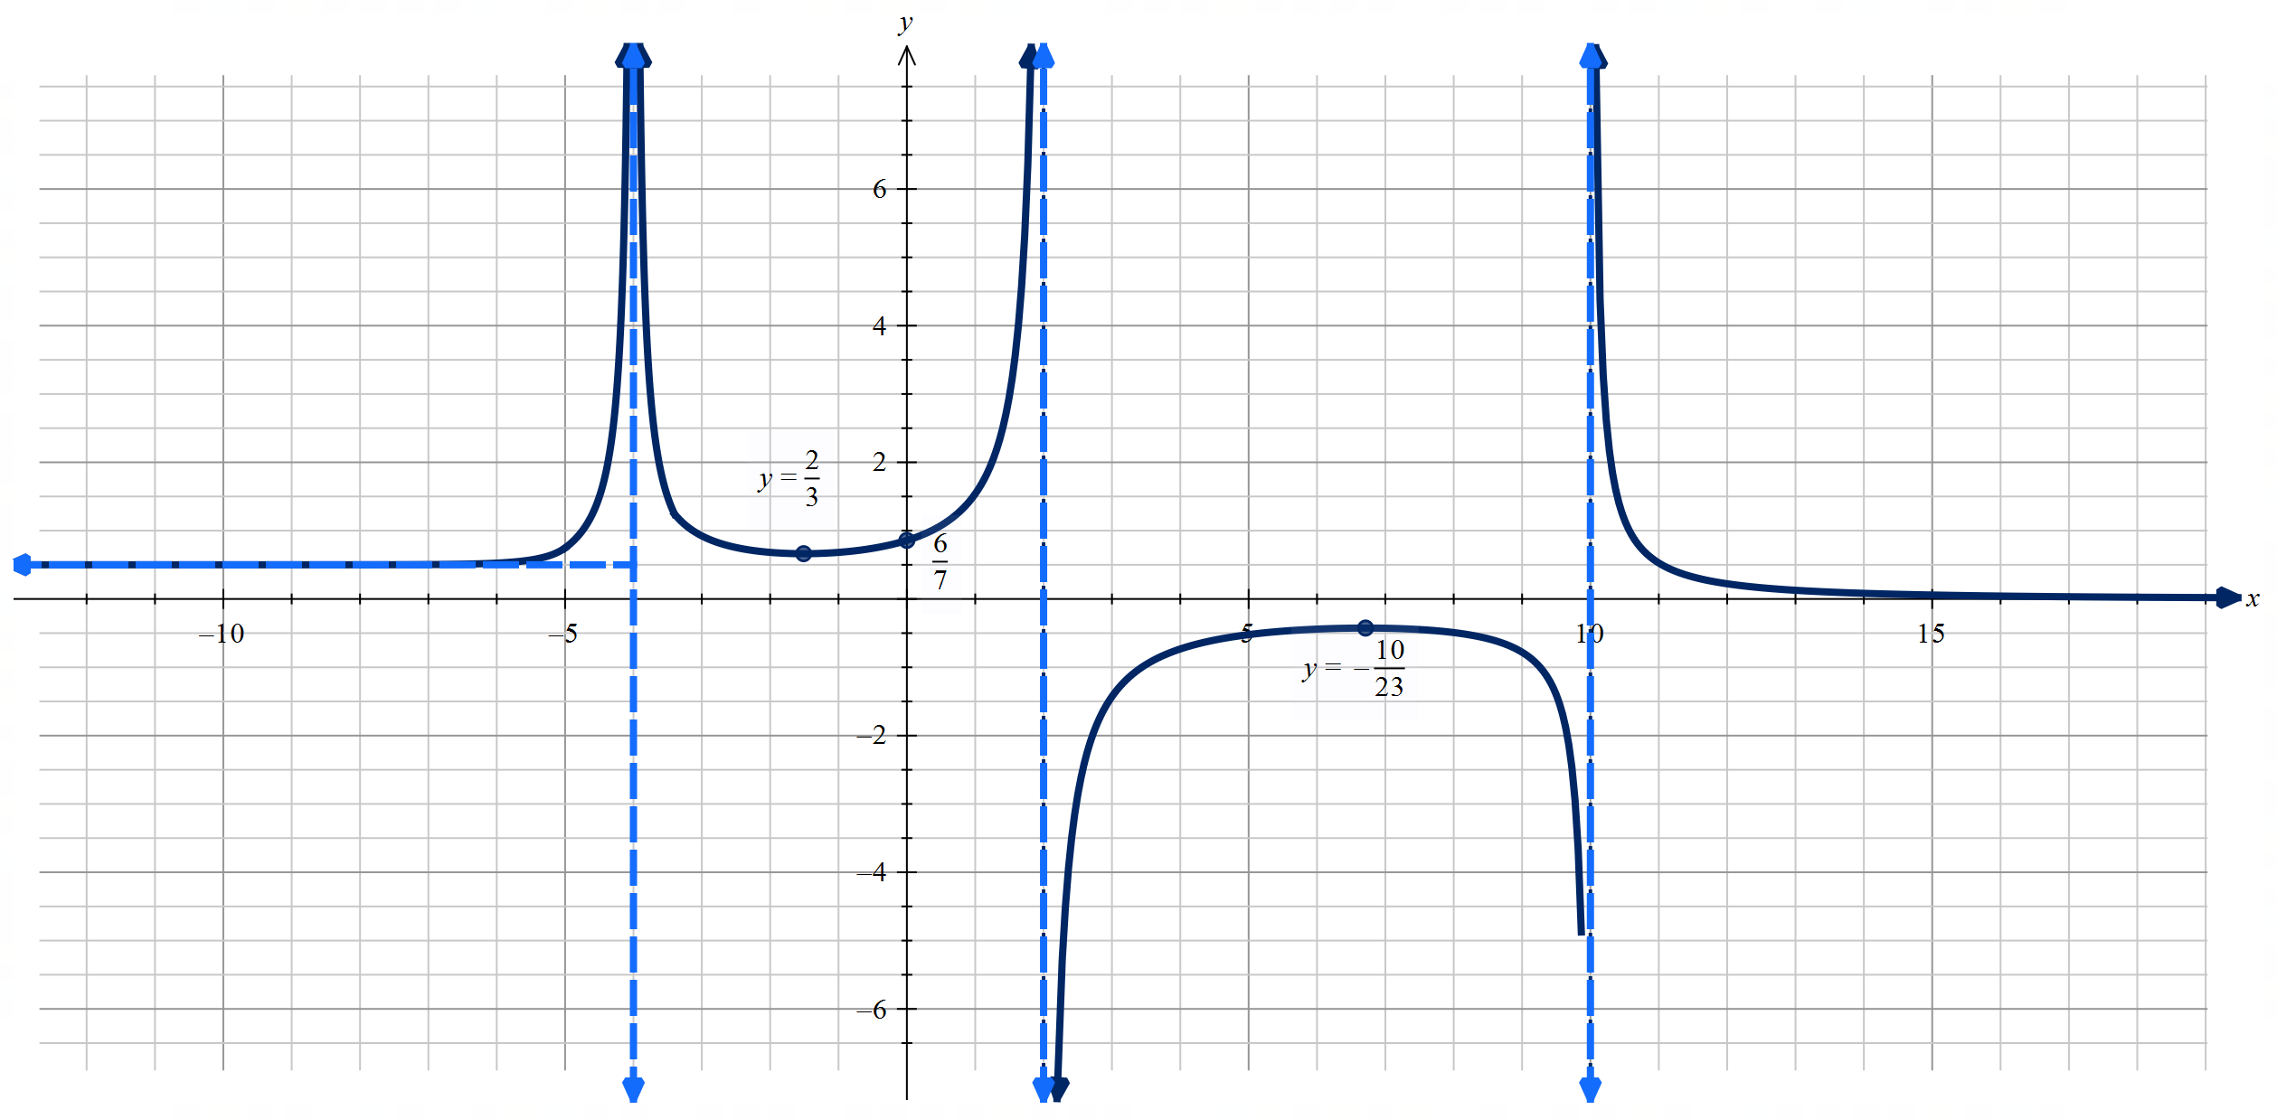

Appendix B – Maths Venn – reciprocal functions

Multiple functions match each region. Below is one example of each.
Region A – $f\left(x\right)=x^{2}+1$
Region B – $f\left(x\right)=-2$
Region C – $f\left(x\right)=x^{2}-1$
Region D – $f\left(x\right)=2$
Region E – $f\left(x\right)=-\sqrt{\left(4-x^{2}\right)}$
Region F – $f\left(x\right)={\left(x+2\right)}^{2}{\left(x-2\right)}^{2}$
Region G – $f\left(x\right)=\sqrt{\left(4-x^{2}\right)}$
Region H – $f\left(x\right)=\frac{1}{x}$

References
This resource contains NSW Curriculum and syllabus content. The NSW Curriculum is developed by the NSW Education Standards Authority (NESA). This content is prepared by NESA for and on behalf of the Crown in right of the State of New South Wales. The material is protected by Crown copyright.
Please refer to the NESA Copyright Disclaimer for more information https://www.nsw.gov.au/education-and-training/nesa/copyright.
NESA holds the only official and up-to-date versions of the NSW Curriculum and syllabus documents. Please visit NESA https://www.nsw.gov.au/education-and-training/nesa and NSW Curriculum https://curriculum.nsw.edu.au.
Mathematics Extension 1 11–12 Syllabus © NSW Education Standards Authority (NESA) for and on behalf of the Crown in right of the State of New South Wales, 2024.
Barton C (n.d.) Maths Venns [website], accessed 18 February 2026.

© State of New South Wales (Department of Education), 2026
The copyright material published in this resource is subject to the Copyright Act 1968 (Cth) and is owned by the NSW Department of Education or, where indicated, by a party other than the NSW Department of Education (third-party material).
Copyright material available in this resource and owned by the NSW Department of Education is licensed under a Creative Commons Attribution 4.0 International (CC BY 4.0) license.

This license allows you to share and adapt the material for any purpose, even commercially.
Attribution should be given to © State of New South Wales (Department of Education), 2026.
Material in this resource not available under a Creative Commons license:
- the NSW Department of Education logo, other logos and trademark-protected material
- material owned by a third party that has been reproduced with permission. You will need to obtain permission from the third party to reuse its material.
Links to third-party material and websites
Please note that the provided (reading/viewing material/list/links/texts) are a suggestion only and implies no endorsement, by the New South Wales Department of Education, of any author, publisher, or book title. School principals and teachers are best placed to assess the suitability of resources that would complement the curriculum and reflect the needs and interests of their students.
If you use the links provided in this document to access a third-party's website, you acknowledge that the terms of use, including licence terms set out on the third-party's website apply to the use which may be made of the materials on that third-party website or where permitted by the Copyright Act 1968 (Cth). The department accepts no responsibility for content on third-party websites.

