Addition and subtraction of functions
Students examine the relationship between pairs of functions and determine features of their graphs when they are added and subtracted.
Students will need at least one digital device per pair to interact with Amplify Classroom during this lesson.
Learning intentions and success criteria should be shared with students later in the learning episode.

Learning intentions
- To be able to sketch the graph $y=f\left(x\right)+g(x)$ and $y=f\left(x\right)-g(x)$.
- To be able to determine the domain and range of $y=f\left(x\right)+g(x)$ and $y=f\left(x\right)-g(x)$.

Success criteria
- I can use graphing applications to graph $y=f\left(x\right)+g(x)$ and $y=f\left(x\right)-g(x)$.
- I can add or subtract ordinates to assist in sketching a new graph.
- I can add or subtract function values to assist in sketching a new graph.

Outcomes
A student:
- develops understanding and fluency in mathematics through exploring and connecting mathematical concepts, choosing and applying mathematical techniques to solve problems, and communicating their thinking and reasoning coherently and clearly MAO-WM-01
- solves problems involving inequalities, functions and their inverses, graphical relationships between functions, and parametric equations ME1-11-01

Content

Graphical relationships
- Examine the relationship between the graphs of $y=f\left(x\right)$ and $y=g\left(x\right)$ and the graphs of $y=f\left(x\right)+g\left(x\right)$ and $y=f\left(x\right)-g\left(x\right)$ using graphing applications, and graph $y=f\left(x\right)+g\left(x\right)$ and $y=f\left(x\right)-g(x)$ given $y=f\left(x\right)$ and $y=g\left(x\right)$ in algebraic or graphical form
- Determine the domains and ranges of the sum and difference of functions where possible, and, if appropriate, verify them using a graphing application
- Apply knowledge of graphical relationships to solve problems involving graphs of functions, justifying conclusions in the context of the problem where appropriate
Mathematics Extension 1 11–12 Syllabus © NSW Education Standards Authority (NESA) for and on behalf of the Crown in right of the State of New South Wales, 2024.

Table 1: lesson summary
Section | Summary of activity | Teaching strategies | Teaching points
Activating prior knowledge | Display slide 3 of the PowerPoint, which features a graph of 4 functions representing the costs of takeaway food. Students discuss the addition of each function. | Notice and wonder  Pose-Pause-Pounce-Bounce | Students recognise that 2 cost functions can be summed and sketched to represent a new cost function.
Connecting learning | The learning intentions are revealed on slide 5, before using slides 6–10 to complete a slow reveal of the sum and difference of 2 functions. | Slow reveal graphs  Mini whiteboards  Think-Pair-Share | Students make observations about the domain and range, and what characteristics from the original functions carry forward to the functions made by $f\left(x\right)+g\left(x\right)$ and $f\left(x\right)-g\left(x\right)$.
Releasing responsibility | Use slides 12–16 to complete worked examples before using Amplify Classroom (bit.ly/AddSubFunctions) to sketch the sum and difference of the pairs of functions from slide 17. Students then use Appendix B to create Four quadrant notes. | Worked examples (Your turn)  Pose-Pause-Pounce-Bounce  Visibly random groups of 3  Vertical non-permanent surfaces  Four quadrant notes | Students are explicitly taught techniques to add and subtract functions graphically as well as manipulating functions algebraically before practising these techniques.
Independent practice | Students use an existing resource to consolidate their skills before completing the exit ticket in Appendix C. | Exit ticket | Students consolidate their ability to sketch the addition and subtraction of functions.

Activity structure
Please use the associated PowerPoint Addition and subtraction of functions to display images in this lesson.

Activating prior knowledge
- Display slide 3 of the PowerPoint and ask students to consider what they notice and wonder (bit.ly/noticewonderstrategy) about the information displayed.
Slide 3 features 4 functions graphed on the same plane to represent various average costs related to a takeaway meal for 2 people being delivered through a phone application. The functions represent:
- $C(x) =$In-store purchase price of takeaway food
- $M(x) =$ Markup that stores place on items in delivery apps
- $S(x) =$ Service fee for using the delivery app
- $D(x) =$ Delivery fee for using the delivery app.
- Use the Pose-Pause-Pounce-Bounce questioning strategy (PDF 557KB) (bit.ly/posepausepouncebounce) to prompt students to consider how the total cost of a takeaway purchase on a delivery app could be predicted. The following are some suggested prompts:
- How could this graph be used to predict the total cost for takeaway purchases through a delivery app at the start of 2022?
- If we repeated that process for every year, what would we be creating?
- Would a new rule that inputs each year and outputs the total cost be a function? Why or why not?
- How do you think this relates to our study of functions?

Connecting learning
- Show slide 5 to reveal the learning intentions and success criteria.
- Use slides 6–8 to complete the ‘slow reveal graphs’ activity (slowrevealgraphs.com).
Students should notice the following for each slide:
- Slide 6: there are 2 graphs; a parabola and a straight line.
- Slide 7: the graphs are labelled $f\left(x\right)=x^{2}-3x$ and $g\left(x\right)=x-3$.
- Slide 8: a new parabola, $y=x^{2}-2x-3$, is revealed. Students may recognise this represents $f\left(x\right)+g(x)$. If students do not identify this characteristic, further questioning should be used to prompt this recognition.
- Slide 9: 3 pairs of coordinates are revealed, connected by a broken line.
- Keeping slide 9 displayed, in a Think-Pair-Share (bit.ly/thinkpairsharestrategy) have students determine the domain and range of the 3 functions and discuss how the highlighted points could inform sketching the resultant graph.
Students could identify that the domains for the original 2 functions were the same, and the resulting function also has the same domain. Students could recognise that the resulting function is a quadratic, resulting in the range changing based on the vertex.
- Display slide 10 and ask students what they notice about the graphs.
A new parabola, $y=x^{2}-4x+3$, is revealed with some points marked. Students may recognise this represents $f\left(x\right)-g(x)$. If students do not identify this characteristic, further questioning should be used to prompt this recognition.
- In a Think-Pair-Share, ask students to determine the domain and range of $f\left(x\right)-g(x)$ and discuss how the same highlighted points as those from slide 9 inform sketching the resultant graph.

Releasing responsibility
- Use slides 12–16 from the PowerPoint to model worked examples of addition and subtraction of functions using the Worked examples (Your turn) method (bit.ly/supportingstrategies). Appendix A ‘Worked examples – Your turn’ should be used to support students in attempting the ‘Your turn’ questions.
Paper strips can be used to help determine the lengths. See differentiation advice for more details.
- Ensure all students have access to a device for them to access the Amplify Classroom activity ‘Adding and subtracting functions’ (bit.ly/AddSubFunctions), which they will use in combination with slide 17.
Before completing this activity, you will need to set up an Amplify Classroom (bit.ly/createamplifyclassroom). Teachers may wish to use the pacing tool to restrict students from screens until appropriate.
Amplify Classroom provides the opportunity for immediate feedback as well as tailored feedback from the teacher as students’ progress.
- Display slide 17, which shows pairs of equations and have students enter the first pair of equations into screen 2.
- Use screen 3 to verify their sketch with the graph of $f\left(x\right)+g(x)$ and then use the Pose-Pause-Pounce-Bounce questioning strategy to allow students to consider the accuracy of their sketches. Some possible prompts include:
- How accurate was your graph?
- What happens when 2 positive functions’ values are added?
- What happens when one function’s value is zero?
- What happens when one function’s value is negative and the other positive?
- Ask students to state the domain and range of $f\left(x\right)+g(x)$ in their workbooks.
- Discuss with the class how they would approach graphing $f\left(x\right)-g(x)$ and what they expect it to look like.
- Use screen 4 to have students sketch $f\left(x\right)-g(x)$ and state its domain and range in their workbooks.
- Use screen 5 to verify their sketch with the graph of $f\left(x\right)-g\left(x\right)$ and then use the Pose-Pause-Pounce-Bounce questioning strategy to allow students to consider the accuracy of their sketches. Some possible prompts includes:
- What happens to $f\left(x\right)-g\left(x\right)$ when $f\left(x\right)=0$? How does this change when $g\left(x\right)=0$?
- What happens when both $f\left(x\right)$ and $g\left(x\right)$ are positive?
- What happens when $f\left(x\right)$ is positive and $g\left(x\right)$ is negative?
- What happens when both $f\left(x\right)$ and $g\left(x\right)$ are negative?
- Ask students to discuss what the difference will be between $f\left(x\right)-g\left(x\right)$ and $g\left(x\right)-f(x)$ as a Think-Pair-Share (bit.ly/thinkpairsharestrategy) before verifying the solution digitally using screen 6.
In screen 6, the green graph is $f\left(x\right)-g(x)$ while the orange graph is $g\left(x\right)-f(x)$.
- Using screen 7, have students repeat the process of sketching $f\left(x\right)+g(x)$ and $f\left(x\right)-g\left(x\right)$with the remaining pairs of functions, discussing the domain and range in their pairs.
There are 8 pairs of functions on slide 16, which can be revealed individually through animation.
- Conduct a class discussion about what students observed about the different pairs of functions, and how addition and subtraction affected their domain and range.
Students should observe that the domain of the sum or difference excludes any $x$-values for which either $f(x)$ or $g(x)$ is undefined. Students may observe that changes in the range depend entirely on the original 2 functions and how they interact.
- Assign students to visibly random groups of 3. Ask them to complete Four quadrant notes to their future forgetful selves (bit.ly/supportingstrategies) using Appendix B ‘Four quadrant notes’ at a vertical non-permanent surface (bit.ly/VNPSstrategy).

Independent practice
- Use an existing resource for students to build fluency with this concept. Ask students to verify the domain and range of their functions with graphing applications.
- Check for understanding by using the exit ticket (bit.ly/exitticketstrategy) in Appendix C ‘Exit ticket’.

Assessment and differentiation

Suggested opportunities for differentiation
Activating prior knowledge
- A notice and wonder strategy is used when there is no correct answer, so that all students can participate in the discussion
Connecting learning
- The pair of functions used in the slow reveal graphs can be modified to meet student needs.
- Students could be prompted to consider connections to solving simultaneous equations.
Releasing responsibility
- The pairs of functions on slide 17 can be modified to match the needs of students.
- More combinations of quadratic functions and linear functions could be used for cohorts with low readiness.
- More varied combinations of functions could be used for cohorts with high readiness.
- The pacing for the release of the pairs of functions should be appropriate for the students. Use mini whiteboards and classroom observations as checks for understanding to ensure a gradual release of responsibility.
- The domain and range supplied in the solutions to the worked examples could be modified to worded descriptions or inequalities for students who are still developing their understanding of interval notation.
- Students could use strips of paper as a concrete model for the sum and difference of 2 functions. By cutting the strips to match the vertical distance between each function and the $x$-axis, students physically combine and reposition the strips to illustrate how adding and subtracting functions affects their outputs.
- The self-explanation prompts can be modified to draw attention to different aspects of the graph.
Independent practice
- The existing resource should be calibrated to meet students at their point of need.
- The exit ticket can be adapted to focus on the area of most need

Suggested opportunities for assessment
Activating prior knowledge
- Monitor responses in class discussions to check for student understanding of function values in a graph.
Connecting learning
- Use mini whiteboards as a check for understanding.
- Students give each other peer feedback, before sharing with the class in a Think-Pair-Share.
Releasing responsibility
- Monitor student responses in the ‘Your turn’ section to gauge student understanding of the sum and difference of functions.
- Student responses to the self-explanation prompts during worked examples provide an opportunity to assess student reasoning.
Independent practice
- Existing resources or the exit ticket could be collected to show student understanding.

Appendix A

Worked examples – Your turn
- The graphs of $y = f(x)$ and $y = g(x)$ are shown. Draw the graph of $y = f(x) - g(x)$ and comment on its domain and range.
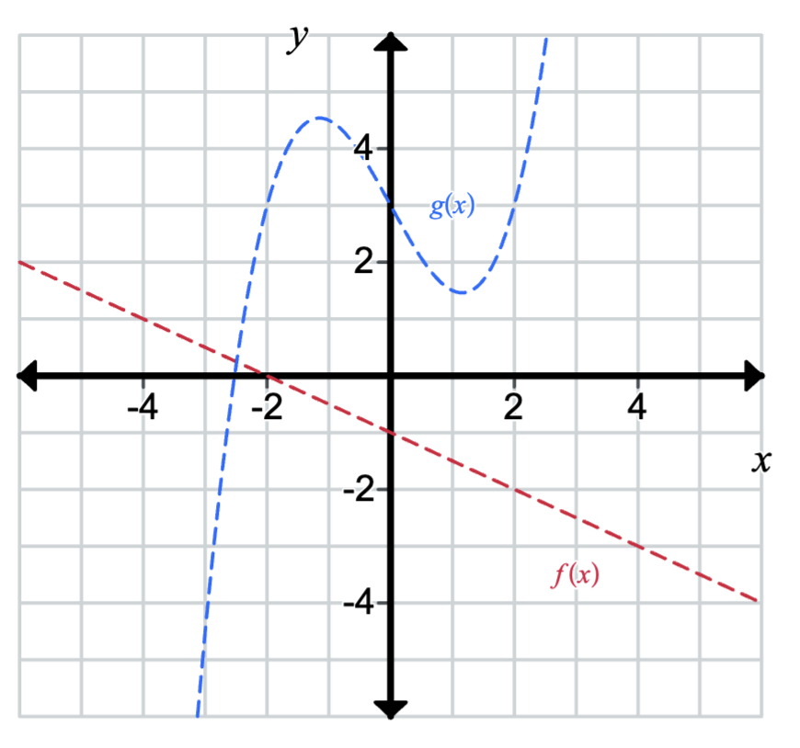
- Consider the functions $f\left(x\right)=x^{3}-4x^{2}+3x$ and $g\left(x\right)=-x^{2}+4x-4$.
On the same diagram, sketch the graph $y=f(x)$ and $y=g(x)$. Use these graphs to sketch $y=x^{3}-5x^{2}+7x-4.$
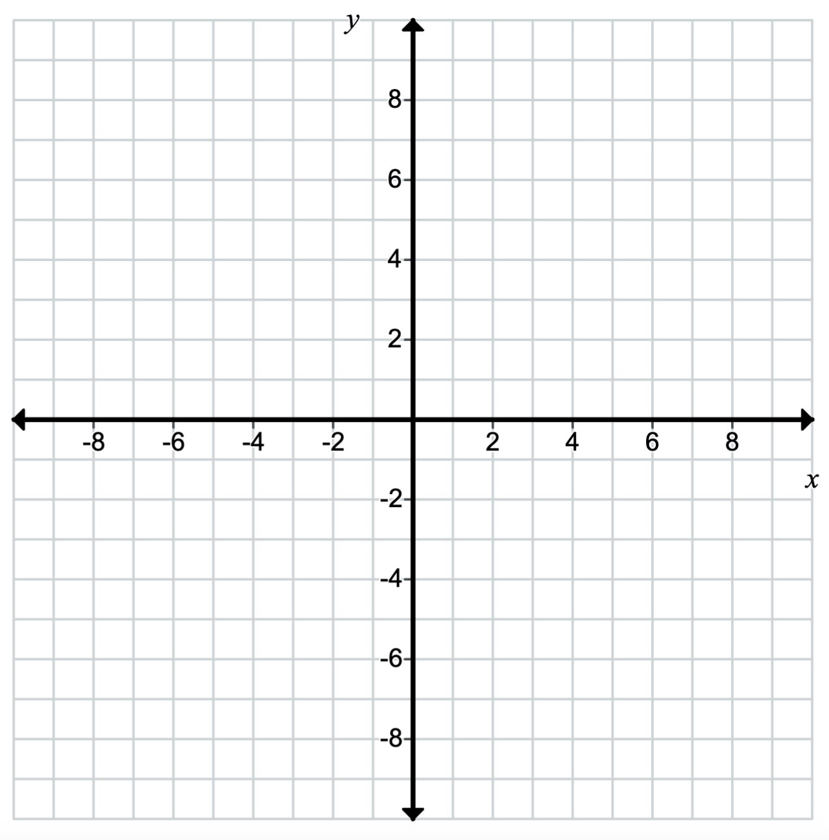

Appendix B

Four quadrant notes
Example 1  The graphs of $y = f(x)$ and $y = g(x)$ are shown. Draw the graph of $y = f\left(x\right)+ g(x)$ and comment on its domain and range.  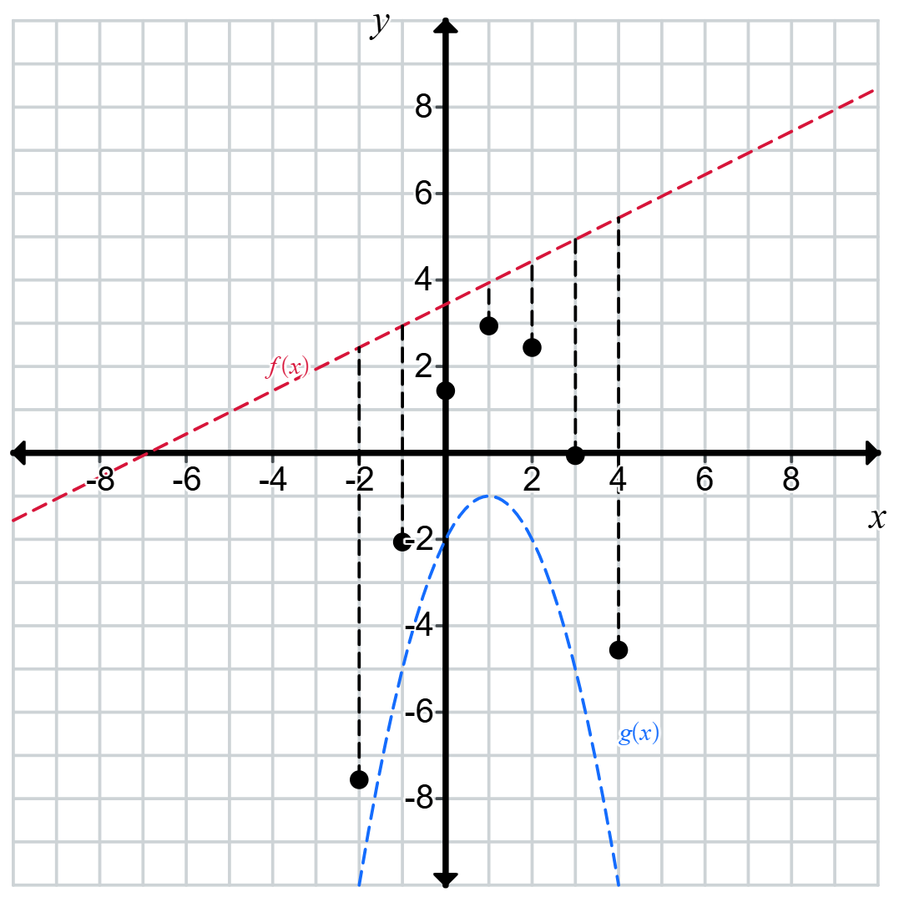  Domain: Range: | Example 2  Consider the functions $f\left(x\right)=x^{3}-3x^{2}+2x$ and $g\left(x\right)=-x^{2}+6x-5$.  On the same diagram, sketch the graph  $y=f(x)$ and $y=g(x)$. Use these graphs to sketch $y=x^{3}-2x^{2}-4x+5.$
Things to remember | Example 3

Appendix C

Exit ticket
Consider the functions $f\left(x\right)=-\frac{1}{2}x$ and $g\left(x\right)=\sqrt{x+9}$.
- Determine $f\left(x\right)+g\left(x\right)$.
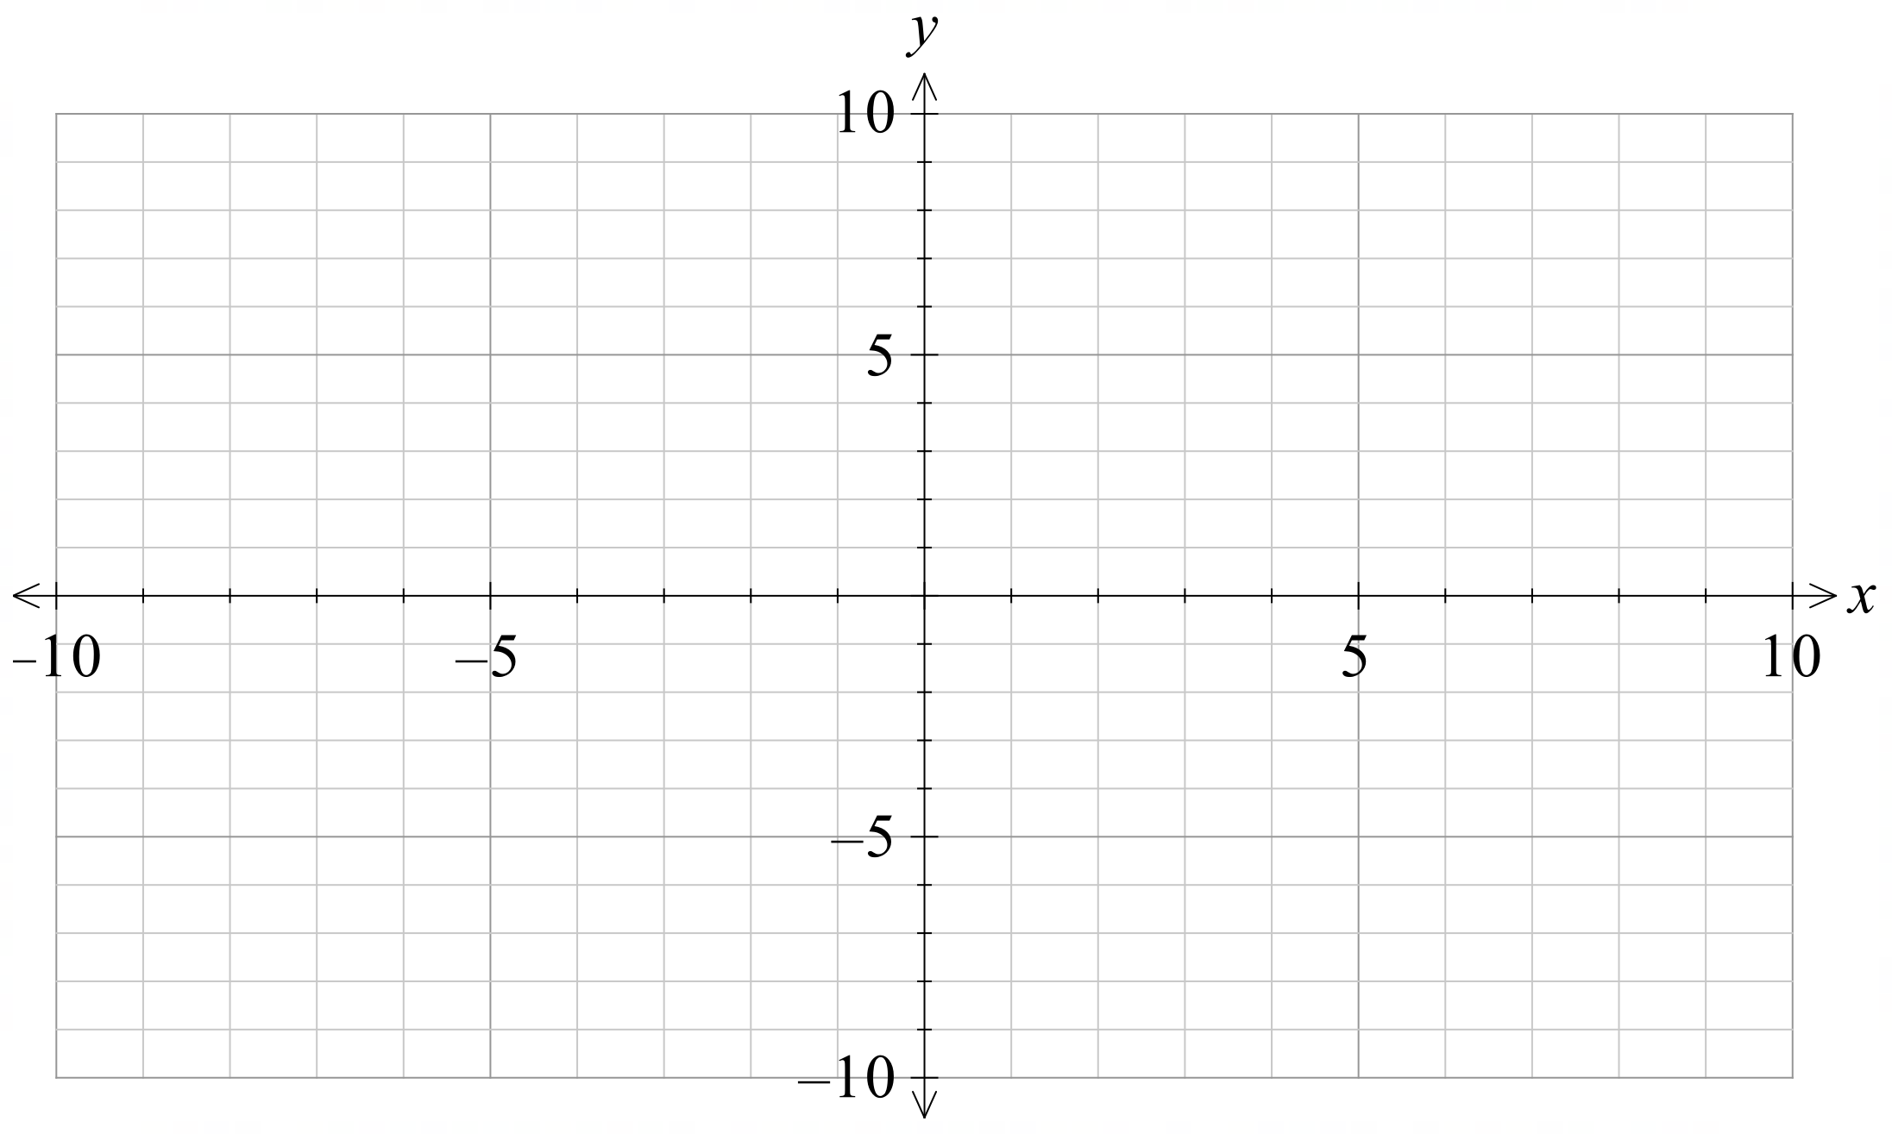
- Determine $f\left(x\right)-g\left(x\right)$.

Sample solutions

Appendix A – Worked examples – Your turn

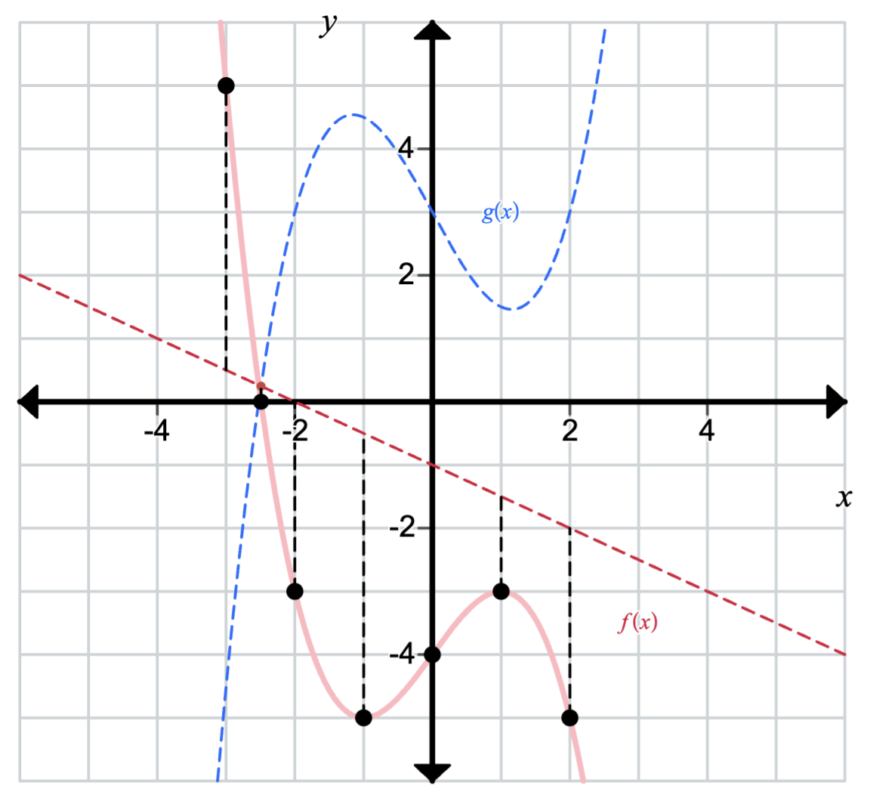
Domain: $\left(-∞,∞\right),$Range: $(-∞,∞)$

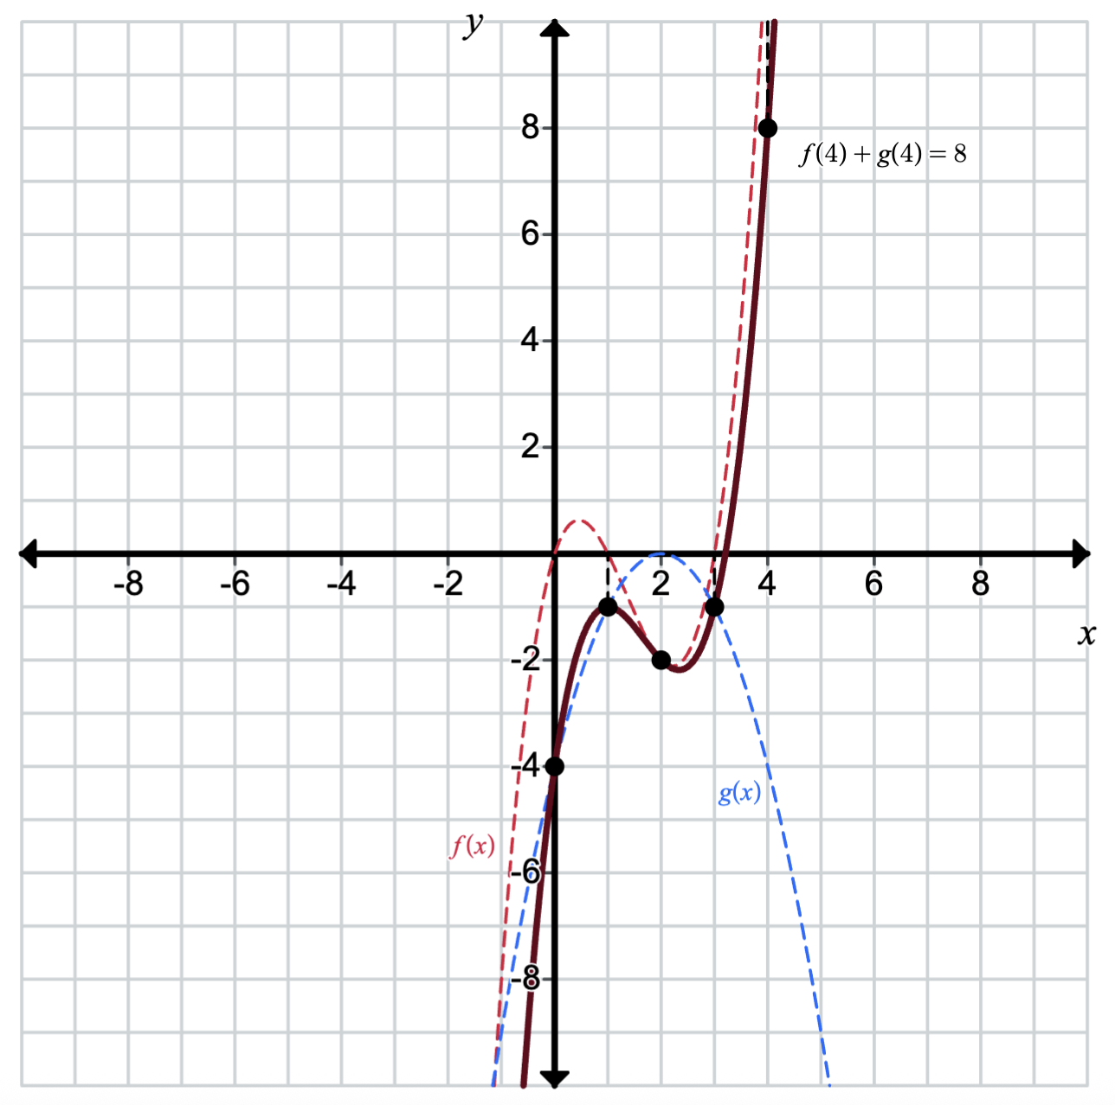

Appendix B – Four quadrant notes
Example 1  The graphs of $y = f(x)$ and $y = g(x)$ are shown. Draw the graph of $y = f\left(x\right)+ g(x)$ and comment on its domain and range.  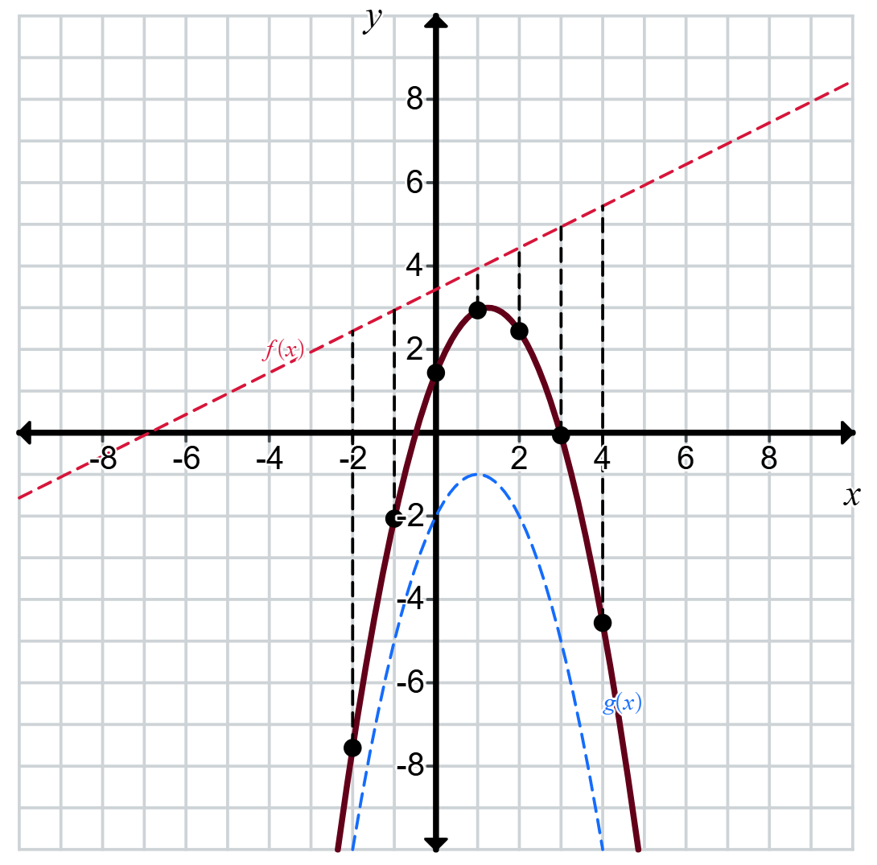  Domain: all real $x$ Range: $y≤3$ | Example 2  Consider the functions $f\left(x\right)=x^{3}-3x^{2}+2x$ and $g\left(x\right)=-x^{2}+6x-5$.  On the same diagram, sketch the graph  $y=f(x)$ and $y=g(x)$. Use these graphs to sketch $y=x^{3}-2x^{2}-4x+5.$  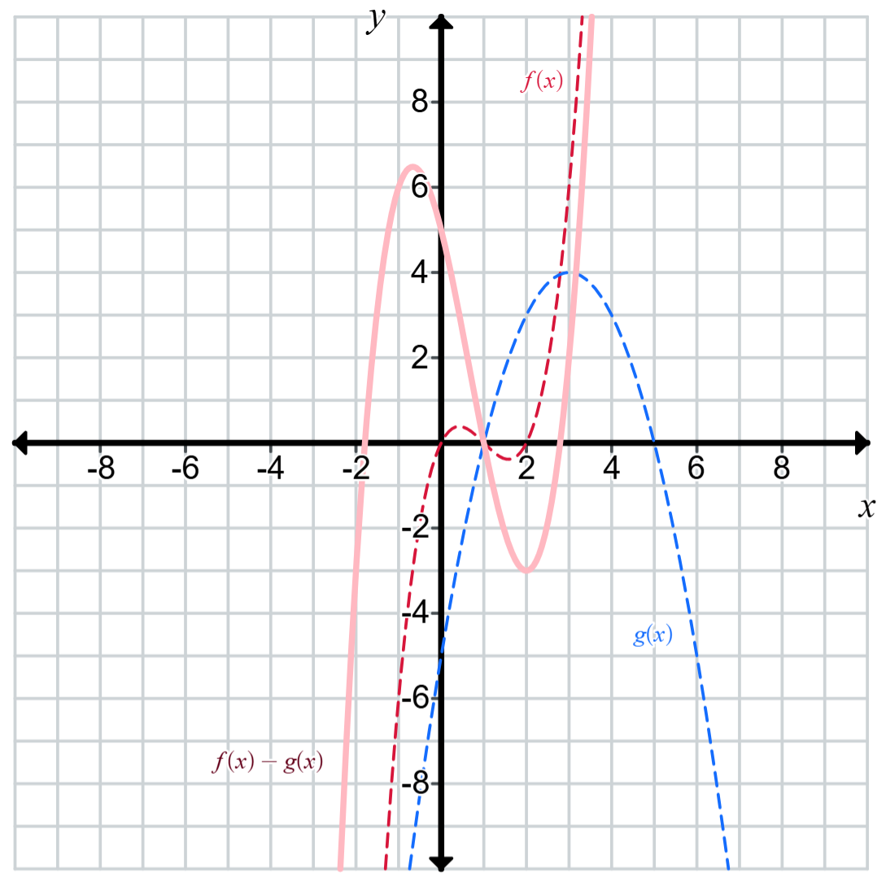
Things to remember  - Add or subtract the function values, not the values from the domain.  - Can only evaluate when $f(x)$ and $g(x)$ exist.  - Vertical asymptotes are inherited.  - $f\left(x\right)-g\left(x\right)≠g\left(x\right)-f(x)$. | Example 3  $$f\left(x\right)=2^{x}, g\left(x\right)=\frac{1}{x},f\left(x\right)-g(x)$$  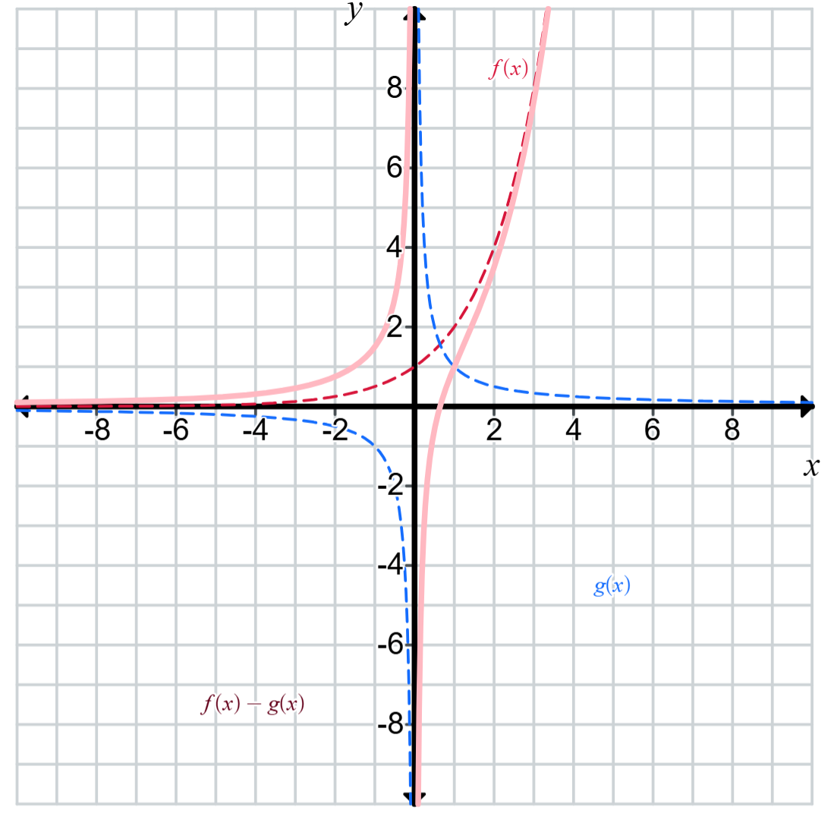

Appendix C – exit ticket

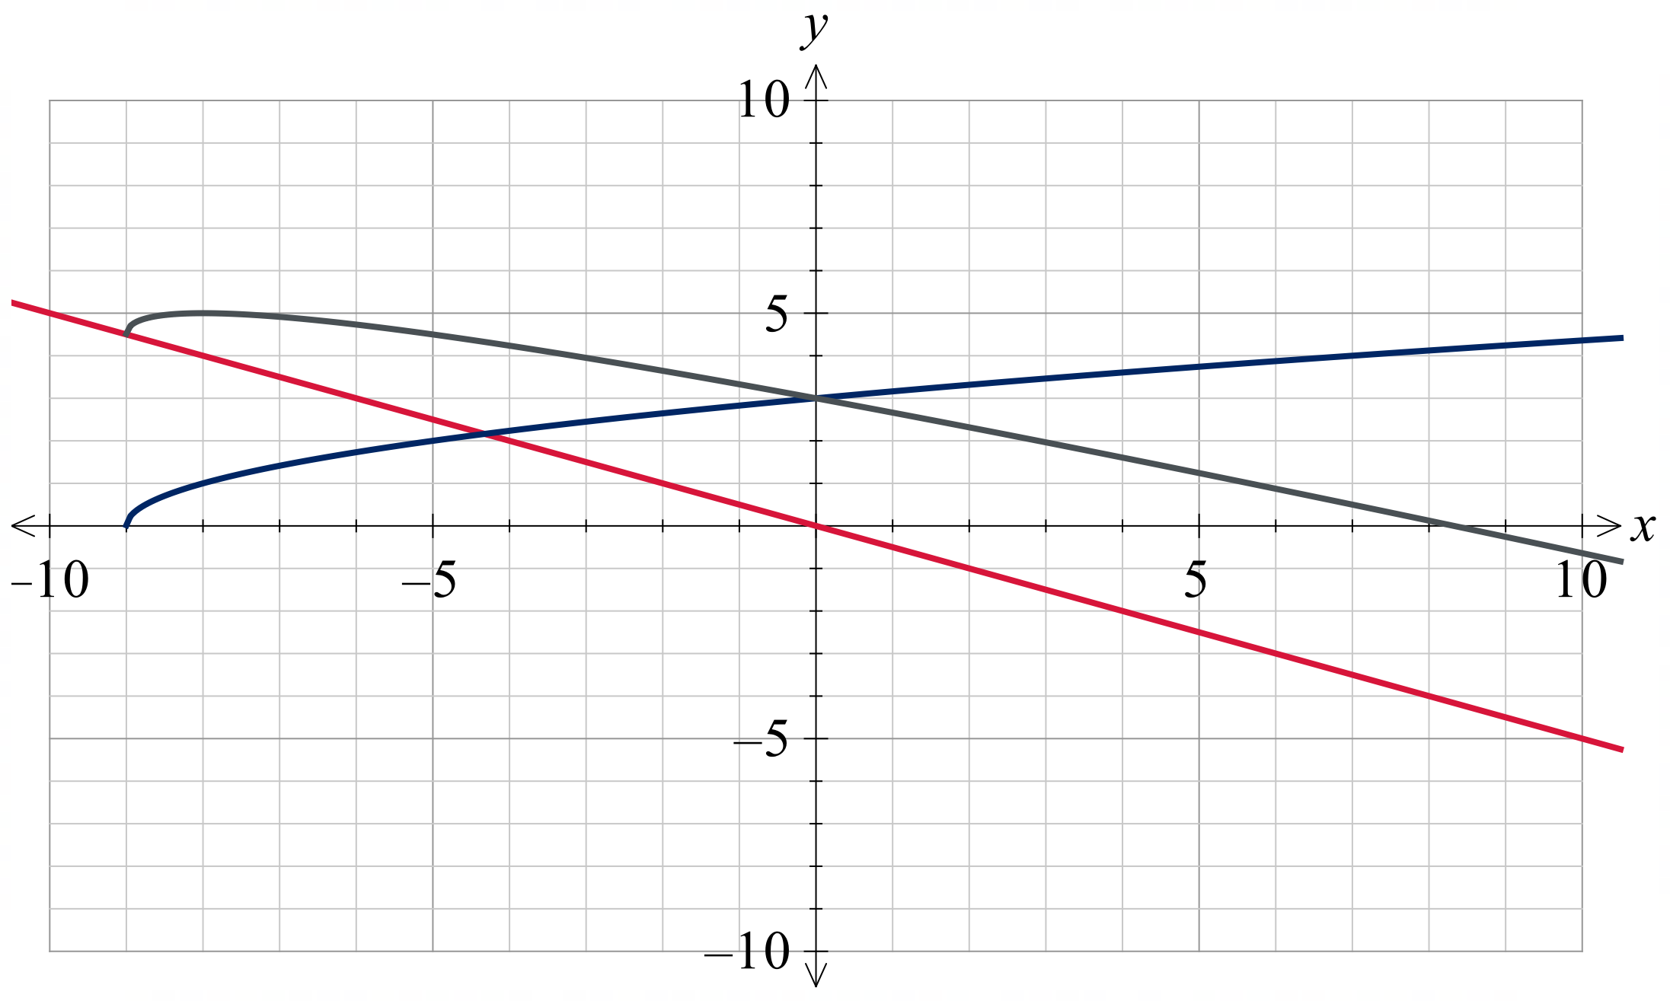

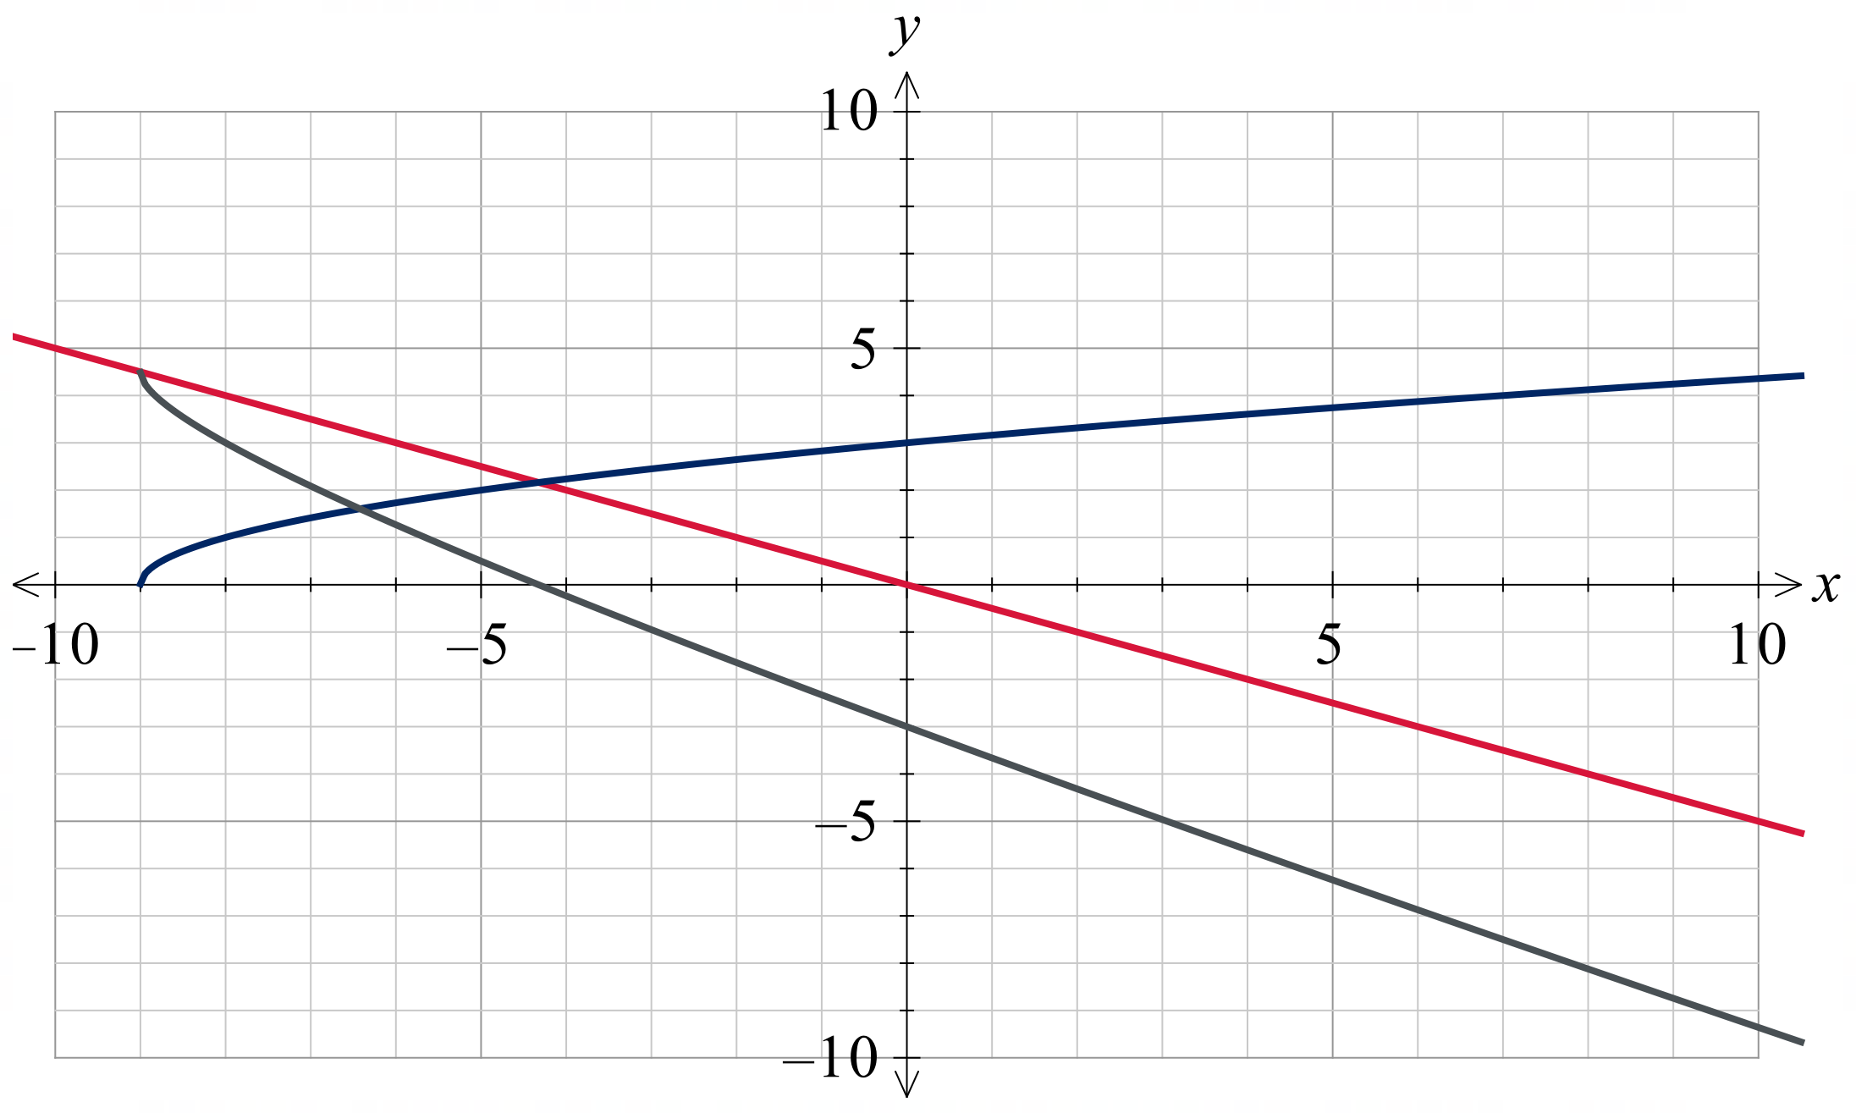

References
This resource contains NSW Curriculum and syllabus content. The NSW Curriculum is developed by the NSW Education Standards Authority (NESA). This content is prepared by NESA for and on behalf of the Crown in right of the State of New South Wales. The material is protected by Crown copyright.
Please refer to the NESA Copyright Disclaimer for more information https://www.nsw.gov.au/education-and-training/nesa/copyright.
NESA holds the only official and up-to-date versions of the NSW Curriculum and syllabus documents. Please visit NESA https://www.nsw.gov.au/education-and-training/nesa and NSW Curriculum https://curriculum.nsw.edu.au.
Mathematics Extension 1 11–12 Syllabus © NSW Education Standards Authority (NESA) for and on behalf of the Crown in right of the State of New South Wales, 2024.

© State of New South Wales (Department of Education), 2026
The copyright material published in this resource is subject to the Copyright Act 1968 (Cth) and is owned by the NSW Department of Education or, where indicated, by a party other than the NSW Department of Education (third-party material).
Copyright material available in this resource and owned by the NSW Department of Education is licensed under a Creative Commons Attribution 4.0 International (CC BY 4.0) license.

This license allows you to share and adapt the material for any purpose, even commercially.
Attribution should be given to © State of New South Wales (Department of Education), 2026.
Material in this resource not available under a Creative Commons license:
- the NSW Department of Education logo, other logos and trademark-protected material
- material owned by a third party that has been reproduced with permission. You will need to obtain permission from the third party to reuse its material.
Links to third-party material and websites
Please note that the provided (reading/viewing material/list/links/texts) are a suggestion only and implies no endorsement, by the New South Wales Department of Education, of any author, publisher, or book title. School principals and teachers are best placed to assess the suitability of resources that would complement the curriculum and reflect the needs and interests of their students.
If you use the links provided in this document to access a third-party's website, you acknowledge that the terms of use, including licence terms set out on the third-party's website apply to the use which may be made of the materials on that third-party website or where permitted by the Copyright Act 1968 (Cth). The department accepts no responsibility for content on third-party websites.

