Finding the equation of the inverse
Students develop the strategy of interchanging the variables $x$ and $y$ to find the equation of the inverse function, given a one-to-one function or a function with an appropriate restriction. Students formalise their definition of inverse functions and use this to verify solutions.

Learning intention
- To be able to find the equation of the inverse function.

Success criteria
- I can interchange the $x$ and $y$ variables to find the inverse.
- I can rearrange the equation to change the subject of the inverse function.
- I can define an inverse function formally.
- I can verify an inverse function algebraically.

Outcomes
A student:
- develops understanding and fluency in mathematics through exploring and connecting mathematical concepts, choosing and applying mathematical techniques to solve problems, and communicating their thinking and reasoning coherently and clearly MAO-WM-01
- solves problems involving inequalities, functions and their inverses, graphical relationships between functions, and parametric equations ME1-11-01

Content

Inverse functions
- Determine the equation for the inverse function $f^{-1}(x)$ of a given one-to-one function $y=f(x)$ by interchanging the variables $x$ and $y$ in $y=f(x)$
- Establish that the domain of $f^{-1}\left(x\right)$ is the range of $f\left(x\right)$, and the range of $f^{-1}\left(x\right)$ is the domain of $f\left(x\right)$, and use this relationship to solve problems
- Define formally $f^{-1}(x)$ to be the inverse function of $f(x)$ if the relationships $f\left(f^{-1}\left(x\right)\right)=x$ and $f^{-1}\left(f\left(x\right)\right)=x$ hold, and use this definition to solve problems
- Solve problems based on the relationship between a function and its inverse function using algebraic and graphical techniques, including determining the points of intersection of a function and its inverse, where they exist
Mathematics Extension 1 11–12 Syllabus © NSW Education Standards Authority (NESA) for and on behalf of the Crown in right of the State of New South Wales, 2024.

Table 1: lesson summary
Section | Summary of activity | Teaching strategies | Teaching points
Activating prior knowledge | Students use the formula to convert temperature between Celsius and Fahrenheit, rearrange the formula and sketch the functions on Appendix A. Students discuss the graphs and their function properties. | Mini whiteboards  Pose-Pause-Pounce-Bounce | Students review substitution, rearranging equations, sketching and reflecting on whether a function is one-to-one and what it means.
Connecting learning | Polypad is used to visualise the Celsius–Fahrenheit conversion with its inverse (bit.ly/PolypadCF) and a quadratic function with its inverse (bit.ly/PolypadInvQuad). Use Appendix B to record the results of the inverse function. Students are then shown the formal definition of an inverse function. | Think-Pair-Share  Pose-Pause-Pounce-Bounce | Students connect the properties of one-to-one functions and domain restrictions on graphs to equations before seeing the formal definition of an inverse function.
Releasing responsibility | Worked examples on slides 9–12 are used to demonstrate determining the equation for the inverse function by interchanging the variables $x$ and $y$. Use Appendix C and slide 13 to consider when to swap the variables and consolidate with an existing resource. Discuss how to prove a function is an inverse and then use Appendix D to apply the definition before completing a Frayer diagram from Appendix E. | Worked examples (Your turn)  Think-Pair-Share  Faded examples  Worked example comparison  Frayer diagram | Students learn to interchange variables to determine the equation of the inverse and apply the definition. Students also consider when to interchange variables.
Independent practice | Students complete the HSC style question on slide 15. Slide 16 shows the marking criteria and an incorrect solution to discuss how to get one mark. Slide 17 shows another incorrect solution for students to identify the error before completing Appendix F as an exit ticket. | Think-Pair-Share  Exit ticket | Students develop fluency in determining the inverse function and identifying some common errors.

Activity structure
Please use the associated PowerPoint Finding the equation of the inverse to display images in this lesson.

Activating prior knowledge
- Read the following scenario to the class.
You are in a university lab working with a temperature sensor used in aircraft systems testing.
The sensor is manufactured in the USA, and the device’s calibration sheet is written entirely in Fahrenheit.
The lab’s data-logging software records all measurements in Celsius.
The US manual warns: ‘Do not exceed $185°F$ or permanent sensor damage may occur.’
The sensor is currently at room temperature, which is $23°C$.
- Show slide 4, which summarises the scenario and provides the formula for converting Celsius to Fahrenheit. Students are to use mini whiteboards (bit.ly/miniwhiteboards) to convert the room temperature of the lab from Celsius to Fahrenheit.
The students should calculate the room temperature to be 73.4$°$F.
- Ask students to clear their mini whiteboards and rearrange the equation so it can be used to calculate the temperature in Celsius from a given temperature in Fahrenheit.
The formula is $C=\frac{5}{9}(F-32)$.
- Ask students to clear their mini whiteboards and calculate what temperature, in Celsius, will cause permanent damage to the sensor.
The sensor will experience permanent damage at 85$°$C.
- Ask students to sketch the graph of each function on Appendix A ‘Axis’. Display slide 5 to show students the graphs.
- Use the Pose-Pause-Pounce-Bounce questioning strategy (PDF 557KB) (bit.ly/posepausepouncebounce) to initiate a class discussion and connect prior knowledge. Possible questions could include:
- What do you notice about the 2 graphs in relation to the line $y=x$?
- What might that mean about how these functions are connected?
- Which parts of the graphs help you decide whether this relationship is one-to-one?
- How does this help you to know that you can find an inverse function?
Students may notice that the graphs reflect each other in the line $y=x$ and that both functions pass the horizontal line test which indicates that the inverse function exists. Students are familiar with the horizontal line test from Lesson 3 – one-to-one functions and sketching an inverse.

Connecting learning
If students have their own devices, this section of the lesson could be adjusted to be completed by students working individually.
- Display the Polypad ‘Celsius and Fahrenheit’ (bit.ly/PolypadCF).
- Try different inputs from the number tiles menu in both pairs of function machines. Then discuss in a Think-Pair-Share (bit.ly/thinkpairsharestrategy) whether the outputs match expectations and why.
Students should notice that the input and final output are the same because the 2 functions are inverses of each other. They should also recognise that each function is one-to-one.
- Display the Polypad ‘Inverse functions – quadratic’ (bit.ly/PolypadInvQuad).
- Distribute Appendix B ‘Inverse functions – quadratic’ for students to record different inputs from the number tile list as it moves through each pair of function machines.
- Once students have collected enough data, ask students to discuss in a Think-Pair-Share what they notice about the displayed function in both machines.
Students may recognise that the displayed function is a quadratic function, which would not be one-to-one. Machine 1 will produce the same output for $x≤3$. Machine 2 will produce the same output for $x≥3$. If students do not recognise that the pink and burgundy functions are the inverse of the displayed function for a restricted domain, draw their attention to the inputs and outputs and how they are like the temperature conversion functions.
- Use the Pose-Pause-Pounce-Bounce questioning strategy to connect prior knowledge of inverse functions, one-to-one functions and domain restrictions to the function machine. Possible questions include:
- What makes this function different to the temperature conversion functions?
- Based on the inputs, what domain restriction could we use to enable the inverse to be a function?
- How could we determine the functions created by the pink and burgundy function machines?
Students are prompted to recall that for an inverse to be a function, the original function must be one-to-one or have an appropriate domain restriction. They may recognise that for the temperature conversions there was no restriction to the domain, but for the 2 machines a restriction is required to make the functions one-to-one.
- Using Appendix B conduct a class discussion to compare the domain and range with each function.
The goal of this discussion is to recognise that the domain of the function machines on the left matches the range of the function machines on the right, once the domain restrictions are applied. Further, the range of the function machine on the left matches the domain of the function machines on the right.
- Ask students to recall that, when they draw an inverse function, they reverse the coordinates, and suggest that this approach is also valid for finding its equation.
- Display slide 7 which displays the definition of an inverse function. Have students notice how this is linked to the reversal of coordinates in Appendix B.
Both machines demonstrate $f\left(f^{-1}\left(x\right)\right)=x$. Teachers may wish to swap the left and right function to demonstrate $f^{-1}\left(f\left(x\right)\right)=x$.
Students should recognise the notation in the definition as a composite function.
- Animate slide 7 to show the inverse function for Machine 2 and have students algebraically demonstrate how to apply the definition.
Students should substitute each function into the other and show they both equal $x$.

Releasing responsibility
- Use slides 9–12 from the PowerPoint to model worked examples of finding the inverse algebraically using the Worked examples (Your turn) method (bit.ly/supportingstrategies).
The worked examples concentrate on finding the inverse of a quadratic function. Teachers could look to use the same approach to explore other types of functions, such as a reciprocal function (for example, $f(x)=\frac{1}{x+2}$ ), or a basic cubic function (for example, $f\left(x\right)=x^{3}-1$ ). Approaching exponentials should wait until the Mathematics Advanced course has completed the learning associated with MAV-11-07.
- Distribute Appendix C ‘Worked example comparison’ and display slide 13. In a Think-Pair-Share, ask students to consider the benefits and when you may choose to use either method.
- Use an existing resource to develop fluency in finding the equation of an inverse function, including opportunities to describe the domain and range of the inverse function.
- Students are to complete the faded worked examples (bit.ly/fadedexamplesstrategy) in Appendix D ‘Verifying the inverse’. These gradually release responsibility and model communicating mathematically.
- To consolidate understanding of inverse functions, have students complete the graphic organiser in Appendix E ‘Frayer diagram’ (bit.ly/frayerdiagram).

Independent practice
- Display slide 15 of the PowerPoint and have students complete the HSC style question on their own.
- Animate the slide to reveal the solution for students to check against their own work.
- Display slide 16 which provides an incorrect solution and the marking criteria. In a Think-Pair-Share, have students unpack the marking criteria and discuss the different ways they could get one mark.
- Continuing in their pairs, display slide 17 which provides another incorrect solution and have students identify the error.
- Have students allocate marks based on the marking criteria for the incorrect solution on slide 17 before discussing as a class the marks awarded and reasons why.
- Check for understanding by using Appendix F ‘Exit ticket’ (bit.ly/exitticketstrategy) and collecting the task for review.

Assessment and differentiation

Suggested opportunities for differentiation
Activating prior knowledge
- The scenario may need to be withheld if it will add too much cognitive load to the learners.
Connecting learning
- Challenge students to consider why the turning points of functions that are not one-to-one functions are used when determining restrictions.
- Create alternative Polypad activities that explore other functions and their inverses, such as basic cubic functions or translated reciprocal functions.
Releasing responsibility
- Some students may require retrieval practice of composite functions before seeing the definition.
- Modify the example or faded examples to ensure the task meets your students’ capabilities at their point of need.
- Select an appropriate existing resource.
Independent practice
- The HSC style question could be substituted with a function that requires a restriction.
- The exit ticket can be modified to an appropriate level of challenge for students.

Suggested opportunities for assessment
Activating prior knowledge
- Monitor responses in class discussions to check for student understanding of inverse functions.
- Mini whiteboards are used for immediate checks for understanding.
Connecting learning
- Observe students’ reasoning and justification in response to the provided prompts about domain restrictions and one-to-one functions.
Releasing responsibility
- The ‘Your turn’ solution, existing resource, faded examples or Frayer diagram could be collected as evidence of students’ understanding of inverse functions.
- Student responses to the self-explanation prompts during worked examples provide an opportunity to assess student reasoning.
Independent practice
- Peer feedback is given on the HSC style question.
- The exit ticket is to be collected to check for student understanding of inverse functions.

Appendix A

Axis
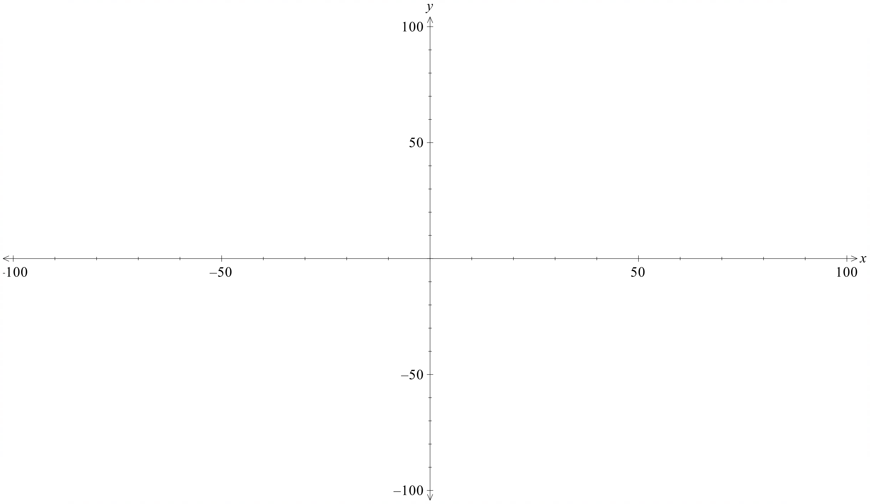

Appendix B

Inverse functions – quadratic
Record the input and output values for each machine in the tables below.
Machine 1
Input | Output 1 | Output 2
Machine 2
Input | Output 1 | Output 2

Appendix C

Worked example comparison
Find the inverse of $f\left(x\right)=x^{2}-4x-12$ for $x≥2$.
Method 1: Make $x$ the subject first.  Range of $f^{-1}\left(x\right):y≥2$  $$y=x^{2}-4x-12 \\ y=x^{2}-4x+4-16 \\ y={\left(x-2\right)}^{2}-16 \\ y+16={\left(x-2\right)}^{2} \\ ±\sqrt{y+16}=x-2 \\ x=2±\sqrt{y+16} \\ y=2±\sqrt{x+16}$$  $$y=2+\sqrt{x+16}, \text{since the range is} y≥2$$  $$∴f^{-1}\left(x\right)=2+\sqrt{x+16}$$ | Method 2: Swap $x$ and $y$ first.  Range of $f^{-1}\left(x\right):y≥2$  $$x=y^{2}-4y-12 \\ x=y^{2}-4y+4 -16 \\ x={\left(y-2\right)}^{2}-16 \\ x+16={\left(y-2\right)}^{2} \\ \sqrt{x+16}=y-2, \text{since the range is} y≥2 \\ y=2+\sqrt{x+16} \\ ∴f^{-1}\left(x\right)=2+\sqrt{x+16}$$

Appendix D

Verifying the inverse
Use the definition of an inverse function to determine if each person was correct.
Alan identified $f^{-1}\left(x\right)=-2+\sqrt{x+6}$ as the inverse function of $f(x)=x^{2}+4x-2$ when $x≥-2$. | Bella identified $f^{-1}\left(x\right)=\frac{x+1}{4}$ as the inverse function of $f(x)=4x-1$. | Jemma identified $f^{-1}\left(x\right)=-2x+6$ as the inverse function of $f\left(x\right)=3-\frac{1}{2}x$.
Check if $f\left(f^{-1}\left(x\right)\right)=x$  $$f\left(f^{-1}\left(x\right)\right)={\left(-2+\sqrt{x+6}\right)}^{2}+4\left(-2+\sqrt{x+6}\right)-2$$  $$f\left(f^{-1}\left(x\right)\right)=4-4\sqrt{x+6}+x+6-8+4\sqrt{x+6}-2$$  $$f\left(f^{-1}\left(x\right)\right)=x$$ | Check if $f\left(f^{-1}\left(x\right)\right)=x$  $$f\left(f^{-1}\left(x\right)\right)=4\left(\frac{x+1}{4}\right)-1$$  $$f\left(f^{-1}\left(x\right)\right)=x+1-1$$  $$f\left(f^{-1}\left(x\right)\right)=x$$ | Check if $f\left(f^{-1}\left(x\right)\right)=x$  $$f\left(f^{-1}\left(x\right)\right)=3-\frac{1}{2}\left(-2x+6\right)$$  $$f\left(f^{-1}\left(x\right)\right)=3+x-3$$  $$f\left(f^{-1}\left(x\right)\right)=x$$
Check if $f^{-1}\left(f\left(x\right)\right)=x$  $$f^{-1}\left(f\left(x\right)\right)=-2+\sqrt{\left(x^{2}+4x-2\right)+6}$$  $$f^{-1}\left(f\left(x\right)\right)=-2+\sqrt{x^{2}+4x+4} \\ f^{-1}\left(f\left(x\right)\right)=-2+\sqrt{{\left(x+2\right)}^{2}}$$  $$f^{-1}\left(f\left(x\right)\right)=-2+x+2$$  $$f^{-1}\left(f\left(x\right)\right)=x$$ | Check if $f^{-1}\left(f\left(x\right)\right)=x$  $$f^{-1}\left(f\left(x\right)\right)=\frac{\left(4x-1\right)+1}{4}$$ | Check if $f^{-1}\left(f\left(x\right)\right)=x$
Conclusion  $f^{-1}\left(x\right)=-2+\sqrt{x+6}$ is the inverse of $f(x)=x^{2}+4x-2$ when $x≥-2$. | Conclusion | Conclusion

Igor identified $f^{-1}\left(x\right)=\sqrt[3]{1-x}$ as the inverse function of $f(x)=1-x^{3}$. | Eva identified $f^{-1}\left(x\right)=3-\sqrt{x-5}$ as the inverse function of  $f(x)=x^{2}-6x+14$ when $x≤3$.
Check if $f\left(f^{-1}\left(x\right)\right)=x$
$$f\left(f^{-1}\left(x\right)\right)=1-{\left(\sqrt[3]{1-x}\right)}^{3}$$
Check if $f^{-1}\left(f\left(x\right)\right)=x$

Conclusion

Appendix E

Frayer diagram
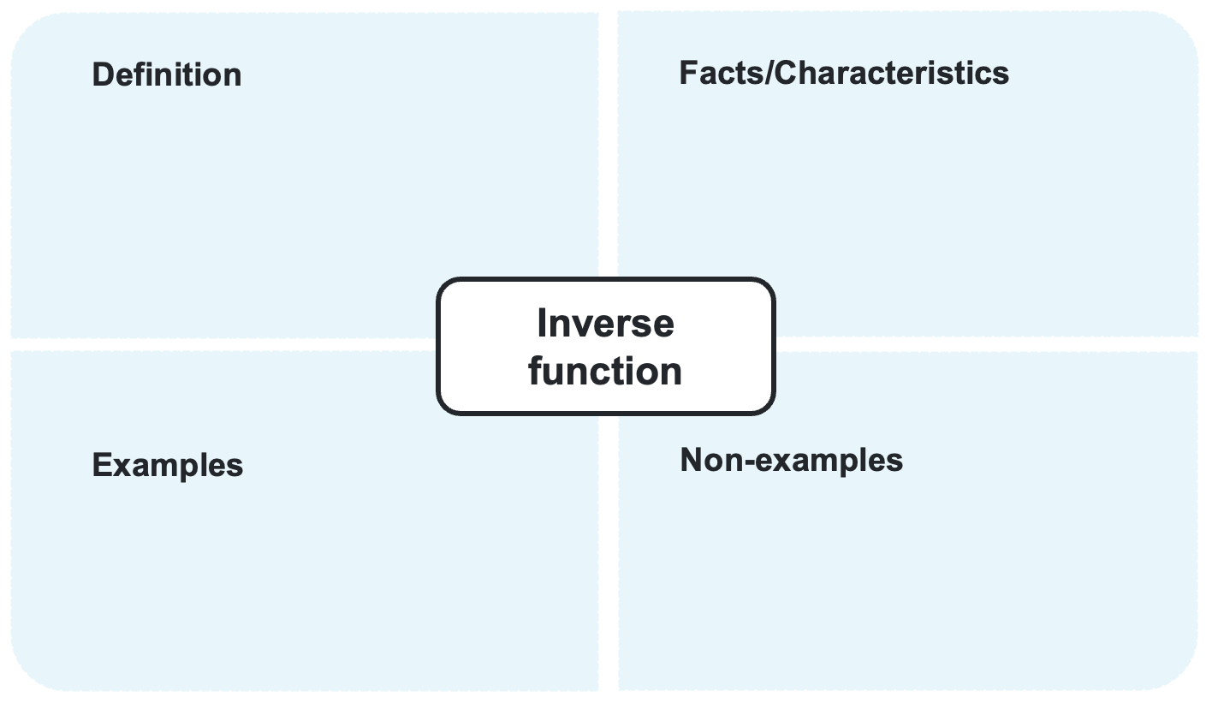

Appendix F

Exit ticket
A function is defined by $f\left(x\right)=1+{\left(4-\frac{x}{2}\right)}^{2}$ for $x$ in the domain $(-∞,8]$.
- Sketch the graph of $y=f(x)$ showing all intercepts.
- Find the equation of the inverse function, $f^{-1}(x)$, and state its domain.
- Sketch the graph of $y=f^{-1}(x)$.
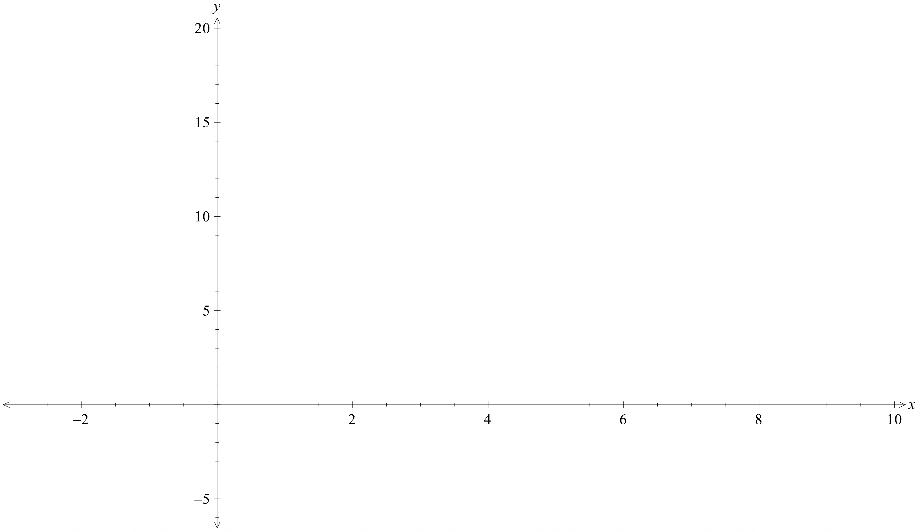

Sample solutions

Appendix D – verifying the inverse
Alan identified $f^{-1}\left(x\right)=-2+\sqrt{x+6}$ as the inverse function of $f(x)=x^{2}+4x-2$ when $x≥-2$. | Bella identified $f^{-1}\left(x\right)=\frac{x+1}{4}$ as the inverse function of $f(x)=4x-1$. | Jemma identified $f^{-1}\left(x\right)=-2x+6$ as the inverse function of $f\left(x\right)=3-\frac{1}{2}x$.
Check if $f\left(f^{-1}\left(x\right)\right)=x$  $$f\left(f^{-1}\left(x\right)\right)={\left(-2+\sqrt{x+6}\right)}^{2}+4\left(-2+\sqrt{x+6}\right)-2$$  $$f\left(f^{-1}\left(x\right)\right)=4-4\sqrt{x+6}+x+6-8+4\sqrt{x+6}-2$$  $$f\left(f^{-1}\left(x\right)\right)=x$$ | Check if $f\left(f^{-1}\left(x\right)\right)=x$  $$f\left(f^{-1}\left(x\right)\right)=4\left(\frac{x+1}{4}\right)-1$$  $$f\left(f^{-1}\left(x\right)\right)=x+1-1$$  $$f\left(f^{-1}\left(x\right)\right)=x$$ | Check if $f\left(f^{-1}\left(x\right)\right)=x$  $$f\left(f^{-1}\left(x\right)\right)=3-\frac{1}{2}\left(-2x+6\right)$$  $$f\left(f^{-1}\left(x\right)\right)=3+x-3$$  $$f\left(f^{-1}\left(x\right)\right)=x$$
Check if $f^{-1}\left(f\left(x\right)\right)=x$  $$f^{-1}\left(f\left(x\right)\right)=-2+\sqrt{\left(x^{2}+4x-2\right)+6}$$  $$f^{-1}\left(f\left(x\right)\right)=-2+\sqrt{x^{2}+4x+4} \\ f^{-1}\left(f\left(x\right)\right)=-2+\sqrt{{\left(x+2\right)}^{2}}$$  $$f^{-1}\left(f\left(x\right)\right)=-2+x+2$$  $$f^{-1}\left(f\left(x\right)\right)=x$$ | Check if $f^{-1}\left(f\left(x\right)\right)=x$  $$f^{-1}\left(f\left(x\right)\right)=\frac{\left(4x-1\right)+1}{4}$$  $$f^{-1}\left(f\left(x\right)\right)=\frac{4x}{4} \\ f^{-1}\left(f\left(x\right)\right)=x$$ | Check if $f^{-1}\left(f\left(x\right)\right)=x$  $$f^{-1}\left(f\left(x\right)\right)=-2\left(3-\frac{1}{2}x\right)+6$$  $$f^{-1}\left(f\left(x\right)\right)=-6+x+6 \\ f^{-1}\left(f\left(x\right)\right)=x$$
Conclusion  $f^{-1}\left(x\right)=-2+\sqrt{x+6}$ is the inverse of $f(x)=x^{2}+4x-2$ when $x≥-2$. | Conclusion  $f^{-1}\left(x\right)=\frac{x+1}{4}$ is the inverse of  $f\left(x\right)=4x-1$. | Conclusion  $f^{-1}\left(x\right)=-2x+6$ is the inverse of  $f\left(x\right)=3-\frac{1}{2}x$.

Igor identified $f^{-1}\left(x\right)=\sqrt[3]{1-x}$ as the inverse function of $f(x)=1-x^{3}$. | Eva identified $f^{-1}\left(x\right)=3-\sqrt{x-5}$ as the inverse function of  $f(x)=x^{2}-6x+14$ when $x≤3$.
Check if $f\left(f^{-1}\left(x\right)\right)=x$  $$f\left(f^{-1}\left(x\right)\right)=1-{\left(\sqrt[3]{1-x}\right)}^{3}$$  $$f\left(f^{-1}\left(x\right)\right)=1-\left(1-x\right)$$  $$f\left(f^{-1}\left(x\right)\right)=1-1+x$$  $$f\left(f^{-1}\left(x\right)\right)=x$$ | Check if $f\left(f^{-1}\left(x\right)\right)=x$  $$f\left(f^{-1}\left(x\right)\right)={\left(3-\sqrt{x-5}\right)}^{2}-6\left(3-\sqrt{x-5}\right)+14$$  $$f\left(f^{-1}\left(x\right)\right)=9-6\sqrt{x-5}+x-5-18+6\sqrt{x-5}+14$$  $$f\left(f^{-1}\left(x\right)\right)=x$$
Check if $f^{-1}\left(f\left(x\right)\right)=x$  $$f^{-1}\left(f\left(x\right)\right)=\sqrt[3]{1-\left(1-x^{3}\right)}$$  $$f^{-1}\left(f\left(x\right)\right)=\sqrt[3]{1-1+x^{3}} \\ f^{-1}\left(f\left(x\right)\right)=\sqrt[3]{x^{3}}$$  $$f^{-1}\left(f\left(x\right)\right)=x$$ | Check if $f^{-1}\left(f\left(x\right)\right)=x$  $$f^{-1}\left(f\left(x\right)\right)=3+\sqrt{\left(x^{2}-6x+14\right)-5}$$  $$f^{-1}\left(f\left(x\right)\right)=3+\sqrt{x^{2}-6x+9} \\ f^{-1}\left(f\left(x\right)\right)=3+\sqrt{{\left(x-3\right)}^{2}}$$  $$f^{-1}\left(f\left(x\right)\right)=3+x-3$$  $$f^{-1}\left(f\left(x\right)\right)=x$$
Conclusion  $f^{-1}\left(x\right)=\sqrt[3]{1-x}$ is the inverse of $f(x)=1-x^{3}$. | Conclusion  $f^{-1}\left(x\right)=3-\sqrt{x-5}$ is the inverse of $f(x)=x^{2}-6x+14$ when $x≤3$.

Appendix E – Frayer diagram
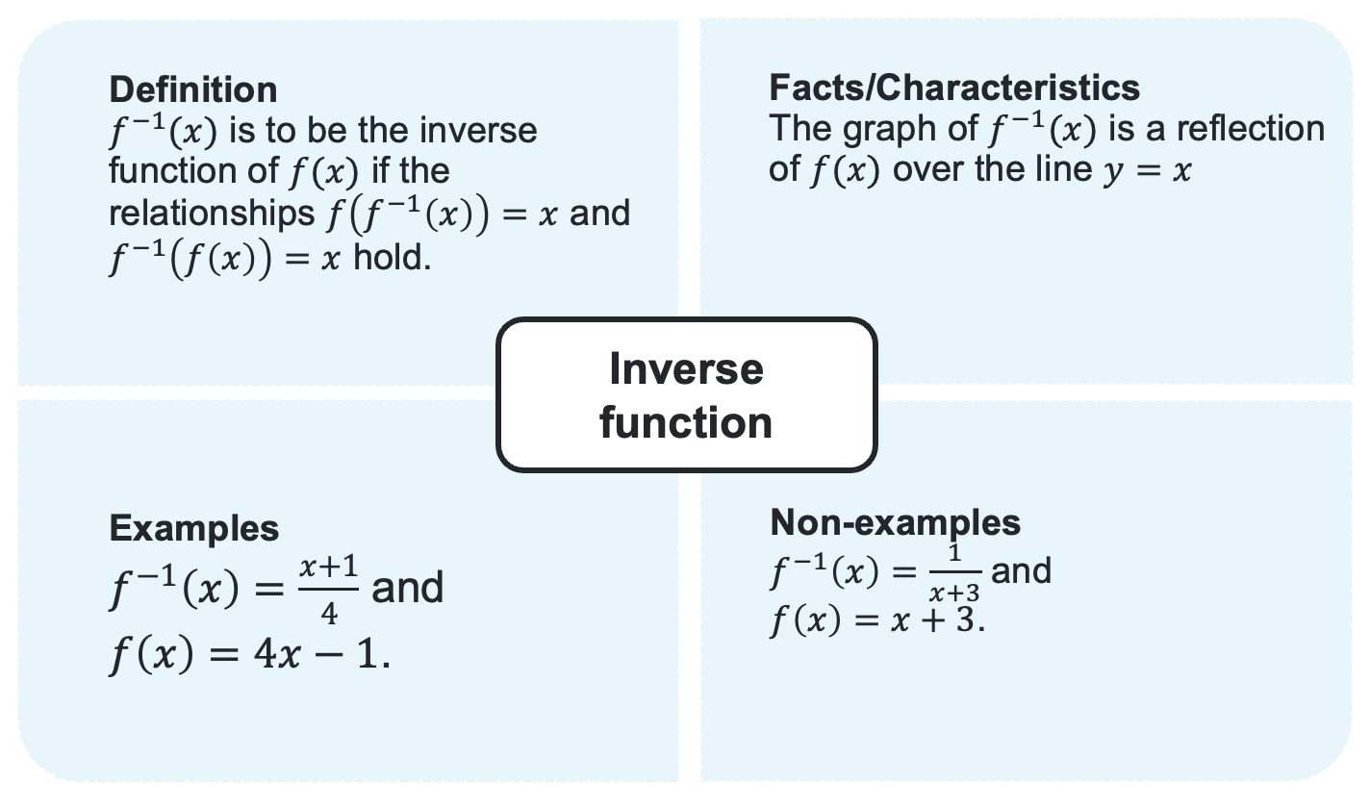

Appendix F – exit ticket
- 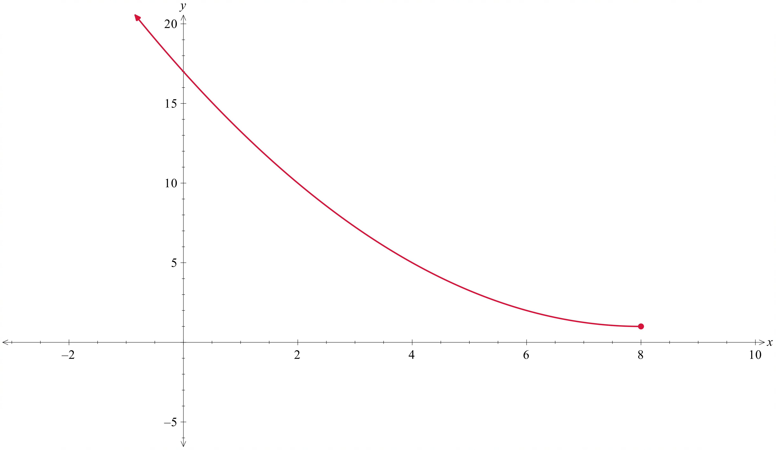
- Domain of $f(x)$: $x≤8$, Range of $f(x)$: $y≥1$
Domain of $f^{-1}(x)$: $x≥1$, a range of $f^{-1}(x)$:$y≤8$
$x=1+{\left(4-\frac{y}{2}\right)}^{2}$$$x-1={\left(4-\frac{y}{2}\right)}^{2}$$$\sqrt{x-1}=4-\frac{y}{2}$since range $y=8$, $\sqrt{x-1}$ is positive
$$-4+\sqrt{x-1}=-\frac{y}{2}$$$y=8-2\sqrt{x-1}$.
- 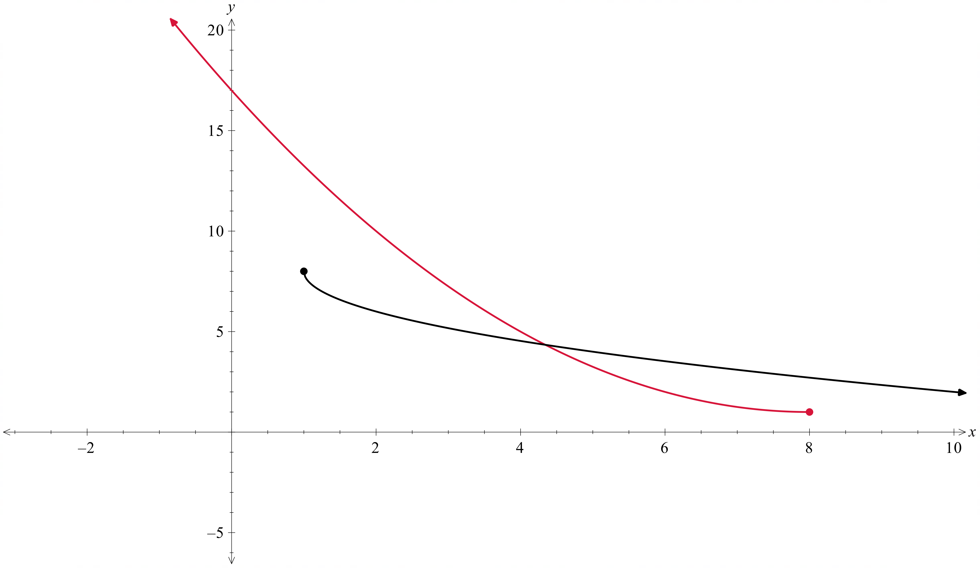

References
This resource contains NSW Curriculum and syllabus content. The NSW Curriculum is developed by the NSW Education Standards Authority (NESA). This content is prepared by NESA for and on behalf of the Crown in right of the State of New South Wales. The material is protected by Crown copyright.
Please refer to the NESA Copyright Disclaimer for more information https://www.nsw.gov.au/education-and-training/nesa/copyright.
NESA holds the only official and up-to-date versions of the NSW Curriculum and syllabus documents. Please visit NESA https://www.nsw.gov.au/education-and-training/nesa and NSW Curriculum https://curriculum.nsw.edu.au.
Mathematics Extension 1 11–12 Syllabus © NSW Education Standards Authority (NESA) for and on behalf of the Crown in right of the State of New South Wales, 2024.

© State of New South Wales (Department of Education), 2026
The copyright material published in this resource is subject to the Copyright Act 1968 (Cth) and is owned by the NSW Department of Education or, where indicated, by a party other than the NSW Department of Education (third-party material).
Copyright material available in this resource and owned by the NSW Department of Education is licensed under a Creative Commons Attribution 4.0 International (CC BY 4.0) license.

This license allows you to share and adapt the material for any purpose, even commercially.
Attribution should be given to © State of New South Wales (Department of Education), 2026.
Material in this resource not available under a Creative Commons license:
- the NSW Department of Education logo, other logos and trademark-protected material
- material owned by a third party that has been reproduced with permission. You will need to obtain permission from the third party to reuse its material.
Links to third-party material and websites
Please note that the provided (reading/viewing material/list/links/texts) are a suggestion only and implies no endorsement, by the New South Wales Department of Education, of any author, publisher, or book title. School principals and teachers are best placed to assess the suitability of resources that would complement the curriculum and reflect the needs and interests of their students.
If you use the links provided in this document to access a third-party's website, you acknowledge that the terms of use, including licence terms set out on the third-party's website apply to the use which may be made of the materials on that third-party website or where permitted by the Copyright Act 1968 (Cth). The department accepts no responsibility for content on third-party websites.

