One-to-one functions and sketching the inverse
Students will learn how to describe a function as one-to-one and use this fact to recognise and sketch its inverse.
Students will need at least one digital device per pair to interact with Amplify Classroom during this lesson.

Learning intentions
- To understand why an inverse function must be a one-to-one function.
- To be able to sketch an inverse function.

Success criteria
- I can recognise when a graph is a one-to-one function.
- I can sketch an inverse function.
- I can apply a domain restriction to sketch an inverse function.

Outcomes
A student:
- develops understanding and fluency in mathematics through exploring and connecting mathematical concepts, choosing and applying mathematical techniques to solve problems, and communicating their thinking and reasoning coherently and clearly MAO-WM-01
- solves problems involving inequalities, functions and their inverses, graphical relationships between functions, and parametric equations ME1-11-01

Content

Inverse functions
- Describe a function as one-to-one if every element in the range of the function corresponds to exactly one element of the domain
- Recognise that inverse functions exist for one-to-one functions
- Graph the inverse function of a given one-to-one function
- Explain that the reflection in the line $y=x$ exchanges horizontal and vertical lines and recognise that the horizontal line test can therefore be applied to the graph of $y=f(x)$ to determine whether its reflection in the line $y=x$ is a function
- Apply restrictions to the domain of a function, if it is not one-to-one, to obtain an inverse function
- Solve problems based on the relationship between a function and its inverse function using algebraic and graphical techniques, including determining the points of intersection of a function and its inverse, where they exist
Mathematics Extension 1 11–12 Syllabus © NSW Education Standards Authority (NESA) for and on behalf of the Crown in right of the State of New South Wales, 2024

Table 1: lesson summary
Section | Summary of activity | Teaching strategies | Teaching points
Retrieval practice | Students apply the vertical line test to the relations in Appendix A to determine whether each one is a function. | Variation Theory  Turn and talk | Students recall the vertical line test as a method for determining whether a relation is a function.
Activating prior knowledge | Students discuss functions through the analogy of vending machines. | Think-Pair-Share  Pose-Pause-Pounce-Bounce | Students consolidate understanding of domain, range and the requirements of a function.
Connecting learning | Amplify Classroom (bit.ly/1to1Functions) is used to examine the vertical line test when applied to relations and their inverses. The definition of a one-to-one function is explored and applied to a range of functions before the need for restrictions is established. The analogy is revisited throughout this process. | Think-Pair-Share | Students explore the definition of a one-to-one function and apply restrictions to ensure that the inverse of a function is a function.
Releasing responsibility | Students complete the Frayer diagram in Appendix B, before sorting the cards in Appendix C into 3 piles; one-to-one functions, not one-to-one functions and not functions, and then sketch the inverses of the equations on the cards. | Frayer diagram  Mini whiteboards | Students consolidate their understanding of one-to-one functions by defining them, identifying examples and non-examples and sketching some inverses.
Independent practice | Students sketch inverse functions by hand using an existing resource before completing the exit ticket in Appendix D. | Exit ticket | Students build fluency in using the existing coordinates of the original function to sketch the inverse.

Activity structure

Retrieval practice
- Distribute Appendix A ‘Vertical line test’, which uses Variation Theory (variationtheory.com/introduction/) to retrieve prior knowledge about using the vertical line test to determine which relations are functions.
Students learnt about the vertical line test in Lesson 1 – functions of Mathematics Advanced Unit 2 – introduction to functions.
- Ask students to verify and share their solutions through a turn and talk (bit.ly/classroomtalkmoves).

Activating prior knowledge
This section refers to the Amplify Classroom activity ‘Vending machines and other functions’ (bit.ly/FunctionsVendingMachine) which students used in Lesson 1 – functions of Mathematics Advanced Unit 2 – introduction to functions.
- Tell students that we are going to use a vending machine as an analogy for a function.
- In a Think-Pair-Share (bit.ly/thinkpairsharestrategy), ask students to consider why we would use a vending machine as a function analogy?
The teacher may wish to display the Amplify Classroom activity to support the analogy, specifically with reference to the following screens:
- Screen 2: shows a blue vending machine that follows the function definition.
- Screen 6: shows the input and output mapping of the blue vending machine.
- Use the Pose-Pause-Pounce-Bounce questioning strategy (PDF 557 KB) (bit.ly/posepausepouncebounce) to activate prior knowledge of the function definition and connect it to the email analogy. Possible question prompts include:
- How is the way a vending machine uses your input, similar to what a function does?
- How does the vertical line test apply to this analogy?
- If you selected a bottle of apple juice but instead got a bottle of water, does that violate the function definition? Why or why not?
- How do the concepts of domain and range connect to the analogy?
The vending machine analogy frames a function as a rule-bound system. This allows the vertical line test to appear naturally: as we scan through the inputs and outputs, if any input corresponds to more than one output, the relation is not a function. The analogy helps students to ground ideas of domain, range, mapping and the one-output rule in a familiar context before translating the reasoning back into mathematical form.

Connecting learning
- With at least one device per pair of students, assign the Amplify Classroom activity ‘One-to-one functions’ (bit.ly/1to1Functions) for students to complete screens 1–5.
Before completing this activity, you will need to set up an Amplify Classroom (bit.ly/createamplifyclassroom) and use the pacing feature to restrict the students to screens 1–5.
- Pause the activity to discuss student responses to screens 2–5 and summarise what a one-to-one function is and is not.
The description of a one-to-one function from the syllabus dot point is provided on screen 4 of the activity.
- While the activity is paused, ask students to reflect on what one-to-one would mean in the vending machine analogy.
In the analogy, one-to-one would mean that each input directly relates to the output in that option. For example, if a student selected input 10, then they would get a drink from only slot 10 of the vending machine.
- Explain that there is a more efficient way, than finding the inverse first and then applying the vertical line test, to check whether the inverse of a function will also be a function. This idea will be explored in the next section of the Amplify Classroom activity. Extend the pacing to include screen 6 for students to complete.
- In a Think-Pair-Share, have students discuss how they think the horizontal line test can be applied to check whether the inverse of a function will also be a function.
Students may mention that if a function passes the horizontal line test, then when reflected in the line $y=x$, the horizontal line will be come a vertical line and the inverse function will pass the vertical line test.
- Extend the pacing to include screen 7 where students can apply the horizontal line test to a variety of functions.
- Use the ‘Sync to Me’ feature on the teacher dashboard to move all students to screen 8 to complete.
- Display screen 8 of the Amplify Classroom activity and conduct a class discussion on what students notice is similar and different between the 2 functions shown.
Students should identify that the graphs are the same, but one includes a domain restriction which enables it to pass both the vertical and horizontal line tests. This language will be introduced in the following screens.
- Extend the pacing to screens 9–11 to introduce the concept of domain restrictions to create an inverse function and discuss student responses.

Releasing responsibility
- To build vocabulary, have students complete the graphic organiser in Appendix B ‘Frayer diagram’ (bit.ly/frayerdiagram).
- Distribute Appendix C ‘Card sort’ to pairs of students. Ask students to perform the horizontal line test on each relation and sort the functions into 3 piles:
- Functions that are one-to-one
- Functions that are not one-to-one
- Relations that are not functions.
Cards are not in order, so students can be provided with the appendix and be required to cut the out the cards themselves. Appendix C includes 18 cards for consideration. If time management of this activity is a concern, the removal of cards is encouraged, based on complexity, to ensure students engage meaningfully with each example rather than rush through the set to complete the task. The restricted domain section of the appendix will be used after the card sort.
- Ask students to use mini whiteboards (bit.ly/miniwhiteboards) to sketch the inverse of the functions from the one-to-one pile and verify their solutions through a turn and talk.
- Draw students’ attention to the coloured domain restriction cards from the bottom of Appendix C.
- Ask students to match these with the remaining cards in the functions that are not one-to-one pile, so that they will all be one-to-one functions, and then repeat the previous step with these functions.

Independent practice
- Use an existing resource to develop fluency in graphing inverse functions by hand, including opportunities to apply domain restrictions.
- Check for understanding by using Appendix D ‘Exit ticket’ (bit.ly/exitticketstrategy).

Assessment and differentiation

Suggested opportunities for differentiation
Retrieval practice
- Appendix A should be modified to meet the needs of students, to either include a greater range of functions or more linear functions.
Connecting learning
- The pacing of the Amplify Classroom activity could be adjusted to meet the needs of students.
- The Amplify Classroom activity could be edited to include different functions.
- An existing resource could be delivered at the point of need to develop student fluency of finding the inverse of given one-to-one functions before exploring the application of domain restrictions.
Releasing responsibility
- Sentence starters could be provided to support the completion of the Frayer diagram.
- Example functions could be provided for the Frayer diagram.
- The examples and non-examples section of the Frayer diagram could be completed after the card sort activity.
- Students could compare solutions with a graphics application such as Desmos graphing calculator or GeoGebra.
- Appendix C could be reduced to several cards appropriate for the needs of students.
- Support students completing Appendix C by helping them plan how they would use the vertical line test after using the horizontal line test to sort the cards in the appropriate categories.
- Extend students by asking them to consider if a function passes the horizontal line test, if it then needs to pass the vertical line test as well.
Independent practice
- The existing resource should be appropriate for the capabilities of students in the class.
- The exit ticket could be modified to explore a different function.

Suggested opportunities for assessment
Retrieval practice
- Students receive feedback as part of a turn and talk.
- Appendix A can be collected as a check for understanding of the vertical line test.
Activating prior knowledge
- Monitor responses in class discussions to check for student understanding of functions through the analogy of vending machines.
Connecting learning
- Student responses are saved in Amplify Classroom for later review.
Releasing responsibility
- The Frayer diagram could be collected as evidence of student understanding of one-to-one functions.
- Students provide feedback to each other through a turn and talk.
- Monitor discussions during the card sort activity and the drawing of inverse functions to check student understanding of one-to-one functions
Independent practice
- The existing resource and exit ticket can be collected as evidence of student learning.

Appendix A

Vertical line test
Perform the vertical line test on the relations below to identify which relations are functions.
$$y=9-2x$$  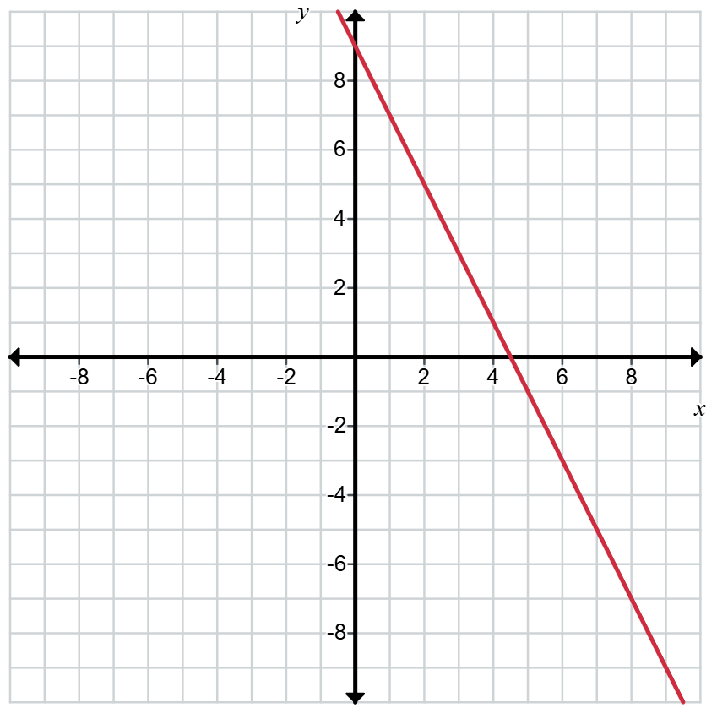 | $$y=\sqrt{9-x^{2}}$$  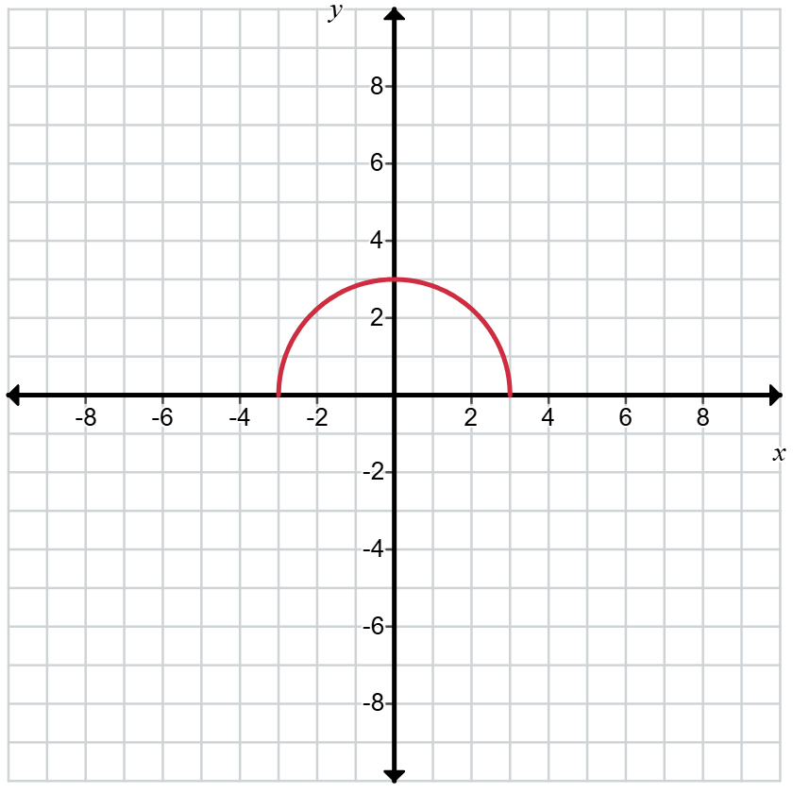
$$y=9-x^{2}$$  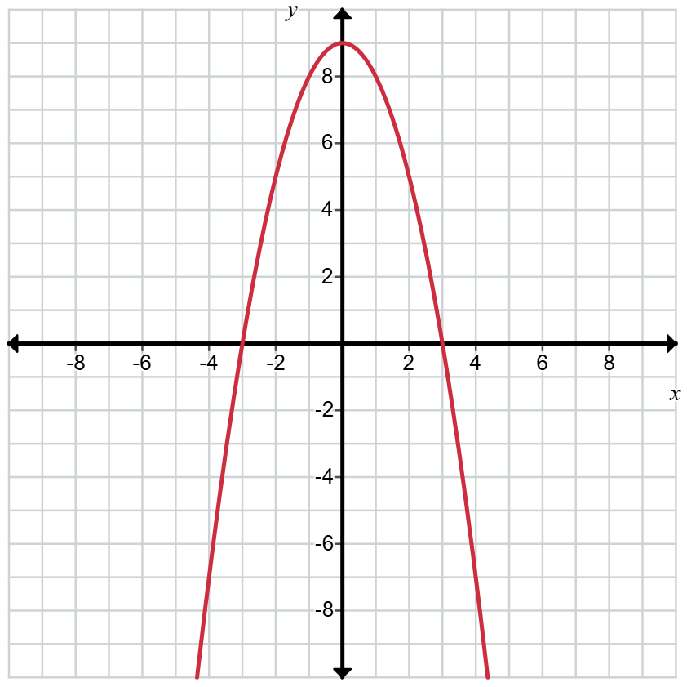 | $$y=\sqrt{9-x}$$  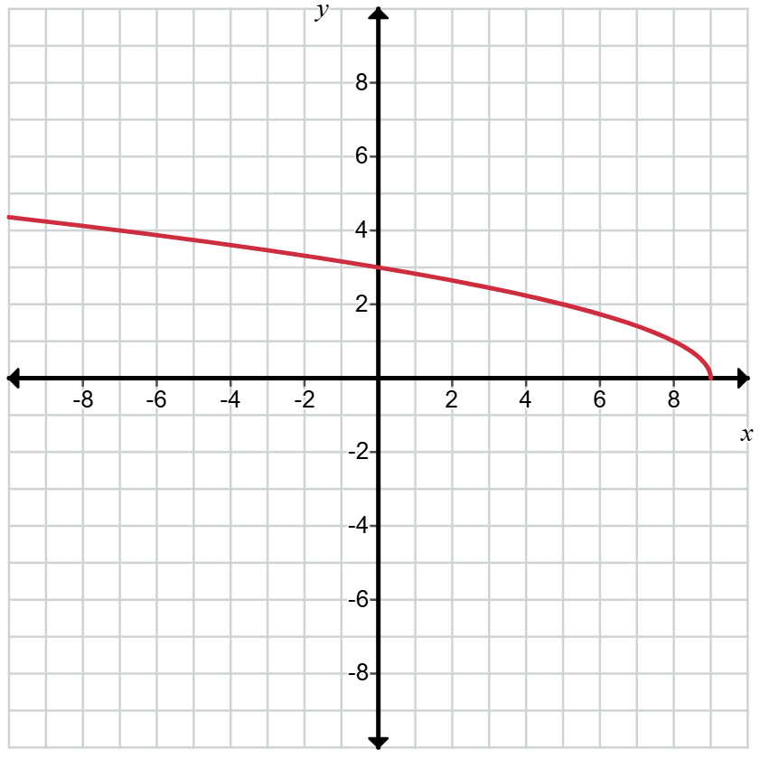
$$x^{2}=9$$  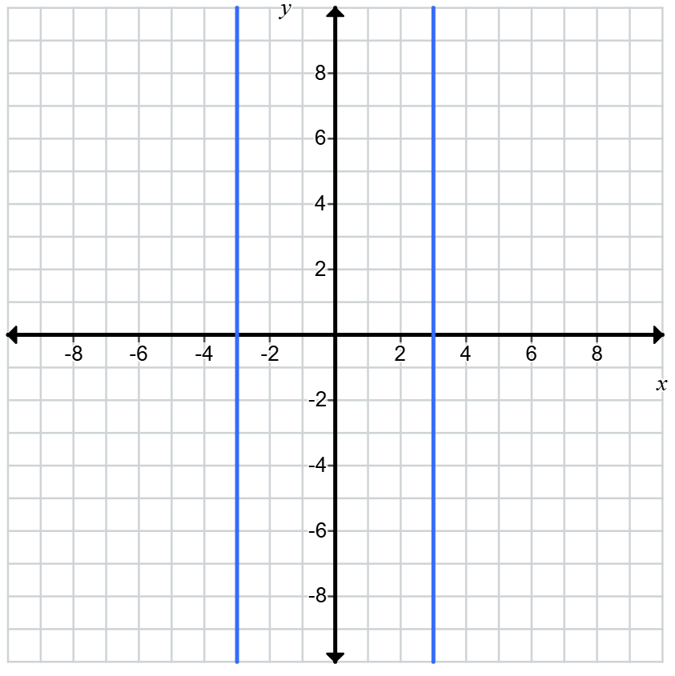 | $$x^{2}+y^{2}=9$$  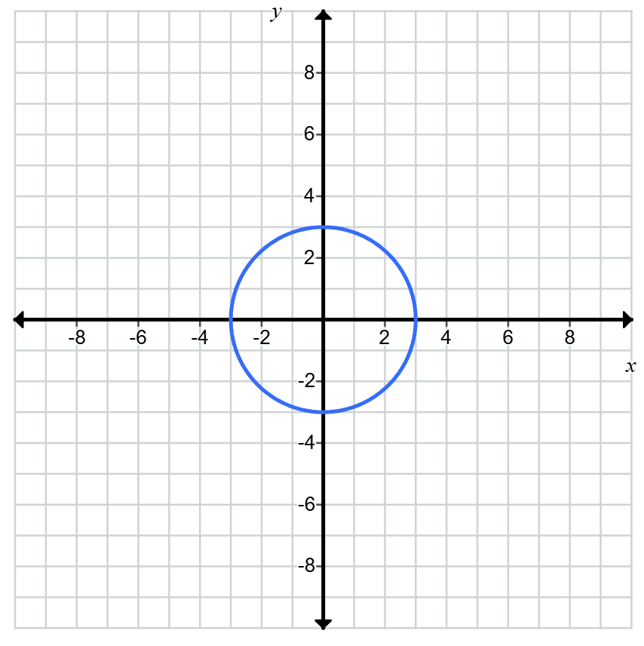
$$x^{2}+y=9$$  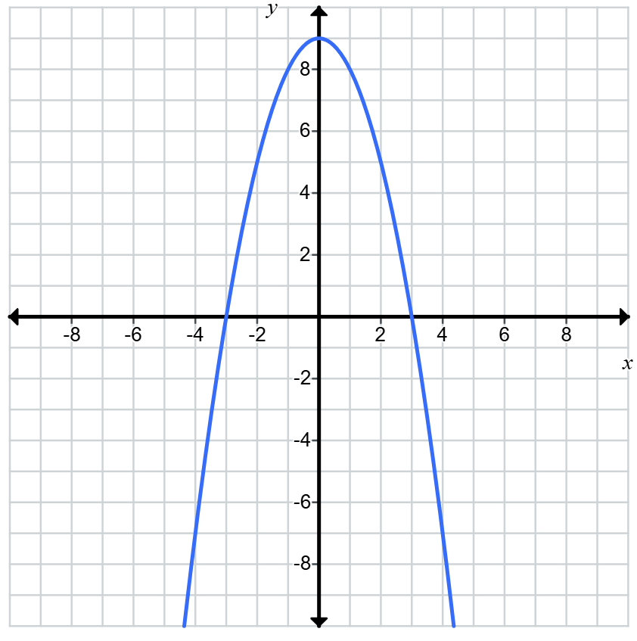 | $$x^{3}+y=9$$  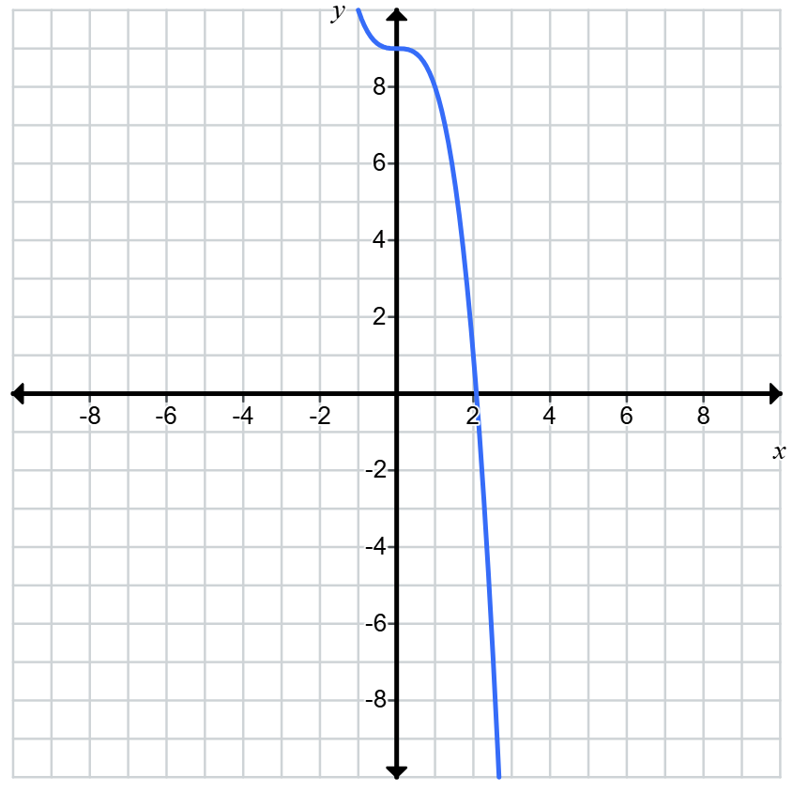

Appendix B

Frayer diagram
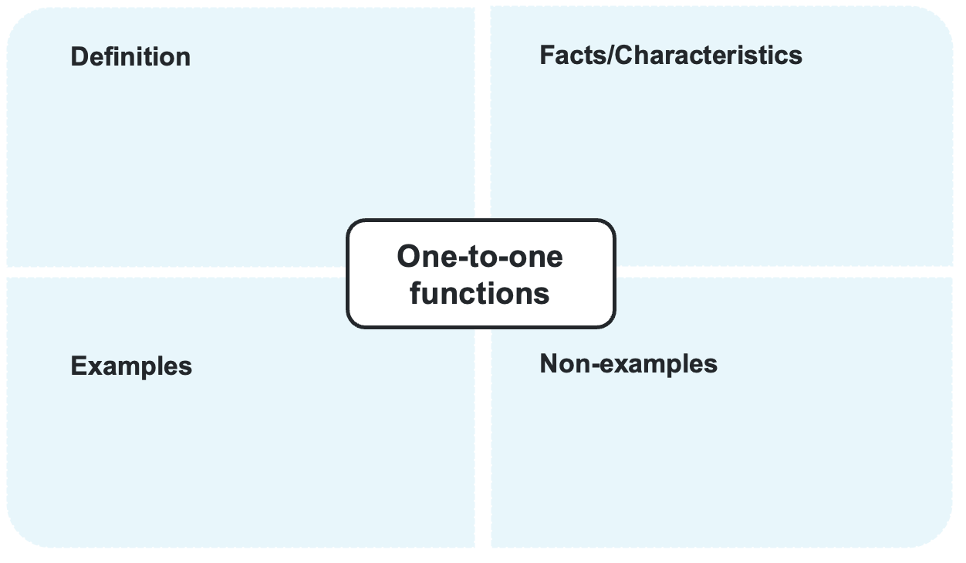

Appendix C

Card sort
$$f(x)=-2$$  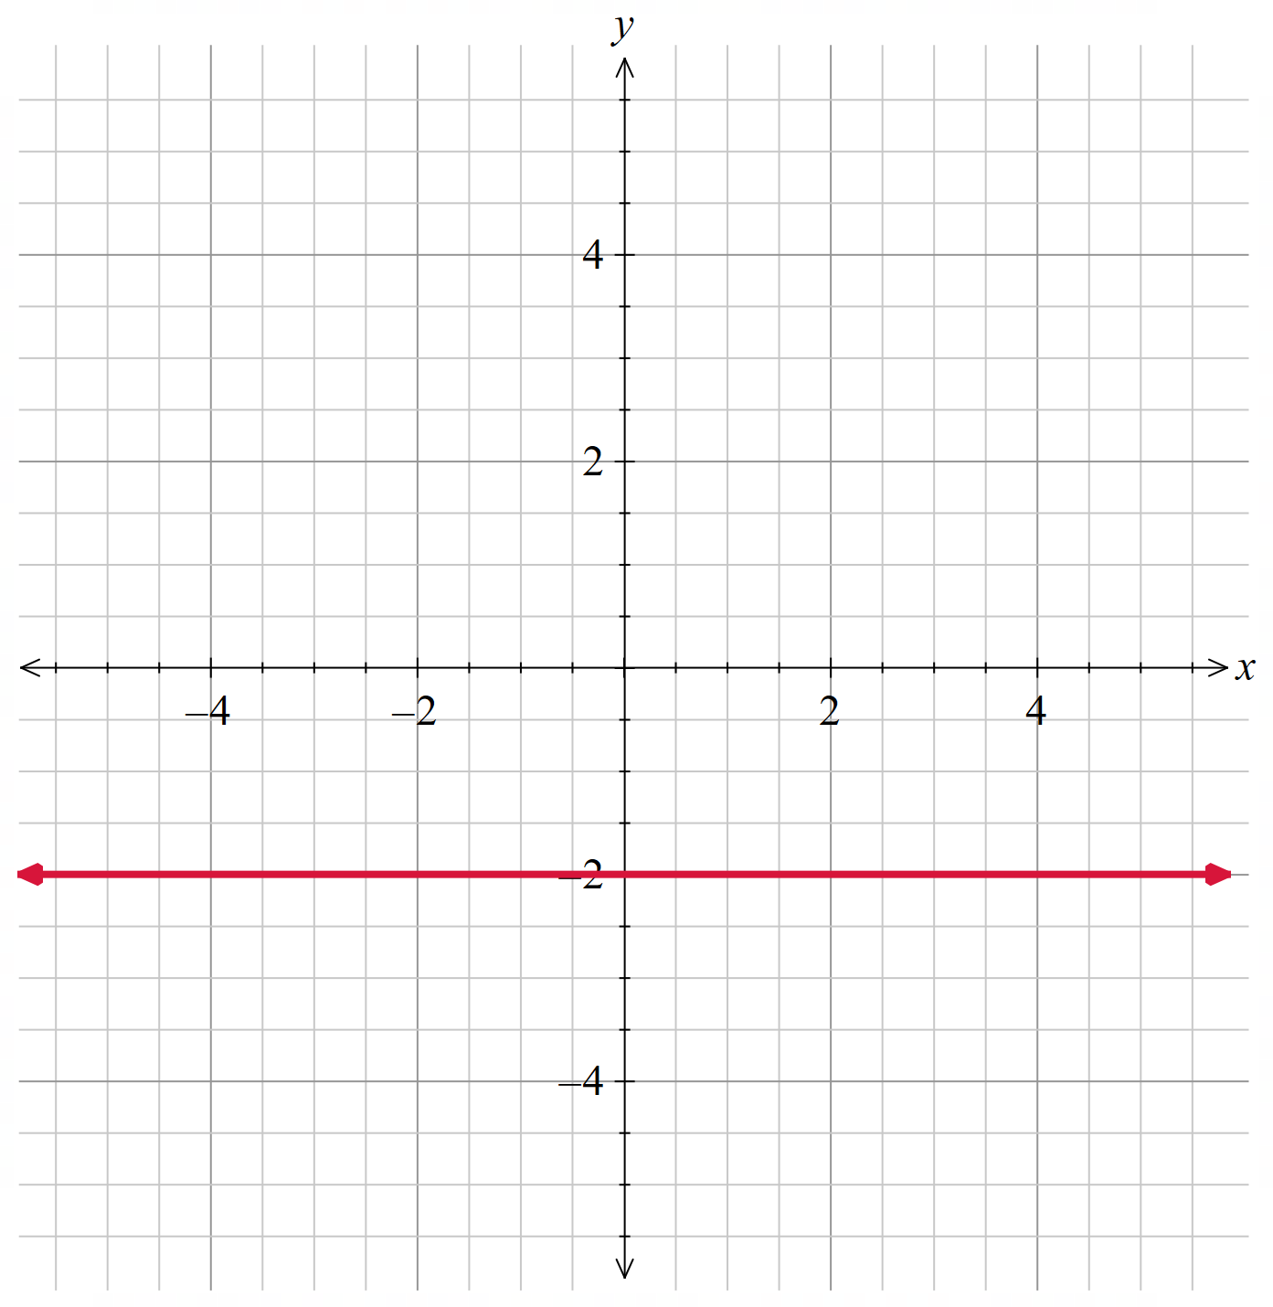 | $$x=4$$  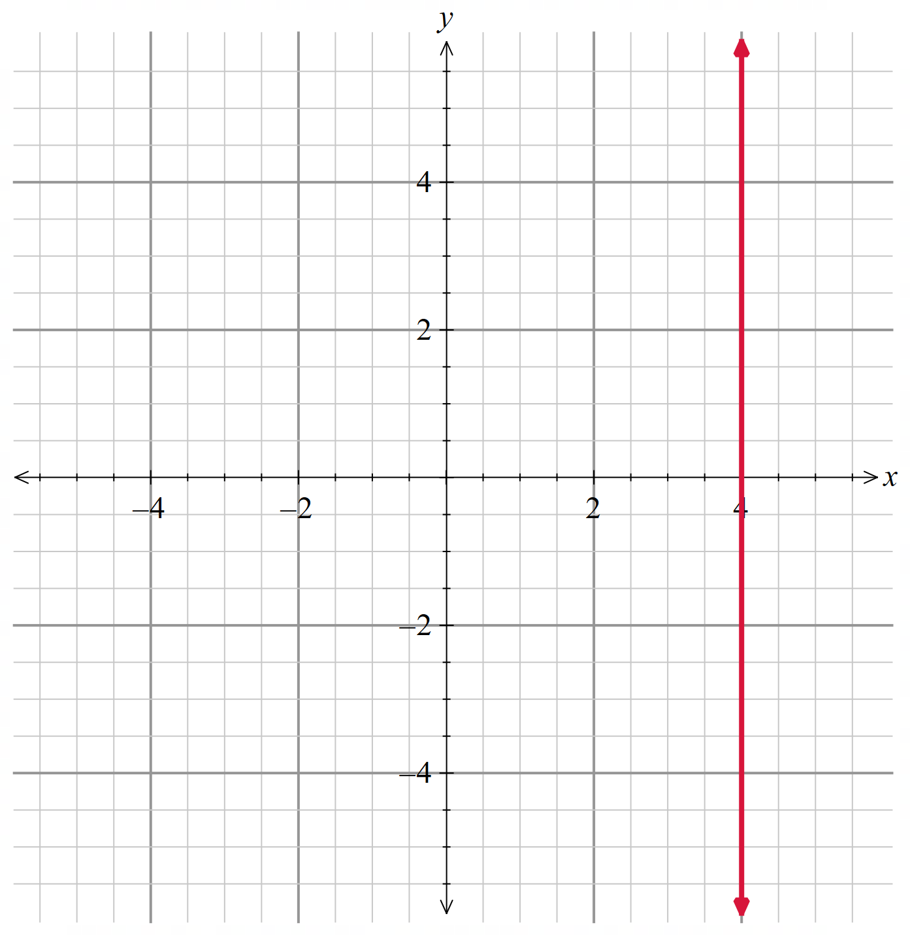 | $$f(x)=3-x^{2}$$  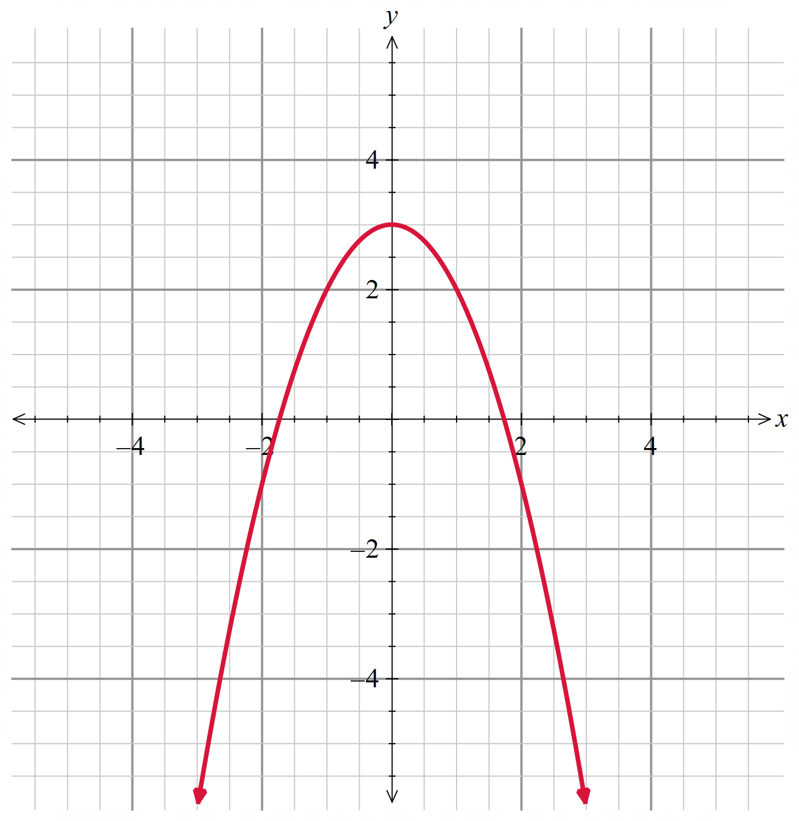
$$f\left(x\right)=-x$$  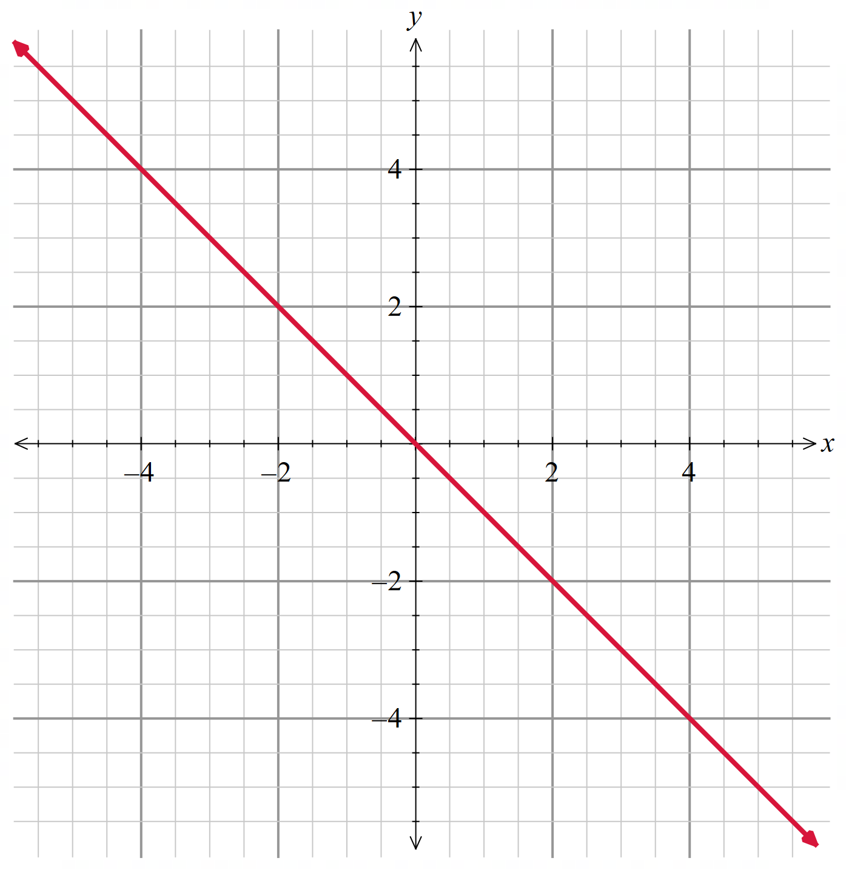 | $$f(x)=2^{x-1}$$  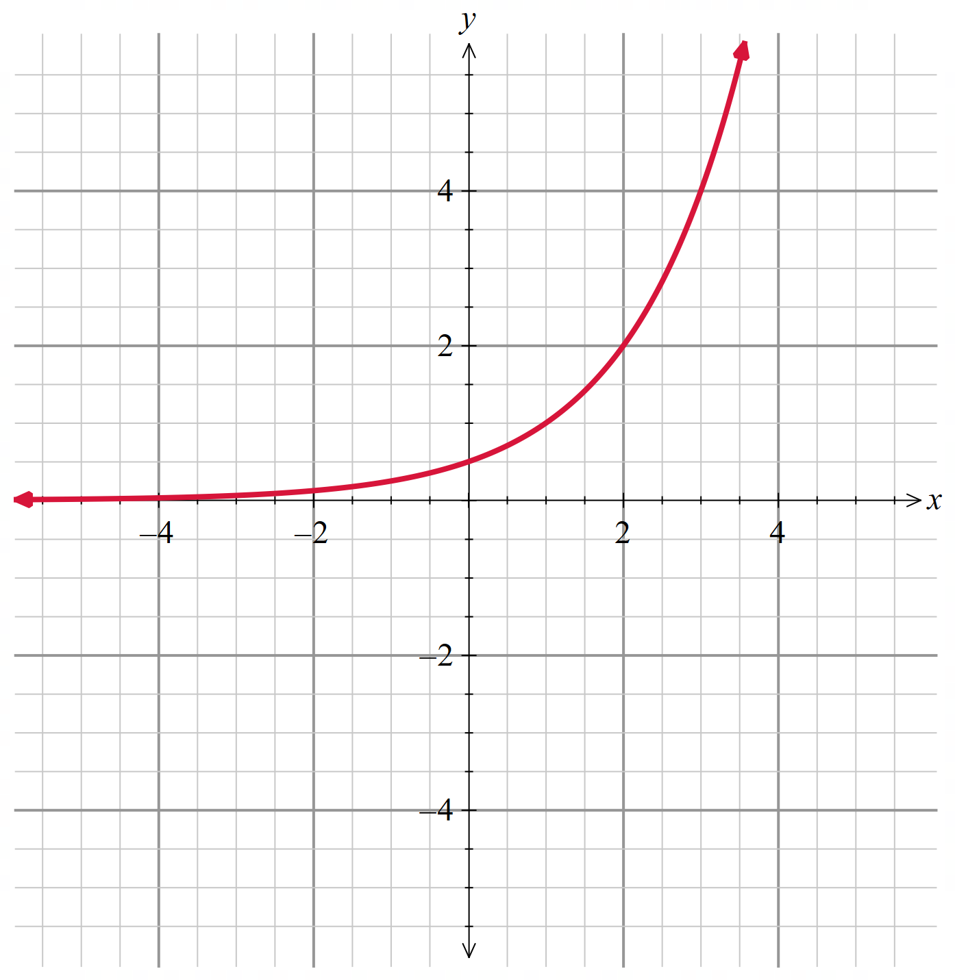 | $$f(x)=|2x+1|$$  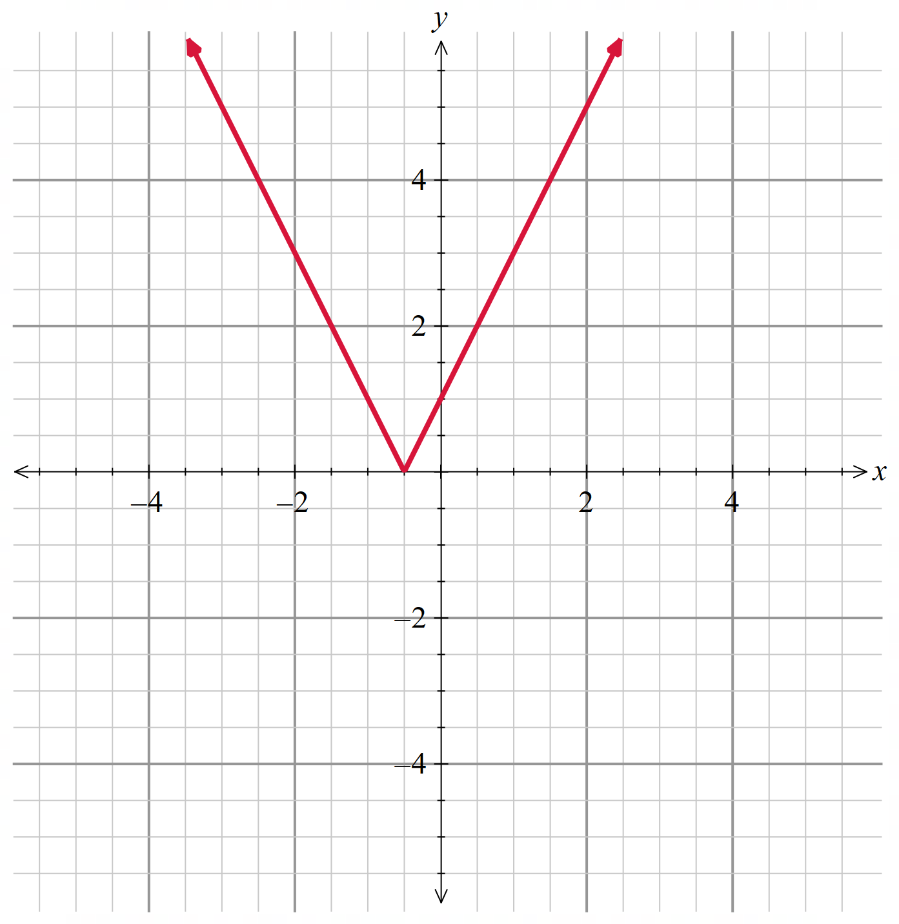
$$x^{2}+y^{2}=16$$  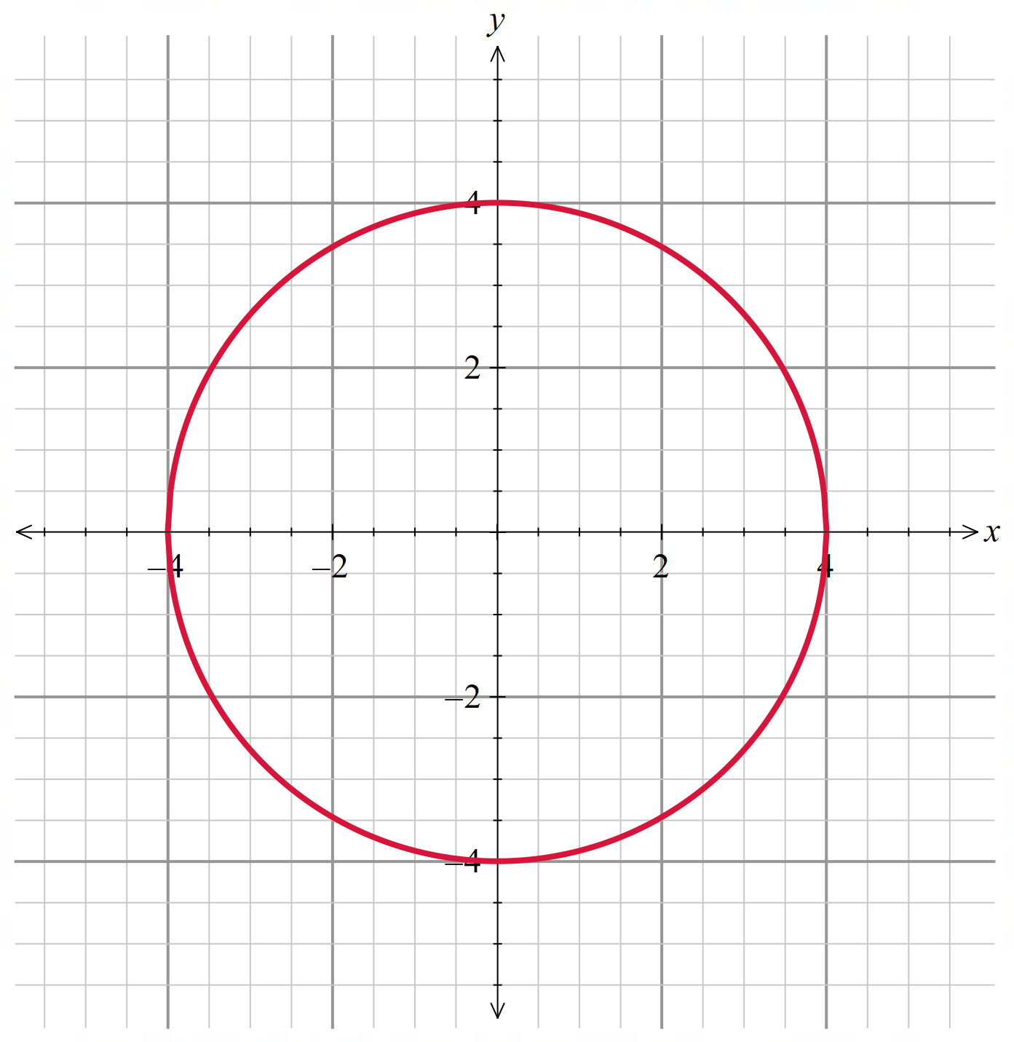 | $$f(x)={2x}^{3}$$  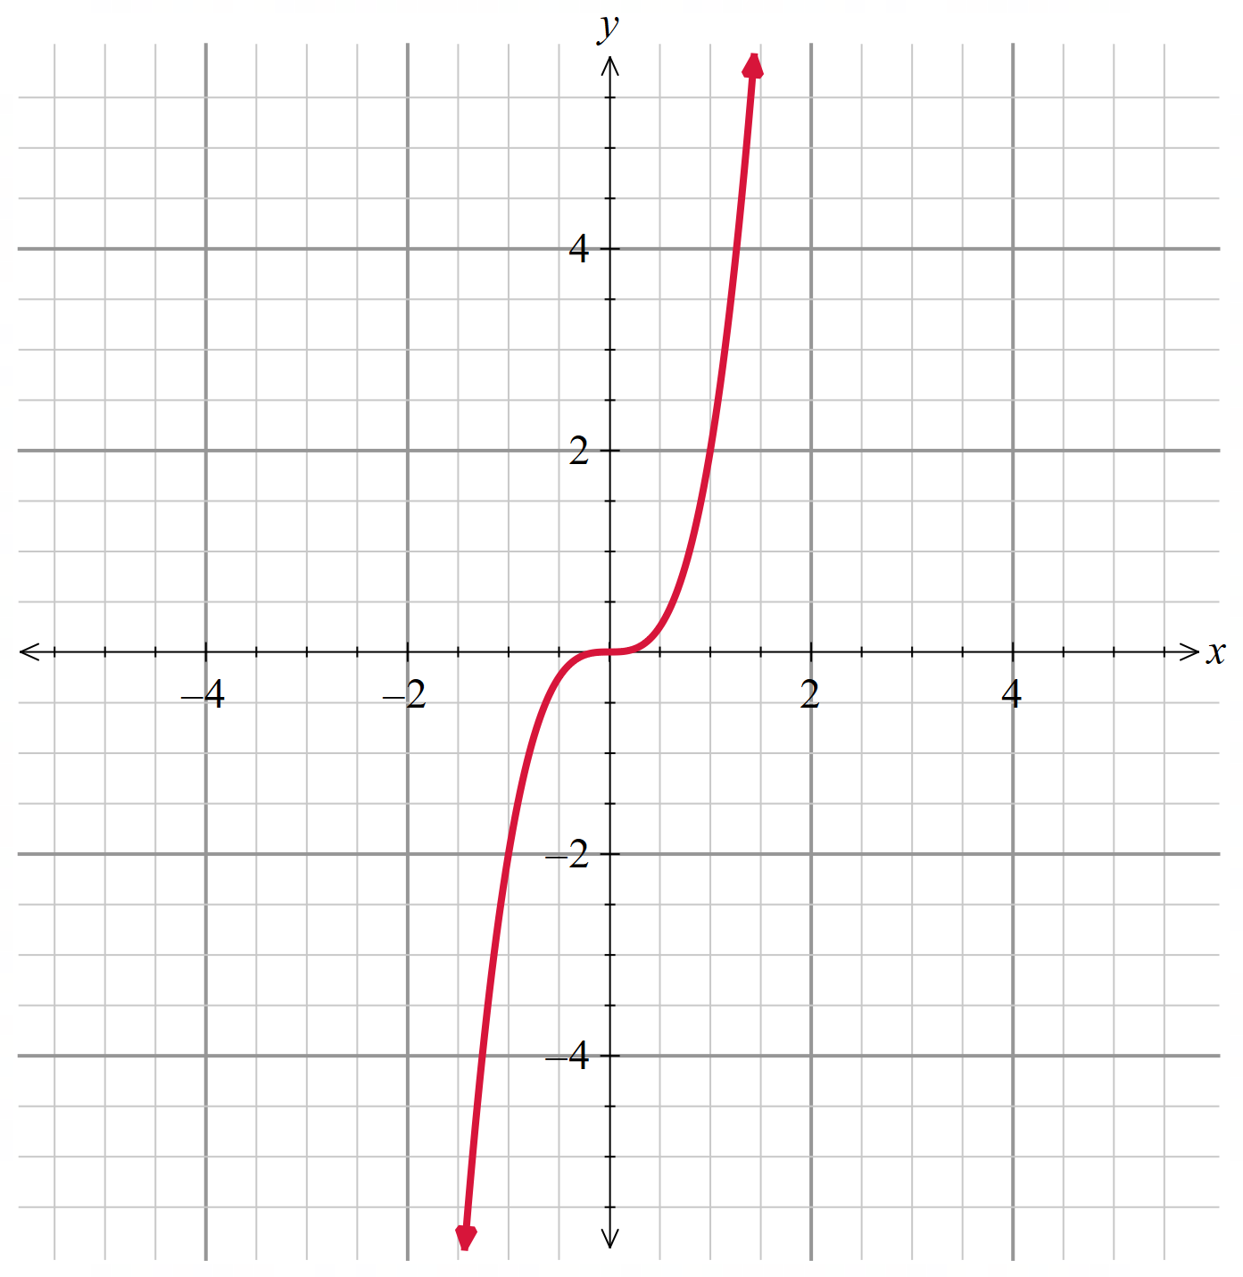 | $$f(x)=|x^{3}|$$  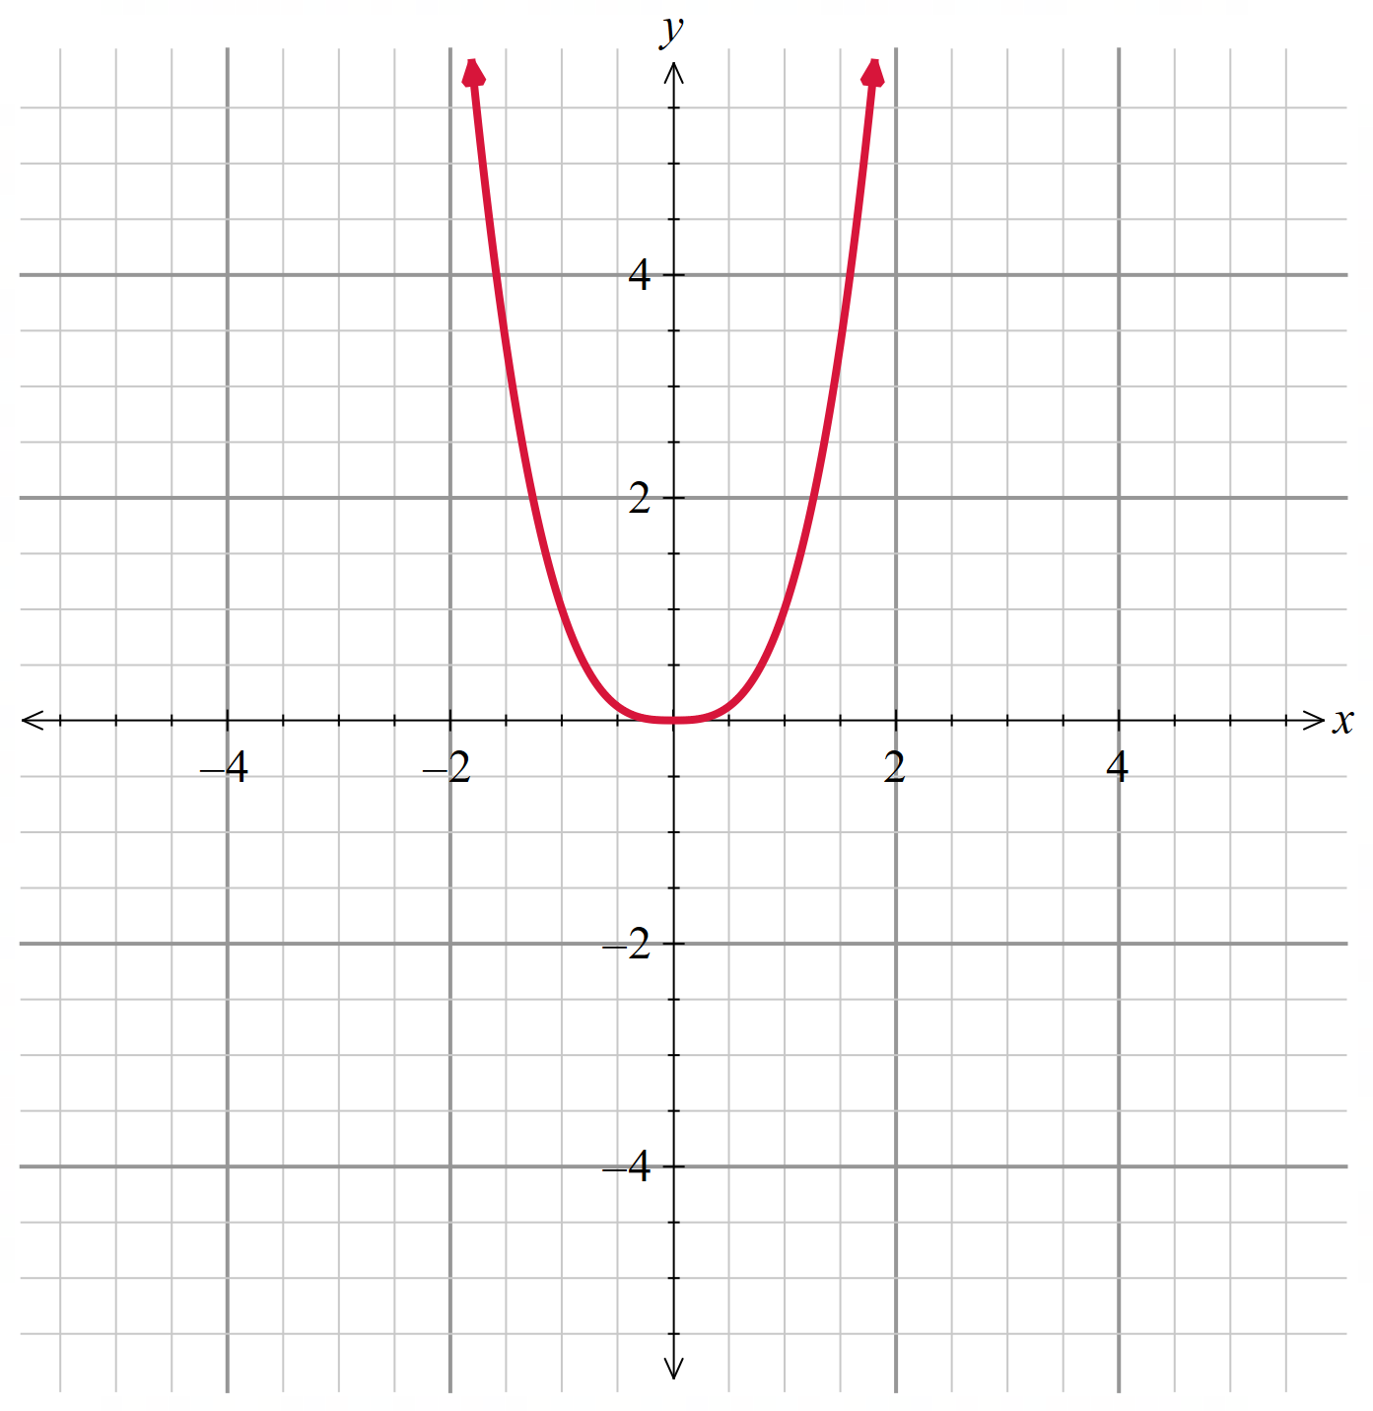
$$f(x)=(x+2)(x-1)$$  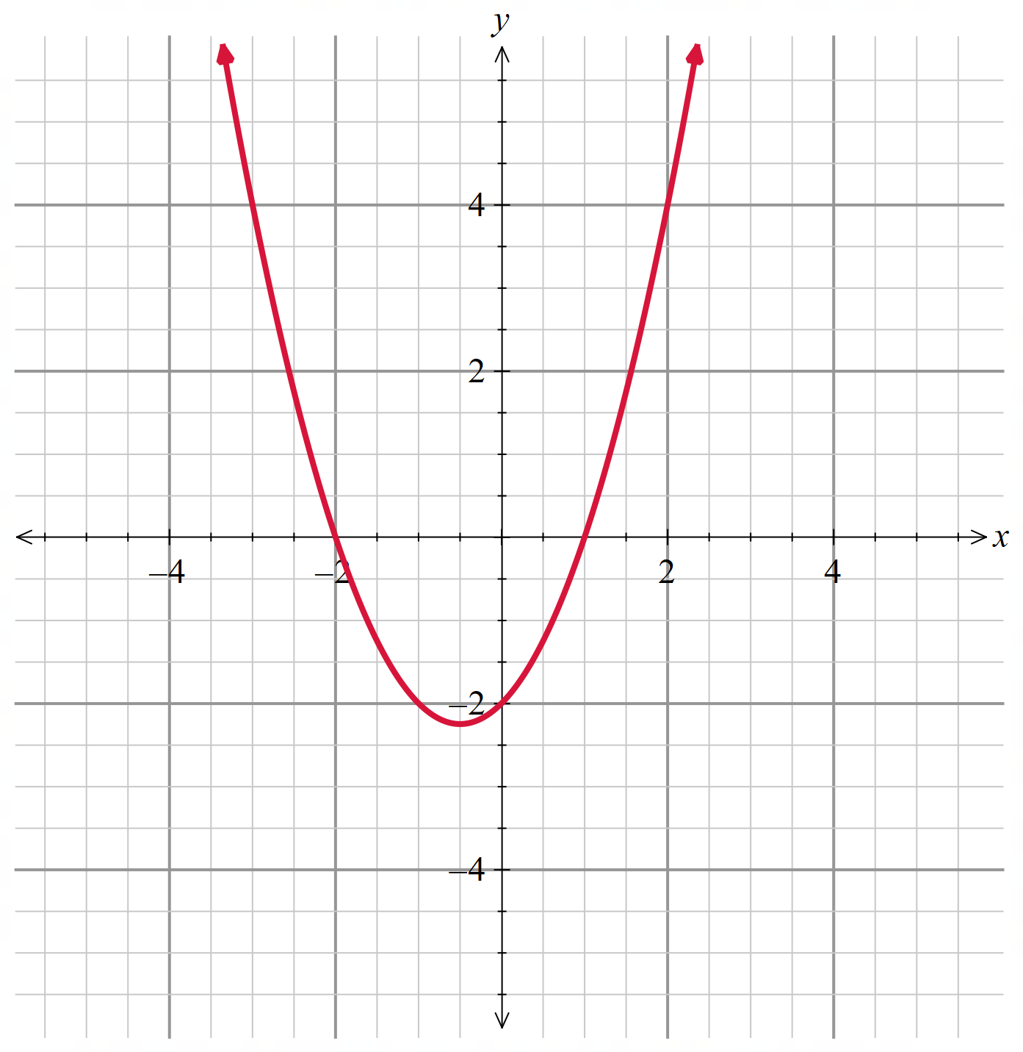 | $$f(x)=x{\left(x-1\right)}^{2}$$  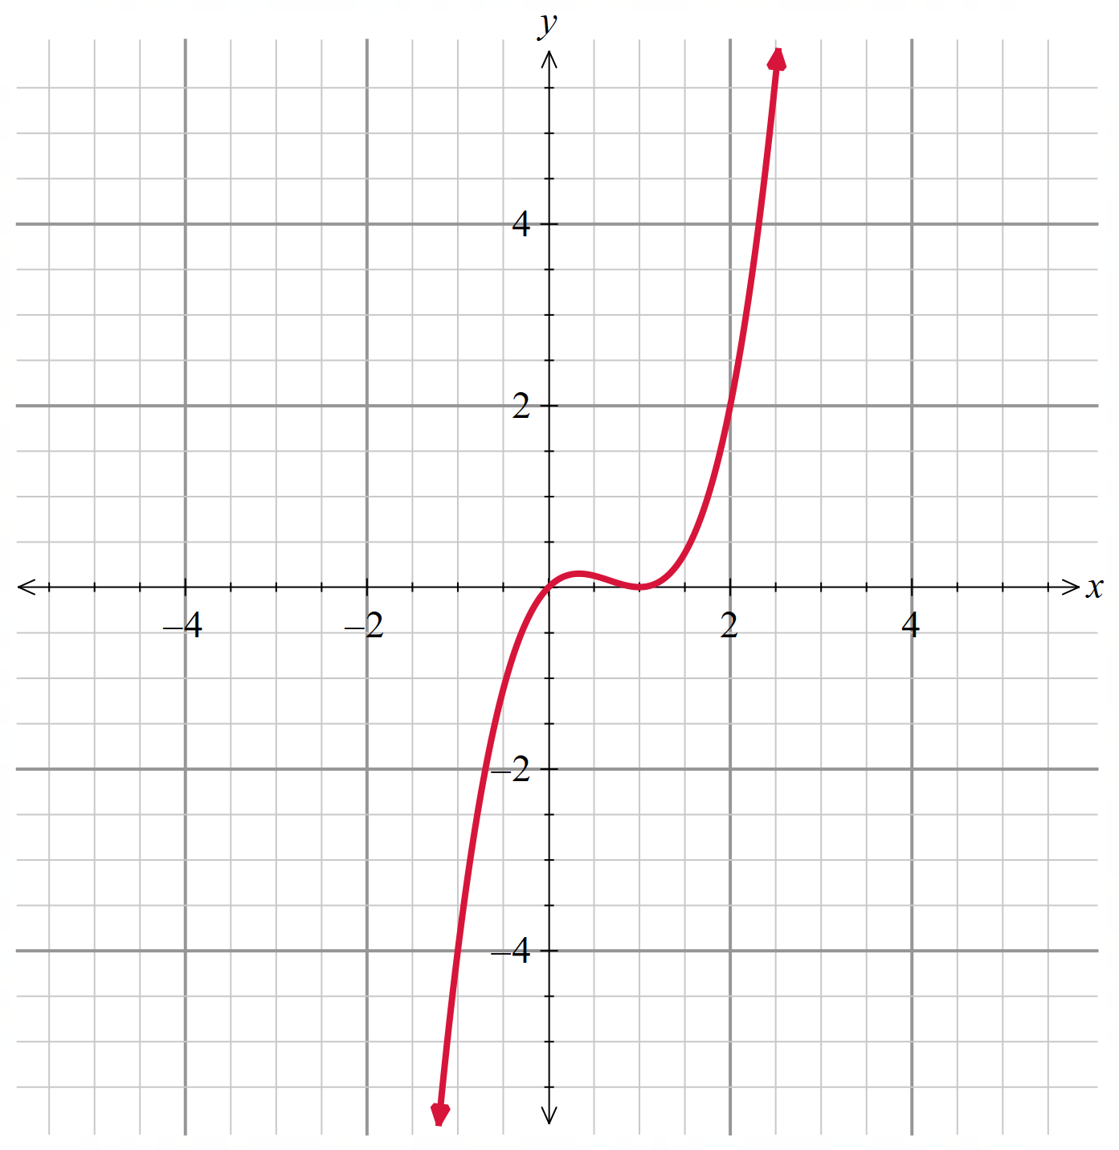 | $$f(x)=\sqrt{4-x^{2}}$$  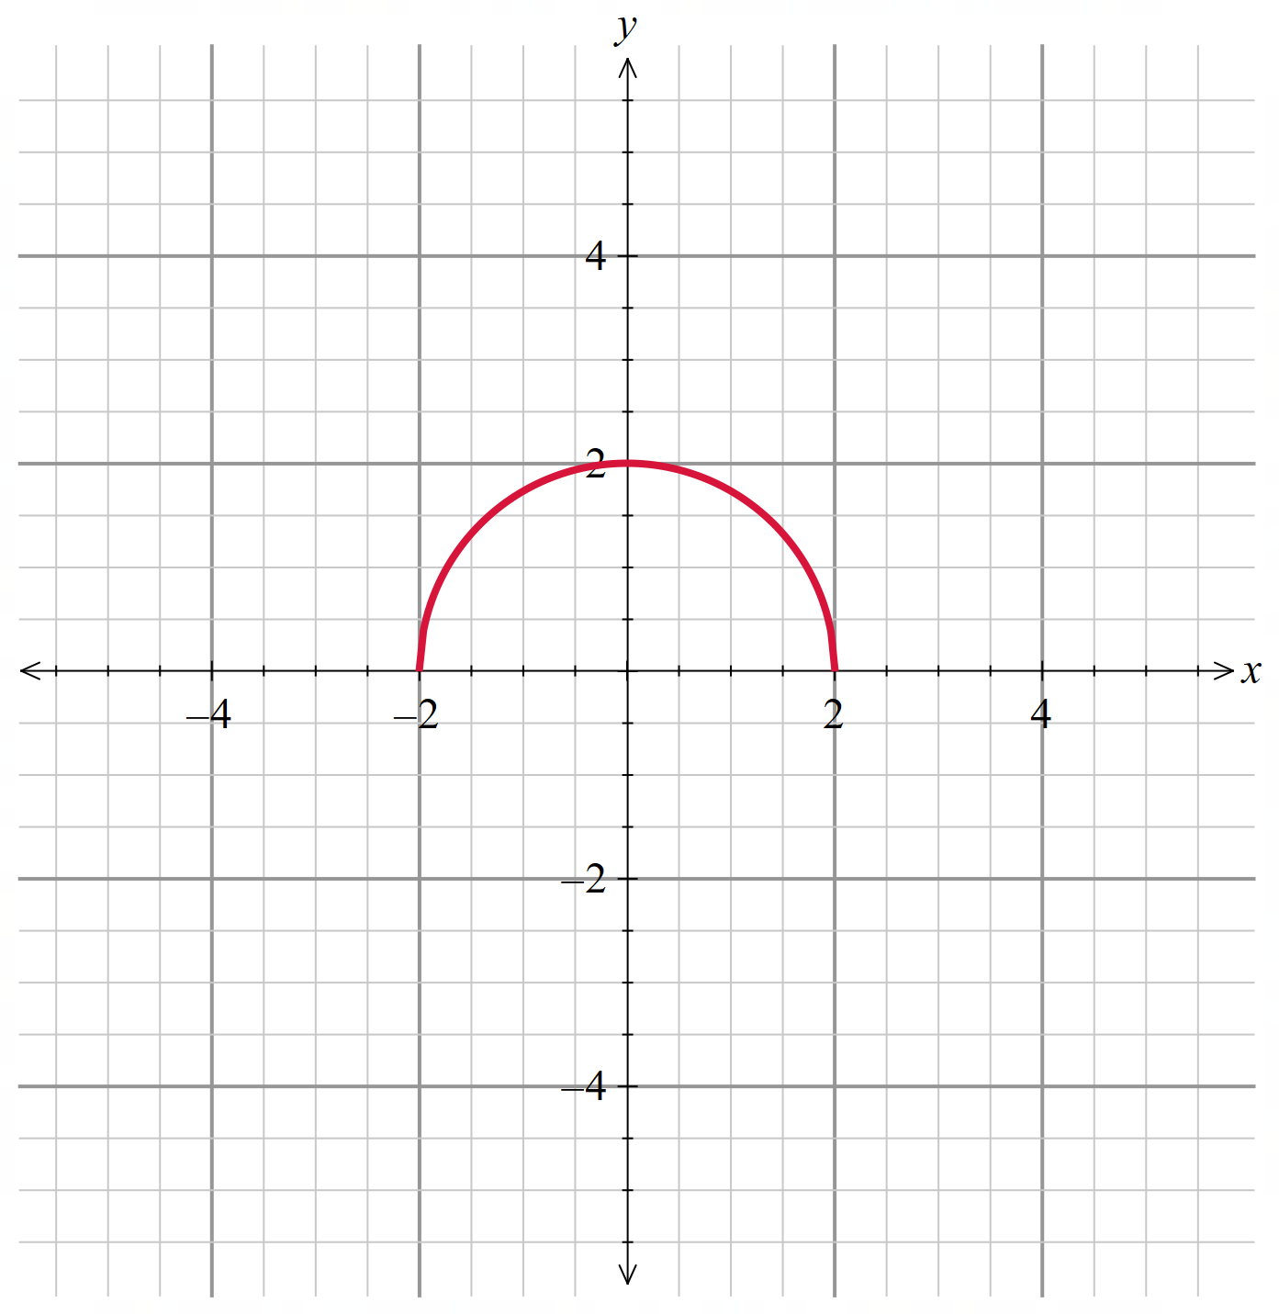
$$f(x)=(3-x)(x-1)(x+1)$$  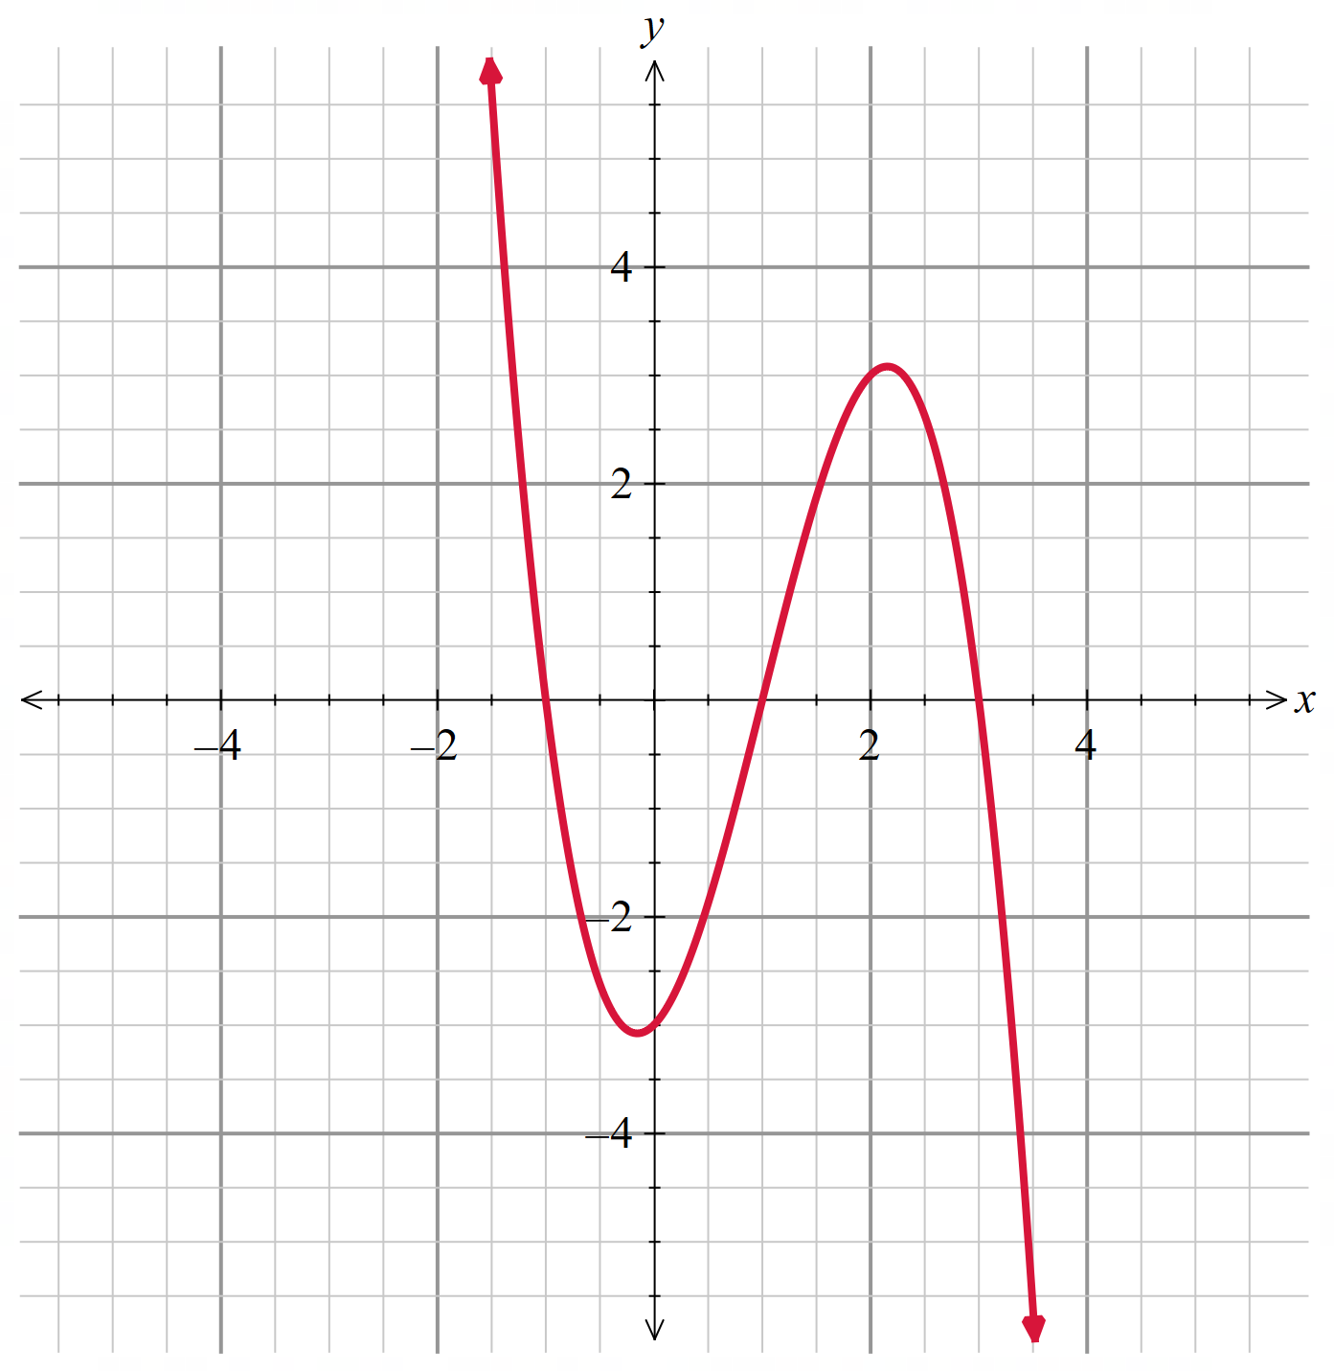 | $$f(x)=\frac{1}{x+3}$$  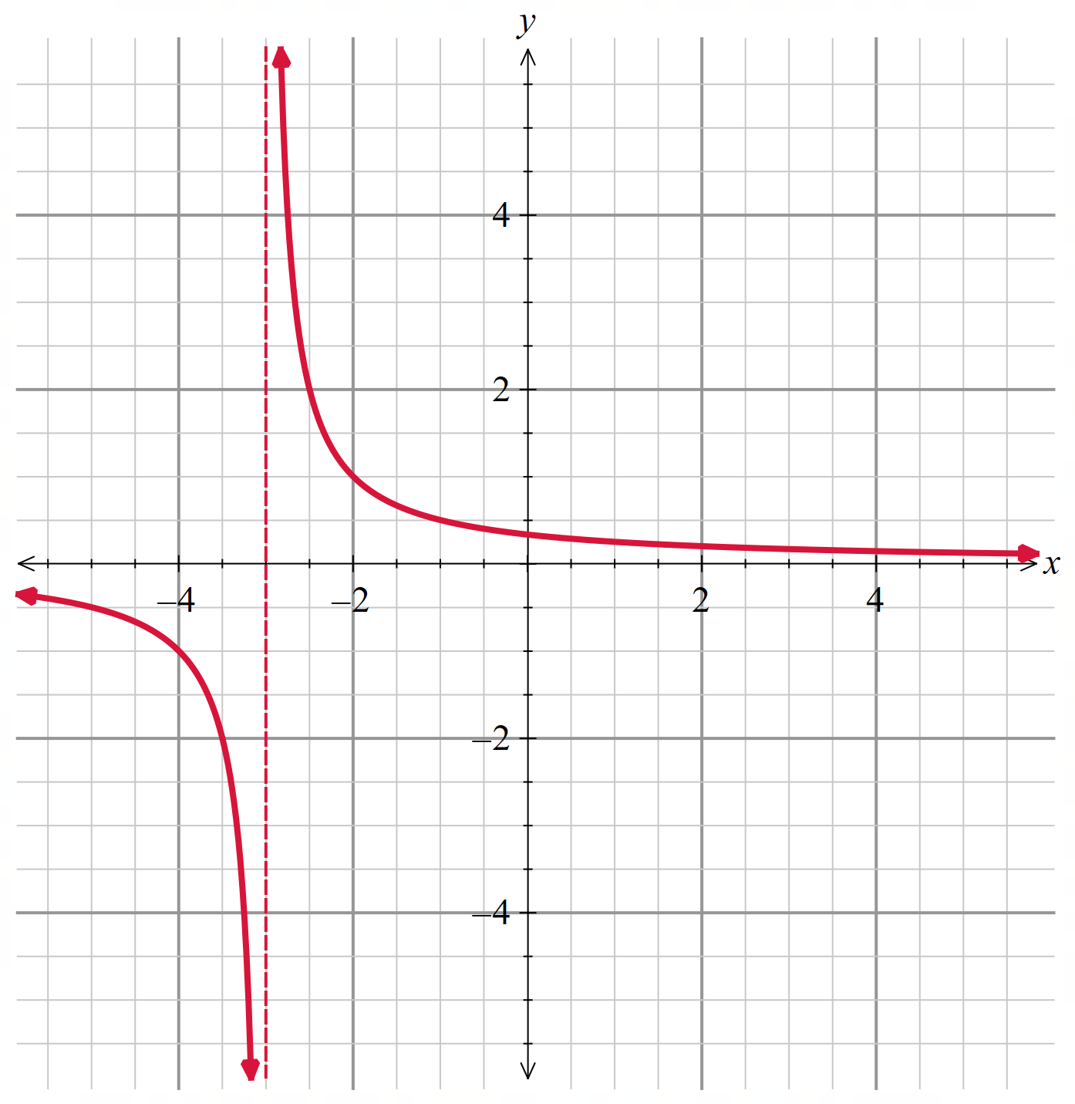 | $$f\left(x\right)=\left\{\begin{aligned}x+3 for x≤2 \\ 9-x^{2} for x>2\end{aligned}\right.$$  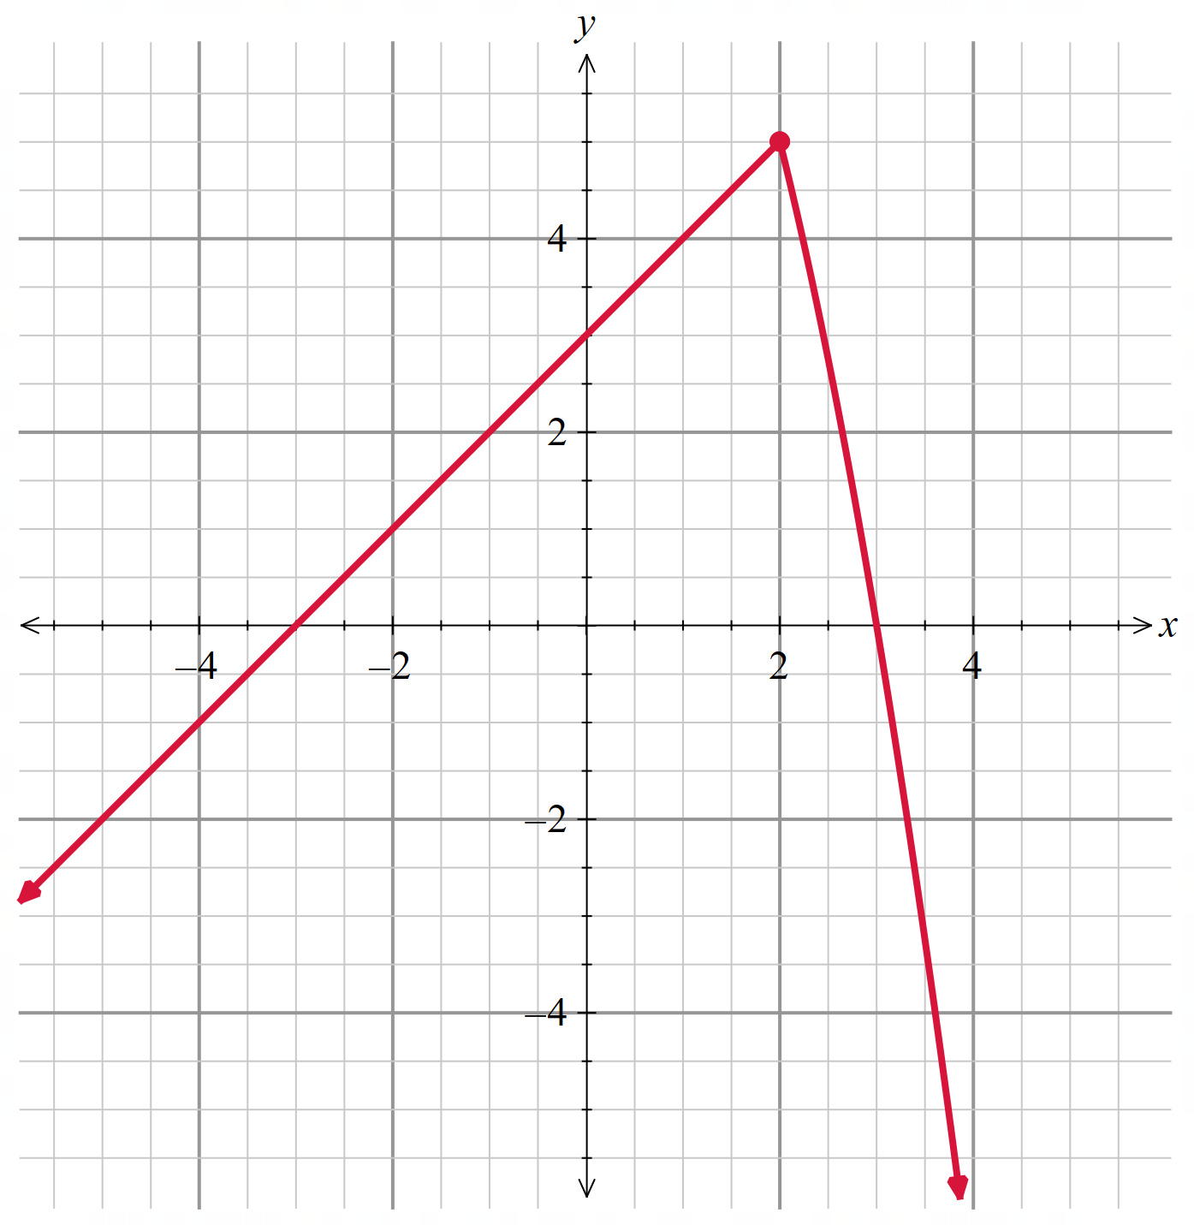
$$f\left(x\right)=\left\{\begin{aligned}x+3 for x≤2 \\ x^{2}+1 for x>2\end{aligned}\right.$$  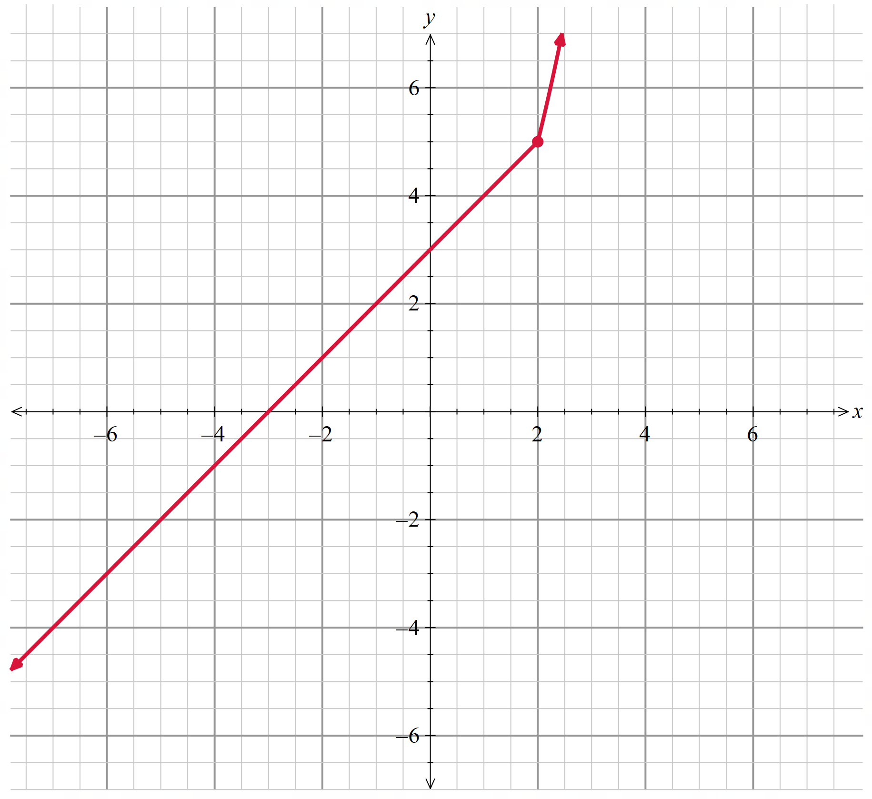 | $$f\left(x\right)=\left\{\begin{aligned}x+3 for x>2 \\ x^{2}+1 for x≤2\end{aligned}\right.$$  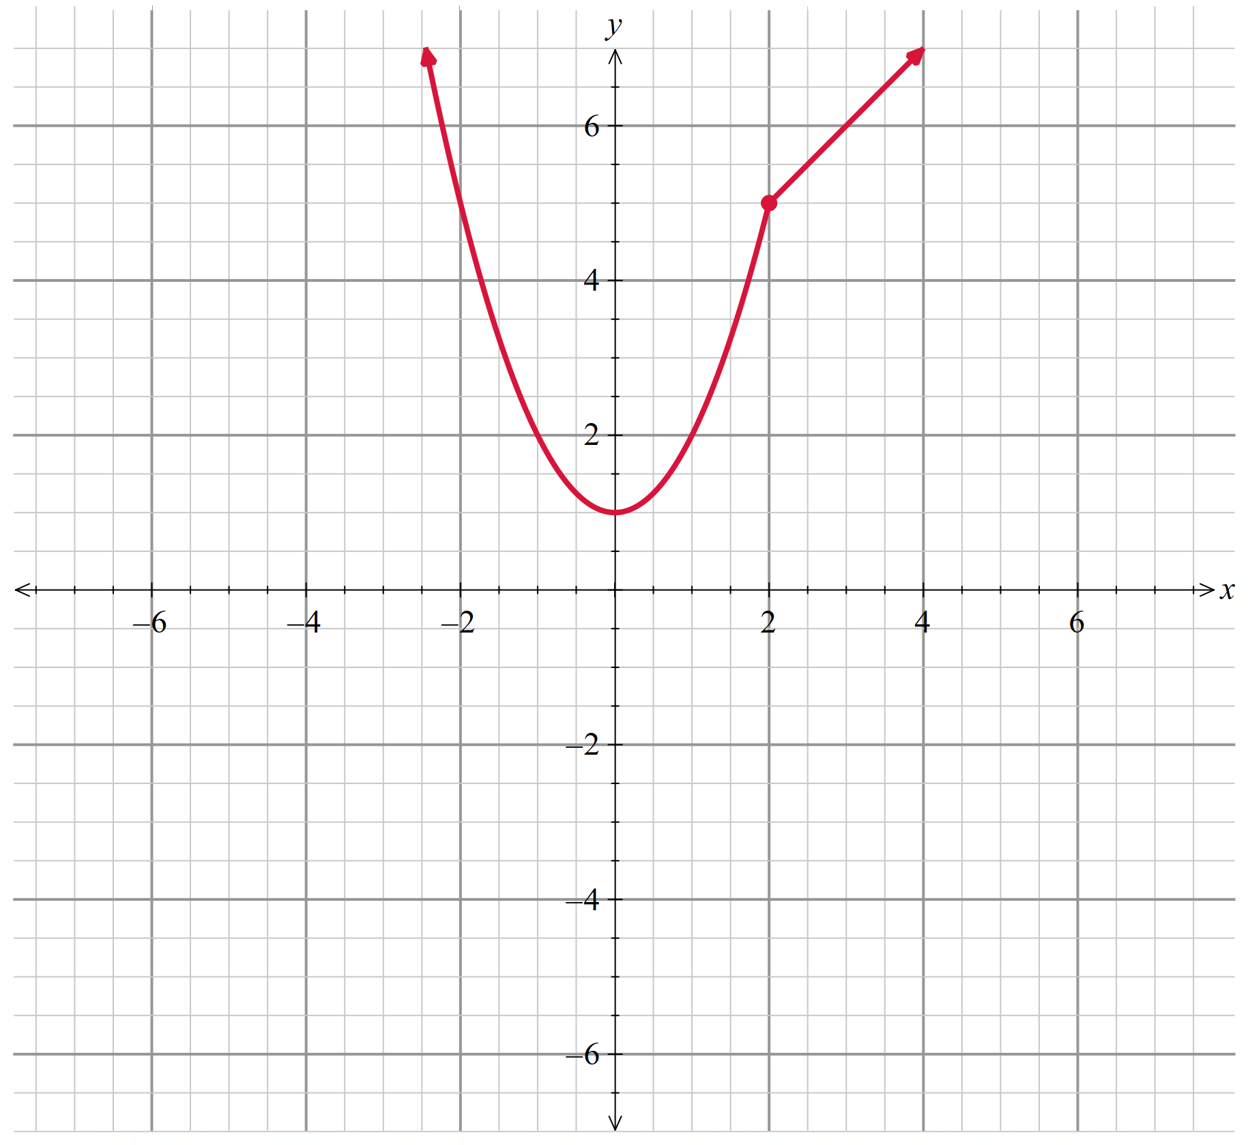 | $$f\left(x\right)=\left\{\begin{aligned}2^{-x} for x<-1 \\ 1-x^{3} for x≥-1\end{aligned}\right.$$  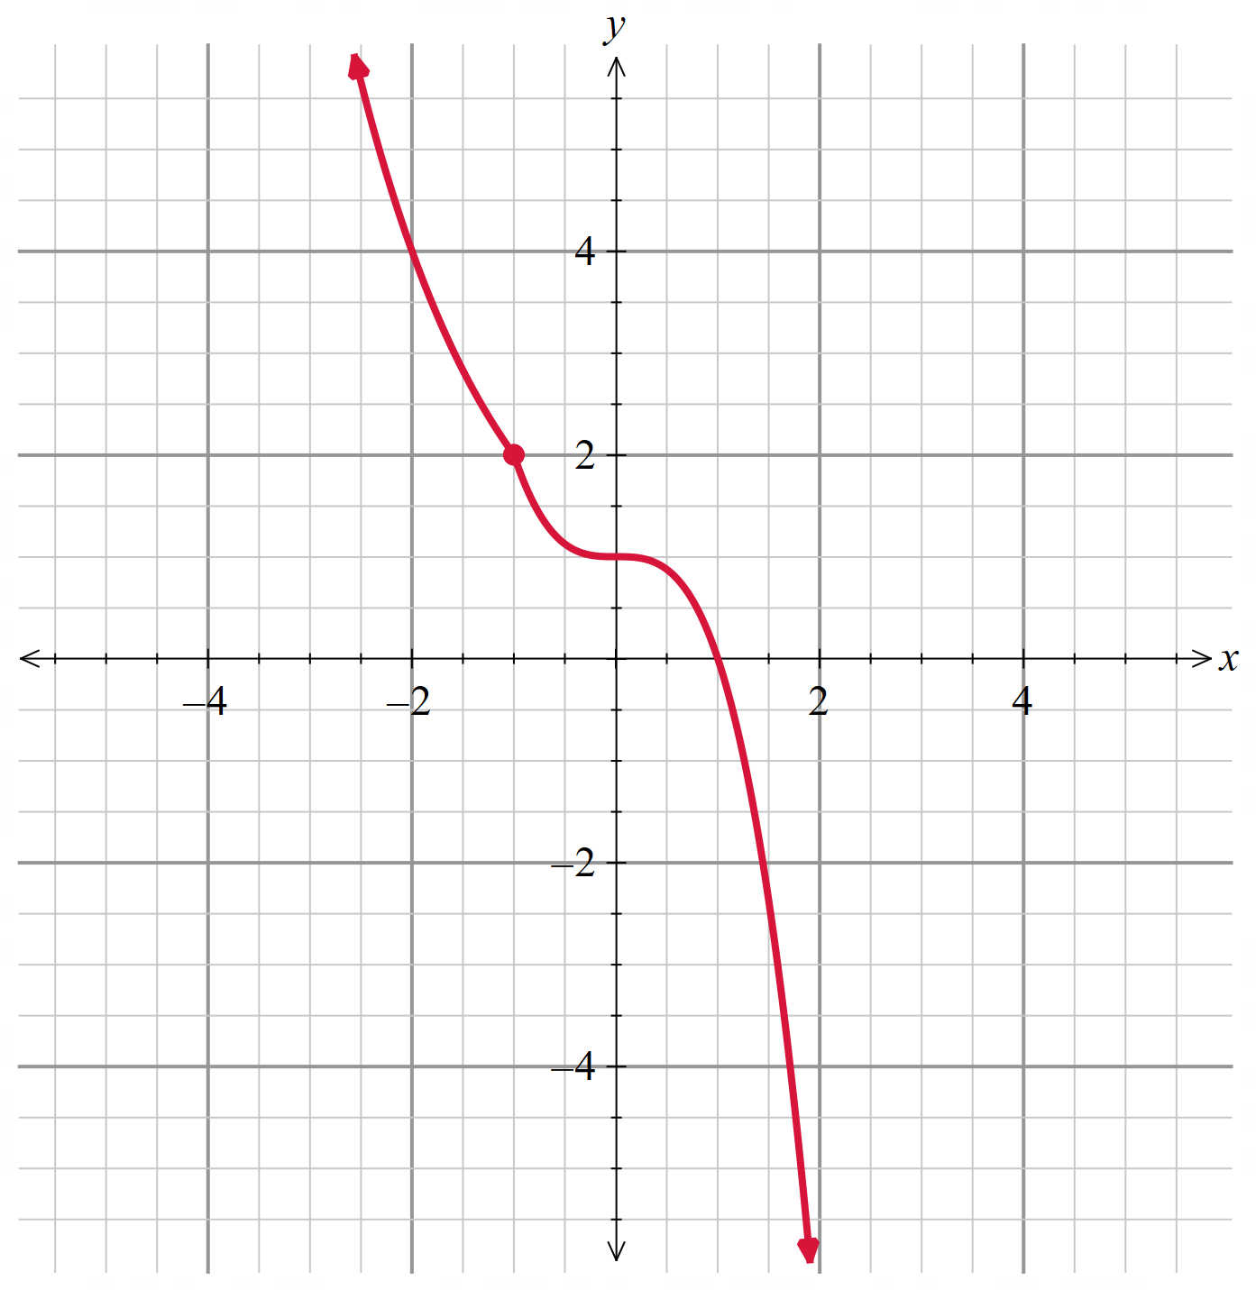

$$x≥0$$ | $$x≥2$$ | $$x≤-0.155$$
$$x≤0$$ | $$x≥0$$ | $$x≥-0.5$$
$$x≤0$$ | $$x≤-0.5$$ | $$x≥1$$

Appendix D

Exit ticket
Let $f\left(x\right)=x^{2}-8x+15$ for $x≥4$.
For the restricted domain, sketch the inverse function on the same number plane below. Clearly identify all axis intercepts.
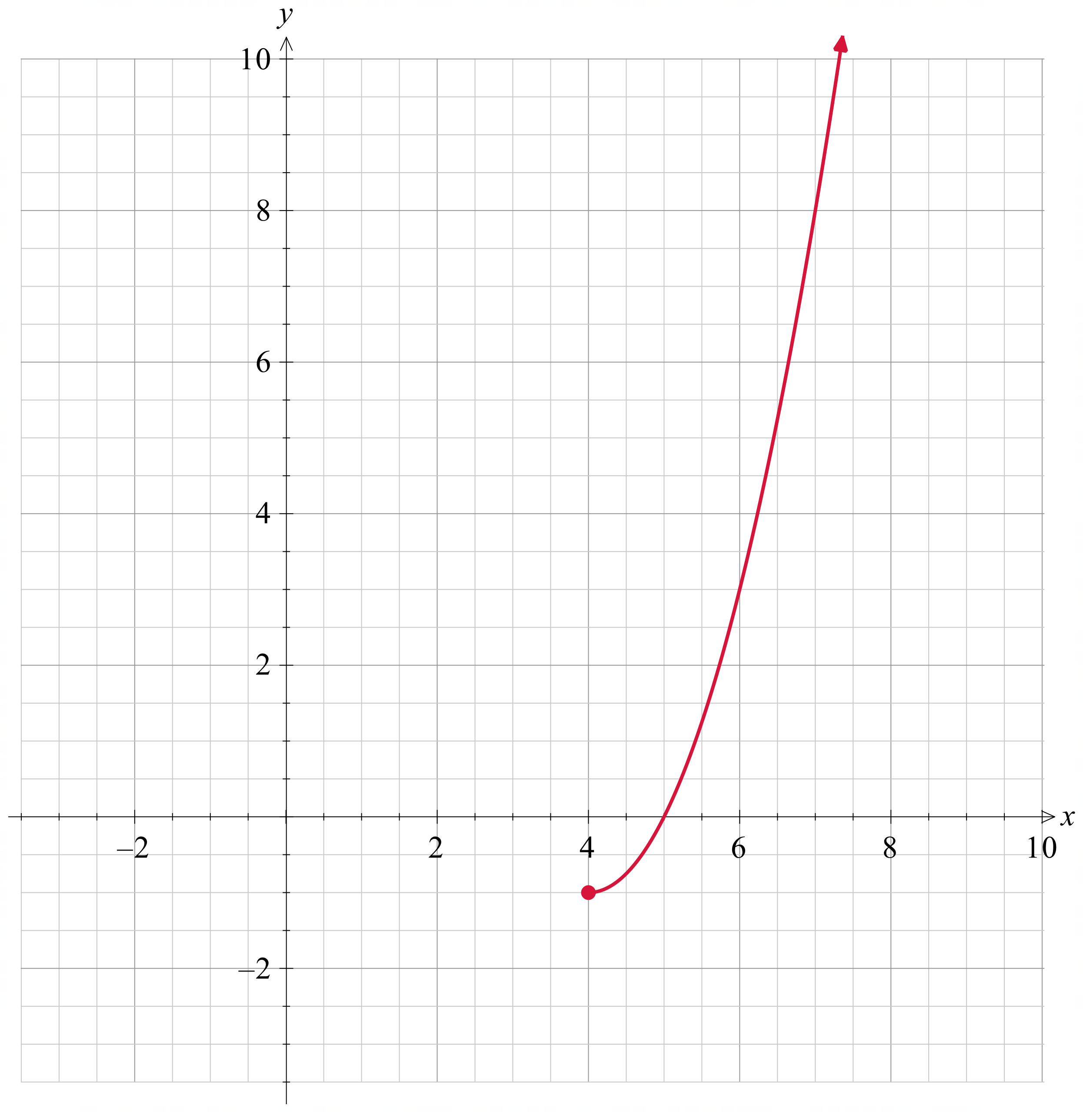

Sample solutions

Appendix A – vertical line test
$$y=9-2x$$  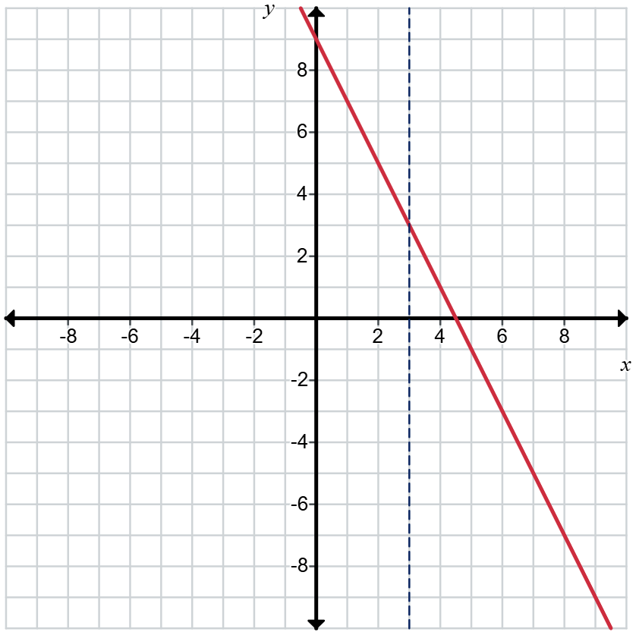  This is a function | $$y=\sqrt{9-x^{2}}$$  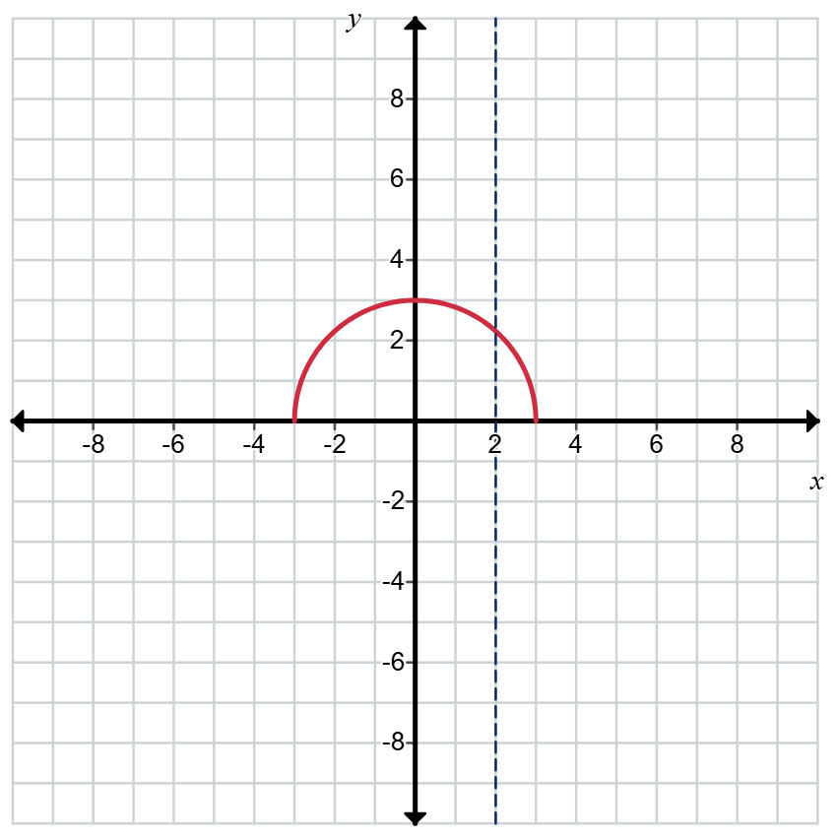  This is a function
$$y=9-x^{2}$$  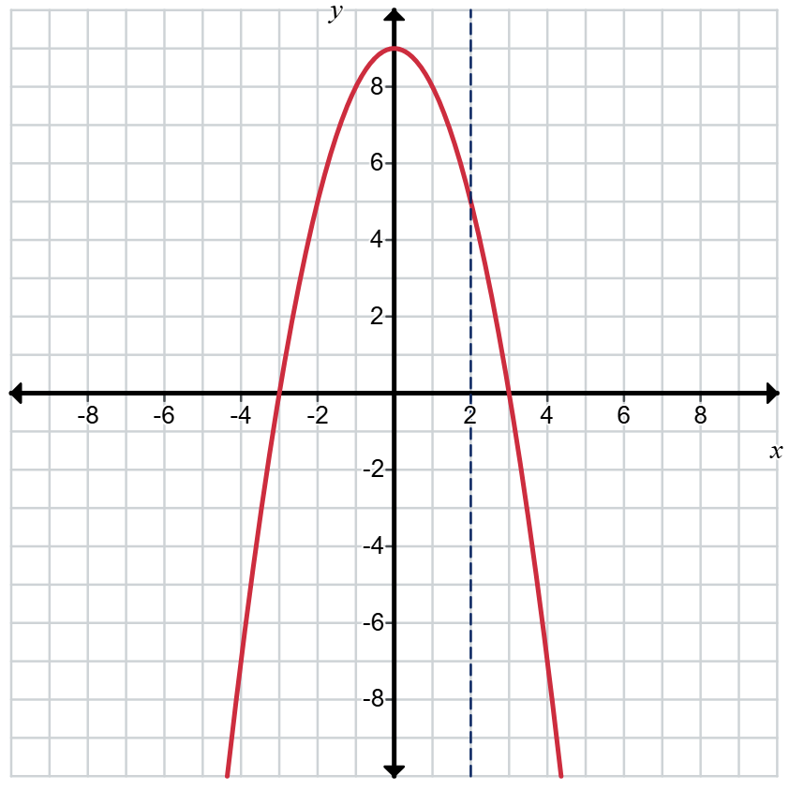  This is a function | $$y=\sqrt{9-x}$$  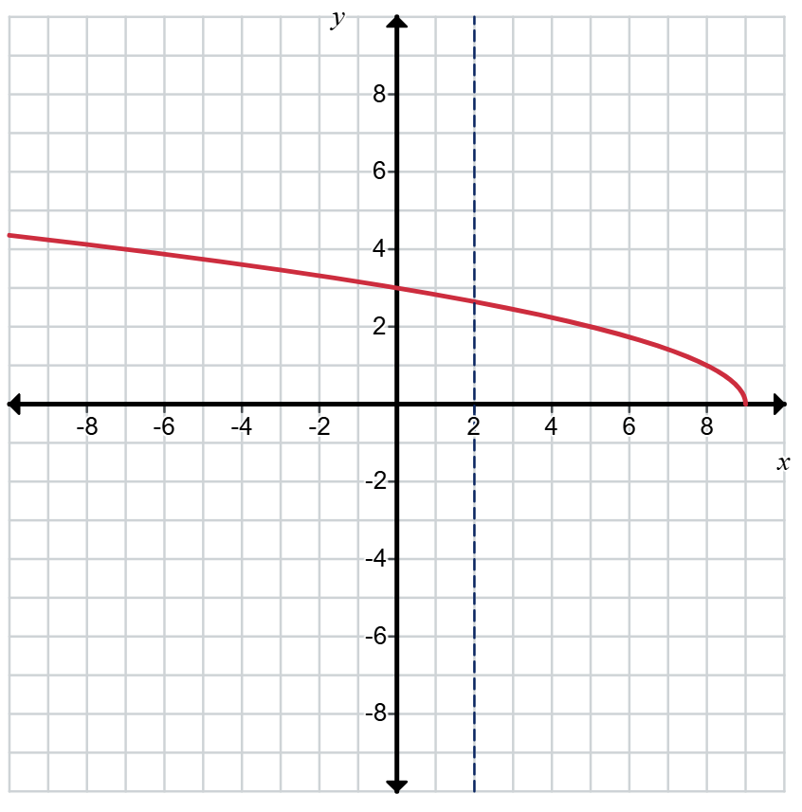  This is a function
$$x^{2}=9$$  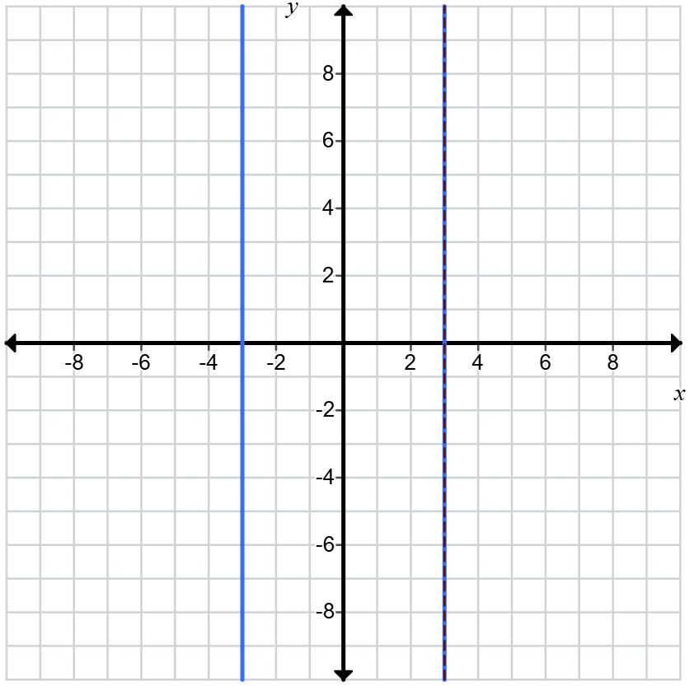  This is not a function | $$x^{2}+y^{2}=9$$  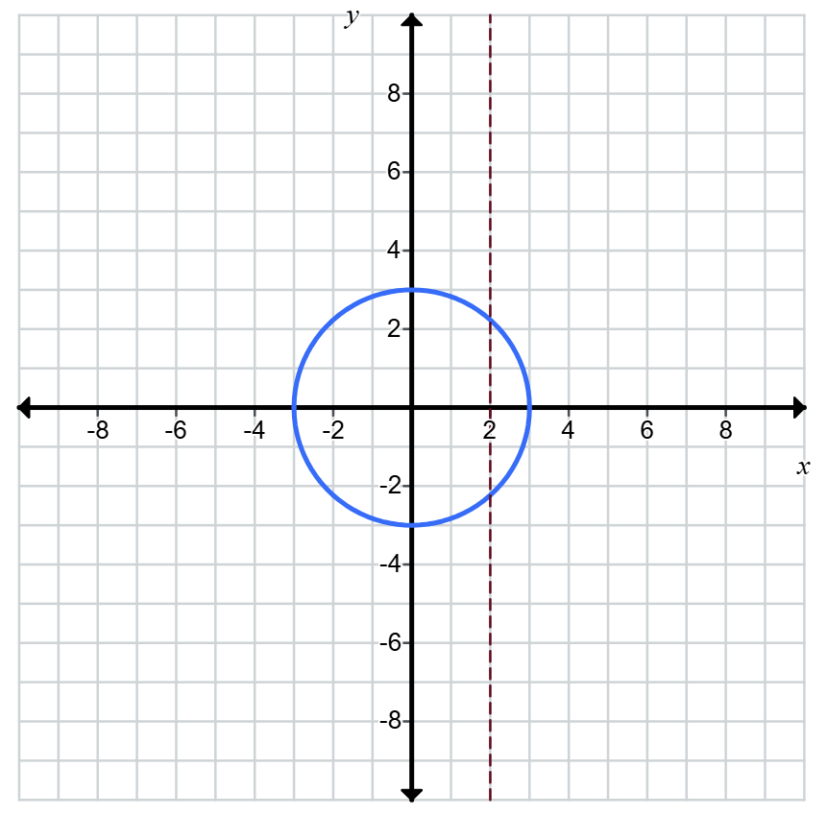  This is not a function
$$x^{2}+y=9$$  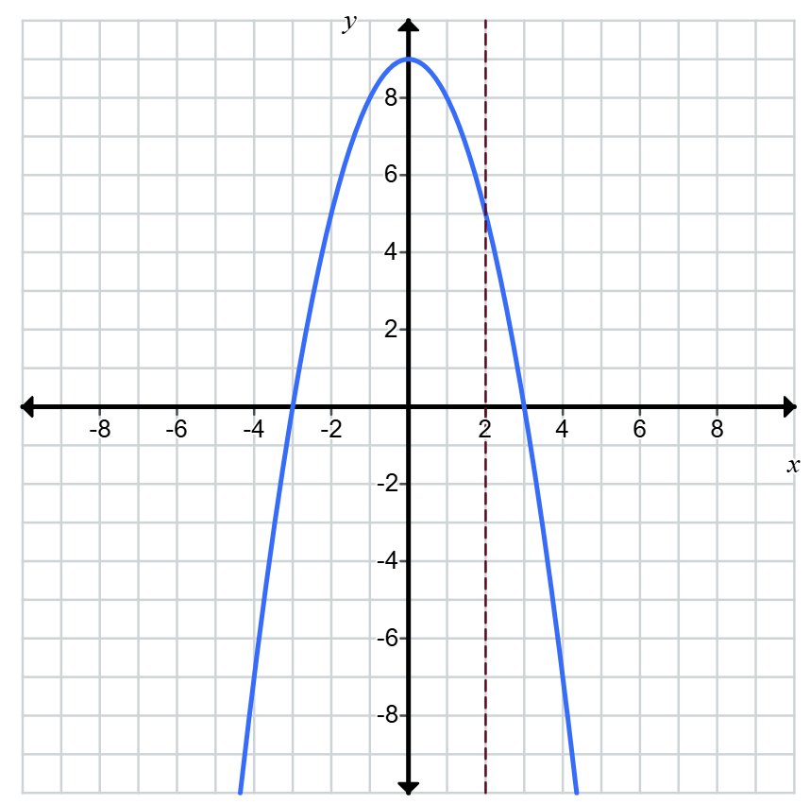  This is a function | $$x^{3}+y=9$$  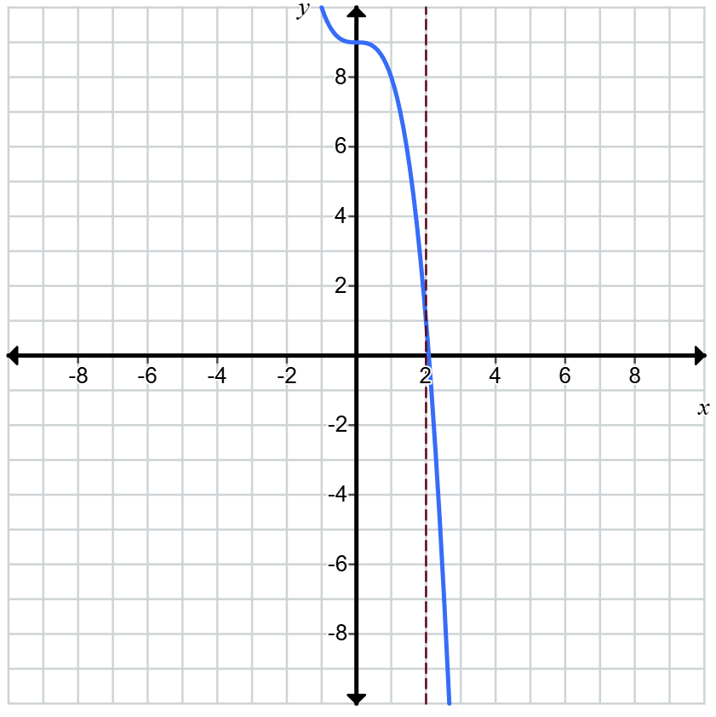  This is a function

Appendix B – Frayer diagram
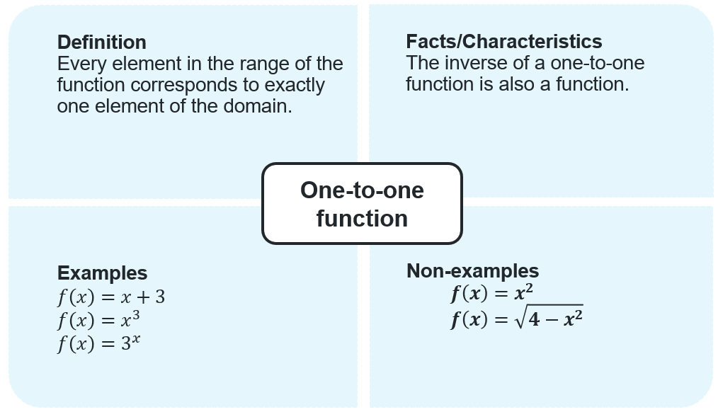

Appendix C – card sort

Functions that are one-to-one
$$f\left(x\right)=-x$$  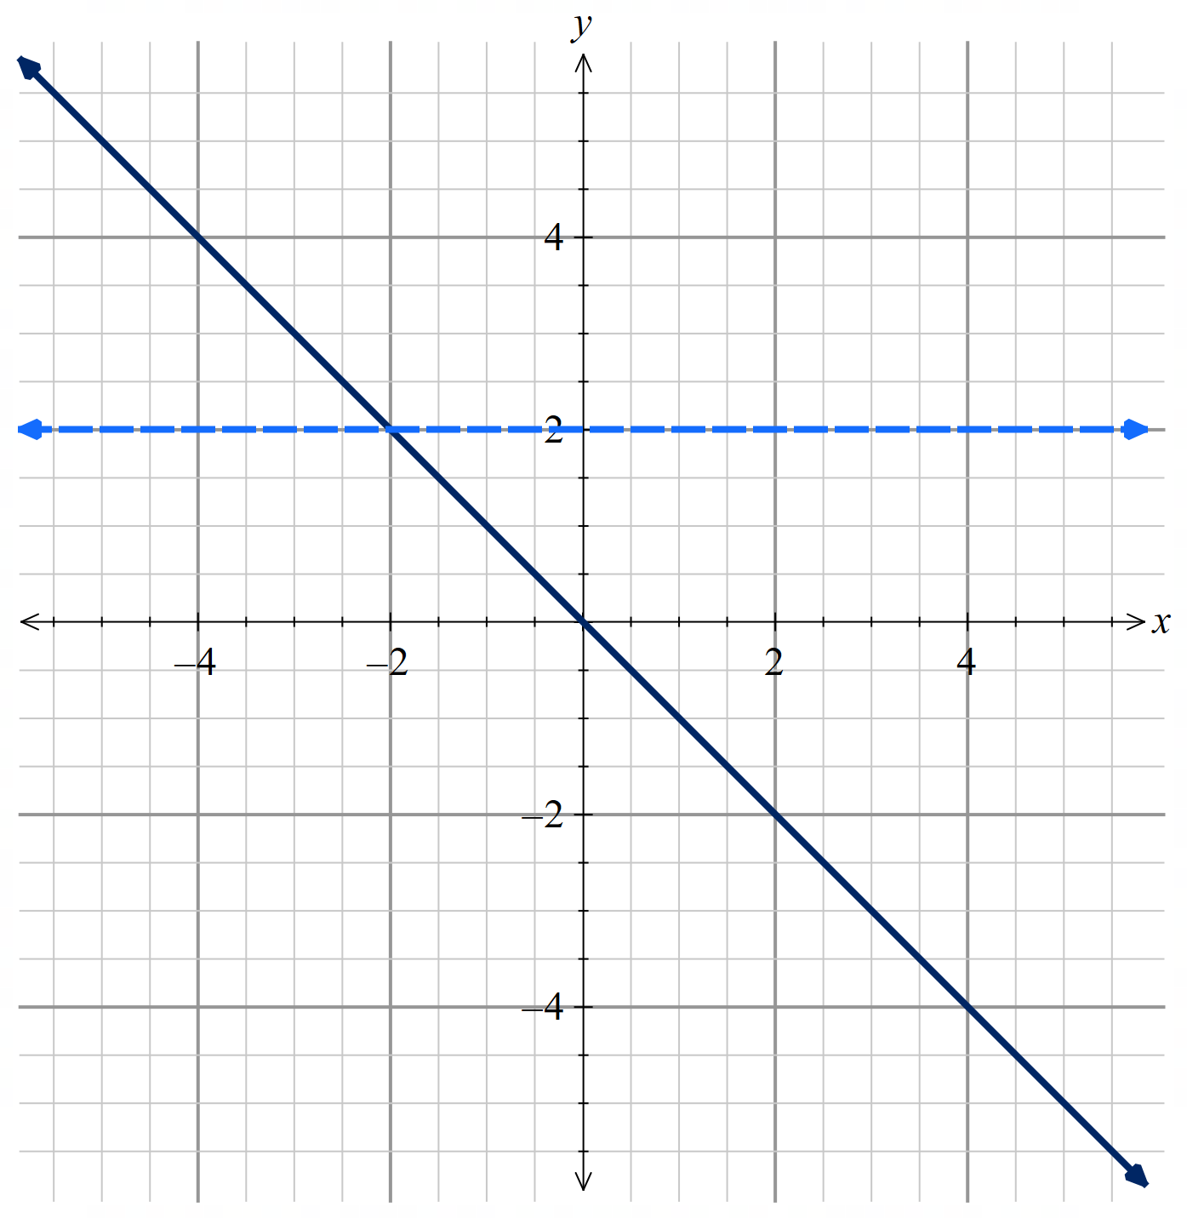 | $$f(x)=2^{x-1}$$  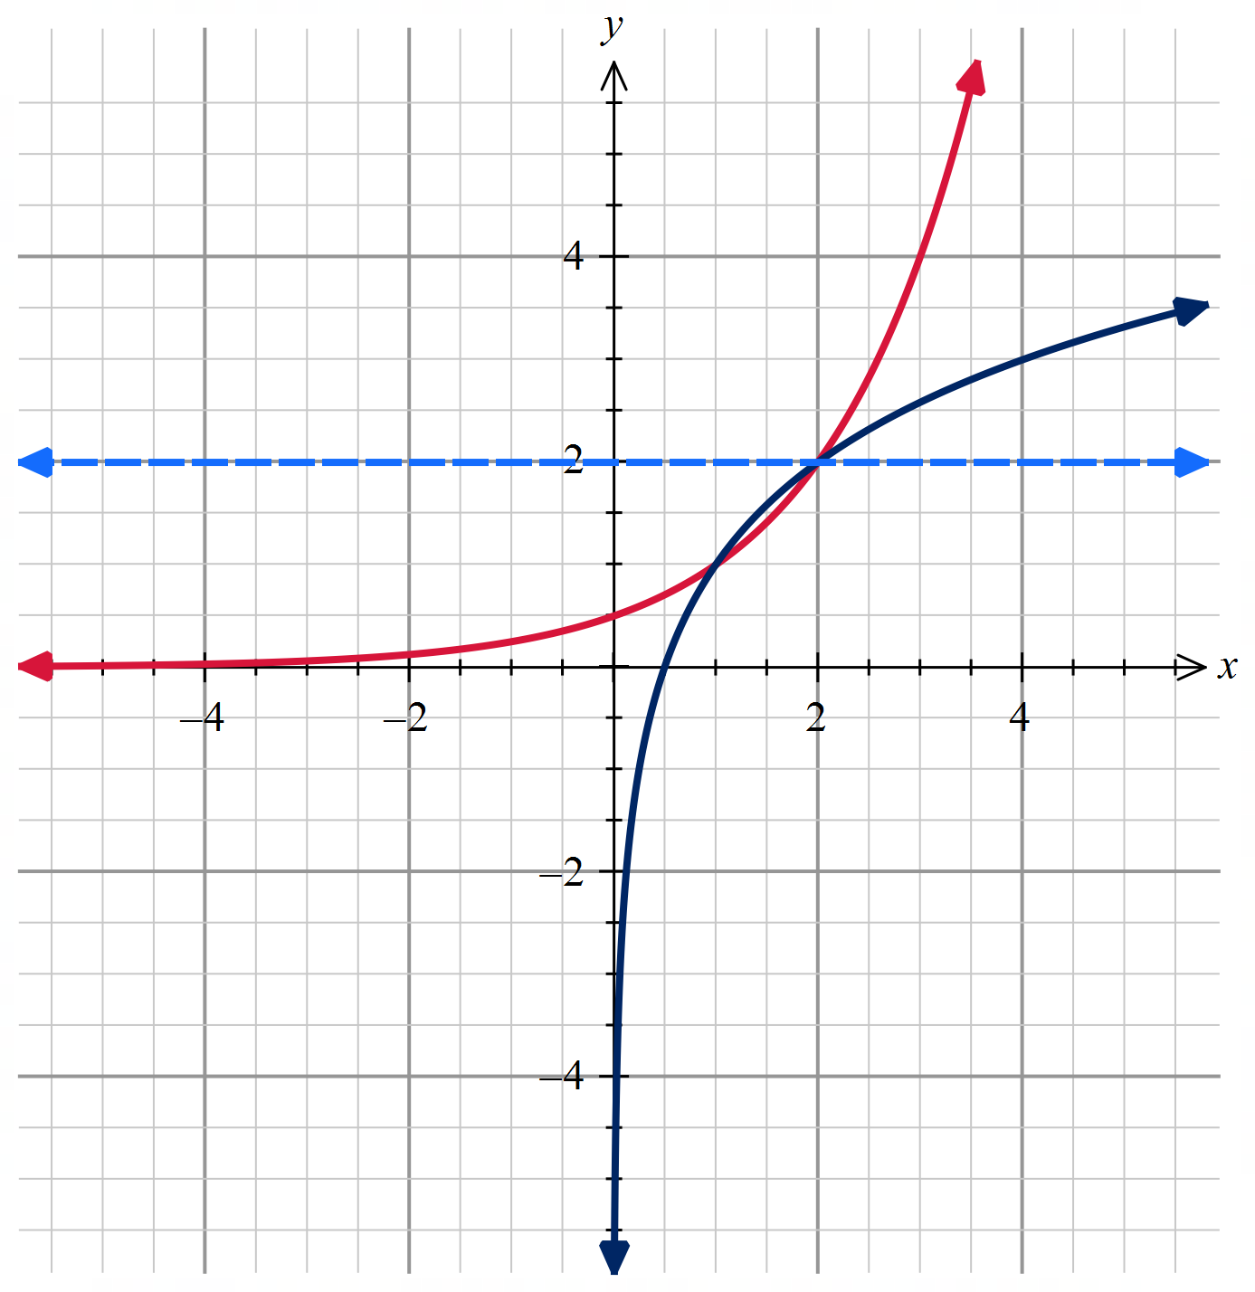 | $$f(x)={2x}^{3}$$  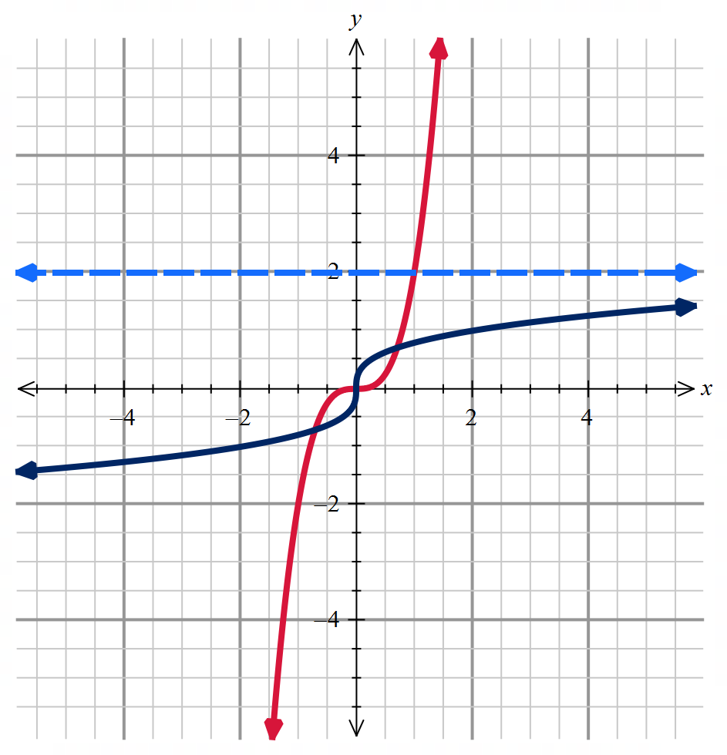
$$f(x)=\frac{1}{x+3}$$  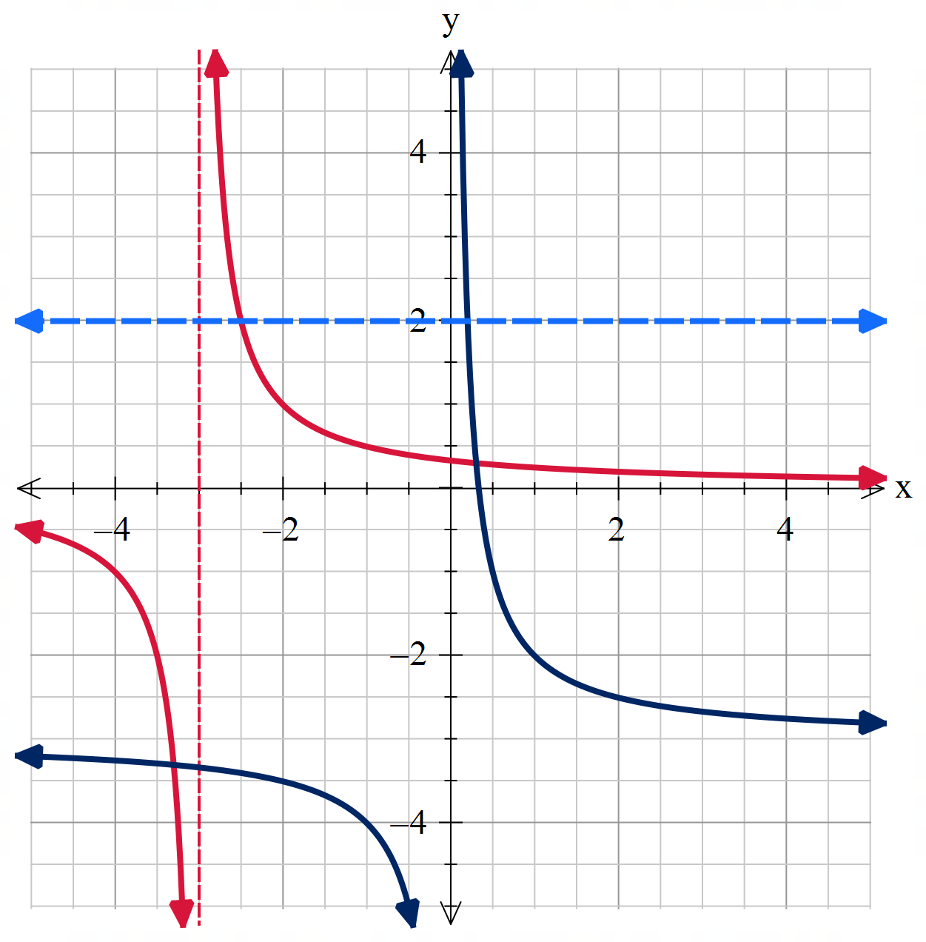 | $$f\left(x\right)=\left\{\begin{aligned}x+3 for x≤2 \\ x^{2}+1 for x>2\end{aligned}\right.$$  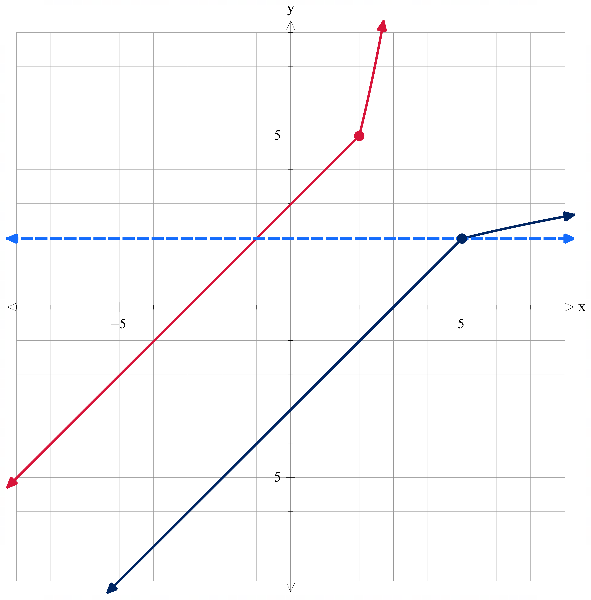 | $$f\left(x\right)=\left\{\begin{aligned}2^{-x} for x<-1 \\ 1-x^{3} for x≥-1\end{aligned}\right.$$  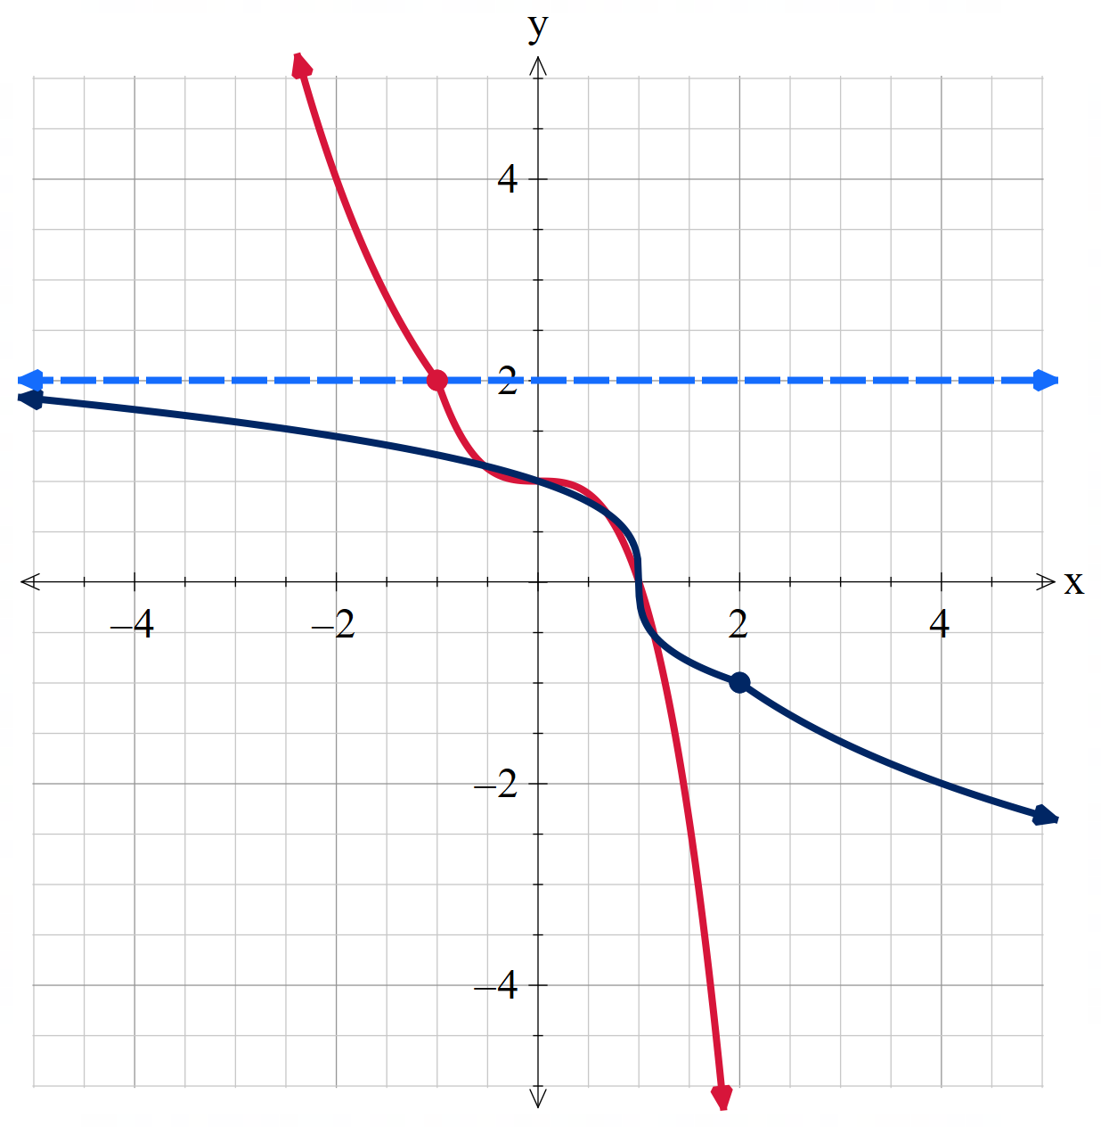

Functions that are not one-to-one
Due to the nature of the domain restrictions, some of these answers may vary depending on how the students have matched them.
$$f(x)=3-x^{2}$$  With domain restriction $$x≥0$$  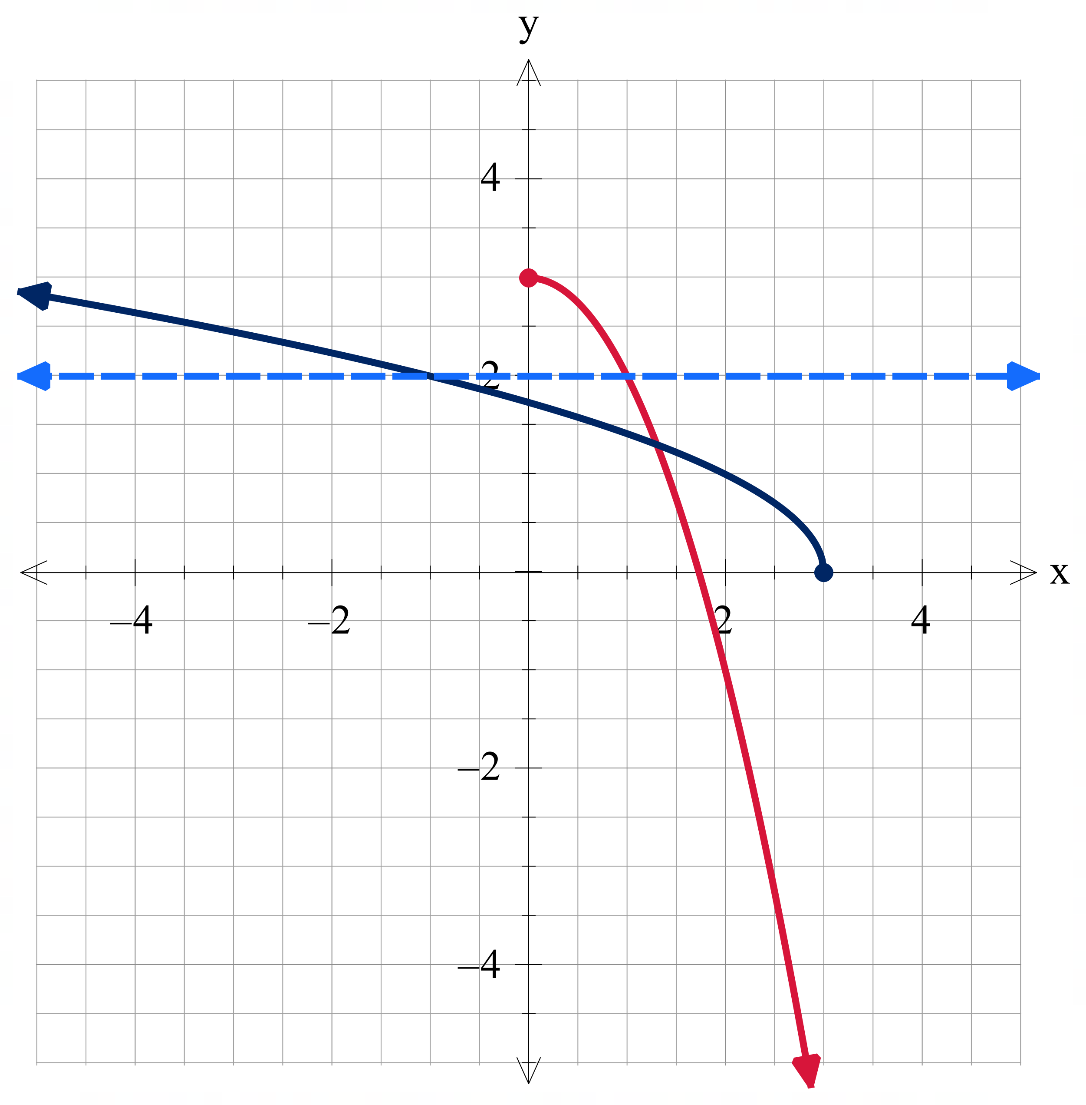 | $$f(x)=|2x+1|$$  With domain restriction $$x≤-0.5$$  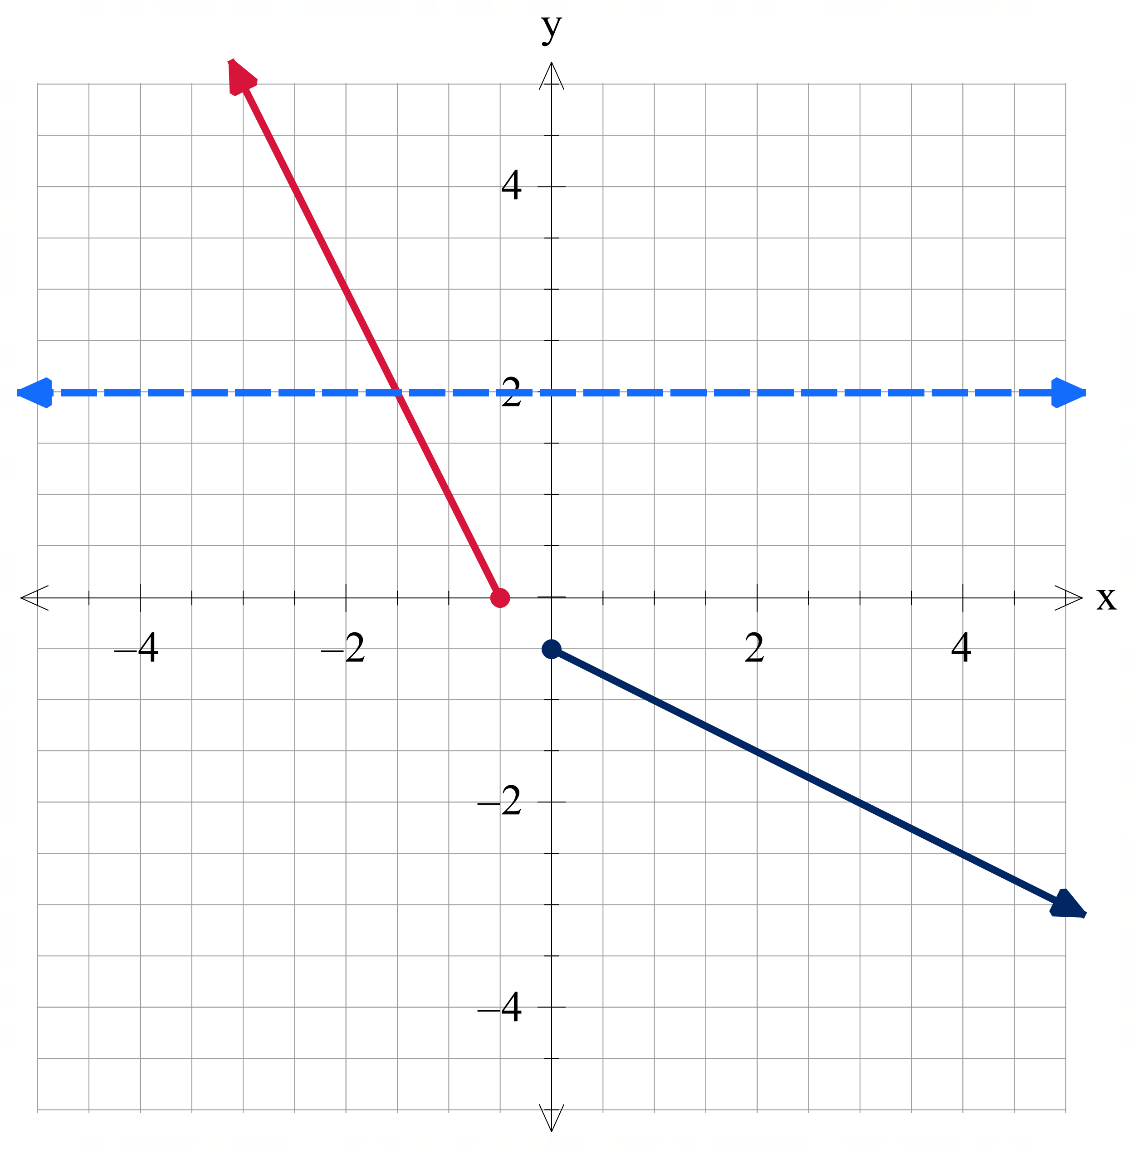 | $$f(x)=|x^{3}|$$  With domain restriction $$x≤0$$  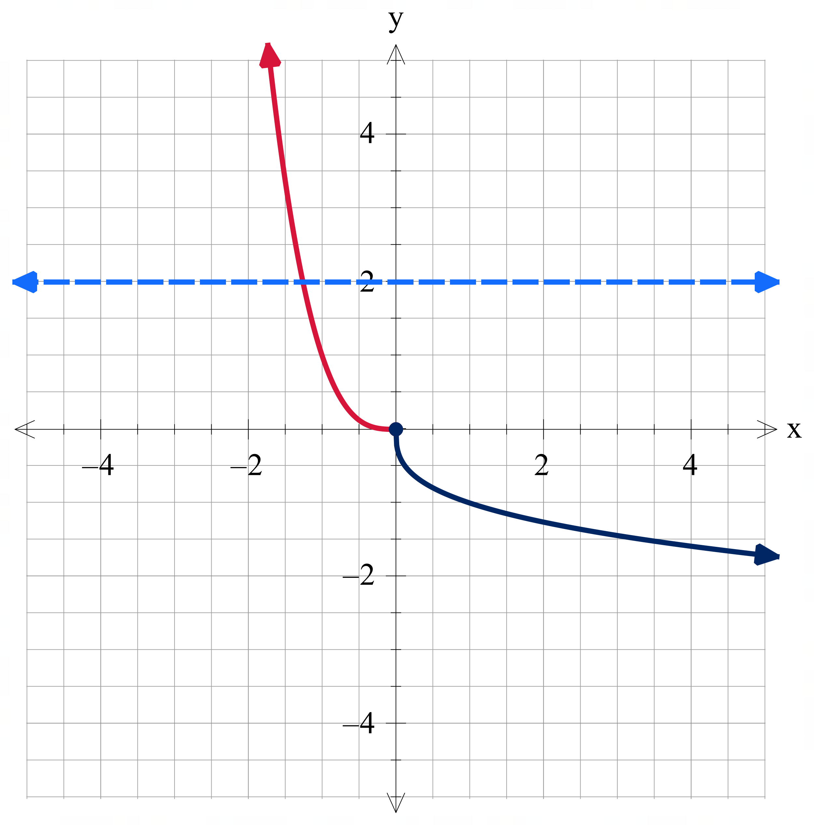

$$f(x)=(x+2)(x-1)$$  With domain restriction $$x≥-0.5$$  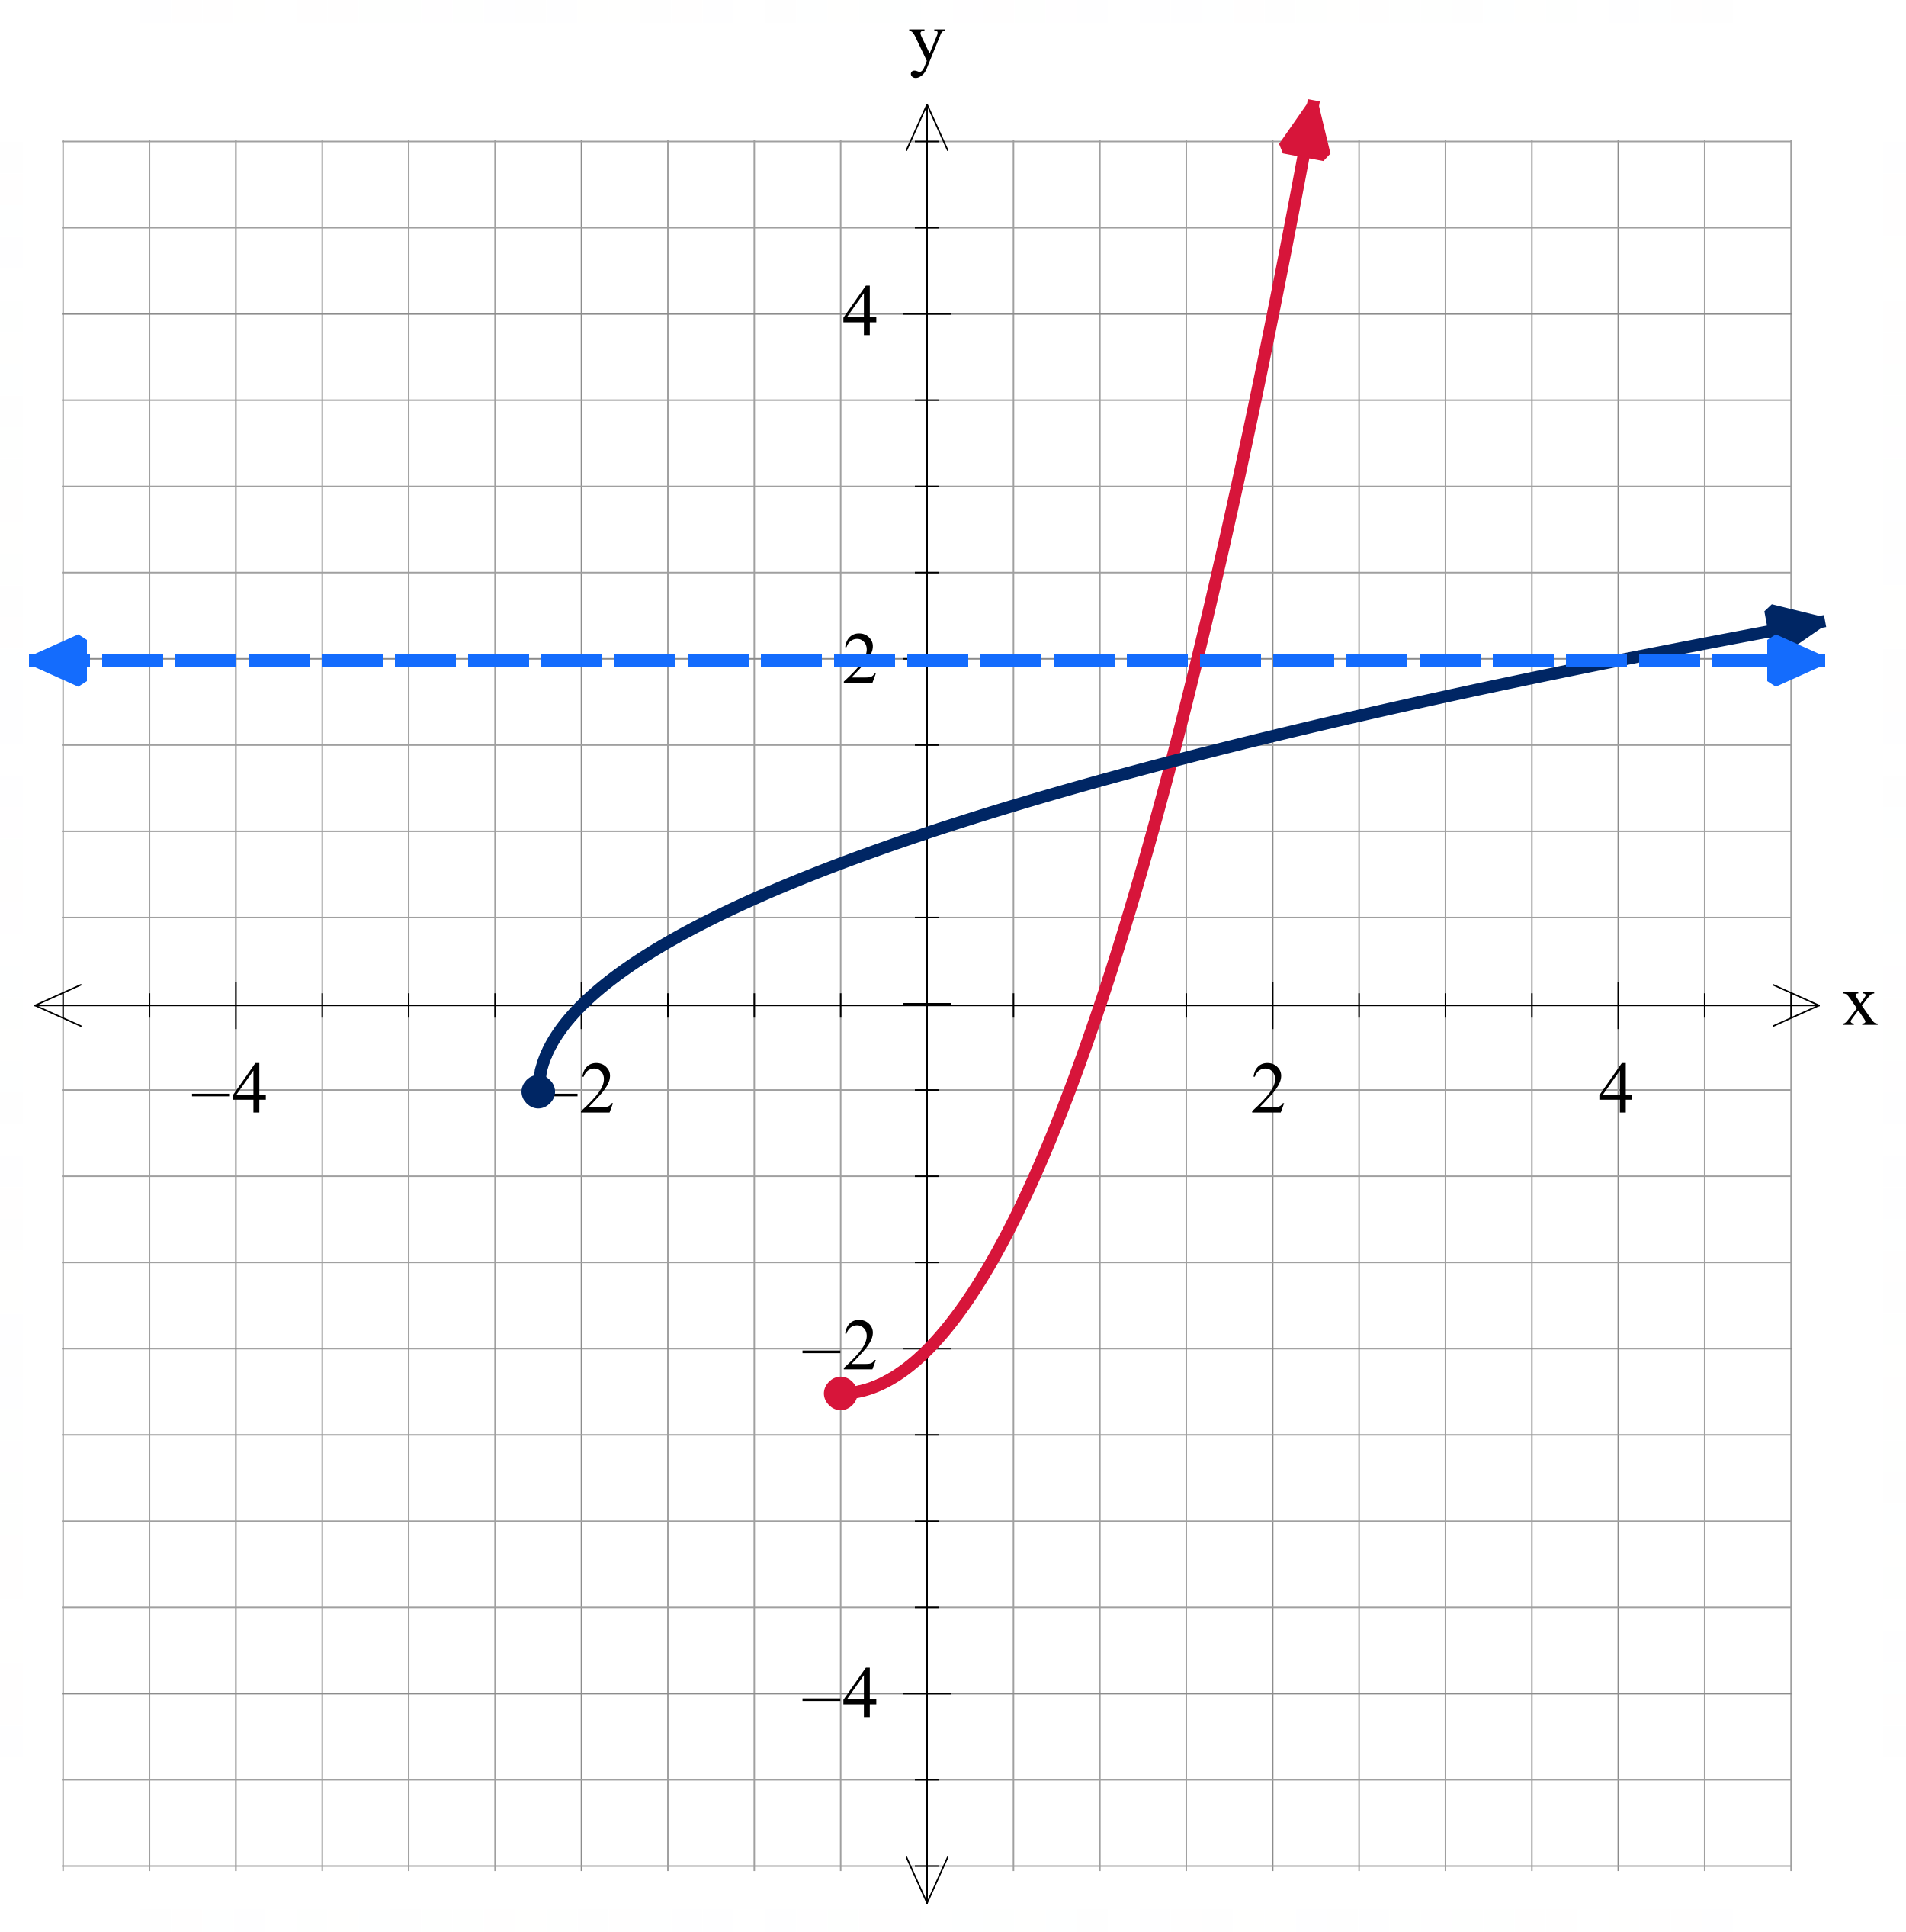 | $$f(x)=x{\left(x-1\right)}^{2}$$  With domain restriction $$x≥1$$  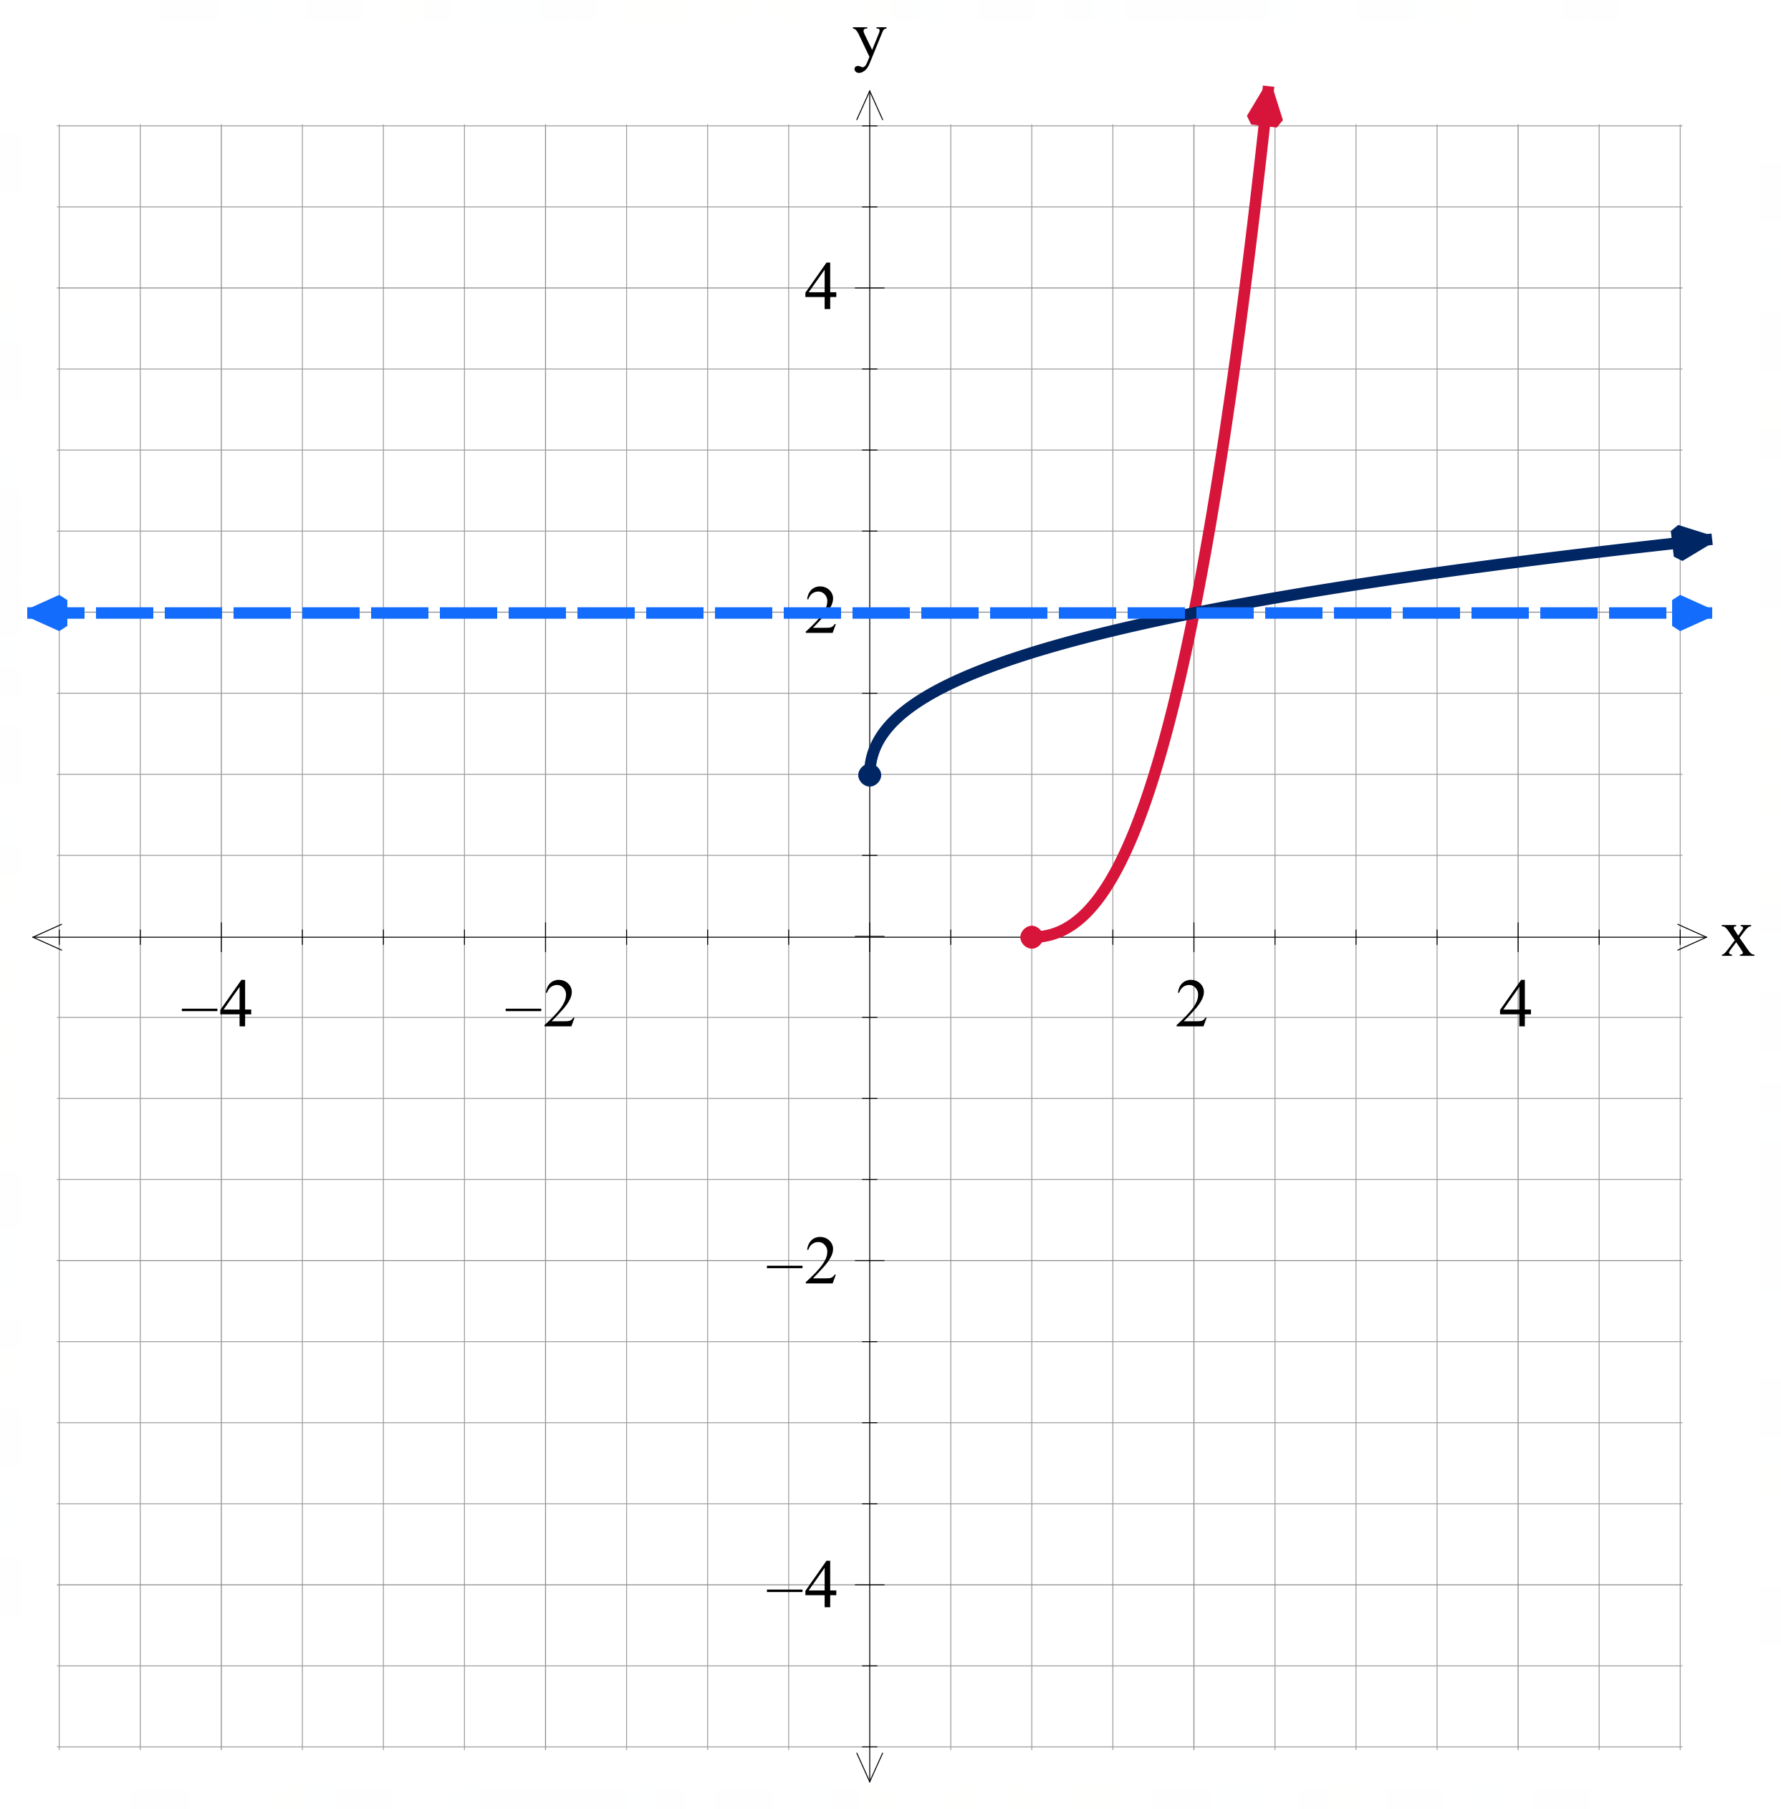 | $$f(x)=\sqrt{4-x^{2}}$$  With domain restriction $$x≤0$$  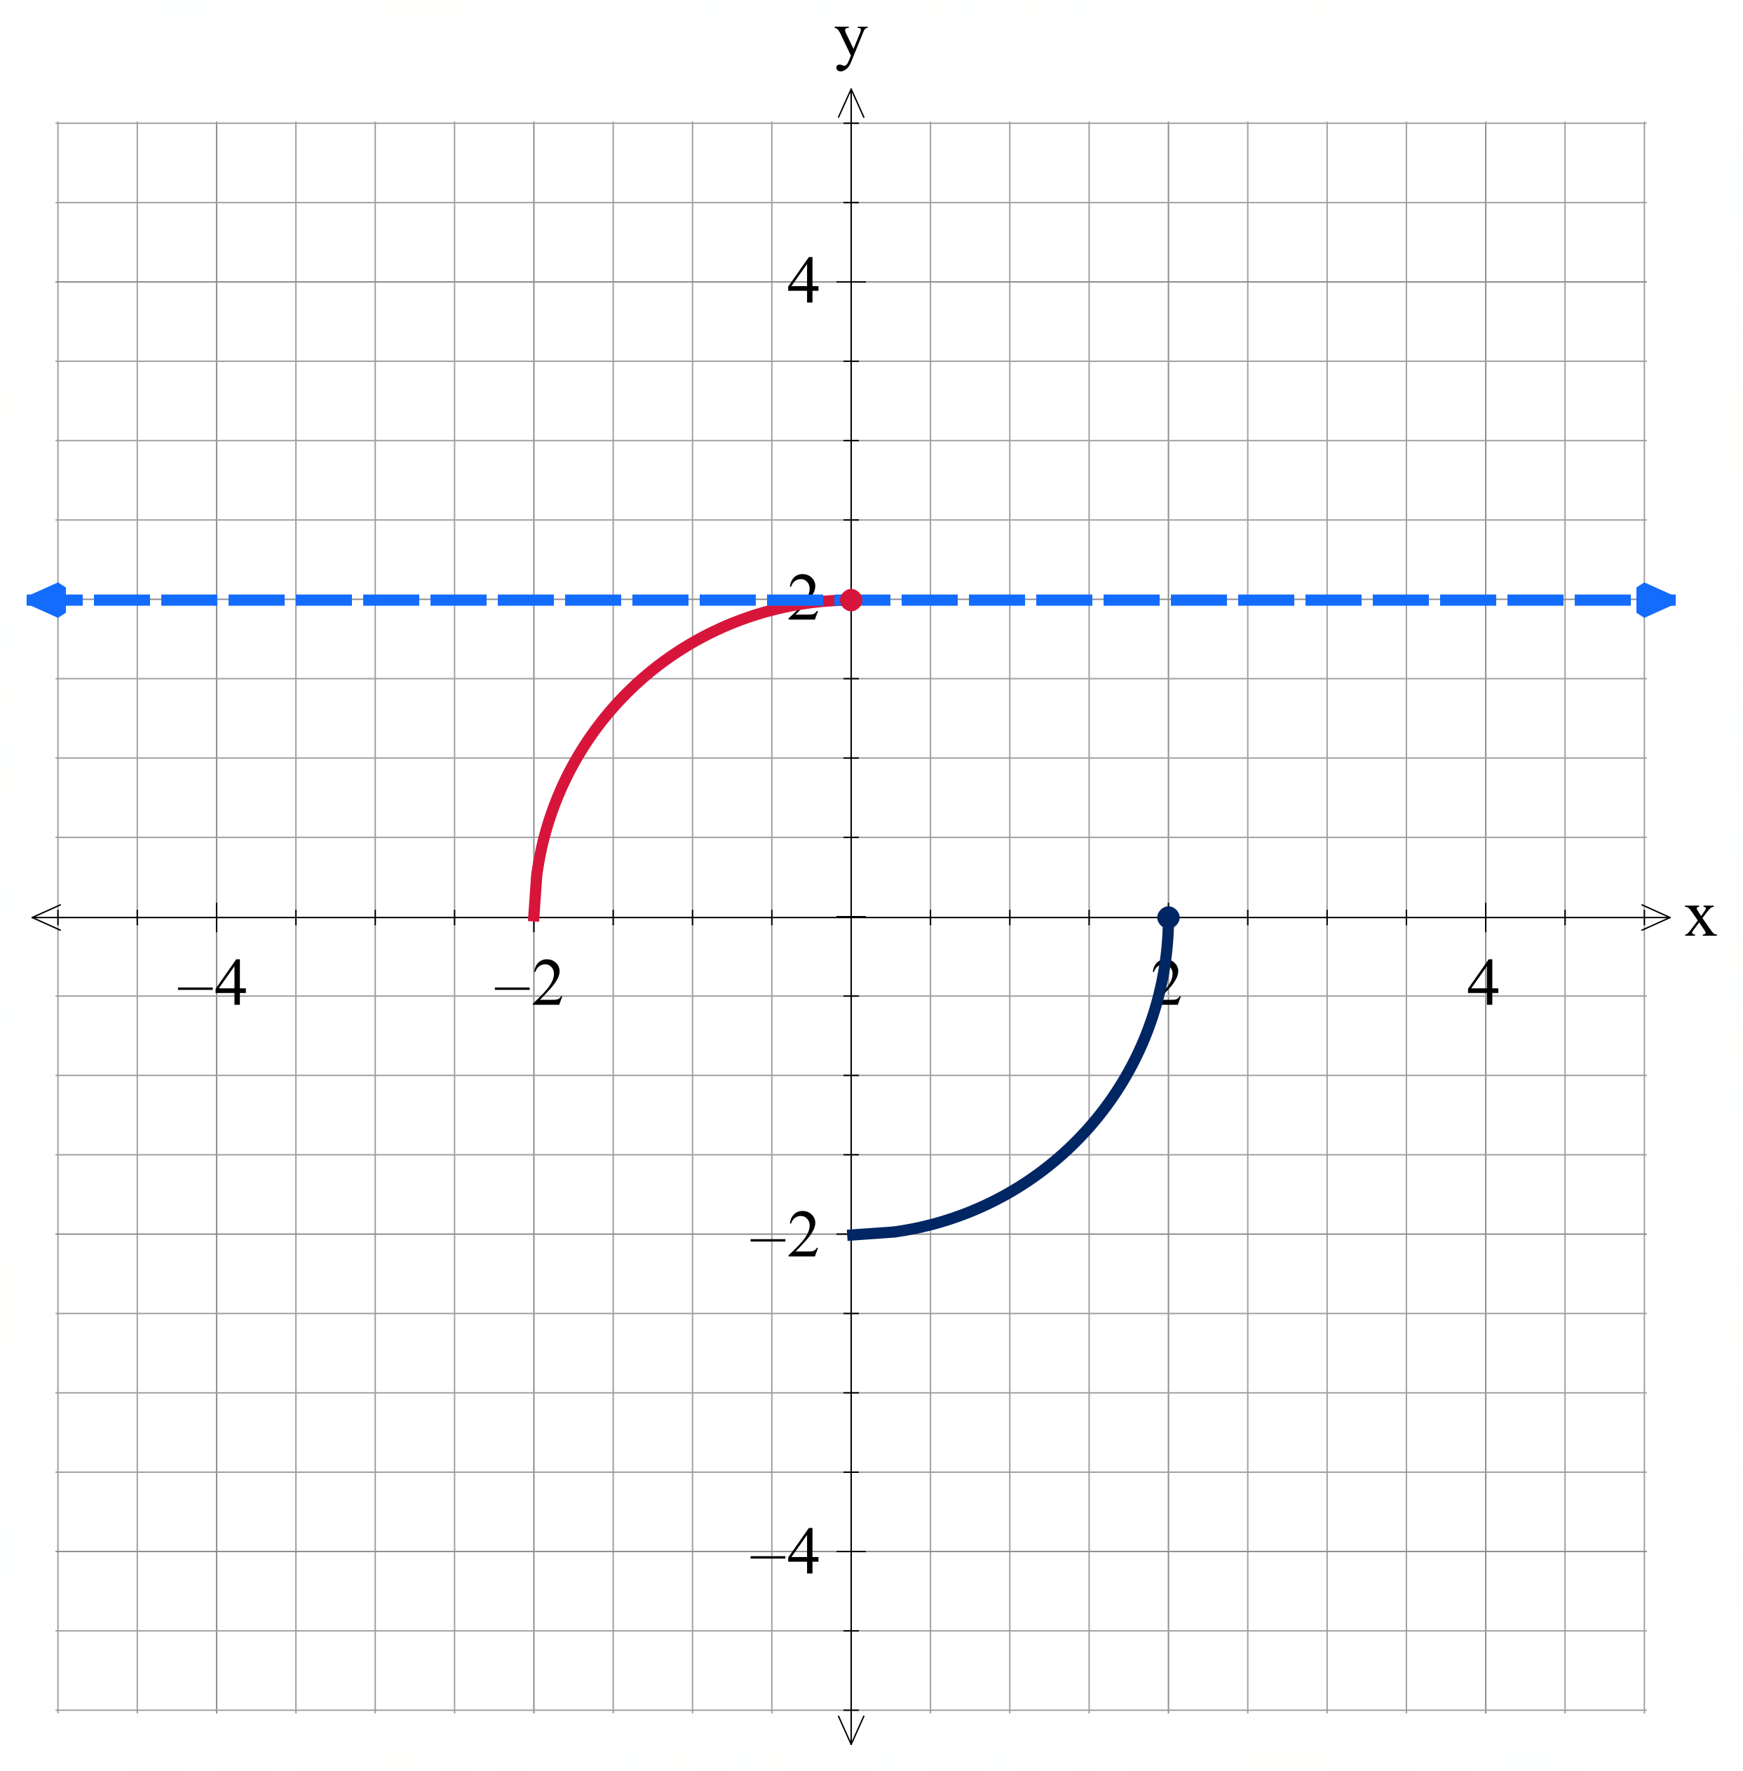
$$f(x)=(3-x)(x-1)(x+1)$$  With domain restriction $$x≤-0.1555$$  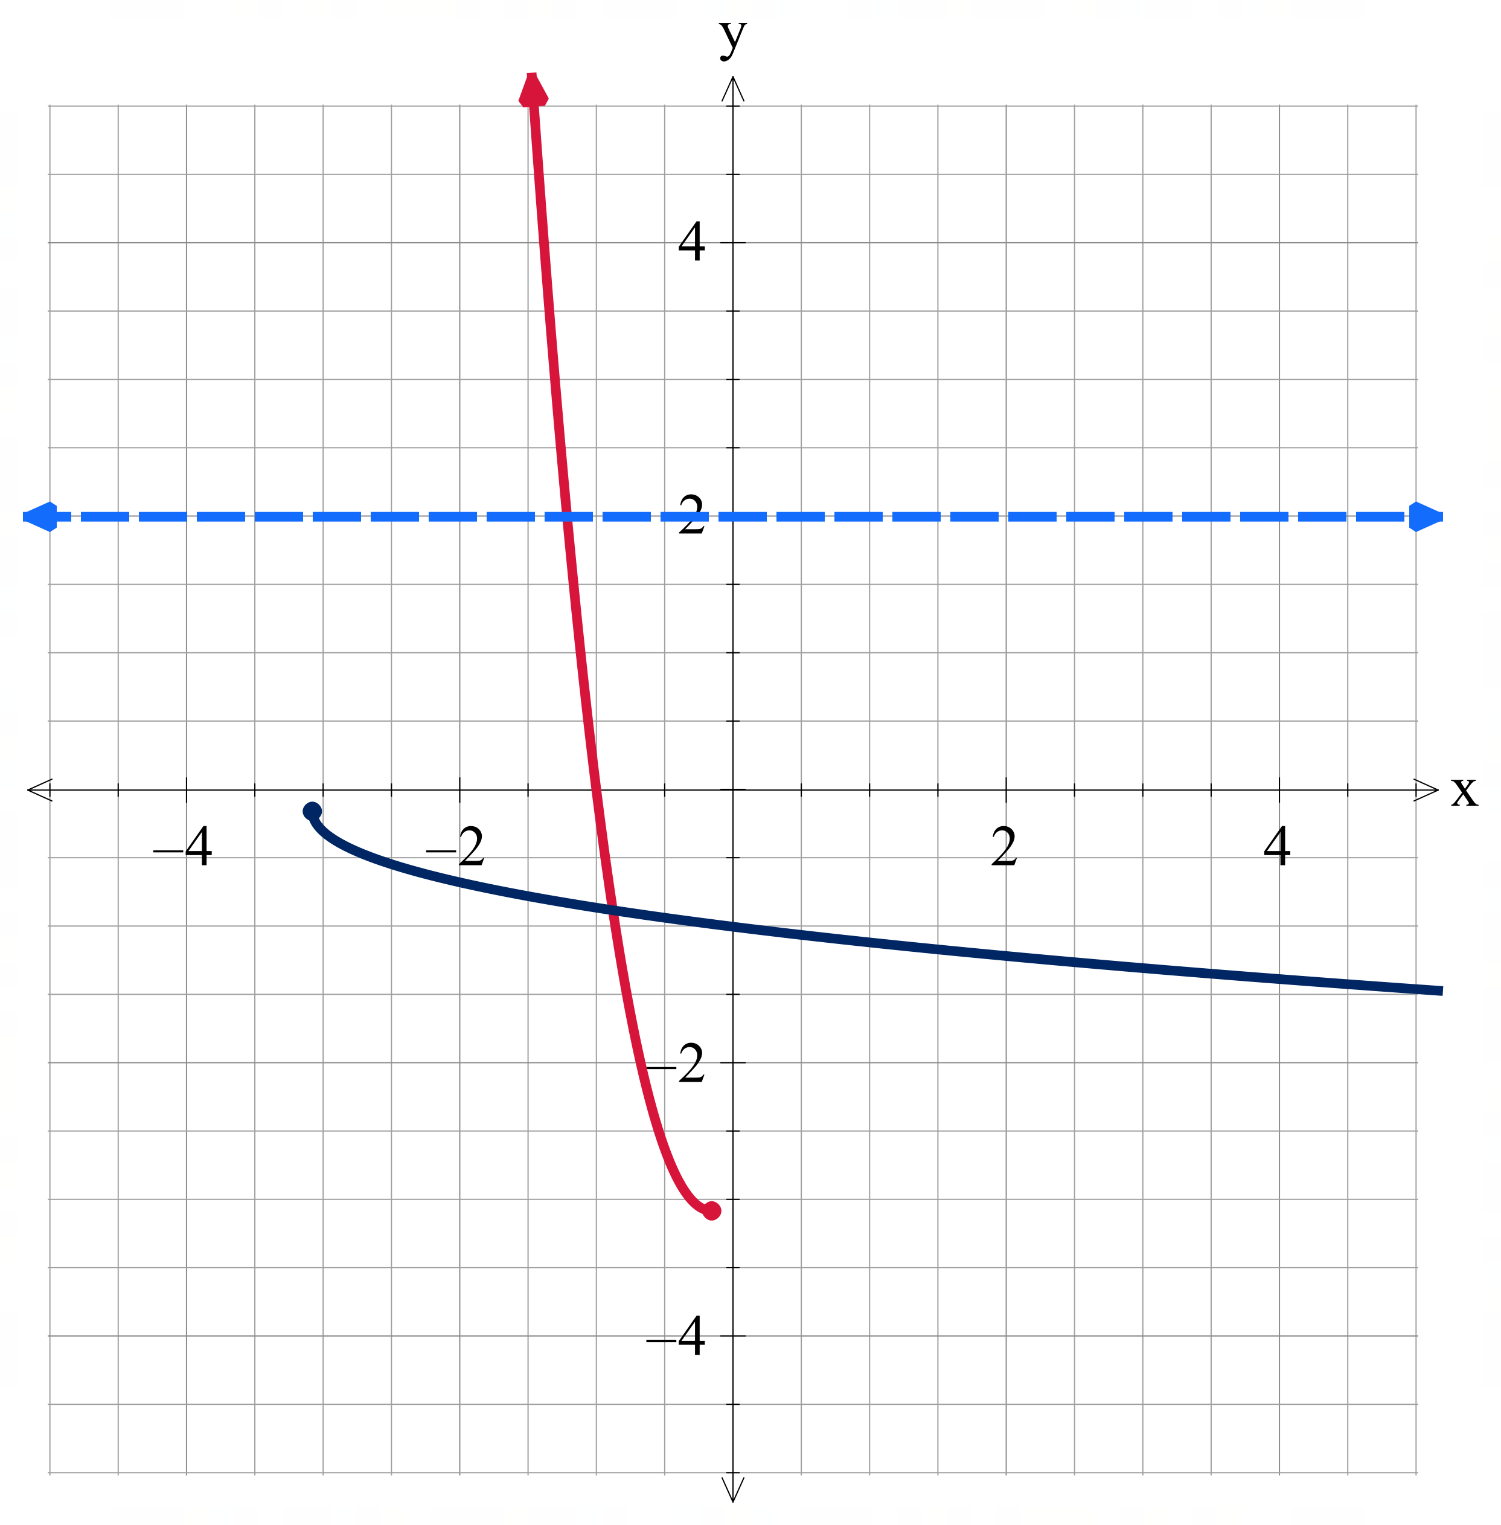 | $$f\left(x\right)=\left\{\begin{aligned}x+3 for x≤2 \\ 9-x^{2} for x>2\end{aligned}\right.$$  With domain restriction $$x≥2$$  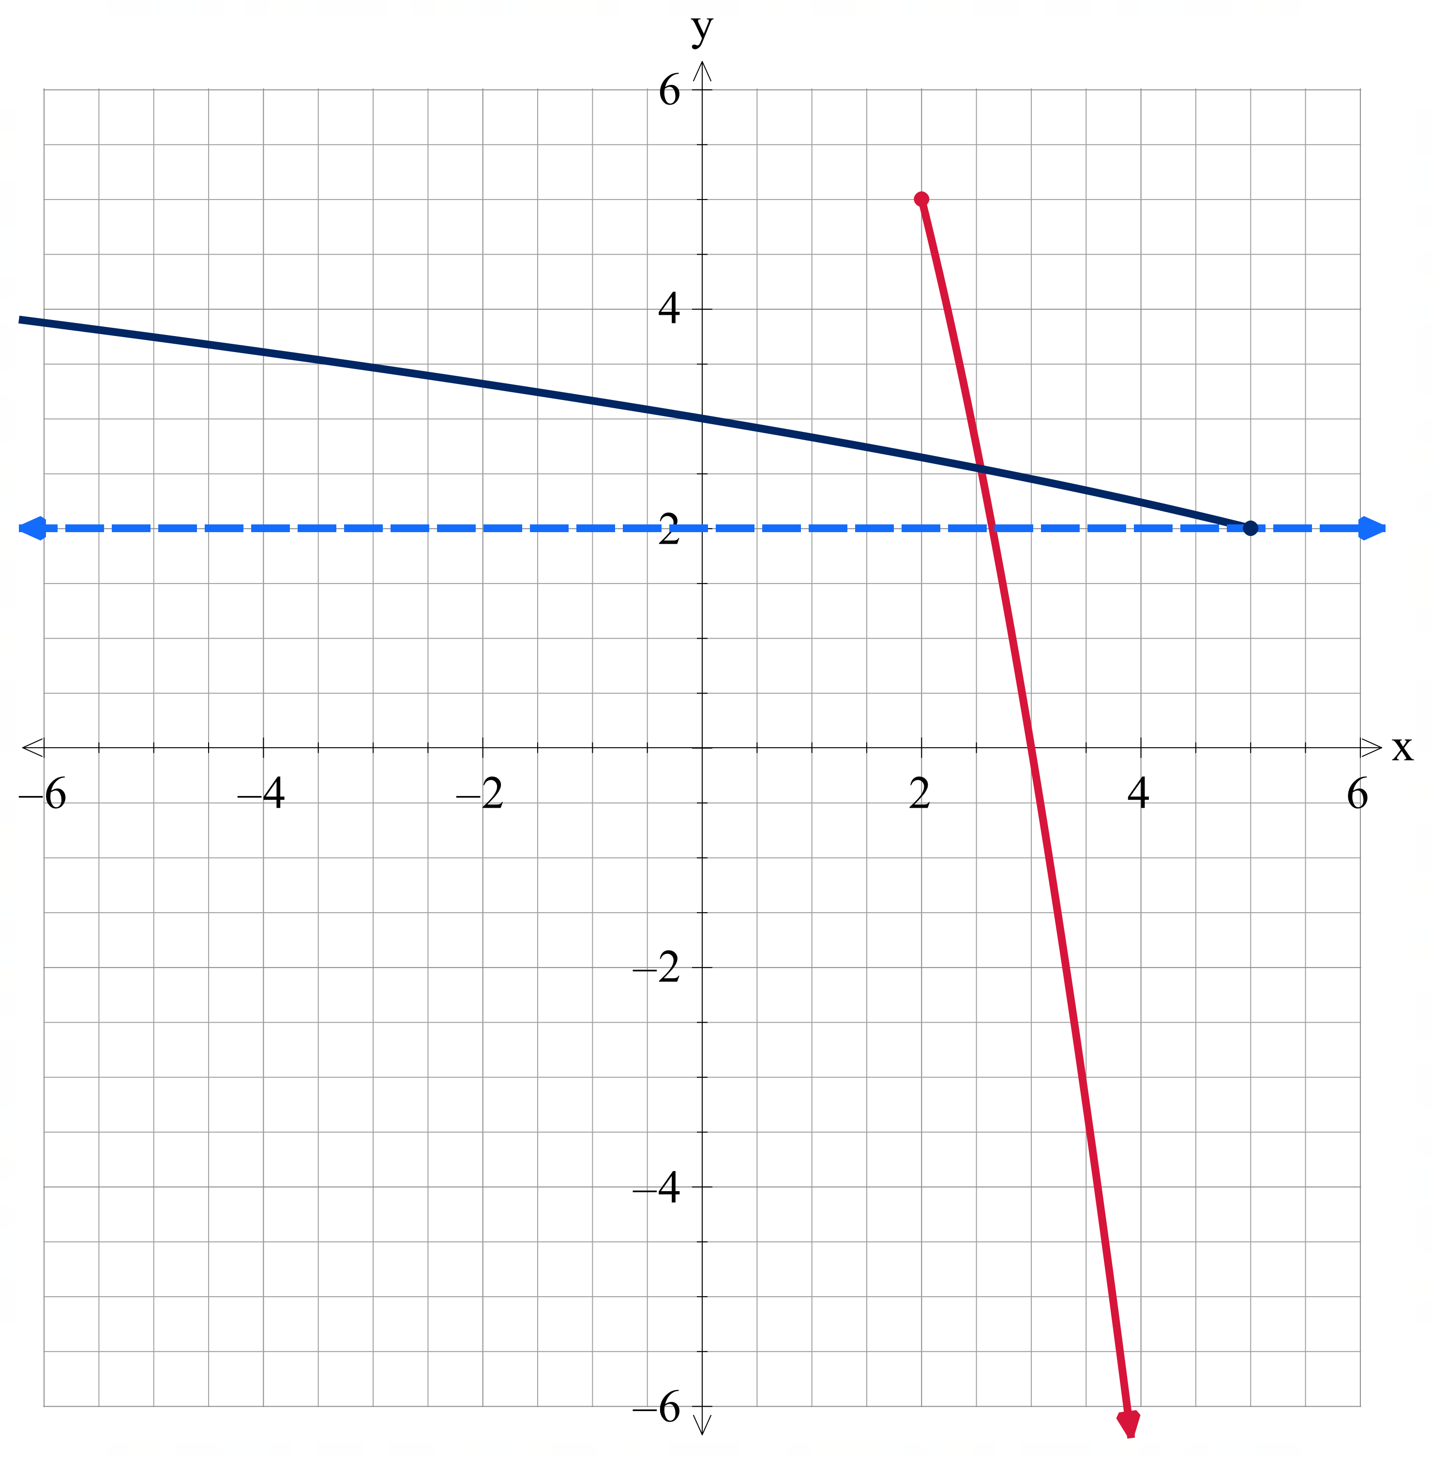 | $$f\left(x\right)=\left\{\begin{aligned}x+3 for x>2 \\ x^{2}+1 for x≤2\end{aligned}\right.$$  With domain restriction $$x≥0$$  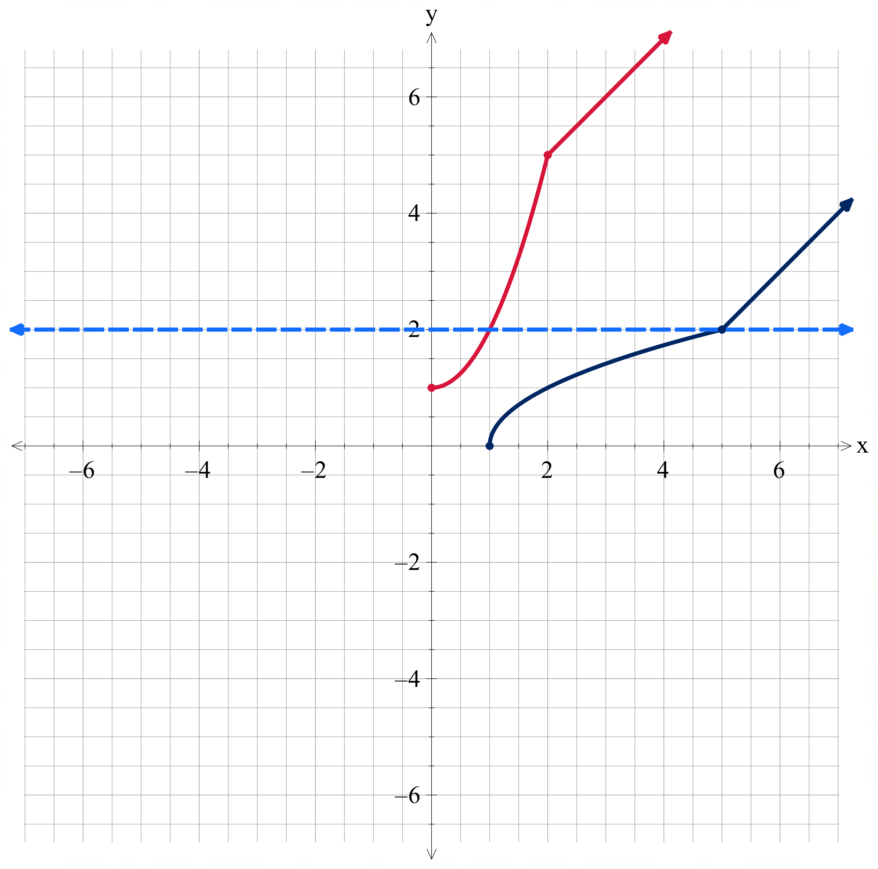

Functions that are not one-to-one (but the graph inverse hasn’t been graphed)
$$f(x)=-2$$
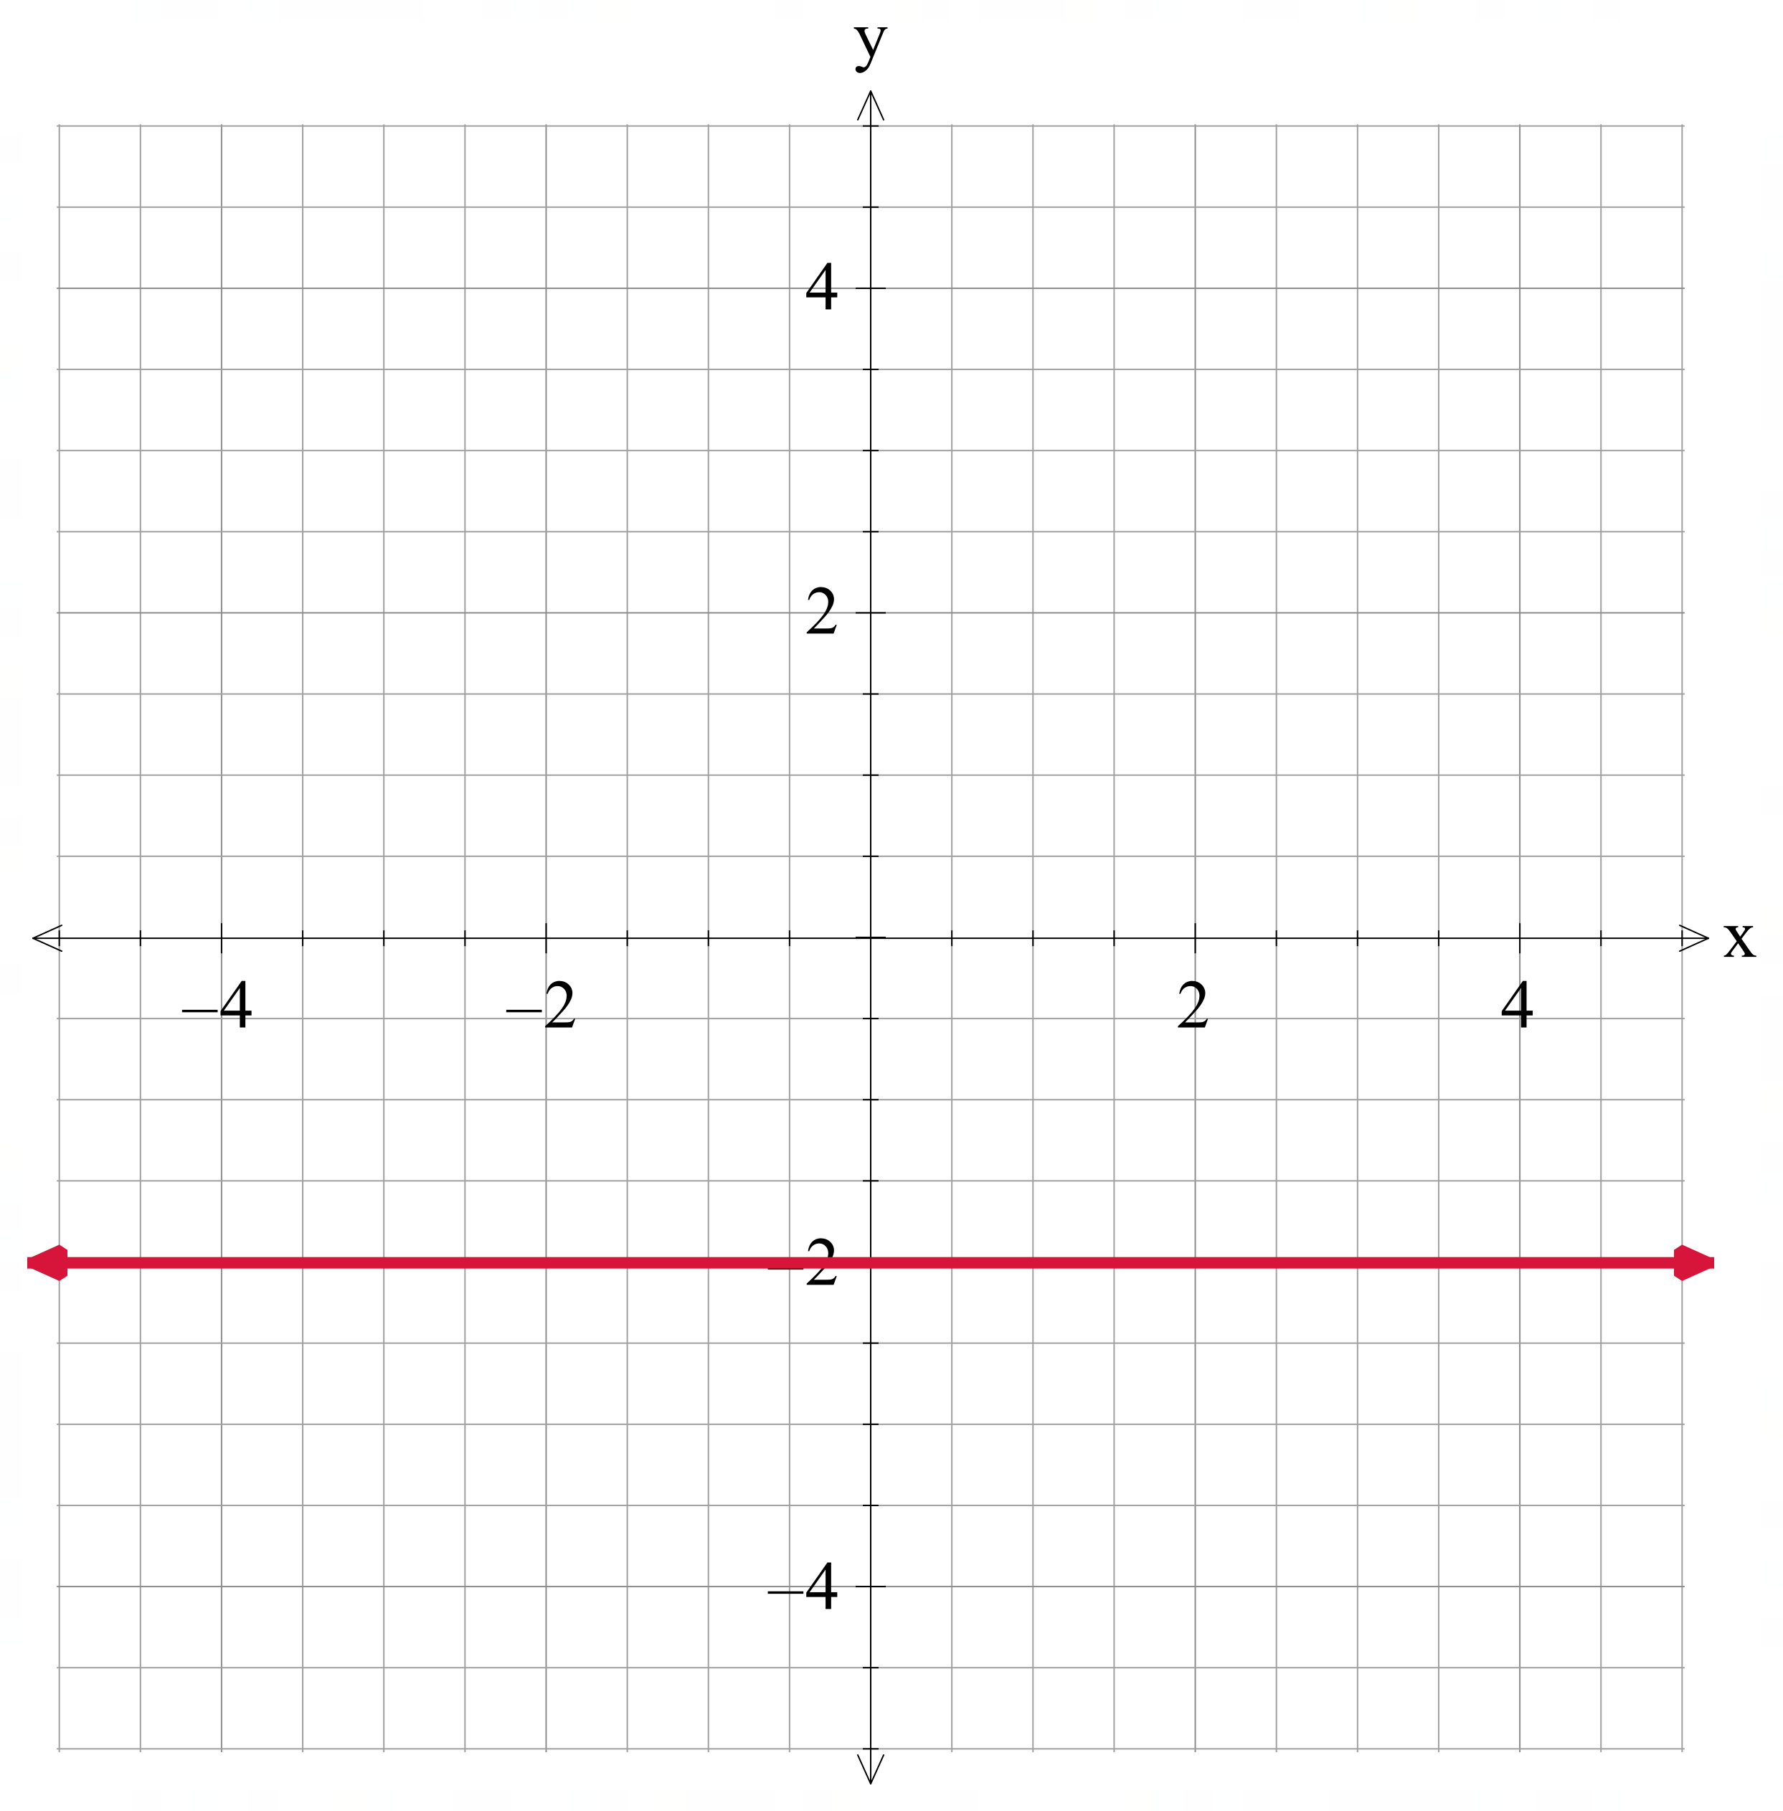

Relations that are not functions
$$x=4$$  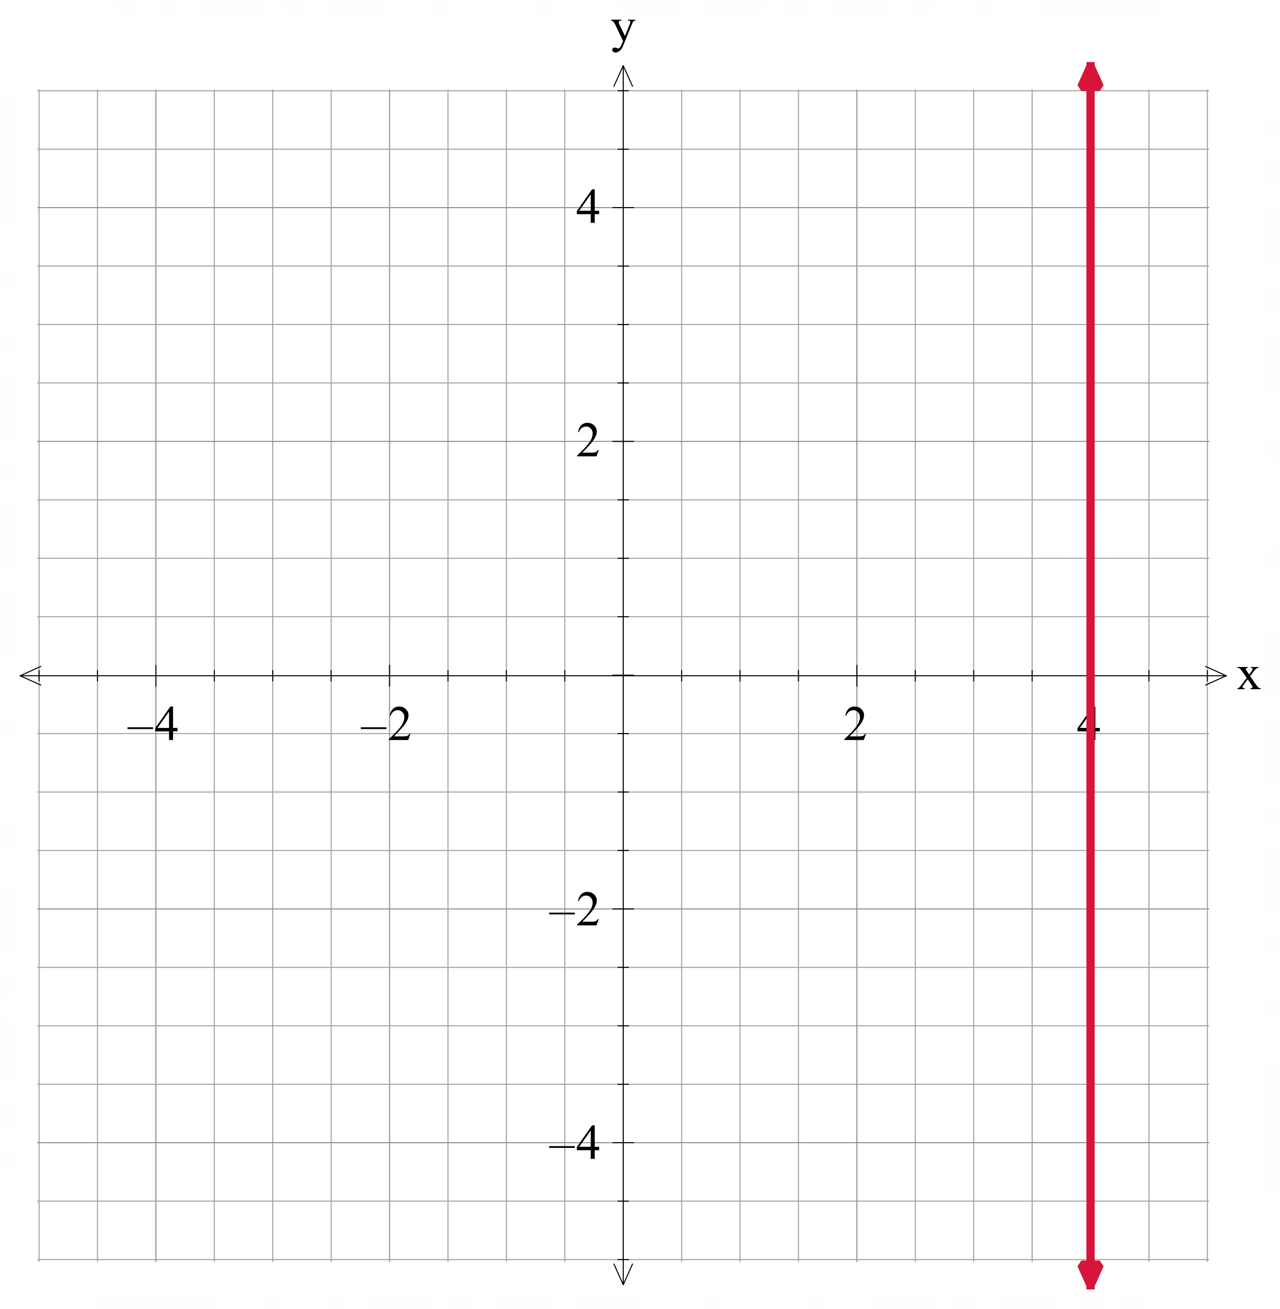 | $$x^{2}+y^{2}=16$$  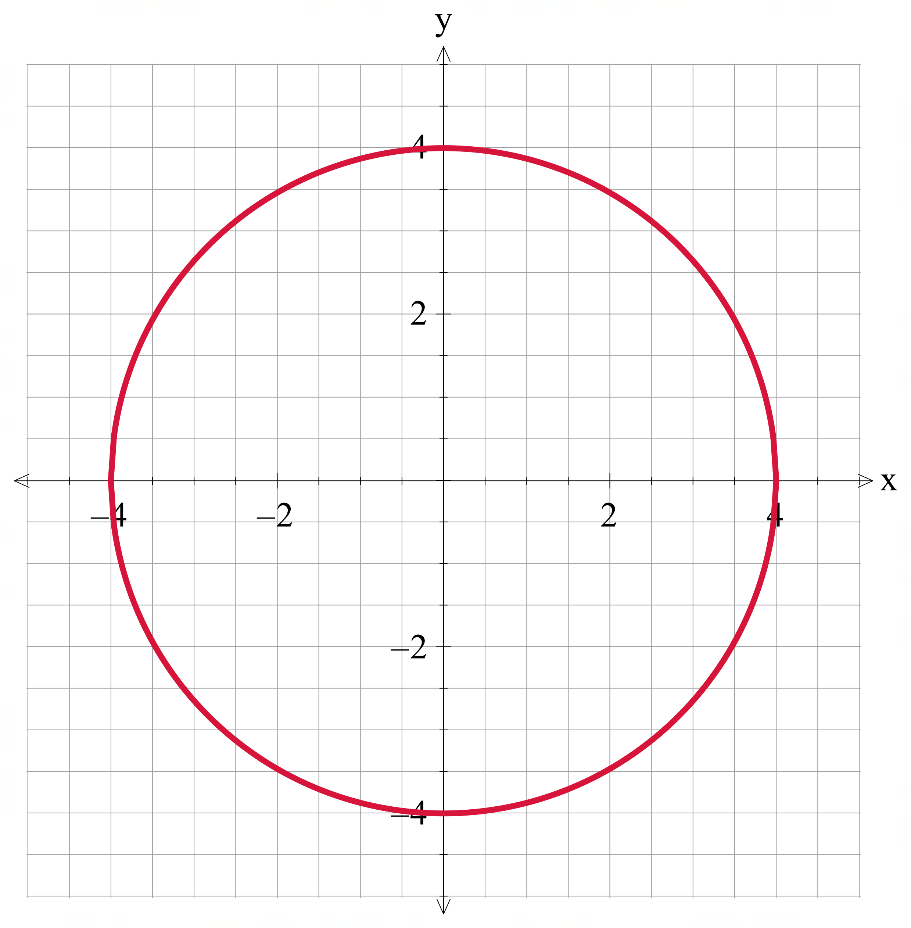

Appendix D – exit ticket
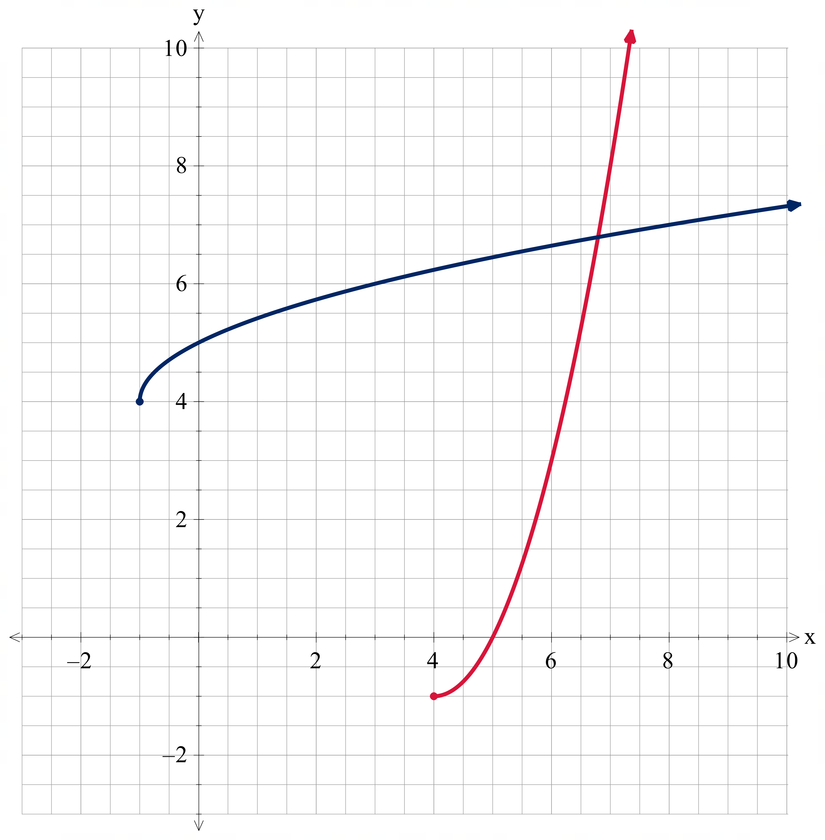

References
This resource contains NSW Curriculum and syllabus content. The NSW Curriculum is developed by the NSW Education Standards Authority (NESA). This content is prepared by NESA for and on behalf of the Crown in right of the State of New South Wales. The material is protected by Crown copyright.
Please refer to the NESA Copyright Disclaimer for more information https://www.nsw.gov.au/education-and-training/nesa/copyright.
NESA holds the only official and up-to-date versions of the NSW Curriculum and syllabus documents. Please visit NESA https://www.nsw.gov.au/education-and-training/nesa and NSW Curriculum https://curriculum.nsw.edu.au.
Mathematics Extension 1 11–12 Syllabus © NSW Education Standards Authority (NESA) for and on behalf of the Crown in right of the State of New South Wales, 2024

© State of New South Wales (Department of Education), 2026
The copyright material published in this resource is subject to the Copyright Act 1968 (Cth) and is owned by the NSW Department of Education or, where indicated, by a party other than the NSW Department of Education (third-party material).
Copyright material available in this resource and owned by the NSW Department of Education is licensed under a Creative Commons Attribution 4.0 International (CC BY 4.0) license.

This license allows you to share and adapt the material for any purpose, even commercially.
Attribution should be given to © State of New South Wales (Department of Education), 2026.
Material in this resource not available under a Creative Commons license:
- the NSW Department of Education logo, other logos and trademark-protected material
- material owned by a third party that has been reproduced with permission. You will need to obtain permission from the third party to reuse its material.
Links to third-party material and websites
Please note that the provided (reading/viewing material/list/links/texts) are a suggestion only and implies no endorsement, by the New South Wales Department of Education, of any author, publisher, or book title. School principals and teachers are best placed to assess the suitability of resources that would complement the curriculum and reflect the needs and interests of their students.
If you use the links provided in this document to access a third-party's website, you acknowledge that the terms of use, including licence terms set out on the third-party's website apply to the use which may be made of the materials on that third-party website or where permitted by the Copyright Act 1968 (Cth). The department accepts no responsibility for content on third-party websites.

