Reflecting in the line $y=x$
Students examine the relationships between functions and their reflections in the line $y=x$. They informally define an inverse function and develop strategies to check if 2 graphs have been reflected in the line $y=x$.
Students will need at least one digital device per pair to interact with Amplify Classroom during this lesson.

Learning intentions
- To know that a reflection in the line $y=x$ reverses the coordinates of a point.
- To understand that functions reflected in the line $y=x$ are inverse functions.

Success criteria
- I can identify graphs that have been reflected in the line $y=x$.
- I can reflect the equation of a graph in the line $y=x$.
- I can informally determine an inverse function from a graph or table of values.

Outcomes
A student:
- develops understanding and fluency in mathematics through exploring and connecting mathematical concepts, choosing and applying mathematical techniques to solve problems, and communicating their thinking and reasoning coherently and clearly MAO-WM-01
- solves problems involving inequalities, functions and their inverses, graphical relationships between functions, and parametric equations ME1-11-01

Content

Inverse functions
- Establish that the reflection of a point in the line $y=x$ reverses the coordinates of the point
- Define an inverse function $f^{-1}$ informally as a function that reverses or undoes the effect of the function $f$
- Compare the graphs of a function and its inverse function using graphing applications, and recognise that the two graphs are reflections of each other in the line $y=x$
Mathematics Extension 1 Stage 6 Syllabus © NSW Education Standards Authority (NESA) for and on behalf of the Crown in right of the State of New South Wales, 2024

Table 1: lesson summary
Section | Summary of activity | Teaching strategies | Teaching points
Activating prior knowledge | Using slide 4 of the PowerPoint, students identify reflections across the $x$- and $y$-axis along with their equations before completing Appendix A. | Notice and wonder  Mini whiteboards | Review student understanding of reflections across the axis.
Connecting learning | Using the Amplify Classroom activity (bit.ly/ReflectInTheLineYEqualsX) students establish that the reflection of a point in the line $y=x$ reverses the coordinates. Students begin to informally define an inverse function. Slide 6 displays graphs to help identify patterns | Pose-Pause-Pounce-Bounce | Students establish that a point reflected in the line $y=x$ has its coordinates reflected.
Releasing responsibility | Using slide 8, students complete a table of values to observe how an inverse function undoes the effect of a function before showing the informal definition. Slide 9 and Appendix B has students comparing 2 methods to determine if an equation is the inverse of another before annotating Appendix B to create notes. | Think-Pair-Share  Worked example comparison  Notes to future forgetful selves | Students informally define an inverse function as a function that undoes the effect of the original function.
Independent practice | Using screen 10–13 in the Amplify classroom, students identify which graph is the correct reflection in the line $y=x$. Students then discuss the differences between the graph in screen 13 and the graphs in screens 10–12. | Notice and wonder | Students use graphs to identify the inverse function and start to consider why restricting the domain is necessary to ensure that the inverse graph is a function.

Activity structure
Please use the associated PowerPoint Reflecting in the line y=x to display images in this lesson.

Activating prior knowledge
- Display slide 4 of the PowerPoint and ask students what they notice and wonder (bit.ly/noticewonderstrategy) about the graphs with the solid blue and black lines when compared to the graph with the dashed line.
Students should recognise that the 2 solid graphs are reflections across the $x$- and $y$-axis.
- Click to animate slide 4 to reveal the equation of the graph. Distribute mini whiteboards (bit.ly/miniwhiteboards) to each pair of students and have them write down the equation of each reflected function.
- Animate slide 4 to reveal each equation.
Students learnt about reflections in Lesson 4 – reflection of Mathematics Advanced Unit 4 – graphing transformations.
- Distribute Appendix A ‘Reflections across the axis’ for students to complete in their pairs.

Connecting learning
- With at least one device per pair, assign the Amplify Classroom activity ‘Reflecting in the line y=x’ (bit.ly/ReflectInTheLineYEqualsX) for students to complete screens 1–5.
Before doing this activity, you will need to set up an Amplify Classroom (bit.ly/createamplifyclassroom) and use the pacing feature to restrict the students to screens 1–5.
Amplify Classroom provides the opportunity for immediate feedback as well as tailored feedback from the teacher as students progress.
- Use the Pose-Pause-Pounce-Bounce questioning strategy (PDF 557KB) (bit.ly/posepausepouncebounce) to lead a class discussion around what students observed from screens 1–5. Some prompts include:
- When the graph was reflected across the $x$- or $y$-axis, what did you notice about the distance between the reflected coordinates and the axis of reflection?
- How did you know that the graph in screen 4 was reflected in the line $y=x$?
- What happens to the coordinates when a point is reflected in the line $y=x$?
Slide 6 of the PowerPoint can be used to display screenshots of screens 2–4 to provide a visual prompt for the discussion.
- Extend the pacing in the Amplify Classroom activity to screens 6–8 where students identify if 2 functions have been reflected in the line $y=x$.
Screens 6–8 gradually release responsibility showing how to determine if a graph is reflected in the line $y=x$.
- Extend the pacing to screen 9 and ask students what they notice about the equations of the functions that were a reflection in the line $y=x$.
Students may notice that functions that are reflected across the line $y=x$ have inverse operations and reversed coordinates and wonder if this is always the case for more complex functions.
Screens 10–13 of the Amplify classroom activity will be used later in the Independent practice section of the lesson.

Releasing responsibility
- Display slide 8 of the PowerPoint and have students complete the table of values for both functions on their mini whiteboards.
- Ask students in a Think-Pair-Share (bit.ly/thinkpairsharestrategy) to consider if these 2 functions represent a reflection in the line $y=x$.
- Animate slide 8 to informally define an inverse function as a function that reverses or undoes the effect of the original function.
- Ask students to discuss in a Think-Pair-Share how they can determine if a function is the inverse of another function.
Students may suggest that they can use inverse operations to determine the inverse function and use a table of values to confirm this.
- Distribute Appendix B ‘Worked example comparison’ to show how to determine if 2 functions are the inverse of each other using a graph and a table of values.
- Lead a class discussion around what is similar and different for each method. Slide 9 can be used to aid discussion.
Students should recognise that both methods verify the inverse function. The graphical method involves sketching both functions and then determining whether they are a reflection in the line $y=x$ while the table of values method requires students to select and test corresponding coordinates.
- Have students annotate Appendix B to create notes for their future forgetful selves (bit.ly/notestofutureself).

Independent practice
- Have students practise reflecting functions in the line $y=x$ from an existing resource.
- Extend the Amplify Classroom activity to screens 10–13 for students to determine the inverse graph using the reflection in the line $y=x$.
- Ask students to notice and wonder about the difference between the graphs in screens
10–13.
Students may notice that all the graphs are functions. However the graph in screen 13 has no restriction while the graphs in screens 10–12 have a restricted domain. They may notice that in screen 13, the reflection is a relation while in screens 10–12, the reflections are functions.
Students will learn about one-to-one functions in Lesson 3 of this unit.

Assessment and differentiation

Suggested opportunities for differentiation
Activating prior knowledge
- Teachers may wish to use a simpler function to support students as they recall how to reflect a function across the axis.
Connecting learning
- Teachers may wish to use a simpler function in screens 2–5 if students find it difficult to see the reflections.
- Using Amplify Classroom allows the teacher to adjust the pacing to support student understanding.
- Teachers can print functions and use Mira mirrors in the line $y=x$ for students to sketch and test the reflections.
Releasing responsibility
- Support students by graphing the equations of $f(x)$ and $g\left(x\right)$ for them to see visually that the 2 functions are reflections of each other.
Independent practice
- Pause the Amplify Classroom activity between each screen for students to better unpack why the other solutions are not correct.

Suggested opportunities for assessment
Activating prior knowledge
- Monitor student responses on mini whiteboards to quickly gauge individual understanding and identify misconceptions relating to reflections across the $x$- and $y$- axis.
Connecting learning
- Using the teacher dashboard in the Amplify Classroom activity allows the teacher to monitor student progress and understanding of reflections.
- Monitor student responses in class discussions to check for student understanding of swapping coordinates when reflecting in the line $y=x$.
Releasing responsibility
- A Think-Pair-Share provides students with the opportunity to reflect on their understanding of an inverse function and how it relates to the reflection.
- Students will demonstrate their Working mathematically skills in discussions and justifications in Appendix B.

Appendix A

Reflections across the axis
Sketch each reflection and write the equation of the reflected graph.
Original graph | Reflection across the $y$-axis | Reflection across the $x$-axis
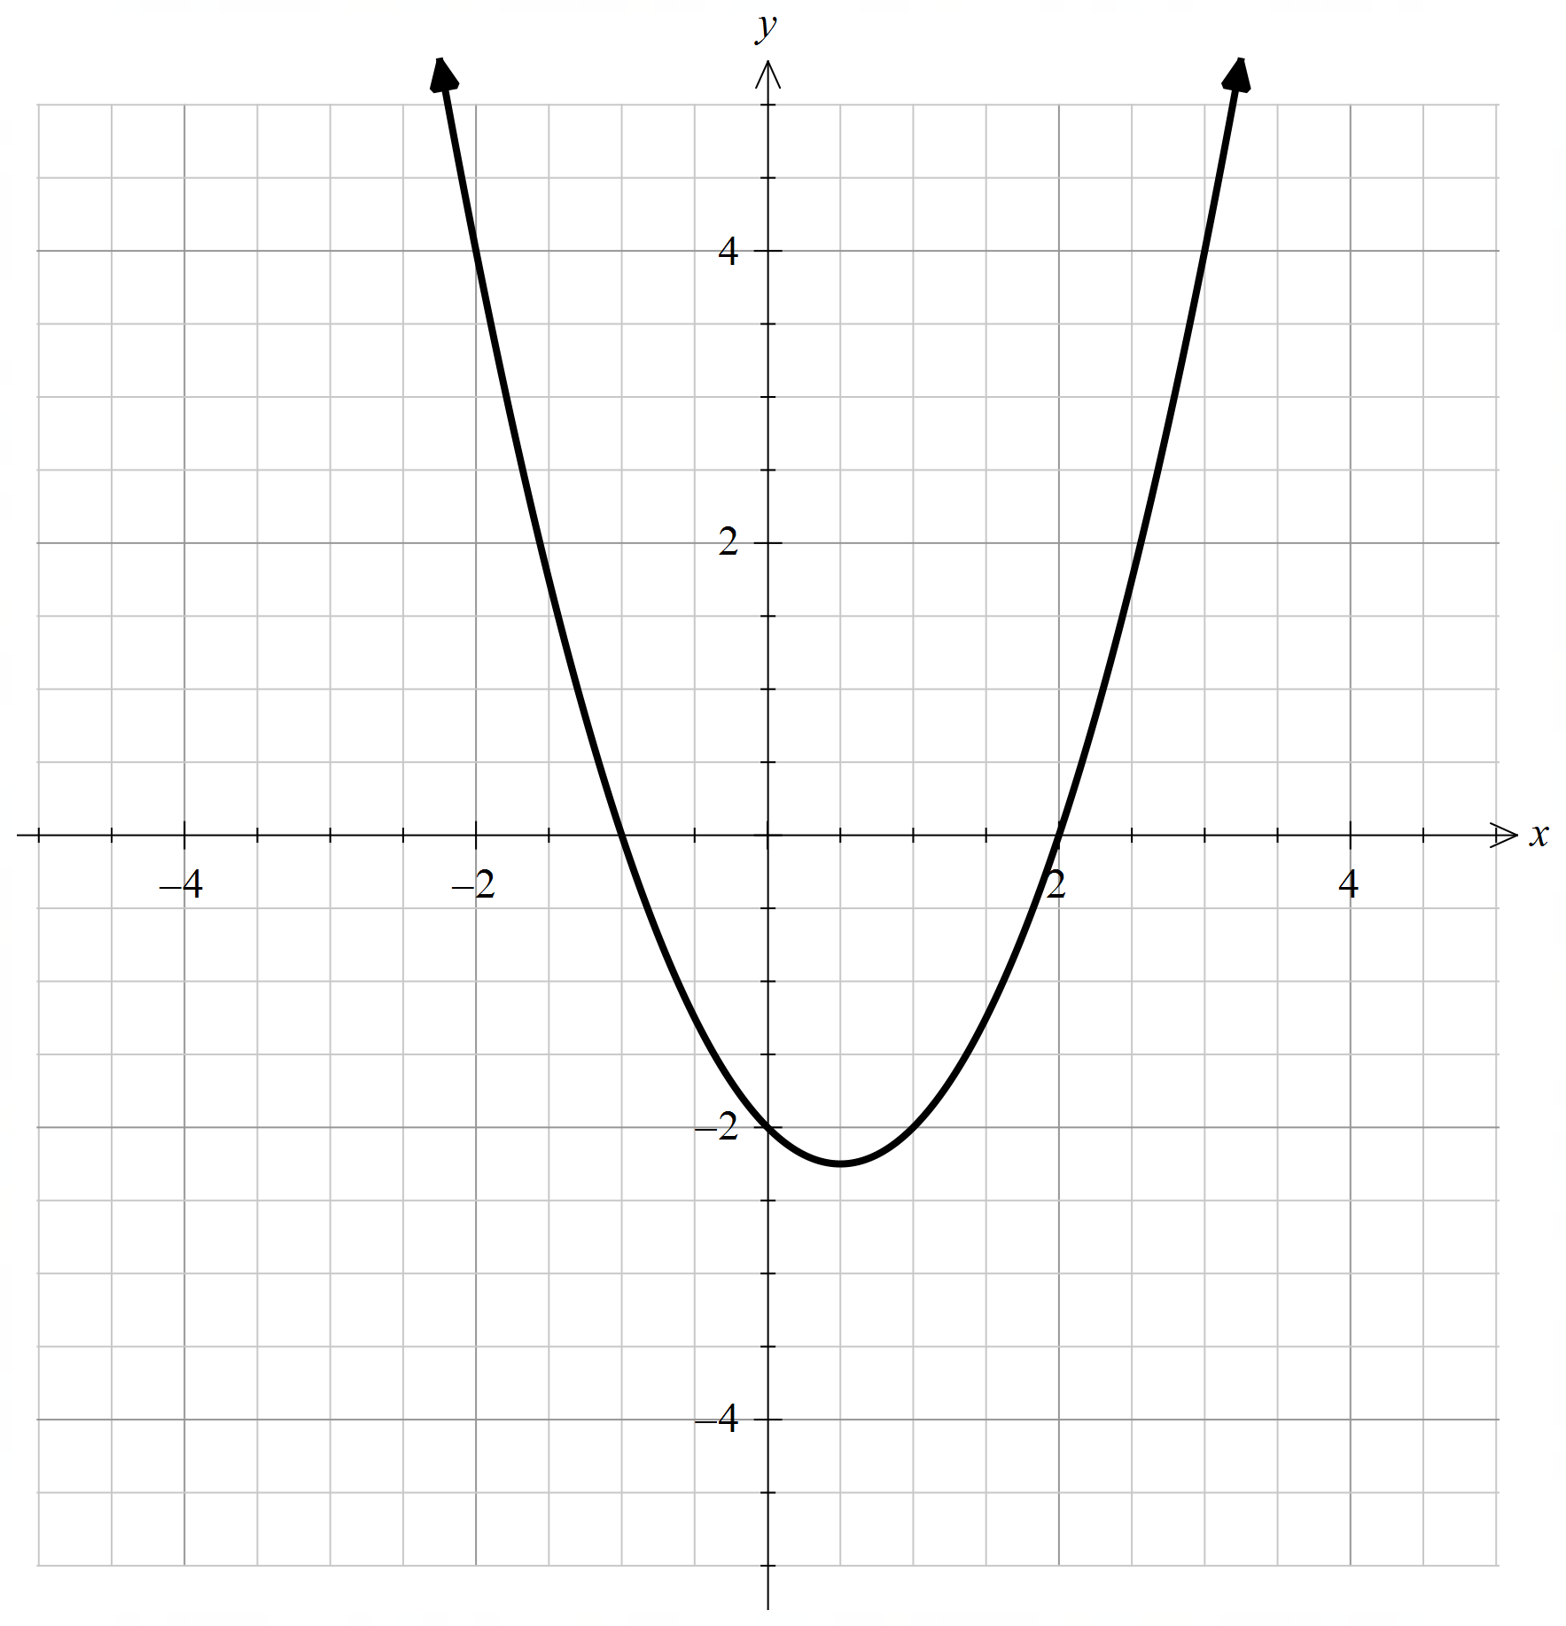  $$f\left(x\right)=(x-2)(x+1)$$ | 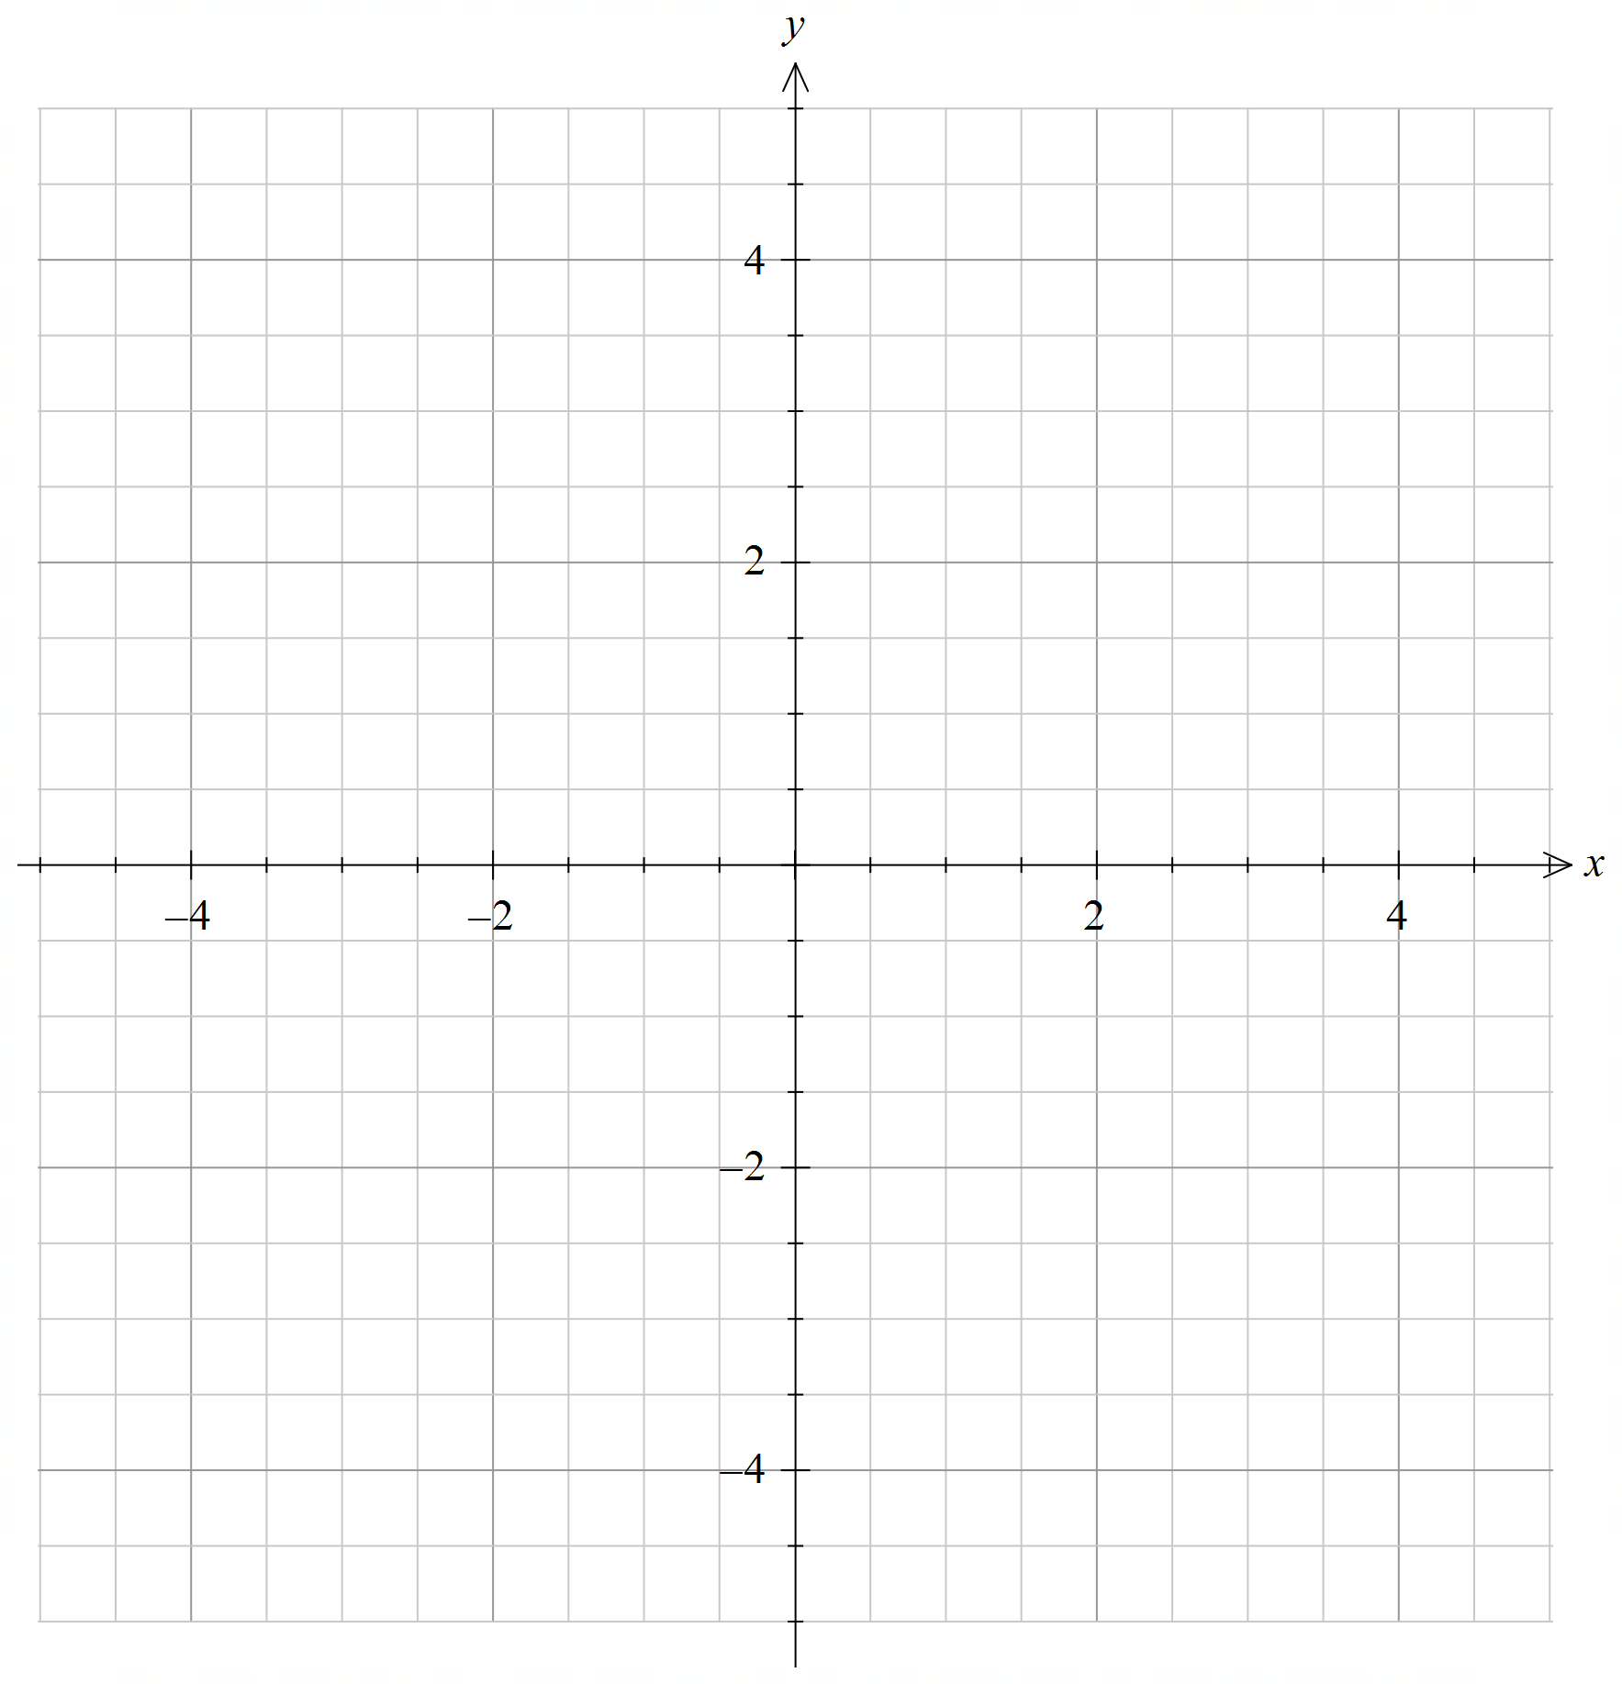
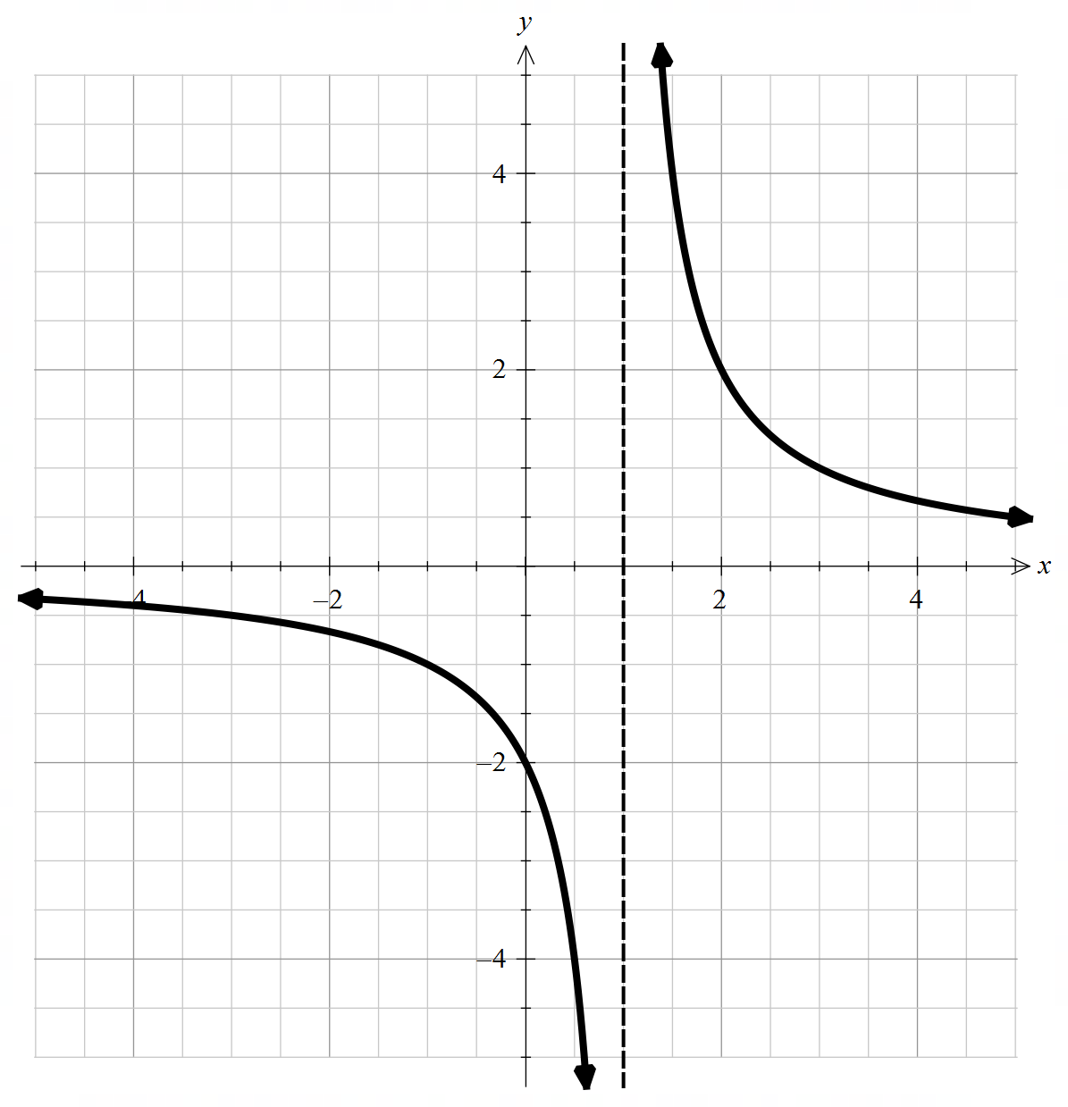
$$f\left(x\right)=\frac{2}{x-1}$$
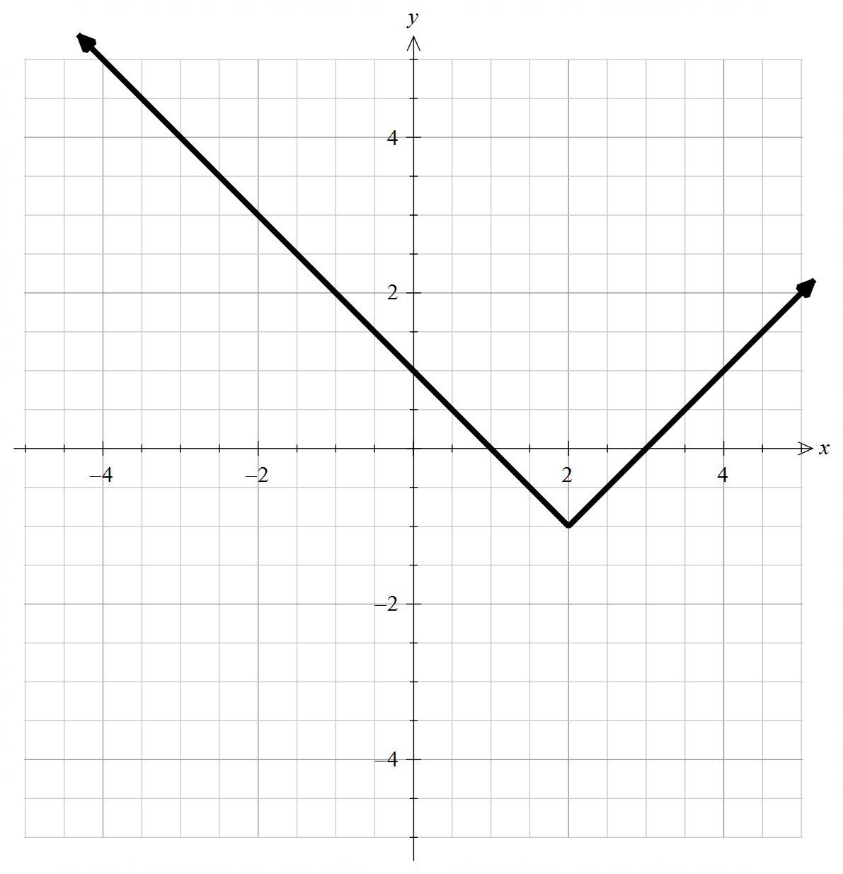
$$f\left(x\right)=\left|x-2\right|-1$$

Appendix B

Worked example comparison
Show that for the function $f\left(x\right)=\frac{1}{2}x+5$ that its inverse is $g\left(x\right)=2x-10$.
Graphical method  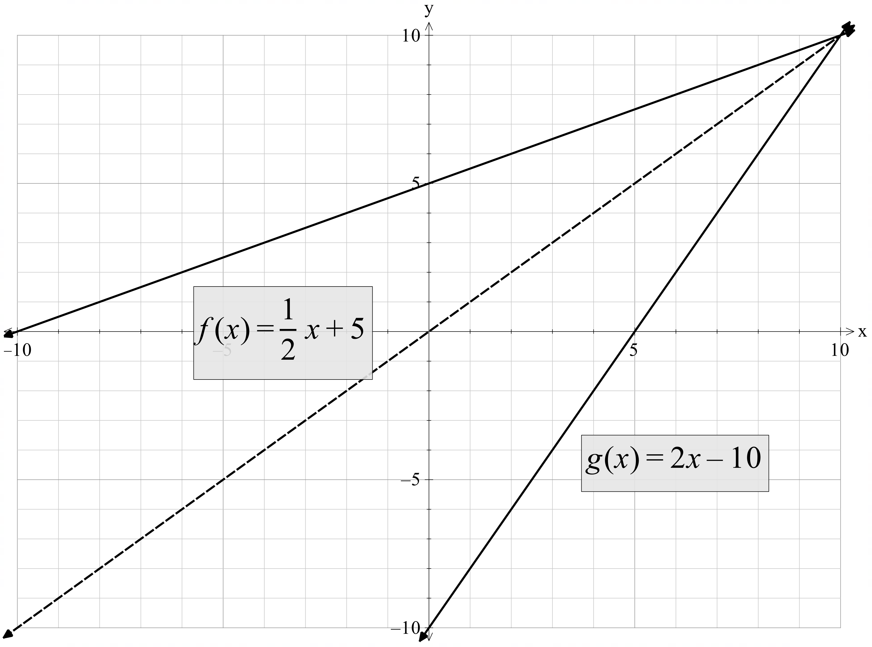  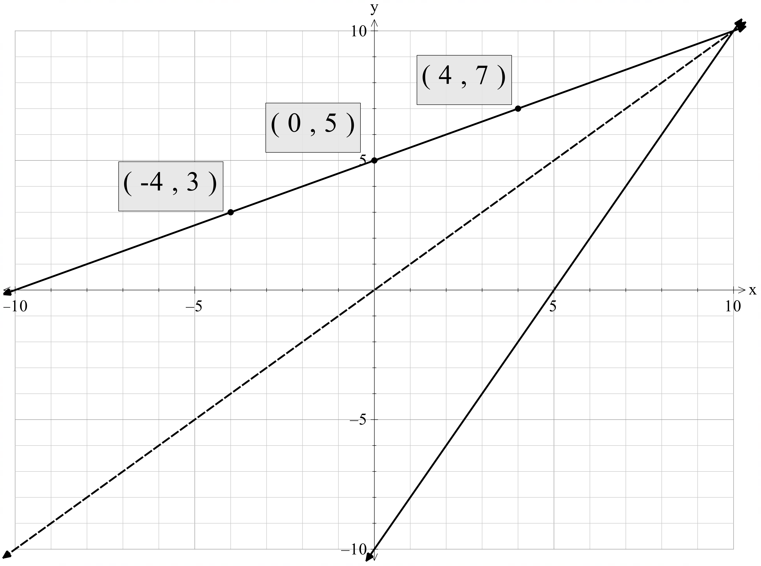  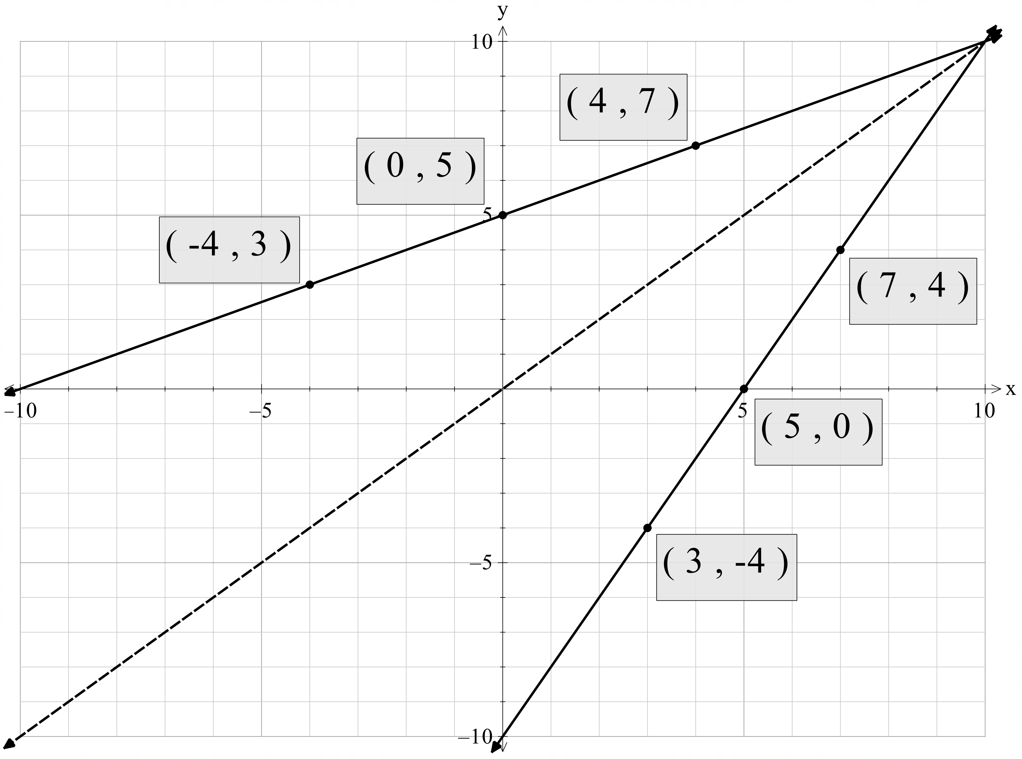  Since $g(x)$ reflects $f(x)$ across the line $y=x$, $∴g\left(x\right)=f^{-1}(x)$. | Table of values method  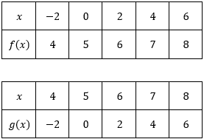  Since the values are reversed, $g(x)$ is the inverse of $f(x)$.  $$∴g\left(x\right)=f^{-1}(x)$$

Sample solutions

Appendix A – reflections across the axis
Original graph | Reflection across the $y$-axis | Reflection across the $x$-axis
$$f\left(x\right)=(x-2)(x+1)$$ | 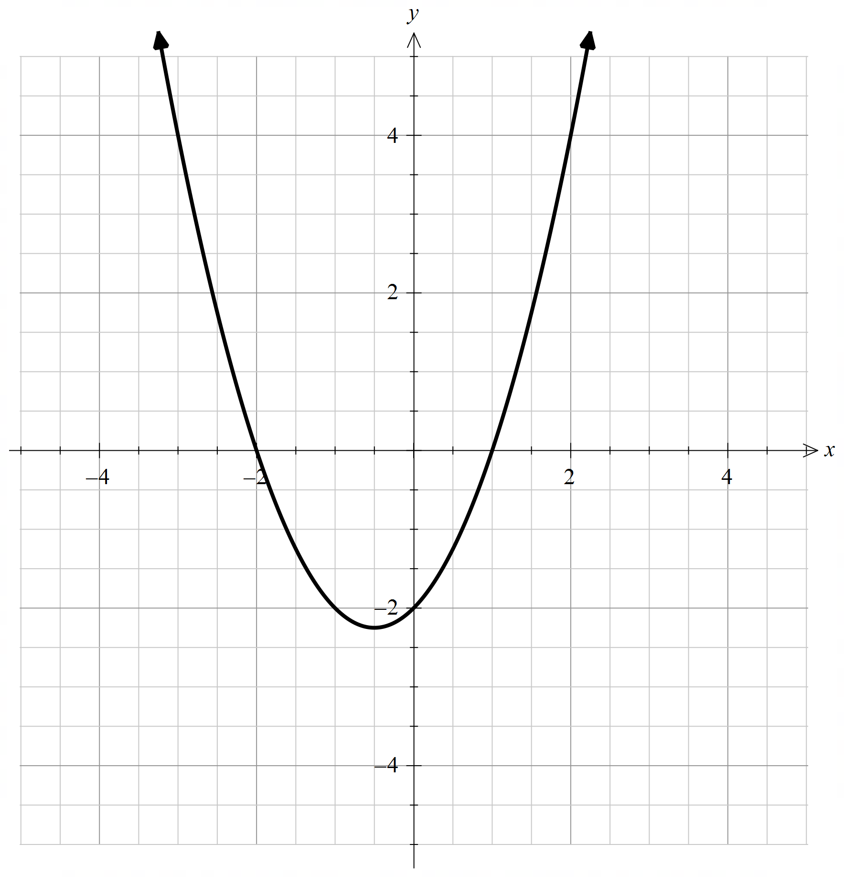  $$f\left(-x\right)=-(x+2)(1-x)$$ | 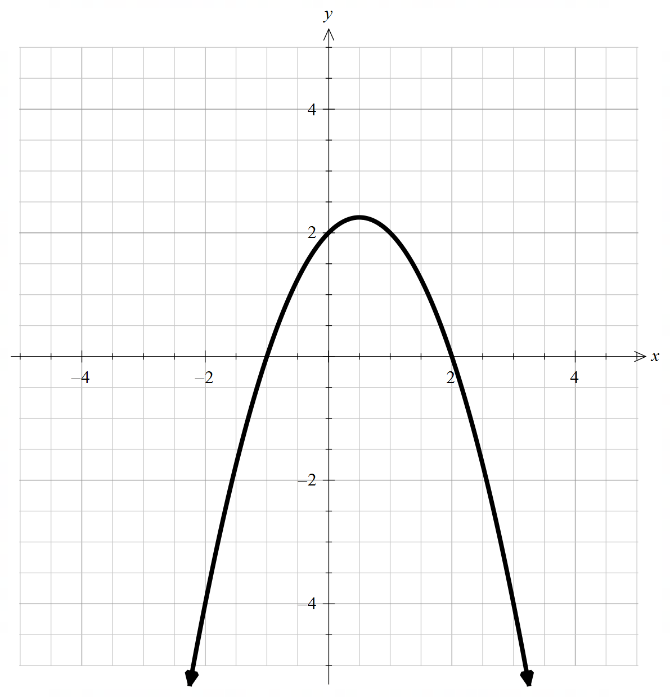  $$-f\left(x\right)=(2-x)(x+1)$$
$$f\left(x\right)=\frac{2}{x-1}$$ | 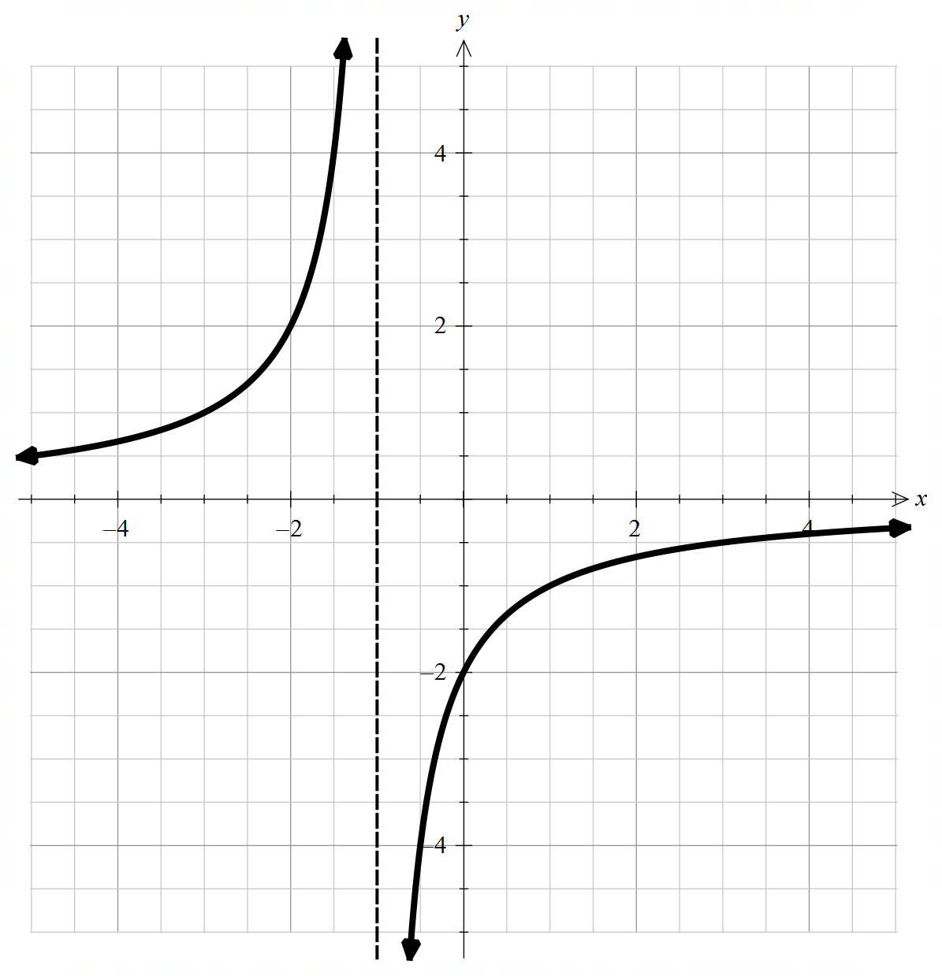  $$f\left(-x\right)=\frac{2}{-x-1}$$ | 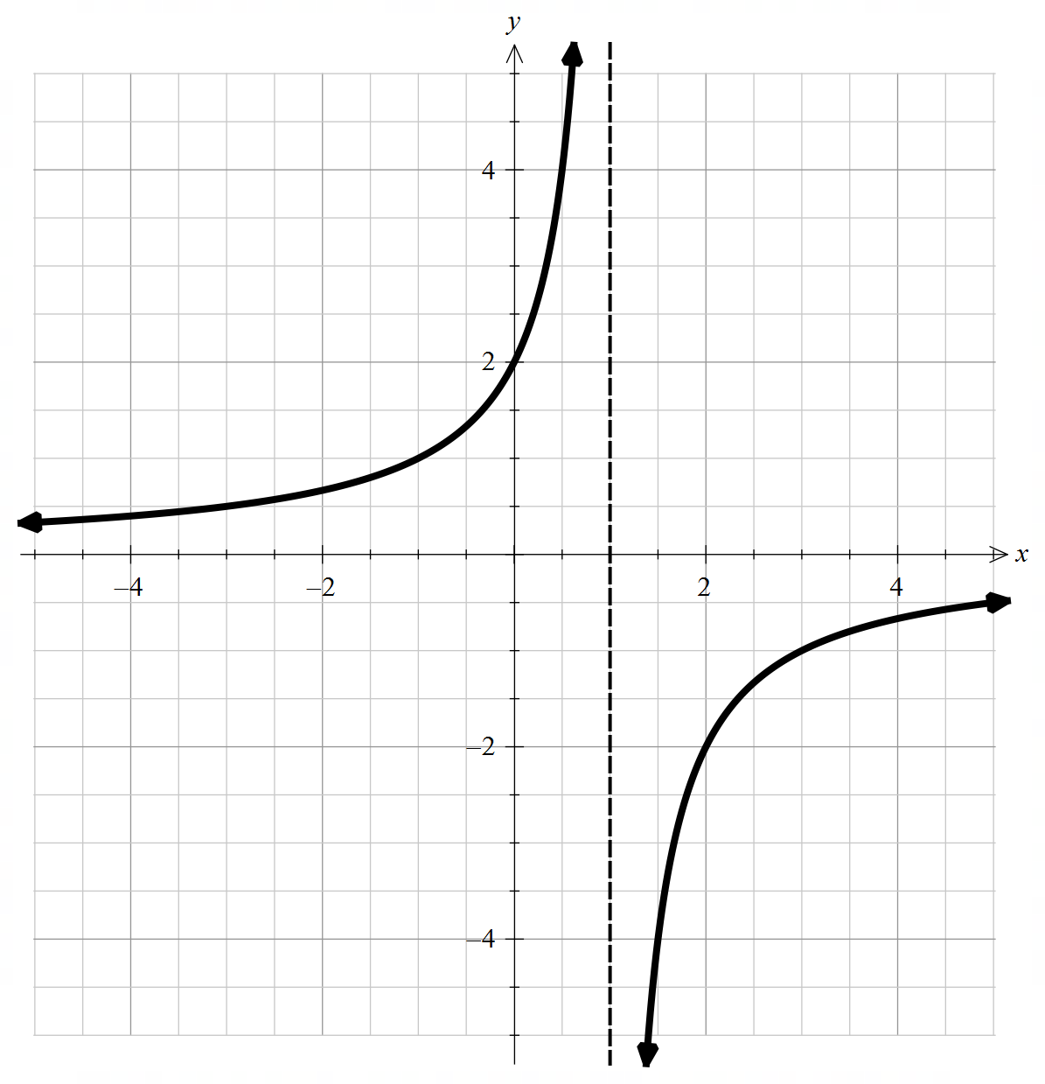  $$-f\left(x\right)=\frac{2}{1-x}$$
$$f\left(x\right)=\left|x-2\right|-1$$ | 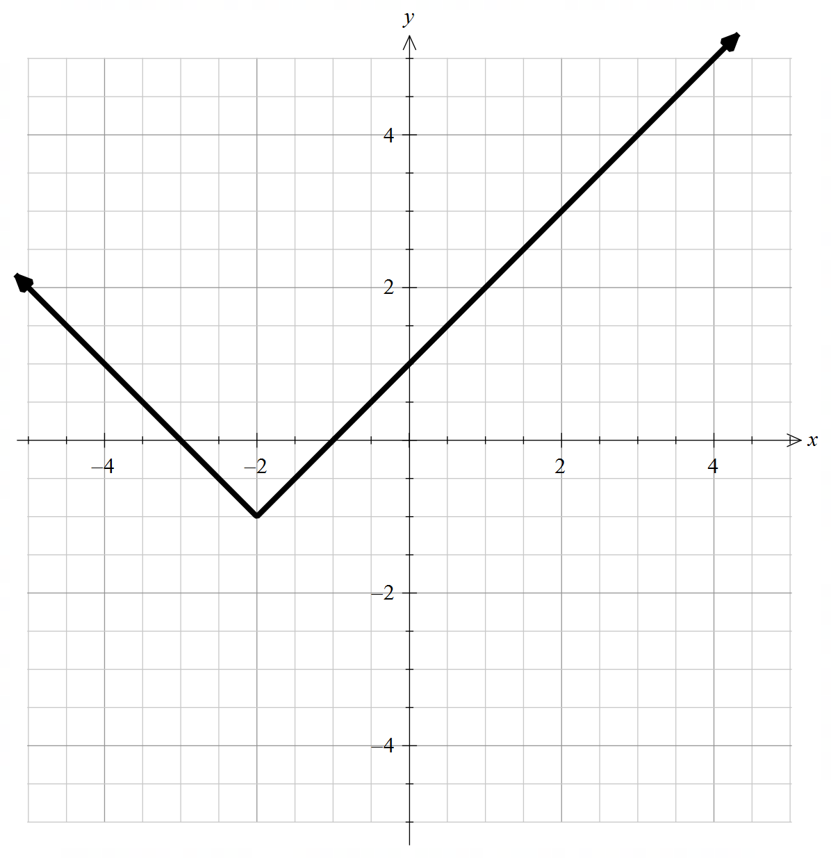  $$f\left(-x\right)=\left|-x-2\right|-1$$ | 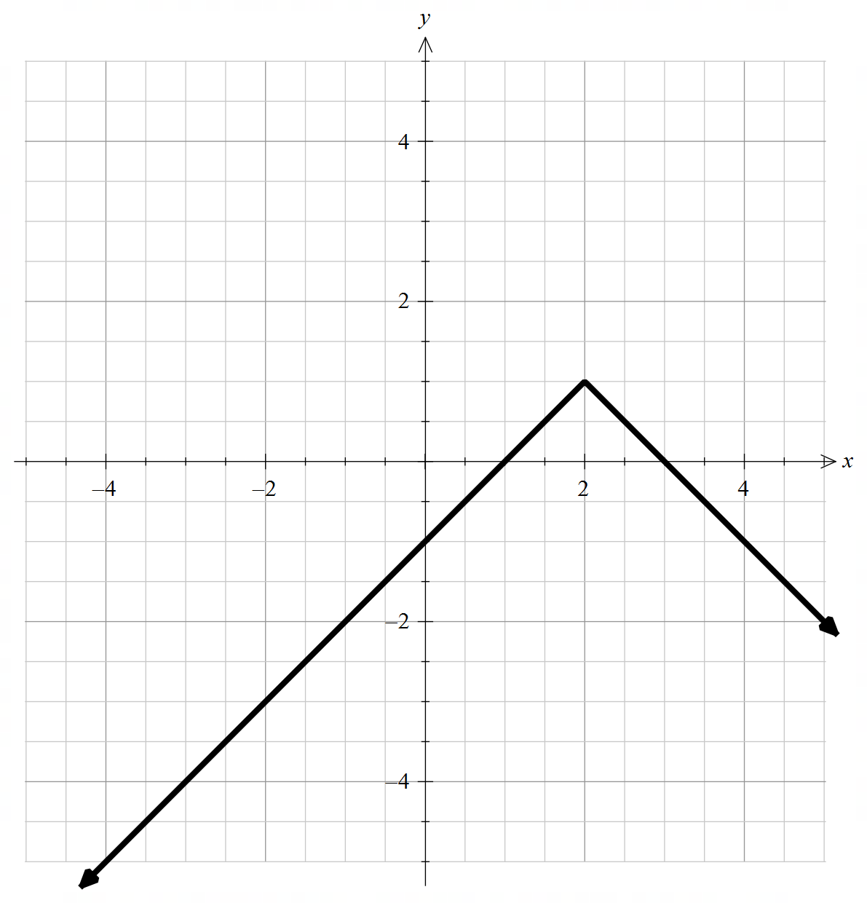  $$-f\left(x\right)=1-|x-2|$$

References
This resource contains NSW Curriculum and syllabus content. The NSW Curriculum is developed by the NSW Education Standards Authority (NESA). This content is prepared by NESA for and on behalf of the Crown in right of the State of New South Wales. The material is protected by Crown copyright.
Please refer to the NESA Copyright Disclaimer for more information https://www.nsw.gov.au/education-and-training/nesa/copyright.
NESA holds the only official and up-to-date versions of the NSW Curriculum and syllabus documents. Please visit NESA https://www.nsw.gov.au/education-and-training/nesa and NSW Curriculum https://curriculum.nsw.edu.au.
Mathematics Extension 1 11–12 Syllabus © NSW Education Standards Authority (NESA) for and on behalf of the Crown in right of the State of New South Wales, 2024.

© State of New South Wales (Department of Education), 2026
The copyright material published in this resource is subject to the Copyright Act 1968 (Cth) and is owned by the NSW Department of Education or, where indicated, by a party other than the NSW Department of Education (third-party material).
Copyright material available in this resource and owned by the NSW Department of Education is licensed under a Creative Commons Attribution 4.0 International (CC BY 4.0) license.

This license allows you to share and adapt the material for any purpose, even commercially.
Attribution should be given to © State of New South Wales (Department of Education), 2026.
Material in this resource not available under a Creative Commons license:
- the NSW Department of Education logo, other logos and trademark-protected material
- material owned by a third party that has been reproduced with permission. You will need to obtain permission from the third party to reuse its material.
Links to third-party material and websites
Please note that the provided (reading/viewing material/list/links/texts) are a suggestion only and implies no endorsement, by the New South Wales Department of Education, of any author, publisher, or book title. School principals and teachers are best placed to assess the suitability of resources that would complement the curriculum and reflect the needs and interests of their students.
If you use the links provided in this document to access a third-party's website, you acknowledge that the terms of use, including licence terms set out on the third-party's website apply to the use which may be made of the materials on that third-party website or where permitted by the Copyright Act 1968 (Cth). The department accepts no responsibility for content on third-party websites.

