Absolute value
Students examine the relationship between the graph of $y=f(x)$ and the graphs of $y=|f\left(x\right)|$ and $y=f\left(\left|x\right|\right)$ and sketch the graphs of $y=|f\left(x\right)|$ and $y=f(\left|x\right|)$ when given $y=f(x)$ in algebraic or graphical form.

Learning intention
- To understand the relationship between the graph of $y=f(x)$ and the graphs of $y=|f\left(x\right)|$ and $y=f(\left|x\right|)$.

Success criteria
- I can sketch $y=|f\left(x\right)|$ if given $y=f(x)$.
- I can sketch $y=f(\left|x\right|)$ if given $y=f(x)$.

Outcomes
A student:
- develops understanding and fluency in mathematics through exploring and connecting mathematical concepts, choosing and applying mathematical techniques to solve problems, and communicating their thinking and reasoning coherently and clearly MAO-WM-01
- solves problems involving inequalities, functions and their inverses, graphical relationships between functions, and parametric equations ME1-11-01

Content

Graphical relationships
- Examine the relationship between the graph of $y=f\left(x\right)$ and the graphs of $y=|f(x)|$ and $y=f(|x|)$ using graphing applications, and graph $y=|f(x)|$ and $y=f(|x|)$ given $y=f\left(x\right)$ in algebraic or graphical form
Mathematics Extension 1 11–12 Syllabus © NSW Education Standards Authority (NESA) for and on behalf of the Crown in right of the State of New South Wales, 2024.

Table 1: lesson summary
Section | Summary of activity | Teaching strategies | Teaching points
Retrieval practice | Using slide 4 of the PowerPoint, students sketch curves that are familiar to them. | Mini whiteboards | Recall prior knowledge of curve sketching.
Activating prior knowledge | Using slide 6, students sketch the linear function $f\left(x\right)=\frac{1}{2}x-3$ and then the absolute value function $y=\left|\frac{1}{2}x-3\right|$ to consider how the graphs vary. | Mini whiteboards  Think-Pair-Share | Recall how the graphs of $y=ax+b$ and $y=|ax+b|$ relate to each other.
Connecting learning | Using the function from slide 6, students consider what $y=f\left(\left|x\right|\right)$ would look like. Using the Desmos graphing calculator, students describe the effect of $y=|f\left(x\right)|$ and $y=f(\left|x\right|)$ on the graph of $y=f(x)$ before using slide 8 to check for understanding. | Mini whiteboards  Think-Pair-Share  Pose-Pause-Pounce-Bounce | Discuss with students how the graph of $y=f(x)$ differs from the graph of $y=|f\left(x\right)|$ and $y=f\left(\left|x\right|\right)$, using Desmos to visually confirm their findings.
Releasing responsibility | Use slides 10–13 to model how to sketch the graphs of $y=|f\left(x\right)|$ and $y=f\left(\left|x\right|\right)$ when given $y=f(x)$ in algebraic form before students consolidate their understanding with notes in Appendix B. | Worked example (Your turn)  Visibly random groups of 3  Vertical non-permanent surfaces  Four quadrant notes to future forgetful selves | Model how to sketch $y=|f\left(x\right)|$ and $y=f(\left|x\right|)$ before consolidating understanding with an existing resource and notes.
Independent practice | Use slide 16 to present 2 HSC style questions for students to complete. | Approaching questions scaffold  Pose-Pause-Pounce-Bounce | Students apply their learning. Students consider what key points should be labelled on their sketches and how they can use them or other points to verify the sketched function.

Activity structure
Please use the associated PowerPoint Absolute value to display images in this lesson.

Retrieval practice
- Display slide 4 of the PowerPoint and distribute Appendix A ‘Axis’ in a plastic sleeve to use as a mini whiteboard (bit.ly/miniwhiteboards) for students to sketch each graph.
- After each graph, have students compare their sketches with another student and reach a consensus if there is variation in their sketches.

Activating prior knowledge
- Display slide 6 and ask students to sketch the graph $f(x)=\frac{1}{2}x-3$ on their mini whiteboards.
- In a Think-Pair-Share (bit.ly/thinkpairsharestrategy) ask students what would happen to the graph if the absolute value sign was placed around $f\left(x\right).$
- Have students graph the absolute value function on their mini whiteboard and discuss with their partner how they could check for accuracy.
- Animate slide 6 to display the solution.
Students learnt about the graph of the absolute value function $y=|ax+b|$ in Lesson 2 – absolute value of Mathematics Advanced Unit 4 – graphing transformations.

Connecting learning
- On their mini whiteboards ask students to write down what the equation would be for $y=f(\left|x\right|)$ where $f\left(x\right)=\frac{1}{2}x-3$.
- Students should hold up their mini whiteboards for the teacher to check their equations.
- Ask students to sketch this function on their mini whiteboards and share their sketch with a partner.
- Play the animation on slide 6 to show all 3 graphs.
- In a Think-Pair-Share, have students discuss the differences between the graphs of $y=\left|f(x)\right|$ and $y=f(\left|x\right|)$.
- Using the Desmos graphing calculator (https://bit.ly/Ext1AbsValue), display the graph and ask students, in a Think-Pair-Share, to consider what the function would look like if it was $y=|f\left(x\right)|$.
- Enter the function $y=\left|f\left(x\right)\right|$ to verify the students’ results.
Draw students’ attention to the fact that where the graph was below the $x$-axis, it has been reflected across the $x$-axis and is now above the axis. All y-values are now positive.
- Ask students in a Think-Pair-Share how the function would change if it was $y=f(\left|x\right|)$.
Students may suggest in their sharing that the part of the graph on the right of the $y$-axis is reflected across the $y$-axis.
- Hide the $y=|f\left(x\right)|$ graph and enter $y=f(\left|x\right|)$ to verify the change in the graph.
- Use the Pose-Pause-Pounce-Bounce questioning strategy (PDF 557KB) (bit.ly/posepausepouncebounce) to consolidate student understanding about the relationship between $y=f(x)$, $y=|f\left(x\right)|$ and $y=f(\left|x\right|)$. Some possible prompts include:
- If we want the features of the graph below the $x$-axis to be reflected above the axis, how would we adjust the function?
- Describe what the graph of $y=f(\left|x\right|)$ looks like compared to the graph of $y=f\left(x\right).$
- Display slide 8 to check for student understanding by asking them to sketch $y=\left|f\left(x\right)\right|$ and $y=f\left(\left|x\right|\right)$ for the function on the screen.
The sketch of $y=|f\left(x\right)|$ is the same as $y=f(x)$.
Teachers may wish to use Desmos to show the final graphs. The function displayed on slide 8 is $f\left(x\right)={\left(x-2\right)}^{2}+3$.

Releasing responsibility
- Use slides 10–13 to model worked examples of graphing using the Worked examples (Your turn) method (bit.ly/supportingstrategies). Students can use Appendix A in plastic sleeves to support them in attempting the ‘Your turn’ questions.
Teachers may choose to only do one of the worked examples depending on how well the students are understanding the concept.
- Use an existing resource for students to build fluency with this concept.
- Assign students to visibly random groups of 3 at vertical non-permanent surfaces (bit.ly/VNPSstrategy) and ask them to complete Four quadrant notes to their future forgetful selves (bit.ly/supportingstrategies) from Appendix B ‘Four quadrant notes’.

Independent practice
- Use slide 15 to unpack the ‘Approaching questions scaffold’ for students.
The ‘Approaching questions scaffold’ offers students a 4-step framework to work through questions. Each step is accompanied by an icon which corresponds to different aspects of the solution process.
- Distribute Appendix C ‘HSC style questions’ to display HSC style questions for students to complete individually. These can also be displayed using slide 16.
- Have students compare their graphs with another student to discuss similarities and differences.
- Using the Pose-Pause-Bounce-Pounce questioning strategy, ask students to consider how they could check their graph. Some prompting questions include:
- What information must be included in the sketch? How does this relate to the allocation of marks?
- How could you check that you have reflected the correct parts of the graph?
Students can always resort to creating a table of values and plotting the points, to check their graph.
- Display slide 17 which shows the solutions to both questions.
- Have students sketch $y=|f\left(x\right)|$ for question 1 and $y=f(\left|x\right|)$ for question 2.
- Display slide 18 which shows the solutions.

Assessment and differentiation

Suggested opportunities for differentiation
Retrieval practice
- Support students by adjusting the type of equations to suit their prior knowledge of graphing.
Activating prior knowledge
- Mira mirrors can be used for students to visualise the reflection of their graphs.
Connecting learning
- Using the Desmos graphing calculator, add additional functions for students to explain the effect of $y=|f\left(x\right)|$ and $y=f(\left|x\right|)$ as required.
- Extend students by asking them to consider what the function of $y=|f\left(\left|x\right|\right)|$ or $y=f(-\left|x\right|)$ would look like.
Releasing responsibility
- Teachers may choose to only show one of the worked examples depending on how well the students are understanding the concept.
Independent practice
- Depending on student understanding, support them by only completing one HSC style question.
- Add extra questions that have students either reflect from a graph or from an equation, depending on student progress.

Suggested opportunities for assessment
Retrieval practice
- Students give and receive feedback as they compare their sketches with each other.
Activating prior knowledge
- A Think-Pair-Share provides students with the opportunity to reflect on their understanding of absolute values before sharing with the class.
Connecting learning
- Monitor student responses on mini whiteboards to quickly gauge individual understanding and identify misconceptions related to absolute value and its graph.
- The teacher could facilitate a class discussion and observe students’ reasoning and justification in response to the provided prompts.
- Use slide 8 of the PowerPoint as a check for understanding to ensure students are ready to proceed.
Releasing responsibility
- Student responses to the self-explanation prompts during worked examples provide an opportunity to assess student reasoning around which features of the graph are reflected and across which axis.
- Monitor student responses in the ‘Your turn’ section to check for understanding of how to sketch $y=|f\left(x\right)|$ and $y=f(\left|x\right|)$.
Independent practice
- HSC style questions could be collected as an exit ticket and student work sample.

Appendix A

Axis
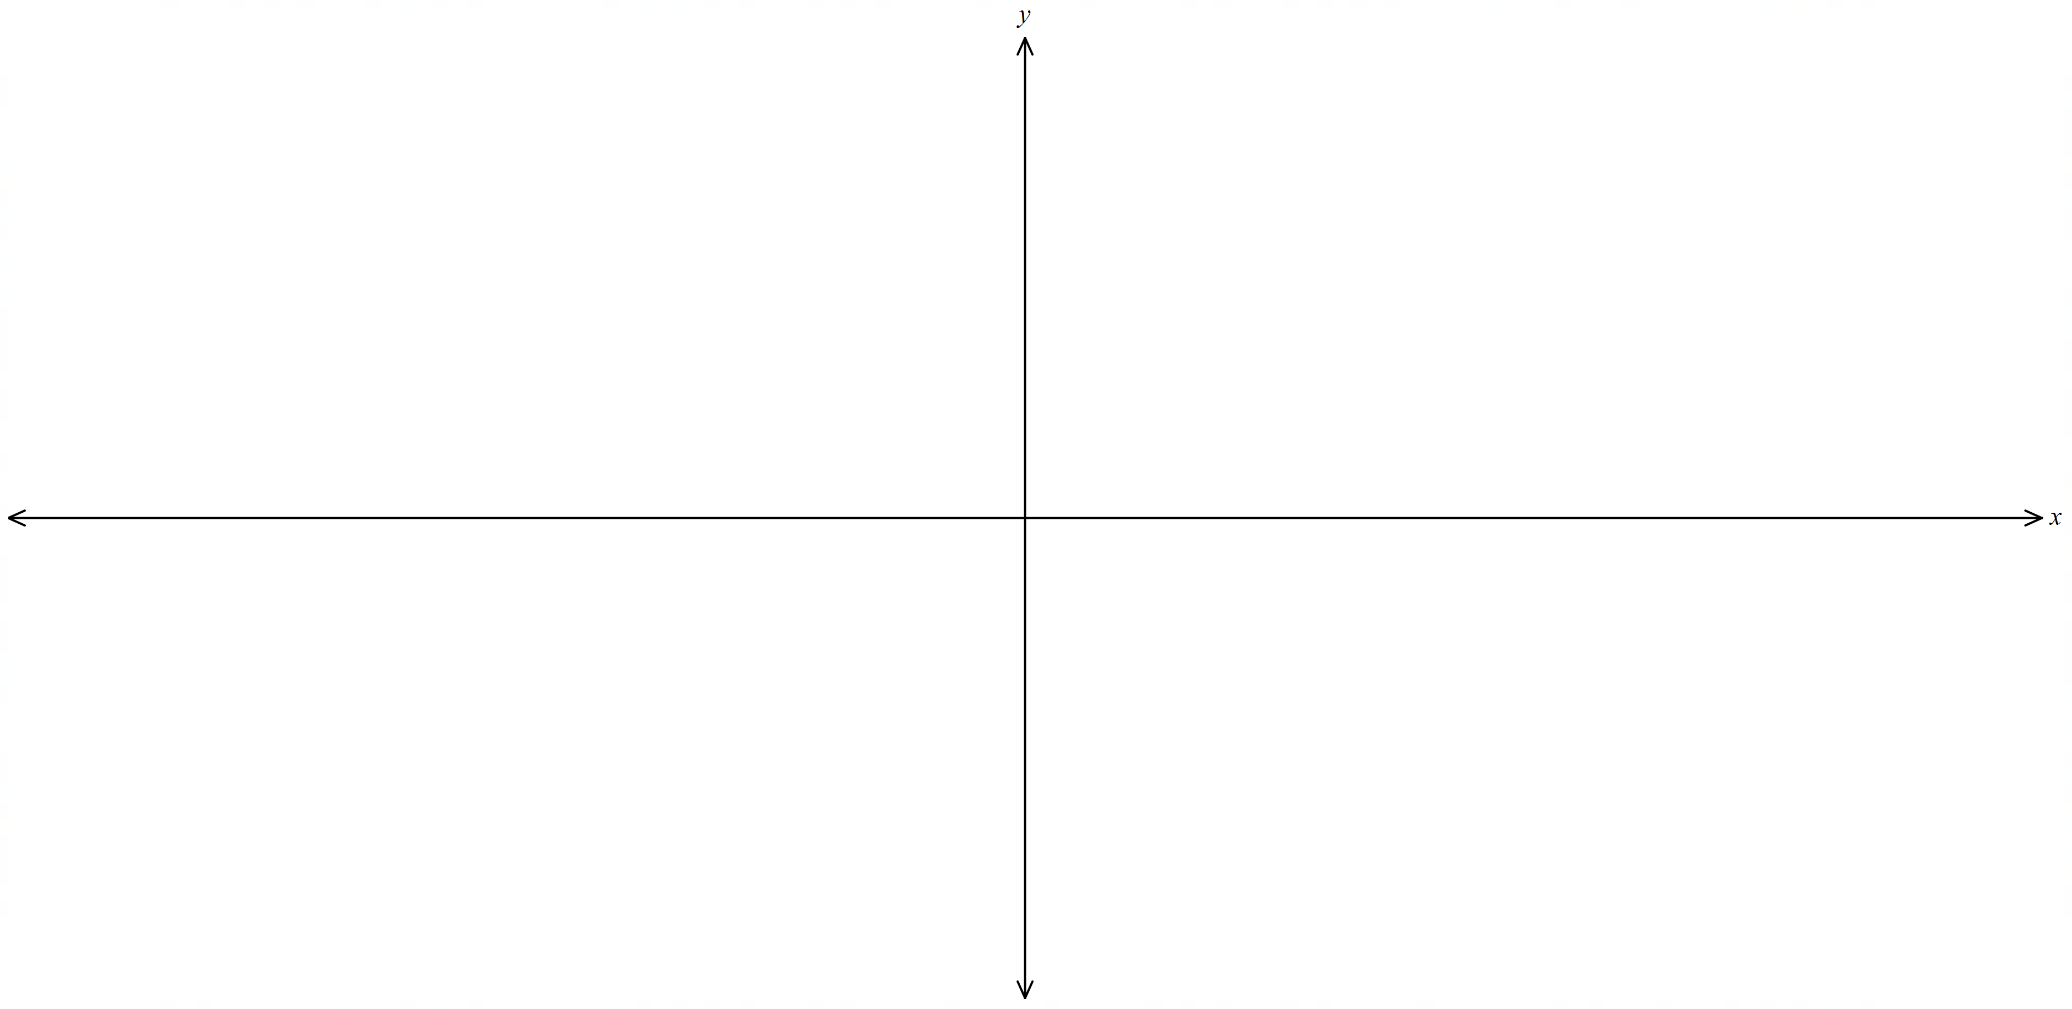

Appendix B

Four quadrant notes
Example 1  If $f\left(x\right)=-x^{3}+9x$, sketch $y=f(\left|x\right|)$.  Factorise $f\left(x\right)=-x(x+)(x-)$.  Sketch $y=f(x)$.  Sketch $y=f(\left|x\right|)$.  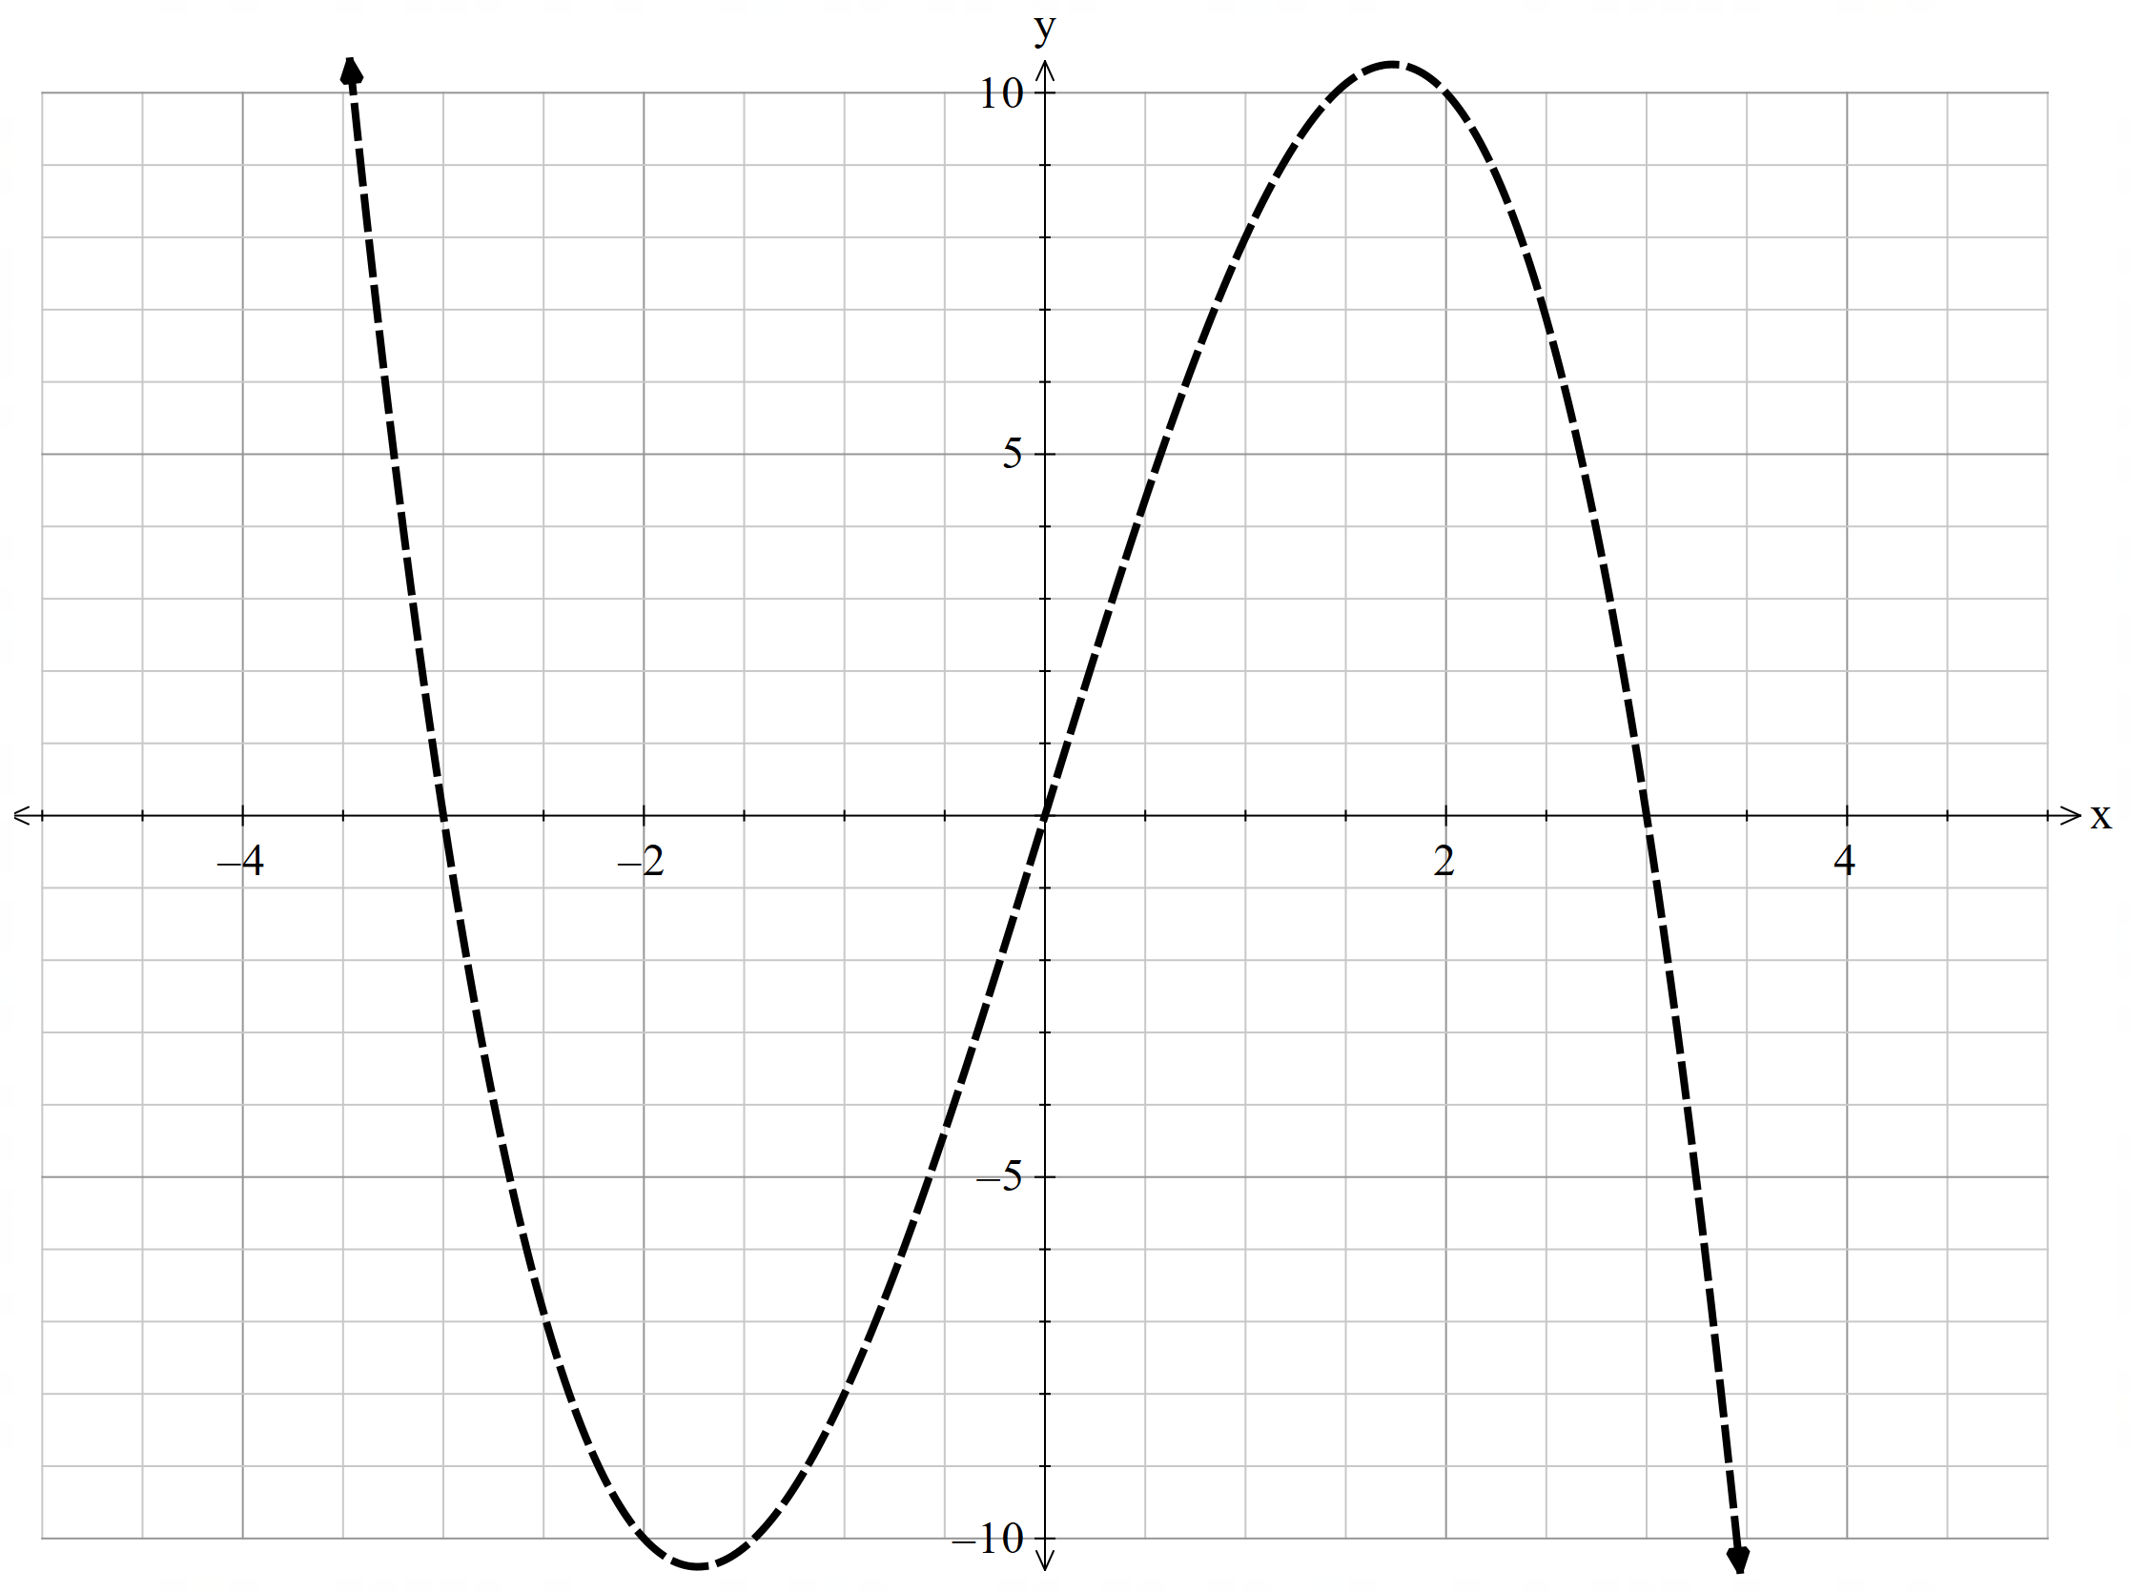 | Example 2  If $f\left(x\right)=x^{2}+x-2$, sketch $y=|f\left(x\right)|$.  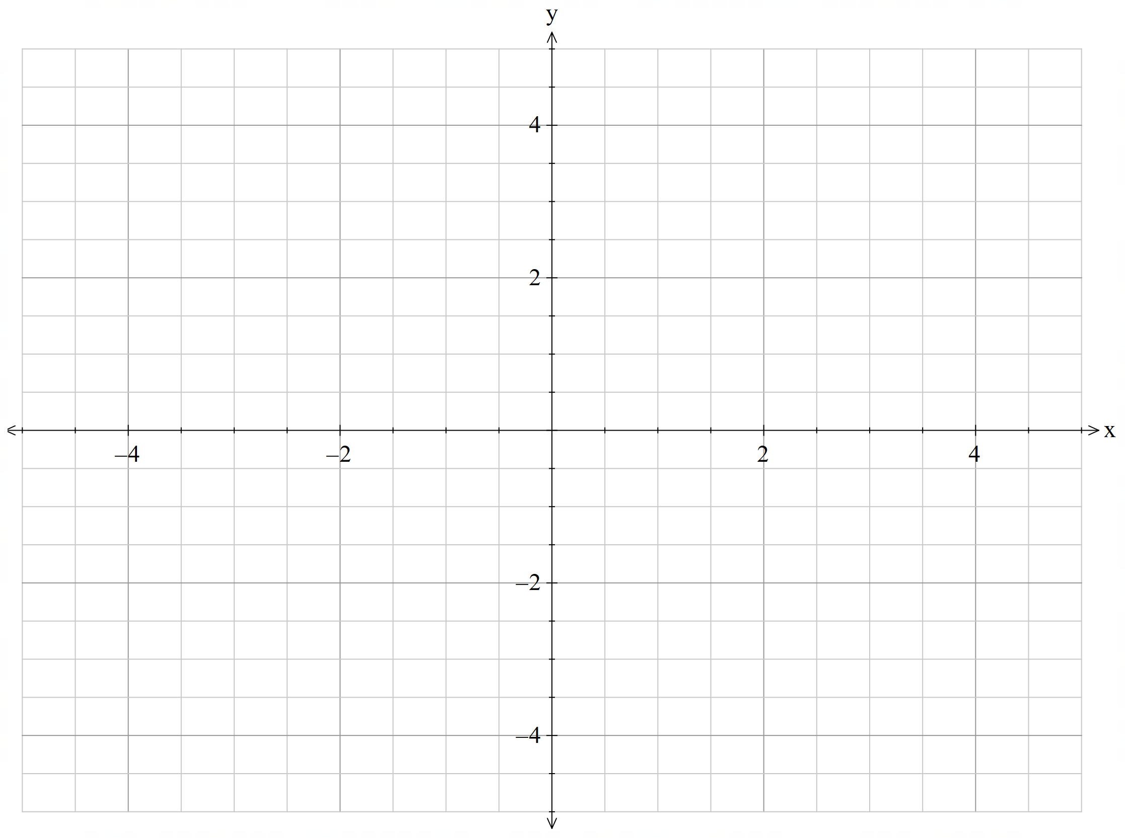
Things to remember | Example 3

Appendix C

HSC style questions
- The diagram shows the graph of $y=f(x)$. The line $y=x$ is an asymptote. Draw a sketch of $f(\left|x\right|)$. (2 marks)
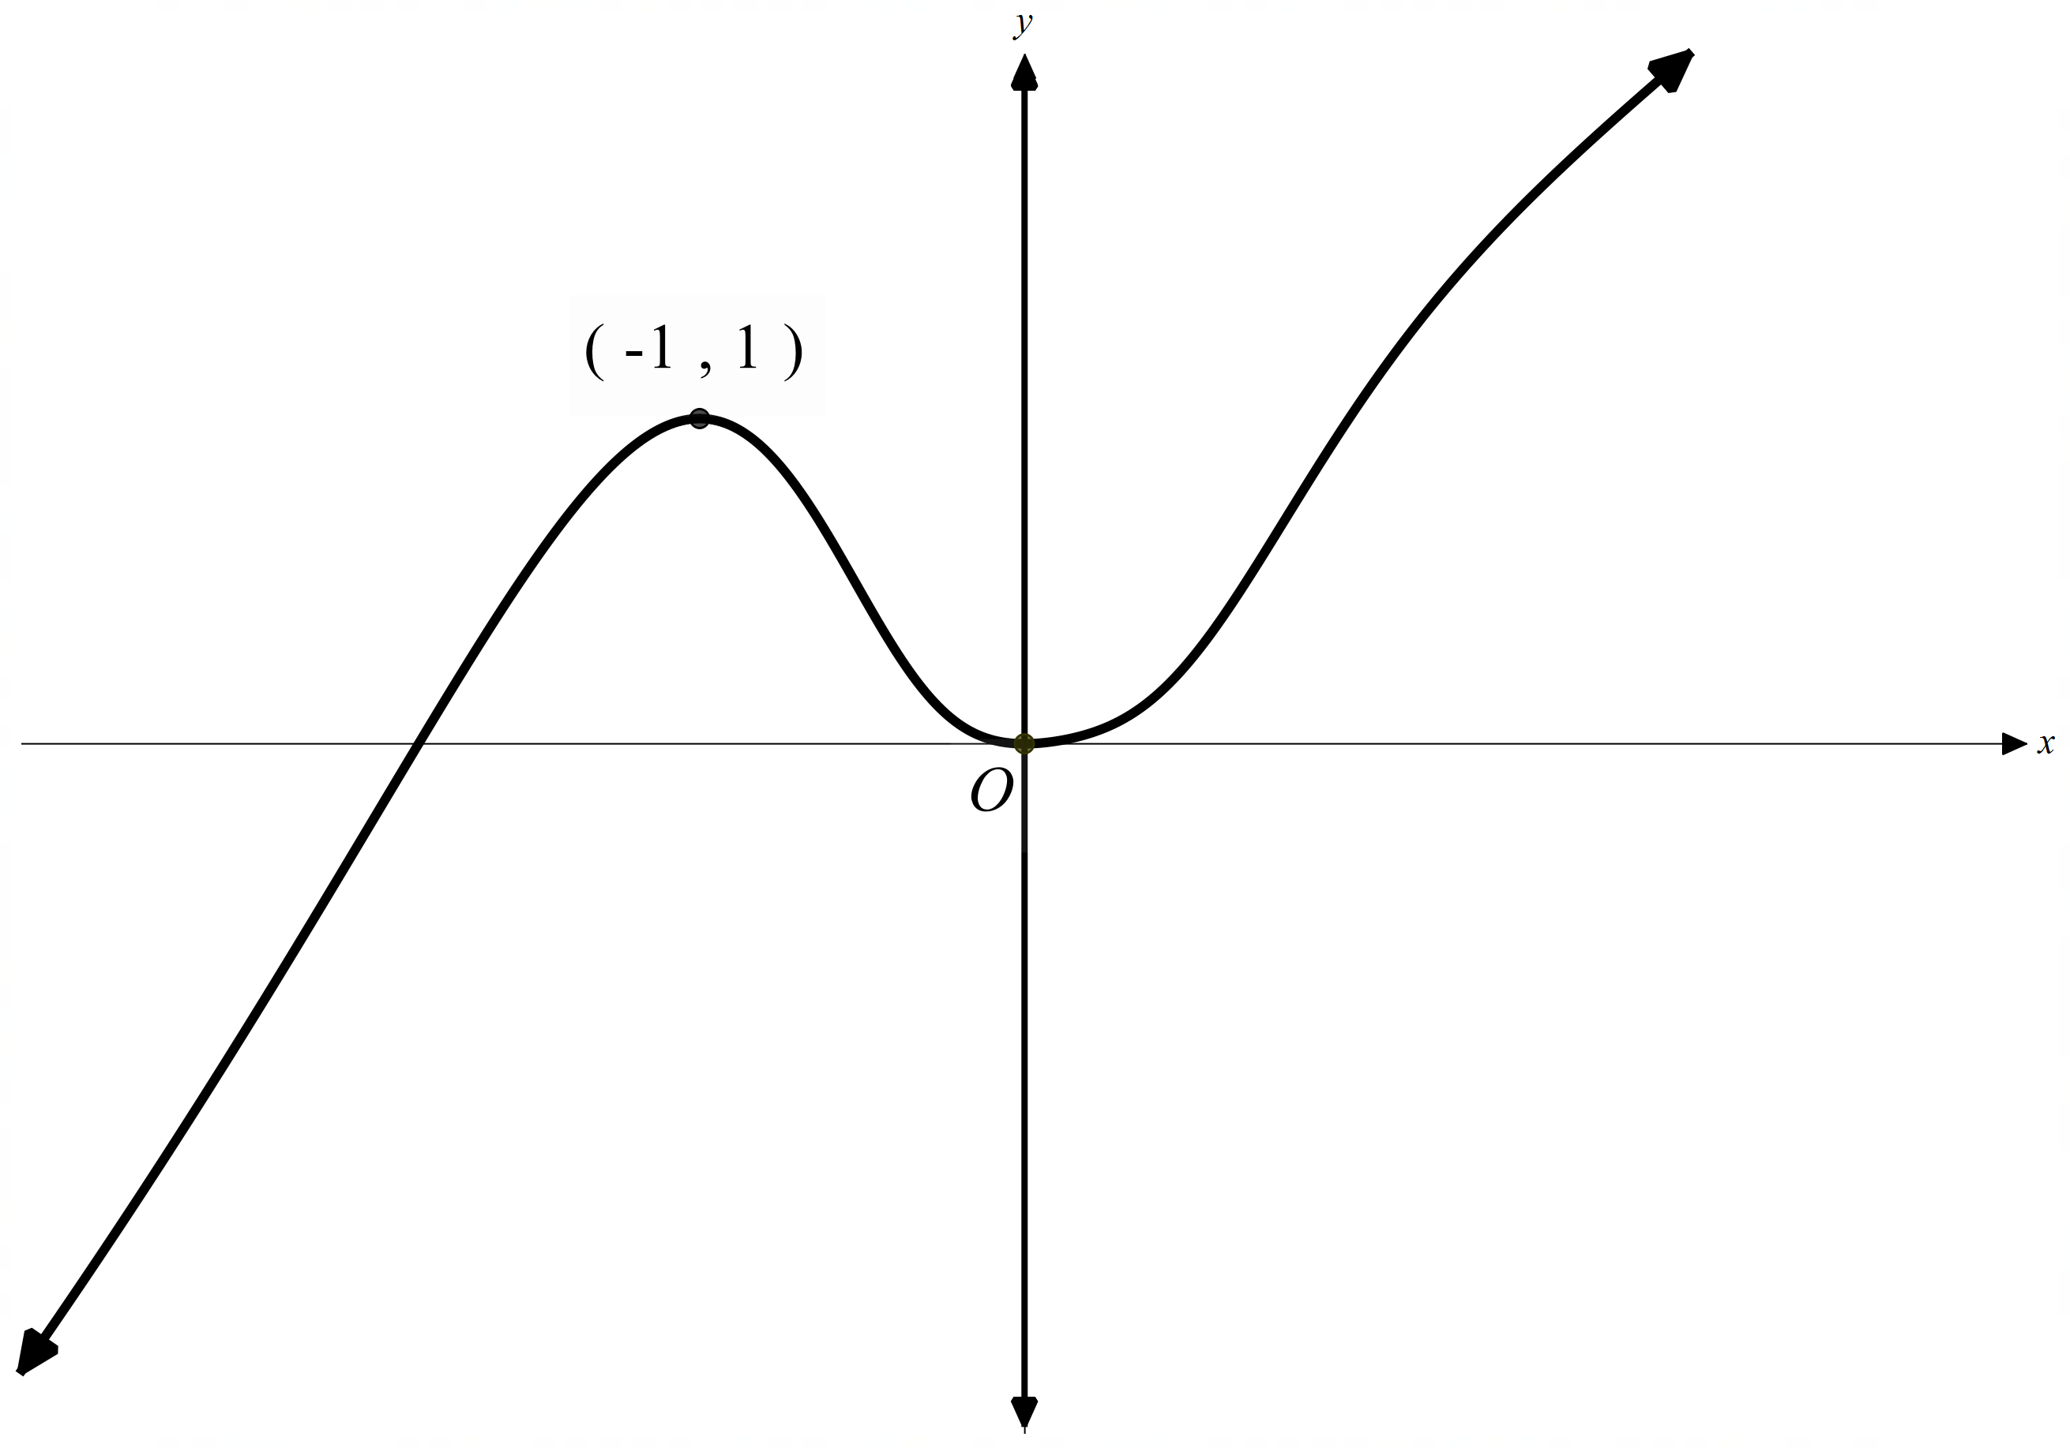

- Consider the function $f\left(x\right)=x^{3}+1$. Sketch the graph of $y=|f\left(x\right)|$. (1 mark)

Sample solutions

Slide 4 graphs

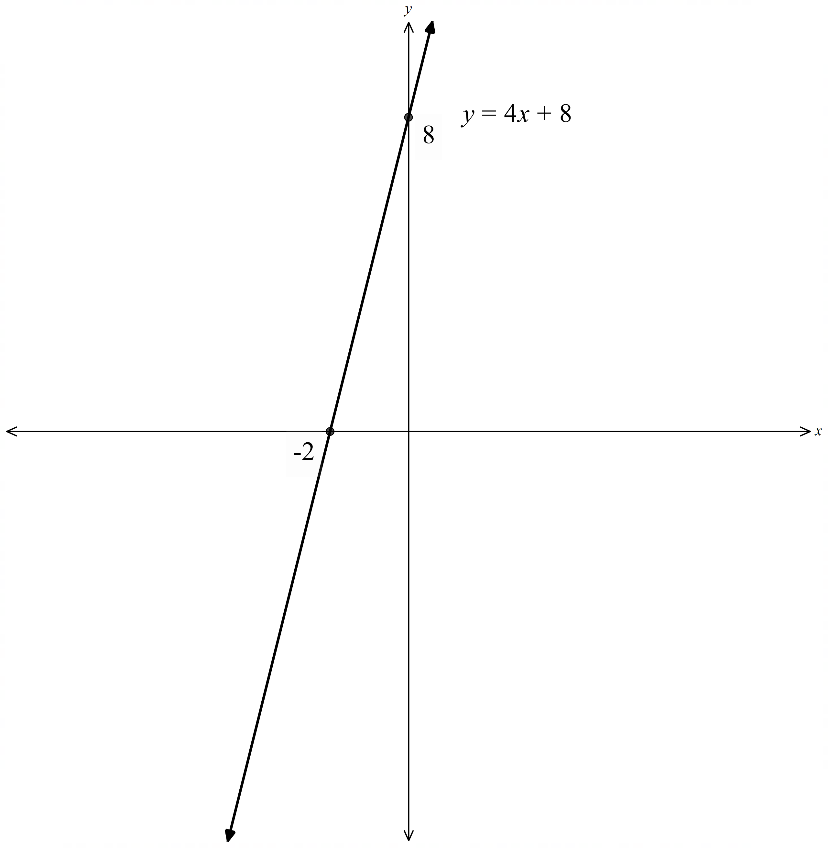

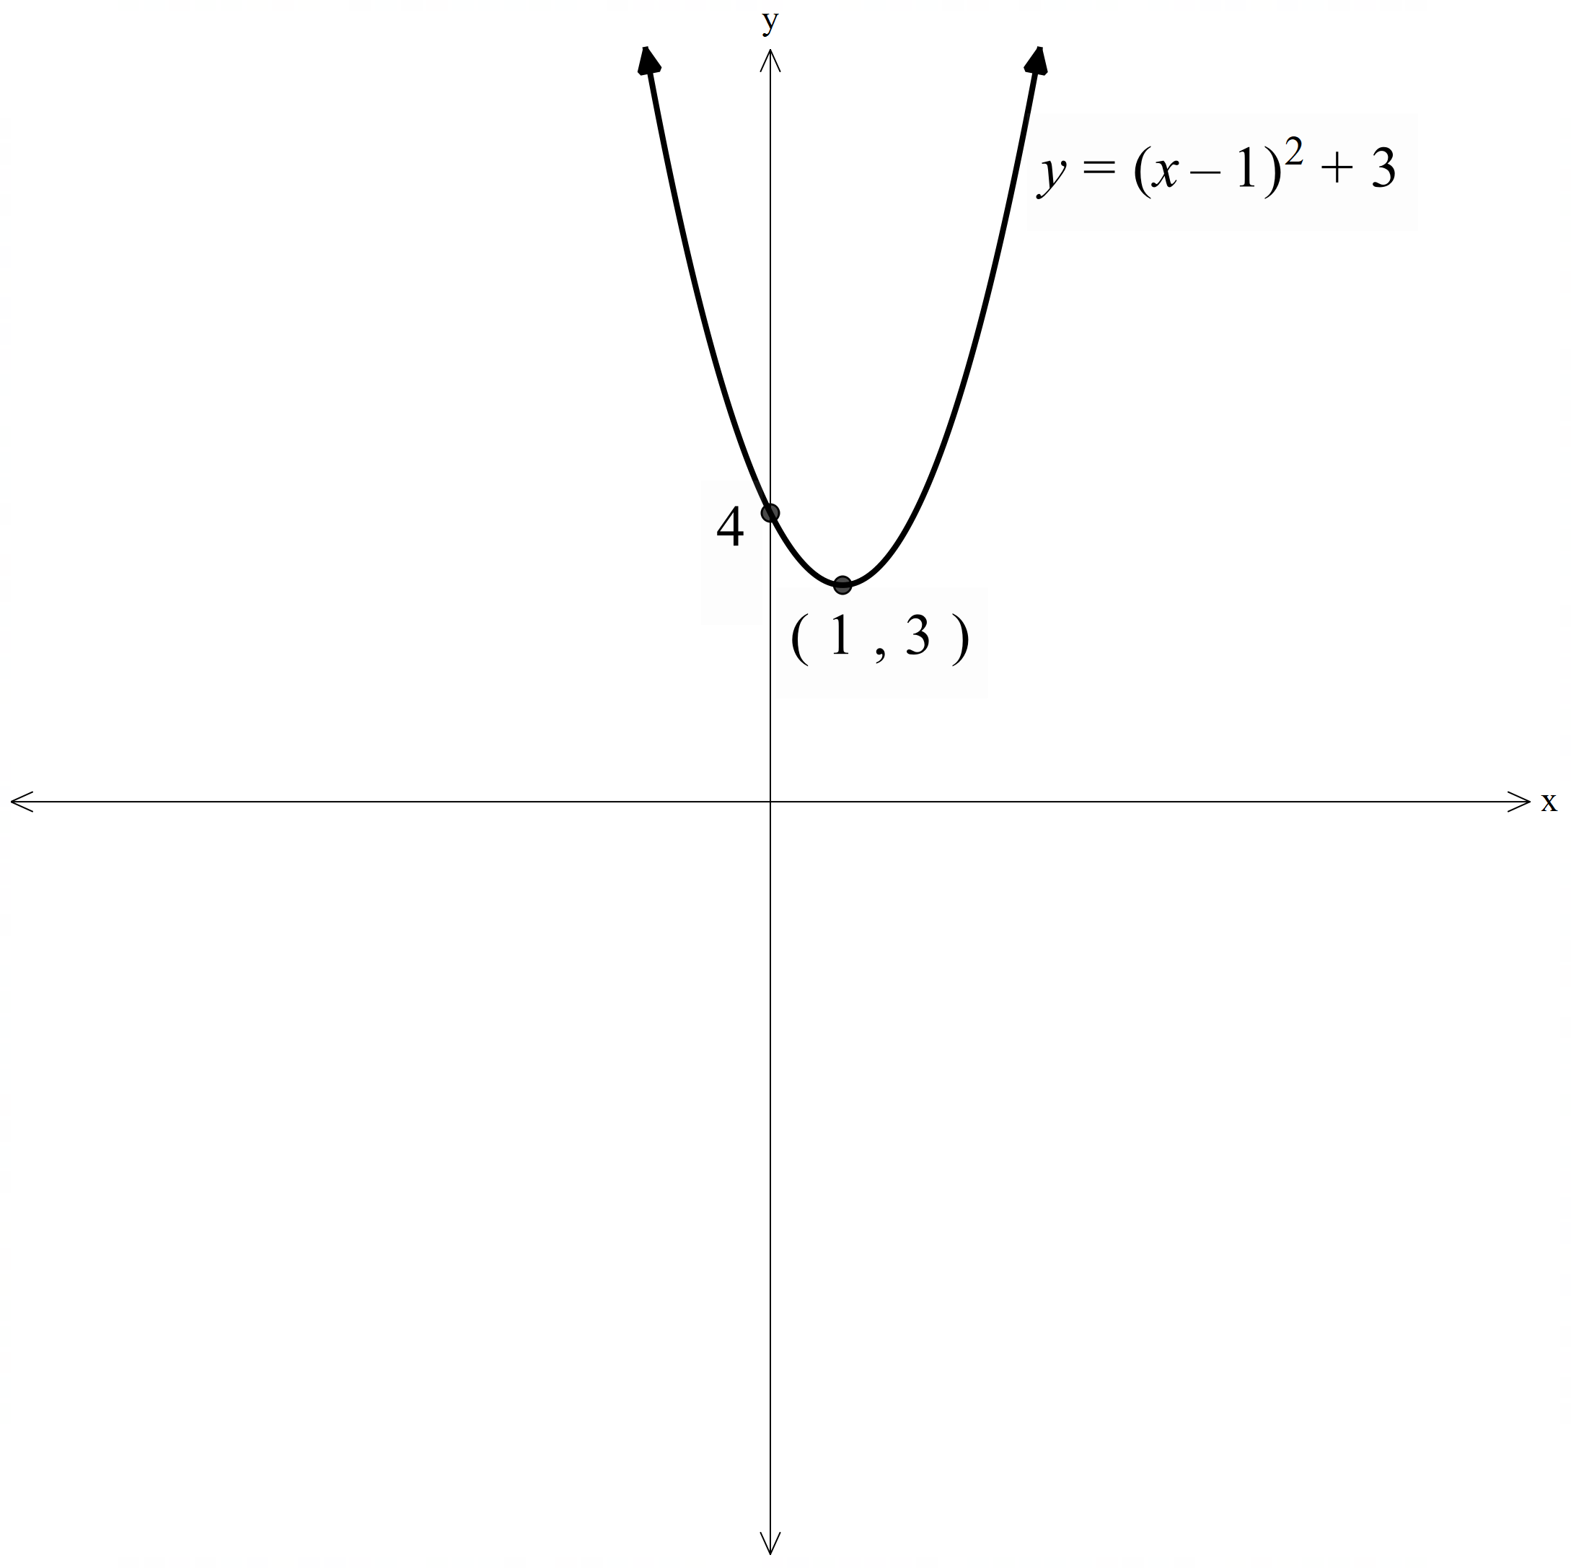

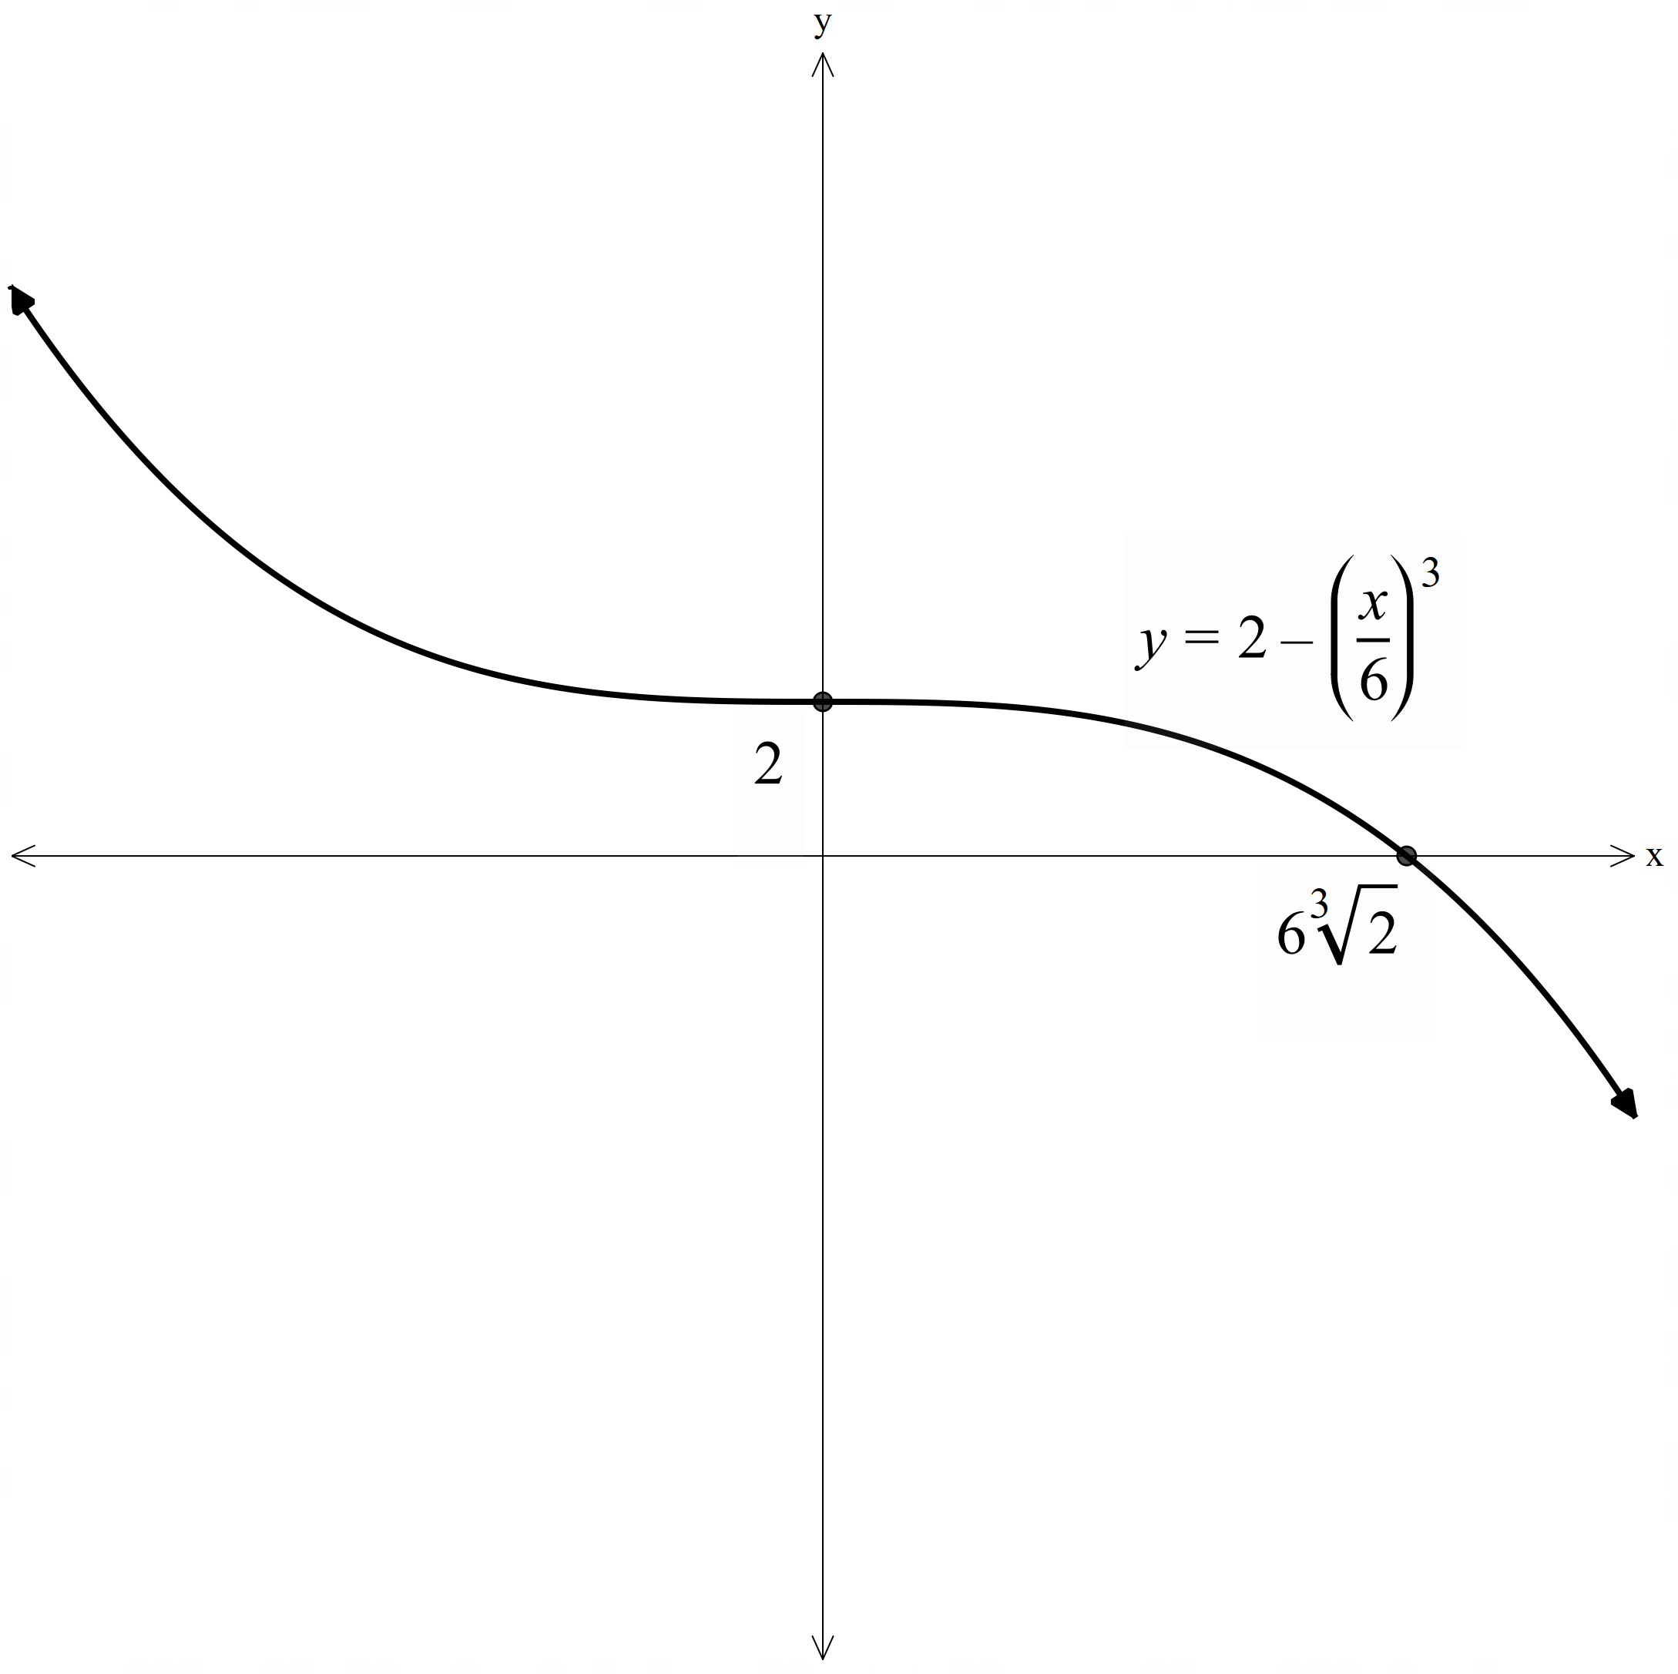

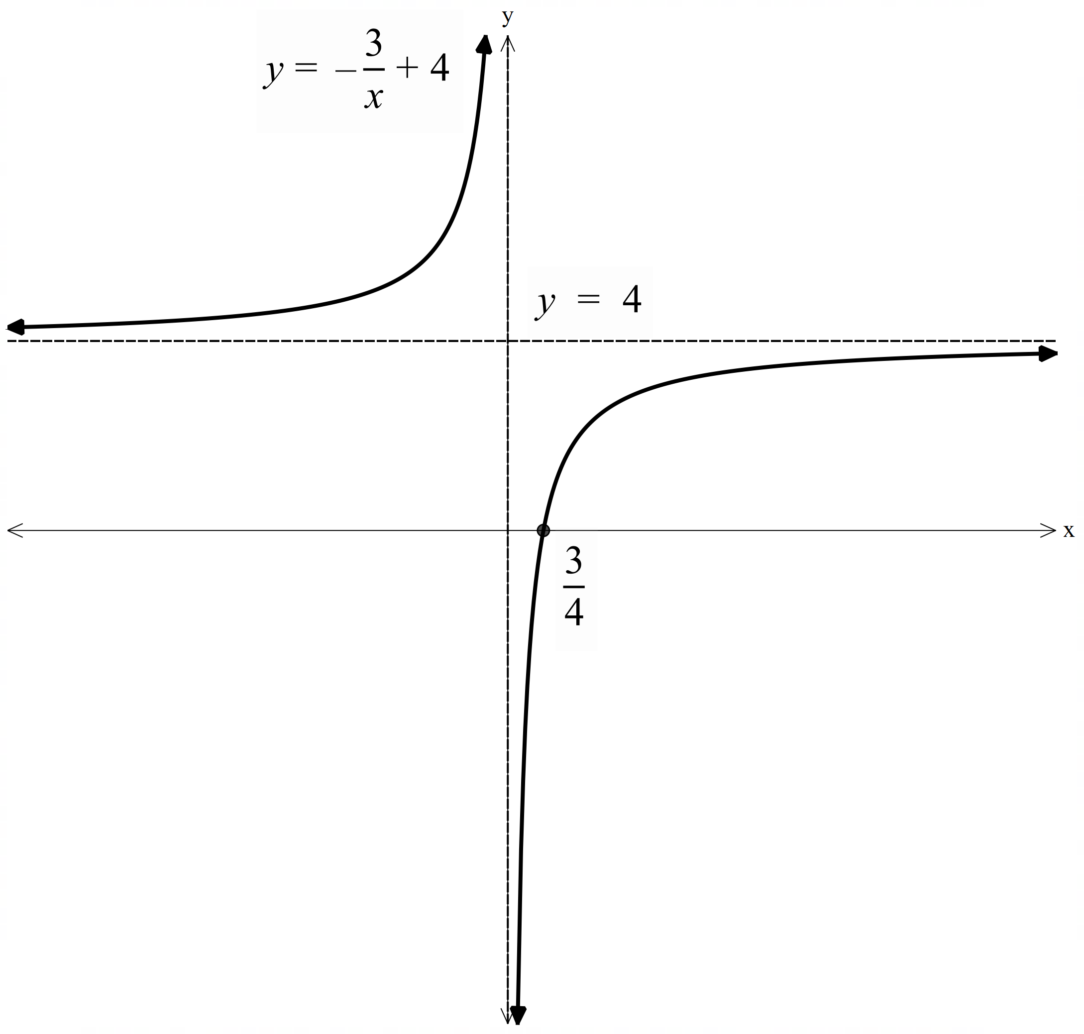

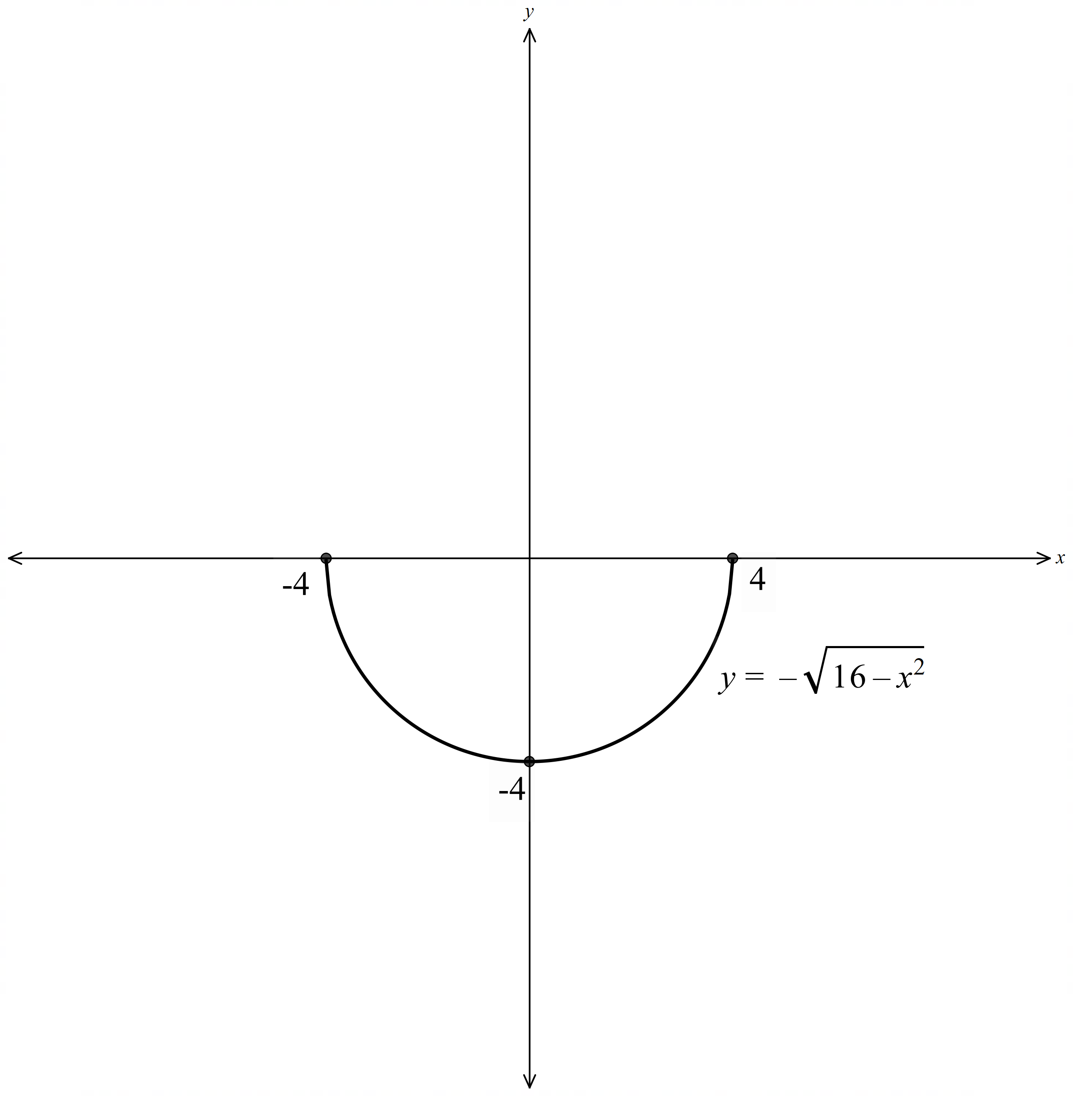

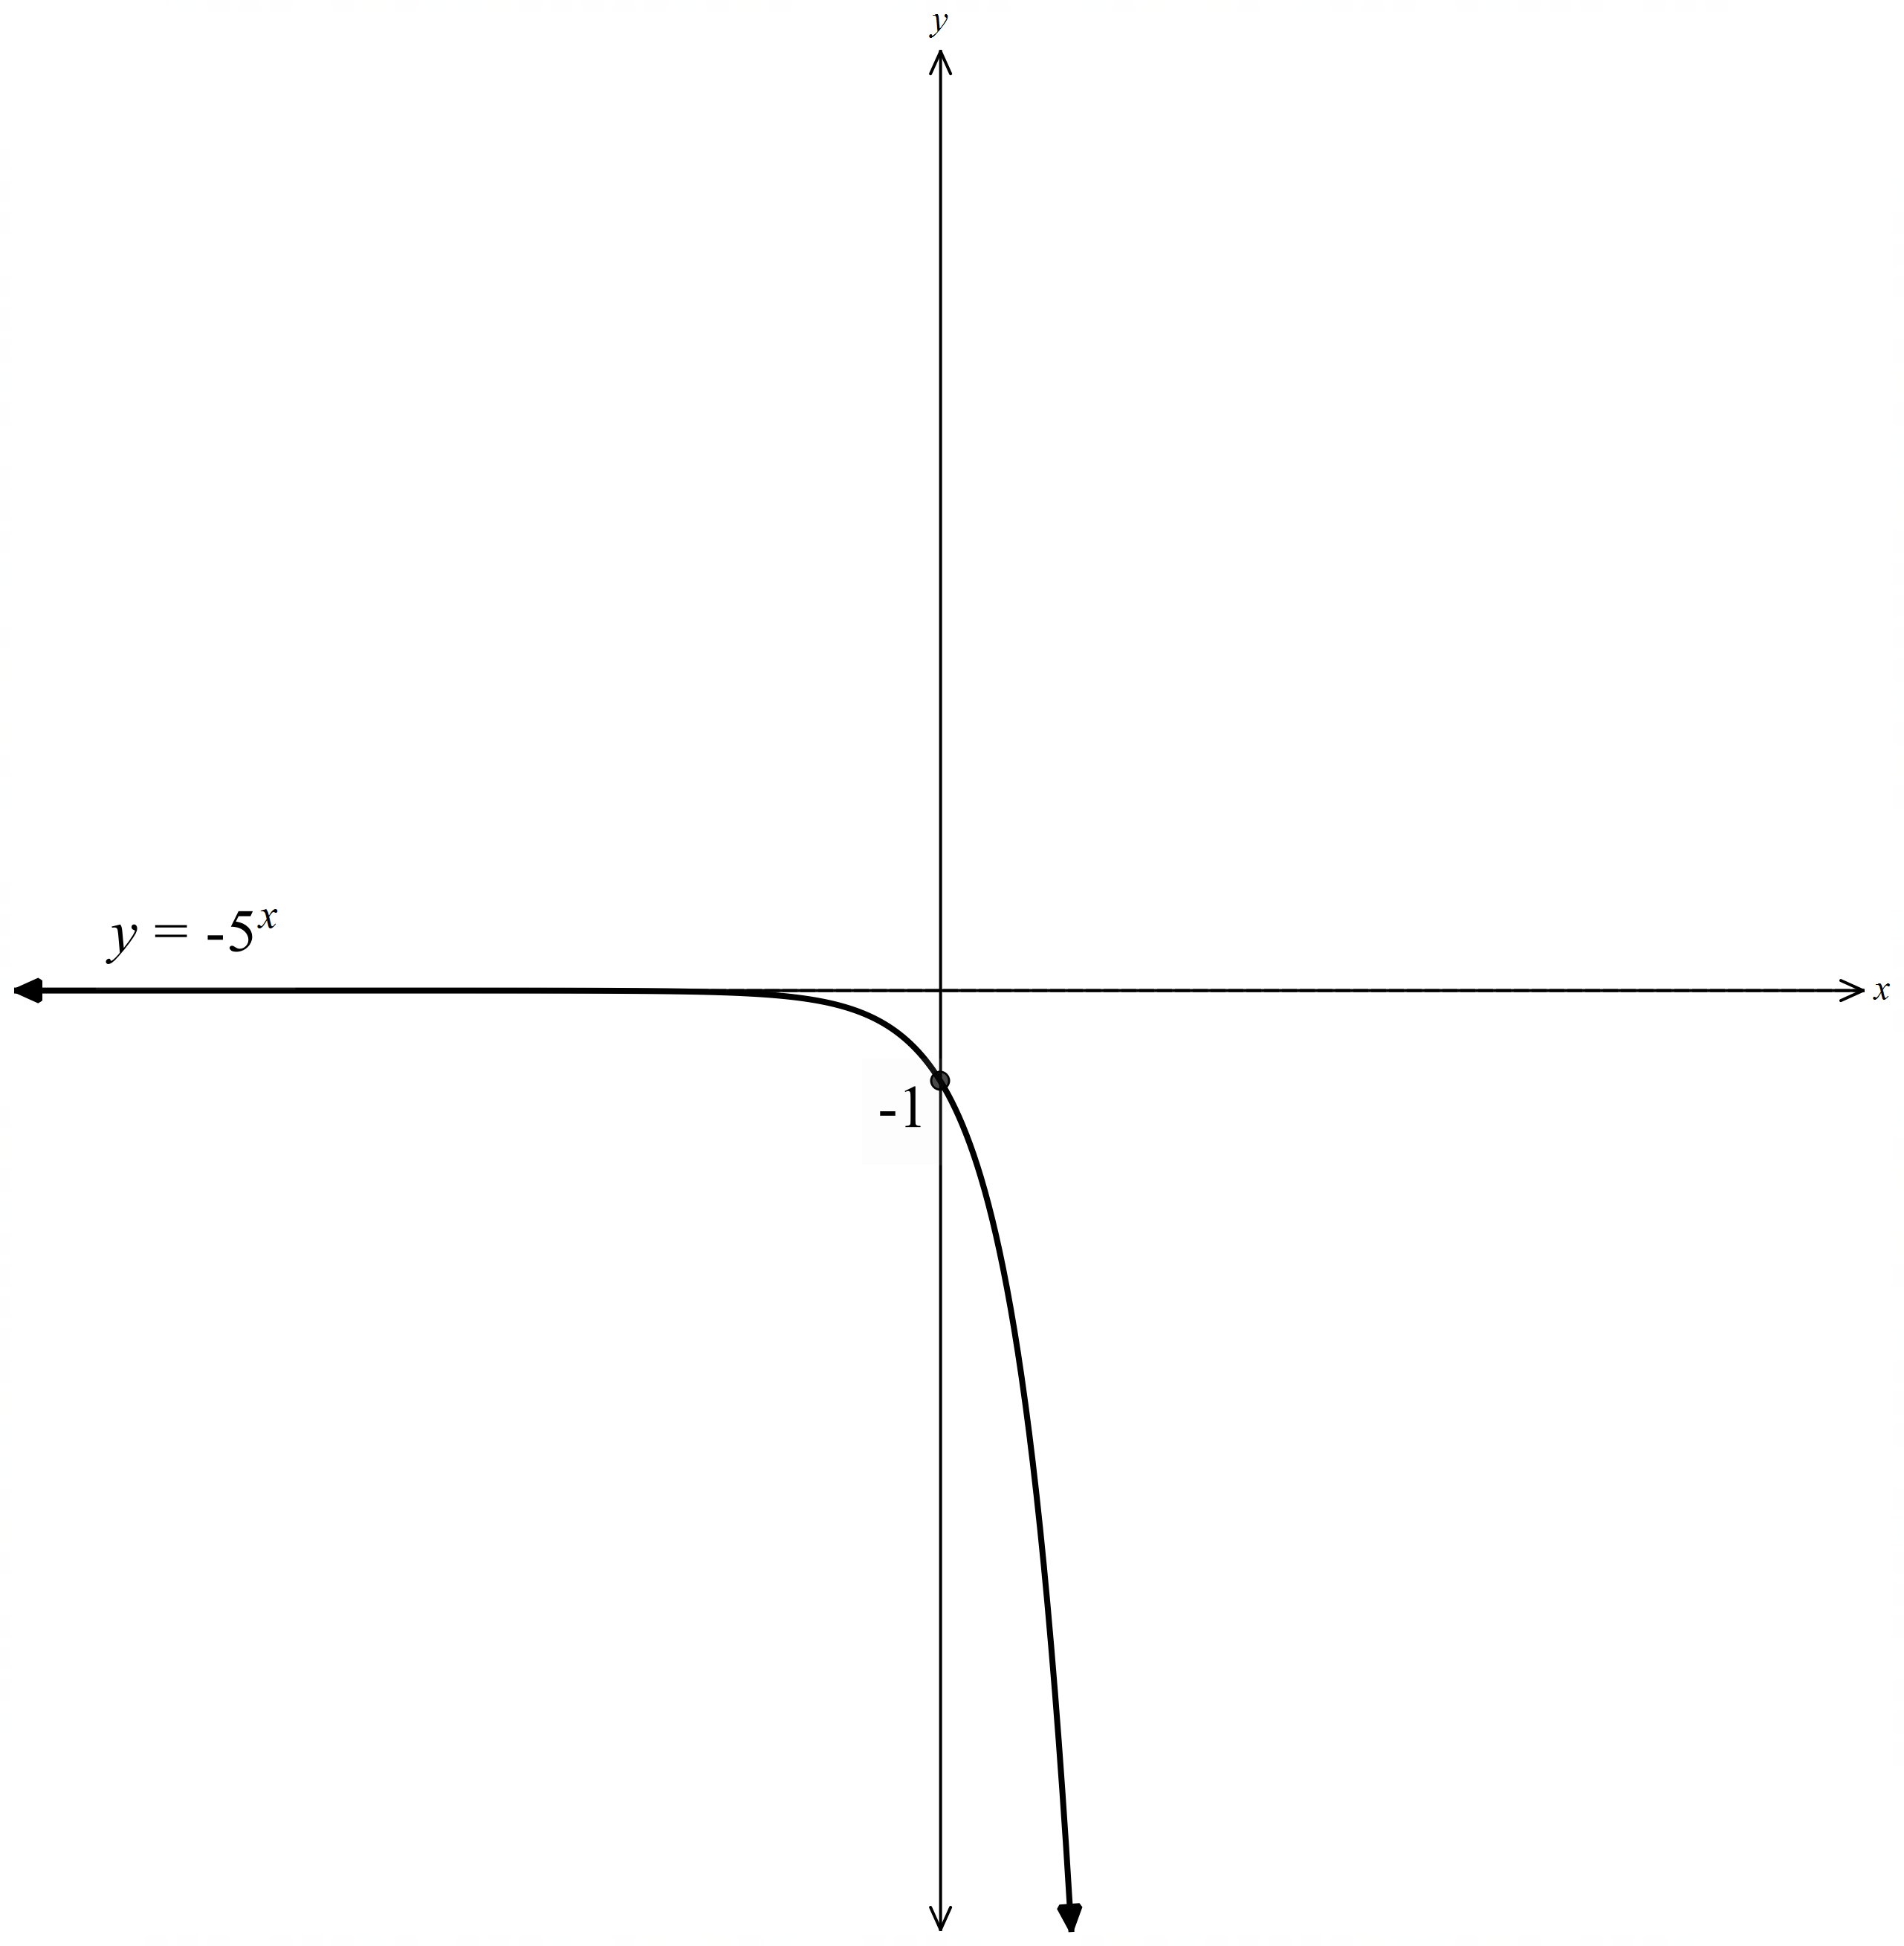

Appendix B – Four quadrant notes
Example 1  If $f\left(x\right)=-x^{3}+9x$, sketch $y=f(\left|x\right|)$.  Factorise $f\left(x\right)=-x(x+3)(x-3)$.  Sketch $y=f(x)$.  Sketch $y=f(\left|x\right|)$.  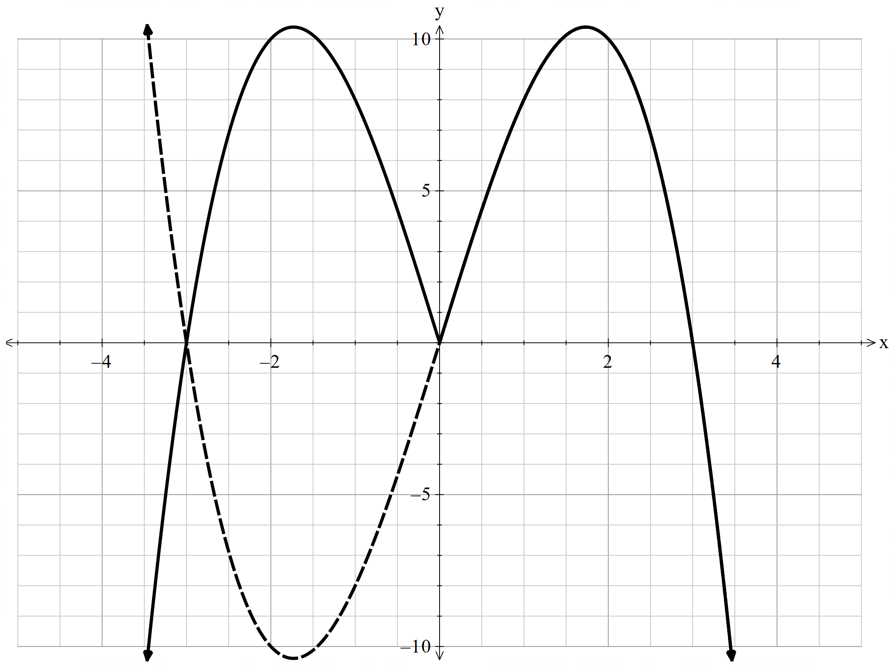 | Example 2  If $f\left(x\right)=x^{2}+x-2$, sketch $y=|f\left(x\right)|$.  Factorise $f\left(x\right)=\left(x+2\right)\left(x-1\right)$.  Sketch $y=f(x)$.  Sketch $y=|f\left(x\right)|$.  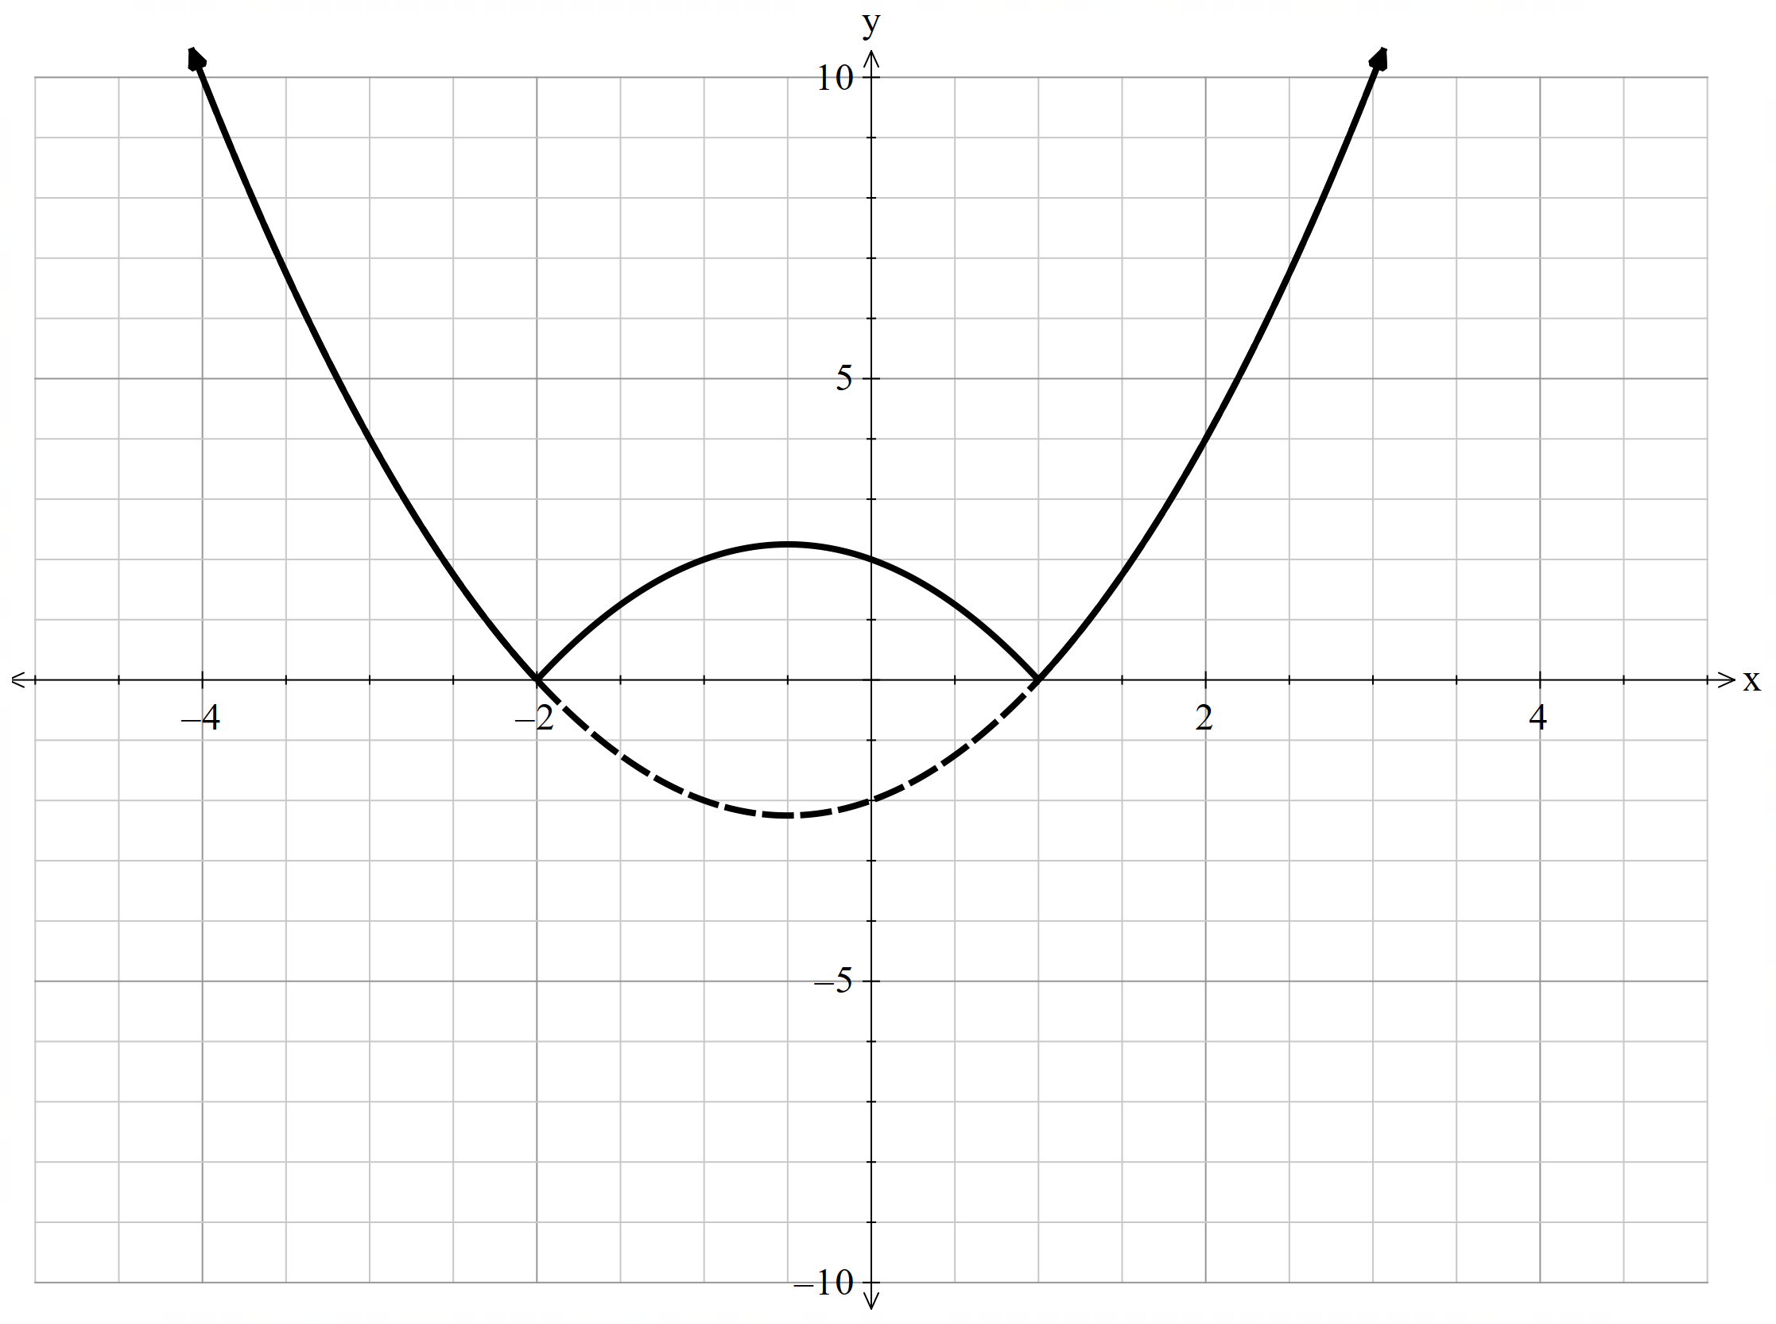

References
This resource contains NSW Curriculum and syllabus content. The NSW Curriculum is developed by the NSW Education Standards Authority (NESA). This content is prepared by NESA for and on behalf of the Crown in right of the State of New South Wales. The material is protected by Crown copyright.
Please refer to the NESA Copyright Disclaimer for more information https://www.nsw.gov.au/education-and-training/nesa/copyright.
NESA holds the only official and up-to-date versions of the NSW Curriculum and syllabus documents. Please visit NESA https://www.nsw.gov.au/education-and-training/nesa and NSW Curriculum https://curriculum.nsw.edu.au.
Mathematics Extension 1 11–12 Syllabus © NSW Education Standards Authority (NESA) for and on behalf of the Crown in right of the State of New South Wales, 2024.

© State of New South Wales (Department of Education), 2026
The copyright material published in this resource is subject to the Copyright Act 1968 (Cth) and is owned by the NSW Department of Education or, where indicated, by a party other than the NSW Department of Education (third-party material).
Copyright material available in this resource and owned by the NSW Department of Education is licensed under a Creative Commons Attribution 4.0 International (CC BY 4.0) license.

This license allows you to share and adapt the material for any purpose, even commercially.
Attribution should be given to © State of New South Wales (Department of Education), 2026.
Material in this resource not available under a Creative Commons license:
- the NSW Department of Education logo, other logos and trademark-protected material
- material owned by a third party that has been reproduced with permission. You will need to obtain permission from the third party to reuse its material.
Links to third-party material and websites
Please note that the provided (reading/viewing material/list/links/texts) are a suggestion only and implies no endorsement, by the New South Wales Department of Education, of any author, publisher, or book title. School principals and teachers are best placed to assess the suitability of resources that would complement the curriculum and reflect the needs and interests of their students.
If you use the links provided in this document to access a third-party's website, you acknowledge that the terms of use, including licence terms set out on the third-party's website apply to the use which may be made of the materials on that third-party website or where permitted by the Copyright Act 1968 (Cth). The department accepts no responsibility for content on third-party websites.

