Absolute value inequalities
This lesson builds on students’ prior knowledge of absolute value and introduces the use of the axis of symmetry to solve absolute value inequalities. Students will learn to solve these inequalities using 3 different methods.
Students will need at least one digital device per pair to interact with Amplify (Desmos) during this lesson.

Learning intention
- To be able to solve absolute value inequalities.

Success criteria
- I can graph an absolute value graph and use it to identify critical points.
- I can solve absolute value inequalities by finding the distance from the critical point.
- I can solve absolute value inequalities by graphing 2 separate equations.
- I can solve absolute value inequalities algebraically.

Outcomes
A student:
- develops understanding and fluency in mathematics through exploring and connecting mathematical concepts, choosing and applying mathematical techniques to solve problems, and communicating their thinking and reasoning coherently and clearly MAO-WM-01
- solves problems involving inequalities, functions and their inverses, graphical relationships between functions, and parametric equations ME1-11-01

Content

Further work with functions

Inequalities
- Solve absolute value inequalities of the form $\left|ax+b\right|≥k, \left|ax+b\right|≤k, \left|ax+b\right|<k, \left|ax+b\right|>k$ where $a, b$ and $k$ are constants, using algebraic and graphical methods or the characterisation of $|x|$ as the distance of $x$ from the origin
Mathematics Extension 1 11–12 Syllabus © NSW Education Standards Authority (NESA) for and on behalf of the Crown in right of the State of New South Wales, 2024.

Table 1: lesson summary
Section | Summary of activity | Teaching strategies | Teaching points
Activating prior knowledge | Display slide 4 of the PowerPoint Absolute value inequalities to introduce tolerances in manufacturing and the use of absolute value inequalities. | Think-Pair-Share | Engineers use $\left|x-10\right|≤0.02$to express 0.02 on either side of 10.
Connecting learning | Students complete the Amplify (Desmos) activity ‘Absolute value inequalities’ (bit.ly/absolute_value_inequalities) to solve absolute value inequalities graphically and by using a number line. Using slides 6–7, students solve an absolute value equation and inequality algebraically to connect learning and determine a suitable method for solving inequalities. | Amplify (Desmos)  Think-Pair-Share  Visibly random groups of 3  Vertical non-permanent surfaces | Solving absolute value inequalities using graphs, number lines and algebraically by considering positive and negative cases of the expression inside the absolute value.
Releasing responsibility | Use slides 9–10 to model solving absolute value inequalities algebraically. Students then practise using Appendix A. | Worked examples (Your turn)  Faded examples | Students practise solving absolute value inequalities algebraically.
Independent practice | Students use Appendix B to solve absolute value inequalities using multiple methods before making notes. Use slides 12–13 to challenge students to solve an absolute value inequality with an absolute value on both sides. | Notes to future forgetful selves  Visibly random groups of 3  Vertical non-permanent surfaces | Students consolidate and apply learning to familiar and unfamiliar examples.

Activity structure
Please use the associated PowerPoint Absolute value inequalities to display images in this lesson.

Activating prior knowledge
- Display slide 4 of the PowerPoint and define a washer as a thin, flat disc with a hole in the centre, used in conjunction with a bolt, screw or nut.
A washer distributes the load of a bolt or nut to prevent damage to surfaces and materials. It can also help prevent loosening, provide spacing or create a seal in mechanical connections.
- Tell students that washers are designed to match specific bolt or screw sizes and are made to fit precisely. Although machines are very accurate, they’re not perfect so a small amount of variation, called tolerance, is allowed when making washers.
- Using the example on slide 4, ask students to write an inequality outlining the acceptable values for the diameter of the washer, letting $x$ be the diameter of the washer in millimetres.
- Animate slide 4 to reveal the inequality $9.98≤x≤10.02$.
- Tell students that in engineering they use an absolute value equation to express this inequality.
- Animate slide 4 to reveal the absolute value inequality $\left|x-10\right|≤0.02$ for a 10 mm washer.
- In a Think-Pair-Share (bit.ly/thinkpairsharestrategy), ask students why an absolute value and an inequality are used to express the tolerance of a washer's diameter.
Absolute value is used to express the distance from the ideal size, irrespective of whether the washer is a little too small or large. An inequality is used to allow a range of acceptable values –anything within that distance is okay. This shows that small variations are allowed, as long as the variations don’t go beyond the tolerance limit.

Connecting learning
- With at least one device per pair, assign the Amplify (Desmos) activity ‘Absolute value inequalities’ (bit.ly/absolute_value_inequalities) for students to complete.
Before using this activity, you will need to set up an Amplify (Desmos) classroom. (bit.ly/createamplifyclassroom).
The pacing feature can be enabled to manage student progression. For example, restrictions could be applied at the end of screen 4 to focus students on investigating $y=\left|x\right|$and at screen 9 to limit their exploration to horizontal translations.
If devices are not available, the activity should be completed as a whole class, with student input sections explored and discussed together.
- Allow students time to complete the Amplify (Desmos) activity.
- In a Think-Pair-Share, ask students why absolute value inequalities that include an inequality in the form $\left|ax+b\right|$ are best solved by graphing on a plane rather than on a number line.
Guide students to recognise that the graph of an absolute value function in the form $y = |ax + b|$ has rate of change $|a|$. When solving inequalities that contain $|ax + b|$ we cannot simply read the horizontal distances from the critical point off the number line without considering the effect of the gradient.
- Tell students that there are 3 different methods of solving absolute value inequalities. They looked at the method of solving absolute value inequalities graphically and using the distance on a number line from a central (critical) point during the Amplify (Desmos) activity and will now look at how to solve them algebraically.
- Assign students to visibly random groups of 3 (bit.ly/visiblegroups) at vertical non-permanent surfaces (VNPS) (bit.ly/VNPSstrategy).
- Ask students to solve the equation $\left|3x+4\right|=5$algebraically using 2 methods, one where you consider the positive and negative cases for the left-hand side and one where you consider it for the right-hand side.
Students were taught how to solve absolute value equations in Mathematics Advanced Unit 4 – Lesson 2 – absolute values. Students may need a reminder to consider both the positive and negative scenarios in each method.
- Display slide 6 of the PowerPoint showing the 2 methods and have students consider what is the same and what is different.
- Ask students to solve the inequality $\left|3x+4\right|>5$ using the 2 algebraic methods from slide 6.
- Once students have finished, ask them to check their solutions graphically using an online graphing program.
- Display slide 7 showing the working out for the 2 methods and ask students to again identify what is the same and what is different.
Students should notice that the positive case is the same for both methods, but the negative case produces different solutions.
- Using the Pose-Pause-Pounce-Bounce questioning strategy have students consider which solution is correct and why. Prompt students to consider if they can split the inequality into another 2 valid cases by considering absolute value as a distance from the origin.
Through discussion, students should observe that:
- the 2 methods give different answers for the negative case.
- the first method (considering positive and negative cases of the left-hand side or expression inside the absolute value) produces the correct solution that matches the graphical and number line solutions.
- the second method (considering positive and negative cases of the right-hand side or constant, $k$) can lead to incorrect results when solving inequalities because it misunderstands the structure of absolute value inequalities which require us to consider the entire expression inside the absolute value in relation to the constant $k,$ rather than treating $k$ as a variable that can be positive or negative.

Releasing responsibility
- Use slides 9–10 of the PowerPoint to model solving absolute value inequalities algebraically using the Worked examples (Your turn) method (bit.ly/supportingstrategies).
Animate the ‘Worked example’ slide 3 times to show self-explanation prompts one at a time and animate the ‘Your turn’ slide to show the solutions.
- Distribute Appendix A ‘Faded examples’ and have students practise solving absolute value inequalities algebraically using a gradual release of responsibility (bit.ly/fadedexamplesstrategy).

Independent practice
- Distribute Appendix B ‘Solving 3 ways’ and have students complete each question using the distance away from the critical point, graphically and algebraically.
Students should be able to self-check their answers by comparing the 3 different methods.
- Have students write notes to their future forgetful selves (bit.ly/notestofutureself) at the end of Appendix B using an example to explain the 3 different methods.
- Back in their groups of 3 at vertical non-permanent surfaces, display slide 12 of the PowerPoint.
- Ask students to discuss possible solution strategies and attempt to solve the problem.
Encourage students to share different approaches, consider both algebraic and graphical methods, and justify their reasoning as they work towards a solution.
Use slide 13 to demonstrate the solution graphically. The algebraic solution can be found using slide 14 but is outside the scope of the course.

Assessment and differentiation

Suggested opportunities for differentiation
Connecting learning
- Students may need to be reminded that continuous inequalities are written together and non-continuous inequalities are written separately.
- Students could be extended to develop generalisations for solving absolute value inequalities in the form $|ax+b|$ using the critical point and number line.
- Students may need to revise graphing straight lines and absolute value functions.
- The difficulty of the absolute value equation could be modified to suit your context.
Releasing responsibility
- There are a variety of different approaches to solving absolute value inequalities. These could be explored and compared.
- Students could be exposed to absolute value inequalities beyond the scope of the syllabus such as those in the form $\left|ax+b\right|<cx+d$.
Independent practice
- Appendix B could be changed to incorporate more difficult absolute value inequalities.
- Slide 12 could be omitted if students are not ready for intersecting absolute value graphs.

Suggested opportunities for assessment
Connecting learning
- Use this activity to gauge students’ prior knowledge of absolute value functions.
- The teacher could monitor students' responses to the Amplify (Desmos) to assess their ability to graph absolute value functions, graph linear functions in the form $y=k$ and express regions using inequalities.
Releasing responsibility
- The teacher should monitor students' answers to the self-explanation prompts to assess their understanding of absolute values and inequalities.
Independent practice
- Appendix B could be collected as an exit ticket to check students' ability to solve absolute value inequalities using a variety of methods.

Appendix A

Faded examples
$$\left|3x+5\right|≤1$$ | $$\left|5x-3\right|≤1$$ | $$\left|3x-5\right|≥1$$ | $$\left|5x-3\right|>1$$
Positive case  $$3x+5≤1 \\ 3x≤-4 \\ x≤-\frac{4}{3}$$ | Positive case  $$5x-3≤1 \\ 5x≥4 \\ x≥\frac{4}{5}$$ | Positive case
Negative case  $$-\left(3x+5\right)≤1 \\ -3x-5≤1 \\ -3x≤6 \\ x≥-2$$ | Negative case | Negative case
$$-2≤x≤-\frac{4}{3}$$

Appendix B

Solving 3 ways
Equation | Distance from a critical point | Graphically | Algebraically
$$\left|x-2\right|≥4$$
$$\left|3-x\right|<-5$$
$$\left|4x+2\right|≤10$$
Things to remember:

Sample solutions

Appendix A – faded examples
$$\left|3x+5\right|≤1$$ | $$\left|5x-3\right|≤1$$ | $$\left|3x-5\right|≥1$$ | $$\left|5x-3\right|>1$$
Positive case  $$3x+5≤1 \\ 3x≤-4 \\ x≤-\frac{4}{3}$$ | Positive case  $$5x-3≤1 \\ 5x≤4 \\ x≤\frac{4}{5}$$ | Positive case  $$3x-5≥1 \\ 3x≥6 \\ x≥2$$ | Positive case  $$5x-3>1 \\ 5x>4 \\ x>\frac{4}{5}$$
Negative case  $$-\left(3x+5\right)≤1 \\ -3x-5≤1 \\ -3x≤6 \\ x≥2$$ | Negative case  $$-\left(5x-3\right)≤1 \\ -5x+3≤1 \\ -5x≤-2 \\ x≥\frac{2}{5}$$ | Negative case  $$-\left(3x-5\right)≥1 \\ -3x+5≥1 \\ -3x≥-4 \\ x≤\frac{4}{3}$$ | Negative case  $$-\left(5x-3\right)>1 \\ -5x+3>1 \\ -5x>-2 \\ x<\frac{2}{5}$$
$$-2≤x≤-\frac{4}{3}$$ | $$\frac{2}{5}≤x≤\frac{4}{5}$$ | $$x≤\frac{4}{3} and x≥2$$ | $$x<\frac{2}{5} and x>\frac{4}{5}$$

Appendix B – solving 3 ways
Equation | Distance from a critical point | Graphically | Algebraically
$$\left|x-2\right|≥4$$ | 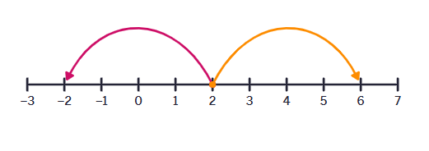  $$x≤-2 ∪x≥6$$ | 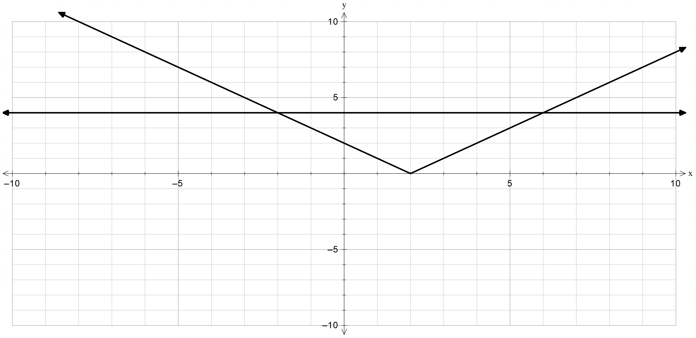  $$x≤-2∪x≥6$$ | Positive case  $$x-2≥4 \\ x≥6$$  Negative case  $$-\left(x-2\right)≥4 \\ -x+2≥4 \\ -x≥2 \\ x≤-2$$  $$x≤-2 ∪ x≥6$$
$$\left|3-x\right|<5$$ | 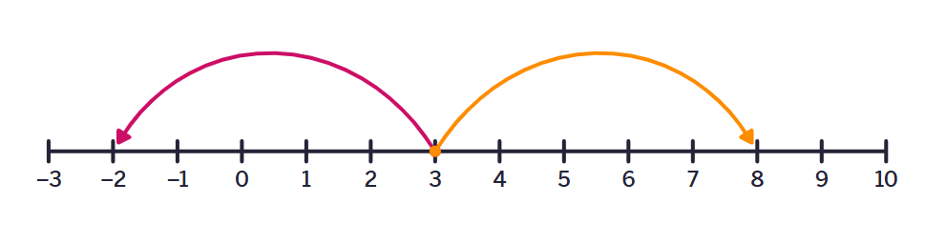  $$-2<x<8$$ | 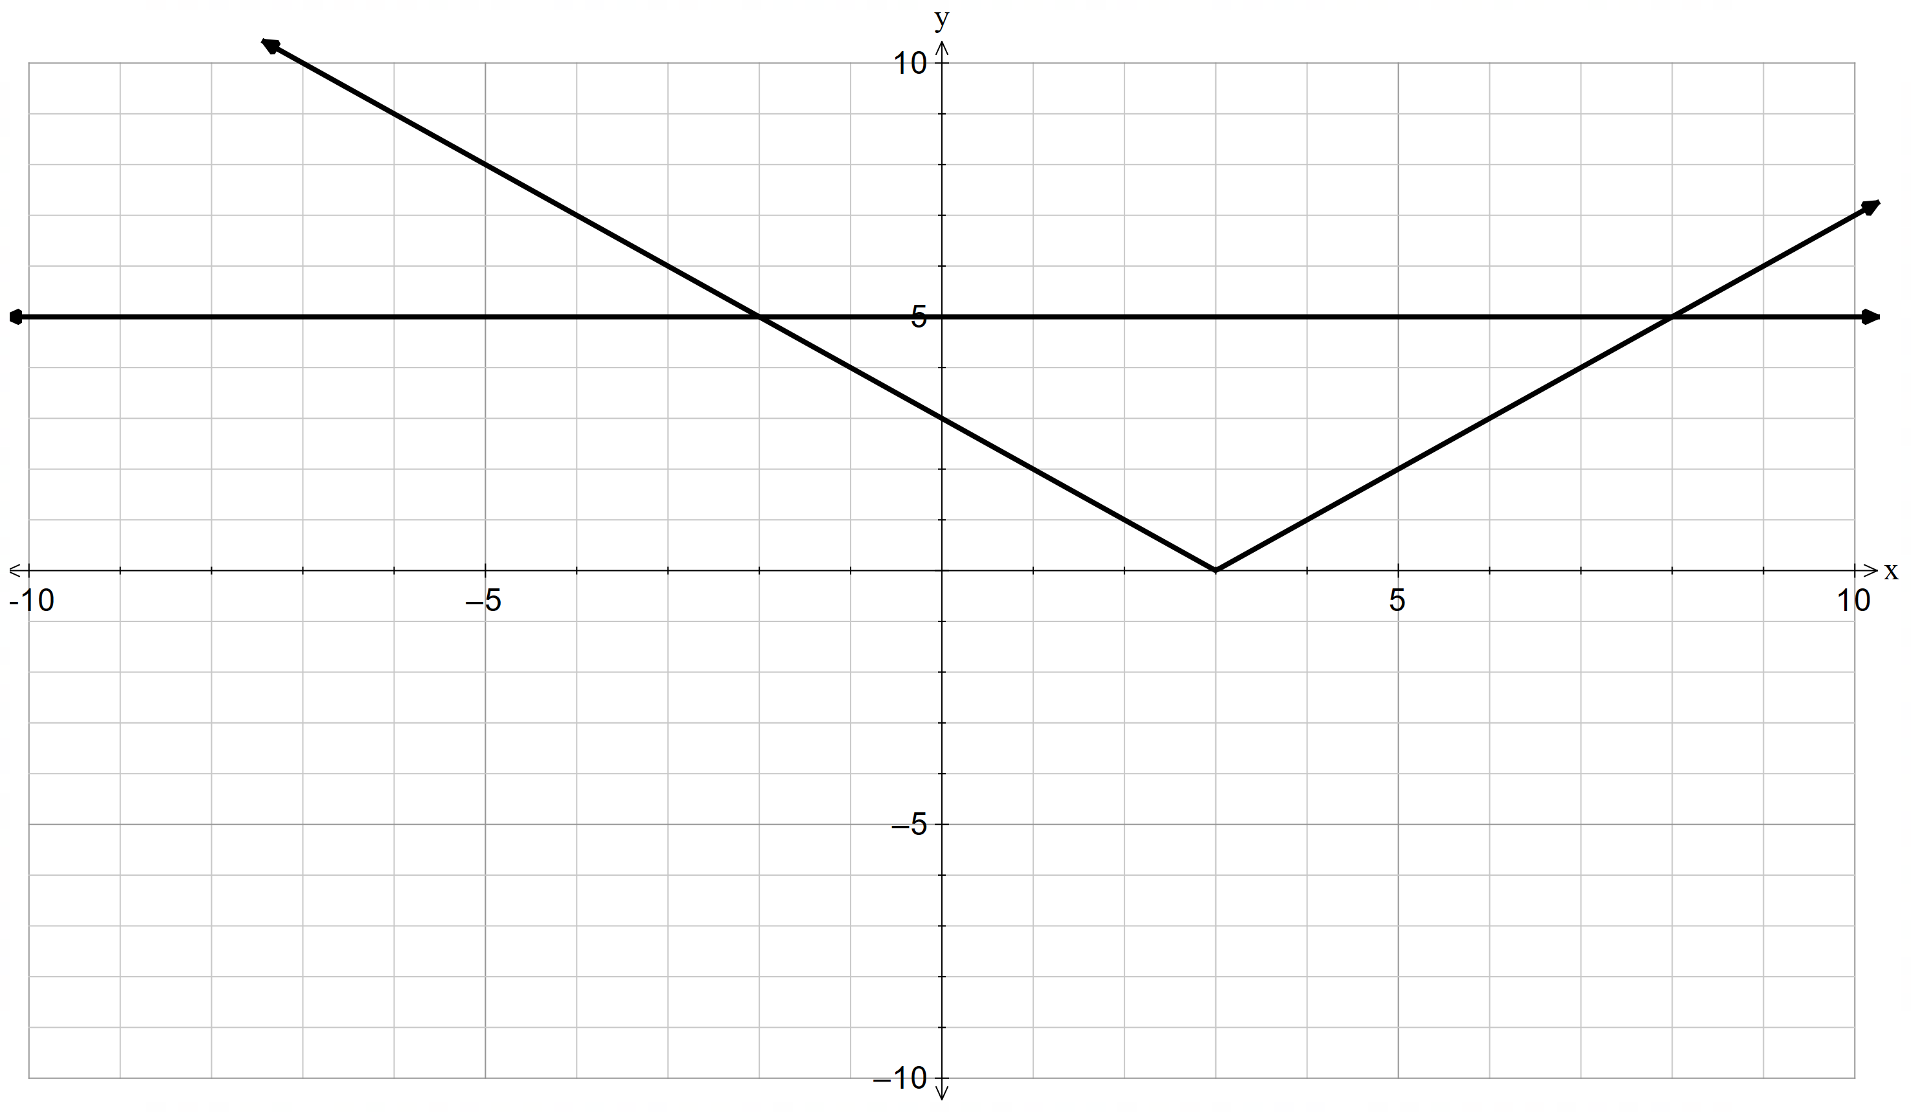  $$-2<x<8$$ | Positive case  $$3-x<5 \\ -x<2 \\ x>-2$$  Negative case  $$-\left(3-x\right)<5 \\ -3+x<5 \\ x<8$$  $$-2<x<8$$
$$\left|4x+2\right|≤10$$ | This is not a method that should be used. | 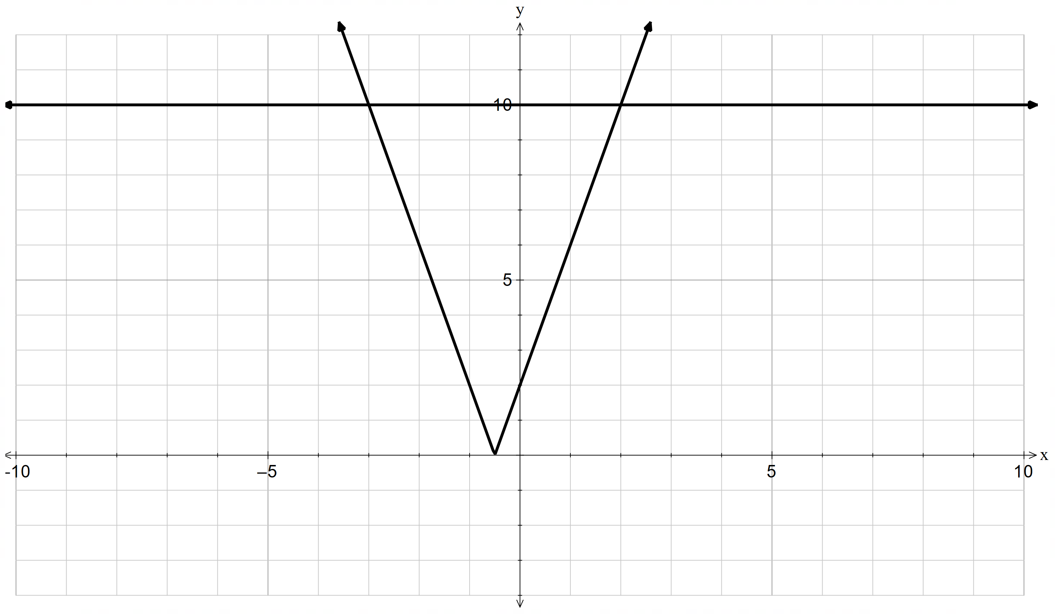  $$-3≤x≤2$$ | Positive case  $$4x+2≤10 \\ 4x≤8 \\ x≤2$$  Negative case  $$-\left(4x+2\right)≤10 \\ -4x-2≤10 \\ -4x≤12 \\ x≥-3$$  $$-3≤x≤2$$

References
This resource contains NSW Curriculum and syllabus content. The NSW Curriculum is developed by the NSW Education Standards Authority. This content is prepared by NESA for and on behalf of the Crown in right of the State of New South Wales. The material is protected by Crown copyright.
Please refer to the NESA Copyright Disclaimer for more information https://educationstandards.nsw.edu.au/wps/portal/nesa/mini-footer/copyright.
NESA holds the only official and up-to-date versions of the NSW Curriculum and syllabus documents. Please visit the NSW Education Standards Authority (NESA) website https://educationstandards.nsw.edu.au/ and the NSW Curriculum website https://curriculum.nsw.edu.au/.
Mathematics Extension 1 11–12 Syllabus © NSW Education Standards Authority (NESA) for and on behalf of the Crown in right of the State of New South Wales, 2024.

© State of New South Wales (Department of Education), 2025
The copyright material published in this resource is subject to the Copyright Act 1968 (Cth) and is owned by the NSW Department of Education or, where indicated, by a party other than the NSW Department of Education (third-party material).
Copyright material available in this resource and owned by the NSW Department of Education is licensed under a Creative Commons Attribution 4.0 International (CC BY 4.0) license.

This license allows you to share and adapt the material for any purpose, even commercially.
Attribution should be given to © State of New South Wales (Department of Education), 2025.
Material in this resource not available under a Creative Commons license:
- the NSW Department of Education logo, other logos and trademark-protected material
- material owned by a third party that has been reproduced with permission. You will need to obtain permission from the third party to reuse its material.
Links to third-party material and websites
Please note that the provided (reading/viewing material/list/links/texts) are a suggestion only and implies no endorsement, by the New South Wales Department of Education, of any author, publisher, or book title. School principals and teachers are best placed to assess the suitability of resources that would complement the curriculum and reflect the needs and interests of their students.
If you use the links provided in this document to access a third-party's website, you acknowledge that the terms of use, including licence terms set out on the third-party's website apply to the use which may be made of the materials on that third-party website or where permitted by the Copyright Act 1968 (Cth). The department accepts no responsibility for content on third-party websites.

