Cubic inequalities
Students will learn how to solve cubic inequalities by graphing them on a Cartesian plane and represent the solutions graphically, on a number line or algebraically. They will consider how a business might use a cubic inequality to make decisions.

Learning intention
- To be able to solve cubic inequalities where the cubic is expressed as a product of linear factors.

Success criteria
- I can locate the roots of a cubic equation when it is expressed as a product of linear factors.
- I can use a graph to solve a cubic inequality.
- I can represent the solution of an inequality graphically.
- I can represent the solution of an inequality algebraically.

Outcomes
A student:
- develops understanding and fluency in mathematics through exploring and connecting mathematical concepts, choosing and applying mathematical techniques to solve problems, and communicating their thinking and reasoning coherently and clearly MAO-WM-01
- solves problems involving inequalities, functions and their inverses, graphical relationships between functions, and parametric equations ME1-11-01

Content

Further work with functions
Inequalities
- Solve cubic inequalities where the cubic is expressed as a product of linear factors
Mathematics Extension 1 Year 11–12 Syllabus © NSW Education Standards Authority (NESA) for and on behalf of the Crown in right of the State of New South Wales, 2024.

Table 1: lesson summary
Section | Summary of activity | Teaching strategies | Teaching points
Activating prior knowledge | Students use a Which one doesn’t belong? on slide 4 of the PowerPoint Cubic inequalities to identify significant features of graphs of quadratic inequalities. They are then asked to match the graphs to their number line solution in Appendix A. | Which one doesn’t belong?  Think-Pair-Share  Pose-Pause-Pounce-Bounce | Recognise the solution of a quadratic inequality and how the solution can also be graphed on a number line.
Connecting learning | On slide 6, students are shown a cubic equation and its graph. On slide 7 is the graphical and algebraic solution of the equation when it is equal to zero and on slide 8 the solution when it is changed to an inequality. Students are encouraged to consider the differences between the equation and inequality and the differences when the solution is graphed on a Cartesian plane, a number line and shown algebraically. Students solve cubic inequalities in Appendix B, which uses Variation Theory to draw attention to how a solution is impacted by changes in the inequality. | Think-Pair-Share  Notice and wonder  Pose-Pause-Pounce-Bounce  Variation Theory | Compare the similarities and differences between an equation and inequality and consider the benefits of different representations of the solution to an inequality.
Releasing responsibility | Students complete the Four quadrant notes in Appendix C. They then complete the Venn diagram in Appendix D to consider different cubic inequalities | Four quadrant notes  Venn diagram | Consolidate understanding of finding the solution of an inequality and representing it using a graph on a Cartesian plane, a number line and algebraically.
Independent practice | Students work in groups of 3 to consider business scenarios in Appendix E and complete questions which connect to the real world. | Visibly random groups of 3  Vertical non-permanent surfaces | Recognise how a cubic inequality can be used to model a real-world scenario and consider how it can be used to make decisions.

Activity structure
Please use the associated PowerPoint Cubic inequalities to display images in this lesson.

Activating prior knowledge
- Display slide 4 of the PowerPoint, which displays 4 graphs of quadratic inequalities.
- In a Think-Pair-Share (bit.ly/thinkpairsharestrategy), ask students to connect to prior learning by choosing which one doesn’t belong (talkingmathwithkids.com/wodb-about).
Reasons they give may include that the first graph has the equation in factored form, the second graph has the orange section below the $x$-axis, the third graph is only greater than, not equal to, and in the fourth graph the parabola is concave down.
- Use the Pose-Pause-Pounce-Bounce questioning strategy (PDF 557 KB) (bit.ly/posepausepouncebounce) to initiate a class discussion to discuss the graphs and how they represent the solution of each inequality. Useful question prompts may include:
- How do the roots of the equation help form the solution to the inequality?
- How do we decide which section of the graph agrees with the inequality?
- How do we know if there should be an open or closed circle at the roots of the equation?
- What does an open or closed circle indicate?

The roots show where the graph crosses the $x$-axis and the graph moves one side of the axis to the other.
The parts of the graph are above the $x$-axis, therefore they are $>0$. The parts of the graph that are below the $x$-axis are $<0$. Where the graph crosses the $x$-axis, the graph is equal to zero.
When the inequality is $>$ or $<$, the circle is open, which means the value of the root is not a part of the solution of the inequality.
When the inequality is $≥$ or $≤$, the circle is closed, which means the value of the root is a part of the solution of the inequality.
- Distribute Appendix A ‘Match the graphs’ and ask students to match each of the quadratic inequality graphs to its number line solution. The graphs are the same as those on slide 4 of the PowerPoint.
- Use the Pose-Pause-Pounce-Bounce questioning strategy to draw attention to features of a number line solution. Useful question prompts may include:
- Why were there only 3 number lines for the 4 graphs?
- How did you know which number line matched a graph?
- Why would we use open circles on a number line solution?

Connecting learning
- Display slide 6 of the PowerPoint, which shows the graph of a cubic equation, and ask students what they notice and wonder (bit.ly/noticewonderstrategy).
Students might suggest that the graph is a cubic curve, the $x$-intercepts are $-2$, $1$ and $4$, the $y$-intercept is 8 and that all points on the line satisfy the equation.
- Display slide 7 which shows the previous cubic equation rewritten as an equation equal to zero and the solution on the Cartesian plane. Ask students what they notice and wonder about the graph, number line and the algebraic solution.
Students should recognise that the 3 points on the graph are orange, rather than parts of the cubic curve because the solution is $x=-2,x=1$ and $x=4$.
Students should notice that the graph on the right is a Cartesian plane which shows a faint cubic curve, the graph on the left is a number line and both graphs have orange points at $x=-2$, $x=1$ and $x=4$. They may wonder if both graphs are appropriate to represent the solution.
- Display slide 8, which shows the previous cubic equation rewritten as an inequality, the solution on a Cartesian plane and on a number line and the algebraic solution. Ask students what they notice and wonder.
Students should notice that the equation has been changed to an inequality, that the solution shows the values of $x$ that would satisfy the inequality and that the solution is represented on a Cartesian plane, on a number line and algebraically.
Students may notice that the Cartesian plane shows the solution to the inequality by highlighting the part of the curve that is above the $x$-axis, the number line shows the solutions by using open circles and orange lines and the algebraic solution has 2 parts.
Students may wonder if all 3 ways of representing the solution are needed.
- Use the Pose-Pause-Pounce-Bounce questioning strategy to discuss how to show the solution to a cubic inequality. Useful question prompts may include:
- How can we find the zeroes when solving a cubic inequality?
- How do we know where to highlight the graph on the Cartesian plane?
- How do we know where to draw an open circle on the $x$-axis when drawing the graph on the Cartesian plane?
- How do we know when to use an open circle when showing the solution on a number line?

Students found the zeroes of an equation in Mathematics Advanced – Unit 3 – Lesson 6 – factorising and graphing monic quadratics.
The zeroes are found by letting the inequality equal zero. The graph of the cubic equation is highlighted when the curve is above the $x$-axis. Open circles on the number line are used when the equality does not include the equals component.
- Assign students to visibly random groups of 3 (bit.ly/visiblegroups) to work at vertical non-permanent surfaces (bit.ly/VNPSstrategy).
- Distribute Appendix B ‘Solving cubic inequalities’ for students to complete in their groups.
The questions have been created using Variation Theory (variationtheory.com/introduction) which draws student attention to how small changes to the question can influence the solution.
- Use the Pose-Pause-Pounce-Bounce questioning strategy to draw attention to how changes to the inequalities impacted the solution and to discuss the benefits of the different ways of representing the solutions. Useful question prompts may include:
- How did changes in the equations affect the graphs?
- How can the graph inform where to highlight the number line?
- How do the graph and number line support the algebraic solution?

Releasing responsibility
- Distribute Appendix C ‘Four quadrant notes’ (bit.ly/supportingstrategies) and ask students to complete them first in their groups of 3, then individually.
- Distribute Appendix D ‘Venn diagram’ and ask students to complete the Venn diagram in their groups of 3 on the vertical non-permanent surfaces.
- Use a gallery walk (bit.ly/DLSgallerywalk) for students to view the solution of other groups.
- Use the Pose-Pause-Pounce-Bounce questioning strategy to discuss the strategies students used to complete the Venn diagram the first time and how they might adjust their strategy to identify a second solution for each region.

Independent practice
Continuing in their visibly random groups of 3 and working at vertical non-permanent surfaces, distribute Appendix E ‘Business problems’ for each group to solve.

Assessment and differentiation

Suggested opportunities for differentiation
Activating prior knowledge
- Students may benefit from revisiting their notes on solving quadratic inequalities from the Mathematics Advanced course.
Connecting learning
- Students may benefit from seeing more examples or being given more challenging examples.
Releasing responsibility
- Students might be challenged to find a family of functions that fit within each region of the Venn diagram.
Independent practice
- Students could be provided with a graph of the cubic equation and a scaffold to support interpretation of the graph in relation to the context of the equation.

Suggested opportunities for assessment
Activating prior knowledge
- Student responses during the share phase of the Think-Pair-Share can be used to determine student understanding of quadratic inequalities.
Connecting learning
- Student responses during the share phase of the Think-Pair-Share can be used to determine student understanding of solving cubic inequalities.
- Student responses to Appendix B can be used as a check for understanding and to determine if concepts such as shading the Cartesian plane, identifying the zeroes and representing a solution algebraically need to be revisited.
Releasing responsibility
- Students’ Four quadrant notes may be collected for formative assessment against the success criteria.
Independent practice
- Student responses to the business problem questions can support formative assessment, indicating understanding of how to interpret the graph of a cubic inequality.

Appendix A

Match the graphs
Match each graph with its number line solution.
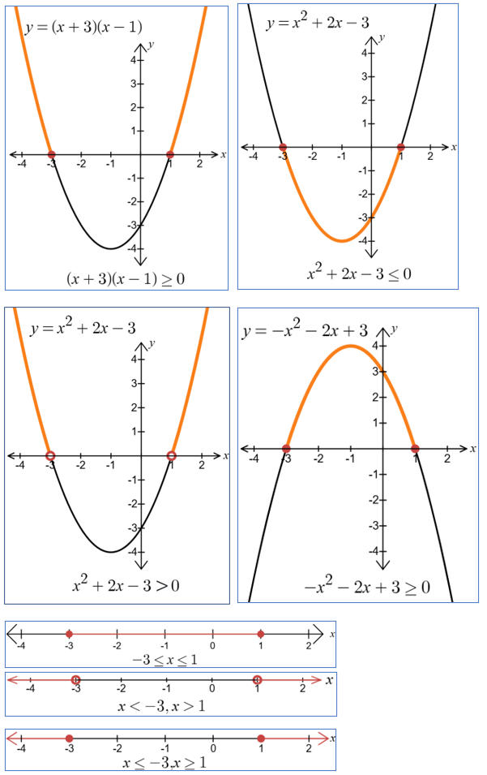

Appendix B

Solving cubic inequalities
For each of the following inequalities:
- Identify the zeroes
- Find the $y$-intercept
- Draw the graph of the equation on a Cartesian plane and highlight the solution of the inequality
- Represent the solution on a number line
- Write the solution algebraically
- $\left(x+2\right)\left(x-1\right)\left(x-4\right)<0$
- $\left(x+2\right)\left(x-1\right)\left(x-4\right)≤0$
- $\left(x+2\right)\left(x-1\right)\left(x-4\right)≥0$
- ${\left(x-1\right)}^{2}\left(x-4\right)>0$
- $x\left(x-1\right)\left(x-4\right)>0$
- $x{\left(x-2\right)}^{2}>0$

Appendix C

Four quadrant notes
Example 1  Solve the inequality $\left(x+2\right)\left(x-1\right)\left(x-4\right)<0$  Zeroes: when$y=0,$ $x=__,__,__$  $y$-intercept (when $x=0$)$=2×-1×-4$$$=__$$  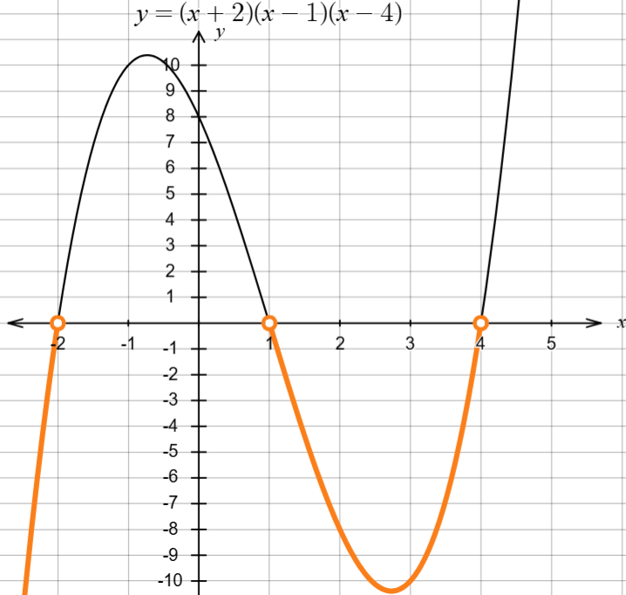  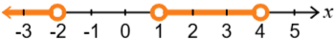  $$__<__,__<x<__$$ | Example 2  Solve the inequality $\left(x+1\right)\left(x-2\right)\left(x-3\right)<0$
Things to remember | Example 3

Appendix D

Venn diagram
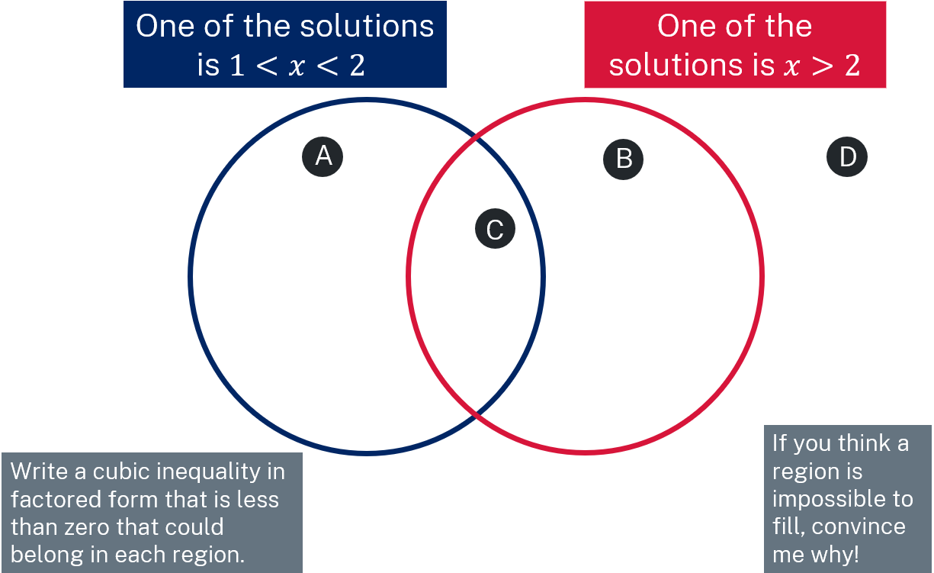

Appendix E

Business problems
- Max is the manager of a trailer rental business. The business models the return on investment (ROI) of the trailers using the cubic function:
$$R\left(x\right)=-x\left(x-5\right)\left(x-10\right)$$
Where:
- $R\left(x\right)=$ ROI in thousands of dollars over 5 years.
- $x$ is the purchase cost of a trailer, in thousands of dollars.
- What are the $x$-intercepts of the function $R(x)$ and what do these intercepts represent in the context of the ROI for the trailer rental business?
- What is the $y$-intercept of $R(x)$, and what does it imply for the business's ROI?
- Graph the function $R\left(x\right).$
- Explain why a negative ROI is possible and what factors might contribute to such a scenario in the trailer rental business.
- How might the end behaviour of the function influence Max’s decision when the purchase cost of a trailer is very high?
- Max plans to attend an agricultural show to purchase a new trailer. What information does the graph provide Max regarding how much he should spend on a new trailer?

- Freya owns a small business that produces handcrafted wooden toys. The profit $P(x)$ from the production and sale of these toys for the year can be modelled by the cubic function:
$$P\left(x\right)=x\left(x-1\right)\left(x-4\right)$$
Where:
- $P(x)$ is the profit, in thousands of dollars
- $x$ represents the number of toys produced and sold (in hundreds).
- Graph the function.
- Explain why the factors $x$, $(x-1)$ and $\left(x-4\right)$ are important for Freya’s toy production business.
- Freya thinks she has capacity to produce 200 toys. What factors should she consider before making this production decision?
- What does the behaviour of the graph indicate about producing more than 100 toys and what might be the reasons for this?
- How might the shape of the curve influence Freya’s decision about the number of toys to produce?
- What production levels would you recommend for maximising profit?

Sample solutions

Appendix A – match the graphs
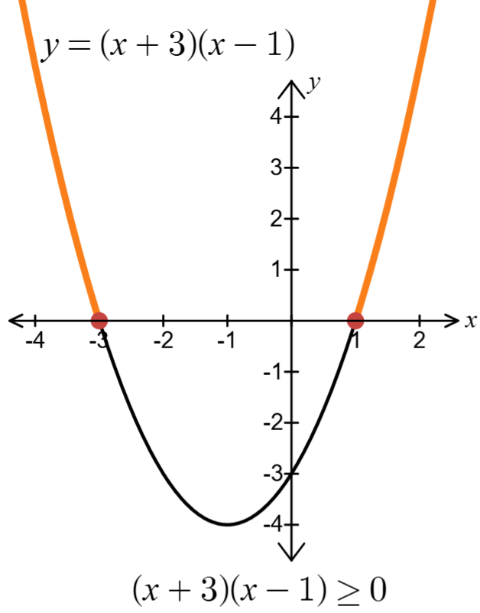  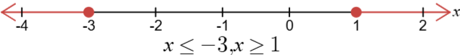 | 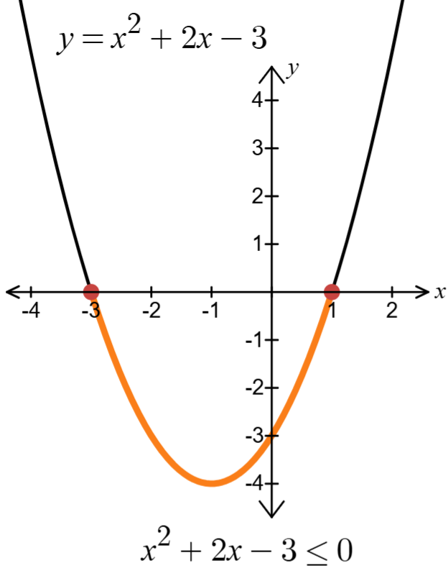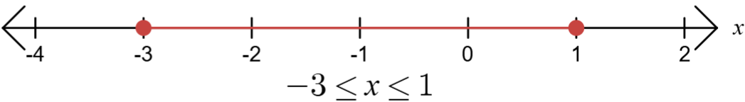
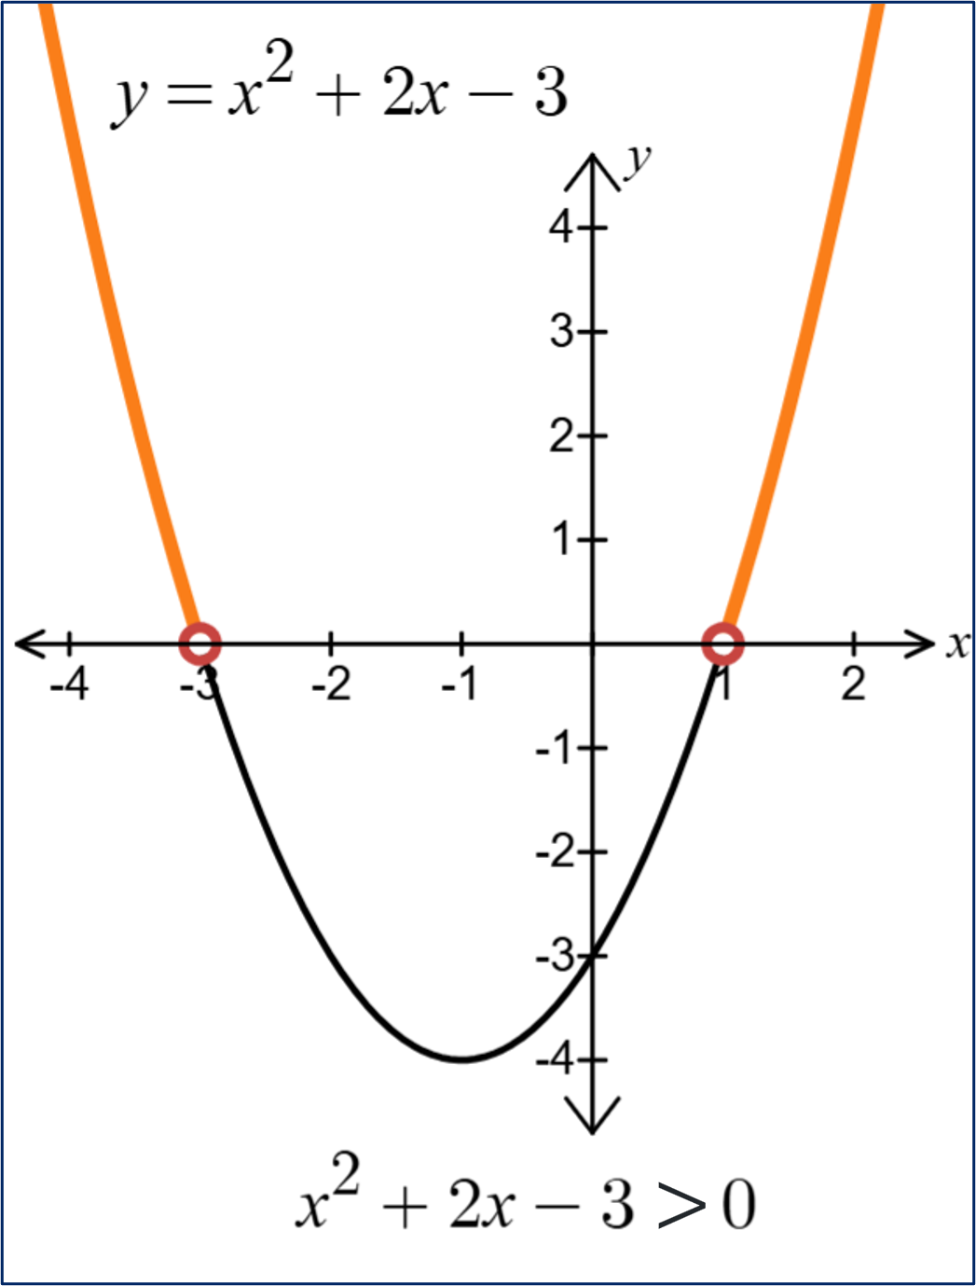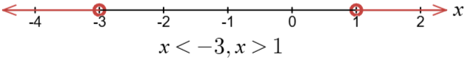 | 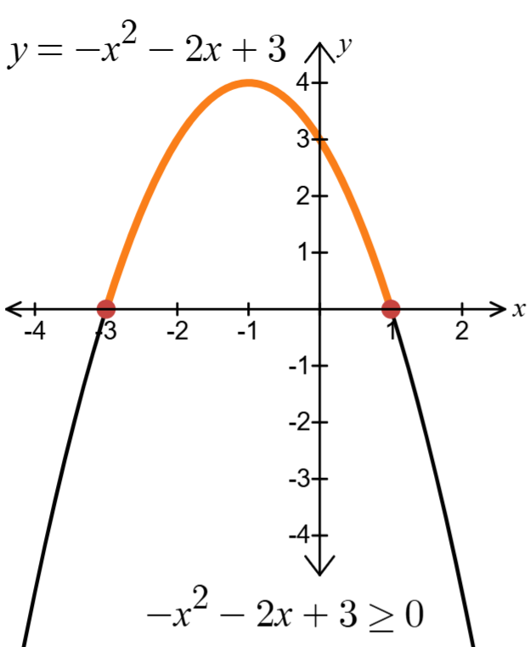

Appendix B – solving cubic inequalities
- $\left(x+2\right)\left(x-1\right)\left(x-4\right)<0$ | - $\left(x+2\right)\left(x-1\right)\left(x-4\right)≤0$ | - $\left(x+2\right)\left(x-1\right)\left(x-4\right)≥0$
Zeroes: $x=-2, x=1, x=4$ | Zeroes: $x=-2, x=1, x=4$ | Zeroes: $x=-2, x=1, x=4$
$y$-intercept: when $x=0, y=8$ | $y$-intercept: when $x=0, y=8$ | $y$-intercept: when $x=0, y=8$
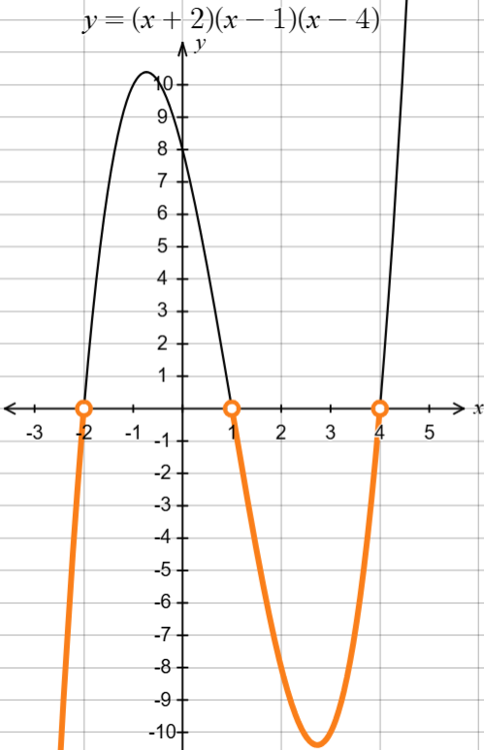 | 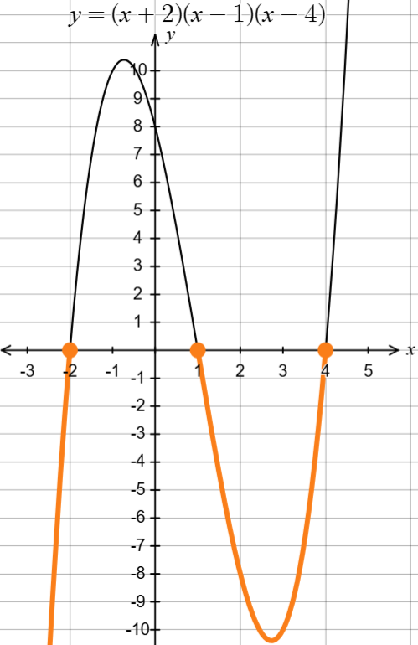 | 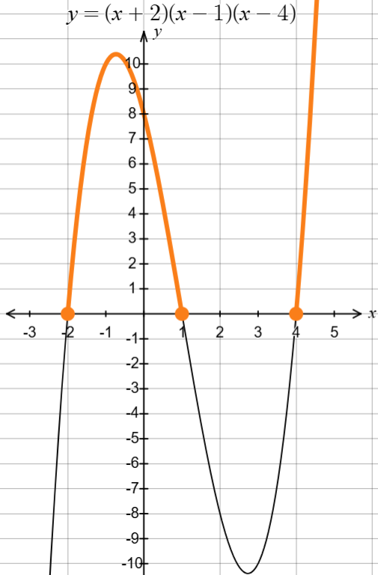
 | 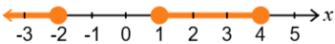 | 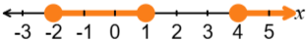
$$x<-2,1< x<4$$ | $$x≤-2,1≤ x≤4$$ | $$-2≤x≤1,x≥4$$

- ${\left(x-1\right)}^{2}\left(x-4\right)>0$ | - $x\left(x-1\right)\left(x-4\right)>0$ | - $x{\left(x-2\right)}^{2}>0$
Zeroes: $x=1, x=4$ | Zeroes: $x=0, x=1, x=4$ | Zeroes: $x=0, x=2$
$y$-intercept:  when $x=0, y=-4$ | $y$-intercept: when $x=0, y=0$ | $y$-intercept: when $x=0, y=0$
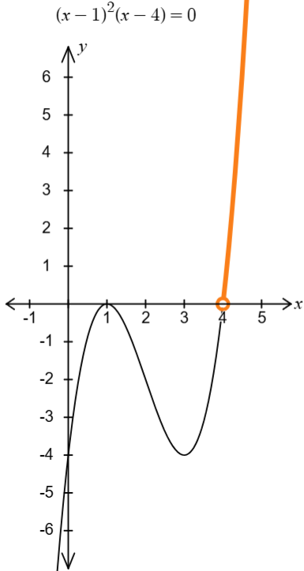 | 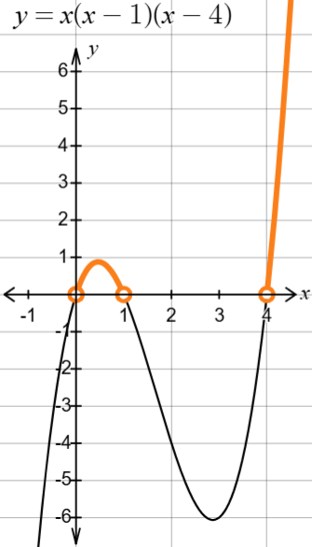 | 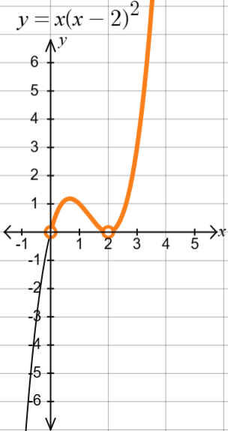
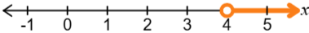 | 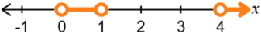 | 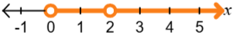
$$x>4$$ | $$0<x<2, x>4$$ | $$0<x<2, x>2$$

Appendix C – Four quadrant notes
Example 1  Solve the inequality $\left(x+2\right)\left(x-1\right)\left(x-4\right)<0$  Zeroes: when$y=0,x=-2, 1, 4$  $y$-intercept (when $x=0$)  $$y=2×-1×-4 \\ =8$$  $$x<-2,1<x<4$$ | Example 2  Solve the inequality $\left(x+1\right)\left(x-2\right)\left(x-3\right)<0$  Zeroes: when$y=0, x=-1, 2, 3$  $y$-intercept (when $x=0$)  $$y=1×-2×3 \\ =-6$$  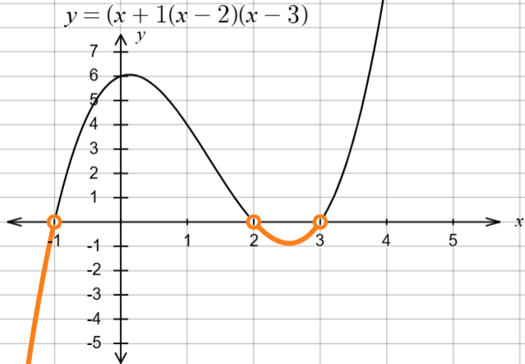  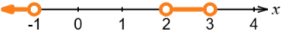  $$x<-1,2<x<3$$

Appendix D – Venn diagram
A $\left(x+1\right)\left(x-1\right)\left(x-2\right)<0$
B $-\left(x+3\right)\left(x+1\right)\left(x-2\right)<0$
C $-\left(1-x\right){\left(x-2\right)}^{2}<0$
D $(x+2)\left(x+1\right)\left(x-4\right)<0$

Appendix E – business problems

- Intercepts: $x=0, 5, 10$
The values represent the cost of the trailers, in thousands of dollars, that will return zero dollars on investment.
- The $y$-intercept of $R(x)$ is $0$, which means that when nothing is spent on a trailer, there is no return on investment.

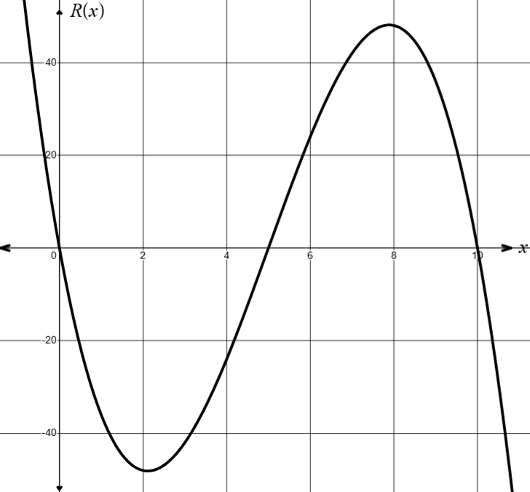
- A negative ROI is possible because a trailer in that price range may not be what customers want or the maintenance of that trailer may be too high, meaning the trailer will lose money.
- Once a trailer costs more than $10 000, its price is too high to make a return on that investment. Max should avoid purchasing trailers that cost $10 000 or more.
- Max should focus on trailers that cost between $5000 and $10 000. He should look in particular at trailers that cost between $7000 and $9000 because that is the cost that maximises profit.

- 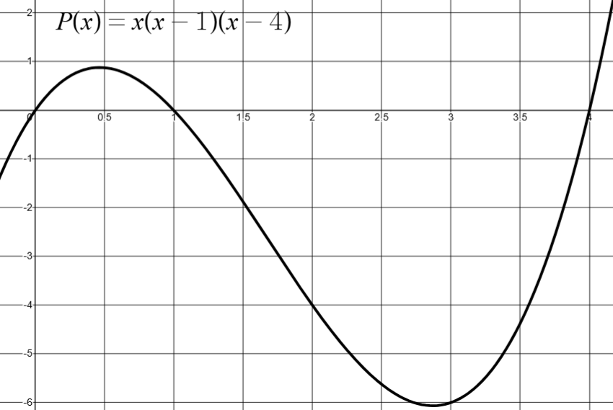
- The factors show the zeroes of the equation $P(x)$ and show when the profit becomes a loss or the loss becomes profit, depending on how many toys are produced.
- Freya should note that the model shows she would operate at a loss of about $4000.
- When Freya produces more than 100 toys, she begins to make a loss. This might be because she needs to advertise to attract more customers, employ more people to make more toys, order material in bulk or buy more equipment.
- Freya may decide to produce less than 100 toys, to make a small profit, or she might decide to produce more than 400 toys to grow her business.
- If Freya wants to keep her business small, she should produce about 50 toys. But if she wants to grow her business, she should consider making at least 420 toys to go past the profit possible from making 50 toys.

References
This resource contains NSW Curriculum and syllabus content. The NSW Curriculum is developed by the NSW Education Standards Authority. This content is prepared by NESA for and on behalf of the Crown in right of the State of New South Wales. The material is protected by Crown copyright.
Please refer to the NESA Copyright Disclaimer for more information https://educationstandards.nsw.edu.au/wps/portal/nesa/mini-footer/copyright.
NESA holds the only official and up-to-date versions of the NSW Curriculum and syllabus documents. Please visit the NSW Education Standards Authority (NESA) website https://educationstandards.nsw.edu.au/ and the NSW Curriculum website https://curriculum.nsw.edu.au/.
Mathematics Extension 1 11–12 Syllabus © NSW Education Standards Authority (NESA) for and on behalf of the Crown in right of the State of New South Wales, 2024.

© State of New South Wales (Department of Education), 2025
The copyright material published in this resource is subject to the Copyright Act 1968 (Cth) and is owned by the NSW Department of Education or, where indicated, by a party other than the NSW Department of Education (third-party material).
Copyright material available in this resource and owned by the NSW Department of Education is licensed under a Creative Commons Attribution 4.0 International (CC BY 4.0) license.

This license allows you to share and adapt the material for any purpose, even commercially.
Attribution should be given to © State of New South Wales (Department of Education), 2025.
Material in this resource not available under a Creative Commons license:
- the NSW Department of Education logo, other logos and trademark-protected material
- material owned by a third party that has been reproduced with permission. You will need to obtain permission from the third party to reuse its material.
Links to third-party material and websites
Please note that the provided (reading/viewing material/list/links/texts) are a suggestion only and implies no endorsement, by the New South Wales Department of Education, of any author, publisher, or book title. School principals and teachers are best placed to assess the suitability of resources that would complement the curriculum and reflect the needs and interests of their students.
If you use the links provided in this document to access a third-party's website, you acknowledge that the terms of use, including licence terms set out on the third-party's website apply to the use which may be made of the materials on that third-party website or where permitted by the Copyright Act 1968 (Cth). The department accepts no responsibility for content on third-party websites.

