Dividing polynomials
Students review the area model for multiplying numbers and polynomials and then use the model in reverse to divide polynomials.
Students will need at least one digital device per pair to interact with a graphing calculator.

Learning intention
- To be able to divide polynomials and use correct terminology to express the division.

Success criteria
- I can accurately describe division of polynomials using the terms ‘dividend’, ‘divisor’, ‘quotient’ and ‘remainder’.
- I can divide polynomials.
- I can express polynomials in the form $P\left(x\right)=A\left(x\right)Q\left(x\right)+R(x)$ or $\frac{P\left(x\right)}{A(x)}=Q\left(x\right)+\frac{R\left(x\right)}{A(x)}$.
- I can explain why $\deg{R\left(x\right)<degA(x)}$.

Outcomes
A student:
- develops understanding and fluency in mathematics through exploring and connecting mathematical concepts, choosing and applying mathematical techniques to solve problems, and communicating their thinking and reasoning coherently and clearly MAO-WM-01
- applies the remainder and factor theorem and sums and products of zeroes to solve problems involving polynomials ME1-11-02

Content

Remainder and factor theorems
- Examine the process of division of polynomials by comparing with the process of division with remainders for whole numbers, and use the terms dividend, divisor, quotient and remainder
- Express in the form $P\left(x\right)=A\left(x\right)Q\left(x\right)+R(x)$ the result of dividing $P(x)$ by a divisor $A\left(x\right),$that is not the zero polynomial, with quotient $Q(x)$ and the remainder $R\left(x\right),$ and explain why either $R\left(x\right)=0$ or $\text{deg}R\left(x\right)<\text{deg}A(x)$
- Express the result of the division also in the form $\frac{P\left(x\right)}{A\left(x\right)}=Q\left(x\right)+\frac{R\left(x\right)}{A\left(x\right)}$
Mathematics Extension 1 11–12 Syllabus © NSW Education Standards Authority (NESA) for and on behalf of the Crown in right of the State of New South Wales, 2024.

Table 1: lesson summary
Section | Summary of activity | Teaching strategies | Teaching points
Retrieval practice | Students solve 35 ÷ 4, labelling the terms ‘dividend’, ‘divisor’, ‘quotient’ and ‘remainder’. |  | Use slide 4 of the PowerPoint Dividing polynomials to review key terms.
Activating prior knowledge | Students use an AI model analogy to interpret zeros as incorrect predictions and use digital graphing tools to graph the polynomial $F\left(x\right)=x^{4}+x^{3}-11x^{2}-9x+18$ before seeing the effects of dividing by $\left(x+2\right).$Students discuss how reducing zeros through division mirrors how AI improves accuracy. | Think-Pair-Share | This section aims to explain how long division is used to improve the accuracy of AI.
Connecting learning | Students multiply 586 × 23 before being reintroduced to the area model on slide 6, practise the method and then apply it to expand  $\left(x^{2}+4x+5)(x+2\right)$on slide 7. After completing the practise questions on slide 8, students reverse the process to divide polynomials and discuss how their division would change if a remainder were present. | Think-Pair-Share  Assessing and advancing questions  Visibly random groups of 3  Vertical non-permanent surfaces  Gallery walk | Demonstrate how the area model for multiplication can be applied to divide polynomials.
Releasing responsibility | Use slides 10–14 for a slow reveal of how to divide polynomials using an area model before practicing using Appendix A. Remainders are introduced through a worked example (slides 15–16) before formalising the language using slide 17. Students discuss how to set up the area model and why the $\text{deg}R\left(x\right)<\text{deg}A\left(x\right)$, then use Appendix B to create notes. | Worked example (Your turn)  Think-Pair-Share  Four quadrant notes  Visibly random groups of 3  Vertical non-permanent surfaces | Formalise the process and the language. Slide 18 can be used to compare long division with area models.
Independent practice | Use slide 20 to discuss how the process of dividing polynomials helps us find zeroes and graph the function before practising graphing using Appendix C. | Think-Pair-Share  Pose-Pause-Pounce-Bounce | Link degree of polynomials to help students check for understanding

Activity structure
Please use the associated PowerPoint Dividing polynomials to display images in this lesson.

Retrieval practice
- Ask students to solve 35 ÷ 4 without the use of a calculator, writing all their working.
- Ask students to identify and label each part of their calculation as ‘dividend’, ‘divisor’, ‘quotient’ and ‘remainder’.
- Display slide 4 of the PowerPoint so students can check their understanding.

Activating prior knowledge
- Spark students’ interest by asking them to consider ‘What makes AI such a powerful tool?’
Guide the discussion towards the idea that AI can learn from past experiences and improve over time.
- Tell students that an AI model is making predictions, but something is going wrong. The polynomial $F\left(x\right)=x^{4}+x^{3}-11x^{2}-9x+18$ represents the AI’s behaviour. When the polynomial $F\left(x\right)=0$, the AI is making a completely wrong prediction.
- Using a computer graphing program, have students graph the polynomial $F\left(x\right)=x^{4}+x^{3}-11x^{2}-9x+18,$ noting the number of wrong predictions the polynomial represents.
Students should see 4 wrong predictions.
- Tell students that software engineers have discovered that whenever $x=-2$, the AI always fails.
- Have students graph adding, subtracting, multiplying and dividing $F\left(x\right)$ by $x+2$ and note the effect each operation has on the number of wrong predictions.
- In a Think-Pair-Share (bit.ly/thinkpairsharestrategy), have students discuss which operation would be best to eliminate the error at $x=-2$ in the AI model.
Students should note that division eliminated the zero at $x=-2$ and reduced the number of zeroes overall, as opposed to the other operations that either add zeroes or remain unchanged.

Connecting learning
Polynomial division in this lesson is taught using the area model, as students are already familiar with this structure from primary school and have not been taught long division. At the end of the ‘Releasing responsibility’ section, a comparison strategy is used to show the area model and long-division methods side-by-side, allowing students to recognise the connection and understand the format used in many existing resources.
- Ask students to solve 586 × 23 using a written strategy, without using a calculator.
- Present slide 6 which demonstrates 2 different approaches to solving this multiplication.
- In a Think-Pair-Share, have students discuss the multiplication methods shown on the slide and explain how the area model works.
The area model splits numbers into hundreds, tens and units, multiplies each part and then sums the results.
- Animate slide 6 which prompts students to use both methods to multiply $x^{2}+4x+5$ by $x+2$.
- Once students have completed the algebraic multiplication, display slide 7 for students to check their understanding.
- Display slide 8 and have students complete the 3 questions. Animate the slide to reveal solutions.
- Tells students that we are going to use the model to perform division of polynomials.
- Assign students to visibly random groups of 3 (bit.ly/visiblegroups) at vertical non-permanent surfaces (bit.ly/VNPSstrategy) and have each group solve a problem from the list below using the area model.
$$\left(x^{3}+3x^{2}-x-3\right)÷\left(x-1\right)$$
$$\left(x^{3}+2x^{2}-13x+10\right)÷\left(x+5\right)$$
$$\left(x^{3}+2x^{2}-x-2\right)÷(x-1)$$
($x^{3}+5x^{2}+11x+10)÷(x+2)$
$$\left(x^{3}+6x^{2}+5x-6\right)÷(x-3)$$
Sample solutions can be found at the end of this document.
- Ask students assessing and advancing questions (bit.ly/supportingstrategies) to transfer their understanding of multiplying to using the area model for division.
Table 2: assessing and advancing questions
Assessing questions | Advancing questions
How do you know which term to place in the first box? | Where are you placing the dividend and divisor in the area model?
How do you determine the value in the box? | What information do you have and how can you use it to continue progressing?
How can you check if your answer is correct? | How would the model look if the dividend had missing terms such as $P\left(x\right)=x^{3}-2x+1$?
- Once students have completed the problem, have students perform a gallery walk (bit.ly/DLSgallerywalk) to observe other group’s divisions.
- Bring the class back together and facilitate a discussion about remainders in polynomial division. Use prompting questions such as:
- Did any of your polynomial divisions result in a remainder? How can you tell from your working?
- If a polynomial division did have a remainder, what would that look like?

Releasing responsibility
- Use slides 10–14 to progressively reveal small changes, like a slow-reveal graph (slowrevealgraphs.com). Animate each slide to highlight where students can apply known information.
- Pausing on slide 14, ask students to discuss in a Think-Pair-Share if they could write the solution another way. Prompt students to revisit the ‘Retrieval practice’ section of the lesson if they are having trouble.
Students should recognise that quotient × divisor = dividend.
- Distribute Appendix A ‘Dividing polynomials’ to students and have them practise dividing polynomials and writing the solution in 2 different forms.
- Use slides15–16 to model worked examples of dividing polynomials with a remainder using the Worked examples (Your turn) method (bit.ly/supportingstrategies). Animate the slides to reveal self-explanation prompts and the worked solution.
- Use slide 17 to formalise the language associated with the division of polynomials.
- Initiate a class discussion about how to sketch an area model for division if not given a scaffold. Use prompting questions such as:
- Where do you place the dividend in your sketch?
- Where do you place the divisor?
- How many rows will your box need?
- How many columns will your box need?
The goal of this discussion is to help students confidently sketch their own area-model ‘box’ when one is not provided, understand where each part of the division problem belongs and know how to begin the process.
- Have students practise dividing polynomials with a remainder using an existing resource.
- In a Think-Pair-Share, have students reflect on the relationship between the degree of the remainder and the degree of the divisor and if their relationship will hold for every division.
Draw out with students that the $\text{deg}R\left(x\right)<\text{deg}A(x)$ because if the remainder’s degree were equal to or higher than the divisor’s, we could divide further, so it would not really be the remainder.
- With students back in their random groups of 3 at a vertical non-permanent surface, have students complete Four quadrant notes to their future forgetful selves (bit.ly/supportingstrategies) from Appendix B ‘Four quadrant notes’.
- Display slide 18 and have students compare the 2 different methods for dividing polynomials using the Worked examples – comparison method (bit.ly/supportingstrategies).
The comparison between long division and the area model is optional. Students may use any valid division method. The comparison has been included to support teachers who typically use long division and to assist students who may encounter long-division formats in other resources.

Independent practice
- Display slide 20 and allow students time in a Think-Pair-Share to discuss how they would graph the polynomial.
Students have not yet learned the factor theorem so they will only be able to graph this by using a table of values.
- Animate the slide to show students that $x-4$ is a linear factor of $P(x)$. Continuing in a Think-Pair-Share, have students discuss how this may help them graph the polynomial.
Students should recognise that dividing the polynomial will find a quotient with a smaller degree that is a quadratic which can be factorised to find the zeroes of the polynomial.
- Using a Pose-Pause-Pounce-Bounce questioning strategy (PDF 557 KB) (bit.ly/posepausepouncebounce), ask students to reflect on how dividing polynomials helps to graph functions. Prompting questions could include:
- How does the process of dividing polynomials help us find zeroes and graph the function?
- What does it mean when the division leaves a remainder? How does that affect the graph or our understanding of the polynomial?
- Connect students back to the AI example for the ‘Activating prior knowledge’ section of the lesson by reminding them that zeroes represented errors or incorrect predictions in an AI model.
- Have students consider what effect the remainder will have on the model in a Think-Pair-Share.
If the remainder is non-zero, the divisor is not a root, indicating an approximation or further refinement is needed.
- Distribute Appendix C ‘Using division to graph polynomials’ and have students complete the table, first finding the zeros then using them to graph the polynomial.

Assessment and differentiation

Suggested opportunities for differentiation
Activating prior knowledge
- Before showing the graph of $F(x)$, challenge students to estimate how many zeros the polynomial might have.
- Give students a polynomial with a smaller degree to graph first so they can practise identifying zeros before tackling the quartic.
- Offer sentence starters during the Think-Pair-Share to support students in explaining how zeros relate to incorrect predictions and why division reduces them.
Connecting learning
- The questions in Appendix A could be modified to include quadratic or quartic equations.
- A template for an area model could be made available for students.
Releasing responsibility
- Appendix A could be organised as faded examples.
- Students should be encouraged to multiply their answers to verify their work.
- Ask students to compare and critique are area model and long division methods, explaining when one method may be more efficient.
Independent practice
- Scaffold Appendix C for students to reduce its complexity.

Suggested opportunities for assessment
Retrieval practice
- Students’ answers can be used to evaluate their understanding of division-related terminology.
Activating prior knowledge
- During the Think-Pair-Share comparing $F(x)$and $G(x)=\frac{F(x)}{x+2}$, the teacher can assess students’ ability to explain how dividing a polynomial reduces the number of zeros
Connecting learning
- Assess students’ understanding of using area models to multiply numbers before transitioning to algebraic expressions.
- Assess students’ understanding of using area models to multiply algebraic expressions before introducing the division of polynomials.
Releasing responsibility
- Collect students’ response to Appendix A to assess their ability to divide polynomials without a remainder.
- Observe students as they complete division tasks from existing resources to assess whether they can correctly set up the area model.
Independent practice
- Provide an exit ticket containing a polynomial division question for students to complete independently.
- Collect Appendix C to assess students’ understanding of why polynomials are divided and how factors are used to graph polynomials.

Appendix A

Dividing polynomials
$$(x^{3}-x^{2}-7x+10)÷(x-2)$$ | $$(2x^{3}-x^{2}-7x+2)÷(x-2)$$
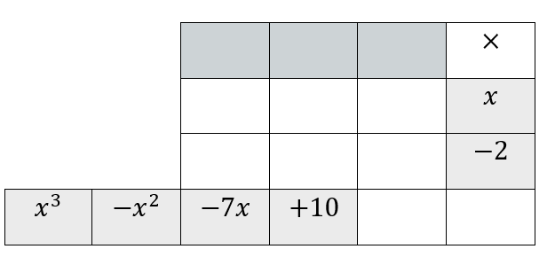  $$\frac{x^{3}-x^{2}-7x+10}{x-2}=$$ | 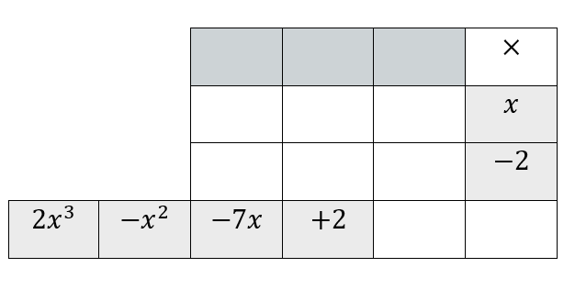  $$\frac{{2x}^{3}-x^{2}-7x+2}{x-2}=$$
$$({x^{4}+2x}^{3}-x^{2}-7x-14)÷(x-2)$$ | $$({x^{4}+2x}^{3}-{2x}^{2}-3x+2)÷(x^{2}+x-2)$$
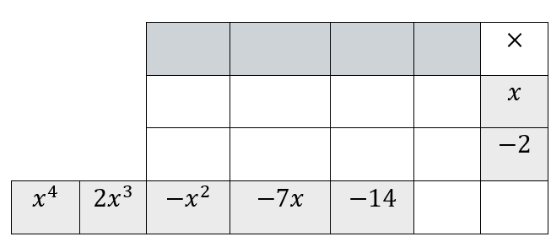  $$\frac{{x^{4}+2x}^{3}-x^{2}-7x-14}{x-2}=$$ | 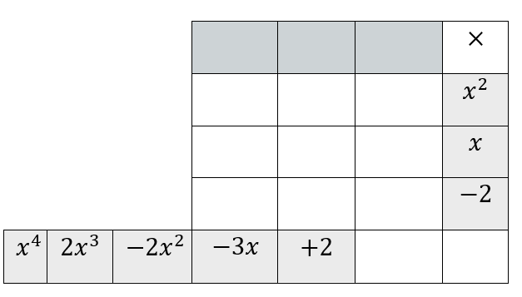  $$\frac{{x^{4}+2x}^{3}-2x^{2}-3x+2}{x^{2}+x-2}=$$

Appendix B

Four quadrant notes
Example 1  $$(x^{3}+2x^{2}-5x-8)÷(x+1)$$  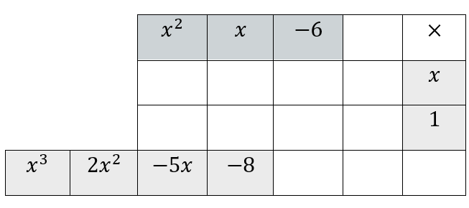  $$\frac{x^{3}+2x^{2}-5x-8}{x+1}=$$ | Example 2  $$({2x}^{3}+x^{2}-x+3)÷(2x-1)$$  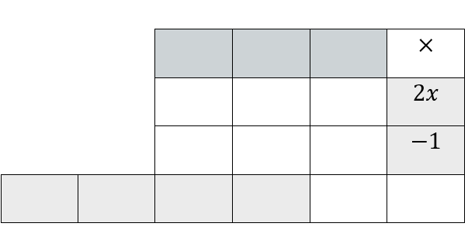
Things to remember | Example 3

Appendix C

Using division to graph polynomials
Function $F(x)$ | Factor 1 | Factor 2 | Factor 3 | Graph of $F(x)$
$$F\left(x\right)=x^{3}+2x^{2}-5x-6$$ | $$(x+1)$$
$$F\left(x\right)={2x}^{3}-9x^{2}+10x-3$$ |  | $$(2x-1)$$
$$F\left(x\right)=3x^{3}+16x^{2}+23x+6$$ |  |  | $$(x+3)$$
$${F\left(x\right)=2x}^{3}-3x^{2}-17x-12$$ | $$(x+1)$$
$$F\left(x\right)={2x}^{3}-x^{2}-41x-20$$ |  |  | $$(x+4)$$
$${F\left(x\right)=-x}^{3}+4x^{2}+20x-48$$ |  |  | $$(x+4)$$

Sample solutions

Connecting learning division problems
- $\left(x^{3}+3x^{2}-x-3\right)÷\left(x-1\right)$
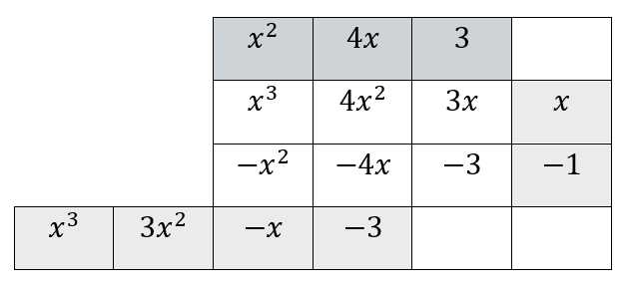
- $\left(x^{3}+2x^{2}-13x+10\right)÷\left(x+5\right)$
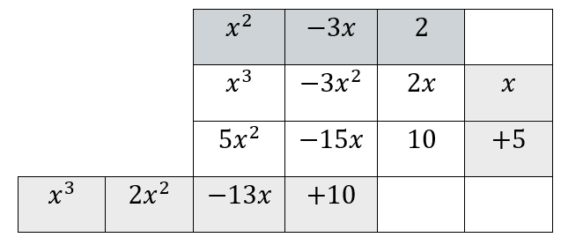
- $\left(x^{3}+2x^{2}-x-2\right)÷(x-1)$
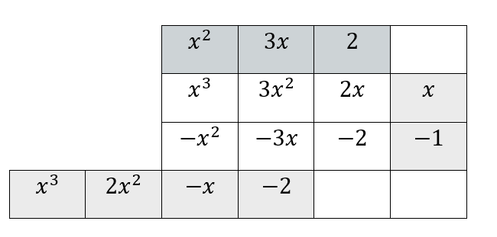
- ($x^{3}+5x^{2}+11x+10)÷(x+2)$
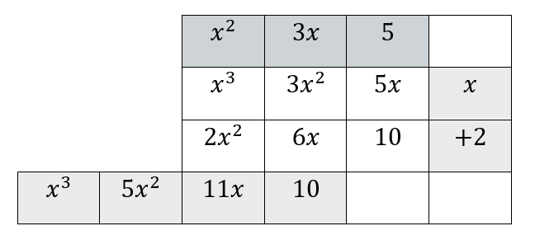

- $\left(x^{3}+6x^{2}+5x-6\right)÷(x-3)$
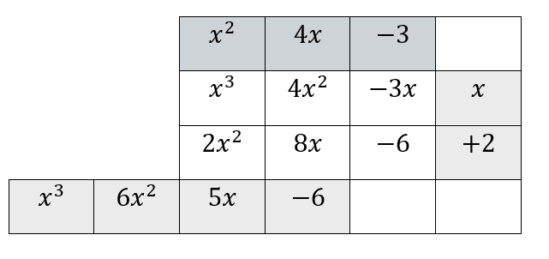

Appendix A – dividing polynomials
$$(x^{3}-x^{2}-7x+10)÷(x-2)$$ | $$(2x^{3}-x^{2}-7x+2)÷(x-2)$$
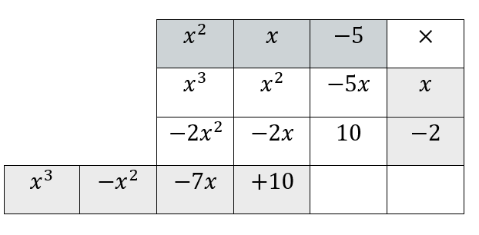  $$\frac{x^{3}-x^{2}-7x+10}{x-2}=x^{2}+x-5$$  $$∴\left(x^{2}+x-5\right)\left(x-2\right)=x^{3}-x^{2}-7x+10$$ | 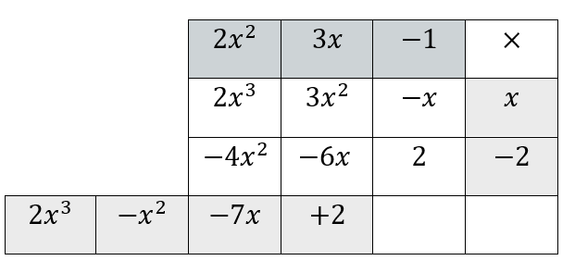  $$\frac{{2x}^{3}-x^{2}-7x+2}{x-2}=2x^{2}+3x-1$$  $$∴\left({2x}^{2}+3x-1\right)\left(x-2\right)=2x^{3}-x^{2}-7x+2$$
$$({x^{4}+2x}^{3}-x^{2}-7x-14)÷(x-2)$$ | $$({x^{4}+2x}^{3}-{2x}^{2}-3x+2)÷(x^{2}+x-2)$$
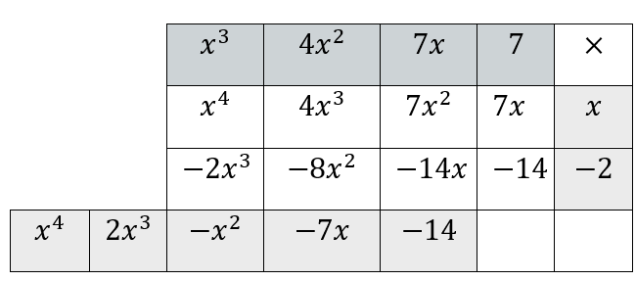  $$\frac{{x^{4}+2x}^{3}-x^{2}-7x-14}{x-2}$$  $$={x^{3}+4x}^{2}+7x+7$$  $$∴\left({x^{3}+4x}^{2}+7x+7 \right)\left(x-2\right)$$  $$={x^{4}+2x}^{3}-x^{2}-7x-14$$ | 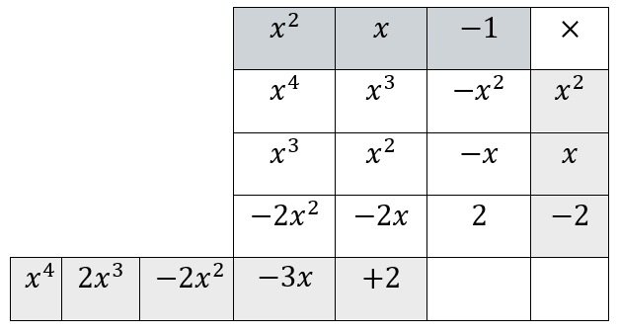  $$\frac{{x^{4}+2x}^{3}-2x^{2}-3x+2}{x^{2}+x-2}$$  $$=x^{2}+x-1$$  $$∴\left(x^{2}+x-1\right)\left(x^{2}+x-2\right)$$  $$={x^{4}+2x}^{3}-2x^{2}-3x+2$$

Appendix B – Four quadrant notes
Example 1  $$(x^{3}+2x^{2}-5x-8)÷(x+1)$$  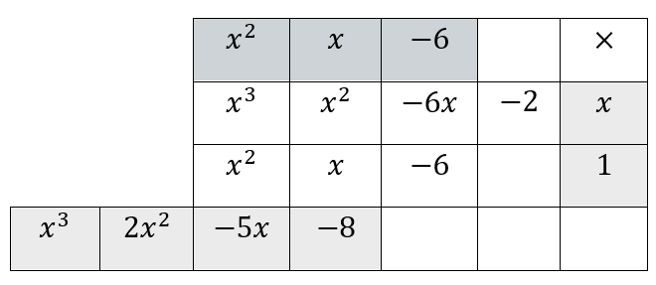  $$\frac{x^{3}+2x^{2}-5x-8}{x+1}=x^{2}+x-6-\frac{2}{x+1}$$ | Example 2  $$({2x}^{3}+x^{2}-x+3)÷(2x-1)$$  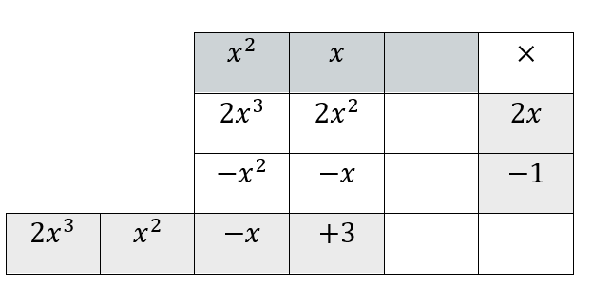  $$\frac{2x^{3}+x^{2}-x+3}{2x-1}=x^{2}+x+\frac{3}{2x-1}$$

Appendix C – using division to graph polynomials
Function $F(x)$ | Graph of $F(x)$
$$F\left(x\right)=x^{3}+2x^{2}-5x-6$$  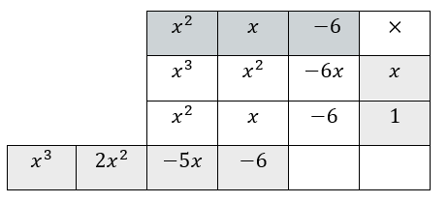  $$F\left(x\right)=\left(x+1\right)\left(x^{2}+x-6\right) \\ =(x+1)(x+3)(x-2)$$ | 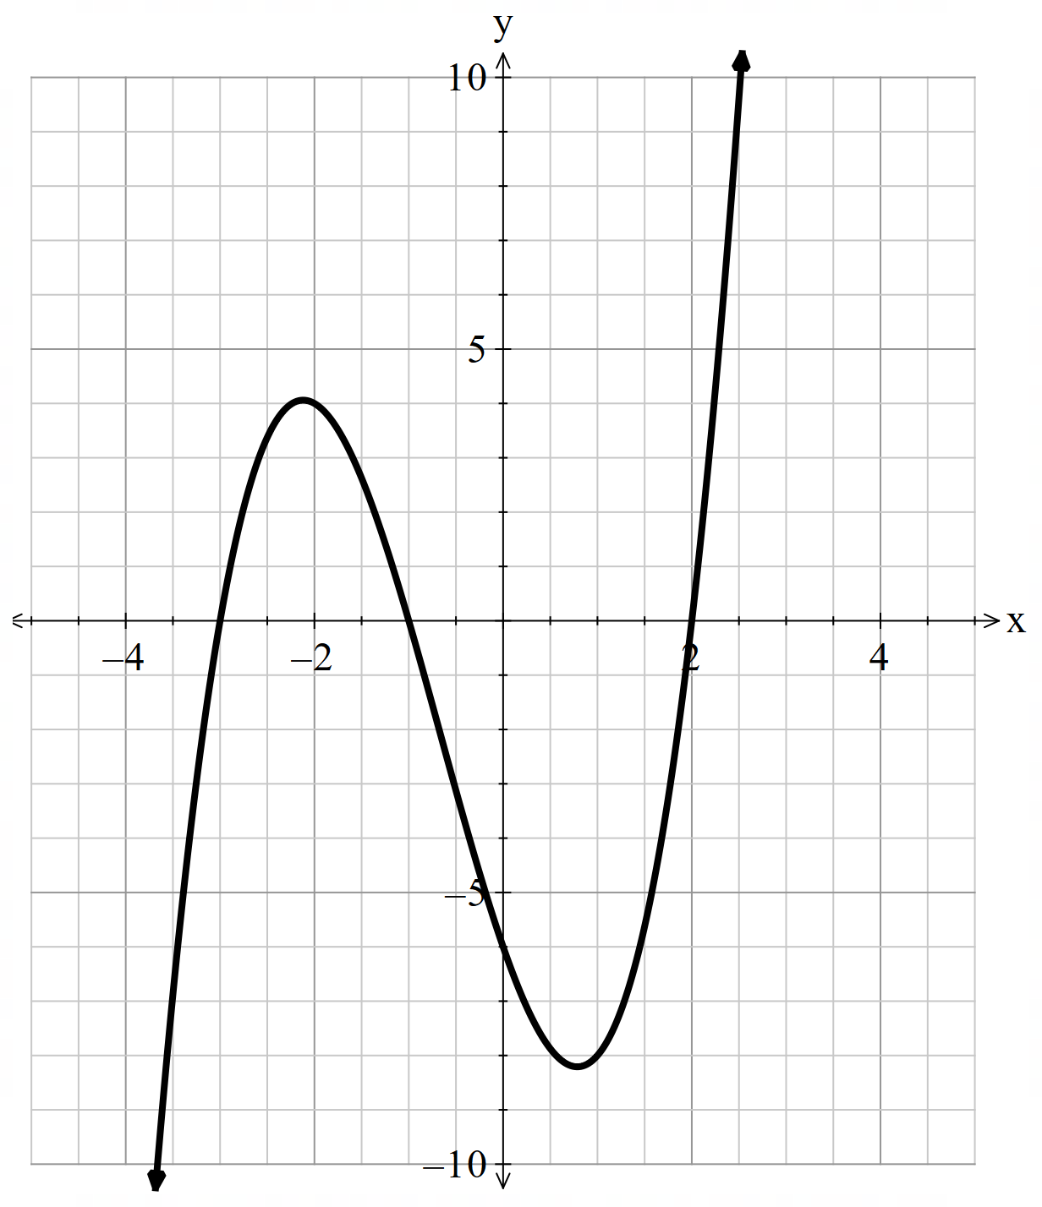
$$F\left(x\right)={2x}^{3}-9x^{2}+10x-3$$  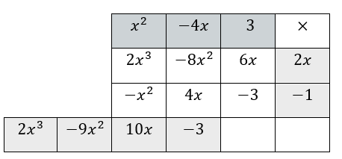  $$F\left(x\right)=\left(2x-1\right)\left(x^{2}-4x+3\right) \\ =(2x-1)(x-3)(x-1)$$ | 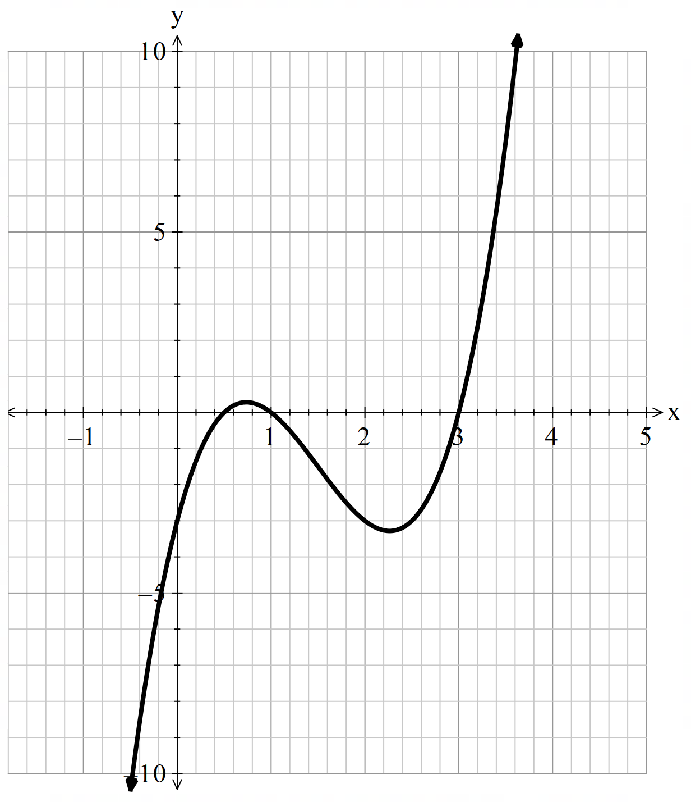
$$F\left(x\right)=3x^{3}+16x^{2}+23x+6$$  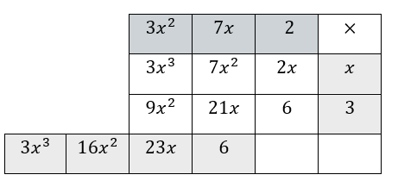  $$F\left(x\right)=\left(x+3\right)\left(3x^{2}+7x+2\right) \\ =(x+3)(3x+1)(x+2)$$ | 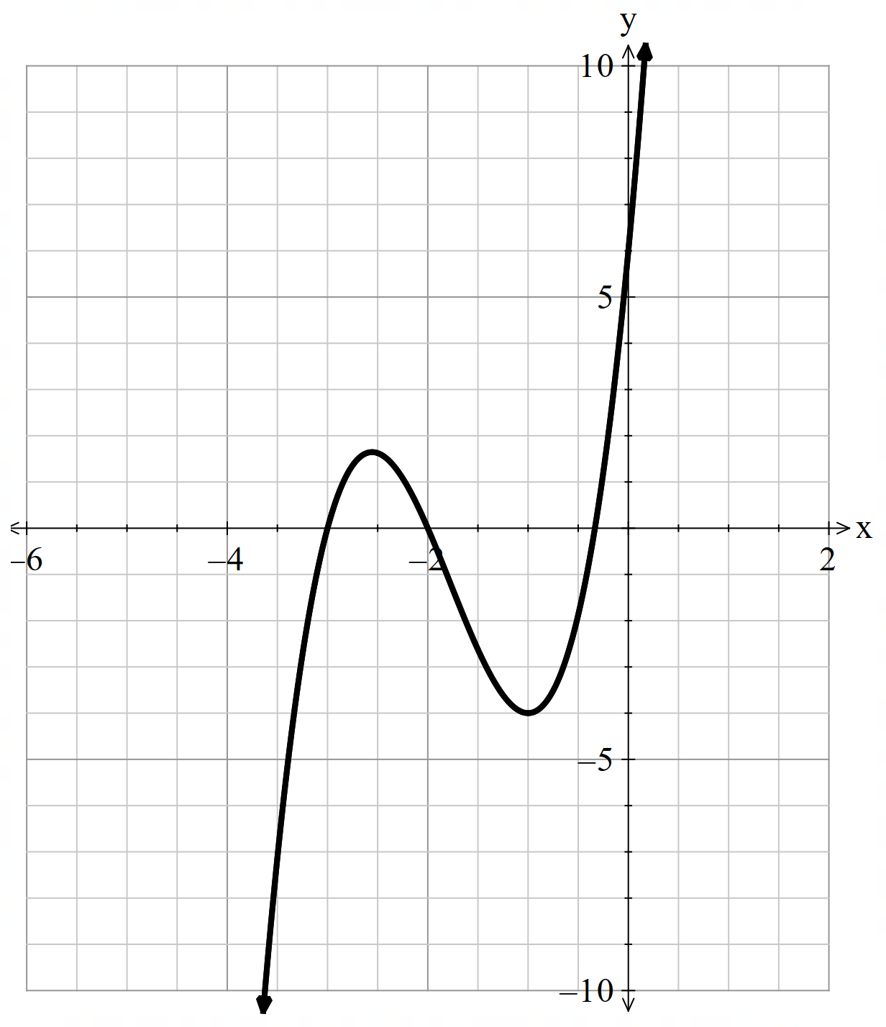
$${F\left(x\right)=2x}^{3}-3x^{2}-17x-12$$  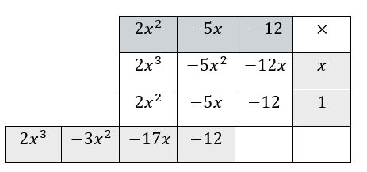  $$F\left(x\right)=\left(x+1\right)\left(2x^{2}-5x-12\right) \\ =(x+1)(2x+3)(x-4)$$ | 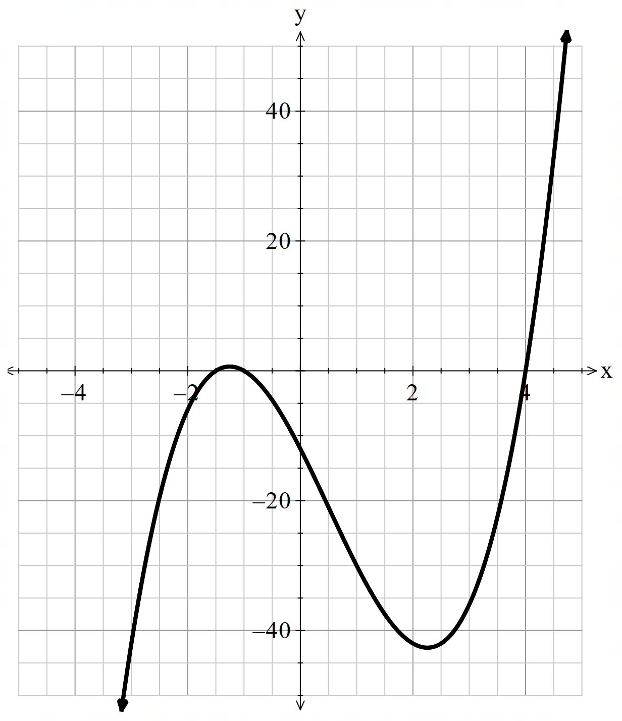
$$F\left(x\right)={2x}^{3}-x^{2}-41x-20$$  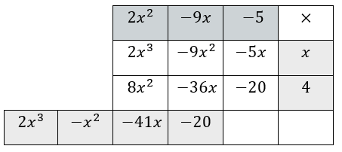  $$F\left(x\right)=\left(x+4\right)\left(2x^{2}-9x-5\right) \\ =(x+4)(2x+1)(x-5)$$ | 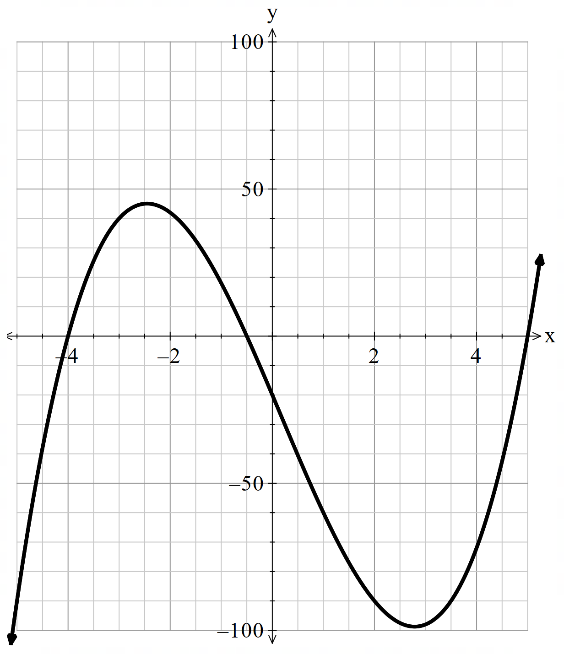
$${F\left(x\right)=-x}^{3}+4x^{2}+20x-48$$  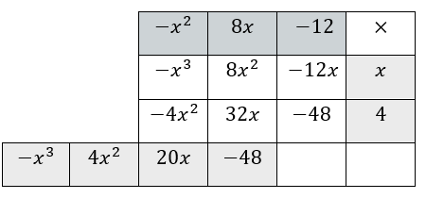  $$F\left(x\right)=\left(x+4\right)\left(-x^{2}+8x-12\right) \\ =(x+4)(2-x)(x-6)$$ | 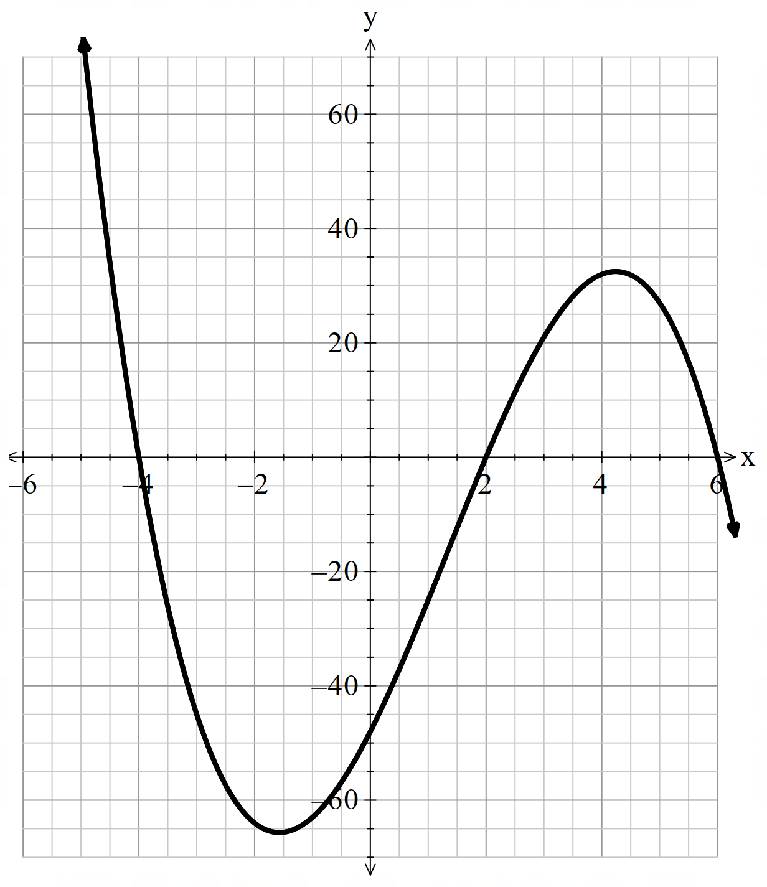

References
This resource contains NSW Curriculum and syllabus content. The NSW Curriculum is developed by the NSW Education Standards Authority (NESA). This content is prepared by NESA for and on behalf of the Crown in right of the State of New South Wales. The material is protected by Crown copyright.
Please refer to the NESA Copyright Disclaimer for more information https://www.nsw.gov.au/education-and-training/nesa/copyright.
NESA holds the only official and up-to-date versions of the NSW Curriculum and syllabus documents. Please visit NESA https://www.nsw.gov.au/education-and-training/nesa and NSW Curriculum https://curriculum.nsw.edu.au.
Mathematics Extension 1 11–12 Syllabus © NSW Education Standards Authority (NESA) for and on behalf of the Crown in right of the State of New South Wales, 2024.

© State of New South Wales (Department of Education), 2026
The copyright material published in this resource is subject to the Copyright Act 1968 (Cth) and is owned by the NSW Department of Education or, where indicated, by a party other than the NSW Department of Education (third-party material).
Copyright material available in this resource and owned by the NSW Department of Education is licensed under a Creative Commons Attribution 4.0 International (CC BY 4.0) license.

This license allows you to share and adapt the material for any purpose, even commercially.
Attribution should be given to © State of New South Wales (Department of Education), 2026.
Material in this resource not available under a Creative Commons license:
- the NSW Department of Education logo, other logos and trademark-protected material
- material owned by a third party that has been reproduced with permission. You will need to obtain permission from the third party to reuse its material.
Links to third-party material and websites
Please note that the provided (reading/viewing material/list/links/texts) are a suggestion only and implies no endorsement, by the New South Wales Department of Education, of any author, publisher, or book title. School principals and teachers are best placed to assess the suitability of resources that would complement the curriculum and reflect the needs and interests of their students.
If you use the links provided in this document to access a third-party's website, you acknowledge that the terms of use, including licence terms set out on the third-party's website apply to the use which may be made of the materials on that third-party website or where permitted by the Copyright Act 1968 (Cth). The department accepts no responsibility for content on third-party websites.

