Combinatorial patterns
Students make connections between binomial expansions and combinations through pattern recognition in Pascal’s triangle and algebraic expansion. They build conceptual understanding of why the coefficients in the expansion of ${\left(x+y\right)}^{n}$ correspond to combinations and apply this knowledge to expand binomial expressions and simplify binomial coefficients using identities.
Learning intentions and success criteria will be shared with students at the conclusion of the ‘Activating prior knowledge’ section.

Learning intentions
- To understand the equivalence between coefficients in binomial expansions and combinations.
- To be able to use key combinatorial identities.

Success criteria
- I can use combinations to determine the coefficients of binomial expansions.
- I can explain why the coefficients in the expansion of ${\left(x+y\right)}^{n}$ are given by ^{n}C_{r}.
- I can use the identities ^{n}C_{r} $=$ ^{n-1}C_{r-1} +^{n-1}C_{r} and ^{n}C_{r} $=$ ^{n}C_{n-r} to simplify expressions involving binomial coefficients.
- I can apply patterns and identities to expand binomial expressions using combination notation.

Outcomes
A student:
- develops understanding and fluency in mathematics through exploring and connecting mathematical concepts, choosing and applying mathematical techniques to solve problems, and communicating their thinking and reasoning coherently and clearly MAO-WM-01
- uses the binomial theorem to solve problems and prove identities ME1-11-05

Content

The binomial theorem
- Recognise the equivalence between the coefficient of $x^{n-r}y^{r}$ in the expansion of ${\left(x+y\right)}^{n}$ and ^{n}C_{r,} when $n$ is a positive integer
- Use patterns and symmetry in Pascal’s triangle to confirm the identities ^{n}C_{r} = ^{n-1}C_{r-1} + ^{n-1}C_{r} for $1≤r≤n-1$and ^{n}C_{r} = ^{n}C_{n-r} for $0≤r≤n$
- Use the identities, ^{n}C₀ $=1$, ^{n}C_{n} $=1$, ^{n}C_{r} $=$^{n-1}C_{r-1} +^{n-1}C_{r} for $-1≤r≤n-1$and ^{n}C_{r} $=$^{n}C_{n-r} for
$0≤r≤n$ to simplify expressions involving the binomial coefficients
Mathematics Extension 1 11–12 Syllabus © NSW Education Standards Authority (NESA) for and on behalf of the Crown in right of the State of New South Wales, 2024.
Table 1: lesson summary
Section | Summary of activity | Teaching strategies | Teaching points
Activating prior knowledge | Use Appendix A for students to complete 4 workstation tasks followed by a class debrief to draw out the connections between Pascal’s triangle, combinations and coefficients in binomial expansions. Use slide 3 of the PowerPoint Combinatorial patterns to reveal the learning intentions and success criteria. | Visibly random groups of 3  Pose-Pause-Pounce-Bounce | Row 4 of Pascal’s triangle and the coefficients of decreasing powers of $x$ in the expansion of ${\left(x+y\right)}^{4}$ are equivalent to the combinations ⁴C₀, ⁴C₁, ⁴C₂, ⁴C₃ and ⁴C₄.
Connecting learning | Students notice and wonder about equivalent expressions of ${\left(x+y\right)}^{4}$ on slide 5 and then explore why the coefficient in the term $\text{4}\text{C}\text{1 }x^{3}y^{1}$ is $\text{4}\text{C}\text{1}$by considering ${\left(x+y\right)}^{4}$ as 4 factors of $(x+y)$. The reasoning is displayed using slide 6.  Use slide 7 and Appendix B to explain Pascal’s triangle as represented using combination notation and the connection to coefficients in binomial expansions.  Student groups are assigned Row 6, 7 or 8 of Pascal’s triangle to use known patterns to confirm the identities on slide 8  (^{n}C₀ =^{n}C_{n} = 1, ^{n}C_{r} = ^{n}C_{n-r} and ^{n}C_{r} = ^{n-1}C_{r-1} + ^{n-1}C_{r}). | Notice and wonder  Pose-Pause-Pounce-Bounce  Visibly random groups of 3  Vertical non-permanent surfaces | To obtain a term in $x^{n-r}y^{r}$, we can select $y$ from $r$ factors and $x$ from the remaining $n-r$ factors in ^{n}C_{r} ways, yielding ^{n}C_{r} as the coefficient of $x^{n-r}y^{r}$.  Each entry in Pascal's triangle represents the number of ways to choose $r$ items from $n$ and is equivalent to the coefficients in the expansion of ${\left(x+y\right)}^{n}$.  The identities ^{n}C₀ = ^{n}C_{n} = ,1 ^{n}C_{r} = ^{n}C_{n-r}  and ^{n}C_{r} = ^{n-1}C_{r-1} + ^{n-1}C_{r} can be confirmed by using patterns in Pascal’s triangle.
Releasing responsibility | Use a class discussion and slide 10 to summarise the patterns and identities. Students complete Appendix C, using the identities to simplify expressions involving binomial coefficients, before annotating Appendix B to write notes about the connections between Pascal’s triangle, combinations and coefficients. Students complete self-explanation prompts on slide 12 to compare this to the equivalent expansion using numerical coefficients. | Pose-Pause-Pounce-Bounce | Each row of Pascal’s triangle can be written using combinations without knowing the previous row.
Independent practice | Students complete Appendix D to consolidate learning. | Visibly random groups of 3  Vertical non-permanent surfaces | Each coefficient in the expansion of ${\left(x+y\right)}^{n}$ is ^{n}C_{r}, which reflects the number of ways to choose $r$ items from $n$ and reinforces the connection between combinations and binomial coefficients.

Activity structure
Please use the associated PowerPoint Combinatorial patterns to display images in this lesson.

Activating prior knowledge
- Use Appendix A ‘Workstation tasks’ to set up workstations around the classroom.
Print one or more copies of each task and place them around the room.
- Ask students to divide a page in their workbook into 4 sections to record their answers and any necessary working out for each of the tasks.
- In visibly random groups of 3 (bit.ly/visiblegroups), have students rotate around the room to complete each task.
The tasks can be completed in any order. As groups finish, ask them to begin considering any connections they can identify between the tasks.
Students were introduced to combinations, including how to calculate ^{n}C_{r} using a calculator and/or the formula in Lesson 07 – introduction to combinations of Unit 1 – permutations and combinations.
- When all groups have completed all tasks, use the Pose-Pause-Pounce-Bounce questioning strategy (PDF 557KB) (bit.ly/posepausepouncebounce) to facilitate a class debrief to draw out connections between the tasks. Have students record the connections in their workbook in their own words. Possible questions to pose:
- What did you notice across all the tasks?
- How are the tasks connected?
- How could we use combinations to find coefficients in binomial expansions?
Row 4 of Pascal’s triangle (1, 4, 6, 4, 1) corresponds to the coefficients for decreasing powers of $x$ in the expansion of ${\left(x+y\right)}^{4}$. These coefficients are also equivalent to the combinations ⁴C₀, ⁴C₁, ⁴C₂, ⁴C₃ and ⁴C₄, representing the number of ways to get 0, 1, 2, 3 and 4 tails respectively when tossing 4 coins. Therefore, the rows of Pascal’s triangle and coefficients in binomial expansions can be expressed using combinations.
- Display slide 3 of the PowerPoint to reveal the learning intentions and success criteria to students.

Connecting learning
- Use slide 5 of the PowerPoint, which shows ${\left(x+y\right)}^{4}$ expressed as 4 factors of $(x+y)$ and the full expansion of ${\left(x+y\right)}^{4}$ both with coefficients as numerals and combination notation, to demonstrate that binomial coefficients can be expressed using combinations.
Slide 5:
$${\left(x+y\right)}^{4}=x^{4}y^{0}+\text{4}x^{3}y^{1}+\text{6}x^{2}y^{2}+\text{4}x^{1}y^{3}+{x^{0}y}^{4}$$
$${\left(x+y\right)}^{4}={\text{4}\text{C}\text{0}x}^{4}y^{0}+\text{4}\text{C}\text{1}x^{3}y^{1}+\text{4}\text{C}\text{2}x^{2}y^{2}+\text{4}\text{C}\text{3}x^{1}y^{3}+\text{4}\text{C}\text{4}{x^{0}y}^{4}$$
- Ask students what they notice and wonder (bit.ly/noticewonderstrategy) about the 2 equivalent expressions for ${\left(x+y\right)}^{4}$.
Students may notice that the numerical coefficients in the first expression correspond directly to the combinations in the second expression. They might also notice the symmetry in the coefficients and observe the powers of $x$ decrease from 4 to 0, while the powers of $y$ increase from 0 to 4 in both expressions.
Students may wonder why the combinations match the numerical coefficients, how they are calculated and why they represent the coefficients. They could also wonder if this pattern holds true for other powers of ${\left(x+y\right)}^{n}$.
- Pose the following question to students and use the Pose-Pause-Pounce-Bounce questioning strategy to facilitate a class discussion: For the terms in the expansion of ${\left(x+y\right)}^{4}$, what is the relationship between the coefficient of each term, the power of the binomial (4) and the powers of $x$ and $y$ in each term?
Students should recognise the sum of the powers of $x$ and $y$ is always 4 and generalise that the coefficient is always ⁴C_{r}, where $r$ is the power of $y$ in each term.
- Assign students to visibly random groups of 3 at vertical non-permanent surfaces (VNPS) (bit.ly/VNPSstrategy).
- Display slide 6 and ask students how many brackets they would need to multiply to result in the term with $x^{3}$ $y^{1}.$Ask students how many different combinations of brackets would results in the term $x^{3}$ $y^{1}.$
If necessary, prompt students to consider Task 3 (tossing 4 coins) from the workstation tasks.
- Have students compare their thinking with another group and explain their reasoning to each other using combinations.
- To check for understanding, facilitate a class discussion using the Pose-Pause-Pounce-Bounce questioning strategy for the following question: Why is the coefficient 4?
Choosing $x$ from 3 factors and $y$ from one factor can occur in the following ways: 𝑥𝑥𝑥𝑦, 𝑥𝑥𝑦𝑥, 𝑥𝑦𝑥𝑥, 𝑦𝑥𝑥𝑥. There are ⁴C₃ ways of choosing 3 𝑥’s from 4 factors. Equivalently, there are ⁴C₁ ways of choosing one 𝑦 from 4 factors. Therefore, the term in $x^{3}y$ can occur in ⁴C₃ $=$⁴C₁ $=4$ ways.
- Animate slide 6 to summarise why the coefficient of $x^{3}y$ is equal to 4.
- Assign each group a different term in the expansion of ${\left(x+y\right)}^{4}$ and ask students to use the information on slide 6 as a guide to demonstrate on their VNPS how the coefficient aligns with a combination problem for their assigned term.
- Have groups complete a gallery walk (bit.ly/DLSgallerywalk) to observe similarities with other groups and facilitate a class discussion to generalise the observations.
Guide students to generalise that to obtain a term of $x^{n-r}y^{r}$, we need to select $y$ from $r$ factors and $x$ from the remaining $n-r$ factors. This can be done in ^{n}C_{r} ways, yielding ^{n}C_{r} as the coefficient of $x^{n-r}y^{r}$.
- Click to animate slide 6 for this generalisation to appear on the slide.
- Display slide 7 and distribute Appendix B ‘Pascal’s triangle’ which shows Pascal’s triangle represented using combination notation. The slide also shows the expansions for powers of $(x+y)$ from 0 to 4 to demonstrate the relationship between Pascal’s triangle, combinations and coefficients.
Recall that an alternate notation for ^{n}C_{r} is $\left({n \atop r}\right)$. Emphasise that each row, $n$, is equivalent to the coefficients for the expansion of ${\left(x+y\right)}^{n}$.
Each entry in Pascal's triangle represents the number of ways to choose $r$ items from $n$. The first or top row is Row 0 and represents choosing from $n=0$ items and the first term in each row represents choosing $r=0$ items.
- Continuing in groups of 3 at VNPS, assign each group a specific row of Pascal’s triangle beyond Row 5 (for example, Row 6, 7 or 8). For larger classes, multiple groups can be assigned to the same row.
- Ask each group to write only their assigned row in combination notation. Ask students to notice the number of entries in their row and consider the relationship between the position of the entry and the value of $r$ in ^{n}C_{r}.
Students should recall that there are $n+1$ entries in row $n$ with the first entry being ^{n}C₀ and the last entry being ^{n}C_{n}. Guide students to generalise that the value of $r$ in ^{n}C_{r} is one more than the position of that entry because the first entry represents choosing 0 items ($r=0$).
- Display slide 8 which lists the combinatoric identities, ^{n}C₀ $=$ ^{n}C_{n} $=1$, ^{n}C_{r} $=$^{n-1}C_{r-1} + ^{n-1}C_{r} and ^{n}C_{r} $=$^{n}C_{n-r}. Ask students to think about which patterns in Pascal’s triangle the identities refer to.
Students have studied these combinatoric identities in Lesson 07 – introduction to combinations of Unit 1 – permutations and combinations.
- Set a value for $r$, for example $r=2$, and ask students to substitute into the second and third identities within their assigned row, to verify them. For example, row 6 would show that ⁶C₂ $=$⁵C₁ +⁵C₂ and ⁶C₂ $=$⁶C₄.
- Have groups select another value of $r$ to support them to describe the identities in terms of known patterns in Pascal’s triangle (from Lesson 01 – Pascal’s triangle).
- Facilitate a class discussion where each group shares how they used patterns to confirm one or more identities, explaining their calculations and reasoning. Encourage other groups to ask questions and provide feedback.

Releasing responsibility
- Facilitate a class discussion using the Pose-Pause-Pounce-Bounce questioning strategy to summarise the key takeaways. Guiding questions could include:
- How did you use combinations to demonstrate the patterns?
- Which identities did you use to simplify specific combinations?
- How can the patterns and identities help when working with binomial expansions?
- Display slide 10 of the PowerPoint to show the key takeaways. That is, how the patterns and symmetry in Pascal’s triangle confirm the identities.
Each row starts and ends with 1: ^{n}C₀ $=$ ^{n}C_{n} $=1.$
Each row is symmetrical: ^{n}C_{r} $=$ ^{n}C_{n-r.}
Each entry is the sum of the 2 entries directly above it from the previous row: ^{n}C_{r} $=$ ^{n-1}C_{r-1} $+$ ^{n-1}C_{r.}
- Distribute Appendix C ‘Tarsia puzzle’ for students to complete in pairs. The puzzle allows students to practise using patterns and identities to simplify expressions involving binomial coefficients in combination notation.
To complete the Tarsia puzzle, students will need to cut out the 9 individual squares and then match expressions to recreate the full 3 × 3 square.
Students should complete the puzzle without the use of a calculator. Encourage pairs to justify their choices by explaining the identity used.
- Students are to annotate Appendix B ‘Pascal’s triangle’, making notes on the connections between Pascal’s triangle, combinations and the coefficients in binomial expansions.
- Display slide 12 which shows the expansion of ${\left(x+y\right)}^{5}$ both with coefficients as numerals and combination notation and ask students to discuss the self-explanation prompts in their groups.
- Call on one or more groups to share their explanations with the rest of the class.
Students should be able to explain:
- the relationship between the position of the term and the value of $r$ in ^{n}C_{r}
- the symmetry of coefficients using the identity ^{n}C_{r} $=$^{n}C_{n-r} which represents that choosing $r$ items from $n$ is equivalent to choosing $n-r$ items from $n$
- the coefficient of the first and last term is 1 because ^{n}C₀ $=1$ and ^{n}C_{n} $=1$.

Independent practice
- Have groups complete Appendix D ‘Combinatorial patterns’ to consolidate their learning and demonstrate understanding of combinatorial patterns and identities.

Assessment and differentiation

Suggested opportunities for differentiation
Activating prior knowledge
- Support students by providing partial expansions or prompting students to expand ${\left(x+y\right)}^{4}$ by repeatedly multiplying factors of $(x+y)$.
- Students could be challenged to verify the connections in other rows of Pascal’s triangle.
Connecting learning
- Slide 6 could be used to unpack the reasoning instead of students working in groups to explore why the coefficient is 4 using combinations.
- Before displaying slide 7, challenge students to think about how the symmetry in Pascal’s triangle affects the coefficients in binomial expansions.
- If the class size does not allow for groups of 3, it is recommended to form random pairs, ensuring students continue working on vertical non-permanent surfaces (VNPS).
Releasing responsibility
- Circulate among groups, providing guidance and support as needed. Offer hints or scaffolding questions to groups that may be struggling.
- For the identity ^{n}C_{r} $=$ ^{n-1}C_{r-1} $+$ ^{n-1}C_{r,} challenge students to consider the edge cases by asking questions such as: ‘What happens when $r=0$ or $r=n$?’ or ‘Why does the identity still hold true for the edge values (1s) in Pascal’s triangle?’
Independent practice
- Provide struggling students with extra practice problems that gradually increase in difficulty or include hints to guide them through the concepts of combinations and Pascal's triangle.
- Challenge students to consider how the identities could help to calculate a single coefficient without fully expanding.

Suggested opportunities for assessment
Activating prior knowledge
- Review students’ notes in their workbook for accuracy during the workstation tasks.
- Observe students’ notes and contributions to group and class discussions to assess their ability to articulate and verify the connections between Pascal’s triangle, combinations and binomial coefficients.
Connecting learning
- Observe contributions to group and class discussions to assess students’ comprehension of combinatorial reasoning and understanding.
Releasing responsibility
- As pairs complete Appendix C, observe communication, focusing on language and reasoning.
- Observe the completed puzzle in Appendix C to assess understanding of combinatorial identities.
Independent practice
- Observe responses to Appendix D to assess understanding of binomial coefficients and application of identities.
- Students could complete an exit ticket, explaining the questions in Appendix D in their own words.
- When working in groups of 3, students provide and receive peer feedback on their understanding of binomial coefficients and combinatorial patterns.

Appendix A

Workstation tasks
Task 1
Write out Pascal’s triangle up to Row 4. Remember that the first row is Row 0.
List the numbers in Row 4.

Task 2
Expand ${\left(x+y\right)}^{4}$ writing the expansion in decreasing powers of $x$. Highlight the coefficients.

Task 3
List all the outcomes for tossing 4 coins (HHHH, HHHT and so on) to answer the following:
- How many ways are there to get 0 tails?
- How many ways are there to get 1 tail?
- How many ways are there to get 2 tails?
- How many ways are there to get 3 tails?
- How many ways are there to get 4 tails?

Task 4
Calculate the following:
- ⁴C₀
- ⁴C₁
- ⁴C₂
- ⁴C₃
- ⁴C₄

Appendix B

Pascal’s triangle
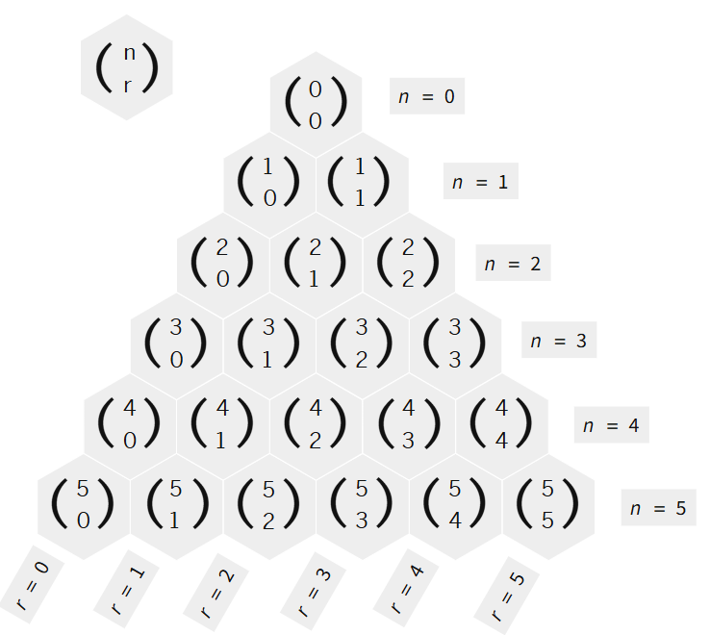

Appendix C

Tarsia puzzle
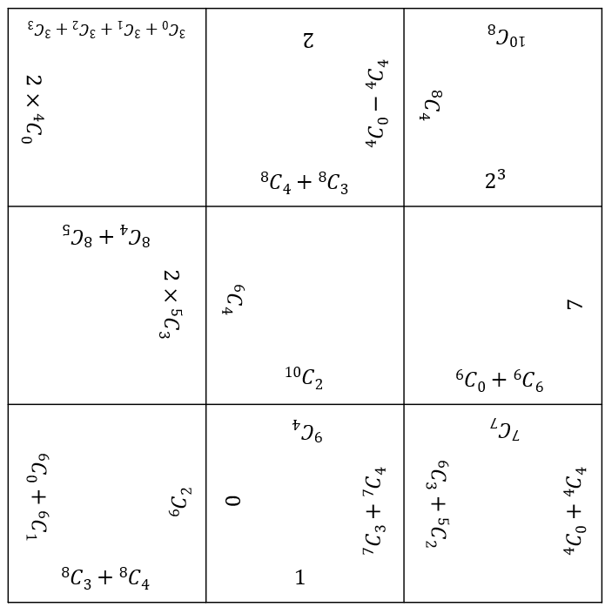

Appendix D

Combinatorial patterns
- Identify the value of $r$ in the coefficient ^{n}C_{r}, for the 9th term in the expansion of ${\left(x+y\right)}^{25}$. Hence, find the coefficient.
- Identify which other term in the expansion of ${\left(x+y\right)}^{25}$ would have the same coefficient as the 9th term. Use combinations to justify your response.
- Identify the 2 combinations that sum to give the coefficient of the 9th term in the expansion of ${\left(x+y\right)}^{25}$. Use combinations to justify your response.

Sample solutions

Appendix A – workstation tasks

Task 1
1, 4, 6, 4, 1

Task 2
$${\left(x+y\right)}^{4}=x^{4}+4x^{3}y+6x^{2}y^{2}+4xy^{3}+y^{4}$$
Coefficients: 1, 4, 6, 4, 1

Task 3
- 1
- 4
- 6
- 4
- 1

Task 4
- 1
- 4
- 6
- 4
- 1

Appendix C – Tarsia puzzle
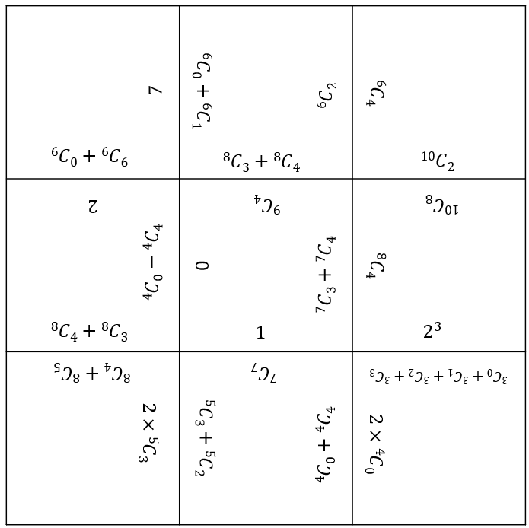

Appendix D – combinatorial patterns
- Identify the value of $r$ in the coefficient ^{n}C_{r}, for the 9th term in the expansion of ${\left(x+y\right)}^{25}$. Hence, find the coefficient.
In the expansion of ${\left(x+y\right)}^{25}$, the 9th term corresponds to $r=8$ (because we start counting $r$ from 0). The power of the binomial, $n$, is 25.
Therefore, the coefficient $\left({n \atop r}\right)$ is given by $\left({25 \atop 8}\right)$.
$$\left({25 \atop 8}\right)=\frac{25!}{8!\left(25-8\right)!}=\frac{25!}{8!×17!}=1 081 575$$
- Identify which other term in the expansion of ${\left(x+y\right)}^{25}$ would have the same coefficient as the 9th term. Use combinations to justify your response.
The symmetry in Pascal’s triangle gives us ^{n}C_{r} $=$ ^{n}C_{n-r}. Therefore, in the expansion of ${\left(x+y\right)}^{25}$, the term that has the same coefficient as the 9th term, $\left({25 \atop 8}\right)$, would be the term with the coefficient $\left({25 \atop 25-8}\right)=\left({25 \atop 17}\right)$. This is the term corresponding to $r=17$ or the 18th term.
To verify, $\left({25 \atop 17}\right)=\frac{25!}{17!\left(25-17\right)!}=\frac{25!}{17!×8!}=1 081 575$, which is the same coefficient as the 9th term.
- Identify the 2 combinations that sum to give the coefficient of the 9th term in the expansion of ${\left(x+y\right)}^{25}$. Use combinations to justify your response.
Using Pascal’s identity, ^{n}C_{r} $=$ ^{n-1}C_{r-1} +^{n-1}C_{r}, for the 9th term ($r=8$), we have:
$\left({25 \atop 8}\right)=\left({24 \atop 7}\right)+\left({24 \atop 8}\right)$.
Therefore, the 2 combinations that sum to give the coefficient of the 9th term, $\left({25 \atop 8}\right)$, are $\left({24 \atop 7}\right)$and$\left({24 \atop 8}\right)$.
To verify, $\left({24 \atop 7}\right)+\left({24 \atop 8}\right)=\frac{24!}{7!×17!}+\frac{24!}{8!×16!}=346 104+735 471=1 081 575$, which is the value of $\left({25 \atop 8}\right)$.

References
This resource contains NSW Curriculum and syllabus content. The NSW Curriculum is developed by the NSW Education Standards Authority. This content is prepared by NESA for and on behalf of the Crown in right of the State of New South Wales. The material is protected by Crown copyright.
Please refer to the NESA Copyright Disclaimer for more information https://educationstandards.nsw.edu.au/wps/portal/nesa/mini-footer/copyright.
NESA holds the only official and up-to-date versions of the NSW Curriculum and syllabus documents. Please visit the NSW Education Standards Authority (NESA) website https://educationstandards.nsw.edu.au/ and the NSW Curriculum website https://curriculum.nsw.edu.au/.
Mathematics Extension 1 11–12 Syllabus © NSW Education Standards Authority (NESA) for and on behalf of the Crown in right of the State of New South Wales, 2024.

© State of New South Wales (Department of Education), 2025
The copyright material published in this resource is subject to the Copyright Act 1968 (Cth) and is owned by the NSW Department of Education or, where indicated, by a party other than the NSW Department of Education (third-party material).
Copyright material available in this resource and owned by the NSW Department of Education is licensed under a Creative Commons Attribution 4.0 International (CC BY 4.0) license.

This license allows you to share and adapt the material for any purpose, even commercially.
Attribution should be given to © State of New South Wales (Department of Education), 2025.
Material in this resource not available under a Creative Commons license:
- the NSW Department of Education logo, other logos and trademark-protected material
- material owned by a third party that has been reproduced with permission. You will need to obtain permission from the third party to reuse its material.
Links to third-party material and websites
Please note that the provided (reading/viewing material/list/links/texts) are a suggestion only and implies no endorsement, by the New South Wales Department of Education, of any author, publisher, or book title. School principals and teachers are best placed to assess the suitability of resources that would complement the curriculum and reflect the needs and interests of their students.
If you use the links provided in this document to access a third-party's website, you acknowledge that the terms of use, including licence terms set out on the third-party's website apply to the use which may be made of the materials on that third-party website or where permitted by the Copyright Act 1968 (Cth). The department accepts no responsibility for content on third-party websites.

