Pascal’s triangle
Students investigate patterns in Pascal’s triangle including the connection between the values in Pascal’s triangle and the coefficients of binomial expansions.
Learning intentions and success criteria will be shared with students at the conclusion of the ‘Activating prior knowledge’ section.

Learning intentions
- To be able to identify patterns in Pascal’s triangle.
- To understand how Pascal’s triangle connects to binomial expansions.

Success criteria
- I can identify and describe various patterns in Pascal’s triangle.
- I can recognise a binomial as an algebraic expression consisting of 2 terms.
- I can expand binomial expressions of the form ${\left(x+y\right)}^{n}$ for $n=0, 1, 2, 3, 4, 5$.
- I can make connections between the coefficients in a binomial expansion and corresponding values in Pascal’s triangle.

Outcomes
A student:
- develops understanding and fluency in mathematics through exploring and connecting mathematical concepts, choosing and applying mathematical techniques to solve problems, and communicating their thinking and reasoning coherently and clearly MAO-WM-01
- uses the binomial theorem to solve problems and prove identities ME1-11-05

Content

The binomial theorem
- Recognise that a binomial is an expression with two terms, and that a binomial expansion is an expansion of a power of a binomial
- Examine the symmetry formed by the coefficients of decreasing powers of $x$ in the expansion of ${\left(x+y\right)}^{n}$ for $n=0, 1, 2, 3, 4, 5$ and arrange the coefficients into Pascal’s triangle
Mathematics Extension 1 11–12 Syllabus © NSW Education Standards Authority (NESA) for and on behalf of the Crown in right of the State of New South Wales, 2024.
Table 1: lesson summary
Section | Summary of activity | Teaching strategies | Teaching points
Activating prior knowledge | Show slide 4 of the PowerPoint Pascal’s triangle and ask students to expand ${\left(x+y\right)}^{n}$ for $n=0,1,2, 3, 4, 5$. Have them observe any patterns in the expansions. | Visibly random groups of 3  Vertical non-permanent surfaces | Students should notice that the number of terms in each expansion is one more than the power of the binomial, that the powers of $x$ and $y$ in each term add up to $n$ and that the powers of $x$ increase as the powers of $y$ decrease (or vice versa).
Connecting learning | Use slide 6 and Appendix A for students to explore Pascal’s triangle and the various patterns within it, including but not limited to: rows start and end with 1, row symmetry, the second number in each row are counting numbers, the third number in each row are triangular numbers and the sum of each row, $n$, is $2^{n}.$ Watch ‘What you don’t know about Pascal’s triangle’ (7:01) (bit.ly/HistoryofPascal) for more patterns. | Think-Pair-Share | The key patterns students need to know are:  - Each row starts and ends with 1.  - Each row contains one more term than its row number.  - Every number is the sum of the 2 numbers above it.  - The rows are symmetrical.
Releasing responsibility | Display slide 8 to show definitions, then slide 9 to confirm patterns in binomial expansions. Students identify terms belonging to different binomial expansions in Appendix B. | Think-Pair-Share  Notes to future forgetful selves | Students familiarise themselves with the patterns within the coefficients and powers of terms of binomial expansions.
Independent practice | Students expand ${\left(a+b\right)}^{9}$ using observed patterns before checking their answer algebraically. |  | Reinforce understanding of patterns in binomial expansions, including how coefficients correspond to the rows of Pascal’s triangle.

Activity structure
Please use the associated PowerPoint Pascal’s triangle to display images in this lesson.

Activating prior knowledge
- Assign students to visibly random groups of 3 (bit.ly/visiblegroups) at vertical non-permanent surfaces (VNPS) (bit.ly/VNPSstrategy) and ask them to expand ${\left(x+y\right)}^{n}$ for $n=0,1,2,3,4,5.$ This can be seen on slide 4.
Students should be familiar with and fluent in expanding up to $n=2$. Encourage students to multiply the previous expansion by the bracket $(x+y)$ or look for opportunities to use ${\left(x+y\right)}^{2}$.
Instruct students to arrange the terms in each expansion from the largest to smallest power of $x$ (that is, decreasing powers of $x$).
- Students compare their work with another group and discuss any differences, justifying their answers. Solutions can be found in the ‘Sample solutions’ section.
- Have students identify patterns in the expansions. If needed, prompt them to consider the number of terms, the coefficients and the powers of $x$ and $y$. Possible prompting questions could include:
- What is the relationship between the number of terms and the power?
- How does the sum of the powers of $x$ and $y$ relate to the power of the binomial?
- What pattern do you notice in the powers of $x$ and $y$ in the expansion?
Students should notice that the number of terms in each expansion is one more than the power of the binomial, that the powers of $x$ and $y$ in each term add up to $n$ and that the powers of $x$ increase as the powers of $y$ decrease (or vice versa).

Connecting learning
- Display slide 6 and using a Think-Pair-Share (bit.ly/thinkpairsharestrategy) have students discuss the patterns they observed and predict the next row.
Students should observe that each number is the sum of the 2 numbers directly above it from the previous row. The next row in the pattern is 1 4 6 4 1.
- Tell students that the triangular pattern of numbers is called Pascal’s triangle. Prompt students to consider a link between Pascal’s triangle and the expansions from the ‘Activating prior knowledge’ section of the lesson.
Students should notice that the numbers in Pascal’s triangle are the coefficients of each expansion.
- Provide students with Appendix A ‘Pascal’s triangle’ and have them fill in the missing numbers. Have students confirm their numbers with a partner, working together to reason out the discrepancies.
- Back in their random groups of 3 at their VNPS, have groups examine Pascal’s triangle to identify at least 3 distinct patterns in the rows, columns or diagonals. Encourage exploration of symmetry, position, sums or shapes. They should record their patterns and be prepared to share their reasoning or examples.
To support thinking, you might provide optional prompts, such as:
- What do you notice about the first and last numbers in each row?
- Is there a relationship between the row number and the number of elements in that row?
- Can you find any interesting patterns in the diagonals?
- Are any familiar number sequences hiding in the triangle?
- Bring the class back together to share the patterns the groups found. Record them on the board. Discuss similarities, differences and the mathematical significance of the identified patterns. Prompt deeper thinking with questions like:
- Did multiple groups find the same patterns? Why might that be?
- Which patterns were surprising or unexpected?
- Can we explain why these patterns occur?
Patterns include but are not limited to:
- Each row is symmetrical.
- Each row starts and ends with 1.
- Row $n$ contains $n+1$ numbers.
- The second number in each row (and second last) matches the row number and are counting numbers.
- The third number in each row (and third last) corresponds to triangular numbers.
- The sum of the numbers in row $n$ is $2^{n}$.
- Show students the video ‘What you don’t know about Pascal’s triangle’ (7:01) (bit.ly/HistoryofPascal) to show 3 other interesting patterns.

Releasing responsibility
- Display slide 8 and define the terms ‘binomial’ and ‘binomial expansion’ to students.
- Display slide 9 of the PowerPoint and use a Think-Pair-Share for students to answer the self-explanation prompts.
- Distribute Appendix B ‘Match the terms’ to student pairs. Explain that the sheet contains the individual terms for 4 different binomial expansions, ${\left(x+y\right)}^{5}, {\left(x+y\right)}^{6}, {\left(x+y\right)}^{7}$ and ${\left(x+y\right)}^{8}$. Ask pairs to use colours or symbols to match each term to the correct expansion.
- In a Think-Pair-Share ask students to discuss different strategies they used to group the terms and identify each binomial expansion.
- Have students write each binomial expansion out in order from largest power of $x$ to smallest before confirming that the patterns observed in the ‘Activating prior knowledge’ section for $n=0,1,2,3,4,5$work for $n=6,7,8.$
The patterns observed for $n=0,1,2,3,4,5$were that the number of terms in each expansion is one more than the power of the binomial, that the powers of $x$ and $y$ in each term add up to $n$ and that the powers of $x$ increase as the powers of $y$ decrease (or vice versa).
- Using Appendix A ‘Pascal’s triangle’ have students write notes to their future forgetful selves (bit.ly/notestofutureself) next to the triangle. The notes should include how the numbers in Pascal’s triangle are formed, any patterns and how the values relate to binomial expansions.

Independent practice
- Ask students to use Pascal’s triangle to predict the expansion of ${\left(a+b\right)}^{9}$.
Encourage students to apply the patterns they have identified by prompting them to consider:
- the coefficients from Row 9 of the triangle
- the powers of $x$ decreasing from 9 to 0
- the powers of $y$ increasing from 0 to 9.
- Have students check their expansion by multiplying ${\left(a+b\right)}^{8}(a+b)$.
- In pairs, have students explain one specific aspect of Pascal’s triangle or binomial expansions to a partner.

Assessment and differentiation

Suggested opportunities for differentiation
Activating prior knowledge
- If the class size does not allow for groups of 3, it is recommended to form random pairs, ensuring students continue working on vertical non-permanent surfaces (VNPS). In the case of very small classes, the teacher should participate as a student, using their own VNPS to contribute responses that would typically emerge in larger classes.
- Support students by scaffolding the binomial expansions.
- Challenge students to consider what changes would occur if the binomial was ${\left(x-y\right)}^{n}.$
Connecting learning
- The patterns in the rows, columns or diagonals of Pascal’s triangle could be highlighted or scaffolded to emphasise the patterns for students to observe.
- Select relevant patterns for students to examine in Pascal’s triangle depending on readiness.
Releasing responsibility
- Colour code other binomial expansions like that on slide 9 of the PowerPoint to help students identify the patterns or have students line the expansions up next to Pascal’s triangle.
- Appendix B could be modified to include a negative sign and/or coefficients greater than one.
Independent practice
- The example could be modified to include a negative sign or coefficients greater than one.

Suggested opportunities for assessment
Activating prior knowledge
- Observe students expand brackets to assess students’ algebraic skills.
Connecting learning
- Observe groups writing out Pascal’s triangle to assess students' understanding of how the numbers are formed.
- Listen to group discussions to assess students’ ability to articulate and reason about the identities observed.
Releasing responsibility
- Observe as groups complete the expansions to assess students' ability to expand and collect like terms.
- Listen to student contributions to pair and class discussions to check for understanding of the connection between Pascal’s triangle and binomial coefficients.
- Collect students’ notes to their future forgetful selves to check for accuracy and completeness.
Independent practice
- The expansions of ${\left(a+b\right)}^{9}$, or another variation, could be collected as an exit ticket (bit.ly/exitticketstrategy) to assess students' algebraic skills and ability to apply Pascal’s triangle to expand binomials to a power.

Appendix A

Pascal’s triangle
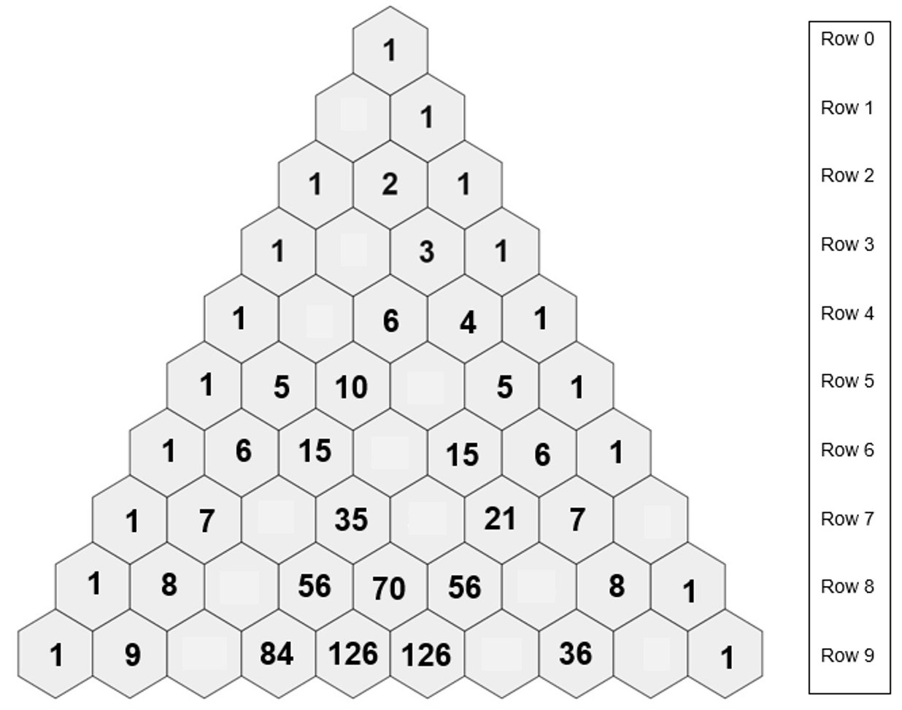

Appendix B

Match the terms
Match each term to the correct binomial expansion: ${\left(x+y\right)}^{5}, {\left(x+y\right)}^{6}, {\left(x+y\right)}^{7}$ or ${\left(x+y\right)}^{8}$ using different colours for each expansion.
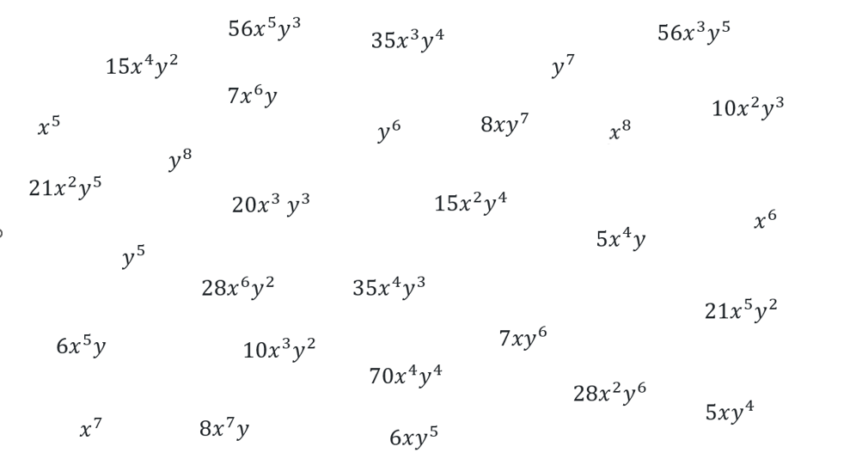

Sample solutions

Activating prior knowledge
$${(x+y)}^{0}$$ | $$1$$
$${(x+y)}^{1}$$ | $$x+y$$
$${(x+y)}^{2}$$ | $$x^{2}+2xy+y^{2}$$
$${(x+y)}^{3}$$ | $$x^{3}+3x^{2}y+3xy^{2}+y^{3}$$
$${(x+y)}^{4}$$ | $${x^{4}+4x}^{3}y+6x^{2}y^{2}+4xy^{3}+y^{4}$$
$${(x+y)}^{5}$$ | $${{x^{5}+5x}^{4}y+10x}^{3}y^{2}+10x^{2}y^{3}+5xy^{4}+y^{5}$$

Appendix A – Pascal’s triangle

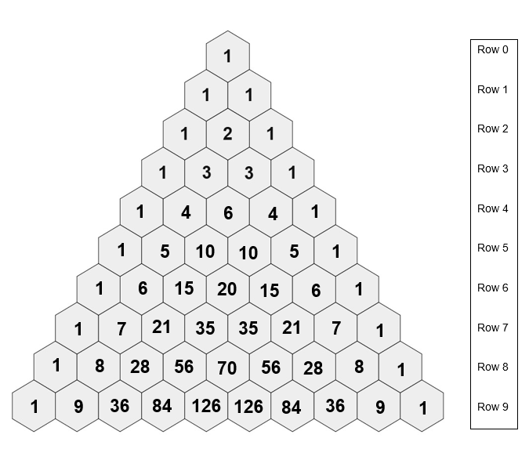

Appendix B – match the terms
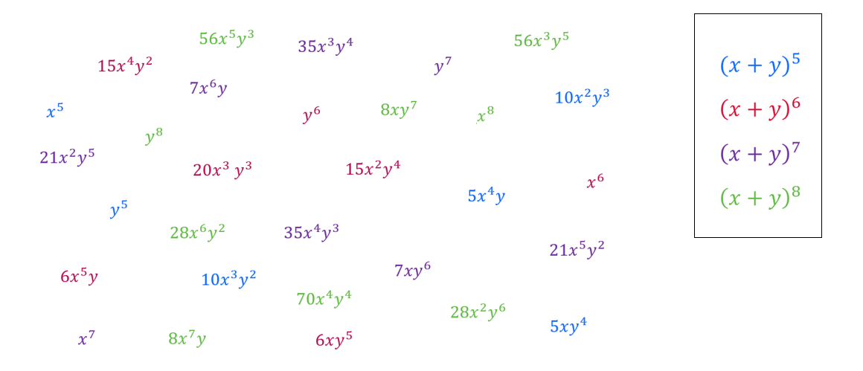
$${(x+y)}^{5}$$ | $${{x^{5}+5x}^{4}y+10x}^{3}y^{2}+10x^{2}y^{3}+5xy^{4}+y^{5}$$
$${\left(x+y\right)}^{6}$$ | $${{x^{6}+6x^{5}y+15x}^{4}y^{2}+20x}^{3}y^{3}+15x^{2}y^{4}+6xy^{5}+y^{6}$$
$${\left(x+y\right)}^{7}$$ | $${{x^{7}+7x^{6}y+21x^{5}y^{2}+35x}^{4}y^{3}+35x}^{3}y^{4}+21x^{2}y^{5}+7xy^{6}+y^{7}$$
$${\left(x+y\right)}^{8}$$ | $${{x^{8}+8x^{7}y+28x^{6}y^{2}+56x^{5}y^{3}+70x}^{4}y^{4}+56x}^{3}y^{5}+28x^{2}y^{6}+8xy^{7}+y^{8}$$

References
This resource contains NSW Curriculum and syllabus content. The NSW Curriculum is developed by the NSW Education Standards Authority. This content is prepared by NESA for and on behalf of the Crown in right of the State of New South Wales. The material is protected by Crown copyright.
Please refer to the NESA Copyright Disclaimer for more information https://educationstandards.nsw.edu.au/wps/portal/nesa/mini-footer/copyright.
NESA holds the only official and up-to-date versions of the NSW Curriculum and syllabus documents. Please visit the NSW Education Standards Authority (NESA) website https://educationstandards.nsw.edu.au/ and the NSW Curriculum website https://curriculum.nsw.edu.au/.
Mathematics Extension 1 11–12 Syllabus © NSW Education Standards Authority (NESA) for and on behalf of the Crown in right of the State of New South Wales, 2024.

© State of New South Wales (Department of Education), 2025
The copyright material published in this resource is subject to the Copyright Act 1968 (Cth) and is owned by the NSW Department of Education or, where indicated, by a party other than the NSW Department of Education (third-party material).
Copyright material available in this resource and owned by the NSW Department of Education is licensed under a Creative Commons Attribution 4.0 International (CC BY 4.0) license.

This license allows you to share and adapt the material for any purpose, even commercially.
Attribution should be given to © State of New South Wales (Department of Education), 2025.
Material in this resource not available under a Creative Commons license:
- the NSW Department of Education logo, other logos and trademark-protected material
- material owned by a third party that has been reproduced with permission. You will need to obtain permission from the third party to reuse its material.
Links to third-party material and websites
Please note that the provided (reading/viewing material/list/links/texts) are a suggestion only and implies no endorsement, by the New South Wales Department of Education, of any author, publisher, or book title. School principals and teachers are best placed to assess the suitability of resources that would complement the curriculum and reflect the needs and interests of their students.
If you use the links provided in this document to access a third-party's website, you acknowledge that the terms of use, including licence terms set out on the third-party's website apply to the use which may be made of the materials on that third-party website or where permitted by the Copyright Act 1968 (Cth). The department accepts no responsibility for content on third-party websites.

